Working together: gender equality
Module length: 5 x 60 minutes

Summary
Using the fifth United Nations’ Sustainable Development Goal (gender equality) as the focus, this module explores how the Australian Government aims to support a peaceful and productive neighbourhood regionally.
Students begin by exploring the concept of gender equality and what it means in terms of specific targets. They discuss the links between gender equality and prosperity, productivity, greater peace and social cohesion. They explore examples of development programs that the Australian Government runs in partnership with organisations and governments in neighbouring countries. Students reflect on what they have learned about the connection between gender equality and social cohesion. They finish by reflecting on the challenges and positives of working with another person, and what the partnerships process might mean for Australia when working with other countries to achieve a goal.
The module supports the global education theme of ‘interdependence and globalisation’. Throughout the learning activities, students work in pairs, practising social competencies such as collaboration, negotiation, critical thinking, managing differences and problem-solving. Communication skills are facilitated as they develop posters and learn from each other through a jigsaw activity. Students working in pairs to mirror the potential partnerships that occur between countries working together on development programs, and to provide opportunities for learning and reflection about this process. Get students to work in the same pairs throughout the unit so that they can reflect on the advantages and disadvantages of working with another student to complete a task.

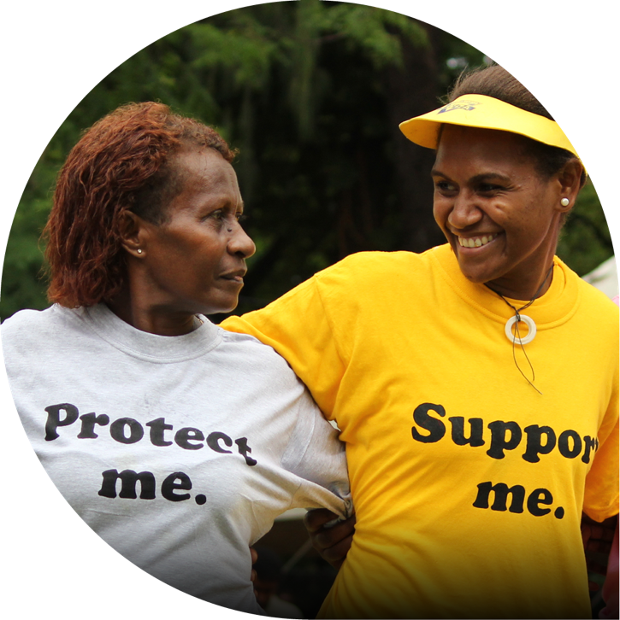
Jeremy Miller/Department of Foreign Affairs and Trade, CC BY 2.0

t of Foreign Affairs and Trade, CC BY
n
e
m
t
r
a
p
e
D
/
s
e
m
l
o
H
m
i
J
©

Please note
In teaching about gender equality, the following is important:
- Establishing empathy for a community increases students’ motivation to work on a topic.
- There may be backlash about the topic. This resource is helpful: (En)countering resistance: Strategies to respond to resistance to gender equality initiatives (especially pages 10 and 11).
- In this unit, students explore what is happening in another country in terms of gender equality. It can be easy to be judgemental and/or patronising about another culture if the context is not unpacked. Remind students that every country, including Australia, experiences levels of gender inequality and that countries, over time, have had different levels of access to resources, education and other key factors.
- Target 5.3 of Sustainable Development Goal 5 (Lesson 2) involves addressing the practice of female genital mutilation/cutting. Your context may be such that it is difficult to include this topic; the module can be taught without reference to this target.

Success criteria
At the end of this module, students should be able to:
- define the term ‘gender equality’ and describe the key elements that contribute to creating gender equality
- identify some of the ways that Australia is working in partnership with neighbouring countries to develop greater gender equality in those societies
- effectively reflect on the process of working in partnership with someone else, showing understanding of the challenges and positives of this kind of relationship.

Organising ideas
The organising ideas are global relationships, global responsibilities and global futures. These reflect the Australian Government’s aims to build genuine partnerships to jointly tackle global challenges, protect international rules, promote Australia’s international interests, and sustain a peaceful and prosperous future that keeps our region stable.

Prior knowledge
This unit assumes that students have some prior knowledge of the Sustainable Development Goals (SDGs). If this
is not the case, use the Global Goals Posters poster series as the basis for a quick summary of what the goals represent.

Key terminology

gender equality
productivity
prosperity
social cohesion

Further resources
- Understand Goal 5: gender equality (Secondary)
- Explainer: Sustainable Development Goal 5
- SDG indicator dashboard
- Indicators of Australia’s progress towards Goal 5
- Let’s talk about equality and equity
- 9 powerful social change movements you need to know about
- Bringing data to life: SDG human impact stories from across the globe
- BTN Special: Foreign Aid

Curriculum links
The table below lists the content descriptions explicitly addressed in this module. In addition to a focus on Civics and Citizenship, the module potentially connects with aspects of the History curriculum, such as The Globalising World, where Year 10 students study a major global influence, for example, the rise of feminism and movement towards global equality. It also connects with the Year 10 Geography curriculum, which explores the interactions between government and non-government organisations in the Pacific and Asia in terms of human wellbeing.

Civics and Citizenship

Knowledge and understanding: Citizenship, diversity and identity
Year 10: the challenges to and ways of sustaining a resilient democracy and a cohesive society in Australia and/or in our region or globally AC9HC10K05

Skills: Questioning and researching
Year 10: develop and modify questions to investigate Australia’s political and legal systems, and contemporary civic issues AC9HC10S01
Year 10: locate, select and compare information, data and ideas from a range of sources AC9HC10S02

Skills: Communicating
Year 10: create descriptions, explanations and arguments using civics and citizenship knowledge, concepts and terms that incorporate evidence AC9HC10S05

History

Knowledge and understanding: The globalising world
Year 10: the effects of global influences on Australia’s changing identity as a nation and its international relationships AC9HH10K19

Geography

Knowledge and understanding: Geographies of human wellbeing
Year 10: responses of international and national government and non-government organisations to improve human wellbeing in Australia, within India and another country in the Pacific AC9HG10K08

General capabilities
Personal and Social Capability: Students work in pairs, and are provided with regular opportunities to reflect on this process and to apply the concept of working in partnership to a broader context.

Cross-curriculum priorities
Asia and Australia’s Engagement with Asia: Students develop understandings of the region’s contemporary challenges and opportunities for women and girls. They explore some of the ways in which Australia engages strategically with countries in Asia and the Pacific.

Gender equality – connecting with the topic
Learning intentions | Materials
- To understand the term ‘gender equality’ and some of the challenges in achieving greater equality.  - To understand some of the ways Australian society has worked towards achieving gender equality over time. | - Video: Let’s talk about equality and equity  - Video: What is feminism? – BTN High  - Website: Gender equality through the cartoonists’ lens  - Exit card: Gender equality – are we there yet?

Introduction (30 min)
- Explain that the focus of this unit is to look at how people work to achieve gender equality both in Australia and around the world. Write this question on the whiteboard: ‘Gender equality: are we there yet?’ (It might be useful to narrow the context to, for example, Australian society or the lives of students.) Students should discuss the question in pairs for a few minutes. Conduct a whole-class discussion, noting the responses. Some of following might come up:
- Defining gender equality.
- What ‘we’ means in this question.
- What a state of equality might look like.
- Why achieving gender equality is desirable for society but can be controversial.
- What change in this area might look like.
It’s not necessary to have answers to these questions at this point – the aim of the activity is to engage and raise awareness.
- Show the video Let’s talk about equality and equity, which unpacks the terms ‘equality’ and ‘equity’ and the rationale for providing special programs that lead to equal outcomes.
- Show the video What Is feminism? This 7-minute Behind the News video describes the history of women’s rights in Australia and explores questions such as: What is feminism? Do we still need it in modern Australia? Who can be feminists?
Ask students to identify some of the changes in Australian society that have led to greater gender equality.

What do cartoonists say about gender equality? (15 min)
- The class will now look at how cartoonists around the world interpret the topic of gender equality. Have students link to the UN Women webpage Gender equality through the cartoonists’ lens. In pairs, students look through the cartoons on this page. Tell them to:
- select the one cartoon that they think is most effective at making its point
- identify what that cartoon is saying about gender equality.

- Have a brief whole-class discussion to draw out responses to the cartoons and the different ways that the topic is being explored (men not taking women seriously; the degree of difficulty in reaching positions of power and influence; the impact of war on capacity to develop as a human being; patriarchal attitudes; unequal pay; the expectation that women will do unpaid work such as domestic work; stereotyped attitudes). Some prompts could include:
- How do the cartoons explore this topic?
- Which cartoons were most popular and why?
- How are they different/similar?
- The cartoons are drawn from a range of cultures – to what extent does this make a difference in trying to understand the themes of gender inequality?

Learning review
Ask students to complete an exit card with these two dot points:
- Two things I learned today.
- One question that I have.
© Aaron Kearney

Gender equality – are we there yet?
My exit card | My exit card
Two things I learned today | Two things I learned today
One question that I have | One question that I have
Two things I learned today | Two things I learned today
 | One question that I have

The elements of gender equality
Learning intention | Materials
To learn about one of the elements that help build a more gender-equal world, as agreed by most countries in the world. | - A set of icons for SDG 5. These can be downloaded from the Global Goals’ Brand assets page. There are nine target icons – print an assortment of the target icon cards to be used by pairs of students.  - Worksheet: Unpacking a gender equality target  - Worksheet: Working together.

Unpacking the gender equality targets from Sustainable Development Goal 5 (45 min)
- Explain that the Sustainable Development Goals (SDGs) are one of the drivers of change in the world. They were ratified by all 193 United Nations member countries in 2015 and aim to achieve significant change by 2030. Australia has signed up too and is working on each of the 17 goals, making varying progress depending on the goal.
SDG 5 focuses on gender equality. Tell students that they are going to spend a couple of lessons unpacking this goal in more detail.
- Each SDG has several targets. Hand out individual targets of SDG 5 to pairs of students. Make sure that all the targets are covered within your class. (Some pairs might cover the same target, depending on the size of your class.)
- Give students the ‘Unpacking a gender equality target’ worksheet.
- Tell students, working in pairs, to make a slideshow that responds to these questions:
SDG target icon © European Union, 1995-2025, CC BY 4.0
- What does this target mean?
- How do you think this target helps achieve gender equality?
- Give some concrete examples of what actions a government could take to achieve this target.
- Are there ways that the target might help decrease poverty, strengthen social cohesion or improve economic productivity?
Some of the suggested websites on the worksheet include data and associated information about how different countries are doing in terms of this target.
Tell students they will report back to the class in the next lesson.

Learning review
Give each student a copy of the ‘Working together’ worksheet and ask them to make some notes, as individuals, for homework. Ask students to focus on the process of working in pairs – the challenges and positives. Tell them that they will not be sharing the contents of the worksheet unless they want to, so they should be as honest as possible.

Unpacking a gender equality target
Make a slideshow (three slides maximum) about the gender equality target card you have been given.
- What does this target mean?
- How do you think this target helps achieve gender equality?
- Give some concrete examples of what actions a government could take to achieve this target.
- Are there ways that the target might help decrease poverty, strengthen social cohesion or improve economic productivity?
Use simple language that your classmates will understand and answer the questions using dot points.

Websites
Choose websites that are relevant to your target card.

- Terminology flashcards
- SDG 5 gender equality – UN Sustainable Development Goals – DEEP DIVE (this video is divided into sections that specifically address some of the targets for SDG 5)
- SDG Target #5.1
- SDG Target #5.2
- SDG Target #5.3
- SDG Target #5.4
- SDG Target #5.5
- SDG Target 5.6
- SDG Target #5a
- SDG Target #5b
- SDG Target #5c
- Gender equality
- Achieve gender equality and empower all women and girls
- Strategic partner on women: peace and security with the Pacific

Use any other relevant website to support your research.
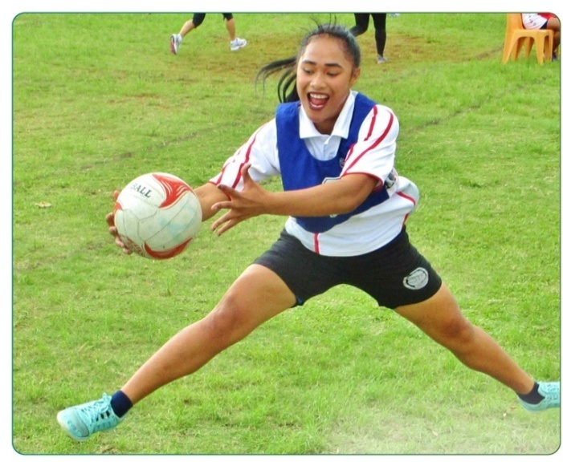
© Aaron Kearney

Working together
Choose one of the projects on the list.
Lesson | Learning intention | How well did my partner and I work together? Consider the challenges and positives.
2 | To learn about one of the elements that help build a more gender-equal world, as agreed by most countries in the world.
3 | To learn about all nine elements that help build a more gender-equal world, as agreed by most countries in the world.
4 | To explore the connections between gender equality and concepts such as social cohesion, productivity and prosperity.  To explore specific projects aimed at supporting greater gender equality in one of our neighbouring countries.

Overall reflection
Focus on these points:
- What did you learn by working closely with another person to complete a set of tasks?
- What might you do differently next time you need to work closely with another student to achieve a goal?
- Australia works in partnership in development programs with other countries. What would help these partnerships to be effective (based on your experience working as a pair in this module)?

Differentiated instruction

For students who need additional support
- Pair with stronger students within the class during the research stage.

For EALD students
- The United Nations SDG website is offered in six different languages. Show students how to navigate to a different language setting in the upper right-hand section of the website.

For students who need a challenge
- Encourage students to consider all nine gender equality targets.
- Which target would make the biggest difference to improving the prosperity of a society?
- Which target would make the biggest difference to social cohesion?
- Which target would make the biggest difference to improving productivity?
- In their opinion, which target would make the biggest difference to improving the lives of women?

Additional activity
Students can test some of what they have learned using Gapminder: UN Goal 5 Gender equality.
© Sarah Friend / Department of Foreign Affairs and Trade, CC BY

Where are we at right now with gender equality?
Learning intention | Materials
To learn about all nine elements that help build a more gender-equal world, as agreed by most countries in the world. | - Student slideshows created in Lesson 1  - SDG 5 overview poster  - Worksheet: About the gender equality targets  - Worksheet: Working together (started in Lesson 2)

Presentations (30 min)
- Have students present their slideshows to the class. Give each student the ‘About the gender equality targets’ worksheet. Students should make notes about each of the targets as they listen to the presentations so that, at the end, they will understand what each target means.

Where are we at with SDG 5? (5 min)
- Show the SDG 5 poster.

Learning review: Headlines (10 min)
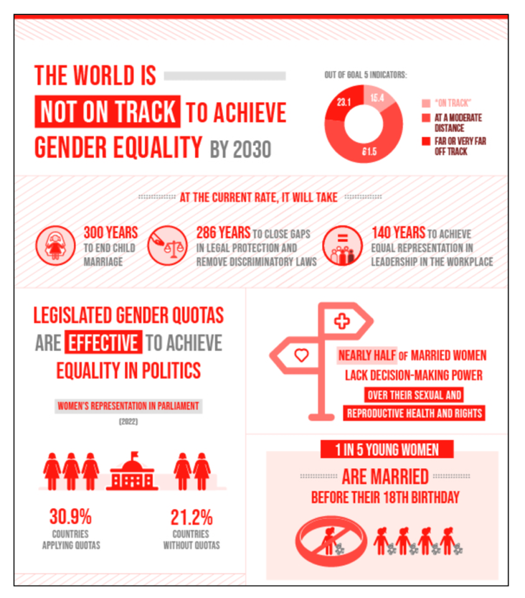
© European Union, 1995-2025, CC BY 4.0

- Ask the students to reflect individually about the core ideas of the topic of gender equality.
Say, ‘Think about all that we have been talking about today in class. If you were to write a headline for [topic/issue] right now that captured the most important aspect that should be remembered, what would it be?’ Give them time to form their headlines. Invite the students to share their headlines with their neighbour.
You might finish the lesson by asking ‘Who heard a headline from someone else that they thought was particularly good at getting to the core of the issue?’
- For homework, ask students to make further notes, as individuals, on the Working together worksheet. They should focus on the process of working in pairs – the challenges and positives.

About the gender equality targets
Make notes about the following:
- How well do you think Australia is doing at achieving this target?
- What do you think some of the challenges might be in achieving the target?
- Can you think of a few ways that this target might be achieved?
- Which target do you think would make the greatest difference in achieving gender equality?
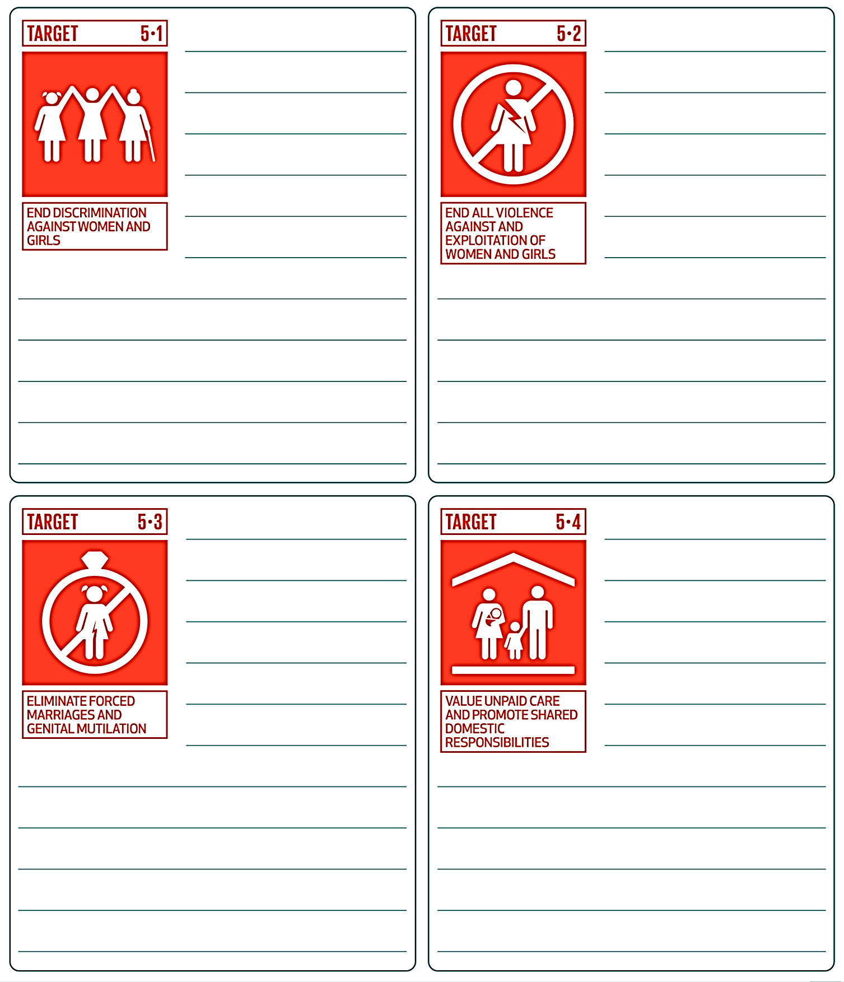
SDG target icons © European Union, 1995-2025, CC BY 4.0

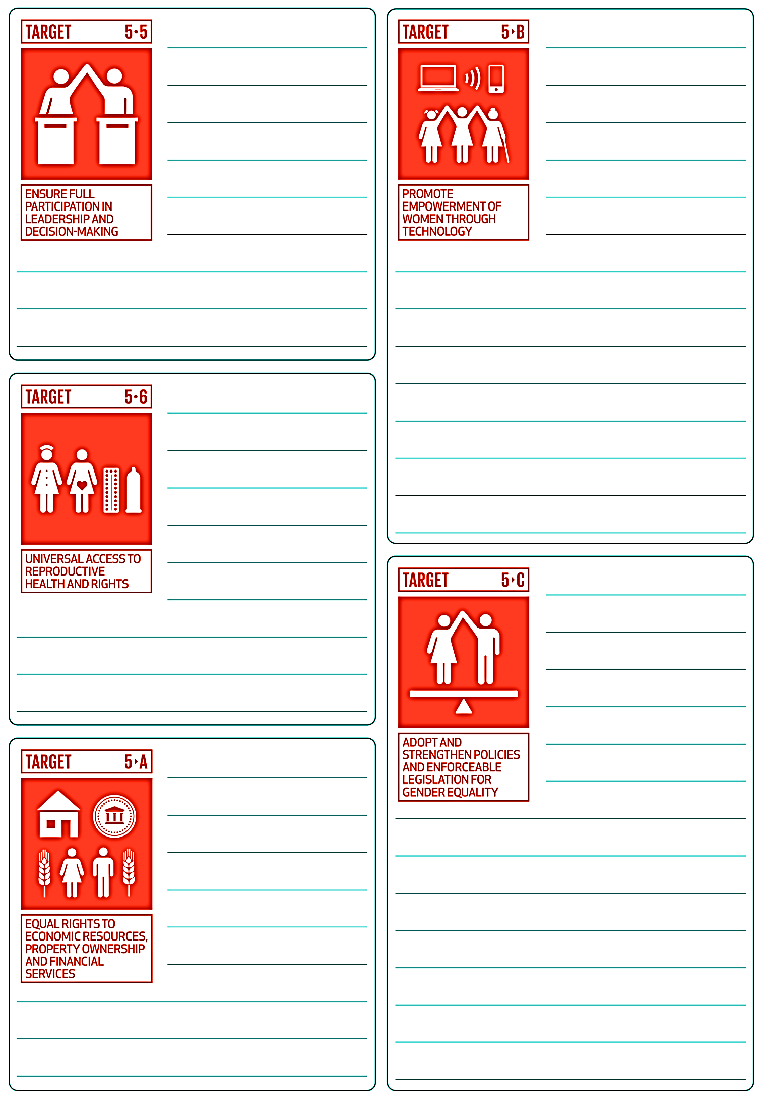
SDG target icons © European Union, 1995-2025, CC BY 4.0

What does a gender equality project look like?
Learning intentions | Materials
- To explore the connections between gender equality and concepts such as social cohesion, productivity and prosperity.  - To explore specific projects aimed at supporting greater gender equality in one  of our neighbouring countries. | - PowerPoint: Working together: gender equality  - Worksheet: Gender equality – working in partnership with our neighbours: projects  - Worksheet: Working together (started in Lesson 2)

Introduction (15 min)
- Show students this quote from the Working together: gender equality PowerPoint (slide 2):
‘We know that gender equality is a stronger predictor of peace than a nation’s wealth or political system.’ (Foreign Minister Penny Wong, February 2025)
Ask students to discuss the quote in pairs, identifying the reasons why gender equality might contribute to a peaceful society.
Facilitate a brief class discussion drawing out responses to the quote.
- Show students the next part of the quote (slide 3):
‘We know that peace agreements are more likely to last when women can participate in them. And we know that gender equality reduces poverty, strengthens social cohesion, unlocks economic productivity and enhances prosperity for current and future generations.
If women participated in the economy on equal terms with men, it could add up to US$28 trillion to the international economy. So the whole world pays the price for the lack of gender equality. We pay that price in a world that is more dangerous, more divided, less stable, and poorer.’ (Foreign Minister Penny Wong, February 2025)
It is important that students understand the concepts of social cohesion, productivity and prosperity, so spend time on these definitions if required.
As a class, discuss the quote, drawing out responses about how increasing gender equality might help to decrease poverty, strengthen social cohesion, improve economic productivity and/or create a more peaceful society.

Poster project (30 min)
- Tell the class that they will explore some of the projects where the Australian Government is partnering with organisations in other countries to work towards gender equality in those locations. Students will work in pairs to make a poster that describes the project.
- Give students the Gender equality – working in partnership with our neighbours: projects worksheet. Students should choose one of the projects on this list. Each project has an associated webpage that provides some basic information about the project. Students should complete the posters in pairs, working through the prompts on the worksheet.
- Provide students with time to work on the projects. They may require time at home to complete them.

Learning review
- As homework, ask students to make further notes, as individuals, on the Working together worksheet. They should focus on the process of working in pairs – the challenges and advantages.

Gender equality – working in partnership with our neighbours: projects
Choose one of the projects on the list.
Project | Description
Teaching women to produce eco-friendly bricks for low-cost homes | Build Up Nepal is a social enterprise that trains women, young people and returning migrants to produce eco-friendly bricks and build low-cost homes.
Samoa’s geek girls are busting the myth of boys better at science | Samoan Cybersecurity expert, Tagilima Neemia, helps Samoan girls get tech-savvy.
Tackling Solomon Islands period poverty, one reusable pad at a time | Kaleko SteiFree team is working with Australia’s Red Hat Impact to make reusable sanitary pads.
Meet one of the first women to qualify as a surfing instructor on Solomon Islands | Meet a young woman as she and her team use their passion for surfing to empower girls by challenging stereotypes about men and women.
Lao’s Rugby Game Changer | Viengsamai Souksavanh uses rugby as a way of connecting with young people and helping with personal development and building life skills.
Safe Sport Day 2024 | Team Up ran a Safe Sport Day to reinforce the importance of safeguarding in sports.
‘Ana, an unstoppable force reshaping Tonga | The Pacific Girl program has increased the rights and opportunities of more than 3,000 adolescent girls across the Pacific.
Promoting women’s leadership in a male-dominated industry | Tira Austenite, a trading company selling technical machinery, wanted to double the number of women in managerial jobs.
Regional Training Program on Gender, Violence Against Women and Girls, Human Rights and Development | Women from Pacific countries participate in training on topics such as rape, domestic violence, sexual harassment, child abuse and human rights laws.
Palau women cultivate success from the taro patch to the policy table | This project supports women’s associations to transition to organic agricultural practices and helps them engage in developing relevant policies.
A new era of netball for PNG | This project supports more women and girls to play netball in Papua New Guinea.
Increasing the number of women candidates in local elections in Tonga | Support group FFFT ran a series of election candidate workshops to provide support to women standing for election.
Australia, ASEAN and OSCE advocate an end to child, early and forced marriage | A new regional guideline will provide a framework for countries to work towards eradicating child and forced marriage.
Campaigns target male advocates for gender equality | In Indonesia, two campaigns highlight how both women and men benefit when domestic responsibilities are shared equally.
IW-supported gender equality campaigns win Philippine Quill awards | Two Filipino organisations created high-quality gender equality campaigns.
The power of connecting local, regional and global levels of action: The story of the Pacific Women Mediators Network | The Pacific Women Mediators Network is a locally led, inclusive platform to support women’s political leadership.
Industry awards bolster business case for ‘unstereotyping’ marketing campaigns | This project supports digital marketing campaigns that challenge inequalities based on factors such as gender.
Unlocking the potential of quality part-time work for women’s economic equality | This project is paying for a study that examines gender-inclusive part-time work policies and best practice for part-time work.
Australian High Commission seeks strong support for equality in politics | The Australian High Commission supports a Nigerian Bill that proposes allocating seats especially for women in the various state houses of Assembly and in the National Assembly.

Create a poster that includes the following information:
- A brief description of the project.
- What is the issue or problem that is being addressed?
- How does it relate to specific targets within Sustainable Development Goal 5?
- How will the program make a difference? (Consider whether the program is running training, advocacy, legal change, networks, building local skills, communicating about an issue, providing safety and support, attitude change, behaviour change, or a combination of these.)
- How will it make a difference in terms of gender equality? (Think about the targets that you explored in the previous lessons. What targets are the focus here?)
- How might the project help decrease poverty, strengthen social cohesion, improve economic productivity or create a more peaceful society?
- Where is the project happening?

Pooling ideas
Learning intention | Materials
To identify some of the ways that Australia works with neighbouring countries to achieve greater levels of gender equality. | - Group posters (produced in Lesson 4)  - Worksheet: Working together (started in Lesson 2)

Small group synthesis (20 min)
- Combine pairs of students into groups of six. Try to have a spread of different projects in each group. Each pair should show their poster to their group.
- Ask the groups to write a paragraph explaining how Australia’s work in gender equality aims to contribute to a cohesive society in our region.
(If you want a more structured approach, you could allocate smaller tasks within the group. For example, one student creates the topic sentence, another provides supportive evidence, one student argues for or against, the other writes the concluding statement.)

Module wrap-up (25 min)
- Share the groups’ paragraphs as a whole class. Try to draw out the following:
- What students have learned about gender equality.
- What students have learned about social cohesion.
- Ask students to complete an overall summary, as individuals, on the Working together worksheet. They should focus on these points:
- What did you learn by working closely with another person to complete a set of tasks?
- What might you do differently next time you need to work closely with another student to achieve a goal?
- Australia works in partnership in development programs with other countries. What would help these partnerships to be effective (based on your experience working as a pair in this module)?

