Gender equality – are we there yet?
My exit card | My exit card
Two things I learned today | Two things I learned today
One question that I have | One question that I have
Two things I learned today | Two things I learned today
One question that I have | One question that I have

Working together
Choose one of the projects on the list.
Lesson | Learning intention | How well did my partner and I work together? Consider the challenges and positives.
2 | To learn about one of the elements that help build a more gender-equal world, as agreed by most countries in the world.
3 | To learn about all nine elements that help build a more gender-equal world, as agreed by most countries in the world.
4 | To explore the connections between gender equality and concepts such as social cohesion, productivity and prosperity.  To explore specific projects aimed at supporting greater gender equality in one of our neighbouring countries.

Overall reflection
Focus on these points:
- What did you learn by working closely with another person to complete a set of tasks?
- What might you do differently next time you need to work closely with another student to achieve a goal?
- Australia works in partnership in development programs with other countries. What would help these partnerships to be effective (based on your experience working as a pair in this module)?

Differentiated instruction

For students who need additional support
- Pair with stronger students within the class during the research stage.

For EALD students
- The United Nations SDG website is offered in six different languages. Show students how to navigate to a different language setting in the upper right-hand section of the website.

For students who need a challenge
- Encourage students to consider all nine gender equality targets.
- Which target would make the biggest difference to improving the prosperity of a society?
- Which target would make the biggest difference to social cohesion?
- Which target would make the biggest difference to improving productivity?
- In their opinion, which target would make the biggest difference to improving the lives of women?

Additional activity
Students can test some of what they have learned using Gapminder: UN Goal 5 Gender equality.

© Sarah Friend / Department of Foreign Affairs and Trade, CC BY

About the gender equality targets
Make notes about the following:
- How well do you think Australia is doing at achieving this target?
- What do you think some of the challenges might be in achieving the target?
- Can you think of a few ways that this target might be achieved?
- Which target do you think would make the greatest difference in achieving gender equality?
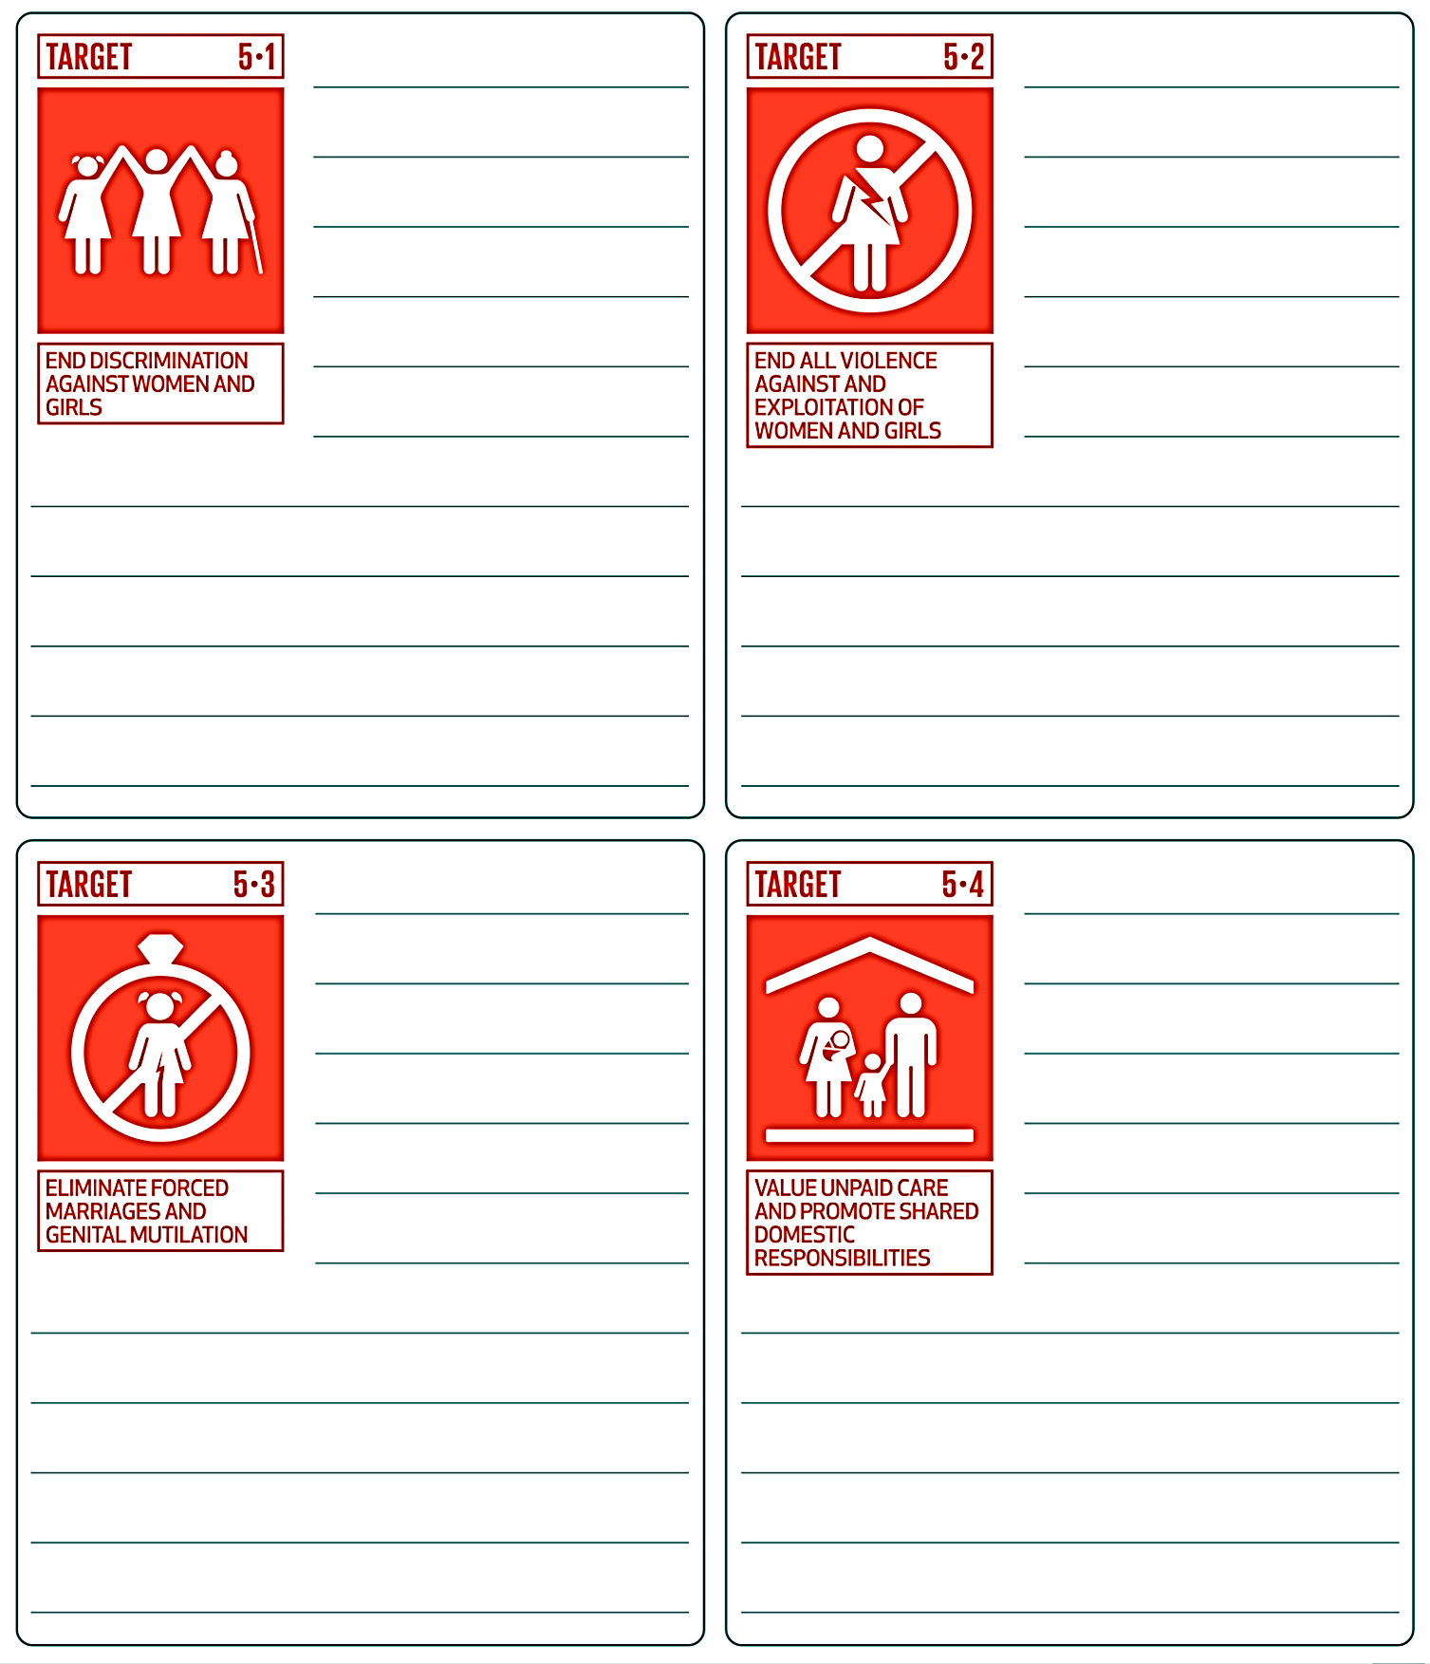
SDG target icons © European Union, 1995-2025, CC BY 4.0

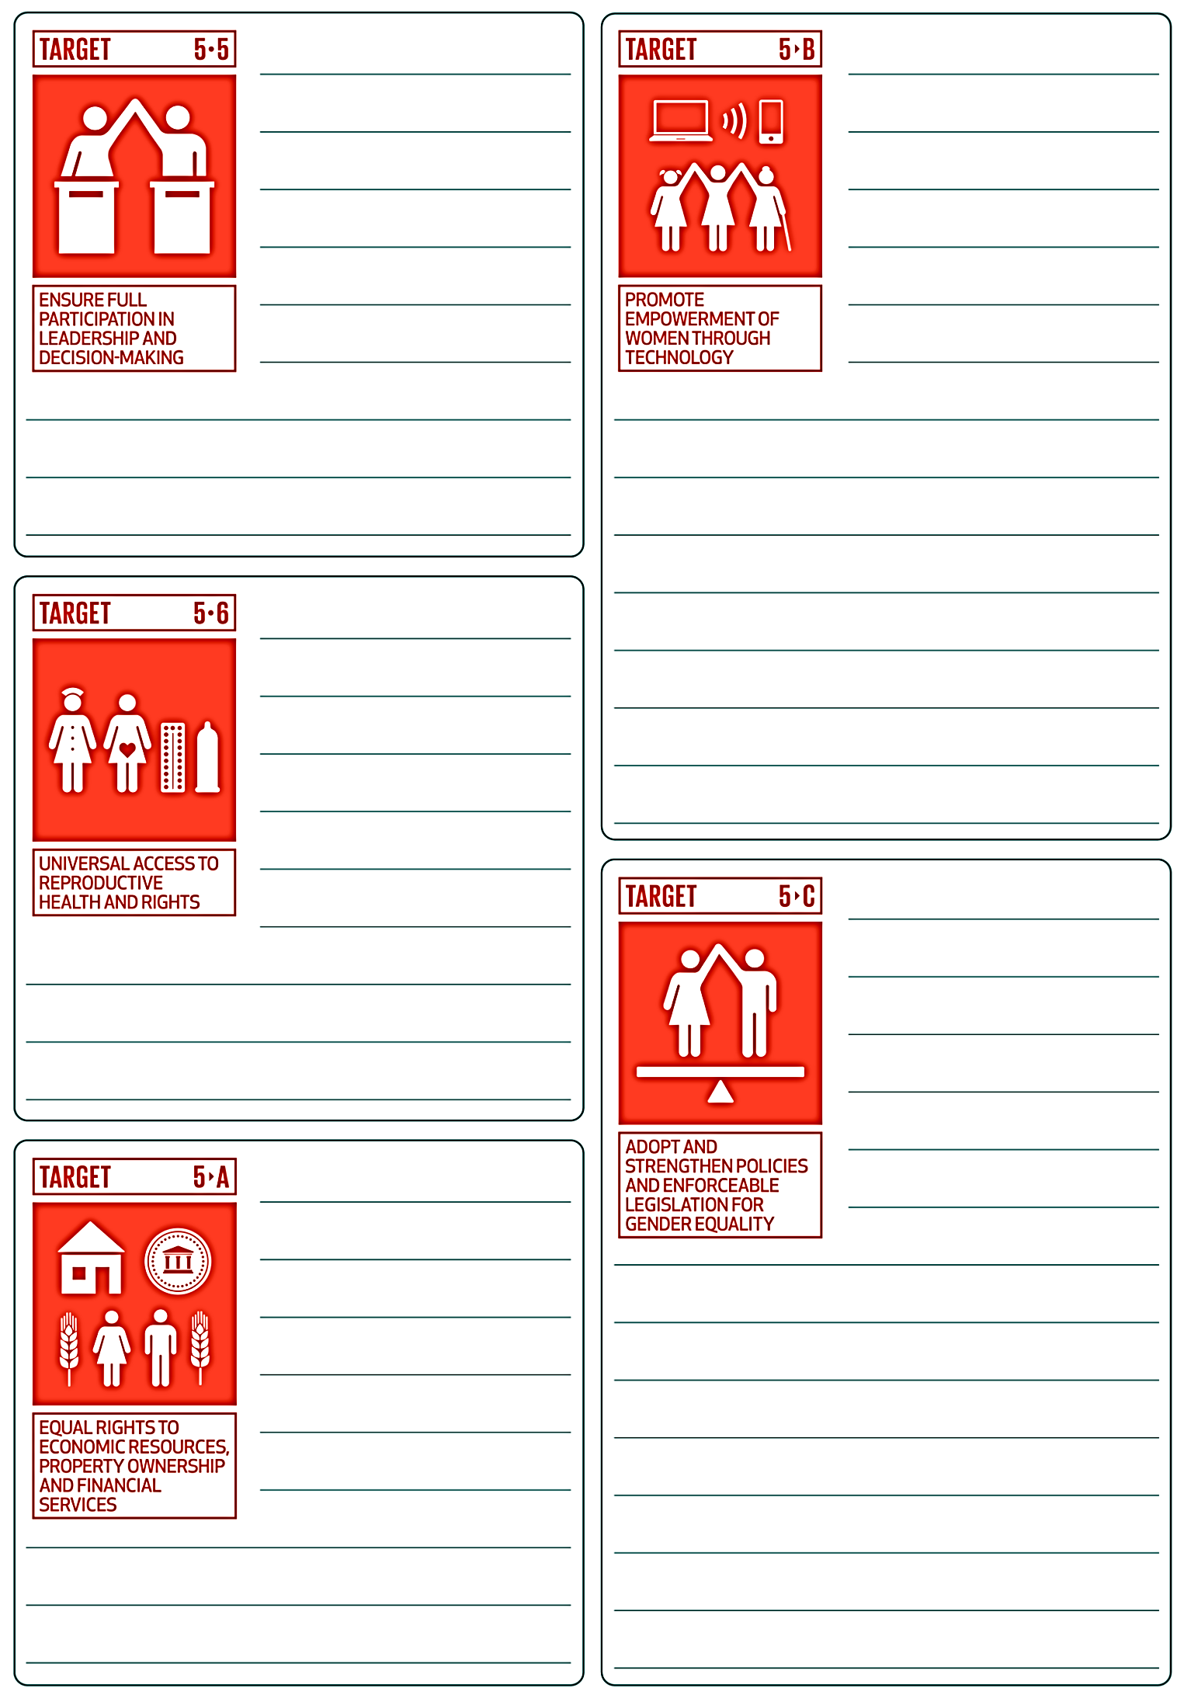
SDG target icons © European Union, 1995-2025, CC BY 4.0

Gender equality – working in partnership with our neighbours: projects
Choose one of the projects on the list.
Project | Description
Teaching women to produce  eco-friendly bricks for low-cost homes | Build Up Nepal is a social enterprise that trains women, young people and returning migrants to produce eco-friendly bricks and build low-cost homes.
Samoa’s geek girls are busting the myth of boys better at science | Samoan Cybersecurity expert, Tagilima Neemia, helps Samoan girls get tech-savvy.
Tackling Solomon Islands period poverty, one reusable pad at  a time | Kaleko SteiFree team is working with Australia’s Red Hat Impact to make reusable sanitary pads.
Meet one of the first women  to qualify as a surfing instructor on Solomon Islands | Meet a young woman as she and her team use their passion for surfing to empower girls by challenging stereotypes about men and women.
Lao’s Rugby Game Changer | Viengsamai Souksavanh uses rugby as a way of connecting with young people and helping with personal development and building life skills.
Safe Sport Day 2024 | Team Up ran a Safe Sport Day to reinforce the importance of safeguarding in sports.
‘Ana, an unstoppable force reshaping Tonga | The Pacific Girl program has increased the rights and opportunities of more than 3,000 adolescent girls across the Pacific.
Promoting women’s leadership in  a male-dominated industry | Tira Austenite, a trading company selling technical machinery, wanted to double the number of women in managerial jobs.
This link will take you to the Fiji Women's Crisis Centre website | Women from Pacific countries participate in training on topics such as rape, domestic violence, sexual harassment, child abuse and human rights laws.
Palau women cultivate success from the taro patch to the policy table | This project supports women’s associations to transition to organic agricultural practices and helps them engage in developing relevant policies.
A new era of netball for PNG | This project supports more women and girls to play netball in Papua New Guinea.
Increasing the number of women candidates in local elections in Tonga | Support group FFFT ran a series of election candidate workshops to provide support to women standing for election.

Australia, ASEAN and OSCE advocate an end to child, early and forced marriage | A new regional guideline will provide a framework for countries to work towards eradicating child and forced marriage.
Campaigns target male advocates  for gender equality | In Indonesia, two campaigns highlight how both women and men benefit when domestic responsibilities are shared equally.
IW-supported gender equality campaigns win Philippine Quill awards | Two Filipino organisations created high-quality gender equality campaigns.
The power of connecting local, regional and global levels of action: The story of the Pacific Women Mediators Network | The Pacific Women Mediators Network is a locally led, inclusive platform to support women’s political leadership.
Industry awards bolster business  case for ‘unstereotyping’ marketing campaigns | This project supports digital marketing campaigns that challenge inequalities based on factors such as gender.
Unlocking the potential of quality  part-time work for women’s economic equality | This project is paying for a study that examines gender-inclusive part-time work policies and best practice for part-time work.
Australian High Commission seeks strong support for equality in politics | The Australian High Commission supports a Nigerian Bill that proposes allocating seats especially for women in the various state houses of Assembly and in the National Assembly.
Create a poster that includes the following information:
- A brief description of the project.
- What is the issue or problem that is being addressed?
- How does it relate to specific targets within Sustainable Development Goal 5?
- How will the program make a difference? (Consider whether the program is running training, advocacy, legal change, networks, building local skills, communicating about an issue, providing safety and support, attitude change, behaviour change, or a combination of these.)
- How will it make a difference in terms of gender equality? (Think about the targets that you explored in the previous lessons. What targets are the focus here?)
- How might the project help decrease poverty, strengthen social cohesion, improve economic productivity or create a more peaceful society?
- Where is the project happening?

