Appendix 10 – Stakeholder Survey VWC MTR
1) The VWC provide high quality counselling and support services to women and children who are victims of violence
Response |  |  | % | Number |  |  |  |  |  |  | 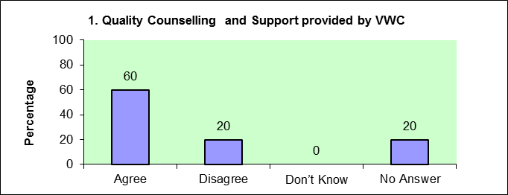
Agree |  |  | 60 | 3
Disagree |  |  | 20 | 1
Don’t Know |  |  | 0
No Answer |  |  | 20 | 1
 |  |  |  | 5
Women that we have referred to the centre have appreciated the confidential
counselling but this has not been followed through with ongoing support, often felt
abandoned at court and police station
2) Information provided by the VWC to community members about violence against women and children is helpful
 |  |  |  |  |  | 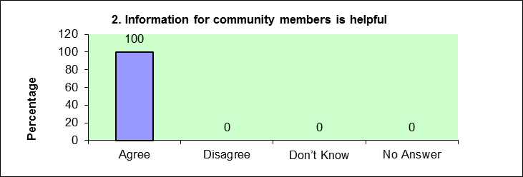
Response |  |  | % | Number
Agree |  |  | 100 | 5
Disagree |  |  | 0 | 0
Don’t Know |  |  | 0 | 0
No Answer |  |  | 0 | 0
 |  |  |  | 5
Comments
3) The CAVAWs have had a positive impact on changing community attitudes
Response |  |  | % | Number |  | 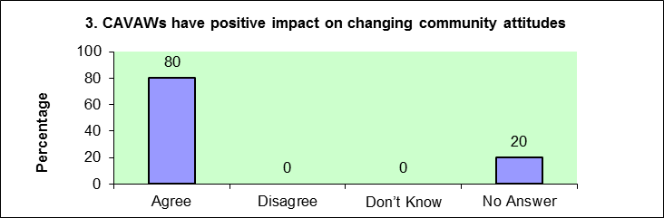
Agree |  |  | 80 | 4
Disagree |  |  | 0 | 0
Don’t Know |  |  | 0 | 0
No Answer |  |  | 20 | 1
 |  |  |  | 5
4) The CAVAWS have had a positive impact on supporting victims in the community
 |  |  |  |  |  |  |  |  |  |  | 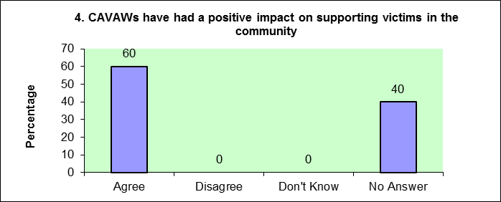
Response |  |  | % | Number
Agree |  |  | 60 | 3
Disagree |  |  | 0 | 0
Don't Know |  |  | 0 | 0
No Answer |  |  | 40 | 2
 |  |  |  | 5
Some CAVAWS cannot distinguish between basic human rights and culture and would advise confusingly.
Not sure about CAVAWs understanding
5) The Male Advocacy Program for Women's Human Rights has helped the community understand that violence against women is a crime.
Response |  |  | % | Number |  | 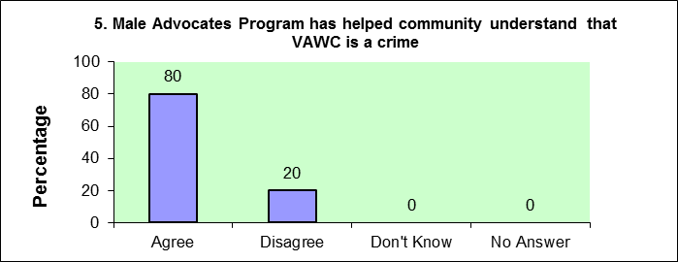
Agree |  |  | 80 | 4
Disagree |  |  | 20 | 1
Don't Know |  |  | 0 | 0
No Answer |  |  | 0 | 0
 |  |  |  | 5
6) The VWC has helped to increase community acceptance that violence against women and children is a violation of human rights
 |  |  |  |  |  | 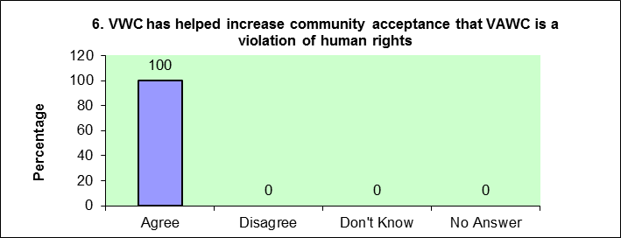
Response |  |  | % | Number
Agree |  |  | 100 | 5
Disagree |  |  | 0 | 0
Don't Know |  |  | 0 | 0
No Answer |  |  | 0 | 0
 |  |  |  | 5
Comments
7) Women who are victims of violence have more access to counselling and support due to VWC

Response |  |  | % | Number |  | 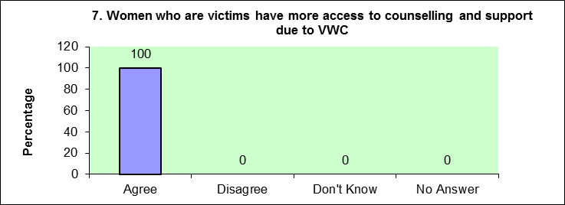
Agree |  |  | 100 | 5
Disagree |  |  | 0 | 0
Don't Know |  |  | 0 | 0
No Answer |  |  | 0 | 0
 |  |  |  | 5
Comments
For remote areas I don’t think they are
aware and have access to services
8) Children who are victims of violence have more access to counselling and support due to VWC
 |  |  |  |  |  |  |  |  |  |  | 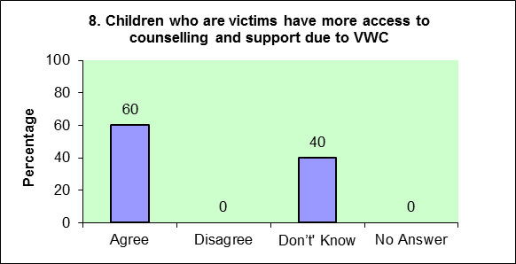
Response |  |  | % | Number
Agree |  |  | 60 | 3
Disagree |  |  | 0 | 0
Don’t' Know |  |  | 40 | 2
No Answer |  |  | 0 | 0
 |  |  |  | 5
Comments
Most cases seen at VWC are women
9) Men are more supportive of women's rights to live free from violence
 |  |  |  |  |  | 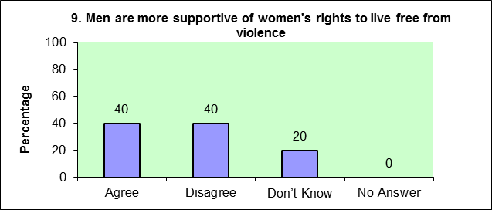
Response |  |  | % | Number
Agree |  |  | 40 | 2
Disagree |  |  | 40 | 2
Don’t Know |  |  | 20 | 1
No Answer |  |  | 0 | 0
Comments: |  |  |  | 5
More education awareness is needed in
the rural community
But still need a lot of education
10) More women are empowered to assert their right to live free from violence
 |  |  |  |  |  | 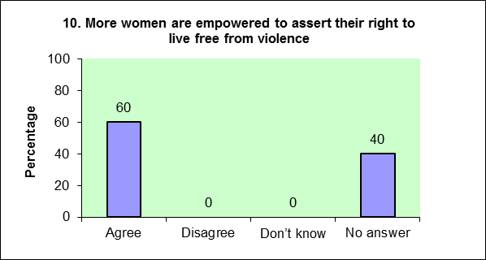
Response |  |  | % | Number
Agree |  |  | 60 | 3
Disagree |  |  | 0 | 0
Don’t know |  |  | 0 | 0
No answer |  |  | 40 | 2
 |  |  |  | 5
Comments:
11) VWC provides effective community education and awareness raising (workshops, talks, radio, mobile counselling)
 |  |  |  |  |  | 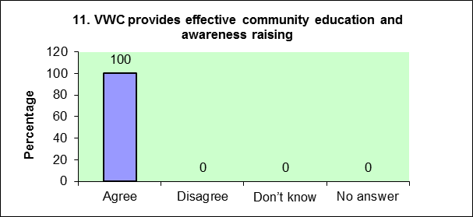
Response |  |  | % | Number
Agree |  |  | 100 | 5
Disagree |  |  | 0 | 0
Don’t know |  |  | 0 | 0
No answer |  |  | 0 | 0
 |  |  |  | 5
12) VWC Community Education materials are helpful (radio, posters, brochures, newsletters, leaflets)
 |  |  |  |  |  | 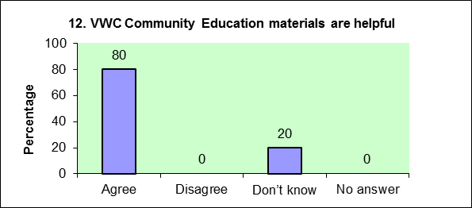
Response |  |  | % | Number
Agree |  |  | 80 | 4
Disagree |  |  | 0 | 0
Don’t know |  |  | 20 | 1
No answer |  |  | 0 | 0
 |  |  |  | 5
13) VWC Responds to requests for assistance in a timely manner
 |  |  |  |  |  | 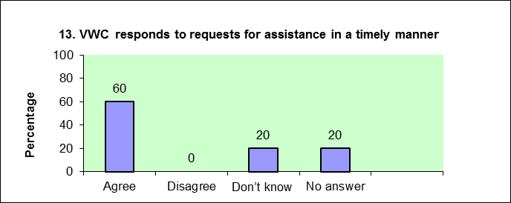
Response |  |  | % | Number
Agree |  |  | 60 | 3
Disagree |  |  | 0 | 0
Don’t know |  |  | 20 | 1
No answer |  |  | 20 | 1
 |  |  |  | 5
Comments:
14) VWC collaborates with a range of government and non government organisations
 |  |  |  |  |  | 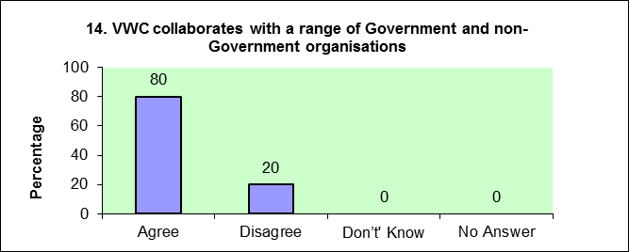
Response |  |  | % | Number
Agree |  |  | 80 | 4
Disagree |  |  | 20 | 1
Don’t' Know |  |  | 0 | 0
No Answer |  |  | 0 | 0
 |  |  |  | 5
Limited and hierarchical
15) VWC and its programs are well managed
 |  |  |  |  |  | 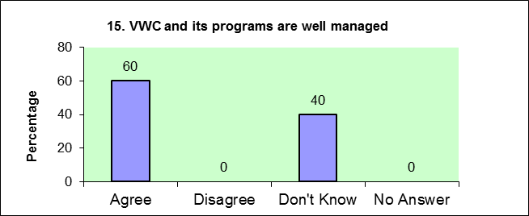
Response |  |  | % | Number
Agree |  |  | 60 | 3
Disagree |  |  | 0 | 0
Don't Know |  |  | 40 | 2
No Answer |  |  | 0 | 0
 |  |  |  | 5
Comments
Prompt progress report and annual
report
16) What do you think are the most significant achievements and changes VWC have made or contributed to?
Response |  |  | % | Number |  |  |  |  |  |  | 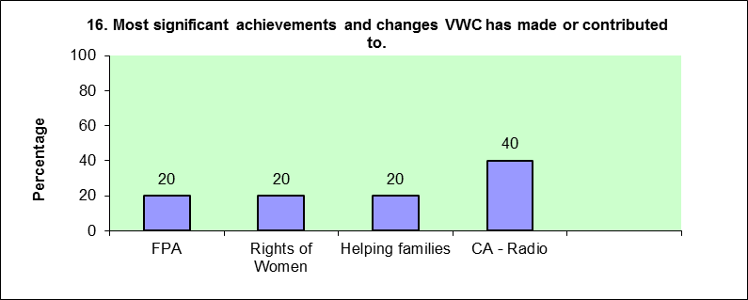
FPA |  |  | 20 | 1
Rights of Women |  |  | 20 | 1
Helping families |  |  | 20 | 1
CA - Radio |  |  | 40 | 2
5

Rights of Women, Gender equity, Alerting women to report
domestic violence to seek justice, providing equal employment opportunity
Promotion of women, example Churches Decade to Overcome Violence 21.10.02
Radio Programme every Thursday x 2
Excellent posters and pamphlets but often information sharing quite limited
reports not always available to be shared with other NGOs and networks
Put VAW on Agenda but: Need to re evaluate advocacy approach and strategy
and build alliances
 |  |  |  |  |  |  |  |  |  |  | 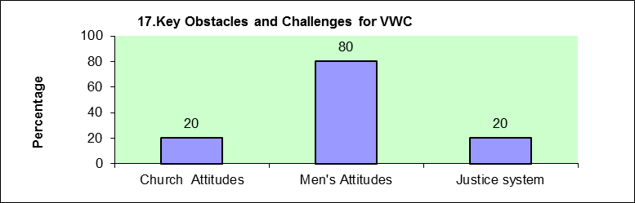
17) What are the key obstacles and challenges for VWC?
Response |  |  | % | Number
Church Attitudes |  |  | 20 | 1
Men's Attitudes |  |  | 80 | 4
Justice system |  |  | 20 | 1
 |  |  |  | 6
Comments
Women against women
Churches in particular - the Anglicans could not comprehend
Violence against women is power and control
Individual men should begin to understand or compromise
to the point as to how women suffer in many cases

18) How VWC works with Government and CSOs
 |  |  | 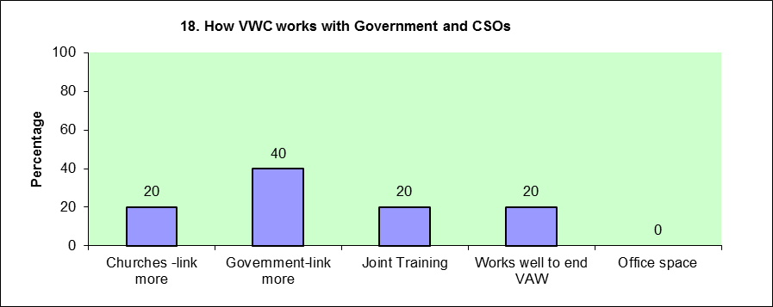
Response | % | Number
Churches -link more | 20 | 1
Government-link more | 40 | 2
Joint Training | 20 | 1
Works well to end VAW | 20 | 1
Office space | 0 | 0
 |  | 5
Comments:
19. Further feedback.
 |  |  | 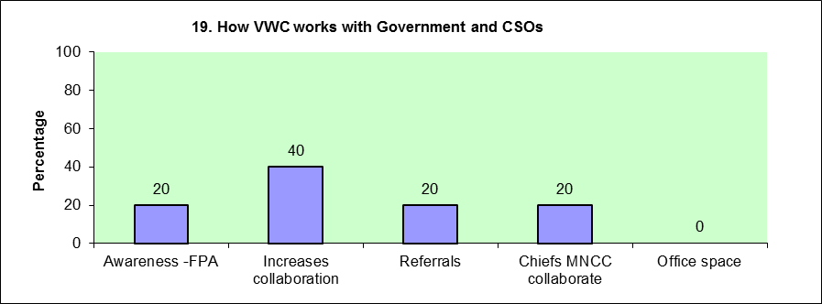
Response | % | Number
Awareness -FPA | 20 | 1
Increases collaboration | 40 | 2
Referrals | 20 | 1
Chiefs MNCC collaborate | 20 | 1
Office space | 0 | 0
 |  | 5
Comments:
VWC should be commended highly of the work it is doing to promote women as equal partners in the development of this country
Our communities need a lot of awareness of FPA.Just to make people understand clearly what is FPOA and what they should do if they become victims to the problems
Government, churches and Chiefs (Kastom) and Ngos including all community organisations need to work together for the common good of the new generation to come

