What is a good neighbour?
Module length: 5 or 6 x 60-minutes sessions

Summary
This module explores what it means to be a good neighbour. It encourages students to think about the communities around them, and to consider the types of interactions and programs that help communities to function, providing us with a feeling of security and confidence. This learning sequence works well as an introduction to the Civics and Citizenship themes that underpin Global Education.
Students begin by connecting their personal experiences of neighbours and their place in community. Next they consider the ways in which Australia, as a country, interacts with our neighbours. The idea of working in partnership is explored – both experientially as students work in partnership to meet a challenge, and through examples of how partnerships are formed between countries to address challenges. Students then identify and research a specific example of an individual who is working to make a difference in their community and vote for the projects they deem most worthy.

Success criteria
At the end of this module, students should be able to:
- define the qualities of a good neighbour
- identify some of the neighbouring countries with whom Australia works in partnership
- identify the benefits and key considerations of working in partnerships
- identify the impacts on both individuals and the community of working with others to make a difference in the community
- articulate a research question about this topic and synthesise sources to create an effective presentation.

Organising ideas
The organising ideas are global relationships, global responsibilities and global futures. These emphasise how cooperation between countries strengthens resilience, stability and shared prosperity in our Indo-Pacific region.
The module explores the experience of being a neighbour and aligns this experience with the idea of being a global citizen (as individuals and as countries).
© Darren James/Australian Volunteers Program, CC BY 4.0

For individuals: good neighbours and global citizens
Being a good neighbour is a way of being a global citizen. Global citizenship involves:
- extending compassion – showing kindness and compassion to people in other parts of the world with shared challenges to work together on locally led, mutually beneficial solutions, just as you would help a neighbour in need fostering partnership and respect – building
- connections based on mutual respect and cooperation
- protecting shared interests – caring for shared spaces and for resources into the future.

For countries: good neighbours and global partnerships
Partnerships between countries go beyond being good neighbours; these partnerships contribute to regional resilience and shared prosperity.
Some lessons in this module use videos accessed via YouTube.

Key terminology

neighbour
partnership
peaceful and stable society

Curriculum links
The table below lists the content descriptions explicitly addressed in this module. Note that the concept of ‘Australian society’ has been used in a very broad way in this module – it has been expanded so students can explore sustainability, security, health and other issues that present interconnected challenges for social cohesion and democracy in our region. It is intended that the values element is explored through the actions of individuals working in partnership to address shared challenges.
In addition to a focus on Civics and Citizenship, the module connects with the topic of Liveability, explored within Year 7 Geography; in particular, the ‘strategies used to enhance the liveability of a place’.

Civics and Citizenship

Knowledge and understanding: Citizenship, diversity and identity
Year 7: how values based on freedom, respect, fairness and equality of opportunity can support social cohesion and democracy within Australian society AC9HC7K05

Skills: Questioning and researching
Year 7: develop questions to investigate Australia’s political and legal systems, and contemporary civic issues AC9HC7S01
Year 7: locate, select and organise information, data and ideas from different sources AC9HC7S02

Skills: Civic participation and decision-making
Year 7: explain the methods or strategies related to making decisions about civic participation AC9HC7S04

Skills: Communicating
Year 7: create descriptions, explanations and arguments using civics and citizenship knowledge, concepts and terms that reference evidence AC9HC7S05

General capabilities
Personal and Social Capability: Students work in pairs or small groups and are encouraged to reflect on the advantages and challenges of working in partnership.

Cross-curriculum priorities
Asia and Australia’s Engagement with Asia: Students learn about partnerships with countries in the Asia-Pacific region.

What makes a good neighbour?
Learning intention | Materials
- To identify the ways in which our neighbours can and do make a difference to how we experience society – how safe we feel, how supported we feel, and how we might solve problems together. | - Stimulus resources: What makes a good neighbour?  - Exit card: What makes a good neighbour?

Introduction (10 min)
- Break the class into groups of 3 or 4 students. Introduce the topic by asking:
- Are you a good neighbour?
- Do you have good neighbours?
Ask students to discuss these questions in their groups.

Neighbours: an exploration (40 min)
- Use the What makes a good neighbour? stimulus package of resources. The package is designed to illustrate a range of perspectives and contains 20 different resources, ranging from images to short pieces of writing to short videos. Give each group 2 or 3 resources to explore from the package. Ask the students to read through their resources and make notes about the following questions:
- What feelings do we experience when we have good neighbours?
- What feelings do we experience when we have bad neighbours?
- What are the qualities of good neighbours?
- Is being a good neighbour important? What difference does it make?
- What are the most important things in your neighbourhood?
- What do people mention as issues?
- Are there things that help support the neighbourhood to work together?
- Facilitate a class discussion once the groups have completed their work. Some of the feelings that could be drawn out include how it feels to be safe or unsafe; connected or disconnected; to share produce, services or experiences; to learn something; to help someone or be helped by someone in a crisis.
A discussion about neighbourhood support mechanisms might include neighbourhood groups (online and offline), shared interests (sporting clubs), regular get-togethers (street Christmas parties) and Neighbourhood Watch.

Learning review (10 min)
- Distribute the Exit cards and ask students to complete a headline about the content that they have explored.

What makes a good neighbour?

Write a headline that captures what it means to be a good neighbour.

Write a headline that captures what it means to be a good neighbour.

Write a headline that captures what it means to be a good neighbour.

Write a headline that captures what it means to be a good neighbour.

Who are our neighbours?
Learning intentions | Materials
- To build on the concept of ‘neighbour’.  - To understand the ways in which Australia works together in partnership with neighbouring countries to address shared challenges and share knowledge. | - PowerPoint: What is a good neighbour?  - Websites: Australian values (Department of Home Affairs); Australian values (Rule of Law Centre); Australia Aid Tracker (Development Policy Centre, ANU)  - Animation: What is a partnership? (secondary version 3 min)

Working with our neighbours (60 min)
- Ask students to identify what they think some Australian values might be. After discussing their suggestions, tell students that the Australian Government has articulated some Australian values through the Department of Home Affairs, with the aim of helping people who are new to the country to understand these values. The webpage states that these values ‘have created our peaceful and stable society’. Show the students the webpage Australian values.
If you feel students require more support to understand these values, you could use the Australian values worksheet from the Rule of Law Centre. Using this worksheet, students can match the values to the correct definition.
For a deeper dive, ask students to identify the values they feel are most important for creating a peaceful and stable society, using a diamond ranking exercise.
- Recap Lesson 1. Remind students that they considered some of the qualities of being a neighbour and how people might respond to local issues. Tell students that this lesson will focus on the country of Australia as a neighbour.
- Show students a map of the Asia-Pacific region. Ask them to suggest who Australia’s neighbours might be. Ask students to brainstorm what they know about Australia’s relationships with neighbouring countries. It is unlikely they will know a lot about this topic, beyond possible holiday experiences. You can suggest some themes, such as:
- Do we have sporting links with some neighbours?
- Have we helped each other when there has been a natural disaster?
- Which are the closest neighbours to us geographically?
- Do some neighbours have particular issues that you know about?
- Have we shared regional peacekeeping, humanitarian response, or disaster recovery experiences with our neighbours?
- Do we face some similar problems? If so, what might these be?
Capture this conversation in a Mind Map on the board. Some of the ideas that are worth drawing out include:
- Our countries may be different in many ways but we have some common issues.
- Some challenges can’t be solved by just one country on its own.
- Different perspectives can assist with problem-solving.
- Tell the students that, like people, countries have their own sets of values. As a country, we don’t tell other countries how they should live. But we can do things to help each other when times are tough or when we face the same challenges.
Show the animation: What is a partnership? Ask students to write down one main thing they learned or a question they have from the video. Invite some students to contribute some of their responses to the whole class.
- Show students the map of Official Development Assistance (ODA) distribution for 2023 on the Australia Aid Tracker website (from ANU's Development Policy Centre).
Ask students:
- Looking at the world map, in what region are most Australian international development programs being carried out?
- Why do you think this is?
Explain that many of the projects that occur in partnership between Australia and our neighbours focus on clean water, climate change and health.
Ask students:
- Why are problems such as clean water, climate change and health important to address?
- What kind of difference do you think it makes when countries work together on challenges like these? Does it make a difference to both countries? If so, what difference does it make to each country?
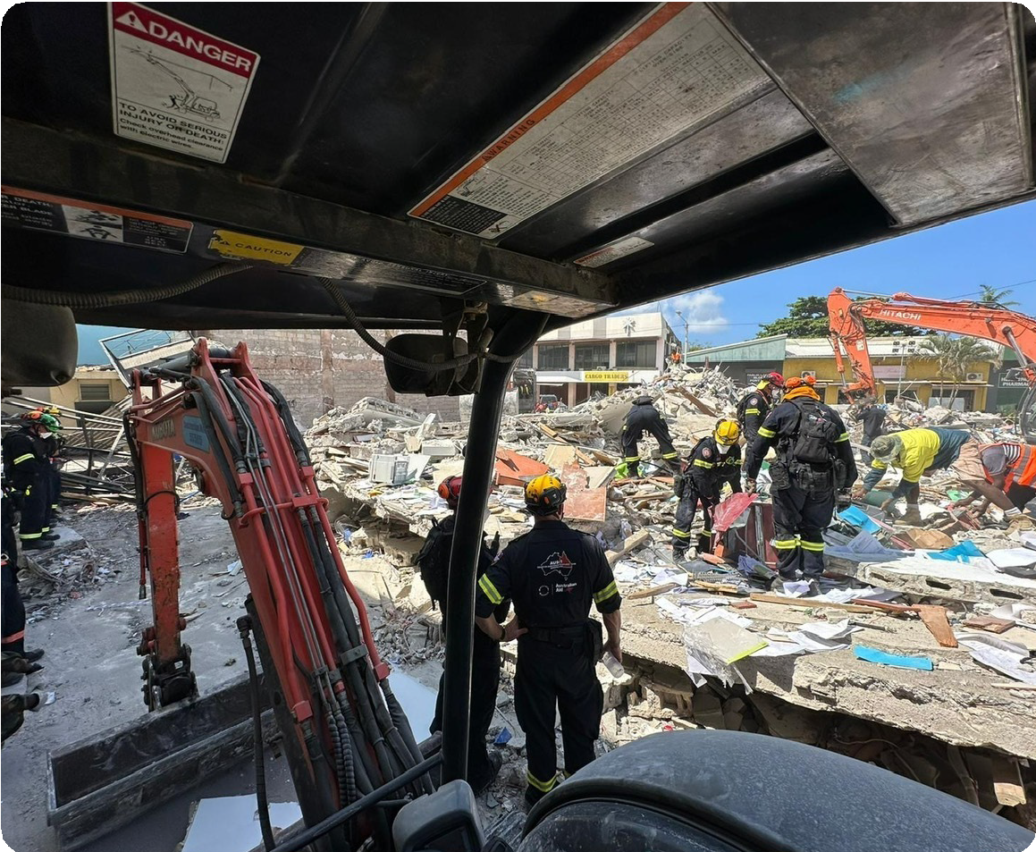
© Queensland Fire Department.
- Show students the What is a good neighbour? PowerPoint. Use the teacher notes provided for each slide. The following points could be made.
- There are many ways in which partnerships are mutually beneficial.
- Different countries and cultures bring different strengths to a partnership.
- We can achieve more when we work together.
- In many cases we face similar issues to our neighbours, for example, climate change, risk of pandemics, overfishing, biosecurity risks.
- Our security and stability as a country depends on the extent of security and stability among our neighbours.
Note: if time permits, this content could be extended by asking students to work in small groups with one of the examples from the PowerPoint. Students could explore and report back on the following:
- What are the aims of this project?
- What benefits do each of the partners gain in working with each other?

Partnerships in practice
Learning intention | Materials
- To experience and articulate the benefits and key elements of working in a partnership. | - Equipment related to the game you choose for the class.

Group challenge (40 min)
The focus of this lesson is on students working in pairs or small groups to complete a task. The aim is to draw out a conversation about what it is like to work together, including the benefits and challenges.
- Begin by telling the students that they are going to play a game. You can choose one of the suggested options or select a game that you are familiar with. The game should emphasise cooperation and teamwork over competition (though there could be a minor competitive element between teams, depending on the game). The aim of playing the game is to provide opportunities for students to reflect on the process of working with someone else, to identify the ways in which they derive benefits from working in partnership, and to identify some of the key considerations of working this way.

Game options
- Build a Tower
Find Build a Tower (Game 16). Students work in pairs to build towers using blocks of varying sizes. A variation on this game is Leaning Tower of Feetza (Game 10), which uses shoes instead of blocks.
- Emoji storytelling
Assign each team a random set of emojis and challenge them to craft a short story or skit that incorporates each emoji meaningfully.
It could be a story about neighbours. The Creating stories using emojis webpage provides some examples. Emoji story generator is also a useful tool.
- The Great Egg Drop
Locate The Great Egg Drop challenge on this website. Each group of students must come up with strategies for dropping an egg out of the window without it breaking.
- Minefield
Locate Minefield on the website. One student navigates through a ‘Minefield’ guided only by verbal commands from their peers.
- Diagrams
In Team-building exercises for teens, find Diagrams. This exercise emphasises problem-solving through different methods of communication. Teens work in pairs, with one person guiding the other in an attempt to make a simple drawing.

Reflection on the group challenge (20 min)
- After the chosen game is over, ask students to write a paragraph responding to the following prompts:
- What was it like working in this team?
- What skills and abilities did you bring to this partnership? What about the other person or people you worked with?
- What did you learn from the game about working together in partnership?
- Think of a time that you worked with someone else and you felt great about it. Why was this? (Students may need prompts, such as learning a new sporting skill, being taught something by a grandparent, creating a project in class, or doing something for friends or family.)
- How did your partnership help you achieve something you couldn’t have done alone, and how is that similar to how countries benefit from working together?
Have a quick whole-class discussion, seeking input from any volunteers. Some of the elements you might try to draw out include experiencing unexpected outcomes, new learnings, different perspectives or better outcomes, and that you can’t fix the problem on your own. Not all experiences may be positive; you can remind students that working with other people can be complex.
- Ask students to create a PowerPoint slide that has advice for people who have been asked to work in partnership on a project. This can be done for homework if necessary.
Extension: Ask students to identify activities that rely on people working in partnership for the success of the project. (These might be highly technical, like performing hip replacement surgery; or fun, like a Guinness Book of Records attempt; or related to complex challenges, such as managing the COVID-19 pandemic or a Clean-Up Australia Day.)

Some people make the neighbourhood a better place
Learning intentions | Materials
- To identify the impact of working with others to make a difference in the community for both individuals and the community as a whole.  - To apply research skills to explain a challenge in the community. | - Worksheet: People who make a difference  - (Optional) Graphic organiser: Making a difference in the neighbourhood  - Rubric: People who make a difference – presentation

Making a difference in the neighbourhood (60–120 min)
Note that the activities in this lesson may require 2 x 45-minute sessions and include time at home to complete.
- Recap Lessons 1–3. Remind students that the focus of these lessons was on partnerships – how they work and how they contribute to the liveability of a community. Ask volunteers to share some examples of their advice for people working in partnership, created as a PowerPoint slide (completed in Lesson 3 or as homework).
Facilitate a class discussion about the following questions:
- What kinds of values help people to work together?
- What is the impact if we don’t work together well?
- The focus of this lesson is on people who make a positive difference in the community.
Tell students they will be working in pairs to create a presentation about a person or a group that is making a difference in their community. This presentation can be used as an assessment task.
Provide students with the Worksheet: People who make a difference. This worksheet lists some examples of people who are trying to make a positive difference in their community. Students can either use one or more of these examples or they can choose their own example (for instance from the Australian Volunteers website, which has a range of stories). The worksheet embodies a broad definition of community by listing people who are active in their local community, people who work at a statewide or national level and people who work in one of Australia’s neighbouring countries. In most cases, students will need to go beyond the links provided in the worksheet to find enough information about the individual or the project to respond to the task.
- Help individual students to develop an overarching question about this activity. It could be one of the following questions or a question they develop themselves:
- Who benefits from participation in community challenges?
- What makes a difference in a neighbourhood or community?
- What can I find out about the characteristics of a good neighbour?
- What are some different ways of working in a community to make a difference (if students choose a couple of examples to compare).
- Students should aim to research the role their chosen person or group performs in the community and how it makes a difference. Prompt them to consider the following questions:
- What motivates the person or group to undertake their role?
- What benefits do they get?
- What benefits does the community receive from this work?
- What values underpin what they are doing?
- Who else is involved in this project?
- Tell students they will be creating PowerPoint presentations of their research, or provide them with a graphic organiser if you wish for them to use this instead of PowerPoint. Also provide them with the rubric that you will use for assessing their work.
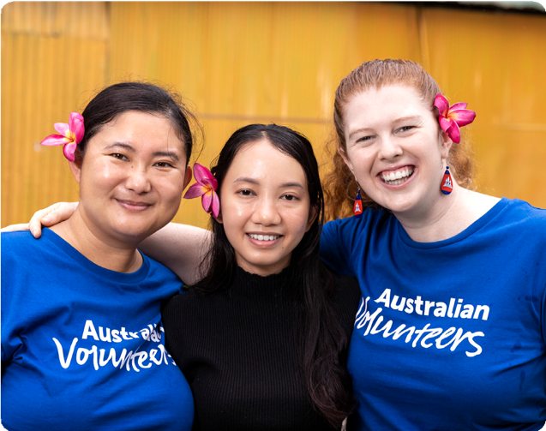
© Harjono Djoyobisono/ Australian Volunteers Program, CC BY 4.

People who make a difference
In pairs, research a person or group who, in your opinion, is making a positive difference in your neighbourhood or the wider community. You can choose from the list below or select someone or a group that you know or have heard about. If you choose a person or group from the list provided below, you may need to locate additional online information about them to complete the research brief.
Potential focus for research | What they do in the community
BlazeAid volunteers | Volunteer organisation BlazeAid provides support to help with the impact of bushfires.
Hope in Action | Australian volunteers contribute to locally led development across the Pacific, Asia and Africa through the Australian Volunteers Program.
An Australian of the Year | People from all around country have won the Australian of the Year award for the outstanding work they do in the community.
Dr Joshua Francis: infectious disease specialist | This doctor was part of a team in Timor-Leste making a difference with infectious diseases such as tuberculosis (TB) and COVID-19.
Olivia Magoffin: Australian pilot | Olivia Magoffin worked as a pilot delivering supplies to the front line of the COVID-19 pandemic in the Pacific.
Nilesh Dilushan: 2025 NT Young Australian of the Year | Nil Dilushan co-founded two not-for-profit organisations: The Kindness Shake and Rotaract Young Professionals Northern Territory.
Doris Rounds: Young Pacific Change Makers, Fiji | The Young Pacific Change Makers project celebrates and supports Pacific Islanders aged 18 to 30 who are making a difference in their communities.
Aunty Rose: Kaurareg Traditional Owner | Kaurareg Traditional Owner Aunty Rose teaches skills in making jewellery with iTaukei women in Fiji.
Anthony Healy: sports volunteer | Australian volunteer Anthony Healy runs ‘Smart Start Niukick’, AFL PNG’s grassroots development program in schools.
Nas Campanella: volunteer and journalist | Journalist Nas Campanella worked with the Spinal Injury Association of Fiji, helping to support the association’s media and communications activities.
Amar Singh: Turbans 4 Australia | Amar Singh established Sikh-led charity Turbans 4 Australia to provide emergency food, goods and support to people in need.
Skipton FNC: WorkSafe Local Legends | Two volunteers talk about what they have done to support the local rural football and netball clubs.
Add a person of your own …

Use the graphic organiser provided by your teacher or create a PowerPoint presentation. Start with a key inquiry question and include information about the person or group, the role and how the work they do makes a difference in the community. Ensure your research answers the following questions:
- What motivates the person or group to undertake this role?
- What benefits do they get?
- What benefits does the community receive from this work?
- What values underpin what they are doing?
- Who else is involved in this project?
Make sure you put the information into your own words and that you reference the sources that you have used. You may need to go beyond the links provided in this worksheet to find enough information about the individual or project to respond to the task.

Graphic organiser: Making a difference in the neighbourhood
Inquiry question and response:
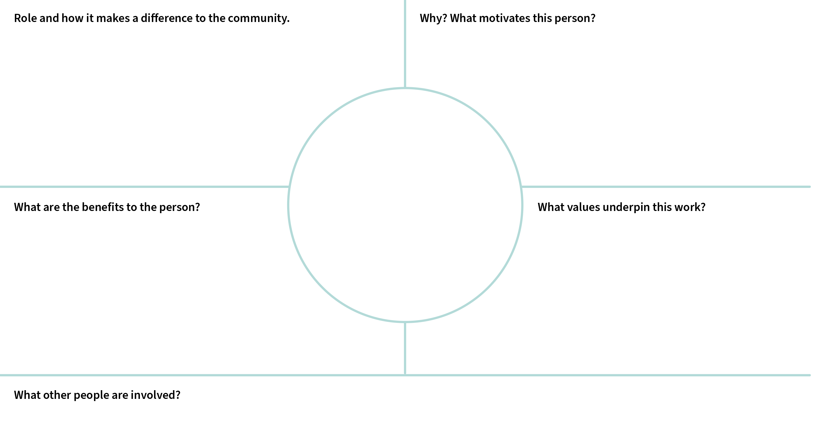

Rubric: People who make a difference – presentation
A | B | C | D | E
Development of questions and purposeful location, selection and organisation of information from sources | Development of questions and effective location, selection and organisation of information from sources | Development of questions and location, selection and organisation of information from sources | Guided development of questions and partial location, selection and/or organisation of information from sources | Directed development of questions and basic location, selection and/or organisation of information
Identification and thorough description of the methods used by individuals to contribute to community life | Identification and informed description of the methods used by individuals to contribute to community life | Identification and description of the methods used  by individuals to contribute to community life | Identification and simple description of the methods used by individuals to contribute to community life | Statement/s about methods used by individuals to contribute to community life
Use of appropriate sources to create purposeful descriptions and/or explanations | Use of appropriate sources to create effective descriptions and/or explanations | Use of appropriate sources to create descriptions and/or explanations | Use of sources to create simple descriptions and/or explanations | Use of sources to create fragmented descriptions and/or explanations

Module wrap-up – Best Neighbour Action Awards
Learning intention | Materials
- To share examples of effective partnerships that are working to address challenges in our community. | - Voting slips: enough for 3 per student  - Worksheet: Summary statements  - (Optional) Differentiated instruction

Pitch for the Best Neighbour Action Awards (60 min)
Tell students that they will each present their examples of effective partnerships and will then vote on each other’s examples. Please note that the activity of voting is designed to ensure students listen to each other and that they think about elements of the projects described. The aim is to canvas a breadth of different types of partnerships and outcomes. Stress that there is no correct outcome in this process, but that you will be interested in the criteria that students use to make judgements about the projects.
- Have students work in pairs to write a 3 to 4 sentence pitch outlining why the person or group they researched in Lesson 4 should be considered for the Best Neighbour Action Awards.
- Have each pair of students pitch to the class. Each pair should be given three voting slips and encouraged to vote for the people or groups that they consider most worthy of the award. Show a map of Australia and the Asia-Pacific to the class. As students make their pitch, make sure that the location where the person or group does its work is noted.
- Count the votes and present the awards.
- Conclude with a brief discussion about the criteria that students used when awarding their votes, for example, a project that made the biggest difference, the efforts of an individual, the degree of challenge, or the pairs who presented the best argument.
- Give each student a Summary statements worksheet. Explain that this is an opportunity for them to reflect on what they have learned about working with neighbours. Ask students to complete the worksheet for homework. (If time permits, you could place each of the summary statements around the classroom and ask students to cluster near the statement that they feel best reflects their opinions. Facilitate a brief discussion among volunteers about why they have placed themselves where they are.)
© AlphaLemur via Wikimedia Commons, CC BY 4.0.

Best Neighbour Action Awards
Voting slip | Voting slip | Voting slip | Voting slip | Voting slip
Best Neighbour Action Awards | Best Neighbour Action Awards | Best Neighbour Action Awards | Best Neighbour Action Awards | Best Neighbour Action Awards
Voting slip | Voting slip | Voting slip | Voting slip | Voting slip
Best Neighbour Action Awards | Best Neighbour Action Awards | Best Neighbour Action Awards | Best Neighbour Action Awards | Best Neighbour Action Awards
Voting slip | Voting slip | Voting slip | Voting slip | Voting slip
Best Neighbour Action Awards | Best Neighbour Action Awards | Best Neighbour Action Awards | Best Neighbour Action Awards | Best Neighbour Action Awards
Voting slip | Voting slip | Voting slip | Voting slip | Voting slip
Best Neighbour Action Awards | Best Neighbour Action Awards | Best Neighbour Action Awards | Best Neighbour Action Awards | Best Neighbour Action Awards
Voting slip | Voting slip | Voting slip | Voting slip | Voting slip
Best Neighbour Action Awards | Best Neighbour Action Awards | Best Neighbour Action Awards | Best Neighbour Action Awards | Best Neighbour Action Awards

Summary statements
Think about what you have learned about working with neighbours. Respond to at least two of the summary statements (minimum 100 words). Use examples of people or groups you have learned about.

Summary statements
Good neighbours want to know and understand each other.
Helping our neighbours helps our society become a safer and more secure place.
Despite differences in how we live, we basically have the same need for friendship.
We gain more from building bridges than fences.
We gain more than we give when working in partnership with other people.
Cooperating with others on projects leads to safer, fairer and more sustainable communities.
People have a responsibility to each other and their neighbours.
Add your own …

Differentiated instruction

For students who need additional support
- Pair students who require support with another student who can help them during the research stage.
- This video may be suitable as a research focus: Australian volunteers clean the ocean one straw at a time
Students could answer questions such as:
- What is the problem?
- What did Harriet Spark want to do about the problem?
- Who helps with the Operation Straw project?
- How does this work make a difference in the neighbourhood?

For CAL/D students
- This video may be suitable as a research focus: Australian Volunteers Clean the Ocean One Straw at a Time
Students could answer questions such as:
- What is the problem?
- What did Harriet Spark want to do about the problem?
- Who helps with the project Operation Spark?
- How does this work make a difference in the neighbourhood?

For students who need a challenge or additional activity

Option 1
Pose the question: How can I be a better neighbour or global citizen? Encourage students to identify a challenge in their neighbourhood (or more broadly) and to outline some ways of working together with others to address that challenge.

Option 2
Give students the Kindness matters guide. Ask them to read the article. Pose these questions:
- Individuals can receive a cognitive reward for kindness. What do countries get from acts that include kindness, generosity or working in partnerships?
- How important is it that people should ‘get something back’ in response to their actions?
- Ask students to write a response to the Kindness matters guide outlining their ideas.

