What makes a good neighbour?

Write a headline that captures what it means to be a good neighbour.

Write a headline that captures what it means to be a good neighbour.

Write a headline that captures what it means to be a good neighbour.

Write a headline that captures what it means to be a good neighbour.

People who make a difference
In pairs, research a person or group who, in your opinion, is making a positive difference in your neighbourhood or the wider community. You can choose from the list below or select someone or a group that you know or have heard about. If you choose a person or group from the list provided below, you may need to locate additional online information about them to complete the research brief.
Potential focus for research | What they do in the community
BlazeAid volunteers | Volunteer organisation BlazeAid provides support to help with the impact of bushfires.
Hope in Action | Australian volunteers contribute to locally led development across the Pacific, Asia and Africa through the Australian Volunteers Program.
An Australian of the Year | People from all around country have won the Australian of the Year award for the outstanding work they do in the community.
Dr Joshua Francis: infectious disease specialist | This doctor was part of a team in Timor-Leste making a difference with infectious diseases such as tuberculosis (TB) and COVID-19.
Olivia Magoffin: Australian pilot | Olivia Magoffin worked as a pilot delivering supplies to the front line of the COVID-19 pandemic in the Pacific.
Nilesh Dilushan: 2025 NT Young Australian of the Year | Nil Dilushan co-founded two not-for-profit organisations: The Kindness Shake and Rotaract Young Professionals Northern Territory.
Doris Rounds: Young Pacific Change Makers, Fiji | The Young Pacific Change Makers project celebrates and supports Pacific Islanders aged 18 to 30 who are making a difference in their communities.
Aunty Rose: Kaurareg Traditional Owner | Kaurareg Traditional Owner Aunty Rose teaches skills in making jewellery with iTaukei women in Fiji.
Anthony Healy: sports volunteer | Australian volunteer Anthony Healy runs ‘Smart Start Niukick’, AFL PNG’s grassroots development program in schools.
Nas Campanella: volunteer and journalist | Journalist Nas Campanella worked with the Spinal Injury Association of Fiji, helping to support the association’s media and communications activities.
Amar Singh: Turbans 4 Australia | Amar Singh established Sikh-led charity Turbans 4 Australia to provide emergency food, goods and support to people in need.
Skipton FNC: WorkSafe Local Legends | Two volunteers talk about what they have done to support the local rural football and netball clubs.
Add a person of your own …

Use the graphic organiser provided by your teacher or create a PowerPoint presentation. Start with a key inquiry question and include information about the person or group, the role and how the work they do makes a difference in the community. Ensure your research answers the following questions:
- What motivates the person or group to undertake this role?
- What benefits do they get?
- What benefits does the community receive from this work?
- What values underpin what they are doing?
- Who else is involved in this project?
Make sure you put the information into your own words and that you reference the sources that you have used. You may need to go beyond the links provided in this worksheet to find enough information about the individual or project to respond to the task.

Graphic organiser: Making a difference in the neighbourhood
Inquiry question and response:

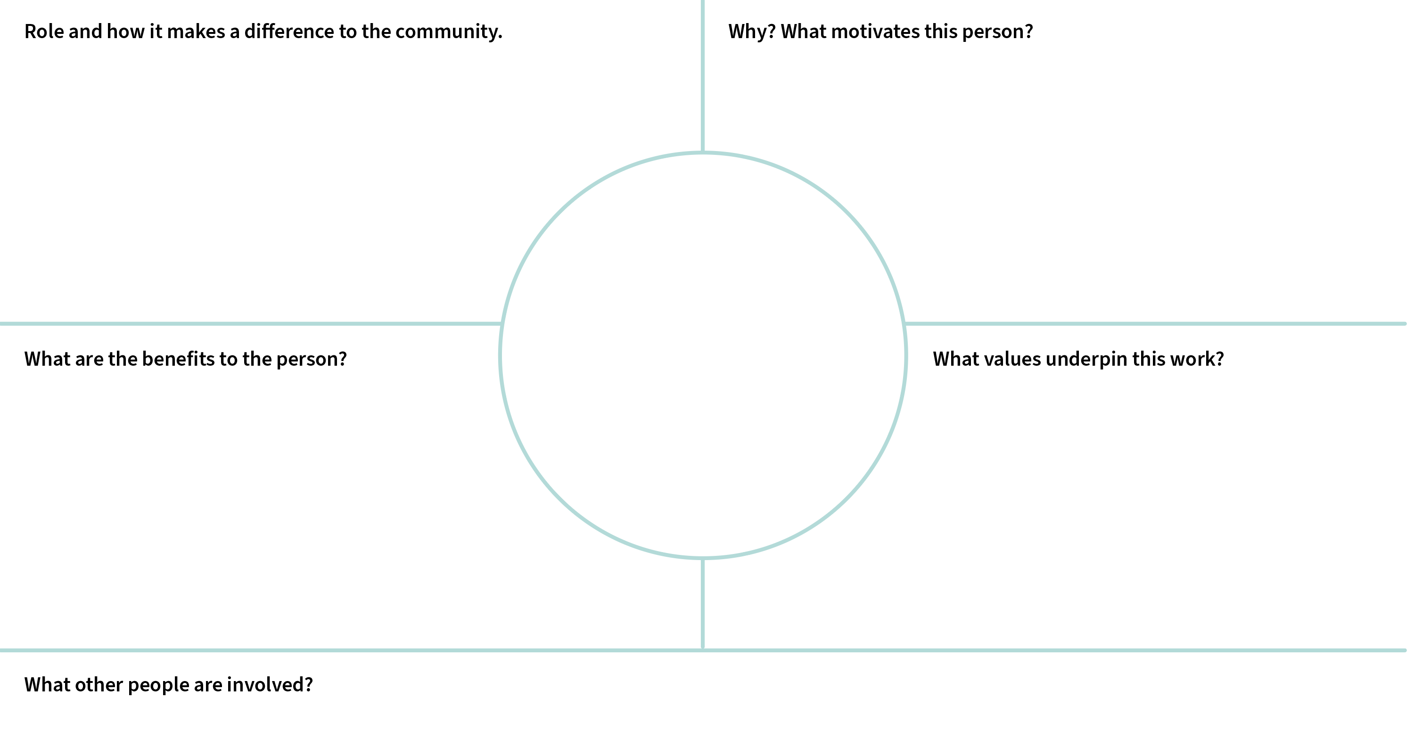

Rubric: People who make a difference – presentation
A | B | C | D | E
Development of questions and purposeful location, selection and organisation of information from sources | Development of questions and effective location, selection and organisation of information from sources | Development of questions and location, selection and organisation of information from sources | Guided development of questions and partial location, selection and/or organisation of information from sources | Directed development of questions and basic location, selection and/or organisation of information
Identification and thorough description of the methods used by individuals to contribute to community life | Identification and informed description of the methods used by individuals to contribute to community life | Identification and description of the methods used  by individuals to contribute to community life | Identification and simple description of the methods used by individuals to contribute to community life | Statement/s about methods used by individuals to contribute to community life
Use of appropriate sources to create purposeful descriptions and/or explanations | Use of appropriate sources to create effective descriptions and/or explanations | Use of appropriate sources to create descriptions and/or explanations | Use of sources to create simple descriptions and/or explanations | Use of sources to create fragmented descriptions and/or explanations

Best Neighbour Action Awards
Voting slip | Voting slip | Voting slip | Voting slip | Voting slip
Best Neighbour Action Awards | Best Neighbour Action Awards | Best Neighbour Action Awards | Best Neighbour Action Awards | Best Neighbour Action Awards
Voting slip | Voting slip | Voting slip | Voting slip | Voting slip
Best Neighbour Action Awards | Best Neighbour Action Awards | Best Neighbour Action Awards | Best Neighbour Action Awards | Best Neighbour Action Awards
Voting slip | Voting slip | Voting slip | Voting slip | Voting slip
Best Neighbour Action Awards | Best Neighbour Action Awards | Best Neighbour Action Awards | Best Neighbour Action Awards | Best Neighbour Action Awards
Voting slip | Voting slip | Voting slip | Voting slip | Voting slip
Best Neighbour Action Awards | Best Neighbour Action Awards | Best Neighbour Action Awards | Best Neighbour Action Awards | Best Neighbour Action Awards
Voting slip | Voting slip | Voting slip | Voting slip | Voting slip
Best Neighbour Action Awards | Best Neighbour Action Awards | Best Neighbour Action Awards | Best Neighbour Action Awards | Best Neighbour Action Awards

Summary statements
Think about what you have learned about working with neighbours. Respond to at least two of the summary statements (minimum 100 words). Use examples of people or groups you have learned about.

Summary statements
Good neighbours want to know and understand each other.
Helping our neighbours helps our society become a safer and more secure place.
Despite differences in how we live, we basically have the same need for friendship.
We gain more from building bridges than fences.
We gain more than we give when working in partnership with other people.
Cooperating with others on projects leads to safer, fairer and more sustainable communities.
People have a responsibility to each other and their neighbours.
Add your own …

