What makes a good neighbour?
‘Never worry about numbers. Help one person at a time, and always start with the person nearest you.’
– Mother Teresa

Resource 2: Wi-fi password
‘A good neighbour is one who does not put a password on their wi-fi.’

Resource 3: School ‘neighbours’
Your school is a community, and your fellow students and teachers are your neighbours during school time. What classroom and school rules help students to get along? What other aspects of school help students get along and understand each other?

Resource 4: The brick through the window
This is an extract from a true story written in 2009 by a man living with his family in a Melbourne suburb.
I have never been good at violence. Not even at mild arguments. So when the brick came smashing through our bedroom window in the middle of the night, I leapt from our bed and screamed. Our children came running in, more worried and frightened by the noise I had made than by the brick or by the glass scattered on our floor. This is all history now. Well, not quite. As with all history, even when the telling is done, there are repercussions we are still dealing with, still pondering. My scream was instant but also premeditated. It was directed at whoever was throwing the brick, and we all knew pretty well who was doing that, because it was the second time it had happened in a week. I wanted the brick thrower to be chilled by my scream; to have the night marked not by the satisfying sound of breaking glass but by the unexpected sound of a man’s prolonged scream.
We had been living with violence and threats of violence from our neighbours for nearly five years. During this time, we had been talking to friends and family, hoping for useful advice or even some insights into our situation. Sometimes we were asking for protection …
In my mind, it all began when the young daughter of the family (we’ll call her H) came to visit us shortly after we moved into the street. We had moved to the street about the same time as them, so we were happy to make neighbourly contact. H, then at primary school, liked to play with our children. She would visit most afternoons, so often in fact that our daughter began to complain. Things drifted along.
One day, while H was playing outside in the street with a shopping trolley, she accidentally ran it into our car and put a small dent in the side. Our daughter, Sarah, had been watching this from the front window and told us, so we went to talk to our neighbours in the hope that would be more careful … The father, after matching the trolley to the dent, pulled money from his pocket and asked us how much we wanted, while the older daughter shouted at him that if her sister said she didn’t do it, she didn’t do it…
Extract from an article by Kevin Brophy originally published in Australian Book Review April 2009, no. 310. Reproduced with permission.

Resource 5: Which example is a good neighbour?
A good neighbour keeps to themselves and minds their own business.
A good neighbour is someone who you can call on if you need help.
A good neighbour is someone with children my age that I can hang around with.
A good neighbour does things for the local community.
A good neighbour shares things like a lawnmower and lemons from their tree.

Resource 6: Lost dog (facebook neighbourhood group)
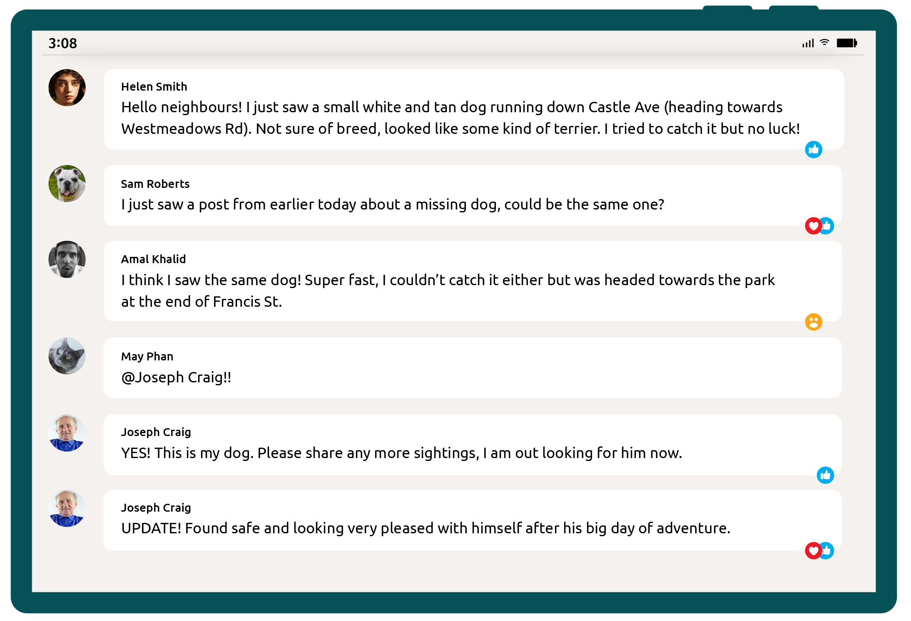

Resource 7: Noisy neighbours
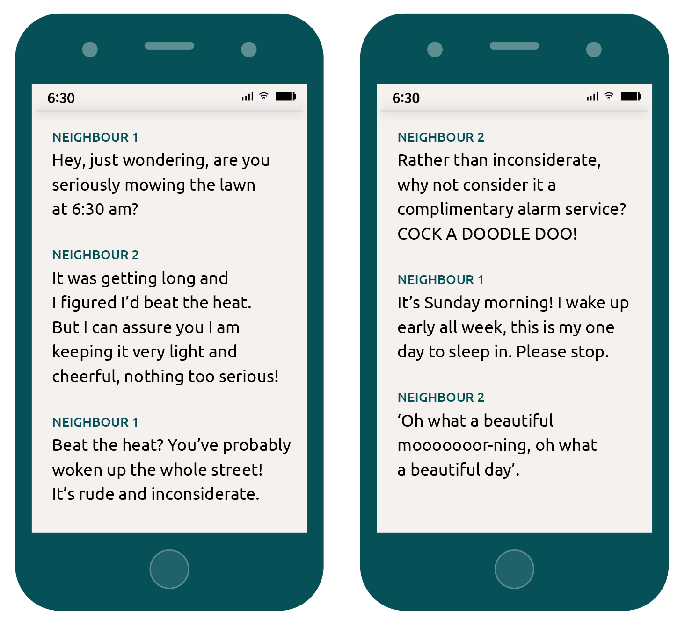

Resource 8: What is your level of generosity?
Good neighbours: Lessons from a loaf of bread is an online story about how people interacted with someone new in their neighbourhood. Reading time approximately 3 minutes.

Resource 9: Good neighbour stories from Huon Valley
This 5-minute video provides examples of how neighbours help each other in Huon Valley.

Resource 10: Dealing with difficult neighbours
Two neighbours work through conflict in this 2-minute video.

Resource 11: Make ‘neighbour’ a verb
This 5-minute video provides some tips about being a better, more-connected neighbour by ‘making neighbour a verb’.

Resource 12: Street libraries
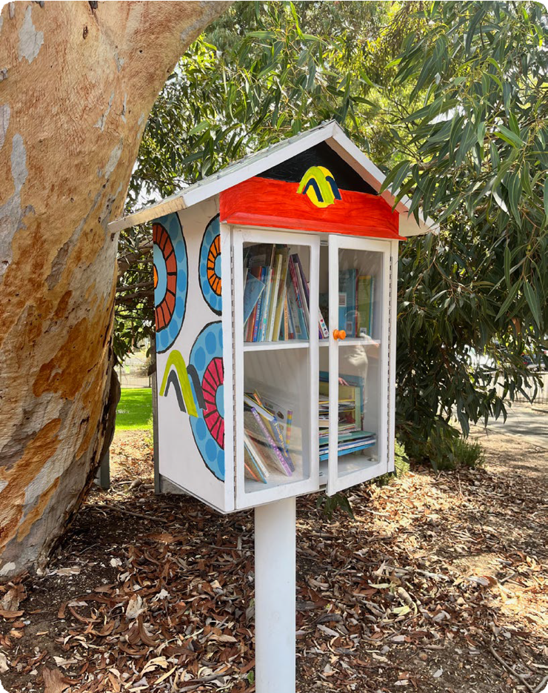
© AlphaLemur via Wikimedia Commons, CC BY 4.0.

Resource 13: Social experiment – know thy neighbour
This newspaper column explores the efforts of one man to get to know his neighbours better by inviting himself to stay at their houses. Reading time approximately 3 minutes.

Resource 14: ‘Know your neighbour’ social experiment
This 3-minute video shows a social experiment by a council in Singapore to bring people closer together.

Resource 15: What makes a good neighbour?
This TikTok 1-minute video shows people from Minnesota, in the United States, responding to the question ‘What makes a good neighbour?’

Resource 16: How well do you know your neighbours?
An insurance company asked Australians about what makes a good neighbour in this 4-minute video.

Resource 17: Keep the hedge
‘Love your neighbour, yet pull not down your hedge.’
– English Proverb

Resource 18: The responsibility!
Read a short article about a neighbour who is sick of the responsibility of looking after his neighbours.

Resource 19: Happy neighbours
‘If my neighbour is happy, my own work will go easier, too.’
– Macedonian proverb

Resource 20: New neighbours – what’s the go?
