Contents

[What is AusTender? 2](#_Toc119490990)

[Who is responsible for the information on AusTender? 2](#_Toc119490991)

[Become a Registered User 2](#_Toc119490992)

[On this page 2](#_Toc119490993)

[Benefits of becoming an AusTender Registered User 2](#_Toc119490994)

[How to Register 3](#_Toc119490995)

[Set up and manage your notifications 4](#_Toc119490996)

[Notification Hot Tips 4](#_Toc119490997)

[Business Opportunities 4](#_Toc119490998)

[Current Approaches to Market 4](#_Toc119490999)

[Future Business Opportunities 4](#_Toc119491000)

[Understanding the Lodgement Requirements 5](#_Toc119491001)

[Preparation is key! 5](#_Toc119491002)

[Practice Lodging a Response 5](#_Toc119491003)

[Hot Tips - Lodgement Preparation Checklist 5](#_Toc119491004)

[I have a newer version of my Lodgement documents, what can I do? 6](#_Toc119491005)

[If the tender is still open, you can: 6](#_Toc119491006)

[Missed the tender Closing Time? What now? 6](#_Toc119491007)

[How do I edit my contact details? 6](#_Toc119491008)

[Where do I get help or advice? 7](#_Toc119491009)

# What is AusTender?

AusTender is the Australian Government's procurement information system which provides centralised publication of Business Opportunities, Annual Procurement Plans and Contracts awarded.

AusTender is commonly used to undertake market research, and contains a range of [information reports](https://help.tenders.gov.au/getting-started-with-austender/information-made-easy/) so you can identify current or future Business Opportunities, or see what types of goods or services are being provided through contracts already awarded.

You can even find details of [What the Government Buys](https://help.tenders.gov.au/getting-started-with-austender/information-made-easy/what-the-government-buys/).

Whether you are a new business operator or a well-established company, if you provide quality goods and services that the Australian Government buys, there may be an opportunity for you.

You can also register on AusTender to be automatically notified of Business Opportunities. Information and Tips when registering can be found [here](https://help.tenders.gov.au/getting-started-with-austender/become-a-registered-user/).

# Who is responsible for the information on AusTender?

The Australian Government is comprised of a large number of individual Agencies. AusTender centralises information from these Agencies to make it easy for you to navigate and find information in a central location.

Agencies that use AusTender are required to ensure they follow the [Commonwealth Procurement Rules (CPRs)](https://www.finance.gov.au/government/procurement/commonwealth-procurement-rules) which explains their obligations, and the Finance [PGPA Act Flipchart](https://www.finance.gov.au/government/managing-commonwealth-resources/structure-australian-government-public-sector/pgpa-act-flipchart-list) provides a full list of Relevant Agencies (Commonly referred to as Entities).

# Become a Registered User

As a Registered User you can receive notification of Business Opportunities direct to your nominated email address.

You can also download documents, receive addenda notifications, and lodge responses.

You will need to become a Registered User if you want to download any documents for a particular procurement opportunity.

# On this page

* [Benefits of becoming an AusTender Registered User](https://help.tenders.gov.au/getting-started-with-austender/become-a-registered-user/#benefits%20of%20becoming%20an%20austender%20registered%20user)
* [Set up and manage your notifications](https://help.tenders.gov.au/getting-started-with-austender/become-a-registered-user/#set%20up%20and%20manage%20your%20notifications)

# Benefits of becoming an AusTender Registered User

AusTender provides the following benefits to Registered Users:

1. Automatic notification of new Business Opportunities.
2. Ability to download Business Opportunity documentation.
3. Instant notification of updates to Business Opportunities.
4. You can establish a "watch-list" of future opportunities and be notified of changes as they occur.
5. Ability to lodge secure Tender Responses.

# How to Register

1. Click here to [Create your account](https://www.tenders.gov.au/RegisteredUser/Register). Complete the Mandatory fields that are marked with an asterisk.
2. Check the Notifications Details as follows:

This is a screen capture of How to Register 

3. Notification Details 
Email Format*
In which format do you wish to receive AusTender emails
The Options are - 
HTML 
Plain text

Would you like to receive notifications of new open business opportunities and/or Planned Procurements?
Options  - 
Yes
No

If so, you must specify your notification preferences on the following page. 

This is a screen capture of next steps, if you selected 'yes', you would you like to receive notifications of new open business opportunities and/or Planned Procurements.

The page reads as follows: 

Notify me about - (tick boxes)
Planned Procurements 
Approaches to Market

Enter key words (eg Construction) 

The next drop down offers categories to select from, click the down arrow. 

Location - tick your state, territory, overseas, or other, capitals

CVS File Attachment 
Would you like to receive new open business opportunities and/or Planned Procurements in a spreadsheet format? 
Select - 
Yes
No 

Disclaimer note-
Important: All Planned Procurements are subject to revision or cancellation. Information about Planned Procurements us provided for planning purposes only and it does not represent solicitation or constitute a request for proposal, nor is it a commitment by the Government to purchase the described property or service. 
The Terms of Use which you have already agreed also applies to AusTender email notification service. This information provided by you on this page is covered by our Privacy Policy. 

Click box - Save Details  



1. Establish what notifications you would like to be informed about, we suggest that you check as the ***Building and Construction and Maintenance Services*** category as this is where the EOI and RFT documents will be published under.
2. Monitor your email inbox for a notification from [No-Reply@tenders.gov.au](mailto:No-Reply@tenders.gov.au), an example is provided below for ease of reference.

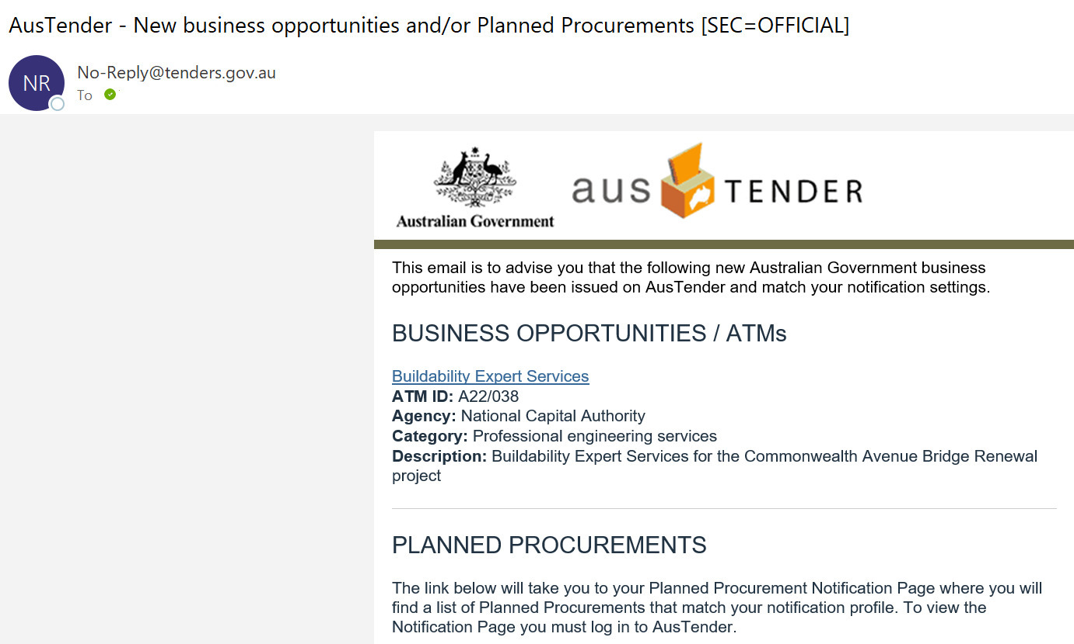

# Set up and manage your notifications

Using filters like Keywords or Categories will ensure you receive automatic notification emails where Business Opportunities and/or Planned Procurements match your profile. Caution should be used to prevent over-limiting your notifications.

# Notification Hot Tips

* Settings which are too prescriptive could lead to missed opportunities.
* Using keywords, category, and location in your profile will filter the number of notifications you are sent.
* AusTender will match your notification filters and will only provide you with notifications for opportunities where all your chosen filters are matched.  
  Filters are not individual, so they have a cumulative effect to minimise the number of opportunities you will receive notifications for.
* If you are unsure about setting up notifications, you can save AusTender in your favourites and visit regularly to identify opportunities.
* Alternatively, simply don't select any filters and you will receive notifications of all available Business Opportunities.

# Business Opportunities

Business opportunities are published as Approaches to Market (ATMs). ATMs are open for potential suppliers to participate and include requests for tender, requests for quote, expressions of interest, or proposals.

# Current Approaches to Market

Current [Approaches to Market (ATMs)](https://help.tenders.gov.au/getting-started-with-austender/information-made-easy/current-approaches-to-market/) on AusTender are notices inviting potential suppliers to participate in a procurement.

ATMs are published on AusTender by Commonwealth Agencies to make it easier for suppliers to locate opportunities and submit tender responses.

Further information on identifying opportunities is available at the [Selling to Government](https://sellingtogov.finance.gov.au/guide/identifying-opportunities-to-sell-to-government) website.

# Future Business Opportunities

These are potential Business Opportunities that are published on AusTender as [Planned Procurements](https://help.tenders.gov.au/getting-started-with-austender/information-made-easy/future-business-opportunities/).

The purpose of Planned Procurements is provided advanced notice to potential suppliers about expected significant procurements.

Planned Procurements are subject to revision, withdrawal, or cancellation, and are provided for planning purposes only.

# Understanding the Lodgement Requirements

Each procurement activity is unique, and it is important to understand the lodgement requirements before responding. Read the information on the tender page on AusTender and associated procurement documentation to make sure you lodge your response according to these requirements.

Always ensure that you understand:

* When the tender closes as you cannot lodge a response on AusTender after it closes.
* Any response format requirements like the type, or size of files that will be accepted

# Preparation is key!

1. Review - Read the instructions, each Tender is different.
2. Prepare - Gather information and understand how to respond and what to include.
3. Practice – A demo tender is available to practice using the submission process.
4. Don't Miss out - The lodgement process switches off when the tender closes.  No responses are possible after the deadline.

# Practice Lodging a Response

If you have not used AusTender to lodge a response before there is a demonstration tender where you can test the lodgement process.

To test lodgement:

1. Locate the [Demo ATM](https://www.tenders.gov.au/Atm/Show/f5750c7a-c277-47dc-bc4b-50c87dffb08a) (search “demo” and find “Demo ATM to test eLodgement and Download”).
2. Select the 'Lodgement Page' button.
3. If you have not already logged in to AusTender you will have to login or create a new Registered User account at this step.
4. Browse your computer to choose your test files. Please note that test responses will not be downloaded.
5. Select 'Lodge Response'.
6. An on-screen receipt will display if lodgement was successful.
7. A receipt will also be emailed to your Registered User email address.

# Hot Tips - Lodgement Preparation Checklist

* Internet connection - is it strong and stable.
* Time - allow sufficient time to lodge response and / or problem solve if errors occur.
* File names - Less than 100 characters, no special characters.
* File location - save in a location that is easily accessible (e.g. Desktop).
* File types - Check the tender to confirm requirements.
* Virus Check - If we can't open your response, we can't evaluate it!

**Note:** During a lodgement session only 5 files can be submitted, the AusTender system allows the use of compressed files to aid in the lodgement process.

Please take care to confirm that the file type is compatible with AusTender, supported file types include Microsoft Word, Excel, or PDF files.

**After selecting 'Lodge Response' button do not select back or close your browser until the on screen receipt appears.**

If you encounter technical issues, contact [AusTender Help Desk](https://www.tenders.gov.au/contactus/show" \t "_blank" \o "AusTender Help Desk) immediately

# I have a newer version of my Lodgement documents, what can I do?

Once a document has been uploaded, it can no longer be managed. AusTender allows multiple submissions while the Opportunity is still open.

All documents lodged under the same AusTender registered user account will go into a folder marked under your company name.

# If the tender is still open, you can:

* Upload the new documents, with a unique identifier such as version number
* Contact the Opportunity Contact Officer.
* Provide them with the information of which files should be considered during the evaluation process by email.
* This will help the Contact Officer while preparing the tender submissions for evaluation.

Unfortunately, if the opportunity is closed only the previously uploaded documents can be evaluated.

# Missed the tender Closing Time? What now?

The Australian Government has a late submissions policy which states that late submissions must not be accepted unless the submission is late as a consequence of mishandling by the relevant agency.

This is detailed in the [Commonwealth Procurement Rules](https://www.finance.gov.au/government/procurement/commonwealth-procurement-rules). This is also reflected in the AusTender [Terms of Use](https://help.tenders.gov.au/terms-of-use/).

Once a tender on AusTender reaches the closing time it is no longer possible to lodge a response. As this is the case don't miss out by leaving lodgement to the last minute.

If you have missed the closing time you should immediately get in touch with the Tender Contact as detailed within the tender documents and on AusTender.

# How do I edit my contact details?

You can edit your details on AusTender by logging in using your email address and password and selecting the ‘Edit Profile’ link which can be accessed by selecting the arrow to the right of your login details.

After editing your user profile, select the ‘Save’ button to confirm the changes made.

# Where do I get help or advice?

The AusTender Help Desk is available between 9am and 5pm Australian Eastern Daylight time, Monday to Friday (excluding Australian Capital Territory and national public holidays), via email at [tenders@finance.gov.au](mailto:tenders@finance.gov.au). Please note, questions regarding tender documentation should be directed to the nominated agency Contact Officer that is shown in the tender documentation or on the AusTender page for the particular procurement.

How will I know if my tender response has been successfully lodged? Lodgement receipts are automatically displayed on screen and a confirmation email is sent to confirm the opportunity which was responded to.