DEED OF AMENDMENT

BETWEEN

COMMONWEALTH OF AUSTRALIA

represented by the Australian Agency for International Development
(AusAID)

ABN 62 921 558 838 and

UNIVERSITY OF MELBOURNE, through the Department of Paediatrics, International Child Health Unit ABN 84 002 705 224;

THE MACFARLANE BURNET INSTITUTE FOR MEDICAL RESEARCH AND PUBLIC HEALTH LTD. ABN 49 007 349 984; AND

MENZIES SCHOOL OF HEALTH RESEARCH ABN 70 413 542 847.

FOR

THE WOMENS AND CHILDREN'S KNOWLEDGE HUB AUSAID AGREEMENT 44748 (also known as 44902)

Amendment No. l

THIS DEED OF AMENDMENT is made this ""2. 2.. day of PECGVne£1e- 2010

BETWEEN:

The COMMONWEALTH OF AUSTRALIA, represented by the AUSTRALIAN AGENCY FOR INTERNATIONAL DEVELOPMENT, ABN 62 921 558 838 ("the Commonwealth") ofthe one part

AND

UNIVERSITY OF MELBOURNE, through the Department of Paediatrics, International Child Health Unit ("CICH") ABN 84 002 705 224; THE MACFARLANE BURNET INSTITUTE FOR MEDICAL RESEARCH AND PUBLIC HEALTH LTD ("BURNET") ABN 49 007 349 984; and MENZIES SCHOOL OF HEALTH RESEARCH ("MENZIES") ABN 70 413 542 847, jointly called the WCH Organisations (the "Organisations").

WHEREAS:

A. On 7 April 2008 the Commonwealth and the Organisations entered into Funding Agreement 44748 (also known as 44902) in writing for the provision of the Activity described in the Agreement.

B. The Parties have now agreed to alter the Funding Agreement as set out herein.

NOW THEREFORE THIS DEED WITNESSETH as follows:

1. In this Deed unless the contrary intention appears, a reference to the "Agreement" is to the Agreement referred to in Recital A.

2. Subject to Clause 3 herein the Agreement is amended as set out below:

Clause 1.2 | Delete existing Clause 1.2 and replace with new Clause 1.2 as follows:  " 1.2 The implementation period commencing in 1 January  2009 and ending 31 December 2011".
Clause 2.1.c | Delete existing Clause 2.1.c and replace with new Clause 2.1.c as follows:  "c) one (1) month prior to the end of the Agreement between  AusAID and the WCH Organisations, a final report."

Amendment No 1
Clause 2.2 Final  Report | Delete Final Report paragraph in Clause 2.2 and replace with a new paragraph as follows:  "Final Report  The Final Report, submitted as per Clause 2.1.c above, must contain ..."
Clause 5.2 | Delete existing Clause 5.2 and replace with new Clause 5.2 as follows:  " 5.2 The WCH Organisations must commence the WCH Hub  Initiative on 7 Apri12008 and conclude by 31 December  2011."

3. The amendments set out in this Deed take effect on the date on which this Deed is signed by both parties.

4. In all other respects the parties confirm the Agreement.

EXECUTED AS A DEED by the Commonwealth, by an authorised officer, and by the
Organisation by its authorised officer.

SIGNED for and on behalf of the COMMONWEALTH OF AUSTRALIA represented by the Australian Agency for International Development by:

in the presence of:

... . . .
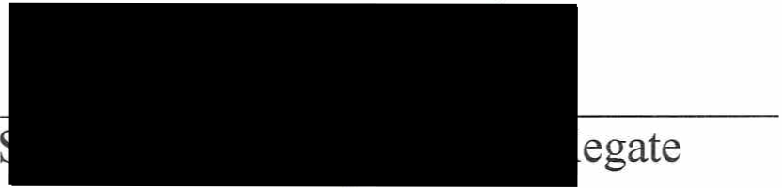

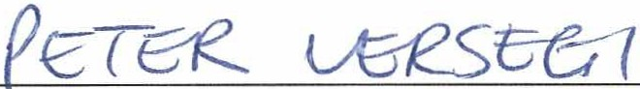
Name Name ofwitness
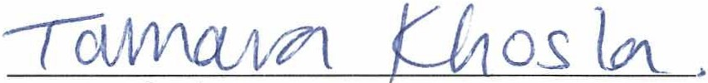



Position, Section

SIGNED for and on behalf of
UNIVERSITY OF MELBOURNE by


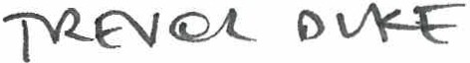

Name and Position
(Print)
Signature

By executing this Deed of Amendment the signatory warrants that the signatory is duly authorised to execute this Deed of Amendment on behalf of the Organisation.

in the presence of -

......t\ . ...B . ·························


Name of Witness

SIGNED for and on behalf of


THE FOR HE

s·
Secretary

V\A- l?J0 -E
c \I{ tovei44L- t1-1fv{ft_c-rz.

Name ofDirector

SIGNED for and on behalf of MENZIES SCHOOL OF HEALTH RESEARCH by
V,·c K,· 1 oy 1-of...
..Ch :.e..f ....Or.. g:tJ.r).<j...O.f.f.l:( (
Name and Position

s
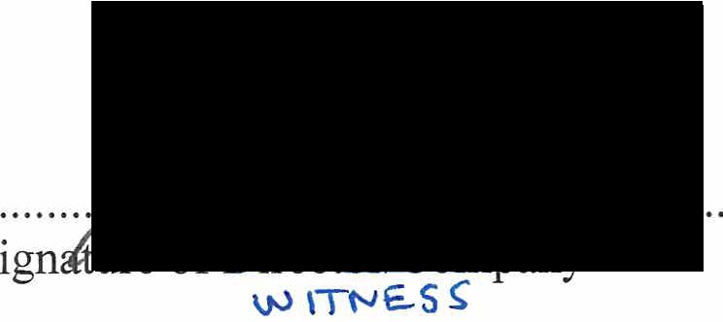

...?. ·......... - ········
Name of Bireetor/Compaay Seeretar)'
\.J"-:1111"-l£...$ s

By executing this Deed of Amendment the signatory warrants that the signatory is duly authorised to execute this Deed of Amendment on behalf of the Organisation.


in the presence of -

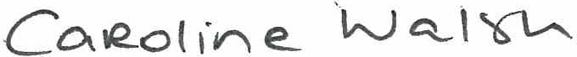


Name of Witness

AMENDMENT SUMMARY SHEET

The Funding Agreement has been varied in accordance with the clause headed Agreement
Amendments of the Funding Agreement on the following dates relating to:

Amendment  # | Date | Very Brief Summary of amendment | Increase ecrease in financial limit | Adjusted Financial Limit  (AUD)
1 | October  2010 | Extension of the completion date to 31 December 2011 | Nil | 6,000,000

