Australia’s aid program
in Vietnam
May 2013

Why we give aid
Vietnam is one of Australia’s most important and valued regional partners. Therefore, we have a national interest in working with Vietnam to overcome poverty. A prospering Vietnam promotes stability and growth that is good for cooperation, security trade and prosperity in the region.
Since the early 1990s, Vietnam has experienced rapid economic growth and reforms helping lift more than 35 million people from poverty. In 2010, Vietnam joined the ranks of lower middle income countries however 43.4 million people are still living on less than US $2 a day. Vietnam hopes to become a higher income industrial economy and to reduce poverty but faces constraints including infrastructure, human resources and institutional weaknesses.

How we give aid
The Australia – Vietnam Joint Aid Program Strategy (2010–2015) focuses on human resource development, economic integration and environmental sustainability. Australia will work with Vietnam in a relationship of mutual trust, recognition and accountability to achieve improvements in these areas. Australia partners with the Asian Development Bank, World Bank, United Nations Development Programme, UN Women, NGOs and civil society groups to deliver its aid program in Vietnam.

Improving the quality of human resources
Poor education quality remains a barrier to Vietnam’s transition to an industrialised economy. The Australia Awards program builds on more than 35 years of investment in improving the credentials of Vietnam’s workforce. The Australia Awards Scholarships build closer partnerships, capacity and leadership skills so that individuals can contribute to Vietnam’s development. A total of 1293 long-term and 656 short-term awards were provided to Vietnam from 2007–2012. Gender equality is a key component of the scholarships program to empower women to participate in Vietnam’s economy, leadership and education.

Australia's Governor-General, Quentin Bryce, talks with students at RMIT University in Vietnam. Skilling up Vietnam’s youth is critical for continued economic growth and poverty reduction in Vietnam. Photo: AusAID

Supporting economic integration
Australia will assist Vietnam to finance and construct the hard infrastructure necessary for strong national and regional economic integration. Investments in infrastructure will improve food security, open markets and increase employment and enterprise opportunities for poor people in rural and urban areas.
Australia will invest $160 million in the Central Mekong Delta Connectivity Project over six years to support the design and construction of a new bridge across one of two branches of the Mekong River at Cao Lanh in Dong Thap Province.
Australia’s investment in the Beyond World Trade Organisation program supports the use of reviews, analysis and research to inform Government of Vietnam led reforms in areas including competition policy, state owned enterprises and land management.
Australia will continue to work across borders at a regional level to address the serious issues of people trafficking and HIV/AIDS transmission. This includes strengthening the criminal justice response to human trafficking and providing HIV/AIDS training for health workers and high risk groups near major road construction.

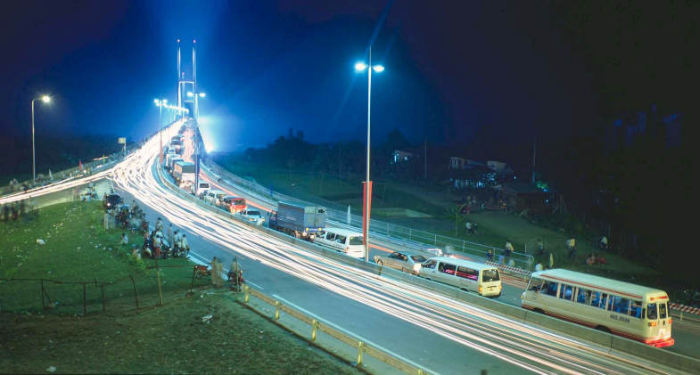
By 2015, the Mekong Delta will have improved transport infrastructure, lowering the operating costs of travel and travel time needed to access local and regional markets.

Enhancing environmental sustainability
Climate change is a critical issue affecting Vietnam. Addressing climate change will ensure that the development gains achieved are not undone and will guarantee food security for millions of people. Australian assistance will help Vietnam adapt to a changing climate and reduce greenhouse gas emissions in line with global efforts. We will help reduce the negative impacts of climate change and other environmental factors on poor people by developing a new portfolio of initiatives that help Vietnam deal with the challenges of climate change. Water-borne diseases have a major health and economic impact on rural populations in Vietnam. It is estimated that only 51 per cent of the population has access to safe sanitation. The Rural Water Supply and National Target Program Phase 3 aims to improve the health and living conditions of the rural poor by providing clean water and sanitation and by promoting safe hygiene practices.

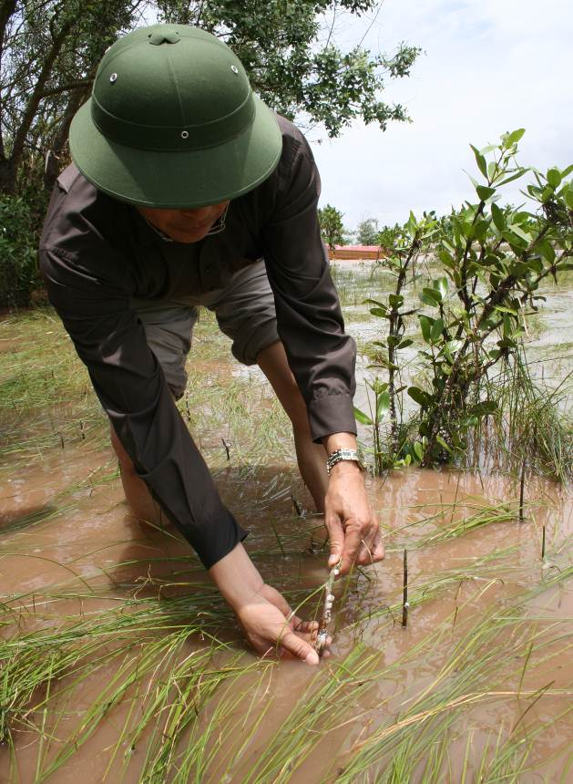
By 2015, the Government of Vietnam develop a climate change response that builds resilience in vulnerable communities and enables adaptation planning, by improving understanding of climate change impacts and identifying practical approaches to adapt.

More information
For more information on the Australia—Vietnam aid program strategy visit www.ausaid.gov.au

