AUSTRALIA – WORLD BANK STRATEGIC PARTNERSHIP PHASE 2 (ABP2)

INDEPENDENT
EVALUATION REPORT

Submitted to the World Bank and DFAT
By Mekong Economics

December 2025

Table of Contents

Acronyms iv
List of Tables and Figures v
Tables v
Annexed Figures v
Executive Summary 1
Summary of Findings 1
Recommendations 4
1. Introduction 5
1.1 Background and Context 5
1.2 Objectives, Methodology and Structure 6
1.3 Evaluation Limitations 8
2. Relevance 9
2.1 Are the themes/activities under the ABP2 Programme relevant and supporting the country development strategies of the Vietnamese Government, the WB and Australia? 9
2.2 Do ABP2 activities address the critical development needs of Viet Nam? 11
2.3 How has the partnership adapted to maintain its relevance to the changing context? 11
3. Effectiveness 11
3.1 To what extent has the partnership achieved its intended objectives? 12
3.2 What changes could be made to ensure objectives are met? 13
4. Efficiency 14
4.1 How effective was the Programme in terms of funding arrangement, governance structure, modality of support, and approach in supporting the activities? 14
4.2 How does the partnership modality efficiently help to leverage the World Bank’s lending portfolio in Viet Nam since 2020? 15
4.3 To what extent is the partnership modality best suited for future collaboration in the changing context (World Bank trust fund reforms, Australia’s priorities and resources, etc.)? 15
5. Gender Equality and Inclusion 15
5.1 How was gender effectively mainstreamed into ABP2 activities? To what extent has gender mainstreaming been operationalised into ABP2 and World Bank activities? 16
5.2 To what extent has the Disability Inclusion been mainstreamed into the WB operations? Has this been appropriately resourced? 16
6. Key findings: Challenges and Insights 17
6.1 Inclusive Development 17
6.2 Gender Equality and Women’s Economic Empowerment 18
6.3 Climate Resilience in the Mekong Delta 18
6.4 Low Carbon Infrastructure Development 19
6.5 Digital Transformation 20
6.6 Economic Management 20
7. Understanding the Australia-World Bank Partnership ‘Model’ 21
7.1 The governance and challenges 21
7.2 The World Bank model of supporting reforms 22
8. Conclusion and Recommendations 25
8.1 Greater alignment on the relevance of activities 25
8.2 Ensure adequate resourcing for any subsequent phase, including required staffing capacity 26
8.3 Strengthen Monitoring, Evaluation, and Learning (MEL) 26
Annex 1. List of Stakeholders Interviewed 27
Annex 2. List of Stakeholders Contacted 29
Annex 3. Inclusive Development Case Study: Revisions to the Social Insurance Law No. 41/2024/QH15 30
Annex 4. Gender Case Study: National Scheme on Improving the Quality of Care and Education for Children of Workers in Areas with Many Employees (2025-2030, Vision to 2045) 35
Annex 5. Climate Resilience in the Mekong Delta Case Study: The Design and Approval of MERIT 39
Annex 6. Low Carbon Infrastructure Development Case Study: E mobility 43
Annex 7. Digital Transformation Case Study: HCMC Data Governance Strategy 47
Annex 8. Economic Management and Growth Case Study: Revisions to the Public Investment Law (No. 69/2025/QH15) 52
Annex 9. Terms of Reference 56

Acronyms
Acronym | Full Form
ABP2+ | Australia–World Bank Partnership Phase 2 Extended
AI | Artificial Intelligence
CNG | Compressed Natural Gas
DFAT | Department of Foreign Affairs and Trade (Australia)
DIC | Department of Information and Communications (HCMC)
DPPA | Direct Power Purchase Agreement
DXCentre | Digital Transformation Center
EV | Electric Vehicle
EVN | Viet Nam Electricity
GEDSI | Gender, Equality, Disability, and Social Inclusion
GIS | Geographic Information System
GoV | Government of Viet Nam
GIZ | Deutsche Gesellschaft für Internationale Zusammenarbeit
HCMA | Ho Chi Minh National Academy of Politics
HCMC | Ho Chi Minh City
LCID | Low Carbon and Resilient Infrastructure Development
MAE | Ministry of Agriculture and Environment
MERIT | Mekong Delta Climate Resilience and Integrated Transformation (Project)
MoHA | Ministry of Home Affairs
MoIT | Ministry of Industry of Trade
NA | National Assembly
NDC | Nationally Determined Contribution
NDTA | National Digital Transformation Authority
NSGE | National Strategy on Gender Equality
ODA | Official Development Assistance
PDP8 | Power Development Plan 8
PPP | Public-Private Partnership
SI | Social Insurance
ToR | Terms of Reference
VSS | Viet Nam Social Security
WB | World Bank

List of Tables and Figures

Tables
Table 1. Breakdown of Key Informant Interviews

Figures in the Main Report
Figure 1. Performance rubric
Figure 2. Selected case studies
Figure 3. Governance Interventions explained.
Figure 4. The World Bank Approach to Governance Interventions
Figure 5. The Private Management Firm approach to Governance Interventions

Annexed Figures
A1. Results Map of revisions to the Social Insurance Law
A2. Results Map of National Childcare Scheme
A3. Results Map of design and development of MERIT
A4. Results Map for E-mobility
A5. Results map for HCMC Data governance
A6. Results map for economic management

Executive Summary

The Australia – World Bank Strategic Partnership, phase 2 (ABP2) is a nine-year Programme (2017-2026) valued at AUD50 million to support Viet Nam’s development agenda in key areas by sharing knowledge and strengthening policies and programs for selected development priorities, with a particular focus on gender equality. The Programme has been extended three times during its implementation. Building on earlier phases of collaboration, the third extension of the Programme, ABP2+, commenced in July 2023 with six thematic pillars: (1) Gender Equality and Women’s Economic Empowerment, (2) Climate-Resilient Development in the Mekong Delta, (3) Inclusive Development, (4) Economic Management and Growth, (5) Digital Transformation, and (6) Low-Carbon Infrastructure Development.
ABP2’s End-of- Programme Outcomes (EOPOs) are:
- Strengthened development policies and regulations (laws, decrees resolutions, decisions, policy plans etc.) impacted, - of which are gender informed.
- Strengthened development programs of the WB’s investment which are gender informed.
This evaluation provides an independent assessment of ABP2+ from July 2023 to mid-2025. It synthesises overall findings on the programme’s performance against the evaluation criteria of relevance, effectiveness, efficiency, and integration of gender equality and inclusion, and presents summaries of achievements, challenges, and insights under each thematic pillar. Six case studies, one per pillar, illustrate how ABP2+ technical assistance has contributed to Viet Nam’s reforms and World Bank operations (projects and programmes). The report provides recommendations to guide the design and resourcing of the next phase of the partnership - The Australia – World Bank Strategic Partnership, phase 3 (ABP3).

Summary of Findings
Relevance
The Programme's relevance is rated as ‘Strong’ | 
The themes and activities of the Programme are relevant. All themes and components of the Programme are aligned with existing Government of Viet Nam (GoV) strategies. The World Bank initiates activities only upon formal request by the GoV, indicating strong country ownership. Activity design is grounded in the World Bank’s institutional understanding of where analytical contributions can improve working processes.
In practice, the emphasis placed on different priorities varies somewhat across key partners. While all the pillars are aligned with Australia’s strategic priorities, Australia places a stronger emphasis on Gender, Equality, Disability, and Social Inclusion (GEDSI), the GoV prioritises immediate national agendas, particularly climate resilience and infrastructure, and the World Bank, as a lending institution, tends to assign significant weight to interventions that support future investment operations. These varying priorities have at times contributed to delays, reduced traction, and even resulted in proposed activities being dropped. The Evaluation Team concludes that improved relevance in the next phase will require clearer upfront agreement on what is feasible within the political and institutional context, and stronger alignment of partner priorities.
Effectiveness

The Programme effectiveness is rated between ‘strong’ and ‘very strong’ | 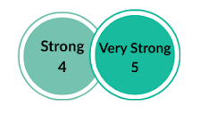

The Australia-supported Bank-GoV partnership has proven to be highly effective for the following reasons:

- Significant Achievement of Programme’s Overall Objective

Six case studies were selected to assess ABP2+ performance against its objective of sharing knowledge and strengthening policies or programs for selected development priorities for Viet Nam, with a particular focus on gender equality. Across all six cases, the Evaluation Team found that the analytical and technical contributions of the Programme have had tangible impact on targeted policies or programs.

The analysis found that ABP2+ contributed through clear uptake of its analytical recommendations, strengthened institutional capacity for design and implementation, and improved coordination across central and provincial levels, enabling more coherent and integrated planning.

- Responsiveness to emerging development priorities

The partnership demonstrated strong responsiveness to emerging development priorities of the Government of Viet Nam. ABP2+ showed flexibility in adjusting the scope and timing of its analytical and technical support as reform needs evolved, and it provided timely inputs during several critical reform moments. This included the rapid redirection of the Urban Care Study to support the development of the National Childcare Scheme when Government priorities shifted, as well as the accelerated provision of analysis for revisions to the Public Investment Law, where the World Bank worked under tight deadlines to meet urgent Government requests. Examples from the case studies underpin the Evaluation Team’s assessment that the programme adapted effectively to periods of heightened reform momentum and was able to deliver targeted inputs that met immediate needs.

ABP2+ was also found to be responsive to Australia’s emerging priority on disability inclusion, although progress remained modest. Disability inclusion was incorporated into the programme and supported through activities such as accessibility upgrades in health facilities, a community-based care pilot, and preparatory analytical work. However, progress on reform stalled due to changes in Government restructuring. Overall, responsiveness to disability inclusion was evident, although external constraints limited progress.

Efficiency

The Programme efficiency is rated as strong.
Resources are used efficiently, and the Programme effectively leverages trust funds to support impactful reforms and investments. There remains some scope for improving communication and clarity of processes between partners.
A key driver of delivery efficiency is the partnership modality. The World Bank is a highly effective channel for Australia’s development financing due to its long-standing credibility with the Government of Viet Nam and its reputation for impartial, high-quality technical advice. The World Bank’s ability to identify critical entry points for dialogue and research has enabled Australia to align its support with Viet Nam’s reform priorities, resulting in a strategically targeted and impactful investment agenda. Sustained dialogue and strong working relationships between Bank staff and government counterparts further support timely engagement and the delivery of relevant analysis.
These strengths are reinforced by DFAT’s strategic direction, diplomatic engagement, and oversight, which ensure that the partnership’s analytical work informs and complements Australia’s broader development Programme. Together, these contributions streamline delivery, reduce duplication of effort, and lower transaction costs by integrating ABP2+ support into existing Bank–government processes rather than creating parallel systems.
However, the evaluation identified room for improvement in communication and coordination at both management and pillar levels. Intermittent lapses in information-sharing have reduced Australia’s early sight of activities, limited opportunities for joint work planning, particularly for Australia’s deeper contribution to GEDSI, and resulted in some activities being added in a more ad hoc manner or not fully aligned with thematic objectives or sequencing within ABP2+.
The modality remains fit for future collaboration given its close alignment with the World Bank’s lending Programme and GoV reform agenda. Its ongoing relevance, however, will depend on stronger DFAT–World Bank communication and planning, and on both partners adapting to forthcoming World Bank trust fund reforms and Australia’s evolving priorities and resourcing.
Gender Equality and Inclusion

The Programme’s gender equality and inclusion is rated between moderate and strong. | 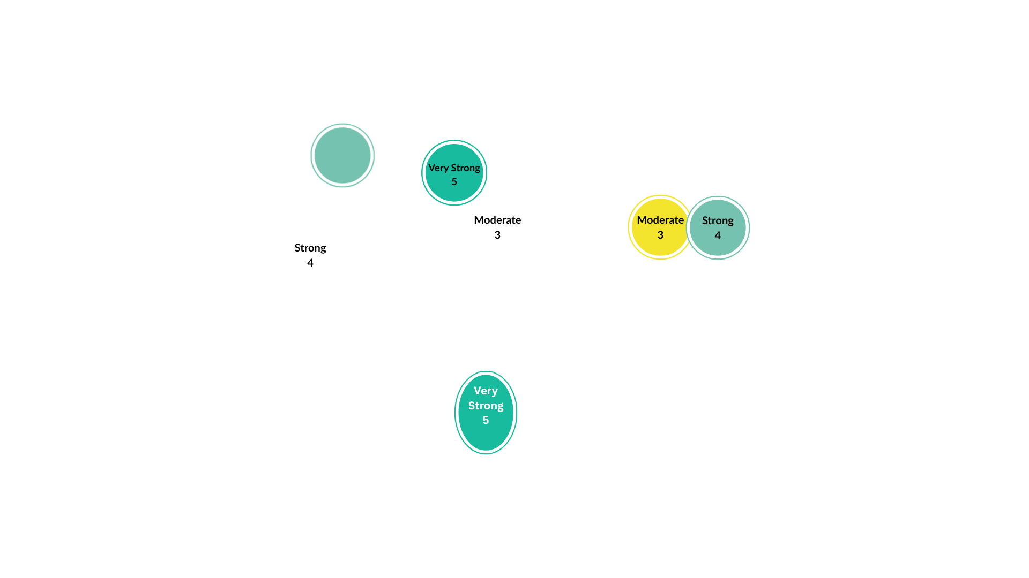

The evaluation finds that gender equality has been partially mainstreamed and operationalised within ABP2+ and World Bank activities, but progress is uneven, and disability inclusion remains weak. Gender integration is strongest where it has been explicitly prioritised - such as the inclusion of gender-sensitive revisions in the Social Insurance Law and the operationalisation of gender considerations within the Grassroots Health Service Delivery Project. However, mainstreaming is not yet consistent across themes, and current efforts rely on individual champions rather than systematic processes or dedicated resourcing. The evaluation concludes that stronger internal advocacy, clearer expectations for cross-theme integration, and increased resources for GEDSI are required for the partnership to meet its stated commitments to gender equality and disability inclusion.

Recommendations

- Greater Alignment on ‘relevance’ of Activities
To strengthen the relevance of future activities and minimise delays, two actions are recommended. First, ABP3 should streamline the number of thematic pillars to avoid dispersing resources and focus on areas with the strongest traction and political demand. Second, the Programme should ensure more comprehensive and collaborative discussions on the prioritisation and feasibility of proposed activities during the development of pillar- and activity-level concept notes. Concentrating resources on fewer, well-resourced pillars would enhance both relevance and efficiency and ensure critical regulatory windows are effectively leveraged.

- Ensure Adequate Resourcing for ABP3, Including Required Staffing Capacity
If the number of thematic pillars is streamlined under ABP3, it will be important to maintain an adequate overall funding envelope so that the remaining pillars, and the staffing required to deliver them, are properly resourced. The evaluation found that the World Bank’s ability to mobilise skilled national and international experts with strong technical expertise and established government relationships is central to the Programme’s effectiveness. Sustaining appropriate staffing levels will therefore be essential for ABP3 to meet emerging reformdemands and maintain the quality and timeliness of analytical and advisory support.

- Strengthen Monitoring, Evaluation, and Learning
The Programme’s Monitoring, Evaluation, and Learning approach would benefit from greater consistency across themes. In several areas, targets had not been updated for an extended period, making it more difficult to demonstrate progress clearly. Introducing a harmonised and periodically refreshed set of indicators and reporting standards under ABP3, supported by qualitative contribution case studies and more systematic tracking of Government uptake, would help strengthen the Programme’s ability to capture results and enhance cross-theme learning.

1. Introduction
This report presents an independent evaluation of the ABP2+ programme. It combines an assessment of programme performance against agreed evaluation criteria with an in-depth qualitative case study analysis of how technical assistance activities have contributed to key guiding documents and regulatory outcomes. In doing so, the evaluation provides evidence of the programme’s achievements, identifies lessons learned, and offers recommendations to inform the design of future Australia–World Bank collaboration in Viet Nam beyond the programme’s end in June 2026.

1.1 Background and Context
ABP is a strategic partnership, funded by the Australian Government and implemented by the World Bank with a development objective to share knowledge and strengthen policies and programs for selected development priorities for Viet Nam, with a particular focus on gender equality.

The first phase of the Australia-World Bank partnership (ABP1) started in 2012 and was completed in 2016. The programme focused on five thematic areas: transports; social, urban, rural and water; energy; climate change and green growth; macro-economic reforms and public financial management. ABP2 was implemented starting 2017. To maintain relevance with Viet Nam’s development priorities, as well as those of the partnership, the themes were modified. The themes were: Gender Equality and WEE, Viet Nam 2035, Investing in Viet Nam’s ethnic minorities, Trade and Competitiveness, Towards Efficient and Sustainable Transport for Viet Nam, and Mekong Delta: Advancing Climate Resilience Development Recognizing the value of the partnership and the positive impact of its activities, the World Bank and Australia extended the implementing period of ABP2. The extended phase 2 (ABP2+) began in July 2023. However, once again, to ensure continued alignment with Viet Nam’s evolving development priorities, the extended phase introduced new thematic areas and revised existing ones. The six themes of ABP2+ are:

- Inclusive Development
- Gender Equality and Women’s Economic Empowerment
- Climate-Resilient Development in the Mekong Delta
- Low-Carbon Infrastructure Development
- Digital Transformation
- Economic Management and Growth
Total funding during the 13-year life of ABP 1 and 2 amounted to AUD95.5 million (including AUD 45.5million for phase 1 and AUD 50 million for phase 2).
During ABP2 two independent evaluations were conducted: a Mid-Term Review (2019) and a Qualitative Impact Evaluation (2021). In June 2025, Mekong Economics Limited (MKE) was contracted to undertake an independent evaluation for the ABP2+. MKE is a Viet Nam-based development consulting firm with more than 20 years of experience in economic and social research, as well as impact and Programme evaluations across Viet Nam and the broader Mekong region. The firm has a long track record of conducting independent evaluations for bilateral and multilateral partners, including work on governance, economic management, gender equality, and inclusion. Drawing on this expertise, MKE led the evaluation design, data collection, analysis, and synthesis, and ensured alignment with the methodology, scope, and deliverables specified in the Terms of Reference (ToR).

1.2 Objectives, Methodology and Structure
This Evaluation will provide an independent assessment of the extent to which the extended phase of the Australia–World Bank Partnership Programme (ABP2) achieved its intended goals. The evaluation covers the period from July 2023 to August 2025 and examines the programme’s contribution to Viet Nam’s evolving development priorities. In particular, it focuses on six thematic areas: Gender Equality and Women’s Economic Empowerment, Climate-Resilient Development in the Mekong Delta, Inclusive Development, Economic Management and Growth, Digital Transformation, and Low-Carbon Infrastructure Development.
The methodology used for this evaluation is qualitative - a combination of stakeholder interviews, document review, and in-depth case study analysis. A comprehensive review of programme documents and relevant literature, including progress reports, annual reports, guidelines/rules, concept notes, and analytical outputs. Additionally, semi-structured interviews were conducted with the three key stakeholders: GoV (relevant to selected case studies), World Bank and DFAT teams. The table below shows a breakdown of how many interviews were conducted and with whom.
Table 1. Breakdown of Key Informant Interviews.
Description | Informant | KII
Implementing agency | World Bank Theme Leads | 6
Implementing agency | World Bank Case Study Focal Point | 5
Donor | DFAT Staff | 10
Government Focal Point/ | Central and Provincial | 5
National Assembly | Representative | 1
Total |  | 27

The evaluation assesses ABP2+ against the four evaluation criteria stipulated in the ToR: relevance, effectiveness, efficiency, and the integration of gender equality and inclusion. The assessment of these criteria is directly structured around the specific evaluation questions outlined in the ToR (see Annex 9 for detail).
The evaluation examines the degree to which Programme activities have been aligned with the strategic priorities of the Government of Viet Nam (GoV), Australia, and the World Bank, and to what extent they have contributed to Vietnam’s development pathway or mobilized investments. Beyond assessing results, the evaluation identifies lessons learned and provides practical recommendations to inform the design of future collaboration between Australia and the World Bank in Viet Nam following the programme’s conclusion in June 2026.
The following chapters present the evaluation’s findings against the four criteria. Each criterion is assigned a score, against the agreed performance rubric (Figure 1), supported by a justification that draws on evidence from across the Programme. The assessment criteria of each criterion are detailed below, directly addressing the relevant evaluation questions in the ToR:
- Relevance: Assessed by the extent to which Programme activities align with the strategic priorities and critical development needs of the Government of Viet Nam (GoV), Australia, and the World Bank.
- Effectiveness: Assessed based on the Programme’s success in achieving its intended outcomes and contributing to national and global development priorities. This analysis is supported by evidence from six case studies examining the Programme’s attributable influence on key policies and legislation. These case studies are provided in Annex 3-8.
- Efficiency: Assessed by how effectively the partnership has enabled the optimal use of financial, technical, and human resources, including the effectiveness of its funding arrangement, governance structure, and modality of support.
- Gender Equality and Inclusion: Assessed by the degree to which these principles have been operationalized and mainstreamed across World Bank-supported activities, including the adequacy and effectiveness of resourcing for disability inclusion.
The report then presents a chapter titled “Key Findings: Challenges and Insights,” which synthesises the key insights and challenges thematically and provides the contextual analysis underpinning each criterion’s score.

Figure 1. Performance rubric.

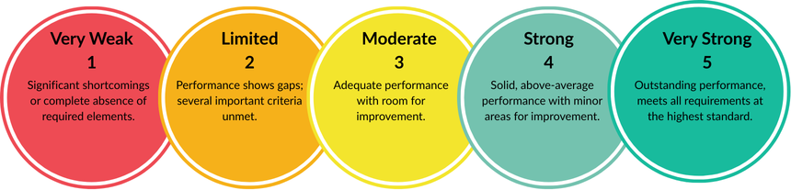

The penultimate chapter, “Our Understanding of ABP2,” is situated after the Key Findings. It analyses the distinctive nature of the Australia-World Bank partnership by contrasting it with a standard donor-management firm model. This comparison serves to highlight and affirm the Evaluation Team’s conviction that the World Bank model is highly effective due to its unique capacity to share global knowledge, technical expertise, long-term commitment, and adaptiveness in meeting Viet Nam’s changing priorities.
The final chapter the evaluation’s independent assessment of the overall value of ABP2+, drawing back on points made throughout, including evidence from the thematic chapters, case studies, and partnership analysis. It highlights the programme's effectiveness, rooted in its alignment with Viet Nam’s priorities, the unique value adds of the Australia-World Bank partnership, and its contribution to improve decision making process, before offering recommendations to guide future collaboration.

Figure 2. Selected case studies.
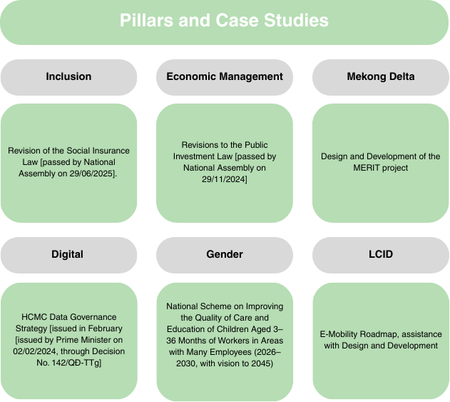Figure 2 shows a list of case study under each ABP2 pillar. They include:
- Inclusion: Revision of the Social Insurance Law (passed by the National Assembly on 29 June 2025
- Economic Management: Revisions to the Public Investment Law (passed by the National Assembly on 29 November 2024)
- Mekong Delta: Design and Development of the MERIT (WB’s lending) project.
- Digital Transformation: Hochiminh City Data Governance Strategy (issued in February by the Prime Minister on 2 February 2024, Decision No. 143/QD-TTg)
- Gender Equality: National Scheme on Improving the Quality of Care and Education of Children Aged 3-36 months of workers in Areas of many employees (2026-2030, with vision to 2045).
- Low Carbon Infrastructure Development: E-mobility Roadmap, assistance with Design and Development.

1.3 Evaluation Limitations

This Evaluation has certain limitations that should be acknowledged.

- Limited data sources. In some areas, findings may be less robust due to difficulty in securing interviews. This was particularly the case for the Inclusion Theme. Despite multiple attempts - including a formal letter and several follow-up calls - the evaluation team was unable to secure interviews with Viet Nam Social Security (VSS) and the Ministry of Home Affairs (MOHA). As a result, the evaluation relied primarily on interviews with the World Bank teams. This limitation was partially mitigated using available public statements and data from VSS, which provided supplementary insights into the World Bank’s contribution.
- Interview and researcher bias. Interviews inherently carry the risk of bias. Stakeholders may exaggerate their role, while GoV officials may be reluctant to voice criticism (a form of courtesy bias). There is also a risk of researcher bias, particularly in the form of confirmation bias - interpreting evidence in ways that align with existing assumptions and omitting contradictory data. To reduce these risks, the evaluation systematically triangulated findings across multiple data sources wherever possible.
- Timing of Impacts. For some case studies, the impact is not yet fully realised, as certain outcomes remain prospective. For example, this is the case with the anticipated incorporation of the World Bank’s recommendations into the National Scheme on Improving the Quality of Care for Children Aged 3–36 Months of Workers in Areas with Many Employees (2026–2030, with a vision to 2045). In such instances, the assessment necessarily relies on interviewee accounts and their informed judgement regarding expected trajectories of influence.

2. Relevance

Relevance is rated “Strong.” All six ABP2 themes align with the priorities of the three partners. However, the relevance of some activities could be further enhanced through closer joint prioritisation and clearer alignment at design and implementation.

2.1 Are the themes/activities under the ABP2 Programme relevant and supporting the country development strategies of the Vietnamese Government, the WB and Australia?
The six themes of the programme are, at a foundational level, highly relevant to each partners’ priorities. Each theme, and outputs under them, can be clearly linked to a government documents and guidelines, Australia’s strategic priorities with Viet Nam, and the World Bank’s institutional focus, which legitimised their inclusion at the design and concept note stage.

GoV officials interviewed across themes confirmed that the work delivered by the World Bank under ABP2+ remains aligned with national policy directions. These include the ambition to reach high-income status by 2045, Resolution 120 on the Mekong Delta, the National Digital Transformation Strategy, and commitments linked to the net-zero by 2050 target. Major reforms, schemes or programs examined in this evaluation, such as the Social Insurance Law, the National Childcare Scheme, MERIT, and revisions to the Public Investment Law, were initiated by the Government itself, with the World Bank providing analytical and advisory support. This demand-driven nature has ensured that ABP2+ aligns closely with the Government’s own reform priorities and timelines.

For the World Bank, ABP2+ is firmly aligned with its institutional priorities and country engagement strategy in Viet Nam. The programme’s focus on climate resilience, public investment reform, economic management, and digital governance reflects the World Bank’s emphasis on upstream analytics, institutional strengthening, and supporting evidence-based decisions. Many ABP2+ activities - such as digital governance work in HCMC, and analytical inputs to the Social Insurance and Public Investment Laws – have served as critical upstream foundations for the World Bank’s lending programme and broader engagement with Government. As such, ABP2+ continues to be highly relevant to the World Bank’s operational model and its long-term approach to supporting Viet Nam’s reform agenda.
For Australia, ABP2+ is strongly aligned with the priorities set out in the Australia–Viet Nam Development Partnership Plan 2025–2030 (DPP’s) which positions gender equality, inclusive economic growth, climate and energy transition, and resilient infrastructure as central pillars of Australia’s development engagement with Viet Nam. The programme’s work on childcare, social insurance reform, and social protection analytics has bolstered Australia’s existing work advancing women’s economic empowerment and improving opportunities for vulnerable and marginalised groups. Likewise, ABP2+ contributions in the Mekong Delta and low-carbon development themes align with the DPP’s emphasis on supporting Viet Nam manage climate impacts and transition to a greener, more sustainable growth model.
While the partnership’s themes demonstrate a high level of strategic relevance across all three partners, the evaluation found that alignment was weakened in areas where partners placed different levels of importance on specific priorities. This was especially noticeable within the Inclusive Development theme. What began as a focus on ethnic minorities was broadened during the ABP2 restructuring into a much wider “Inclusion” agenda. This shift – with work covering poverty analytics, minority education, disability inclusion, and Mekong-related livelihoods – created a collection of components that, while conceptually related, were not strongly integrated in practice. As a result, the clearer thematic coherence of the earlier, more focused approach to the Inclusive Development theme became less evident.
Additionally, differences in partner emphasis contributed to delays in progressing the Programme's work. For instance, the approval of the Gender Concept Note was delayed for this reason and ultimately contributed to the cancellation of the planned Mekong Gender Activity. Given that this activity sat at the intersection of gender and climate resilience, its cancellation represented a missed opportunity to advance intersectional GEDSI objectives. Similarly, disability inclusion - an area of high priority for Australia- advanced more slowly than expected, largely due to institutional restructuring within the GoV and deemphasis of the work area.
These trends reflect a broader pattern observed by the evaluation: although the overarching themes remain relevant to all parties, the salience of priorities varies, with issues that sit high on Australia’s agenda not always placed at the forefront of the GoV or the Bank attention. For the World Bank, activities with clearer links to lending pathways or major reforms often received greater emphasis; for the Government, pressing national priorities such as climate resilience or large-scale economic reforms tended to take precedence.
These differences do not undermine the fundamental value of the partnership model, but they do highlight the need for more explicit expectation-setting and tighter scoping at the design stage. A more deliberate discussion of priorities - particularly where partners’ interests diverge - would help reduce fragmentation and ensure that Australian resources are deployed where they can achieve the greatest strategic leverage.

2.2 Do ABP2 activities address the critical development needs of Viet Nam?
Across its six themes, ABP2+ addressed the three core dimensions central to Viet Nam’s long-term development trajectory and its ambition to achieve high-income status by 2045: namely, sustained economic growth, stronger climate resilience, and inclusive social development.
ABP2+ responded to critical national needs, as evidenced by the case studies presented in Annexes 3–8. Support to the revision of the Social Insurance Law tackled a major structural challenge in an ageing, highly informal economy by expanding coverage and improving adequacy, and was repeatedly requested during compressed drafting windows. The National Childcare Scheme addressed a clear gap constraining women’s labour force participation, with GoV drawing heavily on ABP2 analysis to shape a nationwide early childhood care system. In the Mekong Delta, the MERIT case demonstrates how ABP2+ provided the analytical foundation for a large-scale climate resilience investment programme in one of Viet Nam’s most climate-vulnerable and food-insecure regions. ABP2 also supported productivity-linked reforms through revision to the Public Investment Law, strengthened digital governance in HCMC by addressing data and interoperability gaps aligned with national digital transformation, and advanced low-carbon pathways (including e-mobility modelling) consistent with PDP8 and the net-zero 2050 commitment.
Taken together, these activities show that ABP2 directly engaged with Viet Nam’s most pressing social, economic, climate, and governance priorities, and that its support was well aligned with the country’s long-term development needs.

2.3 How has the partnership adapted to maintain its relevance to the changing context?

The Evaluation finds that the partnership is extremely adept at responding to changing context to maintain relevance. Examples of this noted by the Evaluation team include the rapid redirection of the Urban Care Study to support the development of the National Childcare Scheme when Government priorities shifted under the Gender Theme. Furthermore, the Inclusion theme team showed resourcefulness in navigating government restructuring by commissioning a data assessment to inform a planned revision of Decision 03/2017 on reporting for persons with disabilities, rather than dropping work on disability altogether when met with challenges. This approach reflects a pragmatic and strategic response to contextual shifts. Rather than pushing for engagement at an inopportune time, or dropping activities and reallocating funds elsewhere, the team adopted a solution that allowed time for conditions to stabilise and for re-engagement when Government buy-in became feasible. This flexibility has been a key factor in sustaining the relevance of ABP2+ across shifting environments.

3. Effectiveness
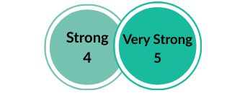
The Programme’s effectiveness is rated strong to very strong. The Australia–World Bank partnership (ABP2+) has proven highly effective in achieving its intended objective of "sharing knowledge and strengthening policies or programs for selected development priorities for Viet Nam, with a particular focus on gender equality". The section below provides detailed justification for this assessment, structured around the evaluation questions set out in the ToR.

3.1 To what extent has the partnership achieved its intended objectives?
ABP2+ has achieved its intended objectives. The partnership has been effective in influencing a set of high-priority reforms and programmes that sit at the centre of Viet Nam’s development agenda, with clear contribution evidenced across all six case studies. Across themes, the evaluation finds a consistent pattern: where ABP2+ support was pulled in by Government demand, delivered credible technical inputs, and timed to real windows, it helped shape reform choices and strengthen programme design in tangible ways. The summaries below highlight specific contribution pathways and evidence of influence, with the full case studies presented in the Annex.
Revisions to the Social Insurance Law No.41/2024/QH15
Findings demonstrate that the Programme had a substantive and traceable influence on the revisions made to the social insurance law. The evaluation found that the World Bank’s approach was strategic, aligning technical assistance to National Assembly drafting windows and sustaining engagement over multiple years in a way that kept reform momentum alive as political appetite strengthened. This sequencing proved important. ABP2+ analytical work, simulations and analytical briefs supported the fiscal and political case for a set of priority provisions that were adopted in June 2024. These included expanded mandatory coverage, improved benefits under the voluntary scheme (including maternity), stronger integration between voluntary and compulsory systems, the pre-pension transitional subsidy, and measures to reduce early lump-sum withdrawals. The uptake of this support was publicly recognised by Viet Nam Social Security (VSS), which described the World Bank as a key partner in strengthening social and health insurance policy implementation. This institutional acknowledgement, alongside the close alignment between ABP2+ recommendations and the reforms enacted in the final Law, indicates a strong and traceable contribution to this legislative outcome.

National Childcare Scheme on Improving the Quality of Care and Education for Children of Workers Vision to 2045)
While the Scheme was Government-initiated and Government-led, findings confirm that ABP2+ played an important supporting role at a key turning point in the process, when MOET shifted from broad intent to detailing a national design. ABP2+ inputs brought in international lessons, options and implementation experience that strengthened the technical rigour and practical feasibility of the Scheme. Interviewees highlighted the timeliness and responsiveness of this support, and noted that the analytical work was formally integrated into the final proposal. As one GoV counterpart explained, “They enriched our understanding with practical evidence and experiences, which we integrated into our proposal.” (GoV 1). Overall, the case provides evidence that ABP2+ contributed to advancing the childcare agenda from a concept to an adopted national programme framework.

The Design and Shaping of MERIT
Findings confirmed that ABP2+ was effective in shaping the Mekong Delta Climate Resilient and Integrated Transformation Project (MERIT) into an integrated, inter-regional programme design that Government counterparts could advance as a major resilience investment for the Delta. While MERIT was Government-led, ABP2+ resourcing enabled the World Bank team to provide sustained technical guidance and consultations during the design window, and these inputs were used by counterparts to strengthen MERIT’s core programme logic. In practice, ABP2+ influence was most visible in three areas highlighted in the case study: (i) supporting a more coherent inter-provincial design by linking provincial priorities into a unified regional approach; (ii) strengthening the investment rationale and ODA justification for MERIT; and (iii) embedding livelihood transformation and private-sector engagement alongside infrastructure as central elements of the programme rather than add-ons. A provincial representative was explicit about the contribution and its importance for the final design: “Without the World Bank’s support, the design of MERIT would not have been possible… [they] helped us draft the proposals and build our capacity to design MERIT.” (GoV 3). Overall, the findings provide clear evidence that ABP2+ shaped how the MERIT was designed and positioned for implementation.

Low Carbon Infrastructure Development: E-mobility
Triangulation of evidence from the e-mobility case study confirms that ABP2+ made a direct and attributable contribution to the development of Viet Nam’s E-Mobility Roadmap and the regulatory reforms that followed. This influence is reflected in the way ABP2-supported recommendations were carried through into subsequent legal and regulationinstruments, including Circular 54/2025/TT-BGTVT, Decision 768/QD-TTg, Decree 51/2025/ND-CP, and Decree 05/2025/ND-CP. ABP2+ combined high-quality modelling with inclusive convening platforms that created space for decision-makers to engage with evidence, align priorities, and work through feasible transition pathways. Government counterparts confirmed that these dialogues supported the translation of technical analysis into concrete decisions, ensuring that the Roadmap was technically sound and actionable. ABP2+ shaped both the content of the Roadmap and the reform pathway that the Government has since adopted.

Digital Transformation: Ho Chi Minh City (HCMC) Data Governance Strategy
While the Data Governance Strategy was driven by HCMC’s own digital transformation agenda and aligned with national priorities, the evaluation finds that ABP2+ made an attributable contribution to how the Strategy was developed, adopted, and operationalised. ABP2+ support provided technical drafting inputs, practical international examples, and targeted capacity strengthening that counterparts used to directly shape the Strategy’s content and implementation approach. The Programme’s effectiveness stemmed from combining this technical support with facilitation and relationship management, which enabled city authorities to translate global good practice into locally applicable, city-level solutions. The establishment of the Data Administration Guidelines, the creation of the DXCentre, and the design of the citizen-facing data application all demonstrate ABP2+’s support to decision making process intent and operational reform. By piloting a subnational data governance model that informed two national strategies later approved by the Prime Minister, ABP2+ achieved impact beyond the HCMC and contributed to Viet Nam’s broader digital transformation agenda.

Economic Management and Growth: Revisions to the Public Investment Law (No.69/2025QH1
ABP2+ contributed to revisions adopted under the Public Investment Law (No. 69/2025/QH15) by enabling technical inputs and sustained dialogue on public investment quality as a constraint to productivity growth. Interview evidence confirms that these inputs were used to strengthen the substance of the amendments. As one Government counterpart noted, “Vietnamese government officials hold the work undertaken [especially] by the World Bank in high regard… contributing to the enhancement of Vietnamese legislation.” (GoV 6). The case therefore indicates ABP2+ added substantive value to institutional reform central to Viet Nam’s growth agenda.

3.2 What changes could be made to ensure objectives are met?
The evaluation finds that ABP2+ has already delivered strongly against its intended objectives, and that any changes for future phases should focus on consolidating existing strengths rather than addressing fundamental weaknesses. Across themes, effectiveness has been driven by a combination of (i) deep technical trust between GoV and the World Bank, (ii) long-term Vietnamese expertise and relationships that make advice politically usable, and (iii) flexible resourcing that allows high-quality inputs to align with genuine reform opportunities. To sustain this success, future phases would benefit from keeping each pillar tightly focused on a small number of high-traction reforms with clear pathways to uptake, rather than expanding scope in ways that dilute coherence and leverage. Sharper prioritisation and scoping at design stage would help ensure ABP2+ resources remain concentrated where the partnership is most likely to shape decision making process and programme outcomes.
An area where targeted changes could strengthen effectiveness is the mainstreaming of GEDSI across the portfolio. While the World Bank’s Progress Review highlights mainstreaming successes - such as gender inputs into VN2045 work, workforce development studies, and support to investment projects - the evaluation finds that mainstreaming has been less consistent in some pillars, particularly the Digital and Economic themes, where gender is not always treated as a core performance driver. To strengthen effectiveness in future phasis, the Evaluation recommends (i) making GEDSI integration an explicit expectation for all pillar leads, (ii) ensuring gender specialists are engaged at the earliest concept and design stages rather than mainly at later review points, and (iii) allocating dedicated time and budget within each pillar for mainstreaming work. These measures would help embed gender considerations upstream in reform-facing activities and increase the likelihood that GEDSI objectives are achieved consistently across the Programme.

4. Efficiency

The Programme’s efficiency is rated as strong. The evaluation finds that ABP2+ has made effective use of financial, technical, and human resources to deliver results, particularly by leveraging the World Bank’s convening power, analytical capacity, and long-term engagement with Government. The partnership’s modality – anchored in flexible, upstream technical assistance – has enabled Australian funding to achieve disproportionate influence relative to its scale, particularly in shaping high-impact strategic guidelines and regulatory reforms. However, the evaluation also identifies opportunities to further strengthen efficiency through sharper prioritisation, clearer governance signals, and more systematic performance monitoring, particularly as the programme has expanded in scope over time.

4.1 How effective was the Programme in terms of funding arrangement, governance structure, modality of support, and approach in supporting the activities?

ABP2+ trust-fund resources have been used efficiently and strategically to provide advisory and technical support to the GoV that have translated into high-value reforms and lending pipelines. Case studies demonstrate clear leverage: ABP2+funded simulations and guidelines informed five adopted provisions in the 2024 Social Insurance Law; VN2045 analyses and dialogues supported adoption of four out of five recommendations in the 2025 Public Investment Law; and Mekong ASA financed through ABP2+ underpinned preparation of MERIT and the wider Delta investment package. In Low-Carbon Infrastructure Development theme, ABP2+ modelling and convening helped shift HCMC away from CNG transitional buses toward full electrification, followed by concrete regulatory updates aligned with Bank recommendations.
A key driver of efficiency is the partnership modality itself. The World Bank’s technical credibility, deep local staffing base, and long-term relationships enable rapid, demand-led contributions inside tight national reform opportunities, reducing transaction costs and avoiding parallel advisory systems. The World Bank’s convening role also supports inter-ministerial and inter-provincial coordination, preventing fragmented planning and rework, as evidence by the co-design of MERIT with the provinces. DFAT’s strategic direction and diplomatic engagement further reinforce efficiency by ensuring ABP2+ analytics complement Australia’s broader programme and avoid duplication.
Nonetheless, efficiency has at times been constrained by intermittent coordination and information-sharing lapses. Limited early visibility over some activities – notably in the Low-Carbon Infrastructure Development theme – reduced opportunities for joint sequencing. Vertical communication gaps and weak cross-theme integration have also limited economies of scope for GEDSI and digital mainstreaming. Additionally, uneven governance clarity contributed to slower drawdown in some components, increasing the risk of under-utilisation before programme close. Strengthening joint planning processes and transparency at both management and pillar levels would preserve flexibility while improving sequencing and partner alignment.

4.2 How does the partnership modality efficiently help to leverage the World Bank’s lending portfolio in Viet Nam since 2020?
Notwithstanding, the areas for improvement in efficiency, overall, the World Bank–Australia partnership is functioning efficiently and should continue. The ABP2 model remains distinctive: unlike a conventional donor–recipient arrangement, DFAT works through the World Bank’s leadership, drawing on its deep understanding of Viet Nam’s context and close alignment with GoV priorities. This substantially reduces transaction costs and duplication, ensures that assistance is embedded in existing Bank–GoV systems, and allows relatively modest trust-fund inputs to generate high leverage—both in shaping major reform guidelines and in informing large lending operations. The World Bank’s technical credibility, access to senior expertise, and ability to respond quickly to short strategic opportunities further strengthen efficiency by ensuring that support is timely, demand-driven, and targeted where it can have the greatest effect.

4.3 To what extent is the partnership modality best suited for future collaboration in the changing context (World Bank trust fund reforms, Australia’s priorities and resources, etc.)?
Looking ahead, the evaluation finds that this modality remains well suited for future collaboration. Its integration with the World Bank’s lending Programme and alignment with GoV reform priorities position it as an efficient and strategic channel for Australian support in a fast-moving policy environment. However, sustaining these efficiency gains will require more consistent joint planning and communication between DFAT and the World Bank to avoid ad hoc activity additions and uneven visibility across themes. Proactive adaptation to forthcoming World Bank trust-fund reforms, alongside Australia’s evolving priorities and resourcing, will also be important to ensure that the partnership continues to deliver strong value for money.

5. Gender Equality and Inclusion
Gender and Disability Inclusion is rated moderate to strong (score 3.5). This reflects solid progress in integrating gender analysis into several key ABP2+ activities and embedding GEDSI across a meaningful share of World Bank operations. At the same time, mainstreaming remains stronger in some themes than others and often depends on committed individuals. Disability inclusion specifically has progressed at a more gradual pace, but is nonetheless becoming integrated more systematically into larger-scale reforms.

5.1 How was gender effectively mainstreamed into ABP2 activities? To what extent has gender mainstreaming been operationalised into ABP2 and World Bank activities?
Gender analysis has been mainstreamed into ABP2+ themes and operationalised in World Bank activities, although progress has been uneven and there remains scope to strengthen cross-pillar integration. Under ABP2+, there have been notable achievements in gender mainstreaming and in operationalising gender within the World Bank’s programme in Viet Nam. Gender-responsive provisions were incorporated into the revised Social Insurance Law (including expanded maternity-related measures), and gender analysis was integrated into VN2045 work, identifying childcare, women’s STEM participation, and gender wage gaps as priorities for inclusive growth. Gender has also been effectively operationalised through the lending portfolio, with gender embedded in 28 WB projects with a combined value of USD 5.4 billion. Illustratively, the Health Services Project strengthened cervical cancer screening and nutrition services for women, while the Southern Waterways Project introduced sex-disaggregated workforce data and promoted women’s participation in tourism-linked employment opportunities.
Despite this progress, mainstreaming is not yet consistent across themes. Interviews conducted with DFAT and WB staff, together with the evaluation’s analysis, indicate that gender integration is strongest where it is explicitly prioritised. More systematic commitment is needed from WB staff outside the Gender team to ensure that gender analysis is consistently incorporated into outputs and activities across the wider programme. Current progress relies too heavily on individual champions, rather than on shared expectations and dedicated resourcing.

5.2 To what extent has the Disability Inclusion been mainstreamed into the WB operations? Has this been appropriately resourced?
Disability inclusion has made moderate progress under ABP2+. The World Bank has clearly resourced this area and delivered concrete outputs, but the overall depth, scale, and visibility of results are still more limited than for gender. On the output side, ABP2+ supported practical improvements such as accessibility upgrades in 464 commune health clinics and district hospitals, including ramps, handrails, and accessible toilets, as well as a community-based care pilot reaching over 1,100 elderly people with severe disabilities. Disability considerations have also been built into pipeline work—for example, through the Sustainable Fisheries Development Project, where universal access principles are being integrated into infrastructure design, backed by technical advice aligned with Circular 06/2024/TT-BXD on universal access in civil works.
That said, progress has been uneven and relatively contained in scale. In part, this is because disability inclusion still depends heavily on a small number of committed champions in the World Bank Inclusion teams and has not yet been consistently driven across pillars or strongly reinforced through management-level expectations. At the same time, where planned pillar activities have moved slowly, the evaluation finds that this largely reflects external constraints rather than internal dynamics and resourcing gaps, notably GoV restructuring and shifting counterpart mandates, which reduced reform bandwidth and delayed engagement. As a result, disability work has so far focused on studies, data assessments, pilots, and targeted technical inputs, with fewer opportunities yet for cross-theme mainstreaming or major uptake in decision making process.

6. Key findings: Challenges and Insights

6.1 Inclusive Development
While all activities broadly fall under the umbrella of Inclusion, the breadth of initiatives has diluted strategic focus, leaving the Theme fragmented and less clearly aligned with DFAT’s priorities. The Inclusion Theme remains a key pillar for DFAT because of its emphasis on GEDSI - an area where Australia can demonstrate technical expertise and supporting decision making process. Nonetheless, during this phase of the Programme, DFAT staff noted increasing fragmentation, particularly questioning the relevance of some Mekong-related activities to the Inclusion Pillar.
Following the shift from the focused Social Development theme: Investing in Viet Nam’s Ethnic Minorities, to the broader Inclusion Theme, components came to encompass poverty analytics, education for ethnic minority groups, livelihoods in the Mekong, and disability inclusion. Each area is connected to partner priorities at a foundational level and can be linked conceptually to Inclusive Social Development, and Australia’s Priorities on Inclusive Development. Yet, in some cases this connection has been relatively shallow, falling short of reflecting the Australian Government’s strategic priorities. Mekong-related initiatives - though contributing to climate-resilient livelihoods - are seen as more appropriately aligned with the Mekong Pillar, rather than with DFAT’s Inclusion objectives. The quote below reflects this perspective:
Clearer alignment of activities with DFAT’s strategic priorities would help sharpen the focus of the Inclusive Development theme and enhance Australia’s visibility. Achieving this will require more active advocacy of priorities not only by Inclusive Development theme team members (on both sides), but also World Bank staff across other relevant pillars.

Despite delays in the disability component, the determination and effective communication of locally based World Bank staff have been instrumental in driving momentum, helping the agenda gain traction and advancing its mainstreaming. Although a higher priority for the Australian Government than the World Bank, the determination of local Bank staff has prevented disability inclusion from slipping off the agenda, despite the challenges caused by Government restructuring. At a time when other stakeholders have struggled to access GoV counterparts, local World Bank staff have managed to sustain engagement – for instance, in enabling data collection for disability accessibility in primary healthcare. This has helped maintain visibility of disability inclusion and demonstrates the critical role of local staff and trusted relationships in advancing DFAT priorities, even where these are not at the top of the GoV’s agenda.

While the Inclusive Development theme has made good progress so far, coordination and communication have sometimes lapsed. During an extended period there was a noticeable decline in regular communication and shared understanding between DFAT and the WB. This was described as a problem of both sides not “keeping the fire.” This partly reflects high staff turnover – a challenge also highlighted in the Australia-World Bank Partnership Health Check 2024 Report. Frequent changes in personnel mean new staff have to try ‘catch up’ while heavy workloads and competing priorities placed additional pressure on the World Bank’s Inclusive Development theme Team Leads and DFAT’s management team.

Nonetheless, while workload and funding constraints clearly contribute to this trend, the evaluators judge that the issue is not solely resource dependent. Even within current constraints, more regular joint monitoring - such as a shared dashboard that is consistently updated - could provide a practical prompt for engagement, helping to restore momentum and effectively “relight the fire.”

6.2 Gender Equality and Women’s Economic Empowerment
Government counterparts commended the quality of reporting and analysis provided by ABP2 within the Gender Theme, noting that these have been important drivers of progress against ABP objectives (Senior Official, MOET). The evaluation identifies two key drivers of this performance: (i) strategic and tenacious engagement, and (ii) the partnership’s ability to mobilise high-calibre national and international specialists.
Strategic and tenacious engagement is evident in the theme’s ability to maintain and expand relationships with Government despite recent restructuring. When MOLISA was dissolved and merged into MOHA, the Theme adapted by broadening partnerships with high-level policy-making bodies at both national and provincial/municipal levels. Engagement with MOET was deepened, new relationships were established within MOHA, and partnerships were extended to the Viet Nam Labour Union and district-level departments (Interview with Gender Theme Leader, PR). These relationships have been crucial for delivering agreed outputs and sustaining reform momentum.
The evaluation finds that the partnership’s engagement on gender has been strengthened by its ability to mobilise high-calibre specialists, particularly where technical credibility and political navigation are both required. Stakeholders pointed to the contribution of the national Gender expert based in Hanoi and embedded within the World Bank Gender Team as a decisive enabling factor.
The evaluation also notes that senior World Bank gender expertise – such as the Washington-based Gender Theme Leader – has added strategic weight and international connectivity to this work. Interview evidence suggests that the combination of national and international specialists has increased both the quality of technical support and the partnership’s standing within DFAT and the World Bank. The program was assessed by both the World Bank and by DFAT Canberra as one of the best examples of the World Bank-Australia partnering and delivering results on gender or women’s economic empowerment
At the same time, gender mainstreaming is an area where performance could be strengthened. While the World Bank’s Progress Review highlights strong results across VN2045 work, workforce development studies, and technical support to many investment projects, DFAT expressed a more cautious view. They noted that mainstreaming remains uneven across the partnership and is weaker in some pillars, particularly Digital and Economic Management. From an evaluation perspective, this points to a structural issue: gender is not yet consistently treated as a shared responsibility across other theme’s Team Leads, and gender specialists are not always engaged early enough to shape activity design and sequencing. This issue was raised repeatedly in annual partnership reviews, indicating a persistent rather than incidental gap. Addressing it will require clearer expectations for all theme Team Leads, alongside dedicated financial and human resourcing to support early and routine integration.

6.3 Climate Resilience in the Mekong Delta
The evaluation finds that the Mekong Theme’s engagement approach—working closely with Government counterparts and cultivating reform champions—has been highly effective in achieving ABP objectives. The MERIT loan, currently under preparation and valued at approximately US$500 million, represents a particularly significant achievement. The evaluators assess that securing a loan of this scale has been possible because of the WB’s long-term relationships with the Government and its sustained effort to co-create solutions, provide technical support, and build institutional capacity.
Discussions with Government counterparts confirm that this effort is recognised and highly valued. As one provincial representative explained:
“Without the World Bank’s support, the design of MERIT would have been fragmented and less comprehensive. With their technical support, we could prepare a strong proposal and coordinate between the central and provincial levels. This capacity building was indispensable. I coordinated directly with WB colleague, and her technical support and guidance were crucial in helping us draft the proposals and build our capacity to design MERIT.” – (GoV 3)
The evaluation interprets this testimony as illustrating how personal relationships built by the World Bank, combined with its technical expertise, have been central to MERIT’s progress. These relationships not only underpin the pipeline of large-scale investment loans but also ensure the Government sees the World Bank and DFAT as trusted long-term partners in implementing transformative reforms.
A further key strength is the Mekong Theme’s unique convening power, particularly its ability to bridge central and provincial government. As one stakeholder noted, “Without the World Bank’s cooperation, it’s not easy for us to coordinate between the proposals of the central level and the provincial level.” DFAT similarly observed that “the World Bank can get all the ministries and provinces around the table in a way that others can’t” (DFAT 7). The evaluation considers this bridging function a clear comparative advantage in the Delta context, where integrated planning and joint ownership are prerequisites for climate resilience investments.
Despite high relevance, the evaluation finds that opportunities have been missed to integrate more gender-responsive analysis into Mekong analytical and advisory work. Stakeholders noted on GEDSI that, while the World Bank recognises its importance, integration into the Mekong Theme remains weak.
There is scope to deepen the GEDSI contribution by complementing existing analytical work with more practical support for provinces. Stakeholders suggested that clearer examples, guidance, or tools on how to incorporate gender and social inclusion into climate investment design would help translate commitments into more consistent practice. Strengthening the analytical base on GEDSI in Delta-specific contexts would also support this shift.

6.4 Low Carbon Infrastructure Development
While full-scale implementation is still underway, there is clear evidence that ABP2 has already supported government planning and decision-making. The e-mobility roadmap and transport resilience recommendations were integrated into internal drafts of sectoral planning documents, demonstrating direct use of World Bank analysis.
Concrete examples of influence include the decision to shift Ho Chi Minh City’s urban transport strategy away from compressed natural gas buses toward full electrification. Government stakeholders attributed this change to both the technical evidence provided and the consensus-building environment created through ABP2 workshops. Similarly, the inland waterway freight paper informed the Ministry of Transport’s analysis of modal shift options, and climate resilience issues raised by the World Bank have been discussed at cabinet-level infrastructure planning meetings.
The World Bank’s impact stems from its combination of technical expertise and convening power, which has enabled coordinated decision-making across ministries and development partners. Government representatives emphasised the high quality and relevance of the Bank’s technical advice, noting that strong relationships between local World Bank staff and line ministries - along with direct access to senior decision-makers - have strengthened the credibility, uptake, and political feasibility of recommendations. This trusted relationship was widely seen as a key factor in ensuring that the recommendations were technical sound and actionable in the GoV’s decision making context.
At the same time, findings indicate some challenges in adapting quickly to Viet Nam’s fast-changing priorities. Several stakeholders suggested that setting aside a portion of the budget for rapid-response activities could improve the Programme’s ability to meet urgent requests as they arise. The evaluation notes, however, that both Government and World Bank counterparts highlighted procedural and approval requirements on each side as a practical constraint, limiting how easily resources can be reallocated in practice.

6.5 Digital Transformation
Interview evidence demonstrates that ABP2 has driven tangible, visible reforms in HCMC. The DXCentre became fully operational in 2024, providing a centralised platform to coordinate digital transformation across all 22 districts and Thu Duc City. Additionally, practical tools—including a city-wide dashboard and a mobile application linking residents to services and real-time flood information—have improved public service delivery and citizen engagement.
The Programme’s training and technical support reached more than eighty senior officials, equipping them with skills in data integration, GIS, and digital planning. These efforts improved institutional capacity and fostered a shared vision for reform. Targeted interventions also helped identify and cultivate internal champions, who have been instrumental in sustaining momentum and expanding adoption across departments.
At the national level, ABP2’s work ensured that local innovation informed central decision making. Government officials confirmed that two national data strategies approved by the Prime Minister in mid-2025 drew an estimated 60–65 percent of their content directly from the HCMC model developed with World Bank support. For the evaluation team, this represents more than technical replication: it is evidence that ABP2 helped position HCMC as a national “proof of concept,” consistent with the Bank’s approach of piloting subnational reforms to inform national frameworks.
From an efficiency perspective, ABP2 avoided duplication by coordinating closely with other development partners and aligning support with Viet Nam’s national strategies. The World Bank’s role as an intermediary between city-level and central authorities was repeatedly highlighted by DFAT and Government stakeholders as critical in ensuring coherence across levels of government. This role combined technical expertise with convening power: local World Bank staff and consultants provided hands-on support to adapt policies and tools to Viet Nam’s specific context, while the Bank leveraged its partnership with DFAT to facilitate international exchanges—such as the Australia study visit—that strengthened institutional capacity and political support for reforms.

6.6 Economic Management
Formulation of the Concept Note for the Economics team took longer than anticipated. While the World Bank sought a GoV-led process, engagement with the Viet Nam Institute for Development Strategies (VIDS) under the Ministry of Planning and Investment (MPI) proved slow and resource-intensive. Ultimately, the World Bank assumed a stronger analytical role, guided by GoV feedback – a pragmatic approach in a context where officials face significant delivery pressures.
Throughout the ABP2+ period, the World Bank team has been proactive to disseminate research findings to decision makers and key stakeholders. The team convened five workshops and seminars, hosted three High-Level Events, produced three communication products, and published two briefs. While precise attribution is challenging, the evaluation concludes that the combination of rigorous analysis and active dissemination has had a meaningful influence on reform outcomes, consistent with the Bank’s role in sharing global economic good practice. Public Investment Law case study illustrates how this approach supported “game-changing” reforms aligned with Party-led priorities.

7. Understanding the Australia-World Bank Partnership ‘Model’
This chapter explains why the Australia-World Bank partnership provides value to Australia that is not always captured by conventional OECD-DAC criteria. It first outlines the underlying governance and reform challenge faced by development partners in Viet Nam. It then compares how this challenge is addressed through the World Bank partnership modality versus a more conventional management-firm approach, before highlighting additional benefits DFAT derives from the relationship and implications for future trust-fund management.

7.1 The governance and challenges
Through ABP2+ and Australia’s wider development cooperation, Australia supports Viet Nam to advance institutional strengthening and policy reforms that are aligned with Viet Nam’s own development priorities and evolving international good practice. ABP2+ is one mechanism within a wider suite of Australian support modalities, including multilateral partnerships, bilateral programming, and other channels - to contribute to Viet Nam’s reform agenda.

A central challenge in governance and reform support is that donor-financed inputs do not automatically translate into sustained outcomes. Unlike sectors where outputs lead predictably to outcomes, governance reforms depend on genuine domestic political traction, institutional readiness, and decisions taken by Vietnamese counterparts over time. This is not unique to ABP2+; it is a defining feature of governance-oriented development assistance in general.

Assessing the likelihood of reform therefore requires careful judgement about “determination for change”. It is rarely sufficient to rely on a single public statement or the views of one senior leader. While such evidence may establish relevance, governments routinely articulate extensive reform agendas, many elements of which are never implemented.

Figure 3 illustrates this pathway. It shows that while development partners can support evidence generation, technical dialogue, and implementation support, the step from outputs to outcomes is ultimately driven by Vietnamese decisions and timing. As a result, limited uptake or delayed reform cannot be interpreted solely as delivery underperformance. Instead, the focus should be on whether the chosen approach is appropriate for identifying credible reform opportunities, engaging at the right moment, and sustaining engagement until traction emerges.

A key implication of Figure 3 is that, in the governance sphere, those responsible for implementing activities and delivering outputs cannot reasonably be “blamed” if Vietnamese counterparts decide not to produce - or to delay - the intended outcomes. Yet without outcomes, there can be no impact, raising fundamental questions about what relevance, efficiency, effectiveness, and sustainability ultimately mean in this context.

It is therefore reasonable to expect that many governance investments will not yield outcomes, particularly in the short term. Even in the private sector, approximately 30 per cent of start-ups fail within their first two years. Accordingly, if outcomes and impacts are the objective, what becomes critical is the approach – the “model” – through which governance interventions are designed, sequenced, and delivered.

Figure 3: Governance Interventions explained.

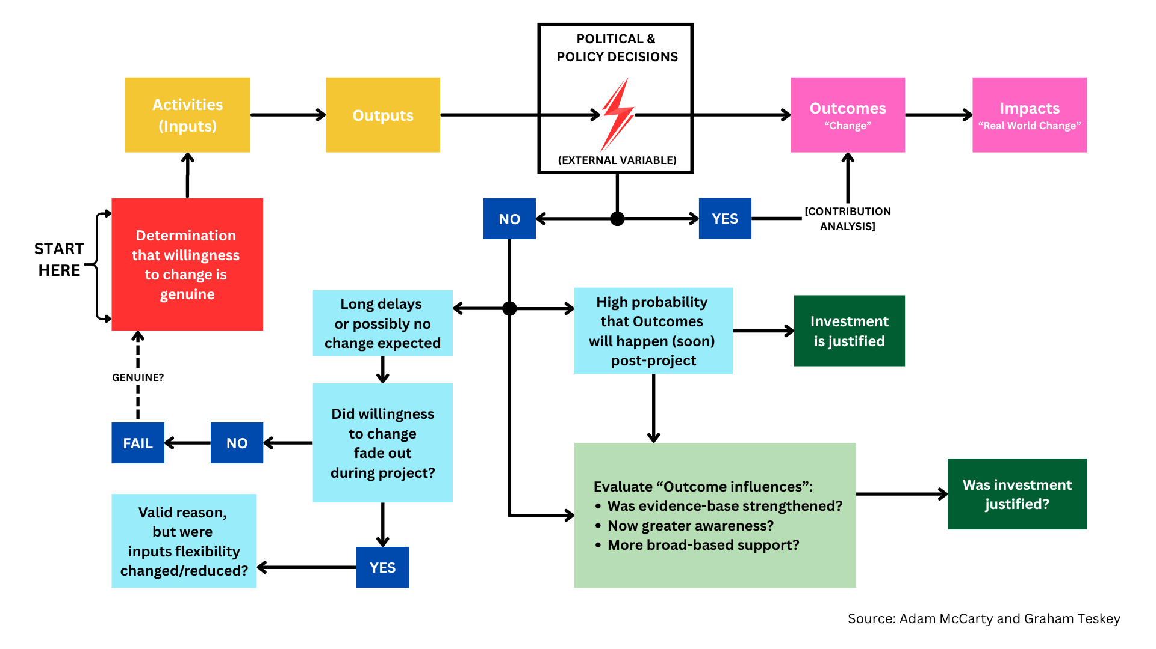

7.2 The World Bank model of supporting reforms
In 1996, the World Bank declared its ambition to become a “Knowledge Bank,” and it now holds a leading position in providing a comprehensive suite of analytical and knowledge services to developing countries. UNDP and other UN agencies, along with the regional development banks (e.g., the ADB), complement this expertise; however, with a staff of more than 12,000, the World Bank remains the most comprehensive provider of objective analysis and advisory services at scale. By contrast, the EU and most bilateral donors, with some exceptions, tend instead to operate through management firms that in turn source technical expertise to design governance interventions.

Accordingly, the World Bank occupies a position of considerable strength in both capacity and reputation for delivering high-quality governance analysis and advice. Another notable institutional advantage lies in its country offices, which employ a mix of local and international analytical staff. In particular, the World Bank’s long-term, high-calibre national staff contribute deep contextual knowledge, help build networks of trust within the Government of Viet Nam (GoV), and enable informed judgments about, as one interviewee observed, “where we can shift the needle.”

This “historically informed” capacity reflects institutional memory accumulated over decades of engagement in governance domains: a body of tacit knowledge about how to advance dialogue, how to combine informal and formal advocacy, and how to interpret the political economy. As illustrated in Figure 4 illustrates, these strengths shape how the World Bank approaches governance and reform: advice is anchored in long-run engagement, framed in ways that are usable in Viet Nam’s institutional context, and delivered through channels that government counterparts already rely upon.

Figure 4. The World Bank Approach to Governance Interventions
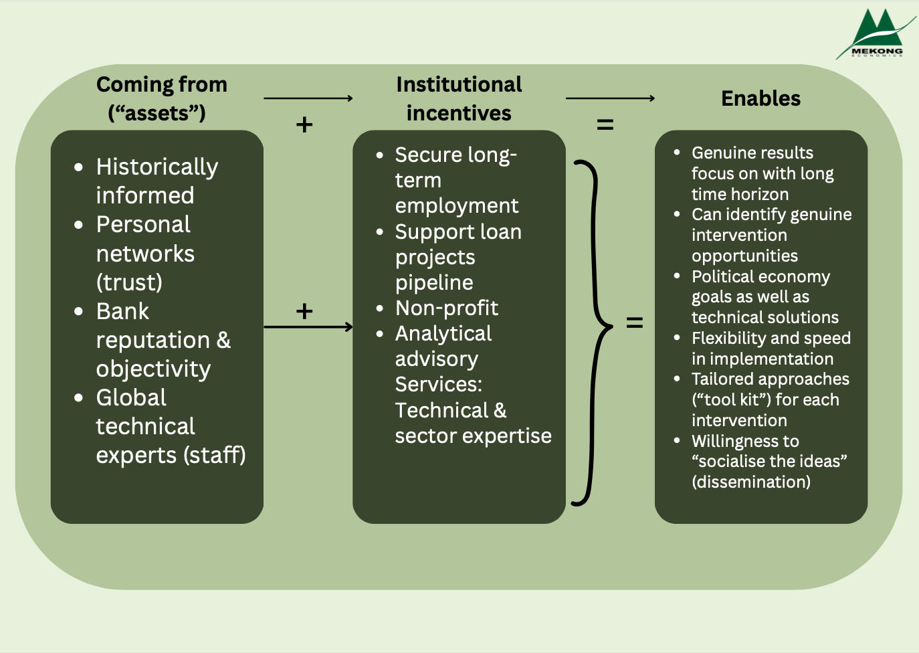

World Bank staff operate within a non-profit institutional setting with relatively high employment security, which allows them to focus primarily on results rather than contract renewal. Some performance pressures nevertheless exist: analytical staff are expected to contribute to the development of a pipeline of loan projects and must prepare Concept Papers to justify funding. Once a Concept Paper is approved, however, staff are allocated a budget to execute rather than to minimise. Bank staff not only manage projects, but also serve as the principal technical and sectoral experts (based in-country or in Washington), drawing on external consultants where relevant. They are required to report on completed activities, and outputs are subject to quality assurance processes and are typically made public. Beyond these considerations, staff can focus primarily on results—namely, their contributions to change.

These institutional features facilitate the identification of genuine opportunities for governance interventions, which can then be pursued with minimal distraction and a sustained focus on results. In this context, inputs can remain flexible, and responses can be rapid. For example, if a Government of Viet Nam (GoV) Deputy Prime Minister requests inputs by telephone, the approval and initiation of delivery may require only a single, brief meeting. Interviews with Bank staff, together with the case studies cited above, provided numerous examples of activities being adjusted as circumstances evolved on the ground. This flexibility operates across the board, encompassing both minor adaptations - such as on-call assistance - and shifts in the sequencing of advocacy efforts: “we decided not to push too much about the Just Energy Transition Partnership” and that “we decided to wait for the Party Congress before getting back to Regional Masterplans.” Flexibility is also evident at the project level, including decisions to scale back work on important issues such as Banking Sector Supervision when returns - in terms of regulatory outcomes - have proven minimal.

A context-sensitive understanding of Viet Nam’s governance environment and established institutional practices also supports more tailored approaches to reform opportunities. These may combine engagement at senior levels (e.g., visits by Bank Vice Presidents and high-profile events) with more discreet, demand-driven support at technical levels (e.g., ad hoc assistance provided without prominent Bank branding), alongside a multi-channel strategy for encouraging change. Considerable emphasis is also placed on disseminating core messages from analytical reports through a wide range of platforms, including university lectures, workshops, Chambers of Commerce, and media engagements. As one Bank interviewee noted, “it is important to socialise the ideas.”

Figure 5: The Private Management Firm approach to Governance Interventions
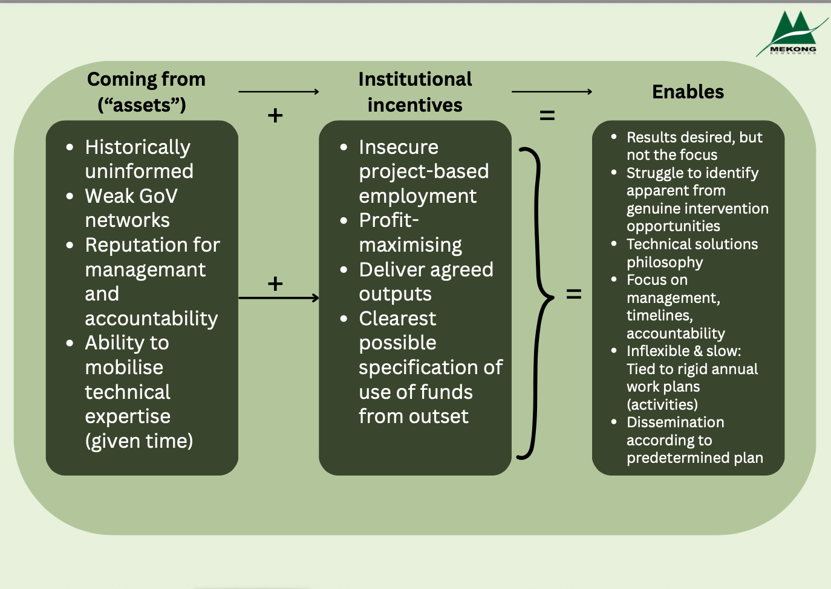

As shown in Figure 5, this model differs from a more conventional project-contracting approach in that it relies less on rigid upfront specification and more on sustained relationship- driven engagement throughout the reform process. Management-firm models typically incentivise detailed planning at the outset, prioritising adherence to timelines, predictable disbursement, and compliance with contractual deliverables. While well suited to sectors such as infrastructure, this approach is less effective for governance and institutional reform, where progress is typically non-linear and requires adaptive engagement.

In this sense, “doing governance” requires precisely the institutional assets and incentive structures that the World Bank offers. This informed and trusted approach is particularly important in contemporary Viet Nam. Traditional models that rely heavily on short-term international experts are facing increasing constraints, with sensitivity to foreign influence increasing – even as “learning from international experience” remains encouraged. By contrast, the World Bank is routinely trusted to sign non-disclosure agreements, is invited into closed-door discussions of draft regulations, and can deliver expert input to reform champions within days or weeks. With the GoV counterparts facing intense pressure to deliver rapid reforms, it may be timely to rethink and refine traditional models of contracting and delivering governance assistance in Viet Nam, particularly where Australia seeks to influence complex policy reforms in fast-moving political environments.

8. Conclusion and Recommendations
The Evaluation Team concludes that the Australia–World Bank partnership is performing strongly. The ABP2+ modality provides a high-impact and mutually beneficial channel for Australian support in Viet Nam. It enables the World Bank to deliver sustained policy engagement, technical assistance, and dissemination at a scale and level of influence that would be difficult to achieve through stand-alone project financing. At the same time, DFAT experiences a strong return on investment, particularly in comparison to a project-based approach, through its contribution to Viet Nam’s reform agenda and through its influence over the prioritisation of gender equality and inclusion within the World Bank’s country Programme.
Evidence from the six case studies indicates that ABP2+ activities have generated tangible outcomes, with analytical and advisory outputs consistently contributing to reforms, institutional strengthening, and investment pipelines. These results reflect the World Bank’s comparative advantage: long-term relationships with Government counterparts, strong convening power, access to high-quality technical expertise, and a delivery model that is flexible and able to respond quickly to policy windows. Overall, the partnership remains a unique and efficient mechanism for supporting Viet Nam’s reform momentum and should be sustained.
Notwithstanding these strengths, the Evaluation Team identifies areas where the partnership can be refined to maintain or increase impact in any subsequent phase or similar future programming. The recommendations below aim to strengthen relevance, efficiency, and results monitoring while preserving the flexibility that underpins the model’s success.

8.1 Greater alignment on the relevance of activities
To strengthen relevance and reduce delays in future phases, the Evaluation Team recommends two linked actions.
- Streamline the thematic structure:
Subsequent phases should reduce and consolidate pillars to avoid dispersing resources across too many themes. Under ABP2+, some pillars have become broad or fragmented, which has occasionally diluted focus and created differing interpretations of what sits within scope. A smaller number of pillars, with clearer boundaries and objectives, would sharpen thematic coherence, strengthen advocacy, and improve efficiency by concentrating expertise and budgets where traction is highest. Consolidation should be guided by (i) strongest alignment with GoV priorities, (ii) clear linkage to the World Bank’s lending and reform Programme, and (iii) DFAT’s strategic priorities. Importantly, streamlining pillars should not be treated as a proxy for reducing resourcing; rather, it is intended to increase the depth and strategic concentration of support within fewer, better-resourced areas.
- Strengthen joint prioritisation and feasibility assessment at concept note stage
Introduce more comprehensive and collaborative discussions between DFAT and the World Bank before pillar- and activity-level concept notes are finalised. These early discussions should:
- agree on priority activities for the year/phase;
- test feasibility in the prevailing political and institutional context;
- confirm how activities align with DFAT and GoV priorities (including GEDSI and disability where relevant)
Embedding joint prioritisation earlier in the cycle would reduce the likelihood of ad hoc additions later, clarify expectations for both partners, and improve relevance in practice while lowering the need for corrective management.

8.2 Ensure adequate resourcing for any subsequent phase, including required staffing capacity
The Evaluation Team recommends that subsequent phases maintain an adequate overall funding envelope, even if the number of pillars is reduced, so that remaining themes are properly resourced and able to respond to policy windows at pace. The evaluation finds that Programme performance relies heavily on the World Bank’s ability to mobilise skilled national and international experts with strong technical expertise, credibility, and established Government relationships. Subsequent phases should therefore:
- Maintain flexible trust-fund resources to allow rapid mobilisation of advisory inputs during reform periods. Viet Nam’s current operating environment continues to move quickly, and the modality’s ability to provide timely, high-quality support is a core efficiency and effectiveness asset.
- Sustain robust national and international expertise within the Bank through close collaboration with Australian counterparts. The integration of national staff possessing in-depth local knowledge and strong government relationships, together with international staff who contribute global experience—including that gained from Australia—will optimise the quality of the work.
- Maintain sufficient human resource to match to the scale of ambition. Each pillar should have a sufficient team composition – covering technical leads, national policy specialists, and technical expertise - linked to the agreed annual workplan and lending pipeline. This will help avoid thinly spread teams and protect delivery quality.

8.3 Strengthen Monitoring, Evaluation, and Learning (MEL)
Subsequent phases should strengthen MEL to better demonstrate outcomes and support adaptive management. The evaluation finds that monitoring across ABP2+ themes has been uneven, with indicators not always updated and reporting standards varying in depth. The partnership should:
- Adopt a harmonised results framework across pillars, with a refreshed indicator set reviewed at least annually. Indicators should track not only outputs (e.g., studies completed, events held) but also outcomes, such as evidence of Government uptake, institutional changes, or linkage to investment preparation.
Introduce common reporting standards and schedules for pillar-level reviews, so performance evidence is consistent and comparable across themes.
- Systematically capture qualitative contribution evidence, including short contribution case studies and periodic feedback from Government counterparts, to document how ABP3 inputs influenced reforms or investment decisions.
- Strengthen cross-theme learning, by using MEL outputs to identify where integration is working (e.g., GEDSI, digital, climate) and where it requires adjustment in subsequent work planning cycles.

Annex 1. List of Stakeholders Interviewed
World Bank
No. | Theme | Name of Stakeholder | Role | Interview Date
1 | Inclusion | Paul Andres Corral Rodas | TTL/Theme Lead | First 09/07/25; second: 03/07/25
2 | Inclusion | Nga Thi An Hoang | TTL | First: 09/07; second: 03/07/25
3 | Inclusion | Nguyen Tam Giang | TTL | 09/07/25
4 | Gender | Helle Buchhave | TTL/Theme Lead | First: 03/07/25; second 15/07/25
5 | Gender | Nguyen Tam Giang | TTL | 03/07/25
6 | Mekong | Phuong Hoang Ai Nguyen | TTL/Theme Lead | First: 05/06/25; second 04/07/25
7 | LCID | Zayra Romo | TTL/Theme Lead | 04/06/25
8 | LCID | Victor Frebault | TTL | 05/06/25
9 | LCID | Bowen Wang | TTL | 24/07/25
9 | Digital | Tran Thi Lan Huong | TTL/Theme Lead | First: 04/06, second: 24/06/25
11 | Economic | Andrea Coppola | TTL/Theme Lead | First: 06/06, second: 24/06/25
12 | Economic | Dorsati Madani | TTL | 06/06/25
13 | Economic | Quyen Hoang Vu | TTL | 24/06/25
14 | N/A | Kathleen A. Wimp | Operations Manager | 12/06/25
15 | N/A | Dung Thi Thuy Dao | Operations Officer | 12/06/25
DFAT

No. | Theme | Name of Stakeholder | Role | Interview Date
1 | N/A | Nguyen Tu-Uyen | Programme Manager | 18/06/2025
2 | Inclusion/Gender | Cathy McWilliam | First Secretary | 05/10/2025 & 16/10/2025
3 | Inclusion | Nguyen Hoai Nam | DFAT Lead | 16/10/2025
4 | Gender | Than Thien Huong | DFAT Lead | 05/10/2025
5 | Gender | Mia Urbano | Team Member | 05/10/2025
6 | Mekong | Madeleine Plocki | DFAT Lead | 12/10/2025
7 | Mekong | Nguyen Thuy Linh | DFAT Team Member | 12/10/2025
8 | Low Carbon | Vu Duc Cong | DFAT Team Member | 05/09/25
9 | Digital Transformation | Cao Thanh Diep | DFAT Team Member | 10/09/25
10 | Economic |  | DFAT Lead | 26/08/2025
The Government of Viet Nam
National Assembly
No. | Theme | Name of Stakeholder | Agency and Title | Interview Date
1 | Gender
2 | Mekong | Vuong Viet Hung | MERIT Project CPMU Deputy Director, MAE | 25/08/2025
3 | Mekong | Nguyen Huu Nghia | Deputy Director, Irrigation Department, DAE | 20/08/2025
4 | LCID | Phuong Hien | President of Transport Development Strategy Institute, MOT | 14/08/2025
5 | Digital | Võ Thị Trung Trinh | Director of HCMC DXC | 11/09/2025
6 | Economic | Vu Duc Quan |  | 08/10/2025

No. | Theme | Name of Stakeholder | Agency and Title | Interview Date
1 | Economic | Vu Danh Hiep |  | 4/09/2025

Annex 2. List of Stakeholders Contacted
Government of Viet Nam (GOV)

No. | Theme | Name of Stakeholder | Agency and Title | Last Contact Date
1 | Inclusion | Pham Truong Giang | Wage and Social Insurance Department - MOHA | 04/10/2025
2 | Inclusion | Tran Thi Thu Tra | VSS Office | 04/10/2025

Annex 3. Inclusive Development Case Study: Revisions to the Social Insurance Law No. 41/2024/QH15
A3.1 Context and Timeline

A country's Social Insurance Law is a crucial component of their social protection system. Viet Nam first enacted a Social Insurance Law in 2006 [71/2006/QH11]. Despite representing a significant legal milestone, its implementation revealed critical limitations in both design and coverage. In pursuit of making the law more comprehensive, in 2014, the National Assembly passed the revised Social Insurance Law (Law No. 58/2014/QH13). However, implementation revealed that there were still significant limitations to the law. These included the law’s inability to reach informal workers and the requirement of 20 years of contributions to qualify for a pension. The GoV acknowledged these shortcomings in 2018, with the issuance of Resolution No. 28-NQ/TW in 2018, which set targets for 2030 including at least 60% of the labour force covered by social insurance, 45% of retirees receiving a pension or social benefit, and 50% of the working-age population enrolled in unemployment insurance. Shortly thereafter, the ABP2 Programme began working to influence revisions to the Social Insurance Law.

The Results Map, below, outlines ABP2’s programmatic activities aimed at informing revisions to the Social Insurance Law and supporting the implementation of Resolution 28-NQ/TW. Since 2018, ABP has been working to improve the provision of Social Insurance. Building on the success of the nationally replicated pilot digital payment initiative funded by APB II, the team has engaged with the social insurance agenda at this critical juncture in the law’s revision process.

From 2019 onward, the World Bank supported a series of analytical studies and simulations to inform rules and regulations design. This included provincial-level simulations of coverage expansion, fiscal modelling of subsidy levels for informal sector participation, and comparative analysis of international practices on lump-sum withdrawal restrictions and incentives for voluntary schemes. These strands of work were deliberately sequenced - first to raise awareness and test feasibility, and then to provide evidence and options for reform - ultimately feeding into the revisions of the Social Insurance Law adopted in June 2024.
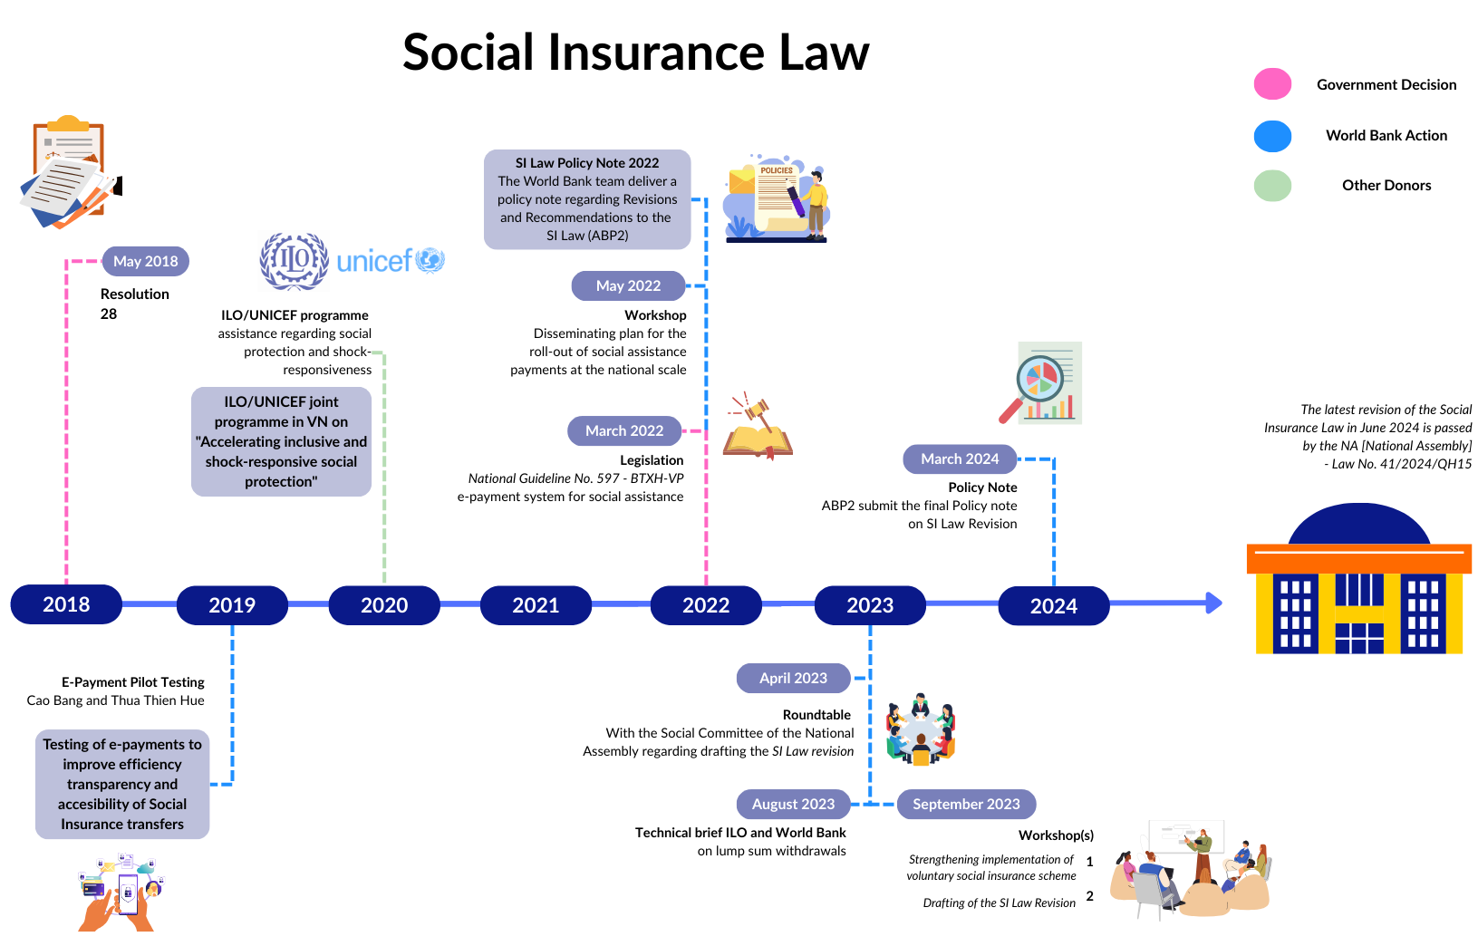
Figure A1. Results Map of revisions to the Social Insurance Law
A3.2 Themes and analysis

Findings indicate that revisions to the Social Insurance Law were led by the strong domestic political commitment for reform. The Revision made to the Law in 2014, and subsequent amendments are the early reflections of this commitment. This momentum then culminated in the issuance of Resolution 28 (2018). However, this does not diminish the World Bank’s influence on the law. As aptly stated by the Theme Leader of the Inclusion Theme: “There would be no traction without the political appetite for reform” (WB1).

The World Bank’s approach is strategic. It aligned technical assistance with the Government's own political will to ensure that the contributions it gives result in transformative change. Revisions to the Law are ‘demand-led’, but the Theme’s attributable impact is clear in the reforms made to the Revisions of the Law.

VSS publicly highlights that the 2024 Law presented 11 key changes:

- Integrated non-contributory pension as a social insurance system
- Introduction of a bridge pension to discourage lumpsum withdrawals
- Expanded mandatory social insurance coverage
- Increased benefits for social insurance participants
- Dedicated chapter on SI collection and contribution compliance
- Introduction of a “reference level” for SI premium contribution
- Base salary floor and ceiling for contributions
- Specific contribution rates for non-salaried positions
- More detailed SI fund investment and management rules
- Simplified administrative procedures
- Stronger integration between voluntary and compulsory schemes

A comparison of the changes made and those recommended in the Final Policy Note the Inclusion Theme issued to MoLISA in 2024 and inputs for the decree 159/2025 on voluntary scheme, show the direct alignment of recommendations the World Bank gave and the reforms to the law in 5 areas:

- Introduced bridge pension - the Inclusion team proposed a monthly allowance for workers not eligible for annuity
- Expanded Mandatory SI coverage - ABP2 used simulations conducted to support recommendations for province-specific expansion strategies.
- Increased benefits for voluntary contributors - The Policy Note advocated maternity benefits in voluntary SI and benefit parity with compulsory SI
- Integration of voluntary and compulsory schemes - ABP2 proposed formula blending income and salary histories for pensions and survivorship benefits.
- Proposed increasing the matching contribution for informal workers participating in the voluntary social insurance scheme to 50%, with the estimated cost calculated as a share of GDP

Additionally, ABP2 also strongly advised against lump sum withdrawals, which although does not prominently feature in public reports, was implemented in the 2024 Law and following implementing decrees (158/2025 and 159/2025).

It is important to note that other external stakeholders outside of the ABP2 programme were also engaged in influencing revisions to the Social Insurance Law. In addition to the WB and Australian Embassy, other stakeholders working in a similar capacity included the International Labour Organisation (ILO). This sometimes makes attribution complex, as multiple actors supported the same reforms. For example, the ILO also focused on lump-sum withdrawal reform, and the World Bank worked with them to produce a joint technical brief to influence policy complimentarily. What the ABP2 theme offers in the reform process is the World Bank’s expertise in technical support, such as fiscal analysis, an area in which it was explained that the World Bank is the historically trusted partner:
“For areas like fiscal analysis, even if UNDP offer this, they go to the World bank, which is historically how it’s done”
- WB 1

The impact that the Theme has had on influencing revisions to the Law is largely attributed to the quality of technical assistance that they can offer the Government. One of the greatest strengths of the ABP2 Programme is its flexibility to hire technical experts and commission targeted analytical studies. In the case of the Social Insurance Law, these included provincial-level simulations of social insurance coverage expansion, fiscal modelling of subsidy options for informal sector participation, and comparative international reviews of lump-sum withdrawal restrictions and voluntary scheme incentives. This capacity allows the Theme to respond rapidly to Government requests and provide convincing, evidence-based recommendations for reforms. Public commendations made by Government agencies reflect the GoV’s esteem and reliance on the technical capabilities the World Bank has at hand. For example, Viet Nam Social Security (VSS) issued the following statement on the changes to the Social Insurance Law:
“The World Bank is a key partner of Viet Nam Social Security in advising on improving social insurance policy implementation…The technical assistance projects provided by WB to VSS have yielded positive results, contributing to the streamlining, modernization, and transparency of social insurance and health insurance policy implementation”
- VSS

The World Bank’s ability to offer this level of strategic technical support is made possible through grant funding under the ABP2 Programme, underscoring the value of continued donor partnership in driving government-led reform. However, attribution goes further than technical assistance. The relationships that the theme has cultivated with ‘reform champions’ has been essential in securing the uptake of the Programme’s recommendations. An inclusion theme team member explained how the theme's close working relationship with government counterparts is not incidental. Although they do not perform stakeholder mapping, their close collaboration with government ministries allows them to seek out and identify advocates for change. These advocates are then influential in convincing the GoV to act on the recommendations made for reform. In this case, team members had a close relationship with the Ministry of Home Affairs (MOHA) who the team explained had a prolific commitment to reform of the Social Insurance Law. Additionally, the team explained that they keep an updated record of government members, so that they can continually update their targets for engagement when positions change. The importance of the close relationships formed in influencing change was emphasised by the Theme leader:

“With the close work that Nga’s team has been doing with specific ministries, it’s clear how essential those relationships are, without them, it’s incredibly difficult to even get a foot in the door. The connection Nga has built over time is clearly collegial and well-established. In a context like this, those kinds of relationships are absolutely crucial”
- WB 1

A3.3 Conclusion
The Inclusive Development Theme is an important Theme for the partnership, being solely focused on addressing issues of Inclusive Development - a key priority for DFAT. A key strength lies in the Theme’s ability to link evidence-based analysis to tangible policy influence, most notably demonstrated through its contribution to revisions of the Social Insurance Law. The flexibility and resourcefulness of the team, particularly in navigating delays caused by government restructuring, highlight its adaptive approach and commitment to sustaining momentum despite external constraints. Strong relationships forged by local World Bank staff with government counterparts have been instrumental in ensuring that disability inclusion and GEDSI priorities remain on the agenda, even when not at the forefront of GoV priorities.
At the same time, the wide scope of initiatives has led to fragmentation, with some activities, particularly Mekong-related work, being only loosely aligned with DFAT’s Inclusive Development priorities. Coordination lapses between DFAT and the World Bank also reduced the consistency of engagement, suggesting the need for more structured mechanisms such as regular monitoring tools or shared dashboards.

Annex 4. Gender Case Study: National Scheme on Improving the Quality of Care and Education for Children of Workers in Areas with Many Employees (2025-2030, Vision to 2045)

A4.1 Context and Timeline

As in other countries, rapid urbanisation and industrialisation in Viet Nam has created a ‘care gap’; in Ho Chi Minh City, pre-school facilities meet only 2% of demand. To address this, the Ministry of Education and Training (MoET) initiated the “Scheme on Improving the Quality of Care and Education for Children of Workers in Areas with Many Employees (2025–2030, Vision to 2045)” in 2023. The Scheme seeks to strengthen regulation, enhance quality assurance, and expand affordable childcare for working families. It has been submitted to the National Assembly and has recently been adopted by the prime minister in November 2025. The Results Map on the next page traces the policy milestones leading to the National Childcare Scheme, starting with Article 137 of the 2019 Labour Code. This legal foundation was reinforced by the 2021 National Strategy on Gender Equality, which elevated childcare to a national policy priority by linking it to women’s workforce participation, leadership, and the reduction of unpaid care work. Building on this momentum, the World Bank’s Urban Care Supply and Demand Study (conceptualised in 2020 to support Labour Code implementation), was reframed at MoET’s request to inform the new Scheme. Subsequent reforms included Circular 24/2023/TT-BGDDT, which strengthened teacher training requirements for ICGs and set quality recognition criteria for subnational authorities. In 2024, the Gender Theme supported MoET in national consultations on the Scheme’s design, covering subsidies, Public-Private Partnership models, and service quality. By mid-2025, the Urban Childcare Supply and Demand Report was drafted - a Decision Meeting was scheduled for November
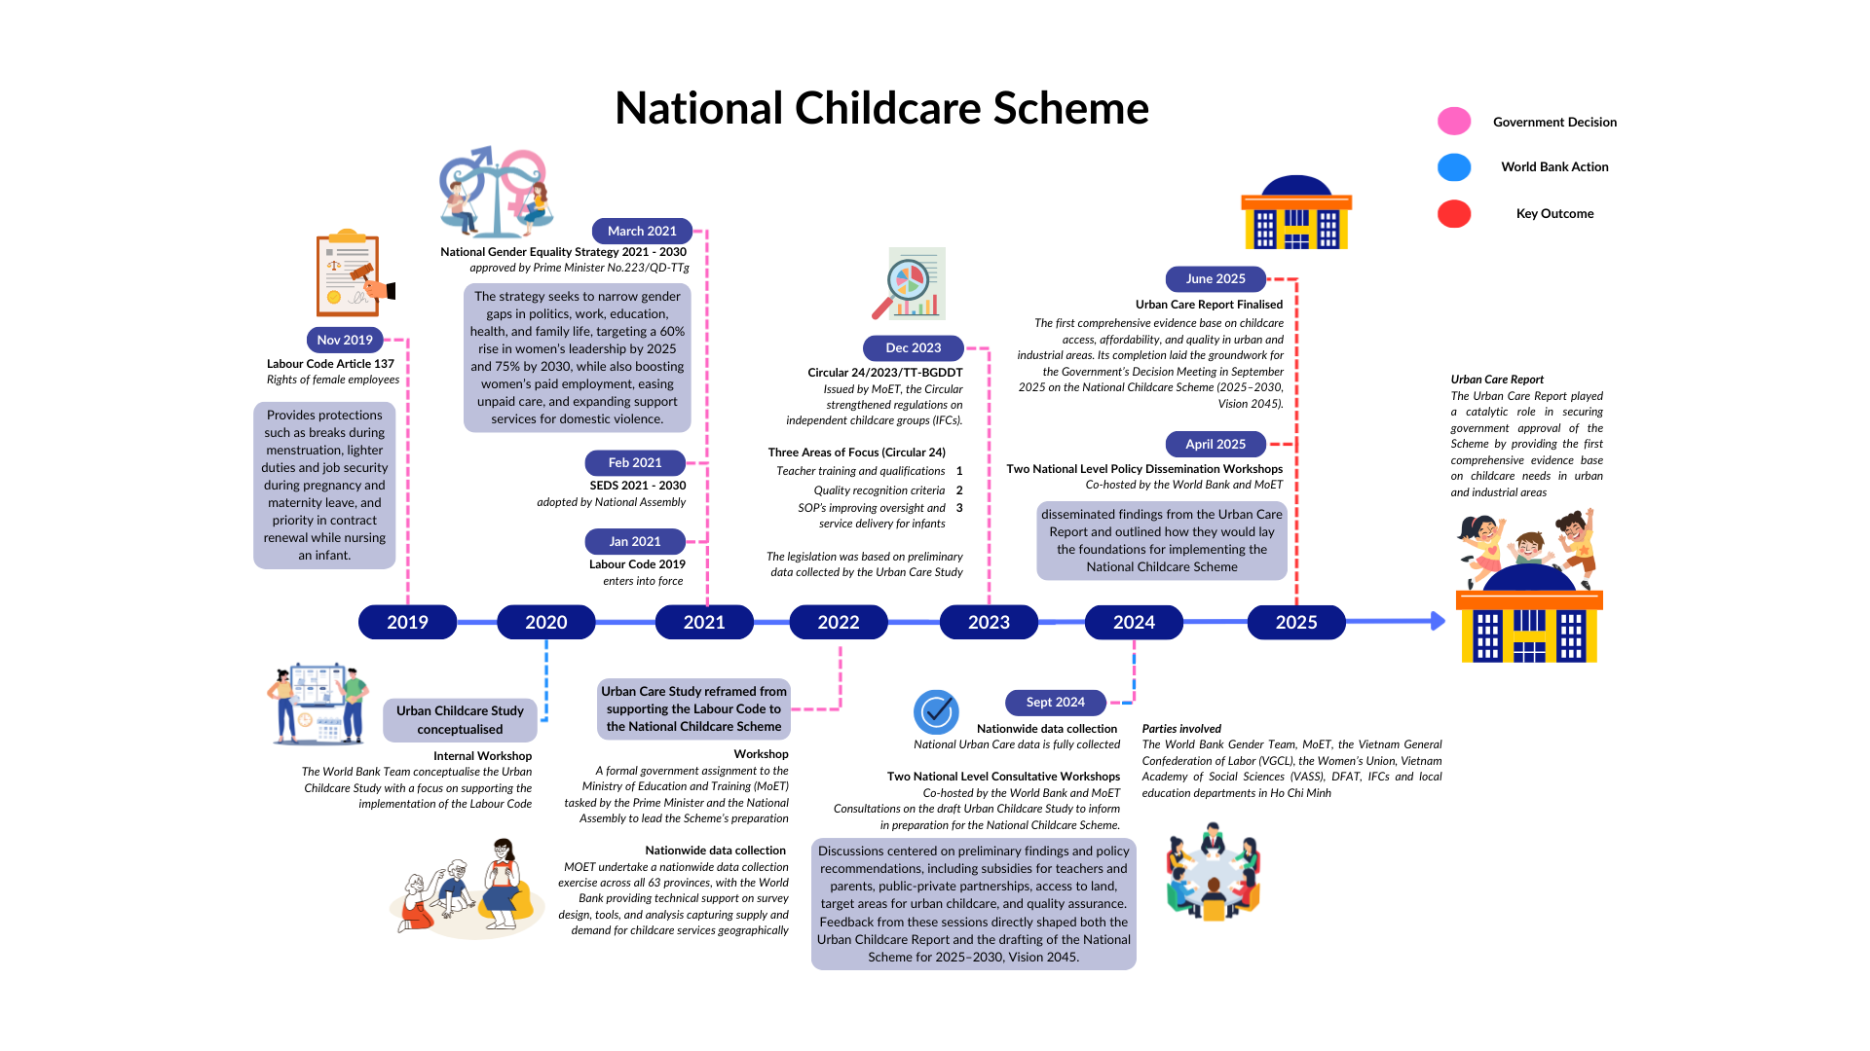
Figure A2. Results Map of the National Childcare Scheme

A4.2. Themes and Analysis

The National Scheme was formally tasked by the Prime Minister and developed under the direction of the Government of Viet Nam (GoV), without engagement from the National Assembly during its preparation. It represents a government-led initiative that was ultimately approved and adopted by the Prime Minister. As a Senior Officer of MOET explained, through repeated meetings with workers, the Prime Minister in collaboration with the Viet Nam General Confederation of Labour, recognised the strong demand for childcare support. In parallel, the National Assembly paid close attention to voters’ opinions. As a result, MOET was formally tasked by both the Prime Minister and the National Assembly to develop the Scheme (GoV 1).

Although findings confirm that the Scheme was government-led, they also demonstrate that ABP2 had a definitive attributable impact. Despite not being able to share the details of specifically what, a senior official at MOET confirmed that recommendations for the scheme made by the World Bank have been formally integrated into the Scheme. They stated:

“They enriched our understanding with practical evidence and experiences, which we integrated into our proposal.”
- GoV 1
One key reason for impact was the World Bank’s role as the Government’s sole technical partner. A senior MOET official explained that this support had been formally requested: “Our leaders formally requested support from the World Bank, such as experts and research reports.” The ability to draw upon world experts, makes the technical studies they provide are highly regarded by GoV. The value of support is emphasised in the following statement:
“The ABP2 Programme provided strong technical support, particularly in deep data analysis on children under 36 months and in reviewing different childcare models. This served as an important foundation for our proposed solutions… Without ABP2 support, we still would have had to develop the proposal, but with fewer technical consultations and weaker evidence. They helped with experts, reports and funding for workshops (e.g., venues and logistics). The World Bank reports presented at MOET were highly valued for the scientific rigour”
- GoV 1
As shown in the quote above, alongside technical assistance, MOET also underscored the value of the consultations that were funded and organised by the ABP2 Programme. The importance of these consultations in shaping the draft of the National Childcare Scheme were recurrently mentioned. It was explained that without the World Bank’s support, MOET would have organised far fewer consultations, whereas ABP2 enabled large-scale workshops with ministries, unions, and local authorities.
The World Bank’s longstanding relationship with the Government, and its flexibility to adjust the Urban Childcare Study at the Government’s request, from originally targeting informing the Labor Code implementation to also providing the evidence base for the Draft Scheme, made the World Bank not only highly trusted, but also flexible and responsive to Government demands. A MOET representative emphasised the appreciated flexibility and responsive of the World Bank:
“Working with the World Bank team has been very positive—they are responsive, supportive, and efficient. We have collaborated for three to four years, and whenever we requested support, they responded promptly.”
- GoV 1

A4.3 Conclusion
MKE finds the Gender Theme to be highly relevant and on track to meet its objectives. A key strength lies in the strong relationships forged with the Government of Viet Nam by national staff and consultants, coupled with the Theme’s flexibility and responsiveness in adapting studies to align with emerging policy windows. When opportunities arise, the team responds to GoV requests, and adjusts work to maximise policy traction and impact, whilst keeping work aligned with the partnership's priorities.
While delays have occurred, stem more from higher-level management processes than from the Theme team itself. This suggests that sustaining momentum should be prioritised earlier in the concept stage. To further mainstream, there needs to be greater commitment of human and financial resources from the World Bank.

Annex 5. Climate Resilience in the Mekong Delta Case Study: The Design and Approval of MERIT

A5.1 Context and Timeline
To address the risks caused by climate change and upstream development, the Government issued Resolution 120/NQ-CP in November 2017, which set the overall direction for sustainable and climate-resilient development of the Delta. In August 2018, the Ministry of Agriculture and Rural Development (MARD) proposed the “Integrated Climate Resilience and Sustainable Livelihood Transformation” project (WB11) through Official Letter 5231/BNN-HTQT, signalling a request for World Bank support to implement Resolution 120.
In February 2022, the Mekong Delta Regional Master Plan (MDRM) was approved under Decision No. 287/QĐ-TTg. This was the first regional plan developed under Resolution 120 and provided a framework for coordinated multi-sector investments. The Plan was launched in Can Tho in June 2022, creating momentum for government and development partner engagement.
From late 2022 to mid-2023, the Government and the World Bank worked together to shape the MERIT Programme. This included Ministry of Public Investment (MPI) feedback on WB11 proposals in October 2022 and the first joint GoV–World Bank mission in June–July 2023. Soon after, the World Bank Country Director Caroline Turk confirmed financial and technical support for MERIT.
In March 2024, the Prime Minister approved MERIT under Decision 233/QĐ-TTg. Following this approval, technical studies were advanced. Draft reports on sediment and erosion were completed in early 2025, and findings were shared at World Bank workshops in Hanoi in March 2025.The Results Map on the next page shows this progression- from Resolution 120 to the approval of MERIT - highlighting the combined steps of government policy, World Bank inputs, and technical work that shaped the Programme
Figure A3. Results Map of design and development of MERIT.
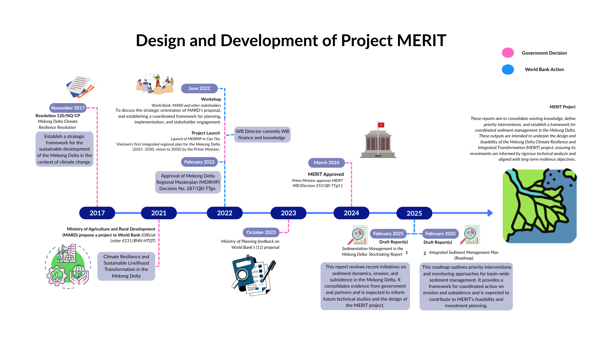
A5.2 Themes and Analysis

MERIT was a government-led initiative, coordinated by central and provincial authorities in the Mekong Delta, and proposed by MAE to secure international funding for climate resilience. Provincial governments had already developed responses to salinity intrusion and freshwater scarcity under Resolution 120’s “in harmony with nature” principle. For instance, in 2021 Sóc Trăng proposed a freshwater reservoir to supply 72.5 million m³ annually, ensuring stable water for 79% of farmland and 63% of its population. Lacking resources to self-fund, the province’s plan gained urgency and legitimacy from MONRE’s 2020 Climate Change Scenario [Official Letter No. 8272, 31/12/2021], which provided scientific justification for integrating such initiatives into MERIT as a coordinated, internationally funded Programme.
Although MERIT was government-led, the World Bank strongly influenced its shaping and design. Both Provincial and Central Government Stakeholders relevant to the MERIT project regarded the World Bank’s contributions highly, particularly in technical design, proposal development, and institutional coordination. Below are the areas where GoV (GoV 2 & GoV 3) mentioned the World Bank’s influence:
- Identified Infrastructure Needs: The World Bank emphasized modern water management (irrigation, retention, supply), climate-smart agriculture, salinity/flood/drought control, river/coastal protection, multimodal transport (esp. inland waterways), and supporting systems such as energy, waste management, and data.
- Enhanced Rationale and Justification: Proposals were required to show a clear theory of change, investment objectives, scale, outcomes, sustainability, and target groups, while aligning with the 2021–2030 Mekong Delta Master Plan and 2050 sector strategies. Close collaboration with provinces supported this. For example, the Deputy Director of Irrigation in Cần Thơ described how direct work with ABP2’s Mekong Theme Team Leader, Ms. Ái Phương, strengthened his understanding of ODA procedures and improved project management capacity.
- Livelihood Transformation: The World Bank recommended embedding livelihood diversification, skills development, financial mechanisms, technology adoption, and private sector engagement alongside infrastructure investments.
- Institutional Coordination: The Mekong WB Team worked with central ministries and provinces to align proposals into a regional framework, while supporting consultations and workshops to ensure local needs matched national strategies.
Without the technical guidance and consultations provided by the ABP2, MERIT would be drastically different. A Provincial Government member stated that: “There would be many differences”. He went on to explain the counterfactual outcome of MERIT, as detailed below:
- The project design would not be integrated at the inter-regional scale for climate change response, but fragmented and uncoordinated across the Delta (due to localism and being spread thin in some provinces).
- There would be a lack of sustainable livelihood models, since ODA funds mainly focus on infrastructure and counterpart funding would reduce activities dedicated to livelihoods. He explained that this would mean that support for vulnerable groups would not be targeted, or strong enough to lead to a ‘breakthrough’ effect.
Findings show that the unique value add of the ABP2 Programme’s contributions to MERIT is multifaceted including technical expertise, coordination, and training support. Through the ASA work funded under ABP2, the World Bank carried out in-depth technical studies on sediment management, erosion, and nature-based solutions that directly informed the design of MERIT investments. ABP2 financing enabled the World Bank to bring in global experts from the Netherlands, US, and UK, ensuring that project proposals rested on strong analytical foundations and international best practices. The World Bank’s longstanding relationships with central ministries and provincial departments in the Mekong Delta and numerous workshops and meetings convened between 2022-2024 ensured that the MERIT emerged as a coordinated and cohesive regional response. Additionally, the training and hands-on support provided to provincial officials under ABP2 built their confidence and capacity in managing ODA projects, especially in areas such as bidding, financial management, and safeguards.
The partnership between Australia and the World Bank added a further unique dimension. Australia’s flexible funding through ABP2 made it possible to incorporate livelihood studies into the MERIT design, a component that government stakeholders repeatedly stressed as vital. Without this partnership, MERIT risked focusing narrowly on infrastructure, overlooking the social and livelihood challenges facing communities. By ensuring that both the technical and social sides of resilience were addressed, the partnership allowed MERIT to respond more fully to the needs of the Mekong Delta as a whole.
When asked about how the project could be improved or what challenges existed, government stakeholders did not raise concerns about ABP2 itself. Instead, their main points related to the World Bank’s loan conditions (Gov 2 & GoV 3). They highlighted the high borrowing costs, which underscores the importance of ABP2’s role in financing technical studies and supporting livelihood and social components that might otherwise be neglected. The only direct criticism was that the World Bank’s procedures remain too bureaucratic, with one stakeholder suggesting they should be simplified and better harmonised with Viet Namese processes.
A5.3 Conclusion
The Mekong Theme has been central in advancing Viet Nam’s climate resilience agenda, with ABP2+ support directly shaping the design of the MERIT project and strengthening coordination between central and provincial levels. Its effectiveness has stemmed from the World Bank’s convening power, trusted relationships, and ability to embed technical expertise into government-led processes. While progress has been strong, greater integration of gender and social dimensions, as well as attention to emerging priorities such as climate finance, if continued for another phase would enhance relevance. Overall, the Theme demonstrates how ABP2+ can translate analysis into major investments, supporting long-term resilience and sustainable livelihoods in the Delta.

Annex 6. Low Carbon Infrastructure Development Case Study: E mobility
A6.1 Context and Timeline
Viet Nam’s commitment to achieving net zero emissions by 2050 has positioned transport emissions as a critical challenge that must be addressed. Senior government stakeholders confirmed that electric mobility is viewed as a cornerstone solution, requiring careful coordination between vehicle deployment, energy demand, and charging infrastructure. Despite these priorities, progress has been slowed by fragmented planning processes, unclear energy demand forecasts, and limited institutional capacity for evidence-based policymaking.
To address these challenges, the Australia–World Bank Partnership Phase 2 (ABP2) provided targeted technical and financial assistance under the Accelerating Low Carbon and Resilient Infrastructure Development (LCID) Programme. Through this initiative, the World Bank worked with the Government of Viet Nam to integrate electric vehicle planning into the national power sector strategy, assess infrastructure requirements, and ensure alignment with broader energy transition goals outlined in Power Development Plan 8 (PDP8).
From 2023 onward, ABP2 facilitated a series of modelling studies, intensive survey-based analyses, and stakeholder workshops. These activities provided a solid evidence base that culminated in the launch of Viet Nam’s first national E-Mobility Roadmap in November 2024. This roadmap set out clear priorities for urban bus electrification and the development of sustainable charging infrastructure across major cities.

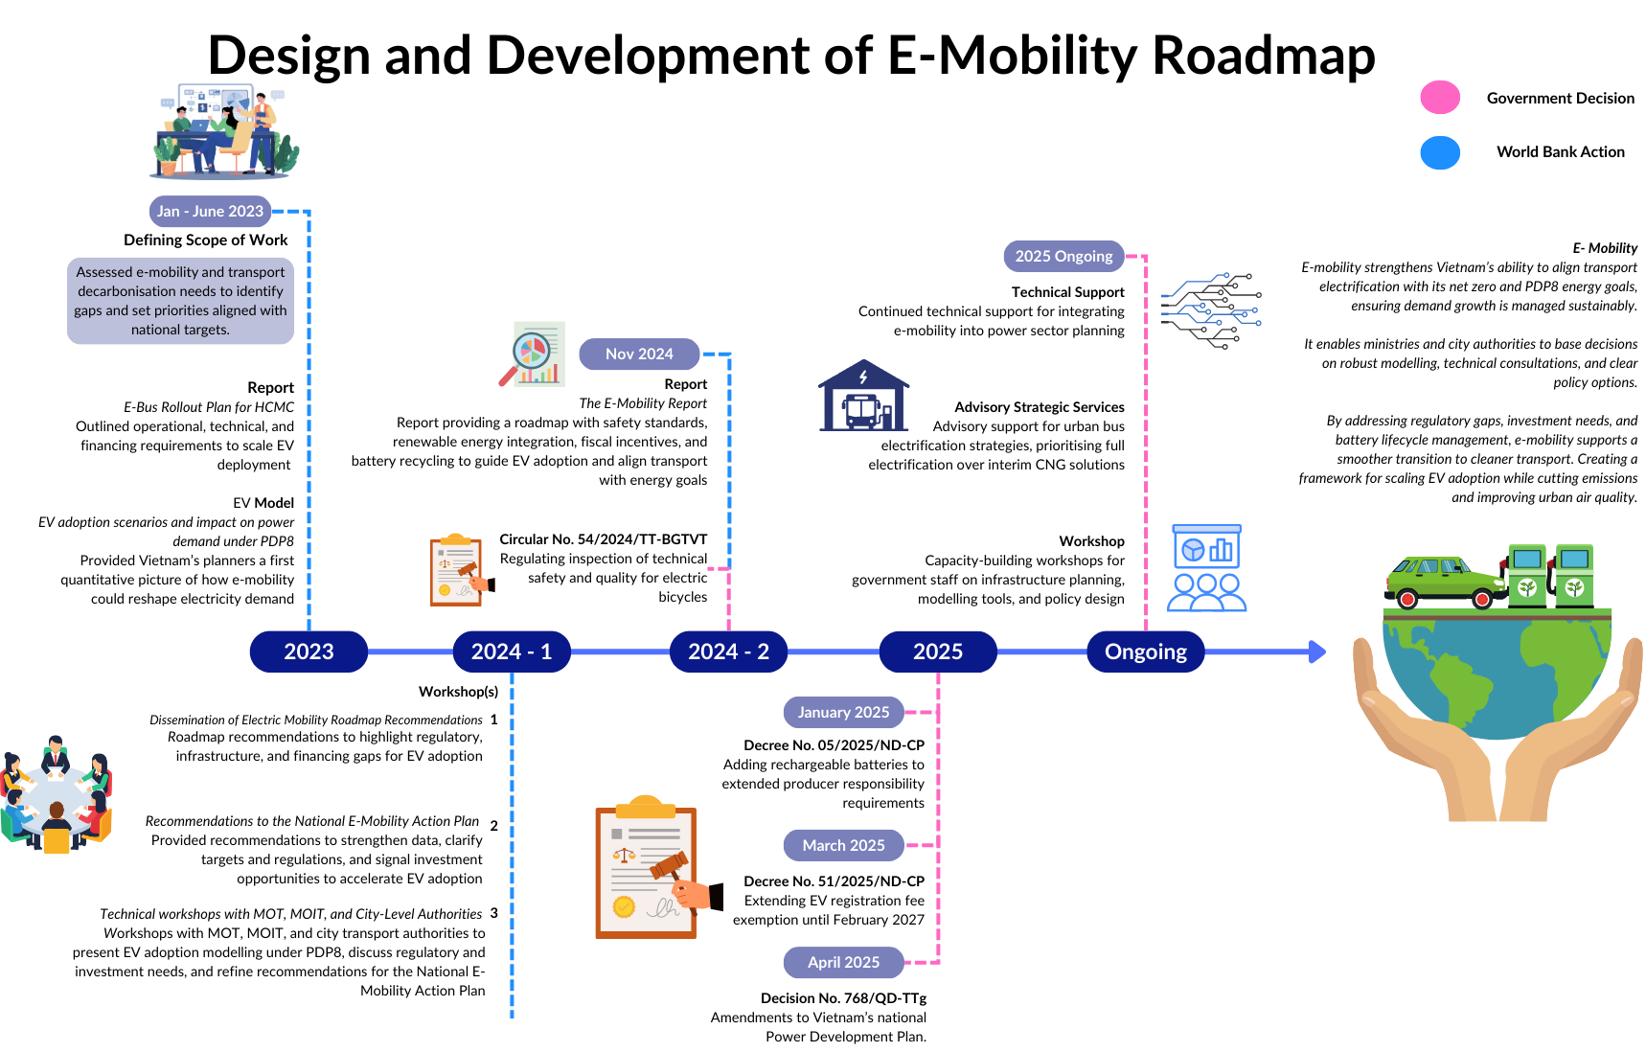
Figure A4. Results map for E-mobility
A6.2 Themes and Analysis
The World Bank’s support was consistently described by government stakeholders as both highly relevant and impactful. Its modelling work introduced new planning concepts to Viet Nam’s e-mobility sector, offering detailed operational and infrastructure scenarios that had not previously been available. This technical foundation enabled informed decision-making at both national and city levels.
Beyond technical analysis, the World Bank’s influence came from its role as a trusted convener. Workshops and consultation sessions brought together senior government officials, leading academics, and private sector stakeholders in a neutral setting. These forums provided opportunities to review evidence, debate trade-offs, and build consensus on the direction of e-mobility policy.
A key outcome of this process was a shift in policy priorities. Initially, Ho Chi Minh City had considered using compressed natural gas (CNG) buses as a transitional solution. However, officials confirmed that World Bank analysis, combined with agreement reached during stakeholder workshops, led to the decision to move directly to full electrification of urban bus fleets. This marked a significant step toward long-term decarbonisation and avoided lock-in to transitional technologies.
Since the release of the E-Mobility Report in November 2024, several legal and regulatory reforms have been enacted that reflect ABP2’s recommendations:
- Circular 54/2024/TT-BGTVT introduced safety and quality inspection standards for electric bicycles, addressing concerns over consumer trust.
- Decision 768/QD-TTg enabled electric vehicle charging operators to access renewable energy through direct power purchase agreements, strengthening the sustainability of charging networks.
- Decree 51/2025/ND-CP extended electric vehicle registration fee exemptions until February 2027, supporting demand growth.
- Decree 05/2025/ND-CP added rechargeable batteries to extended producer responsibility rules, improving battery recycling and waste management.
Government representatives noted that ABP2 provided both the technical evidence and political alignment needed for these reforms to be adopted, linking World Bank-supported activities directly to national-level policy change.
“They try to introduce new concepts for e-mobility, and they always consider the whole ecosystem. They conduct intensive surveys and use these to optimise operations.”
- GoV 4
The Programme’s effectiveness was enhanced by its dual approach of technical modelling and relationship-driven stakeholder engagement. While the modelling filled critical knowledge gaps for planning agencies, the workshops ensured that this evidence was translated into actionable policies. This was further reinforced by the presence of experienced local Bank staff, who leveraged decades of relationships with government officials to secure senior participation and foster open, cross-agency dialogue.
“Our technical assistance and reports are always of a high quality. However, the workshops which brought together government officials as well as experts in the sector of E-Mobility were most important in being able to influence policy by providing a platform to share information to the right people.”
- WB 9
The Programme also benefited from strong collaboration with other development partners. Coordination with GIZ helped align strategies and avoid duplication of efforts. DFAT’s involvement further broadened the Programme’s impact by facilitating exchanges with international experts and introducing global best practices on vehicle electrification and infrastructure planning.
A6.3 Conclusion
The case of Viet Nam’s e-mobility transition demonstrates that technical expertise alone is not sufficient to drive transformative policy change. The true impact of ABP2 lay in its ability to combine high-quality modelling with trusted, inclusive convening platforms. These platforms allowed decision-makers to engage with evidence, align priorities, and translate analysis into tangible legislative reforms.
One of the most significant achievements was preventing investment in transitional technologies like CNG buses. Through early evidence-based dialogue, ABP2 demonstrated the long-term benefits of full electrification, directly shaping policy decisions in Ho Chi Minh City and beyond. This not only advanced Viet Nam’s net-zero objectives but also encouraged innovation in transport planning, infrastructure development, and financing strategies.
Going forward, sustaining these gains will depend on maintaining coordination among transport, energy, and environmental agencies, while continuing to build the technical and institutional capacity required for full-scale implementation.

Annex 7. Digital Transformation Case Study: HCMC Data Governance Strategy

A7.1 Context and Timeline
Viet Nam has identified digital transformation as a national priority and a key driver of socio-economic development. However, systemic challenges persist. These include fragmented public data systems, weak coordination between central and local governments, and limited clarity in policies governing data sharing, artificial intelligence, and cross-border data flows. While some progress has been made, these gaps have constrained the country’s ability to deliver efficient, transparent public services.
As Viet Nam’s largest economic hub, Ho Chi Minh City (HCMC) was selected to pilot digital reforms that could later be scaled nationally. In 2023, HCMC launched its Data Governance Strategy, aligning with broader national initiatives such as the National Digital Transformation Programme, Decision 06 on digital government services, and the Socio-Economic Development Strategy (2021–2030).
The strategy was developed with technical and financial support from the World Bank under the Australia–World Bank Partnership Phase 2 (ABP2).
“The World Bank helped us design the DXCentre based on international best practices. They gave advice and examples from other countries, like Singapore, which helped us build a model tailored to our needs.”
- GoV 5
Key milestones included:
- September 2023: Issuance of the Data Administration Policy and City Data Catalogue, establishing Viet Nam’s first city-wide framework for public data management.
- 2024: Launch of the Digital Transformation Center (DXCentre) to coordinate digital governance and cybersecurity efforts across all 22 districts.
- April 2024: Roundtables on Data Regulations and Policy Mapping to align local reforms with emerging national legislation.
- Summer 2025: Approval of two national data strategies by the Prime Minister, which were reported to be heavily informed by lessons from HCMC’s pilot.
A7.2 Themes and Analysis
The ABP2 Programme was central to HCMC’s digital reform, providing hands-on support to the Department of Information and Communications (DIC) and the HCMC People’s Committee. Officials emphasised that the Data Administration Policy and City Data Catalogue were foundational for creating consistent, standardised processes across city departments.
The DXCentre, launched in 2024, was a direct outcome of the World Bank’s advice and international expertise. It now plays a vital role in overcoming fragmentation, coordinating digital initiatives, and managing cybersecurity across the city.
“The DXCentre was developed due to the World Bank’s guidance. They helped us design a modern agency that could coordinate transformation across all departments.”
– GoV 5

The World Bank’s support extended beyond policies and systems to practical, citizen-focused innovations. A key achievement was the launch of a mobile application that allows residents to access information on education, healthcare, and social services, while also providing real-time alerts on flooding and inaccessible roads.
“The app has been very helpful for our citizens, giving them practical and reliable information in one place.” - GoV 5
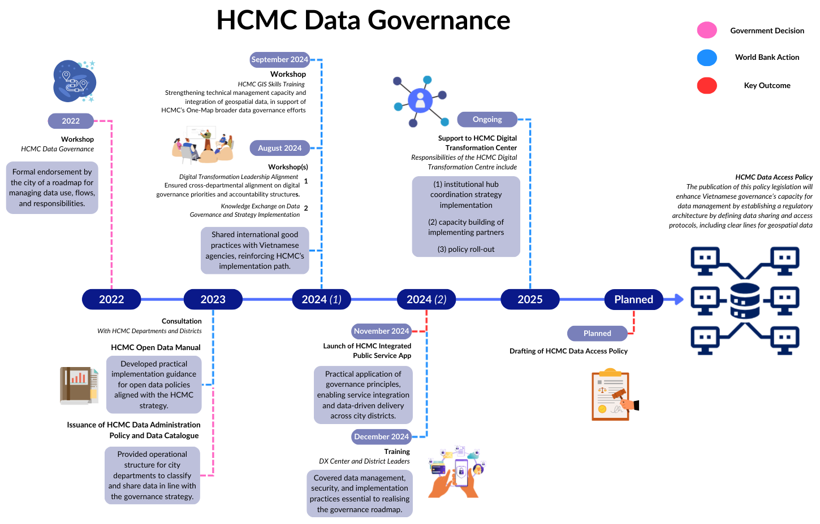
Figure A5. Results Map for Data Governance

To build institutional capacity, ABP2 delivered targeted training to over 80 senior officials, covering data integration, GIS, and digital leadership. The Programme also identified internal champions within city departments. These champions became vital drivers of reform, helping to foster collaboration across departments and ensure sustainability. One such champion presented HCMC’s progress to central ministries, which generated national interest in replicating the model.
The influence of HCMC’s reforms has been significant at the national level. Officials estimated that 60–65% of the content of two national data strategies approved by the Prime Minister in mid-2025 was based directly on lessons learned in HCMC.
“When the central government asked how to design the national strategy, they looked to HCMC as an example.”
- GoV 5
The World Bank partnered with DFAT to organise a study tour to Australia for 15 Viet Namese officials. DFAT’s involvement was crucial in securing access to Australian government agencies and aligning the tour with Australia’s bilateral cooperation agenda.
“Our support helps bridge relationships and knowledge between Viet Namese officials and international experts.”
– DFAT 9
To ensure relevance, ABP2 designed its workshops through stakeholder consultations and integrated feedback into future sessions. This iterative approach strengthened trust and ensured activities met actual needs.
Key knowledge products delivered included:
- International Good Practices on Data Governance
- HCMC Open Data Manual
- Open Data Solutions Challenge Design Report
A7.3 Conclusion
The ABP2 Programme’s support for HCMC has delivered tangible and scalable reforms. The Data Administration Policy and City Data Catalogue created Viet Nam’s first consistent framework for managing public data, while the DXCentre established a permanent institution to oversee digital initiatives and cybersecurity. These structures have reduced duplication, increased efficiency, and laid the foundation for sustainable transformation.
The Programme has also delivered direct benefits to citizens, most notably through the mobile application that improves access to essential services and public safety information. Nationally, the approval of two data strategies in 2025 demonstrates that ABP2’s work has already influenced central government policy, showing clear upward scalability.
“Both central and local leadership were very good. It was challenging at first to coordinate locally, but this has proven very effective.”– GoV 5
Despite this progress, key challenges remain. Integration with national platforms, such as digital ID and land registries, has not yet been achieved, limiting interoperability. The Data Access and Sharing Policy are still awaiting approval due to overlapping mandates and regulatory complexity. Cybersecurity gaps persist, especially at the district level, and data quality issues continue to affect decision-making. From HCMC’s perspective, there is a need to expand reforms to the commune level, where data integration and usage remain minimal.
“At the agency level, data systems are working well, but at the commune level, there is almost no integration or use of data.” – GoV 5
Scaling the data strategy downwards would enable local authorities to make data-driven decisions, improving services and responsiveness at the community level. Furthermore, knowledge sharing between provinces will be essential to replicate successes nationwide. Under ABP2+, these exchanges and documented lessons can help ensure that HCMC’s progress contributes to Viet Nam’s broader digital transformation goals.

Annex 8. Economic Management and Growth Case Study: Revisions to the Public Investment Law (No. 69/2025/QH15)
A8.1 Context and timeline
The process of reforming the Public Investment Law (PIL) illustrates how ABP2-supported evidence, dialogue, and relationships contributed to one of Viet Nam’s most important pieces of economic legislation. Between 2022 and 2025, a series of VN2045 reports, workshops, and high-level dialogues - ranging from the Spatial Economy Report to the “Trading Up in a Changing World” study - created an evolving evidence base. These were complemented by structured consultations convened by HCMA and policy discussions with MPI, ensuring that analysis fed directly into legislative debates. By June 2025, the revised PIL had adopted four of the five recommendations put forward under ABP2+, a concrete example of evidence-to-policy translation.
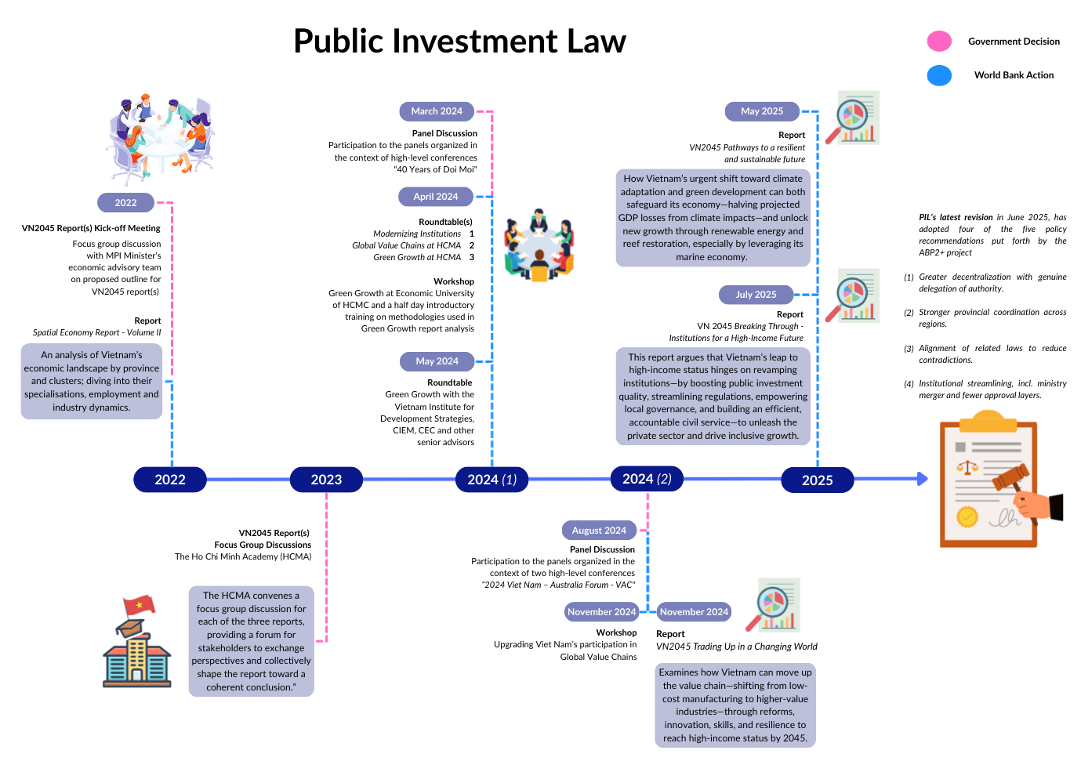
Figure A6. Results map Public Investment Law
A8.2 Themes and analysis

1. Trust and Longstanding Relationships
The success of the PIL process reflects the deep trust built between the World Bank’s Viet Nam team and the government over decades. This trust is not abstract: as a representative Economics/Politics in the National Assembly, observed.
“The World Bank is a longstanding relationship in Viet Nam … The World Bank can be quick to help with our teams’ short deadlines … We focus more on the World Bank because they have demonstrated an understanding of Viet Nam at the ground level for the longest time.” - NA 1
Such relational capital meant World Bank reports and recommendations carried real weight in legislative debates.
2. Responsiveness and Timeliness
Government counterparts consistently emphasized the value of the World Bank’s team’s speed in delivering high-quality input. Senior Governance Specialist from the World Bank noted.
“I regularly receive calls from ministers and other leading government officials over the weekend asking for my recommendations on a given policy reform that needs to be drafted as soon as early next week!” - WB 13
The secretary general of the Economic and Business Department at the National Assembly echoed this, remarking emphasizing this capacity to respond under pressure enhanced the World Bank’s credibility and positioned its outputs as “go-to” references during reform windows.
3. Ground-Level Understanding
Unlike external consultants who often rotate in and out, the local Bank team has cultivated a granular understanding of Viet Nam’s institutional dynamics. This shaped not only the relevance of technical analysis but also the way evidence was framed and communicated. A representative from the National Assembly stated:
“We focus more on The World Bank because they have demonstrated an understanding of Viet Nam at the ground level for the longest time.” - NA 1
The VN2045 reports were valued precisely because they were rooted in this contextual awareness.
4. Iterative Engagement and Government Ownership
The PIL revision was not the result of a single report or consultation, but rather the accumulation of iterative engagements: spatial economy analysis, VN2045 thematic reports, HCMA dialogues, and international forums. This sequencing created legitimacy and gave Vietnamese institutions ownership of the reform process. The adoption of ABP2+ recommendations into the 2025 PIL revision demonstrates how carefully sequenced dialogue can generate durable policy outcomes. As Senior Governance Specialist at the World Bank, explained:
“Vietnamese government officials hold the work undertaken [especially the reports] by the World Bank in high regard as our team has always, and continues to deliver on-demand, timely and meaningful contributions contributing to the enhancement of Vietnamese legislation.” - WB 13
A8.3 Conclusion
The Economic Management and Growth Theme has provided influential analytical and policy support to help Viet Nam sustain long-term growth and avoid the middle-income trap. Key outputs such as the Viet Nam 2045 reports and studies on trade, climate transition, and institutional reform have been widely disseminated and used to inform debates at the highest levels. The Theme’s contribution to the revisions of the Public Investment Law demonstrates how evidence-based analysis and trusted relationships can translate into major legislative reform. While monitoring could be strengthened through clearer targets and systematic reporting, overall, the Theme has proven highly relevant and effective in shaping Viet Nam’s long-term economic trajectory.

Annex 9. Terms of Reference

AUSTRALIA-WB STRATEGIC PARTNERSHIP IN VIETNAM – PHASE 2 (ABP2)
JOINT INDEPENDENT EVALUATION
TERMS OF REFERENCE

- BACKGROUND
In April 2017, as an important continuation and evolution of the Australia - World Bank Strategic Partnership Phase 1 (ABP1), Australia and the World Bank Group (WBG) in Vietnam agreed to enter into Phase 2 of the partnership (ABP2). Australia’s total investment was AUD50 million to further promote Vietnam’s development agenda and to sustain achieved efforts in priority areas. ABP2 was set up as a programmatic trust fund (TF). ABP2’s overall goal is to impact Vietnam’s development agenda in key areas through sharing knowledge, strengthening policies and programs for selected development priorities for Vietnam, with a particular focus on gender equality.

ABP2’s End-of- Program Outcomes (EOPOs) are:

- Strengthened development policies and regulations (laws, decrees resolutions, decisions, policy plans etc.) impacted, - of which are gender informed (%)
- Strengthened development programs of the WB’s investment which are gender informed.

The partnership originally covered six themes which were broad and allowable for flexibility in meeting Vietnam’s development needs while aligning with Australia’s and the WB’s priorities. Six themes included (1) gender equality and women’s economic empowerment, (2) climate-resilient development in the Mekong Delta, (3) investment in ethnic minorities, (4) trade and competitiveness, (5) efficient and sustainable transport, and (6) moving the Vietnam 2035 Report from strategy to action (VN2035).

In 2021, in responding to the Government of Vietnam’s evolving policy focus on becoming a high-income economy by 2045, Australia and the World Bank (WB) adjusted the program. While the themes on (1) gender equality and women’s economic empowerment and on (2) climate-resilient development in the Mekong Delta remained as before, new themes were added to focus on (3) inclusive development, (4) economic management, (5) low-carbon infrastructure development, and (6) digital transformation. Activities under these themes were completed in June 2023.

In February 2023, in recognition of the progress made under this fruitful partnership and the important work ahead, the Australian Government’s Department of Foreign Affairs and Trade (DFAT) and the WB agreed to extend the partnership by three years, to June 30, 2026, with additional funding of AUD 15 million, bringing the total amount for the program to AUD 50 million.

The activities under ABP2 are mostly bank-executed and endorsed through WB’s internal Concept Review meeting. DFAT is invited to provide comment and participate in the meetings. The ABP2 has a robust, quantitative result framework using existing WB’s M&E system and standards to track the progress of achieving the targeted result indicators.

In August 2023, Australia’s Government published a new International Development Policy which steers Australia’s international development program for years to come. It reflects Australia’s strong commitment for a peaceful, stable and prosperous Indo-Pacific region. This commitment has been clearly elaborated in a Development Partnership Plan (DPP) in Vietnam which is likely to be launched in December 2024.

Since the program started, two independent evaluation/assessment have been conducted: Mid-Term Review (2019) and the Qualitative Impact Assessment (2021). These evaluations have assessed relevance of the program’s original development objectives in light of the current country context and to evaluate the likelihood of achieving them as well as independently evaluate the impacts of the works done by this partnership in policy advocacy and reform in Vietnam. The reviews concluded positively on partnership impacts to Vietnam’s development agenda.

As ABP2 is due to complete in June 2026, ABP2 is now commissioning an independent evaluation. The evaluation report will inform Australia and the WB Management teams in country for design future collaboration between Australia and WB in Vietnam beyond June 2026.

- OBJECTIVES
To independently assess to what extend ABP2 extended phase (since 2023) has achieved its objectives including the relevance of prioritized themes/areas, how the partnership modality/approach has helped to achieve all parties’ strategic objectives and provide lessons and recommendations for the future collaboration between Australia and the WB.

- SCOPE OF WORKS
During the assignment period, the consultant firm will undertake the following steps:

- Meet with the ABP2 Secretariat to discuss on initial ideas on proposed methodology and choice of samples/case studies in selected themes/areas for the evaluation.
- Develop an evaluation plan which propose the approach and methodology for the evaluation including the questionnaires, expected data sources, targeted interviewees, and timeline. This will be shared for comments with the World Bank and DFAT Secretariat.
- Undertaking the evaluation process based on the agreed Evaluation Plan including desk review, meetings and discussion with relevant stakeholders including GOV agencies, WB and DFAT team members.
- Capture lessons learnt, and provide forward-looking recommendations to ensure that the program can effectively capture optimal impact;
- Make recommendations on further enhancing the relevance and efficacy of the program and inform future design.
- STAKEHOLDERS OF THE ASSESSMENT
The following groups of stakeholders would be the primary audiences for consultations during the assessment: Australia (DFAT) in Hanoi including Senior Management Team (HOM, DHOM), DFAT staff and WB Senior Management Team and staff working on ABP2 activities, National Assembly, government agencies, institutes, researchers and beneficiaries.

- EVALUATION CRITERIA
The evaluation team/consultant firm will assess the performance of ABP2 against the following criteria:

  - Relevance: To what extend the current partnership themes meet GoV’s, Australia’s and WB’s priorities in Vietnam?
    - Are the themes/activities under the ABP2 program relevant and supporting the country development strategies of the Vietnamese’s Government, the WB and Australia?
    - Do ABP2 activities address the critical development needs of Vietnam?
    - How has the partnership adapted to maintain its relevance to the changing policy or operating context? What are most relevant areas of priorities that Australia and the WB collaboration?

  - Effectiveness:
    - To what extend ABP2+ has achieved its intended objective?
    - What changes could be made to ensure the objectives is met?
    - How effective has the partnership responsive to the emerging priorities e.g.: Australia’s disability inclusion, Vietnam’s digitalization agenda?
    - Select case studies for in- depth understanding.
- Efficiency: Assess whether the partnership approach is making efficient use of available resources of both agencies to achieve objectives.
- How effective was the program in terms of funding arrangement, governance structure, modality of support, and approach in supporting the activities?
- How does this partnership approach/modality efficiently help to leverage the Bank’s lending portfolio in Vietnam since 2020?
- To what extend the partnership modality would be best suitable for future collaboration in the changing context (WB’s trust fund reform, Australia’s priorities and resources etc.)?

- Gender Equality and Inclusion:
- How was gender are effectively mainstreamed into ABP2 activities? To what extend Gender mainstreaming has been operationalized into ABP2 and WB activities?
- To what extend the WB’s operation would better mainstreamed Disability Inclusion into ABP2 implementation? Has this been appropriately resourced?
- Any recommendation for improvement?

- METHODOLOGY
The evaluation team/consultant firm will (i) review background material provided by the WB and Australia - Section I – Reference Materials below; (ii) develop and Evaluation Plan including proposed methodology and instruments; (ii) conduct the evaluation including undertaking focus group discussion (on-line interviews if needed) with relevant respondents (including Australia Embassy, WB, clients and beneficiaries); (iii) Prepare for an Aid Memoire/De-briefing once completion of interviews/meetings/field mission; (iv)compose the draft report for WB and DFAT initial feedback and discussion; and (iv) finalize the evaluation for ABP2 Steering Committee’s endorsement. As per the DFAT Evaluation Policy and Transparency Requirements, the final report will be published on DFAT website together with DFAT’s Management Responses. DFAT will discuss with evaluation team how to frame any sensitivities and DFAT requirements for documents to meet website accessibility guidelines.
The evaluation should be further substantiated, where possible, by highlighting specific examples, beneficiary stories, quotes, graphs, and pictures to demonstrate results on the ground.

- DURATION AND PHASING
The assignment is expected to involve:
- Up to 2 days travel from/to country to Vietnam (if international consultants from oversea)
- Up to 5 days desk review of the document and development of an Evaluation Plan including approach and methodology
- Up to 15 days for conducting meetings and discussion with relevant stakeholders.
- Up to 5 days drafting report
- Up to 4 days for report finalization including a version which meets DFAT’s requirements for website publication.

- OUTPUTS
- Evaluation Plan to WB by April 15, 2025. The plan should identify the methods, tools, and information sources to be used for addressing the evaluation questions and provide an indicative timetable (including the timing of meetings, and delivery of outputs). This will be submitted to the WB and for consultation with Australia Secretariat by email for comments and subsequent approval.

- The plan should also outline the selected case studies, study methodology including type and interview methodology, questionnaires, targeted respondents (who, what level, how many and how they will be selected) within 5 days of desk study on materials provided by the ABP2 Secretariat.
- An Aide Memoire, summarizing initial findings and recommendations to be presented to WB and Australia by the end of the (in-country) review mission.
- A draft evaluation report provided to WB within 15 working days after completion of the interviews and field work for comments by WB and Australia.
- The final report is expected to be submitted 10 days (max 30 pages) upon receipt of such comments on the draft version. Team Leader will incorporate any changes based on the feedback received and then submit the final report in English in electronic copy to the WB and Australia.

The consultant firm will directly work with Kathy Whimp, Operations Manager, and Dung Thi Thuy Dao, ABP2 Trust Fund Program Manager of the WB. The WB will be responsible for coordinating in getting feedback from relevant reviewers in Australia and WB, approving the evaluation plan, providing feedback on the draft report, and approving the final report. The final report will be submitted to the Steering Committee for their endorsement. The consultant will also submit the WB Secretariat the completed questionnaires, data and recordings – anonymized if there are sensitivities involved regarding people’s identities.

- CONSULTANT QUALIFICATION AND TEAM COMPOSITION
Requirements of the candidate are:
- Strong knowledge and experience in international development and policy reform.
- Demonstrated expertise in the evaluation of aid interventions, including sound understanding of operations of multilateral and bilateral organizations
- Experience in monitoring and evaluation methods and impact assessment of partnership arrangements and development activities, especially trust funds
- Demonstrated analytical skills and proficiency in verbal and written communication, especially report writing.
- Experience in development of Social and Gender Equality in policy reform.

K. CONTRACTING ARRANGEMENT
The consultant firm will submit claims and supporting documents by the end of the assignment to the ABP2 Program Manager. Payment will be made to the consultants after verification of deliverables and payment claims by the WB.

- REFERENCE MATERIALS
- Approved Overall Concept Notes of the ABP2+
- Approved Trust Fund Proposal
- Operations Manual
- ABP2 Annual Progress Reports
- Partnership Health Check Summary Note
- Minutes of Meetings of Steering Committee Meetings
- ABP2 Quarterly Newsletters
- Approved P-ASA Concept Notes
- Approved P-ASA progress reports
- Australia New International Development Policy
- Australia - Vietnam Development Partnership Plan (2025-2030)
- DFAT Aid Investment Plan Vietnam: 2015-16 to 2019-20
- Vietnam COVID-19 Development Response Plan (2020/21-2021/22)
- DFAT ABP2 Investment Monitoring Reports 2021-2024
- DFAT ABP2 World Bank Partner Performance Assessment 2021, 2022, 2023 and 2024
- WB Country Partnership Framework
- WB Performance Learning Review (PLR)
- ABP2 Mid Term Review Report and DFAT’s Management Response.
- ABP2 Qualitative Impact Assessment (2022)
- Selected analytical works from selected Themes

Australian Government Department of Foreign Affairs and Trade. (2025). Australia–Viet Nam development partnership plan 2025–2030. Department of Foreign Affairs and Trade.
Australian Government Department of Foreign Affairs and Trade. (2025). Australia–Viet Nam development partnership plan 2025–2030. Department of Foreign Affairs and Trade.
Australia-World Bank Partnership Health Check 2024 Report, p.26.
Viet Nam Social Security. (2024, August 20). New Law on Social Insurance: More Regulations Are Supplemented to Ensure More Participants’ Benefits. Retrieved September 20, 2025, from https://vss.gov.vn/english/news/Pages/viet Nam-social-security.aspx?CateID=0&ItemID=12311
Viet Nam Social Security (VSS). The World Bank – a key partner of Viet Nam Social Security in advising on improving social insurance policy implementation. VSS News, 2023. Available at: https://vss.gov.vn/english/news/Pages/viet Nam-social-security.aspx?CateID=0&ItemID=12529
International Finance Corporation (IFC), Tackling Childcare: The Business Case for Employer-Supported Childcare in Viet Nam (Washington, DC: IFC, 2020), 13, https://ergonassociates.net/wp-content/uploads/2020/08/Final_IFC_Childcare_Viet Nam_Web.pdf
World Bank, Viet Nam Women’s Economic Empowerment Programme (P500445): Progress Review (Washington, DC: World Bank, July 14, 2025)
Annexes to Annual Progress Report. Australia-World Bank Strategic Partnership in Viet Nam - Phase 2(abp2). January 2025.
World Bank. Viet Nam Women’s Economic Empowerment Programme (ABP2 Gender 02) Progress Review. July 14. 2025.
Ibid.

