**Design of Non-scholarship  
HRD Components**

**January 2017**

Aus4Skills is an Aus4Vietnam Investment - managed by Coffey,   
a Tetra Tech company, on behalf of the Australian Government

Table of contents

Executive Summary 1

1 Introduction 3

2 Background and Context 4

2.1 Implementation of HRD Strategy 5

2.2 Rationale for focus on five major components 7

2.3 Design Logic 10

3 Description of Components 14

3.1 Promoting Industry Linkages with Vocational Education and Training 14

3.2 Improving Quality in North Western Universities 17

3.3 Advancing Women in Leadership 20

3.4 Supporting Australia’s Aid Investment Plan 22

3.5 Supporting Australia’s Broader Interests 22

4 Implementation Arrangements 23

4.1 Guidelines for Choices of Delivery Modalities 24

4.2 Management Arrangements 29

4.3 Indicative Budget and Resources 38

5 Key background docs 41

Attachments

Attachment 1 Overall Theory of Change

Annexes

Annex 1 Promoting Industry linkages with Vocational Education and Training

Annex 2 Improving Quality in North Western Universities Component

Annex 3 Advancing Women in Leadership Component

Annex 4 Indicative Implementation Timeline - Aus4Skills Non-scholarship HRD Activities

List of tables

Table A: Mechanism for generic and tailored short courses 26

Table B: Indicative responsibilities of Managing Contractor, Sub-contractors and Targeted organisations 33

Table C: Indicative total non-scholarship budget for each component 2017-2021 (in AUD) 39

Table D: Estimated non-scholarship budget for each component 2017/2018 (in AUD) 40

List of figures

Figure 1: Aus4Skills Non-Scholarship Design Logic - Outcomes Pathway 12

Figure 2: Design Logic by categories of targeted organisations 13

[Figure 3: Backwards mapping of the Promoting Industry Linkages with Vocational  
Education and Training Component 16](#_Toc482610992)

Figure 4: Backwards mapping of the Improving Quality in North Western Universities Component 19

Figure 5: Summary of Steps in Aus4Skills Delivery Approach 30

Figure 6: Proportional representation of total non-scholarship budget from 2017-2021 39

Figure 7: Proportional representation of total non-scholarship budget for FY2017-2018 40

Abbreviations

|  |  |
| --- | --- |
| AAF | Australia Awards Fellowships |
| AAS | Australia Awards Scholarships |
| AAV | Australia Awards Vietnam |
| AFD | Agence Française de Développement (French Development Agency) |
| AIP | Aid Investment Plan |
| APEC | Asia-Pacific Economic Cooperation |
| AVID | Australia Volunteers for International Development |
| AU | Australia |
| AUD | Australian Dollar |
| BTC | Belgian Technical Cooperation (Belgian Development Agency) |
| CSO | Civil Society Organisation |
| DET | Department of Education and Training (Australia) |
| DFAT | Department of Foreign Affairs and Trade (Australia) |
| DOET | Provincial Department of Education and Training (Vietnam) |
| DOLISA | Provincial Department of Labour, Invalids and Social Affairs (Vietnam) |
| GDVT | General Department of Vocational Training (Vietnam) |
| GEDSI | Gender Equality, Disability and Social Inclusion |
| GeLead | Vietnam’s Centre for Gender and Women’s Leadership |
| GIZ | Deutsche Gesellschaft fur Internationale Zusammenarbeit  (German Development Agency) |
| GoA | Government of Australia |
| GoV | Government of Vietnam |
| HCMA | Ho Chi Minh National Academy of Politics |
| HE | Higher education (which includes education at university and post-secondary vocational education) |
| HRD | Human Resource Development |
| ILOs | Informal Learning Opportunities |
| IRC | Industry Reference Committee |
| ITAC | International Training and Assessment Courses |
| MC | Managing Contractor |
| M&E | Monitoring and Evaluation |
| MOET | Ministry of Education and Training (Vietnam) |
| MOLISA | Ministry of Labour, Invalids and Social Affairs (Vietnam) |
| NCP | New Colombo Plan |
| NGO | Non-Government Organisation |
| PO | Program Outcome |
| SCA | Short Course Awards |
| SO | Short-term Outcome |
| SoR | Statement of Requirements |
| STEM | Science, Technology, Environment and Math |
| STT | Short term training |
| TBU | Tay Bac University |
| TNU | Thai Nguyen University |
| TUAF | Thai Nguyen University of Agriculture and Forestry |
| VAHRDP | Vietnam-Australia Human Resource Development Partnership |
| VCCI | Vietnam Chamber of Commerce and Industry |
| VET | Vocational Education and Training |
| VLA | Vietnam Logistics Association |
| VN | Viet Nam |
| VNU | Vietnam National University |
| VWU | Vietnam Women’s Union |
| WIL | Women in Leadership |
| WiPPA | Centre for Women in Politics and Public Administration |

**Notes on terminology used in this Design**

In the Australia-Vietnam Human Resource Development Strategy (p 5, 15, 21) and the Statement of Requirements (p26) the word ‘*complementary*’ is used to refer to the range of other activities and programs to be initiated in addition to Australia Award Scholarships. An early concept note about the “HRD toolbox” (1 April 2016) provided a category of “Australia Award Complementary Assistance” which was a very particular use of the term ‘complementary’. The “HRD Toolbox” distinguished between “Australia Award Complementary Assistance” and the category of “Informal Learning Opportunities”. The toolbox category of “Australia Award Complementary Assistance” would be included in the range of activities referred to as ‘complementary’ in the Strategy. In the Vietnam-Australia Partnership Human Resource Development Final Design Document (2015), the term ‘*informal learning opportunities*’ (ILOs) also occurs. ILOs refer to all sorts of HRD activities that are not able to meet the definitions of being an Australia Award.

To avoid confusion, this Design uses the term “*non-scholarship*” inputs and activities to refer collectively to all the activities and inputs which are not long term scholarships nor alumni activities that are individually focussed to directly improve the ability of alumni to access, or maximise benefits from, long term Australia Awards. Management of long-term scholarships is still part of Aus4Skills but not considered in this Design. Another way of looking at this is to remember that under Aus4Skills *non-scholarship* inputs are primarily driven by organisational needs and Australia interests in Vietnam in priority sectors.

Toolbox and toolkit are used interchangeably as the terms ‘box’ and ‘kit’ are found in various Program related documents to mean the same thing.

The “Program” means Aus4Skills – known as Vietnam-Australia Human Resource Development Partnership (VAHRDP) until January 2017 - unless otherwise indicated.

The “Embassy” means the Embassy of Australia in Hanoi unless otherwise indicated.

# Executive Summary

The Government of Australia (GoA) has committed to assist in stimulating the private sector, upskilling the workforce and supporting inclusive growth, and thereby contributing to promoting prosperity and reducing poverty in Vietnam.

The Aus4Skills Program – herein referred to as the Program - positions Australia and Vietnam as partners in achieving the shared goal that **“Vietnam can access and use high level professional and technical knowledge skills and competencies to contribute to the country’s sustainable economic and social development, and enduring links with Australia.”**

The Program, intended to run until January 2021, is designed to achieve the following three end-of-program outcomes:

* + - 1. male and female alumni use new skills and knowledge to make positive contributions to selected priority areas;
      2. stronger workplace enabling environments for skills utilisation in selected priority areas; and
      3. Australia and Vietnam have stronger, sustainable links in selected sectors/agencies.

Aus4Skills commenced in 2016, a year of transition from the predecessor program which primarily focussed on long term scholarships. Aus4Skills focusses on implementing the Australia-Vietnam Human Resource Development (HRD) Strategy 2014-2020. This strategy along with the Aid Investment Plan (AIP) provides a new set of Australian diplomatic and development priorities in selected areas. This Design describes the components specified in the Statement of Requirements as “selected sub program, short term training (including any Short Course Awards), women in leadership, and any ad hoc support identified by Department of Foreign Affairs and Trade (DFAT) and the Contractor” (p 26, Contract 72156).

The *Design of Non-scholarship HRD Components* has four major sections, and the fifth section lists the key sources and reference documents. Annexes provide details of the design of Components.

After the introduction, the background and context for the Design are laid out in Section 2. Section 2 concludes with an overall Design logic for the non-scholarship components.

Five major components are described in Section 3 of this Design. They are:

1. Promoting Industry Linkages with Vocational Education and Training (VET),
2. Improving Quality in North Western Universities,
3. Advancing Women in Leadership (WIL),
4. Supporting Australia’s Aid Investment Plan (AIP), and
5. Supporting Australia’s Broader Interests

These components will comprise a wide range of HRD activities that contribute to all three overall end-of-program outcomes by contributing to one or more of the desired short-term outcomes:

**Short-term Outcome 1:** Improved management of targeted work units in Higher Education

**Short-term Outcome 2:** Increased access to Higher Education by targeted disadvantaged groups

**Short-term Outcome 3:** Improved workplace practices in 2-3 targeted organisations in the program

**Short-term Outcome 4:** Increased useful links with Australia

**Short-term Outcome 5:** Increased opportunities for women to provide formal input to organisational decision-making

*Promoting Industry Linkages with Vocational Education and Training* addresses the identified problem in Vietnam that VET quality of training and graduates does not meet the requirements of the employers and the labour market. Initially, Aus4Skills expects to work with the logistics sector and selected VET training organisations. The Program will also offer additional leadership development opportunities to selected VET managers including a focus on equitable leadership.

*Improving Quality in North Western Universities* addresses the identified problem that universities cannot meet market demand in terms of quality or quantity of education and research. Aus4Skills will begin work with Thai Nguyen University and Tay Bac University, both located in the relatively economically disadvantaged area of northern mountain region in Vietnam populated by many ethnic minorities. Activities will focus on improving leadership and management, strengthening curriculum, and increasing the effective support for academic success of ethnic minority students.

*Advancing WIL* addresses the identified problem that women do not have equal opportunities to be promoted to top leadership positions in business, public service and politics. This problem and activities to remedy it cut across all the other four components. Activities in this component will contribute especially to Short-term Outcome 5: *Increased opportunities for women to provide formal input to organisational decision-making*. Target participants in this component are likely, in many cases, to be participants also in activities in other components, including men and women in universities and VET training organisations, and selected male and female leaders in other priority areas. The Managing Contractor (MC) has been exploring opportunities to cooperate with GeLead (Vietnam’s Centre for Gender Equality and Women’s Leadership) as a partner in delivery for certain activities in this component.

*Supporting Australia’s AIP* will be delivered specifically to meet requests from DFAT Hanoi for HRD assistance to other priority organisations i.e. Vietnamese organisational actors in other Australian aid programs. It is anticipated that this component includes some Short Course Awards (SCAs) for generic skills training that can be offered across organisations. Depending on need and demand, and available funds, this component may also provide for other more specific technical skills development. Activities will be designed and delivered in ways that take every opportunity to showcase Australian expertise and providers. Any modalities in the HRD toolbox may be used, but for this component a more limited range is anticipated compared to the investments in the foregoing components. Activities in this component are expected to contribute to Short-term Outcomes 4 and 5.

*Supporting Australia’s Broader Interests* provides for HRD assistance to organisations, and potentially individuals, as directed by the Embassy, outside the groups of organisations targeted in the former components; i.e. beyond the AIP when such interests emerge. Any modalities in the HRD toolbox may be used, but the activity must contribute to the intended Program Outcomes.

Section 4 of this Design covers the arrangements for implementation. Budget to implement becomes available from FY2017/2018. Coffey, a Tetra-tech company, appointed as the Aus4Skills MC will continue to work as One Team with the DFAT Hanoi staff (as described in the Annual Plan 2016). Articulated principles guide the implementation including selection of HRD modalities. An extensive toolbox of flexible and responsive HRD modalities, including technical assistance and research are available to be used as needed and agreed under Aus4Skills.

Many of the planned HRD activities will be innovative; therefore implementation is staged with pilots before scaling up or down depending on the evidence from monitoring. The DFAT Hanoi team provides consent to proceed at key points in the implementation of each component. The detailed schedule of activities will be planned annually and presented in the Annual Plan for approval each year. As part of the annual planning process the overall Program plans for promotions and communications, monitoring and evaluation, and risk management are updated, so details are not included in this Design. Indicative activities and budget for the non-scholarship activities in years 2017-2021 are provided in Section 4.

There are four Annexes included with this Design. The first three give more details about the design of the components: Promoting Industry Linkages with Vocational Education and Training, Improving Quality in North Western Universities, and Advancing Women in Leadership. Annex 4 provides an indicative timeline for implementation of activities in each component in 2017-2018 and subsequent years.

# Introduction

The Government of Australia (GoA) is committed to assist Vietnam stimulate the private sector, upskill the workforce, and support inclusive growth, and thereby contribute to promoting prosperity and reducing poverty in Vietnam.

The Aus4Skills Program – herein referred to as the Program - positions Australia and Vietnam as partners in achieving the shared goal that **“Vietnam can access and use high level professional and technical knowledge skills and competencies to contribute to the country’s sustainable economic and social development, and enduring links with Australia.”**

At the earlier design phase, this Program was called Vietnam-Australia Partnership for Human Resource Development. The Final Design Document (DFAT 2015) provided for the application of a toolbox with a wide range of flexible types of Human Resources Development (HRD) assistance, to be delivered based on need and demand in selected areas, targeting provision where Australia can best add value, and focusing effort so Australian assistance can show impact in accordance with Australian diplomatic and development priorities.

The Program is intended to run until January 2021 and produce the following **three end of program outcomes**:

a. male and female alumni use new skills and knowledge to make positive contributions to selected priority areas;

b. stronger workplace enabling environments for skills utilisation in selected priority areas; and

c. Australia and Vietnam have stronger, sustainable links in selected sectors/agencies.   
(§2.1 Statement of Requirements, Contract 72156, VAHRDP)

2016, the first year of this Program, has been a year of transition from the earlier Australia Awards Vietnam (AAV) program to a new set of Australian diplomatic and development priorities and focus for program activities to deliver on those priorities. All stakeholders have been adjusting to the new focus, and the contract allowed time for the Managing Contractor (MC) to develop an appropriate mode of operation and design new activities, especially non-scholarship components, to meet the new requirements, including to organise resources, as required, and to ensure effective implementation. The budget for implementation becomes available from FY2017/2018.

This Program is distinguished from its predecessor, the AAV program, by concerns with stronger workplace enabling environments and sustainable linkages in priority areas/sectors/agencies selected in accordance with the Aid Investment Plan (AIP) and the DFAT Hanoi Strategic Framework. **Section 2 Background and Context** elaborates how these key documents, other published strategies, and the preparatory investigations and relationship building done in 2016, set the context for the design presented here for the non-scholarship components of this Program.

To achieve the given outcomes, the MC has designed, and will ensure delivery of, HRD activities to meet defined needs for skills and knowledge in the priority areas chosen by DFAT. Recommendations are made with a view to meeting agreed targets for the participation of women, people with disabilities and people from disadvantaged rural groups (including ethnic minorities). Effectively, the MC will provide a facility for delivering the agreed HRD activities. One set of the activities consists of the Australia Awards long term scholarships promotions, the annual placement and mobilisation of awardees, on-award monitoring, and relationship with and support for the Australian Awards alumni. That set is excluded from consideration in this Design as the arrangements for that group of activities are well-established and continue relatively unchanged but adjusted to ensure that all those activities contribute to the three Program outcomes. Those on-going activities and adjustments are not the subject of this Design.

This Design of Non-scholarship HRD Components is written to comply with the scheduled deliverable in §11.1 of the Statement of Requirements (SoR). A number of elements of the SoR have been clarified as will be highlighted in this Design. In early 2017, the official name of the Program has also been changed from VAHRDP to Aus4Skills.

This document is prepared in accordance with the requirement for a “design of the complementary HRD Components” specified as the “selected sub program, short term training (including any Short Course Awards), women in leadership, and any ad hoc support identified by DFAT and the Contractor” (p 26, SoR, Contract 72156, VAHRDP). For reasons described in the Notes on terminology used in this Design, ‘non-scholarship HRD’ is preferred to ‘complementary HRD’. The reasons for viewing the Program investment in terms of five major components are explained in Section 2. These components are:

1. **Promoting Industry Linkages with Vocational Education and Training (VET),**
2. **Improving Quality in North Western Universities,**
3. **Advancing Women in Leadership (WIL),**
4. **Supporting Australia’s Aid Investment Plan (AIP), and**
5. **Supporting Australia’s Broader Interests.**

At the end of Section 2, a revised program logic focussed on the non-scholarship elements of this Program is presented.

**Section 3**, **Description of components**, elaborates on the details of activities in each of these component areas. **Section 4, Implementation Arrangements** provides a description ofthe guidelines for choices of delivery modalities, management arrangements and the implementation timelines and budget as far as can be predicted at this stage.

# Background and Context

The GoA is committed to support Vietnam’s ongoing HRD as outlined in the Australia-Vietnam HRD Strategy 2014-2020. The commitment builds on the well-established place of education at the heart of the bilateral relationship. Australia’s on-going assistance for the coming four to five years is targeted to areas of Australia’s interest and expertise, as outlined in the AIP 2015-2016 to 2019-2020 and DFAT Hanoi Strategic Framework (2016). DFAT-funded activities are intended to complement activities of other Australian agencies such as the Department of Education and Training (DET) and Austrade.

This Design uses the definition of HRD in the GoA’s Australia-Vietnam HRD Strategy (2014): “**Human Resource Development is the enhancement of knowledge, skills and competencies of citizens, and of capacities for applying them effectively towards the advancement of the nation’s development goals**.”

*‘Knowledge’* identifies what a person needs to know to perform the work in an informed and effective manner;

*‘Skills’* describes the application of the knowledge to situations where understanding is converted into a workplace outcome; and

*‘Competencies’* arethe consistent application of knowledge and skill to the standard of performance required in the workplace.[1]

Fundamental to HRD quality is creating organisational enabling conditions to effectively use skills and knowledge to improve workplace productivity. In a centrally organized state and economy like Vietnam, the articulation of laws and decisions is also important to create a mandate for action to equitably enable both men and women to contribute to productivity. Yet, the gap between robust legal frameworks and consistent implementation can be wide and challenging to bridge. Both the external context and internal operating environment may contain strong forces that can work for and against desired changes. The chosen focus for this Program is at organisational level to operationalize skills, knowledge and effective HRD and other business practices.

The AIP for Vietnam summarises the national socio-economic context for the Program:

“…Vietnam now faces a challenging period …with growth potentially faltering ... Firms, and international firms in particular, report a lack of skilled employees as one of the most problematic factors in doing business, reflecting a mismatch between the supply of skills and market demands. The business environment more generally remains challenging, with private sector growth constrained by poor infrastructure and an uncertain policy environment characterised by unclear rules, overlapping legislation, and inconsistent enforcement.

“Inequality remains significant and ... Gender disparities still exist in access to and ownership of economic assets and women are poorly represented in leadership roles. Vietnam is one of few countries in which the gender pay gap has widened over the last decade, during which women’s representation in the National Assembly has also fallen. Ethnic minorities have still not benefitted equally from economic growth...

“Vietnam’s Socio Economic Development Strategy (SEDS) 2011-20 provides the country’s overarching policy for responding to these challenges. It sets three high priorities – improving market institutions, promoting human resources, and infrastructure development – and highlights the need for a combination of structural reforms, macroeconomic stability, environmental sustainability, and social equity.

“The demand from Vietnam is for an economic partnership that shares lessons from our own reform experiences, finds innovative ways to maximise the reach of limited public resources, leverages greater private investment, and promotes inclusive growth” (p2-3).

To use limited resources most effectively, the intent is to focus and prioritise Program inputs and activities in the ways described below.

## Implementation of HRD Strategy

Aus4Skills is the major vehicle for implementation of the Australia-Vietnam HRD Strategy 2014-2020. The articulated outcomes are broad and mutually-reinforcing. As Vietnam continues to develop, men and women with new skills and knowledge are needed everywhere, but this Program will focus on the provision and application of new skills and knowledge in selected priority areas identified in the current AIP. In particular, Aus4Skills focusses on strengthening higher education provisions to better meet national needs for skills and knowledge, and building capability in targeted organisations to use new skills and knowledge to be effective partners with Australian organisations in priority areas. Higher education refers to both university and post-secondary vocational education[2].

**Application of skills and knowledge** in a workplace requires an enabling environment. Tracer studies and evaluations[3] have indicated that individuals with increased skills and knowledge may encounter a variety of barriers in their effort to apply those skills and knowledge in their workplaces in Vietnam. This Program will work in ambitious and focussed ways in a small number of selected workplaces and/or work units to make a visible difference in the enabling environment practices for the use of skills and knowledge gained through Australian funded activities.

**Changing practices in an established workplace environment** typically entails changing visions and deeply embedded values and sub-conscious behaviours. This not only takes planning and time; but senior management commitment to the change including development of senior managers’ competencies in leading and managing change. In three to four years, the impacts of this Program’s efforts to strengthen workplace enabling environments are expected to be evident at local departmental levels and in niches, not entire Government of Vietnam (GoV) ministries, universities or large private enterprises.

A particular application of skills and knowledge is for Vietnamese organisations to **maintain linkages with Australians and Australian organisations**. In turn, these linkages can be expected to continue to generate new skills and knowledge and their application. Again, Aus4Skills efforts will be focused to selected areas of Australian interest, where Australian organisations are willing to invest in linking with Vietnamese organisations.

Both the HRD Strategy and the original Program Design explicitly acknowledge that long term scholarships alone cannot produce all the desired Program outcomes. Those desired outcomes need a strategic theme-based and cross-cutting approach, including long term scholarships, with capacity to fund additional activities based on specific HRD needs of target groups. The number of short course award (SCA) recipients is expected to increase subject to demand and budget availability. SCAs and other flexible formats of short term training (STT) are expected to be well suited to senior and critical staff who cannot be absent from the workplace for long, and for women or others who for various reasons also prefer not to be absent for long. Although SCAs and STT can be heavy to manage, both technically and administratively, this modality can provide more diversity, flexibility, and quicker response to short term needs than long term scholarships. Section 3.6 provides more details on the plans for using short courses and other innovative modalities to achieve the Program outcomes.

The GoA’s Gender Equality Strategy has made an explicit commitment to **gender equality and empowering women** as an essential element of economic growth and achieving peace and security, as expressed in the Gender Equality and Women’s Empowerment Strategy (DFAT 2016). The Embassy in Hanoi has committed to enacting this GoA Strategy and supporting Vietnam’s National Gender Equality Strategy 2011-2020. The Embassy published and launched in November 2016 its Gender Equality Strategy 2016-2020. Accordingly, Aus4Skills has been designed to include an integrated emphasis on increasing the number of and opening opportunities for “Women in Leadership”. This emphasis on women in leadership in the original Program Design was reiterated and re-affirmed as the first priority of the Embassy’s Gender Equality Strategy in Vietnam.

The AIP clearly positions the overarching intent of Aus4Skills to work with Vietnamese organisations to achieve effective HRD:

“A skilled workforce that is harnessed by successful businesses will assist Vietnam to move into a new phase of growth and invest in innovation, ensuring that domestic industries can remain competitive. These needs are recognised in the focus of Vietnam’s SEDS 2011-20 on quality human resource development. Vietnam’s Human Resource Development Master Plan 2011-20 also articulates plans to improve the quality of the workforce through demand-based training and enhancing capacity of policy makers, entrepreneurs and skilled workers” (AIP p5).

What follows is the rationale for focusing Program planning on five major components, a description of different categories of organisations who will receive differential benefits from the Program, a short description of the ‘toolbox’ at the disposal of the Program and a revised Program Logic.

## Rationale for focus on five major components

The starting points for preparation of this Design were the intended Program outcomes. Further considerations were the emphases in the earlier overall Program Design and SoR on i. priority sectors in the AIP, ii. the subprogram/s focus on universities and VET provisions, iii. the need for SCAs to be designed and implemented, and iv. ensure an integrated and cross-cutting focus on women in leadership throughout the Program, as well as the demand to support to other development programs under the AIP. To develop this Design the MC has consulted with the DFAT Hanoi, the Trade Commissioner, the Education Counsellor and team, the Agriculture Counsellor and team, and with various other stakeholders in Vietnam such as other Australian Embassy staff, the Vietnamese Ministry of Education and Training (MOET), Vietnamese Ministry of Labour, Invalid and Social Affairs (MOLISA), other donors, and potential beneficiaries and partners in delivery of the Program.

The MC has considered carefully how the program outcomes can be achieved by delivering what is required in the SoR, and intended in the overall Program Design, subject to clarification with the HRD staff at the Embassy of details and any changes in priorities.

The SoR refers repeatedly to AIP priority sectors (e.g. §1.3,1.4, 5.4, 6.15, 6.19, 6.25). These are “economic reform, transport infrastructure, and education… [and] focus on the private sector and supporting more women and men to participate fully in the economy” (AIP p3).

The AIP sets three mutually reinforcing objectives:

a. Enabling and engaging the private sector for development

b. Assisting the development and employment of a highly skilled workforce

c. Promoting women’s economic empowerment, including ethnic minorities.

Aus4Skills sits under AIP objective ii. It is also clear that this Program will provide support where possible, and at the request of DFAT in Hanoi, to the other programs which at the time of writing are still in the pipeline.

These considerations direct Aus4Skills particular focus to:

a. the universities in the north western provinces to provide quality education that redresses the systemic disadvantages experienced there, including the limited capacity to realise economic development; and

b. the private sector to ensure that training and education meet industry needs.

The overall Program Design and SoR for this Program directed attention to “sub-program/s” to be identified from within one or both of the following options:

a. universities (faculties) in priority areas of geographical and sector focus; and

b. technical vocational education and training (VET). (SoR §6.20)

The complexity and also the inefficiency of the VET sector in Vietnam have been noted in many reports[4]. Current GoV policy is to strengthen the role of employers in determining curriculum content and standards so that education provisions better meet labour market needs. Australia has experience and expertise in industry-led VET curriculum design, so Aus4Skills sought industry sectors in Vietnam where a) Australian interests are already active and needing a highly skilled labour force, and b) the sector is ready to engage in partnerships for VET curriculum design and delivery.

It would be simplest for Australia to support more effective industry-VET linkages focused at the level of colleges (i.e. VET training organisations) and industry sectors (i.e. employers). However, lessons learned from other donors working in the VET sector are that working simultaneously at policy level ensures better acceptance of impact at the college and sector level, and thus increases the likelihood of sharing, transfer and scaling of the learning and benefits gained. Embassy staff and staff from the MC have conferred with General Directorate of Vocational Training (GDVT), some colleges, some industry representatives, other bilateral donors and about what Aus4Skills can do.

In October 2016 DFAT approved the concept note to initially develop the design of potential activities for VET in logistics. Thus **Promoting Industry Linkages with Vocational Education and Training[5]** has become one component.

DFAT and MC staff visited both regional universities under MOET in the north western provinces of Vietnam to assess their potential willingness and readiness to be target recipients of this Program. The north western provinces were chosen because of their relative socio-economic disadvantage, and the number of ethnic groups residing there. In October 2016 the Embassy approved the concept note to further develop the design of potential activities for these two universities, Tay Bac University (TBU) in Son La Province and Thai Nguyen University (TNU) in Thai Nguyen Province. Thus **Improving** **Quality in North Western Universities[6]** has become one component.

Annexes 1 and 2, provide more detailed descriptions of these components 1 and 2 and explain further the initial focus on the logistics sector for vocational training and interests in the two universities in the north western provinces of Vietnam.

As noted earlier, Australia has made a strong commitment to gender equality and this is an important element of the enabling environment in every workplace the Program may target. Gender equality is a complex concept and contested. Aus4Skills uses at its reference point the distinction between gender equity and gender equality used by UNFPA, and which is consistent with other GoA sources; i.e.

“Gender equity is the process of being fair to women and men. To ensure fairness, strategies and measures must often be available to compensate for women’s historical and social disadvantages that prevent women and men from otherwise operating on a level playing field. Equity leads to equality.” Source: <http://www.unfpa.org/resources/frequently-asked-questions-about-gender-equality#sthash.vbFpTXOi.dpuf> Accessed 20 November 2016

The DFAT Gender Equality and Women’s Empowerment Strategy 2016 declares:

“The Australian Government is committed to pursuing gender equality outcomes across the international agenda… (p4)

… Gender equality is about equal opportunities, rights and responsibilities for women and men, girls and boys. It does not mean that women and men are the same. Gender inequality is a result of unequal power distribution between women and men, exacerbated by ongoing discrimination, weaknesses in laws, policies and institutions, and social relations that normalise inequality.

[DFAT] sees gender as a power relation. Work on gender equality therefore aims to address unequal gender norms that constrain women and men, as well as transgender and intersex people. It is a global issue, relevant to Australia and the economic, social, welfare and foreign policies of all countries…” (p5)

The Australia in Vietnam Gender Equality Strategy 2016 refers to supporting organisations “to implement and monitor gender equitable practices in their work places.”

Advancing these stated priorities, the MC will be looking for ways the targeted organisations can develop gender equitable leadership, that is, leaders that are sensitive and responsive to gender equity and aspire to gender equality. So **Advancing Women in Leadership** is identified as acomponent that provides for specific investments to ensure that women receive more equitable opportunities to provide formal input into organisational decision-making.

While theother programs planned in the AIP are still in various stages of the pipeline as this Design is prepared, the Program commits toproviding limitedHRDsupport for other AIP Programs.(These other programs are Aus4Equality, Aus4Reform, Aus4Transport, Aus4Water, and Aus4Innovation.) This component, **Supporting Australia’s Aid Investment Plan**, described further in Section 3, will provide support for Vietnamese organisations already working with Australia and important to Australia’s future priorities and Vietnam’s development; i.e. organisational actors in the other Australian aid programs in Vietnam.

In addition to all the foregoing components, the HRD strategy intends to provide for Australia’s desire to have the flexibility to respond to emerging HRD needs and interests. The component, **Supporting Australia’s Broader Interests,** will provide for this responsiveness to organisations outside those targeted universities, VET organisations and their industry sector partners, and AIP program partners mentioned in the foregoing components.

**Categories of organisations that will receive assistance**

To help plan the kind of attention to be afforded, effort to be expended, and inputs and activities that may be designed, the MC and HRD staff at the Embassy have agreed on a simple categorisation of organisations that are targeted for assistance in the Program. There are three categories (Concept Note 20.9.2016) as described below:

The first category is***HRD selected organisations*** including selected regional universities, selected industry sectors and their VET partners. This category encompasses the organisations that receive the fullest package of assistance in this Program, that is the integrated use of a range of inter-related HRD modalities.

The second category is***other AIP partners*** who areorganisations or work units that are priorities for AIP programs and are not the HRD selected organisations. The organisations in this category are introduced by other AIP programs, and the HRD team at the Embassy will determine the level at which this Program will serve identified needs. The assistance provided is likely to include prioritisation for Australia Awards, and based on identified needs may include other modalities with the intent to strengthen the enabling environment and linkages with Australia, or possibly to develop specific and relevant skills and knowledge.

Selected employees in these organisations and the HRD selected organisations are expected to be potential participants in cross-cutting Advancing Women in Leadership activities.

The third category is ***broader Australia’s interests****,* i.e.organisations or groups of individuals which will not be engaged further than targeted Australia Awards Scholarship promotional activities, except under specific direction from the Embassy.

The combination of all three categories equates to those organisations included in the ‘at least 30%’ target for ‘non-open’ Australia Award Scholarships in the 2018 intake. The proportion of non-open Australia Award Scholarships will be reviewed with the Embassy each year. The GoA Vietnam HRD Strategy indicated up to ten organisations to target in total to keep efforts focussed and maximise the outcomes (p23).

**HRD Toolbox**

The term “HRD Toolbox” is used in the overall Program Design (sections 1.4.3 and 2.3) and in the SoR §1.6 to refer to the wide range of modalities or HRD tools, including technical assistance, that can be deployed to serve the achievement of the Program outcomes.

Broadly speaking, the tools or modalities are the activities and inputs at the disposal of Aus4Skills, including formal Australia Awards, complementary assistance for Australia Awards recipients, and informal learning activities. In some cases informal learning activities may include specific technical assistance. Section 4.1 below provides more details on the kinds of modalities that are anticipated to be deployed and guidelines on the choice of the appropriate modalities.

## Design Logic

To manage for results with respect to the intended program outcomes and enable a performance assessment framework, the overall logic for the design of the non-scholarship elements of Aus4Skills is captured in Figure 1. The figure shows the outcomes and outputs and their logical relationships with each other, which is called the outcomes pathway.

Figure 2 provides an overview of the relationship between the desired short-term outcomes, and the required activities and inputs with particular groups of target organisations to achieve the desired impact. The short-term outcomes (SOs) and activities are precondition to achieve the three desired end-of-program outcomes (POs).

The different components and how they each contribute are described in **Section 3**.

The complete overall design logic of five components is attached in **Attachment 1**.

As shown in Figure 1, the Design Logic, collectively the components will all contribute to the end of program outcomes and the desired short-term outcomes and which will depend on the required key outputs.

The overall Aus4Skills end-of-program outcomes (PO) are:

1. Male and female alumni use new skills and knowledge to make positive contributions to selected priority areas;
2. Stronger workplace enabling environments for skills utilisation in selected priority areas; and
3. Australia and Vietnam have stronger, sustainable links in selected sectors/agencies.

For components 1 to 3, a problem analysis has been conducted and the results are presented in the respective Annexes. Addressing the selected causes of each problem is expected to provide the following desired short-term outcomes. While a single problem analysis is not appropriate for components 4 and 5, activities in those components will also be conducted with the relevant desired short-term outcomes (SO) in focus:

*SO1: Improved management of targeted work units in Higher Education*

*SO2: Increased access to higher education by targeted disadvantaged groups*

*SO3: Increased opportunities for women to provide formal input to organisational decision-making*

*SO4: Improved workplace practices in 2-3 target organisations (in the program)*

*SO5: Increased useful links with Australia.*

Not every component will contribute equally to the short-term outcomes; and this is explained briefly below and more fully in the annex for each component 1 to 3. Given the desired overall impact of Aus4Skills, a backward mapping process was applied to identify the following key outputs across all components.

1. Target number of people in disadvantaged groups has access to skills development.
2. Alumni/ program participants have necessary skills and knowledge to contribute to priority areas.
3. Number of program participants completing program supported WIL activities.
4. Two to three targeted organisations (in the program) develop and implement a competency framework/s to enhance skills utilisation.
5. Institutions apply Australia's good practices for University & VET management, industry linked provision, and inclusion.
6. Alumni/ program participants in selected agencies have relevant and useful networks with Australia and maintain linkages.

Figure 1: Aus4Skills Non-Scholarship Design Logic - Outcomes Pathway

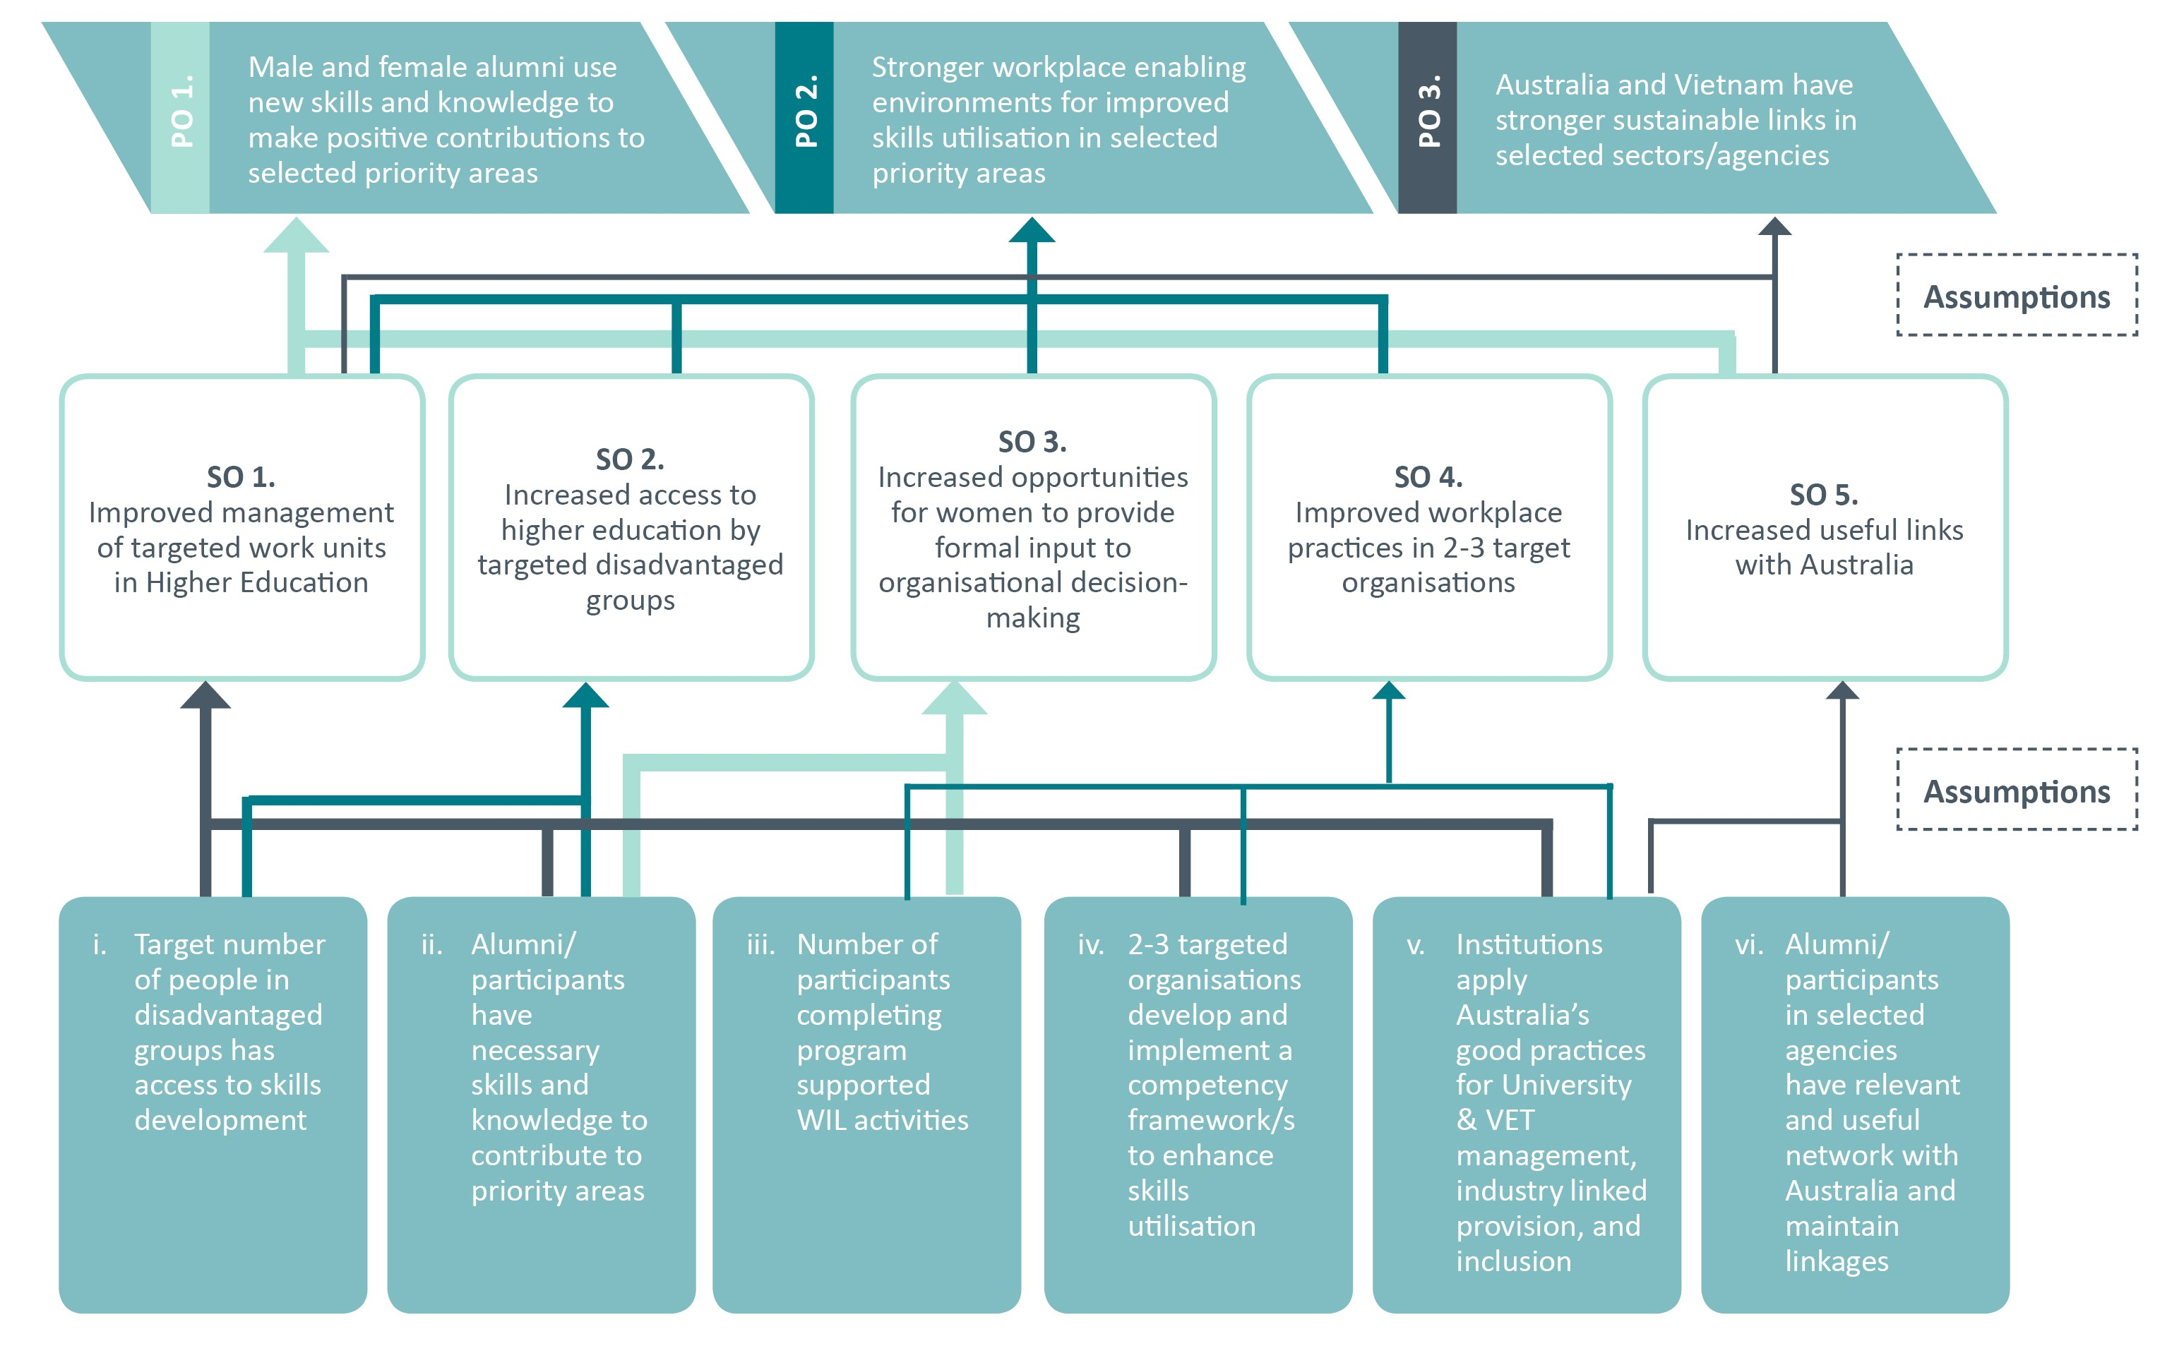

Figure 2: Design Logic by categories of targeted organisations

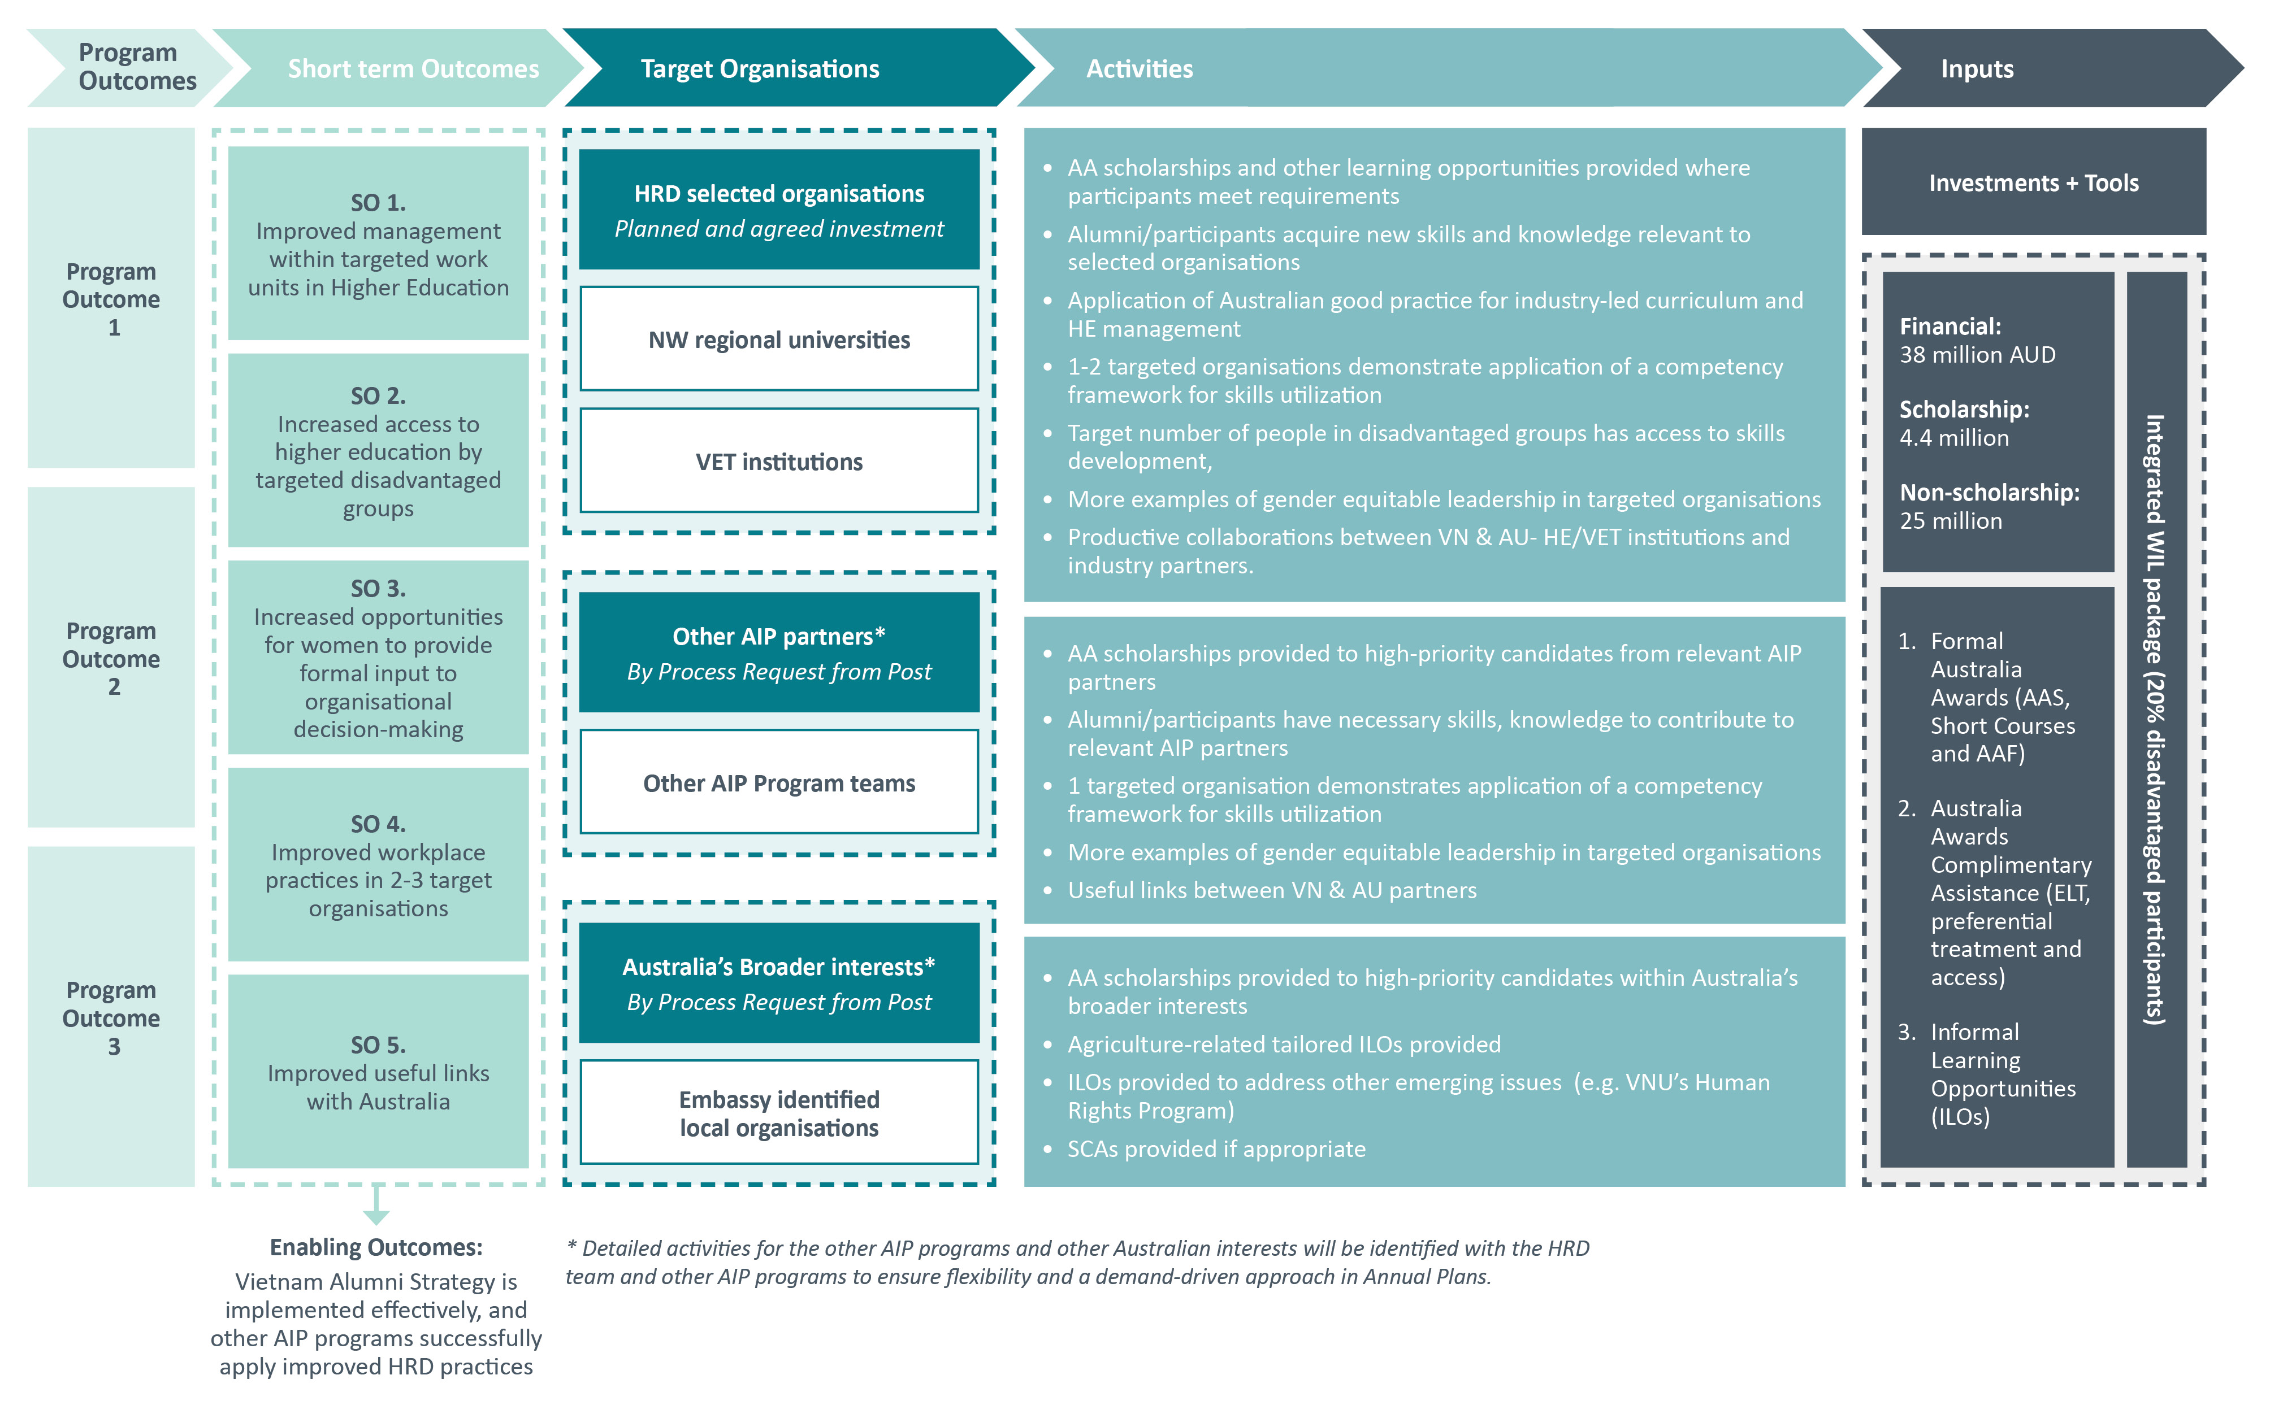

# Description of Components

This section describes how each component will contribute to the short-term outcomes through a range of inputs and activities, and in turn ensure the final end-of-program outcomes are delivered. These activities will support the high level policy dialogues conducted by the GoA on related issues with the relevant GoV stakeholders. It is important to recognise that the Program is managed as a responsive facility that can design, deliver, adapt and scale different types of HRD in a timely manner according to identified problems and needs in different priority sectors. Thus, depending on the component and GoA priorities, the range of activities may be expanded, narrowly focussed, tightly integrated, or not, which is explained further below.

## Promoting Industry Linkages with Vocational Education and Training

In September 2016 the GoV rationalised the governance of the vocational education and training (VET) sector in Vietnam so that all vocational training organisations (except teacher training colleges which remain under MOET’s jurisdiction) are overseen by the GDVT in MOLISA. The sector still remains complex. However, the earlier overall program design recommended working in the sector to transfer to Vietnam elements of the Australian system of industry-led VET. To achieve sustainable change will require effort at the government, industry/employer and training provider levels to agree on occupational standards and training curriculum. In the relatively short timeframe of Aus4Skills, i.e. 4 years, achievable goals need to be set and, importantly, coordination with other donors working in this sector can ensure good leverage for Australian investments. Synergies will be sought especially with the Aus4Reform activities as they develop. This component will support ongoing policy dialogues between the GoA and GoV representatives on the importance of vocational skills and governing frameworks for efficient and effective skills development.

A thorough problem analysis has been prepared based on engagement and consultations with GDVT, other donors, selected VET colleges, industry representatives, and desk review of other reports. Consideration of ways that addressing the problem identified can achieve the intended three program outcomes has produced the following recommendations for component specific short term outcomes and related activities.

The key problem is widely agreed to be **VET quality of training and graduates do not meet requirements of the employers and the labour market.** This component is designed to meet the following identified causes of the problem in order to achieve the desired outcomes:

* + Lack of the links between demand and supply for skills in the labour market:
  + The private sector is not actively engaged in curriculum development and training delivery;
  + Limited capacity/resources and lack of tools to identify future skills needs for business/industry;
  + GDVT and VET leaders are unsure how to implement an industry linked system; and
  + Lack of a working mechanism/formula/agency like Industry Reference Committees in Australia.
  + Lack of competence in training institutions:
  + Lack of management and leadership skills;
  + Trainers/teachers lack skills in competency based training; and
  + Trainers/teachers lack recent industry experience.
  + Gender bias facing female students and teachers/staff.

To begin, the logistics sector has been identified as an industry sector important to Australia, and where Aus4Skills can leverage work on occupational standards at the APEC level in which the GoA has already invested. In the logistics sector in Vietnam, there is need and interest in improved training for the workforce. Other sectors, such as tourism, may be included later.

**Annex 1** provides more details on the design of this component. A workshop with key stakeholders will be scheduled for the first half of 2017 to confirm the problem analysis and the theory of change. Figure 3 below shows how the indicative types of activities are expected to lead to short-term outcomes in this component that will result in the overall achievement of the end of program outcomes.

The choice of activities will be designed and delivered to achieve the desired short-term outcomes 1, 3, 4, and 5, with the following considerations.

**Short-term Outcome 1:** Improved management of targeted work units in higher education

Aus4Skills will consult with GDVT and industry/employer stakeholders about the choice of colleges with whom to work, but those identified as Colleges of High Quality are more likely than others to be chosen at least initially.

It is intended to build managers’ and leaders’ skills in various ways so they have better capacity for effective linkages that enable the efficient development of competency based curriculum for skills needed in the labour market.

While this component focusses on promoting industry linked with VET, the management of VET training providers themselves can use competency tools for planning their own future skills needs.

There will be a focus on strengthening leadership equitably, enabling career pathways for men and women.

**Short-term Outcome 3:** Increased opportunities for women to provide formal input to organisational decision-making

Women from the VET sector will be selected to participate in activities under the component Advancing Women in Leadership. Both women and men in the VET sector will be offered opportunities to build their own personal capacity for gender equitable leadership. When both men and women apply their new skills, more women will choose to be more visibly active in organisational decision-making.

**Short-term Outcome 4:** Improved workplace practices in 2-3 targeted organisations

At least one VET college or unit in a college will be a targeted organisation to demonstrate improved workplace practices that enable gender-equitable utilisation of new skills and knowledge. Here the focus is on how the workplace environment enables participants and alumni of Aus4Skills use new skills and knowledge gained in this program.

**Short-term Outcome 5:** Increased useful links with Australia

This component will pursueincreased productive collaborations between Vietnamese and Australian VET institutions and industry partners to serve a variety of interests, e.g. sharing or building management skills, effective linkages with industry, curriculum quality, teaching skills, potentially placements and exchanges. Australian Industry Reference Committees and training providers will have opportunities to showcase their experience and learning and explore with Vietnamese partners what is transferable into the Vietnamese context.

At the planning workshop for stakeholders a detailed plan for activities with identified participant groups in the coming year will be agreed and scheduled in May 2017.

Figure 3: Backwards mapping of the Promoting Industry Linkages with Vocational Education and Training Component

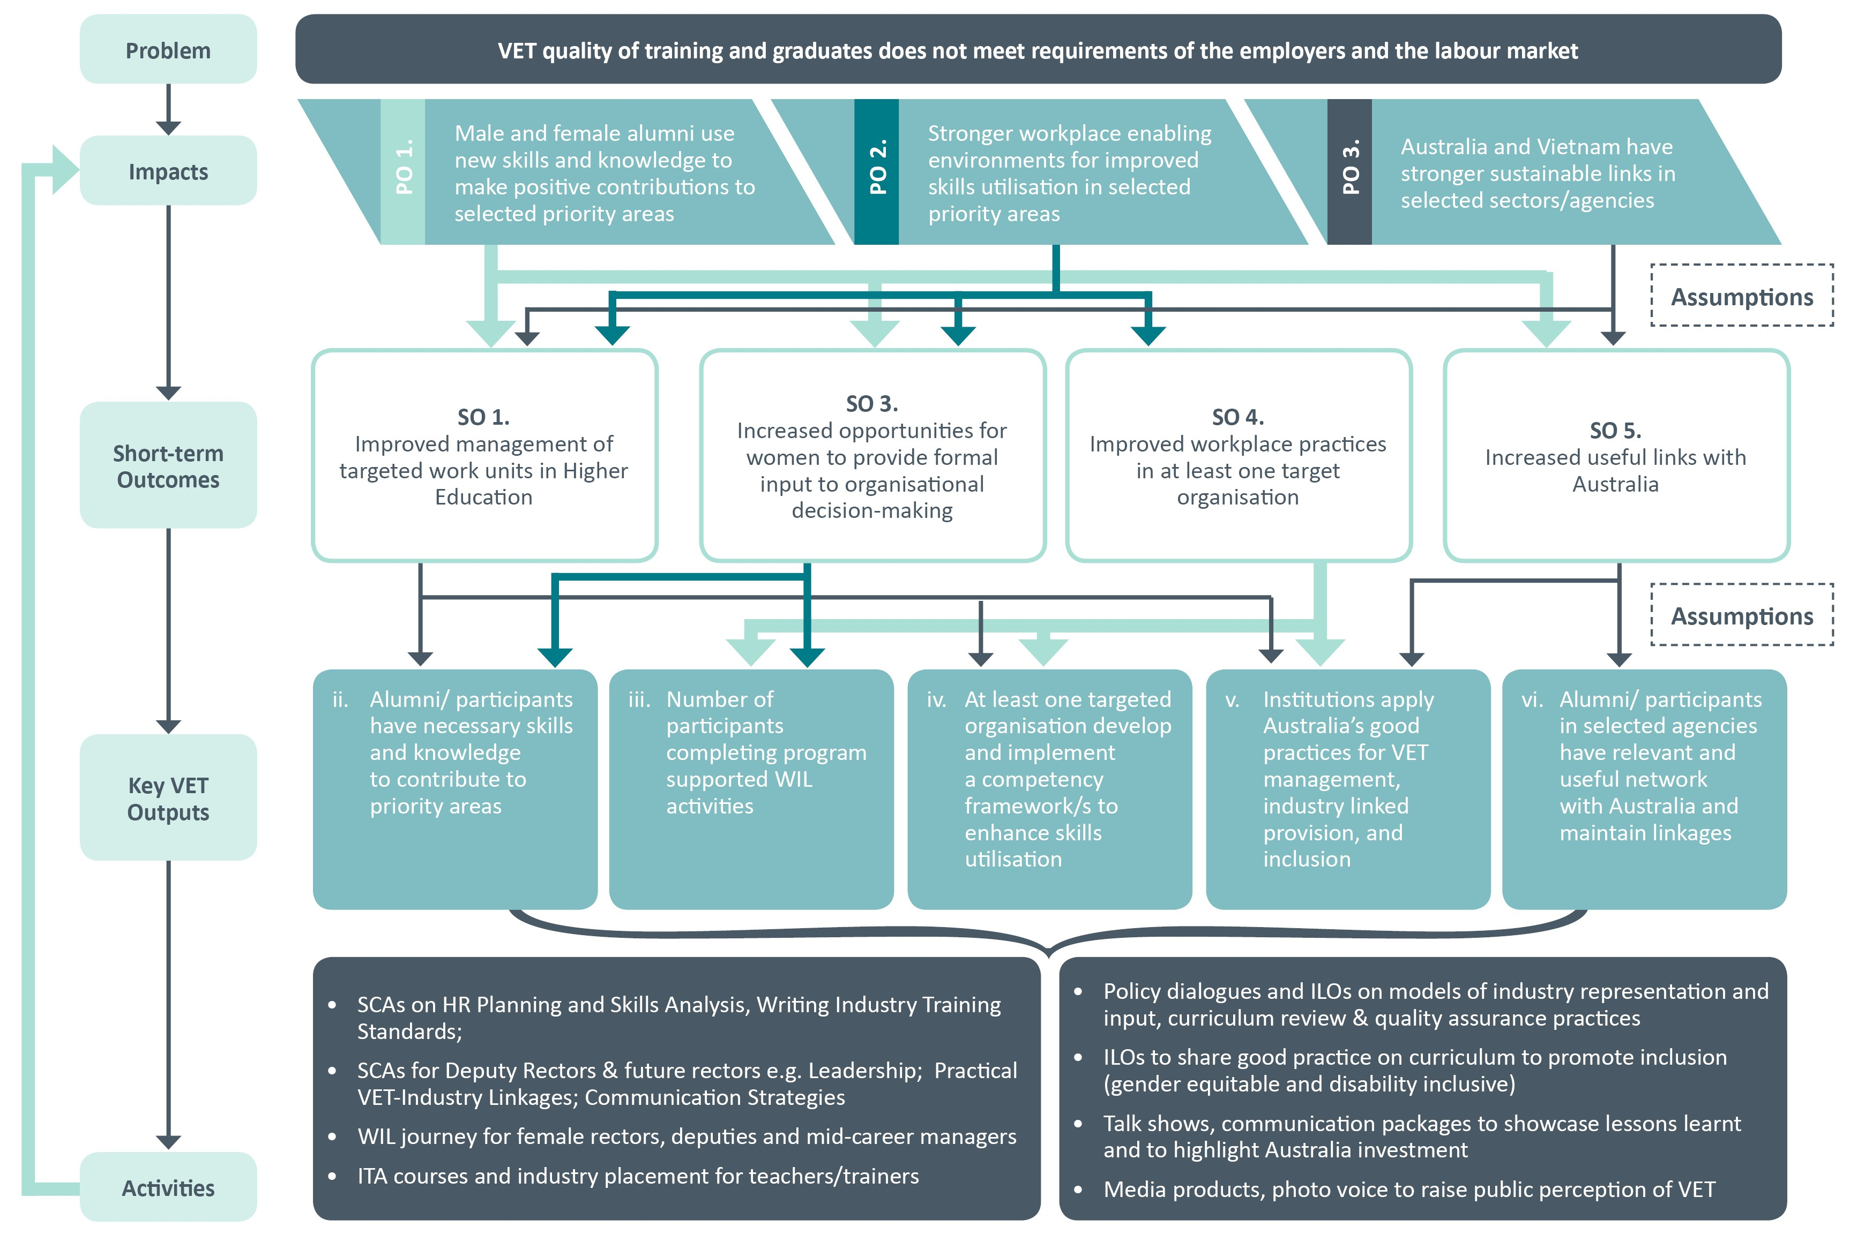

## Improving Quality in North Western Universities

There is great diversity among universities in Vietnam, but the AIP directed geographic focus to the northern mountain region. Initial focus will be on the two regional universities in the region reporting to MOET i.e. TNU and TBU. The problems of these two relatively young universities in this socially and economically disadvantaged region of Vietnam are numerous. A problem analysis has been prepared based on extensive engagement and consultations (as reported in the Annual Report 2016).

The key problem has been identified as **Universities cannot meet market demand in terms of quality or quantity of education and research.** This component is designed to address the following identified causes of the problem:

* + Teachers do not have skills to assist students who need additional assistance;
  + Teaching lacks consistent quality and relevance to the needs of the labour market;
  + Lack of strong relations with employers interested in curriculum content;
  + Industry and other stakeholders do not partner for planning and use of research;
  + Academic staff lack strong research skills & international networks;
  + Lack of agreement on how the university should be led & managed;
  + Lack of management and leadership skills; and
  + Glass ceiling for women’s promotion to highest levels.

Addressing the problem to achieve the intended Program outcomes has produced the following considerations to achieve the desired short-term outcomes. This component can contribute to all the desired short-term outcomes.

**Short-term Outcome 1:** Improved management of targeted work units in higher education.

Senior university management and future university leaders will learn how to demonstrate credible and trustworthy strategic and future-oriented leadership. Work unit leaders will learn about the particularities of managing for research and curriculum quality and relevance to the regional needs (as specified in both university mission statements).

There will be a focus on strengthening leadership equitably enabling career pathways for both men and women.

**Short-term Outcome 2:** Increased access to higher education by targeted disadvantaged groups.

Both the targeted universities serve a high proportion of ethnic minority students, and other disadvantaged groups. Teachers will develop skills and the universities better capacity to assist disadvantaged students who need additional assistance to succeed at university. This will require both ensuring that the curriculum is designed inclusively and that the teachers model and embrace inclusive ways of teaching and relating to each other and students. The development of special programs (outside the regular academic curriculum) that strengthen the successful participation of disadvantaged groups may be supported.

**Short-term Outcome 3:** Increased opportunities for women to provide formal input to organisational decision-making.

Women from these two universities and their regional stakeholder organisations will be selected to participate in activities under the component Advancing Women in Leadership. Both women and men in the universities and closely related stakeholder organisations will be offered opportunities to build their own personal capacity for gender equitable leadership. When both men and women apply their new skills, more women will choose to be more visibly active in organisational decision-making in their workplaces and community groups.

**Short-term Outcome 4:** Improved workplace practices in 2-3 targeted organisations.

At least one unit in a university will be a targeted organisation to demonstrate improved workplace practices that enable gender-equitable utilisation of new skills and knowledge. Here the focus is on how the workplace environment enables participants and alumni of Aus4Skills to use new skills and knowledge gained in this program.

**Short-term Outcome 5:** Increased useful links with Australia.

This component, in particular,will pursueincreased productive collaborations between Vietnamese and Australian universities or research partners. Relationships with Australian industry partners will equally be encouraged where available. At institutional level, both universities have expressed interest in developing ‘sister’ relationships and joint programs with Australian universities. Linkages may also develop usefully at unit level, or in networks of research teams, or among academics with particular interests in such practices for enabling success for disadvantaged groups.

See **Annex 2** for more details on the design of this component. Both universities face similar challenges and are eager for better links with Australian universities. It is expected that as they will each work to address the issues they can leverage from each other’s learning, and synergies can be found for efficiencies in delivery of HRD solutions. A workshop with key stakeholders is scheduled for the end of March 2017 to confirm the problem analysis and Aus4Skills response. Figure 4 below shows how the planned type of activities are expected to lead to short-term outcomes in this component that will result in the overall achievement of the end of program outcomes.

Figure 4: Backwards mapping of the Improving Quality in North Western Universities Component

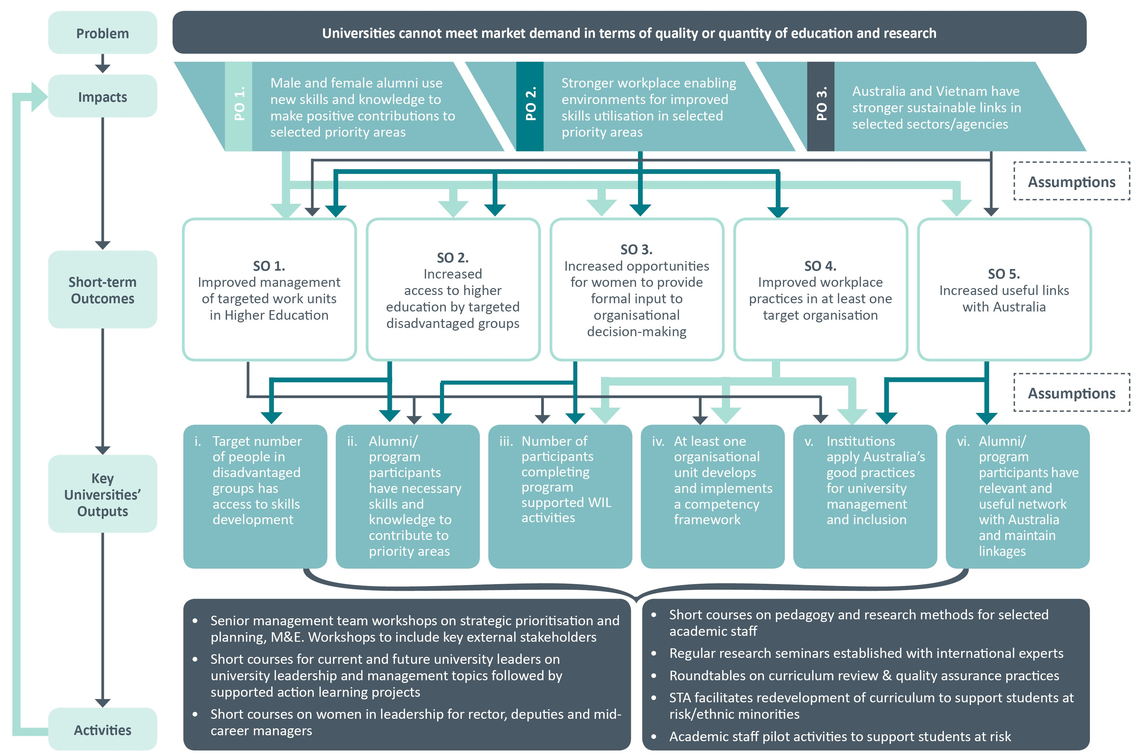

## Advancing Women in Leadership

Gender equality is an important right and a powerful driver for economic growth and development. Promoting gender equality is integral to advancing Australia’s national interests and reflects Australian values of fairness and substantive equality. There are more female alumnae than male alumni of Australia Award Scholarships, but more males hold top positions and tracer studies have shown that males progress faster and higher (than women) in their careers upon completing their scholarship. In the universities and colleges visited in 2016 under the auspices of Aus4Skills, women were under-represented in leadership compared to national targets for Vietnamese workplaces. The logistics sector is currently male dominated but no overt reason exists why women should not be able to contribute and progress in logistics.

Given the Aus4Skills desired program outcomes, this component focusses on developing the capability for gender inclusive leadership that enables both women and men to realise their potential and make active choices about their progress upwards in organisational hierarchies, and enabling women to take up leadership roles. **Gender inclusive leadership involves fostering gender inclusive leadership practices, for example seeking out and listening to diverse perspectives and reflecting these perspectives in work practices, policy development and decision-making**. Measurement of this component for evaluation purposes will focus on the gender inclusive dimension of leadership. This focus for evaluation acknowledges that striving for fully gender equitable leadership is the goal, but achieving this requires fundamental long term change in attitudes and values that will take a long time to realise.

Significant research work has been done about the issues affecting the recognition and participation of women in leadership roles in Vietnam. The key problem has been identified as **Women do not have equal opportunities to be promoted to top leadership positions in business and politics.** This component is designed to address the following identified causes of the problem:

* Double-standard for female and male leadership in the public and private sector:
  + Higher standards (of experience, qualifications and conduct) are applied for women to be promoted to top positions;
  + Leadership often identified as a male competency; and
  + Double-standards for self-promotion i.e. males’ self-promotion is often acceptable when females’ self-promotion is not.
* Lack of examples of or role models for women's pathways to leadership in the public sector;
* Women lack opportunities to develop leadership, networking, and communication skills (e.g. presentation, negotiation, public speaking);
* Discriminatory HR policies and promotion practice in selected priority organisations; and
* Lack of gender responsive male and female leaders, including few advocates for women’s promotion, in the public sector.

Advancing Women in Leadership Component will contribute especially to both

**Short-term Outcome 3:** Increased opportunities for women to provide formal input to organisational decision-making, and

**Short-term Outcome 4:** Improved workplace practices in 2-3 targeted organisations.

This component provides a cross-cutting, integrated focus on enabling women in leadership throughout Aus4Skills initiatives. Therefore, creative means to integrate enabling women in leadership have been, and will continue to be, sought in the other components. This will involve a range of modalities, including activities that involve men and women together, some for men only and some for women only.

Women’s leadership will be enabled by (1) *agency* - the skills, knowledge and confidence to lead; (2) *relations* - the networks, relationships and coalitions between women and women, and women and men; and (3) *structural conditions* - social and cultural norms, policies, political, economic and social institutions and at its core this links back to values and beliefs and attitudes, including unconscious bias.

This Advancing Women in Leadership component will include:

* + A WIL-specific short course award, called WIL Journey, that can be tailored for various cohorts and be actively inclusive of women from disadvantaged groups
  + One short-course and ILOs to provide gender sensitisation training, career planning, review of HR policies and procedures for selected partners
  + One male only STT – emerging male gender champions of change
  + GeLead (Vietnam’s Center for Gender and Women’s Leadership) is expected to agree to deliver gender equitable leadership training to mid-career men and women in the public sector and research capacity on women’s leadership issues relevant to Aus4Skills outcomes. The preparation of the details of the agreement are underway.

In the first half of 2017, short term technical advice will be used to write a generic set of terms of reference for a SCA on the broad topics of Enabling and Supporting Women in Leadership. Once developed, this course will be ready to deliver to multiple target groups, and tailored appropriately for each one, over the coming four years. Targeted organisations may have it tailored to their needs, or specific groups of participants may be targeted on a thematic basis which will contribute to the achievement of Program outcomes, e.g specific groups of Australian alumni, a delivery especially for rurally disadvantaged women, or for persons with disabilities.

Based on mission and capacity, GeLead has been confirmed as an implementing partner for this component. GeLead is a teaching, consultancy and research unit of the Ho Chi Minh National Academy of Politics (HCMA). The MC has engaged with GeLead management to identify their available and suitable curriculum and training and research competencies. Subject to formal agreement, the MC has reached in principle agreement with GeLead to cooperate in networking and communications, in identifying organisational and individual needs, and in delivering ILOs. Already the GeLead Deputy Director has facilitated, in Vietnamese, the very well-received Women in Leadership Forum (November 2016) which brought together key actors in gender equality from all sectors in Vietnam. The discussion at the Forum has helped focus the selection of activities with respect to enabling and supporting Women in Leadership in this Design.

See **Annex 3** for more details on the design of this component.

## Supporting Australia’s Aid Investment Plan

In addition to the organisations identified in Components 1 and 2, other “priority organisations” will be nominated by DFAT Hanoi. Those organisations will be targeted for HRD assistance because they are already working with Australia and are important to Australia’s future priorities and Vietnam’s development; i.e. organisational actors in the other Australian aid programs in Vietnam. At the time of writing specific organisations had not been identified (beyond the target organisations for Australia Awards Scholarships for the 2018 Intake).

The MC and DFAT are aware of the risk of high but diffuse demands for assistance. Spreading energies and resources thinly risks lowering outcomes’ achievement and impact. Most of the AIP areas are male-dominated so it is predictable that all will benefit from efforts towards gender inclusion and gender equitable leadership. As the organisations plan for new endeavours or growth they can also be predicted to benefit from competency analysis and planning for skills needs because such practices are not widely used in Vietnam. It is anticipated that this component includes some generic skills training that can be offered across organisations. Depending on need and demand, it may also provide for other more specific technical skills development.

Any modalities in the HRD toolbox may be used, but a more limited range is anticipated in this component compared to the investments in the foregoing components. To help keep Program efforts focussed and cohesive, some learning opportunity/ies can be designed on generic themes (i.e. ready packages on the shelf), for offer once a year to target organisations with the potential and readiness for tailoring to specific organisational characteristics or contexts.

In this component, targeted priority organisations need to demonstrate commitment to collaboration with Australian partners. The HRD assistance will be tailored to meet their specific needs and demands with regard to their Australian partnerships. Identified priority organisations, among other things, should be willing to incorporate inclusive and gender equitable practices and competency approaches to workplace operations, and support the adaptation and delivery of relevant workplace-oriented short course training.

## Supporting Australia’s Broader Interests

This component provides for HRD assistance to organisations, and potentially individuals, as directed by the Embassy, outside the groups of organisations targeted in the former components i.e. beyond the AIP when such interests emerge. Any modalities in the HRD toolbox may be used, but the activity must contribute to the intended program outcomes. In the early years of the Program, relevant activities in this area may include specialist technical assistance to renew the curriculum on human rights at Vietnam National University (VNU) Hanoi, and response to a request for assistance in training abattoir workers processing Australian live cattle and red meat.

# Implementation Arrangements

Aiming for an effective, efficient, focused, innovative and results-based investment in HRD in Vietnam, the implementation of the non-scholarship activities will be managed in ways that align with the following eight implementation principles:

1. **Maximise linkages and complementarities between GoA investments**

Maximising linkages and complementarities will assist the strategic cohesion of the broad aid investment. The details of modalities will be chosen to directly serve the joint interests of Australia and the targeted organisation/s, where possible delivering across organisations if appropriate (e.g. common need that can be met with the same modality). The MC will work as far as possible with the current Australia Volunteers for International Development (AVID) program (to be replaced by the new Australian Volunteers Program in July 2017), applicants for and host organisations of Australia Award Fellowships and Vietnam-bound New Columbo Plan (NCP) participants also to seek complementarities and linkages. To expedite this cohesion, the DFAT staff and the MC will work as One Team to engage with targeted organisations, and advance the achievement of Australia’s objectives in Vietnam.

1. **Promote partnerships between Australian and Vietnamese organisations**

In the Program priority sectors, when both sides invest materially in the ongoing relationship for mutual benefit, including peer learning, the effects of the activities can be expected to be sustainable i.e. outlive DFAT funding. The MC needs to develop and maintain relationships with both the Vietnamese and Australian actors for partnership. The Australian side may be other GoA departments, Australian industry, education and training providers or other key stakeholders in partnerships that DFAT chooses to support through Program inputs *to* develop and maintain those working relationships effectively.

1. **Assess readiness**

Organisations who are targeted will be assessed for their willingness and ability to commit to the partnership and contribute to design and implementation of a HRD package. This readiness includes readiness to deploy competency based approaches, to nominate and support participants equitably and inclusively; and to provide co-contributions to the resourcing of activities in terms of co-funding or in-kind contributions.

1. **Promote Gender Equality, Disability and Social Inclusion (GEDSI) inclusion**

Organisations who are targeted should be GEDSI responsive and willing to improve their practices for the sake of equality and enabling opportunities for disadvantaged GEDSI groups including for long term awards. The MC will work with targeted organisations to identify where improvement efforts can be directed, and aim to design specific activities to make a positive difference in practice. DFAT and the MC acknowledge that some organisations may be at the stage of needing initial awareness training and the road may be long before visible changes in practice are evident.

1. **Engage with the private sector**

GoA representatives in Vietnam and the MC will engage with private sector representatives in Vietnam to encourage them to see the benefits of competency based occupational standards, and investment in relationships with universities and VET providers in ways that contribute to efforts to produce work-ready graduates. To this end, the MC looks for ways to engage also with relevant Australian businesses and Australian and Vietnamese peak industry bodies who have an interest in the achievement of the Program outcomes.

1. **Build on and promote Australian strengths**

The design of inputs and activities will take advantage of Australia’s demonstrated strengths and expertise, and use Australian providers where possible. Using Australian providers also provides opportunities to build linkages and partnerships.

1. **Ensure value for money**

The MC will aim to avoid unnecessary duplication of efforts, and wherever possible design activities and inputs that add value to existing activities delivered under the Program or by other organisations with similar interests and objectives (could be local or international organisations, donors or non-government organisations, private organisations etc), and contribute to the achievement of already defined priorities (work with organisational momentum where possible). The MC will look for synergies between activities and inputs in different target organisations, including synergies where relevant and available with other Australian-funded HRD activities in the region. The MC will take advantage of lessons learned from other HRD activities in the region and apply those lessons as far as possible in this Program.

1. **Seek innovative solutions**

Wherever possible, the MC will,based on a clear rationale,try new approaches where these are appropriate, working with identified champions inside target organisations as allies. New activities will be piloted, then scaled if they are shown to work and show promise to achieve the desired outcomes. Innovation here especially includes application: where inputs provide new skills and knowledge, the MC will ensure that the design includes mechanisms for application of these in organisations, and that mechanisms are in place to capture learning about the applicability of particular skills and knowledge e.g. action learning.

## Guidelines for Choices of Delivery Modalities

This section describes further the choices about the use of what the overall Program Design document and SoR (§1.6) referred to as the HRD “toolbox.” The term was used to indicate the broad range of possible HRD tools or modalities that are available to be used to achieve the Program outcomes. Given the potential breadth and range, it is important to remember that in addition to considering the principles of implementation listed above, modalities recommended by the MC for use will:

* + be preferentially targeted to specific work units in priority organisations;
  + address the values and interests of Vietnamese and other stakeholders;
  + be chosen for their realistic likelihood of achieving the desired outputs and outcomes; and
  + avoid unnecessary duplication of effort.

The HRD Toolbox which sets out three categories of “tools” or modalities: Formal Australia Awards, Australia Award Complementary Assistance and Informal Learning Opportunities (ILOs) as described below.

**Formal Australia Awards**

These consist of Australia Awards Scholarships, Australia Awards Short Courses and Australia Awards Fellowships (AAF). The MC will be cognizant of the relevant definitions and standards that apply to these Awards.

Australia Awards Scholarships will be available, either directly, through targeted provision to an organisation as agreed with the Embassy, or indirectly, by default through ‘open’ application processes. The use of Australia Awards Scholarships and processes for delivery are set out in detail in the main Aus4Skills (VAHRDP) design.

When considering the assistance that is likely to help a target organisation, the MC may identify AAF as desirable. In this case the MC will assist in the identification of an Australian organisation who may be willing to apply for, and if the application is successful, host a fellowship including participants from the targeted Vietnamese organisation.

*Short Course Awards*

Australia Awards Short Course Awards (SCAs) can be substantially more flexible and responsive than long-term awards, but they still provide some form of recognised academic credit or statements of competency (to Australian Qualifications Framework (AQF) standards) to participants who successfully complete the course requirements. They involve engaging an Australian university or Registered Training Organisation to conduct the short course as a separate exercise to its normal academic intakes. This means that SCAs can be customised so the timing and content of a short course can be tailored to suit specified needs.

Short courses may be delivered in Vietnam or Australia, or a combination of both.

Short course awardees may be offered some pre-departure and on-ward enhancement support, depending on the scope of the course and the needs it is intended to meet. For example, in some cases English language preparation may be included.

Based on the preferences expressed by GoV, discussions with HRD staff at the Embassy, and experience of the direction of DFAT’s HRD programs in neighbouring countries, short courses will become an increasingly common modality so warrant more description. Hitherto short courses have not played a prominent part in Australia’s aid programs in Vietnam, but the Vietnamese Government requested more short courses for their ability to target very specific knowledge and skills needs, and the reduced time that participants are expected to be in Australia.

The MC has no indications of resistance to this modality from targeted organisations or potential participants, but is also wary that short courses do not guarantee the use of new skills and knowledge or sustainable linkages between Australia and Vietnam. Short courses still take individuals away from their regular duties and some targeted organisations and target participants have limited tolerances for absences. The MC will **test investments in new courses before scaling up** where short courses prove to be effective to achieve the intended outcomes.

An essential matter is that the participants and their organisations perceive the relevance of any short course and that **the content is tailored in ways that allow the participants to apply it to their context** in Vietnam. Site visits in Australia are highly valued when the relevance is self-evident, and the high pastoral needs for groups visiting Australia for the first time and only for short visits also must be noted. Many in the target groups may not have high levels of English language competence and depend heavily on translation and interpretation. Both in Australia or Vietnam, **contemporary, educationally sound delivery methods** such as blended learning, project based learning, flipped classroom and competency based learning are preferred. Guided cycles of action planning and reflection and adjustment of plans and actions to apply lessons to each participant’s working context in Vietnam are proven tools for optimising the benefits derived from training.

SCAs meet specific criteria under Australia Awards. Wherever possible and appropriate, short term training will be designed and delivered to meet the Awards criteria. In the first quarter of 2017, the MC will develop **a Manual for the development and delivery of SCAs** under this Program. The Manual will include processes for prioritising requests, scoping, procuring, delivering, monitoring and evaluating SCAs. The MC notes that the Australia Awards Indonesia Program has implemented a manual for similar purposes, and been using it long enough that an evaluation report on SCAs is already available, including a “lessons learned” section. The MC will take these documents into consideration and consult with our counterparts in the Indonesian program to adapt their expertise to the circumstances in Vietnam.

DFAT staff in Hanoi have a role in prioritising short course proposals to address the HRD needs of target organisations and priority sectors under the AIP, and overall decision-making on priorities for short courses. For budgeting and planning purposes, a clear **pipeline of courses for the coming financial year**(s) needs to be established, while allowing some flexibility for delivery of a small number of ad hoc courses that may be identified/proposed outside of the prioritisation process.

The SCA mechanism will need to be ready to provide both *generic training and education* (a standing contract to deliver more generic courses that can be accessed by participants from multiple organisations) and *tailored offerings* (specific to an identified skills gap in an organisation or sector, more technically focussed). Table A below indicates how the mechanism can operate.

Table : Mechanism for generic and tailored short courses

|  |  |  |  |  |  |
| --- | --- | --- | --- | --- | --- |
|  | **2016/17** | **2017/18** | **2018/19** | **2019/20** | **2020/21** |
| Establishment of processes |  |  |  |  |  |
| Start working with partners on concepts for pilot courses |  |  |  |  |  |
| Deliver pilot courses to test processes |  |  |  |  |  |
| Set up sub-contract for multi-year/repeat/generic courses |  |  |  |  |  |
| Deliver multi-year/repeat/generic courses |  |  |  |  |  |
| Deliver tailored courses for targeted organisations under AIP |  |  |  |  |  |

Typically in Aus4Skills, a SCA design –whether generic or tailored - will include an in-Australia ‘core’ module to provide opportunity for an “Australia experience” (SoR §1.22) that is sandwiched between an initial module in Vietnam and a follow-up module that involves supported ‘action learning’ to apply the knowledge and skills learned where possible and appropriate. As specified in the SoR, the in-Vietnam components of SCAs should be delivered in partnership between an Australian Registered Training Organisation (RTO) and a Vietnamese organisation to provide mutual benefits.

**Pre-core modules** will typically involve travel to Vietnam by trainers and representatives of the selected Australia training partner in order to conduct a workshop or structured activity aimed at priming course participants for the in-Australia module. Pre-core visits may result in changes to the content of the **in-Australia core module/s** based on learning and deeper understanding of the needs of participants. **Post-core modules** will typically involve ongoing contact between the Australian provider and the participants to support a structured process of application of skills and knowledge in the workplace accompanied by reflection and capturing learning about the effectiveness of the application efforts.

Details about **content, duration and location** will be determined for each SCA as part of a detailed design process leading to a finalised Course Design document. SCAs will be designed around a set subject matter and customised around recipients’ needs with the aim of maximising learning opportunities. SCAs will generally require less than three months for the in-Australia core module. Providers and delivery locations may differ from course to course, however in most cases courses will include pre- and post-core modules delivered in Vietnam, and a core module delivered in Australia. This will be specified in Terms of Reference for the detailed development of the required SCA.

Each short course will be **designed for a clearly specified target group of participants**. The Manual will include information about managing selection participants, pre-departure support, on award engagement, and alumni engagement. Research indicates that between 15 and 20 participants is the optimum number for each course. Aggregated across the whole program, the **participant profile must conform to Program targets** for inclusion of at least 50% women, and the notional 20% target for people with a disability and people disadvantaged by rural isolation. Without careful selection of organisational units, when training opportunities are primarily targeted to senior leadership, and management teams and identified potential managers, the rate of participation of disadvantaged groups can be low. These disadvantaged groups may also face other barriers e.g. discriminatory attitudes and unconscious bias by management that travel for an in-Australia experience will be too challenging or too resource intensive, but the MC will ensure that processes are in place for these people to participate equitably. The Manual will reiterate that short courses will be designed and delivered to achieve GEDSI targets.

Based on an overview of the Program, the MC and HRD staff at the Embassy from time to time may identify, for short courses, **thematic target groups** who are not part of only one targeted organisation or sector. The likely target group for the WIL course is a case in point. Another thematic target group could be managers in VET colleges who have been nominated at Centres of Excellence or managers in various targeted organisations, when a common need for managerial skills development is identified.

Only when an agreed short course need and/or the context determines a short course response will not meet the SCA definition, (such as when a Vietnamese or other non-Australian training provider is justified), or where the SCA mechanism is unavailable), will separate STT be considered outside of the Australia Awards Short Course Awards (SoR §1.23) Other STT that does not meet the criteria to be an Australia Award is correctly an Informal Learning Opportunity. The **mix of tools to be used for each component** will be agreed annually by the MC and HRD staff at the Embassy.

Initially the MC will identify and agree with the DFAT staff up to three SCAs that can be repeated and each delivered up to three times over Years 3, 4 and 5 of the program. This is to enable both quality design, continuous quality improvement based on lessons learned, and economies of scale. These courses may serve any of the five Program components described above. The requests from other AIP programs have not yet been specified at the time of writing.

Based on available needs analysis, the MC recommends developing initially the following **two short course awards for repeated delivery**:

a. A course in gender equitable leadership for women working at mid-level of their organisation either as experts or in designated management posts.

b. A course in strategic management and leadership for leaders in various organisations of interest to Australia. Initially, target participants of this course will be from higher education i.e. senior unit managers and deans and deputies from the NW universities, selected VET managers, with possible inclusion of key MOET, GDVT, and provincial officials from agencies like Provincial Department of Education and Training (DOET) and Provincial Department of Labour, Invalids and Social Affairs (DOLISA). It may also be possible to include leaders from VET colleges and training managers in enterprises in the targeted VET sectors. When other AIP programs are implemented other organisations and their leaders will be identified to participate.

As more targeted organisations are identified from other AIP programs or within the scope of Australis’s broader interests, a SCA need may be recognised for a course on topics such as public policy or skills analysis for future planning. The engagement and needs analysis, as described in 4.2 below will serve to recognise such needs.

**Australia Award Complementary Assistance**

As the name suggests, this part of the toolbox is that which provides additional assistance to individuals who are Australia Awards applicants, recipients or alumni. The activities and intended outcomes are described mainly in the On Award Engagement Plan and the Alumni Engagement Plan.

This is assistance which may be preferentially provided to an organisation. It is limited to forms of assistance that directly improve the ability of individuals in that organisation to access, or maximize benefits from, formal Australia Awards. For example:

* + Preferential access by candidates from the organisation to English Language Training (ELT);
  + Preferential treatment for candidates of the organisation within Australia Award selection processes;
  + Provision of assistance to candidates from the organisation to complete and submit Australia Award applications;
  + Direct assistance to the organisation to formulate and submit AAF proposals in association with relevant Australian organisations (including assistance with identification of relevant proposal partners and associated negotiations); or
  + Preferential access to on-Award activities and assistance.

In appropriate circumstances with agreement or direction from DFAT, Australia Award Complementary Assistance may also be offered to groupings of individuals across targeted priority organisations. This may be necessary when targeting special types of individuals, such as program managers, female alumni, ethnic minorities, rural populations, etc.

**Informal Learning Opportunities (ILO)**

ILOs are a highly flexible means of providing a virtually unlimited range of HRD-related assistance to an organisation. They do not need to meet the definitions or standards set by formal Australia Awards[7] and therefore allow for more flexible deployment. They will be used purposefully, and built from scratch if necessary, to meet HRD needs and demand aligned to Program outcomes.

ILOs may be offered, as appropriate and with agreement or direction from DFAT, to individuals, organisations or cross-cutting thematic groupings of individuals. Targeting cross-cutting thematic groups may be particularly relevant when individuals, such as program managers, female alumni, people with disabilities, ethnic minorities, rural populations, etc. require strong inter-sectoral partnerships within their sector and/or between various sectors.

Recognising that the uptake of skilled workers can be hampered by employers’ limited leadership capabilities and understanding of human resources development, technical support may also be provided to improve organisational capacity for skills utilisation.

ILOs may include, but are not limited to, the following pre-existing or tailor designed activities:

* + non-Australia Awards short courses of any form;
  + seminars/workshops/conferences/study tours;
  + Technical Assistance in any relevant field (showcasing Australian and alumni expertise);
  + Agency visits with facilitated debriefing sessions;
  + Simulations;
  + Film and performance events with Q&A;
  + Guest speaker events including events in Ted Talk and lounge style formats;
  + Facilitated Communication for Development(C4D)/advocacy opportunities;
  + Mentoring and coaching exercises;
  + Short work placements;
  + Identifying, negotiating and facilitating opportunities for linkages between Australian and Vietnamese organisations (unless contrary to Australian Commonwealth Procurement Rule);
  + A flexible fund for miscellaneous un-foreseen short term activities to be drawn on as directed by DFAT.

While this plan sets out the Design for investments in five components, the detailed mix of modalities will be re-confirmed each year subject to monitoring the pilots and budget availability. Whatever modalities are chosen, they will be deployed with clearly specified targets, responsive to the context and strategic intents, to optimise the likelihood of achievement of the Program outcomes.

## Management Arrangements

Coffey, a Tetra-tech company, has been appointed as the MC for the Aus4Skills Program, and therefore manages the implementation of the components described herein, in accordance with Annual Plans agreed with DFAT Hanoi. The One Team approach articulated in the Inception Plan (2016) is operating to ensure that the DFAT HRD team in Hanoi and the MC are acting hand in hand as Aus4Skills is implemented. The strategies and plans that were delivered in 2016, predominantly through Thematic Working Groups, apply to the whole program and will be updated on an annual basis to ensure that they suffice for each of the components in this Design.

Non-scholarship components with relevant activities and inputs will be introduced into the Annual Plans from 2017 onwards. A review of the Program management and staffing structure has been initiated and any adjustments and/or change-management needs recognised and introduced from early 2017, and reviewed annually as part of the annual planning process. This includes any revision to the Thematic Working Groups or how they operate.

Similarly the budget will be fully reviewed with DFAT and any approved budget reallocations will be introduced from early 2017 and approved through the annual planning process, and, if applicable, any contract amendments.

**Delivery steps for non-scholarship activities**

This sub-section explains the steps for developing for inputs and activities for selected priority organisations and/or selected target groups. The overall approach will follow agreed steps, elaborated below and illustrated in Figure 5. Detailed actions will be tailored according to DFAT interests and the identified needs of the targeted priority organisation or group. The end result will be “HRD solution packages” for targeted organisations that achieve specific measurable outcomes.

The amount of time needed for each step will depend on the nature of the DFAT intent with the targeted organisation. Completing the steps is anticipated to be more complex and time consuming with the **HRD selected organisations** than with the **other AIP partner organisations**. In the latter case and with **other Australian interests**, often a problem analysis will have been done by others and a relatively specific request will be forwarded to the MC from DFAT.

Each step is subject to DFAT’s written approval. This may be given in email. In accordance with the One Team principle, DFAT and the MC will be in frequent communication along the way so that written approvals will essentially be confirmations of agreements already arrived at together.

Figure 5: Summary of Steps in Aus4Skills Delivery Approach

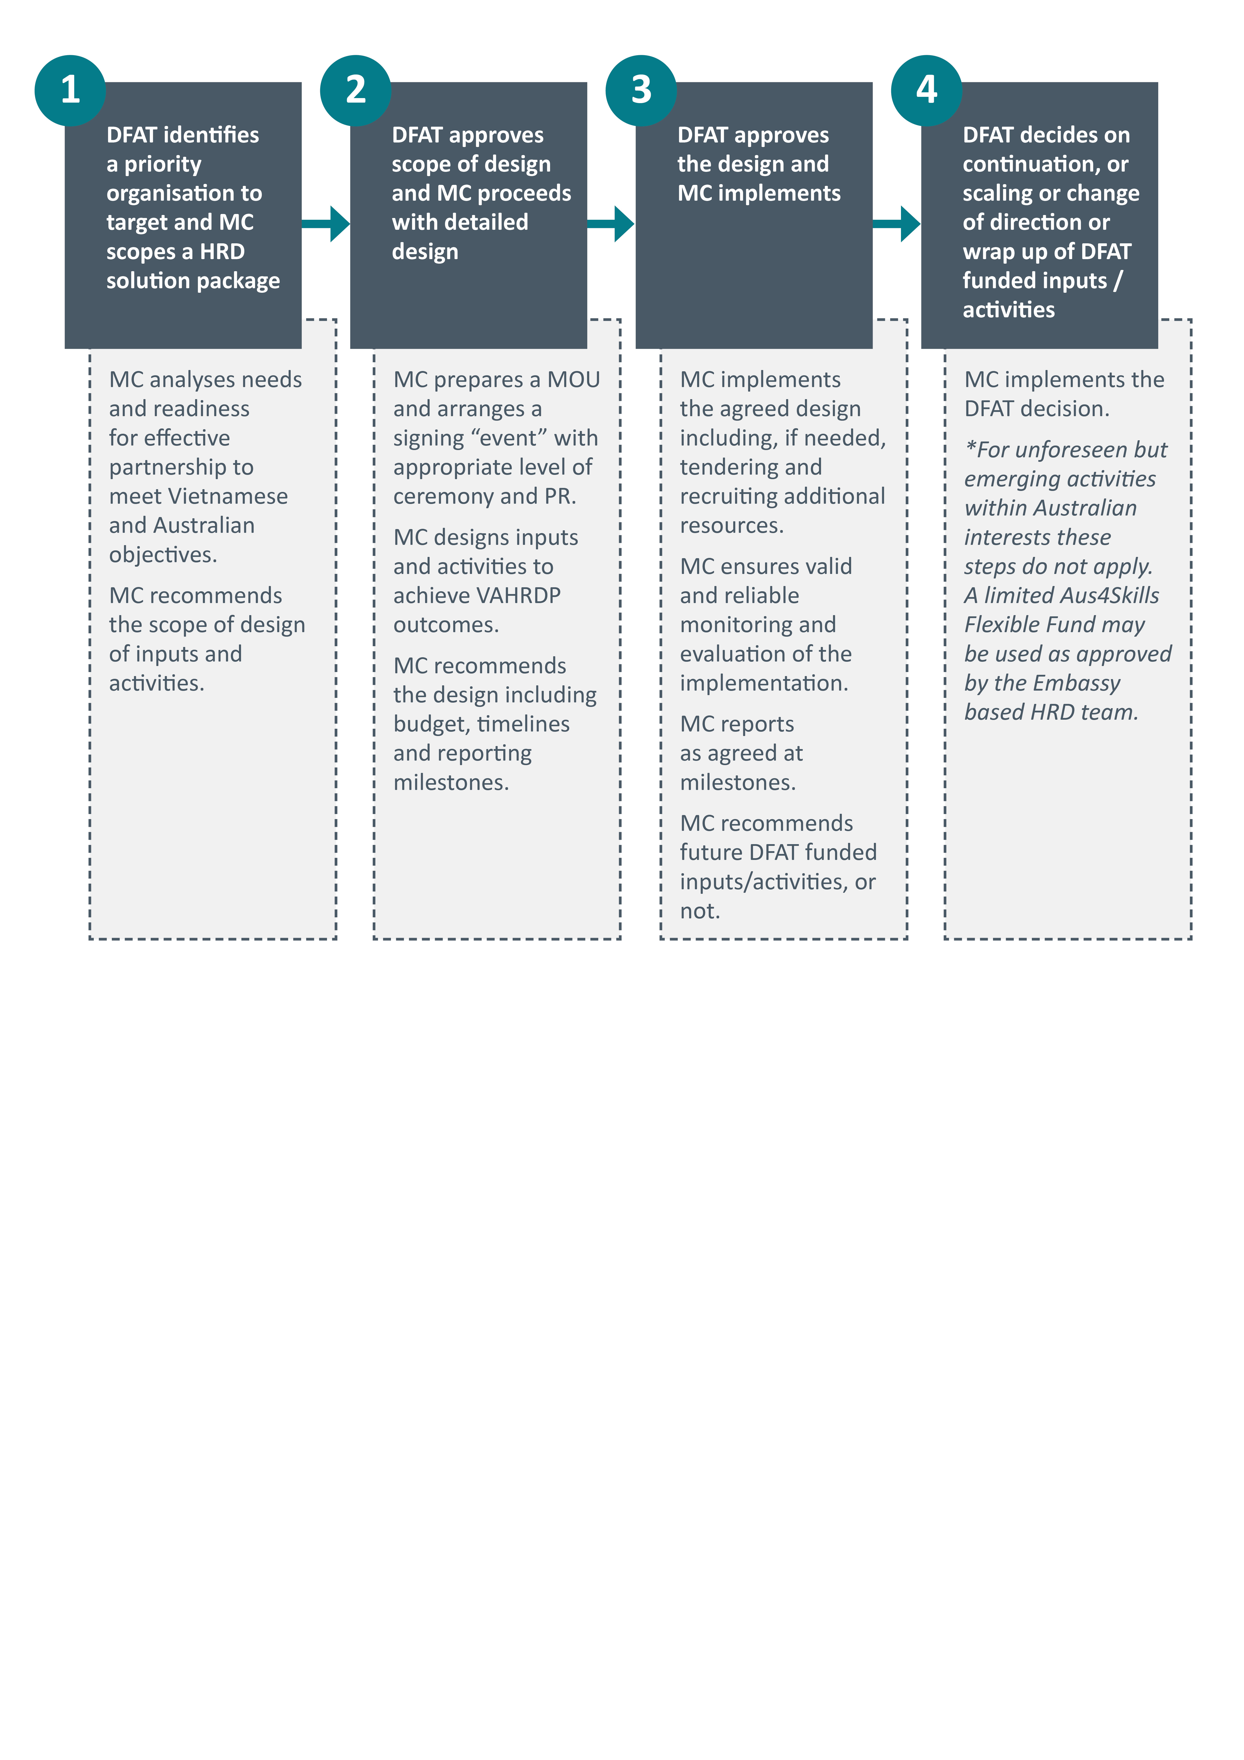

**Step 1: DFAT identifies a priority organisation to target under Aus4Skills and MC scopes a HRD solution package**

DFAT identifies priority organisations and make the appropriate introduction on the purpose and scope of the HRD intervention so the MC can engage with each prioritised organisation. Based on an organisational assessment, the MC may recommend the scope of design of inputs and activities under Aus4Skills for each suggested priority organisation. The extent and depth of the organisational assessment will depend on the intent of the DFAT program manager.

If DFAT can identify target organisations each year by agreed time that should allow time for Step 1 to be completed in time for inclusion of steps 2-4 in the forthcoming annual planning cycle. That Plan is submitted each March for the coming financial year.

The organisational assessment will be primarily an assessment of readiness, including:

* + **Organisational purpose:** understanding the organisational purpose and current strategic priorities, based on organisational texts and discussions with senior management and key stakeholders including players that represent GEDSI interests;
  + **Current needs:** analysing the current needs for assistance so the organisation can most effectively partner with Australia to serve mutual interests (including supporting gender equitable leadership), based on discussions with senior management and interviews with key staff and key stakeholders including players that represent GEDSI interests (and alumni where applicable), visits to key locations for site and process observations;
  + **Institutional context:** evaluating the institutional and operating context to ascertain the organisational unit’s willingness and ability to incorporate new skills and knowledge so they are applied in practice to help the organisation achieve its goals, based on discussions with senior management, available HRD plans and HR policies, interviews with key staff, and alumni where available; and
  + **Willingness:** assessing the willingness and ability to co-contribute to resourcing particular inputs and activities, based on discussions with senior management.

Given the identified priority organisations will typically be ones with whom Australia already works, the likelihood of DFAT identifying an organisation whose organisational assessment indicates very little readiness is low. Nonetheless, this may occur and the MC will alert DFAT as soon as early warning signs appear and check DFAT’s interest in continuing. In that unlikely case, the MC most likely will recommend a very narrow scope of design of inputs and activities if any. Accurate assessment of readiness will be critical to determining what work with any particular organisation will provide the desired Program outcomes. Organisations nominated later in the Program lifecycle will need to be relatively more ready (than those nominated earlier) to show outcomes by 2020.

Importantly, during the organisational assessment process, the MC will build a trusting and respectful relationship with key actors in the priority organisation and other relevant stakeholders. Where there are Australian alumni in the organisation, the MC will aim to contact them and consult them about their experience in the organisation. Through these relationships, insights and understandings will be available that will be essential for the success of future activities and inputs. The broader relations with stakeholders also help the MC understand the broader institutional and operating environment of the organisation.

Based on the assessment findings, the MC recommends to DFAT the scope of design of inputs and activities for the targeted organisation. Where appropriate, the MC can provide DFAT with a draft MOU for the Australian and Vietnamese partner to sign at the highest possible level. This MOU and an accompanying prestigious signing ceremony can be an important visible endorsement of partnership for organisational members and stakeholders and a symbol of the commitment to achieving outcomes under Aus4Skills.

**Step 2: DFAT approves of the scope of design, and MC proceeds with the detailed design of a HRD package**

DFAT will approve the scope (or re-negotiate the scope) and the MC will design with the target organisation a package including budget, timelines and reporting milestones, in accordance with the approved scope. The MC will:

* + in close consultation with DFAT, prepare an MOU and arrange a signing “event” with appropriate level of ceremony and PR. An exception may be where Aus4Skills is only providing a minor HRD package to complement a much larger AIP program;
  + in consultation with the target organisation, design inputs and activities that will improve the skills and knowledge of the organisational participants to ensure there is a positive enabling environment for both the use of new skills and knowledge, and strengthening linkages with Australia;
  + identify the known limits to what the activities and inputs can achieve, and prepare a risk management plan;
  + recommend the detailed design including budget, timelines and reporting milestones; and
  + establish the baseline for future comparison and evidence of change at step 2.

**Step 3: DFAT approves the designed HRD package and MC proceeds to implementation**

DFAT will approve the designed package before the MC proceeds to implementation with each targeted organisation. The MC will coordinate the delivery of agreed inputs and activities, including monitoring and evaluation, i.e. the MC will:

* + implement the agreed design including tendering and recruiting additional resources, as needed;
  + ensure valid and reliable monitoring and evaluation (M&E) of the implementation;
  + report as agreed at milestones; and
  + recommend continuation, scaling, change of direction or wrap up as appropriate for the DFAT funded inputs/activities.

**Step 4: DFAT decision on continuation, change of direction or wrap up of activities and inputs**

On the basis of monitoring and evaluation, inputs and activities may be adjusted, scaled, amended or wound up according to agreements with the organisation and DFAT in Hanoi. The DFAT decision will be implemented by the MC. Lessons learned will be gathered to inform future initiatives.

**Implementation and Procurement considerations**

The execution of the non-scholarship components will require the MC to **restructure the responsibilities of the current staff in Hanoi** because of the necessities to manage a rapid increase in the number and variety of activities that must be coordinated in close cooperation with partners. These partners are the targeted recipient organisations, and partners in delivery/sub-contractors. Relationship management with these partners is going to be an essential part of the MC work to ensure the quality and success of activities and achieving the Aus4Skills program outcomes. The Annexes identify some of the most likely partners to begin with. New partners will be identified as the MC subcontracts for management of SCAs, STT, ILOs and other inputs such as research or technical assistance. Some events may be externally managed by subcontractors and so might some of the basic transactional aspects of mobilising Vietnamese participants to travel to Australia for short courses and study tours.

In addition to a strong emphasis on partnerships with selected organisations, the other characteristic of the non-scholarship components of Aus4Skills is that the MC needs to be able to **respond flexibly and fast as needs are identified** by DFAT Hanoi in tasking notes. This especially applies to the Australia’s Broader Interests Component. Effective working relationships with local providers for events, venues, etc, are important to be able to provide these fast flexible responses, and likewise a Standing Offer arrangement with a range of specialist technical advisors to provide the services over a set period. (AAI has demonstrated success with the latter model.)

The MC has a comprehensive Contract Management System which is fully compliant with Commonwealth Procurement Guidelines and Rules. This is implemented through the Aus4Skills Operations Manual and, in practice, **both the MC’s management support team and legal teams provide support to ensure compliant processes**. Any additions such as a Short Course Manual will be produced by the MC in conjunction with the Aus4Skills team and informed by lessons learned in other programs, including AAI.

Table B indicates the division of responsibilities among key actors – the MC, subcontractors (SC), and targeted organisations - for the diverse range of functions and tasks that need to be undertaken efficiently and effectively for the success of Aus4Skills. In its oversight role, the MC will be monitoring and providing support as need to ensure the other actors fulfil their responsibilities. Manyof the functions will be required in each component, but with different focus with respect to both content and how content is treated. For example, the WIL component is cross cutting and may involve participants who are also participating in other component activities, but still the nature of the WIL activities will be distinctive in content and thus often in process. Subsequently different types of venues will be needed for different activities, but with oversight the MC will be in a position to negotiate value for money arrangements for multiple bookings at one venue, or multiple delivery by one Australian provider[8].

Table B: Indicative responsibilities of Managing Contractor, Sub-contractors and Targeted organisations

| **MC program management responsibilities** | **Services procured and sub-contracted by MC** | **Targeted organisations’ responsibilities** |
| --- | --- | --- |
| **Engage with key stakeholders, scoping and designing activities** | | |
| Establish working relationships with potential partners |  | Engage if Aus4 Skills is of interest |
| Conduct high level organisational analysis |  | Indicate readiness and ability to participate and change practices |
| Compile Annual Plan for DFAT |  | Participate in annual planning workshops |
| Design and write scope of work for DFAT approval |  |  |
| Gain DFAT agreement on scope of work then detailed development of plans and planning for provision of services |  | Participate in detailed planning of appropriate activities, timing, participants, intended use of new skills and knowledge, measurable outcomes etc |
| Engage partners’ participation in annual planning |  | Engage actively in annual review of plans |
| Manage tendering for subcontracts in accordance with VN and AU regulations |  |  |
| Make recommendations to DFAT on the best supplier of services (to be-contracted) |  |  |
| Sub-contract conforming to all VN & AU legal requirements and quality standards |  |  |
| **Ensure high quality activities are developed and delivered** | | |
| Recruit and manage project staff located in selected key partner organisations |  | Host nominated project staff and enable them to do their work (only in selected key partner organisations) |
| Plan selected workshops and some special learning events | Undertake detailed technical needs analysis where needed | Contribute to detailed planning |
| Host selected ILOs | Conduct specific research on specified technical areas | Make relevant data available in a timely efficient manner wherever possible |
| Control quality of sub-contracted activity | Detail educational design of SCA/ILO as contracted | Collaborate with sub-contractor as far as possible |
| Manage recruitment and selection of participants, agreed aspects of mobilisation etc | Deliver SCA/ILO as contracted; (may include complementary ELT) | Nominate participants to meet the target profile for HRD activities |
| Monitor pilots and make recommendations on adjustments and scaling | Manage events logistics including suitable venue identification and hire |  |
| Ensure target organisation are well aware of long term Australia Awards opportunities and how to access those | Mobilise selected participants to be ready for SAC/ILO at the right place at the right time | Release and support chosen participants for HRD activities |
| Broker AAF and other linkage opportunities as needed | Manage on award engagement |  |
| Manage alumni engagement | Produce video as contracted |  |
|  | Design and formatting of documents |  |
| **Monitor, Evaluate and Learn** | | |
| Ensure partners and sub-contractors provide relevant activity level data for program M&E purposes | Provide accurate timely activity level data as contracted | Make relevant data available in a timely efficient manner as agreed in advance |
| Write up case studies, spot checks for M&E | Make available relevant data for case studies | Make available relevant data for case studies |
| Conduct Program monitoring and evaluation | Report on monitoring and evaluation of individual activities as contracted | Contribute open constructive feedback |
| Capture and disseminate lessons learned |  | Apply new skills and knowledge |
| Adjust activities based on monitoring and evaluation and lessons learned | Adjust activities based on monitoring and evaluation and lessons learned |  |
| **Throughout the program implementation** | | |
| Negotiate and manage of timing and integration of all component activities |  |  |
| Compile contracted progress and annual reports to DFAT |  |  |
| Provide of advice to DFAT |  |  |
| Operate committees to ensure effective communications and key stakeholder engagement |  | Provide a high level responsible representative to participate in the committee |
| Look for and harness opportunities to leverage other Australian investments in Vietnam |  |  |
| Link with AVID volunteers and NCP initiatives where that serves Aus4Skills outcomes |  |  |
| Broker opportunities for new organisational linkages between Australian organisations and Vietnamese organisations in selected priority areas |  |  |
| Manage messaging and media for promotions and communications |  |  |
| Optimise all opportunities for public diplomacy |  | Cooperate to create opportunities for public diplomacy |
| Manage disbursement of funds according to budget |  |  |
| Manage risk |  |  |

**Annex 4** provides indicative implementation timelines for these activities by component.

**Strategic Communications**

The Program has already delivered a Promotions and Communications Strategy and Plan in 2016 for the full duration of the Program to 2021. Those principles and activities apply to this non-scholarship HRD Design, although a review is scheduled to update details for the Annual Plan 2017-2018 as relevant.

P**romotions and communications efforts will be closely aligned with specific HRD activities, prioritising direct targeting and digital media. Consistent visual identity and messaging for all communication and promotions activities will be adopted to assist in raising the awareness and engagement of target audiences in the Program’s activities.**

**With an increasing number of partners for the expanding number of activities, the MC will pay special effort to being clear in communications about whom is responsible for what. Partner organisation and individual participants, journalists, and any other enquirers, all appreciate being very clear which is the right contact point for a particular need or interest.**

**Regarding non-scholarship activities two types can be distinguished that will require different communication effort from the MC: (1) those that require participants to be identified (e.g. through nomination or application processes) and (2) those that have predetermined participants.**

For HRD exercises (including SCA and ILOs) that require identification/selection of participants, a scaled down version of the promotion approach to the Australia Awards Scholarships will be implemented (including all GEDSI measures). For HRD activities which have pre-identified participants, the role of promotions and communications is limited to reporting on the impact/success of these activities.

As these are new components of the program, all applications of existing promotions and communication measures will be applied on a ‘pilot’ basis, with the annual review of the Promotions and Communications strategy used to review and revise approaches in light of lessons learnt.

**Production of public diplomacy products will be an especially important way to showcase Australia’s contributions, successes and impacts of the programmatic efforts. The number and variety of activities planned is expected to increase the opportunity for public diplomacy products.**

**Monitoring and Evaluation**

The Monitoring and Evaluation Plan is updated for Aus4Skills annually as part of the Annual Plan process, so a separate plan is not presented here. This Design does introduce an extended, program-aligned logic, all through a problem solving lens, and these have been fully reviewed by the monitoring and evaluation team. The five components described herein are already encompassed by the Aus4Skills Monitoring and Evaluation Plan.

Due to the innovative nature of the non-scholarship HRD activities and the emphasis on application of new skills and knowledge and enabling environments, for many outcome indicators qualitative data is going to be a necessary starting point. Whether for activity, short-term or program level outcomes, all data gathering will be carried out at activity level and aggregated up, where feasible. Monitoring of activities will be the responsibility of those implementing an activity, with the program M&E team providing relevant tools or advice, as needed. Key partner organisations such as GeLead, TNU and TBU, GDVT, VLA and VET tranining organisations (to be identified) will also be expected to provide six monthly progress (output) reports to the MC – for input to the Annual Plan and Annual Report.

**Risk Management**

The Aus4Skills Risk Register is updated with each Annual Plan, and then quarterly. Consequently there is no separate risk matrix here. More generally, mainstreaming HRD Components into Aus4Skills performance management systems is a critical part of ensuring success at implementation

The following five key risks associated with the components were identified in this Design (and the Aus4Skills team will identify appropriate risk treatments):

* + Target Organisations are unwilling or unable to release relevant staff to participate in agreed activities.

This is a real but low risk because the target organisations (identified to date) have been and will be closely involved in designing the activities and expected outputs and activities. Furthermore, Aus4Skills hopes to gain publicity for activities such that organisations will be very proud to release their staff to participate.

* + Relevant staff in target groups do not commit sufficient time and energy to the learning process including the application of skills and knowledge on the job.

Importantly, in this Design the application of skills and knowledge is considered an essential aspect of the learning process; so that learning is not only abstract or theoretical. So participants need to commit time not only for ‘classes’ but also for on the job learning and reflection on the efficacy of their application of skills and knowledge. The risk that they will not commit sufficient time is a moderate risk especially for chosen participants who have other commitments and responsibilities in addition to their job. However the MC will aim to mitigate this risk by asking potential participants to demonstrate their ability and willingness to commit time and energy; and identifying what supplementary support may enable the commitment and providing that where feasible (e.g. childcare). It is intended that activities will be designed in ways that the learning cohort collaborates to support and encourage each other’s learning processes and commitment to the processes.

* + The quality of learning activities do not meet required standards.

This is a low risk that the MC will manage by defining a clear Terms of Reference in collaboration with target recipient organisations, and providing sufficient budget to recruit high quality providers to design and deliver in accordance with the Terms of Reference. The MC will define expectations with delivery partners and providers, after thorough investigation of their capability and interests before agreement to partner and/or sub-contract. The MC will also monitor the quality of activities designed and delivered by the chosen the provider, in order to act promptly if inadequacies appear.

* + Inability to recruit sufficiently high level and skilled speakers, facilitators and trainers.

This is a low risk given the MC’s extensive networks in Australia and Vietnam.

* + Lack of synergies between the activities in different components.

This risk is a medium risk because of the diversity of the offering. The MC will mitigate the risk by careful annual planning, and adequate resourcing for oversight, coordination and monitoring of activities.

# Key background docs

**Concept Notes**

|  |  |
| --- | --- |
| **Date** | **Topic of Note** |
| April 2016 | Description of Toolbox |
| Sep 2016 | Proposed Procedural Approach to consultation with Organisations |
| Oct 2016 | Development of the Subprogram for the University Sector |
| Oct 2016 | Proposed approach to Women in Leadership Forum |
| Nov 2016 | Development of the VAHRDP subprogram in the VET sector |

**Program References**

* + Vietnam-Australia Partnership for Human Resource Development: Final Design Document 2015
  + VAHRDP Inception Plan February 2016
  + VAHRDP Annual Plan 2016-2017 (with Annexes)
  + VAHRDP Progress Report July 2016
  + VAHRDP Annual Report December 2016

**Government of Australia Sources**

* + DET (nd) Vocational Education and Training in Vietnam Background. Retrieved August 2016 from [https://internationaleducation.gov.au/International-network/vietnam/ publications/Documents/VET%20Background%20-%20for%20AEI%20website.pdf](https://internationaleducation.gov.au/International-network/vietnam/%20publications/Documents/VET%20Background%20-%20for%20AEI%20website.pdf)
  + DFAT (2014) Aid Investment Plan Vietnam 2015-16 to 2019-20
  + DFAT (2014) Australia Vietnam Human Resource Development Strategy 2014-2020
  + DFAT (2015) Vietnam-Australia Partnership Human Resource Development Final Design Document
  + DFAT (2016) Gender equality and women’s empowerment strategy
  + Embassy of Australia, Vietnam (2016) Australian Alumni in Vietnam Engagement Strategy 2016-2021
  + Embassy of Australia, Vietnam (2016) Australia in Vietnam Gender Equality Strategy 2016-2020
  + National Skills Standards Council (2012) National Quality Council Training Package Glossary
  + Office of Development Effectiveness (2015) Building Women’s Leadership: the Contribution of Australia Awards Scholarships

**Government of Vietnam Sources**

* + GoV (and World Bank) Vietnam 2035
  + GoV Fundamental and Comprehensive Reform of Higher Education in Vietnam 2006-2020
  + GoV Human Resource Development Master Plan 2011-2020
  + GoV National Strategy on Gender Equality 2011-2020
  + GoV Social and Economic Development Strategy 2011-2020
  + GoV Vision 2020
  + GDVT (2016) Report on improving quality of vocational training to meet labour market demand and international integration

**Other Sources**

* + Asian Development Bank (ADB) (2014) Technical and vocational education and training in the Socialist Republic of Viet Nam: An assessment.
  + Amazan, R. (2016) Structural barriers limit impact of scholarships. Retrieved from <http://devpolicy.org/structural-barriers-limit-impact-scholarships-20160512/> on 12.5.2016
  + Domingo, P. et al (2015) Women’s voice and leadership in decision-making. UK: the Overseas Development Institute (ODI)
  + Harman, G. et al (eds) (2010) Reforming Higher Education in Vietnam. Higher Education Dynamics 29, DOI 10.1007/978-90-481-3694-0_4
  + Negin J. (2014) Scholarships-and-the-aid-program-part-two-emerging-results-of-research-into-scholarships-in-three-african-countries. Retrieved from <http://devpolicy.org/scholarships-and-the-aid-program-part-two-emerging-results-of-research-into-scholarships-in-three-african-countries-20140818/> on 12.5.2016
  + The World Bank (2008) Vietnam: Higher Education and Skills for Growth. Washington DC: The World Bank.
  + UNDP (2013) Women’s Leadership in Vietnam: Leveraging a resource untapped.
  + UNESCO 2010 Vietnam: Information on VET in Vietnam. International Centre for Technical and Vocational Education and Training.

1. Source: National Skills Standards Council (2012). National Quality Council Training Package Glossary
2. http://www.australia.gov.au/information-and-services/education-and-training/higher-education
3. E.g. Amazan 2016; Domingo et al 2015; GoV National Strategy on Gender Equality for the 2011-2020; Negin J. 2014.
4. E.g. see ADB 2014, GDVT 2016, UNESCO 2010.
5. In this context industry refers to any business sector, not only manufacturing. In Vietnamese, the term ‘doanh nghiệp’ will be used.
6. The program will mainly work with regional universities in the northern mountain region of Vietnam. In this context, the translation in Vietnamese will be "Nâng cao chất lượng giảng dậy tại các trường đại học vùng miền núi phía Bắc"
7. If they can meet such definitions or standards, they should be provided under category 1.
8. Wherever appropriate and possible, providers of courses and training will be Australian universities or Registered Training Organisations.