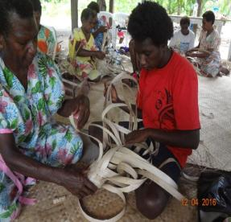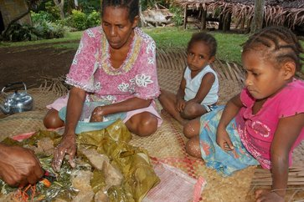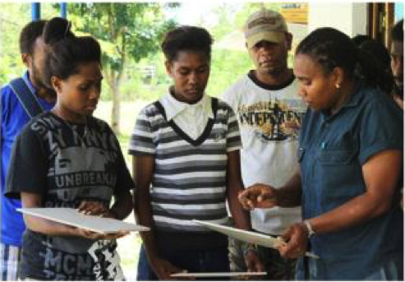

Supporting Women in Provincial Vanuatu:

TVET Program Gender Equality Report

May 2016 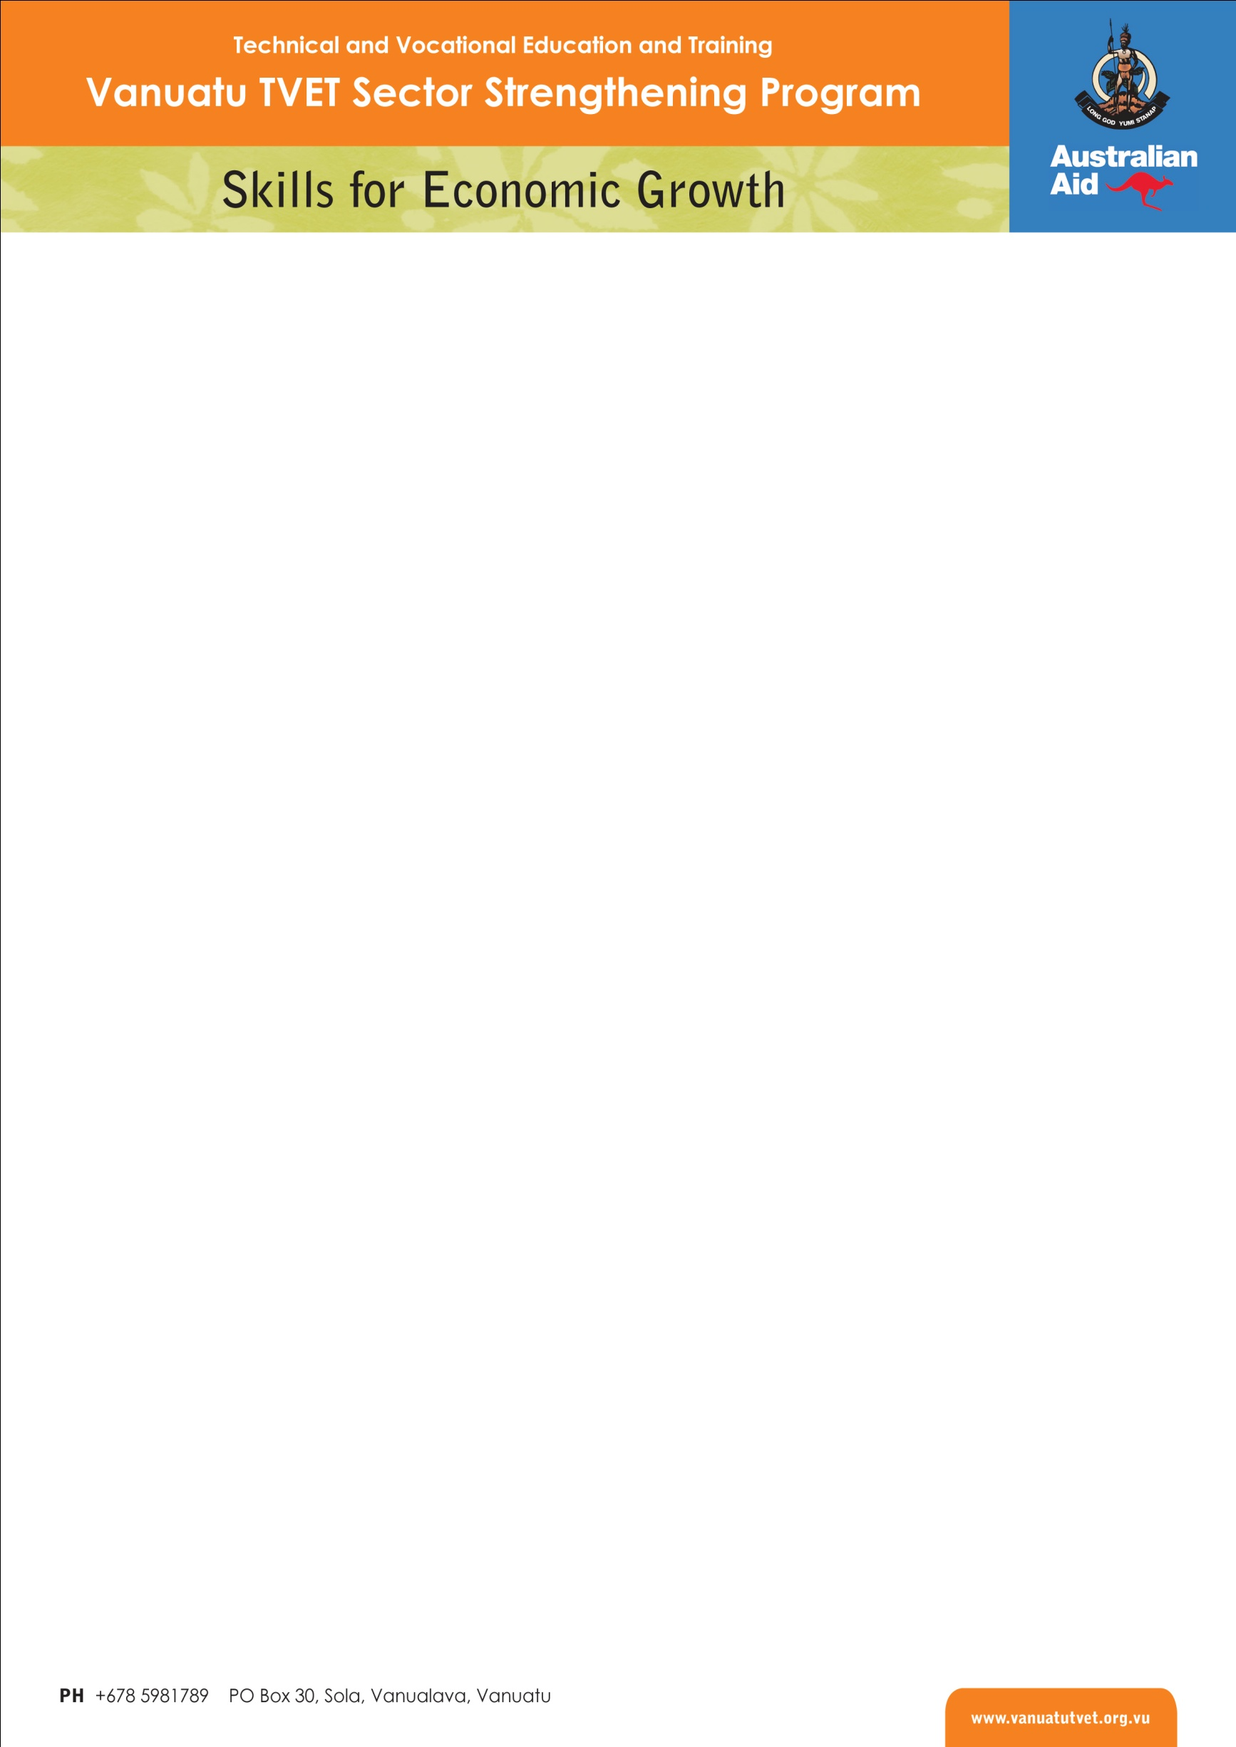

# Table of Contents

1 Background 1

2 The TVET Program 2

2.1 Pacific Women 2

3 Report Overview 3

4 TVET Program Approach 3

4.1 TVET Centres Gender Equality Strategy 5

4.2 Gender-based violence 5

4.3 Gender equality inside the TVET Program 6

4.4 Gender equality and disability inclusion 7

4.5 Partnerships for gender equality 8

4.6 Monitoring, Evaluation, Communication 9

5 Outcomes for Women 10

5.1 Skills Development and Economic Opportunity 10

5.2 Coaching, Mentoring and Training in Tourism 14

5.3 Upskilling Women Trainers 16

5.4 Language, Literacy and Numeracy for Women 18

5.5 Pathways to Further Education and Training 18

6 Conclusions and Reflections 20

Annex 1: Program Logic 22

Annex 2: Gender Strategy 23

Annex 3: ODE evaluation - Vanuatu Country Paper 23

# List of Acronyms

|  |  |
| --- | --- |
| APTC | Australia Pacific Technical College |
| CEDAW | Convention on the Elimination of Discrimination Against Women |
| DFAT | Department of Foreign Affairs and Trade (Australian) |
| DoT | Department of Tourism (Vanuatu) |
| LLN | Language, Literacy and Numeracy |
| MHC | Malampa Handicrafts Centre |
| MoET | Ministry of Education and Training (Vanuatu) |
| PGTB | Provincial Government Training Board (Vanuatu) |
| QMS | Quality Management System |
| TfT | TVET for Tourism Program |
| TVET | Technical and Vocational Education and Training |
| VQA | Vanuatu Qualifications Authority |

# Background

Women in Vanuatu are key contributors to society and are seen as those who hold families and communities together. Their role in society is closely associated with motherhood, protectors of culture and religious worship. While women are increasingly entering the formal economic sphere in Vanuatu, their potential is hindered by a number of barriers[1]. According to a recent literature review, the root cause of the barriers to women’s economic empowerment in Vanuatu lie in the social norms, values and practices that condone and perpetuate discrimination towards women and girls[2].

Despite high level commitments from the government, there has been slow progress towards gender equality in Vanuatu. There is resistance to change due to prevailing gender norms which grant men control over female behaviour, notions of masculinity linked to power and decision making, and an acceptance of violence as a way to resolve conflict[3]. This lack of progress has been highlighted in CEDAW reports[4] and recognised by the government in the 2010 Millennium Development Goals Report[5] and the Priorities and Action Agenda[6].

Some of the barriers to women’s economic empowerment in Vanuatu include:

* Gender norms mean that women’s roles are tied to domestic responsibilities and women are expected to fulfil these in addition to economic activities[7];
* More than three quarters of Vanuatu’s population live in rural areas[8] hence a large proportion of people experience limited access to markets, small scale of markets and high costs of transport;
* Limited literacy, numeracy, financial literacy and business skills can hold women back from economic empowerment;
* Male dominance in leadership positions, politics and some occupational fields;
* Limited access to finance; and
* Lack of support from husband/partner or family. For example, a national survey found that 23% of women (almost 1 in 4) had been prevented from accessing or continuing their education, mainly by their parents but also by husbands/partners[9].

# The TVET Program

The Vanuatu Technical and Vocational Education and Training (TVET) Sector Strengthening Program (the TVET Program), now known as *Skills for Economic Growth*, is funded by the Australian Government and implemented in partnership with the Government of Vanuatu. The third phase of the TVET Program began in March 2013 and continues until June 2016. It is designed to work in three Key Results Areas:

1. National TVET System
2. Provincial Skills Development Coordination
3. Training, Business Development and Employment

The program logic of the TVET Program (shown at Annex 1) sets out the intended outcomes of the program across the three results areas, which include outcomes for men and women in terms of increased income, job creation and business improvement, as well as building a more equitable training and skills development sector in Vanuatu.

The TVET Program is supporting the Ministry of Education and Training (MoET) and the Vanuatu Qualifications Authority (VQA) to implement the National TVET Policy, including assisting with: strengthening links between national stakeholders; increasing awareness and support for investment in skills development; improving the quality of TVET provision; and support for improved management and planning for the sector.

At the provincial level the TVET Program facilitates the delivery of business development support and nationally accredited skills training in response to provincial economic development priorities. Operating TVET Centres in four provinces (Sanma, Malampa, Torba and Tafea), the Program finances skills development activities as well as supporting Provincial Government Training Boards (PGTBs) and productive sector representatives to plan and coordinate skills development.

## Pacific Women

The Australian Government created the Pacific Women initiative in 2013 to improve and safeguard opportunities for the political, economic and social advancement of Pacific women. It grew from the then Prime Minister Julia Gillard’s commitment of up to $320 million over ten years, and is an unprecedented level of investment in gender equality and women’s empowerment in the Pacific.

The Pacific Women initiative focuses on seven key results areas, three of which are directly relevant to the work of the TVET Program:

* Improved women’s leadership and decision making opportunities
* Increased economic opportunities for women
* Reduced violence against women and expanded support services

Within its Vanuatu Country Plan, Pacific Women recognised the importance of the tourism and hospitality sector in Vanuatu in providing economic opportunities for women across Vanuatu’s dual labour market (formal, urban-based, and informal, rural-based). It further noted that while agriculture is likely to continue to be a major source of employment (or livelihood), tourism and related industries offer the best prospects for gender-equitable growth in the formal sector.

In light of this alignment between the aims of the Vanuatu TVET Program and Pacific Women, Pacific Women contributed A$700,000 as supplementary funding to support the work of the TVET Program. This funding contribution was intended to support a number of inter-related components of work:

* funding for disbursement through the TVET Centres to finance training focused on women’s economic empowerment and access to non-traditional trade and market areas
* customised mentoring and coaching for women in small business
* up-skilling and the national/regional certification of women trainers in areas of high demand
* support for the implementation of the emerging National Workplace Literacy and Numeracy Strategy, with a specific focus on women’s literacy
* training courses that will make participants job ready for various roles in the tourism industry including the operation of small businesses

This additional funding brought the overall value of the Vanuatu TVET Program to more than $11 million over 40 months to June 2016.

# Report Overview

This report provides a description of the approaches used by the TVET Program to contribute to gender equality in Vanuatu, and the outcomes the Program has achieved as a result of its efforts and investments. A wide range of Program information sources were used to draw together the evidence presented in this document, together with some reflections from the Program team about its experiences and learnings. The report concludes with some reflections on the experiences of the TVET Program in addressing gender equality in skills development, and includes links to key source documents that offer further information and deeper analysis.

# TVET Program Approach

The TVET Program has a strong focus on women’s economic empowerment, but also works to address both women’s voice and leadership, and gender-based violence, through an approach that seeks to mainstream gender equality.

The TVET Program works on the basis that culture is a changeable phenomenon and that change must occur in order to achieve gender equality. It equally recognises that it is essential to respect and work within traditional systems and practices, particularly those that affirm the intrinsic value of all people, regardless of their gender[10].

The 2014 evaluation of Australian aid support for women’s economic empowerment[11] cited Vanuatu’s TVET Centres as good practice models for women’s economic empowerment. The report notes that the TVET Program has effectively addressed gender in design and implementation through creative and gender-responsive approaches. These include:

* actively seeking to attract women applicants, including by engaging the Vanuatu Women’s Development Scheme (VANWODS)[12] to help recruit women;
* using modular and flexible delivery strategies that allow multiple entry and exit points enabling women to balance training with employment and domestic responsibilities, and work towards a certified qualification in a timeframe responsive to the demands on their time;
* offering trainees gender-responsive employment counselling and mentorship;
* paying for child care services in some instances, to enable women to attend training; and
* promotion of women’s involvement in non-traditional vocations, such as building construction and masonry including, set-out, reinforced foundations and flooring, hollow-block laying, tiling and grouting.

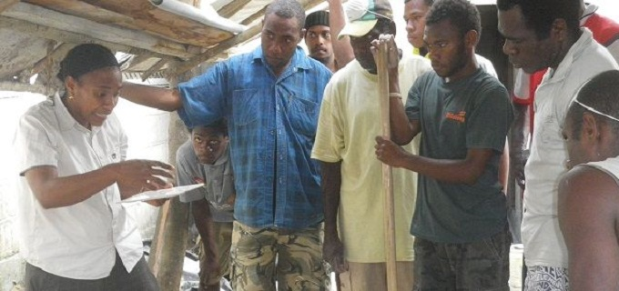

Tiling trainer Gael Waki demonstrating skills to a group of trainees

The Program’s partnership with the Vanuatu Qualifications Authority (VQA), and the quality management systems (QMS) coaching it has provided for training providers, has supported those providers to have a gender equality policy as part of their quality management systems.

The TVET Program also recognises that for many women (and men) in Vanuatu economic empowerment is often more likely to come from self employment rather than formal employment – especially if they stay in rural areas. Therefore it supports skills development for employment and job readiness, but also puts a strong emphasis on supporting women to establish, build and manage their own businesses, especially in the tourism sector.

## TVET Centres Gender Equality Strategy

The TVET Program has worked to address gender equality since its inception. With the expanding network of TVET Centres in Phase 3, and the beginning of their transition into Government of Vanuatu structures, the Program decided to document and formalise its gender approach. With the support of an Australian Volunteer for International Development, the TVET Program prepared the *Gender Equality Strategy for the Vanuatu TVET Centres* in 2014.

The Strategy provides guidance on how to promote gender equality in TVET Centre activities, and is written primarily for Program staff and TVET Centre stakeholders including PGTB members, training providers, national and provincial government officials and NGOs. The strategy has five objectives:

1. Address barriers to participation in TVET Centre activities experienced by women.
2. Ensure a family friendly work environment in TVET Centres that allows male and female staff to achieve their potential and an appropriate work–life balance.
3. Strengthen partnerships for advocacy and research in gender equality and improved access to finance.
4. Ensure a responsive monitoring system to track and report on gender equality results.
5. Take steps to reduce TVET Centre participants’ vulnerability to violence and provide support to survivors of violence.

The Strategy is made up of a number of actions, which will support the achievement of each of these objectives. The Program plans to review the Strategy in late 2016, and will further enhance it based on the findings of that review.

## Gender-based violence

Women’s economic empowerment can give women the opportunity to escape violent situations by giving them financial independence and increased confidence. However it can equally create increased risk of violence by challenging established patterns of power and control within family and community structures. The TVET Program is acutely aware of this risk in its skills development work, and has sought to work with staff, training providers and other stakeholders to reduce this risk. A number of practical examples illustrate how the Program has done this:

* Established a partnership with DFAT’s *Stretem Rod blong Jastis* program, initially through its Gender Adviser, to ensure evidence-based learning around vulnerability to gender-based violence, particularly that associated with economic empowerment, are incorporated into TVET Program strategic planning, including awareness of risks and support networks.
* Through this partnership, the TVET Program identified skill development activities linked to potential economic opportunities specifically for survivors of gender-based violence. A pilot initiative was conducted in the Maskelyns in Malekula, in collaboration with the Malampa Provincial Council of Women and community leaders. The activity supported survivors of violence and other vulnerable young women to learn basic human rights and issues of gender violence, including an understanding of support services available, alongside traditional crafting and weaving skills.
* Integrated access to gender-based violence related counselling within the work supporting handicraft production for sale at the Malampa Handicraft Centre (see page 12).
* Promotion of the participation of male-female ‘couples’ – i.e.: inclusion of husbands or brothers where appropriate – in skills development and business coaching activities to foster appreciation among these key male family members of the benefits of the activities, and to reduce their perceptions of exclusion and jealousy, which can be potentially dangerous for women.

The TVET Program’s participant outcomes surveys also sought to collect evidence about whether women participants had experienced violence, discrimination or other negative outcomes as a result of their skills development. However those surveys had a number of limitations in this regard, and did not deliver reliable insights into these aspects of women participants’ experiences. The Program is considering whether a more targeted evaluation can be done in Phase 4 to explore the extent to which women are experiencing negative outcomes, including of violence, from their participation in skills development, and if so, how these can be mitigated against while ensuring women’s ongoing access to training and employment opportunities.

## Gender equality inside the TVET Program

In a culture where men traditionally hold positions of power and authority, the Program has explicitly sought to demonstrate gender equality in leadership and promote women to take on roles that in many ways challenge the status quo. It does this within its own structures and processes as well as its services and activities. For example, the Program has actively supported women to develop skills and confidence to move into more senior roles (such as the Operations Manager, Finance and Administration Manager, and the former Team Leader), and other women in the Program team to make similar advances in their careers. The Program has also deliberately sought to build men’s acceptance and appreciation of women in these roles. Within the full-time staff of 26, thirteen are women, including the Operations Manager and the Finance and Administration Manager, while three of the five international specialists working on the program in 2015 were women.

One notable tactic has been the 'gender lens' interview technique for personnel recruitment: for many years interviews for new staff have routinely been undertaken by a man and a woman from the management team. This enables interviews to be partly structured to explore how a male candidate responds to questions asked by the woman on the interview panel, and specifically whether he responds to the male panel member.

Additionally, the Program has invested time in developing male ‘gender equality advocates’, within both its staff and local civil and government counterparts, to facilitate change in social norms in a highly patriarchal context. As a practical example, in situations (meetings, workshops, etc.) with stakeholders who have shown discriminatory attitudes towards women, senior male staff members will strategically and purposefully demonstrate their respect for the women in leadership within the Program, while simultaneously conveying how this does not detract from their own position or masculinity. This may include explicit deferral to the female staff member for her advice or opinion, or supporting her to take the lead in chairing/facilitating the meeting. Conversely, the female staff member also takes care to use this authority in a respectful way, thereby modelling female leadership as non-threatening and constructive.

The Program has also created an authentic family friendly culture for its staff, providing genuine flexibility, support for breast-feeding and accepting the presence of children in the workplace. This has benefited both men and women staff.

Since 2015 the Program staffing structure has included one of its TVET System Specialists to be designated as the Gender Focal Person, a role focused on working across all TVET Centres to assist all staff in the implementation of the Gender Equality Strategy. It also includes strengthening partnerships with key stakeholders at national and provincial levels, and identifying specific skill development initiatives to be supported by the Program that will promote women’s economic empowerment, increase female leadership and voice, and reduce vulnerability to gender-based violence. The fact that the Gender Focal Person is a highly educated and culturally respected male is also strategically utilised by the Program to counter negative views about issues around gender equality being purely ‘women’s business’.

Finally, since the commencement of the Pacific Women partnership and the Program’s focus on making its gender equality work explicit, the Program leadership team has ensured that dedicated whole-of-staff capacity building sessions on mainstreaming gender equality have been conducted on a six-monthly basis. This has reinforced the approach of inclusion being a core part of every staff member’s job description, and has provided an opportunity for staff to discuss together – across geographic sites and roles – successful strategies, lessons learned and opportunities for future activity.

## Gender equality and disability inclusion

The TVET Centres Gender Strategy notes that women with disability face unique challenges as they often experience intersectional discrimination: the combination of both disability and gender discrimination. The Pacific Women Vanuatu Country Plan also recognises that women with disabilities in Vanuatu are doubly stigmatised due to the stereotypes associated with disability and gender[13]. The TVET Program provides a number of practical supports to facilitate the participation of people with disability and to help maximise their learning in an inclusive training environment. These include the support of a caregiver and interpreter for participants with disability and training and support given to the trainers so that they have the skills to know how to meaningfully include people with disability.

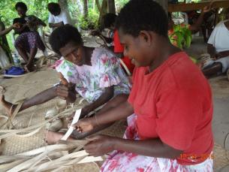

Participant in handicrafts training with a hearing impairment (right)   
with an interpreter (left)

The TVET Program has supported a number of skills development activities designed specifically for participants with disability, especially women. These have included training in sewing and handicrafts, in which women and their caregivers and support people worked together with trainers to build skills and knowledge. However, the work of the Program to build a more inclusive TVET sector across Vanuatu has also included support for general mainstream training to be accessible to women and men with disabilities.

Feedback from one recent disability-inclusive skills development activity highlighted how women with a disability value learning new skills and knowledge as well as the opportunity to discover and build their self-confidence inside a regular training environment. Community leaders also expressed appreciation of how TVET Centre inclusive trainings are making a positive impact on community attitudes towards people with disabilities and their rights to access skills training so they can break out of the poverty cycle. A community leader observed: “We have had awareness on disability previously but this is the first training that has enabled the participation of people with disabilities. It’s good for them and for our community”

## Partnerships for gender equality

The TVET Program has developed partnerships with a diverse range of agencies within the Government of Vanuatu, other development partners and other Australian aid programs, to support its work to address gender equality through skills development. The Program has secured additional resources through Australian Volunteers for International Development, which provided a volunteer Gender Officer in 2014, and the US Peace Corps for a Language, Literacy and Numeracy (LLN) volunteer in 2016[14]. The Peace Corps partnership has enabled the Program to spearhead the development of the first National Adult LLN Framework (see page 17). This initiative has had a particular focus on improving access by women to LLN support as a pathway to further vocational education and training, and is strengthening coordination and collaboration between stakeholders – including NGOs and volunteers - already working to improve women’s literacy and numeracy.

As part of the aforementioned focus on the tourism industry given its potential for broad-based economic development opportunity for women, the Program has also partnered with agencies for specific initiatives to maximise the impact of skill development within this sector. This has included collaboration with the New Zealand aid program and DFAT’s Governance for Growth program for the respective establishment of the Malampa and Sanma Travel Call Centres. These Centres enable online marketing and sale to the international market of local tourism products, a large percentage of which, including bungalows and tours, are managed and operated by women.

In response to growing local and tourist demand for authentic handicraft products, the Program has also obtained resources through DFAT’s Direct Aid Program to assist in the development of the Malampa Handicrafts Centre (MHC) in partnership with the Malampa Provincial Council of Women (see page 12). The successful model of the MHC has informed the decision of the Department of Women’s Affairs (DoWA) to work with the Torba TVET Centre, the Department of Agriculture, the Torba Provincial Government and relevant communities to secure additional funding from the DAP to build a Market House in Sola which will also be used as a Handicraft Centre.

Recognition of the effectiveness of these partnerships and of the activities that they have engendered led, at the end of December 2014, to the formalisation of an overarching MoU signed between the Ministry of Justice and Community Services and the TVET Program in December 2014, with the DoWA as the key operational counterpart. The broad goal of the agreement is cooperation in the promotion of gender equality and disability inclusion across the TVET sector, with specific reference to:

* Collaboration in the implementation of the ‘Strategy for the Promotion of Gender Equality in the TVET Centres’ and the ‘TVET Sector Disability Inclusion Strategy’.
* Awareness-raising on gender equality and disability inclusion, in line with national disability and gender policies, in provinces where TVET Centres operate.
* Collaborative identification of appropriate candidates for TVET Centre trainings and trainer up-skilling, in line with TVET Centre gender equality and disability inclusion targets.
* TVET Program staff participation in relevant meetings and activities of the DoWA Community Based Rehabilitation Taskforce, Economic Empowerment Taskforce, National Child protection and Provincial Family Protection Taskforce in TVET Centre provinces.

Finally, through its partnership with the PGTBs, alongside which the TVET Centres have been established, the TVET Program has worked to build these bodies’ capacity to function as an effective coordination and advisory mechanism for skills training at the provincial level. This has included training and awareness-raising for PFTB members on gender equality and inclusive skills development, and both ensuring women are represented on the Board, and women’s perspectives and priorities are reflected in skills planning and funding allocations.

## Monitoring, Evaluation, Communication

The TVET Program monitoring and evaluation system is designed to enable monitoring and analysis of the participation of women and people with disabilities, and the extent to which women and women with disabilities are achieving positive outcomes while avoiding harm. The implementation of the M&E system includes supporting Provincial Government Training Boards to consider M&E data every six months, including the gender disaggregation of this data. This has prompted substantive discussion of the different experiences of women and men in TVET Centre activities, leading to deliberate actions to increase women’s participation. PGTB members now routinely consider women’s participation rates, and how to effectively engage women in skills development across sectors.

Within its public communications activities, the Program places a strong emphasis on producing accessible and popular communications, including DVDs, posters and illustrated short reports that project strong, positive images of women in non-traditional vocational and leadership roles. A powerful example of this is the 2014 DVD *Skilling Women, Empowering Communities*, available at: <http://www.vanuatutvet.org.vu/videos/skilling-women-empowering-communities-3/>, but also includes the strategic selection of images used in program banners, reports and media releases.

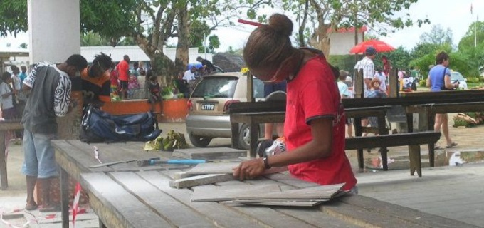

Tiling the Luganville Market Haus as part of skills development training

# Outcomes for Women

The TVET Program has contributed to positive outcomes for women, and for a more inclusive TVET sector. It has achieved these outcomes drawing on its core resources as well as the additional support from Pacific Women.

## Skills Development and Economic Opportunity

### Women’s participation

Since the start of Phase 3 in 2013 to the end of 2015, the Program has enabled more than one thousand women to develop their skills for employment, income generation and livelihood improvement. Women have represented 38% of TVET Centre participants over this period. However there has been a variable level of women’s participation from year to year, as shown in the figure below:



After the relatively low level of women’s participation seen in 2013, the Program worked with Provincial Government Training Boards and productive sector representatives in the provinces to address the issue. This effort coincided with the additional funding from Pacific Women, which increased the extent to which Program could direct resources towards women’s skills development. Clearly this paid dividends in 2014, with women’s participation back up to 48%: close to parity. However 2015 saw another drop in the proportion of participants who are women: 36% of all participants.

The variable level of women’s participation is partly explained by the shifting levels of skills development activity across the different sectors. Most particularly there has been increasing attention to sectors such as agriculture and forestry, as well as the need to support reconstruction skills in the aftermath of Cyclone Pam: most of these are sectors traditionally dominated by men. Thus there has been a resultant drop in the overall proportion of women participating. The sectoral diversity in women’s participation is shown below, which highlights the very low levels of women’s participation in the productive sectors such as livestock, fisheries, and forestry, as well as construction-focused trades and services.



The TVET Program is continuing to carefully monitor the levels of women’s participation, is sustaining the focus on the issue in discussions with sector representatives and national government agencies, and will further strengthen its approach to supporting women in non-traditional sectors. The forthcoming review and revision of the Gender Strategy will inform this work in 2016 and beyond.

### Economic Outcomes

Since 2014 the TVET Program has conducted participant outcome surveys to seek evidence of the extent to which skills development has contributed to changes in the lives of TVET Centre participants. Survey design was founded on the need to analyse any differences in the outcomes and experiences of men and women, as well as other groups.

Survey data shows that women have been more likely to improve their income/livelihood within 6-8 months of their skills development compared to men: an estimated 68% of women improved their income/livelihood, compared to 60% of men[15]. This may partly be explained because many women start from a lower economic base, however generally the survey did not highlight a major difference in the economic outcomes for women and men.

Evidence from the outcomes survey confirms that women-operated business benefited to a high degree from TVET Centre skills development: an estimated 90% of self-employed women experienced an increase in the income their businesses were earning. These improvements in business income came from using new techniques and systems, as well as increasing production, and introducing new equipment.

Women in formal employment situations were less likely than self-employed women to experience improvement in their employment situation, although still a majority experienced positive outcomes 6-8 months after skills development. An estimated 66% improved their employment in terms of new positions, promotion, increased responsibility or higher income. This somewhat lower level of positive outcome within the timeframe (compared to the experiences of self-employed women) is likely explained by the greater rigidity in formal employment arrangements and the longer timeframe required to find new employment or secure a pay rise or promotion.

Outcomes for women operating businesses in the tourism sector, who have been supported in a more ongoing way through TVET for Tourism and enhanced through the additional support from Pacific Women, are described in section 5.2 below.

Malampa Handicrafts Centre… an example of cooperation for women’s economic empowerment

Handicraft makers from Malekula, Ambrym and Paama, mainly women, are now providing their products for sale at the Malampa Handicrafts Centre, which officially opened in October 2014.

The Centre is a remarkable example of cooperation, underpinned by the coordination efforts of the TVET Program and its partnership with the Malampa Provincial Council of Women. The building was built and fitted out with financial assistance from the Australian High Commission Direct Aid Program and with labour from men and women participating in Malampa TVET Centre training activities. It is located on land provided by the Malampa Provincial Government and its development has been supported by a volunteer placed through Australian Youth Ambassadors for Development. Suppliers are being supported to develop skills in handicraft quality through TVET Centre training as well as business development support.

* In the two years since the Centre opened it has achieved sales of approximately Vt 5.9 million (including large special orders from the Activ Foundation and the Red Cross), equivalent to about AUD62,000.
* With around 80% of the income from sales going to the makers, women in Malekula have earned around Vt 4.7million through the Centre since April 2014
* The number of handicraft makers selling products at the Centre has grown from fifteen to more than one hundred.
* Makers are supported to develop skills in handicraft quality and business management through additional TVET Centre training and coaching

To complement the work in Malekula, the program also gave support to strengthen MHC’s marketing links to major handicraft markets in Port Vila, establishing MHC as an inclusive model for supplying genuine Vanuatu handicrafts to the tourism industry and connecting informal women workers to the formal operations of the sector.

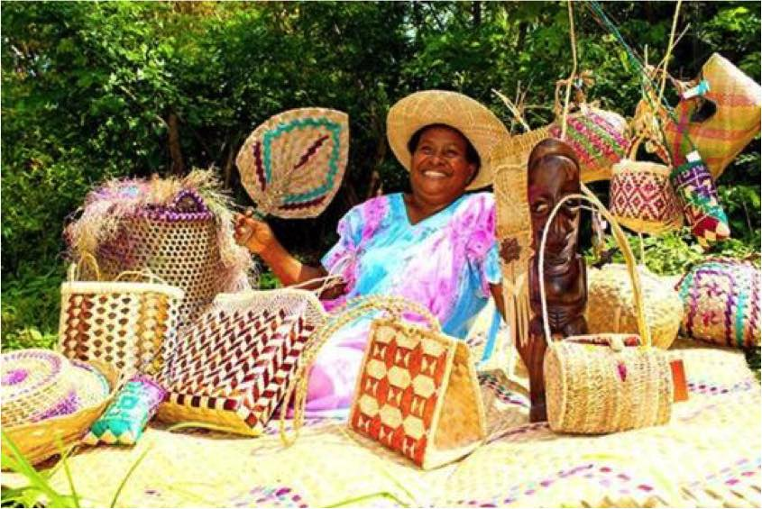

Gloria Jeremiah displaying the handicrafts she has produced for sale at   
the Malampa Handicrafts Centre

## Coaching, Mentoring and Training in Tourism

The TVET for Tourism Program – the major sub-program of the TVET Program – works with ni-Vanuatu-owned tourism businesses in Sanma, Malampa, Torba and Tafea provinces. It offers both skills development through training, coaching and mentoring, using a three staged approach: product development, business development and business management. The methodology blends one-on-one coaching and advice from industry experts with accredited training and specially-designed workshops, delivered on site and contextualised to the specific needs of the client businesses and individual participants.

TVET for Tourism has actively promoted equality throughout tourism-based skill development activities since 2009, and on an expanded basis since 2013. The program encourages women with an interest or business in tourism to attend its coaching, workshops and accredited training activities, and has expanded further since the commencement of support from Pacific Women in 2014. The program also provides support and capacity building opportunities for female industry experts, trainers and Department of Tourism partners, as described in section 5.3.

Within the tourism businesses supported by TVET for Tourism are forty accommodation services and fifteen tour operations which are owned or co-owned by women. The Program supports these women business operators to build skills and businesses through skills development activities addressing:

* Tours and accommodation development
* Housekeeping and room decoration
* Business administration
* Island Food preparation
* Bookkeeping

As a result of this support there is a growing number of women-owned and operated tourism businesses accredited by the Department of Tourism. Almost three-quarters of these businesses (73%) now meet the Vanuatu Tourism Operator Minimum Standards, up from 50% in 2012.

The growth of these women-owned and operated businesses is evidenced by the increasing number which are now developed enough to secure a formal business license, up from 10% in 2012 to 15% in 2016.

Overall, women owned and operate tourism businesses supported by the TVET program are achieving positive business development at the same rate as those managed solely by men.

In addition to this informal skills development through training and coaching, the TVET for Tourism program has enabled 39 women to complete formal qualifications in tourism delivered locally: Certificate 1 Tourism (Tour Guiding) and Certificate 1 Tourism (Accommodation Services).

Women in Tourism: women in non-traditional roles

Erima Nunumbal is a mother, wife and the lead Tour Guide at Rano Cannibal Site and the Dogs Head Tour in Central Malekula. Erima was initially worried about joining the tour guide training as tour guiding was considered to be ‘men’s work’. But with the support of her husband and the TVET for Tourism (TfT) Program, Erima has developed her own tours, which offer a unique opportunity for visitors to Malekula. The TfT Program supported the development of the tour, including the negotiation of access with communities along the entire tour route.

Since the tour began operating, Erima and her husband have earned valuable income which has supported school fees to keep their children in secondary school. Erima continues to be supported by the TfT Program and most recently completed a First Aid course in 2015.

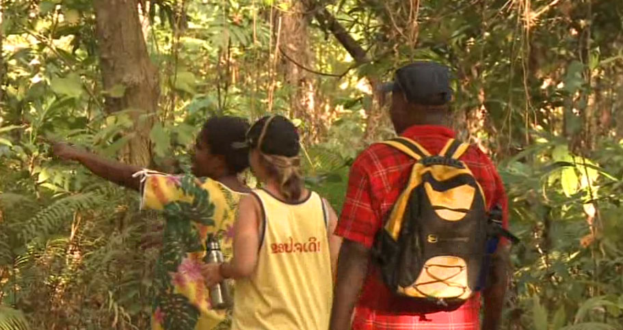

Erima leading the Dogs Head walk in Malekula

Of the 282 people who have participated in TVET for Tourism skills development in 2015, 121 of them were women (43%). But the reach of TVET for Tourism goes well beyond the participants to reach the workers employed by the businesses that are growing with program support. Out of a total 650 workers employed by these businesses, 287 are women, or 44%. This is an excellent level of women’s representation in the provincial communities that are benefiting from increased employment opportunities. As reported through the case studies in the *Skilling Women, Empowering Women* DVD, in addition to economic benefits, a significant outcome experienced by women following their successful participation in training and business development activities was that of attitudinal change within their communities, with many citing that a newfound “respect” had been achieved.

Lakatoro Palm Lodge: women’s economic empowerment in action

Asunda Roy and her husband Jack are a powerful example of economic success built through hard work by mutually supporting couple. Back in 2009, when Asunda started to attend the courses offered by the TVET centre, she was working as a cleaner. “At the time, we had a little bit of land and were planning to build a house but after I started studying, we had the idea of turning our house into a bungalow for visitors.”

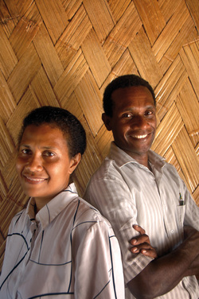During the next three years, as they built their bungalow, Asunda continued to attend the courses run by the TVET Centre and to participate in ongoing coaching and mentoring through the TVET for Tourism program. With her husband Jack’s support, Asunda has played the leading role in developing and expanding their business. As a result, the original basic bungalow that was earning 1,500vt per night, has became delightful island accommodation. Now Asunda proudly operates Lakatoro Palm Lodge with two bungalows that charge 7,000vt per night each. “We are saving to buy some more land as we would like to keep building our business”, she explains.

Asunda and Jack Roy inside their newly built bungalow

As noted above, the TVET for Tourism program has actively sought to model gender equality in its team of program staff and the industry experts and coaches that it engages and supports. The pool of active industry experts is 67% female, with women delivering training and coaching across a range of skills areas including business management, massage, bungalow decoration, island cooking and handicrafts production.

## Upskilling Women Trainers

The TVET Program has invested in developing the training skills of ni-Vanuatu men and women trainers since 2010, recognising that this is a crucial component of effective national skills development across sectors. Overall, 65 people have been supported to upgrade their training skills, achieving either a Community Trainer Certificate I or II, or a Certificate IV in Training and Assessment. Within this group there have been eighteen women trainers from training providers, the Department of Tourism, and private sector tourism operators (including several industry experts involved in the TVET for Tourism program). In addition to its focus on tourism industry trainers, the Program has also concertedly supported the professional development of women trainers in non-traditional trade areas, such as tiling and electrical. These women are then engaged by the TVET Centres to deliver training at the provincial level, where often traditional perceptions about women’s roles prevail. The modelling of these women productively utilising their skills for the wider community benefit has been an important strategy in influencing attitudinal change.

Since 2014 the TVET for Tourism Program has been actively seeking and engaging local industry experts to provide tourism-specific coaching and workshops. As part of this initiative the program has contracted three local female industry experts, Esline Felix, Serah Tari and Trudy Kalotiti to deliver skill development activities in massage therapy, business management and handicrafts production for the cruise ship market. To strengthen these experts’ approaches to skills development, the program supported them to complete a Certificate IV in Training and Assessment (TAE) through the Australia Pacific Technical College.

With their new skills and qualification in training and education, industry experts have told the Program that they are better able to pass their technical skills on to others in the training workshops and coaching activities they are delivering[16].

“The training took me so far …: it helped me to get a proper way of delivering training. Before this training I only applied skills but after the help TVET provided, it changed me a lot. It shows me what to do first and what comes next, it improves me in delivering training… It helped me to find friends that are now my mentors. … It took me home to deliver my first training to my own people, [in] my own language and to change my own land. … It also helped me as a widow to change my home, to provide [for] my children's needs.” (TVET for Tourism industry expert)

“TVET has been helping me in lots of way especially the TAE training at APTC. I [would] never achieve this great qualification without the help of TVET. I was so grateful, thankful for the improvement that helped me change my life and improve my business too….After the APTC training I am not ashamed any more to talk and I am passing my skills to other so they can make a better living! It's empowering me to go further in my future training.” (TVET for Tourism industry expert)

For Department of Tourism officers their qualifications will support their increasing role in coaching and supporting tourism businesses in their provinces.



DoT officers Adela Issachar and Brenda Andre receiving their certificates with TVET Program Team Leader Fremden S Yanhambath and two colleagues

Trainers in Vanuatu have also developed their skills and understanding of disability inclusion, with support from the TVET Program. Ten women trainers and assistant trainers have been involved in delivering disability inclusive trainings during 2014-2016, and the TVET Program supported them to adapt their training approaches to enable full participation by men and women with disabilities. This has further developed the training skills of these women trainers.

## Language, Literacy and Numeracy for Women

Women in Vanuatu are often poorly represented in training, workshops and meetings. One contributing factor is the level of literacy for women. Many girls are taken out of school at a young age due to various reasons, especially in rural areas. To broaden the reach of initiatives to support women’s participation in skills development, the TVET Program has been working with the Ministry of Education and Training to develop a National Adult Language, Literacy and Numeracy Framework. The objective is to enable a consistent national approach to the identification and development of adult language, literacy and numeracy skills. This can then be used as a basis for determining the LLN requirements of TVET courses, which in turn can inform the development of appropriate bridging courses or pedagogical modifications needed to ensure that full potential of the skill development opportunity is not constrained through trainees’ lack of LLN skills.

The Framework establishes a set of descriptors to describe and differentiate between levels of performance in language, literacy and numeracy (LLN) and is designed for the specific circumstances of Vanuatu’s trilingual system as well as its many traditional and local languages. It is designed to be used with all adults in Vanuatu, whether in education, training and or employment, and community settings. Importantly, the Framework provides: a shared language for identifying and describing LLN skills, a systematic approach to benchmarking and reporting on LLN skills performance, and a tool for gathering data for the purpose of designing and funding policies, curriculum and training interventions.

The Framework has been completed and is awaiting approval by the Council of Ministers. Following endorsement at this highest level of the Vanuatu Government, the Framework will then be used as a guide to develop a practical Language, Literacy and Numeracy Strategy.

The focus of TVET Program work most recently has been on piloting the LLN assessment tool kit, which can be used in any of the three languages depending on the purpose of assessment. Of the ten trainers selected to administer the pilot program six were women, and one of the first groups to be assessed following the conclusion of the pilot program were 26 members of the Vanuatu Mamas English Class. The outcome of this pilot will inform the development of the national adult LLN strategy.

## Pathways to Further Education and Training

The TVET Program brings skills development, including nationally accredited training, to rural men and women. One intended outcome of this approach is to open pathways into further education and training for those who might otherwise not have access to this opportunity.

Supporting opportunities for women with disability: Vanessa Siro and the pathway to further training

Vanessa Siro lives with a hearing impairment. She finished her formal education with a year 10 leaving certificate and returned home to Santo, becoming involved in the Frangipani Disability Association.

The TVET Centre in Sanma signed an MOU with the Frangipani Association in 2010, and Vanessa attended several TVET Centre trainings in sewing, cooking and sign language, which were delivered with support for participants with disabilities. She really enjoyed the workshops, especially the cooking training, which was a modular accredited training delivered ‘on-site’ through the TVET Centre by Vanuatu Institute of Technology (VIT) trainers. Vanessa was keen to acquire more skills and knowledge in this field, and with the support and encouragement of the TVET Program, and through recognition of the units she has already completed at the provincial level, she secured entry to the Vanuatu Institute of Technology at its main campus in Port Vila. With sponsorship from TVET Program staff Vanessa completed a Vocational Certificate 1 in Hospitality (Culinary Art and Pastry) at the end of 2015, and the Program continues to support her as she seeks employment in the hospitality industry.

One important additional outcome of Vanessa’s success at the Vanuatu Institute of Technology has been a shift in the perceptions of institution staff and her fellow students regarding the capacities of women and men with disabilities.

Vanessa with her graduation certificate from the Vanuatu Institute of Technology

The most notable success in this area has been within the TVET for Tourism program. Within the client businesses supported by TVET for Tourism, a total of nineteen men and women have proceeded to complete formal qualifications in hospitality and tourism at the Australia Pacific Technical College (APTC) in Port Vila.

Within this group are ten women who may not have advanced to APTC without the active encouragement of the TVET Program, and especially the TVET for Tourism coaches. These women from rural Vanuatu, who were able to develop foundational skills and confidence through participating in trainings and workshops facilitated by the provincial TVET Centres, now have qualifications that are regionally and internationally recognised, opening far more opportunities for employment while also greatly increasing the skills and knowledge they are applying within their existing businesses.

Skills and qualifications increasing women’s community status: Naewen Arnhambath

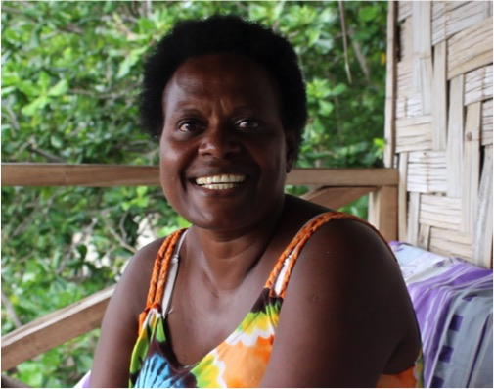Naewen Arnhambath is the manager of Big Nambas Bungalow in Tenmaru, Malekula. She has been part of the TVET for Tourism (TfT) program since 2012, participating in a range of training and business development activities through the Malampa TVET Centre. With the support of the TfT program Naewen recently completed a Certificate III in Hospitality at the Australia Pacific Technical College in Port Vila. Since graduation, Naewen has returned to live in Tenmaru and continues to develop her skills in hospitality and tourism through the TfT program, operating her business successfully.

Naewen recently stated that, due to her success: “now when I walk through the village the men respect me and you can tell that something has changed.”

# Conclusions and Reflections

Reflecting on the experiences of the TVET Program in addressing gender equality across its range of activities and key result areas, a number of observations and conclusions emerge:

* Constant effort is required to maintain levels of women’s participation across sectors, and especially in sectors where women do not traditionally work. The support for women trainers and role models is useful here, but is not sufficient. It will be essential that this is raised at the national level of relevant departments, particularly the Ministry of Agriculture, Livestock, Forestry and Fisheries, to identify current and emerging opportunities for women in the sector that can be supported as part of a collaborative and mainstreamed approach. This work must not be simply limited to the Department of Women’s Affairs.
* Supporting women who have supportive partners, and celebrating these role models, can be a powerful means of advocating for women’s economic empowerment (e.g. Lakatoro Palm Lodge). Using engaging and accessible media to promote these models, such as DVDs, television, and radio, has proven to be successful and should be continued.
* Men need to be part of the gender equality work and the program has tackled this in multiple ways, as discussed throughout this report. This will ensure that the TVET Program continues to go beyond more conventional woman-focussed approaches to gender equality and women’s empowerment.
* The TVET Program is acutely aware of risks to women as well as benefits from economic empowerment, and acknowledges that it doesn’t yet know enough about how this is playing out for the women involved in Program activities. There are great opportunities to build further collaboration with Pacific Women and its work across the Pacific region, including to draw on lessons and research from elsewhere.
* Skills development can be an opportunity to also deliver messages about women’s leadership and gender-based violence, using skills development activities (often in high demand within communities) as a vehicle for integrating (less sought after) awareness-raising of fundamental human rights issues of equality and destructiveness of domestic violence.
* Partnerships with other programs and development partners, designed to respond to specific needs or opportunities, can greatly increase the contribution to gender equality and maximise impact of individual investments. The TVET Program’s experience has demonstrated that women’s economic empowerment cannot simply be achieved by skills development in isolation, but rather the most significant outcomes are realised when resources are pooled from a range of partners to cover different, but inter-related aspects. For example, support from the NZ aid program, and the DFAT DAP program have been essential in terms of the infrastructure funding made available to develop the MHC and the Malampa Tourism Call Centre.
* Additional resources from Pacific Women enabled expanded work in key areas building on the strong foundation already existing within the TVET program. For example, the concentrated investment in the MHC, facilitated by Pacific Women funding, and the tangible economic and social outcomes achieved has led to the Department of Women’s Affairs and Department of Industries recognising this as a prototype for inclusive economic development at the provincial level. Should there be further funding from Pacific Women, a priority could be to support these agencies to roll out this model in other provinces, as well as strengthening cross-provincial linkages, value addition and market access.

# Annex 1: Program Logic



# Annex 2: Gender Strategy

Provided as separate PDF file

# Annex 3: ODE evaluation - Vanuatu Country Paper

Provided as separate PDF file

1. Bowman, C, Cutura, J, Ellis, A and Manuel, C. 2009. *Women in Vanuatu: Analysing Challenges to Economic Participation*. World Bank.
2. Molony, T. 2014. Desk Review: *Women’s and girls’ empowerment program*. CARE International in Vanuatu
3. ibid
4. Office of the Prime Minister and Department of Women’s Affairs. 2004. *Combined Initial, Second and Third Reports on the CEDAW.*
5. Office of the Prime Minister 2010. Millennium Development Goals 2010 Report for Vanuatu.
6. Government of Vanuatu. 2013. Priorities and Action Agenda 2006-2015: A Just, Educated, Healthy and Wealthy Vanuatu, 2012 Update
7. Pacific Women Shaping Pacific Development: Vanuatu Country Plan 2013-2016
8. World Vision. *Vanuatu Country Profile*. Accessed 17 October 2014. <http://www.worldvision.com.au/Libraries/3_2_1_Country_Profiles_-_Asia_Pacific/Vanuatu.pdf>
9. Vanuatu Women’s Centre and Vanuatu National Statistics Office. 2011. *Vanuatu National Survey on Women’s Lives and Family Relationships*. Vanuatu Women’s Centre.
10. Vanuatu TVET Sector Strengthening Program, Gender Equality Strategy for the Vanuatu TVET Centres, 2014
11. Australian Government Department of Foreign Affairs and Trade 2014, *Smart economics: evaluation of Australian aid support for women’s economic empowerment*, Office of Development Effectiveness, Canberra.
12. VANWODS is a non-government organisation which focuses on providing microfinance services to women in Vanuatu.
13. Pacific Women Shaping Pacific Development: Vanuatu Country Plan 2013-2016, 3 September 2013, p9
14. Peace Corps also supported a volunteer to work as Disability Support Officer in 2014.
15. TVET Sector Strengthening Program. February 2016. *Annual Program Monitoring and Evaluation Report 2015*. It should be noted that outcomes data was weighted for analysis – details are available in the Annual Program M&E Report.
16. TVET for Tourism Evaluation Stakeholder Interviews, 14 April 2016