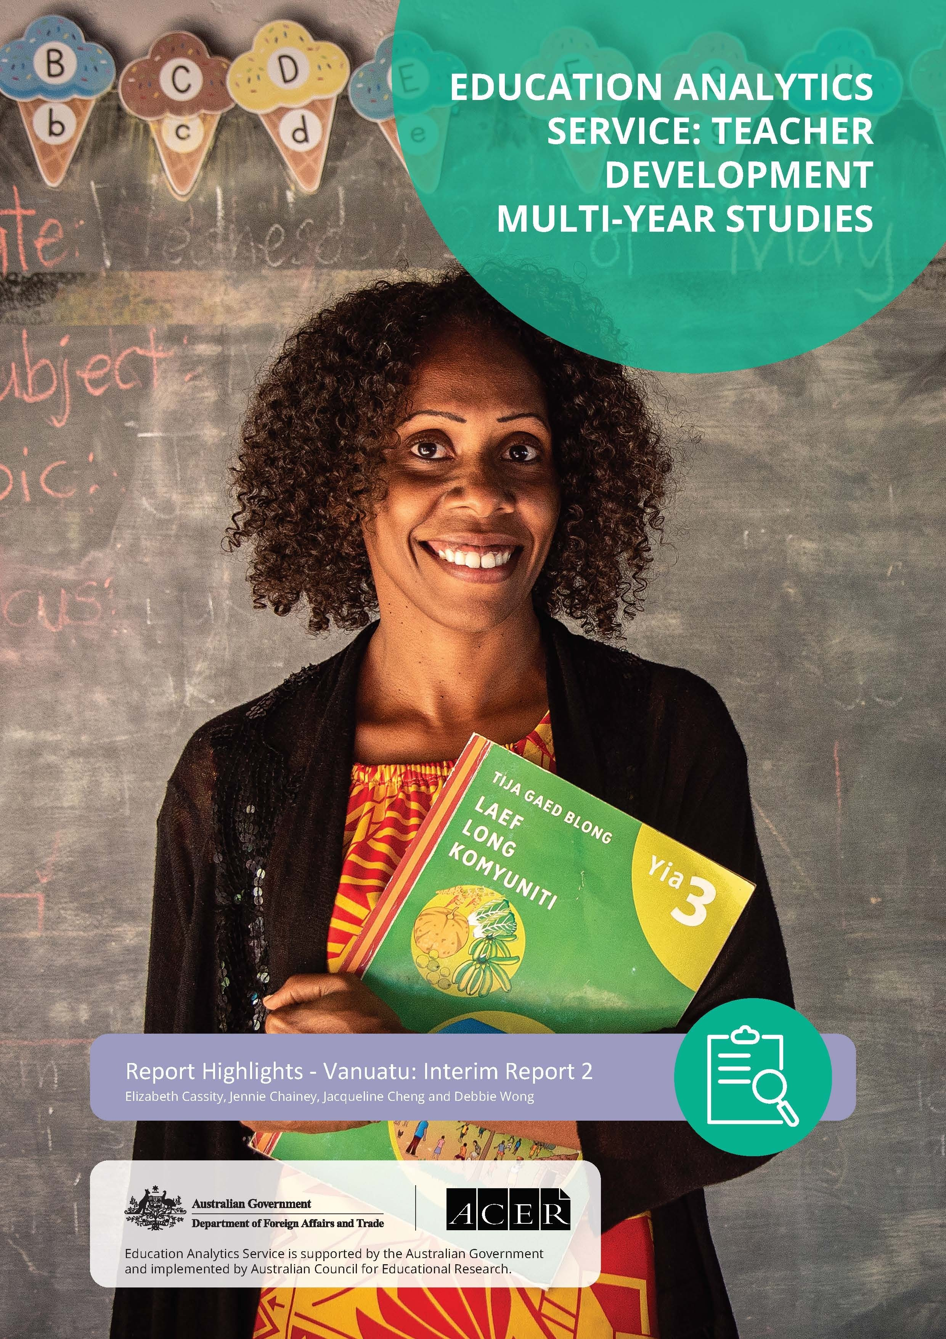

Introduction
The Australian Government is supporting the Government of Vanuatu through its Vanuatu Education Support Program (VESP) to undertake long-term education reforms. A key focus is the rollout of a new national curriculum in conjunction with the National Language Policy (2012), intended to improve teaching quality and student learning outcomes. The multi-year study was commissioned by the Australian Government’s Department of Foreign Affairs and Trade (DFAT), to investigate teaching and learning development initiatives in 3 countries: Lao PDR, Timor-Leste and Vanuatu. In Vanuatu, the Education Analytics Service (EAS) is investigating how the VESP activities are making a difference to these teaching and learning outcomes.
The new primary curriculum has been rolled out to schools by year level, starting with Year 1 in 2016, and is accompanied by the distribution of teaching and learning materials and training. Pedagogical approaches – such as student-centred learning, language transition and classroom-based assessment practices – aim to transform teaching and learning.

Methodology
The Teacher Development Multi-Year Study for Vanuatu seeks to answer the question:
To what extent does this aid investment produce improved teaching quality and improved student
learning?
The 3 specific questions are:
1. To what extent has the investment improved teaching quality in Vanuatu?
2. To what extent has the investment in teacher training and mentoring supported effective implementation of Vanuatu’s new curriculum?
3. To what extent have teacher training and support activities led to improved learning outcomes?

Summary of findings
Positive progress has been made towards improved teaching quality and student learning outcomes.
Teachers and principals are knowledgeable about the new curriculum and are applying new methods into their practice. However, limited follow-up in teacher professional learning and inconsistencies in how the language policy is applied and communicated in schools have created challenges.
Changes in provincial structure, such as the discontinuation of the provincial trainers (PTs) and school improvement officers (SIOs) have negatively impacted the delivery of in-service training and how teachers are supported in schools.
The new curriculum involves reforms to both teaching and assessment practices. More time and support are needed for teachers to understand and fully incorporate new approaches into their teaching practice. While there are indications of improved student participation and engagement in the classroom, it is too early to associate these changes with improved student learning.
It is important to acknowledge that education is a long-term investment. It takes time for educational reforms to translate into positive learning outcomes.

Teaching quality
VESP-supported trainings reported as particularly helpful by teachers
- Effective Learning and Teaching
- Ademap Lanwis (language transition)
- Language and Communication
To what extent has the investment improved teaching quality in Vanuatu?
The 2019 and 2021 results indicate that VESP-supported training for teachers and principals, along with the provision of curriculum materials and resources, have been effective in strengthening application of new pedagogical methods. They have also improved content knowledge of the curriculum. Guides and curriculum resources have assisted teachers in lesson planning and using more student-centred classroom activities.
There has been an increase in engagement between students and teachers, with teachers stating that being able to use students’ mother tongues, including Bislama or the vernacular, has been crucial to classroom interaction. When teachers and principals participated in specific training courses, particularly related to inclusion, they developed knowledge and skills in engaging all children.

Curriculum Implementation
Key challenges to implementing new curriculum
- Peer support
- Provincial support for schools
- Language transition
- Language policy communication and application
The 2019 and 2021 findings indicate that the professional learning support received through VESP has helped teachers improve their practice and ability to implement the new curriculum. However, teachers interviewed acknowledged the need for ongoing or follow up support and feedback.
Teachers highlighted the importance of peer support in planning and discussing pedagogies at the school level but said networking with peers at other schools was a challenge due to distance between schools and the cost of transport.
Ongoing support from provincial offices to implement the curriculum has been inconsistent. The discontinuation of PT and SIO roles, while beyond the control of VESP, has left a critical gap in the teacher support structure. In particular, greater support for teachers is needed to enable them to help students with the important transition in Years 3 and 4 to French or English.
Respondents observed increased levels of student and parental engagement in schools because of the language policy and the new curriculum. While communities generally recognised the benefits of the language policy, they raised concerns due to uneven communication about the policy and its inconsistent application in schools.

Student learning outcomes
To what extent have teacher training and support activities led to improved learning outcomes?
Teachers reported student-centred strategies and familiar language as making students feel more happy, confident, interested and engaged.
The extent to which the VESP leads to improved learning outcomes for Vanuatu students remains difficult to quantify at this point in the reform cycle. Results from VANSTA 2017 and 2019 show a high level of variation in student performance across the country. A high proportion of students are not meeting the learning outcomes expected at their grade level – particularly in French and English literacy.
However, evidence about student engagement is an important indicator of student performance. International research explores the relationship between student engagement (including well-being and interest in lessons), learning and achievement. Respondents observed students as being more talkative and expressive in class, and able to speak more coherently and clearly because they were able to use their mother tongue. Data also suggests that students are happier, more confident interested in lessons and engaged under the new curriculum. Student-centred strategies and a familiar language were key factors identified by respondents.

Recommendations
- Embed professional learning for teachers and principals.
The Ministry of Education and Training (MoET) needs to investigate ways to resource ongoing and refresher professional learning for teachers and principals to ensure long-term take up of the curriculum, and to enable teachers to support students with language transition and improve their literacy and numeracy skills. Few teachers and principals have been able to access the full suite of training provided by VESP. Conducting an audit of who has received training and offering targeted training to those teachers who have missed out are strategies to address professional learning gaps.
2. Provide support for teachers and principals at the provincial level.
Institutional change at the provincial level has led to inconsistency of support, especially with teaching practice and classroom observations. There is an urgent need to prioritise strategies that improve knowledge and implementation of the new curriculum. MoET needs to address the critical gaps in teacher support structures at the provincial and school level, and to consider re-instating provincial level roles that support professional learning.
3. Support schools to engage with parents and caregivers.
Parents and caregivers can play a key role in supporting student learning. This can be achieved through ongoing community engagement with the curriculum and language policy. National information campaigns and workshops can be helpful in building community understanding of the objectives of the new curriculum, and how parents can support their children’s learning. It would be useful to investigate high-performing schools who have consistently applied the language policy to understand the approaches they have used.
4. Continue to provide learning opportunities on gender equality, disability and social inclusion (GEDSI).
Opportunities for teachers and principals to develop learning and skills in gender equality, disability and social inclusion are needed. Offering specialist courses to teachers, such as the Special and Inclusive Education Diploma administered by the University of the South Pacific would be beneficial. Teachers who undertook this diploma gained specialist knowledge about GEDSI and effectively applied it to their school contexts to improve learning outcomes of students with special needs.
To read the full Vanuatu: Interim Report 2 please visit the DFAT website.
Education Analytics Service is supported by the Australian Government and implemented by the Australian Council for Educational Research
© 2022 The Commonwealth of Australia, represented by the Department of Foreign Affairs and Trade.
Recommended APA citation:
Cassity, E., Chainey, J., Cheng, J., & Wong, D. (2022). Teacher development multi-year study series. Report highlights. Vanuatu: Interim report 2. Australian Council for Educational Research.

