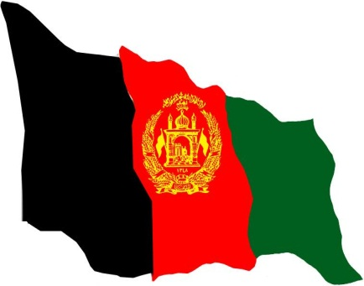

Not official translation

Uruzgan Provincial Development Plan for

1390

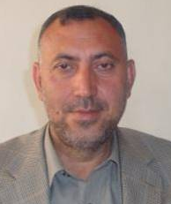
Foreword
At no other point in recent history does the development of Uruzgan Province mattered so much to the stability and peaceful future of Afghanistan. The country is undergoing institutional reforms in order to reconstruct and re-establish state mechanisms despite the current insecurity which is unjustly denying the population access to, and participation in government and development programs. A government accountable and inclusive to the people and which enables all access to basic goods and services is essential to achieving a sustainable peace. Reforms highlighted by Sub-National Governance Policy (SNGP) have been developed and approved with the vision of promoting active citizenry and participation in the national reconstruction and development efforts whilst making government more decentralised and legitimate to the people.
Even though Uruzgan is one of the poorest provinces in the country and rests in the southern region of Afghanistan, it has been gradually improving in security and subsequent development services to the population. Despite this improvement 95% of the population still live below the poverty line. It is now time to address how the provincial government can lead and enhance reforms in order to improve planning, coordination and monitoring for effective governance and sustainable development.

The Provincial Development Committee (PDC), of which I have the honor to Chair, consists of Sectoral Working Groups led by respective line ministries. It is with deep appreciation that the sector working groups were able to develop their sector plans through a participatory and consultative process with the assistance of UNDP/ASGP, UNAMA, NGOs and international partners.

The Provincial Development Plan transformed stakeholder’s kaleidoscope of views into one strategic vision to address gaps, challenges and problems of development. The alignment of stakeholders under one vision enhances the ability to capitalize on opportunities and inherent strengths of the community for the development of Uruzgan province.
I would like to thank UNDP ASGP, UNAMA, Head of Sectorial Departments, PRT, NGOs and donors for their tremendous support in the preparation of Provincial Development Plan.
At last, I would like to request the central government, all international agencies and donor to support the mobilizing of resources for implementing this Provincial Development Plan.
I hope, Almighty Allah will support our Province in 1390 to bring change in governance, development and security through implementing the Provincial Development Plan.

Mr Mohhamad Umar Sherzad
Governor of Uruzgan

Table of Content

I | Provincial Development Plan and its purpose | 4
II | Methodology & Introduction of Uruzgan | 5
III | Situation Analysis | 9
IV | Sector Goals | 18
V | Sector Objectives | 19
VI | Investment programme (projects/interventions) | 21
VII | Implementation, Monitoring and Evaluation | 57
VIII | Conclusion | 57
List of Abbreviation:
1. | AHDS- Afghanistan Health and Development Services | 13. | IARCSC- Independent Administrative Reform and Civil Service Commission
2. | ANSF Afghanistan national Security Force | 14. | MDG- Millennium Development Goal
3. | ANDS- Afghanistan National Development Strategy | 15. | NABDP- National Area Based Development Programme
4. | APRP- Afghanistan Peace and Reintegration Programme | 16 | NGO- Non Governmental Organization
5. | ASGP- Afghanistan Sub national Governance Programme | 17. | NRAP- National Rural Access Programme
6. | ASOP- Afghanistan Social Outreach Programme | 18. | PAR – Public Administrative Reforms
7. | AUSAID- Australian Agency for International Development | 19. | PDC- Provincial Development Committee
8. | BPHS- Basic Packages of Health Services | 20. | PDP- Provincial Development Plan
9. | CDC- Community Development Council | 21. | PRT- Provincial Reconstruction Team
10. | CSO – Centre Static Office | 22. | SWG- Sector Working Group
11. | DDA- District Development Assembly | 23. | UNAMA- United Nation Assistance Mission to Afghanistan
12. | EQIP – Education Quality Improvement Programme | 24 | UNDP- United Nation Development Programme
I. PROVINCIAL DEVELOPMENT PLAN AND ITS PURPOSE

The Provincial Development Plan (PDP) is a developing programme that indicates the development needs and priorities of the people of Uruzgan and the strategies proposed to address them. Apart from being an administrative requirement, the Provincial Development Plan also gives a clear direction to the provincial administration and its development partners, as to the agenda to be followed in pursuit of development in the province.

Once funding or technical gaps are identified, development partners and donors can have the choice of selecting which programme area they would like to support in addressing the needs of the people. This way development partners can target their assistance based on their specialized areas of interest in line with agreed priorities. Furthermore it will serve as the platform for coordinating the development activities of all partners in the province.

The Provincial Development Plan has been prepared through a participatory and consultative process to implement the development activities for the year (1390) that will support changes in the socio-economic and environmental conditions of the village/ district as well as support for peace and security.

The objectives of the development plan have been defined & interlinked with the ANDS and MDGs. The situation analysis, objectives & goals along with the prioritized list of projects have been developed for eight sectors (Health and Nutrition; Education, Youth and Culture; Agriculture and Rural Development; Social Protection; Infrastructure and Natural Resources; Governance; Security and the Private Sector). All Government line departments, the PRT, national NGOs, international donors & civil societies that work in the Province or at District level will focus on implementation of prioritized projects included in the provincial development plan. This will bring wider impact in the community, District and Province as a whole.

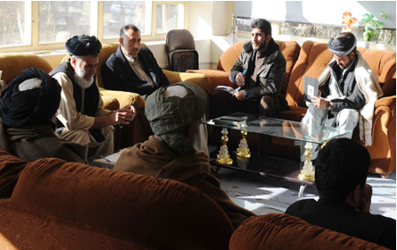

II. METHODOLOGY

A key element underpinning the development of the Provincial Development Plan (PDP) has been ‘participation’. All efforts were made to ensure that:

- the people of Uruzgan who are the ultimate beneficiaries of the PDP, had the opportunity to indicate what their needs and priorities are; and

- the identified investment priorities really reflect and address the needs of the beneficiaries

In the light of the above, the planning process began with technical support from UNDP’s Afghanistan Sub-Governance Program (ASGP) to conduct a consultation process. Planning workshops were held in the Tarin Kot, Chora and Dehrawood districts to discuss, identify and prioritize the needs of the communities. Participants at these workshops were the shura, members of the Community Development Committees (CDCs), District Development Assemblies (DDAs) and tribal leaders. Due to transportation problems and security issues, the process of identifying the issues and priority programs for Uruzgan’s remaining districts (Char Chineh, Khas Uruzgan, Chenartu and Gizab) relied primarily on the District Development Plans. These plans were developed through district development workshops in each district through the Provincial Rural Rehabilitation and Development’s (PRRD) National Area Based Development Program (NABDP). In addition, information from sector and line ministries, and other key partners were also drawn upon.

For each of the eight sectors, a working group consists of the relevant line ministries, NGOs and donors were established. Through these sector working groups, issues and priorities were reviewed and appropriate goals and objectives developed. In relation to the identified community needs, a prioritized list of investment programmes was developed to match the proposed goals and objectives. The overall sector strategies of line ministries and anticipated programmes of other key partners were also considered.
The draft PDP was presented at a consultative workshop where it was reviewed by members of the Provincial Development Committee, representatives of the Provincial Council, significant non-government organizations (NGOs) operating in Uruzgan and the civilian-led Provincial Reconstruction Team (PRT). All related sectors, national stakeholders as well as international donors came together to review the sector plan and provided their comments and suggestions. The revised PDP was subsequently approved by the Provincial Council, and the Provincial Governor.

In addition to the PRT, UNAMA and a number of active NGOs, the following key departments contributed significantly to the development of the PDP: Rural Rehabilitation and Development, Agriculture, Education and Health as well as other line departments.

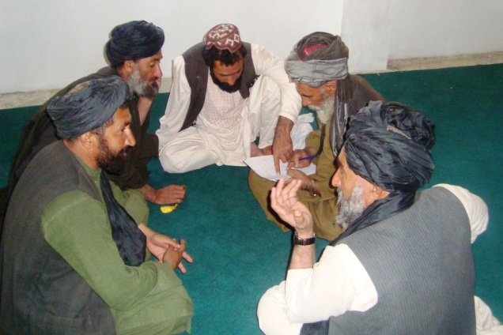 | 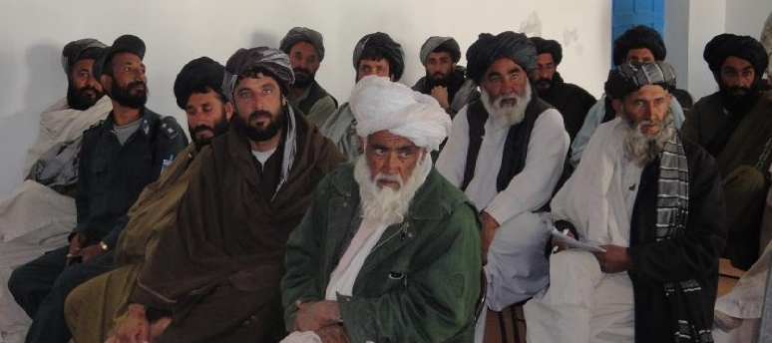  District Planning Workshop

Steps

Preliminary workshop: An orientation workshop was organized by representatives of the Ministry of Economy with the support of ASGP/UNDP. The participants of this workshop were line ministry officials & NGOs members in Uruzgan.

Training of the Trainer (ToT) for core planning team: A core planning team was established with representatives of each sector and an IDLG/ASGP team. UNDP ASGP organized a two-days ToT for the team to facilitate the planning process. After the training, the team was divided and tasked to facilitat district planning workshop and sector working group meetings.

District Planning Workshops: The District planning workshops were organized in Tarin Kot, Dehrawood, and Chora districts with the participation of community councils, tribal elders and DDA representatives.
- 140 members of CDCs, DDAs members participated in district workshops in Tarin Kot, Dehrawood & Chora.

- 50 city residents (including 10 females), 8 Kochis, 15 shaheeds attended in different workshops. The issues discussed in each workshop included development needs/problems, the causes and possible solutions. All issues that arose in the workshops were documented & considered by the relevant sector working groups as part of their process.

Sector Working Group meetings:

In the second stage all the line ministries associated with a sector in accordance with Afghanistan National Development Strategy (ANDS) formed a sector working group. Together they developed a situation analysis picture, defined the goals & objectives for the next 12 months and a prioritized project list that was informed by the District Planning Workshops, District Development Plans and Line Department Plans. The process for each sector included at least five working group meetings. The prioritization criteria were: basic need fulfillment, do-ability, types of plan, beneficiaries coverage and support to ANDS/MDG. The cost estimation was made for each project (i.e. not based on feasibility and design but drawn from information available from similar projects).
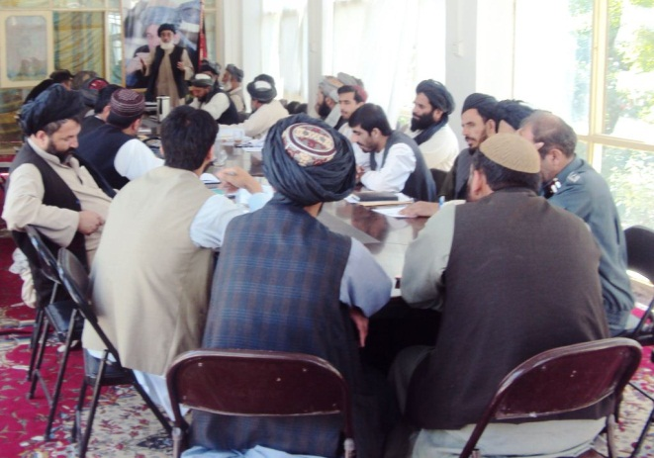 | 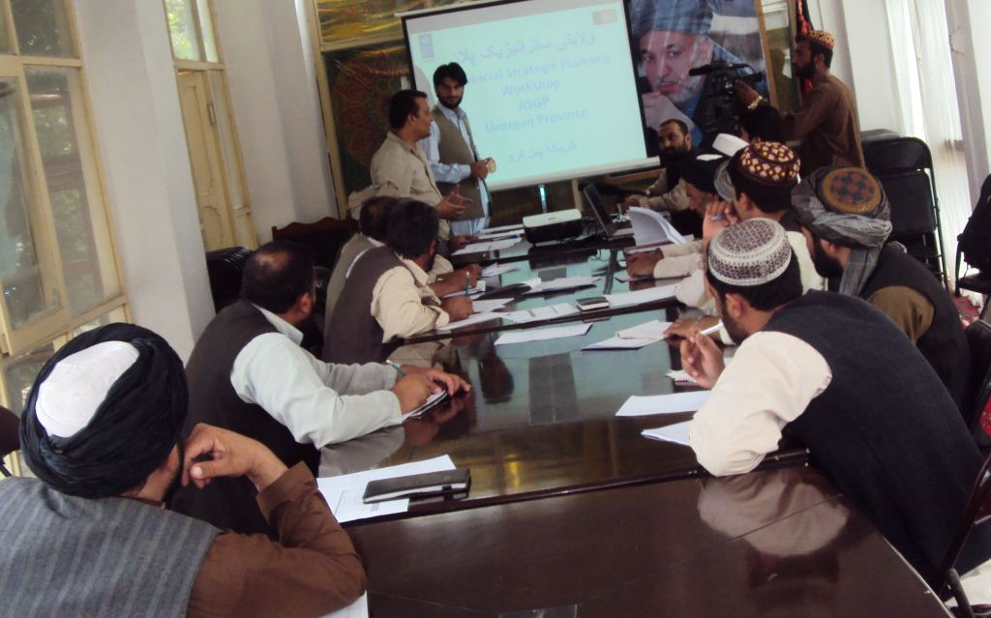  Sector working Group Meetings

Information of Uruzgan Province

Uruzgan is located in central Afghanistan. It is bordered by Daikundi in the north, Kandahar to the south, Zabul and Ghazni on in the east and Helmand to the west. Uruzgan land area is 1260km² of which 72% is mountainous or semi mountainous, 27% is flat or semi flat & the remaining is not reported
Topographic
Flat | Semi Flat | Mountainous | Semi Mountainous | Not Reported | TOTAL
21.1% | 5.9% | 47.2% | 24.5% | 1.2% | 100.0%

Source: CSO/ UNFPA

Population:

The estimated population of Uruzgan is 386,100. This is based on an estimated 55,157 families, with an estimated size of approximately 7 in each family.
Total | District | Char Chineh | Chora | Chenartu | Dehrawood | Gizab | Khas Uruzgan | Tarin Kot
198,700 | Male | 28,200 | 24,500 | 6,200 | 29,700 | 32,600 | 27,400 | 50,100
187,400 | Female | 27,300 | 23,500 | 5,900 | 27,700 | 30,900 | 25,800 | 46,300
386,100 | Total | 55,500 | 48,000 | 12,100 | 57,400 | 63,500 | 53,200 | 96,400

Source: CSO/ UNFPA

Most of the population (96%) lives in rural area at district, villages, suburbs and rest 4% lives in city. The total population of which 51% is male & 49% is female

Government structure:

Uruzgan Government structure includes 570 official positions (tashkil) of which there are currently 235 positions (41.2%) fulfilled. Of these 235 civil servants, 201 have passed the PAR process & the remaining will be processed in the coming year. There are 31 line departments working in the province such as PRRD, Health, Education, Agriculture, Water management, Electricity, Public work, Communication, Transportation, Social affairs etc.

There are many donors and organizations supporting the development of Uruzgan. These include the civilian-led Provincial Reconstruction Team (PRT). The Uruzgan PRT includes civilian representatives from the Australian, the Netherlands and United States government’s aid agencies plus military elements from Australia and the United States. The United Nations Assistance Mission in Afghanistan (UNAMA) office includes representatives from UN agencies, such as the United Nations Development Programme (UNDP).

The Netherlands, Australian and United States governments in turn fund a range of organisations to work in Uruzgan in development programs. These include non-government organisations which deliver donor-funded programs while developing and strengthening links with local NGOs. Other organizations like the German International Organisation (GIZ) or the Central Asian Development Group (CADG) are also supported to implement donor funded programs. The PRT Funded programme consists of the programme funded by The Netherlands, Australian and United States governments in Urozgan. This programme is described in annex 1.

The key national programmes that are being implemented in Uruzgan are: UNDP/ Afghanistan Sub National Governance Programme, National Solidarity Programme, National Area Based Development Programme, Afghanistan Peace and Reintegration Programme, BPHS, EQIP, ASOP, NRAP among others.

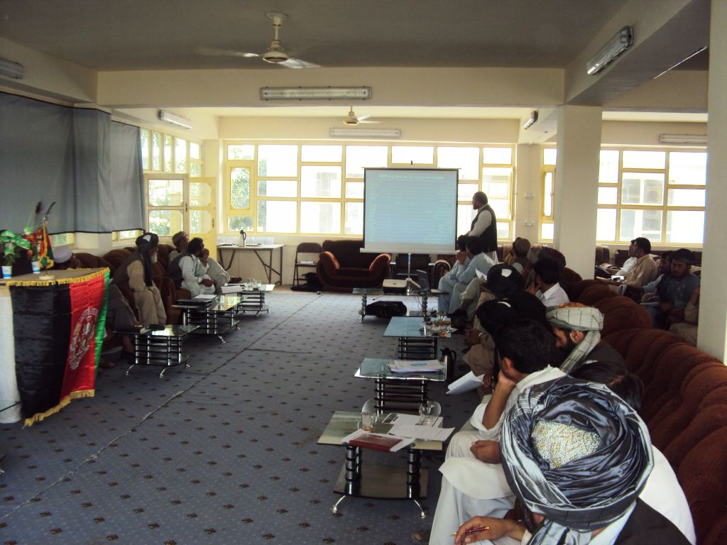 | 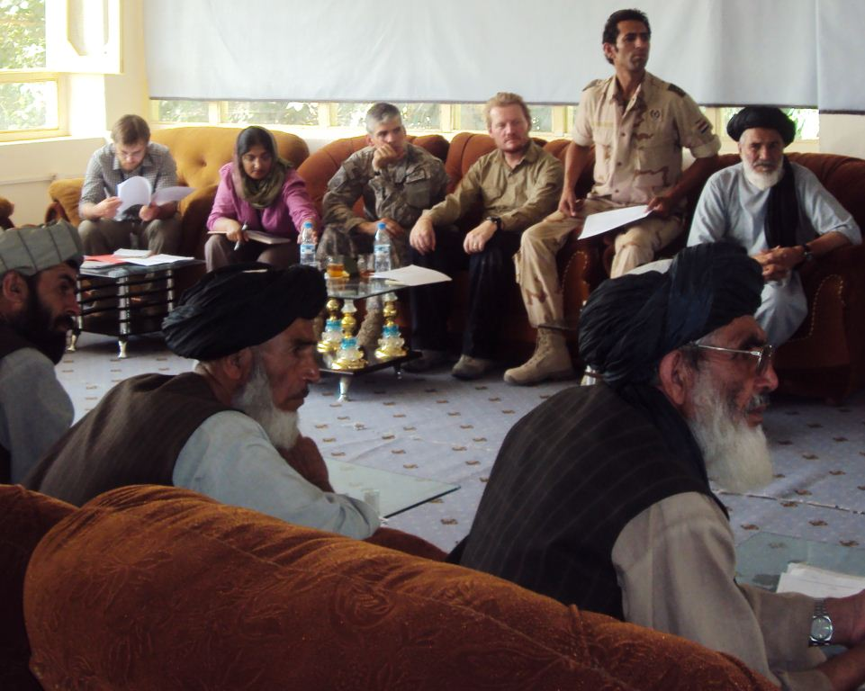
PDP meetings

III. SITUATION ANALYSIS

Education Sector

The education system in Uruzgan is weakened by the lack of qualified teachers, poorly constructed schools and the poor security situation.

Vacant official positions (tashkil) is a major challenge across the education sector. The total number of teachers currently in Uruzgan is 1,344. Only 40% of these teachers have higher education. The majority of teachers are either under - or un -qualified. The quality of teaching is known to be one of the most important factors in improving the educational outcomes for students. One of the constraints is that the education directorate does not receive a list of all the teachers from Kabul who are temporarily fired or hired. This creates a gap in both the knowledge of what teachers are in the province. For example the position of teacher of all school of Gizab has not been approved and they haven’t received the salary since four months as of date.

The lack of sustainable security prevents the relevant authorities from conducting regular monitoring and evaluation activities in schools and in the sector generally. It also prevents the transportation of educational materials and equipment to schools in some districts. While security is a major challenge across each of the sectors in Uruzgan, the education sector is one of the most affected as it impedes the provision of good quality schooling to all the children in the province. For example, it affects the ability to recruit and retain qualified teachers, to construct quality buildings, and to monitor the sector. This is especially the case in the more remote villages or in districts beyond Tarin Kot, Chora and Dehrawood where security has improved. Currently there are approximately 40 local/village educational shuras with an active role in securing the schools and education process for their village.

School / teacher by district
in Uruzgan

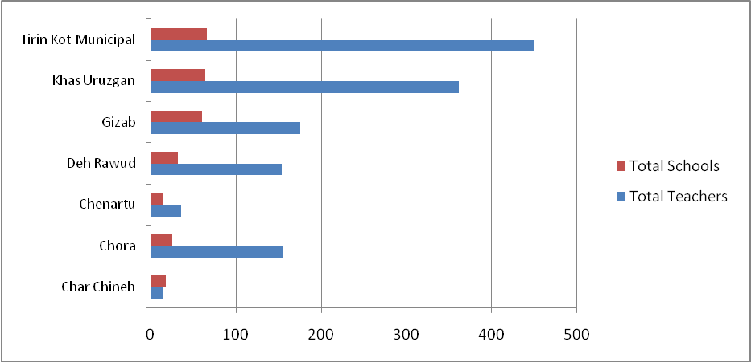
Source: Education Department/ Uruzgan
in Uruzgan

The lack of quality school buildings negatively impacts the quality and quantity of educational services. There are schools with poorly constructed buildings and schools without buildings in which case, the students use tents or the desert as a classroom. The lack of qualified teachers and appropriate school buildings, contributes to a very low provincial literacy rate and low capacity of Uruzgan students. This limits the ability of Uruzgan students to attain places in higher education institutions then succeed at the national universities. The province is therefore unable to receive the benefit of higher skills and experience neededto serve the society and communities.

Uruzgan does not as yet have a dedicated residential area set aside for teachers. In other provinces such a specific residential site has had a positive impact upon the spiritual attitude and life of teachers. The residential area will lead around 500 teachers to have shelters/houses. It is hoped that by having the planned residential area more qualified teachers will be attracted to Uruzgan to increase the quality of educational services offered here.

The disrepair or absence of well-constructed buildings or offices for district education staff reduces the effectiveness of the education directorate staff and puts in danger the safekeeping and accessibility of relevant documents and teaching materials. Upgrading these offices will substantially address the effectiveness at the district level.

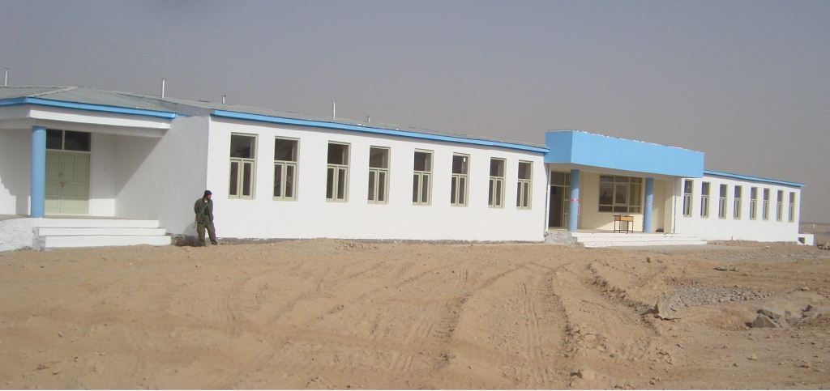
Newly constructed School in Tarin Kot

Governance Sector

Governmental organizations have failed to deliver services to the majority of the people of Uruzgan as required. The core problem has been the very high level of vacancies in official positions. According to the tashkil there should be around 570 staff. However, the existing number of recruited staff is less than half of this number (235). Of these, 201 staff has been recruited according to PAR system. There remains a gap of 235 personnel in governmental organizations. The high rate of vacancies has negatively affected the effectiveness of governmental organizations and creates failures in administrative discipline and compliance with regulations by governmental staff. However, the implementation of an internship programme with coordination of IARCSC and UNDP funded by AUSAID provided an opportunity to fulfill some part of the tashkill. About 15 interns were selected as tashkill in PGO and line departments.

There is a severe lack of awareness of the existing national laws. This gap in knowledge widens the chasm between the government and the people because in the absence of knowledge there are at times unrealistic expectations and sometimes illegal activity. The lack of sustainable security across the province limits the government’s ability to conduct social outreach programmes at the local level across a range of sectors, including the law.

One of the most important reasons for the failure of rule of law in Uruzgan is the existence of corruption and the perception of corruption which undermines the rule of law. The absence of strong accountability and transparency mechanisms between the people and government, combined with the lack of knowledge of the countries laws and high levels of vacancies in the judicial sector contributes to the failures in rule of law. The media while an important transparency medium is not yet decentralized to cover the entire sub-national level.

Another contributing factor to government ineffectiveness is insufficient coordination amongst governmental organizations, NGOs and donors. Improved coordination will increase the focus of activities and targeted positive impacts.

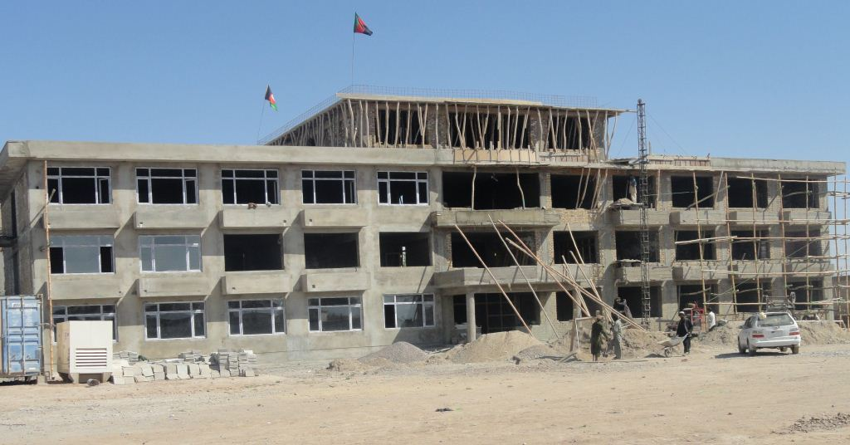
Construction of new Provincial Governor Office

Private Sector

In Uruzgan there are no specific areas for an industrial zone to encourage economic development led by the private sector. Insecurity and poor infrastructure has deterred private sector investments in the province. The poor state of road and transport infrastructure and electricity supply has been particular constraints.

A Chamber of Commerce has not yet been established in Uruzgan. A public outreach program to establish one will be conducted. There are enough businessmen with the potential to invest in several fields; however the limited number of homegrown professional and skilled labors to technically support these activities remains a constraint to investment. Technical personnel and equipment need to be imported from other provinces adding significantly to the costs. The high costs of importing equipment, produce and skills not only effect private investors, but also increases the production cost thus limiting the competitiveness of Uruzgan products in the marketplace.

As noted in other sectors, security also increases the risk and therefore costs of doing business and therefore deters potential private sector investors, particularly in the districts.

National awareness about improvements in security, transportation infrastructure and the human and natural resources of the province, targeted at private investors is needed. This will identify existing opportunities and provide a clear picture and guidance to the investors to encourage them to do business in Uruzgan.
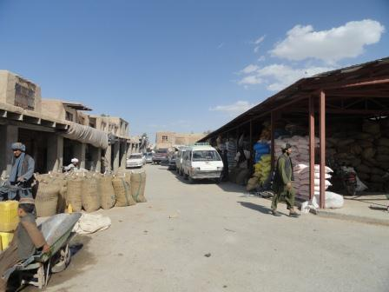  Newly constructed food Markets in Tarin Kot | 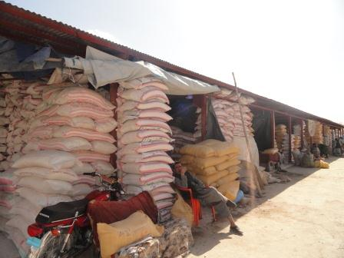

Health Sector

As in other sectors, the lack of qualified professionals, particularly doctors and midwives is a serious challenge in Uruzgan. It affects the delivery of improved health outcomes and services.

The shortage of professionals impacts on the motivation of health care staff. There are no local Uruzgan doctors; all of the current doctors are from different provinces. Attracting and retaining qualified health staff to work in the rural areas and villages is a huge challenge. Low salary is one reason. Currently each official doctor gets paid 12,500 AFs per month as their salary. This is inadequate to attract and retain qualified staff in Uruzgan.

There are 133 doctors available in Uruzgan; 8 of them are government staff the rest of them are paid through Afghan Health and Development Services (AHDS) the contracted basic package of health care implementing partner and other NGOs. According to the official tashkil almost half (47.5%) of the official positions are vacant (both government and NGO) throughout the province. These vacancies are no longer supplemented (as they once were) by temporary doctors sent from the Ministry of Public Health. In the past temporary doctors had moved between provinces providing technical support to provincial health department in different fields.

Beyond low salaries, the lack of sustainable security is the major challenge and it directly affects the recruitment of professional health care staff. According to the National Basic Health Policy the majority of health facilities should be delivered in district/village level. Insecurity and poor infrastructure have thus been an obstacle to the delivery of local level health care services. Currently there are 15 health centers in Uruzgan;- 7 of them locates in secure area, 5 are in semi-secure and 3 others are in insecure area. As a result, 50% people don’t have access to health care services.

Health Facilities by districts

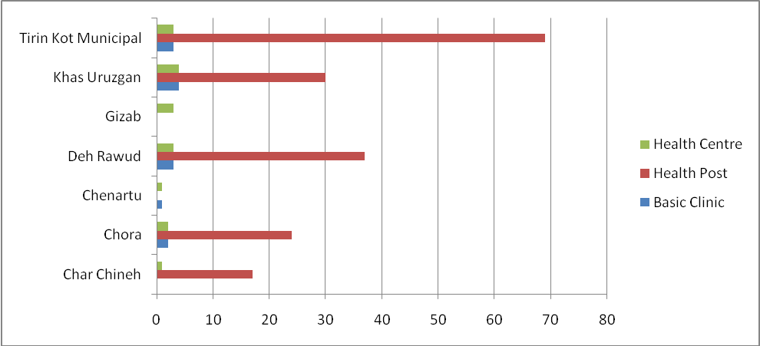
Source: Health Department

Limited awareness of the health care services that are available and understanding of the services each facility or community health worker is able to provide is a particular challenge for rural inhabitants. Public outreach programmes will be conducted to help improve this awareness and to improve the general knowledge of general health care activities and basic assistance.

The lack of access to clean water (estimated to be more than 90%) is another persistent challenge. For the majority of rural inhabitants drinking water comes from streams and rivers, although there are some deep wells. These are generally insufficient for all the people. Some local custom and traditions, lack of access to health care centers and professional qualified health care workers contributes to high mortality rates.

The fact that Uruzgan has not typically featured in central government planning has contributed in the past to failures to improve essential service delivery.
Social protection
The high rate of unemployment, while a country-wide problem, is a particular problem in Uruzgan where the consequences of continuous internal conflicts and droughts mean that 40% of people who have the capability to work but cannot find jobs. Currently, through a range of government and donor-funded activities around 3,000 people have been recruited, but there are far more people looking for jobs than there are opportunities. Increased private sector investment is required to increase the number of sustainable job opportunities.

The lack of a residential area for the disabled and returning displaced or refugees is a major challenge. Approximately 800 people in Uruzgan have significant disabilities as a result of continuous internal conflicts. A number of other people who fled the violence now find they have no home or land to return to.
As in other sectors, the lack of tashkil staff is a significant obstacle. The average salary of each government staff is 3,500 AFs per monthwhich is woefully inadequate to survive on. This contributes to both the number of vacancies and the reason low capacity and morale of staff.
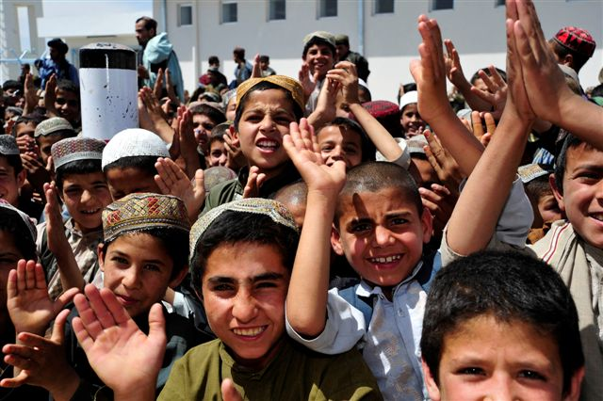  Women and Youth in Uruzgan  in Uruzgan | 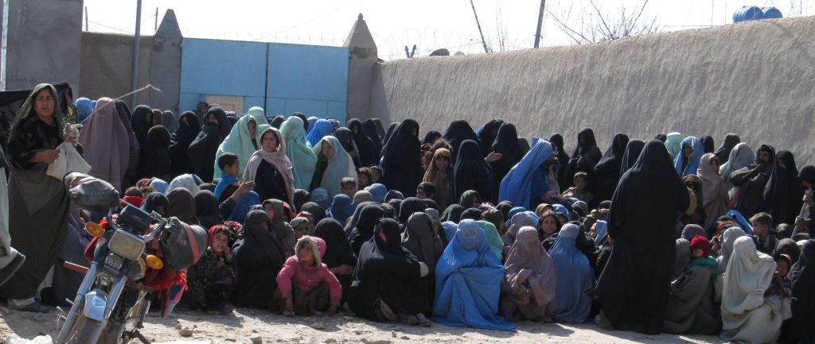

In the context of high unemployment and low local skills, the lack of vocational institutions for both men and women severely limits people’s ability to become economically self-reliant. Currently there are 17 vocational institutions in Uruzgan. In total only 1,100 (700 men and 400 women) are currently in vocational training across a range of fields. The existing number of vocational institutions is insufficient to build the skills capacity for Uruzgan.
While Uruzgan produces handicrafts, a dedicated market where these handicrafts can be sold is lacking. Annually around 5,000 items of handicrafts are being produced in Uruzgan which consists 30% of Uruzgan annual income and provides job opportunities to 25% of its people. This could be increased with a dedicated market.

Agriculture, Rural rehabilitation sector

The neglect and destruction of the canalization system and previous micro dams and water distribution areas in Uruzgan has led to the failure of water supply system for irrigation which in turn negatively impacts on the quality and quantity of agricultural production.
Increasing rates of animal and plants diseases have been the result of the lack of equipped veterinary clinics with professional and qualified personnel. As in other sectors, insecurity has limited the ability of agricultural directorate staff to regularly move between districts to monitor the plants and animals for diseases and to provide agricultural extension services.
As in the case of handicrafts, there are no dedicated agricultural production markets in Uruzgan. Grains being sold in smaller markets are sold at low prices. In order to help farmers sell their agricultural products at higher prices it is proposed that market chain analysis be undertaken, consideration be given to value added processes and the collection in bulk of agricultural product in order to increase the size of potential markets for Uruzgan agricultural products. Poor infrastructure and insecurity increases the time and cost of transportation and limits Uruzgan’s competitiveness in larger markets.
As a consequence of constant droughts agricultural production in Uruzgan has decreased and gardens have been destroyed with a significant impact on the economy.

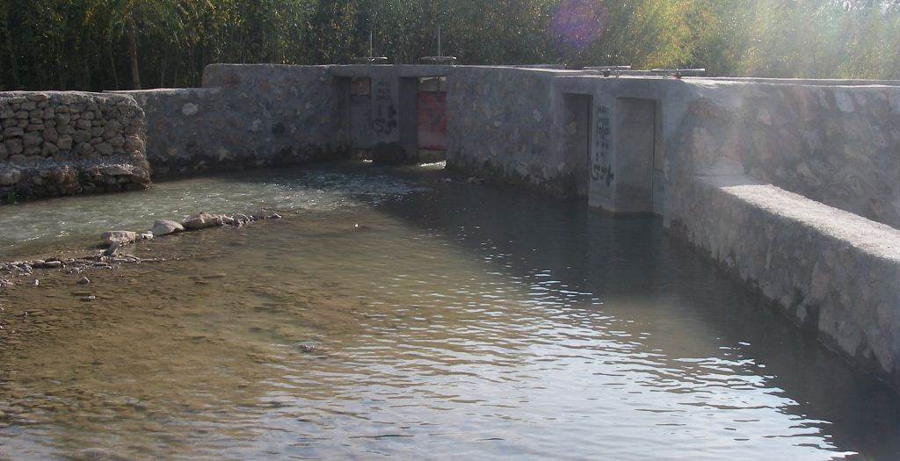 | 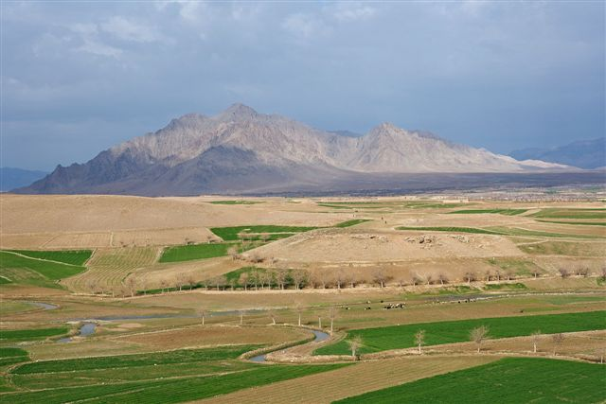
Newly constructed irrigation Canal

Security Sector

As has been noted in each of the other seven sectors, insecurity negatively impacts on every sector. It contributes to lower standards of education, difficulties in improving infrastructure and other construction works in Uruzgan, improving access to health services, and growth in private sector investment by deterring the recruitment of professional personnel to the province and the inability to train enough people from Uruzgan quickly enough and to have them return to their province.
Full cooperation of the people with the Afghan National Security Forces (ANSF) is necessary to ensure sustainable security. Unfortunately, there remains a distance between the people and the government and this is exploited by insurgent elements. Sometimes tribal issues and conflicts cause insecurity in the province. The constitution of the administrative structure based on tribal affiliations has also contributed to both the lack of professional personnel working in government administration and to the distance between government and some communities.
Another cause of concern within communities has been the distribution of ANSF forces on the basis of tribal affiliation rather than professionalism. What is usually considered ‘unauthorized’ house searches and arrest have also contributed to the lack of trust between provincial and local authorities and communities.
Security personnel don’t have a specific residential sites, the existence of warlord and occupiers in the field and problems with local police not receiving their salary on time (lack of regular transportation and lack of banks in the districts), are all considered issues of concern within the security sector.

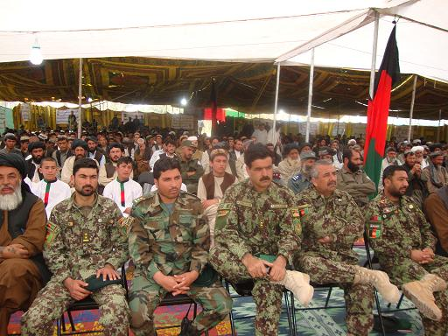 | 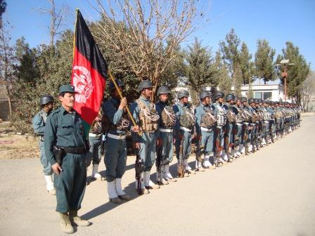
Provincial Reconciliation Shura held in Tarin Kot
in Uruzgan
Afghanistan National Police
in Uruzgan

Poppy cultivation continues within the province and undermines the rule of law. However, in the context of high unemployment and limited market access for other crops, and in the absence of alternate livelihood assistance, people continue to cultivate poppy. In this regard government has to play a substantial role.

Infrastructure and Natural resources

The poor state of infrastructure across the province has been noted as a significant constraint to the delivery of education, health, security, market access and private sector investment. Most roads within Uruzgan are not all-weather roads (whether asphalted or hard-pacted) and the technical maintenance and professional capacity within the key departments, particularly the ministry of public works is severely limited.

The lack of a significant development budget dedicated to improving infrastructure and the high costs of imported construction materials and technical staff are the main reasons for the above mentioned challenge. Each of the line ministries involved in this sector: municipality, communication, rural rehabilitation and development, transportation and irrigation are all facing a lack of professional personnel. The causes have already been described in several parts of this chapter.

The lack of a regular water supply system and electricity, even in the provincial capital, Tarin Kot, is a serious constraint on municipal development as well as across the province. The lack of adequate budget has constrained the implementation of the approved city master plan for Tarin Kot.

At both provincial and district levels there are insufficient telecommunication connections. Insecurity as well as the absence of financial support and lack of coordination of community with private sector continues to be a challenge.

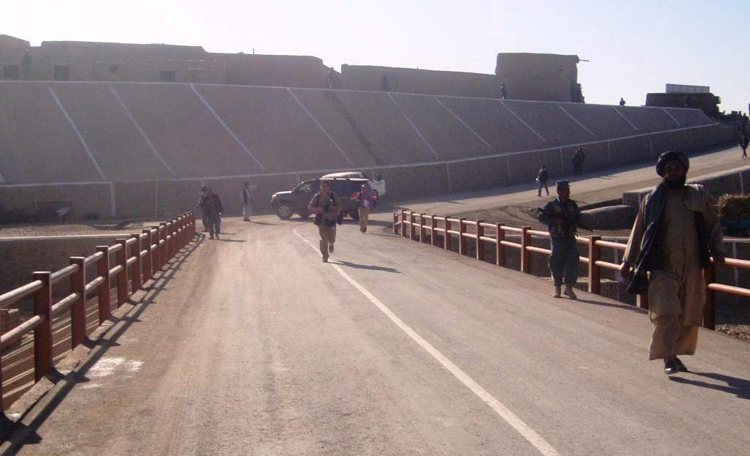
Newly constructed bridge in Chora district
in Uruzgan

IV. SECTOR GOALS

In the light of the situations analysed for the various sectors, corresponding goals have been developed as follows;

Education

To improve the quality of and access to education in Uruzgan
Governance
To link provincial and district levels of government and ensure equitable development
Private Sector
To provide a more supportive environment for private sector investment
Health and Nutrition
To decrease the mortality rate
Social Protection
To provide training and livelihood opportunities, including for women and peoples with disabilities.
Agriculture, Rural Rehabilitation and Development
To ensure food security, support agriculture productivity and reduce poppy production.
Security
To strengthen the rule of law and improve sustainable security across the province
Infrastructure and Natural resources
Implement the city master plan; improve access to clean water, construct roads, bridges and hydropower dams

V. SECTOR OBJECTIVES
Education:
• increase the professionally trained teachers
• construct an additional 10% of schools
• pay extra salary for new 50 teachers
• construct a residential place for teachers
• construct offices / buildings for 50% education sub departments
• provide opportunities for youth to have social & sport activity
• construct a religious school
Governance:
• Fill 50% of vacant tashkil
• Build the capacity of the Provincial Governor’s Office, District Governor Offices and the Municipality and line departments in planning, budgeting, monitoring and public administration
• Conduct public outreach to increase population knowledge about the law
• Construct appropriate professional office accommodation for judges, prosecutors and district government administration
Private sector:
• Identify land for industry zone
• Provide training for businessmen
• increase the number of buildings for finance department
• increase the opportunities for value adding of agricultural products
Health
• Increase access to basic health centers
• Increase the 20% on basic health centers to clinic level
• Provide 20% of the population with health care and nutrition public outreach materials
• Ensure 100% of staff are provided with up skilling trainings
• Build hospital for drug addicts

Social protection
• provide community professional or vocational training by 10%,
• at least 7% professional training opportunities dedicated to women
• 3% of people with disabilities with access to housing
• increase the marketability of handicrafts

Agriculture and Rural Rehabilitation
- Protect an additional 20% of land from floods
- Give 50% farmers more seeds
- Make 15% improvements on the agricultural & livestock products
- Improve saffron/ almond production by 10% to prevent the puppy plantation

Security
- Make buildings for 70% of police in district
- 100% equip the police and army
- Train the police on FDD
- 40 % increase of bases

Infrastructure and Natural Resources
- Increase the all-weather road access from the capital Tarin Kot to each of the districts
- Construct 5 new bridges
- Implement city master plan in Tarin Kot
- Establish bus stops
- Increase the accessibility of basic government facilities such as health clinics, schools, markets and schools by constructing access roads in villages / Districts
- Improve the office accommodation of key stakeholders in this sector
- Improve access to electricity supply and the canalization in Tarin Kot

VI. INVESTMENT PROGRAMME (PROJECTS/INTERVENTIONS):

Education and Culture Sector
S/No | Project name | Village | District | Beneficiaries |  | Quantity | Tentative cost | Criteria |  |  |  |  |  | Priority
 |  |  |  | Direct | Total |  |  | Basic need fulfill-t | Do ability | Type of Plan | Beneficiaries | ANDS/MDG | Total | Priority
1 | Academic Courses | Center | All districts | 1,275 | 80,000 | 6 | $800,000.00 | 5 | 5 | 3 | 5 | 5 | 23 | 1
2 | Building schools and houses for teachers | Shaheed Haji, Fizulhaq, KhanM, and Hnif kahn | Gizab | 1,300 | 50,000 | 2 | $700,000.00 | 5 | 5 | 3 | 5 | 5 | 23 | 1
3 | Buildings for schools and houses for teachers | Yakhdan and Shamashad | Charchneh | 730 | 50,000 | 2 | $700,000.00 | 5 | 5 | 3 | 5 | 5 | 23 | 1
4 | Buildings schools and houses for teachers | Konal kala and chelibai | Chenarto | 1,100 | 50,000 | 2 | $700,000.00 | 5 | 4 | 3 | 4 | 4 | 20 | 1
5 | Building for Agriculture Institute | Center | Tirin Kot | 100 | 500,000 | 1 | $300,000.00 | 5 | 5 | 3 | 5 | 5 | 23 | 1
6 | Building for literature faculty | Center | Tirin Kot | 100 | 500,000 | 1 | $300,000.00 | 5 | 5 | 3 | 5 | 5 | 23 | 1
7 | Buildings for education sub directorates | Center | Khas uruzgan, Gizab, Charcheneh, Chora | 40,000 | 600,000 | 4 | $400,000.00 | 5 | 4 | 3 | 3 | 2 | 17 | 2
8 | Roads, canalization system and park for new teachers resident | Center | Tirin Kot | 500 | 3,500 | 1 | $40,000.00 | 5 | 5 | 3 | 5 | 3 | 21 | 1
9 | Building for students hostel | Center | Tirin Kot | 35 | 260 | 7 | $300,000.00 | 3 | 3 | 2 | 3 | 2 | 13 | 3
10 | Construction of sport & Play grounds | Salam baba, Sayedal kahn, Malali yeklinqa, and religious school | Tirin Kot | 4,000 | 28,000 | 5 | $300,000.00 | 3 | 3 | 2 | 3 | 2 | 13 | 3
11 | Construction of sport & Play grounds | New shar lisa, imranzai, dehsang and sharoghe | Dehrawoud | 2,700 | 19,000 | 4 | $75,000.00 | 3 | 3 | 2 | 3 | 2 | 13 | 3
12 | Construction of sport & Play grounds | Shaheed Haji, Faizulhaq, Khan M, and Hanif khan | Gizab | 2,000 | 14,000 | 4 | $60,000.00 | 3 | 3 | 2 | 3 | 2 | 13 | 3
13 | Construction of sport & Play grounds | Shazaman, shahpar, palan, and peakseyabaghal | Khas Uruzgna | 2,000 | 14,000 | 4 | $80,000.00 | 3 | 3 | 2 | 3 | 2 | 13 | 3
14 | Construction of sport & Play grounds | Ashzai, kalaragh,naswa,sarab and chena | Chora | 1,700 | 11,000 | 4 | $70,000.00 | 3 | 3 | 2 | 3 | 2 | 13 | 3
15 | Construction of sport & Play grounds | Sakar, darsan, oshai, yakdan,and sahmasahd | Charcheneh | 680 | 680 | 4 | $60,000.00 | 3 | 3 | 2 | 3 | 2 | 13 | 3
16 | Construction of sport & Play grounds | Center, konakala, chlibai, and seyaghr | Chenarto | 800 | 800 | 4 | $70,000.00 | 3 | 3 | 2 | 3 | 2 | 13 | 3
17 | Encouraging salary for professional teachers | Tarin Kowt | Uruzgan | 50 | 10.000 | 50 | $480,000.00 | 5 | 5 | 3 | 4 | 2 | 19 | 2
18 | Literacy courses | Center | All districts | 5,000 | 35,000 | 200 | $1400,000.00 | 5 | 5 | 3 | 5 | 5 | 23 | 1
19 | Building for youth social coordinaltion | Center | Tirin kot | 1,000 | 300,000 | 1 | $200,000.00 | 5 | 5 | 3 | 4 | 3 | 20 | 1
20 | Building for education library | Center | Tirin Kot | 5000 | 35,000 | 1 | $100,000.00 | 5 | 5 | 3 | 3 | 2 | 18 | 2
21 | Building for general laboratories | Centre | All districts | 40,000 | 60,000 | 7 | $280,000.00 | 3 | 2 | 4 | 2 | 2 | 13 | 3
22 | Buildings for Information and culture, and TV Radio station | Center | Tirin Kot | 50 | 80,0000 | 1 | $300,000.00 | 5 | 5 | 3 | 55 | 3 | 21 | 2
23 | Pre survey for press | Center | Tirin Kot | 10000 | 25000 | 1 | $10,000.00 | 3 | 2 | 4 | 2 | 2 | 13 | 3
24 | Equipments for the Zwanano zagh radio | Center | Tirin Kot | 500 | 40,0000 | 3 | $5,000.00 | 3 | 4 | 2 | 3 | 2 | 14 | 3
25 | Stadium | Center | Tirin Kot | 200 | 90,000 | 1 | $1,500,000.00 | 5 | 5 | 5 | 5 | 3 | 23 | 1
26 | GYM | Center | Tirin Kot | 400 | 90,000 | 1 | $500,000.00 | 3 | 3 | 3 | 3 | 2 | 14 | 3
27 | Sport area | Center | All district | 14,00 | 60,0000 | 7 | $70,000.00 | 4 | 2 | 3 | 3 | 2 | 14 | 3
28 | Building for sport directorate | Center | Tirin Kot | 30 | 75,0000 | 1 | $200,000.00 | 4 | 2 | 3 | 3 | 2 | 14 | 3
29 | Buildings for religious schools | Center | All districts | 700 | 2000 | 7 | $1,400,000.00 | 5 | 5 | 3 | 3 | 2 | 18 | 2
30 | Religious institution | Center | Tirin Kot | 100 | 1000 | 1 | $200,000.00 | 5 | 4 | 4 | 3 | 4 | 20 | 1
Total Cost of Education Sector Projects: $10,110,000.00

GOVERNANCE SECTOR
S/No | Project name | Village | District | Benefic hires |  | Quantity | Tentative cost | Criteria |  |  |  |  |  | Priority
 |  |  |  | Direct | Total |  |  | Basic need fulfill-t | Do ability | Type of plan | Beneficiaries | ANDS/MDG | Total | Priority
1 | Internship program | Center | Tirin Kot | 200 | 100,000 |  | $400,000.00 | 5 | 5 | 3 | 4 | 5 | 22 | 1
2 | Training workshop | Center | Tirin Kot | 750 | 100,000 | NA | $100,000.00 | 5 | 5 | 3 | 5 | 5 | 23 | 1
3 | Informations program through Radio and TV | Center | All districts | 4000 | 5,000 | 7 | $30,000.00 | 3 | 3 | 3 | 5 | 5 | 19 | 2
4 | Buildings for districts office | Center | Khas Uruzgan, Gizab, Chenarto and dehraword | 50 | 50,000 | 4 | $1,200,000.00 | 5 | 4 | 3 | 3 | 3 | 18 | 2
5 | workshop room | Center | Tirin Kot | 570 | 100,000 | 1 | $150,000.00 | 5 | 5 | 3 | 5 | 5 | 23 | 1
6 | Building for Court | Center | Khas Uruzgan, Gizab, Chenarto, Dherawoud, and Charcheneh | 50 | 70000 | 5 | $150,000.00 | 2 | 5 | 2 | 3 | 3 | 15 | 2
7 | Building for Provincial appeal attorney | Center | Tirin Kot | 50 | 90000 | 1 | $300,000.00 | 3 | 4 | 2 | 3 | 2 | 14 | 2
8 | Building for Attorney | Center | Khas Uruzgan, Gizab, Chora, Chenarto, Dehrawoud, and Charchneh | 300 | 600,000 | 6 | $720,000.00 | 3 | 4 | 2 | 3 | 2 | 14 | 3
9 | Building for Justice | Center | Tirin Kot | 50 | 90000 | 1 | $250,000.00 | 3 | 4 | 3 | 3 | 4 | 17 | 3
10 | Buildings for directorate of Law | Center | All Districts | 60 | 600,000 | 6 | $720,000.00 | 3 | 3 | 2 | 3 | 2 | 13 | 2
11 | Buildings for prisons | Center | All districts | 400 | 600,000 | 7 | $200,000.00 | 4 | 4 | 3 | 3 | 3 | 17 | 2
12 | Building for CSC | Center | Tirin Kot | 20 | 75,0000 | 1 | $250,000.00 | 3 | 5 | 2 | 2 | 2 | 14 | 2
13 | Building for IEC | Center | Tirin Kot | 30 | 75,0000 | 1 | $300,000.00 | 3 | 3 | 2 | 3 | 2 | 13 | 2
14 | Building for religious affairs | center | Tirin Kot | 50 | 75,0000 | 1 | $800,000.00 | 5 | 5 | 2 | 3 | 2 | 17 | 2
15 | Completion of Kabul bank  Building remaining part | Center | Tarin Kot | 60 | 80000 | 1 | $200,000.00 | 5 | 5 | 3 | 5 | 5 | 23 | 1
Total Cost of Governance Sector Project: $9,320,000.00

Private Sector
S/No | Project name | Village | District | Benefic hires |  | Quantity | Tentative cost | Criteria |  |  |  |  |  | Priority
 |  |  |  | Direct | Total |  |  | Basic need fulfill-t | Do ability | Type of plan | Beneficiaries | ANDS/MDG | Total
1 | Basic requirements of industrial park | Center | Tirin Kot | 25 | 100,000 | NA | $50,000.00 | 5 | 5 | 3 | 4 | 5 | 22 | 1
2 | Marketing training workshop, and packing | Center | Tirin Kot | 50 | 5,000 | NA | $100,000.00 | 5 | 5 | 3 | 3 | 4 | 20 | 1
3 | Find markets for handcraft | Center | Tirin Kot | 60 | 5,000 | NA | $40,000.00 | 4 | 3 | 2 | 3 | 3 | 15 | 2
4 | Construction of corn oil factory | Center | Dehrawoud district | 5000 | 35,000 | NA | $1,000,000.00 | 5 | 3 | 2 | 2 | 2 | 14 | 3
5 | Construction of factory for fruit process | Center | Khas Uruzgan district | 5000 | 35,000 | NA | $1,000,000.00 | 5 | 3 | 2 | 2 | 2 | 14 | 3
6 | Buildings for directorate of finance | Center | All districts | 50 | 600,000 | NA | $720,000.00 | 2 | 2 | 2 | 2 | 2 | 10 | 3
7 | Construction of Bricks factory | Center | All districts | 2000 | 600,000 | NA | $200,000.00 | 3 | 3 | 2 | 3 | 1 | 12 | 3
Total Costs of Private Sector Projects: $3,110,000.00

Health and Nutrition Sector
S.N | Project name | Village | District | Beneficiaries |  | Quantity | Tentative cost $ | Criteria |  |  |  |  |  | Priority
 |  |  |  | Direct | Total | Quantity | Tentative cost $ | Basic need fulfill-t | Do ability | Type of plan | Benefic hires | ANDS/MDG | Total | Priority
1 | Construction of BHC | Deyak | Tirin Kot | 20000 | 25000 | 1 | $200,000.00 | 5 | 5 | 5 | 5 | 5 | 25 | 1
2 | Construction of BHC | Chlibai | Chenarto | 20000 | 25000 | 1 | $310,000.00 | 5 | 3 | 5 | 5 | 5 | 23 | 1
3 | Construction of BHC | Tangai | dehrawoud | 25000 | 30000 | 1 | $250,000.00 | 5 | 5 | 3 | 5 | 5 | 23 | 1
4 | Construction of BHC | Garmab | Tirin Kot | 15000 | 17000 | 1 | $250,000.00 | 5 | 5 | 3 | 5 | 5 | 23 | 1
5 | Construction of BHC | Shah mashad | Charchenh | 15000 | 18100 | 1 | $300,000.00 | 5 | 3 | 3 | 5 | 5 | 21 | 1
6 | Construction of BHC | Bolagh | Tirin Kot | 15000 | 18000 | 1 | $250,000.00 | 5 | 5 | 3 | 5 | 5 | 23 | 1
7 | Construction of BHC | Naik abad | Gizab | 15000 | 17000 | 1 | $300,000.00 | 5 | 5 | 3 | 5 | 5 | 23 | 1
8 | Construction of BHC | Khoshkader | Chora | 15000 | 17000 | 1 | $300,000.00 | 5 | 5 | 3 | 5 | 5 | 23 | 1
9 | Construction of CHC | Yakhdan | Charcheh | 20000 | 30000 | 1 | $350,000.00 | 5 | 3 | 5 | 5 | 5 | 23 | 1
10 | Construction of CHC | Center | Charchenh | 3000 | 35200 | 1 | $350,000.00 | 5 | 3 | 3 | 5 | 5 | 21 | 1
11 | Increasing of CHC to DH | Center | Khas Uruzgan | 55000 | 80000 | 1 | $500,000.00 | 5 | 3 | 3 | 5 | 3 | 19 | 2
12 | Increasing of CHC to CHC plus | Center | Gizab | 25000 | 30000 | 1 | $50,000.00 | 5 | 5 | 3 | 5 | 3 | 21 | 1
13 | Construction of 30 beads hospital for drug addict | Center | Khas Uruzgan | 10000 | 18000 | 1 | $300,000.00 | 3 | 2 | 3 | 3 | 2 | 13 | 3
14 | Construction of 50 bed hospital | Center | dehrawoud | 120000 | 182500 | 1 | $500,000.00 | 5 | 5 | 5 | 5 | 5 | 25 | 1
15 | Establishment of training for directorate | Center | Tirin Kot | All employees of Health |  |  | $30,000.00 | 5 | 5 | 3 | 5 | 3 | 21 | 1
16 | Establishment of mobile team | Center | Tirin Kot |  | 12000 |  | $13,000.00 | 5 | 5 | 3 | 3 | 5 | 21 | 1
17 | General public Awareness | Center | Tirin Kot | 250000 | 250000 |  | $80,000.00 | 5 | 5 | 3 | 5 | 3 | 21 | 1
18 | BHC | Naw Abad | Chora | 10000 | 18000 | 1
19 | BHC | Darafshan | Tarin Kot | 10000 | 18000 | 1 | $300,000.00 | 5 | 5 | 3 | 5 | 3 | 21 | 1
Total Costs of Health and Nutrition Sector Projects: $4,863,000.00

SECURITY SECTOR
S/No | Project name | Village | District | Benefic hires |  | Quantity | Tentative cost $ | Criteria |  |  |  |  |  | Priority
 |  |  |  | Direct | Total | Quantity | Tentative cost $ | Basic need fulfill-t | Do ability | Type of plan | Beneficiaries | ANDS/MDG | Total
1 | Construction of Districts Head Quarter Building with equipment | Center | Gizab, Chora, Charcheneh, and Chenarto | 12000 | 50000 | 3 | $3,600,000.00 | 5 | 5 | 5 | 5 | 3 | 23 | 1
2 | Implementing of ALP program in the province | Center | All districts | 14000 | 800000 | 7 | $1,200,000.00 | 5 | 3 | 4 | 5 | 3 | 20 | 1
3 | Law Enforcement team | Center |  | 600 | 700000 | 1 | $1,600,000.00 | 5 | 3 | 3 | 5 | 3 | 19
4 | Construction of 4 Check post | Center | Tirin Kot | 60000 | 80000 | 4 | $600,000.00 | 5 | 5 | 4 | 5 | 3 | 22 | 1
5 | Establishment of security unit for NGOs | Center | Districts | 2000 | 800000 | 1 | $800,000.00 | 5 | 3 | 4 | 5 | 3 | 20 | 1
6 | FDD training for 600 ANP | Center | Tarin Kot |  |  | 1 | $600,000.00 | 5 | 4 | 4 | 5 | 3 | 21 | 1
7 | Establishment of Clinic for Police | Center | Tirin Kot | 1000 | 3000 | 1 | $450,000.00 | 4 | 4 | 5 | 5 | 3 | 21 | 1
8 | Repairing of Police Head Quarter and provide equipment | Center | Tirin Kot | 600 | 80000 | 1 | $200,000.00 | 5 | 4 | 4 | 5 | 3 | 21 | 1
9 | Construction of ANP bases | Kakrak, MirabadDarapshan, Tagab, | Tirin Kot and Charcheneh districts | 160000 | 300000 | 5 | $1,500,000.00 | 4 | 3 | 4 | 5 | 3 | 19 | 2
10 | ANP support by ammunition | Center | All districts | 2000 | 3000 | 7 | $2,400,000.00 | 5 | 4 | 3 | 5 | 3 | 20 | 1
11 | Increasing of 60% ANP | Center | All districts | 3500 | 4600 | 7 | $1,500,000.00 | 5 | 3 | 4 | 5 | 3 | 20 | 1
12 | Equipment for highway battliion | Center | All districts | 6000 | 800000 | 1 | $1,800,000.00 | 5 | 3 | 4 | 5 | 3 | 20 | 1
13 | Creation of 8 ANP literacy courses for | Center | All districts | 2000 | 3000 | 8 | $320,000.00 | 5 | 5 | 4 | 4 | 4 | 22 | 1
14 | Construction of 4 police substations | Center | Tirin Kot | 40000 | 80000 | 4 | $160,000.00 | 4 | 3 | 4 | 5 | 3 | 19 | 2
15 | Construction of ANA base | Khoskhader | Chora | 20000 | 30000 | 1 | $500,000.00 | 5 | 5 | 5 | 5 | 3 | 23 | 1
16 | Construction of ANA base | Charmistan Khskal | Khas Uruagan | 30000 | 28000 | 1 | $500,000.00 | 5 | 3 | 5 | 5 | 3 | 21 | 1
17 | Construction of ANA base | Dashth sarak ke | Tirin Kot | 35000 | 60000 | 1 | $500,000.00 | 5 | 3 | 4 | 5 | 3 | 20 | 1
18 | Construction of ANA base in Baloche road | Baloche | Tirin Kot | 6000 | 19000 | 1 | $500,000.00 | 5 | 3 | 4 | 5 | 3 | 20 | 1
19 | Construction of ANA base | Zede | Dehrawoud | 20000 | 70000 | 2 | $1,000,000.00 | 5 | 3 | 4 | 5 | 3 | 20 | 1
20 | Construction of ANA bases | Sarab and Kishae | Sarab and Charchneh | 50000 | 70000 | 1 | $500,000.00 | 5 | 3 | 4 | 5 | 3 | 20 | 1
21 | 4th Brigadier support by ammunition | Center | Tirin Kot | 3000 | 5000 | 7 | $6,000,000.00 | 5 | 2 | 4 | 5 | 4 | 20 | 1
22 | Creation of 2 team for heavey weapon & vehicles | Center | Tirin Kot | 400 | 1000 | 2 | $2,200,000.00 | 5 | 2 | 3 | 5 | 3 | 18 | 2
23 | Completion of NDS building | Center | Tirin Kot | 400 | 1000 | 1 | $200,000.00 | 5 | 5 | 3 | 4 | 3 | 20 | 1
24 | Operational Fund for NDS | Center | Tirin Kot | 400 | 600 | 7 | $1,300,000.00 | 4 | 2 | 4 | 5 | 2 | 17 | 2
Total Security Projects Cost: $29,930,000.00

Social Protection Sector
S/No | Project name | Village | District | Benefic hires |  | Quantity | Tentative cost $ | Criteria |  |  |  |  |  | Priority
 |  |  |  | Direct | Total | Quantity | Tentative cost $ | Basic need fulfill-t | Do ability | Type of plan | Beneficiaries | ANDS/MDG | Total
1 | Building for social and protection affairs department |  | Tirin Kot | 30 | 50000 | 1 | $300,000.00 | 5 | 5 | 3 | 5 | 5 | 23 | 1
2 | Road building for disable’s residential area |  | Tirin Kot | 1000 | 7000 | 1000m | $60,000.00 | 3 | 3 | 3 | 5 | 2 | 16 | 2
3 | Building for orphanage for orphans |  | Tirin Kot | 100 | 40000 | 1 | $500,000.00 | 5 | 3 | 3 | 5 | 2 | 18 | 2
4 | Building for Kindergarten |  | Tirin Kot | 60 | 10000 | 1 | $200,000.00 | 5 | 3 | 5 | 5 | 3 | 21 | 2
5 | Establishment of vocational training for jobless peoples |  | All districts | 1000 | 50000 | 7 | $120,000.00 | 5 | 3 | 5 | 5 | 2 | 20 | 1
6 | Construction of 8 public toilets in the city |  | Tirin Kot | 500 | 90000 | 8 | $100,000.00 | 5 | 5 | 5 | 5 | 2 | 22 | 1
7 | Establishment of 15 woman council | All districts | Uruzgan | 150 | 3000 | 15 | $75,000.00 | 3 | 3 | 5 | 5 | 3 | 18 | 2
8 | Trainings for women | Center | All district | 700 | 5000 | 7 | $80,000.00 | 3 | 3 | 3 | 5 | 3 | 17 | 2
9 | Establish garden for women | Tirin Kot | Uruzgan | 200 | 1400 | 1 | $60,000.00 | 5 | 5 | 5 | 5 | 5 | 25 | 1
10 | building for women affairs dept. | Tirin Kor | Uruzgan | 10 | 50000 | 1 | $200,000.00 | 5 | 5 | 3 | 5 | 5 | 23 | 1
11 | Construction of markets for handcraft | Tirin Kot | Uruzgan | 40 | 1000 | 1 | $150,000.00 | 20 | 2 | 2 | 3 | 2 | 11 | 3
12 | Tents, food and blankets for displaced people | Tirin Kot | Uruzgan | 1000 | 7000 | 7 | $700,000.00 | 5 | 5 | 3 | 5 | 5 | 23 | 1
Total cost of social protection projects: 2,545,000.00 USD

Agriculture & RRD Sector

S/No | Project | Village | District | Beneficiary |  | Qty | Estimated Cost $ | Prioritization criteria |  |  |  |  |  | Priority
 |  |  |  | Direct | Indirect | Qty | Estimated Cost $ | Basic need fulfill-t | Do ability | Type of plan | Beneficiaries | ANDS/MDG | Total | Priority
1 | Providing of improved seeds and fertilizers |  | Uruzgan | 150000 | 150000 | 700 Ton | $1,000,000.00 | 5 | 5 | 5 | 5 | 5 | 25 | 1
2 | Construction of research Karna farm | Karna | Tirin Kot | 100000 | 100000 |  | $800,000.00 | 5 | 5 | 3 | 5 | 5 | 23 | 1
3 | Planting of fruit and non-fruit saplings |  | Uruazgan | 60000 | 60000 | 200J | $120,000.00 | 5 | 5 | 5 | 5 | 2 | 22 | 1
4 | Distribution of fruit trees and non-fruit trees |  | Uruzgan | 200000 | 200000 | 50000 | $20,000.00 | 5 | 5 | 5 | 5 | 5 | 25 | 1
5 | Establishment of green houses |  | Uruzgan | 2000 | 2000 | 400 | $140,000.00 | 5 | 5 | 3 | 5 | 2 | 20 | 1
6 | Planting of saffron in 1000 Acres land |  | Uruzgan | 1000 | 1000 | 1000 J | $800,000.00 | 5 | 5 | 3 | 5 | 2 | 20 | 1
7 | Construction of animal clinic for nomads (Kochi) |  | Uruzgan | 8000 | 1000F |  | $720,000.00 | 3 | 5 | 4 | 3 | 4 | 17 | 2
8 | Establishment of fish farm |  | Uruzgan | 1000 | 100 | 100 | $210,000.00 | 4 | 3 | 4 | 5 | 4 | 21 | 1
9 | Establishment of chicken farm |  | Uruzgan | 1000 | 100F | 6 | $210,000.00 | 5 | 4 | 5 | 4 | 3 | 22 | 1
10 | Vaccination for animal diseases control |  | Uruzgan | 200000 | 20000F | باب 2 | $105,000.00 | 5 | 5 | 5 | 4 | 2 | 21 | 1
11 | Implementing of IPM program |  | Uruzgan | 10000 | 1000F |  | $140,000.00 | 5 | 5 | 4 | 5 | 3 | 22 | 1
12 | Establishment of cow farm |  | Center | 15000 | 500F | 1 | $200,000.00 | 5 | 5 | 5 | 5 | 3 | 23 | 1
13 | Establishment of station for artificial insemination |  | center | 15000 | 500F | 1 | $50,000.00 | 5 | 5 | 5 | 5 | 5 | 25 | 1
14 | Construction of cold storages |  | Uruzgan | 80000 | 1000F | 6 | $420,000.00 | 5 | 5 | 3 | 5 | 5 | 23 | 1
15 | Construction of stock room |  | Uruzgan | 100000 | 2000F | 6 | $280,000.00 | 5 | 5 | 5 | 3 | 4 | 22 | 1
16 | Providing tractors for cooperatives |  | Center | 50000 | 500F | 10 | $200,000.00 | 5 | 5 | 3 | 5 | 5 | 23 | 1
17 | Diary process machine |  | Center | 50000 | 500F | 1 | $100,000.00 | 4 | 5 | 3 | 4 | 5 | 21 | 1
18 | Fruit process machine |  | Center | 50000 | 500F | 1 | $250,000.00 | 5 | 5 | 4 | 2 | 3 | 19 | 2
19 | Providing loans for farmers |  | Uruzgan | 6400 | 800F |  | $200,000.00 | 5 | 5 | 4 | 5 | 4 | 23 | 1
20 | Construction of extension unit with equipment |  | Uruzgan | 10000 | 1200F | 6 | $150,000.00 | 5 | 5 | 4 | 5 | 4 | 23 | 1
21 | Vocational courses for Agriculture employees |  | Uruzgan | 50000 | 80 |  | $20,000.00 | 3 | 5 | 4 | 2 | 3 | 17 | 2
22 | Providing of car and motorbike for Agriculture employees |  | Uruzgan |  | 80 | 10 | $100,000.00 | 5 | 5 | 3 | 5 | 5 | 23 | 1
23 | Creation of Agricultural database |  | Uruzgan |  |  | 1 | $5,000.00 | 5 | 5 | 5 | 3 | 5 | 23 | 1
24 | Micro Irrigation extension | Center | Tirin Kot | 800 | 100F |  | $50,000.00 | 4 | 5 | 3 | 4 | 5 | 21 | 1
25 | Making poultry farm | Center | Chora |  | 1000 | 1 | $40,000.00 | 5 | 5 | 5 | 5 | 5 | 25 | 1
26 | Construction of check dam and storage dam |  | Uruzgan |  |  | 23 | $100,000.00 |  | 5
26.1 | Karam Kariz dam | Karam Kariz | Tirin Kot | 10000 | 1200F | 1 | $400,000.00 | 5 |  | 5 | 3 | 4 | 22 | 1
26.2 | Sarab chick dam | Sarab | Tirin Kot | 6400 | 800F | 1 | $450,000.00 | 5 | 5 | 3 | 5 | 5 | 23 | 1
26.3 | Sarkum zerdagai chick dam | Sarkum | Tirin Kot | 3200 | 400F | 1 | $400,000.00 | 4 | 5 | 3 | 4 | 5 | 21 | 1
26.4 | Chenar chick dam | Chenar | Tirin Kot | 5600 | 700F | 1 | $400,000.00 | 5 | 5 | 2 | 2 | 3 | 17 | 2
26.5 | Kalam kariz chick dam | Kalam | Tirin Kot | 2400 | 300F | 1 | $300,000.00 | 4 | 5 | 3 | 4 | 3 | 18 | 2
26.6 | Sarmaghab ada manda chick dam | Srmarghab | Tirin Kot | 10400 | 1300F | 1 | $350,000.00 | 4 | 4 | 4 | 2 | 2 | 16 | 2
26.7 | Loudiyna manda chick dam | Loudiyana manda | Dehrawoud | 7200 | 900F | 1 | $250,000.00 | 4 | 4 | 4 | 3 | 3 | 18 | 1
26.8 | Anarjoe diversion dam | Anarjoe | Dehrawoud | 8800 | 1100F | 1 | $120,000.00 | 5 | 4 | 3 | 5 | 3 | 20 | 1
26.9 | Dehrayet storage dam | Dehrayat | Dehrawoud | 14400 | 1800F | 1 | $1,000,000.00 | 4 | 4 | 2 | 2 | 2 | 11 | 3
26.10 | Gizab dara storage 7 dam | Gizab | Gizab | 9600 | 1200F | 1 | $700,000.00 | 3 | 1 | 2 | 3 | 2 | 11 | 3
26.11 | H abdul khaliq Khan diversion dam | Haji Abdul Khaliq Khan | Gizab | 4800 | 600F | 1 | $300,000.00 | 4 | 1 | 3 | 4 | 4 | 20 | 1
26.12 | Khalaj diversion dam | Khalaj | Gizab | 4800 | 600F | 1 | $250,000.00 | 5 | 5 | 4 | 3 | 2 | 17 | 2
26.13 | Agah Jan dam | Agha jan | Chenarto | 5000000 | 30000F | 1 | $5,000,000.00 | 5 | 3 | 4 | 4 | 3 | 21 | 1
‍26.14 | Shaflaq storage dame | Shaflaq | Chenarto | 8000 | 1000F | 1 | $350,000.00 | 4 | 5 | 3 | 5 | 4 | 21 | 1
26.15 | Lowi kariz storage dame | Lowi kariz | Chenarto | 4800 | 600F | 1 | $320,000.00 | 5 | 5 | 4 | 4 | 3 | 21 | 1
26.16 | Construction of Darnakana diversion dame | Dornakanal | Charcheneh | 4000 | 500F | 1 | $250,000.00 | 5 | 5 | 4 | 4 | 3 | 21 | 1
26.17 | Tagao dame | Tagao | Charcheneh | 3200 | 400F | 1 | $400,000.00 | 5 | 5 | 4 | 5 | 3 | 22 | 1
26.18 | Dowan sapolah diversion dame | Dowan sapolah | Charcheneh | 3200 | 400F | 1 | $260,000.00 | 5 | 5 | 4 | 5 | 4 | 23 | 1
26.19 | Garamab sparko kanal diversion | Garamab sparko | Charcheneh | 4000 | 500F | 1 | $250,000.00 | 2 | 5 | 3 | 2 | 2 | 11 | 3
26.20 | Khalili dame | Kahlili | Chora | 8000 | 1000F | 1 | $300,000.00 | 4 | 2 | 2 | 3 | 4 | 16 | 2
26.21 | Aowyan dame | Aowyan | Chora | 3500 | 450F | 1 | $350,000.00 | 5 | 3 | 4 | 3 | 2 | 17 | 2
26.22 | Munighar dame | Monighar | Chora | 11600 | 1200F | 1 | $700,000.00 | 5 | 3 | 4 | 3 | 2 | 17 | 2
26.23 | Sartangai dame | Sartangai | Khas Uruzgan | 12000 | 1500F | 1 | $4,000,000.00 | 5 | 3 | 4 | 3 | 2 | 17 | 2
26.24 | Tor dame | Tor | Khas Uruzgan | 6400 | 800F | 1 | $300,000.00 | 5 | 3 | 4 | 5 | 4 | 23 | 1
26.25 | Renting wall around Helmand River |  | Dehrawoud and Charcheneh | 80000 | 10000F | 35km | $2,000,000.00 | 5 | 5 | 4 | 5 | 4 | 23 | 1
27 | Construction and cleaning of Canal and Karizes |  | Uruzgan |  |  | 40km
27.1 | Cleaning of Kariz | Aborda | Tirin Kot | 4000 | 500F | 1 | $50,000.00 | 5 |  | 4 | 5 | 4 | 23 | 1
27.2 | Construction and cleaning of Canal | Shamansor | Tirin Kot | 3200 | 400F | 1 | $50,000.00 | 5 | 5 | 4 | 5 | 4 | 23
‍27.3 | Construction of Noriden Canal | Noriden | Tirin Kot | 4000 | 500F | 1 | $50,000.00 | 5 | 5 | 4 | 5 | 4 | 23 | 1
27.4 | Construction of Sarmurghab Canal | Sarmurghab | Tirin Kot | 11600 | 1200F |  | $80,000.00 | 2 | 5 | 3 | 2 | 2 | 11 | 3
27.5 | Tarak Canal | Tarak | Dherawoud | 8000 | 1000F | 1 | $90,000.00 | 5 | 2 | 4 | 5 | 4 | 23 | 1
27.6 | Construction of Mazar Canal | Mazar | Charcheneh | 4000 | 500F | 1 | $40,000.00 | 5 | 5 | 4 | 5 | 4 | 23 | 1
27.7 | Construction of Canal | Paik | Khas Uruzgan | 3200 | 40F | 290m | $70,000.00 | 5 | 5 | 4 | 5 | 4 | 23 | 1
27.8 | Construction of Canal | Haji Mohammad | Khas Uruzgan | 560 | 70F | 340m | $90,000.00 | 5 | 5 | 4 | 5 | 4 | 23 | 1
27.9 | Construction of Canal | Garmab | Khas Uruzgan | 400 | 49F | 400m | $80,000.00 | 5 | 5 | 4 | 5 | 4 | 23 | 1
27.10 | Construction of Canal | Guzargah | Khas Uruzgan | 240 | 29F | 700m | $160,000.00 | 5 | 5 | 4 | 3 | 2 | 17 | 2
27.11 | Construction of Canal | Shashpar | Khas Uruzgan | 240 | 30F | 600m | $150,000.00 | 2 | 3 | 3 | 2 | 2 | 11 | 3
27.12 | Construction of Canal | Awparan | Khas Uruzgan | 230 | 28F | 420m | $100,000.00 | 2 | 2 | 3 | 2 | 2 | 11 | 3
27.13 | Construction of Canal | Dahan kachi | Khas Uruzgan | 280 | 35F | 280m | $70,000.00 | 2 | 2 | 3 | 2 | 2 | 11 | 3
27.14 | Construction of Canal | Deh kol | Khas Uruzgan | 360 | 45F | 360m | $80,000.00 | 5 | 2 | 4 | 3 | 2 | 17 | 2
27.15 | Construction of Canal | Shakh Ahu | Khas Uruzgan | 240 | 30F | 456m | $125,000.00 | 5 | 3 | 4 | 3 | 2 | 17 | 2
27.16 | Construction of Canal | Balagha | Khas Uruzgan | 480 | 60F | 760m | $190,000.00 | 2 | 3 | 3 | 2 | 2 | 11 | 3
27.17 | Construction of Canal | Sya Baghal | Khas Uruzgan | 400 | 50F | 380m | $100,000.00 | 5 | 2 | 4 | 3 | 4 | 19 | 2
27.18 | Construction of Canal | Kundalan | Khas Uruzgan | 640 | 80F | 400m | $100,000.00 | 2 | 3 | 3 | 2 | 2 | 11 | 3
‍27.19 | Construction of Canal | Abparan Ulea |  | 320 | 40F | 470m | $125,000.00 | 5 | 2 | 4 | 3 | 3 | 18 | 2
27.20 | Construction of Canal | Oranchi | Khas Uruzgan | 2000 | 250F | 500m | $125,000.00 | 2 | 3 | 3 | 2 | 2 | 11 | 3
27.21 | Construction of Canal | Arbasto | Khas Uruzgan | 400 | 50F | 240m | $60,000.00 | 3 | 2 | 5 | 2 | 3 | 18 | 2
27.22 | Construction of Canal | Khijazai | Khas Uruzgan | 320 | 30F | 450m | $125,000.00 | 4 | 5 | 4 | 4 | 2 | 17 | 2
27.23 | Construction of Canal | Joi Betab, Qadam shali | Khas Uruzgan | 480 | 60F | 350m | $85,000.00 | 3 | 3 | 3 | 2 | 2 | 12 | 3
27.24 | Construction of Canal | Qala khor | Khas Uruzgan | 400 | 50F | 280m | $70,000.00 | 5 | 2 | 5 | 4 | 3 | 21 | 1
27.25 | Construction of Canal | Qatabzai | Khas Uruzgan | 320 | 40F | 180m | $50,000.00 | 4 | 4 | 2 | 3 | 2 | 15 | 2
27.26 | Construction of Canal | Sakhar | Charcheneh | 400 | 50F | 200m | $100,000.00 | 3 | 4 | 3 | 2 | 2 | 12 | 3
27.27 | Construction of Bato, Regak, Pasodosang Canals | Regak | Charcheneh | 240 | 30F | 160m | $70,000.00 | 5 | 2 | 3 | 5 | 3 | 20 | 1
27.28 | Construction of Uloumbagh canal | Uloumbagh | Charcheneh | 340 | 60F | 200m | $100,000.00 | 4 | 4 | 5 | 4 | 4 | 20 | 1
27.29 | Construction Kishta and lwar govergin Canal | Lwargavergin | Chracheneh | 490 | 70F | 190m | $90,000.00 | 5 | 3 | 4 | 5 | 4 | 23 | 1
28 | Construction of protection walls |  | Uruzgan |  |  | 170 | $70,000.00
28.1 | Construction of protection wall | Sakhum shawali | Tirin Kot | 420 | 60F | 420m | $336,000.00 | 4 |  | 4 | 5 | 5 | 22 | 1
28.2 | Construction of protection wall | Kalan kariz | Tirin Kot | 160 | 20F | 430m | $336,000.00 | 4 | 4 | 4 | 4 | 3 | 20 | 1
28.3 | Construction of protection wall | Aborda tamba | Tirin Kot | 480 | 60F | 110m | $88,000.00 | 4 | 5 | 2 | 3 | 2 | 15 | 2
28.4 | Construction of protection wall | Abord Athiqullla | Tirin Kot | 370 | 45F | 120m | $96,000.00 | 4 | 4 | 2 | 3 | 2 | 15 | 2
‍28.5 | Construction of protection wall | Sosang | Tirin Kot |  | 45F | 280m | $175,000.00 | 5 | 4 | 4 | 4 | 4 | 22 | 1
28.6 | Construction of protection wall | Bolagh Qawi | Tirin Kot |  | 30F | 300m | $240,000.00 | 4 | 5 | 2 | 3 | 2 | 15 | 2
28.7 | Construction of protection wall | Bedak | Tirin Kot |  | 70F | 80m | $65,000.00 | 4 | 4 | 5 | 4 | 4 | 20 | 1
28.8 | Construction of protection wall | Gulkhano manda | Tirin Kot |  | 50F | 580m | $460,000.00 | 5 | 3 | 4 | 5 | 4 | 23 | 1
28.9 | Construction of protection wall | Sarkhom shah M khan | Tirin Kot |  | 40F | 380m | $260,000.00 | 5 | 5 | 4 | 4 | 4 | 22 | 1
28.10 | Construction of protection wall | Alokozai 1 | Tirin Kot |  | 40F | 340m | $230,000.00 | 4 | 5 | 4 | 5 | 5 | 22 | 1
28.11 | Construction of protection wall | Alokozai 2 | Tirin Kot |  | 35F | 306m | $215,000.00 | 4 | 4 | 2 | 3 | 2 | 15 | 2
28.12 | Construction of protection wall | Alokozai 3 | Tirin Kot |  | 40F | 420m | $230,000.00 | 5 | 4 | 4 | 5 | 4 | 23 | 1
28.13 | Construction of protection wall | Alokozai 4 | Tirin Kot |  | 50F | 320m | $225,000.00 | 5 | 5 | 4 | 4 | 4 | 22 | 1
28.14 | Construction of protection wall | Alokozai 5 | Tirin Kot |  | 35F | 304m | $200,000.00 | 4 | 5 | 4 | 5 | 5 | 22 | 1
28.15 | Construction of protection wall | Bakar | Tirin Kot |  | 30F | 40m | $28,000.00 | 4 | 4 | 4 | 4 | 3 | 20 | 1
28.16 | Construction of protection wall | Zao Naemmirza and Assadulla | Tirin Kot |  | 40F | 480m | $336,000.00 | 4 | 5 | 5 | 4 | 4 | 20 | 1
28.17 | Construction of protection wall | Zao Abrahim | Tirin Kot |  | 24F | م380m | $270,000.00 | 5 | 3 | 4 | 4 | 4 | 22 | 1
28.18 | Construction of protection wall | Zao Azim | Tirin Kot |  | 35F | 600m | $420,000.00 | 4 | 5 | 3 | 3 | 2 | 16 | 2
28.19 | Construction of protection wall | Katakhanjak gulshan | Tirin Kot |  | 25F | 90m | $63,000.00 | 5 | 4 | 4 | 5 | 4 | 23 | 1
28.20 | Construction of protection wall | Katakhanjak Nor M 1 | Tirin Kot |  | 44F | 380m | $270,000.00 | 5 | 5 | 4 | 5 | 2 | 21 | 1
28.21 | Construction of protection wall | Katakhanjak Mohammad 2 | Tirin Kot |  | 70F | 315m | $225,000.00 | 4 | 5 | 3 | 3 | 2 | 16 | 2
28.22 | Construction of protection wall | Katakhnjak sarkhai mand | Tirin Kot |  | 56F | 280m | $140,000.00 | 4 | 4 | 4 | 3 | 2 | 17 | 2
28.23 | Construction of protection wall | Katakhnjak sarkhai mand2 | Tirin Kot |  | 45F | 260m | $185,000.00 | 4 | 4 | 3 | 5 | 2 | 18 | 2
28.24 | Construction of protection wall | Katakhnjak Hashtomanda | Tirin Kot |  | 35F | 280m | $200,000.00 | 4 | 4 | 3 | 3 | 2 | 15 | 2
28.25 | Construction of protection wall | Katakhnjak Hashto manda 2 | Tirin Kot |  | 40F | 340m | $240,000.00 | 4 | 3 | 3 | 3 | 4 | 18 | 2
28.26 | Construction of protection wall | Katakhanjak spekai manda | Tirin Kot |  | 30F | 370m | $260,000.00 | 4 | 4 | 4 | 3 | 2 | 17 | 2
28.27 | Construction of protection wall | Katakhanjak spekai manda 2 | Tirin Kot |  | 40F | 360m | $290,000.00 | 4 | 4 | 3 | 3 | 4 | 18 | 2
28.28 | Construction of protection wall | Katakhanjak parso manda1 | Tirin Kot |  | 50F | 450m | $315,000.00 | 3 | 4 | 3 | 2 | 2 | 12 | 3
28.29 | Construction of protection wall | Katakhanjak parso manda2 | Tirin Kot |  | 70F | 380m | $400,000.00 | 4 | 2 | 3 | 3 | 4 | 18 | 2
28.30 | Construction of protection wall | Katakhanjak parso manda3 | Tirin Kot |  | 80F | 480m | $266,000.00 | 4 | 4 | 3 | 3 | 3 | 17 | 2
28.31 | Construction of protection wall | Katakhanjak lewani manda1 | Tirin Kot |  | 56F | 300m | $340,000.00 | 4 | 4 | 3 | 3 | 5 | 19 | 2
28.32 | Construction of protection wall | Katakhanjak lewani Shela2 | Tirin Kot |  |  | 320m | $210,000.00 | 4 | 4 | 3 | 3 | 4 | 18 | 2
28.33 | Construction of protection wall | Katakhanjak bayabani Shela1 | Tirin Kot |  | 34F | 290مت | $225,000.00 | 4 | 4 | 3 | 3 | 3 | 17 | 2
28.34 | Construction of protection wall | Katakhanjak bayabani shela1 | Tirin Kot |  | 23F | 370m | $260,000.00 | 4 | 4 | 5 | 4 | 4 | 20 | 1
28.35 | Construction of protection wall | Talani yakhchal Shela1 | Tirin Kot |  | 25F | 340m | $240,000.00 | 4 | 3 | 3 | 3 | 5 | 19 | 2
28.36 | Construction of protection wall | Talani yakhchal manda 2 | Tirin Kot |  | 80F | 450m | $315,000.00 | 4 | 4 | 3 | 3 | 4 | 18 | 2
28.37 | Construction of protection wall | Talani yakhchal manda 3 | Tirin Kot |  | 60F | 270m | $190,000.00 | 4 | 4 | 3 | 3 | 5 | 19 | 2
28.38 | Construction of protection wall | Talani | Tirin Kot |  | 57F | 460m | $325,000.00 | 4 | 4 | 3 | 3 | 5 | 19 | 2
28.39 | Construction of protection wall | Talani yakhchal manda5 | Tirin Kot |  | 80F | 520m | $365,000.00 | 5 | 4 | 4 | 5 | 4 | 23 | 1
28.40 | Construction of protection wall | Sorkhmurghab1 | Tirin Kot |  | 40F | 90m | $63,000.00 | 3 | 5 | 3 | 2 | 3 | 13 | 3
28.41 | Construction of protection wall | Sorkhmurghab2 | Tirin Kot |  | 60F | 400m | $280,000.00 | 3 | 2 | 3 | 2 | 4 | 14 | 3
28.42 | Construction of protection wall | Sorkhmurghab3 | Tirin Kot |  | 90F | 580m | $410,000.00 | 3 | 2 | 3 | 2 | 1 | 11 | 3
28.43 | Construction of protection wall | Sorkhmurghab4 | Tirin Kot |  | 70F | 400m | $280,000.00 | 5 | 2 | 5 | 4 | 4 | 22 | 1
28.44 | Construction of protection wall | Sorkhmurghab5 | Tirin Kot |  | 60F | 380m | $270,000.00 | 5 | 4 | 5 | 4 | 3 | 21 | 1
28.45 | Construction of protection wall | Shorang hadera | Tirin Kot |  | 60F | 280m | $200,000.00 | 4 | 4 | 5 | 3 | 2 | 18 | 2
28.46 | Construction of protection wall | Haramsah | Tirin Kot |  | 60F | 400m | $280,000.00 | 4 | 4 | 3 | 3 | 2 | 16 | 2
28.47 | Construction of protection wall | Charamgha khshkarab | Tirin Kot |  | 60F | 600m | $420,000.00 | 4 | 4 | 3 | 3 | 3 | 17 | 2
28.48 | Construction of protection wall | Sarchakli pazal karim | Tirin Kot |  | 35F | 120m | $84,000.00 | 5 | 4 | 3 | 5 | 5 | 23 | 1
28.49 | Construction of protection wall | Ghaznigaka Abdul malik | Tirin Kot |  | 25F | 400m | $280,000.00 | 5 | 5 | 5 | 5 | 2 | 22 | 1
28.50 | Construction of protection wall | Loudiyana | Dhearawoud |  | 70F | 400m | $280,000.00 | 5 | 5 | 5 | 5 | 5 | 25 | 1
28.51 | Construction of protection wall | Meyndow Habibullah | Dhearawoud |  | 60F | 600m | $420,000.00 | 5 | 5 | 3 | 5 | 2 | 20 | 1
28.52 | Construction of protection wall | Shegola bridge | Dhearawoud |  | 45F | 400m | $280,000.00 | 5 | 5 | 3 | 5 | 4 | 22 | 1
28.53 | Construction of protection wall | Loudiyana 3 | Dhearawoud |  | 80F | 340 | $240,000.00 | 5 | 5 | 5 | 5 | 4 | 22 | 1
28.54 | Construction of protection wall | Loudiyana 4 | Dhearawoud |  | 50F | 300m | $210,000.00 | 5 | 3 | 5 | 5 | 3 | 23 | 1
28.55 | Construction of protection wall | Anarjoi | Dhearawoud |  | 23F | 220m | $155,000.00 | 4 | 5 | 3 | 3 | 2 | 16 | 2
28.56 | Construction of protection wall | Meyandow tamba | Dhearawoud |  | 16F | 96m | $68,000.00 | 5 | 4 | 3 | 5 | 2 | 20 | 1
28.57 | Construction of protection wall | Loblan Akbar | Dhearawoud |  | 70F | 700m | $490,000.00 | 5 | 5 | 5 | 5 | 3 | 23 | 1
28.58 | Construction of protection wall | Loblan manda | Dhearawoud |  | 30F | 130m | $90,000.00 | 5 | 5 | 5 | 5 | 5 | 25 | 1
28.59 | Construction of protection wall | Yatemak | Dhearawoud |  | 14F | 200m | $140,000.00 | 5 | 5 | 3 | 5 | 2 | 20 | 1
28.60 | Construction of protection wall | Mukhtalip | Dhearawoud |  | 500F | 25 | $90,000.00 | 5 | 5 | 3 | 5 | 5 | 23 | 1
28.61 | Construction of protection wall | Mukhtalip | Dhearawoud |  | 500F | 25 | $280,000.00 | 4 | 5 | 5 | 3 | 2 | 18 | 2
28.62 | Construction of protection wall | Yatimak 2 | Dhearawoud |  | 60F | 230m | $165,000.00 | 4 | 4 | 3 | 3 | 2 | 16 | 2
28.63 | Construction of protection wall | Yatimak 3 | Dhearawoud |  | 16F | 200m | $140,000.00 | 4 | 4 | 3 | 3 | 3 | 17 | 2
28.64 | Construction of protection wall | Jonow canal 1 | Dhearawoud |  | 34F | 380m | $266,000.00 | 5 | 4 | 3 | 5 | 2 | 18 | 2
28.65 | Construction of protection wall | Jonow canal 2 | Dhearawoud |  | 40F | 240m | $170,000.00 | 5 | 3 | 3 | 5 | 4 | 22 | 1
28.66 | Construction of protection wall | Sokhta manda 1 | Dhearawoud |  | 24F | 280m | $200,000.00 | 4 | 5 | 3 | 3 | 2 | 16 | 2
28.67 | Construction of protection wall | Sokhta manda 2 | Dhearawoud |  | 30F | 280m | $200,000.00 | 5 | 4 | 3 | 5 | 4 | 22 | 1
28.68 | Construction of protection wall | Amanullah bazar | Dhearawoud |  | 200F | 130m | $90,000.00 | 4 | 5 | 3 | 3 | 2 | 16 | 2
28.69 | Construction of protection wall | Dewanawarkh gulkhana | Dhearawoud |  | 260F | 130m | $90,000.00 | 4 | 4 | 3 | 5 | 3 | 20 | 1
28.70 | Construction of protection wall | Yatimaki Ghlamidin | Dhearawoud |  | 180F | 130m | $90,000.00 | 3 | 5 | 4 | 3 | 4 | 16 | 2
28.71 | Construction of protection wall | Yatimak Abdullah | Dhearawoud |  | 15F | 130m | $90,000.00 | 5 | 2 | 3 | 4 | 3 | 20 | 1
28.72 | Construction of protection wall | Kounj | Dhearawoud |  | 300F | 130m | $90,000.00 | 4 | 5 | 4 | 3 | 3 | 17 | 1
28.73 | Construction of protection wall | Barikai | Dhearawoud |  | 35F | 350m | $245,000.00 | 4 | 3 | 3 | 5 | 3 | 20 | 1
28.74 | Construction of protectionwall | Dershang | Dhearawoud |  | 70F | 600m | $420,000.00 | 3 | 5 | 4 | 3 | 4 | 16 | 2
28.75 | Construction of protection wall | Deza Aliya | Dhearawoud |  | 90F | 700m | $490,000.00 | 4 | 2 | 3 | 5 | 3 | 20 | 1
28.76 | Construction of protection wall | Dezak | Dhearawoud |  | 50F | 500m | $350,000.00 | 3 | 5 | 4 | 3 | 3 | 15 | 2
28.77 | Construction of protection wall | Dezak cheno | Dhearawoud |  | 25F | 800m | $560,000.00 | 3 | 2 | 4 | 4 | 4 | 17 | 2
28.78 | Construction of protection wall | Jangal wali | Dhearawoud |  | 20F | 80m | $56,000.00 | 3 | 2 | 2 | 3 | 2 | 13 | 3
28.79 | Construction of protection wall | Nazer kariz | Dhearawoud |  |  | 400m | $280,000.00 | 3 | 3 | 4 | 2 | 3 | 14 | 3
28.80 | Construction of protection wall | Kanath Bahath | Dhearawoud |  | 70F | 200m | $140,000.00 | 5 | 2 | 2 | 2 | 3 | 15 | 2
28.81 | Construction of protection wall | Engineer kariz | Dhearawoud |  | 45F | 400m | $280,000.00 | 4 | 3 | 2 | 3 | 3 | 16 | 2
28.82 | Construction of protection wall | Amranzai jungal | Dhearawoud |  | 50F | 500m | $350,000.00 | 4 | 4 | 5 | 3 | 2 | 18 | 2
28.83 | Construction of protection wall | Korak | Dhearawoud |  | 60F | 400m | $280,000.00 | 4 | 4 | 3 | 3 | 2 | 16 | 2
28.84 | Construction of protection wall | Segzai | Dhearawoud |  | 70F | 400m | $280,000.00 | 4 | 4 | 3 | 3 | 3 | 17 | 2
28.85 | Construction of protection wall | Bagh Jamak tark | Dhearawoud |  | 60F | 200m | $140,000.00 | 5 | 4 | 3 | 5 | 2 | 18 | 2
28.86 | Construction of protection wall | Aler manda | Dhearawoud |  | 80F | 600m | $420,000.00 | 4 | 3 | 5 | 3 | 2 | 18 | 2
28.87 | Construction of protection wall | Loudiyana sapli | Dhearawoud |  | 90F | 600m | $420,000.00 | 4 | 4 | 3 | 3 | 2 | 16 | 2
28.88 | Construction of protection wall | Aghakhil Loudiyana | Dhearawoud |  | 120F | 100m | $70,000.00 | 4 | 4 | 3 | 3 | 2 | 16 | 2
28.89 | Construction of protection wall | Mulada shartoghai | Dhearawoud |  | 50F | 250m | $175,000.00 | 3 | 4 | 2 | 3 | 2 | 13 | 3
28.90 | Construction of protection wall | Taraki Haji Nazar | Dhearawoud |  | 36F | 250m | $175,000.00 | 4 | 3 | 3 | 5 | 3 | 20 | 1
28.91 | Construction of protection wall | Korwala | Dhearawoud |  | 50F | 600m | $420,000.00 | 4 | 5 | 3 | 5 | 3 | 20 | 1
28.92 | Construction of protection wall | Yatimak M shah | Dhearawoud |  | 290F | 150m | $100,000.00 | 4 | 5 | 4 | 3 | 2 | 17 | 2
28.93 | Construction of protection wall | Lobnan M umar | Dhearawoud |  | 90F | 300m | $210,000.00 | 4 | 4 | 2 | 2 | 2 | 14 | 2
28.94 | Construction of protection wall | Meyandow M Hakim | Dhearawoud |  | 50F | 200m | $14,000.00 | 4 | 4 | 3 | 2 | 2 | 15 | 2
28.95 | Construction of protection wall | Loudiyana Naqibullah | Dhearawoud |  | 40F | 100m | $70,000.00 | 4 | 4 | 3 | 3 | 2 | 16 | 2
28.96 | Construction of protection wall | Loundiyana Zalmai Ahmadi | Dhearawoud |  | 80F | 140 | $98,000.00 | 4 | 4 | 3 | 5 | 3 | 20 | 1
28.97 | Construction of protection wall | Kor Haji wali aka | Dhearawoud |  | 120F | 700m | $490,000.00 | 4 | 5 | 5 | 3 | 2 | 18 | 2
28.98 | Construction of protection wall | Dara kagh Abdul qahir | Gizab |  | 12F | 150m | $100,000.00 | 4 | 4 | 4 | 5 | 3 | 21 | 1
28.99 | Construction of protection wall | Dara kakh shawali | Gizab |  | 12F | 150m | $100,000.00 | 4 | 5 | 4 | 3 | 2 | 17 | 2
28.100 | Construction of protection wall | Nekozai Moahmad Nor | Gizab |  | 11F | 150m | $100,000.00 | 3 | 4 | 2 | 3 | 2 | 13 | 3
28.101 | Construction of protection wall | Ashezai manda | Gizab |  | 14F | 150m | $100,000.00 | 4 | 3 | 5 | 5 | 3 | 22 | 1
28.102 | Construction of protection wall | DaranTamazan Sor | Gizab |  | 36F | 150m | $100,000.00 | 4 | 5 | 3 | 5 | 3 | 20 | 1
28.103 | Construction of protection wall | Dara e Tamazan Wahab | Gizab |  | 18F | 150m | $100,000.00 | 4 | 5 | 5 | 5 | 3 | 22 | 1
28.104 | Construction of protection wall | Darai tamazan | Gizab |  | 12F | 150m | $100,000.00 | 3 | 5 | 4 | 5 | 3 | 20 | 1
28.105 | Construction of protection wall | Rabataki Haqdad | Gizab |  | 18F | 150m | $100,000.00 | 4 | 5 | 4 | 5 | 3 | 21 | 1
28.106 | Construction of protection wall | Rbataki Aminullah | Gizab |  | 17F | 150m | $100,000.00 | 3 | 5 | 4 | 5 | 3 | 20 | 1
28.107 | Construction of protection wall | Bazma Shazada | Gizab |  | 14F | 150m | $100,000.00 | 4 | 5 | 2 | 5 | 3 | 19 | 1
28.108 | Construction of protection wall | qodos Helmand | Gizab |  | 12F | 150m | $100,000.00 | 4 | 5 | 4 | 5 | 3 | 21 | 1
28.109 | Construction of protection wall | Choni Helmand | Gizab |  | 15F | 150m | $100,000.00 | 4 | 5 | 4 | 5 | 3 | 21 | 1
28.110 | Construction of protection wall | kakh helmand | Gizab |  | 80F | 700m | $420,000.00 | 4 | 5 | 5 | 5 | 3 | 22 | 1
28.111 | Construction of protection wall | Kakozai A. Ahad | Gizab |  | 40F | 150m | $100,000.00 | 4 | 5 | 4 | 5 | 3 | 21 | 1
28.112 | Construction of protection wall | Soor kariz | Chenarto |  | 60F | 300m | $210,000.00 | 4 | 5 | 5 | 5 | 3 | 22 | 1
28.113 | Construction of protection wall | Kounj Abdulal Raziq | Chenarto |  | 45F | 400m | $280,000.00 | 4 | 5 | 4 | 5 | 3 | 21 | 1
28.114 | Construction of protection wall | Seyagar pul | Chenarto |  | 24F | 250m | $180,000.00 | 4 | 5 | 3 | 5 | 3 | 20 | 1
28.115 | Construction of protection wall | Seyagr pul | Chenarto |  | 12F | 280m | $196,000.00 | 4 | 5 | 5 | 5 | 3 | 22 | 1
28.116 | Construction of protection wall | Arghasinung Hakim | Chenarto |  | 35F | 250m | $175,000.00 | 4 | 5 | 5 | 5 | 3 | 22 | 1
28.117 | Construction of protection wall | Akhtar Mohammad | Chenarto |  | 13F | 340m | $240,000.00 | 4 | 5 | 5 | 4 | 2 | 19 | 2
28.118 | Construction of protection wall | Kriz Kalan | Chenarto |  | 40F | 320m | $225,000.00 | 4 | 4 | 5 | 3 | 2 | 17 | 2
28.119 | Construction of protection wall | Ashazai | Chora |  | 60F | 500m | $350,000.00 | 4 | 3 | 4 | 5 | 3 | 21 | 1
28.120 | Construction of protection wall | Popalzai | Chora |  | 70F | 500m | $350,000.00 | 3 | 5 | 5 | 4 | 2 | 18 | 2
28.121 | Construction of protection wall | Ashazai | Chora |  | 50F | 300m | $210,000.00 | 3 | 4 | 2 | 3 | 2 | 13 | 3
28.122 | Construction of protection wall | Popalzai | Chora |  | 14F | 300m | $210,000.00 | 4 | 3 | 5 | 4 | 2 | 19 | 2
28.123 | Construction of protection wall | Kalairagh | Chora |  | 40F | 900m | $630,000.00 | 4 | 4 | 5 | 3 | 2 | 17 | 2
28.124 | Construction of protection wall | Asahzai Gadezai | Chora |  | 50F | 900m | $630,000.00 | 4 | 3 | 3 | 5 | 3 | 20 | 1
28.125 | Construction of protection wall | Sultan M. | K. Urz |  | 500F | 900m | $630,000.00 | 4 | 5 | 3 | 5 | 3 | 20 | 1
28.126 | Construction of protection wall | Qadam Shali | K. Urz |  |  | 500m | $350,000.00 | 4 | 5 | 3 | 5 | 3 | 20 | 1
28.127 | Water Canal | Baghchar | K. Urz |  |  | 300m | $210,000.00 | 4 | 5 | 3 | 5 | 3 | 20 | 1
28.128 | Water Canal | Sartangi Haji Amin | K. Urz |  |  | 300m | $210,000.00 | 4 | 5 | 3 | 5 | 3 | 20 | 1
28.129 | Canal Diversion | Shali rod | K. Urz |  | 40F | 900m | $630,000.00 | 4 | 5 | 3 | 5 | 3 | 20 | 1
28.130 | Bridge | Shali manda | K. Urz |  | 60F | 900m | $630,000.00 | 4 | 5 | 3 | 5 | 3 | 20 | 1
28.131 | Road | Sero | K. Urz |  | 70F | 300m | $210,000.00 | 4 | 5 | 3 | 5 | 3 | 20 | 1
28.132 | Road | Baghchar | K. Urz |  | 50F | 900m | $630,000.00 | 4 | 5 | 3 | 5 | 3 | 20 | 1
28.133 | Digging of Drinking water wells | Uruzgan | Uruzgan |  | 60F | 300m | $210,000.00 | 4 | 5 | 3 | 5 | 3 | 20 | 1
29 | Drinking water wells |  | Tirin Kot |  | 70F | 350 m |  | 4 | 5 | 5 | 5 | 3 | 22 | 1
29.1 | Drinking water well |  | dehrawoud |  | 50F | 50 | $100,000.00 | 4 | 5 | 5 | 5 | 3 | 22 | 1
29.2 | Drinking water well |  | Chora |  | 50F | 50 | $100,000.00 | 4 | 5 | 4 | 5 | 3 | 21 | 1
29.3 | Drinking water well |  | Charcheneh |  | 50F | 50 | $100,000.00 | 4 | 5 | 3 | 5 | 3 | 20 | 1
29.4 | Drinking water well |  | Chenarto |  | 50F | 100 | $300,000.00 | 5 | 5 | 5 | 5 | 5 | 25 | 1
29.5 | Drinking water well |  | Gizab |  | 1000F | 100 | $300,000.00 | 5 | 5 | 5 | 5 | 5 | 25 | 1
29.6 | Drinking water well |  | Khas uruzgan |  | 1000F | 100 | $300,000.00 | 5 | 5 | 5 | 5 | 5 | 25 | 1
29.7 | Counter Narcotics Department Building |  | Center |  | 1000F | 100 | $300,000.00 | 5 | 5 | 5 | 5 | 5 | 25 | 1
31 | Construction of Park |  | Center |  | 10 | 1 | $300,000.00 | 5 | 5 | 5 | 5 | 5 | 25 | 1
32 | Providing of improved seeds and fertilizers |  | Uruzgan |  | 80 | 1 | $200,000.00 | 5 | 5 | 5 | 5 | 5 | 25 | 1
33 | Construction of clinic for drug user |  | Center |  | 100 | 1 | $300,000.00 | 5 | 5 | 5 | 5 | 5 | 25 | 1
Total cost of Agriculture Projects: $67,214,000.00

Infrastructure and Natural Recourses
S/No | Project name | Village | District | Benefic hires |  | Quantity | Tentative cost $ | Criteria |  |  |  |  |  | Priority
 |  |  |  | Direct | Total | Quantity | Tentative cost $ | Basic need fulfill-t | Do ability | Type of plan | Beneficiaries | ANDS/MDG | Total
1 | Asphalt road from Tirin Kot to Kandahar |  | Tirin Kot | 600000 | 600000 | 171km | $27,360,000.00 | 5 | 5 | 5 | 5 | 5 | 25 | 1
2 | Asphalt road from Tirin Kot to Khas Uruzgan |  | Tirin Kot Khas Uruzgan | 60000 | 60000 | 110km | $17,600,000.00 | 5 | 5 | 3 | 5 | 5 | 23 | 1
3 | Asphalt road from Chora to Gizab |  | Chora and Gizab | 60000 | 60000 | 95km | $16,000,000.00 | 5 | 5 | 5 | 5 | 2 | 22 | 1
4 | Asphalt road from Tirin Kot to Deharawoud |  | Tirin Kot and Dherawoud | 60000 | 60000 | 65km | $10,400,000.00 | 5 | 5 | 5 | 5 | 5 | 25 | 1
5 | Asphalt road from Dehraword to Charchneh |  | Dehrawoud and Shaheed assas | 60000 | 60000 | 75km | $12,000,000.00 | 5 | 5 | 3 | 5 | 2 | 20 | 1
6 | Construction of bridges in Charchneh district | Oshe and Kaldak | Charchneh | 40000 | 40000 | 200m | $500,000.00 | 5 | 5 | 3 | 5 | 2 | 20 | 1
7 | Construction of two bridges in Gizab | Gandogak and Dehan kagh | Gizab district | 40000 | 40000 | 200m | $900,000.00 | 3 | 3 | 4 | 3 | 4 | 17 | 1
8 | Construction of bridge | Tamazan | Gizab District | 20000 | 20000 | 80m | $200,000.00 | 4 | 4 | 4 | 5 | 4 | 21 | 1
9 | Construction of bridge | Abran | Khas Uruzgan | 30000 | 1000 | 100m | $400,000.00 | 5 | 5 | 5 | 4 | 3 | 22 | 1
10 | Construction of bridge | Khwajazai | Khas Uruzgan | 12000 | 200000 | 100m | $400,000.00 | 5 | 5 | 5 | 4 | 2 | 21 | 1
11 | Building for department of transport | Cente | Tirin Kot | 50 | 400000 |  | $300,000.00 | 5 | 5 | 4 | 5 | 3 | 22 | 1
12 | Bus Parking | Center | All Districts | 100 | 70000 | 1 | $1,000,000.00 | 5 | 5 | 5 | 3 | 4 | 22 | 1
13 | Construction of electricity station | Tirin Kot | Tirin Kot | 1200 F | 8400 F | 50 كانال | $4,000,000.00 | 5 | 5 | 3 | 5 | 5 | 23 | 1
14 | Establishment of micro power system |  | All districts | 2000 F | 2000 F | 1 | $150,000.00 | 4 | 5 | 3 | 4 | 5 | 21 | 1
15 | Surveying of Ulambagh dam | Ulambagh | Charchneh | 40000 | 40000 | 200m | $500,000.00 | 5 | 5 | 3 | 5 | 2 | 20 | 1
16 | Construction of Ulambagh dam | Ulambagh | charchneh | 2000 F | 2000 F | 1 | $1,000,000.00 | 5 | 5 | 2 | 2 | 3 | 17 | 2
17 | Implementing of master plan in 1356 | Tirin Kot | Tirin Kot | 900F | 7200 | 1 | $100,000.00 | 5 | 5 | 3 | 5 | 5 | 23 | 1
18 | Implementing of master plan in 1387 year for new city | Tirin Kot | Tirin Kot | 900F | 7200 | 1 | $50,000.00 | 5 | 4 | 3 | 5 | 3 | 20 | 1
19 | Establishment of drinking water and canalization system | Tirin Kot | Tirin Kot | 900F | 7200 | 1 | $2,000,000.00 | 5 | 5 | 3 | 5 | 5 | 23 | 1
20 | Asphalt roads in TK city | Tirin Kot | Tirin Kot | 900F | 7200 | 16km | $16,000,000.00 | 4 | 5 | 3 | 4 | 5 | 21 | 1
21 | Buildings for 4 zone of TK | Tirin Kot | Tirin Kot | 80 | 5000 F | 1 | $800,000.00 | 4 | 4 | 3 | 3 | 4 | 18 | 2
 | Building for municipality offices | Centre | All Districts | 60 | 400000 | 1 | $1,400,000.00 | 5 | 3 | 4 | 3 | 2 | 17 | 2
22 | Construction of Park | Tirin Kot | Tirin Kot | 200 | 1400 | 1 | $150,000.00 | 5 | 5 | 4 | 4 | 3 | 21 | 1
23 |  |  |  | 40 | 35000 | 1 | $800,000.00 | 4 | 3 | 4 | 3 | 2 | 16 | 2
24 | Building for communication office | Center | Gizab, Charchino, Khas Urozgan, Chinartoo | 500F | 4000 | 5km | $160,000.00 | 2 | 3 | 3 | 3 | 4 | 16 | 2
25 | Bridge and culverts | Lowitakir | Gizab | 1000F | 8000 | 5km | $100,000.00 | 2 | 3 | 2 | 3 | 4 | 14 | 3
26 | Khail now road | Khailnow | Gizab | 450F | 3500 | 5km | $100,000.00 | 5 | 3 | 4 | 3 | 2 | 17 | 2
27 | Road from Gehyaryan to Sangshekh | Sangshekh | Gizab | 2000 F | 2000 F | 1 | $1,000,000.00 | 5 | 5 | 2 | 2 | 3 | 17 | 2
42 | Road from Bazarkona to Rbatak | Rabatak | Gizab | 1200F | 11600 | 5km | $100,000.00 | 5 | 3 | 4 | 3 | 2 | 17 | 2
43 | Road from Bazarnikabad to M apzal dam | M Apzal | Gizab | 1500F | 12000 | 5km | $100,000.00 | 5 | 3 | 4 | 3 | 2 | 17 | 1
44 | Asphalt road in Nikabad bazar | Nikabad | Gizab | 800F | 6400 | 5km | $800,000.00 | 4 | 4 | 3 | 3 | 4 | 18 | 2
45 | Road from kandakag bridge to Nikabad bazar | Nikabad | Gizab | 10000F | 80000 | 10km | $200,000.00 | 5 | 5 | 4 | 5 | 4 | 23 | 1
46 | Asphalt road in Chonai bazar | Chonai | Gizab | 900 F | 8200 | 5km | $1,600,000.00 | 5 | 5 | 4 | 5 | 4 | 23 | 1
47 | Road from Sarangha to Meme | Meme | Gizab | 500F | 4000 | 10km | $200,000.00 | 2 | 2 | 3 | 2 | 2 | 11 | 3
48 | Road from Tainal to Meme |  |  | 400F | 3200 | 10km | $200,000.00 | 3 | 2 | 4 | 5 | 3 | 17 | 2
49 | Road from Nikabad bazar to Charbagh | Charbagh | Gizab | 500F | 4000 | 10km | $200,000.00 | 5 | 5 | 4 | 5 | 4 | 23 | 1
50 | Road | Chowni-kandogak | Gizab | 1200F | 11600 | 10km | $200,000.00 | 3 | 2 | 4 | 3 | 3 | 15 | 2
51 | Road | Choni Rebat | Gizab | 1000F | 8000 | 10km | $200,000.00 | 5 | 5 | 4 | 5 | 4 | 23 | 1
 | Road | -Chnoi Saidan |  | 500F | 4000 | 10km | $200,000.00 | 3 | 3 | 4 | 3 | 3 | 16 | 2
52 | Road | Kandogak-Shiro | Gizab | 500F | 4000 | 10km | $200,000.00 | 5 | 5 | 4 | 5 | 4 | 23 | 1
61 | Sapidkharwali road | Sapidkhar | Tirin Kot | 30F | 240 | 460m | $20,000.00 | 5 | 5 | 4 | 4 | 3 | 21 | 1
62 | Road from water machine to Dr manda | Dr manda | Tirin Kot | 60F | 480 | 760m | $40,000.00 | 5 | 5 | 4 | 4 | 3 | 21 | 1
63 | Road from Shahedan to new hospital | Shaheedan | Tirin Kot | 50F | 400 | 380m | $20,000.00 | 5 | 5 | 4 | 4 | 3 | 21 | 1
64 | Charchneh road | Charcheneh | Charchneh | 250F | 2000 | 10km | $200,000.00 | 5 | 5 | 4 | 4 | 3 | 21 | 1
65 | Road in Khas Uruazgan | Khas Uruzgn | Khas Uruzgan | 40F | 320 | 40km | $400,000.00 | 5 | 3 | 4 | 3 | 3 | 18 | 2
Total Cost of Infrastructure Sector Projects: $123,750,000.00

VII. IMPLEMENTATION, MONITORING AND EVALUATION

After submitting the plan to the Ministry of Economy, delegations headed by Governor of Uruzgan will go to Kabul for discussions with the related Ministers & donors and to lobby for funding to implement the approved PDP in Uruzgan.
The Provincial Governor’s Office (PGO) has established a Monitoring & Evaluation Committee. This committee will monitor & evaluate the progress of the projects and conduct site visits. This committee will report to the Governor and Provincial Development Committee meetings. In addition, plan implementation activities of the line departments and sectors would be regularly discussed at the Provincial and District Assembly meetings as well as the PDC meetings. To aid in the effective monitoring & evaluation the PGO is creating a project database which will include all the projects being undertaken by line ministries, donors & NGOs. Along with this Provincial Development Plan, this database will assist in the coordination of development activities across the Province.

VIII. CONCLUSION

The Provincial Development Plan has been prepared during five months (since October 2010) through a participatory and consultative process to implement the development activities for the year (1390). This PDP has supported to establish the planning system in the province. There are total 385 projects of total cost $250,842,000.00. Although the total number of projects and the costs are ambitious, it is the first time the PDP has been prepared through a participatory process and therefore more work is needed to manage expectations and to strengthen the prioritization process. However, it is hoped that this PDP will help to provide baseline for developing Provincial Strategic Plan. The below table gives the detail information of the project by sector wise and their total cost.

Summary Sheet of 1390 year PDP Projects by sector wise along with Tentative Costs
S.N | Sector | No. of Projects | Total Project Cost
1 | Infrastructure | 44 | $123,750,000.00
2 | Agriculture | 228 | $67,214,000.00
3 | Social Protection | 11 | $2,545,000.00
4 | Security | 24 | $29,930,000.00
5 | Health | 19 | $4,863,000.00
6 | Private Sector | 7 | $3,110,000.00
7 | Governance | 22 | $9,320,000.00
8 | Education | 30 | $10,110,000.00
Grand Total of PDP Projects: 385 $250,842,000.00

PRT PROGRAM DATA Annex 1

Governance Programs

Serial | Program | Objectives | Status | Donor | Implementing  Partner
1 | Civil Service Internships | Uruzgan  To address the serious staffing short-fall in Uruzgan’s civil service by providing a cadre of high-school leavers trained in public administration skills | Start Date: 2010  End Date: 2011 | Australia | NIBP/Civil Service Commission
2 | Uruzgan Provincial Development Project / Support for Local Governance in Uruzgan | Uruzgan  To strengthen the capacities of Uruzgan civil servants through mentoring, infrastructure and short term training | Start Date: September 2010  End Date: December 2013 | Australia | GIZ
4 | Conflict and Tribal Analysis | Uruzgan  To provide tribal and conflict analysis, and activities to improve provincial dialogue, stabilisation, and peace-building efforts. | Start Date: July 2008  End Date: October 2013 | Australia and Netherlands | TLO
5 | Small Project Facility for Uruzgan | Uruzgan  To fund community-identified small projects to fill the GIRoA service-delivery gap, and mitigate the consequences of insurgency – contributes to stabilisation. | Start Date: March 2010  End Date: October 2014 | Australia | GIZ
6 | Support to Rule of Law | Uruzgan  Rather than separate ‘program’ access to training, research and mentoring opportunities will be sought through the range of existing national and regional programs working with different institutions and processes involved in the sector. | Start Date: November 2010  End Date: Ongoing | Australia, United States (through regional / national Rule of Law programs), Netherlands (EUPOL) | Various
7 | Performance Based Governors Fund (PBGF) | National  To empower Provincial Governors by providing them with operational budgets to enhance their relationships with citizens and improve their overall management capacity. | Start Date: November 2009  End Date: May 2011 | United States | TAF
8 | Afghanistan Social Outreach Program (ASOP) | National  To support IDLG by developing community councils at the district level to connect GIRoA to communities at the district level in the absence of formally elected District Councils. | Start Date: July 2009  End Date: January 2012 | United State | AECOM

Serial | Program | Objectives | Status | Donor | Implementing  Partner
9 | Regional Afghan Municipalities Program for Urban Populations (Ramp-Up) | National  To provide capacity building assistance and resources to provincial municipalities for more responsive service delivery and municipal planning, revenue generation and economic development | Start Date: Nov 2010  End Date: May 2013 | United States | Chemonics
10 | Afghanistan Sub-National Governance Program (ASGP) | National  Increase quality of Sub-National Governance at national and Uruzgan level | Start Date: 2 November 2008  End Date: 2 November 2012  New proposal for ASGP under Australian consideration | Netherlands | IDLG, UNDP

Health Programs

Serial | Program | Objectives | Status | Donor | Implementing  Partner
1 | Basic Package of Health Services (BPHS) and Essential package of Hospital Services (EPHS) | National  To improve access to Primary Health Care in Afghanistan (Dutch element for construction of BHCs and sub-centers, medical equipment and medicine) | Start Date: 1 June 2007  End Date: 31 December 2010 | EC / Netherlands  (Australia considering funding from 2011) | MoPH, AHDS
2 | School Health Education (SHE) | Uruzgan  To provide health and hygiene education support to selected schools in Uruzgan Province in Afghanistan. The project will improve health and hygiene of school children and detect those children with underlying illnesses that require further medical attention | Start Date: December 2010  End Date: November 2012 | Australia | Save the Children, AHDS, MoPH
3 | Polio Eradication | Uruzgan  To support eradication of polio in Uruzgan province. | Start Date: May 2010  End Date: June 2012 | Australia | WHO, AHDS

Education Programs

Serial | Program | Objectives | Status | Donor | Implementing  Partner
1 | Education Quality Improvement Project (EQUIP) | National  To strengthen the capacity of schools and communities to manage teaching and learning activities  To invest in human resources (teachers, principals, and educational administration personnel) and physical facilities; and  To reinforce the capacity of schools, district education departments, provincial education departments, and the Ministry of Education. | Start Date: 1 May 2007  End Date: Ongoing | World Bank, Netherlands | MoE, Save the Children
2 | Quality Primary Education Project (QPEP) | Uruzgan  To construct 5 new schools, 4 Teacher Resource Centres (partial funding), 30 tube wells (for water supply), furniture procurement for several schools, construction of 10 boundary walls & guard posts in existing schools. | Start Date: August 2010  End Date: July 2011 | Australia | Save the Children
3 | Quality Primary Education Project (QPEP) South | Informal education, aimed at returning children that have fallen out of school back into the formal education system through the provision of an accelerated learning program. | Start Date: 1 January 2008  End Date: 30 June 2012 | Netherlands | Save the Children
4 | Quality Primary Education Programme (QPEP) South Annex | Complementary support and additional funding to EQUIP objectives. Supports: the construction of 25 EQUIP schools; provision of furniture for 55 schools; construction of 87 perimeter walls: construction of 4 teacher resource centres (partial funding); 120 scholarship programmes to train new teachers. | Start Date: 1July 2008  End Date: 30 June 2012 | Netherlands | Save the Children
5 | Technical and Vocational Education and Traning (TVET School Building Tarin Kowt) | To provide effective instruction and training for students from Tarin Kowt and the surrounding area. The focus will be on practical, technical training and on preparing young people for their chosen trade. | Start Date: 22 July 2009  End Date: 31 December 2011 | Netherlands | GIZ
6 | Basic Education - MOE | To help ensure that all Afghan students in primary schools have better access to quality education. | Start Date: 2002  End Date: Ongoing | United States | DANIDA
Agriculture and Rural Development Programs

Serial | Program | Objectives | Status | Donor | Implementing  Partner
1 | National Solidarity Program (NSP) | National  To strengthen community governance and re-build the trust and confidence of the people of Afghanistan through democratically elected Community Development Councils (CDCs) who, through the use of community-managed reconstruction and development subprojects, improve their access to social and productive infrastructure and services. | Start Date: June 2010  End Date: September 2015 | Multi-Donor  (ARTF) | MRRD
2 | Support for FAO Operations | Uruzgan  To support orchard management and plant disease control. | Start Date: TBC  End Date: TBC | Netherlands and Australia | FAO
3 | Alternative Development Program - South | Uruzgan  To increase agricultural output, and improve value chain development (access to markets, cold storage). | Start Date: March 2009  End Date: March 2011 | United States | ARD / TLO
4 | Community Development Program (CDP) | National  To promote stability through temporary employment and income generation in targeted populations to reduce the number of unemployed Afghans joining the insurgency. - bottom-up community development program that supports the hold to build transition, where all subprojects are created at the district level. | Start Date: March 2009  End Date: September 2011 | United States | CADG
5 | Afghanistan Civilian Assistance Program (ACAP) | National  To provide support for Afghan civilian families and communities that have suffered losses resulting from military operations between coalition forces and insurgents. Provides sustainable assistance directly to families. | Start Date: April 2007  End Date: September 2011 | United States | IOM
6 | Local Governance, Community Development | National  To provide innovative interventions that respond to the unique needs of individual communities - bottom-up community development program, where all subprojects are created at the provincial level. | Start Date: October 2006  End Date: April 2011 | United States | DAI

Serial | Program | Objectives | Status | Donor | Implementing  Partner
7 | Afghanistan Small and Medium Enterprise Development | National  To provide business development services to encourage the establishment and growth of small and medium enterprises (SMEs). | Start Date: October 2006  End Date: October 2011 | United States | DAI
8 | Agricultural Education | National  The Afghan Ministry of Education (MoE), the Ministry of Agriculture, Irrigation and Livestock (MAIL), the Ministry of Rural Rehabilitation and Development (MRRD) and the Netherlands have developed a programme to improve agricultural education in Afghanistan in cooperation with Wagening University (incl. PTC+). This will involve the establishment of a National Agriculture Education Centre (NAEC), Regional Institutes and Provincial Agricultural Schools. | Start Date: 1 October 2009  End Date: 31 March 2013 | Netherlands | MAIL, MoE, Wageningen University
9 | Purchase and Distribution of Wheat Seed and Fertiliser | Uruzgan  To support improved food security of vulnerable farming families in Uruzgan through diversification of agricultural livelihoods. This involved the distribution of seed, fertiliser and poultry to 8000 vulnerable families that have been identified by Community | Start Date: 1 August 2008  End Date: 31 January 2011 | Netherlands | FAO
10 | Fruit and amenity trees nurseries, Uruzgan | Uruzgan  Providing alternative livelihoods by establishing Fruit and amenity trees nurseries in TK, Deh rawod and Chora districts. | Start Date: 1 December 2008  End Date: 30 November 2010 | Netherlands | SADA
11 | Saffron production and other agricultural inputs | Uruzgan  Promotion of Saffron farming for export in Uruzgan, includes Small Scale Agriculture inputs | Start Date: 25 June 2007  End Date: 30 June 2011 | Netherlands | Blue Green World

Infrastructure Programs

Serial | Program | Objectives | Status | Donor | Implementing  Partner
1 | National Rural Access Program (NRAP) | National  - Establish a quality rural road network that connects all villages to basic rural infrastructures and services, such as markets, health care and schools  - Provide increased employment opportunities through using labour intensive methods and a private sector-led approach for all works  - Enhance the capacity of communities and the private sector to manage, deliver and maintain public transportation facilities through on-the-job capacity development | Start Date: 2002  End Date: Ongoing | Australia (ARTF) | MRRD / UNOPS
2 | ADF Works Section Reconstruction Program | Uruzgan  To provide infrastructure improvements in support of essential service delivery for the people of Uruzgan. | Start Date: 2007  End Date: Ongoing | Australia | Australian Defence Force
3 | Trade Training School Procurement Support | Uruzgan  Support to ADF efforts to provide employment opportunities for youth in Tarin Kowt | Start Date: 2009  End Date: Ongoing | Australia | Australian Defence Force
4 | Chora Municipal Infrastructure Project | Uruzgan  To support construction and rehabilitation of municipal infrastructure in Chora. | Start Date: December 2010  End Date: November 2012 | Australia | TBC
5 | Strategic Provincial Roads Program | Uruzgan  To rehabilitate / improve key provincial roads in Uruzgan. | Start Date: November 2007  End Date: December 2011 | United States | IRD

Serial | Program | Objectives | Status | Donor | Implementing  Partner
7 | Bridge Construction | Uruzgan  To help improve security and economic development by constructing two major bridges in the remote district of Shahidi Hasas bordering Helmand, connecting the district with the rest of the province. | Start Date: October 2009  End Date: October 2011 | United States | Louis Berger Group
6 | Bridge Construction | Uruzgan  To help improve security and economic development by constructing two major bridges in the remote district of Chahar Chineh bordering Helmand, connecting the district with the rest of the province. | Start Date: October 2009  End Date: October 2011 | United States | Louis Berger Group
7 | Uruzgan Province Development Program (UPDP) – TK-Chora Road | Uruzgan  Contribution to stability, capacity building, and economic growth in Uruzgan, with the main investment being the construction of a road from Tarin Kowt to Chora. | Start Date: 1 January 2008  End Date: 30 June 2011 | Netherlands | GIZ
8 | National Area-Based Development Programme Phase III | National  A joint initiative between MRRD and UNDP, this comprehensive rural development program works through the District Development Assemblies (DDAs) to strengthen local governance and deliver rural infrastructure and promote economic livelihoods. | Start Date: 1 October 2009  End Date: 30 September 2012 | Netherlands | MRRD, UNDP
9 | Flight Connections to Uruzgan | Uruzgan  Subsidies provided to KAMAIR flights to facilitate transport to and from the province, especially for NGOs and other implementing partners who rely on air transport to undertake their operations. | Start Date: 1 June 2009  End Date: 31 May 2011 | Netherlands | KAMAIR
10 | Construction of a Civilian Terminal | Uruzgan  To construct a civilian passenger terminal in Tarin Kowt to encourage and enable expansion of the air industry in Uruzgan, | Start Date: 22 July 2009  End Date: 31 December 2011 | Netherlands | GIZ

Water Programs

Serial | Program | Objectives | Status | Donor | Implementing  Partner
1 | Emergency Irrigation and Rehabilitation Program (EIRAP) | National  supports rehabilitation of irrigation schemes AND national hydro-meteorological network, preparation of feasibility studies and monitoring, and inst’l development. | Start Date: December 2003  End Date: March 2011 | World bank | MRRD
2 | Rural Water Supply and Irrigation Program (RuWATSIP) | National  To improve basic service through provision of minimum 25 litres/person/day of drinking water, access to sanitary latrines and the construction or rehabilitation of water and sanitation facilities on a cost‐sharing basis. | Start Date: November 2003  End Date: Ongoing | Multi-Donor  (ARTF) | MRRD
3 | Department of Energy & Water (DEW) Support Activity | Uruzgan  To build the capacity of key staff in the Department of Energy and Water, to provide supplementary expertise and to facilitate the implementation of small activities for improved service delivery for local communities | Start Date: March 2010  End Date: December 2010 | Australia | DAFA (GRM) / MEW
4 | Integrated Water Resources Assessment / Integrated Water Resources Management Plan | Uruzgan  To provide analysis of the water resources situation in Uruzgan province, and to formulate a draft strategy for the policy planning and implementation by the Afghan authorities (with donor support). | Start Date: 1 April 2010  End Date: 1 November 2010 | Netherlands | Royal Haskoning
6 | Afghan Sustainable Water Supply and Sanitation (SWSS) | National  To support national and local government agencies, PRTs, and other stakeholders to design, install, and operate sustainable potable water systems, sanitation facilities, and hygiene education programs in rural areas. | Start Date: October 2009  End Date: September 2012 | United States | Association for Rural Development, (ARD) Inc.

Energy Programs

Serial | Program | Objectives | Status | Donor | Implementing  Partner
1 | Afghan Clean Energy Project (ACEP) | Nationwide  To foster energy independence and development through increased use of renewable energy resources, and provide technical assistance to the Ministry of Energy and Water (MEW) in key areas of power sector reform. | Start Date: June 2009  End Date: June 2014 | United States

Private Sector Programs

Serial | Program | Objectives | Status | Donor | Implementing  Partner
1 | Microfinance Investment Support Facility for Afghanistan (MISFA) | National  To facilitate the development and growth of a long-term, strong and healthy microfinance sector in Afghanistan that provides high quality and efficient financial services to low income people | Start Date: June 2003  End Date: Ongoing | EC | WOCCU
2 | Uruzgan Economic Development Fund | Uruzgan  Support to private sector development and investment in Uruzgan through joint ventures with international companies. | Start Date: 1 October 2008  End Date: 30 September 2014 | Netherlands | (Numerous)
3 | Business Development Centre | Uruzgan  Establishment of a Province Business Development Centre in Uruzgan for potential entrepreneurs. | Start Date: 1 November 2009  End Date: 31 October 2012 | Netherlands | ACTD
4 | Tailoring training for women | Uruzgan  Promoting the economic position of women in Uruzgan (modern broidery techniques, business development and marketing), including a long-term plan. | Start Date: 15 November 2009  End Date: 14 November 2010 | Netherlands | AWBF
5 | Rural Finance and Cooperative Development (RUFCOD) | National  To establish a network of credit unions that are Sharia-compliant (known in Afghanistan as Islamic Investment and Finance Cooperatives, or IIFCs), owned and operated by Afghans, and whose management and financing products have been adapted to the culturally and religiously conservative rural areas of Afghanistan. | Start Date: December 2009  End Date: December 2012 | United States | WOCCU

Multi-Sector Programs

Serial | Program | Objectives | Status | Donor | Implementing  Partner
1 | Dutch Consortium of Uruzgan | Uruzgan  The Consortium draws on the experience of five NGOs to improve education (Save the Children), develop rural areas (Cordaid), improve health care (HealthNet-TPO), supply drinking water (ZOA Refugee Care) and provide veterinary services (Dutch Committee for Afghanistan). The Five NGOs are partnering with 11 local NGO partners to strengthen their capacity and deliver essential services to the people of Uruzgan. | Start Date: 1 April 2009 (main phase)  End Date: 31 March 2014 | Netherlands | Save the Children, Cordaid, HealthNet-TPO, ZOA Refugee Care, Dutch Committee for Afghanistan
2 | Media Support | Uruzgan  To support production and broadcasting of drama series and awareness programs. | Start Date: 1 May 2010  End Date: 30 April 2012 | Netherlands | SABA Media Organisation
3 | Ambassador’s Small Grants Program to Support Gender Equality | National  To provide a grant program for Afghan organizations that help women secure opportunities and advocate for themselves. Works with the Afghan Ministry of Women’s Affairs and Afghan Civil Society Organizations. Flexible, rapid response grants will address Afghan women’s needs in education, healthcare, skills training, economic opportunities, counselling on family issues, and public advocacy. | Start Date: July 2009  End Date: November 2011 | United States | Creative Associates International

However there is difference in information from different sources. Population figures vary and debatable without a current government census.

