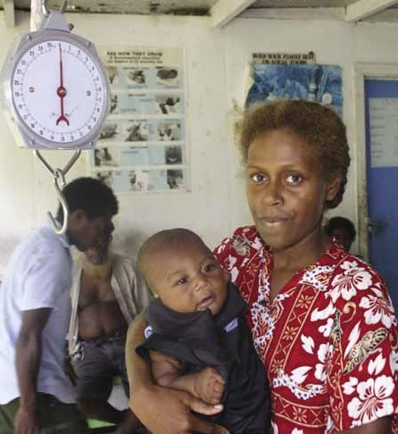
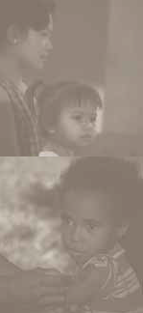
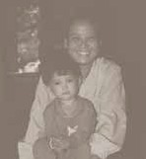
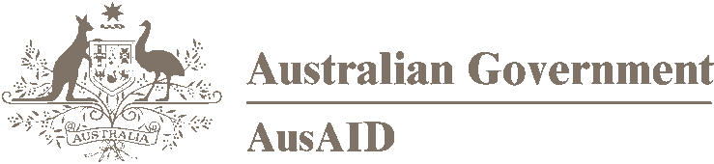
www.ausaid.gov.au

Helping health systems deliver

A POLICY FOR AUSTRALIAN DEVELOPMENT ASSISTANCE IN HEALTH AUGUST 2006

Helping health systems deliver

A POLICY FOR AUSTRALIAN DEVELOPMENT ASSISTANCE IN HEALTH AUGUST 2006

© Commonwealth of Australia 2006. This work is copyright. Apart from any use as permitted under the Copyright Act 1968, no part may be reproduced by any process without prior written permission from the Commonwealth. Requests and inquiries concerning reproduction and rights should be addressed to the Commonwealth Copyright
Administration, Attorney General’s Department, Robert Garran Offices, National Circuit, Barton ACT 2600 or posted at http://www.ag.gov.au/cca

ISBN 1 920861 80 7

Published by the Australian Agency for International Development
(AusAID), Canberra, August 2006.

This document is online at www.ausaid.gov.au/publications

This health policy draws on recent published sources, background papers and an AusAID-commissioned Health and Development Issues Paper prepared by a consortium of health and development experts. Comments on draft versions were received from an expert advisory
group of health researchers and practitioners as well as stakeholders in
Australia and internationally.

For more information about the
Australian overseas aid program, contact: Public Affairs Group
AusAID
GPO Box 887
Canberra ACT 2601
Phone 02 6206 4727
Facsimilie 02 6206 4695
Internet www.ausaid.gov.au

Designed by GRi.D, Canberra
Printed by Pirion
cover photos

main: A nurse weighs a 6-month-old infant at a village health clinic in Solomon Islands. Monitoring child weight and other measurements on a regular basis can detect faltering growth, which would signal the need
for appropriate health follow-up. photo: Peter Davis

top left: Attending the Mother and Child Health Unit at Phiang District Hospital, Sayaboury Province, Laos. photo: Tim Acker

middle left: A health sister tends to a young child at a clinic near Madang, Papua New Guinea. photo: Peter Davis

bottom left: Participants in the Nutrition Education Rehabilitation Program in Vietnam. photo: Jacinta Cubis

HELPING HEALTH SYSTEMS DELIVER A POLICY FOR AUSTRALIAN DEVELOPMENT ASSISTANCE IN HEALTH iii



ABOVE: Mother and daughter in Tan Phong commune south-west of Hanoi in Vietnam. They are participants in the Nutrition
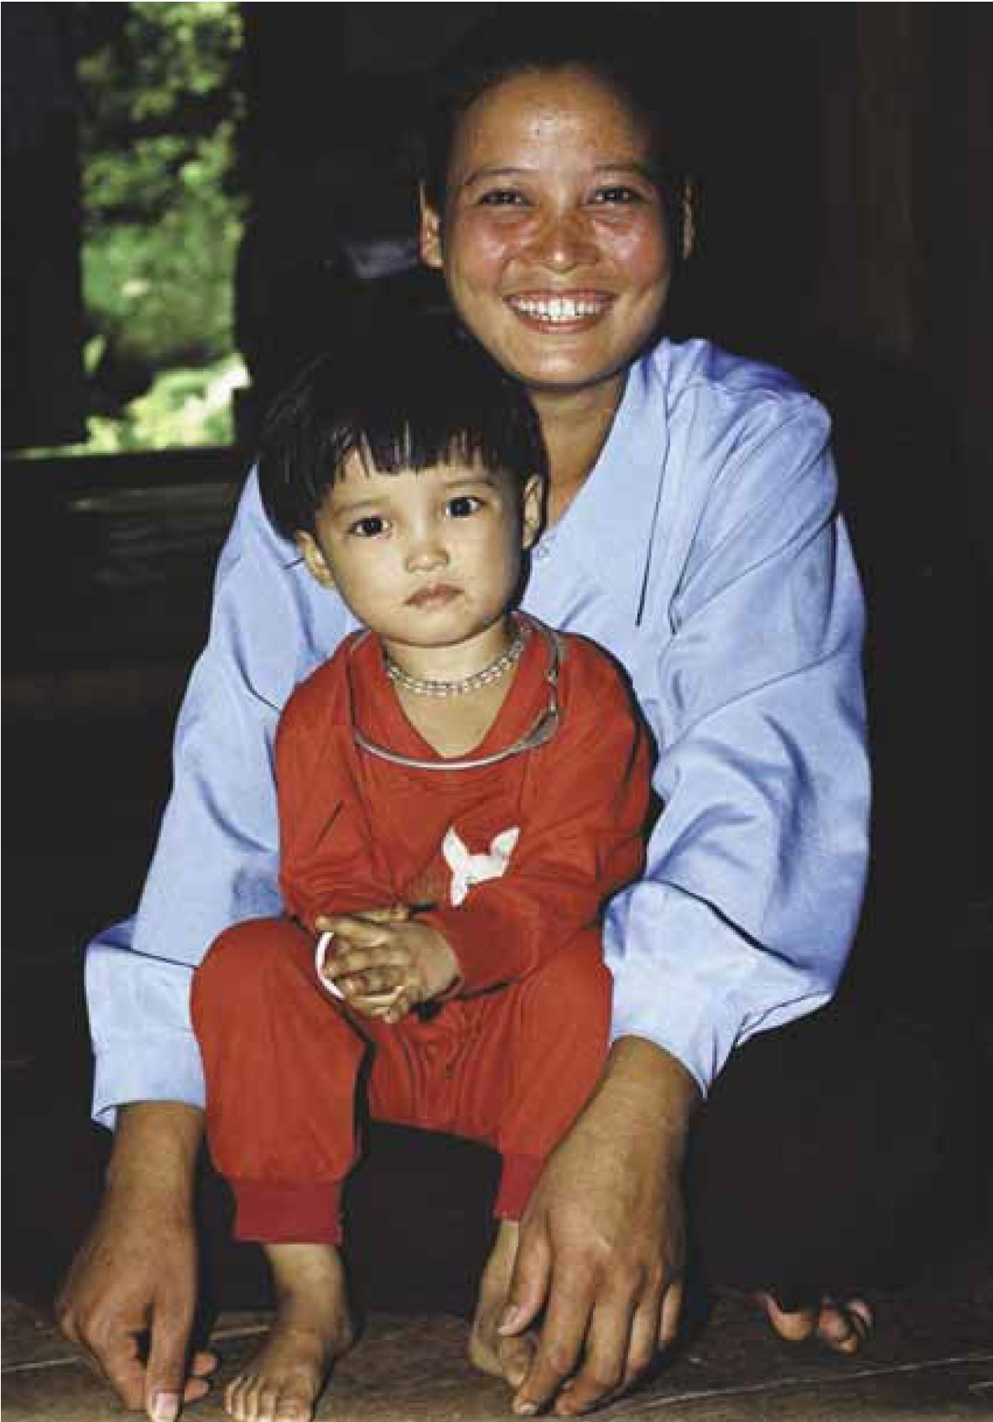

Education Rehabilitation Program. PHOTo: Jacinta Cubis

iv HELPING HEALTH SY S TEMS DELIVER A POLICY FOR AUSTRALIAN DEVELOPMENT ASSISTANCE IN HEALTH

Contents

SELECTED TERMS AND ABBREVIATIONS vii

SUMMARY 1

1 HEALTH IN A CHANGING WORLD 3
Health inequity 3
Malfunctioning health systems 3
Persistent health challenges 5
Emerging health problems 6

2 FUNDING FOR HEALTH: DONOR ASSISTANCE 8
Trends in health development assistance 8
Global health initiatives 8
Aid effectiveness: what have we learned? 10
Priorities for Australian assistance 12

3 GETTING THE FUNDAMENTALS OF HEALTH SYSTEMS RIGHT 16
Human resources development and management 16
Health financing 18
Infrastructure and supplies 18
Quality of care 18
Health information systems 18
Informed and engaged communities and individuals 19
Strategic health policy planning, legislation and management 19

4 ADDRESSING THE NEEDS OF WOMEN AND CHILDREN 20
Maternal mortality 20
Women’s health 21
Children’s health 21
Nutrition 22

5 SUPPORTING COUNTRY-SPECIFIC HEALTH PRIORITIES 23
Chronic diseases, injuries and mental health problems 23
Malaria and other significant infectious diseases 24
Social determinants of health 24
Emergency and crisis situations 24

6 REDUCING VULNERABILITY TO EMERGING INFECTIOUS DISEASES AND HIV/AIDS 26

7 MAKING OUR ASSISTANCE MORE EFFECTIVE 28
Promoting country ownership and sector-wide approaches 28
Optimising partnerships 29
Expanding the knowledge base 31
Increasing performance orientation 31
Strengthening processes and resources 32

Boxes and figures

Box 1 Recent Australian support for the health sector: a snapshot 9
Box 2 Sector programs or sector-wide approaches in health: some early lessons 11
Box 3 Focus areas for Australian health assistance 14
Box 4 The International Conference on Population and Development 20
Box 5 Fighting malaria in the Pacific 24
Box 6 Australia’s engagement with the World Health Organization 30
Figure 1 Annual health expenditure per person in selected Asia-Pacific countries in 2003,
ranked by government health expenditure 4
Figure 2 Major causes of death at age 0–4 years worldwide, 2000–03 5
Figure 3 Effective service delivery needs health system support from all levels 17

vi HELPING HEALTH SYSTEMS DELIVER A POLICY FOR AUSTRALIAN DEVELOPMENT ASSISTANCE IN HEALTH

Selected terms and abbreviations

DAC Development Assistance Committee, the OECD committee that deals with development cooperation matters. A key forum of major bilateral donors.

Fragile states States that face particularly difficult development prospects because of weak governance, policies and institutions.

MDG Millennium Development Goals <www.un.org/millenniumgoals/>

Micronutrients Nutrients such as iodine, vitamin A, iron, zinc and folate needed by the body in only small amounts but critical to growth, development and the functioning of the immune and reproductive systems.

Medium-term expenditure framework An annual, rolling three-year expenditure plan that sets out medium- term expenditure priorities and budgetary constraints against which sector plans can be developed, monitored and refined.

NGO non-government organisation

OECD Organisation for Economic Co-operation and Development,
a forum of 30 market democracies that focuses on economic, social and governance challenges and opportunities and that produces internationally agreed instruments, decisions and recommendations in areas requiring multilateral agreement.

Oral rehydration therapy The replacement of essential fluids and salts to treat dehydration caused by diarrhoea.

Pandemic Outbreak of infectious disease that spreads across a large region or worldwide.

STEPwise approach The World Health Organization’s standardised method for collecting, analysing and disseminating data on non-communicable disease risk factors that involves sequential steps of questionnaires, simple physical measurements, and biochemical assessment of blood samples.

UNFPA United Nations Population Fund UNICEF United Nations Children’s Fund WHO World Health Organization
Zoonotic diseases Diseases caused by infectious agents that can be transmitted
between animals and humans.

HELPING HEALTH SYSTEMS DELIVER A POLICY FOR AUSTRALIAN DEVELOPMENT ASSISTANCE IN HEALTH
vii

Summary

‘IMPROVING THE HEALTH AND LONGEVITY OF THE POOR IS AN END IN ITSELF, A FUNDAMENTAL GOAL OF ECONOMIC DEVELOPMENT. BUT IT IS ALSO A MEANS TO ACHIEVING THE OTHER DEVELOPMENT GOALS RELATING TO POVERTY REDUCTION.’
Commission on Macroeconomics and Health1

During recent decades the Asia-Pacific region has enjoyed economic growth and, with it, greater prosperity and stability. But this progress masks a number of underlying and persistent development challenges.

A key challenge is to address the failure of health systems to deliver sustained improvements in the wellbeing of the poorest in the region. This challenge is now well recognised. Improving health through effective aid occupies a prominent place in the international development agenda. Health is at the core of the Millennium Development Goals, and new public–private funding partnerships have emerged
to mobilise resources only dreamt of in years gone by. Nevertheless, health remains a constant worry
for millions of the poorest in the region who face the daily prospect of a manageable disease becoming a life-threatening one.

Improving health has always been a key objective of Australia’s development assistance. The Asia- Pacific region faces diverse health challenges, both old and new. Infectious diseases continue to claim the lives of children, and women face high risks during pregnancy and childbirth. Yet the majority of maternal and child deaths could be prevented
if women and children had access to proven interventions. The spread of HIV is accelerating in our region, and emerging infectious diseases,
including a possible influenza pandemic, are causes of increasing concern. In Melanesia malaria has
been resistant to efforts to bring it under control, and the rise of chronic or non-communicable diseases in developing countries has been labelled a
‘neglected epidemic’.

If we are to make measurable progress across all these fronts, we will need to increase our health investment and make our work more effective. The White Paper on the Australian Government’s overseas aid program, released in April 2006, demonstrates our commitment to do both. This health policy provides guidance on how a whole- of-government effort will be marshalled to give
full effect to the White Paper directions. The policy focuses on:

> strengthening health system fundamentals

– the finance systems to support them

– the people to deliver them – their training, supervision and incentives
– the strategic policy, planning and management that underpin the system
– the necessary infrastructure/supplies and health information systems
– the quality of care, and

– the engagement of communities in their own health care
> addressing the priority health needs of women and children, including reproductive health, nutrition, and preventive and care measures for childhood diseases

1 Commission on Macroeconomics and Health, Macroeconomics and health: investing in health for economic development, World Health Organization, Geneva, 2001, p. 1.

HELPING HEALTH SYSTEMS DELIVER A POLICY FOR AUSTRALIAN DEVELOPMENT ASSISTANCE IN HEALTH 1

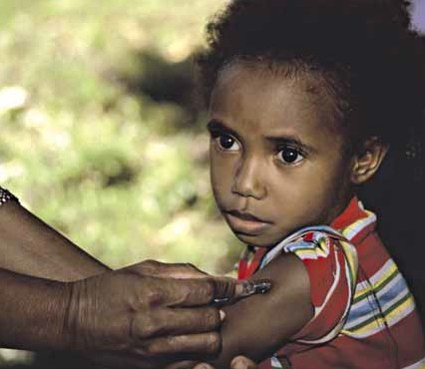

ABOVE: A health sister tends to a young child at a clinic near Madang, Papua New Guinea. photo: Peter Davis

> supporting country-specific priorities to address high-burden health problems (for example, malaria and chronic diseases) using known cost- effective interventions, and

> ensuring systems can reduce regional vulnerability to HIV/AIDS and emerging infectious diseases, including a pandemic threat.

The way Australia delivers and measures the impact of health assistance will change substantially.
New approaches will be consistent with the Paris
Declaration on Aid Effectiveness, particularly the harmonisation of donor procedures and the alignment of initiatives with local policies and systems.

In several countries of the region, government-led sector-wide approaches will be developed to channel health assistance by Australia and its development partners. Such approaches will be explicitly linked
to national health plans and underpinned by strong performance-based principles. Results will be strengthened through expanded partnerships with organisations in Australia, the region
and internationally.
Securing additional resources to scale up health assistance will depend on demonstrating that investments are meeting their objectives and
can deliver a lasting impact. Pilot projects will be undertaken to test new ways of working, particularly in applying output-based aid approaches.

Across all activities there is greater emphasis on measuring performance. This requires improving our skills and processes and reinforcing ways to access networks of external expertise. A program of health research will be developed to underpin our front-line work with the best evidence available.

The health program policy will guide the Australian
Government’s international health work over the next 10 years and especially to the year 2010 when aid in health is expected to have doubled. Implementation of the policy will be subject to ongoing review to ensure it continues to meet needs in this critical area of development.

1 Health in a changing world

‘DISPARITIES AND INEQUITIES IN HEALTH REMAIN MAJOR DEVELOPMENT CHALLENGES IN THE NEW MILLENNIUM, AND MALFUNCTIONING HEALTH SYSTEMS ARE AT THE HEART OF THE PROBLEM.’
World Health Organization 2

HEALTH INEQUITY

Life expectancy in developing countries has improved dramatically, but health conditions in the world’s poorest countries remain far from optimal, and the gaps between rich and poor have become wider.3 In our region, for example, life expectancy at birth in East Timor is 55.5 years compared with 80.3 years in Australia. Disparities within countries are also stark. In poor regions the wealthiest 20 per cent are twice
as likely to have their children immunised and five times as likely to have professional assistance for childbirth compared with the poorest 20 per cent.4

Low-income countries spend on average US$21 per person on health in a year, whereas high-income countries spend US$2735.5

For the poor, out-of-pocket expenditure on health care is itself one of the most important causes of household poverty and indebtedness – a vicious cycle of need and deprivation. Financial, physical and cultural barriers result in unequal treatment of not
only the ‘income poor’ but women, ethnic minorities, disabled people, and other groups.

Such inequities in health and health care threaten social cohesion. The lack of effective health services can have a destabilising effect, stimulating grievances about the maldistribution of resources and the
failure of the state to respond to people’s needs. Health, stability and security links are particularly relevant in states emerging from conflict and those with weak institutions. A vital part of Australian aid efforts has been, and will continue to be, maintaining or restoring service delivery in fragile states.

MALFUNCTIONING HEALTH SYSTEMS

Health systems in most developing countries face serious resource challenges. There are wide differences among countries in their total health expenditure and in the amount provided by government. As Figure 1 shows, in our region annual government expenditure ranges from
$1939 per person in Australia to less than $50 per person in many Asian countries. In the Pacific, total expenditure on health tends to be higher than in Asia, and government spending makes up a larger proportion of the total in Pacific countries. In many Asian countries much of the burden of health
financing falls on individuals.

2 WHO, World report on knowledge for better health: strengthening health systems, World Health Organization, Geneva, 2004, p. 18.
3 Between 1970 and 2000 the mortality of children under five years old fell by more than 71 per cent in high-income countries and by only 40 per cent in low-income countries (CG Victora et al.,
‘Applying an equity lens to child health and mortality: more of the same is not enough’, Lancet, vol. 362, 2003, pp. 233–41).
4 D Carr, Improving the health of the world’s poorest people, Health Bulletin Number 1, Population Reference Bureau, Washington, DC, 2004.
5 World Bank, World development report 2004: making services work for poor people, World Bank, Washington, DC, 2003, Table 3, p. 257.

HELPING HEALTH SYSTEMS DELIVER A POLICY FOR AUSTRALIAN DEVELOPMENT ASSISTANCE IN HEALTH 3

Approximately 179 million
people in the world suffer financial catastrophe each year because of out-of- pocket payments for health services, and 104 million are impoverished.6

Within government outlays there are major inefficiencies and misallocations of resources, with disproportionate support for urban and tertiary-level facilities. There are chronic shortages of human resources overall, imbalances in skill mix and distribution, and a largely unregulated private health
sector. In many countries the cost of delivering services to remote areas is high and that problem is compounded by inadequate allocations for health services at district levels.

In some contexts health services can be part of the problem rather than the solution, because of weak quality assurance. Poorly trained providers, a lack of supervision, deficiencies in supplies
and sometimes a lack of basic hygiene lead to misdiagnosis, infections, drug resistance and inadequate follow-up services. About 500 000 deaths a year are attributable to unsafe injection practices in medical settings.7

Health system weaknesses are at the heart of the problem of inequities in health, and affect all other health challenges. Building stronger health systems is the unifying theme for future Australian support of the health sector.

FIGURE 1 ANNUAL HEALTH EXPENDITURE PER PERSON IN SELECTED ASIA-PACIFIC COUNTRIES IN 2003, RANKED BY GOVERNMENT
HEALTH EXPENDITURE

3250

3000

2750
Annual health expenditure per person ($ international)

2500

2250

2000

1750

1500

1250

1000

750

500

250

1939

675

255 233 165 160

TOTAL health expenditure at international dollar rate 2003

GOVERNMENT health expenditure at international dollar rate 2003

135 118 101 95 81 81 76 55 46 40 36 22 21 20

18 13 10
0

Note: International dollars are derived by dividing local currency units by an estimate of their purchasing power parity (PPP) compared with the US dollar. That is, it is a measure that minimises the consequences of differences in price levels between countries.

Source: WHO, The world health report 2006, World Health Organization, Geneva, 2006, Annex Table 3.

6 ‘Improving health system financing in low income countries’, Background paper prepared for the meeting ‘The Montreux Challenge: Making Health Systems Work’ hosted by World Health Organization, Geneva, 2005, p. 1. ‘Financial catastrophe’ is defined by WHO as occurring when 40 per cent or more of effective household income (net of subsistence) is spent on health.
7 WHO, World health report 2002: reducing risks, promoting healthy life, World Health Organization, Geneva, 2002, p. 78.

PERSISTENT HEALTH CHALLENGES

Major infectious diseases, especially malaria and tuberculosis, continue to cause deaths and limit the potential of infected people to lead productive lives. Although not usually considered among the most important infectious diseases, diarrhoea and acute respiratory infections (pneumonia) remain two of the biggest killers, mostly of children. Also, diseases that can be prevented by immunisation are still widespread. Social factors such as education levels,
water supplies, sanitation, housing and nutrition are powerful determinants of health outcomes.

Nearly 11 million children under five years of age die each year, and progress in reducing child mortality has slowed since 1990.8
In the Asia-Pacific region child mortality remains very high in Cambodia, East Timor, Papua New Guinea, Laos and Burma and has increased in Solomon Islands. Deaths are caused mainly
by neonatal disorders (those in the first four weeks of life) and infectious diseases, often with undernutrition as an underlying cause (Figure 2).

Millions of children do not receive oral rehydration therapy for diarrhoea when they need it, do not
receive treatment for acute respiratory infections, and are not fully immunised against childhood infections.

Along with a high death rate of newborn infants, every year half a million women die from complications related to pregnancy and childbirth
– 99 per cent of them in developing countries – and over the past decade little progress has been made
in reducing maternal mortality by 75 per cent, which is a key Millennium Development Goal (MDG). In our region, maternal mortality is especially high in Laos, Cambodia, Burma, Papua New Guinea, East Timor and Indonesia. For every woman who dies
in childbirth up to 100 women suffer major illness
associated with their pregnancy or childbirth.

FIGURE 2 MAJOR CAUSES OF DEATH AT AGE 0–4 YEARS WORLDWIDE, 2000–03

Malaria 8% Measles 4%

Diarrhoea 17%

HIV/AIDS 3%

Pneumonia 19%

Injuries 3% Other 10%
Causes of neonatal deaths

Other 7% Tetanus 7% Diarrhoea 3%

Sepsis or pneumonia 26%

Asphyxia 23% Congenital 8%
Preterm 28%

Neonatal 37%

Note: Undernutrition is an underlying cause of 53 per cent of deaths of children under 5 years of age.

Source: J Bryce, C Boschi-Pinto, K Shibuya and RE Black, ‘WHO estimates of the causes of death in children’, Lancet, vol. 365, 2005, pp. 1147–52.

8 United Nations, The Millennium Development Goals report 2005, United Nations, New York, 2005.

More than 50 per cent of women in the world’s poorest regions deliver their babies without the
help of a skilled birth attendant.9 Some 200 million couples still have an unmet need for safe and effective contraception. Unsafe abortions cause an
estimated 68 000 maternal deaths a year, in addition to non-fatal complications and financial burdens for the individuals and the health systems.10 Preventing unintended pregnancies through access to family planning would avert an estimated 20–35 per cent
of all maternal deaths, saving the lives of more than
100 000 mothers each year. Fewer unintended pregnancies mean healthier women, babies and societies.

EMERGING HEALTH PROBLEMS

Changed ecosystems and human behaviour are leading to a growing number of emerging infectious diseases as well as the resurgence of old threats, the control of which may have deteriorated in the face
of failing health systems. The growth and mobility
of human populations, urbanisation, environmental pollution, the spread of slums, the clearance of forests and the incorrect use of antibiotics all contribute to increasing health problems. These include diseases transmitted from animals like
avian influenza, vector-borne diseases like dengue, and drug-resistant forms of common diseases like malaria and tuberculosis.

Concerns about an influenza pandemic have
been kindled by the spread of avian influenza and incidences of human cases with a high fatality rate. Though there has been no evidence of effective human-to-human transmission of avian influenza to date (early 2006), pandemic influenza spread by this route is a possibility and has the potential to
cause an enormous loss of human life. The resulting economic impact could be much larger than the impact of the Severe Acute Respiratory Syndrome (SARS) and could set back development prospects around the world, particularly affecting the poor and otherwise vulnerable populations.
HIV/AIDS also has the potential to erode not only health gains but wider development progress. It is predicted that the Asia-Pacific region will account for 40 per cent of all new HIV infections by 2010 if responses are not intensified. Characteristics of the epidemic vary by setting, and responses need to adapt to the context. In our region, for example, Papua New Guinea demands an ‘emergency
response’ as the prevalence there is one of the worst in the Asia-Pacific region. Papua New Guinea’s workforce could be reduced by as much as 12.5 per cent by 2025 due to HIV/AIDS.11 Other sexually transmitted infections are also emerging as major health problems in our region.

Emergencies and disasters continue to pose a threat, requiring not only emergency responses but efforts to increase the preparedness and resilience of people and institutions.

Not least among the emerging challenges are chronic or non-communicable diseases, increasing as a result of lifestyle changes and growing in significance because of the mounting evidence of their contribution to the burden of disease. Evidence is also accumulating on the significant burden of mental health problems, including those related to conflict and disaster.

Causing 35 million deaths a year – 80 per cent of them in the developing world – conditions such as circulatory disease (heart
disease and stroke), cancer, asthma and chronic respiratory disease, and diabetes have been labelled
a ‘neglected epidemic’.12

9 WHO, Reproductive health strategy (adopted by 57th World Health Assembly), World Health Organization, Geneva, 2004.
10 UNFPA, State of the world population 2005: the promise of equality, United Nations Population Fund, New York, 2005.
11 AusAID, Impacts of HIV/AIDS 2005–2025 in Papua New Guinea, Indonesia and East Timor – synopsis report of the HIV Epidemiological Modelling and Impact Study, Australian Agency for International Development, Canberra, 2006.
12 R Horton, ‘The neglected epidemic of chronic disease’ in ‘Chronic diseases: the neglected development goal’, Lancet, London, 2005.

6 HELPING HEALTH SYSTEMS DELIVER A POLICY FOR AUSTRALIAN DEVELOPMENT ASSISTANCE IN HEALTH

In all but the least developed countries of the world, poor people are more likely than the wealthy to develop chronic diseases, and everywhere are more likely to die prematurely as a result.

Tobacco use is the single largest preventable cause of death in the world. If current trends continue, by 2030, 70 per cent of all tobacco-related deaths
– 10 million a year – will be in developing countries. The use of illicit drugs and alcohol not only directly affects health but can affect health through its link
to violence.
Australia has significant expertise in cost-effective interventions for chronic disease. We have played an important role in the WHO Framework Convention on Tobacco Control as well as the WHO Global Strategy on Diet, Physical Activity and Health. Australia has provided support to build capacity in WHO’s STEPwise approach to assessing risk factors associated with chronic disease, including diet, physical activity, and alcohol and tobacco use.

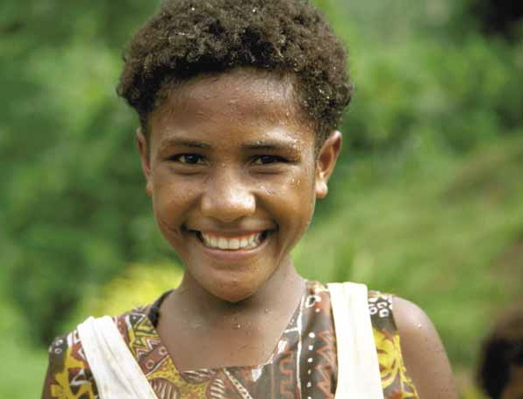

above: Sports carnival on a wet day on Taveuni island, Fiji. The carnival was supported by the Australian-funded Taveuni Community Health Project. The health benefits of physical activity are promoted to help address the rising rates of non-communicable diseases such as heart disease and type 2 diabetes. photo: Peter Davis

2 Funding for health: donor assistance

‘COUNTRIES NEED TO FINANCE THEIR OWN HEALTH INTERVENTIONS AS MUCH AS POSSIBLE, BUT FOR THE WORLD’S LOW-INCOME COUNTRIES, EXTERNAL ASSISTANCE IS ALREADY, AND WILL CONTINUE TO BE, AN IMPORTANT SOURCE OF FUNDING.’
World Bank 13

TRENDS IN HEALTH DEVELOPMENT ASSISTANCE The volume of aid provided by OECD Development Assistance Committee donors, including Australia, has recently increased after a decade or more of stagnation. In the health sector, there was real
growth in development assistance globally despite
falls in total aid during the 1990s. New funding sources such as global health initiatives and special US funding for HIV/AIDS resulted in further increases in development assistance for health
from US$6.4 billion in 1997–98 to an estimated US$8.1 billion in 2002. The largest part of this increase was used to address HIV/AIDS.14

Australia’s aid to the health sector (Box 1) has made up around 11–12 per cent of its total aid expenditure in recent years, higher than the overall average percentage for OECD bilateral donors.

Whereas other donors directed their increases in aid mostly to Africa, Australia remains committed mainly to the Asia-Pacific region where we have extensive development experience and close socioeconomic and political ties.15
In September 2005 the Prime Minister announced Australia’s goal to increase its overseas aid allocation to about A$4 billion a year by 2010. This represents
a doubling of Australia’s official development assistance from 2004 levels. But it is subject to the continued effective use of resources by Australia, and the effective performance of partner governments
and institutions. In other words, funding will follow results.

GLOBAL HEALTH INITIATIVES

A significant development in the international health field has been the entry of major funders. These include the Bill & Melinda Gates Foundation and the global health initiatives, ranging from the large Global Fund to Fight AIDS, TB and Malaria (GFATM) and the Global Alliance for Vaccines and Immunization (GAVI) to smaller initiatives such as the Global Alliance for TB Drug Development (TB Alliance) and the Health Metrics Network (HMN).

It is estimated that there are more than 75 such funds in the health field, the majority being public–private partnerships. They work in several areas, including research and development, technical assistance and advocacy, and they directly finance programs.

13 World Bank, Priorities in health, World Bank, Washington, DC, 2006, p. 15.
14 C Michaud, ‘Development assistance for health: recent trends and resource allocation’, paper prepared for the Second Consultation Commission on Macroeconomics and Health, World
Health Organization, Geneva, 29–30 October 2003 <www.who.int/macrohealth/events/health_for_poor/en/dah_trends_nov10.pdf>.
15 Although Australian health assistance is concentrated mainly in East Asia and the Pacific countries, over A$15 million went to South Asia and Sub-Saharan Africa in 2003–04.
In terms of assistance from all donors, Africa receives by far the largest amounts of health aid per person – four times more than Asia (OECD, Health, poverty and development cooperation, Development Cooperation Report 2000, Organisation for Economic Co-operation and Development, Paris, 2001).

8 HELPING HEALTH SYSTEMS DELIVER A POLICY FOR AUSTRALIAN DEVELOPMENT ASSISTANCE IN HEALTH

BOX 1 RECENT AUSTRALIAN SUPPORT FOR THE HEALTH SECTOR: A SNAPSHOT
In 2005–06 Australia’s aid program provided an estimated A$280 million in direct support to the health sector. Health has accounted for around 11–12 per cent of Australia’s total aid expenditure over the past five years. A recent review of Australian health development assistance provided the following insights.16

> Basic health care assistance, such as primary health care programs and training for paramedical personnel, accounted for 25 per cent of health flows. Basic health assistance doubled in the two years following the 1998 health aid policy, and has remained at high levels. Recent activities range from a large bilateral rural health care project in Indonesia to a primary health care and health awareness program for Palestinian refugees run by a non-government agency.

> Health governance, such as policy and management of health systems, also accounted for 25 per cent of health assistance, after increasing sharply between 2000–01 and 2002–03. Recognising that service delivery in health is often hampered by poor planning and inadequate systems Australia has supported capacity building in these areas in a range of countries, particularly in the Pacific.

> HIV/AIDS and other sexually transmitted infections were targeted through programs of assistance that increased dramatically to 21 per cent of health assistance in 2003–04. This assistance continues to be the fastest growing segment of the health program, in recognition of the enormous threat the pandemic poses to development across all sectors and of its immense burden on health status and health services.

Other areas of health assistance that accounted for A$10 million or more in 2003–04 included infectious disease control, reproductive health care, and basic health infrastructure. Health-related inputs are also an important part of our emergency and humanitarian assistance.

Papua New Guinea is the largest single country recipient of Australian health aid – around a quarter of the total. East Asian countries and Pacific island countries receive most of the remainder, mirroring the regional distribution of Australian aid flows overall.

Most Australian aid to the health sector (over 70 per cent) is delivered through country and regional programs, but we also work with multilateral partners such as multilateral development banks, the World Health Organization (WHO), the UN Children’s Fund (UNICEF), the UN Population Fund (UNFPA), the Global
Fund to Fight AIDS, Tuberculosis and Malaria (GFATM), UNAIDS and, from 2006, the Global Alliance for
Vaccines and Immunization (GAVI).

Non-government and volunteer programs play a vital role, and whole-of-government cooperation is important to ensure a coherent Australian approach.

16 Except where otherwise indicated, figures refer to 2003–04, the most recent published statistics.

The vast majority of global
health initiatives focus on infectious diseases, with
60 per cent targeting HIV (in particular), TB and malaria. Over 60 per cent of funds are channelled
to Africa.17

To date, Australia has invested through AusAID in global health initiatives such as GFATM, Stop TB and Roll Back Malaria (through WHO), the Rotary Polio Partnership and GAVI. Through these partnerships, Australia can gain access to economies of scale and contribute to health programs we may not otherwise have the technical expertise or resources to focus
on. The regional or global focus of these initiatives complements our mostly bilateral programs. We can leverage additional investment from such initiatives as GFATM by working with partner governments to access this significant source of funding to scale up successful pilots or projects.

Recent assessments have concluded that, overall, global health initiatives have been successful in advocacy work, mobilising funding and producing cost-effective impacts in their area of focus, particularly some neglected diseases. Australia’s work with these initiatives should attempt to address some of their negative impacts, such
as imbalances in international health funding caused by large amounts of funds flowing through specific initiatives, or the distortion of priorities
and staff resources, which undermine already weak health systems.
The support we provide through the global health initiatives should complement our other efforts to strengthen health systems and donor coordination, and involve sector-wide approaches
where appropriate. In November 2005 the High Level Forum on the Health MDGs outlined a set of best practice principles for global health initiatives at a country level, and Australia should be guided by these.18

AID EFFECTIVENESS: WHAT HAVE WE LEARNED? Increasing the effectiveness of development assistance has been a major theme for donors in recent years, yielding major principles for aid in the health sector as well as other sectors.

> Donors must align programs with the partner country’s policies and institutions. This
may require its policies and institutions to be strengthened, but in the long run it is essential that the partner country owns the development efforts.

> Donors need to harmonise procedures.19
This means all donors should coordinate their procedures and use local structures for delivering aid rather than setting up parallel structures
that place heavy administrative burdens on the partner country. Development assistance for
health typically involves large numbers of bilateral, multilateral and private sector actors that are often not well coordinated.

> Donors should consider more programmatic approaches to delivering aid. Although stand-alone aid projects have a place in specific contexts, such projects have significant transaction costs for partners, and donors retain much of the control. Aid provided through sector programs or sector- wide approaches (SWAps) are increasingly seen as models for delivering aid (see Box 2).

> Donors need to emphasise outputs, outcomes and impacts rather than focus on the process of aid interventions. This should include establishing a common monitoring and evaluation framework involving partner countries. Where necessary donors should support capacity building in
this area.

17 K Caines, Background paper: key evidence from major studies of selected global health partnerships, High Level Forum on the Health MDGs, Health Resource Centre, Department for
International Development, London, 2005.
18 Working Group on Global Health Partnerships, Best practice principles for global health partnership activities at country level, High Level Forum on the Health MDGs, Paris, 2005
<www.hlfhealthmdgs.org/Documents/GlobalHealthPartnerships.pdf>.
19 Alignment and harmonisation principles are the key principles agreed to by donors in the 2005 Paris Declaration on Aid Effectiveness <www.oecd.org/dac/effectiveness/
parisdeclaration/>.

> Donors need to ensure that technical assistance focuses on implementation. In line with achieving better results, technical assistance needs to emphasise implementation and monitoring. Longer term institutional partnerships as well as technical assistance coordinated among donors
would help in this area.
> Donors need to link policy and practice to evidence. Policy formation and implementation needs to be informed by high-quality research that identifies real needs, but also by an appraisal of
the economic, social and political context. Lessons learned need to be better documented and shared.

BOX 2 SECTOR PROGRAMS OR SECTOR-WIDE APPROACHES IN HEALTH: SOME EARLY LESSONS
A sector-wide approach is one in which:

… all significant funding for the sector supports a single sector policy and expenditure program, under government leadership, adopting common approaches across the sector and progressing towards relying on government procedures to disburse and account for all funds.20

Not many countries have well-developed versions of this challenging approach, so the evidence base is not strong. However, we have already learned some lessons.

> The approach requires commitment to shared goals, a good macroeconomic basis and sound overall public spending.

> Mapping government and external financial inputs against a common medium-term expenditure framework has proven useful in directing funds to priorities, identifying gaps and ensuring accountability.

> There is no single blueprint.

> The approach requires new skills for donors in policy dialogue, and a changed relationship among participants at a high level of engagement. These changes can take time.

> Policy dialogue can facilitate a focus on pro-poor policy in delivering health services.

> Involving non-government organisations can be advantageous; they have felt marginalised in some contexts.

> The contribution of global health initiatives needs to be coordinated within a program approach.

> Sector-wide approaches to delivering services need to avoid too much focus at the central level to the exclusion of the district level and moves to decentralise delivery.

> The development of joint policy, monitoring and management frameworks may be as important as, or even more important than, pooled funding.21

> Dialogue may need to include government agencies other than health, particularly the central agencies for finance, planning, labour and education.

> Participants in sector-wide approaches should continue to share experiences with other countries to learn from each other.

20 M Foster et al., Findings, issues and recommendations from the experiences of implementing SWAps in six countries, Overseas Development Institute, London, 2000.
21 WHO, Health and the Millennium Development Goals, World Health Organization, Geneva, 2005, p. 48.

> Donors must address governance and corruption directly in order to improve health services. In the health sector there is evidence that development assistance has improved health outcomes in countries where the policy environment is good
or even average, but not in countries characterised by major corruption and inefficient bureaucracies. The World Bank reminds us, however, that
‘countries need not move from “bad” policies to “excellent” policies in order for aid to be justified’.22 Policy dialogue and capacity building can help to improve governance.

> Sound gender analysis contributes to more effective aid.23 A full understanding of the roles
of women and men in a particular setting – from a health delivery context to wider society – helps ensure that development objectives can be met.

> Greater equity is feasible. Evidence of ways to better direct health assistance to the poor has been accumulated by the World Bank and others. These range from initiatives against specific diseases
of the poor, to contracting non-government organisations for service delivery, to social marketing – illustrating that ‘one size does not necessarily fit all’.

Donors are also accumulating evidence on approaches to engage with fragile states – those either unable or unwilling to deliver core state functions to the majority of their population. Australia will be guided by recent OECD Principles for Good International Engagement in Fragile States.24

PRIORITIES FOR AUSTRALIAN ASSISTANCE

The trends and issues in health and development assistance illustrate the wide range of challenges
that face the Australian aid program and the need to direct our health assistance to where it will have the greatest impact.
Australia makes up
only a small percentage of total aid flows in the world and around 2 per cent of bilateral donor flows for health. Rather than spreading our efforts geographically and across all areas of health assistance we can
have a greater impact by strategically focusing our investment.

The focus of our health assistance will be determined by the wider policy context of Australian development assistance and the future priorities for health sector support, under the unifying theme of helping health systems deliver better health services and outcomes.

AUSTRALIA’S WHITE PAPER ON AID

On 26 April 2006 the Australian Government released a White Paper on Australia’s overseas aid program. The White Paper sets out future
directions of Australia’s aid engagement, particularly with its key partner countries – Papua New
Guinea, the Pacific, Indonesia and Asia more generally. It presents approaches to aid under four thematic priorities:

> accelerating economic growth

> fostering functioning and effective states

> investing in people

> promoting regional stability and cooperation.

22 A Wagstaff and M Claeson, The Millennium Development Goals for health: rising to the challenges, World Bank, Washington, DC, 2004, p. 157.
23 A new AusAID gender policy and accompanying guide will be developed in 2006.
24 OECD, Development Co-operation Directorate, Principles for Good International Engagement in Fragile States, DCD (2005)8/REV2, Organisation for Economic Co-operation and
Development, Paris, April 2005.

A main focus under the White Paper theme of
‘investing in people’ is the strengthening of health systems, particularly their financing and workforces. Major diseases, especially HIV/AIDS and malaria, and a pandemic of a new or re-emerging infectious disease will receive enhanced responses.
The White Paper also signals significant change in the way aid is delivered, with a shift to more
sector-wide approaches rather than stand-alone projects. More emphasis will be placed on aid effectiveness, possibly including direct links between funding allocations and aid outputs. The
paper advocates broader links between Australia and our development partners as well as a larger, more diversified research program to provide a sound basis for aid initiatives.

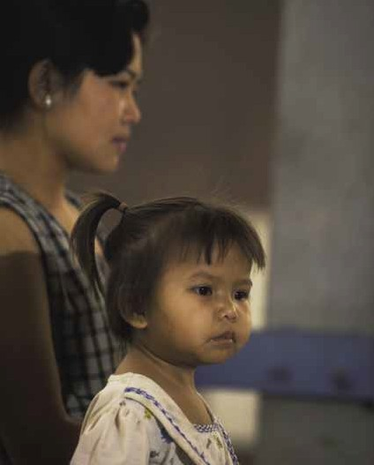

above: Attending the Mother and Child Health Unit at Phiang District Hospital, Sayaboury Province, Laos. photo: Tim Acker

HELPING HEALTH SYSTEMS DELIVER A POLICY FOR AUSTRALIAN DEVELOPMENT ASSISTANCE IN HEALTH 13

AUSTRALIA’S REGION OF CONCENTRATION

Australia will maintain high and increasing levels
of support for Papua New Guinea. We will continue to place emphasis on Indonesia and expand our program with the Philippines, the focal points being eastern Indonesia and the southern Philippines. The vulnerable Mekong region is another area of focus.

The 2006 White Paper on Australia’s overseas aid program reaffirmed a focus on the Asia-Pacific
region, where we have close socioeconomic, political, security and development ties.25

Our aid relationships reflect the diversity of the Asia- Pacific region, ranging from the major economic growth giants of China and India to the post-conflict states of Cambodia and East Timor, and the small island states of the Pacific.

Health assistance will be shaped by the diverse
health needs in each country as well as wider aspects of aid and development. In China, for example, Australia is moving to a bilateral program focusing on mutual benefit, which seeks to build government
links and to work collaboratively on regional issues such as water and health security. In South Asia the program is increasingly developing partnerships with multilateral agencies, non-government
organisations and other donors. Regional integration and cooperation are growing in importance in both Asia and the Pacific.

Whether the health sector receives priority within a country’s program of assistance is determined when developing the strategy for the country program (see Section 7).

A UNIFYING THEME FOR HEALTH ASSISTANCE: HELPING HEALTH SYSTEMS DELIVER
To help meet current and future health needs in the Asia-Pacific region, and consistent with the White Paper, Australia’s central focus will be on helping to strengthen health systems.

Some health improvements can be achieved by working within existing systems and we will continue to address urgent needs as we work toward the goal of building stronger systems. Priority areas are listed in Box 3. Even targeted programs for women and children’s health as well as country- specific priorities should be delivered in such a way that they contribute to health systems.

Australia’s development assistance in health will need to strike a balance between addressing major and immediate health concerns and managing
the longer term task of strengthening underlying
health systems.

BOX 3 FOCUS AREAS FOR AUSTRALIAN HEALTH ASSISTANCE
> Strengthening health system fundamentals

> Addressing the priority health needs of women and children

> Supporting country-specific priorities to address high-burden health problems

> Ensuring systems can reduce regional vulnerability to HIV/AIDS and emerging infectious diseases

25 AusAID, Australian aid: promoting growth and stability, A white paper on the Australian Government’s overseas aid program, Australian Agency for International Development, Canberra, 2006.

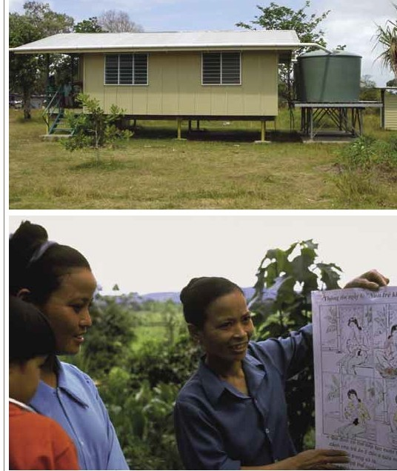

1.%o.•r;:.A. hv (;)')l ;..,.• ('). )')l oiJ 'P ;..,. M
fwJotJb}'b. 't lti'IJ0:WGO CJiMfwJ. H!CIII'C(p;i>'#M C1b'

:'1Ji b:.vb.i> .bWtb.A.1MfD )')0: \1ofSJrbltJvrc.<M r ::o m.(;o<r::lofPff?C/111 Wt'W
G .,!"'V.\:b0:b;v..t;.j:.rb:.>tb.l> (Nrcp0: · (').. ) rdi<::SM 'tr«0>."->g b.d. J.O n. vrmg-
•r-g IIJip.'yof ioirns,H')'Cofm.cwJ» u.-1tlti'IJ•»oo : J) r<:jcr 'tiol.<lly1U
J) ,l"'v!,.,;Jut?MofDttrc.<, H!CIII'C( Jwt..f;./D

Getting the fundamentals of health
3 systems right

‘THE HEALTH SYSTEM IS A CORE SOCIAL INSTITUTION, NOT SIMPLY A MECHANICAL STRUCTURE FOR DELIVERING TECHNICAL INTERVENTIONS ... HEALTH SYSTEMS FUNCTION AT THE INTERFACE BETWEEN PEOPLE AND THE STRUCTURES THAT SHAPE THEIR BROADER SOCIETY.’
UN Millennium Project 26

The WHO definition of a health system is ‘all the activities whose primary purpose is to promote, restore, or maintain health’.27 It implies that donor support can and should go beyond technical inputs into a formal health care system and provide assistance that will enable the total system to
work more effectively. Both supply factors (health
services) and demand factors (people’s needs and expectations) are part of the equation.

Ultimately the responsibility for a country’s health system lies with its government, though elements of the system involve the private sector, non-government organisations (including church groups), the community (including traditional health practitioners) and, of course, individuals and families themselves.

Australia will support efforts at all levels, focusing on helping countries to get the fundamental elements
of a sustainable health system in place over the
next decade. These include human resources (their development and management), mechanisms for financing health services, and enabling policies
and procedures (some beyond the health sector) (see Figure 3).
When providing assistance to strengthen health systems Australia will seek to complement and, where feasible, directly engage with other donors. Where practicable, the support will be provided through a sector program or sector-wide approach (see Section 7).
HUMAN RESOURCES DEVELOPMENT AND MANAGEMENT
Health workers have been called the ‘cement’ of the health system and are often the largest expenditure item, yet their part in the health system is frequently neglected. Fundamental but challenging issues include the need for strategic management and
long-term planning that addresses imbalances in the current skill mix and rural–urban distribution, and more and better pre-service and in-service training. Poor pay scales and a lack of performance recognition or other worker incentives add to
the challenge.

Australia will provide direct support for training health workers, but will also assist through capacity building in planning and in managing workforce and financing issues. Skills are needed not only in health- specific competencies but generic management.

Workforce issues have a strong gender dimension because women provide much of the health care but are seldom involved in policy decisions. Better documentation and policy discussion are needed on how to manage the emigration of skilled
health workers.

26 UN Millennium Project, Who’s got the power? Transforming health systems for women and children, Task Force on Child Health and Maternal Health, Earthscan, London, and Sterling, Virginia, 2005, p. 20.
27 WHO, World health report – health systems: improving performance, World Health Organization, Geneva, 2000, p. 5.

16 HELPING HEALTH SYSTEMS DELIVER A POLICY FOR AUSTRALIAN DEVELOPMENT ASSISTANCE IN HEALTH

FIGURE 3 EFFECTIVE SERVICE DELIVERY NEEDS HEALTH SYSTEM SUPPORT FROM ALL LEVELS

WHAT IS NEEDED AT THE SERVICE DELIVERY LEVEL?

WHAT SUPPORT IS NEEDED FROM THE
‘DISTRICT’ LEVEL?
WHAT SUPPORT IS NEEDED FROM THE CENTRAL MINISTRY
OF HEALTH?

WHAT SUPPORT IS NEEDED BEYOND THE HEALTH SECTOR?

WHAT ARE THE ESSENTIAL COMPONENTS AT ALL LEVELS?

Staff with curative, preventive and care skills, management

Staff with management skills and
Staff with advocacy, planning and
management skills
Adequate employment conditions for
public service Human resources development and

skills and adequate work conditions
supportive
supervision skills
Good staff,
planning, recruitment and deployment
Good professional training institutions
management

Funds for running costs

No financial
HEALTH OUTCOMES
RESEARCH

Mechanism for efficient, transparent budgeting and for disbursing and accounting for funds

Mechanisms of Health financing
Appropriate allocation and timely
disbursement of health budget

Supportive

Funds and financial management

barriers to consumers
prepayment or
exemption of the poor
policies and revenue collection
financial policy environment

Drugs and consumables

Essential

Efficient logistics for drugs and other supplies
Appropriate drug policies

Efficient procurement
Supportive trade policies

Good government procurement procedures

Supplies and equipment management

equipment Equipment maintenance system

Information on care, commodities and finance

Mechanism to monitor quality of care and to summarise, analyse and respond to information
Information to monitor health sector performance

Health information system

Access to and demand from communities and individuals

Mechanisms to inform and engage consumers

Health promotion
Civil society engagement, advocacy and monitoring
Informed
and engaged communities and individuals

RESEARCH

Note: The diagram is not an attempt to comprehensively capture all of the complexities of a health system, but is designed to show that the system operates at all levels to support the ultimate aim of improved service delivery and health outcomes.

HEALTH FINANCING

Efficient health expenditure requires effective mechanisms for financial planning, allocation, disbursement and monitoring – all areas of weakness in many developing countries. Donor assistance in developing medium-term expenditure frameworks and national health accounts has proven valuable in the Asia-Pacific region.

A more basic issue is how to mobilise sufficient resources, given the severe economic limitations in much of the region. Tax-based systems, user fees, various health insurance schemes and voucher systems have been pursued, but more evidence is needed on their effectiveness and particularly their equity and ability to shield people from large health outlays that can cause or aggravate poverty.

The WHO principle for financing is that ‘whatever system of financing a country adopts, that
system should not deter people from seeking and using services’.28

Australia supports the WHO principle for financing, which implies that any fees should be based on ability to pay, but fee-exemption systems have been difficult to implement. Overall, health financing
has proved to be one of the most intractable health system challenges.

In addition to providing technical assistance, Australia will support pilot schemes for financing health care that clearly investigate the feasibility
of scaling up the schemes as part of their design, to test their relative efficiency and equity in a particular context.
INFRASTRUCTURE AND SUPPLIES

Critical needs include the construction and maintenance of appropriate buildings, the provision and maintenance of equipment, and procurement systems for consumables, including
pharmaceuticals. Technology must be affordable and appropriate to the local situation and need. Overall planning needs to ensure that recurrent costs can be financed and are sustainable.

In addition to weak planning and logistical capacity,
‘leakage’ or corruption in the supply system often needs to be addressed. Combating counterfeit medicines is one priority for regional collaboration.

QUALITY OF CARE

Equipment that does not function, inadequate supplies, incentives to provide unnecessary and inappropriate services, and ineffective treatments are direct threats to health standards. Good quality care involves more than supplying technical inputs; it includes providing information, responding to questions and treating people with respect. Issues extend beyond the public sector to the need for regulating and monitoring private providers.

HEALTH INFORMATION SYSTEMS

Sound decision-making at all levels in a health system requires reliable health information that is disaggregated by sex, age and socioeconomic
characteristics. At a policy level, decisions informed by evidence contribute to more efficient resource allocations and, at the delivery level, information about the quality and effectiveness of services can contribute to better outcomes.

Information systems need to be simple and sustainable. Lower levels of the system need feedback on how routine data can be used, to give staff the incentive to collect it. Capacity building is also required to ensure policymakers at all levels have
the ability to use health data, whether it originates from routine systems, health surveys or special
operational research.

28 WHO, Health and the Millennium Development Goals, World Health Organization, Geneva, 2005, p. 36.

18 HELPING HEALTH SYSTEMS DELIVER A POLICY FOR AUSTRALIAN DEVELOPMENT ASSISTANCE IN HEALTH

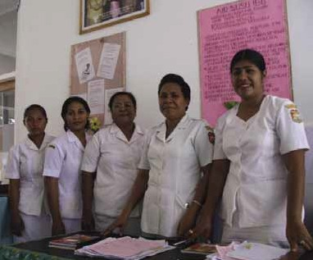
above: Midwives and nurses in a district hospital in West Sumba, Indonesia. Human resources are the backbone of the health system. In addition to pre-service training, health workers need ongoing training as well as supervision and support to ensure quality of care. photo: Widya Setyowati

INFORMED AND ENGAGED COMMUNITIES AND INDIVIDUALS
Communities and individuals need to be involved in decisions about health systems in order to achieve
a high standard of care. Building health systems requires information on user perspectives, and can involve a fundamental culture change – not only for service providers but for the users of health systems, who often have low expectations of care. Providing health education is essential for preventive health care, as are wider health promotion efforts.

Given Australia’s domestic expertise in promoting good health there is potential for collaboration – with approaches suitably adapted for local contexts – in such areas as controlling tobacco use, improving
diets and increasing physical activity. Leadership and political commitment are crucial to informing and engaging communities and individuals, and Australia has been active in investing in this in the fight against the spread of HIV/AIDS.
STRATEGIC HEALTH POLICY PLANNING, LEGISLATION AND MANAGEMENT
Overall planning and management tie the elements of a health system together. Australia’s assistance for capacity building at the policy level to improve health planning and management will be linked to evidence of improved service delivery at the community level. In line with our aid’s poverty reduction objective, policies should also focus on improving equity. Gender analysis, for example, will inform resource allocation and other management decisions.

Assistance needs to consider the challenges presented by the decentralisation of government functions in our region. The involvement of central agencies such as ministries for finance, planning, labour, education and training are critical to successfully implementing ministry of health plans.

Policy coherence and cooperation in health-
related trade policy could be an area for Australian assistance, as we have offered to do in the case of antiretroviral treatment for AIDS. Australia also has expertise in public health legislation relevant to areas ranging from pharmaceutical benefits to
tobacco advertising, to managing HIV/AIDS in ways consistent with human rights.

Addressing the needs of women
4 and children

ABOUT TWO-THIRDS OF CHILD DEATHS COULD BE PREVENTED IF THERE WERE UNIVERSAL ACCESS TO INTERVENTIONS THAT ARE AVAILABLE TODAY AND ARE FEASIBLE FOR IMPLEMENTATION IN LOW-INCOME COUNTRIES. THREE-QUARTERS OF MATERNAL DEATHS COULD BE AVERTED BY USING PROVEN COST-EFFECTIVE
INTERVENTIONS.29

Improvements in health systems should benefit everyone in society. Often, however, the health needs of women and children are not accorded high priority.

To help achieve the MDG targets of reducing maternal mortality by three-quarters and child mortality by two-thirds by 2015 Australia will provide both long-term support to strengthen health systems and targeted programs for women’s and children’s health that contribute to rather than undermine health systems.

High maternal mortality and child mortality persist in our region, but change can be achieved. A significant reduction in maternal and neonatal mortality in Malaysia, for example, resulted from proactive programs of community hospitals and training for birth attendants.
MATERNAL MORTALITY

Reducing maternal mortality requires a functioning health system, with core interventions such as skilled birth attendants close to the community and access
to back-up emergency obstetric care.

Australia, as a signatory to the International Conference on Population and Development (ICPD) Programme of Action (Box 4), also recognises that interventions are important not only at the time of
a pregnancy or birth but much earlier in life. For example, to ensure that women are not only prepared for pregnancy, but can choose whether and when to get pregnant, they need:

> improved nutrition as girls and adolescents

> comprehensive sexual and reproductive health education, and
> safe and effective contraception based on informed choice.30

BOX 4 THE INTERNATIONAL CONFERENCE ON POPULATION AND DEVELOPMENT

The ICPD Programme of Action in 1994 <www.unfpa.org/icpd/> set priorities in a wide range of population- related areas and pioneered an approach that focused on meeting the needs of individuals, including in sexual and reproductive health. The Programme of Action was endorsed by 179 countries including Australia. The Australian Prime Minister reaffirmed our commitment in 2004. At the 2005 United Nations Millennium Summit heads of state agreed to work toward universal access to reproductive health by 2015.

29 A Wagstaff and M Claeson, The Millennium Development Goals for health: rising to the challenges, World Bank, Washington, DC, 2004, p. xi.
30 AusAID guidance on family planning activities is consistent with the ICPD Programme of Action. See AusAID’s website <www.ausaid.gov.au>.

20 HELPING HEALTH SYSTEMS DELIVER A POLICY FOR AUSTRALIAN DEVELOPMENT ASSISTANCE IN HEALTH

WOMEN’S HEALTH

In addition to maternal mortality there are other areas of sexual and reproductive health
as well as broader health needs for women that require attention.

There are an estimated 340 million new cases
of sexually transmitted bacterial infections each year and millions more viral infections, including
5 million new HIV infections, requiring preventive education, counselling and care services. As the HIV epidemic matures in many countries, larger numbers of women are being infected and they are
being infected at younger ages. Efforts to prevent and manage HIV need to be integrated into reproductive health services to increase both their effectiveness
and efficiency.

Added to these problems are other disabilities related to sexual and reproductive health such as obstetric fistulae acquired through giving birth, infertility (which in many cases can be prevented and treated with basic interventions), female genital
mutilation and other conditions that are often under- represented in calculating the burden of disease
for women.

Chronic disease and mental illnesses are other challenges that are becoming increasingly prominent as causes of women’s mortality and morbidity.
Gender-based violence requires appropriate interventions and protective mechanisms based on sound knowledge of local contexts.

It is estimated that violence against women is as serious a cause of death
Higher levels of female education will underpin all efforts to improve women’s health.

Men cannot be excluded from programs aimed at improving women’s and children’s health. Although women are the main health caregivers, men are crucial to health decision-making at all levels
– family, community, health facilities and policy. Men’s role in sexual and reproductive health affects outcomes for their own as well as their family’s health. Male health problems also demand attention in their own right, and donor support will address these where the burden of the problems indicates their priority.

CHILDREN’S HEALTH

Addressing maternal mortality will also help infants, given the main causes of newborn death are low
birth weight and problems arising at the time of delivery or shortly thereafter. Adequately spaced childbearing through family planning contributes significantly to child survival rates.

Interventions within health systems are also required to deal with the specific threats that kill young children beyond the first weeks of life: diarrhoea, pneumonia, both with undernutrition as a major underlying factor, and in some areas malaria and measles. Of these, only measles can be prevented through a vaccination currently in widespread use
in developing countries, though as vaccines become available for diarrhoeal disease and pneumonia these would become priority interventions.

The other major killers of children require a broader approach that incorporates prevention and effective treatment, such as the WHO/UNICEF Integrated Management of Childhood Illness (IMCI) approach
32

and incapacity as cancer
now adopted by more than 100 countries.
This

among reproductive-age women worldwide.31
approach includes improving the case management
skills of health workers, improving the health system by ensuring the availability of essential drugs and supplies and more effective management, and improving family and community practices.

31 UNFPA, State of the world population 2005, United Nations Population Fund, New York, 2005, p. 5.
32 IMCI: integrated management of childhood illness, a joint WHO/UNICEF initiative <www.who.int/child-adolescent-health/New_Publications/IMCI/imci.htm>.

Australian assistance will help to ensure, as a first priority, that children living in areas of high childhood mortality will have access to preventive and care measures for the most common
fatal diseases.

NUTRITION

Nutrition is worthy of special emphasis because poor nutrition disproportionately affects children and women and is a cofactor in preventing infectious diseases. The prevalence of underweight children
is an indicator for the MDG target of halving the proportion of people who suffer from hunger.
Protein-energy malnutrition as well as deficiencies in micronutrients such as iron, folate, vitamin A, iodine and zinc can lead to many forms of morbidity.

Poor nutrition can stem from a lack of food, inappropriate feeding practices (for example, a lack of breastfeeding and inappropriate complementary feeding) as well as a lack of education in proper nutrition. In the past many nutrition programs focused on pregnancy and the immediate postpartum period but programs need to involve
women earlier in their lives.
Malnourished people living with HIV are more likely to experience rapid progression of the virus to AIDS, and antiretroviral therapy may be less effective in people who are malnourished.

Many interventions are well known and cost effective. Copenhagen Consensus 2004 and 2006, which ranked development programs in order
to prioritise spending, considered interventions in nutrition to be high priorities because of their returns on investment.33 Nevertheless, nutrition programs are underfunded relative to the health burden they are trying to address, and interventions still require functioning health systems to deliver them. Australia has supported nutrition indirectly
as part of wider food security and has funded several major efforts to reduce micronutrient deficiency, especially iodine deficiency. There is scope to better integrate nutrition into women’s and children’s health programs.

In some countries in our region there are nutrition problems related to poor diet that can lead to chronic disease (discussed in Section 5).

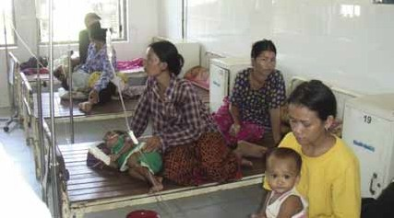
above: Ang Roka Hospital in Cambodia. Most sick children can be treated close to their home before their condition becomes severe. But good quality hospital care for those who need it is an essential part of the health system. Investment in hospital infrastructure must be complemented by support for maintenance and continuous monitoring and improvement in the quality of care. photo: Jim Tulloch

33 See the Copenhagen Consensus Center <www.copenhagenconsensus.com>.

22 HELPING HEALTH SYSTEMS DELIVER A POLICY FOR AUSTRALIAN DEVELOPMENT ASSISTANCE IN HEALTH

Supporting country-specific
5 health priorities

‘TO DETERMINE THE BEST ALLOCATION OF PUBLIC FUNDS, POLICY MAKERS NEED INFORMATION ABOUT RELATIVE COSTS TO DETERMINE WHAT COMBINATION OF INTERVENTIONS CAN YIELD THE GREATEST IMPROVEMENTS IN HEALTH.’
World Bank 34

Some health problems in our region receive inadequate support, even though there are cost- effective interventions, because their burden
has not been well documented, they are not recognised as global priorities by funding agencies, or the health systems are too weak to support effective interventions.

Priorities for Australian aid will be based on current or projected health burdens that are not being addressed by ongoing initiatives and are in areas with known cost-effective interventions that make the best use of resources.

Determining such priorities by researching the burden of health problems is itself an important area for donor assistance, as many of our partner
countries lack accurate information on which to base sound resource allocation decisions.

The changes in health profiles over time need to be followed and findings built into the health planning process. While good quality information on the burden of health problems is the foundation for setting priorities, it is important to also take into account societal views of health needs.

All efforts to address the following country-specific health priorities require links to a well-functioning health system. However, developing such a system is a long-term process, particularly in fragile states.
Cost-effective solutions
need to be context-specific, but regional data can
be adapted to a specific country setting.35

In some contexts donor assistance can be short-term targeted programs while wider reforms are being undertaken. But these programs should ultimately benefit the health system.

CHRONIC DISEASES, INJURIES AND MENTAL HEALTH PROBLEMS
Although chronic diseases, injuries and mental health problems are receiving more attention they remain health issues that are in increasing need
of attention for both women and men. A focus on preventive and control measures will help to demonstrate their cost effectiveness compared with high-technology programs that might otherwise be the priority of policymakers.
Assistance can include documenting the extent and impact of these health problems, a task Australia has already begun to support in the Pacific.

34 World Bank, Priorities in health, World Bank, Washington, DC, 2006, p. 56.
35 See, for example, the WHO CHOICE (choosing interventions that are cost-effective) project <www.who.int/choice>. See also the Disease Control Priorities Project <www.dcp2.org>.

HELPING HEALTH SYSTEMS DELIVER A POLICY FOR AUSTRALIAN DEVELOPMENT ASSISTANCE IN HEALTH 23

Other potential assistance can include implementing legal frameworks and health promotion campaigns covering, for example, tobacco, physical activity
and diet, and interventions such as monitoring blood pressure using appropriate technology. For tobacco, banning the advertising of tobacco products as well as taxing these products have been shown
to be very cost effective. Some chronic diseases that have roots in infectious diseases such as Hepatitis B require different approaches early in life, including immunisation.

MALARIA AND OTHER SIGNIFICANT INFECTIOUS DISEASES
Not all country-specific health priorities are in ‘new’ areas. Malaria is a major health and development problem in several countries in our region, particularly in Melanesia.

Australia will support the most effective malaria preventive and treatment efforts appropriate to each setting, and support applied and operational research (Box 5). The prevention and treatment of other diseases such as tuberculosis will receive support by Australia if indicated by the burden of the diseases and the availability of cost-effective interventions.

SOCIAL DETERMINANTS OF HEALTH

Targeting the social determinants of health can still
be an effective approach to addressing risks to health. Nutrition, education, housing, water supply and sanitation are all critical. Australia will continue to
support infrastructure and related health education in water and sanitation where programs are not
being addressed by other donors or partner countries themselves. The Australian Government has a separate policy document for water.36

In some countries, rapid population growth is eroding the ability to keep up with the demand for services and is compromising the environment. Widespread urbanisation and the growth of slums bring attendant health problems, and a ‘youth bulge’ – a high proportion of young people in the population – is often linked to unemployment and disaffection, leading to conflict including gender- based violence.

Efforts are required at the policy level to integrate demographic factors into policy and planning, and at the service level to deliver comprehensive sexual
and reproductive health education and services to all, including adolescents.

EMERGENCY AND CRISIS SITUATIONS Meeting health needs remains at the core of humanitarian responses along with protecting life, subsistence and physical security.37 Health needs
in emergency and crisis situations will continue
to require preparedness and response support as well as assistance for post-emergency care. Women and children in such situations often need targeted assistance, such as protection from exploitation and abuse, and contraception for women.

BOX 5 FIGHTING MALARIA IN THE PACIFIC
A proposed initiative to renew the fight against malaria will initially focus on Solomon Islands and Vanuatu. Priorities for assistance include strengthening disease surveillance and control systems, commodity procurement and basic service delivery. Drawing on existing malaria expertise in Australia, a research and mapping exercise will be undertaken both to identify islands and provinces to target and to match interventions to the needs of each area. A review of the initiative’s effectiveness after 12 months may lead to initiatives in other countries with a high malaria burden.

36 AusAID, Making every drop count: water and Australian aid, Australian Agency for International Development, Canberra, 2003. The policy stresses water management and governance, as well as components of delivery, including the financing and maintenance of infrastructure, and water quality.
37 Australia’s policy framework in this area is outlined in AusAID, Humanitarian action policy, Australian Agency for International Development, Canberra, 2004.

24 HELPING HEALTH SYSTEMS DELIVER A POLICY FOR AUSTRALIAN DEVELOPMENT ASSISTANCE IN HEALTH

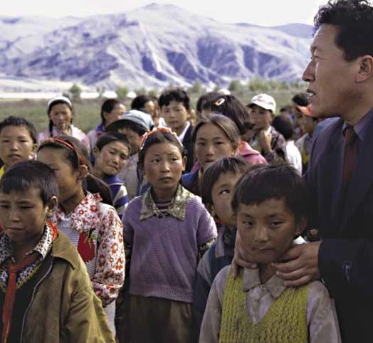

top: Dr Ga Li, Director of Lhasa City Health Bureau in Tibet Autonomous Region, tests schoolchildren for signs of goitre resulting from iodine deficiency. Australian assistance has helped increase the availability of iodised salt needed to reduce the risk of this major health problem.
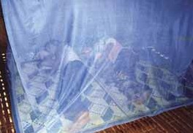

photo: Peter Davis

left: Mosquito nets treated with insecticide can protect families such as this one in Cambodia from malaria if used correctly and consistently. Family-size nets with insecticide impregnation that will last up to five years currently cost around A$7.50 and are beyond the reach of many poor families. The price is expected to decrease to a
more affordable level as their use becomes more widespread.
photo: Dr Boo Khan Therein, National Malaria
Center, Cambodia

HELPING HEALTH SYSTEMS DELIVER A POLICY FOR AUSTRALIAN DEVELOPMENT ASSISTANCE IN HEALTH 25

Reducing vulnerability to emerging
6 infectious diseases and HIV/AIDS

‘WE KNOW THAT EMERGING DISEASES ARE LIKELY TO OCCUR THAT WILL POSE SERIOUS PUBLIC HEALTH THREATS, WITH CORRESPONDING ECONOMIC AND SOCIAL COSTS. THEREFORE, WE MUST BE BETTER PREPARED TO DETECT AND RESPOND TO THESE EMERGING INFECTIOUS DISEASES QUICKLY AND EFFECTIVELY.’
Shigeru Omi , WHO 38

The Australian Government is committed to working in partnership with regional and global organisations to prevent and control the outbreak of emerging infectious diseases and strengthen preparedness
and response capabilities.39 In late 2005 Australia announced a four-year avian and pandemic influenza initiative to enhance preparedness in our region. Support must continue to be developed in close consultation with country partners, based on their national requirements, to ensure individual country needs are met and country ownership and commitment are achieved.

Assistance to prepare for pandemic threats will also improve preparedness for other emergencies such as natural disasters. Although resources must be provided for urgent responses to emergencies, we need to strengthen the underlying national systems to support efforts at all stages. Quality and effectiveness must not be sacrificed to urgency.

Most of the new diseases to emerge in recent decades have been zoonotic (animal-borne but capable of transmission to humans). This trend is likely to continue due to a range of factors that promote disease emergence, establishment and spread. Tackling such diseases requires close collaboration between the human and animal health sectors, as
well as multidisciplinary research.
Threats such as an influenza pandemic require support in several areas:

> multisectoral pandemic preparedness planning for governments and communities

> health education and communication with the public about risks and preventive measures

> integrated surveillance systems to detect and report on public health threats and, in the case of zoonotic diseases such as avian influenza, improvements in the diagnostic capacities of animal and human health laboratories

> outbreak investigation and response, incorporating an integrated animal and human health approach for zoonotic diseases

> related public health functions such as quarantine and infection control

> public health legislation to underpin surveillance and response measures, in line with revised international health regulations

> a better understanding of disease epidemiology and the broad range of risk factors that drive the emergence of infectious diseases

> operational and applied research on systems for detecting threats and intervening, and

38 Shigeru Omi, Regional Director, WHO Western Pacific Regional Office, Opening speech of the WHO Collaborating Centre for Surveillance, Research and Training on Emerging Infectious
Disease, Guandong, China, 13 June 2006.
39 See AusAID, The Australian aid program’s pandemics and emerging infectious diseases strategy, Australian Agency for International Development, Canberra, forthcoming.

26 HELPING HEALTH SYSTEMS DELIVER A POLICY FOR AUSTRALIAN DEVELOPMENT ASSISTANCE IN HEALTH

> effective communication and coordination between countries, including through electronic networks, communication between countries and WHO, and coordinated collaboration with regional bodies such as APEC.

Australia has a separate international HIV/AIDS strategy40 and well-developed multisectoral programs that reflect the profile of the epidemic in countries
in our region. Building on this experience and likely future patterns of the epidemic, prospective programs will continue to:

> foster political commitment through engagement with political, faith and business leaders

> elevate the response to HIV/AIDS in Papua
New Guinea
> support efforts to scale up access to treatment, and

> promote gender equality in access to HIV/AIDS
services.

Preventive efforts will focus on increasing access
to condoms and clean needles, and to treatment of sexually transmitted infections. The link between AIDS and tuberculosis needs recognition in integrated programs. Also needed is stronger integration of HIV/AIDS efforts with wider reproductive health services, including programs to address sexual coercion.
Improved health systems are required to deliver interventions for HIV prevention, diagnostics, counselling and care.

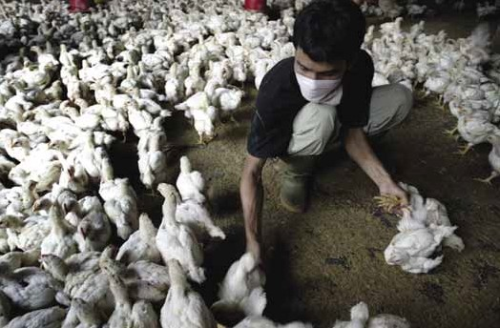

above: An Indonesian worker sorts chickens at a farm in Jakarta. People in close contact with poultry are at greatest risk of infection with avian influenza. Controlling the disease and reducing the risk of a pandemic requires very close collaboration
between various government departments, including human and animal health authorities, at all levels. photo: AAP Images

40 AusAID, Meeting the challenge: Australia’s international HIV/AIDS strategy, Australian Agency for International Development, Canberra, 2004. See also A O’Keeffe, J Godwin and
R Moodie, HIV/AIDS in the Asia Pacific region, background paper for the White Paper on Australia’s aid program, Canberra, 2005.

7 Making our assistance more effective

‘INCREASES IN THE QUANTUM OF AID ARE NECESSARY BUT NOT SUFFICIENT: PROGRESS WILL EQUALLY DEPEND ON POLICY AND INSTITUTIONAL CHANGE ON THE PART OF BOTH DONORS AND GOVERNMENTS.’
World Health Organization and World Bank 41

The directions set by the White Paper on Australian aid require a refocusing of not only areas of assistance in health but also the way programs
are delivered.

Australia’s health sector assistance will reflect the White Paper’s focus on shifting to more sector-wide approaches, engaging with government and non- government partners, strengthening performance orientation, and undertaking more diversified development research.

PROMOTING COUNTRY OWNERSHIP AND SECTOR-WIDE APPROACHES
The majority of Australian development assistance in health is delivered via country programs. Australian aid is not programmed on a sectoral basis, so there is no separate allocation for health. Bilateral priorities are determined through AusAID’s country strategy process, which has become increasingly participative and systematic over the years.

Effective bilateral aid requires priorities to be jointly set within partner policies and structures. To help ensure that health systems are sustainable this
must involve not only ministries of health but also central agencies such as finance, planning, labour, education and training and other relevant agencies instrumental in delivering health services. There
is a role for donor dialogue and assistance in, for
example, the development of a national health plan, but ultimately the document should be owned by the country.

Technical assistance must be provided in a way that builds capacity and does not create dependency.

The main effectiveness principles listed in Section 2 under the heading ‘Aid effectiveness: what have
we learned?’ – especially the need to coordinate and align donor inputs and to shift to more programmatic approaches – help to promote greater country ownership.

Country-led sector-wide forms of aid will be developed in health where feasible in countries in the Asia- Pacific region. This approach represents a major change in the donor–partner relationship and
requires high-level engagement.

Traditional projects will still play a role in pilots, in research studies and where high-priority self- contained packages of assistance are determined to be appropriate.
Strategic multi-country or regional programs will be used where they achieve better economies of scale and add value to national health outcomes.

41 World Health Organization and World Bank, Resources, aid effectiveness and harmonization: high-level forum on the health development goals, Geneva, 2003, p. 1.

Regional cooperation is critical in areas such as emerging infectious diseases where coordinated action is essential to meet the transboundary threat. Country ownership is still important in assistance provided via regional programs. Effectiveness will
be undermined if individual countries are not committed to the effort, or if they lack the capacity to play a meaningful role.

Australia will continue to engage with fragile states where governance and service delivery are weak. Assistance needs to be flexible, have a long time horizon, and not burden already weak systems
by establishing structures for aid projects that will parallel and undermine existing systems. The involvement of non-state agencies needs to be carefully coordinated with efforts to build up government capacity. Because the challenges are
great and experience to date is not well documented it is imperative that Australia and other donors
share experiences.

OPTIMISING PARTNERSHIPS

Partnerships with countries in the region extend from government to local non-government organisations, consultants and other private sector providers. In addition to close country partnerships, Australia’s assistance in health will benefit from further strengthening of links with domestic and international collaborators.

Cooperation on a whole-of-government basis will continue to be central, and will be particularly important in monitoring the implementation of the new health policy. At both working and strategic levels, the main collaboration is between AusAID and the Department of Health and Ageing. This department plays a major role in global and regional health governing bodies. It is the lead Australian agency for Australia’s relationship with WHO.

At a working level, AusAID also collaborates with state health departments. AusAID also provides grants on a competitive basis to Australian government agencies and departments as well as public universities to strengthen counterpart public sector institutions by, for example, transferring skills.
The United Nations, multilateral development
banks and other multilateral agencies are significant players in the health sector and can be particularly effective in regional health initiatives, pandemic threats, global research and governance. They can provide economies of scale and promote donor harmonisation and coherence.

In our region both the World Bank and the Asian Development Bank are significant collaborators. The strong partnership between Australia and WHO is particularly important (Box 6). We look to the United Nations Population Fund in the
critical area of population, reproductive health and adolescent health and to UNICEF for initiatives on child and youth health. In the Pacific the work of the Secretariat of the Pacific Community (SPC) has
assisted in addressing key health needs in the region.

We will continue to assess the strengths and weaknesses of individual agencies and give priority
to those that reinforce central areas of need identified in the new health policy and those that demonstrate responsiveness to Australia’s key interests within the Asia-Pacific region.

Australia will also continue to support global health initiatives that give due regard to their accountability and potential weaknesses and their commitment
to the principles of harmonisation and alignment. While Australia will continue to engage with the Global Fund to Fight AIDS, TB and Malaria by participating in fund governance at the board level, the key to leveraging the most from our investment in the fund is our engagement at country level.

Australian and local non-government organisations and volunteers have critical strengths in health at the community level and in health advocacy. They
can be particularly effective in ‘client demand’ areas, addressing people’s lack of knowledge about formal health services and standards. In some settings
there may be a rationale for supporting their role in directly delivering health services or their pilot activities. The guiding principle should remain working toward integrating their lessons into the wider health system. The performance of Australian non-government organisations is assessed via a rigorous accreditation process.

In view of the long-term support needed for capacity development, institutional twinning arrangements with defined performance benchmarks is an area that could be expanded. Such arrangements could
be linked with the more targeted use of Australian scholarships in health-related areas. Australia already has some experience with these in the health sector – for example, between universities and between hospitals. We will also consider agreements with professional health bodies that could enter into linkage programs with developing country counterparts. The Australian government institutions with long experience in areas such as health budget allocations, health financing, and pharmaceutical registration and benefit schemes could provide relevant advice for partner countries.
For such cooperation to be effective, Australian government and other institutions will need to be able to demonstrate that their experience is relevant or can be adapted to developing country settings.

Where Australian aid programs are being implemented through managing contractors, close cooperation with them will ensure that programs can be adapted to changing needs. Fostering exchanges between different players in the Australian aid community – managing contractors, non-government organisations, researchers and others – will promote better understanding of different perspectives.

BOX 6 AUSTRALIA’S ENGAGEMENT WITH THE WORLD HEALTH ORGANIZATION
Australian support recognises WHO’s valuable role in providing technical assistance and advice to governments, developing new approaches, packages of interventions and normative treatment standards, and providing leadership in global and regional health issues.

The Australian Government, through the Department of Health and Ageing, provides the funds for Australia’s assessed contribution to the regular budget of WHO.

Australia identifies and promotes priority areas for WHO activities and assessed contribution expenditure both in the region and globally by actively participating in the WHO Assembly and the Regional Committee for the Western Pacific, as well as high-level representation on the WHO Executive Board and Programme, Budget and Administration Committee. Australia also engages in shaping the priorities for the WHO General Programme of Work – which guides the biennial WHO Programme Budgets – and helps to set the objectives, strategic approach and expected results framework that surround each budget.

In addition to Australia’s ongoing commitments to WHO through our assessed contribution and AusAID- funded voluntary contributions, the Department of Health and Ageing has made financial contributions to a range of issues of particular priority to Australia, such as cancer research and chemical safety.

Australia will also continue to work in partnership with WHO on issues of importance to our region such as the surveillance and control of avian influenza, pandemic preparedness, prevention of avoidable blindness, tobacco control, improvements in diet and physical activity, and laboratory biosafety.

AusAID and WHO have a separate letter of engagement that details areas of focus in the Asia-Pacific
region. The letter of engagement is reviewed every three years and adjustments made to reflect any strategic policy changes. Over time we expect increasing emphasis to be given to strengthening health systems. Harmonisation and alignment with partner governments, other UN agencies, bilateral donors and the global health partnerships will also receive greater attention.

Australia uses a range of processes to monitor and review WHO performance and provides constructive feedback on a regular basis through, for example, the World Health Assembly and Regional
Committee meetings.

EXPANDING THE KNOWLEDGE BASE

A multi-year health and development research initiative with a collaborative research network is one potential mechanism for accessing high-quality research in the key focus areas identified for the
health policy. Specific research outputs would have a clear policy application and be widely disseminated.

Collaboration with the National Health and Medical Research Council and the Australian Research Council will be explored. Links with institutions such as the Centre for Health and Population Research (ICDDR, B) in Bangladesh and the Institute for Medical Research in Papua New Guinea already play
a valuable role in expanding our knowledge base. There may be scope for supporting more work of the Australian Centre for International Agricultural Research that has direct nutrition applications.

Research carried out in the context of specific aid programs is also critical. Priority will be given to applied research rather than biomedical or clinical studies. Financial and human resources for health programs are particularly high priority areas for applied research.

Problem-solving research that links research to action would meet the need for operational research that examines efficacy and alternative approaches
to improve the ways health systems function. Improved, practical health information systems, special studies, and qualitative approaches as well as quantitative research are all areas that should
receive support. Combined disease and behavioural surveillance is important if health promotion programs are to be effectively targeted.

Also important is research on the social and political dimensions that often determine the feasibility and effectiveness of health programs. Effective ways need to be found to feed research lessons to policymakers. Findings must also be shared among countries that could apply them in similar contexts.

Health service delivery in fragile states will be a priority for research, with emphasis given to developing practical approaches and sharing lessons learned.
As part of our research activities, attention will be given to collaborating with institutions in partner countries and building the capacity of local
researchers. This will include building institutional links as well as providing scholarships for
young researchers.

INCREASING PERFORMANCE ORIENTATION

The White Paper’s emphasis on performance – on demonstrating results – is critical for the health sector, especially programs to strengthen health systems. Australian assistance needs to ensure that capacity building and other inputs to health systems, particularly in the context of a sector-wide approach, translate into meaningful outputs and outcomes on the ground.

Monitoring aid effectiveness in health is a considerable challenge. Short-term and medium- term indicators are needed in addition to longer term measures of health outcomes. For some indicators such as mortality rates it may be many years before improvements become apparent.

Good baseline data and reliable disaggregated health indicator data, generally rare in our partner countries, are needed to show changes. Better statistics on health can in the short term indicate higher recorded morbidity or mortality simply because measurement is more complete, confounding conclusions on genuine trends.

Performance frameworks at the country and sectoral levels are receiving increased emphasis in AusAID and will be a major area of work for its new Office
of Development Effectiveness, which will rely on external expertise as well as expanded in-house capacity. Documenting and sharing lessons learned is an important part of the effort. Building partner countries’ focus on results and their capacity to measure performance is also essential.

As foreshadowed in the White Paper we will also explore the use of output-based approaches in which incentives or payments are linked to defined outputs rather than inputs. In some cases this could involve the use of third-party providers.

STRENGTHENING PROCESSES AND RESOURCES Implementation of the health policy will require cooperation and coordination across AusAID as well as with our development partners in Australia and overseas.

An annual analysis of health sector assistance will
allow patterns and trends to be monitored and will give stakeholders a picture of the ‘state of the sector’. Efforts will be made to refine the automated aid management system (AidWorks) to allow reports to be produced
on key health areas in addition to the existing OECD
health code categories.

Implementation of the policy will demand dedicated resources at several levels.

ADVISORY RESOURCES AND IN-HOUSE SKILLS

> AusAID will investigate the feasibility of forming a Health Resource Centre to provide specialist advice, taking into account the work being done by other donors. The centre would provide updated information on health trends and advise on key areas for health development assistance, especially those common to the development of health systems across most countries.

> Participation in program or sector-wide approaches will require AusAID staff to have enhanced policy dialogue skills to ensure a mature relationship with our development partners. These skills will be enhanced through recruitment processes, training and advisory resources at Posts.

> AusAID will employ in-country health advisers where considered appropriate in country programs that include a large health component.

> The involvement of AusAID’s Advisory Group, especially at a strategic level of health assistance, is critical. The role of the group includes establishing links with health experts in Australia and overseas. Access to a network of such experts
– especially in health systems improvement – will benefit programs across the agency.

> Advisers, especially in performance assessment, will help to improve the measurement of
health outcomes.
> We will further develop the Health Thematic Network of officers involved or interested in health issues. Members will receive information electronically on recent health developments
and will meet regularly to discuss health issues. Topics for discussion could include health
in fragile states, health impact assessment, assessment processes for appropriate technology, and guidance on incorporating health in
country strategies.

> Staff will be assigned to assist coordination, monitoring and reporting on health policy implementation.

ANALYTICAL PROCESSES

> AusAID will renew its commitment to sound gender analysis in program development and monitoring, which will enhance development effectiveness.

> Resources will be applied to ensuring that equity and the needs of the most vulnerable are considered in the design and implementation of health programs.

> Assessing the impact of other aid activities on health is an important part of analysing the effectiveness of aid. AusAID has detailed
environmental impact guidelines, some of which capture health aspects. AusAID may require further guidance on health-specific factors.

> The new Office of Development Effectiveness will provide additional capacity to assist independent evaluations of aid programs in all sectors, including health.

www.ausaid.gov.au

