


UNDERSTANDING AUSTRALIA’S INDIAN COMMUNITIES
  - A STATISTICAL SNAPSHOT

Acknowledgement of Country
The Department of Foreign Affairs and Trade acknowledges Australia’s First Nations peoples as the Traditional Custodians of Country throughout Australia. We recognise the ongoing custodianship of land, sea and sky and the perpetual spiritual connection Aboriginal and Torres Strait Islander people hold with Country. We pay our respects to Elders past and present and extend that respect to First Nations people throughout Australia.
Report prepared by the University of Queensland on behalf of the Department of Foreign Affairs and Trade:
Elin Charles-Edwards, The University of Queensland
Aude Bernard, The University of Queensland
Tomasz Zając, The University of Queensland
Juliet Pietsch, Griffith University
Tom Wilson, Advanced Demographic Modelling
Toan Nguyen, Australian National University
Santosh Jatrana, Deakin University
Charles Siriban, The University of Queensland
Gin Wu, The University of Queensland
Dagmara Laukova, The University of Queensland
Cho Yat Wong, The University of Queensland
The authors would like to thank contributors to the included case studies.
Design and typesetting by Sarah K Jones.

ISBN: 978-1-74322-643-8 (print)
ISBN: 978-1-74322-644-5 (online)

Creative Commons
With the exception of the Commonwealth Coat of Arms, the Department of Foreign Affairs and Trade logo, photographs, images, signatures and where otherwise stated, this publication is provided under a Creative Commons Attribution-Non Commercial- No Derivatives 4.0 International (CC BY-NC-ND 4.0) licence. The licence terms are available at creativecommons.org/licenses/by-nc-nd/4.0. To the extent that copyright subsists in a third party, permission will be required from the third party to reuse the material.

Use of the Coat of Arms
The terms under which the Coat of Arms can be used are set out on the Department of the Prime Minister and Cabinet website at pmc.gov.au/honours-and-symbols/commonwealth-coat-arms.

Contact
Inquiries about the publication are welcome and should be directed to:
India Branch, Department of Foreign Affairs and Trade
RG Casey Building, John McEwen Crescent
Barton ACT 0221
Phone: 02 6261 1111
Email: india.outreach@dfat.gov.au
Table of Contents
EXECUTIVE SUMMARY 5
Data And Definitions 7
Purpose and Structure of Report 9
THE SIZE AND COMPOSITION OF THE INDIAN DIASPORA 10
Key Findings 10
The global Indian diaspora 10
Recent growth of the Indian diaspora in Australia 11
Secondary migrants 12
Age structure 13
Cultural and linguistic diversity 14
Education and earnings 16
MIGRATION PATHWAYS AND TRANSITIONS 20
Key Findings 20
International students 24
THE GEOGRAPHY OF THE INDIAN DIASPORA 28
Key Findings 28
Geographic distribution 28
Regional attraction and retention 30
LABOUR MARKET OUTCOMES 33
Key Findings 33
Labour force participation 33
Occupational structure 34
Entrepreneurship 37
ECONOMIC CONTRIBUTION OF THE INDIAN DIASPORA 40
Key Findings 40
Bilateral trade 40
Income tax 41

POLITICAL ENGAGEMENT OF THE INDIAN DIASPORA 43
Key Findings 43
THE FUTURE OF THE INDIAN DIASPORA IN AUSTRALIA 46
Key Findings 46
Future growth 47
Future distribution 47
OUTLOOK 49
TECHNICAL ANNEX 52
Annex 1: Labour market outcomes 52
Annex 2: Regional retention 54
Annex 3: Contribution to aggregate trade and business growth 56
Annex 4: Population Projections 57

EXECUTIVE SUMMARY

The Indian diaspora in Australia has grown in both size and complexity over the past two decades, emerging as one of the most dynamic migrant communities in the country.
The diaspora population (including first-generation, second-generation and secondary migrants) was estimated at 988,270 people at the 2021 Census, a 3.7-fold increase since 2006. This growth reflects broader global migration trends and changes to Australia’s migration policy.
The Indian diaspora is notably young and highly educated. Most first-generation migrants are between 25 and 44 years old, and 68 per cent hold a bachelor’s degree or higher, well above the national average. Secondary migration is also diversifying, with increasing arrivals from countries such as England, Pakistan, New Zealand, South Africa, and Kenya.
Indian international students account for 47 per cent of Indian arrivals since 2006 which is higher than migrants from other source countries. Retention rates are high, with 77 per cent of Indian students still in Australia after seven years, reflecting strong integration. However, a growing proportion are remaining on temporary visas for extended periods.
Although 90 per cent of Indian-born migrants live in capital cities, mainly Melbourne (34 per cent) and Sydney (29 per cent), regional areas are seeing rapid growth. Regional Tasmania and Victoria have recorded over 200 per cent increases in Indian-born populations since 2016. Retention in regional communities is highest where job diversity and co-ethnic networks are strong, though high living costs are a constraint on long-term settlement.
Indian-born migrants have a higher labour force participation (85 per cent) and employment rate (80.3 per cent) than migrants overall. They are overrepresented in both professional sectors (32.7 per cent) and low-skilled roles (11.6 per cent), indicating segmented labour market outcomes. Despite high education levels, Indian graduates are less likely to hold managerial positions compared to their Australian-born peers.

Performers at the 2023 Starry Sari Nights Festival in Liverpool
The Indian diaspora plays a growing role in Australia’s economy. Business ownership has increased from 30,000 in 2016 to 50,000 in 2021, with each 1 per cent increase in the diasporic population associated with the creation of 123 medium and 6 large businesses. Moreover, Indian migration has strengthened bilateral trade, with each 1 per cent increase in Indian-born residents estimated to boost exports by 0.46 per cent and imports by 0.16 per cent.
As of 2021, 52 per cent of Indian-born residents had become Australian citizens, enabling electoral participation. Indian Australians show high levels of political engagement and democratic values, with a notable trend toward fluid partisan alignment, suggesting sophisticated political participation rather than strong party loyalty.
By 2041, the Indian-born population in Australia is projected to more than double, from 0.7 million in 2021 to 1.7 million, surpassing 1 million by 2026.
The number of Indian-born Australian citizens is expected to grow from 0.4 million to 1.3 million, while the non-citizen population will rise modestly. The median age will increase from 35.7 to 41 years, reflecting an ageing demographic. Most growth will continue to concentrate in Sydney and Melbourne.
In sum, the Indian diaspora represents a vital and rapidly expanding part of Australia’s multicultural fabric. Its contributions span the economic, educational, social, and civic spheres, driving growth, deepening bilateral ties with India, and enriching Australia’s urban and regional communities. As the population continues to grow and diversify, ensuring effective integration, equitable opportunities, and clear migration pathways will be key to unlocking the full potential of this community. Recognising and supporting the Indian diaspora is not only important for fostering a more inclusive society, but also for securing Australia’s long-term prosperity in an increasingly interconnected world.

Introduction
As the world’s largest democracy and the third-largest economy in terms of purchasing power parity, India has become a significant player on the global stage, shaping economic and political dynamics worldwide. In recent years, Australia has aimed to strengthen its ties with India through initiatives like the Australia-India Economic Cooperation and Trade Agreement (ECTA) and Comprehensive Strategic Partnership (CSP), which fosters cooperation in areas such as defence, trade, education, and technology. This partnership is further reinforced through Australia’s participation in the Quadrilateral Security Dialogue (Quad) alongside the United States, Japan, and India. The Quad focuses on ensuring a free, open, and inclusive Indo-Pacific region, addressing shared security challenges, and upholding international law. Regular joint military exercises between Australia and India also underscore the strong defence collaboration, reflecting a mutual commitment to regional security and stability.
In line with India’s growing role as a global partner, there has been a notable increase in the Indian diaspora in Australia, mirroring broader global migration trends. According to the 2021 Australian Census, the Indian-born population in Australia jumped from 455,389 people in 2016 to 673,352 in 2021, a 48 per cent increase in just five years., This makes Indians the second-largest group of overseas-born residents in (overtaking China in 2019) Australia after those born in England.
The Indian diaspora has become an integral part of Australia’s population and holds significant potential as a strategic asset. Recognising the contributions and evolving roles of this community is essential for understanding its impact on Australian society and the broader relationship between Australia and India. As the diaspora continues to grow, its influence on both domestic and international fronts will play a critical role in strengthening the connections between our two nations.

Data And Definitions
The term “diaspora” refers to a population that has spread or been dispersed from its original homeland to various locations worldwide. For this report, the Indian diaspora includes recent migrants, individuals of Indian descent born in Australia and those individuals with Indian ancestry who have migrated to Australia from a third country.
We operationalise this definition using data on Country of Birth and Ancestry (multi-response data) as captured in the Australian Census of Population and Housing. This allows us to identify three distinct parts of the diaspora:
First-generation or Indian-born migrants: the largest component of the diaspora, including all individuals born in India, regardless of their ancestry.
Second-generation (+) migrants: Australian-born individuals who identify Indian ancestry, including children of first-generation migrants as well as later generations.
Secondary migrants: individuals born outside both India and Australia but who identify Indian ancestry.
While this definition balances comprehensiveness with parsimony, it is not without limitations:
It includes everyone born in India, even if they may not identify with the diaspora.
It overlooks individuals born outside India who do not select “Indian” as one of their two nominated ancestries but instead nominate a co-ethnic identity (for example, Tamil or Punjabi).
Despite these limitations, examining both Country of Birth and Ancestry data together offers a more nuanced and comprehensive understanding of the diaspora than relying on either metric independently.
Additionally, focusing ancestry data specifically on “Indian” helps to refine the analysis, avoiding overestimation of the diasporic population by excluding co-ethnic communities that transcend national borders, such as the Punjabi identity shared by India and Pakistan and Tamil ancestry shared between India and Sri Lanka.
This study adopts this broad definition to explore the size, composition and distribution of the diaspora before narrowing its focus to the specific case of Indian-born Australians in the analysis of visa transitions, labour market outcomes, economic contribution, political representation, and population projections.
This study draws on a range of statistical sources for analytic purposes as shown in Table 1. Other statistical sources, such as United Nations data on migrant stocks, are cited in text as they are encountered.

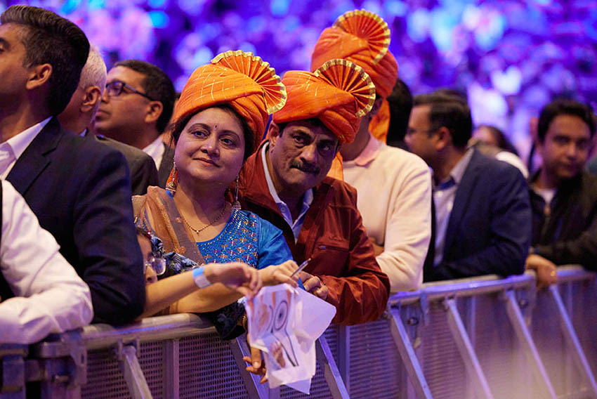
Attendees at the His Excellency Shri Narendra Modi reception in Sydney

- Summary of data sets used in this study
Dataset | Temporal Coverage | Population | Operationalisation of Diaspora | Topics for  this Study
Australian Census of Population  and Housing | 2001, 2006, 2011, 2016, 2021 | All individuals in Australia on Census night (excludes foreign diplomats) | Country of birth of person, Ancestry (multi-response) | Population; Cultural diversity; Education; Employment; Income
Person Level Integrated  Data Asset (PLIDA) | Since 2006 | All individual’s resident in Australia based on 12/16 month rule | Country of birth from Home Affairs module or census | Visa transitions; Economic and employment outcomes
Australian Election  Study (AES) | Federal elections from 1987 to 2022 | Australian voters | Country of birth | Politics and elections; Attitudes to social policy
Business Longitudinal Analysis  Data Environment (BLADE) | 2001-02 to 2018-19 | All active businesses | Country of birth | Key sectors with high Indian worker representation; Business performance; Trade between Australia and India

Purpose and Structure of Report
This report provides an overview of Australia’s Indian diaspora, examining its size, composition, geographic distribution, social impact, and economic contributions, as well as its future trajectory.
It aims to deepen the understanding of the Indian diaspora in Australia, highlighting its potential to strengthen Australia-India economic and strategic ties in the 21st century. It is comprised of the following sections:
- The size and composition of the Indian diaspora
- Migration pathways and transitions
- The geography of the Indian diaspora
- Labour market outcomes
- Economic contribution of the Indian diaspora
- Political engagement of the Indian diaspora
- The future of the Indian diaspora
- Outlook


Crowds at the 2023 Starry Sari Nights Festival in Liverpool

THE SIZE AND COMPOSITION OF THE INDIAN DIASPORA

Key Findings
- The Indian diaspora in Australia was estimated at 988,270 people in the 2021 Census.
- Australia’s Indian diaspora has grown 3.7 times since 2006, with first-generation migrants increasing 4.6-fold.
- Secondary migration is diversifying, with growing numbers from England, Pakistan, New Zealand, South Africa, and Kenya.
- The Indian diaspora is younger than the Australian population, with most first-generation migrants aged between 25-44.
- Indian-born migrants are highly educated, with 68 per cent holding a bachelor’s degree or higher.

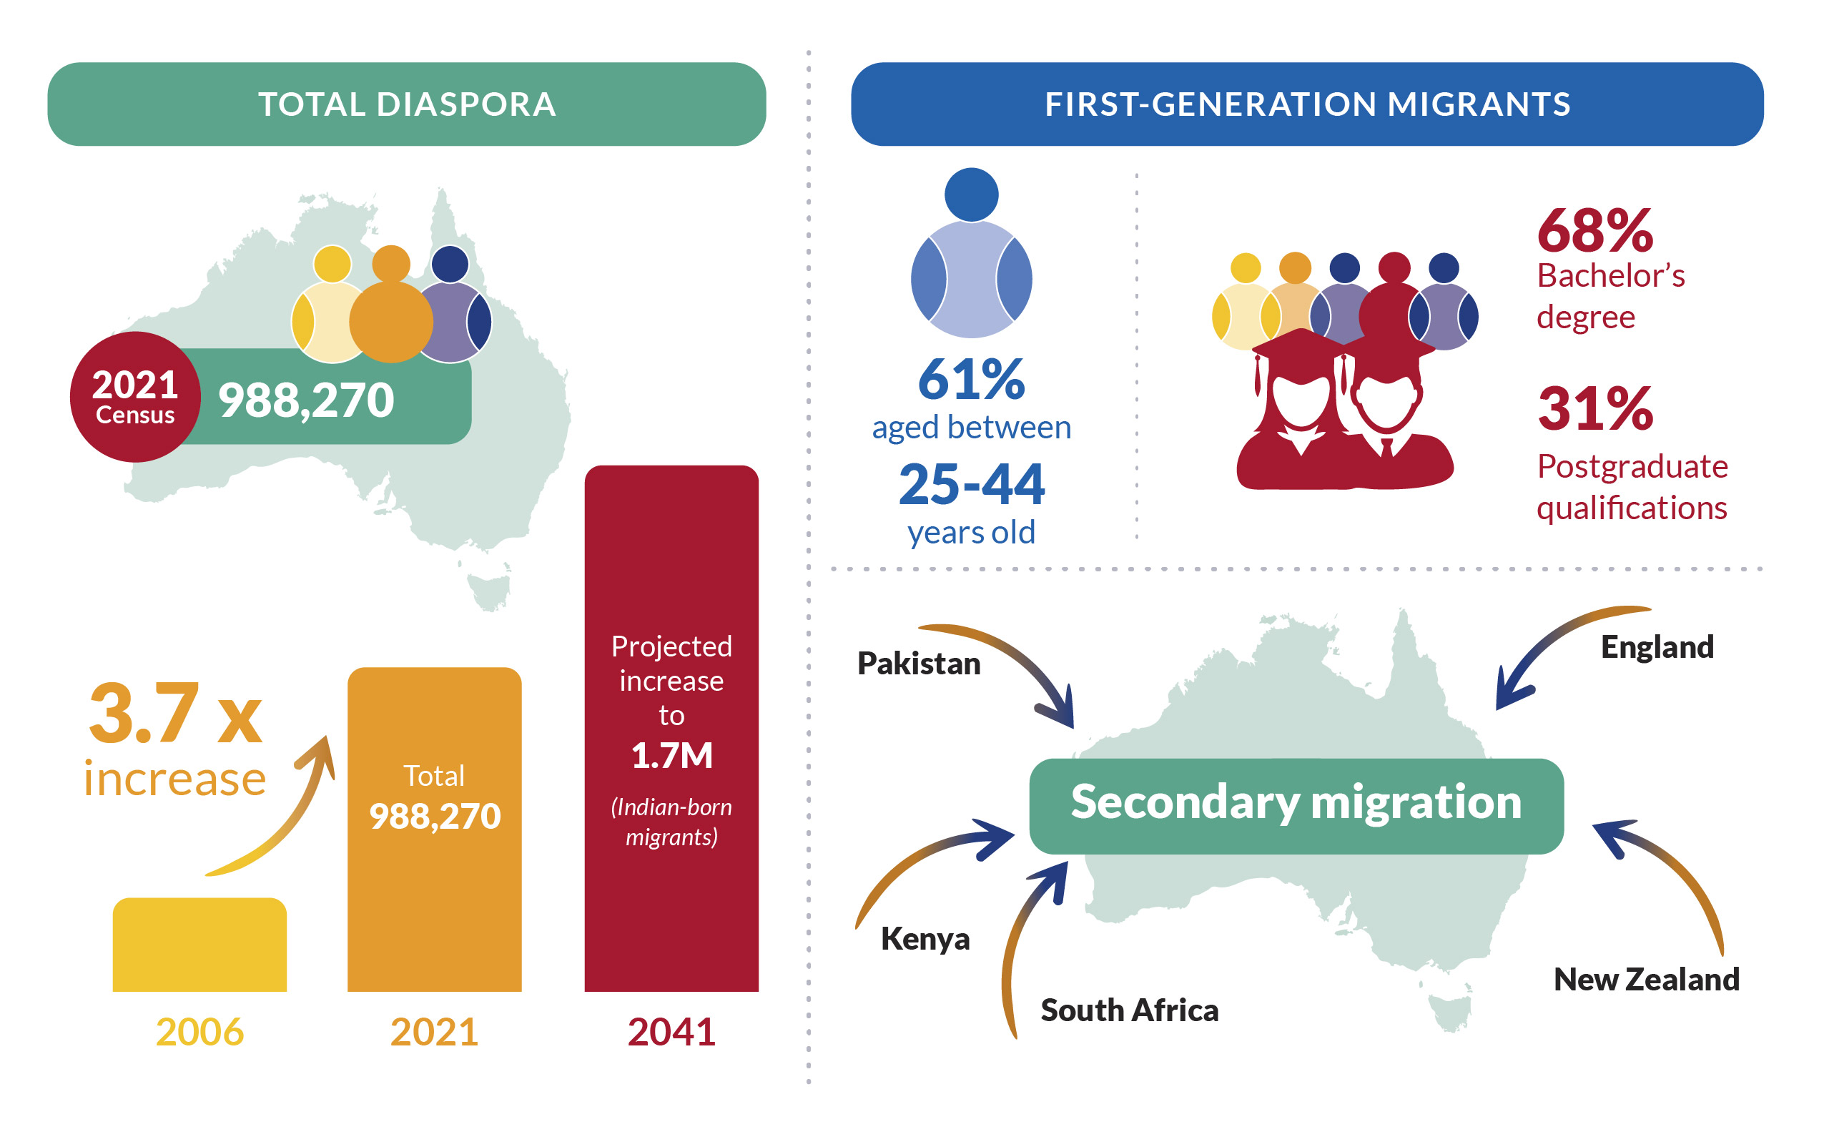

The global Indian diaspora
India has the largest diaspora in the world, with about 18 million people born in India now living abroad (Figure 1). The United Arab Emirates hosts the largest population of expatriate Indians, with 3.24 million in 2024, followed by the United States with 3.2 million, and Saudi Arabia with 2 million. Australia ranks as the 8th largest home for Indian-born migrants globally with an estimated 876,000 people in 2024.
The global distribution of Indian migrants highlights a dual pattern of Indian emigration. Many low-skilled Indian workers move to Gulf states like the United Arab Emirates and Saudi Arabia, while highly skilled professionals are more likely to migrate to countries such as the United States, Canada, and Australia. The latter flows reflect a “migration hump,” where increasing middle-class growth in India drives more people to seek opportunities abroad,, and represents a “brain gain” for host countries, including Australia.

- Growth in the global Indian diaspora, 1990-2024
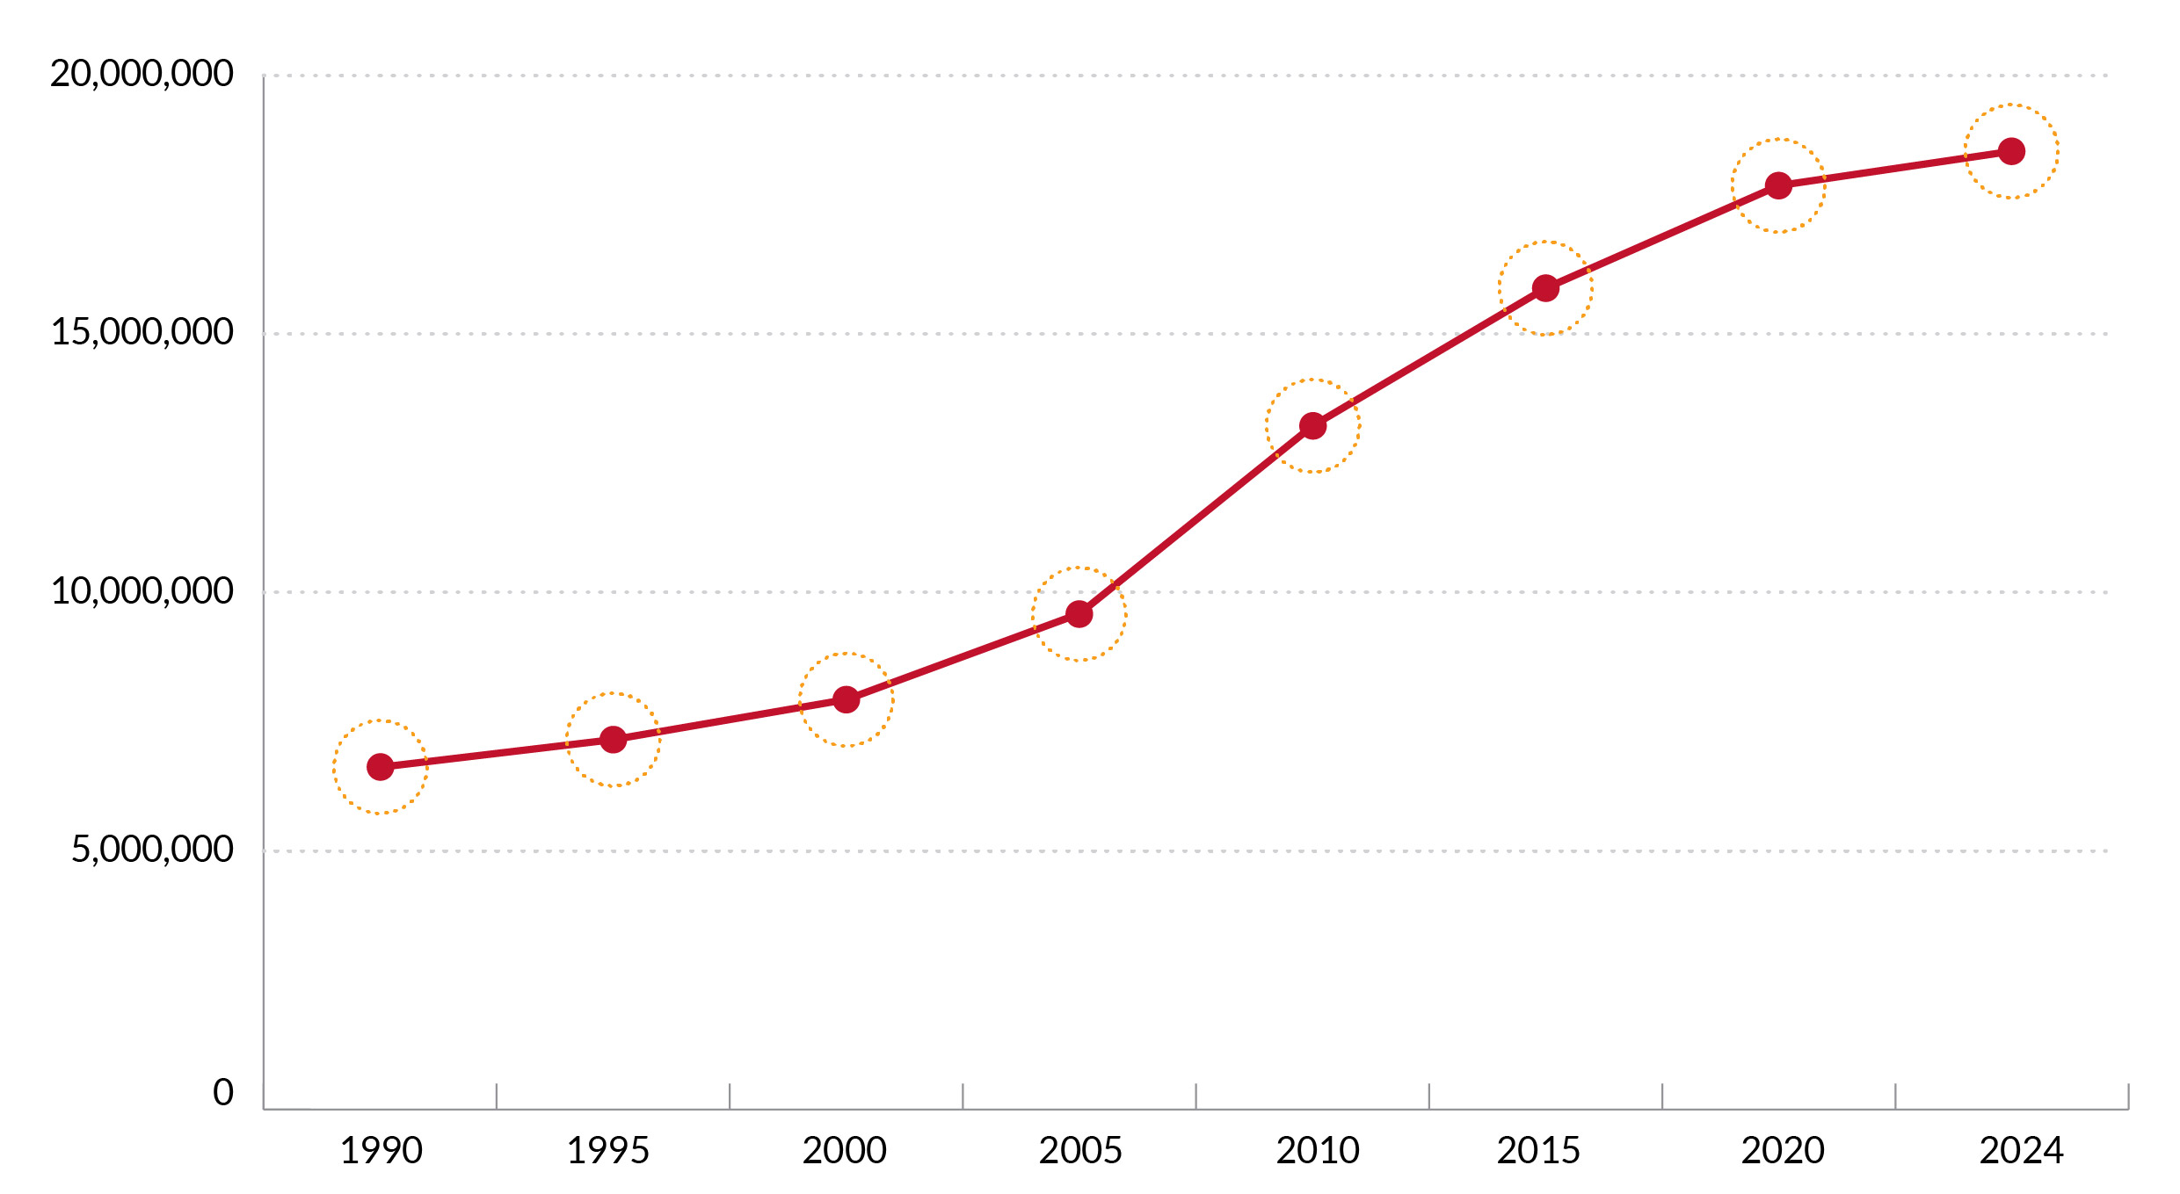
Source: UN DESA 2024

Recent growth of the Indian diaspora in Australia

The Indian diaspora in Australia was estimated at 988,270 people in the 2021 Census (Figure 2), making up 3.9 per cent of Australia’s usual resident population on census night. The diaspora is primarily composed of first-generation migrants, with 673,352 Indian-born residents counted. According to the most recent estimates from the Australian Bureau of Statistics, the Indian population in Australia reached 916,330 as of 30 June 2024, indicating substantial growth since the last Census. Additionally, there were 200,971 second-generation migrants, Australian-born individuals who identify with Indian ancestry, and 113,947 secondary migrants, who were born outside both India and Australia but nominate Indian ancestry. Since 2006, the diaspora has grown 3.7 times, with first-generation migrants experiencing the highest increase, expanding 4.6-fold (Figure 2).
Second-generation migrants saw a 3.8-fold increase, due to births to Indian-born migrants, while secondary migrants grew by 1.6 times over the same period. This rapid growth highlights the expanding footprint and influence of the Indian diaspora within Australia.
Growth in the diaspora has not been uniform over time. The most rapid growth in first-generation migrants occurred between 2006 and 2011 during which time Indian-born residents grew by 15 per cent per annum. This coincided with Australia’s expansion of skilled migration programs, particularly the General Skilled Migration (GSM) stream, which attracted many highly educated Indian professionals in sectors such as IT, healthcare, and engineering. Australia’s points-based immigration system, which prioritised qualifications, English proficiency, and work experience, aligned well with the profile of many prospective Indian migrants during this period. In contrast, growth in both second-generation and secondary migrants was most rapid between 2011 and 2016 at 12 per cent per annum and 7 per cent per annum respectively. The significant growth in second-generation between 2011 and 2016, reflects a natural lag effect, where the birth of Australian-born children to Indian migrants began to reshape the composition of the diaspora.

- Growth in the Indian diaspora, 1991-2024. ABS 2025, Australia's population by country of birth
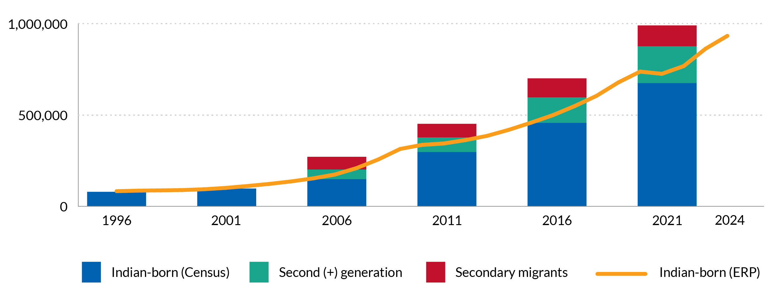

Source: Australian Census of Population and Housing, unpublished data
Note: Data on second (+) generation and secondary migrants were not reported prior to 2006

Secondary migrants
The origins of secondary migrants within the Indian diaspora in Australia have diversified over time (Figure 3). These secondary migrants are the descendants of earlier Indian diasporas who migrated through colonial, economic, or educational routes to other regions before settling in Australia. In 2006, Fijian Indians represented nearly half of this group reflecting the long-established Indo-Fijian community that began migrating to Australia in the 20th century, especially following political instability in Fiji; however, they now constitute just under a third, reflecting the growing range of origins for secondary migrants.
Since 2006, the number of individuals from England, Pakistan, and New Zealand who identify with Indian ancestry has increased threefold. Additionally, there has been a marked rise in secondary migrants from African countries, particularly South Africa and Kenya. These communities descend from Indian traders, indentured labourers, and professionals who settled in East and Southern Africa during the colonial era. Political and economic instability, combined with Australia’s skilled migration policies and multicultural appeal, has driven onward migration from these regions.

- Country of birth, Secondary migrants, 2006-2021
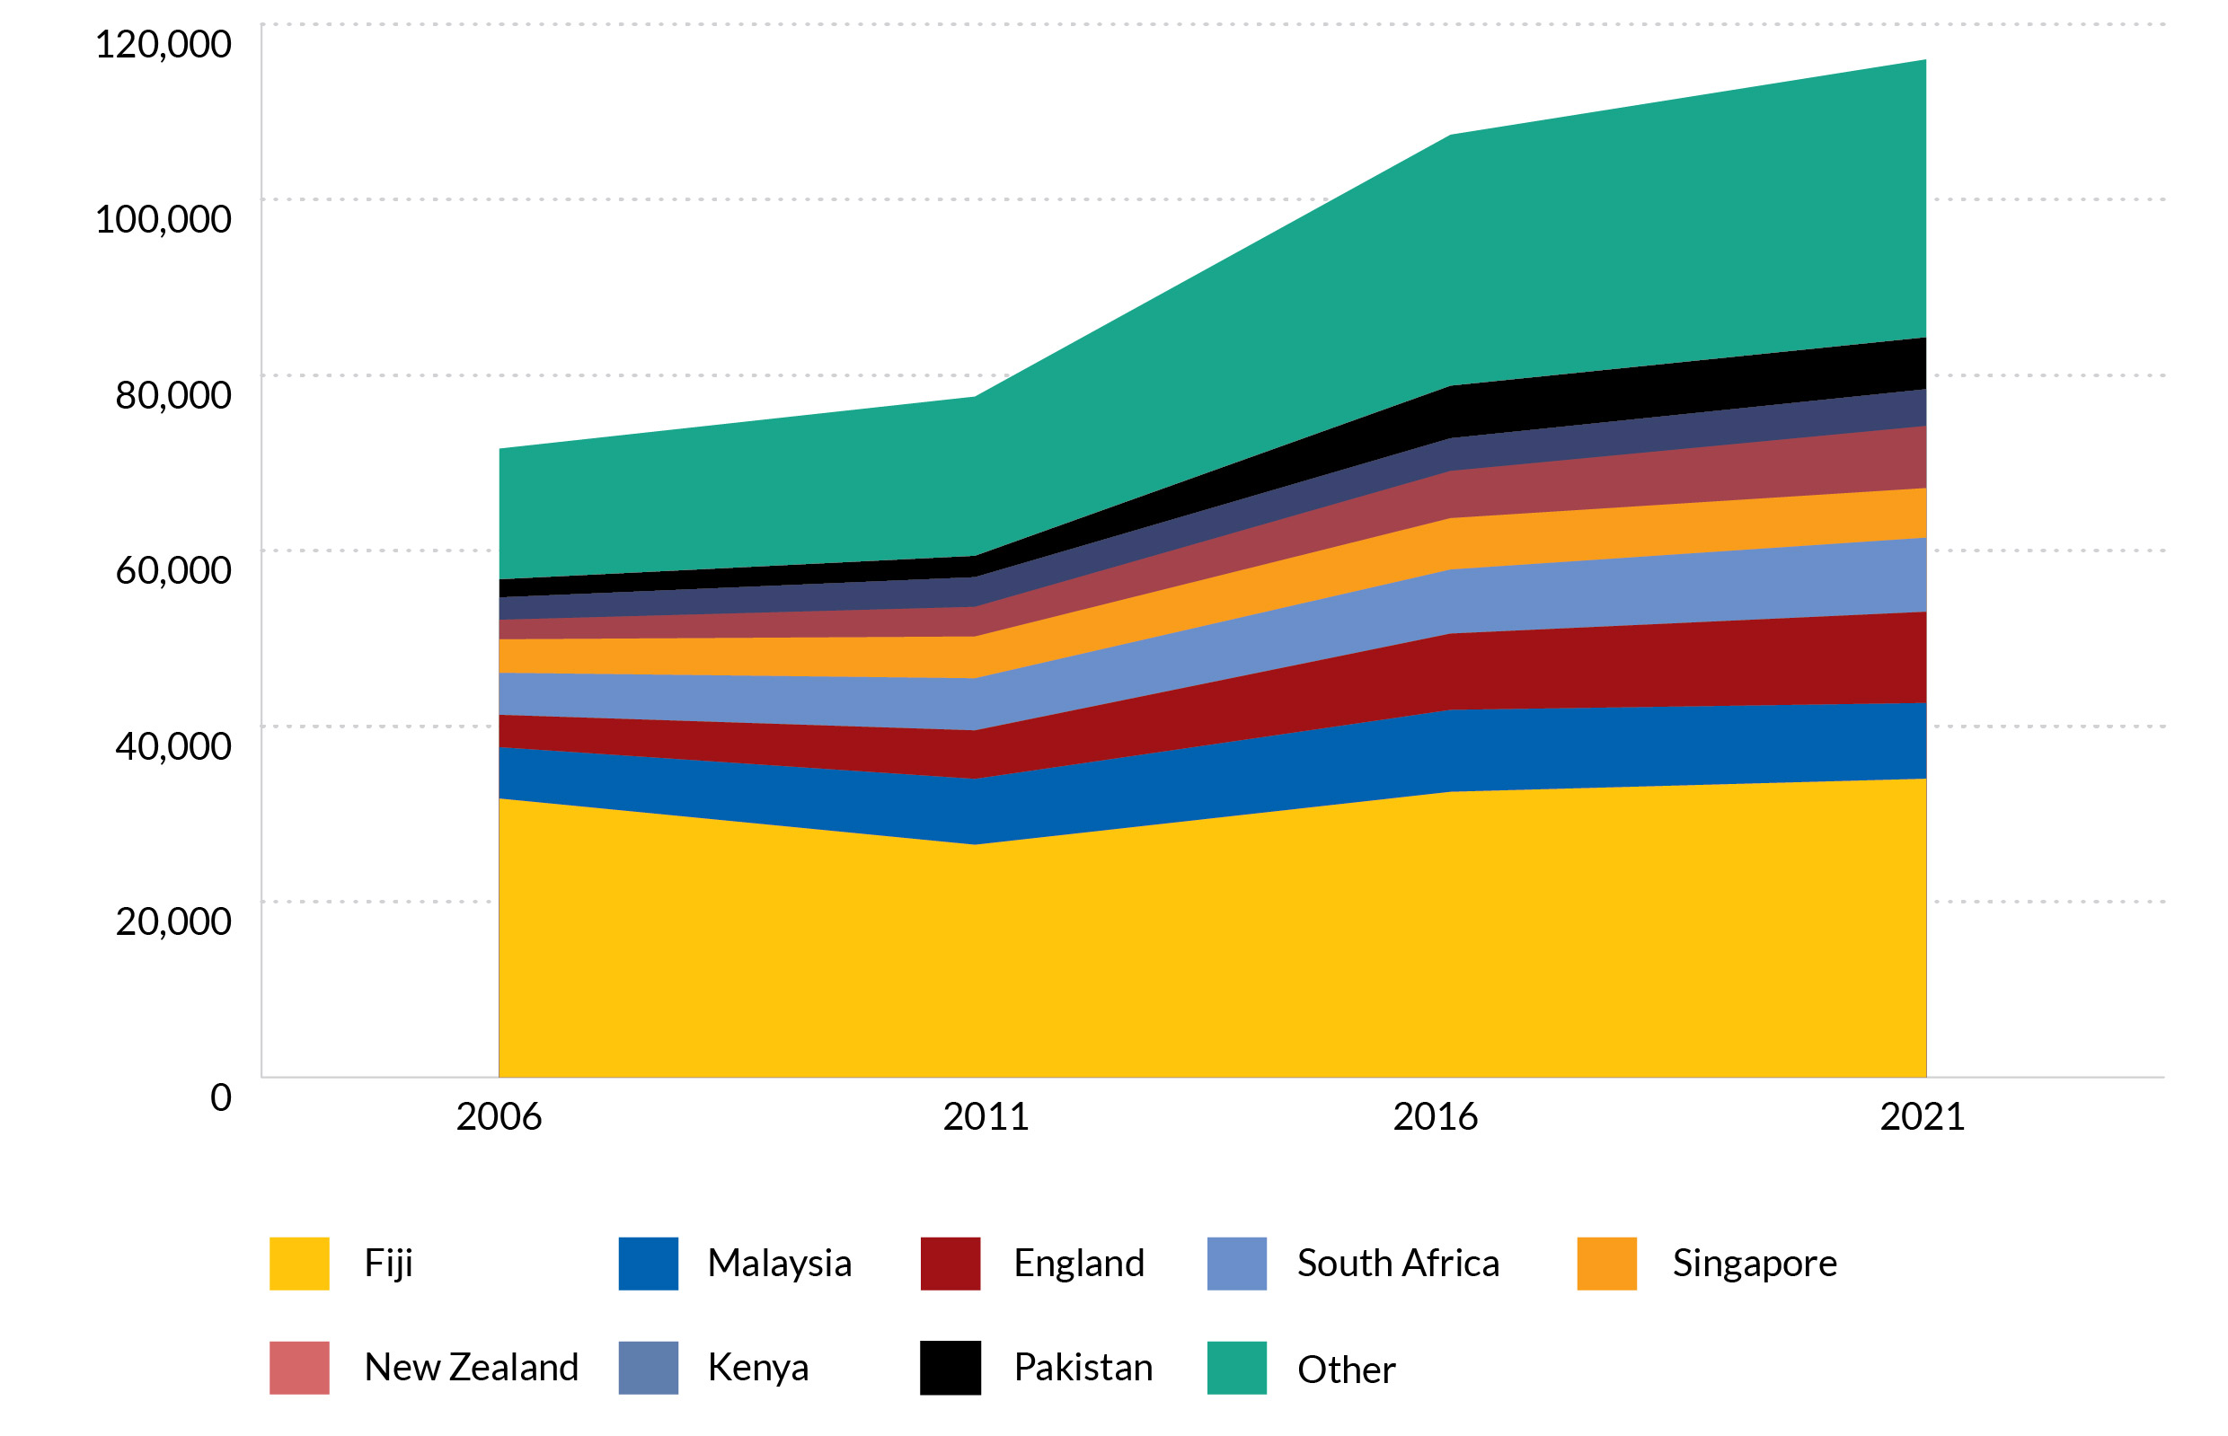
Source: Australian Census of Population and Housing, unpublished data

Age structure
This population pyramid (Figure 4) shows the age structure of the total Australian population (left) and the Indian diaspora (right). It reveals a younger Indian diaspora in Australia compared with the total Australian population. The Indian-born group is concentrated in the 25-44 age range, reflecting the dominance of student and skilled migration to Australia. The second-generation (Australian-born children of Indian ancestry) is significantly younger (0-14 years), reflecting recent fertility and signalling future growth of the diaspora over time. Secondary migrants (individuals born outside both India and Australia but with Indian ancestry) are more evenly spread across ages, with concentrations in the 35-44 range. This more uniform distribution reflects the timing of different waves of secondary migration (for example, migration from Fiji in the late 1980s).

- Population pyramid showing the age structure of the Indian diaspora and Australia’s total population
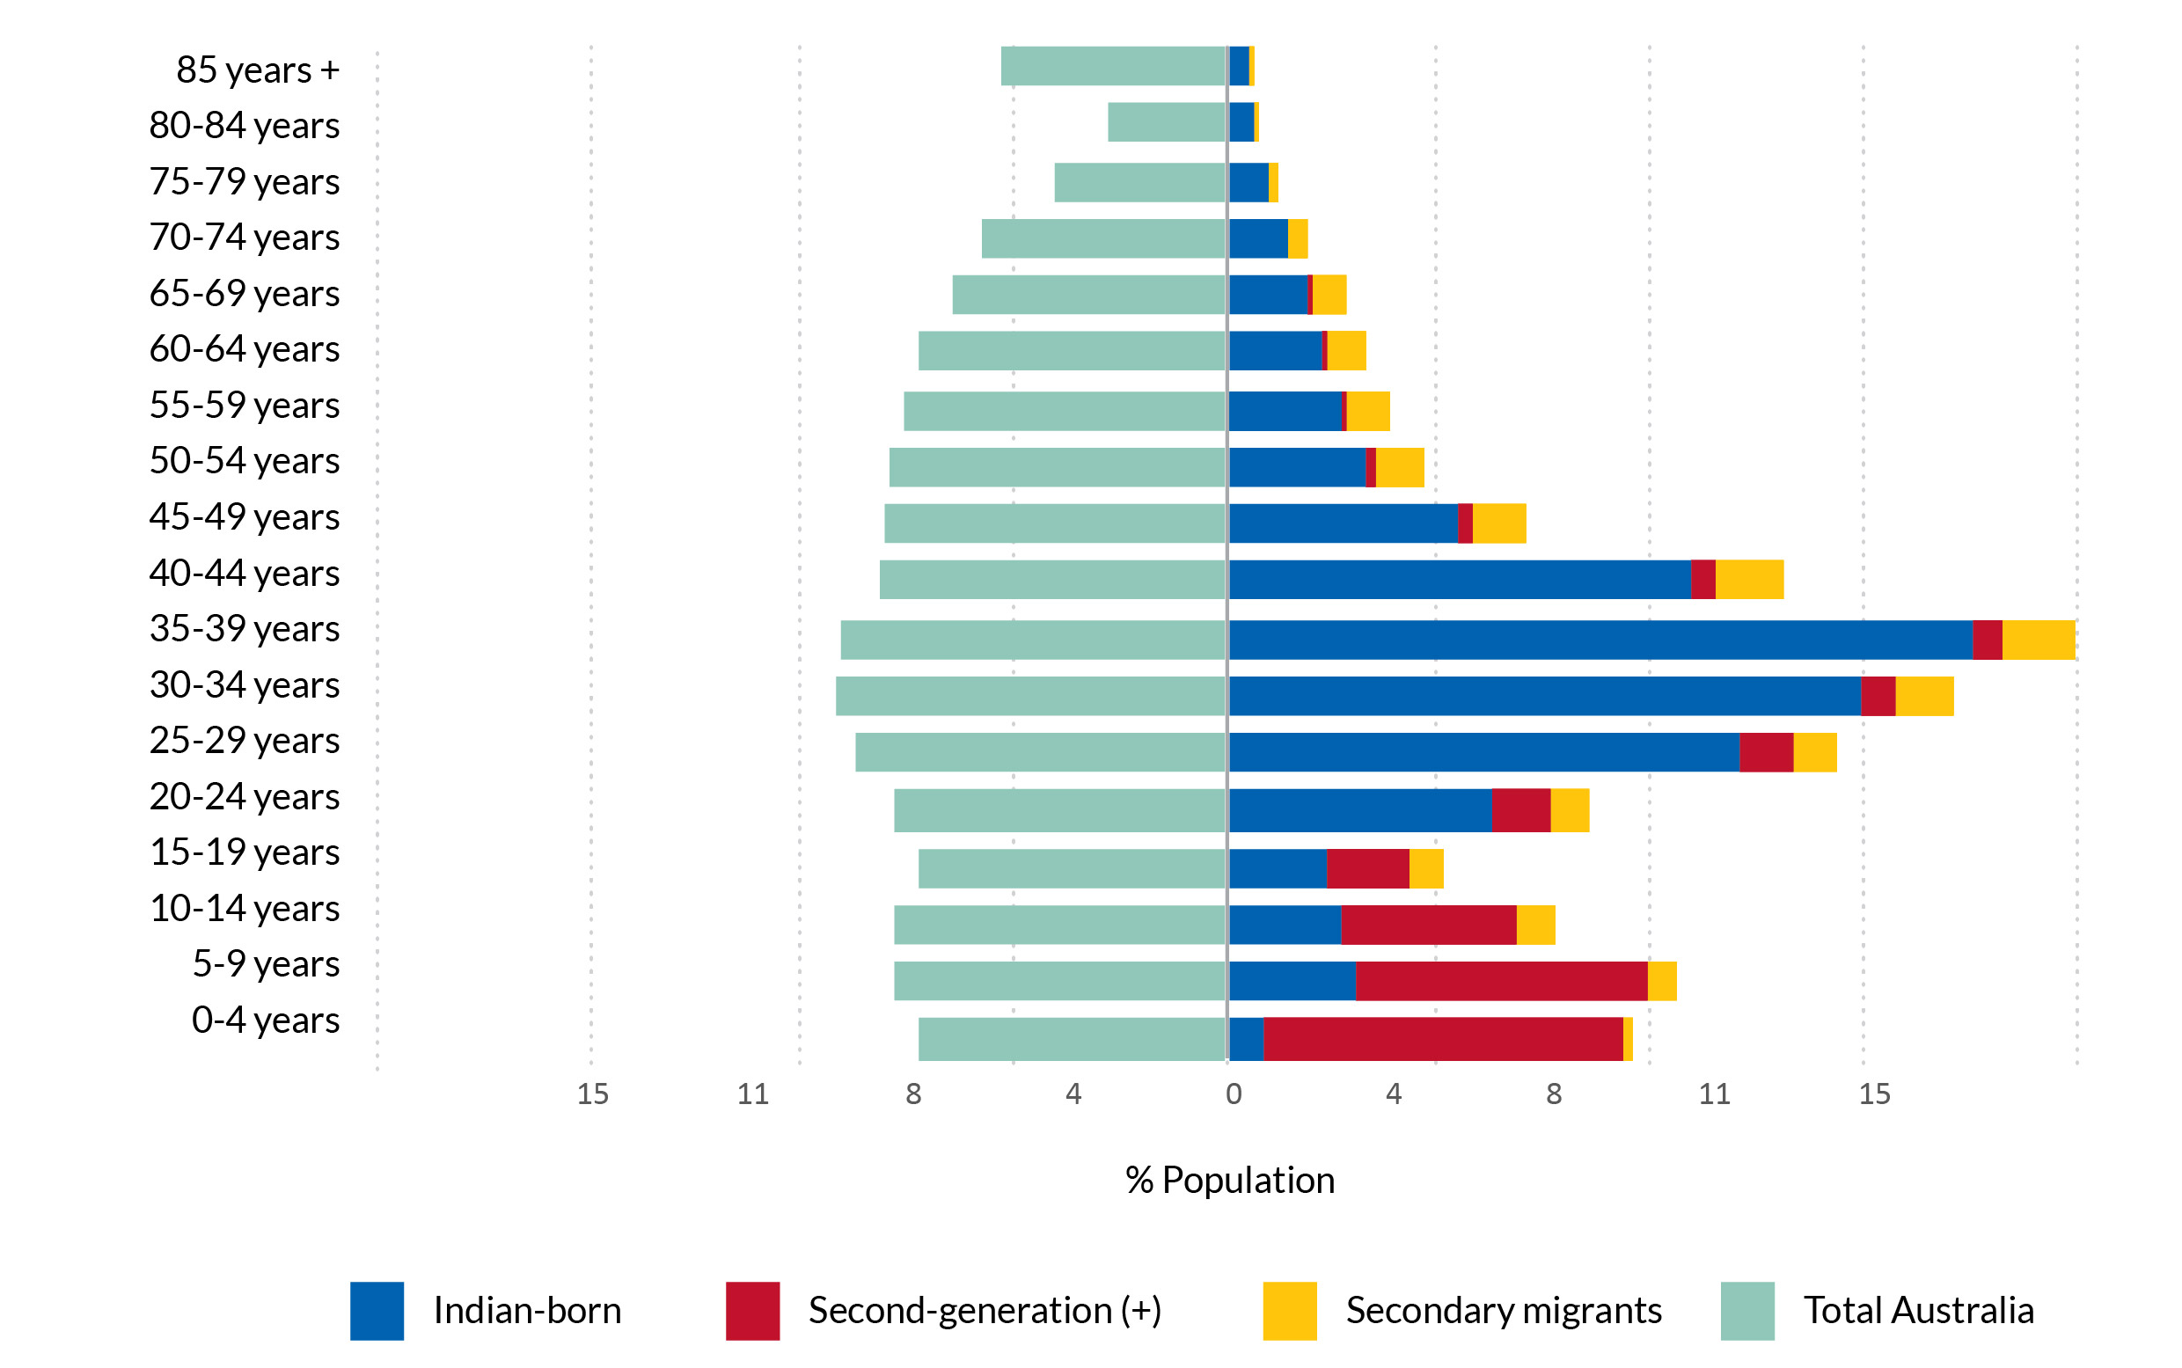
Source: Australian Census of Population and Housing, unpublished data

Cultural and linguistic diversity
There is evidence of a generational shift in language use within Australia’s Indian diaspora (Figure 5). Among first-generation migrants in 2021, Punjabi (27 per cent) and Hindi (19 per cent) are the most common languages, while English accounts for 13 per cent. In the second-generation, however, English takes the lead at 49 per cent, signalling a trend toward cultural integration among Australian-born descendants, although Hindi (12 per cent) and Punjabi (12 per cent) are still present. Secondary migrants, born outside both India and Australia, also predominantly speak English (40 per cent), but Hindi (23 per cent), Malayalam (6 per cent) and Urdu (6 per cent) are all significant reflecting diverse backgrounds.
There is also variation in religious affiliations within Australia’s Indian diaspora, influenced by generational and migration pathways (Figure 6). Among first-generation migrants, Hinduism is predominant at 52 per cent, followed by Sikhism (22 per cent) and Western Catholicism (10 per cent). Small proportions identify as Islamic (4 per cent) or having no religion (4 per cent). In the second-generation, Hinduism still leads at 40 per cent, but there is a notable rise in secularism, with 16 per cent reporting no religion. Western Catholicism (14 per cent) and Sikhism (12 per cent) are also significant. For secondary migrants, Hinduism remains strong at 40 per cent, however Islam (16 per cent) and Western Catholicism (13 per cent) are also significant reflecting differences in the origins of this component of the diaspora. No religion is reported by 12 per cent of secondary migrants.

- Linguistic diversity of first-generation, second(+) generation and secondary migrants, 2021
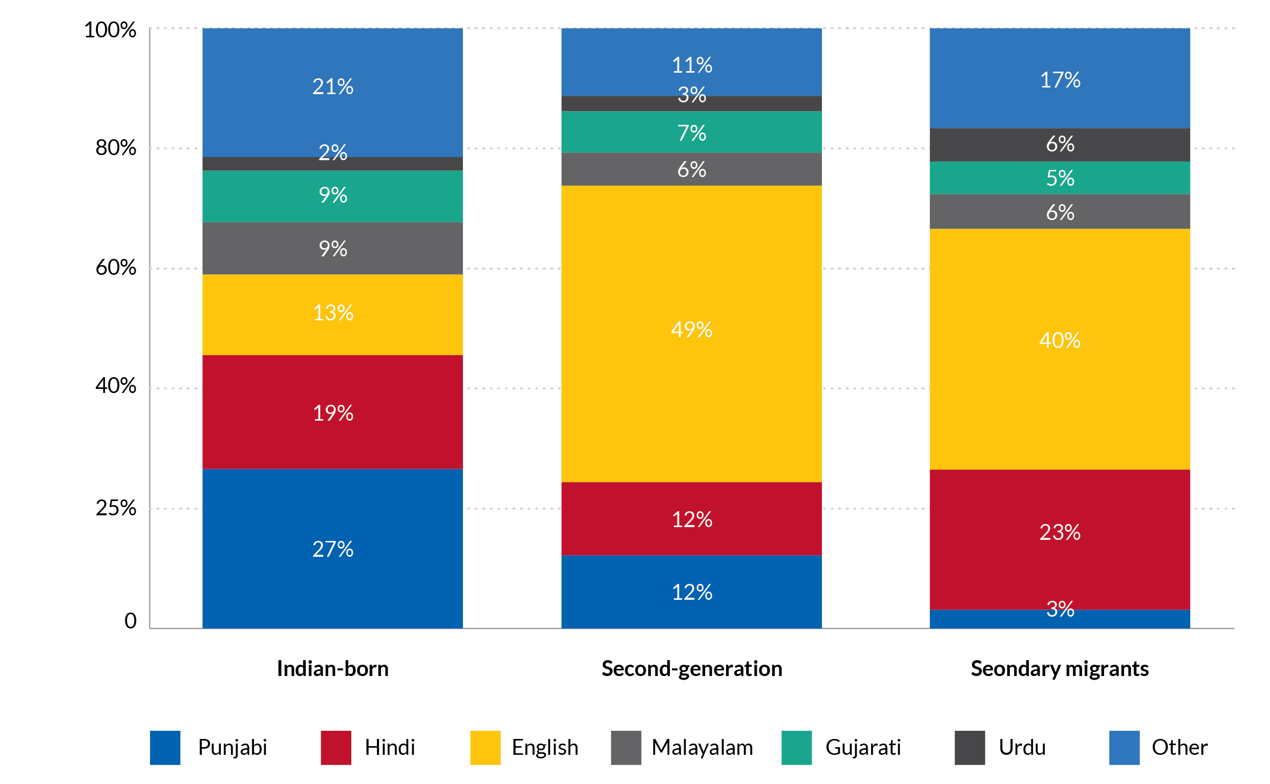
Source: Australian Census of Population and Housing, unpublished data

- Religious diversity of first-generation, second (+) generation and secondary migrants, 2021
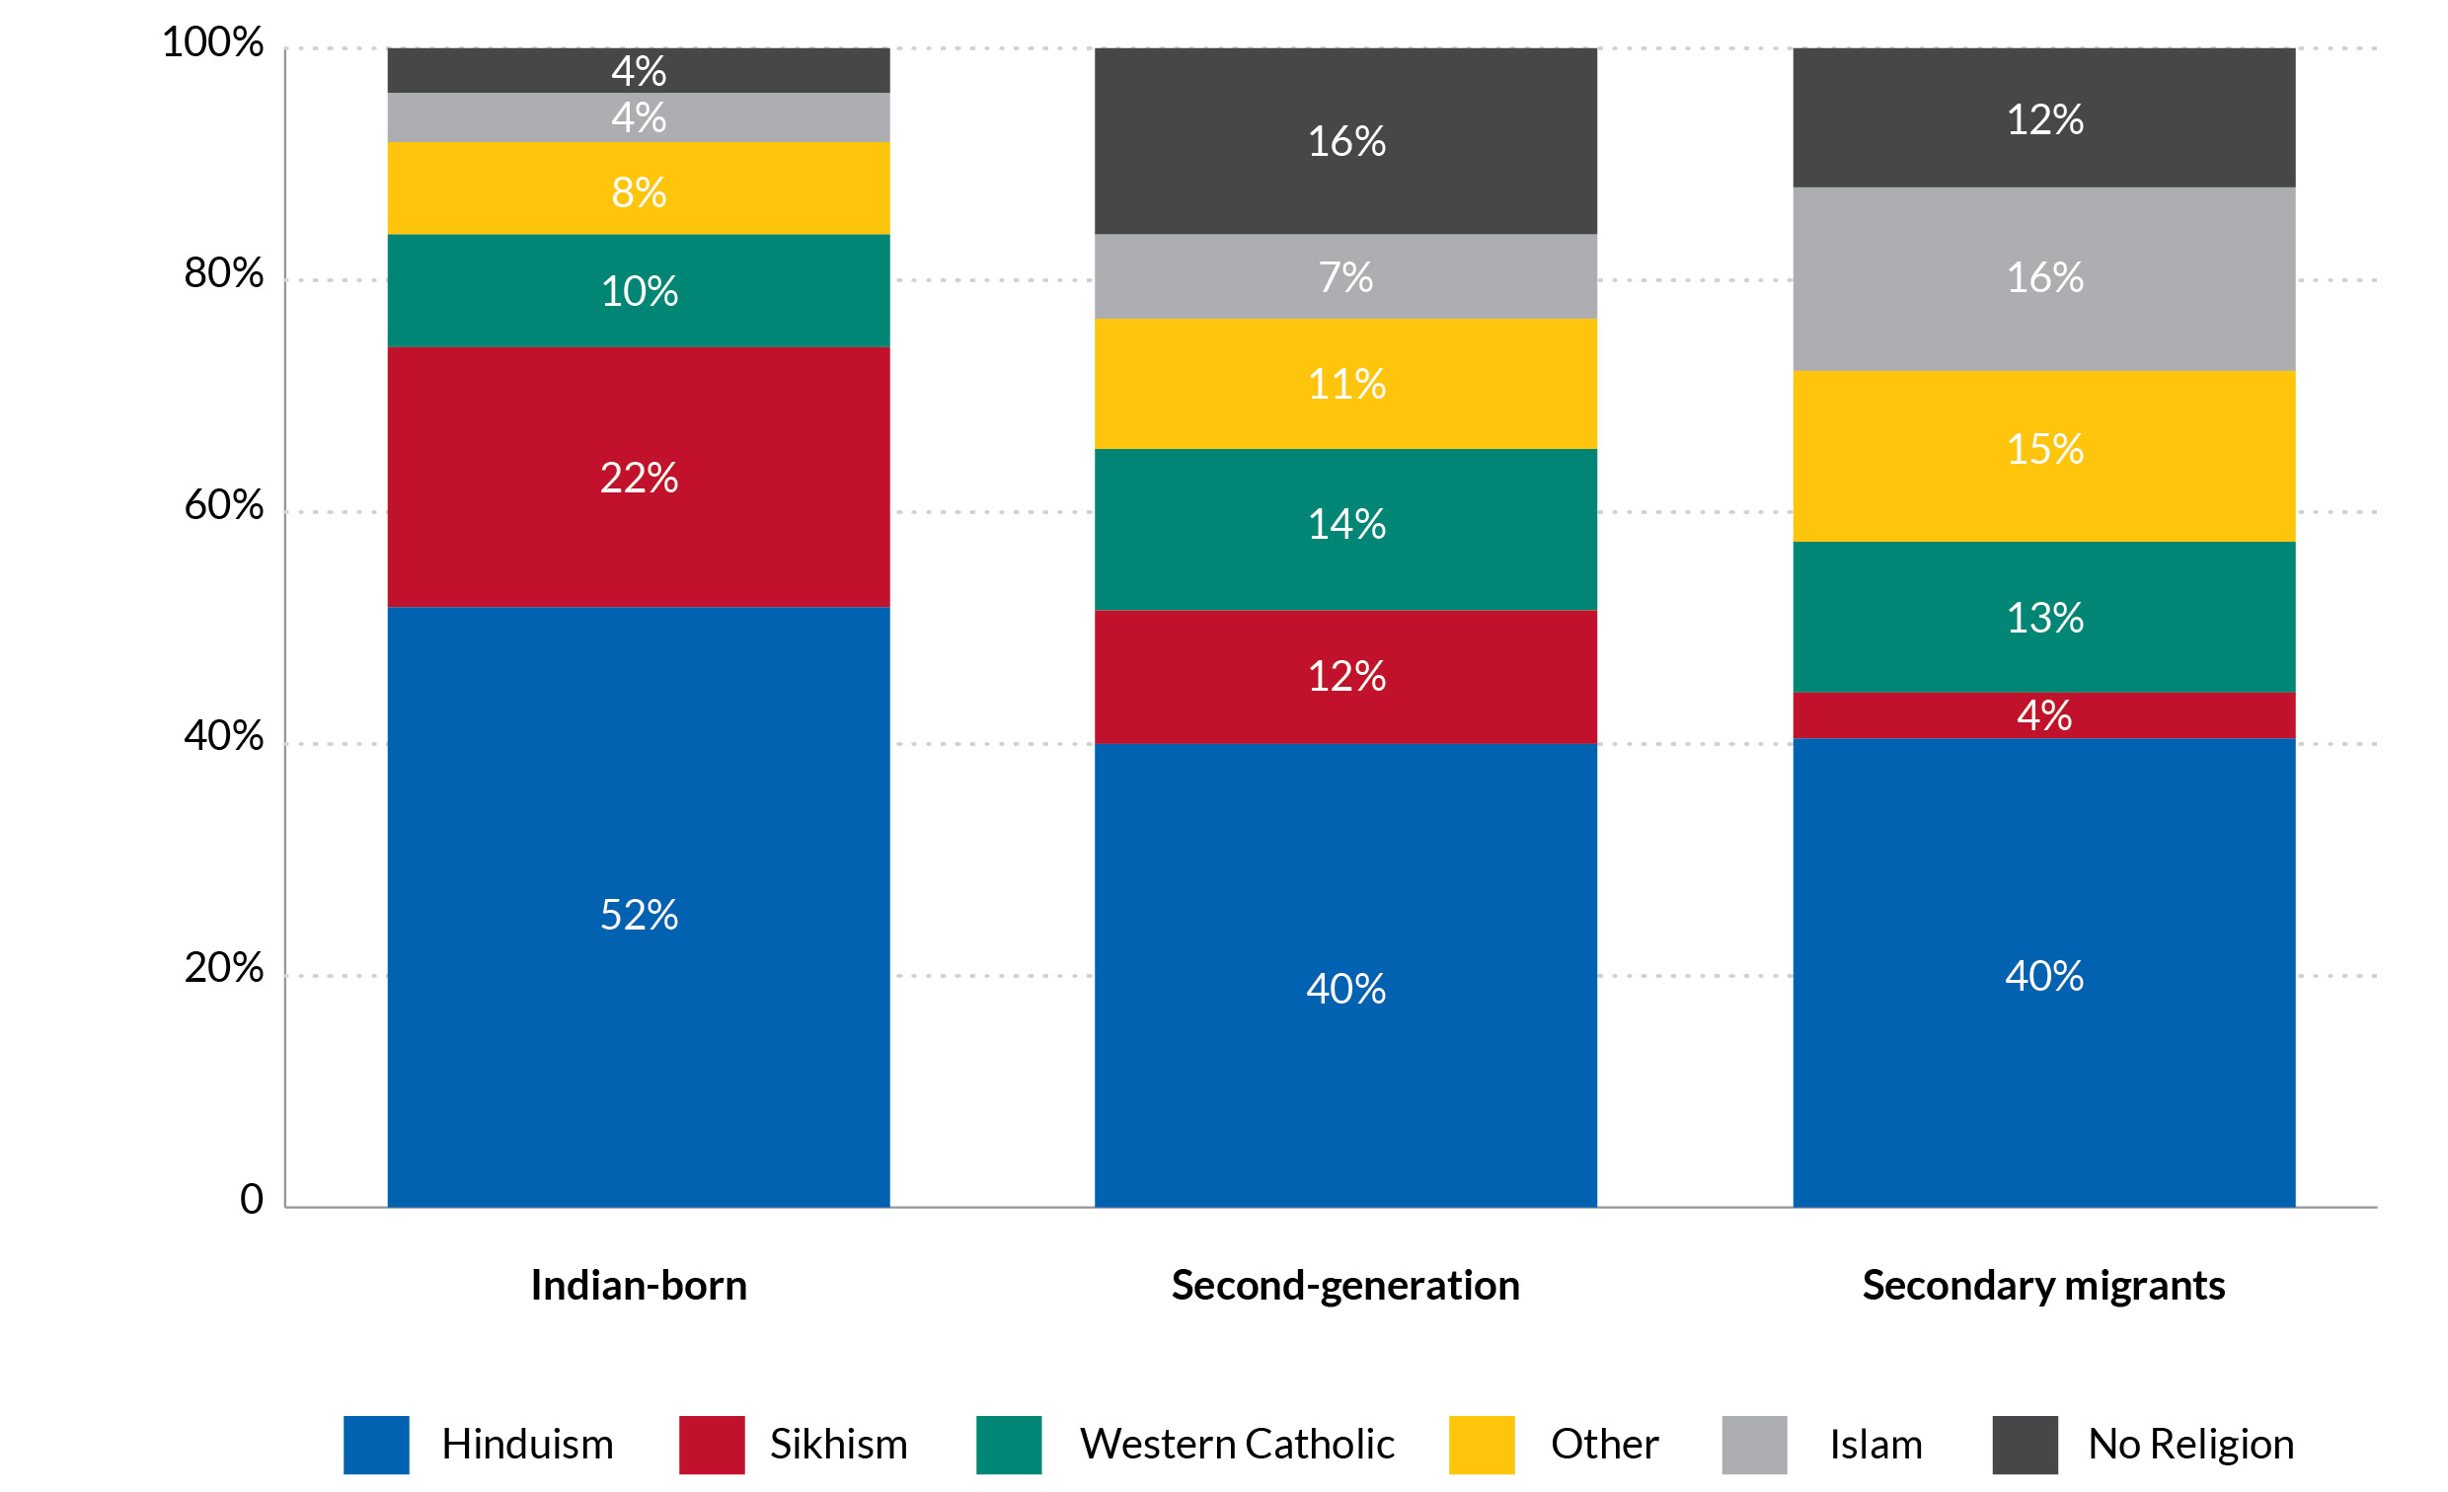
Source: Australian Census of Population and Housing, unpublished data

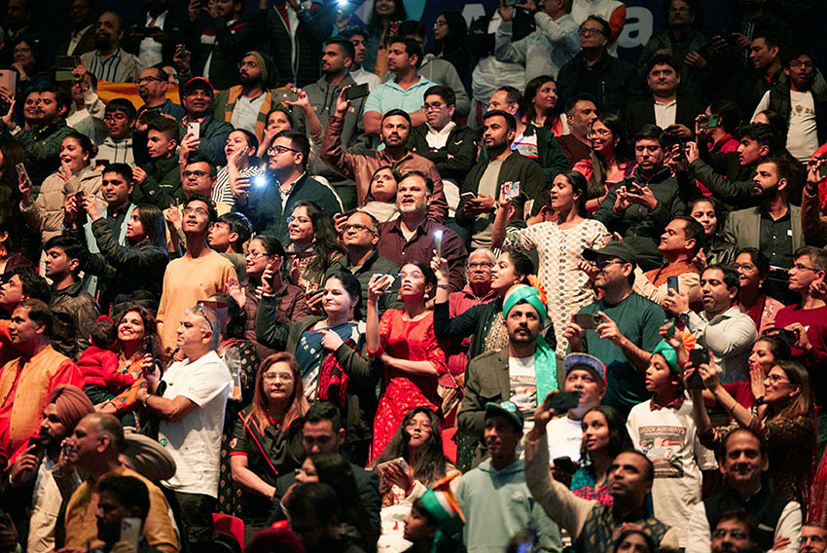
Attendees at the His Excellency Shri Narendra Modi reception in Sydney

Education and earnings
A key feature of the Indian diasporic population in Australia is the high level of educational attainment. More than two-thirds (68 per cent) of Indian-born migrants holding a bachelor’s degree or higher qualification according to the 2021 Census (Figure 7). Notably, 31 per cent of this group hold postgraduate degrees, reflecting Australia’s policy focus on skilled migration intake. Less than 1 per cent of Indian-born migrants lack formal education.
Secondary migrants display more diverse educational backgrounds compared to Indian-born migrants. However, their educational profile still compares favourably with other migrant groups and Australian-born individuals. More than half (51 per cent) of secondary migrants hold a bachelor’s degree or higher, with 15 per cent holding a postgraduate degree. This contrasts with the 39 per cent of all migrants and 36 per cent of Australian-born residents holding a bachelor’s degree or higher.
According to data from the 2021 Census, Indian-born migrants have the highest proportion of top-income earners (18.2 per cent) compared to Australian-born individuals (15.9 per cent), and the lowest share in the bottom income category (17.7 per cent versus 23.2 per cent). However, when socio-demographic and locational factors are considered, these differences shift significantly (Annex 1).
At the upper end of the income distribution, the advantage narrows, with 14.7 per cent of Indian-born migrants in the top bracket compared to 15.8 per cent of Australian-born residents. At the lower end, the proportion of Indian-born migrants rises sharply to 28.2 per cent, compared to 23.1 per cent for the Australian-born, indicating a relative earnings disadvantage. Notably, these disparities disappear among university graduates, with both Indian-born and Australian-born residents holding a bachelor’s degree showing similar income distributions.
The Indian diaspora has both expanded and diversified over the past decades. Well-established communities of secondary migrants from countries such as Fiji are now joined by sizable diasporic populations from nations like Kenya, South Africa, and England. Furthermore, first-generation migrants now outnumber secondary migrants by a ratio of 6 to 1, up from 2 to 1 in 2006. This growing diversity is reflected in greater linguistic and religious heterogeneity within the diaspora. Despite this internal variation, members of the diaspora continue to exhibit high levels of education and a youthful age profile, attributes that significantly benefit both Australian society and its economy.

- Educational attainment, Indian-born, Secondary migrants (Indian ancestry), Overseas-born and Australian-born, 2021 Census
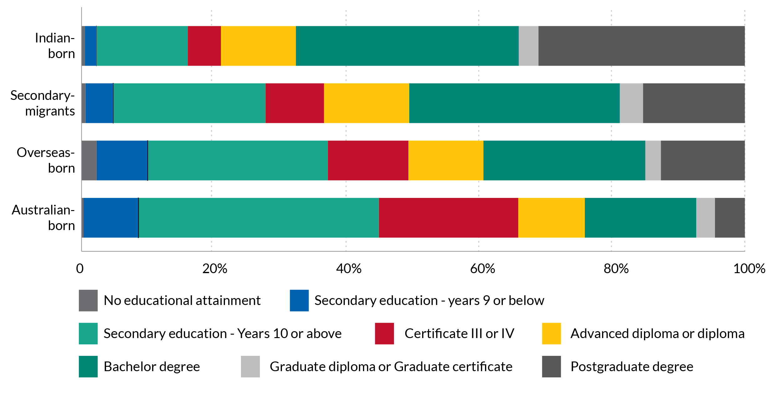
Source: Australian Census of Population and Housing, unpublished data

- Income distribution for Indian-born and Australian-born residents and graduates, 2021 Census data and regression estimates
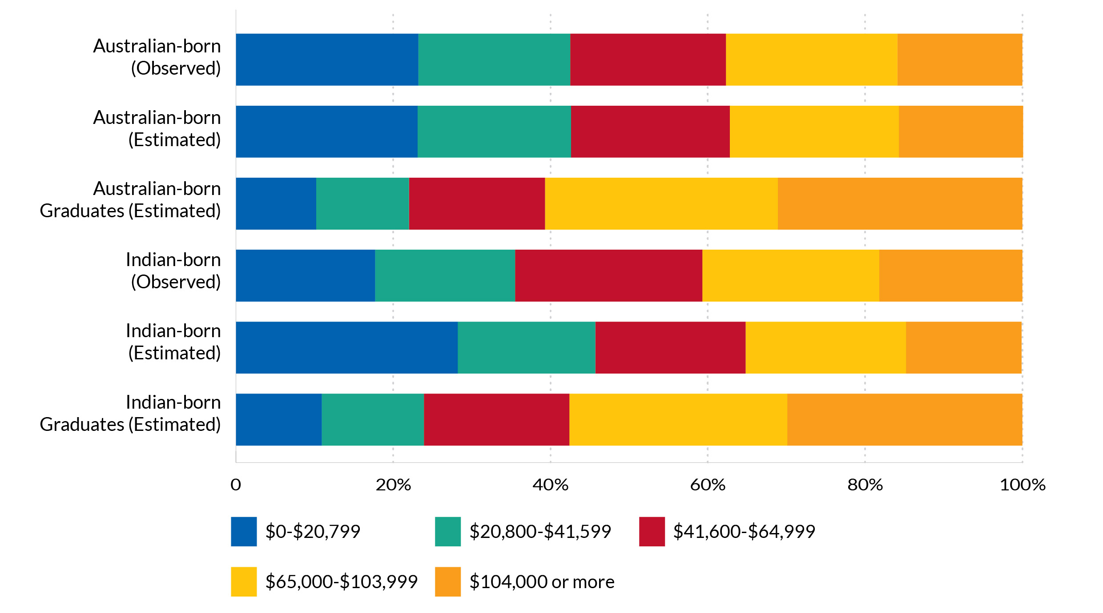

CASE STUDY
The University of Queensland – India Institute of Technology Delhi Research Academy : A Transnational Partnership
Established in 2018 as a joint venture between The University of Queensland (UQ)
and India Institute of Technology Delhi (IITD), the Academy aims to address issues pertinent to Australia and India with global impact, primarily through a joint PhD program linked with industry.
This initiative, driven by a shared vision for research excellence, fosters a long-term, mutually beneficial partnership, developing a substantial transnational research program. The concept originated from the relationship between IITD’s former Director, Professor Ramgopal Rao, and former UQ Pro-Vice-Chancellor Professor Mohan Krishnamoorthy, an Indian diaspora member in Australia.
The joint PhD program allows students to engage in diverse research projects leveraging the strengths of both institutions, with dual supervision and a 12-month exchange.
Since its 2019 launch, the program reached 100 enrolments by 2022 and produced its first graduates in 2023. Currently, it has 119 students and 20 graduates, with up to 25 annual scholarships available.
The Academy also facilitates Strategic Industry Research Partnerships, providing funding, industry experience for PhD students, and enhanced economic engagement. Since 2023, research focuses on six key thematic areas of mutual interest: Advanced Materials and Manufacturing, Clean Energy and Sustainability, Digital Futures and AI, Healthcare and Biotechnology, Societal Transformations and Livelihoods, and Quantum Technologies.
The joint PhD program’s increasing popularity and momentum are driving further expansion of faculty collaborations, industry ties, and additional activities like staff/student mobility and research grants.

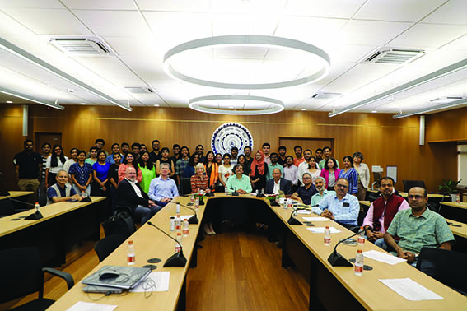
UQ Senior Executive Mission to IITD in October 2023 (with the Academy joint PhD students).
Image courtesy of The University of Queensland

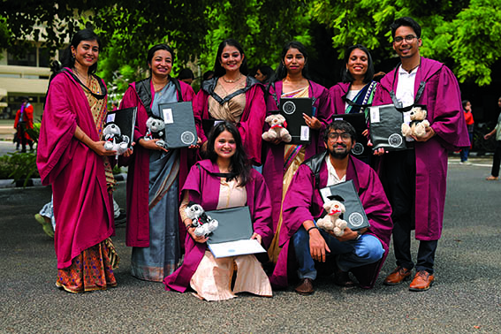
IITD Convocation Ceremony in August 2024 with PhD students.
Image courtesy of The University of Queensland

MIGRATION PATHWAYS AND TRANSITIONS

Key Findings
- International students make up 47 per cent of offshore Indian arrivals higher than the share from other source countries.
- Indian students have the highest retention rates, with 77 per cent still in Australia after seven years, compared to 53 per cent of all students.
- More migrants, including Indians, are staying on temporary visas longer.
- Australia’s 2023 Migration Strategy aims to address long-term visa uncertainty and improve pathways to permanent residency.

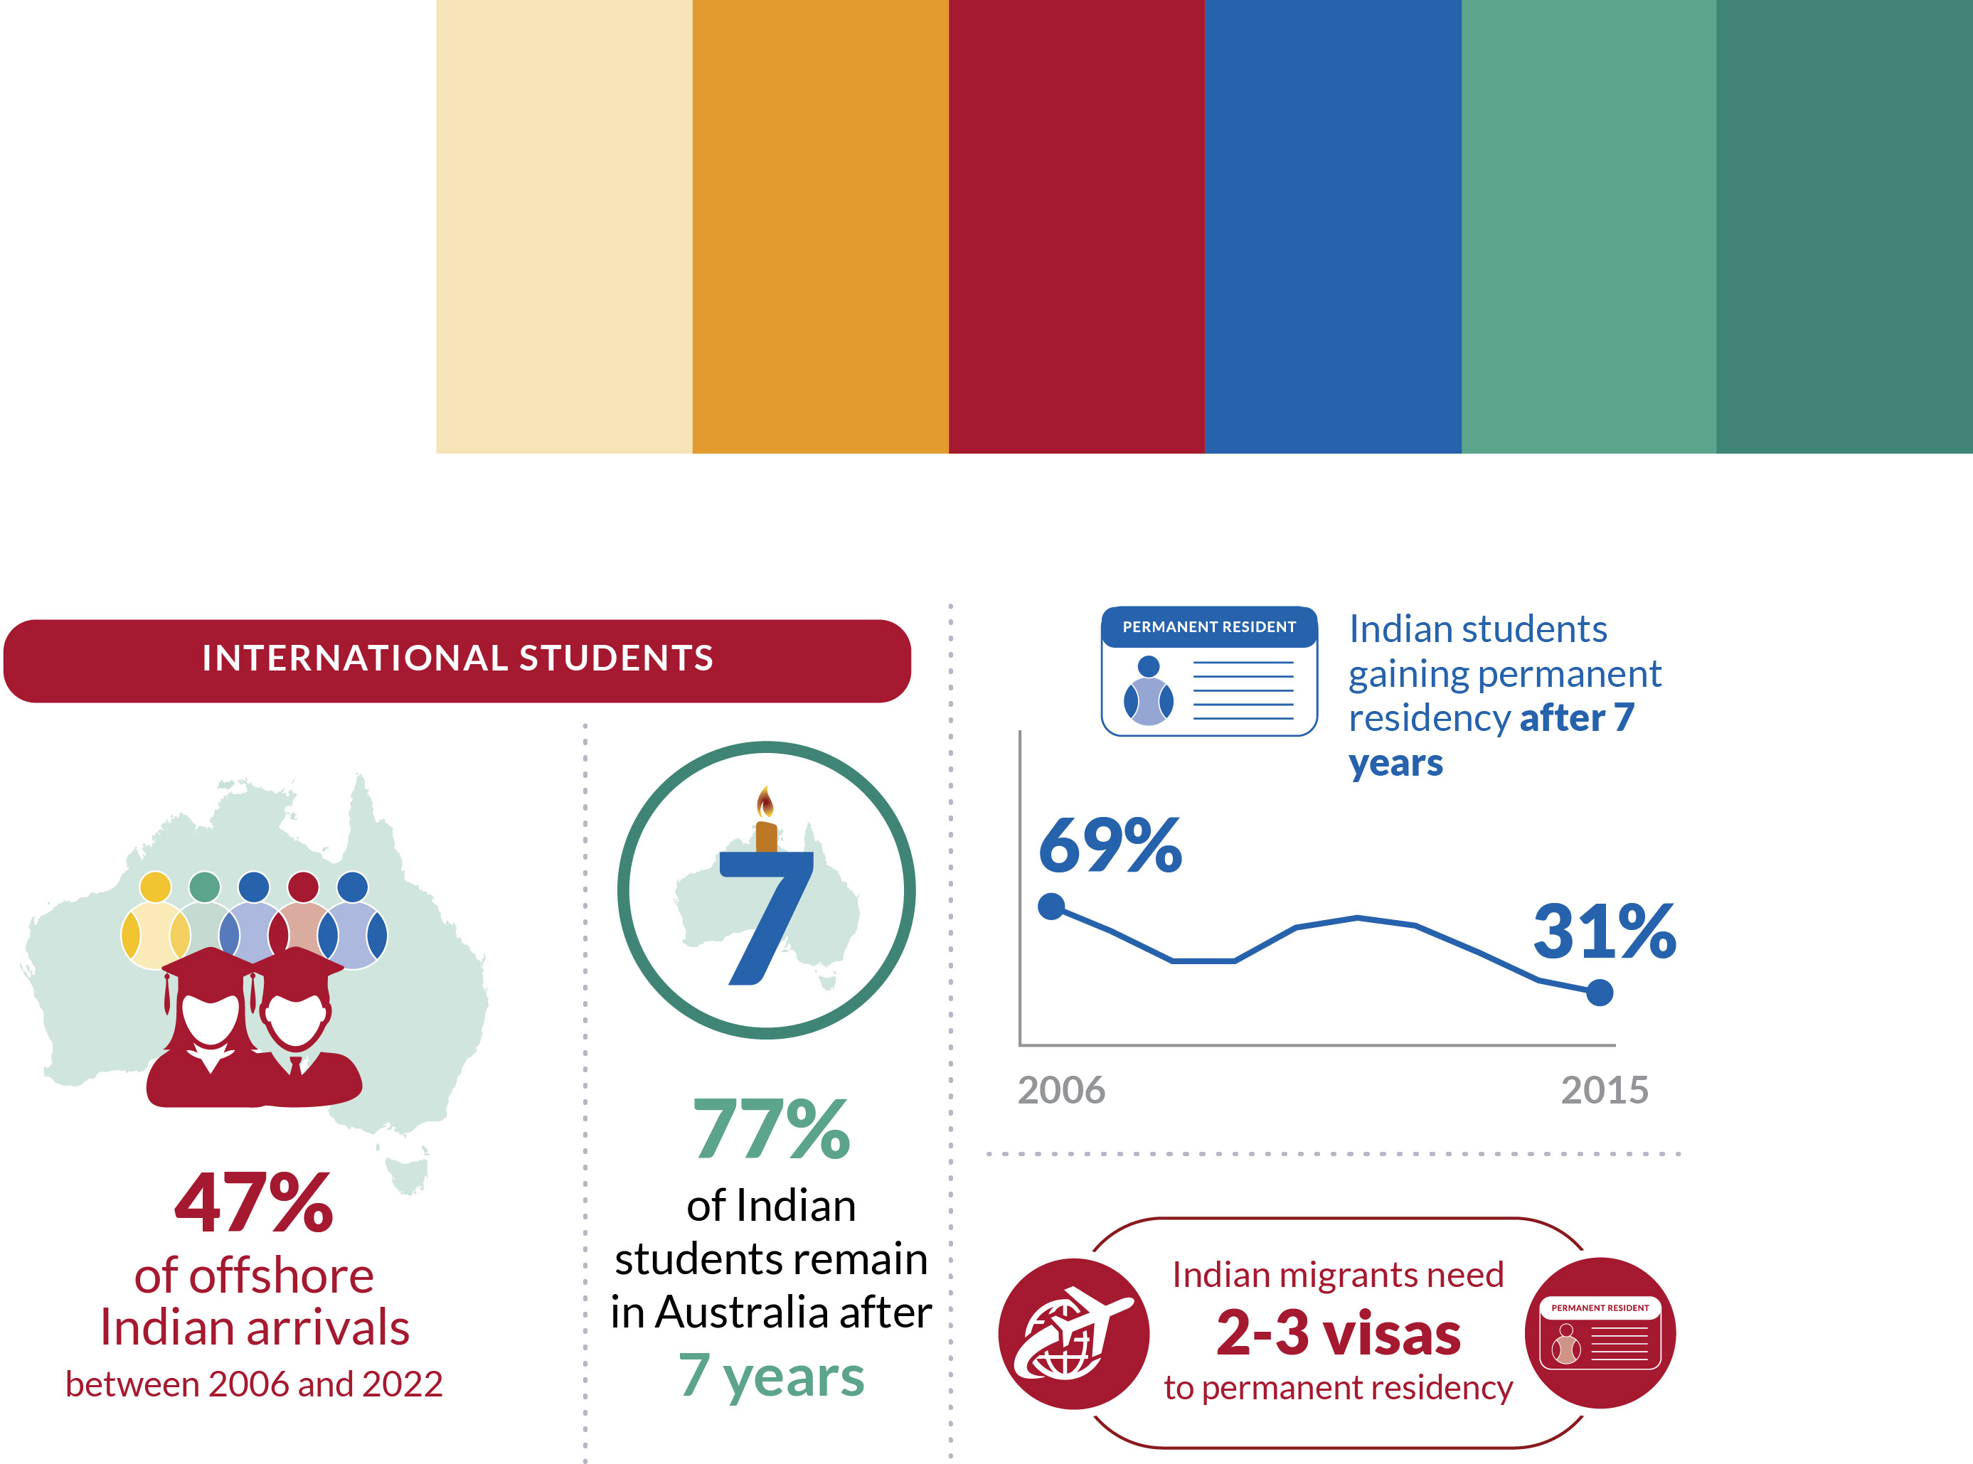

The growth of the Australian Indian diaspora over the past decade reflects broader trends in the global Indian diaspora, shifts in Australia’s migration policies, and the influence of global events such as the Global Financial Crisis and the COVID-19 pandemic. The number of offshore visas (Figure 9) granted to Indian-born migrants rose between 2006 and 2008, peaking at 60,000, before declining sharply to below 20,000 in 2010. From 2011 onward, annual intakes steadily increased, reaching a peak of nearly 92,000 in 2019. This was followed by a significant drop to 29,000 in 2020 and 20,000 in 2021, before rebounding to 84,000 in 2022. While this trend mirrors that of other migrant groups, two distinct features stand out: a steeper decline in Indian arrivals during the late 2000s and a more modest recovery following the COVID-19 pandemic.
- Number of offshore visas granted by year of arrival in thousands
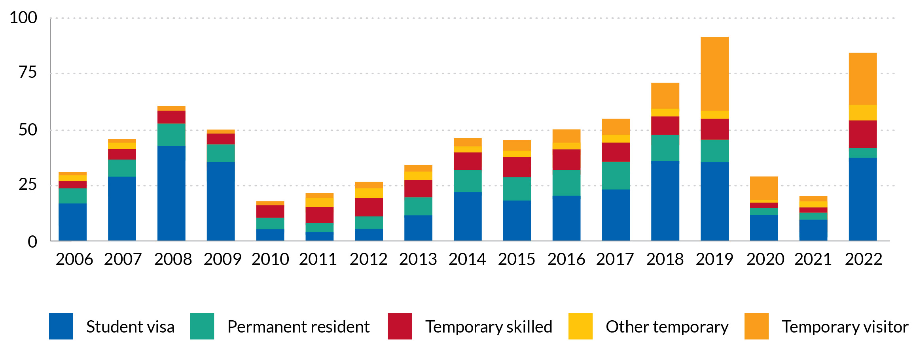
Source: Authors’ calculations from PLIDA. Only migrants who are residents, that is, stayed in Australia for at least 12 of 16 months, are included here, including for temporary visitors. All years are calendar years.

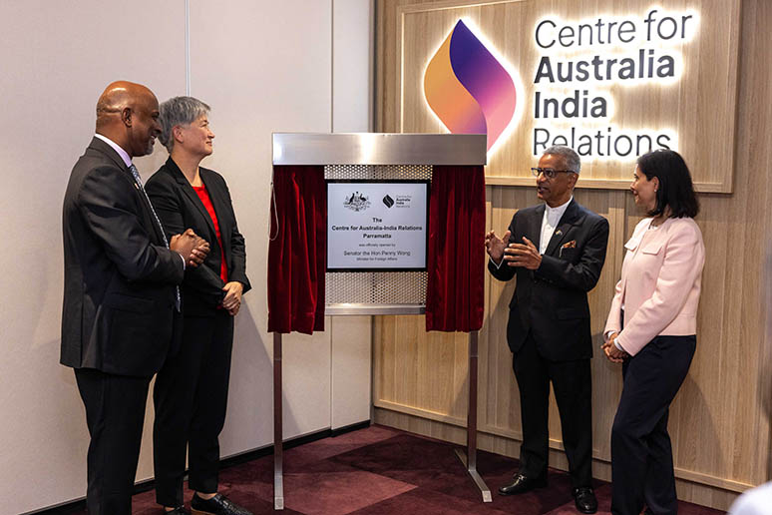
Senator the Hon Penny Wong, Minister for Foreign Affairs alongside His Excellency Gopal Baglay, High Commissioner of India to Australia, Tim Thomas, CEO for the Centre for Australia India Relations and Swati Dave, Chair for the Centre for Australia India Relations

A HISTORY OF INDIAN MIGRATION TO AUSTRALIA
Australia’s migration programs have shaped the size, composition, and distribution of the Indian diaspora, evolving significantly over time.
Indian migration began in two waves during the 19th century, with early arrivals working as labourers, domestic workers, and camel drivers (1800–1860). From 1860 to 1901, many found employment in Queensland’s plantations, goldfields, and as rural hawkers.
The Immigration Restriction Act 1901 (White Australia Policy) severely curtailed Indian migration for much of the 20th century. However, its gradual dismantling—starting with the Citizenship Act 1948 and cemented by the Racial Discrimination Act 1975—paved the way for skilled migration., The early Indian community was largely composed of highly educated professionals, including a small but significant group of Indian students, arriving as early as the 1930s, and increasing under the Colombo Plan in the 1950s, with many later settling as skilled migrants.
The mid-1990s marked a turning point, with the rise of temporary visas and international students. By 2000, temporary entrants outnumbered permanent migrants. A study-to-migration pathway enabled many Indian students to transition to permanent residency—by 2006, two-thirds stayed on. However, concerns over unscrupulous practices by some Indian Vocational Education and Training (VET) providers led to policy reviews, tightening rules around study-migration incentives and temporary visa protections.
VET commencements declined between 2010 and 2013 but rebounded from 2018 onward. Meanwhile, higher education commencements began rising in 2013, peaked in 2019, and quickly recovered after COVID-19, hitting 50,000 in 2023.
As of the 2021 Census, one-third of Indian migrants in Australia (193,177) were on temporary visas—highlighting the continuing evolution of Australia’s Indian diaspora.
Australia’s evolving migration policies, shaped by globalisation, have not only fuelled the growth of the Indian diaspora but also reshaped migration pathways. The Migration Strategy, released on 11 December 2023, sets out a comprehensive vision for the nation’s migration system, featuring a policy roadmap with eight key actions and over 25 new policy commitments and reforms.
- Indian-born international student commencements, VET and Higher Education 2005-2023
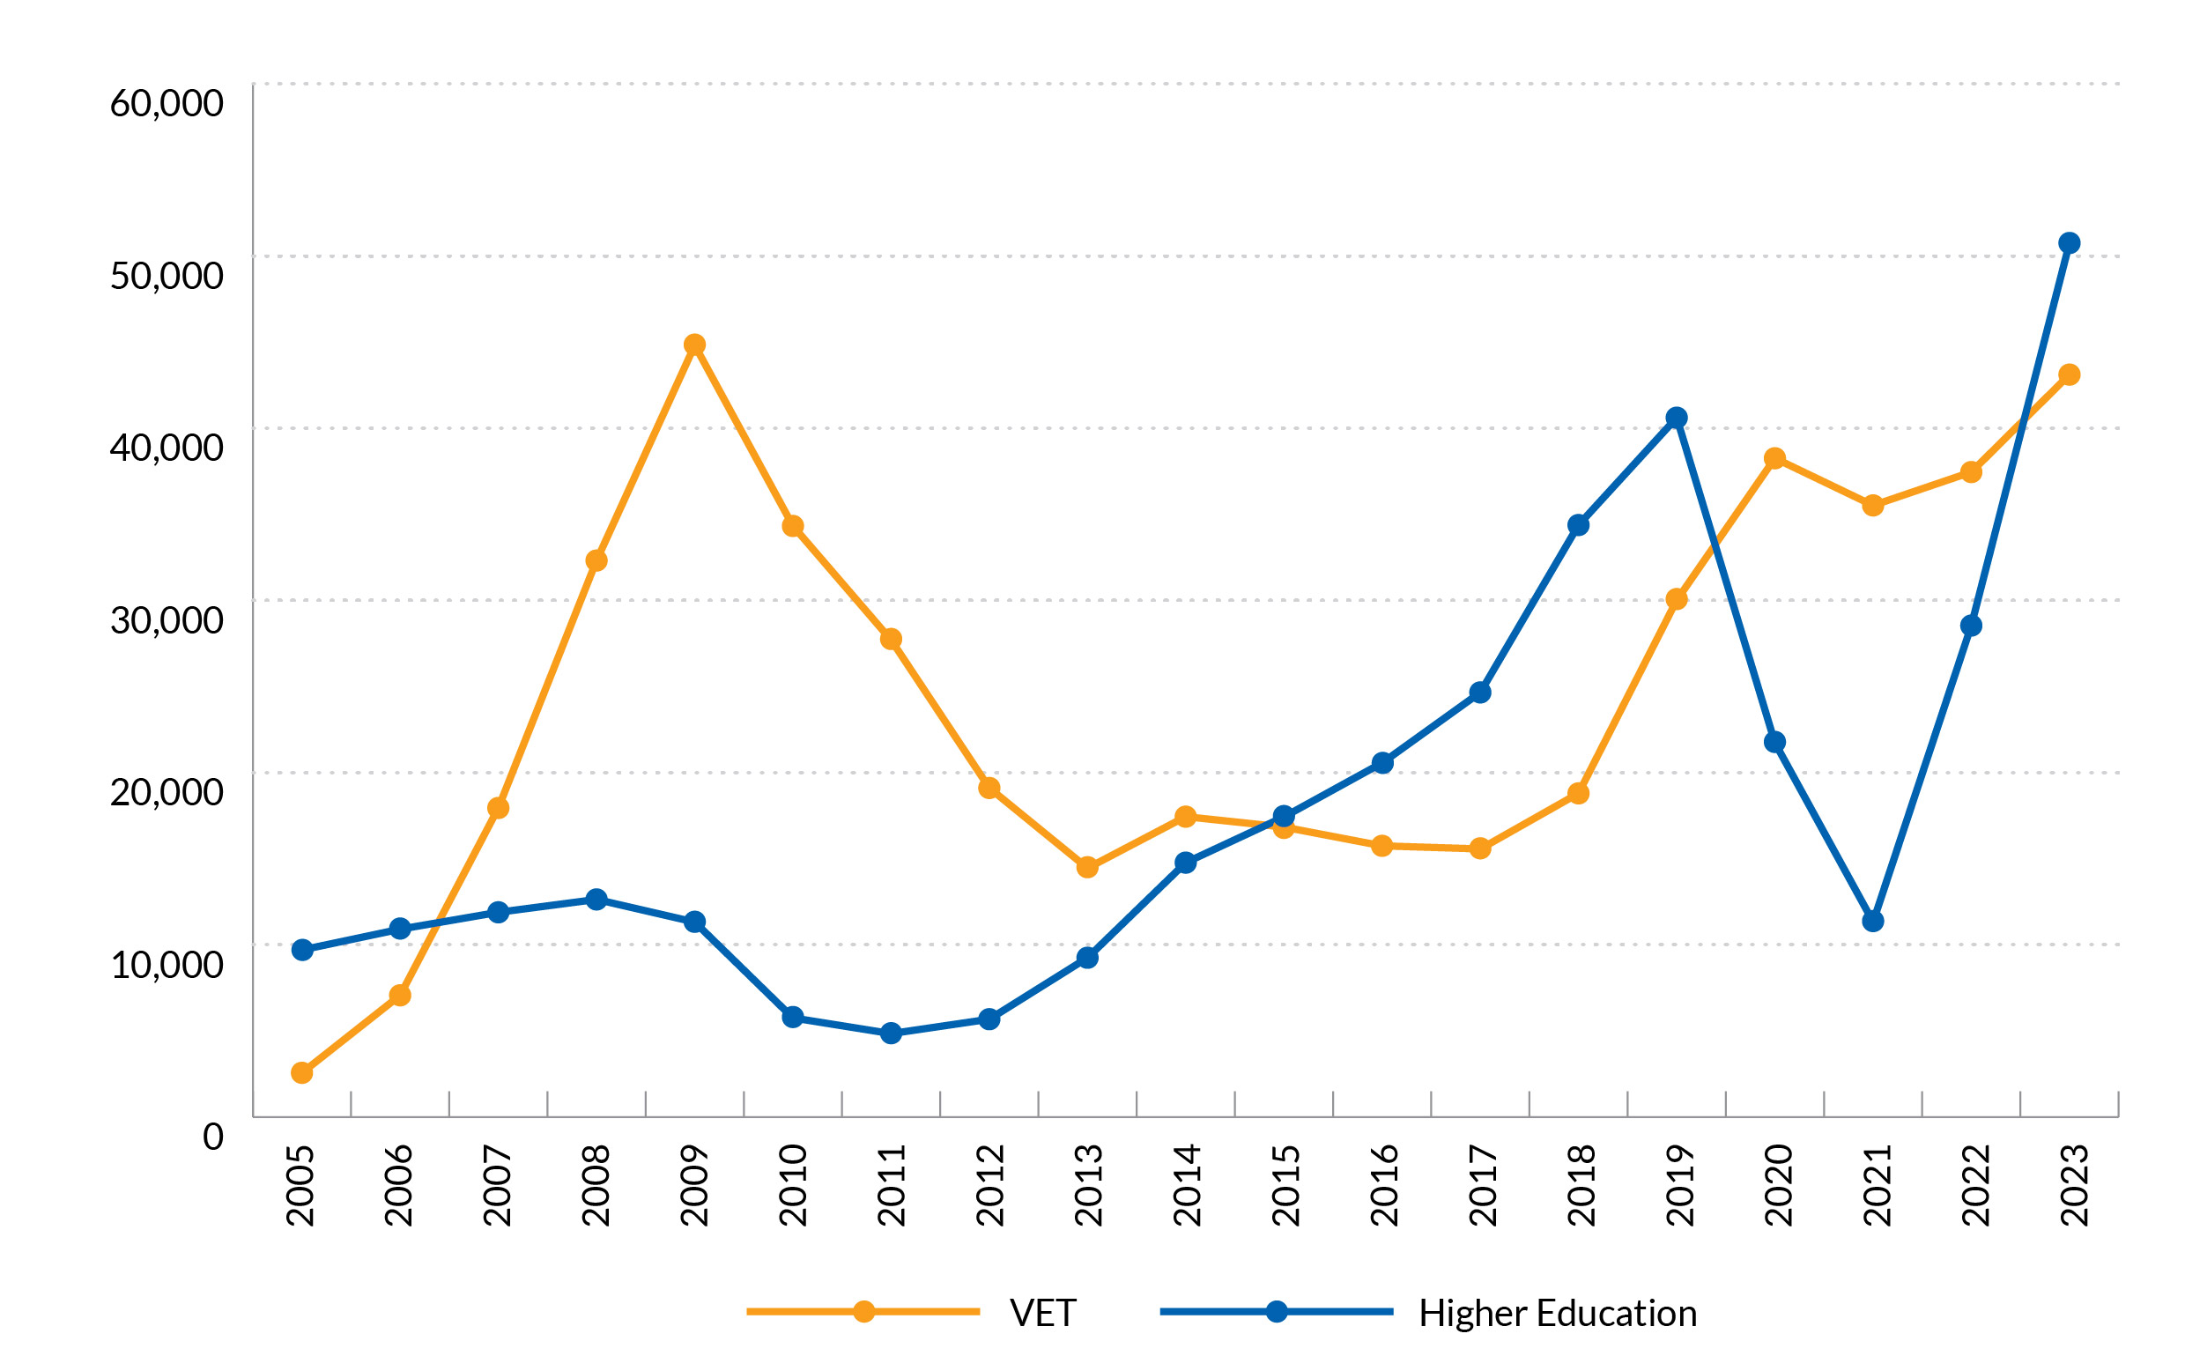
Source: PRISMs data

International students
International students have been the primary driver of growth within the Indian diaspora, accounting for nearly 50 per cent of arrivals from India between 2006 and 2022. While this proportion is lower than that for China (62 per cent), the second most common country of origin among net overseas migrants, it is significantly higher than the average for all migrant groups combined (33 per cent). In contrast, the share of migrants arriving on permanent visas has been considerably smaller, averaging just 16 per cent over the same period. In 2022, the most recent year for which data are available, only 5 per cent of offshore visas granted to Indian-born migrants were permanent. As a result, many recent members of the diaspora did not hold permanent residency at the time of their arrival.
The ability to transition from temporary to permanent residence is a key feature of Australia’s migration system, facilitated by a range of onshore visa classes than enable temporary migrants to transition to permanency over time. This pathway is well used by members of the Indian diaspora in Australia (Figure 11). Tracking visa pathways for temporary visa holders of Indian origin who arrived between 2006 and 2015 reveals that close to 77 per cent of Indian migrants who entered on a student visa are still in Australia (on either a temporary or permanent visa) after seven years compared with 45 per cent of students from China and 53 per cent of all international students. Over 50 per cent of Indian students arriving during this period acquired permanent residency within seven years compared with just 30 per cent of all international students. Among temporary skilled visa holders, Indian migrants display a slightly higher seven-year transition rate to permanent residence than migrants from elsewhere, with 69 per cent Indian migrants who arrived between 2006 and 2015 acquiring permanent residence.

- First temporary visa and visa type seven years later, 2006 to 2015 arrival cohorts from India
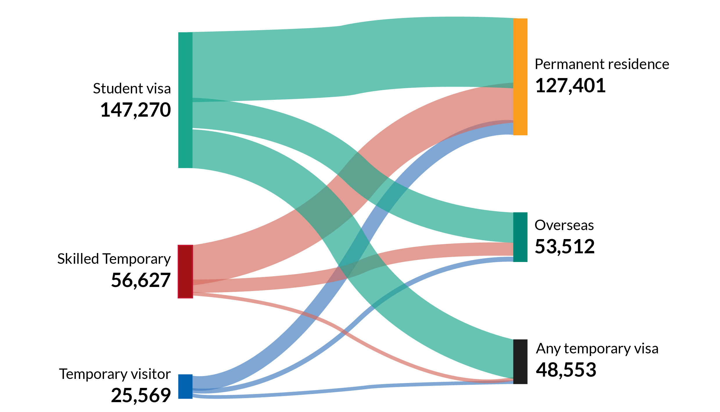

Source: Authors’ calculations from PLIDA. Temporary migrant who arrived between 2006 and 2015 are followed for seven years after arrival. Individuals who passed away during this period account for less than 0.5 per cent and are removed for the analysis.

This is the result of both fewer Indian nationals leaving Australia compared to other migrant groups and a slightly lower share of Indian migrants remaining on a temporary visa.
Migration program planning levels are determined by the Minister each year, and are the main determinant of permanent visa grant volumes. The student visa program is demand-driven, and has seen increasing volumes of student visas being granted to applicants from India. The proportion of temporary visa holders obtaining permanent residence has shifted relative to migration program planning levels, and increasing application volumes.
While the total volume of Indian students obtaining permanent residency has increased, the share of international students from India who are still in Australia on a temporary visa after seven years has also grown from 10 per cent for students arriving in 2006 to 49 per cent of those arriving in 2015. This is largely reflective of the increasing share of the international student market from India relative to the comparatively stable migration program planning levels. The Australian Government has committed to address issues with the migration system through its 2023 Migration Strategy.

- Visa status after seven years, first offshore visa and year of arrival
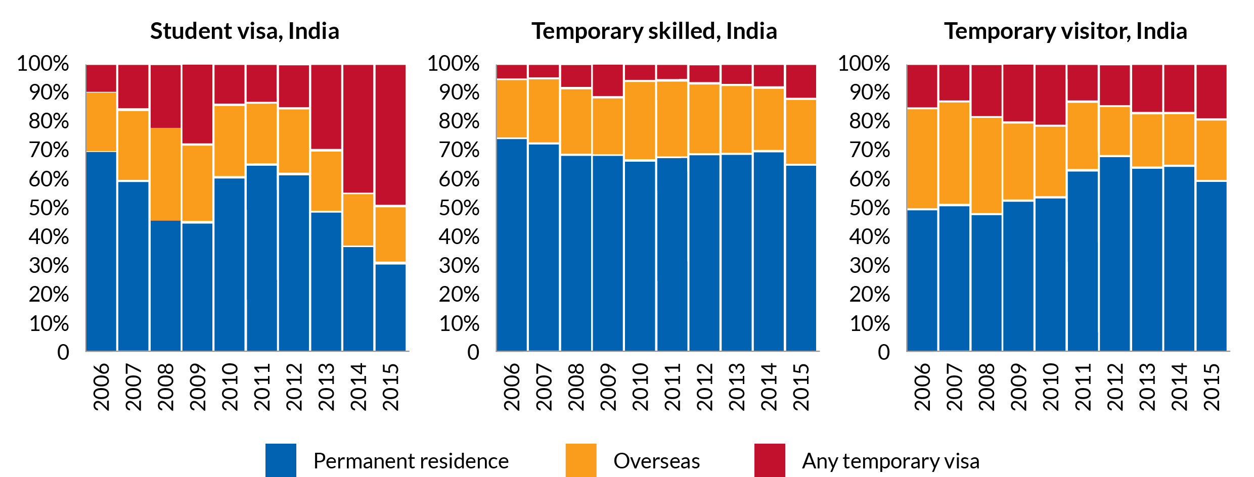
Source: Authors’ calculations from PLIDA. All arrival cohorts are followed for seven years after arrival. Individuals who passed away during this period account for less than 0.5 per cent and are removed for the analysis. All years are calendar years.

CASE STUDY
Priya’s Journey
International students from India often choose to settle in Australia after completing their studies. While they face challenges in finding jobs that match their qualifications, many adapt and contribute to the workforce and society.
Priya’s story is one example. She moved to Australia with her family on a permanent visa. At first, Priya and her family faced cultural and work-related challenges. After moving to Melbourne, they found strong support from the Indian community, which helped them adjust. Priya decided to pursue a PhD. After finishing her doctorate, she worked in sessional academic roles before securing a stable position in higher education.
Priya understands the pressures Indian students face, such as financial stress, cultural adjustment, and difficulties finding a job.
She says, “the support from friends and the community has been incredible. They have helped me navigate personal and professional challenges.” She believes that community networks and institutional support are important for successful integration.
Priya also thinks that Indian students and professionals help strengthen ties between India and Australia through cultural exchange and community involvement. She co-founded an organisation called Green Humans with fellow academics. The group organises activities in schools in India to teach students about environmental care.
Despite the challenges, Priya believes that migration to Australia can be a positive option. She says, “Australia is a beautiful country to live in. I feel like this is my home now.”


Sydney Opera House in New South Wales lit up in the Indian Flag to celebrate the 75th Anniversary of Indian Independence

Melbourne Cricket Ground in Victoria lit up in Indian colours to celebrate the 75th Anniversary of Indian Independence

Optus Stadium in Western Australia lit up in Indian colours to celebrate the 75th Anniversary of Indian Independence

THE GEOGRAPHY OF THE INDIAN DIASPORA

Key Findings
- 90 per cent of Indian-born migrants live in capital cities, mostly Melbourne (34 per cent) and Sydney (29 per cent).
- Regional Tasmania and Victoria also saw over 200 per cent growth, compared to more moderate increases in Melbourne (128 per cent), Sydney (114 per cent), and Brisbane (134 per cent).
- Very few Indian-born migrants move to remote or very remote areas, even among those on regional visas.
- Regions with diverse job opportunities and large co-ethnic communities have higher retention, while high rental costs drive migrants away.

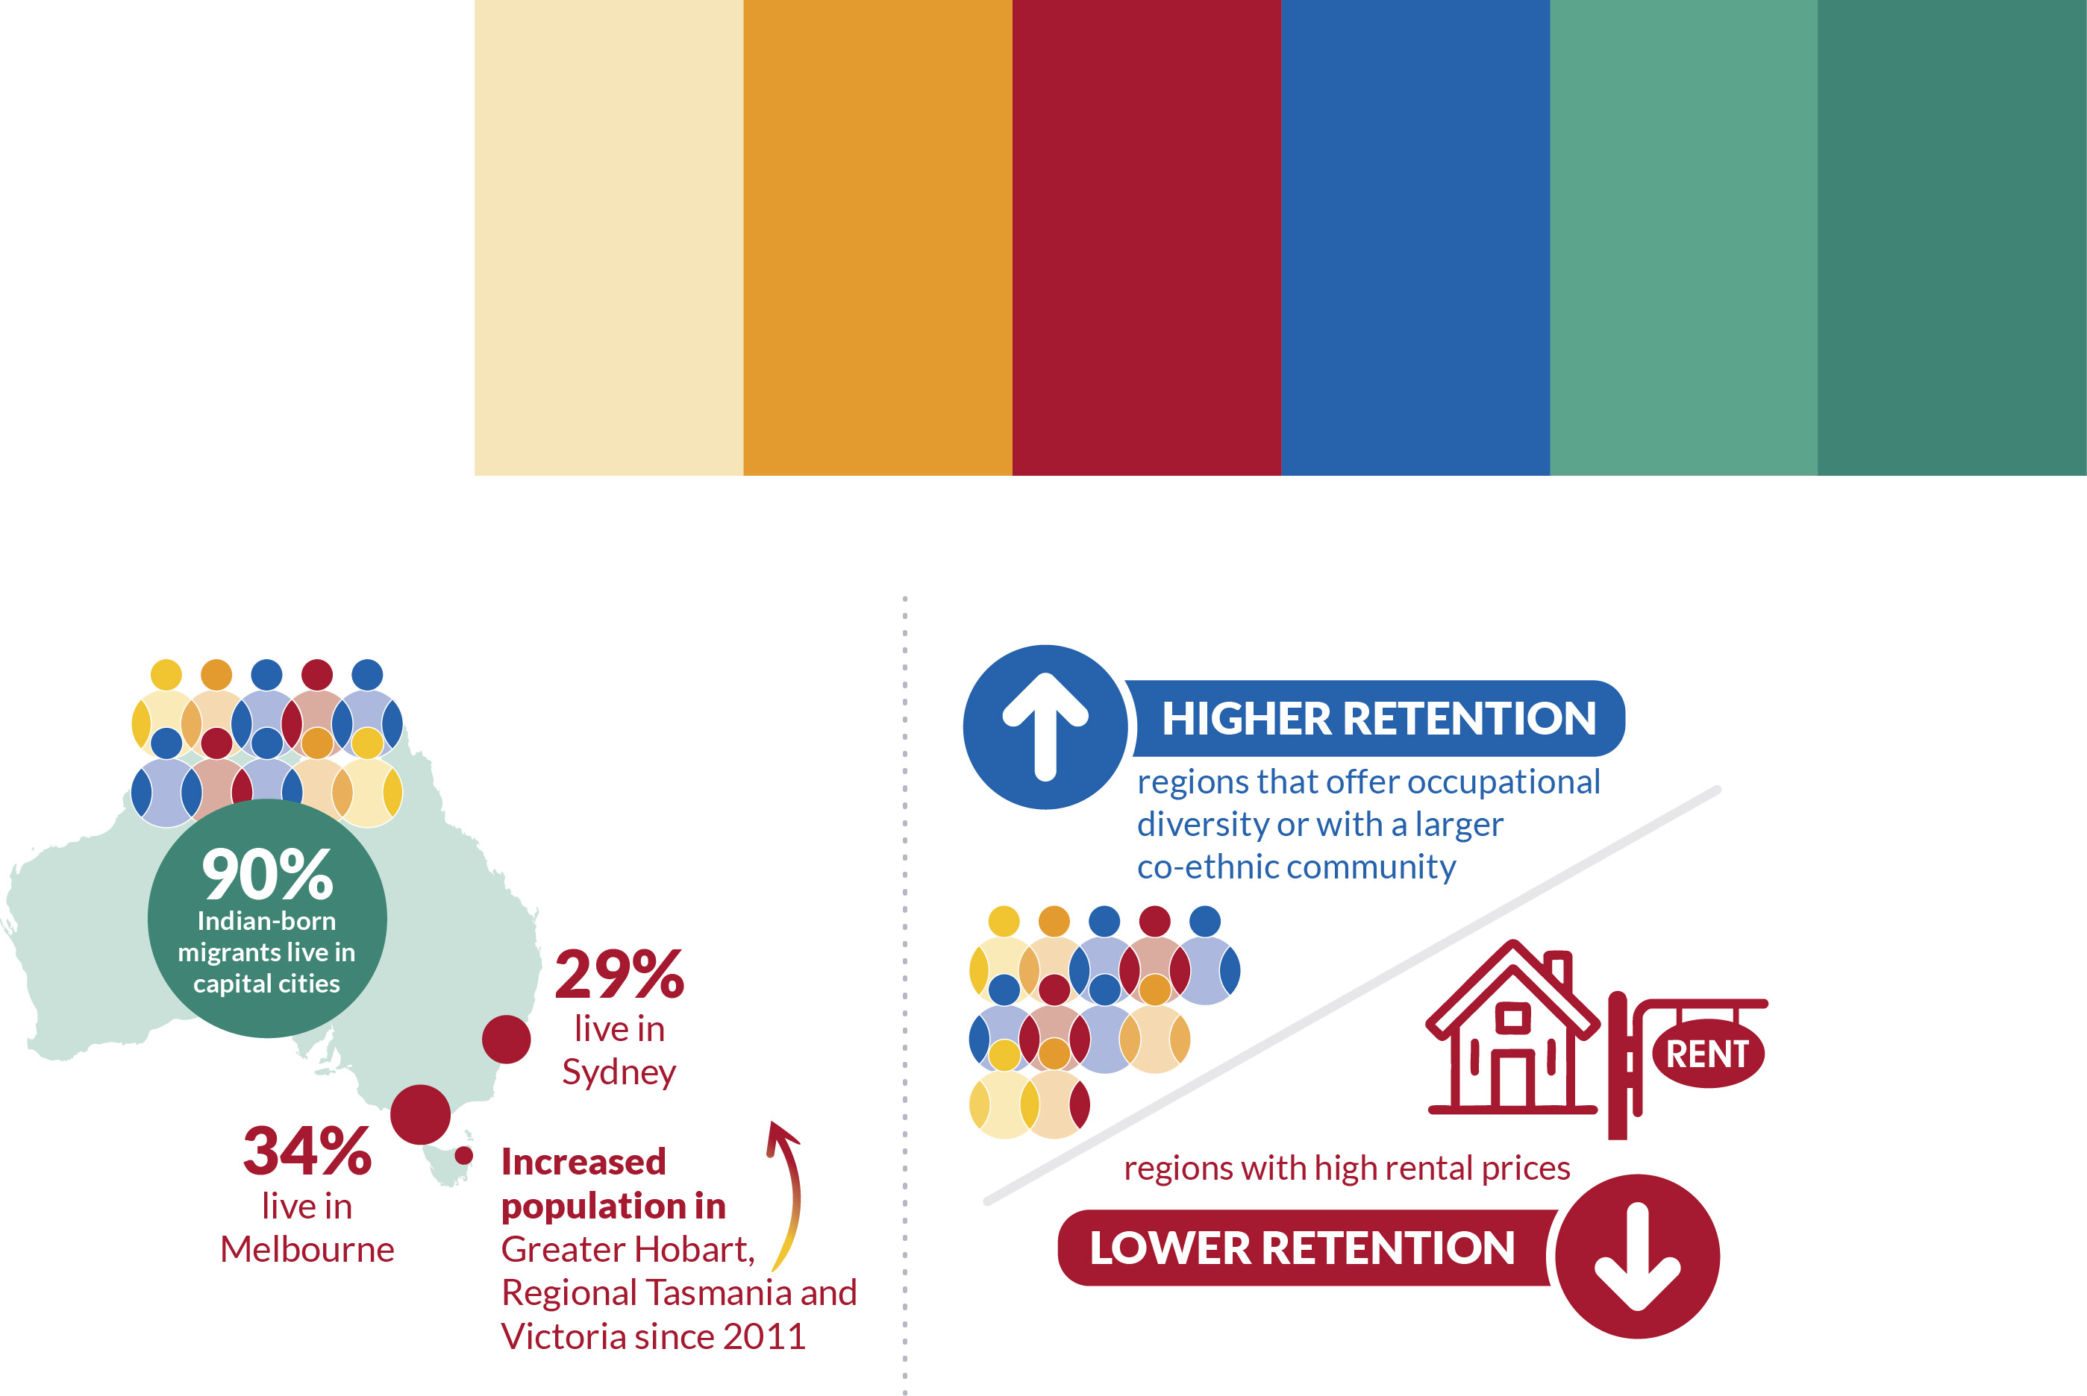

Geographic distribution
The Indian-born community is primarily concentrated in the east coast capital cities, particularly Greater Melbourne and Greater Sydney, however there are significant and growing populations of Indian-born migrants in other Australian cities (Figure 13). Over 90 per cent of Indian-born Australian residents were counted in capital cities at the 2021 Census compare with 64 per cent of Australian-born residents.

Greater Melbourne hosts the largest proportion of the total diaspora, accounting for 34 per cent of the national total (335,634 individuals), followed by Greater Sydney at 29 per cent (286,045). Greater Brisbane (84,948) and Greater Perth (93,572) each host 9 per cent of the diasporic population. Greater Adelaide sits around 6 per cent (42,933). This distribution is mirrored among both first- and second-generation migrants. However, secondary migrants are more heavily concentrated in Greater Sydney, which hosts 34 per cent (38,923 individuals), compared to 24 per cent in Melbourne (27,631). Meanwhile, Greater Brisbane and Greater Perth each host 13 per cent of secondary migrants. Tasmania and the Northern Territory account for a smaller share of the total Indian diaspora, with each state hosting less than 10,000 individuals (<1 per cent) according to the 2021 Census.

- Map showing the location of the Indian diaspora and its components, Greater Capital City Statistical Areas and Rest of States, 2021 Australian Census of Population and Housing
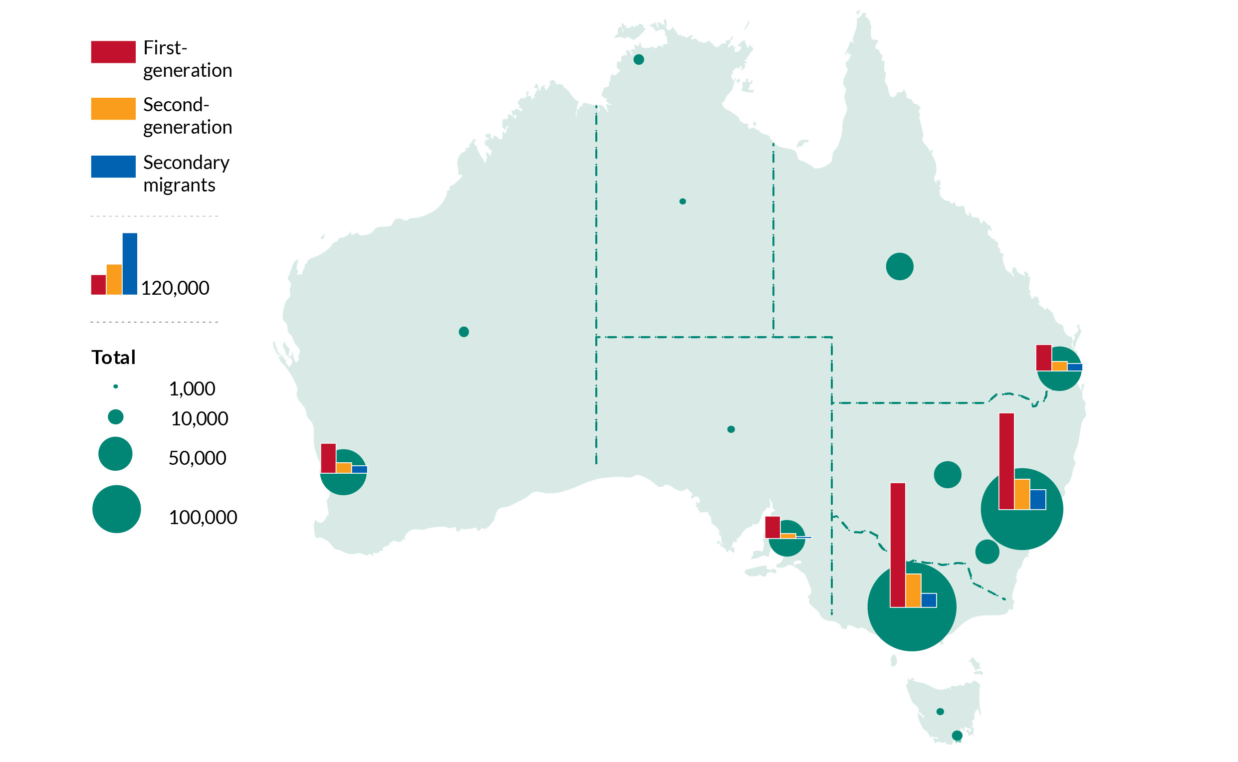
Source: Australian Census of Population and Housing, unpublished data

The growth in the Indian diaspora over the past decade has not been uniformly distributed, with the most rapid growth occurring outside the major capital cities (Figure 14). The population of Indian-born migrants increased almost five-fold in Greater Hobart (379 per cent) between 2011 and 2021, from 850 to 4,074 people. The Rest of Tasmania and Rest of Victoria also both experienced more than 200 per cent growth in the diasporic population. In contrast, growth in the major east coast capital cities was still high but more moderate, with Melbourne growing by 128 per cent, Greater Sydney by 114 per cent and Greater Brisbane by 134 per cent.

Regional attraction and retention
Regional migration visas are intended to reduce the urban concentration of migrant communities by requiring initial settlement in designated regional areas, defined as locations outside Sydney, Newcastle, Illawarra, Melbourne, Geelong, and Brisbane. In the year leading up to the 2016 Census, an estimated 107,875 Indian-born migrants (of all visa types) either settled in, or relocated to, regional Australia. While this helped ease the concentration of the diaspora in Greater Melbourne and Greater Sydney, more than half of these moves (57 per cent) were to the “regional” cities of Greater Adelaide, Greater Perth, and Greater Hobart (Figure 15). This preference for regional metropolitan centres is particularly evident among temporary skilled migrants, 72 per cent of whom settled in these areas. In contrast, only 32 per cent of migrants on regional skilled visas relocated to these major cities, while a significantly higher share (46 per cent) settled in other parts of inner regional Australia. These patterns suggest that regional skilled visas have been relatively successful in attracting members of the Indian diaspora to genuinely non-metropolitan regions.

- Percentage growth in the Indian-born population, Greater Capital City Statistical Areas, 2011 to 2021
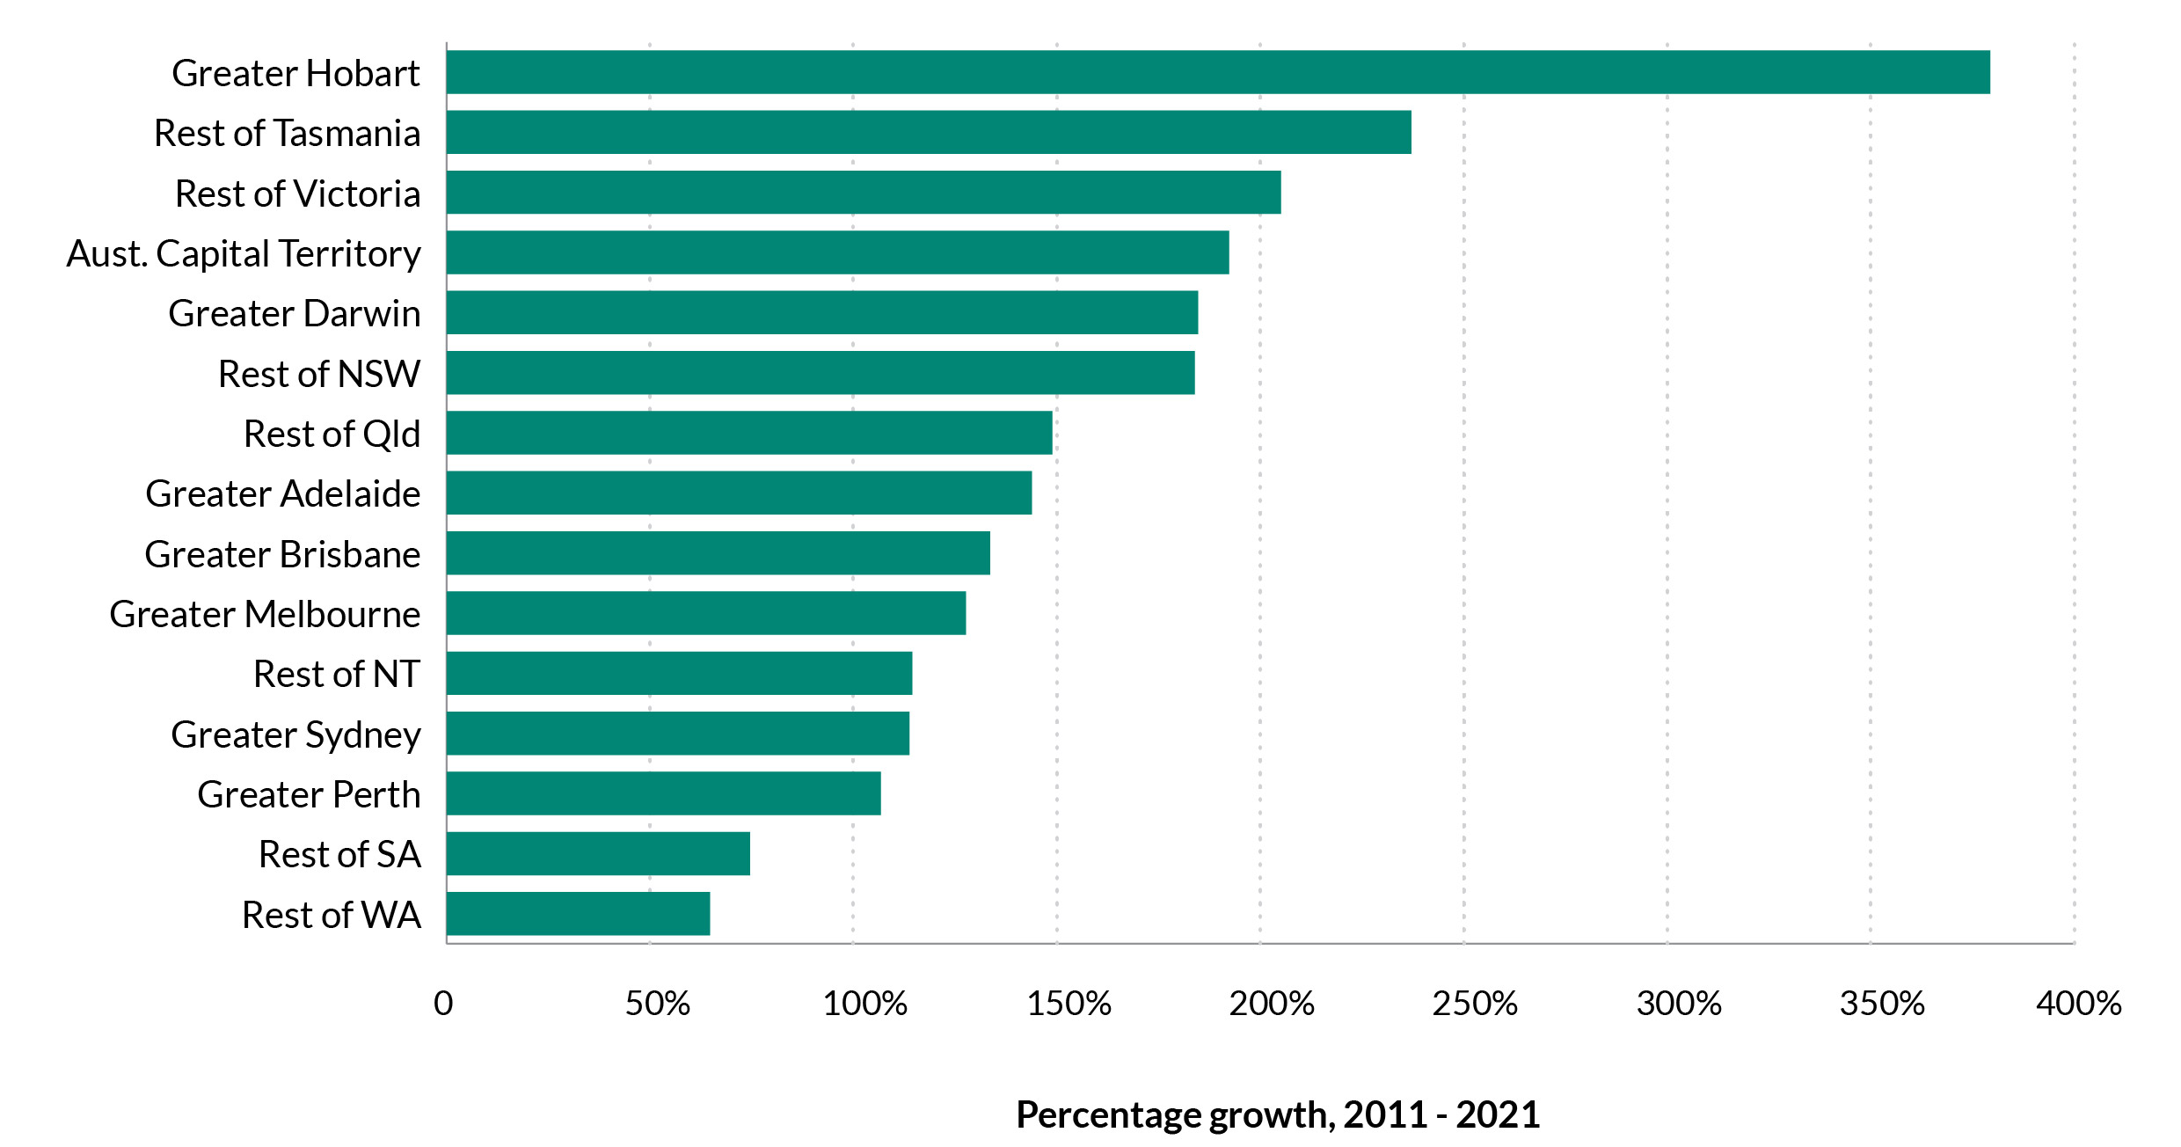
Source: Australian Census of Population and Housing, unpublished data

- Types of destination selected by Indian-born migrants settling in regional Australia in the 12 months to the 2016 Census by visa type
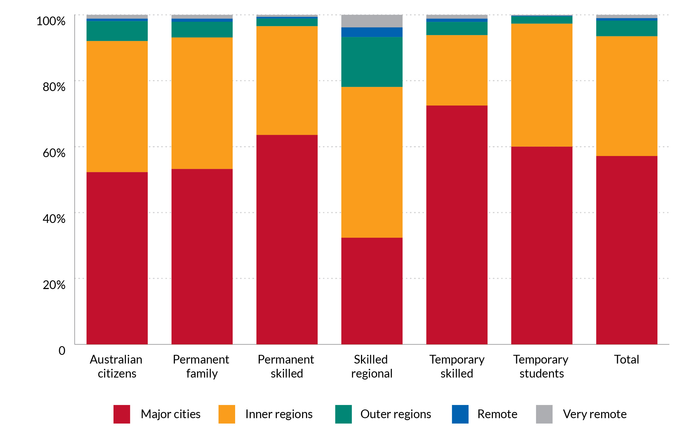
Source: Authors’ calculations from PLIDA

The successful spread of the Indian diaspora beyond major cities depends not only on where migrants initially settle, but also on how long they remain in regional areas. Extended stays support both local economies and communities. While short-term retention is relatively high, the number of Indian-born migrants staying in regional Australia declines over time (Figure 15). After four and a half years, retention rates fall to between 72 per cent and 49 per cent, depending on visa type and citizenship status. Australian citizens are the most likely to remain in regional areas, while temporary and permanent skilled migrants are the least likely. Regional skilled visa holders do not stay at higher rates than other groups.
This pattern suggests a strong tendency for members of the diaspora to gravitate toward capital city regions in the years following initial settlement. The drivers of regional retention are complex. Older migrants, females and individuals with dependent children are more like to stay in regional areas. Conversely, renters, tertiary-educated individuals and high-income earners are more likely to move, which reflects the greater economic return of moving for these individuals. Importantly, regions that offer occupational diversity report significant higher retention and so are regions with a larger co-ethnic community. Conversely, regions with high rental prices fare worse, demonstrating that a range of individual, household and regional characteristics jointly affect the decision to stay and reside in regional Australia (full regression results in Annex 2).


Attendees at the launch of A new Roadmap for Australia’s Economic Engagement with India

- Monthly retention of the Indian-born population moving to regional Australia by visa type
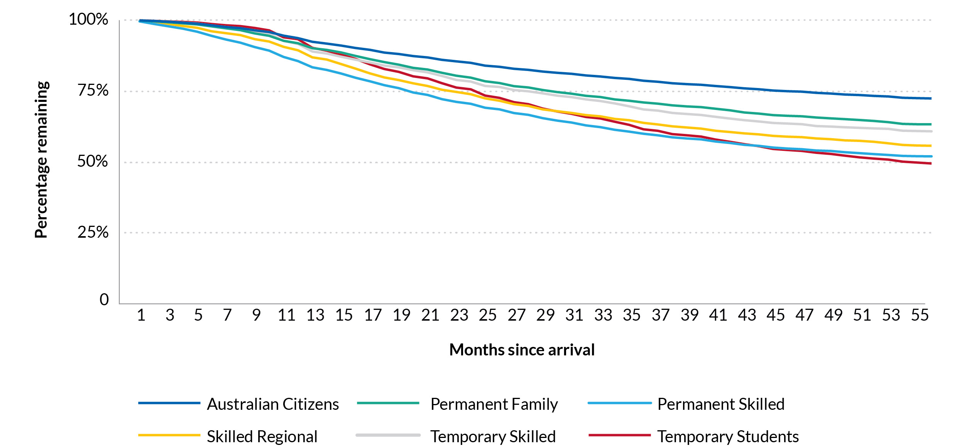

Source: Authors’ calculations using Kaplan-Meier survival analysis on PLIDA

LABOUR MARKET OUTCOMES

Key Findings
- Indian-born migrants have high labour force participation (85 per cent), exceeding Australian-born (78.6 per cent) individuals.
- They are more likely to be employed (80.3 per cent), though overrepresented in both professional roles (32.7 per cent) and low-skilled jobs like driving and machinery operation (11.6 per cent).
- Career progression barriers remain, as Indian graduates are less likely to hold managerial roles (12.8 per cent) than Australian graduates (18 per cent).
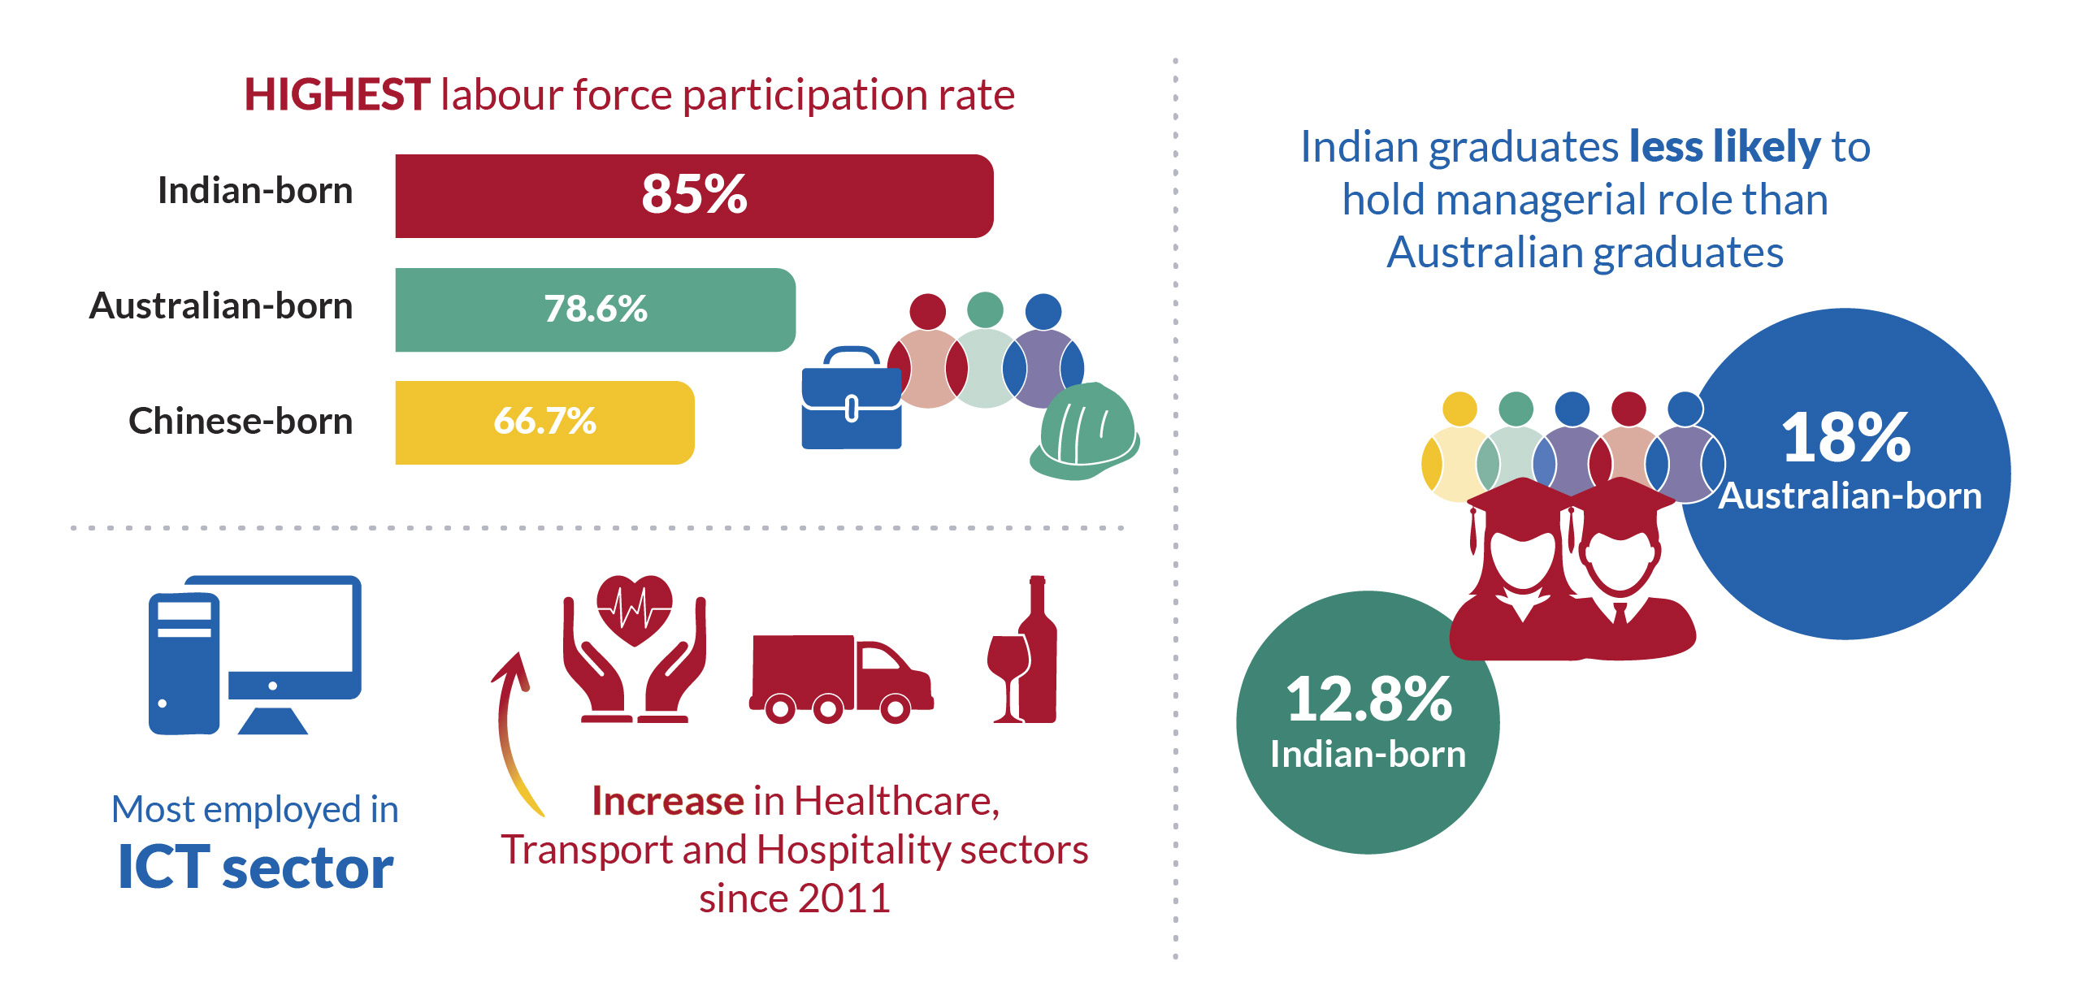

Labour force participation
At the 2021 Census, the Indian-born population had the highest labour market participation rate– nearly 85 per cent, compared to 78.6 per cent among all individuals born in Australia regardless of ancestry. Labour market participation is affected by a socio-demographic and locational characteristics which are not equally distributed among Australian-born and Indian-born populations. For this reason, we run a regression analysis (Annex 1) and control for sex, age, marital status, number of dependent children, highest educational attainment, visa and citizenship status, including whether the person is a primary or secondary applicant, English proficiency and unemployment rate in region of residence. Differences in labour market participation are less pronounced once socio-demographic and locational characteristics are held at the same mean (Table 2). Indian-born migrants are more likely to be employed than other groups even if they report a slightly higher unemployment rate.

Occupational structure
There are marked differences in occupations between Indian-born and Australia-born workers. Indian-born individuals are more likely to hold professional occupations with nearly one-third of reporting being in a professional occupation compared to 22.9 per cent of Australian-born workers and 26.7 per cent of individuals born in other countries. Indian-born migrants are also twice as likely to be machinery operators and drivers than individuals born in Australia. Once we control for socio-demographic characteristics, Indian-born migrants have markedly lower chances of having a managerial or professional job compared to individuals with similar characteristics and remain over-represented in machinery operators and driver’s category (Figure 17).

- Labour force status by country of birth, 2021 Census data and Regression estimates
 | All Australian-born |  | Indian-born
 | Observed | Estimated | Observed | Estimated
Employed | 74.8 % | 73.6% | 80.3% | 76.7%
Unemployed | 3.9% | 3.9% | 4.5% | 4.8%
Not in the  labour force | 21.4% | 22.6% | 15.2% | 18.5%

- Occupation by country of birth, 2021 Census data and regression estimates
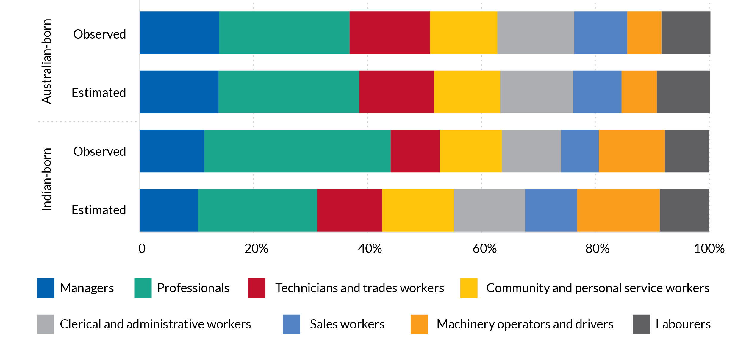


Senator the Hon Penny Wong, Minister for Foreign Affairs at the Centre for Australia-India Relations, Gender Equality in Sport event at the Western Australian Cricket Association Ground

CHANGING OCCUPATIONAL STRUCTURE
While ICT Professionals consistently ranked first as a proportion of all occupations, Road and Rail Drivers rose from the fourth-ranked occupation to second. Similarly, Carers and Aides climbed from seventh to third, likely due to the growing demand for aged care and healthcare support roles. Health Professionals dropped from second to fourth, and Business, Human Resource, and Marketing Professionals dropped from third to fifth, suggesting a relative shift away from business roles as other fields gained importance. Hospitality, Retail, and Service Managers rose from twelfth to eighth, showing increased involvement in hospitality management.
Overall, while ICT remains dominant, the data reveal a trend toward occupational diversification, with more Indian-born residents entering healthcare, transport, and hospitality sectors in Australia.
Higher Education is another sector in which the Indian diaspora continues to make significant contributions is. According to ABS Census data, the share of first-and second-generation migrants in the sector has grown steadily, now accounting for 4 per cent of lecturers and tutors—a 20 per cent increase since 2016. Members of the Indian diaspora hold key leadership roles in universities, contributing to academia’s intellectual and institutional growth.
- Changing ranks of occupations, Indian-born migrants, 2011 to 2021
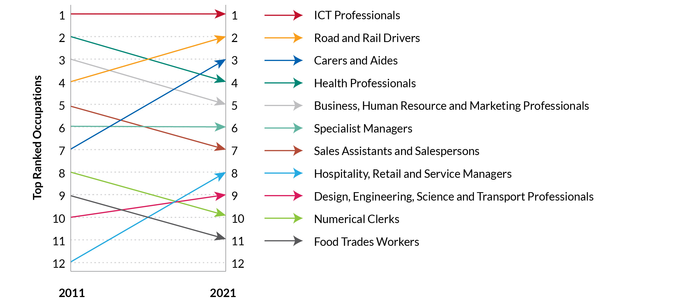
Source: Australian Census of Population and Housing, unpublished data

Entrepreneurship
According to 2021 Census data, Indian-born migrants are less likely to be owner-managers of enterprises (11 per cent) compared to all migrants (14 per cent) and Australian-born residents (14 per cent). Secondary migrants with Indian heritage are even less likely to own businesses, with only 9 per cent of the workforce engaged in entrepreneurship. Despite this, the absolute number of Indian-born business owners and managers has grown significantly, rising from under 30,000 in 2016 to over 50,000 in 2021.
At the aggregate level, growth in the size of the diaspora is contributing significantly to business creation. Modelling, described in Annex 3, estimates that a 1 per cent increase in the size of the Indian-born population is associated with a 0.22 per cent growth in the in number of businesses with 20 to 199 employees and a 0.16 per cent increase in the number of businesses with 200 or more employees. In other words, an additional 6,700 Indian-born migrants would lead to the creation of 123 businesses with 20 to 199 employees and 6 more businesses with 200 or more employees. Overall, this upward trend signals a growing entrepreneurial footprint, suggesting potential for further expansion in the coming years, as modelled by leading members of diaspora in sectors such as IT and healthcare and supported by institutions such as the Indian Australian Business Council.

- Status in Employment, Indian-born, Secondary migrants, Overseas-born and Australian-born individuals
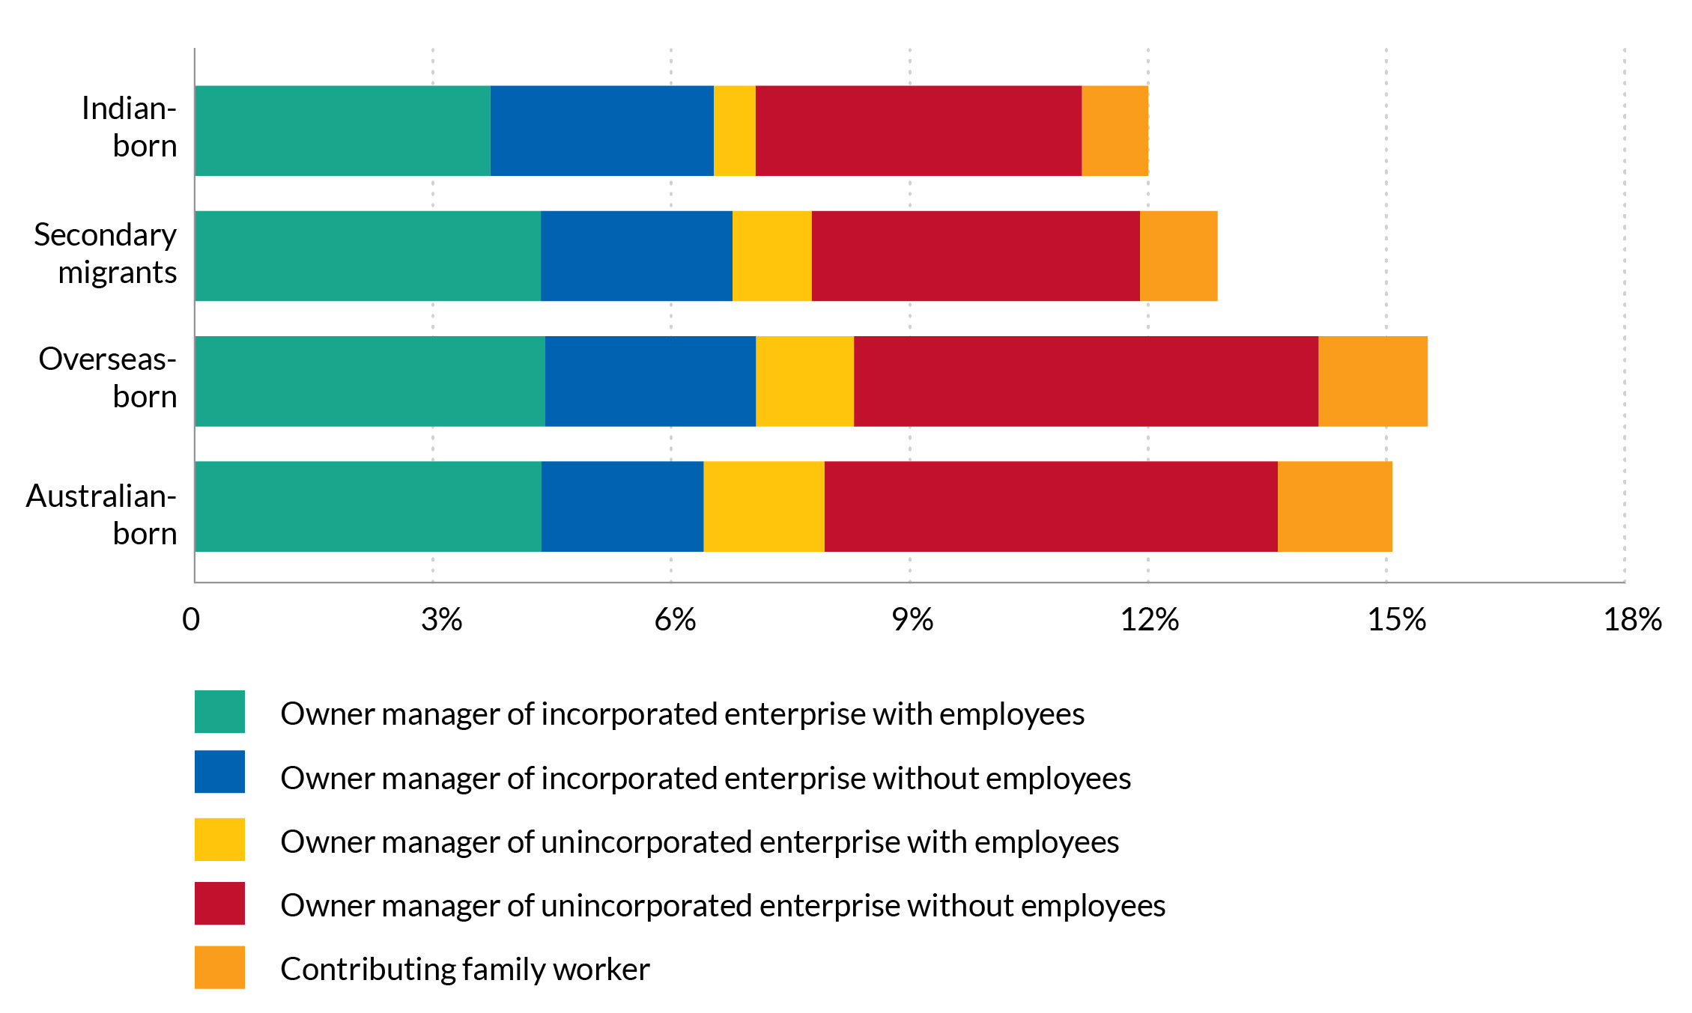
Source: Australian Census of Population and Housing, unpublished data

- Effect of Indian diaspora on business creations
 | Log of number of businesses  (20-199 employees) | Log of number of businesses greater 200 employees
log of Indian-born population | 0.220*** | 0.160***
 | (0.0250) | (0.0337)
Sample size | 1686 | 682
F | 10.75 | 3.198
R² | 0.717 | 0.497
Industry FE | Yes | Yes
State FE | Yes | Yes
Year FE | Yes | Yes
Notes: Standard errors in parentheses * p<0.05, ** p<0.01, *** p<0.001
Source: Data on entrepreneurship from census and business entry and exit data ABS cat 8165.0 and BLADE

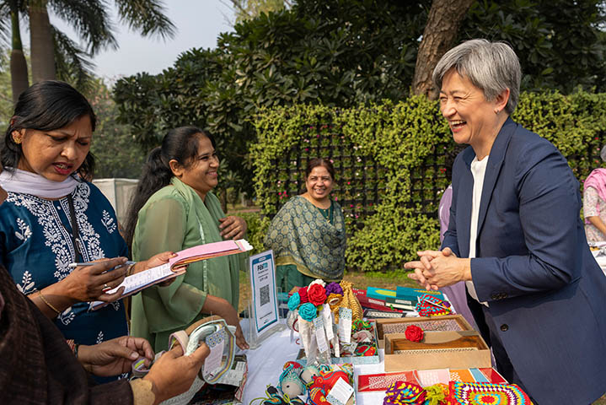
Senator the Hon Penny Wong, Minister for Foreign Affairs visit to New Delhi, India for the Foreign and Defence Ministers
2+2 Meeting

CASE STUDY
Leora Healthcare: Entrepreneurship with heart
Esha Oberoi migrated from India to Australia with her family in 1991 at the age of seven. Arriving without English language skills and facing early experiences of racism and isolation, she found the Australian schooling system challenging, ultimately leaving school in Year 11.
After a period of disengagement from work and study, Esha entered the aged care sector at the encouragement of her father, who recognised emerging needs within Australia’s ageing population.
Her initial role as a nursing home carer provided her with firsthand insight into the challenges faced by both clients and healthcare workers, particularly around workforce burnout and service quality. In response, Esha founded her own home care business in 2008, which would later evolve into Leora Healthcare. The organisation now provides aged care, disability, and mental health services across Australia and New Zealand.
Leora Healthcare distinguishes itself through a strong emphasis on workforce wellbeing, investing in psychological safety, a sense of belonging, and mindfulness-based initiatives.
The company has been named an Australian Financial Review Best Place to Work for five years running, most recently in 2025. Leora is among the small number of disability service providers - only 6 per cent nationally - that meet full registration and compliance requirements, reflecting the organisation’s unwavering commitment to quality, client safety and excellence in service.
Esha’s leadership is shaped by her diasporic identity. After initially distancing herself from her heritage due to early negative experiences, she now integrates aspects of Indian philosophy and wellness practices into the business culture. She also actively employs and supports a diverse workforce, including many first-generation migrants. Looking forward, Leora is exploring opportunities to expand into India, leveraging cross-border strengths in workforce scale and healthcare innovation.

Esha Oberoi, CEO of Leora Healthcare

ECONOMIC CONTRIBUTION OF THE INDIAN DIASPORA

Key Findings
- Australia’s trade with India reached AUD $5.82 billion and imports AUD $2.42 billion in 2023.
- Indian migration boosts trade—a 1 per cent increase in migrants raises exports by 0.46 per cent and imports by 0.16 per cent.
- Indian-born taxpayers contributed AUD $5.8 billion in income tax in 2020, averaging AUD $17,010 per person.

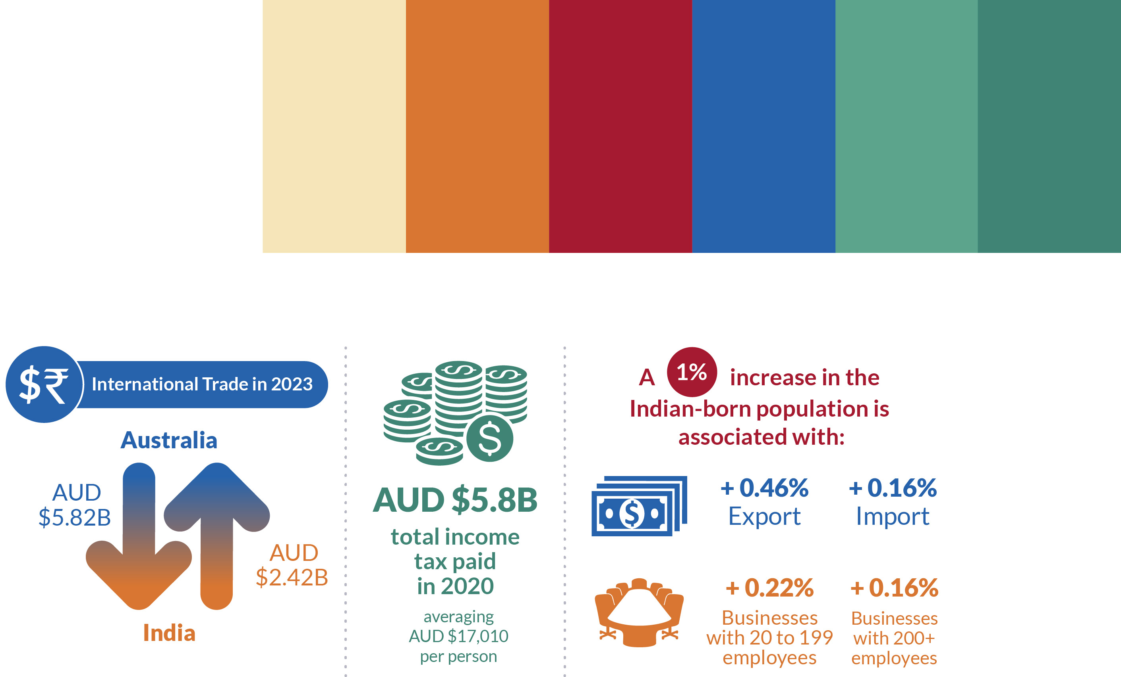

Bilateral trade
In 2023, Australia’s exports to India amounted to AUD $5.82 billion, while imports from India totalled AUD $2.42 billion. In comparison, the respective figures in 2005 were AUD $4.01 billion for exports and AUD $770.85 million for imports, indicating significant growth over the period. To estimate the economic contribution of the Indian-born population to bilateral trade, key sectors with a high share of Indian workers were identified by industry (Australian and New Zealand Standard Industrial Classification, (ANZSIC), level 2) using individual-level data from the Australian Tax Office and demographic data from PLIDA.
Subsequently, the impact of the Indian-born population size on bilateral trade—covering both exports and imports—was estimated using data from the National Freight Data Hub and BLADE, while controlling for macroeconomic shocks at the state and industry levels and mitigating the influence of business cycles. A more detailed explanation of the methodology is provided in Annex 3.
The analysis indicates that a 1 per cent increase in the size of the Indian-born population is associated with a 0.46 per cent increase in the value of exports to India and a 0.16 per cent increase in imports from India (Table 24), highlighting the positive contribution of the Indian-born population to the Australian economy. Specifically, an additional 6,700 Indian-born migrants is estimated to increase exports to India by AUD $26.48 million and imports from India by AUD $3.97 million, resulting in a trade surplus of AUD $22.51 million.
- Effect of Indian diaspora on Export and Import
 | Log of Export | Log of Import
log of Indian-born population | 0.455*** | 0.164***
 | (0.0348) | (0.0231)
Sample size | 4937 | 5771
F | 53.79 | 115.0
R² | 0.638 | 0.763
Industry FE | Yes | Yes
State FE | Yes | Yes
Year FE | Yes | Yes
Notes: Standard errors in parentheses * p<0.05, ** p<0.01, *** p<0.001
Source: Data on entrepreneurship from census and business entry and exit data ABS cat 8165.0 and BLADE

Income tax
Another important economic contribution of the diasporic population is to Australia’s tax base. Between 2011 to 2020, Indian migrants have contributed on average AUD $17,010 annually in income tax. This is significantly higher than Chinese-born migrants, the second largest source of recent overseas migrants, and comparable to New Zealand migrants and Australian-born taxpayers, especially in recent years. This is significant considering most Indian migrants come to Australia as students and work on a part-time basis.
If part-time workers were excluded, the average tax contribution per Indian immigrant would be even higher.
With 342,211 Indian-born taxpayers in Australia in 2020, personal income tax contributions from this group amounted to more than AUD $5.8 billion in that year. These contributions would likely be even higher if business taxes and the spillover effects of the Indian diaspora on business profits, which generate additional tax revenue, were also included.

Attendees at the launch of A new Roadmap for Australia’s Economic Engagement with India

POLITICAL ENGAGEMENT OF THE INDIAN DIASPORA

Key Findings
- 52 per cent of Indian-born residents were Australian citizens in 2021, enabling electoral participation.
- Indian Australians are politically engaged and exhibit strong democratic values, as shown in Australian Election Study Surveys (1987-2022).
- They display fluid partisan attachments, indicating sophisticated political behaviour rather than strong party loyalty.

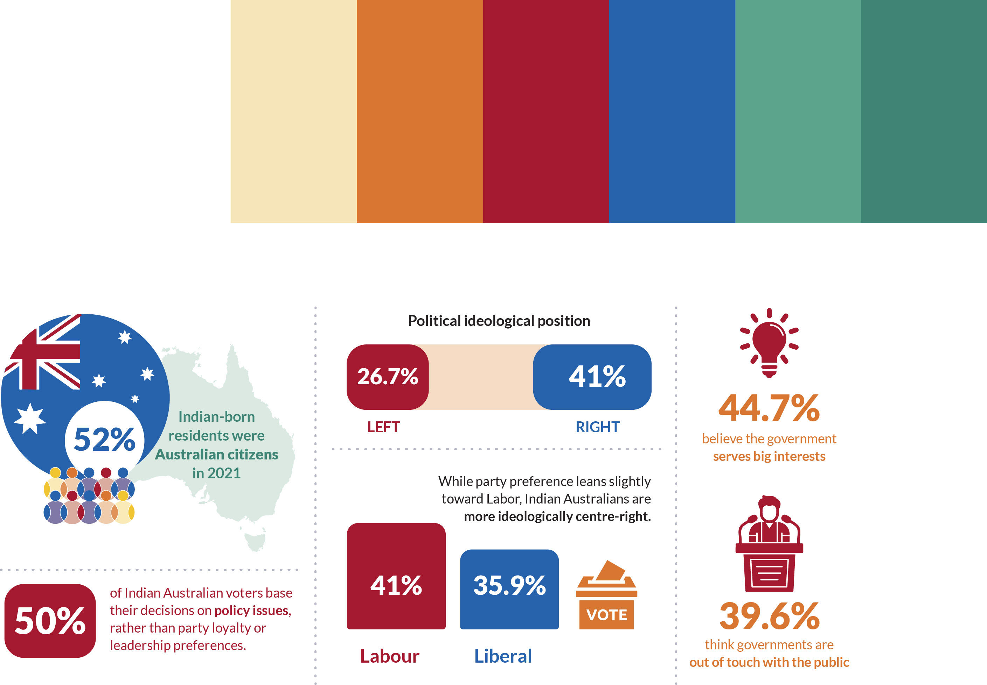
Source: Australian Election Study Surveys (1987-2022)

Despite the growing trend of “temporariness” within parts of the Indian diaspora, over half of Indian-born residents were Australian citizens at the time of the 2021 Census, granting them the right to vote. The combination of their population size and geographic concentration gives the diaspora meaningful potential to influence electoral outcomes. Notably, the political behaviour of Indian Australians diverges from traditional voting patterns in Australia. While party identification has historically been strong—supported by compulsory voting and frequent elections—the Indian diaspora demonstrates more fluid partisan attachments. Around 13.8 per cent report no party affiliation, indicating that, unlike longer-established migrant communities, they have yet to form entrenched political loyalties. This trend is particularly important, as party identification often serves as a key cognitive shortcut that helps voters navigate complex electoral choices.
The voting behaviour of Indian Australians reveals a sophisticated and pragmatic approach to electoral participation.
While actual voting shows a slight preference for the Liberal Party over the Labor Party, half of all voters (50 per cent) cite policy issues as their primary consideration in voting decisions, rather than party loyalty or leadership (Table 5). This policy-focused approach is reflected in voting flexibility, with 46.1 per cent reporting that they have switched their vote between parties, suggesting a willingness to evaluate each election on its merits rather than maintaining rigid party loyalty. Indian Australians appear to be engaging more directly with policy substance. This could reflect their higher educational levels and professional backgrounds, enabling them to process political information without heavy reliance on partisan cues.
Research on Australian political behaviour shows that strong party identifiers typically display high trust in political institutions. 18.7 per cent of Indian Australians report that they are very satisfied with democracy and a further 58.2 per cent report that they are fairly satisfied with democracy.
- Most Important in the vote among the Indian diaspora, 1987-2022, Percentage distribution
Most Important in Vote Decision | (%)
The policy issues | 50.0
The parties taken as a whole | 24.0
The party leaders | 17.2
The candidates in your electorate | 6.3
Source: 1987-2022 Australian Election Study Surveys, n=192

However, while Indian Australians maintain strong democratic support there appears to be significant scepticism about political actors with 44.7 per cent believing government serves big interests, and 39.6 per cent think governments do not know what people think. This sophisticated differentiation between democratic systems and current political practice suggests a mature political outlook.
Indian Australians maintain strong faith in democratic processes and their own political agency (Table 6). A substantial majority (64.8 per cent) believe it makes a significant difference who is in power. These findings point to the positive effects of compulsory voting on political efficacy. This high level of political efficacy, combined with policy-focused voting and willingness to switch parties, paints a picture of an engaged and discerning voter group that takes its democratic responsibilities seriously while maintaining a healthy scepticism toward political institutions and actors. Their combination of democratic faith with political scepticism, and their willingness to switch votes based on policy considerations, makes them an important and discerning segment of the Australian electorate.
In concert, these patterns suggest that unlike the traditional pattern of voting behaviours in Australia where party identification develops early and is relatively stable, Indian Australians appear to be adopting a more flexible, issues-based approach to political engagement. This could reflect both their migration experience and their distinct demographic characteristics – notably their high levels of education, professional skills, and familiarity with democratic processes as migrants from the world’s largest democracy. Their entry into Australian politics during a period of weakening party attachments globally, combined with their sophisticated understanding of democratic systems, has significant implications for understanding political behaviour in multicultural democracies. While party identification has stability-inducing effects, the Indian Australian case suggests that democratic stability might also be achieved through informed, policy-focused engagement, even without strong partisan attachments.
- Political efficacy among the Indian diaspora, 1987-2022, Percentage distribution
Makes a difference Who is in Power | (%)
It makes a big difference (1) | 32.4
Somewhat makes a difference (2) | 32.4
Neutral (3) | 18.8
Limited difference (4) | 12.4
No difference (5) | 4.1
Source: 1987-2022 Australian Election Study Surveys, n=170

THE FUTURE OF THE INDIAN DIASPORA IN AUSTRALIA

Key Findings
- The Indian-born population will grow from 0.7 million (2021) to 1.7 million (2041), passing 1 million in 2026.
- Indian-born Australian citizens will increase from 0.4 million to 1.3 million, while non-citizens will grow slightly to 0.4 million.
- The median age will rise from 35.7 to 41 years, showing an ageing trend.
- Sydney and Melbourne will see the most growth by 2041.
- Projections assume no major policy changes, but global and economic shifts could affect outcomes.

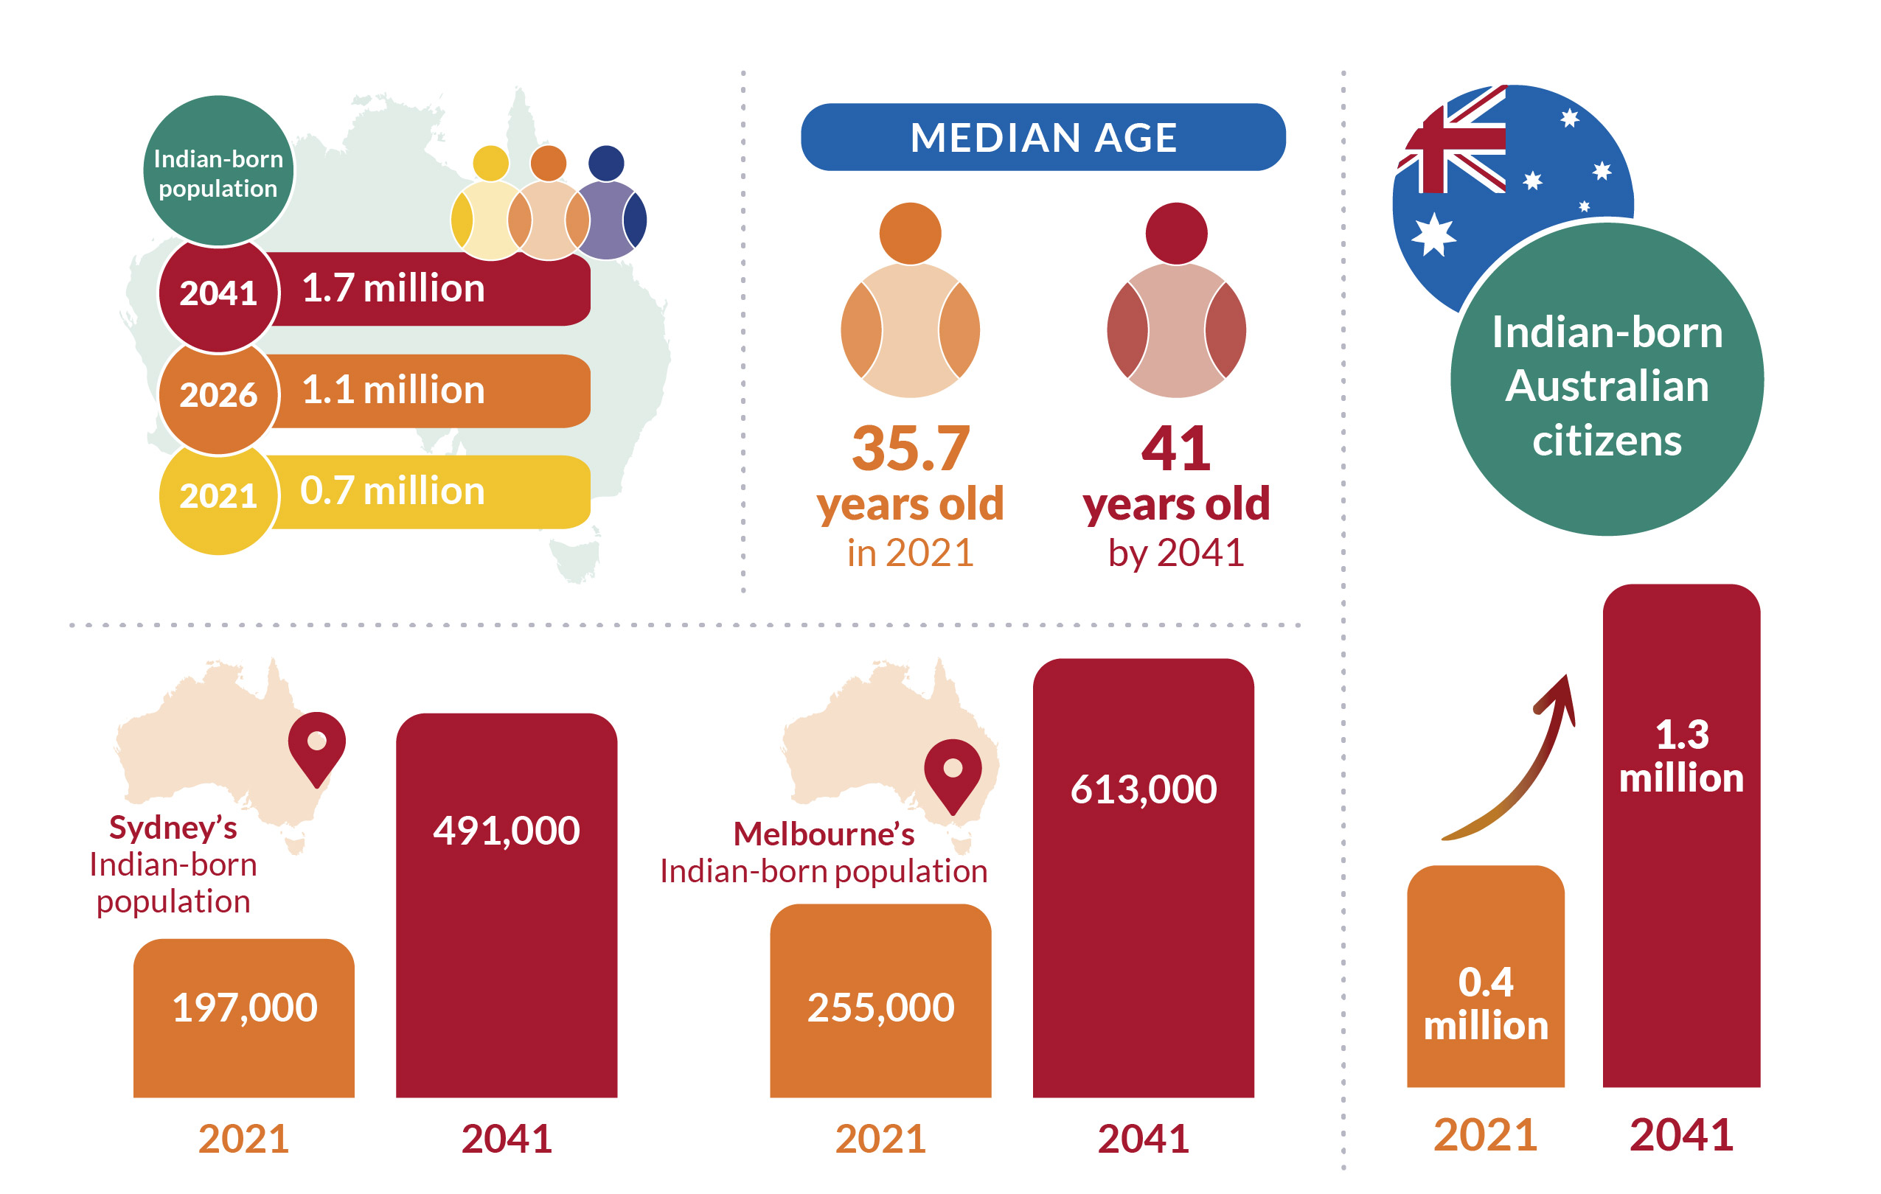

Future growth
There is projected (Annex 4) to be substantial growth in Australia’s Indian-born population over the coming years (Figure 20). At the national level, this population is expected to increase significantly, rising from 0.7 million in 2021 to 1.7 million by 2041, with the 1 million mark anticipated to be surpassed in 2026. Unsurprisingly, immigration is the primary driver of this growth, with mortality and emigration much lower in comparison.
Within the Indian-born population, those without Australian citizenship are projected to increase modestly, from 0.35 million to 0.42 million by 2041. In contrast, the population with Australian citizenship is expected to grow rapidly, increasing from 0.4 million to 1.3 million over the same period. The age structure of this population will also change, with the median age projected to rise from 35.7 years in 2021 to 41.0 years by 2041, reflecting the natural ageing of existing cohorts over time (Figure 21). However, the segment of the population without Australian citizenship will not experience significant ageing due to high outflows from emigration and citizenship acquisition among young adults, which will help maintain its current age profile. Meanwhile, the population of Indian-born individuals with Australian citizenship will age considerably.

Future distribution
At the subnational level, all capital cities and regional areas in Australia are projected to see increases in their Indian-born populations. However, most growth is expected to concentrate in Sydney and Melbourne.

- Projected Population of Indian-born Australian citizens and non-citizens, 2021-2041
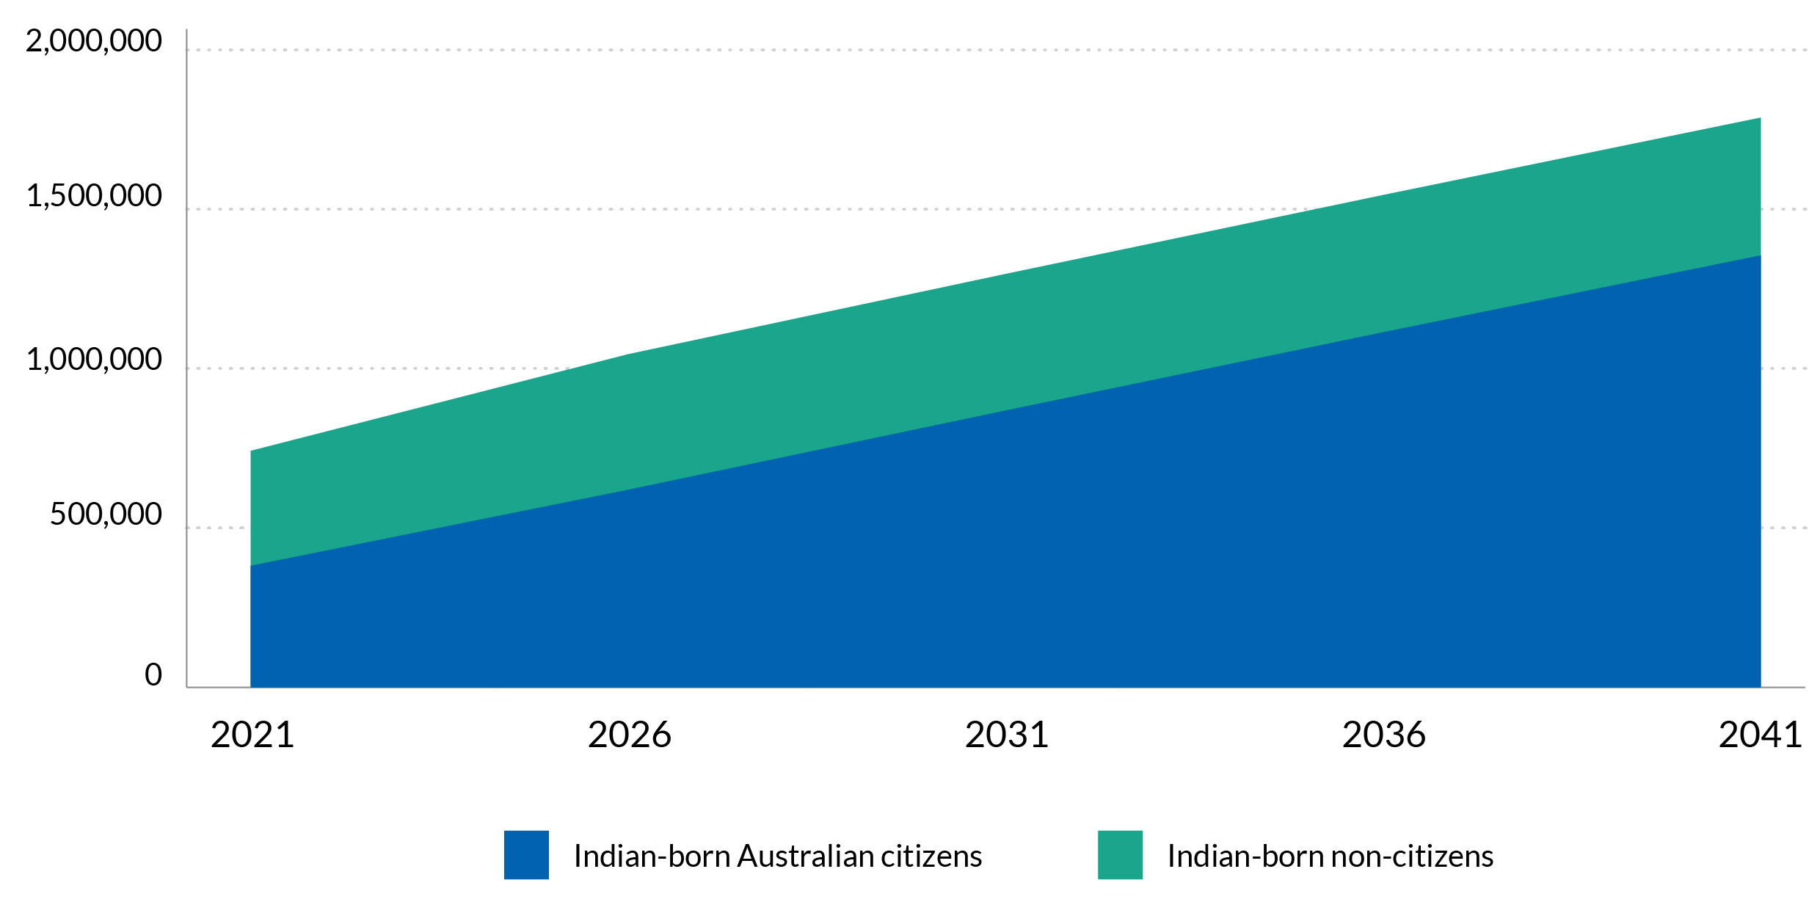
Source: ABS and authors’ projections

- The age-sex structure of the Indian-born population of Australia in 2021 and projected in 2041
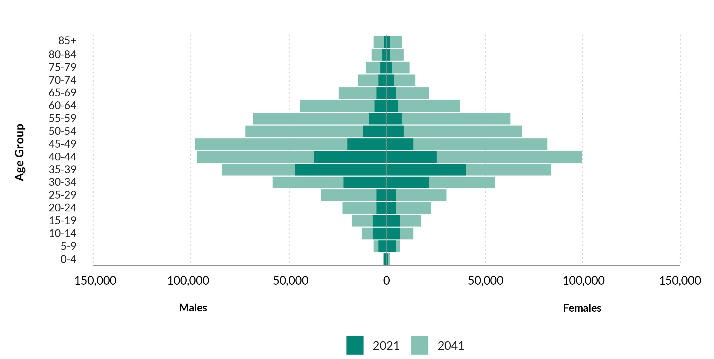
Source: ABS and authors’ projections
Note: The small population in the childhood ages is because babies born in Australia to Indian-born mothers are classified as part of the Australian-born population; the children shown in the graph are migrants born in India

Sydney’s Indian-born population is projected to rise from 197,000 in 2021 to 491,000 by 2041, while Melbourne’s Indian-born population is expected to increase from 255,000 to 613,000 over the same period.
Despite these increases, the proportional distribution of the Indian-born population across capital cities and regional areas is expected to remain largely stable. Sydney’s share of the Indian-born population will increase slightly from 28 per cent to 29 per cent, while Melbourne will maintain its share at 36 per cent. Overall, around 90 per cent of Australia’s Indian-born population is projected to reside in capital cities across states and territories, a proportion that is expected to remain constant.
The primary driver of population growth for the Indian-born population in all capital cities and regional areas will continue to be immigration, with emigration and mortality contributing minimally to change. Net internal migration among the Indian-born population is relatively modest across all regions and is not expected to significantly impact population growth patterns.
It is important to note that these projections are based on ‘business as usual’ assumptions which are based on current migration policy settings and economic conditions. Actual population outcomes will likely differ to some extent from these projections due to changes in migration policy, shifts in the higher education market, global economic and political conditions, and changing fertility trends amongst other factors.

OUTLOOK
The Indian diaspora in Australia has grown significantly in recent decades, reflecting the deepening strategic relationship between Australia and India.
Members of this community continue to make valuable contributions to Australian society and the economy, actively participating across various sectors. With high levels of educational attainment and a largely youthful population, the Indian diaspora represents a considerable asset to Australia’s labour market. Moreover, their successful integration into the country’s democratic and multicultural framework has further strengthened social cohesion and civic engagement.
The diaspora is fostering closer bilateral ties with India through cultural exchange, entrepreneurship and familial links. As this population expands and diversifies, it is increasingly important to ensure equal access to opportunities and clear, fair migration pathways.
Recognising and supporting the Indian diaspora is critical for advancing Australia’s long-term prosperity and strategic interests in the 21st Century.

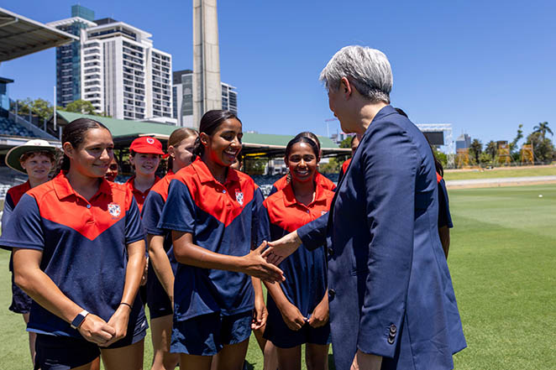
Senator the Hon Penny Wong, Minister for Foreign Affairs at the Centre for Australia-India Relations, Gender Equality in Sport event at the Western Australian Cricket Association Ground

List of Figures
Figure 1. Growth in the global Indian diaspora, 1990-2024 11
Figure 2. Growth in the Indian diaspora, 1991-2024. ABS 2025, Australia's population by country of birth 12
Figure 3. Country of birth, Secondary migrants, 2006-2021 13
Figure 4. Population pyramid showing the age structure of the Indian diaspora and Australia’s total population 14
Figure 5. Linguistic diversity of first-generation, second(+) generation and secondary migrants, 2021 15
Figure 6. Religious diversity of first-generation, second (+) generation and secondary migrants, 2021 15
Figure 7. Educational attainment, Indian-born, Secondary migrants (Indian ancestry), Overseas-born and Australian-born, 2021 Census 17
Figure 8. Income distribution for Indian-born and Australian-born residents and graduates, 2021 Census data and regression estimates 17
Figure 9. Number of offshore visas granted by year of arrival in thousands 21
Figure 10. Indian-born international student commencements, VET and Higher Education 2005-2023 23
Figure 11. First temporary visa and visa type seven years later, 2006 to 2015 arrival cohorts from India 24
Figure 12. Visa status after seven years, first offshore visa and year of arrival 25
Figure 13. Map showing the location of the Indian diaspora and its components, Greater Capital City Statistical Areas and Rest of States, 2021 Australian Census of Population and Housing 29
Figure 14. Percentage growth in the Indian-born population, Greater Capital City Statistical Areas, 2011 to 2021 30
Figure 15. Types of destination selected by Indian-born migrants settling in regional Australia in the 12 months to the 2016 Census by visa type 31
Figure 16. Monthly retention of the Indian-born population moving to regional Australia by visa type 32
Figure 17. Occupation by country of birth, 2021 Census data and regression estimates 34
Figure 18. Changing ranks of occupations, Indian-born migrants, 2011 to 2021 36
Figure 19. Status in Employment, Indian-born, Secondary migrants, Overseas-born and Australian-born individuals 37
Figure 20. Projected Population of Indian-born Australian citizens and non-citizens, 2021-2041 47
Figure 21. The age-sex structure of the Indian-born population of Australia in 2021 and projected in 2041 48

List of Tables
Table 1. Summary of data sets used in this study 8
Table 2. Labour force status by country of birth, 2021 Census data and Regression estimates 34
Table 3. Effect of Indian diaspora on business creations 38
Table 4. Effect of Indian diaspora on Export and Import 41
Table 5. Most Important in the vote among the Indian diaspora, 1987-2022, Percentage distribution 44
Table 6. Political efficacy among the Indian diaspora, 1987-2022, Percentage distribution 45

TECHNICAL ANNEX

Annex 1: Labour market outcomes
The analysis leverages linked individual-level administrative records available in PLIDA. The 2021 Census constitutes the cornerstone of the analytic dataset. Census data provide information on labour market outcomes and a comprehensive set of control variables. These data have been linked to ATO tax records, which provide more detailed information on employment income. Additionally, data on visa grants provided by the Department of Home Affairs were linked to capture the migration status of the foreign-born individuals in the sample.
Analysis was restricted to people of working age, that is, aged between 15 and 64. The total number of observations in the sample is 15,524,752. However, the number of cases varies between models, as some are based on subsamples due to the unavailability of certain outcome variables for all observations. For example, information on occupation is not available for individuals who do not work.
The analysis focuses on four indicators of labour market success. The first three are based on Census variables. The first is labour force status, which is recoded into three categories: employed, unemployed, and in the labour force. The second is occupation. The variable has been coded using the Australian and New Zealand Standard Classification of Occupations. The analysis focuses on the highest level of the classification, which includes eight categories: managers, professionals, technicians and trades workers, community and personal service workers, clerical and administrative workers, sales workers, machinery operators and drivers, and labourers. The third is annualised personal income. Respondents do not report exact amounts in the Census; instead, they select an income band. For this study, responses were grouped into five categories approximating income quintiles: $0 - 20,799, $20,800 - 41,599, $41,600 - 64,999, $65,000 - 103,999, and $104,000 or more. The last outcome variable is income from salaries and wages in the financial year 2021/22, extracted from the ATO records. In sensitivity analysis, a modified version of the income variable was also used, constructed by removing the top and bottom 1 per cent of observations to reduce the impact of outliers.
Labour market activity and outcomes may be affected by a number of factors, such as age and education, that are not equally distributed among Australian-born and foreign-born populations. For this reason, a set of potential confounders is included in the models as control variables. The control variables include:
- Sex that has two categories: male or female
- Age recoded into five categories: 5-24 years, 25-34 years, 35-44 years, 45-54 years, and 55-64 years
- Social marital status that has four categories: married in a registered marriage, married in a de facto marriage, not married, and not applicable.
- The number of dependent children.
- Highest educational attainment grouped into eight categories: postgraduate degree, graduate diploma or graduate certificate, bachelor degree, advanced diploma or diploma, certificate III or IV, Secondary education - Years 10 or above, certificate I or II, secondary education – years 9 or below, no educational attainment.
- Citizenship or migration status, which is derived from the Census and visa grant records. The variable can have one of 11 values: Australian citizen, New Zealand citizen, permanent skilled, permanent family, permanent humanitarian, permanent other, temporary skilled, temporary student, working holiday maker, temporary other, and missing (in case the information was unavailable).
- Secondary visa applicant flag which indicates who was not a primary visa applicant. It has two values: 1 for those with a flag in migration data and 0 for all others (including citizens and people with missing visa information).
- Proficiency in spoken English: speaks English only, uses other language and speaks English very well, uses other language and speaks English well, uses other language and speaks English not well, uses other language and speaks English not at all, missing.
- Unemployment rate in the area of residence (measured at the Statistical Area, Level 4 level). While the models include the unemployment rate, the estimates have been suppressed in the outputs to meet the ABS DataLab output clearance requirements.

Analytic approach
The analysis consists of two steps. In the first one, descriptive patterns are investigated. In the second step, the relationship between the country of birth and labour market outcomes is estimated by fitting a series of regression models. Multivariate analysis allows for a better capture of differences between groups net of other factors, for example, educational attainment. A multinomial logistic regression model is fitted for categorical variables, that is, labour market status, occupation, and personal income category. Each one is actually a set of models estimating the log odds for each category compared to the reference category. The models have the following form:
$$\ln\left(\frac{P\left(Y=j\right)}{P\left(Y=k\right)}\right)= α+β_{1}COB+β_{2}C_{1}$$
Where Y is a categorical dependent variable, P(Y = j) is the probability of the outcome being j-th category, P(Y = k) is the probability of the reference category, COB is the country of birth, C₁ is a set of control variables listed in the previous section; α is the model’s intercept; and β₁ and β₂ are vectors of coefficients to be estimated. Model results are expressed as relative risk ratios (RRRs). RRRs greater than 1 indicate that a one-unit increase in a given explanatory variable is associated with increased odds of respondents taking the value j in the outcome variable compared to the reference category, all else being equal. Correspondingly, RRRs smaller than 1 indicate that a one-unit increase in a given explanatory variable is associated with a decrease in the odds of respondents taking the value j in the outcome variable compared to the reference category, all else being equal. However, for ease of interpretation, key model results are expressed as marginal predictions or average marginal effects (AMEs) calculated holding the covariates at their observed values.
Labour income as a continuous variable could be modelled using a linear regression model of the following form:
$$Y= α+β_{1}COB+β_{2}C_{1}+e$$
Where Y represents labour income, COB and C, like before, represent the country of birth and control variables, respectively, α is the model’s intercept, β₁ and β₂ represent coefficients, and e is the regression error.

Annex 2: Regional retention
Regression coefficients of regional retention from a Cox Proportional Hazards model with 95% confidence intervals

 | Hazard ratio | 95% CI
Individual characteristics
Age group (ref.cat.18-24)
25-34 | 1.028 | [0.982,1.076]
35-44 | 0.877*** | [0.827,0.929]
45-54 | 0.688*** | [0.628,0.755]
55-64 | 0.627*** | [0.550,0.715]
Female | 0.944*** | [0.921,0.969]
Not married | 1.218*** | [1.174,1.264]
Has dependent children | 0.818*** | [0.788,0.848]
Tertiary education | 1.042** | [1.011,1.075]
Occupation (ref.cat. Technicians and Trades Workers)
Not applicable | 1.071* | [1.012,1.134]
Managers | 1.044 | [0.975,1.117]
Professionals | 1.016 | [0.959,1.077]
Community and Personal Service Workers | 0.955 | [0.890,1.025]
Clerical and Administrative Workers | 1.014 | [0.943,1.089]
Sales Workers | 0.981 | [0.915,1.052]
Machinery Operators and Drivers | 0.969 | [0.906,1.036]
Labourers | 0.966 | [0.905,1.031]
Household income quintile (ref.cat. Middle quintile)
Bottom quintile | 1.017 | [0.976,1.060]
Second bottom quintile | 1.002 | [0.958,1.047]
Second top quintile | 1.019 | [0.972,1.069]
Top quintile | 1.047⁺ | [0.995,1.101]
Rented | 2.159*** | [2.066,2.256]
Visa category (ref. cat. Australian)
Permanent Family | 1.050⁺ | [0.995,1.108]
Permanent Skilled | 1.292*** | [1.233,1.353]
Skilled Regional | 1.194*** | [1.116,1.277]
Temporary Skilled | 0.872*** | [0.825,0.923]
Temporary Student | 1.100*** | [1.046,1.158]
Remoteness status (ref.cat., Major cities)
Inner regional | 0.721*** | [0.691,0.752]
Outer regional | 0.835*** | [0.771,0.905]
Remote | 0.946 | [0.801,1.117]
Very remote | 1.150⁺ | [0.991,1.335]

Place-based characteristics
Unemployment rate | 0.947*** | [0.929,0.965]
Occupation diversity (Hachman Index) | 0.453*** | [0.368,0.558]
Median rent price (log) | 1.237** | [1.075,1.422]
Proportion of Indians | 0.937*** | [0.929,0.945]
Median household income (log) | 0.580*** | [0.491,0.684]
N | 68575
Ll | -262017.182
chi2 | 5778.257
Exponentiated coefficients; 95% confidence intervals in brackets
⁺ p < 0.10, * p < 0.05, ** p < 0.01, *** p < 0.001
Note: regression coefficients greater than one indicate higher odds of leaving and coefficient lower than one higher odds of staying.

Annex 3: Contribution to aggregate trade and business growth
Key sectors with a high share of Indian workers by industry (ANZSIC level 2) were identified using individual-level data from the Australian Tax Office and demographic data in PLIDA. Subsequently, annual changes in the Indian-born population were leveraged to estimate how this affects bilateral trade (exports and imports) in key sectors. Data on bilateral detailed exports and imports (in dollar terms) between Australia and India are sourced from the National Freight Data Hub and BLADE. The empirical specification is as follows:
$$E_{ist}=β{ {\ln{e}}_{ist}}_{}+ µ_{i}+ ζ_{s}+ϑ_{t}+ ε_{ist}$$
where:$E_{aet}$represents export/import from industry $i$ in state s$,in year t$ to India. Year, industry and state fixed effects are represented by ${ϑ_{t}, µ}_{i}, and ζ_{s}.$ ${\ln{e}}_{ist}$ is our key explanatory variable, which is log of the size of the Indian immigrants in sector $i$ in state $s$ in year $t$. $β$ is therefore our coefficient of interest.
To robustly quantify the effect of Indian immigrants on bilateral trade, t is necessary to address the potential problem of endogeneity because numbers of Indian immigrants in in sector $i$ in state $s$ in year $t$ may be the result of bilateral trade between the two countries. This endogeneity issue is addressed by using an instrument for ${\ln{e}}_{ist}$, known in the literature as a “shift-share” instrument strategy (Card, 2001; Kerr & Lincoln, 2010).
${\ln{e}}_{ist}= {\ln{(e}}_{is2001}+ {share_{is,2001}*∆{inflows}}_{2001,t})+ε_{ist}$
where: $share_{is,2001}=\frac{{Size}_{is,2001}}{Size_{2001}}$ , ${Size}_{is,2001} and Size_{2001}$ were number of Indian immigrants sector $i$ in state $s$ and number of Indian immigrants in Australia in year $2001$ , respectively.
${∆{inflows}}_{2001,t}$ denotes immigration flows from India to Australia between the years $2001$ and year $t$.

A similar strategy is utilised for the estimation of business growth.

Annex 4: Population Projections

Introduction
Projections of Australia’s Indian-born population from 2021 to 2041 by sex and five-year age group were prepared using a bespoke population projection program created for this project. The program incorporates two projection models, a national model and a subnational model, with the subnational projections being constrained to those from the national model. The modelling is based on the movement population accounts framework and the projection program was operationalised in Excel/VBA.
At The national scale, a cohort-component model creates projections for Australia of:
- the Indian-born population,
- the Australian-born population, and
- all other birthplace populations.
At the subnational scale, the model creates projections for Greater Capital City Statistical Areas for four population groups:
- the Indian-born population with Australian citizenship,
- the Indian-born population without Australian citizenship,
- the Australian-born population, and
- all other birthplace populations.
The national-scale model was designed to work with available national data and this is why the Indian-born population is not disaggregated by Australian citizenship status at this scale.

National projection model
National-scale projections are calculated using a cohort-component model which creates projections of the population by birthplace group, sex and five-year age groups 0-4 to 80-84 and 85+ for every fifth year. The model requires as inputs: projected age-specific fertility rates, projected age-specific death rates, projected age-specific emigration rates, and projected age-specific immigration flows. ‘Headline’ projection assumptions of Total Fertility Rates (TFRs), life expectancies at birth by sex, and net overseas migration (NOM) totals, are used to obtain age-specific rates consistent with these headline assumptions. Age-specific fertility rates are scaled to exactly match TFRs. Age-specific death rates are estimated from a set of life tables by selecting the mortality levels which exactly correspond to the life expectancy at birth assumptions. Age-specific emigration rates and immigration flows are adjusted during the running of the projection program to ensure that they match the NOM total assumptions.
In cohort-component models, projections are calculated for each cohort and sex. The projected population of a cohort five years ahead is calculated by subtracting deaths and emigration, and adding immigration. The population accounting equation is:
$P_{s,a+5}^{Aus,g}\left(t+5\right)=P_{s,a}^{Aus,g}\left(t\right)-D_{s,a→a+5}^{Aus,g}-E_{s,a→a+5}^{Aus,g}+I_{s,a→a+5}^{Aus,g}$ (1)
where $P$ denotes population, $D$ deaths, $E$ emigration, $I$ immigration, $Aus$ Australia, $g$ population group, $s$ sex, $a$ age group, and $t$ time. For newly-born infants the calculations are the same except that they start with the number of births over the projection interval instead of the start-of-interval population, that is:
$P_{s,0-4}^{Aus,g}\left(t+5\right)=B_{s}^{Aus,g}-D_{s,b→0-4}^{Aus,g}-E_{s,b→0-4}^{Aus,g}+I_{s,b→0-4}^{Aus,g}$ (2)
where $B$ refers to births which occur in the projection interval.
The projection program calculates the components of change (births, deaths and migration) in an iterative manner because end-of-interval populations (used to calculate populations-at-risk) are unknown initially. In the first iteration they are set equal to the start-of-interval population and then updated in each iteration until there is no more change. The projected demographic components of change are then used in the population accounting equation. The end-of-interval populations then become the start-of-interval populations for the next projection interval. The process is repeated until the end of the projection horizon.
Deaths are calculated by multiplying rates by populations-at-risk. For example, the number of deaths is projected as:
$D_{s,a→a+5}^{Aus,g}= d_{s,a→a+5}^{Aus,g} \frac{5}{2}\left(P_{s,a}^{Aus,g}\left(t\right)+P_{s,a+5}^{Aus,g}\left(t+5\right)\right)$ (3)
where $d$ is the death rate.
Emigration is projected in a similar manner using emigration rates, but initially the projection model generates preliminary emigration flows. Immigration is projected directly as numbers because it is less a function of the rest of the world’s population size and more the result of Australia’s immigration policy settings. Initially the immigration flows are preliminary. Both preliminary projected immigration and emigration flows are then adjusted to total NOM assumptions specific for each birthplace group. The adjustment is undertaken using a scaling factor (SF) which is calculated using a quadratic equation. This equation requires as inputs the assumed NOM value and the preliminary immigration and emigration totals:
${SF}^{Aus,g}=\frac{{NOM}^{Aus,g}+\sqrt{{{NOM}^{Aus,g}}^{2}+4 I^{Aus,g} E^{Aus,g}}}{2 I^{Aus,g}}.$ (4)
Adjusted total immigration is calculated by multiplying by the scaling factor:
$I^{Aus,g}\left(adj\right)=I^{Aus,g} {SF}^{Aus,g}$ (5)
while adjusted total emigration involves dividing by the scaling factor:
$E^{Aus,g}\left(adj\right)={E^{Aus,g}}/{{SF}^{Aus,g}}$. (6)
Then immigration and emigration by sex and period-cohort are adjusted to match the new totals by multiplying by the ratio of the adjusted to the unadjusted totals:
$I_{s,a→a+5}^{Aus,g}\left(adj\right)= I_{s,a→a+5}^{Aus,g} \frac{I^{Aus,g}\left(adj\right)}{I^{Aus,g}}$ (7)
$E_{s,a→a+5}^{Aus,g}\left(adj\right)= E_{s,a→a+5}^{Aus,g} \frac{E^{Aus,g}\left(adj\right)}{E^{Aus,g}}.$ (8)
Births are projected by multiplying age-specific fertility rates (for ages 15-19 to 45-49) by the number of female person-years at risk. Births are calculated as:
$B_{a}^{Aus,Aus-born}=b_{a}^{Aus,g} \frac{5}{2}\left(P_{f,a}^{Aus,g}\left(t\right)+P_{f,a}^{Aus,g}\left(t+5\right)\right)$ (9)
where $b$ denotes the birth rate, $f$ the female population, and $Aus˗born$ the Australian-born population. Note that all babies born in Australia, irrespective of their mothers’ country of birth, form part of the Australian-born population by definition. Projected births are summed over mothers’ age groups and then split into male and female births using the assumed sex ratio at birth:
$B_{f}^{Aus,Aus-born}=B_{}^{Aus,Aus-born} 100/\left(SRB+100\right)$ (10)
$B_{m}^{Aus,Aus-born}=B_{}^{Aus,Aus-born} SRB/\left(SRB+100\right)$. (11)
where $m$ refers to the male population and $SRB$ the sex ratio at birth.

National data estimation and projection assumptions
National 2021 Estimated Resident Populations (ERPs) for the three birthplace groups by sex and five-year age group were estimated from ABS ERPs by country of birth, national ERPs by sex and age group, and 2021 Census data by country of birth, age and sex. The ERPs by country of birth were available for total populations only (that is, without any sex or age breakdown) while the census data were available by birthplace, sex and age group. Iterative proportional fitting was applied to estimate 2021 populations by birthplace, sex and age group by constraining the census data to country of birth ERP totals and national ERPs by sex and age group.
Fertility assumptions were based on published TFRs and age-specific fertility rates by birthplace of mother for recent years in Births, Australia and earlier editions of this publication back to 2011. The long-run TFR for Australia as a whole was set to 1.50, while the TFR of the three birthplace groups was set as this national TFR multiplied by the birthplace/national TFR ratio averaged over the period 2011-2021. This resulted in long-run TFRs of 1.56 for the Indian-born, 1.52 for the Australian-born, and 1.44 for other birthplaces.
For simplicity, national life expectancy at birth assumptions were used for all population groups. Life expectancy at birth for Australia was projected using an extrapolative mortality model known to perform well. Life expectancy is assumed to increase from 85.9 years for females and 82.1 years for males in 2021-26 to 89.1 for females and 86.3 for males by 2046-51.
Net overseas migration assumptions by birthplace were informed by NOM estimates by birthplace published in Overseas Migration, 2022-23. For the first projection interval, 2021-26, actual estimates for 2021-23 were incorporated. For Australia as a whole NOM from 2026 onwards was set to 1,175,000 per five-year interval (or 235,000 per year), very close to assumptions used by the Centre for Population. NOM assumptions by birthplace group were based on five years’ worth of NOM estimates prior to COVID, scaled to sum to the national NOM assumption. This gave: 258,000 per five-year interval for the Indian-born population, -88,000 for the Australian-born, and 1,005,000 for other birthplaces.
Age-specific emigration rates and immigration flows were estimated using a synthetic migration estimation procedure (details of which are given in Wilson 2022). This procedure uses model migration age profiles fitted to overseas migration data but ensures that migration is consistent with cohort-specific population growth as measured by Estimated Resident Populations.

Sub-national projection model
Subnational projections are calculated using a bi-regional cohort-component model which creates projections of the population by subnational area, birthplace/citizenship group, sex and five-year age groups 0-4 to 80-84 and 85+ for every fifth year. As at the national scale, the main set of assumptions are formulated in terms of summary indicators, including the TFR, life expectancy at birth by sex, and total NOM. In addition, at the subnational scale, assumptions are also made for internal migration in the form of net internal migration (NIM) totals, and for citizenship acquisition of the Indian-born population in the form of Gross Citizenship Acquisition Rates. The latter are defined like the TFR, the sum of age-specific rates multiplied by 5.
To create subnational population projections, the projected population of a cohort five years ahead is calculated by subtracting deaths, emigration, outward moves to citizenship where applicable, and adding immigration and moves into citizenship where applicable. The population accounting equation is:
$P_{s,a+5}^{i,g}\left(t+5\right)=P_{s,a}^{i,g}\left(t\right)-D_{s,a→a+5}^{i,g}-C_{s,a→a+5}^{i,g}-E_{s,a→a+5}^{i,g}+I_{s,a→a+5}^{i,g}+C_{s,a→a+5}^{i,g}$ (12)
where $P$ denotes population, $D$ deaths, $E$ emigration, $I$ immigration, $C$ citizenship acquisition moves, $i$ subnational area, $g$ population group, $s$ sex, $a$ age group, and $t$ time. Only for the two Indian-born population groups are the citizenship move terms non-zero.
For newly-born infants the calculations are the same except that they start with the number of births over the projection interval instead of the start-of-interval population, that is:
$P_{s,0-4}^{i,g}\left(t+5\right)=B_{s}^{i,g}-D_{s,b→0-4}^{i,g}-C_{s,b→0-4}^{i,g}-E_{s,b→0-4}^{i,g}+I_{s,b→0-4}^{i,g}+C_{s,b→0-4}^{i,g}$ (13)
where $B$ refers to births which occur in the projection interval.
Deaths are initially calculated in exactly the same way as in the national model by multiplying rates by populations-at-risk. However, one additional step is made. Constraining is applied to ensure that deaths by sex and period-cohort sum across subnational areas exactly to deaths by the three birthplace groups at the national scale.
Immigration and emigration are also initially projected in the same way as in the national model. Then both sets of migration flows by sex and period-cohort are constrained so that they exactly match flows by sex and period-cohort by the three birthplace groups at the national scale and exactly match total NOM assumptions for each subnational area and population group. This requires iterative proportional fitting to ensure the two sets of constraints are met.
Preliminary internal migration flows are calculated by multiplying rates by populations-at-risk. Out-migration is calculated as:
${OM}_{s,a→a+5}^{i,g}= {om}_{s,a→a+5}^{i,g} \frac{5}{2}\left(P_{s,a}^{i,g}\left(t\right)+P_{s,a+5}^{i,g}\left(t+5\right)\right)$ (14)
where $om$ is the out-migration rate. In-migration is projected using a population-at-risk which consists of all subnational areas except the destination (Australia minus region i):
${IM}_{s,a→a+5}^{i,g}= {im}_{s,a→a+5}^{i,g} \frac{5}{2}\left(P_{s,a}^{Aus-i,g}\left(t\right)+P_{s,a+5}^{Aus-i,g}\left(t+5\right)\right)$ (15)
where $im$ is the in-migration rate. Then iterative proportional fitting is used to (1) constrain to total NIM assumptions by subnational area and population group and (2) ensure that for each population group, in-migration by sex and period-cohort summed over all subnational areas equals out-migration summed over all subnational areas.
Movement from the Indian-born population without Australian citizenship to the Indian-born population with Australian citizenship is projected using citizenship acquisition rates multiplied by the population-at-risk of the Indian-born population without Australian citizenship. It is similar to projecting out-migration from one area to another.
$C_{s,a→a+5}^{i}= c_{s,a→a+5}^{i} \frac{5}{2}\left(P_{s,a}^{i,IBWC}\left(t\right)+P_{s,a+5}^{i,IBWC}\left(t+5\right)\right)$ (16)
where $C$ denotes projected citizenship acquisition flows from the Indian-born population without Australian citizenship to the Indian-born population with Australian citizenship, $c$ is the citizenship acquisition rate, and $IBWC$ refers to the Indian-born population without citizenship.
Preliminary subnational births are projected in the same way as in the national model. Then constraining is applied to ensure that births by population group and age of mother sum over subnational areas to national-scale births by age of mother for the three national birthplace groups.

Sub-national data estimation and projection assumptions
Subnational 2021 Estimated Resident Populations (ERPs) for the four birthplace/Australian citizenship groups by sex and five-year age group were estimated from ABS ERPs by country of birth, subnational ERPs by sex and age group, and 2021 Census data by subnational area, country of birth and Australian citizenship, age and sex. Iterative proportional fitting was applied to estimate 2021 populations by subnational area, birthplace, sex and age group by constraining the census data to country of birth ERP totals and subnational ERPs by sex and age group.
Subnational fertility assumptions were informed by published TFRs and age-specific fertility rates by subnational area and TFRs by country of birth for the 2011-21 period. All TFR assumptions were set as the national TFR assumption multiplied by local/national TFR ratios averaged over the period 2011-2021.
As with the national-scale projections, Australian life expectancy at birth assumptions were used for all population groups and subnational areas.
Subnational net overseas migration estimates for the 2011-21 period were estimated from ABS NOM estimates and census migration data. First, immigration and emigration totals (without age and sex detail) were estimated for all subnational population groups for 2011-16 and 2016-21. Immigration estimates made use of 5-year interval census immigration data by subnational area and population group from the 2016 and 2021 censuses. Iterative proportional fitting was used to constrain to national immigration flows by birthplace group and subnational immigration totals. Emigration was calculated in a similar manner, also using the census immigration flows by subnational area and population group. Assumptions of NOM totals for the projections were based on these immigration and emigration estimates, but with constraining applied so that NOM summed over subnational areas to the national NOM assumptions by birthplace group. Emigration rates and immigration flows by sex and period-cohort were prepared by the synthetic migration estimation procedure.
Net internal migration estimates for the 2011-21 period were estimated from ABS Regional Internal Migration Estimates (RIME) and census migration data. In- and out-migration totals were based on 5-year interval census internal migration data by subnational area and population group from the 2016 and 2021 censuses. Census migration data was constrained using iterative proportional fitting to be consistent with the RIME data and to ensure that when NIM was summed over all subnational areas by population group it was zero. It was assumed that recent NIM values would remain constant throughout the projection horizon.
Estimates of citizenship acquisition by the Indian-born population of Australia were obtained from the Australian Census Longitudinal Dataset (ACLD). This allowed calculation of the proportion of the Indian-born population without Australian citizenship in each subnational area which gained citizenship during the 2011-16 and 2016-21 periods. These proportions were multiplied, respectively, by 2011 and 2016 estimates of the Indian-born population without citizenship to obtain estimates of citizenship gains for those two periods. The estimated citizenship acquisition totals were used in a synthetic estimation process to calculate citizenship acquisition rates by sex and period-cohort. This estimation procedure used a smooth model set of rates of citizenship acquisition by sex and period-cohort at the national level based on data extracted from the ACLD. The estimated citizenship acquisition rates were assumed to remain constant in the projections.

World Bank Group 2024, The World Bank in India. Available at: https://www.worldbank.org/en/country/india (Accessed 8 July 2024).
Department of Foreign Affairs and Trade, no date, Bolstering our ties with India, The Australian Government, Canberra. Available at: https://www.dfat.gov.au/geo/india/bolstering-our-ties-india (Accessed 4 July 2024).
Berger, B., Cooper, V., Myers, L., Uchida, S., and Saini, G. 2023, ‘What Is the Quad?’, The Diplomat. Available at: https://thediplomat.com/2023/06/what-is-the-quad/ (Accessed 10 July 2024).
Wyeth, G. 2019, ‘With AUSINDEX, Australia and India Team Up’, The Diplomat. Available at: https://thediplomat.com/2019/03/with-ausindex-australia-and-india-team-up/ (Accessed 6 July 2024).
ABS 2021, ‘People in Australia who were born in India’, 2021 Census QuickStats Country of Birth, Australian Bureau of Statistics, Canberra. Available at: https://www.abs.gov.au/census/find-census-data/quickstats/2021/7103_AUS (Accessed 1 July 2024).
ABS 2021, ‘Australia’, 2021 Census Community Profile, Australian Bureau of Statistics, Canberra. Available at: https://www.abs.gov.au/census/find-census-data/quickstats/2021/7103_AUS (Accessed 1 July 2024).
United Nations 2024, International Migrant Stock 2024. Available at: https://www.un.org/development/desa/pd/content/international-migrant-stock (Accessed 27 February 2025). Estimate excludes second-generation and secondary migrants.
de Haas, H. 2007, ‘Turning the Tide? Why Development Will Not Stop Migration’, Development and Change, vol. 38, pp. 819–841. doi: 10.1111/j.1467-7660.2007.00435.x.
Khadria, B. 2008, ‘India: Skilled Migration to Developed Countries, Labour Migration to the Gulf’, in S. Castles & R. Delgado Wise (eds), Migration and Development: Perspectives from the South, International Organization for Migration, Geneva, pp. 79–112. Available at: https://publications.iom.int/system/files/pdf/md_perspectives_from_the_south.pdf
West, J. 2014, ‘Indian migration to Australia: puzzles & potentials’. Available at: https://asiancenturyinstitute.com/migration/537-indian-migration-to-australian-puzzles-and-potentials (Accessed 9 July 2024).
Jupp, J. 2001, The Australian People: An Encyclopedia of the Nation, its People and their Origins, Cambridge: Cambridge University Press.
Jupp, J. 2002, From White Australia to Woomera: The Story of Australian Immigration, Cambridge: Cambridge University Press.
Khoo, S.E. 2014, ‘Attracting and Retaining Globally Mobile Skilled Migrants: Policy Challenges based on Australian Research’, International Migration, vol. 52, pp. 20–30. doi: 10.1111/imig.12103.
Kundra, S., Sarwal, A., & Lowe, D. (2024). Indian students and researchers in Australia and making of the skilled diaspora, 1951–1957. Cogent Arts & Humanities, 11(1). https://doi.org/10.1080/23311983.2024.2365049
Phillips, J., & Simon-Davies, J. (2017). Migration to Australia: A quick guide to the statistics. Parliament of Australia. Available at: https://www.aph.gov.au/About_Parliament/Parliamentary_Departments/Parliamentary_Library/pubs/rp/rp1617/Quick_Guides/MigrationStatistics#_Table_3:_Net.
Hawthorne, L. 2018, ‘The Recent Transformation of Indian Skilled Migration to Australia’. Melbourne, Australian India Institute. Available at: https://findanexpert.unimelb.edu.au/scholarlywork/1371193-the-recent-transformation-of-indian-skilled-migration-to-australia.
Department of Home Affairs. (2021). A migration system for Australia’s future. Australian Government. https://www.homeaffairs.gov.au/reports-and-publications/reviews-and-inquiries/departmental-reviews/migration-system-for-australias-future.
Department of Home Affairs. (2023). Rapid review into the exploitation of Australia’s visa system. Australian Government. https://www.homeaffairs.gov.au/reports-and-publications/reviews-and-inquiries/departmental-reviews/rapid-review-exploitation-visa-system
Department of Home Affairs. (2023). Rapid review into the exploitation of Australia’s visa system. Australian Government. https://www.homeaffairs.gov.au/reports-and-publications/reviews-and-inquiries/departmental-reviews/rapid-review-exploitation-visa-system
Dalton, R. (2021). Party Identification and Its Implications. Oxford Research Encyclopedia of Politics. Available at: https://oxfordre.com/politics/view/10.1093/acrefore/9780190228637.001.0001/acrefore-9780190228637-e-72 (Accessed 3 Nov. 2024).
McAllister, I. (2011). The Australian Voter: 50 Years of Change. Sydney: UNSW Press.
While the Census, in principle, cover the entire resident population of Australia, the linkage process results loss of observations. In order to be linked to the PLIDA Spine individuals must be present in one of the core dataset: (1) the Medicare Consumer Directory held by the Department of Health; (2) DOMINIO Centrelink Administrative Data from the Department of Social Services; or (3) Personal Income Tax maintained by the Australian Taxation Office. That means that those how are less likely to interact with the Australian government institutions, like temporary migrants, might be underrepresented in the analytic sample.
For more information about the Census sex variable see: https://www.abs.gov.au/census/guide-census-data/census-dictionary/2021/variables-topic/population/sex-sexp
For more information on how education attainment is captured in the Census see: https://www.abs.gov.au/census/guide-census-data/census-dictionary/2021/variables-topic/education-and-training/level-highest-educational-attainment-heap
Rees P H and Willekens F (1986) Data and accounts. In Rogers A and Willekens F (eds.) Migration and Settlement: A Multiregional Comparative Study. Dordrecht: Reidel Press; pp. 19-58.
ABS (2023) Births, Australia, 2022. Table 6.1 Births, Country of birth of mother; Table 1: Births, summary, Statistical Areas Level 4 of usual residence – 2011 to 2022. https://www.abs.gov.au/statistics/people/population/births-australia/2022
Ediev D M (2008) Extrapolative Projections of Mortality: Towards a More Consistent Method. Part I: The Central Scenario. Vienna Institute for Demography Working Paper 3/2008. https://www.oeaw.ac.at/fileadmin/subsites/Institute/VID/PDF/Publications/Working_Papers/WP2008_03.pdf
Terblanche W (2016). Retrospective testing of mortality forecasting methods for the projection of very elderly populations in Australia. Journal of Forecasting 35(8), 703-717. https://doi.org/10.1002/for.2404
ABS (2023) Overseas Migration, 2022-23. Overseas migrant arrivals by country of birth, state/territory - financial years, 2004-05 to 2022-23; Overseas migrant departures by country of birth, state/territory - financial years, 2004-05 to 2022-23. https://www.abs.gov.au/statistics/people/population/overseas-migration/2022-23-financial-year
Centre for Population (2023) 2023 Population Statement. Australian Government Treasury. https://population.gov.au/publications/statements/2023-population-statement
Wilson T (2022) Preparing local area population forecasts using a bi-regional cohort-component model without the need for local migration data. Demographic Research 46(32): 919-956. https://doi.org/10.4054/DemRes.2022.46.32
ABS (2023) Births, Australia, 2022. Table 6.1 Births, Country of birth of mother; Table 1: Births, summary, Statistical Areas Level 4 of usual residence – 2011 to 2022. https://www.abs.gov.au/statistics/people/population/births-australia/2022
ABS (2023) Births, Australia, 2022. Table 6.1 Births, Country of birth of mother; Table 1: Births, summary, Statistical Areas Level 4 of usual residence – 2011 to 2022. https://www.abs.gov.au/statistics/people/population/births-australia/2022

