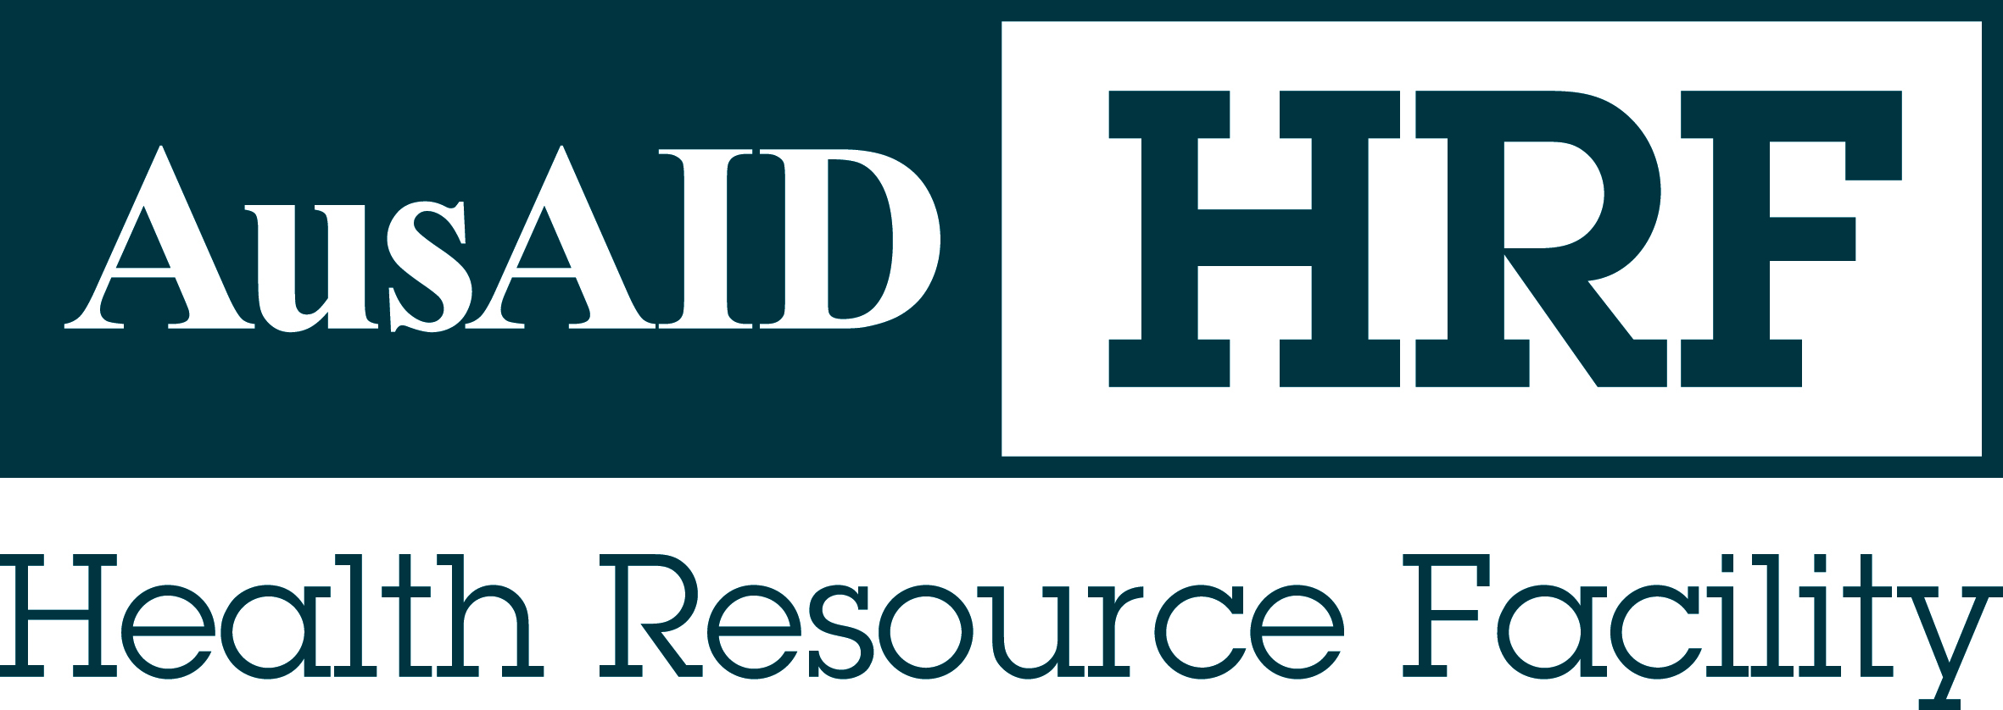

Independent Progress Review of the UN Joint Program on Maternal and Neonatal Mortality Reduction, Philippines

Adrienne Chattoe-Brown
Jenny Kerrison

Final report
12 December 2012

AusAID HRF
HLSP in association with IDSS
GPO BOX 320
15 Barry Drive
Canberra City ACT 2601
Tel: +61 (2) 6198 4100
Fax: +61 (2) 6112 0106
www.ausaidhrf.com.au
Aid Activity Name
AidWorks initiative number | ING400, INJ251
Commencement date | 20 Jan 2006 (ING400) and 30 May 2010 (INJ251) | Completion date | 30 June 2010 (ING400) and 30 June 2013 (INJ251)
Total Australian $ | 22,700,000
Total other $
Delivery organisation(s) | UNFPA, WHO and UNICEF
Implementing Partner(s) | UNFPA, WHO and UNICEF
Country/Region | Philippines
Primary Sector | Health

Acknowledgments
The team would like to thank the JPMNH implementation team for their active and constructive participation during this review. Particular thanks go to Arvi Miguel for his efforts in coordinating our programme and meeting our information needs.
The team would also like to thank Pablo Lucero from AusAID for his guidance and support throughout the review process.

Authors Details
Adrienne Chattoe-Brown (team leader) is a specialist in health systems strengthening and programme performance, quality and evaluation. She has 18 years experience in development work in Asia, Africa, Central Asia, China and the Pacific.
Jenny Kerrison is a maternal and newborn health (MNH) specialist with experience in developing training systems, research and evaluation. Her Doctor of Education degree research was in Program Evaluation. She has worked over eight years in MNH in West Timor, Indonesia. Recently, she worked as an advisor for short periods of time in Bangladesh.

Contents
Acronyms vi
Executive Summary viii
Evaluation Criteria Ratings xi
1. Introduction 1
1.1. Activity Background 1
1.2. Evaluation Objectives and Questions 2
1.2.1 Questions 2
1.2.2 Phases and timeline 2
1.2.3 Methodology and methods 3
1.2.4 Assumptions and Limitations 3
2. Evaluation Findings 4
2.1. Relevance 4
2.1.1 Relevance to AusAID 4
2.1.2 Relevance to Government of Philippines priorities 5
2.1.3 Relevance to context and needs of beneficiaries 6
2.1.4 Alignment with Paris declaration 7
2.1.5 Relevance of Program to UN agencies 8
2.2. Efficiency 8
2.2.1 Program management 8
2.2.2 Timeliness of completion of activities 9
2.2.3 Risks to achievement of objectives 10
2.3. Sustainability 11
2.3.1 Levels of sustainability in the Program design 11
2.3.2 Capacity and resources to train and maintain competencies 12
2.3.3 Sustainability concerns 13
2.4. Gender equality 14
2.5. Monitoring and Evaluation 15
2.5.1 Overview of the M&E system 15
2.5.2 Strengths of the M&E system 16
2.5.3 Weaknesses of the M&E system 17
2.5.4 Evidence of program progress 18
2.5.5 Disaggregation of data 18
2.5.6 Roles and responsibilities for M&E 18
2.6. Analysis and learning 18
2.7. Effectiveness 19
2.7.1 Effectiveness at output level 19
2.7.2 Effectiveness at intervention level 22
2.7.3 Contribution of activities and outputs to the intermediate outcomes 23
2.7.4 Promoting and challenging factors to achieving outputs, outcomes and objectives 24
2.8. Impact 25
2.8.1 Potential for long term impact 25
2.8.2 Adverse influences upon impact 25
3. Evaluation criteria ratings 27
4. Conclusion and recommendations 28
4.1. Conclusions on the transition phase 28
4.2. Recommendations for the next phase 29
4.2.1 Focal areas - geographic 30
4.2.2 Focal areas - technical 30
4.2.3 Monitoring and evaluation 31
4.2.4 Working with DOH 32
4.2.5 Other governance issues 33
4.2.6 Gender 33
Annex 1: Terms of reference 34
Annex 2: Interview guide 41
Annex 3: Province and community site visits 45
Annex 4: Case study: Reaching the Urban Poor 46
Annex 5: Case study - EINC Hospital delivery program 54
Annex 6: Case study - UNFPA Training in BEmONC & CBFP 59
Annex 7: JPMNH Monitoring Framework 61
Annex 8: JPMNH consolidated results table for implementation year 2011 62
Annex 9: Case study: UNICEF r-CHITS 65
Annex 10: RUP results 67
Annex 11: UNICEF results 72
Annex 12: UNFPA results 74
Annex 13: 2011 geographical mapping of JPMNH interventions 75
Annex 14: Estimated funding to the JPMNH 2009 - 2016 80
Annex 15: UNDAF priority areas and GOP MDG breakthrough provinces 81
Annex 16: Suggested format for the revised monitoring framework 82
Annex 17: References 85
Annex 18: Mind map of UNICEF interventions within JPMNH 88
Annex 19: Mind map of WHO interventions within the JPMNH 91
Annex 20: People met 92
Annex 21: IPR Itinerary 94
Annex 22: Core functions and focal agencies for MNCH joint working 99

List of tables
Table 1: Risk analysis and mitigation table with review team comments 10
Table 2: JPMNH objectives, outcomes ad outputs 15
Table 3: Navotas RUP end of project results against baseline 23
Table 4: Tacloban City RUP end of project results against baseline 23

Acronyms
AAA | Accra Agenda for Action
AO | Administrative Order
AusAID | Australian Agency for International Development
BEmONC | Basic Emergency Obstetric and Newborn Care
BHC | Barangay Health Centre
CAPF | Australia’s Comprehensive Aid Policy Framework
CBFP | Competency-Based Family Planning
CHD | Centre for Health Development
CHO | City Health Office
CHT | Community Health Team
DHS | Demographic Health Survey
DOH | Department of Health
EC | European Commission
EINC | Essential Intrapartum and Newborn Care
FP | Family Planning
GAD | Gender and Development
GIDA | Geographically Isolated and Disadvantaged Area
GOP | Government of the Philippines
HRF | Health Resource Facility
IPR | Independent Progress Review
JPMNH | Joint Programme on Maternal-Newborn Health
KP | Kalusugang Pangkalahatan
LGU | Local Government Unit
M&E | Monitoring and Evaluation
MDGs | Millennium Development Goals
MNCHN | Maternal, neonatal, child health and nutrition
MOA | Memorandum of Agreement
ODA | Official development assistance
PhilHealth  PPGD | Philippine Health Insurance Corporation  Philippine Plan for Gender-Responsive Development
PPP | Public Private Partnership
QED | qualitative exploratory descriptive
RN HEALS | Registered Nurse - Health Enhancement and Local Service
RHU | Rural Health Unit
RUP | Reaching the Urban Poor
TrWG  UN | Transition Working Group  United Nations
UNCO | United Nations Coordination Office
UNDAF | United Nations Development Assistance Framework
UNDG | United Nations Development Group
UNDP | United Nations Development Program
UNFPA | United Nations Population Fund
UNICEF | United Nations Children’s Fund
USAID | US Agency for International Development
VAW | Violence against women
WHO | World Health Organization

Executive Summary
This independent progress review (IPR) of the UN Joint Programme on Maternal-Newborn Health (JPMNH) (2009-2016) in the Philippines was commissioned by AusAID to assess progress during the transition phase (against the standard eight evaluation criteria) and to make recommendations for implementation during the next phase.
Following a desk based document review, a two person review team travelled to the Philippines between 24 September and 8 October. Methods employed during the mission included further literature review and key informant interviews using face to face semi-structured interviews with individuals and groups of people from AusAID, the UN implementation team (WHO, UNICEF and UNFPA), Department of Health (DOH), local government units (LGUs), government implementation personnel, and to a limited extent beneficiaries and other donors in the health sector. The team also made site visits to a small number of health facilities at the province and community levels, attempted to map inputs and results by UN JPMNH agencies, and reviewed Program performance data, and service delivery data.
Relevance. The JPMNH has good relevance to AusAID’s global aid priorities of saving the lives of women and newborns. There is strong policy relevance to Government of the Philippines priorities whose Development Plan emphasises maternal and neonatal health, which AusAID supports through its 21012-2017 Aid Program. The JPMNH is strongly aligned to the sub-sector objective of improving local government service delivery, and the cross-cutting objective of good governance and the emphasis on gender equity and inclusive development. Evidence from field work suggested good relevance of technical inputs to local needs. Relevance is therefore rated as a 6 (very high quality).
Efficiency. Whilst it was not possible to quantify the efficiency or value for money of the JPMNH we have been able to observe that it could be greater. There is little sharing of resources despite co-location of two of the agencies, and until recently all three have maintained separate funding arrangements with AusAID. Although progress has been made in moving to a pass through mechanism, changes to the arrangements have interrupted implementation. UN accounting rules also caused disbursement delays at the turn of the year. Recent program management developments should increase efficiency: a joint annual workplan has been presented for 2012, and funding is now being channelled through UNDP, with UNCO in country taking on a coordination role. However on the basis of low efficiency for much of the transition phase, it has been rated as a 3 (less than adequate quality).
Sustainability. Ownership of the Program interventions, which was evident at field level, will facilitate sustainability. Also several interventions are being institutionalised e.g. Essential Intrapartum and Newborn Care (EINC) in participating hospitals and in training programmes and curriculum changes in family planning. Advocacy and policy work at national and sub-national levels have mostly resulted in positive and sustained interventions such as: curriculum changes for EINC and Family Planning (FP). Although sustainability of some interventions remain a challenge, with persistent fundamental issues within the sole purview of government, overall program performance has been good in this area and warrants a rating of 5 (good quality).
Gender equality. The Program is gender responsive as it addresses maternal mortality, but it needs to widen its Gender and Development (GAD) view. There are resources within the UN team, and also monitoring tools that could enable this to happen. This has been rated as a 5 (good quality).
Monitoring and evaluation. Although the monitoring of some individual interventions has been good and there is local ownership of the data being generated, M&E at a higher level has been very weak. The outline results framework in the original program document was never articulated further into an M&E plan and has the following weaknesses: the objectives and outcomes are confused; the original outputs are too broad and not linked to inputs; and amendments to the output indicators have made them less robust. Although a baseline for outcomes has been established, targets were not used at either outcomes or output level. Of most concern is the fact that the monitoring framework does not capture the entirety of the JPMNH. For this reason it has been rated as a 2 (poor quality).
Analysis and learning. While the Program has been based on sound technical analysis, lesson learning through the Program has been limited with few evaluations of interventions and approaches. It has therefore been rated as a 3 (less than adequate quality).
Effectiveness. Given the problems with the M&E system described above it has been difficult for the review team to establish effectiveness of the Program. However there are evidently positive results from individual interventions such as Reaching Urban Poor (RUP) and EINC, which suggest effectiveness in increasing service utilisation and reducing neonatal mortality rates. The effectiveness of some other interventions is problematic e.g. training in Basic Emergency Obstetric and Newborn Care (BEmONC) and long lasting methods of contraception, due to constraints around follow up training. However the effectiveness of successful interventions and the potential success of others once barriers are addressed, means the program merits a rating of 4 (adequate quality).
Impact. In addition to impact resulting from some interventions there is potential for long term impact, particularly if the Program can significantly increase the number of facilities accredited by Philippines Health Insurance Corporation (PhilHealth) and institutionalise quality at facility level. However impact is being compromised by a lack of convergence – topical and geographical - a lack of joint working at intervention level where it could exist, and Program governance issues, in particular the failure of the Program to realise joint working. The capacity of the Department of Health (DOH) to engage meaningfully with the Program and the Program’s broad focus may also reduce its long term impact.
Conclusions. The Program as it currently stands lacks coherence and strategic focus, and the synergies hoped for by AusAID in funding the UN agencies jointly have not yet been demonstrated. The program does however hold considerable potential for greater effectiveness and impact.
Recommendations. The review team recommends that AusAID should continue funding into the next phase, with the following changes to the Program:
- There should be close geographical alignment to where Government of Philippines (GOP) MDG breakthrough provinces converge with UNDAF priority areas. This will mean winding down the Program in some existing areas, consolidating in others, and if funds allow introducing Program activities to new areas. Exit strategies should be planned for existing Program areas with limited continuation activities to ensure sustainability.
- There should be stronger technical focus on interventions with proven results and on those that have the potential to address immediate bottlenecks in utilisation and service quality.
- The M&E system should be given a thorough overhaul.
- Better strategies should be developed for working with DOH more effectively at the national and regional levels.
- The Program should make every effort to engage in genuine joint working.
- The gender analysis of and reporting on the Program should be stepped up.
Evaluation Criteria Ratings
Evaluation Criteria | Rating  (1-6) | Explanation
Relevance | 6 | The JPMNH has good relevance to AusAID’s global aid priorities of saving the lives of women and newborns. There is strong policy relevance to the Government of the Philippine’s Development Plan which aims to reduce maternal and child mortality, and which is supported by AusAID, under AusAID’s 2012– 2017 Aid Program strategy. The JPMNH is strongly aligned to the sub-sector objective of improving local government service delivery, and the cross-cutting objective of good governance and the emphasis on gender equity and inclusive development. The Program is strongly aligned to GoP health sector priorities, in particular its efforts to reach MDG 4 and 5 through the implementation of the MNCHN strategy.
Effectiveness | 4 | Given the problems with the M&E system it has been difficult to measure effectiveness of the Program. However positive results from individual interventions were noted including EINC, RUP, provision of equipment and leveraging funding for FP supplies. Capacity problems at all levels and raising service quality are on-going challenges to the efficacy of these interventions.
Efficiency | 3 | Efficiency could have been greater. There is little sharing of resources, and until recently all three agencies have maintained separate and parallel funding arrangements with AusAID. Changes in funding arrangements have interrupted implementation. Joint working has been minimal. However a consolidated workplan has been prepared for 2012 and there has been evidence of better program coordination and joint working in the past year, which has probably increased efficiency. Several risks identified in program design did not materialise and those that did were handled adequately. DOH engagement with the Program has been limited.
Sustainability | 5 | Ownership of the Program interventions will facilitate sustainability. Also several interventions are being institutionalised. Advocacy and policy work at national and sub-national levels have resulted in positive and sustained interventions. Nevertheless sustainability is a challenge with some persistent fundamental issues within the sole purview of government e.g. staffing numbers.
Gender Equality | 4 | Whilst the Program is gender responsive as it addresses maternal mortality, it needs to ensure that all implementing agencies are gender responsive in their monitoring and reporting.
Monitoring & Evaluation | 2 | Monitoring of some individual interventions has been good and there is local ownership of the data being generated, M&E at a higher level has been very weak. There is no M&E plan, objectives and outcomes are confused, the original outputs are too broad and not linked to inputs, and amendments to the output indicators have made them less robust. Although there is a baseline for outcomes there is no use of targets at either outcomes or output level. The monitoring framework does not capture the entirety of the JPMNH.
Analysis & Learning | 3 | The Program has been based on sound technical analysis, but lesson learning has been limited with few evaluations of interventions and approaches.
Rating scale: 6 = very high quality; 1 = very low quality. Below 4 is less than satisfactory.
- Introduction
AusAID commissioned the HRF to carry out an Independent Progress Review of the UN Joint Programme on Maternal and Neonatal Mortality Reduction (2009-2016) in the Philippines. Terms of reference are at Annex 1. Technically, the IPR is a mid-term review of the JPMNH transition phase which commenced in 2009 and was due to finish in 2011 but is still underway in 2012. Judgements on the Program were made against the standard eight evaluation criteria (relevant, effectiveness, efficiency, impact, sustainability, M&E, gender equality, and analysis and learning). This report provides details of the Program background, evaluation objectives, methodology, methods and findings. Recommendations are also provided for the Programme’s phase 2013-2016 on areas for improvement.
  - Activity Background
The Philippines is far from achieving the MDG 5 target of 52 maternal deaths per 100,000 live births by 2015. According to the 2008 State of World Population Report, maternal mortality ratio in the Philippines is 230 maternal deaths for every 100,000 live births. Eleven (11) women die every day while giving birth. Only 62% of births are assisted by a trained health professional and 44% of births occur in health facilities. The unmet need for family planning remains high. Almost half of all pregnancies are unintended.
With this context, the UN JPMNH Program (2009-2016) was developed by UNFPA (United Nations Population Fund), UNICEF (United Nations Children’s Fund) and WHO (World Health Organisation) in close consultation with the Philippines Department of Health (DOH). The program aimed to support implementation of the national strategy for the rapid reduction of newborn and maternal mortality in target provinces and to assist Government progress towards meeting MDGs 4 and 5. The intention was that the UN agencies would work jointly within their respective mandates and areas of expertise to maximise their comparative advantages in MNH (see Annex 22).
A review of AusAID’s health engagement in the Philippines was conducted in 2008 which recommended a re-focus of health investments on one priority - maternal and neonatal health – in order to be more effective. The same review also suggested channelling support through a joint program implemented by relevant UN agencies. Based on the review recommendations, in 2009 AusAID provided an initial contribution of AUD$ 2 million to UNFPA and UNICEF in support of first year’s activities (June 2009 to June 2010) of a Joint Program.
From June 2010 to December 2011, the Joint Program was implemented in six (6) provinces, namely: Eastern Samar, Ifugao, Lanao del Sur, Maguindanao, North Cotabato and Sarangani and in four (4) urban poor areas in the National Capital Region (NCR) where most babies are delivered by unskilled birth attendants. These areas are also characterised by high maternal and newborn mortality rates and low use of contraceptives. AusAID provided AUD $ 12.2 million for this period.
For the year 2011 to 2012, the AusAID contribution to the UN Joint Program amounted to AUD$ 8.5 million. Total AusAID contributions to the Program since 2009 amount to AUD$ 22.7 million. For 2013 to 2015, the UN Joint Program intends to strengthen UN collaboration in identifying and implementing a package of interventions, scale up of its implementation to additional provinces, geographically-isolated and disadvantaged areas (GIDA) municipalities, and urban poor areas in selected highly urbanized cities in the country while contributing to the implementation of the DOH MNCHN strategic plan currently being developed.
The findings and recommendations of the IPR will feed into refining the scale up design of the project ‘Accelerating Efforts to Attain Targets of MDGs 4 & 5 through Joint Programming on the Rapid Reduction of Maternal and Neonatal Mortality in the Philippines’. The UN has submitted an initial proposed design and is currently revising the proposal based on design guidance provided by AusAID.
  - Evaluation Objectives and Questions
The IPR’s objectives were to assess progress of the UN JPMNH against the standard eight evaluation criteria, and provide recommendations on areas for improving and scaling-up implementation, including whether an expansion within the current design is feasible, and provide options for expansion. Progress in the Program was examined in relation to its achievement of the two intermediate outcomes of:
(1) Improved access to quality continuum of care and services to mothers and newborns in identified program sites;
(2) Increased utilisation of core reproductive health, maternal and newborn services in geographically isolated and depressed areas of program sites.

Questions
Questions used in the IPR were based on the eight evaluation criteria (relevance, effectiveness, efficiency, impact, sustainability, M&E, gender equality, and analysis and learning). Key questions included were:
- Are the intermediate outcomes still relevant to the Australian Government and partner government priorities, and to the context and needs of beneficiaries?
- To what extent do activities and outputs contribute to the 2 intermediate outcomes? Has the Joint Program attained its objectives?
- Is the Joint Program efficiently managed to get value for money from inputs to achieve outputs and outcomes.
- What are the observable intermediate outcomes as a result of the Joint Program, if any? What are the unintended (positive and negative) benefits?
- Do beneficiaries and Joint Program partners demonstrate ownership, capacity and resources to maintain outcomes after funding has ceased?
- Does the M&E system effectively measure progress towards meeting Program objectives? Does the M&E system collect useful information on cross-cutting issues such as gender, disability, child protection?
- How did the Joint Program promote equal participation and benefits for and access by women and men?
- Is the Joint Program based on sound technical analysis and continuous learning?

Phases and timeline
The evaluation mission was conducted in four phases: a desk phase, field phase, synthesis phase and reporting phase. The desk, field and synthesis phases were conducted between 17 September and 8 October 2012. Reporting of the evaluation, which was the last evaluation phase concluded in mid-November 2012.

Methodology and methods
A qualitative exploratory descriptive approach (QED) has underpinned this evaluation design. Key methods applied in the IPR during the two-week visit (24 September to 8 October) included:
• Literature reviews of documents provided by AusAID, the UN implementation team and supplementary material as requested by the team in the field, and online documents gathered by the team (see Annex 17 References).
• Key informant interviews using face to face semi-structured interviews with individuals and groups of people from AusAID, the UN implementation team, Department of Health, local government units, implementation personnel, and to a limited extent beneficiaries and other donors in the health sector. An interview guide was prepared during the desk phase (see Annex 2 Interview guide)
• Site visits to a small number of health facilities at the province and community levels (see Annex 3 for sites visited, Annex 20 for people met, and Annex 21 for the in-country itinerary).

Assumptions and Limitations
Assuming AusAID continues to fund it, the Program is expected to run until 2016, as indicated in Program documents supplied to the IPR team. Thus, this IPR is effectively a mid-term review. This implies that some results may be expected at this stage (at output level) but others may not yet be apparent (at outcome level).
Information provided to the IPR team did not contain much substantive information to support understanding of how the Program had progressed towards achieving the two intermediate outcomes. The theory of change was not clear in the monitoring framework (i.e. the Program logframe) and its indicators did not fully match the output and outcome statements. Thus, the IPR team’s expectation was that baseline data would be available and used in the Programme, to monitor progress in implementation sites, as described in the Program M&E section (2009-2011 Program Document, p. 17). The IPR team also assumed that the Programme would have a robust and functioning M&E system in place, to monitor and evaluate Programme achievements. It was also assumed that the Program would have a sound documentation and reporting system, as part of Program governance and accountability to AusAID.
From June 2009 to December 2011, the Joint Program was implemented in six (6) provinces and in four (4) urban poor areas in the National Capital Region. The length of the review was limited to one and a half weeks of field work to look at implementation in practice, and there was considerable travel time due to the distance between sites. Therefore the team focussed on a small number of sample sites and interventions (see Annexes 4, 5 & 6 for case studies of RUP, EINC and UNFPA), with limited time at each. At the same time the scope and activities of the program are very broad. The IPR team has relied primarily on existing data (largely provided by the program) and interviews with limited number of national and LGU program implementers. Only one Community Health Team consisting of women who are also Program beneficiaries was met by the team.
As a consequence, the IPR consultants were not able to independently verify all the results claimed by the program, but relied on the accuracy of data provided by the program on specific interventions, and focused on inputs and processes to achieve them.
Evaluation Team
Evaluation team
Name | Position | Areas to cover in the evaluation
Adrienne Chattoe- Brown | Team-leader  Performance, Quality and Evaluation Specialist | Overall responsibility for the work of the review team.  Focus on design, management, coordination, M&E and sustainability issues.
Jenny Kerrison | Maternal and Neonatal Health (MNH) Specialist | Assessment of the technical quality of the program.  Focus on MNCH policy and practice, capacity building, program prioritisation, gender, impact of context.

The evaluation team has a total of 26 years’ experience in international development work. Adrienne Chattoe-Brown is a specialist in health systems management and performance, quality and evaluation, with field experience in Asia and Africa.
Jenny Kerrison, the MNH specialist, has worked in the field of MNH in the development context since 1996. Her Doctor of Education degree thesis was in Program Evaluation and the use of Program Logic Model as a program planning tool.
The evaluation team was joined by one or two UN program staff during consultations and site visits. Their role was to act as resource persons to the team and provide context and additional information to enhance the team’s understanding of the MNH context and the Program. They had no report writing responsibilities and judgements are the responsibility of the independent evaluation team.
- Evaluation Findings
  - Relevance

2.1.1 Relevance to AusAID
AusAID supports the Philippines Development Plan (2011–2016) which aims to ensure equitable access to basic health care for all to reduce maternal and child mortality, and morbidity. The Program operates directly in support of achieving these objectives.
The Program was developed during the previous Aid Program Strategy period 2007 - 2011 when it was in line with Australia’s strategy to make women’s and children’s health services more widely available in targeted regions. Since then, with the development of the 2012-2017 strategy, AusAID no longer includes health in its sector sub-objectives. However the Program is strongly aligned to the sub-objective of local government service delivery, as it emphasises local government capacity building, creating political support for essential health services and evidenced based policy making. The Program is also aligned with AusAID’s cross-cutting objective of good governance, and emphasises gender equity and inclusive development.
The Philippines’ high population growth has increased demands on basic services with subsequent delays in achievement of the MDGs. Population control is important to curb the high population growth in the Philippines and achieve MDG 5.,, One of the Program’s strengths is the support for family planning through procurement of contraceptives, capacity building for training, and outreach service delivery. UNFPA’s position on family planning is aligned with AusAID’s Family Planning guidelines (2009).
The Program’s two intermediate outcomes, if achieved, will save the lives of women and newborns. Saving lives is a key Australian Government’s international aid priority. Specifically, AusAID supports family planning programs and improving women’s and children’s health services, as reflected in the Australia-Philippines Development Assistance Strategy 2007-2011; the Philippines Program Health Strategy 2009-2011; and more recently, Australia’s Comprehensive Aid Policy Framework to 2015-2016 (CAPF).,,
Health (saving lives) is one of the five strategic goals for AusAID in the CAPF. Therefore the JPMNH Program is also relevant to the broader Australian Government’s aid policy.

2.1.2 Relevance to Government of Philippines priorities
Broadly, the Program design is aligned with the MNCHN strategy. The general guidelines of the MNCHN strategy are noted in the Program design, including the minimum standard services for the continuum of services consisting of: pre-pregnancy services; antenatal care; care during delivery; and postpartum care and are referred to as the MNCHN core package of services. These services are delivered LGU-wide by the MNCHN service delivery network located at three levels of care: community; Basic Emergency Obstetrics and Newborn Care (BEmONC); and Comprehensive Emergency Obstetrics and Newborn Care facilities. BEmONC can be provided at facilities such as: RHUs, BHC, lying-in clinics, or birth homes managed by skilled health professionals. Universal health care for maternal and child health is supported by Administrative Order No. 2010-0036. Much of the focus of the Program is on developing and improving the service delivery network.
Specific Program interventions and activities such as support to LGUs in achieving PhilHealth accreditation of MNH facilities, and PhilHealth registration of families in the lowest income quintile, is in line with the country’s emphasis on achieving universal health care that is underpinned by the Administrative Order No. 2009-0025; and Administrative Order No. 2010-0036. Support for the Reaching the Urban Poor (RUP), approach is also relevant, as it is incorporated into the Urban Health System Development (USHD), as expressed in the DOH Administrative Order No. 2011-000. Clinical interventions such as EINC and BEmONC and family planning training were also highly regarded by DOH and LGUs.
Alignment to the GOP planning and implementation modalities
At the LGU level, the Program reported alignment with the annual work plan, which is developed from the Province-Wide Investment Plans for Health (PIPH) that details the medium term strategic plan for each province. Bottom-up barangay community planning is one of the outputs in RUP sites.
In clinical interventions (e.g. EINC and BEmONC), the Program has aligned with implementation modalities of the DOH Centres for Health Development (CHD) and Health City Offices at the LGU level. At Eastern Visayas province, the CHD highlighted the need for more support to strengthen their role in supervision following training and in M&E, in general. The RH commodities supply was also implemented using DOH implementation pathways.
However, the use of public-private partnership (PPP) in the Program’s community engagement activities is a relatively new initiative for DOH and LGUs. Internationally, this approach is seen as useful for increasing and reinforcing development results, as noted in the Busan Partnership. In the Philippines, Public-Private Partnership (PPP) is encouraged in the MNCHN strategy and in achieving the Aquino Health Agenda for Universal Health Care (Administrative Order No. 2010-0036) (DOH, 2010, p. 4). The LGUs are encouraged to enter into a partnership with private providers to deliver MNCHN services such as BEmONC or CEmONC. Thus, the Program’s use of PPP is appropriate. However, the Program did not include capacity building for LGU staff to manage competitive tenders and implement PPP projects, including developing appropriate policy and regulations. This is a missed opportunity to develop the local government’s capacity.

2.1.3 Relevance to context and needs of beneficiaries
Focus on the MDGs 4, 5, and 5B is relevant to the Philippines. Achievement of MDG 5B (universal access to sexual and reproductive health) is essential for the achievement of MDG 5. Addressing MDG 4, in particular, newborn mortality rate (NMR) makes sense, as NMR contributes more than 50 per cent of the infant mortality rate in the Philippines.
The Program’s intermediate outcomes remain appropriate given the country’s slow progress towards reducing the MDGs 4 and 5. From 2009 to August 2011, in line with the Administrative Order No. 2010-0036 ) for Universal Health Care, the sub-population GIDAs group was emphasised in the Program. In August 2011 GOP focus was further elaborated with the introduction of Kalusugang Pangkalahatan (KP) (Universal Health Care) which identifies 12 MDG breakthrough geographic locations with the poorest 10.8M households, and targets them for particular support. The Program will need to take this into account in its next phase (see section 4.2).
Alignment with LGUs’ priorities
At the local level, the Eastern Samar province welcomed the Program’s support for family planning interventions (contraceptive supplies, training and outreach services), in particular, as the province reported a contraceptive prevalence rate (CPR) of 18 per cent in 2008 well below the national CPR was 51 per cent. In this province, the Program supported a comprehensive set of relevant core activities such as: providing vital MNH commodities; increasing capacity for EONC, EINC, BEmONC; maternal death reviews; postpartum care for women and newborns; and PhilHealth accreditation of facilities. To increase demands on MNH services, the province also supported the Community Health Teams (CHT). However, the Eastern Samar province reported a relatively good MMR of 129 in 2008, in comparison to the national average of 230 per 100,000 live births.
At Eastern Samar and Eastern Visayas Provinces (sites visited by the IPR team), participation of City/Provincial Health in Program activities was good. City Health Offices (CHO) participate in the City Technical Working Group (CTWG) and review health centre data, select sites based on set criteria, and conduct inspection visits to the sites.

2.1.4 Alignment with Paris declaration
Each UN agency in the Program advocates aid effectiveness, as outlined in the Paris declaration, Accra Agenda for Action (AAA) and Busan partnership. The Program works closely with DOH and LGUs health network and the relationship are founded on several years of credible UN work in the Philippines. Interviews with DOH, CHD and Provincial Health reveal that the managers do feel that they lead in identifying priorities for support from the Program for example, in prioritizing activities/interventions for a coordinated approach to aid. However, DOH reported that they had no inputs in the selection of geographic locations and has requested more coordination and joint planning. They also emphasized the need for coordination with the DOH team and not only with individuals.
Regular feedback of results to DOH is needed. DOH feels that they often “don’t know what happens on the ground”; for example, they may be invited to participate in developing the TOR for the survey and there is no follow up on how the survey progresses. DOH emphasized the need for collegial and healthy interactions between staff and exchange of intellect and ideas. Interactions should be two-way and not one-way only. The call is for more consultation.
Several donors are also working in the Program sites and these include: Asian Development Bank; European Union; World Bank; Japan International Cooperation Agency; and USAID. USAID is the largest donor in the MNH in the country. There was scant information regarding coordination meetings and level of harmonisation between the Program and other donors. Information obtained from the European Commission (EC) suggests that there has been little communication and sharing of knowledge between the Program and EC about Program activities and achievements, but that overall, levels of coordination and communication between development partners is generally rather low.

2.1.5 Relevance of Program to UN agencies
World leaders have acknowledged that they must focus beyond maternal health to include family planning, sexual health and prevention of unsafe abortion, to achieve MDG 5. The WHO recommended targeted approaches in four thematic areas for achievement of MDG 5: strengthening policies; adequate financing; strengthening human resources; and improvement of service delivery. These thematic areas are evident in the Program design and with greater emphasis on improving service delivery.
The UN team reported that approximately 80% of the two UNDAF sub-outcomes on RH/MNH and Universal Access were now being supported by the Program implying that it is closely aligned with and relevant to the UN core programmes.
Since 2012 the three UN agencies have been aiming to ‘Deliver as One’ in line with the global UN emphasis for “…One UN at country level, with one leader, one programme, one budget and, where appropriate, one office.”.. The intended implementation modality of the program, which aimed at joint implementation prior to this date, is well aligned to this.
The program is also well aligned to the mandates of the individual UN agencies, their comparative advantages and their focal areas as outlined in the statement on joint country support to accelerate progress towards improving maternal and newborn health (see annex 22).
  - Efficiency
An assessment of efficiency in part depends on activity and financing data being accessible and comprehensible. Activity reporting on the Program has been limited and varied, as described in section 2.5 below, and the reports do not capture costs by intervention or output.. The review team asked for summary financial statements from the three agencies, grouped by intervention or sets of intervention but these were not forthcoming from all of them. We are therefore limited on what we can say about efficiency and value for money.

2.2.1 Program management
AusAID had intended that the joint program would reduce its transaction costs with individual UN agencies. UNFPA was to be the lead administrative agency channelling funds to the other two agencies and there was meant to be joint planning and monitoring and consolidated reporting and budgeting. This was never fully realised as relations between the agencies quickly became acrimonious, and so AusAID resorted to engaging with individual agencies.
Joint monitoring missions to the field seem to have been limited after the first year and representatives of different agencies working in the same areas were reported to have visited the same field sites on a fairly regular basis. Coordination at field level could clearly have been improved given that the review team heard reports of JPMNH events clashing.
Each agency maintained its own monitoring and contracting arrangements with implementing partners. Separate submission of Program workplans and reporting to AusAID increased its transaction costs with the Program and made progress of the overall program difficult to track.
Since early 2012 the Programme has been operating more explicitly in line with the ‘Delivering as One’ approach. As reported by UNCO to the IPR team, in the joint program modality the Program is supposed to work as a “single concept, thrust and approach and ideally, it should have one budget, one report and one M&E”. A joint work plan was prepared for 2012 and there is the intention to provide a consolidated annual report. A UNCO Program coordinator commenced work in March 2012 to assist in the much-needed coordination of the three agencies in the Program. A designated staff member prepares joint program documents and coordinates meetings for the Program. Whilst it is too early to assess the efficiency or value for money of UNCO, the initial impression is that UNCO has greatly assisted in bringing more trust, collegiality, collaboration and communication between all three agencies. UNCO attributes this to the joint working agenda set by the new UNDAF and the greater emphasis on ‘delivering as one’ in which the Philippines UN Office has invested.
In terms of sharing of resources UNICEF and UNFPA are co-located along with much of the rest of the UN country team which improves communications and working relationships and sharing of meeting rooms. It also makes the work of the UNCO coordinator more efficient. UNICEF and UNFPA are located about an hour away from the DOH which houses WHO, which puts a high travel overhead on meetings which include all parties.
The Program represents good value for money in some aspects of management in that most technical input time from the three agencies is covered by funds outside the Program i.e. the agencies’ regular resources. This enables the Program to make use of e.g. UNFPA local field staff, without cost, and makes the wider resources of the UN available to the Program. Two posts are funded by the Program, the RUP coordinator and the UNCO programme coordinator. WHO also funded another short term contractor to work with DOH on the early stages of EINC. Other technical inputs are bought in from time to time on short term contracts for a period of weeks to do specific tasks. Each agency levies a standard 7% charge top sliced from program funding to each one, and UNDP will charge 1% to act as administrative agent for passing funds through its Multi Partner Trust Fund. The IPR team understands that this is a standard UN charge. Given the very large range of activities funded by the Program and the degree of engagement by the agencies in the Program this may be reasonable value for money.

2.2.2 Timeliness of completion of activities
Completing activities as scheduled is a concern for all three UN agencies in the Program. For example six-month extensions of the work plan have been granted to UNFPA and WHO due to delays in completing scheduled activities for 2011. UNPFA reported that the closure of the 6th Country Program in 2011 resulted in delays to implementation and payments of scheduled activities for example to the Family Planning Consortium. The UN system of annual acquittals means that all monies have to be accounted for before more are released which is good from the financial probity aspect but problematic for implementing partners who usually find themselves without financial support at the turn of the year whilst waiting for the next tranche of money to come through. This can result in a hiatus of activities except among those partners who are familiar with the system, have their own funds to act as a buffer, and who have sufficient faith in their ability to meet UN financial monitoring requirements that they underwrite activities in the interim. This problem is not particular to this programme or the Philippines.
Problems with financial disbursements to implementing partners and delays in completing activities were also caused by changes in the Program funding arrangement with AusAID. The initial pass through arrangement set up with UNFPA was not acceptable to the other agencies so this had to be unpicked and separate parallel agreements made with each partner. This was an inefficient funding arrangement that not only created additional program management work for AusAID but contradicted AusAID’s support for joint programing of UN agencies. This is now in the process of reverting to a pass through arrangement with UNDP. These changes have meant that program funding has been ‘lumpy’ with agencies experiencing delays in being able to access funds which were passed on to implementing partners.

2.2.3 Risks to achievement of objectives
The original program document contained the following risk analysis and mitigation plan. The review team’s comments are in the last column.
Table 1: Risk analysis and mitigation table with review team comments
Risk areas | Probability | Impact on JPMNH | Mitigation | Comments on risk management
- Effects of disasters (e.g. man-made, armed conflict or natural calamities). The macro political risk of armed conflict /unrest disrupting project functioning | High | Medium | Within the joint UN humanitarian response framework alternative mechanisms will be established to provide funding to partner NGOs, IOM, UN-OCHA and UNDPA | During the life of the programme there has been one major humanitarian disaster near one of the Program areas to which the Program responded by providing emergency RH kits. The team is now focussing on supporting the government to preposition commodities to address future such events rather than relying on external emergency procurement
- Worsening global financial crisis possibly resulting in the realignment of funds outside the social sector and change in priorities | Medium | High | Advocate for more predictable funding for MDG 5 through multi-year allocation from national and international development partners | In fact the health sector and MNCH as a priority area has received more funding since the start of the Program.
- Misuse of resources or fraud (Corruption) | Low | Medium | HACT assurance activities comprising of joint spot checks, regular monitoring and periodic internal and external audits | The impression we gained from interviewing implementing partners was that the UN employs stringent audit standards and has carried out spot checks.
- Divergence of UN local level activities from the national priorities | Medium | Medium | A small transition working group (TrWG) of the three agencies comprising the country heads of the UN agencies and their technical focal persons will meet and ensure the smooth functioning of the JPMNH. In all three agencies senior staff members have assigned significant proportions of their time to the JMPNH. Use of exiting national and sub-national management and coordinating structures as a venue in reviewing coherence and embedding joint program activities in relevant PIPJH/CIPH and LGU workplans and adaptation of Country Harmonisation and Alignment tool (CHAT) | This is a persistent tension within the Program (and the health sector as a whole). The UN team has chosen areas which have good alignment to national priorities. Local elections in 2013 may test this further.
- Focusing only on LGU and community partnerships resulting in non-sustainable interventions | Medium | High |  | Evidence from our field visits was that UN engagement at provincial level appeared to be adequate. However there should be more engagement with CHDs.

  - Sustainability

2.3.1 Levels of sustainability in the Program design
One of the key attributes of high quality aid is sustainability. A project/program is considered sustainable if interventions are adopted by stakeholders and there are benefits following project completion (AusAID, 2000). In recent years, project sustainability is integral to aid effectiveness, as emphasised by the Paris Declaration for Aid Effectiveness, Accra Agenda for Action, and more recently, the Busan Partnership.
Ownership, capacity and resources to maintain outcomes after funding has ceased
The Program design with a three year transition phase is an advantage and allows for greater alignment of the Program to the country partners’ needs in the implementation phase.
Ownership by DOH of the Program interventions is potentially good, as all three UN Agencies have engaged with and established relationships with DOH and sub-national government partners in support of the MDGs and other development goals. This is in line with UN Development Group (UNDG) strategic priorities (UNDG 2010-2012). For example, UNFPA’s 1st Country Program started in 1972. Post-programme funding for JPMNH activities is potentially available as DOH faces an increase in its budget and has expressed willingness to the IPR team to support proven interventions. Local resourcing is more challenging because of devolved decision making on budgetary allocations, but those LGUs visited by the IPR team expressed commitment to try to continue programme interventions if funding was available.
Providing RH commodities to the government is not sustainable. However, the IPR supports the Programme’s rationale that in order to build demand and utilization of the service delivery network, and save lives, vital MNH commodities are required. Also, the purchase of commodities was used to galvanise DOH’s own purchase of RH commodities through the UN and stimulate demand for FP within communities. A similar approach is intended at LGU level but no data has yet been gathered to assess whether this was successful.
Examples of programme interventions that facilitate sustainability:
- Advocacy and policy work at the national and subnational levels have resulted in positive and sustained interventions such as: curriculum changes for EINC and FP;
- Program provincial level planning is aligned with the PIPH
- EINC was institutionalized following a suite of activities by WHO, to ensure its sustainability for continuing support from DOH. Several key interventions under Outcome One such as BEmONC are core interventions in the DOH’s MNCHN strategy. Thus, sustainability of these key interventions is high, as ownership, accountability and funding streams are more likely to be developed in Program government partners.
- Maternal Death Review (MDR) is institutionalized in Eastern Samar province where the MDR was first introduced in 2000.
- Establishment of the Family Planning Consortium and the supply of training equipment to the Consortium’s Ortoll Medical Centre, to support its development as a Centre for Excellence in family planning services, training and research.
- RUP is incorporated into the Urban Health System Development (USHD) of the Department of Health.
- Community participation and planning are central to the RUP intervention. In Quezon City, various People’s Organizations are mobilized to provide assistance (e.g. Gawad Kalinga, Arugaan, Senior Citizens, women’s groups, transport groups). Some of the outcomes of community planning are the development of barangays and cities’ plans and policies and increased budget to support priority health needs. For example, Paranaque has expanded RUP to five more communities using their own money.

2.3.2 Capacity and resources to train and maintain competencies
The training of trainers is a sustainability issue with concerns regarding: inconsistencies in the training curriculum (for example, BEmONC); the turnover of trainers; lack of capacity to train trainers, case load for training at the training sites, training facilities (lacked anatomical models and other teaching aids), and funding for training. For example, at the Tondo Medical Centre (a 200-bed public tertiary referral hospital for CEmONC) four of its 10 trainers for EINC will leave the Centre this year. With no funds for the replacement of trainers, the Tondo Medical Centre may experience difficulties that could compromise quality of training programs provided at the Centre. Similar issues regarding training were also noted at the Eastern Visayas Medical Centre in BEmONC training.

2.3.3 Sustainability concerns
Sustainability concerns include the following:
- Post training follow-up to assess trainees and provide supervision and monitoring are concerns, as the lack of these activities will impact on the quality of care and the sustainability of training. Also, CHD lacks staff and capacity to undertake the important role of monitoring standards of practice, research and development for staff development. The Program has been working with DOH and training institutes to address these issues in JPMNH areas.
- DOH reported that they are short of staff. The lack of capable human resources will influence sustainability of interventions in the Program partners (DOH and LGUs). The Government’s commitment and accountability to the Program may be compromised by the lack of staff and competing demands on their time.
- The use of PPP is appropriate given the interests in using PPP in providing MNCHN services. However, the use of PPP for example in RUP interventions, is not sustainable without the capacity building required for government partners in PPP management.
- Lack of Nurses and Midwives in rural locations is a barrier to the Program’s and DOH’s efforts to increase services quality and access. DOH has introduced the RN HEALS (Health Enhancement and Local Service) program in poor communities as a short-term measure to address the skills shortage. However, staffing in rural and poor communities remains a problem.
- Community Health Teams – The important role of the CHTs is noted in the National Strategy towards reducing unmet need for modern family planning as a means to achieving MDGs on maternal health. In the RUP, women in the CHT have increased workload and expectations to educate and promote community health for a wide range of health concerns such as: Malaria, TB, Dengue, and MNCHN related topics for example, family planning, pregnancy tracking and birth planning. The CHT members also work for the CCT program. In one Barangay visited, the women in the CHT reported that increased workload and lack of transport were issues for them. Thus, sustainability of CHT could be compromised.
- Whilst the programme ensures that needles for contraceptive injections are disposed of in line with government regulations and WHO standards for health-care waste management, and are monitored by the DOH, those standards should be higher: needles are buried rather than crushed or incinerated. Waste reduction and segregation are important as treatment of wastes depends on the type of wastes e.g. sharps versus organic matter. Incinerators need to be constructed and maintained properly; and standards followed to reduce emissions of toxic pollutants.
  - Gender equality
The Program transition phase (2009-2011) was implemented during a period of historic achievements for gender equality and women’s empowerment in the Philippines. In country, the GOP introduced several key policy instruments to mainstream gender and development (GAD), these were: Philippine Plan for Gender-Responsive Development (PPGD); Magna Carte and the Harmonised Gender and Development guidelines. Globally, the Philippines is the only country to mandate a GAD budget policy. Under the 1992 Women in Development and Nation-Building Act (as referred to in Republic Act No. 7192), the Philippines introduced GAD strategies to support women’s rights and opportunities. One of the broad strategies is to assign five (5) per cent of a government department’s funding to the official development assistance (ODA) funds to address gender issues in programs/projects (locally known as GAD funds). Other strategies included a whole of government approach for women’s participation and equality in development and gender mainstreaming of all government departments.
Gender equality and women empowerment is a MDG in its own right (MDG 3) and is championed by all UN Development Group members. As the UN JPMNH Program belongs to the UN development system, it is expected that the Program would have a strong gender and development focus. In 2009, the Program was assessed as being gender responsive. This is because the Program is focused on reducing high maternal mortality, which is a key gender issue., In addition, it was noted that the three UN agencies were members of the Philippines ODA-GAD network that promotes use of the Harmonised GAD Guidelines. Thus, the Program has all the hallmarks of a gender responsive program.
However, the Program needs to broaden its GAD view beyond saving maternal and newborn lives, to mainstream the fundamental principles of gender sensitivity and responsiveness in all interventions and activities. UNFPA is the only agency that has a strong gender focus, as reflected in their interventions, monitoring and reporting. In UNFPA pilot provinces, centres were established for teens and women to address violence against women (VAW). They also supported provinces to access ODA funds for GAD projects. We were advised that WHO and UNICEF undertake gender monitoring in their programs but no data specific to the JPMNH was available (e.g. sex disaggregated data on participation of men and women; participation of women in local planning). Similarly there is no systematic reporting of the effects of activities on gender equality and women’s empowerment in community-based activities. The burden of activities on women’s group such as Community Health Teams (CHTs) is also not reported by WHO and UNICEF within the context of the Program. Such information has to be made available within the scope of the MNH program. Also, social marketing materials (e.g. of EINC posters at health care facilities visited by the IPR team) could be seen as targeting women only, as men are not included in the posters. In 2010, UNICEF reported the provision of training for health staff on gender enhancement. However, 2010 and 2011 annual reports from WHO and UNICEF do not provide information on GAD outcomes e.g. is gender inequality addressed in communities; are constraints and opportunities that prevent more women taking part in decision-making and leadership roles identified and addressed; are community wide investment plans gender responsive with increased budget for GAD; and is violence against women reduced?
Given that UNFPA has internal gender capacities, the agency could nominate a gender focal person for the Program, to ensure gender sensitivity and responsiveness in Program interventions and reporting. The UNDG strategic priorities 2010-2012 emphasised the need for this inter-agency collaboration in efforts to deliver as one for increased country-level impact. The Program is not just for and about women; it needs to also focus on how it could be with women.
  - Monitoring and Evaluation

2.5.1 Overview of the M&E system
The M&E of the JPMNH is based on the following objectives, outcomes and outputs.
Table 2: JPMNH objectives, outcomes ad outputs
Programme objectives | Outcome statements | Outputs
- To improve the provision of continuum of quality care and services from pre-pregnancy, ante-natal, intra-partum, post-natal and neonatal care based on agreed national standards adapted to local conditions.  - To increase equitable access to and utilisation of RH/maternal and newborn information, goods and services in the JPMNH priority areas.  - To enhance the effectiveness of national and sub-national support to local planning, implementation and monitoring of the MNCHN strategy. | - Improved access to quality continuum of care and services to mothers and newborns in identified program sites. | 1.1 Improved quality of care practices in health facilities on core RH/maternal and newborn services  1.2 Enhanced capacities of CHDs/PHOs on supervision and M&E of maternal and newborn care
 | - Increased utilisation of core reproduction health, maternal and newborn services in geographically isolated and depressed areas of program sites. | 2.1 Improved community participation on MNC services

There are two logical frameworks in the original program document. One is called a ‘results framework’, and the other is expanded slightly into a ‘monitoring framework’ (MF) which gives the means of verification and introduces two additional outputs. (see Annex 7 JPMNH Monitoring framework). The team referred to this latter version in the course of the review.
Baselines for the outcome indicators were established in 2010 through analysis of existing data available from government systems and a special baseline study. There is little baseline data readily available for the outputs.
The monitoring framework was revised for the 2010/11 implementation in order to prioritise strategic actions and to “reflect the cross-cutting indicators that all three UN agencies can contribute to during the transition phase”. This has not yet been finally approved (the Program team attributed this to staff changes among heads of agencies), but the team reported that they are working to it.
For interventions carried out within the Program by NGOs or government partners, each agency monitors its own interventions, agreeing individual results frameworks for each case.
In terms of reporting on the JPMNH as a whole, the original intention according to the 2009 Programme document was that there should be one consolidated report and that ‘a common format for reporting will be designed based upon agreed principles such as results based annual programming level reporting’. A joint report was prepared in draft for 2009 by the AusAID technical adviser, but it does not seem to have been finalised. Since then, common reporting did not happen and the agencies have continued to present separate progress reports to AusAID. The reports are in different formats, with varying degrees of reference to original programme outcomes, outputs, indicators and the annual workplans and budgets which had been presented by each agency (also separately). Moreover the timing of these reports has varied, UNICEF and WHO reporting against a calendar year and UNFPA against a programme implementation year (June – July).

2.5.2 Strengths of the M&E system
The strengths of the M&E system lie in the monitoring arrangements for some of the individual interventions. These features of the M&E system represent good practice and have improved the quality of the evidence available.
The review team met with several groups of implementers (EINC, RUP and family planning consortium members) who were able to report progress against relevant and appropriate key indicators. Considerable investment had been made in some interventions to develop comprehensive M&E systems and plans. For example the RUP Manual of Operations gives a thorough explanation of the reporting system and details indicators to be collected by each intervention site to allow for systematic data collection across and comparison the whole intervention. The weight of responsibility for reporting on interventions falls largely upon partner NGOs that are involved, however within RUP and other activities reviewed by the team, the government implementing partners demonstrated ownership of the indicators and results. The impression the review team gained was that the selection and monitoring of these indicators had informed implementation. On the whole the team formed a favourable impression of the relevance, value and robustness of the data gathered.
Monitoring of those interventions which were carried out by government partners also appeared to be adequate, although the team was not able to review a wide set of reports. Where government partners were being provided with financial support to carry out activities e.g. training and monitoring, they were required to complete a simple report based on indicators, targets and accomplishments. This is probably sufficiently rigorous (given that the UN partner would also have been closely involved in the activity) and not too burdensome.
At a program outcome level there is an emphasis on the use of data from existing government systems where available.

2.5.3 Weaknesses of the M&E system
Despite some strength in monitoring of individual interventions, the M&E system as a whole does not effectively measure progress towards meeting Joint Program objectives, nor does it adequately provide evidence to show that Program objectives have been achieved. There are a number of reasons for this:
- There is confusion around objectives and outcomes. Some members of the JPMNH team thought the objectives were higher in the results chain than outcomes and some thought that outcomes were the indicators for the objectives.
- The original outputs are poorly defined and measured, and are also very broad. The logic chain is therefore weak between activities, outputs and outcomes. The UN team has tried to use a limited number of indicators to focus and define them, but this has not fully addressed the issue.
- There are parts of the JPMNH missing from the MF. This is either because the output indicators do not reflect the actual range of inputs into the program, or activities are taking place outside the agreed scope of the Program. For example there are no indicators which encompass all the activities happening within the program which contribute to the third objective (to enhance the effectiveness of national and sub-national support to local planning, implementation and monitoring of the MNCHN strategy) i.e. capacity building support to the Department of Health is omitted. There are also large tracts of activity missing around some work streams e.g. on family planning. The program is doing extensive work around institutionalising capacity in the family planning consortium so that it can raise professional standards and technical capacity, create demand for family planning commodities and bring long term methods to underserved areas. In the revised results framework the only possible relevant output indicators are ‘% of LGUs with locally adapted RMNH guidelines and operational facilities’ (which can only be expected to take place some way down the line from where the program is at the moment in agreeing clinical standards for FP) and ‘number of pre-service training institutions integrating MNCHN components’.
- It is not clear that either the original or the revised output indicators are being used for monitoring purposes by the UN agencies. Reporting of performance against outputs and indicators in the annual reports was inconsistent across the three agencies.
- The new indicators being used by the team are weaker than those originally agreed. Generally there is more emphasis on inputs and process than on concrete changes in quality or service availability.
- Neither targets nor milestones are brought out for overall programme monitoring, despite their presence at intervention level, and the use of deliverables (of various specificity) in individual agency annual workplans.
- Some of the individual agency workplans, whilst referring to the same outcomes, create whole new outputs against which the agency proposes to work. There is no one document that links all inputs to the outputs.
- The original monitoring framework in the JPMNH proposal was not worked up into an M&E plan. Output indicators needed to have been further developed once program implementation was underway. Perhaps as a result of this, evaluation of interventions does not play a strong part in JPMNH activities.
As a consequence of these problems, M&E is not used as a management tool at programmatic level, and, importantly for this review, it was difficult for the review team to identify whether the Program was on track to achieve stated outputs and outcomes.

2.5.4 Evidence of program progress
At this stage of implementation i.e. the mid-point, it is reasonable for progress against Program outcomes and objectives not to be fully apparent. However progress against outputs should be evident and measurable.
As a result of the weaknesses above it was difficult for the review team to systematically gather measurable evidence through the annual reports on whether program outputs had been, or are likely to be achieved. As a way of gathering data more consistently the review team therefore asked the three agencies to put together a consolidated report of results against the indicators that they were using for 2011. The table is at Annex 8. The review team also reviewed annual reports and met with each agency to review performance against workplans for 2010-2011. These methods have provided some evidence of progress against outputs. The results are discussed in section 2.7.

2.5.5 Disaggregation of data
The majority of the data collected by the M&E system is implicitly gendered, dealing as it is with, for example, deliveries, ante-natal attendances, and specific family planning commodities for women and men. RUP data is not disaggregated by sex.
Some inputs are focussed on specific age groups e.g. neonates and adolescents so some disaggregation may be possible.
We saw no data related to disability or child protection.
Disaggregation of data on the reach of some interventions by socio-economic class may be possible due to the focus on the lowest quintiles (e.g. RUP) and the collection of this data by health facilities to enable reimbursement by PhilHealth. This is, however, not routinely monitored by the JPMNH.

2.5.6 Roles and responsibilities for M&E
Little joint monitoring is currently carried out by the Program, although there were joint monitoring missions in the first year. Individual agencies therefore rely on their own systems to monitor their activities. Given the low technical and geographic convergence of the different inputs to the Program this is not necessarily crucial. However weak joint reporting of those separately gathered results means that lesson learning across the Program is not maximised.
  - Analysis and learning
The Program is based on sound technical analysis. The UN agencies are very well experienced in their respective fields and are evidently bringing this to bear in their technical approach to interventions.
Lesson learning through the Program has been limited, as the M&E system in practise is primarily concerned with monitoring. The program document makes various statements about evaluation: ‘an evaluation of selected strategic plan outcomes and models (will) examine how the strategies worked in producing outcomes’ and ‘certain standard evaluation questions will be included in all evaluation forms as standards methodologies for assessing the relevance, effectiveness, efficiency, impact and sustainability of the interventions in the UN-GOP assisted areas’.
To date there has been an evaluation of the pre-pregnancy package supported by the Program, and a case study of the r-CHITS pilot.,
The program document also makes references to ‘special studies’ and ‘operations researches’. A limited number of these are in progress, for example, research on sexual and reproductive health needs of adolescents and young people.
In terms of learning from external reviews, the Program had input from a consultant in 2009 that commented on a draft of the Program strategy and proposal and made several recommendations on some of the strategic interventions, M&E, reporting and program management arrangements. Many of these do not seem to have been implemented. The effect of governance issues on progress towards Program outcomes is addressed in section 2.8.
  - Effectiveness

2.7.1 Effectiveness at output level
As discussed in section 2.5, in order to help the review team overcome the problems arising from a poor M&E system, the JPMNH team was asked to provide a single report for 2011 against their currently used indicators and outputs (see Annex 8 JPMNH Consolidated results table). The review team also met with each agency to discuss annual workplans and activities for the same year, and analysed the respective annual reports. Some data was also provided to the team in the summaries requested to highlight individual interventions (see case studies in Annexes 4, 5, 6 and 9. In addition, each agency provided a mind map of their interventions connected to outputs. This section refers to the findings from that process.
Overall there would seem to be some progress towards achieving outputs although many challenges remain to be addressed in the next phase of the Program particularly around institutionalising quality, and sustainability (see also section 2.3 Sustainability).
Outcome one: improved access to quality continuum of care and services to mothers and neonates in identified JPMNH sites
Under output 1 (Improved quality of care practices in health facilities on core RH/maternal and new born services) the Program has seen progress in increasing the capacity of health facilities to carry out BEmONC services by providing equipment and / or supplies (to 60/111 facilities), and training health professionals, in particular midwives (54/83 BEmONC teams trained). Equipping of facilities has been seen by the Program as a necessary first step to quality improvements in service provision but at least one agency intends to scale back and focus on encouraging the government to commit resources. Even in the newly equipped facilities realisation of better quality of care remains a challenge with less than 60% of trained midwives being certified as proficient post training. More work is needed with CHDs to ensure follow up training is developed and made available, and the model used by Friendly Care, Inc. to assess and ensure post training competence in BTL may be of use here. However this may be difficult to achieve as training institutions are under resourced and over stretched to deal with the numbers that need to pass through them even for first training. Training in competency based family planning has also encountered problems with low rates of certification prompting a review of the training curricula and training strategy, more stringent selection of trainees and strengthened mentoring and coaching, including post training supervision.
The ongoing production of a harmonised manual on maternal and newborn care for midwives is intended to improve pre-service training, as is the integration of evidence-based practices in the curriculum of 37 medical institutions. Whilst these are necessary steps to be taken the impact of these on the quality of clinical practices in the workplace will not be immediate.
Quality is being addressed in CEmONC facilities where 12 of 13 now have a mechanism for quality supervision on EINC. However the definition of ‘mechanism’ in the indicator may hide weak implementation given that it only requires 1 EINC implementation meeting within the last 3 months.
34 facilities were supported to gain accreditation by PhilHealth for the Maternal Health Care Package which is an essential step in encouraging facility based deliveries. However much more work needs to be done in this area to achieve coverage. For example at the end of 2011 less than 50% of facilities in Manila Metro were accredited.
The MNCHN policy is gradually being disseminated to JPMNH sites, with three CHDs being reached in 2011, and the monitoring tool, which is an important means of encouraging better quality implementation, has been pre-tested in four provinces and is due for national roll out by DOH. Implementation of the manual is likely to be very challenging; the CHD interviewed by the review team reported that it is large and time consuming to implement, even though it is designed to be used in modules. Moreover the CHDs have limited capacity.
The Program has encouraged the use of evidence based tools and guidelines by LGUs, by carrying out various activities such as developing a scorecard validation framework for the DOH Bureau of Local Health Development, supporting three provinces to carry out maternal death reviews, and proving technical assistance to three provinces to carry out investment case planning using the marginal budgeting for bottlenecks tool. A field visit demonstrated to the review team the value of maternal death reviews in reducing death rates. In Eastern Samar, Provincial health office staff were able to explain to the team how they used the process to identify and address problems with the maternal health service delivery system.
In support of family planning programmes the JPMNH has procured and distributed commodities to approximately one third of all municipalities and half the cities in the Philippines. It is not clear from the data available how this translates into the stock outs indicator used by the Program. Availability of commodities is essential to improving the quality of family planning programmes but provision by the Program is not a sustainable approach and supplies are estimated to be likely to run out within the next two to three months as reported in Eastern Samar. The program intends to use the supply of commodities as a lever to generate more procurement by LGUs and DOH and stimulate demand for FP among communities. This has been partially successful in that DOH plans to increase its expenditure on commodities from PhP6m this year to PhP7.5m next year, but financial commitments at LGU level are not tracked by the Program.
Under output 2 (Enhanced capacities of CHDs/PHOs on supervision and M&E of maternal and new born care) nine LGUs (out of 16 covered by the Program) are planning for their facilities to become accredited by PhilHealth (covering 70 facilities) and seven are being assessed prior to strengthening plans to implement a vital registration system. Five Centres for Health Development and Provincial Health Offices have conducted programme implementation reviews on MNCHN, been trained in mentoring, coaching and supervision, and had MBFHI assessments and certifications carried out. Nine LGU-RUP sites are implementing RUP initiatives in partnership with NGOs.
Other inputs reported by the Program under this output which were not clearly captured in the summary progress report in Annex 8 include:
- Support to LGUs for annual work planning on maternal and neonatal health
- Support to DOH for logistics management of commodities
- Support to CHDs and PHOs on results based management
- Strengthening of the DOH Unified Health Management Information System
- Support to the Family Planning Consortium to develop clinical practice guidelines on FP.
- Creation of demand for, capacity in delivery of, and provision of long term methods of contraception. A total of 4,292 women were provided with BTLs and 1,915 men were provided with vasectomies.
- Strengthening linkages between family planning programmes and the conditional cash transfer programme.
- Support to DOH in the development of national standards for adolescent health services
- Policy advocacy activities around family planning, including encouraging two provinces to operationalize their contraceptive self-reliance policies, and three provinces to budget for FP commodity procurements.
- Development and printing of RH IEC and advocacy materials in support of the RH Bill.
- Operations research on local health accounts.
- Support to hospitals to operationalize the EINC protocol. Some results from this are discussed in section 2.7 Effectiveness.
As presented above, the majority of activities have generated results (e.g. number of facilities providing BEmONC) with little or no information on quality and function. Thus, the review team can only assume that if these activities were conducted and results demonstrated then achievement of output 1 may be feasible. This, in turn, may lead to achievement of Program outcome one.
Outcome two (Increased access and utilisation of core RMNH services in geographically isolated or economically disadvantaged areas of JPMNH sites)
Under Output 1 (Proportion of JPMNH partner LGUs with community support on facility based deliveries), the Program has supported facilities to address physical access barriers and carry out IEC and advocacy activities for Ante-natal care, facility based deliveries, and skilled birth attendance. The Program has trained 11,680 health workers (doctors, nurses, midwives) in postpartum family planning counselling and routine maternal and neonatal care (MNC, trained 1420s barangay health workers on basic family planning, and trained 2850 women in functional literacy, as well as creating 45 new barangay female functional literacy (FFL facilitators. RUP is being implemented in nine sites. It is noted that these activities may increase access but utilization of RMNH services is not assured.
Other inputs reported by the Program under this output, which were not clearly captured in the summary progress report in Annex 8 include:
- Support to community based activities including IMCI, community management of mothers and newborns, enhanced child growth, breastfeeding support groups and community health teams.
- Communications for development to strengthen demand for services.
- A survey across 81 provinces to establish sexual and RH needs of adolescents and young people, and identify gaps in information and services.
- Operations research on women’s attitudes, misconceptions and perceptions about side effects of modern FP methods. Findings will inform the development of IEC materials and counselling activities.
- Disaster preparedness including training in the RH Minimum Intervention Service package, and support to pre-positioning of supplies.
- Some limited work in pro-poor demand side financing.
- Support to the Supplemental Immunisation Activities on Tetanus Toxoid for the province of Maguindanao – vaccination and programme implementation review.
- Capacity building of CHTs.
Similar to the section addressing outcome one, the review team noted that many activity results achieved could lead to increased access to services but cannot guarantee the utilisation of RMNH services. Given the limitations, the review team is unable to thoroughly assess the effectiveness of these activities and their contribution to achievement of the two intermediate outcomes.

2.7.2 Effectiveness at intervention level
In order to try to compensate for the problem of measuring program-wide progress at output level, the team attempted to adopt a case study approach, looking at selected interventions. We wanted to get beyond inputs, and identify results that demonstrated effectiveness of those interventions. This was partially successful in terms of understanding areas of the program better but shortage of time to assess each intervention thoroughly limited the depth of assessment which we were able to make. However, as described in two case studies (Annex 5 EINC and Annex 4, RUP), we noted the following positive results in implementation:
- The Essential Intrapartum and Newborn Care initiative (see case study in Annex 5) at Tondo Medical Centre resulted in reduced admissions to the neonatal intensive care unit (from 519 admissions in 2010 to 371 in 2011). This is likely to have contributed to a lower neonatal mortality rate in the hospital which fell from 4% in 2010 (107 deaths out of 2,678 deliveries) to 3% in 2011 (118 deaths out of 3,489 deliveries). In Eastern Visayas Regional Medical Centre the EINC initiative has contributed to a falling neonatal sepsis rate from 6.8% of deliveries (2011) to 5.48% (January to August 2012) and a dramatic decline in neonatal fatalities from sepsis from 15.2% (2011) to 6.1% (January to August 2012).
- The Reaching the Urban Poor initiative (see RUP case study Annex 4) had individual sites that were able to demonstrate progress in increasing access to and better utilisation of primary health services, e.g. Navotas.
Table 3: Navotas RUP end of project results against baseline
 | 2010  (Jan – Dec) | 2011  (Jan – Dec)
Percentage of deliveries with at least 4 ANC visits beginning in 1st trimester | 32% | 65%
Percentage of facility based deliveries | 30% | 73%
Proportion of newborn breastfed within first hour | 33% | 47%

In Tacloban results were as follows:
Table 4: Tacloban City RUP end of project results against baseline
 | 2010  (Jan–Dec) | 2011  (Jan – Dec)
Number of pregnant women with at least 4 ANC Visits | 146 | 300
Number of facility-based deliveries | 93 | 154
Number of newborn breastfed within first hour | 162 | 228

- The supply of family planning commodities by the JPMNH has directly impacted on their availability and uptake. Assuming that all commodities reached recipients the Program has provided an additional 481,696 couple years protection.

2.7.3 Contribution of activities and outputs to the intermediate outcomes
The JPMNH has developed outcome indicators based on utilisation and service delivery. The eleven indicators are noted in the Monitoring framework in Annex 7.
Annex 10, RUP results, and Annex 11, UNICEF results, summarise some progress to date against some of those indicators. All cities (see Annex 10 RUP results) where RUP was implemented between 2011 and 2012 has shown improvements in one or more outcome indicators demonstrating utilisation of the continuum of care services. Some cities performed better than others for e.g. Navotas City achieved a 33 per cent increase in antenatal 4th visit and 43 per cent increase in facility-based delivery (see Graph 4, Annex 10 RUP results). As these statistics are in percentages, a large increase is meaningless. Monitoring of data on contraceptive use is poor with missing data for many of the cities.
In Annex 11 UNICEF results, data from four provinces (UNICEF status report December 2011) suggest that most provinces have shown increased services utilization. Ifugao province has demonstrated slight increase in most of their maternal and newborn health utilization indicators (as displayed in graph above) for e.g. CPR increased by only 9 per cent in 2010 from the 2008 baseline data. In 2010, there was no improvement in postpartum care. Similar small increases in services were also noted for Saranggani province with an increase of 11 per cent in facility-based delivery.
At outcome level it is to be expected that the Program would only be contributing to results, rather than having all progress attributed to the JPMNH. However it is difficult to assess exactly how that contribution is being made. The RUP data pertains only to RUP sites, but the data collected for other provinces (Annex 11 UNICEF results) was collected province wide whilst the Program was working only in some parts (municipalities) of those provinces. It is therefore not possible to disaggregate from the outcome data, the areas where the Program was working from those where it was not. This makes it more difficult to differentiate between the contribution of the JPMNH and other possible factors such as the conditional cash transfer scheme which is also expected to increase utilisation rates.
Moreover this outcome data only captures interventions by the program which could have had an immediate impact on service access and utilisation. Many of the interventions noted above are several steps removed from access and utilisation, for example operations research on local health accounts, support to CHDs and PHOs on results based management, and support to the Supplemental Immunisation Activities on Tetanus Toxoid in Maguindanao.
This makes it difficult to identify the contribution of activities and outputs to outcomes as currently measured by the Program.
The UNICEF 2011 status report revealed that the Program was able to achieve small gains in outcome indicators at the barangay level (Annex 11 UNICEF results).

2.7.4 Promoting and challenging factors to achieving outputs, outcomes and objectives
The major promoting factor to the achievement of Program outputs and outcomes is the current national political and financial environment in which maternal and neonatal health are being addressed. As discussed in section 2.1 Relevance, DOH has a high priority MNCHN policy and increased funding targeted at reaching MDG 4 and 5. This is in the context of ‘universal coverage’ which focuses on increasing the number of poor families enrolled in PhilHealth, providing a more comprehensive benefits package including maternal and newborn care, and reducing or eliminating co-payments. DOH is aware that it needs the UN and other development partners to help take advantage of this unique opportunity, so there is demand for technical support from the Program.
At local government level the political and financial environment potentially offers both an opportunity and challenge to Program achievements. Devolution of health services to LGUs gives them responsibility for, and financial management of, their own health activities, which means, for example, that a province has to choose whether to buy family planning commodities. The Program has stepped round this issue to a certain extent by only working in places where the political environment is conducive to its support, but the possibility of Program achievements being undermined at the next local elections in 2013 still exists.
Other challenges to the achievement of program outputs, outcomes and objectives include:
- Capacity problems within DOH to absorb the funding needed to realise the MNCHN strategy
- Capacity constraints at local government level (CHD and City/PHO) to develop and sustain program achievements
- Upgrading of health care facilities is costly and the Program may not be able to support this in Phase 2 with less Program funding for each year, in comparison to the transition phase.
- Overcrowding in government health care facilities undermines efforts to improve quality care, as observed by the IPR team at hospitals and one health centre.
- Poor data availability on maternal and child health
- Low demand for essential services among the population most in need
- The persistent risk of humanitarian disasters.
  - Impact
In the analysis of Program impact, the IPR team looked for changes (intended and unintended) that may have been directly caused by the Program. As discussed above there is evidence of impact at intervention level such as EINC and RUP interventions and attribution of the impact can be linked to the Program. There is some evidence of impact at output level but this is more difficult to quantify because of problems with the output indicators as discussed in section 2.5 Monitoring and evaluation. There is also evidence of impact at outcome level according to the results against the indicators used, but this data must be treated with caution. However, the IPR team was unable to assess the quality of care along the continuum of care and services due to the lack of monitoring of services quality.
The team observed no unintended impacts by the Program, other than the benefits of the wider application of some interventions than had been initially hoped. For example DOH reported that the EINC initiative, or variations on it, was being picked up by USAID and some NGOs, in addition to DOH plans to scale it up.

2.8.1 Potential for long term impact
Long term impact may be achieved by the Program if it can enable a significant number of facilities to gain accreditation by PhilHealth as birthing centres. That could improve access and utilisation for the poorest quintile. However the Program will also need to continue its efforts to institutionalise quality at facility level and address the challenges of training staff in BEmONC and CEmONC, in order to drive down maternal and neonatal death rates. Scale up of EINC, with its evident impact on neonatal mortality rates will also contribute. The program will also need to address the problems of the referral network, to release higher level facilities to concentrate on more complicated cases. Long term impact will also be seen if the strategy of generating demand for family planning commodities to promote sustainability proves to be successful.

2.8.2 Adverse influences upon impact
The team has however a number of concerns that impact is being compromised by a lack of convergence – topical and geographical - a lack of joint working at intervention level where it could exist, and governance issues. The capacity of DOH to engage meaningfully with the Program, the program focus and its added value to existing work may also reduce its impact.
Geographical convergence. Although the review of progress against outputs above makes it look coherent and focused, as does the original program document, in practice Program implementation is much more disparate. The activities above were each carried out by three different agencies in 16 different areas across the Philippines, and even within areas of convergence different agencies worked at different levels, so two agencies working in the same province may not have coincided much (see Annex 13 for Map of project sites).
Topical convergence. The three agencies are approaching the program from different organisations, have different mandates, and the scope of interventions possible within maternal and neonatal health and the outcomes and outputs as they are currently defined is very broad (see Annexes 18 UNICEF mind map and Annex 19 WHO mind map and note omission of UNFPA mind map, not submitted). As a result the Program houses a large number and very wide range of activities and it is not clear how activities are prioritised or assessed for inclusion. In fact the review team got the impression that each agency determined what should be included in particular geographical and topical areas and there was little discussion about the merits of these vis a vis other interventions by other agencies. Where these discussions had happened and interventions had been excluded in the early stages of the program, this had clearly caused tension, and separate work planning may have been a welcome haven. This, plus the lack of geographical convergence, has meant that opportunities have been lost for real joint working. For example, although long term family planning methods were being promoted and delivered in Manila Metro there had been no consideration to link their availability with the demand creation being done by the RUP.
Governance issues. Apart from an initial attempt at the beginning of the Program, up until 2012, annual workplanning was carried out as a separate exercise. Similarly, activity and financial monitoring have been done individually too. The review team formed the impression that in its early years the Program had not been jointly and equally owned but rather there had been a tendency for senior people in the agencies to see it as a vehicle for their specific agency. This was heightened by one agency being made the administrative agent for ‘pass-through’ funding which seemed to cause an unacceptable imbalance of power. This caused huge tension and forced the program to fragment administratively and, we believe programmatically, such that opportunities for real joint working may have been missed. Since then senior staff within some agencies have changed or are about to, UNDP has become the administrative agent using the Multi-Partner Trust Fund and UNCO has stepped in to act as a neutral convenor and administrative coordinator. A joint workplan was formed for 2012 and there also seems to be a reasonable amount of team spirit between the three agencies at technical working group level. The agencies have also successfully come together to provide a united response to the RH Bill and they are rightly proud of this. They are also working together on the design of the next phase of the Program.
Capacity of DOH to engage. Active engagement of DOH at national and sub-national levels is key to achieving program impact and sustainability (also see section 2.3 Sustainability). Although the Program has intended to involve them, in practice this has been limited. DOH is short of capacity at all levels, which it acknowledges, and there have been practical problems about the frequency and location of meetings which has compromised its ability to take part. National DOH clearly values the Program and in particular was enthusiastic about the EINC initiative and how it evolved in true partnership. However it was concerned that it had not had enough influence over Program implementation in terms of content and locations and that some old style vertical thinking of donor leadership still remained. Program findings which had policy implications were less likely to have an impact when DOH had not been adequately involved in their generation.
Program focus. As mentioned above, the Program currently houses a very wide range of activities, and there are no real mechanisms for them to become more focused. The original strategic focus of the Program is enormous and impractical and therefore effectively missing as there has been no subsequent work to refine it, the agencies are nervous of stepping on each other’s toes, and the monitoring framework is sufficiently loose to enable more or less anything associated with MNH to be included.
Added value of the Program Several of the interventions and implementation sites had already been supported by the UN before, and the review team got the impression that parts of the agencies’ regular country programs were now being funded by AusAID instead of by UN core funding; for example some NGOs had received funding from one of the agencies before the start of the program and the program was allowing this work to continue. The team got a sense of ‘business as usual’ about the Program with little incentive to do something different. Although there may be value in supporting the UN to continue to do existing work, AusAID had intended that the JPMNH should do more than this, as discussed in the following section, Conclusions and recommendations.
- Evaluation criteria ratings
Evaluation Criteria | Rating  (1-6) | Explanation
Relevance | 6 | The JPMNH has good relevance to AusAID’s global aid priorities of saving the lives of women and newborns. There is strong policy relevance to the Government of the Philippine’s Development Plan which aims to reduce maternal and child mortality, and which is supported by AusAID, under AusAID’s 2012– 2017 Aid Program strategy. The JPMNH is strongly aligned to the sub-sector objective of improving local government service delivery, and the cross-cutting objective of good governance and the emphasis on gender equity and inclusive development. The Program is strongly aligned to GoP health sector priorities, in particular its efforts to reach MDG 4 and 5 through the implementation of the MNCHN strategy.
Effectiveness | 4 | Given the problems with the M&E system it has been difficult to measure effectiveness of the Program. However positive results from individual interventions were noted including EINC, RUP, provision of equipment and leveraging funding for FP supplies. Capacity problems at all levels and raising service quality are on-going challenges to the efficacy of these interventions.
Efficiency | 3 | Efficiency could have been greater. There is little sharing of resources, and until recently all three agencies have maintained separate and parallel funding arrangements with AusAID. Changes in funding arrangements have interrupted implementation. Joint working has been minimal. However a consolidated workplan has been prepared for 2012 and there has been evidence of better program coordination and joint working in the past year, which has probably increased efficiency. Several risks identified in program design did not materialise and those that did were handled adequately. DOH engagement with the Program has been limited.
Sustainability | 5 | Ownership of the Program interventions will facilitate sustainability. Also several interventions are being institutionalised. Advocacy and policy work at national and sub-national levels have resulted in positive and sustained interventions. Nevertheless sustainability is a challenge with some persistent fundamental issues within the sole purview of government e.g. staffing numbers.
Gender Equality | 4 | Whilst the Program is gender responsive as it addresses maternal mortality, it needs to ensure that all implementing agencies are gender responsive in their monitoring and reporting.
Monitoring & Evaluation | 2 | Monitoring of some individual interventions has been good and there is local ownership of the data being generated, M&E at a higher level has been very weak. There is no M&E plan, objectives and outcomes are confused, the original outputs are too broad and not linked to inputs, and amendments to the output indicators have made them less robust. Although there is a baseline for outcomes there is no use of targets at either outcomes or output level. The monitoring framework does not capture the entirety of the JPMNH.
Analysis & Learning | 3 | The Program has been based on sound technical analysis, but lesson learning has been limited with few evaluations of interventions and approaches.
Rating scale:
Satisfactory |  | Less than satisfactory
6 | Very high quality | 3 | Less than adequate quality
5 | Good quality | 2 | Poor quality
4 | Adequate quality | 1 | Very poor quality

- Conclusion and recommendations
  - Conclusions on the transition phase
The conclusion of the review team is that the Program is delivering some results which are helping the Philippines to reduce maternal and neonatal mortality rates. These results can primarily be seen at individual intervention level. The Program is strongly in line with national priorities and has the benefit of a favourable political and financial environment in which to operate, at least at national level. There is a high level of commitment to the program demonstrated by the UN agencies, and their work is valued by recipients, implementation partners and GOP at all levels. The Program has added value to national efforts and has the potential to add more in the future.
The early stages of the Program were difficult. It was a big challenge for the UN agencies to work together and they must be credited with moving beyond initial rivalries such that they now demonstrate constructive attitudes to joint working. There is a joint workplan for 2012 and a cooperative approach to planning the next phase. Everyone wants to make the JPMNH work better.
As discussed above in section 2.8 Impact, the IPR team has concerns that a lack of technical and geographic convergence has impeded program impact. It is difficult to see the strategic focus of the Program as it is currently designed. The original program document is too ambitious to be realistic and there was no subsequent process of refining the Program to focus on those interventions that could really have the biggest impact on MNH. Tensions between the agencies made it easier not to tackle this issue, and the problem was masked by poor monitoring and reporting. As a result the Program contains a small number of focussed interventions (e.g. RUP, EINC, support to training, FP commodity security supply) and a large number of small scale disparate activities which appear to be unrelated other than they are intended to make some contribution to improving MNH – in some cases a long term, indirect contribution.
It was an explicit strategy of AusAID that by funding the three agencies within a program rather than individually they would work “together in a more coordinated way in support of government’s health priorities, including narrowing the scope and scale of their health programs to ensure greater impact.” In response to this the original program document stated that: “UNICEF, UNFPA and WHO are currently working in their own geographic sites and country programmes…….there is strong potential to maximise synergies and create an enhanced impact if the three UN agencies work together in a much wider scale”. This synergy has only happened to a very limited extent and it is not clear that enhanced impact has been delivered either.
As a result the JPMNH to date has been less of a true program – a series of connected, strategically selected and implemented inputs where the total impact comes out of the sum of the parts – and more of an umbrella project – a convenient financing mechanism for small scale, distantly related interventions.
  - Recommendations for the next phase
The IPR team recommends that AusAID continue funding into the next phase. The rationale for this is:
- There is evidence of useful results to date. More may have been apparent had the review team had time to look at more interventions, and it is very likely that more would have been evident if a better M&E system had been in place to draw out achievements across all JPMNH sites (e.g. if data reported under .2.7.2 had been available across the Program).
- The problems of joint working which have compromised impact are potentially fixable, assuming commitment of the agencies to work together more effectively. The achievement of a consolidated workplan for 2012 and the positive effect on the Program of UNCO coordination, points to more positive working relationships. Better joint working will also increase efficiency.
- If geographic convergence can be achieved, the inputs of the Program from each agency are potentially highly complementary, if presented to local partners in a coherent and holistic fashion.
- Although there will be less money per year for the Program (see Annex 14 Funding), this can be used constructively as a spur to focusing on priority interventions which clearly fall within Program geographic and technical boundaries and which enhance convergence. Program effectiveness can be increased by prioritising interventions that have already demonstrated the most impact.
- The UN team are highly committed to the continuation of the Program.
Although the workplan for 2012 has been approved there should be scope within it to start to address the recommendations of this IPR, in order to consolidate the progress to date and prepare for the next phase. In particular the JPMNH team should start to consider exit strategies to enable a focus on successful technical interventions (see 4.2.1) and immediate improvements in M&E (4.2.3).

4.2.1 Focal areas - geographic
The UN agencies need to consider carefully where they will implement the Program next. Alignment with GOP priority MDG breakthrough geographic areas and strategy for reaching MDG 4 and 5 is important. A comparison of UNDAF priority areas and UHC MDG Breakthrough Provinces already undertaken by the Program suggests that Maguindanao and Metro Manila should be the focal areas for continuation, and consolidation or scale up of activities, subject to DOH approval. If the Program was to go to new areas it should consider Metro Cebu and the intersection between Metro Davao and Davao del Sur (Digos City and Santa Cruz), again with DOH approval. (see Annex 15 UNDAF priority areas and GOP MDG breakthrough provinces). Some limited continuation activities may need to be considered for existing program areas to ensure sustainability.

4.2.2 Focal areas - technical
In contrast to the transition years 2009-2011, there is less funding for the Program in 2012-2015. Therefore, we recommend that, subject to DOH approval, the content of the next program in the above places is focussed on interventions with proven results that can address immediate bottlenecks and barriers to scaling up good quality MNH care. Coordination with DOH at national and regional levels, and LGUs, will be essential to leverage on increased government funding under the Kalusugan Pangkalahatan initiative. The review team suggest the following technical interventions:
- Implementation of RUP in JPMNH sites, alongside capacity building for the LGUs in the use of PPP.
- Implementation of EINC in JPMNH sites, with some limited support to DOH for EINC scale up beyond JPMNH sites, and ensuring sustainability in those institutions where it has already been implemented.
- Implementation of FP programs in JPMNH sites, improving the availability and quality of family planning programmes in the target areas, and creating demand within communities. The limited procurement of commodities for these sites may be necessary to support this but it should be carried out strategically to emphasise sustainability of supply once the Program has finished. Demand creation should be clearly linked with RUP. Provision of long term methods, should be focussed on JPMNH sites and should be clearly linked with RUP demand creation activities.
- Improving the functionality and quality of delivery facilities, including training in BEmONC and CEmONC, addressing the problem of capacity post training, and quality assurance of skilled birth attendants.
- Support for accreditation of facilities by PhilHeath for the maternal health package.
- Support to DOH for application of the MNCHN monitoring tool in the JPMNH sites.
- Institutionalisation and capacity development in carrying out maternal death reviews.
- There could also be small ‘slush fund’ (say 20% of next phase funding, with an upper limit for individual interventions to be agreed) of unprogrammed funds which can be requested by any agency at set points of the year (for example at the end of each quarter, with a basic application process, proposals assessed by the steering committee) to be spent on requests from LGUs, support to DOH etc, for one-off strategic interventions that will promote MNH in the program sites.
Where possible, agencies should endeavour to work with each other more closely on technical areas. The review team notes the focal agencies’ mapping to building blocks within the continuum of care in the UNFPA/WHO/UNICEF/World Bank Joint Statement, which gives considerable scope for agencies to work closely on shared interventions.
Generally the Program needs to conduct Phase 2 (terminal phase) with a greater emphasis on impact and the sustainability of key interventions. Exit strategies should be explicitly developed with partners to anticipate the end of AusAID funding.

4.2.3 Monitoring and evaluation
The monitoring system should be given a thorough overhaul, starting with the monitoring framework. This should be underpinned by a clear theory of change which robustly demonstrates the links between interventions and end-of-aid outcomes. The IPR team has seen the initial work done on the next program document, and understand that a further revision is underway. We suggest that the following be done:
- The objectives and outcomes need to be clarified. We suggest that the programme is given a simple impact statement (e.g. a reduction in maternal and neonatal health mortality in JPMNH areas) and then the current objectives and outcomes are reworked into two simple outcome statements, perhaps one concerning quality of care (e.g. better quality of services along the MNH continuum of care within JPMNH areas) the other focussing on access and utilisation (e.g. better access to and utilisation of MNH services within JPMNH areas). A third outcome statement could be added to reflect the current third program objective (“To enhance the effectiveness of national and sub-national support to local planning, implementation and monitoring of the MNCHN strategy”) although the review team are at this stage, more inclined to see this as a means to an end of achieving the other two outcomes, so it may be better to reflect it across a range of outputs.
- Outcome indicators should then be revised to measure more closely the specific contribution of the JPMNH and the outcome statements.
- Outputs should then be developed under each of these outcomes which are much more specific than those currently in place and which really focus on where impact is expected. E.g. LGUs in JPMNH areas adopt and implement MNCHN policies; good quality family planning programmes are delivered at BHC facilities. Each output will probably need several indicators. Baselines, milestones and end of Program targets should also be identified. A suggested logframe format is included at Annex 16.
- Inputs/activities should then be specified for each output, again with milestones and targets.
- The revised monitoring framework needs to be sufficiently comprehensive to specify all the inputs into the program for the remaining period, and to allow for a limited number of opportunistic responses to new circumstances.
Once the MF is revised, the content – including indicators - should be regarded as final for the remainder of the Program, unless changes are specifically agreed with AusAID.
Before the next phase of Program implementation commences the UN team should prepare a detailed M&E plan. This should at the very least specify what, how and when results data will be collected, include a budget and a timeline for doing so, address reporting to AusAID (see below) and anticipate the requirements of AusAID’s end of Program evaluation. AusAID’s current and draft guidance on M&E should be referred to when preparing this plan.
Responsibility for Program M&E should be much more clearly defined with one person on the TWG taking the lead, and the contribution of each agency clearly spelt out. The concept of whole-Program monitoring should be developed, i.e. monitoring the Program as a single entity, not just the individual interventions. Monitoring by individual agencies may continue to be important but there should be clear delineation of responsibilities and more emphasis on shared monitoring activities.
Joint annual workplanning should be closely aligned with the MF so that it is evident how costed activities will contribute to outputs. One workplan should be produced.
Reporting should also be closely aligned with the MF, with one report being produced. A common format and reporting process should be agreed between the UN team and AusAID. Annual reporting should be done against the MF outputs and planned activities, with progress against annual milestones. Expenditure should also be reported at the same time, against activities (and therefore be linked to outputs). AusAID may also wish to consider half yearly reports against activities and budget only.
Evaluation needs to be a stronger focus for the next phase, with a clear strategy for lesson learning and dissemination to other stakeholders (e.g. DOH and international donors). Regular dissemination meetings with other donors working in the same program in order to inform them about program content and progress could also be valuable. The UN team should consider how it can contribute to wider health development efforts in the Philippines by using Program learning to influence policy and implementation.
The end of program evaluation by AusAID is likely to be more demanding of data than this review has been. The Program may be wise to anticipate this by collating intervention results and expenditure against annual workplans for 2010 and 2011. Moreover lessons learned from the UN JPMNH in regards joint program management are important and relevant to AusAID. According to the CAPF, the UN agencies will continue to be important international partners for AusAID in developing countries.
The program should also anticipate future demand from AusAID for disaggregated data along gender, disability and socio-economic lines.

4.2.4 Working with DOH
A closer working relationship with DOH nationally and regionally will be essential to the sustainability of the Program as discussed in section 2.3 Sustainability. When consulted about its engagement in the next phase DOH reported that it would like more influence in program planning and prioritising, easier involvement in program coordination, team-to-team level-by-level interaction (i.e. that lower levels should be linked into the Program too), to know what the JPMNH is doing at the local level, and more dissemination by both sides on what each is doing in the Program and relevant areas.
The Program needs to consider how it can meet these requests, and also reduce transaction costs for DOH to enable it to engage more effectively. Perhaps more TWG meetings could be held in DOH, or scheduling could be changed so that DOH was less involved in meetings about day to day implementation issues but could prioritise more important ones.

4.2.5 Other governance issues
It is important that the Program is able to demonstrate genuine ‘jointness’ in the next phase. A tighter technical focus, better geographic convergence, and common planning and reporting will help. The Program team should renew efforts for local shared coordination and consider where resources could be shared more effectively.

4.2.6 Gender
The team recommends that UNFPA undertake a role as gender advisor to the other two agencies, in particular, to review the revised Program document 2012-16. GOP’s harmonised GAD checklist could be used as a reference point during design, and then in monitoring of implementation. We also recommend monitoring VAW and children, and reporting sex disaggregated data, and include a section on GAD monitoring, in regular reports to AusAID.

Annex 1: Terms of reference
INDEPENDENT PROGRESS REVIEW (IPR)
UN Joint Program on Maternal and Neonatal Mortality Reduction

TERMS OF REFERENCE
(revised version, December 2012)

- BACKGROUND
According to the 2008 State of World Population Report, maternal mortality ratio in the Philippines is 230 maternal deaths for every 100,000 live births. Eleven (11) women die every day while giving birth. Only 62% of births are assisted by a trained health professional and 44% of births occur in health facilities. The unmet need for family planning remains high. Almost half of all pregnancies are unintended.
With this situation, the UN Joint Program on Maternal and Neonatal Mortality Reduction (2009-2016) was formed by the UNFPA (United Nations Population Fund), UNICEF (United Nations Children’s Fund) and WHO (World Health Organisation) in close consultation with the Philippines Department of Health (DOH). This is to support rapid implementation of the national strategy for the rapid reduction of newborn and maternal mortality in target provinces and to assist the Philippine Government progress towards meeting MDGs 4 and 5.
In 2009, Australia through AusAID provided an initial contribution of A$ 2 M to UNFPA and UNICEF in support of first year’s activities from June 2009 to June 2010 of the Joint Program. The support was informed by the 2008 review of AusAID’s health engagement which recommended to re-focus health engagement on one priority, maternal and neonatal health, to be more effective. The same review further suggested to channel support through a joint program implemented by relevant UN agencies.
From June 2010 to December 2011, the Joint Program was implemented in six (6) provinces, namely: Eastern Samar, Ifugao, Lanao del Sur, Maguindanao, North Cotabato and Sarangani and in four (4) urban poor areas in the National Capital Region (NCR) where most babies are delivered by unskilled birth attendants. These areas are also characterised by high maternal and newborn mortality rates and low use of contraceptives. AusAID provided the amount of A$ 12.2 million for this period.
For 2011 to 2012, the contribution of AusAID to the UN Joint Program amounts to A$ 8.5 million, for a total of A$ 22.7 million contributions since 2009.

Progress to date
The UN Joint Program has achieved the following:
- Trained 875 midwives and 11,800 health workers to improve safe delivery, the quality of care and life saving skills;
- Trained 1,420 health workers in family planning methods and modern contraceptive interventions including tubal ligation and non-scalpel vasectomy;
- Improved access to contraceptive supplies in 459 municipalities;
- Improved services in 25 basic emergency obstetric and newborn care facilities and 8 birthing clinics;
- Constructed and equipped 12 additional basic emergency obstetric and newborn care facilities;
- Institutionalised a system for pregnancy tracking and maternal death reviews in Ifugao, Eastern Samar and Lanao del Sur;
- Trained and mobilized 556 volunteers in nine (9) urban centers in NCR, Visayas and Mindanao to provide key messages and facilitate access to MNH services among urban poor communities; and,
- Increased access to and utilization of MNH services among 191 urban poor settlements/ communities in nine (9) urban centers in NCR, Visayas and Mindanao.

For 2013 to 2015, the UN Joint Program will undertake the Phase 2 of the program to strengthen UN collaboration in identifying and implementing a package of interventions, enhance its implementation in the program areas, geographically-isolated and disadvantaged areas (GIDA) municipalities, and urban poor areas in selected highly urbanized cities in the country while contributing to the implementation of the DOH MNCHN strategic plan currently being developed.
Before proceeding with Phase 2 implementation, results and findings of the Independent Progress Review (IPR) will feed into refining the proposal on the project on Accelerating Efforts to Attain Targets of MDGs 4 & 5 through Joint Programming on the Rapid Reduction of Maternal and Neonatal Mortality in the Philippines. The UN has initially submitted a proposal and is currently revising the document based on design guidance provided by AusAID.

- OBJECTIVES
The Joint Program on Maternal and Neonatal Mortality has two (2) intermediate outcomes: (1) improved access to quality continuum of care and services to mothers and newborns in identified program sites; and (2) increased utilisation of core reproduction health, maternal and newborn services in geographically isolated and depressed areas of program sites.
After three (3) years of the UN Joint Program implementation, the conduct of an Independent Progress Review (IPR) will:
- Assess the progress
of the Joint UN Program against the following eight evaluation criterion and provide recommendations on areas for improving/scale-up implementation (including whether an expansion within the current design is feasible and provide options for expansion).
- Relevance
      - Are the intermediate outcomes still relevant to the Australian Government and partner government priorities, and to the context and needs of beneficiaries? If relevant, in what way?

- Effectiveness
      - To what extent do activities and outputs contribute to the 2 intermediate outcomes
      - Has the Joint Program attained its objectives? What are the promoting and hindering factors to the attainment of the objectives?
      - Are the outputs on track to being achieved? What evidence shows this? If not, what changes need to be made to ensure they can be achieved?

iii. Efficiency
- Is the Joint Program efficiently managed to get value for money from inputs to achieve outputs and outcomes. Were outputs/activities achieved on time? Explain why/why not.
- What are the risks to achievement of objectives? Are the risks managed appropriately?
      - How has implementation made effective use of time and resources to achieve desired results expected at this stage?

- Impact
- What are the observable intermediate outcomes as a result of the Joint Program, if any? What are the unintended (positive and negative) benefits?
- Is there evidence of possible long-term positive outcomes as a result of the Joint Program? What are these?
- What are the intended and unintended impacts observed?

- Sustainability
- Do beneficiaries and Joint Program partners demonstrate ownership, capacity and resources to maintain outcomes after funding has ceased?
- What areas of the Joint Program are clearly not sustainable, if any? What lessons can be learned which can be adopted in the implementation of the succeeding scale up phase of the Program? What actions should be taken to address this?

vi. Monitoring and Evaluation
- Does the M & E system effectively measure progress towards meeting Joint Program objectives?
- Does evidence exist to show that objectives have been achieved?
- Were there features of the M & E system that represented good practice and improved the quality of the evidence available?
- Does the M&E system collect useful information on cross-cutting issues such as gender, disability, child protection?
- Was data gender disaggregated to measure the outcomes of the activity on men, women, boys and girls?
- Is data disaggregated by age and socio-economic factors where data is available?

- Gender Equality
- How did the Joint Program promote equal participation and benefits for and access by women and men?
- How did the Joint Program help to develop capacity (donors, partner stakeholder, others) to understand and promote gender equality?

- Analysis and Learning
- Is the Joint Program based on sound technical analysis and continuous learning?
- Has the Joint Program integrated the recommendations and lessons from previous internal or external reviews?
- What are the facilitating and/or hindering factors to the achievement of Program outcomes?
- How have the Program governance arrangements facilitated or hindered progress towards of Program outcomes? (given that this is a joint program and a lot of the effectiveness issues may be due to governance arrangements)

b) Based on IPR results, facilitate the review and re-write of the proposed Joint UN Program Phase 2 proposal submitted by UN JPMNH implementers. This exercise will be in the form of a writeshop to be held with UN JPMNH TWG members and counterpart DoH technical personnel. The consultants will provide technical support and quality assurance to the participants in the workshop, and will be guided by AusAID’s design and quality requirements to include the following:
- Problem/needs analysis for the development problem to be addressed by the UN Joint Program
- Full exposition of the rationale for the Joint Program and a clear articulation of the theory of change
- Confirmation of the partners that need to be involved to address the development problem, and partner government and other stakeholder willingness to commit resources
- The rigour of technical analysis on MNH which underpins the proposal
- Governance arrangements including roles and responsibilities of partners
- Assessing the feasibility and viability of the preferred options for forms of aid in detail by addressing the key design issues
- Confirmation and refinement of achievable and sustainable outcomes
- Integration of cross cutting issues such as gender, anti-corruption, environment, partnerships, child protection, disability and other legal compliance issues;
- Risk assessment and development of a risk management strategy, including risks to the environment and risks to children (if the activity involves working with children) based on AusAid Child Protection Guidelines and must identify all personnel positions to be working with children;
- Development of performance indicators within a monitoring and evaluation framework for the activity; and,
- Determine if the costings are appropriate to the implementation plans and assume proper efforts to ensure value for money (AusAID will provide support to this).

- DURATION AND PHASING
The following are the indicative activities and corresponding input days for 1) the IPR and 2) for inputs into the Phase 2 proposal:
Consultant days allocation by activity
Key activities | Dates | PQE/TL | MNH | Total
Phase 1: IPR of UN Joint MNH Program
Review of documents and discussions with re TORs AusAID | 17-21 Sep | 3 | 2 | 5
Preparation and finalisation of Evaluation Plan | 17-21 Sept | 2 | 1 | 3
Entry Meetings in Manila with AusAID and UN Agencies | 24 Oct | 1 | 1 | 2
Stakeholder consultations and project site visits | 25-04 Oct | 10 | 10 | 20
Analysis of findings and preparation for de-brief | 05-07 Oct | 3 | 3 | 6
De-brief with AusAID, debrief with UN and DoH stakeholders | 08 Oct | 1 | 1 | 2
Writing of Draft (1) IP Report | 11-18 Oct | 7 | 4 | 11
Revising/finalising Draft (2)/Final IP Report | 14 Nov-14 Dec | 2 | 1 | 3
Travel days |  | 3 | 2 | 5
Total days phase 1: |  | 32 | 25 | 57
Phase 2: Proposal Writeshop
Review of draft UN proposal and design of write-shop | 01-02 Nov | 2.5 | 2 | 4.5
Proposal write shop in Manila | 05-09 Nov | 5 | 5 | 10
Inputs towards finalisation of proposal | TBD | 3.5 | 2 | 5.5
Travel to/from the Philippines |  | 3 | 2 | 5
Total days phase 2: |  | 14 | 11 | 25
Total days phase 1 & 2: |  | 46 | 36 | 82

- SCOPE OF SERVICES
The IPR Team will jointly address the following scope of services, and will draw on their collective skills to produce the best possible output. The team will
- Review relevant guiding policies and strategic plans of both Governments and other documents as necessary;
  - Relevant AusAID Guidelines
  - UNFPA/UNICEF/WHO Country Program on maternal and neonatal health
  - Joint Strategy for Maternal and Newborn Health
  - Work Plans of the Joint UN Program
  - Progress and Monitoring Reports
  - AusAID Philippines Program Health Strategy (2009-2011)
  - AusAID Policy, Guidelines and Instructions on Independent Evaluation of an Aid Activity
  - Philippines – Australia Statement of Commitment
  - Draft UN Joint Program on Maternal and Neonatal Health scale-up program design document submitted by UN

- Attend Entry Meeting in AusAID Manila and pre-mission team planning in Manila on 24 September 2012 for the IPR and 5 November 2012 for the design review and re-write.

- Undertake stakeholder interviews and field visits in project sites from 25 September to 4 October
    - Consult with AusAID, UN partners, DOH, LGUs, stakeholders
    - Evaluate the project using the evaluation criteria identified in 2 above
Project site visits will be within Metro Manila and the Visayas

- Analyse findings and prepare for debrief meeting 06-08 October

- Present initial findings, lessons learned and implications on Phase 2 of the the program to AusAID Manila (and other key stakeholders) on 8 October.

- Undertake a thorough analysis of findings and prepare an IPR Report on the program based on AusAID guidelines, including whether an expansion within the current design is feasible and provide options for expansion.

- Based on the outcome of the IPR, prepare for and conduct a review and re-write of the Joint UN Program proposal in collaboration with UN implementers and Joint Program National Steering Committee Technical Working Group from 5 to 9 November 2012 subject to approval of the Joint Program National Steering Committee as detailed in 2B. Make necessary adjustments thereafter on the draft to be submitted for MOH approval.

- Provide additional offsite inputs and comments towards the finalisation of the proposal

- REPORTING REQUIREMENTS
The Team will submit the following deliverables to the AusAID Manila Evaluation Manager according to the following timetable:
- Submission of draft Evaluation Plan – 17 September
- Submission of Final Evaluation Plan – 24 September
- PowerPoint presentation and Aide Memoire of preliminary findings and recommendations – 08 October
- Submission of Draft (1) IPR Report (approximately 25 pages + executive summary and annexes) – 22 October
- Submission of Draft (2) IPR report responding to feedback – 19 November
- Submission of IPR Final Report – 14 December
- 2-page writeshop highlights and inputs/recommendations towards finalisation of the UN JPMNH Phase 2 proposal - TBD

- TEAM COMPOSITION
The Team will consist of:
- Performance, Quality and Evaluation Specialist/Team Leader
- MNH Specialist

The Team should have an appreciation of:
- The Philippine health policy in context particularly on maternal and neonatal health and the Universal Health Care
- Challenges in reproductive health in the Philippines
- Project evaluation principles and AusAID requirements
- Relevant AusAID policies, including gender, anti-corruption, peace and conflict, and education
- AusAID’s reporting and accountability requirements

The team members should have experience in consultative and participatory research methods, have appropriate analytical, research and report writing skills.
The Performance, Quality and Evaluation Specialist/Team Leader should have strong M & E expertise, and should have substantial experience in the conduct of project reviews, appraisals or design in the field of maternal and neonatal health. ARF Discipline Group C Job Level 4.
The Maternal and Neonatal Health (MNH) Specialist should have expertise in MNH and must have experience in the conduct of project reviews or project appraisals. ARF Discipline Group B Job Level 4.
Annex 2: Interview guide
Question area | Int 1 | Int 2 | Int 3
RELEVANCE
Alignment
Alignment to AusAID’s policies and priorities
Alignment to provinces’ priorities
Alignment to LGUs’ priorities
Alignment to Maternal and newborn health strategy
Alignment to GOP health sector strategy
Alignment to GOP implementation modalities
Alignment with other donor implementation modalities
Alignment to national implementation modalities
JP design
What are other donors doing in JP areas?
Right Beneficiaries being reached?
What area selection criteria were used?
What area selection processes were used?
Alignment with GOP priority areas? (inc GIDA)
How were activities identified?
Involvement of gov’t at different levels in identifying activities and areas
Addressing needs of Private health sector users?
Next phase
Lessons learned for next phase?
EFFECTIVENESS
Program logic
Coherence of program design?
Coherence of implementation?
How inputs link to outcomes and impact
Internal logic of the program: how the activities carried out by different UN agencies have come together to achieve objectives.
Context
Impact of social, economic, political and health developments in project areas?
Other factors that have helped and hindered program performance.
Major hindering factors which could affect implementation in the next phase
Promoting factors which could be capitalised on in future.
Impact on JPMNH of other donors in similar technical and geographic areas?
Added value of this program to existing government efforts?
Does the JP replace gov’t efforts?
Any of the 3 agencies in the JP areas before JP - how long? Similar to current? Specific achievements of this JP.

Program understanding
Common understanding of what the program is trying to achieve and how it is trying to achieve it.
Were the program focus and boundaries clear to each agency?
Was each agency clear on its responsibilities?
Have changes in participating organisations affected their engagement with the Program?
Governance
Are program resources (e.g. technical and admin staff, funding, equipment, health staff) adequate to achieve program objectives?
How has JP worked to complement and capitalise on other initiatives?
How effective is the Steering Committee in providing over-all policy direction to the Program?
How effective are the technical working groups?
What critical planning and management factors influenced achievement and non-achievement at different points?
What are each agencies’ internal QA processes?
EFFICIENCY
Execution
Activities and management tasks (e.g. reporting) completed on time?
Look at financial reports for the life of the program and review them against budgets to assess execution rates and spending levels.
Issues or problems in budget execution.
Funding agreements with partners – how well were individual agreements executed?
Risks
Risks identified at design stage - how addressed?
How were new risks identified and how addressed?
Processes
Running costs of 3 (+ 1) UN agencies – what are they?
Separate funding agreements between AusAID and UN agencies - helped or hindered cost efficiency?
Why switched to UNDP?
UNDP and likely impact on efficiency and value for money?
Efficiency of planning and management processes?
How do program processes work?
How has the program learnt from implementation?
The extent to which the planning and implementation process is results oriented.
Working together
How well have the UN agencies worked together?
Sharing of resources (staff, offices, transport, implementing and monitoring systems)?
How have coordination and management arrangements evolved?
What has been learned for the next phase?
Change to UNDP - likely impact on joint working?
Other
How have DOH and local government personnel participated in program design, implementation and monitoring?
To what extent were national systems for implementation and monitoring used by the 3 agencies? If not, why not?
IMPACT
Results of the JP
Attribution or contribution?
Context
Social, political and economic changes – effect on JP results
Achievements
Have the intermediate outcomes of the program have been achieved
Are they likely to be achieved?
What is the likelihood of longer term impact?
Program theory
Is there a program theory underpinning JP?
Evolution
How has the JP evolved over time to capitalise on positive impacts and address negative ones?
How has the JP capitalised on potential new opportunities in the course of implementation, and avoided adverse impacts as they have emerged?
SUSTAINABILITY
Evidence of sustainability
Has practice changed as a result of the JP?
Have policies changed?
Has funding changed?
Is there more capacity?
Evidence of or plans to scale up?
Are completed interventions – continuing?
Are interventions designed to be sustainable?
Does GOP have a sustainability plan?
Context
What formal inter-sectoral (literacy, employment, poverty reduction) collaborations are in place to support women’s health and specifically, MNH, at national and local levels?
M&E
System
Clarify M&E terminology used by the JP.
What is the M&E used by the JP as a whole and individual partners?
How is M&E shared between the 3 Agencies? Is there one over-arching M&E system that monitors implementation and achievements by 3 Agencies?
Own systems or government’s?
How well is program M&E aligned with and makes use of national M&E systems?
Quality
Well planned, systematic approach to M&E?
Are there robust indicators?
Is there reliable data collection?
What is the quality of the data on which JP results are based?
The extent to which data is comparable across the program and with DOH data.
What constitutes adequate evidence of successful delivery of outputs at this stage of the program?
Clarify M&E from the UN JP.doc. Is it in use? How is it working? What are the issues?
What has the M&E emphasised? (e.g. RH commodities; data on access to and utilisation of MNH services; LGUs accountability for MN services management and program planning; gender-based violence; participation of women in health care decision-making).
Value of M&E
Is M&E information used for improving program implementation; policy development and program planning?
Baselines
Do they exist?
Are they being used?
How are they dealing with any lack of them?
GENDER
Implementation
How does gender feature in design, implementation, and results?
Which areas of work have particular gender relevance?
How has JP promoted understanding and capacity of gender?
Alignment
Are indicators aligned with AusAID (2011) ‘Promoting opportunities for all: Gender equality and women’s empowerment’?
Is the JP aligned with national policies on gender equality and women’s health?
ANALYSIS AND LEARNING
Use of technical inputs from various sources e.g. agency guidelines, consultants
Evidence of lessons learned being fed back into JP
How have JP government arrangements facilitated or hindered progress towards outcomes?

Annex 3: Province and community site visits

No | Location | Facility/Organisation
 | Tondo City in Metro Manila | Tondo Medical Centre
 | Navotas city in Metro Manila | Navotas City Health Office
 | Navotas City in Metro Manila | Kaunlaran Health Centre
 | North Bay Boulevard South Barangay, Navotas City | Community Health Team (women volunteers in the team are also Parent Leaders) for CCT and RUP (JPMNH Program)
 | Eastern Samar Province | Borongan Provincial Health Office
 | Eastern Samar Province | Borongan City Health Office
 | Borongan | Rural Health Unit-1
 | Borongan | Borongan Provincial Hospital
 | Eastern Visayas Province | Tacloban City Hall
 | Eastern Visayas Province | Tacloban City Health Office
 | Eastern Visayas Province | Eastern Visayas Regional Medical Center
 | Eastern Visayas Province | Centre for Health and Development
 | Barangay 61, Sagkahan, Tacloban City | Sagkahan Health Centre and Birthing Clinic
 | Quezon City in Metro Manila | QC City Health Office
 | Quezon City in Metro Manila | Health Centre and Lying-in Clinic
 | Ermita, a district in Manila City | Family Planning Consortium & Society – Training Centre for Family Planning

Annex 4: Case study: Reaching the Urban Poor
Written by JPMNH.
1. Title: Reaching the Urban Poor Initiative for MNCHN

2. Implementing Agency:
- WHO with the Department of Health through the Centres for Health Development of the National Capital Region, the Eastern Visayas Region (Region VIII) and the SOCCSKSARGEN (South Cotabato, Cotabato City, Sultan Kudarat, Saranggani Province, General Santos City or Region XII).
- The Local Government Units of the cities of Caloocan, Makati, Malabon.

3. Name of Location:
Category:
Population of Location:
(see annex 1: general profile of RUP sites)
4. Beneficiaries:
An estimated 319,512 urban poor individuals or roughly 64,000 households in 9 urban centres in NCR, Easter Visayas and SOCCSKSARGEN (see annex 1 for breakdown of beneficiaries per City).

5. Rationale for supporting intervention:
The Reaching the Urban Poor Initiative is a strategy to address urban health inequities among the urban poor population and increase their access to basic health services. It is guided by the principles of inter-sectoral action, community partnership, social cohesion and empowerment. It takes stock from the learning experiences gained from implementing the Reaching Every District/ Reaching Every Barangay (RED/REB) approach, which started in 2004. The RUP approach is incorporated into the Urban Health System Development (USHD), as stated in DOH Administrative Order No. 2011-0008. RUP and UHSD have similar goals, which are: 1) to improve health system outcomes; 2) to influence social determinants of health and 3) to reduce health inequities.

RUP is also supportive of the goals of the Universal Health Coverage (UHC) or Kalusugang Pangkalahatan (KP) of the Aquino administration, particularly along its goals of financial risk protection for the poor and attainment of the MDGs. As the RUP approach employs community mobilizing and organizing strategies, it can help in ensuring that the “poorest of the poor” are properly identified and enrolled in PhilHealth, and are prioritized in the delivery of basic health services.

6. Summary of Activities:
  - Engagement and stewardship
The Reaching the Urban Poor approach starts with community engagement, true to its end goal of empowering the community to take the responsibility of analysing their health situation and taking the appreciate actions to address them.

One of the significant activities conducted by the nine RUP sites is the community survey to establish a database reflecting the health situation in the RUP communities, including environmental and sanitation problems and social determinants of health. The sites or cities were allowed to decide on which tools they will use and how the survey would be conducted.

Some cities drafted community maps of their selected RUP communities, marking and taking note of urban poor settlements, households with pregnant women, children under five and family members with health issues.

The health centres were able to update their master list for children under five years old, women in reproductive age (WRA) and pregnant women. In fact, Navotas immediately conducted outreach services (immunization, micronutrients supplementation, deworming and prenatal check-ups) to communities where they identified children who have not completed their antigens and pregnant mothers who have not been seen at the health centre.

Results of the baseline survey are being used to advocate for the enrolment of urban poor households to PhilHealth and inclusion of households who have not been identified through the NHTS be included in the list of indigent households.

The City Health Offices with their NGO partners conducted community assemblies at the barangay or sitio levels. Here, both health and non-health issues were discussed as well as measures to address them. Although not all of the communities were able to translate these assemblies into community plans, nonetheless, the salient points raised during these assemblies became the bases for formulating strategies to improve health outcomes and were used as issues for advocacy to community and city officials.

  - Health service delivery and addressing social determinants
To improve the health service delivery in urban poor communities and address social determinants of health, the city has to employ social mobilization and community organizing techniques, which are proven to be effective methods in ensuring sustainability of initiatives and programs.

All of the seven (7) RUP sites identified, developed and trained volunteer groups to conduct health information dissemination and navigation/ referral services in hard to reach urban poor communities. The volunteers were given training on basic information regarding MNCHN and TB programs. The composition of the groups varies per area:
- Caloocan – the city has three barangay/ community RUP sites – Brgys 28, 34 and 35. In barangay 28, the HC staff mobilized the cluster heads of the households under the 4P’s or CCT program. For Brgys 34 and 35, barangay health workers and women’s groups are being mobilized.
- Makati – the city has identified key people in the barangays, who will compose the community health teams led by midwives in all of its barangays, including the 10 RUP barangays. The city also has existing breastfeeding advocacy and peer counselling groups that they are also mobilizing to provide information on MNCHN programs.
- Malabon – the city is mobilizing People’s Organizations at the community level to reach urban poor households. The NGO partner, SM-ZOTO has a network of PO’s present in the three target barangays – Catmon, Longos and Tonsuya.
- Navotas – various stakeholders are mobilized by the city in its two target barangays – North Bay Boulevard South (NBBS) and Tanza. In some communities, the program is mobilizing 4P’s leaders, while in some communities; volunteer groups are mostly composed of members of people’s organizations and sectoral organizations (women, urban poor, etc).
- Paranaque – the city is also mobilizing groups with various compositions in carrying out health information and navigation services for its target urban poor communities. The groups include members from local urban poor organizations, community leaders, barangay officials and BHWs.
- Taguig – the city is also tapping community organizations to assist the health service providers in providing MNCHN and TB services to the identified urban poor communities.
- Quezon City – the city benefits from the expertise and experience of its partner NGO as it was able to organize communities into clusters of multi-sectoral groups (including local NGOs, PO’s, women’s groups, barangay officials, community leaders and other sectors). Community Health Teams composed of 3 MDs, 2 RNs, 5 RMs, 4 BHWs, 7 BNS, and 29 community volunteers were organized through the RUP approach. TODAs are also actively involved in providing information to transport workers on the danger of TB and have expressed their support in providing transport facilities with pregnant women in times of delivery.
Cities implemented various strategies to improve the health care service delivery and increase their reach to these communities:
- All of the RUP sites have conducted outreach activities to clients who have unmet needs as identified during the baseline survey. This includes – children who have not completed their immunization, pregnant mothers who have not been seen by doctors, TB symptomatics, and potential FP clients, among others.
- Taguig established once-a-week satellite clinics in two of its RUP sites (Barangay Ibayo and Barangay Napindan) as one of the responses to the identified needs of these communities.
- QC and Taguig established microscopy centres to improve case detection. In Barangay Pansol in QC, a community health worker was hired as a laboratory aide through the program, while the medical technologist allotted a specified day to read the slides from the said barangay. In barangay Tatalon, also in QC, a medical technologist was permanently assigned to cater to the barangay and a barangay health worker volunteers as a laboratory aide.
- QC developed its own IEC materials on MNCHN and TB, including a mother and baby booklet, entitled, “Ligtas na Ina, Malusog na Sanggol”, which are being distributed to pregnant mothers in RUP areas.
- Taguig has mandated the setting up of breastfeeding corners in 8 health centres of the RUP communities.
- All of the cities are also implementing education and information activities, although some have developed more creative ways of implementing these activities.
  - QC holds “Buntis Tipanan” and Buntis Cluster Assemblies” to provide services to pregnant women. It also organized four (4) Lakbay Buntis to encourage and familiarize pregnant women on the facilities and services of the lying-in clinics reaching 112 pregnant women on their third term. It also conducted activities such as Nutri-Bingo to educate pregnant women on mother and child nutrition and the Healthy Buntis Pageant.
  - QC also conducted ‘Hilot Dialogue’ to tap hilots of traditional birth attendants as possible partners in ensuring safe motherhood and zero maternal death in the community by encouraging them to cooperate with the BHCs on promoting facility-based delivery.
  - Still in QC, the NGO partner provided the health centres of the RUP areas with hardware and assisted in setting up the use of SMS for health education and information at the BHCs. To date: 1) 383 pregnant women were already enrolled in the server; 2) SMS template on maternal health and TB were developed and sent out regularly to inform and advise pregnant women; 3) 4,000+ SMS advisories have been broadcasted and 4) the health centre uses the SMS system to remind clients of HSD schedules and other alerts.

Safe Water and Sanitation
Taguig and Paranaque cities are implementing community actions to respond to the identified needs and concerns of their RUP communities:
- In Taguig, the City Health Office and the NGO partner is working closely with government line agencies for a safe water supply source in the RUP site of barangay Palingon and for “panambak” or land filling to cover flooded areas in RUP sites in barangays Calzada and Tuktukan.
- Paranaque is addressing environmental and sanitation problems in Sitio Creekville, Brgy Marcelo Green, one of its new RUP sites. The city nutrition office has also scheduled training on meat processing for selected members of the community.

Social Determinants
The QC Health Department, through its NGO partner – Institute of Politics and Governance, facilitated the inclusion of RUP households in the PHILHEALTH sponsored program of the QCLGU, with the support of the Vice Mayor’s Office and Social Services and Development Department (SSDD). A total of 393 households have been enrolled and the enrolment of 681 more is being processed.
Taguig City, through its NGO partner, Simbayanan ni Maria Community Foundation, Inc. has linked with a corporate foundation to conduct skills training on hair dressing and barbering for selected and willing participants from the RUP communities in the city. Health centre staff of Barangay Marcelo Green, a new RUP sites in Paranaque coordinated with their City Nutrition Office to conduct a seminar on dumpling-making” for mothers from their RUP community. The health centre has also coordinated with the barangay to conduct training on cosmetology for interested residents from its target community.

Navotas quickly responded to the needs of some 1,500 families who evacuated from a nearby barangay to barangay NBBS due to the flood caused by the recent typhoons. The city also provided health services to the evacuees using some of the funds from the RUP program. The NGO partner in Navotas is also conducting regular feeding activities for identified underweight children in the RUP sites in response to the problem of high malnutrition among children in the area.

  - Leadership and governance strengthening
It is important that the RUP approach be supported and eventually institutionalized in the local government processes. The RUP implementers have engaged their local chief executives and other local government officials at the city and barangay level in terms of providing support to the implementation of the RUP approach. The results have been encouraging as there are a number of officials who have generously provided assistance to the implementation of the RUP approach.

CIPH/ AOP Integration
- NGO partners of other cities like Malabon, Quezon City, Navotas and Taguig are actively advocating to the LGU for the inclusion of the RUP community plans to be included in the 2012 AOP.
- The seven (7) RUP sites in Metro Manila have integrated RUP strategies/ activities or programs for the urban poor communities in their 2012 Annual Operations Plan. Caloocan, for example, has included social mobilization, community organizing, service delivery/ facility improvement, among others, in their 2012 AOP. Paranaque has expanded to five more communities using their own money.

Other LGU support:
- Although RUP activities were not integrated into their AOP, the Makati City LGU used some of the funds from their MNCHN program to augment the funds that were given to them for the implementation of the RUP approach.
- In Quezon City, the NGO partner was able to get the support of the office of the Vice Mayor to provide snacks, kits for pregnant women and manpower during the regular outreach activities for pregnant women.
- QC established partnership with the Barangay LGUs to organize and conduct the Kumustahan sa Kalusugang Pambarangay (KKB), a BLGU-led participatory and consultative process to identify and respond to the health and non-health needs of the community.

7. Key Results

7.1 Outcome Indicators
Since 2011-2012 implementation of the RUP approach was intended to develop models, good practices or effective approaches, the LGUs had some freedom in determining the indicators which they can effectively measure the results of the strategies that they intended to implement under the RUP program. They were given a list of indicators based on existing tools from DOH. The results of this decision of the WHO and the CHDs to be more flexible in

Six of the nine RUP sites used proportions or percentages in computing for their accomplishments vis-à-vis the indicators that they have chosen (see table 1). Data on Family Planning is seriously lacking; in fact, only three of the nine sites have data on contraceptive prevalence rate or CPR. There are also cities that chose not to measure skilled birth attendance but measured facility-based delivery instead. There was some difficulty in terms of gathering data from the health centres as some records were not regularly updated and data for indicators are not usually collected at the barangay or sitio level. The presence of the partner NGOs facilitated the collection of the required data as they were able to assist the health centre staff in completing their records and physically collecting the data at the health centre level.

Table 1: Comparison of baseline and end of the project data among six RUP sites using proportions/percentages

Percentage/ proportion
 | ACCOMPLISHMENTS (BASELINE VS. ENDLINE DATA)
JPMNH KEY OUTCOME INDICATORS | CALOOCAN |  | GENERAL SANTOS |  | MAKATI |  | NAVOTAS |  | QUEZON CITY |  | TAGUIG
 | Baseline | Endline | Baseline | Endline | Baseline | Endline | Baseline | Endline | Baseline | Endline | Baseline | Endline
Contraceptive Prevalence Rate among Married Women of Reproductive Age |  |  |  |  | 13 | 14 |  |  | 39 | 20 | 44 | 62
Percentage of deliveries with at least 4 ANC Visits beginning in 1st trimester | 18 | 19 | 54 | 83 | 57 | 41 | 32 | 65 | 31 | 35 | 82 | 83
Percentage of Births with Skilled Attendance | 19 | 20 | 51 | 51 | 88 | 84 |  |  | 48 | 97 |  | 79
Percentage of Facility Based Deliveries | 19 | 19 | 47 | 48 | 66 | 78 | 30 | 73 | 86 | 95 | 41 | 78
Proportion of newborn breastfed within first hour | 34 | 40 |  |  | 67 | 62 | 33 | 47 | 89 | 100 | 27 | 87
 |  | No data and/or different indicators were used (not necessarily as proxy indicators)

On the other hand, two sites (managed by the same NGO) chose to use actual numbers in measuring the accomplishments of the project. The indicator “number of consistent FP acceptors” was also used instead of CPR.

Actual Number
JPMNH KEY OUTCOME INDICATORS | MALABON |  | TACLOBAN
 | Baseline | Endline | Baseline | Endline
Contraceptive Prevalence Rate among Married Women of Reproductive Age
Number of pregnant women with at least 4 ANC Visits | 84 | 258 | 146 | 300
Number of facility-based deliveries | 30 | 73 | 93 | 154
Proportion of newborn breastfed within first hour | 45 | 245 | 162 | 228
OTHER INDICATOR
Number of consistent FP acceptors | 366 | 1378 | 545 | 1883

Overall, there were improvements in the performance of the LGUs in terms of the selected MNCHN outcomes at the end of the project as compared to the period when the project has not been implemented.

7.2 Process Indicators
Process indicators were also used to measure the outputs and results of the implementation of the RUP in the different sites in terms of the basic processes of RUP, particularly community partnership and participation and social mobilization as well as addressing social determinants. For more details on accomplishments of the RUP sites in terms of the process indicators, please see attached annex 2.

Annex 5: Case study - EINC Hospital delivery program
Written by JPMNH.
1. Title: Strengthen hospital delivery programme to optimize EINC protocol and improved maternal care and related infection control practices

2. Implementing Agency:
  - Philippine Health Insurance Corporation (PhilHealth)
  - Department of Health and its retained hospitals
  - Association of Philippine Medical Colleges
  - Professional Regulation Commission
  - Philippine General Hospital
  - General Santos City Hospital

3. Name of Location:

3.1 Metro Manila
Population: 11,556,325 (2007 Census)
- Quirino Memorial Medical Centre, BEMONC Training Centre
- Jose Reyes Memorial Medical Centre, Tertiary training and teaching hospital
- Philippine General Hospital, Training hospital for the University of the Philippines
- Don Jose Fabella Memorial Hospital, With Midwifery school, Training hospital for 6 medical schools
- East Avenue Medical Centre, Teaching hospital of 6 medical schools, 14 nursing schools
- Jose Rodriguez Memorial Hospital, Serves as training hospital for 5 nursing schools
- Tondo Medical Centre, Geographic Coverage: Tondo, Caloocan, Malabon, Navotas, 47% of admission in 2009 are obstetric cases
- Las Pinas District Hospital
- San Lorenzo Ruiz Women’s Hospital (Malabon)

3.2 Eastern Visayas Region - Population: 3,915,140

East Visayas Regional Medical Centre - Training hospital of 2 Medical, 9 Nursing, 2 Midwifery schools - Annual Deliveries: 3,000-3,500

3.3 Region XII - Population: 3,830,500
- Cotabato Regional Medical Centre – caters to Region XII (SOCCSKARGEN) and Autonomous Region of Muslim Mindanao i.e., Maguindanao, Shariff Kabunsuan, part of Lanao del Sur (Malabang and Marawi City), part of Zamobanga del Sur (Pagadian)
7 affiliated nursing schools
2010: 6,246 obstetric admissions, 4,213 live births with 31.7% admitted in NICU
BEMONC training hospital
- General Santos City Hospital
Training hospital for 6 affiliated nursing schools and 6 midwifery schools
Coverage: Saranggani province, SOCCKSARGEN Region

4. Beneficiaries:
  - PhilHealth Intervention: pregnant women who would deliver in a facility
  - Hospital Intervention:
      - 11 government hospitals collectively representing about 72,000 annual live births or 3% of all national live births
      - Medical, nursing and midwifery schools affiliated in the above-mentioned training hospitals.
  - Educational Reforms: Medical, Nursing and Midwifery students nationwide

5. Rationale for supporting intervention:
Essential Intrapartum and Newborn care (EINC) is a package of evidence-based practices that is recommended by the Department of Health (DOH), Philippine Health Insurance Corporation (PhilHealth) and the World Health Organization (WHO) as the standard of care in all births by skilled attendants in all government and private settings. It is a basic component of the Department of Health’s Maternal, Newborn and Child Health and Nutrition (MNCHN) strategy as an expression of the national commitment to achieve United Nations Millennium Development Goals (MDG) 4 and 5 by the year 2015.

6. Summary of Activities:
1) Scale-up Writeshop/Planning for WHO-JPMNH team on EINC: A two-day scale-up strategy was conducted to formulate the elements of the Scale-up strategy for EINC at the level of the WHO team.
2) Short Term Consultancy to provide Technical Assistance to PhilHealth on Maternal Care Packages including no-balance bill
- Support to PhilHealth in Professional Survey of Ob-Gynecologist for “no-balance billing policy for maternal and newborn care”
- Newborn care package increased, unbundled and requires core steps of Essential Intrapartum and Newborn care, all foreseen to “incentivize” compliance with the new policy. Hospital reform initiatives
2) Technical Assistance to the develo9pment of the Administrative Order 2009-0049 and 2009-0025 on Adopting Policies and Protocols in Essential Newborn Care.
3) Development of MNCHN EINC Implementation Manual
4) Development of Clinical Practice Guidelines for Intrapartum and Immediate Postpartum care using Grade Methodology (Evidence Based)
5) Establishing EINC centres of excellence as models

A key undertaking was a hospital-based initiative to change practices for safe and quality care in eleven hospitals where collectively 72,000 women annually give birth. A systematic approach with rigorous monitoring and planned transfer of technology was used to create EINC Centres of Excellence. “Spontaneous” scale up from the pilot hospitals to primary care facilities and to private hospitals, in the form of EINC training of active staff, extended the reach of EINC beyond the eleven initial hospitals.
- Philippine General Hospital,
- Don Jose Fabella Memorial Hospital
- East Visayas Regional Medical Centre
- Cotabato Regional Medical Centre
- General Santos City Hospital
- Jose Reyes Memorial Medical Centre
- Tondo Medical Centre
- Las Pinas District Hospital
- San Lorenzo Ruiz Women’s Hospital (Malabon)
- East Avenue Medical Centre
- Jose Rodriguez Memorial Hospital

6) Educational reforms
- Orientation workshop to EINC to 100 persons of the Association of Philippine Medical Colleges, including Deans of medical schools and representatives from Obstetrics, Paediatrics and Community Medicine (October 2010) followed by a Curriculum Integration Workshop
- Orientation workshop to EINC given to 18 pax of PRC.
- Meeting with Boards of Medicine, nursing and midwifery to secure curriculum integration
- An alternative training material has been developed to respond to the need for scale-up of EINC protocol implementation and staff turn-over. The EINC Self Instructional Module has been completed and is ready for pre-testing and finalization (for 2012).

7) EINC Social Marketing Programme
- A baseline survey on Mother’s perception served as an input for the subsequent social marketing and branding of the Essential Intrapartum and Newborn Care Protocol.
- Development and creation of the program brand “Unang Yakap4&5” (First Embrace)
- Creation of campaigns core messages and benefit atrributes: “Essential Intrapartum and Newborn Care 9EINC). Delivering Safe and Quality Care for Mothers and Newborns
- Development of EINC information materials such as :
  - EINC Practice Brochure
  - EINC Policy Brochure
  - EINC Bulletins (six issues); uploaded in EINC blog (www.eincbulletin.blogspot.com)
- EINC Facebook
- Virtual awareness of brand “Unang Yakap
- Advocacy Partners Fora – 80 Advocacy Partners Trained
- MNCHN EINC Advocacy Handbook, September 2011
- MNCHN EINC Advocacy Resource CD Set with PowerPoint presentation
- Supported hospital promotions which were done during National Breastfeeding Week, Hospital Foundation days and Hospital week
- Hospital On-site Reminders

- Scientific Fora on EINC Best Practices: attended by heads of professional societies, key personnel from medical academies, physicians, nurses and midwives, development partners. Presentations on the results of the EINC implementation in the 11 hospitals were presented. Technical recommendation for the adoption of EINC in all health facilities across the entire nation was recommended.

- Re-printing of MNCHN and EINC related materials:
- Policies for EINC Care
- Evidence-based Practices for Safe and Quality Care of Birthing Mothers and their Newborns
- Mother and Child Book
- Essential Newborn Care Handbook

7. Results
Related Outcome Indicator:
- Skilled Birth Attendance
- Facility Based Deliveries (note- 11 hospitals covers 72,000 deliveries annually; or almost 3% of nationwide coverage)
- Exclusive Breastfeeding Initiation in the first hour.

Related Output Indicator:
On 1.1 Supportive Sectoral / financial policies and operations:
Related National Policies supportive of the Essential Intrapartum and Newborn Care:
2008: 0;
2011: 3 (2 DOH Administrative Orders 2009-0049 and 2009-0025; 2 PhilHealth policy – unbundling of newborn package; No Balance Billing for MCN)

On 1.3 RMNH Service Delivery Capacity Strengthened:
Output Indicator 1.3.3 Number of pre-service training institutions integrating MNCHN components:
2008: 0 training hospitals (for EINC)
2011: 9 hospitals (for EINC)

Additional Results: Number of health professionals trained/oriented in EINC:
2008 baseline: 0
2011 target : 11,680

Number of public health providers (midwives, nurses and doctors) trained in EINC:
2008: 0
2011: at least 6,426

Annex 6: Case study - UNFPA Training in BEmONC & CBFP
Written by JPMNH.
1. Title: Training of Health Professionals on Basic Emergency and Newborn Care (BEmONC) and on Competency Based Family Planning (CBFP).

2. Implementation Agency: United Nations Population Fund

3. Name of location: Eastern Samar
Category: Region/City/Province/Municipal/Barangay
Population of location: The province has a population of 461,300 as of the 2010 census.

4. Beneficiaries:
Primary Beneficiaries: Health Service Providers, particularly Doctors, Nurses and Midwives
Secondary(Long Term) Beneficiaries: Filipino Women of Reproductive Age & Newborn

5. Rationale for supporting interventions:
Skills enhancement of health providers continues to be a strong area of focus, to strengthen the quality of reproductive, maternal and newborn health services. While training on competency-based Family Planning (FP), Basic Emergency Obstetric and Newborn Care (BEmONC), Life-Savings Skills (LSS) continued as a priority activity targeting doctors, nurses and midwives to build on their knowledge and competencies as well as to ensure greater understanding of latest technical updates on reproductive health, maternal and newborn health. Post training assessments were undertaken by the FP Consortium for (BTL Trainings), and by the Philippine OB GYNE Society (POGS) for training of midwives on BEmONC, to determine the achievement of desired competencies in skilled attendance to delivery.

6. Summary of activities:
From 2008 to 2011, UNFPA Track under the JPMNH was directed towards the undertaking of key interrelated actions to improve maternal health in JPMNH programme areas. These include capacity building of health service providers on skilled birth attendance, basic emergency and obstetrics and newborn care, competency-based family planning (Level 1 and 2) surgical FP, provision of medical supplies, instruments, kits and equipment to assist health facilities achieve Maternity Care Package(MCP) accreditation by PHILHEALTH; provision of FP commodities, drugs and supplies, institutionalization of the practice of pregnancy tracking, birth planning and maternal death review at provincial and municipal level, strengthening of local capacities in logistics management information system, sustaining public- private partnerships to expand access of the poor couples on permanent methods FP (BTL and NSV), and contributing to the sustained achievement of Outcomes 1 and 2 of the JPMNH and the corresponding outputs under each outcome within the Transition Phase.
For this report, only 2 of the interventions shall be given focus, these are: Basic Emergency Obstetrics and Newborn Care (BEmONC) Training and Family Planning Basic Competency Based Training (FPCBT).

7. Key Results
Results | 2008 | 2009 | 2010 | 2011
Number of HSPs Trained on BEmONC | 20 | 16 | 62 | 15
Number of HSPs trained on FPCBT Level 1 |  | 605 | 405 | 50
Number of HSPs trained on FPCBT Level 2 |  | 78 | 100 | 00

Annex 7: JPMNH Monitoring Framework

Annex 8: JPMNH consolidated results table for implementation year 2011
Supplied by JPMNH.
Outcome 1: improved access to quality continuum of care and services to mothers and neonates in identified JPMNH sites

Output 1: Improved quality of care practices in health facilities on core RH/ maternal and newborn services
Indicator | Baseline | Result
Proportion of facilities without “stock outs” on vital FP commodities in selected JPMNH sites |  | Distributed FP commodities to 459 out of 1,496 municipalities and 62 out of 122 cities in the Philippines
Proportion of medical or allied medical academic associations with agreement to integrate evidence-based maternal and newborn care practices in curriculum |  | Integrated evidence-based practices in the curriculum of 37 medical institutions with the active participation of the Association of Philippine Medical Colleges (Agreements signed or curriculum workshop output)
% of LGU-managed health facilities in JPMNH sites with trained health professionals on BEmONC services and provided with equipment |  | 275 midwives were given a proficiency certificate out of the 484 trained
% of LGU-managed health facilities in JPMNH sites with trained health professionals on BEmONC services and provided with equipment as above | 14 facilities | 34 facilities accredited by PhilHealth for Maternal Care Package
 | 25 teams | 54/83 BEmONC teams trained
 | 48 facilities | 60 health facilities / 111 (22 RHUs and 89 barangay birthing clinics) provided with supplies or equipment
Evidence-based policies, tools and standards developed/enhanced/adapted at LGU sites | 0 | 1 pre-pregnancy package study conducted
 | 0 | MNCHN policy dissemination conducted in 3/3 CHDs
 | 0 | 3/3 GIDA municipalities with baseline data gathered in sentinel sites
 | 0 | 5000 copies of Essential Newborn Care Pocket guide printed and distributed thru 5 CHDs
 | 0 | 1 Production of harmonized manual on maternal and newborn care for midwives (ongoing). This tool seen as main reference to enhance pre-service training activities.
 | 0 | Technical assistance to 1 province on safe blood supply provided
 | 0 | 1 MNCHN Monitoring Tool finalized through a series of national and sub-national consultations. Tool pretested in 4 JPMNH provinces. Planned for scale up by DOH.
 | 0 | 3/3 provinces provided technical assistance in investment case planning using MBB
 | 0 | 1 strategic communication plan developed for 8 GIDAS in N Cotabato & Sarangani
 | 0 | 3 GIDA areas with real time monitoring using Community Health Information system (rCHITS)
 | 0 | 1 LGU scorecard validation system framework developed for DOH Bureau of Local Health Development
 | 1 | 3 of 4 (UNICEF) JPMNH provinces conducting Maternal Death Reviews
Proportion of JPMNH-target CEmONC facilities with mechanism for Quality Supervision on EINC | 1 of 13 | 12 of 13 (Quality Supervision in a facility means having a designated EINC Committee with at least 1 EINC implementation meeting within the last 3 months)
Output 2: Enhanced capacities of CHDs/ PHOs on supervision and M&E of maternal and newborn care (MNC)
Indicator | Baseline | Result
Proportion of targeted JPMNH LGUs with PhilHealth accreditation of facilities in their Annual Operations Plan (AOP) | 2 out of 9 | 9 out of 9.  70 facilities in assisted cities in Metro Manila are in the process of accomplishing the requirements for eligibility to apply for accreditation.
Proportion of JPMNH LGUs with Vital Registration System strengthening plans. | 0 out of 9 | 7 out of 9 assessed  0 out of 9 strengthened  (strengthening plans will be conducted by late 2012/early 2013)
Mentoring, coaching, and supervisory skills course conducted | 0 | 5/5 CHDs and PHOs
Program implementation reviews on MNCHN conducted | 0 | 5/5 CHDs and PHOs
MBFHI assessment and certification training conducted | 0 | 5/5 CHDs

Outcome 2: increased access and utilisation of core RHMNH services in geographically isolated or economically depressed areas of JPMNH sites

Output 1: Proportion of JPMNH partner LGUs with community support on facility based deliveries
Indicator | Baseline | Result
% of JPMNH supported facilities serving GIDAS populations with MNC equipment and supplies | 0 | 4/4 JPMNH provinces with models for : HF-community-family modes of delivery to address physical access barriers (“ayod” teams using hammock, rehabilitation of boats, Barangay Health Emergency response Teams (BHERT) (2010-11)
No. of formative research on baseline health seeking behaviours conducted | 0 | 1/1 formative research
Proportion of targeted provinces with IEC and advocacy activities for ANC, FBD, SBA | 4 | 4/4 provinces
No. of women receiving Female Functional Literacy(FFL) education in GIDA areas | 1950 women, | 2850 women, 45 new barangay –based FFL facilitators trained. Mothers gain skills in adopting key family health practices in addition to reading, writing and counting.
Proportion of targeted CHTs skilled on post-partum FP counselling and routine MNC |  | 11,680 health workers -- doctors, nurses, midwives nationally were trained to deliver safe and quality care for mothers and newborns
Proportion of midwives skilled in post-partum FP counselling and routine MNC
Proportion of targeted BHWs in GIDAS trained on FP counselling |  | 1,420 BHWs trained on Basic Family Planning
Proportion of city JPMNH sites with LGU-NGO partnership in Reaching the Urban Poor | 0 out of 9 | 9 of 9 city LGU-RUP sites are implementing RUP initiatives in partnership with NGOs  6 of 9 sites are partnering/ mobilising community-based organizations, corporate and civic organizations to provide support to RUP activities  7 sites in Metro Manila have integrated RUP strategies in their 2012 Annual Operations Plans
Annex 9: Case study: UNICEF r-CHITS
Written by JPMNH.
1. Title: Real-time Monitoring of Key Maternal and Child Health Indicators through the use of the Community Health Information Tracking System’
2. Implementation Agency: UNICEF
3. Location:
Geographically isolated and disadvantaged (GIDA) municipalities: 1) Glan in Saranggani, 2) Gamay in Northern Samar, and 3)Sto. Domingo in Albay
Population of location: Glan: total population 102,676; Gamay: 21, 537 and Sto. Domingo: 30,711 (as of 2007 census)

4. Beneficiaries:
Same as above
5. Rationale for supporting intervention:
In the Philippines, a large volume of maternal, newborn and child health data is collected daily in a typical government health centre – for the most part written on paper or cards – poses significant challenges including high rates of errors and delays in reporting. Over the last decade, however, information and communication technology has become a vital tool in all sectors including health. In 2011, UNICEF supported the government in a pilot initiative which aims to use technology to improve data collection, reporting systems in rural areas and evidence-based decision-making at decentralized levels in the Philippines.

6. Summary of activities:
The ‘Real-time Monitoring of Key Maternal and Child Health Indicators through the use of the Community Health Information Tracking System’ called ‘rCHITS’, a computerization project for government primary health care centres, was developed collaboratively with the University of Philippines, College of Medicine Medical Informatics Unit and the health staff of Pasay City in metropolitan Manila. rCHITS has been tested in 3 pilot municipalities: Pairing technology-based data collection, organization and use methods with motivated users in decision-making roles is a key feature of this health systems innovation.

rCHITS allows data to be gathered and stored at the barangay (village) level even when there is no access to the internet. Using a data encoding software called Frontline SMS, data gatherers send data via mobile phone to their barangay health unit where a point person stores the data. This data is later sent to the municipal health office and then to National Telehealth Centre server in Manila. Local health planners and mayors gain access to fresh data by logging on to the network to guide decision makers and take strategic directions for adequate implementation of health programmes.

7. Key results:
So far the project has been piloted successfully in the 3 Local Government Units, generating data for administrative use, equity analysis and advocacy with local chief executives. Although concern were raised that some frontline data gatherers, particularly long-serving rural health unit staff and elderly midwives, would have difficulties to take to on the new technology, experiences in the pilot sites indicate that they do adapt to the system easily. Initial evaluation of the pilot phase indicated that a so called LGU dashboard as a visualization tool for local chief executives was very well received.

Annex 10: RUP results
Based on data supplied by JMPMNH
The accomplishments of Reaching Urban Poor intervention are reported in graphs 1 to 8 below from data provided by WHO. The data for all graphs are for periods 2011 and 2012. However, caution should be exercised when analysing across graphs, as the baseline and endline data were collected at different time periods. For e.g. at Navotas, the baseline was from the 2010 annual data (January-December) and endline was 2011 annual data. At Tacloban, the baseline was the 2011 1st quarter data (cumulative Jan-March 2011) and endline was 2012 1st quarter data (cumulative Jan-March 2012). Thus, data collected for Tacloban are small as they were from only first quarter of each year. It should also be noted that in Graphs 1 to 6, the numbers on the axis are in percentages whereas in Graphs 7 and 8, the numbers are absolute figures only.

Graph 1: Caloocan
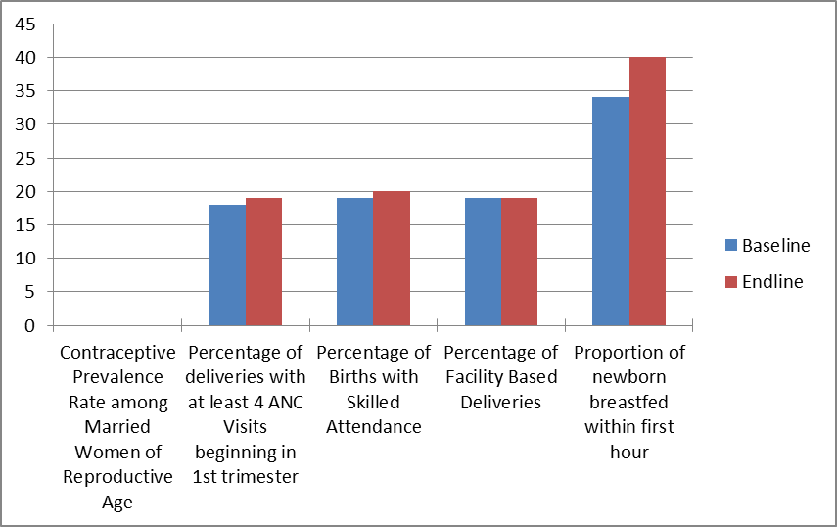
NB: missing data for CPR
Graph 2: General Santos
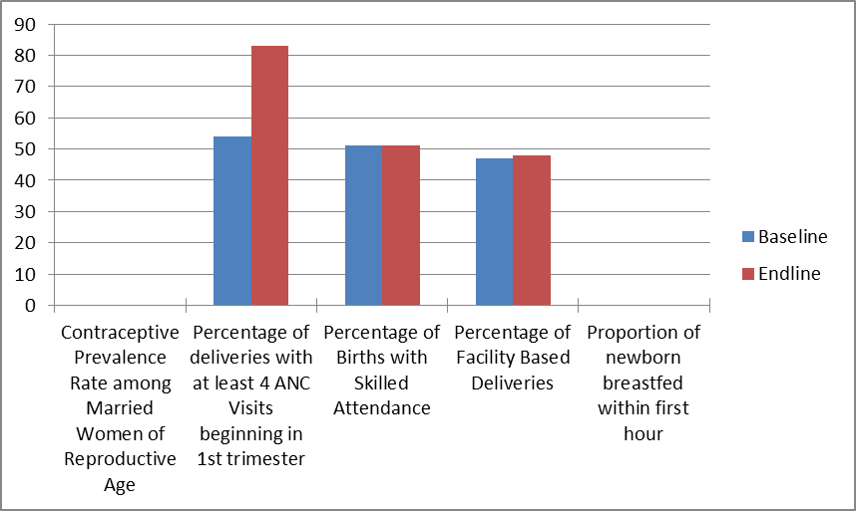
NB: missing data for CPR

Graph 3: Makati
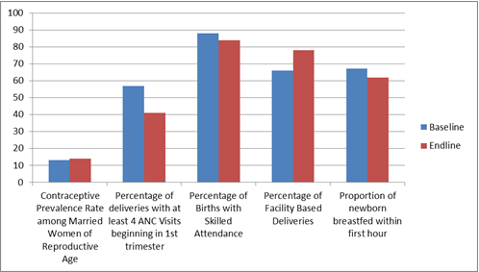

Graph 4: Navotas
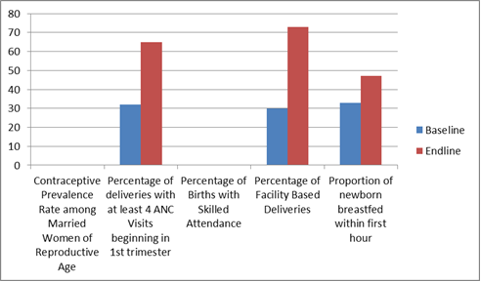
NB: missing data for CPR and SBA

Graph 5: Quezon City
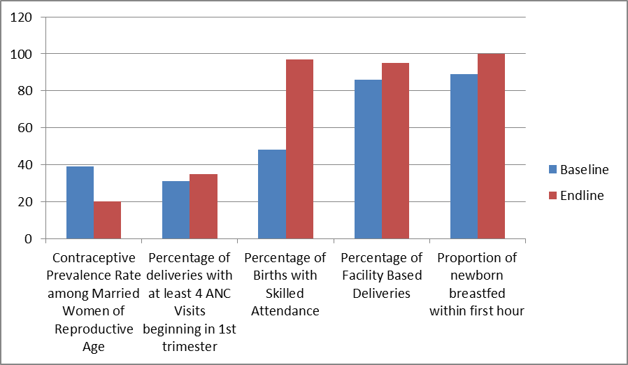

Graph 6: Taguig
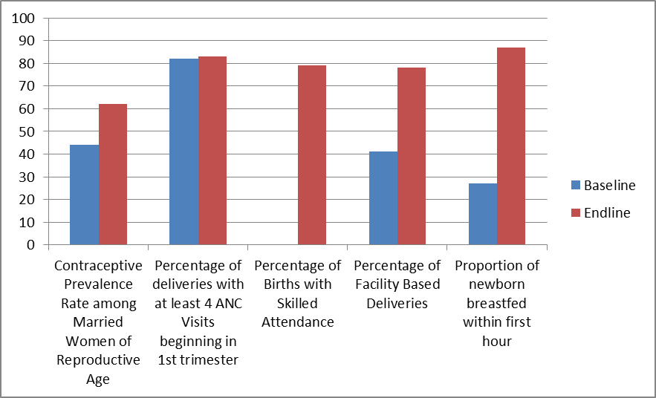

Graph 7: Malabon
Data are absolute numbers and not a percentage.
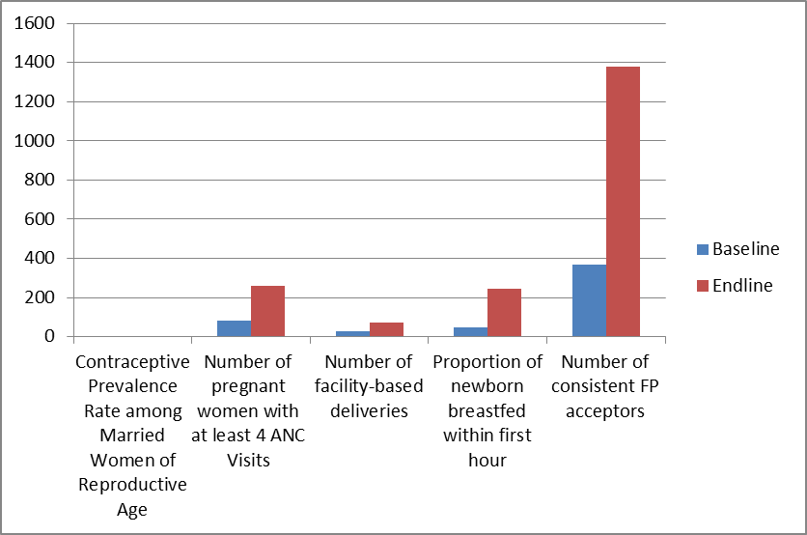
NB: missing data for CPR; the additional indicator of FP acceptors was reported for Malabon.

Graph 8: Tacloban
Data are absolute numbers and not a percentage.
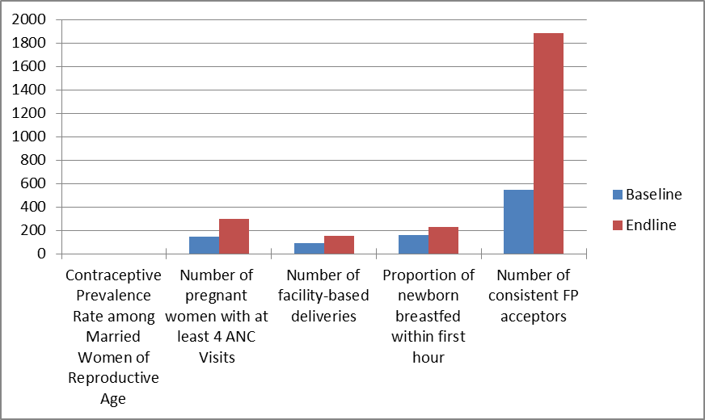
NB: missing data for CPR; the additional indicator of FP acceptors was reported for Tacloban.

Annex 11: UNICEF results
UNICEF Data from 4 provinces: 2008-2010
(2011 data were not used as incomplete)
The data from four provinces (UNICEF status report December 2011) suggest that most provinces have shown increased services utilization.

Province of Ifugao
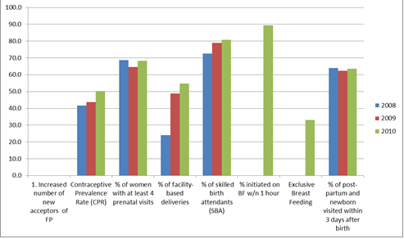

Province of Saranggani
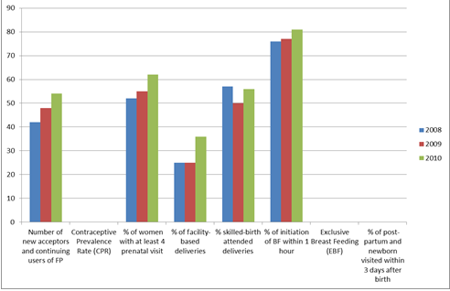

Province of Eastern Samar
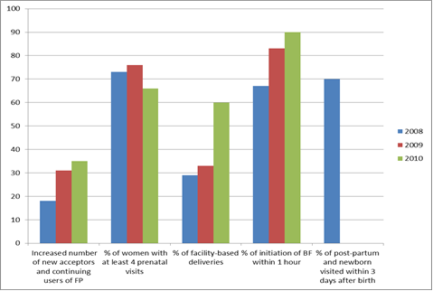
In Eastern Samar province, facility-based delivery reached 60 per cent in 2010, 18 months following commencement of the JPMNH Program

Province of North Cotabato
The Cotabato province showed a large increase of 20 per cent increase in CPR and 9 per cent FBA. Data were not available for deliveries by skilled birth attendants.
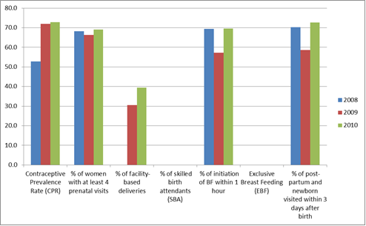
Annex 12: UNFPA results
Barangay data from Lanao del Sur and Ifugao Provinces
Based on data supplied by JPMNH (UNFPA 2011 Status Report)

Province of Lanao del Sur
Graph 9: Barangay Bubong
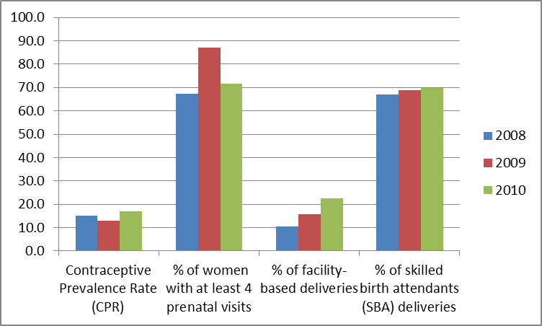

Province of Ifugao
Graph 10: Barangay Asipulo
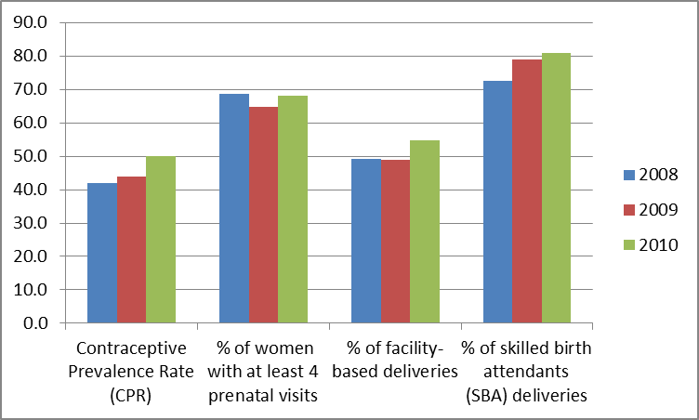
Annex 13: 2011 geographical mapping of JPMNH interventions

Annex 14: Estimated funding to the JPMNH 2009 - 2016

 | Transition | Next phase
Dates: | Mid 2009 – mid 2013 | Mid 2013 - mid 2016
Number of years: | 4 | 3
Total AUD: | $ 22.5m | $ 8m
AUD per year: | $ 5.63m | $ 2.67m

Annex 15: UNDAF priority areas and GOP MDG breakthrough provinces

UNDAF Priority Areas | MDG Dozen
Sultan Kudarat | Metro Manila
Saranggani | Negros Occidental
Maguindanao | Quezon
Lanao del Sur | Cebu
Ifugao | Pangasinan
Albay | Iloilo
Catanduanes | Cavite
Masbate | Magindanao
Bohol | Zamboanga del Sur
Eastern Samar | Leyte
Northern Samar | Davao del Sur
Metro Manila | Pampanga
Metro Cebu
Metro Davao

Annex 16: Suggested format for the revised monitoring framework
IMPACT | Indicator | Baseline + year | Milestone 1 | Milestone 2 | Target + year | Assumptions
 |  | Source of indicator
 | Indicator | Baseline + year | Milestone 1 | Milestone 2 | Target + year
 |  | Source of indicator

OUTCOME 1 | Indicator | Baseline + year | Milestone 1 | Milestone 2 | Target + year | Assumptions
 |  | Source of indicator
 | Indicator | Baseline + year | Milestone 1 | Milestone 2 | Target + year
 |  | Source of indicator
OUTPUT 1.1 | Indicator | Baseline + year | Milestone 1 | Milestone 2 | Target + year | Assumptions
 |  | Source of indicator
 | Indicator | Baseline + year | Milestone 1 | Milestone 2 | Target + year
 |  | Source of indicator
OUTPUT 1.2 | Indicator | Baseline + year | Milestone 1 | Milestone 2 | Target + year | Assumptions
 |  | Source of indicator
 | Indicator | Baseline + year | Milestone 1 | Milestone 2 | Target + year
 |  | Source of indicator

OUTCOME 2 | Indicator | Baseline + year | Milestone 1 | Milestone 2 | Target + year | Assumptions
 |  | Source of indicator
 | Indicator | Baseline + year | Milestone 1 | Milestone 2 | Target + year
 |  | Source of indicator
OUTPUT 2.1 | Indicator | Baseline + year | Milestone 1 | Milestone 2 | Target + year | Assumptions
 |  | Source of indicator
 | Indicator | Baseline + year | Milestone 1 | Milestone 2 | Target + year
 |  | Source of indicator
OUTPUT 2.2 | Indicator | Baseline + year | Milestone 1 | Milestone 2 | Target + year | Assumptions
 |  | Source of indicator
 | Indicator | Baseline + year | Milestone 1 | Milestone 2 | Target + year
 |  | Source of indicator

Annex 17: References
AusAID. (2000). Promoting Practical Sustainability. Retrieved from http://www.ausaid.gov.au/Publications/Pages/4903_3931_6103_952_3539.aspx.
AusAID. (2007). Australia-Philippines Development Assistance Strategy 2007-11. Retrieved from www.ausaid.gov.au/publications.
AusAID. (2009). Philippines Program Health Strategy 2009-11. Retrieved from www.ausaid.gov.au/publications.
AusAID. (2012a). Australia-Philippines Aid Program Strategy (2012-17). Retrieved from www.ausaid.gov.au/publications.
AusAID. (2012b). Factsheet: Australia’s support to strengthen public-private partnerships (PPs) in the Philippines. Retrieved from http://www.ausaid.gov.au/countries/eastasia/philippines/Documents/spppp-factsheet-ausaid-support-ipm.pdf.
AusAID. (2012c). Helping the World's Poor through Effective Aid: Australia's Comprehensive Aid Policy Framework to 2015-16. Retrieved from www.ausaid.gov.au/publications.
DHS. (2008). Philippines National Demographic and Health Survey. Retrieved from http://www.measuredhs.com/publications/publication-FR224-DHS-Final-Reports.cfm.
DOH. (2008). Administrative Order No. 2008-0029: Implementing Health Reforms for Rapid Reduction of Maternal and Neonatal Mortality. Retrieved from http://portal1.doh.gov.ph/health_policies_laws/administrative_order.
DOH. (2009). Administrative Order No. 2009-0025: Adopting New Policies and Protocol on Essential Newborn Care. Retrieved from home.doh.gov.ph/ao/ao2009-0025.pdf.
DOH. (2010). Administrative Order No. 2010-0036: The Aquino Health Agenda: Achieving Universal Health Care for All Filipinos. Retrieved from http://www.doh.gov.ph/system/files/ao2010-0036.pdf.
DOH. (2011a). MNCHN Strategy Manual of Operations: Republic of the Philippines Department of Health.
DOH (2011b). Department Order No.2011-0188. Kalusugan Pangkalahatan Execution Plan and Implementation Framework. Retrieved from http://www.scribd.com/doc/61512046/Kalusugan-Pangkalahatan-Execution-Plan-and-Implementation-Framework.
DOH. (2012). Administrative Order No. 2012-0009: National Strategy Towards Reducing Unmet Need for Modern Family Planning as a means to Achieving MDGs on Maternal Health. Retrieved from http://alfi.org.ph/wp-content/uploads/2012/07/Natl-Strategy-Toward-Reducing-Unmet-Need-DOH-AO-2012-0009-posted.pdf.
Downing et al,. (2011). Pre-Pregnancy Package – a public health interventions targeting women prior to pregnancy.
Illo,J.F. (2012). Gender assessment of the Australian Philippines Aid Program – November 2009. Background paper for Philippines Country Program and Strategy Evaluation. Retrieved from http://pcw.gov.ph/sites/default/files/documents/resources/harmonized_gad_guidelines_2nd_ed.pdf.
Joint UN Program on Maternal and Neonatal Health. 2009. Progress Report June – December 2009, draft (Not for circulation).
JPMNH, WHO (2011). 2011 Accomplishment report,
JPMNH WHO. (2012). RUP Summary Report submitted to IPR Team in October 2012.
Mahintana Foundation. (2011). Terminal Report: Improved utilisation of maternal and newborn services and breastfeeding practices by scaling up Reaching the Urban Poor Model in General Santos City.
Miriam College – Women and Gender Institute. (2010). Accounting for Gender Results: A review of the Philippine GAD budget policy. Quezon City: Miriam College.
NEDA. (2004). Medium-Term Philippine Development Plan (MTPDP) 2004 - 2010. Retrieved from http://www.neda.gov.ph/ads/mtpdp/MTPDP2004-2010/PDF/MTPDP%202004-2010%20NEDA_Intro_Basic.pdf.
NEDA, NCRFW & ODA-GAD Network. (2007). Harmonised gender and development guidelines for Project development, implementation, monitoring and evaluation. 2ed. Retrieved from http://pcw.gov.ph/publication/harmonized-gad-guidelines.
OECD. (2000). Results Based Management in the Development Co-operation Agencies: A review of experience. Retrieved from http://www.oecd.org/development/evaluationofdevelopmentprogrammes/1886527.pdf.
OECD. (2011a). Busan partnership for effective development co-orperation. Fourth high level forum on aid effectiveness, Busan, Republic of Korea Retrieved 7 October, 2012, from http://www.oecd.org/dac/aideffectiveness/49650173.pdf.
OECD. (2011b). Aid Effectiveness 2005–10: Progress in implementing the Paris Declaration. Retrieved from http://www.oecd.org/dac/aideffectiveness/48742718.pdf.
OECD. (ukn). Paris Declaration and Accra Agenda for Action Retrieved 7 October, 2012, from http://www.oecd.org/dac/aideffectiveness/parisdeclarationandaccraagendaforaction.htm#Paris.
Patton, M. (2002). Qualitative research and evaluation methods, 3rd edn. Thousand Oaks:SAGE.
PHO. (2012). MNCHN Status. Province of Eastern Samar. Borongan: Provincial Health Office of E. Samar (personal communication and powerpoint presentation).
UNICEF. (2012). Promoting real-time governance for children and the disadvantaged.
UNDG. (2010). UNDG Strategic Priorities for 2010-2012. Retrieved from http://www.undg.org/docs/12282/UNDG%20Strategic%20Priorities%20for%202010-2012.pdf.
United Nations. (1996). Report of the Fourth World Conference on Women. Beijing, 4-15 September 1995. Retrieved from http://www.un.org/womenwatch/daw/beijing/pdf/Beijing%20full%20report%20E.pdf.
United Nations (2010). UN General Assembly 65th session 2010. Retrieved from http://www.un.org/en/mdg/summit2010/pdf/outcome_documentN1051260.pdf.
United Nations (2010). Every woman every child. Retrieved from http://everywomaneverychild.org/images/Print_Copy-_EWECKEYMESSAGES.pdf.
United Nations. (2006). Delivering as One. Report of the Secretary-General's High-Level Panel. Retrieved from http://www.un.org/events/panel/resources/pdfs/HLP-SWC-FinalReport.pdf.
UNFPA. (2008). State of the World Population Retrieved from http://www.unfpa.org/webdav/site/global/shared/documents/publications/2008/swp08_eng.pdf.
WHO. (2011a). Universal access to reproductive health. Accelerated actions to enhance progress on Millennium Development Goal 5 through advancing Target 5B. Retrieved from http://whqlibdoc.who.int/hq/2011/WHO_RHR_HRP_11.02_eng.pdf.
WHO (2011b). Health-care waste management. Fact sheet N°281. Retrieved from http://www.who.int/mediacentre/factsheets/fs281/en/index.htm
WHO-UNFPA-UNICEF-World Bank Joint Country Support for Accelerated Implementation of Maternal and Newborn Continuum of Care 22 July 2008.
Annex 18: Mind map of UNICEF interventions within JPMNH
UNICEF JPMNH MIND MAP – Outcome 1, Outputs 2-4
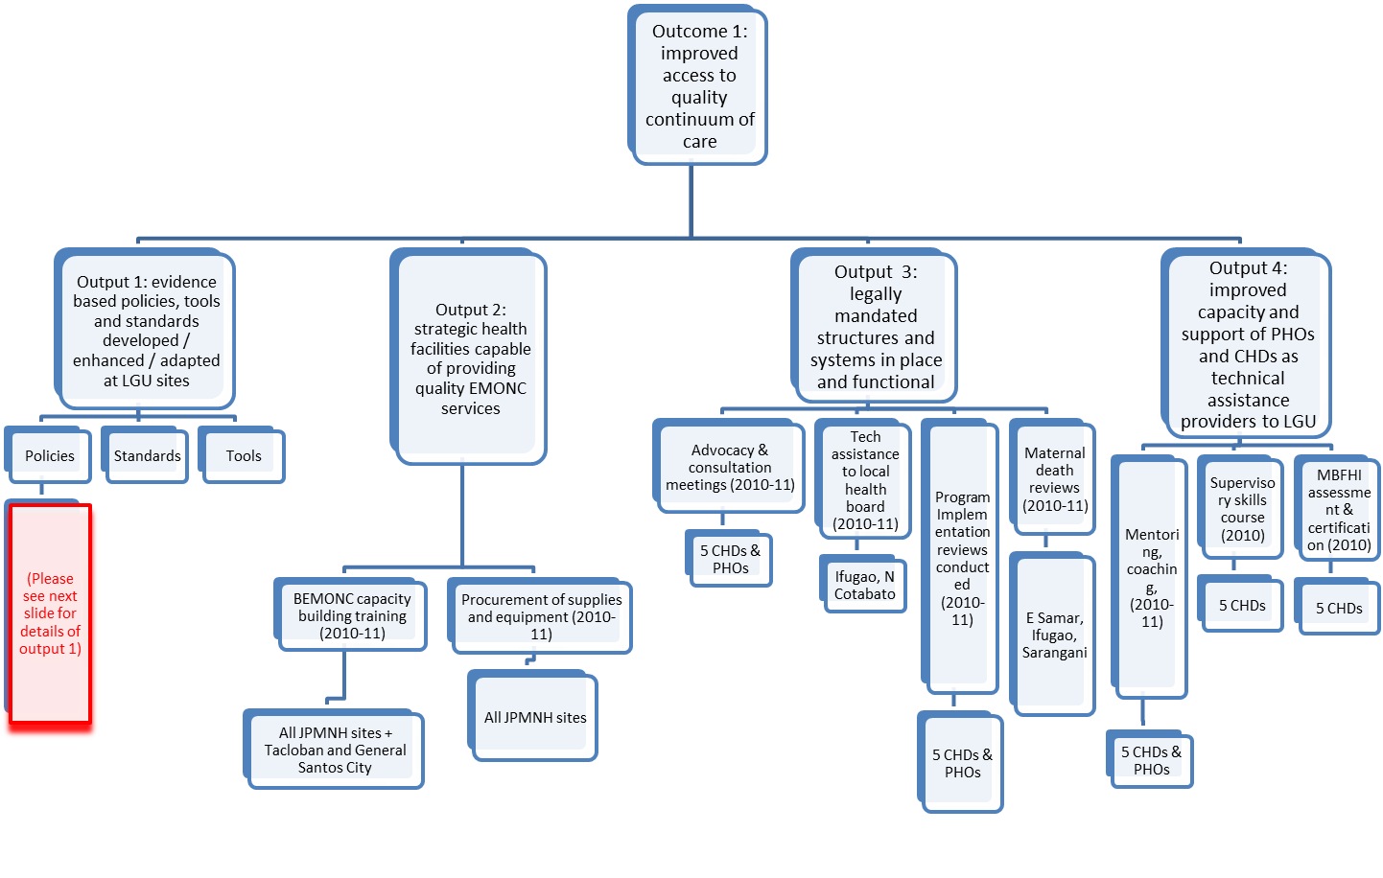
UNICEF JPMNH MIND MAP – Outcome 1, Output 1 details
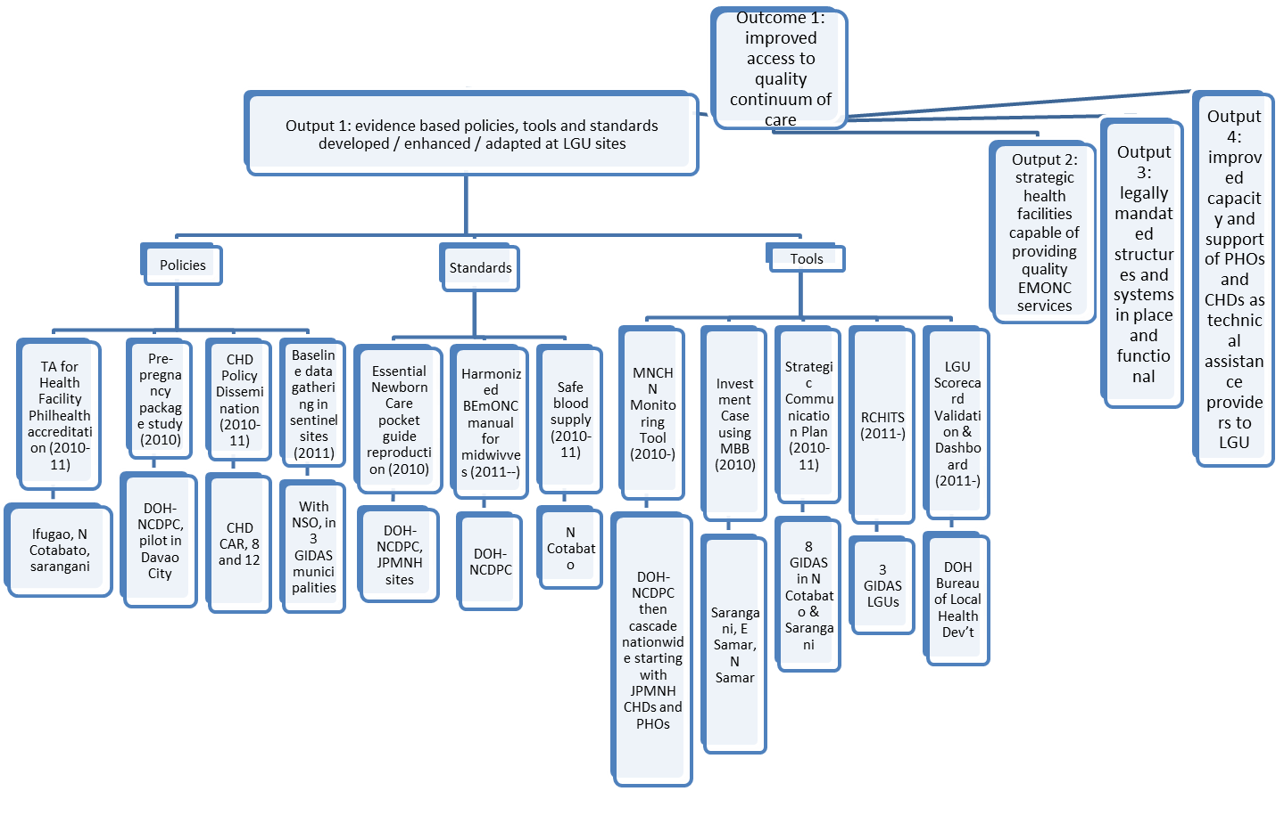
UNICEF JPMNH MIND MAP - Outcome 2
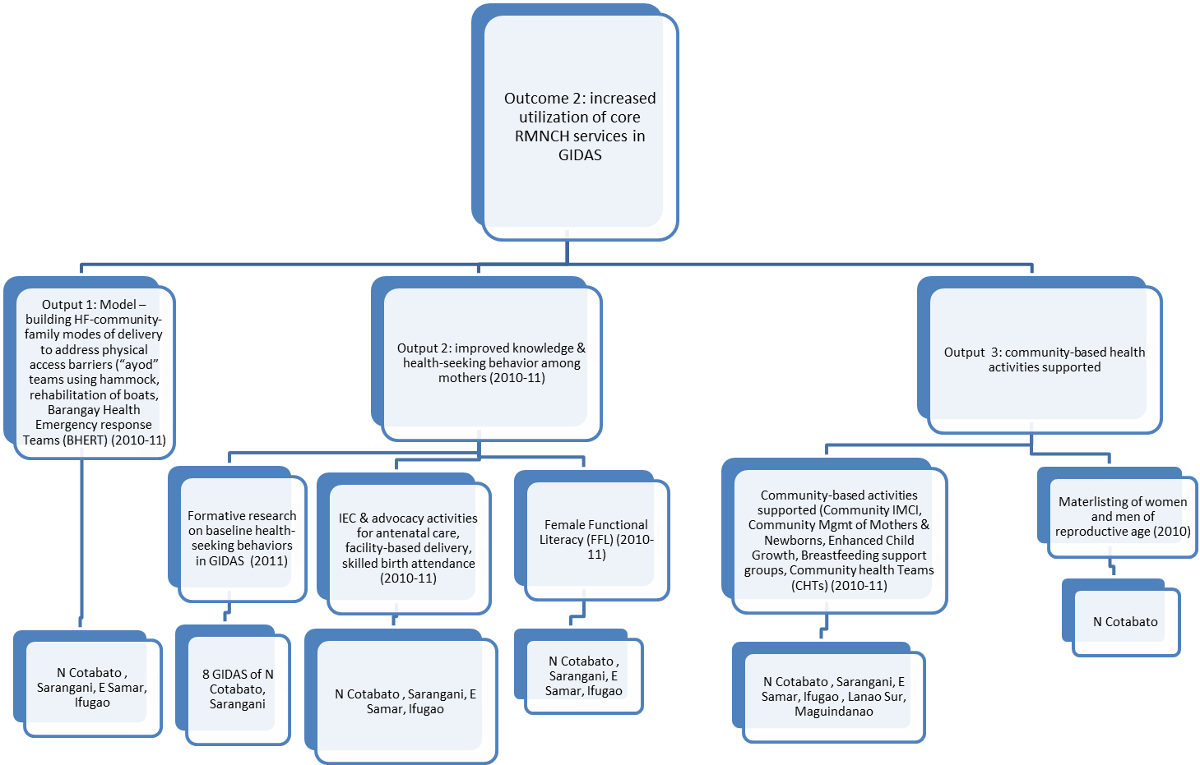
Annex 19: Mind map of WHO interventions within the JPMNH
Annex 20: People met

AusAID
Elaine Ward | Counsellor
Quintin Atienza | Senior Program Officer, Education
Evelyn Daplas | Program Manager, Health Team
Pablo Lucero | Program Officer, Health Team
Grace Triumfante-Borja | Program Officer, Performance and Evaluation team
UN JPMNH team
Mariella Castillo | Health Specialist, UNICEF
Garibaldi Enriquez | Technical coordinator RUP
Florence Tienzo | Programme management officer, WHO
Hector Follosco | UNFPA, Area programme officer
Bel Bado | UNFPA
Asif Husain-Naviatti | Strategic planning adviser UNCO
Rena Dona | Assistant representative, UNFPA
Joseph Michael Singh | National Programme officer, UNFPA
Willibald Zeck | Chief, Health, nutrition and population, UNICEF
Arvi Miguel | JPMNH program coordinator
Jacqueline Kitong | UNFPA
Ermalyn Ador | UNFPA
DOH
Minerva Molon | Director
Paula Sydiongco | Chief
Coracon Sabular | RHO
Maylene Beltran | Director IV
Family Planning Consortium
Lourdes Blanco-Capito | Chair, Dept Obs & Gynae, university of the Philippines
Patricia Gomez | Intergrated midwives association of the Philippines
Jonathan Flavier | Marketing specialist, long acting and permanent methods, PRISM2
Esmeraldo Ilem | MS4
Bernabe Marinduque | Head, Ortoll FP
Maria Manuel | COO FriendlyCare Inc
Leni Cuesta | President
Camila Sarmiento | Research analyst, FriendlyCare
Maria Siuagan | National programme officer
Eastern Visayas Regional Medical Centre
Auene Ras | Medical officer
Susama Merada | Medical officer
Lynor Barrot | Medical officer
Reahmo Molin | Medical officer
PHO Eastern Samar
Jean Marie Egarizo | PHO TL
Trusita Dala | PHO E. Samar
Edna Tumaudao | PHO E. Samar
Mariah Epeyania Isiderio | PHO E. Samar
Tacloban city health office
Jaime M. Opinion | City health officer
Wilfreda Auila
Mirabelle Rexes | MO
Krishna Lim | Nurse
Alilly Romo | Midwife
Tescon John S. Lion | City administrator
A E Mandias | Nurse
Nerissa Llargro | Administrator
Pinky Brosas | HRMO
EU
Anja Bauer | Task Manager, health
Rita Bustamante | Programme officer
Quezon City
Antonieta V. Inumuable | City Health Officer III
Namfa S. Zarate | Medical Officer V
M. Leticia de Guman | Medical Officer IV

Annex 21: IPR Itinerary

Day | Time | Activity | Purpose
Sept 17 (Monday) to 21 (Friday) |  | Consultants’ Review of evaluation documents | Desk review of documents to get the context and background of the JPMNH
Sept. 23 (Sunday) |  | Consultants’ Arrival in Manila
Sept. 24 (Monday) | 8:00-8:30 | Move from hotel in Makati to AusAID
Sept. 24 (Monday) | 8:30-10:15 | Meeting at AusAID Manila | Discussion on the evaluation plan; levelling off on expectations; clarification of issues; direction-setting
Sept. 24 (Monday) | 10:15-10:30 | Move to UN office
Sept. 24 (Monday) | 10:30-12:00 | Meeting with UNCO Strategic Planning Advisor Asif Husain-Naviatti and UN implementers technical personnel (UNFPA, UNICEF, WHO) | Discussion on management and implementation of JPMNH
Sept. 24 (Monday) | 12:00-13:00 | Lunch
Sept. 24 (Monday) | 13:00-15:00 | Continuation of discussions with UN implementers (technical personnel) | Discussion on management and implementation of JPMNH
Sept. 24 (Monday) | 15:00-16:00 | Individual meeting with WHO | Discussion on management and implementation of JPMNH using WHO lens
Sept. 24 (Monday) | 16:00-17:00 | Individual meeting with UNFPA | Discussion on management and implementation of JPMNH using UNFPA lens
 | 17:00-18:00 | Individual meeting with UNCO | Discussion on management and implementation of JPMNH using UNCO lens
Sept. 25 (Tuesday) | 8:00-9:00 | Move to Tondo Medical Center
Sept. 25 (Tuesday) | 9:00-12:00 | Site visit in Tondo Medical Center | Discuss and find out efficiency, effectiveness and impact of the JPMNH through beneficiary lens
Sept. 25 (Tuesday) | 12:00-13:00 | Lunch
Sept. 25 (Tuesday) | 13:00-13:30 | Move to DOH
Sept. 25 (Tuesday) | 13:30-16:30 | Meeting with DOH Family Health Office | Discussion on involvement of DoH on JPMNH; current programs of DoH on MNH and future prospects
Sept. 25 (Tuesday) | 16:30-17:30 | Move back to hotel in Makati
Sept 26 (Wednesday) | 8:00-9:00 | Move to Navotas City Health Office
Sept 26 (Wednesday) | 9:00-12:00 | Site visit in Navotas City | Discuss and find out efficiency, effectiveness and impact of the JPMNH through beneficiary lens
Sept 26 (Wednesday) | 12:00-13:00 | Lunch
Sept 26 (Wednesday) | 13:00-14:30 | Move to airport
Sept 26 (Wednesday) | 14:30-16:00 | IPR team internal discussion
Sept 26 (Wednesday) | 16:00-17:20 | Flight to Tacloban City (PR0393)
Sept 26 (Wednesday) | 17:20-18:00 | Move to Tacloban hotel
Sept. 27 (Thursday) | 7:00-13:00 | Move from Tacloban to Borongan City
Sept. 27 (Thursday) | 13:00-14:00 | Lunch
Sept. 27 (Thursday) | 14:00-17:00 | Site visit and meeting with Provincial Health Office of Eastern Samar | Discuss and find out efficiency, effectiveness and impact of the JPMNH through beneficiary lens
Sept. 27 (Thursday) | 17:00-17:30 | Move to Borongan hotel
Sept 28 (Friday) | 8:00-11:00 | internal discussion between IPR team and UN resource persons | Discussion on implementation of the program through UN field level personnel
Sept 28 (Friday) | 11:00-12:00 | Lunch
Sept 28 (Friday) | 12:00-17:00 | Move from Borongan to Tacloban
Sept. 29-30 (Saturday and Sunday) |  | Initial processing of data gathered from first week and internal discussion
Oct. 1 (Monday) | 8:00-8:30 | Move to Tacloban City Hall
Oct. 1 (Monday) | 8:30-11:30 | Meeting with Tacloban City Health Office | Discuss and find out efficiency, effectiveness and impact of the JPMNH through beneficiary lens
Oct. 1 (Monday) | 11:30-12:30 | Lunch
Oct. 1 (Monday) | 12:30-13:00 | Move to Center for Health and Development Eastern Visayas | Discuss and find out efficiency, effectiveness and impact of the JPMNH through beneficiary lens
Oct. 1 (Monday) | 13:00-14:30 | Meeting with CHD-EV officers | Discuss and find out efficiency, effectiveness and impact of the JPMNH through beneficiary lens
Oct. 1 (Monday) | 14:30-15:00 | Move to Eastern Visayas Medical Center
Oct. 1 (Monday) | 15:00-16:30 | Meeting with EVRMC officers | Discuss and find out efficiency, effectiveness and impact of the JPMNH through beneficiary lens
Oct. 1 (Monday) | 16:30-17:30 | Internal meeting
Oct. 2 (Tuesday) | 6:00-6:20 | Move from hotel to Tacloban airport
Oct. 2 (Tuesday) | 7:25-8:35 | Flight from Tacloban to Manila (PR 192)
Oct. 2 (Tuesday) | 8:50-9:20 | Move to UN
Oct. 2 (Tuesday) | 9:30-11:30 | Discussions with UNFPA and WHO on findings in the site visits | Follow-up questions and data gathering with UN implementers.
Oct. 2 (Tuesday) | 11:30-12:15 | Early lunch
Oct. 2 (Tuesday) | 12:15-13:00 | Move to Quezon City
Oct. 2 (Tuesday) | 13:00-17:00 | Site visit and meeting with QC City Health Office | Discuss and find out efficiency, effectiveness and impact of the JPMNH through beneficiary lens
Oct. 2 (Tuesday) | 17:00-18:00 | Move to Makati hotel
Oct 3 (Wednesday) | 8:00-9:00 | Move to Family Planning Society
Oct 3 (Wednesday) | 9:00-13:00 | Meeting at Family Planning Society | Discuss and find out efficiency, effectiveness and impact of the JPMNH through beneficiary lens
Oct 3 (Wednesday) | 13:00-14:00 | Move to
Oct 3 (Wednesday) | 14:00-17:00 | Meeting with UNICEF | Follow-up questions and data gathering with UN implementers.
Oct. 4 (Thursday) | 8:30-9:00 | Move from Makati hotel to EU
Oct. 4 (Thursday) | 9:00-10:00 | Meeting with EU | Discuss programs of EU on MNH
Oct. 4 (Thursday) | 10:00-10:15 | Move to UN
Oct. 4 (Thursday) | 10:15-11:30 | Follow-up meeting with UNICEF | Follow-up inquiries and data gathering
Oct. 4 (Thursday) | 11:30-13:30 | Internal meeting
Oct. 4 (Thursday) | 13:30-17:00 | Follow-up meeting with UN implementers | Follow-up inquiries and data gathering
Oct. 4 (Thursday) | 17:00-17:30 | Move to Makati hotel
Oct. 5 (Friday) - 7 (Sunday) |  | Consultants’ analysis and preparation for debrief
Oct. 8 (Monday) | 8:30-9:00 | Move from hotel to AusAID
Oct. 8 (Monday) | 9:00-10:00 | Meeting with AusAID health team | Pre-presentation discussion
Oct. 8 (Monday) | 10:00-12:00 | Debrief meeting with AusAID, UN and DOH implementers | Discuss with AusAID, UN and DOH implementers on IPR findings and recommendations
Oct. 8 (Monday) | 12:00-13:00 | Lunch
Oct. 8 (Monday) | 13:00-16:00 | Post-presentation internal discussion with AusAID | Discussion on outcome of debrief
Oct. 8 (Monday) | Evening | Consultants’ depart

Annex 22: Core functions and focal agencies for MNCH joint working

Taken from “WHO-UNFPA-UNICEF-World Bank Joint Country Support for Accelerated Implementation of Maternal and Newborn Continuum of Care - 22 July 2008”
Core functions of the UN agencies based on their comparative advantage:
WHO: Policy, normative, research, monitoring & evaluation
UNFPA: Reproductive health commodity security, support to implementation, human resources for sexual and reproductive health including MNH, technical assistance on building M&E capacity
UNICEF: Financing, support to implementation, logistics & supplies, monitoring & evaluation

Proposed focal agency per building blocks, i.e. core areas within the continuum of care
Area | Focal agency | Partners
Family Planning | UNFPA, WHO | UNICEF
Antenatal Care | UNICEF, WHO | UNFPA
Skilled Attendance at Birth | WHO, UNFPA | UNICEF
B-EmONC | UNFPA, UNICEF | WHO
C-EmONC | WHO, UNFPA | UNICEF
Post-partum | WHO, UNFPA | UNICEF
Newborn care | WHO, UNICEF | UNFPA
Maternal and Neonatal Nutrition | UNICEF, WHO | UNFPA

HLSP Disclaimer

The Health Resource Facility (HRF) provides technical assistance and information to the Australian Government’s Australian Agency for International Development (AusAID). The Health Resource Facility is an Australian Government, AusAID funded initiative managed by Mott MacDonald Limited trading as HLSP in association with International Development Support Services Pty Ltd (IDSS), an Aurecon Company.
This report was produced by the Health Resource Facility, and does not necessarily represent the views or the policy of AusAID or the Commonwealth of Australia.
This document has been prepared for the titled project or named part thereof and should not be relied upon or used for any other project without an independent check being carried out as to its suitability and prior written authority of HLSP being obtained. HLSP accepts no responsibility or liability for the consequences of this document being used for a purpose other than the purposes for which it was commissioned. Any person other than the Commonwealth of Australia, its employees, agents and contractors using or relying on the document for such other purpose agrees, and will by such use or reliance be taken to confirm his agreement, to indemnify HLSP for all loss or damage resulting therefrom. HLSP accepts no responsibility or liability for this document to any party other than to the agency and agency representatives or person by whom it was commissioned.

WHO, Universal access to reproductive health. Accelerated actions to enhance progress on Millennium Development Goal 5 through advancing Target 5B, 2011a.
Patton, M. (2002). Qualitative research and evaluation methods, 3rd edn. Thousand Oaks:SAGE.
AusAID, Australia-Philippines Development Assistance Strategy 2007-11, 2007.
AusAID, Australia-Philippines Aid Program Strategy (2012-17), 2012a.
,AusAID, 2012a. Op. Cit. .
DOH, Administrative Order No. 2012-0009: National Strategy Towards Reducing Unmet Need for Modern Family Planning as a means to Achieving MDGs on Maternal Health. 2012.
WHO, 2011a, Op. Cit.
AusAID, Australia-Philippines Development Assistance Strategy 2007-11, 2007.
AusAID, Philippines Program Health Strategy 2009-11, 2009.
AusAID, Helping the World's Poor through Effective Aid: Australia's Comprehensive Aid Policy Framework to 2015-16, 2012c.
AusAID, 2012c, Op. Cit.
DOH. Administrative Order No. 2008-0029: Implementing Health Reforms for Rapid Reduction of Maternal and Neonatal Mortality. 2008
DOH, MNCHN Strategy Manual of Operations: Republic of the Philippines Department of Health. 2011.
DOH. Administrative Order No. 2010-0036: The Aquino Health Agenda: Achieving Universal Health Care for All Filipinos. 2010.
DOH. Administrative Order No. 2009-0025: Adopting New Policies and Protocol on Essential Newborn Care. 2009.
OECD, Busan partnership for effective development co-orperation. Fourth high level forum on aid effectiveness, Busan, Republic of Korea, 2011a.
DOH., 2011a, Op. Cit. p.60.
AusAID, Factsheet: Australia’s support to strengthen public-private partnerships (PPs) in the Philippines. 2012b
WHO, 2011a, Op. Cit.
DHS. Philippines National Demographic and Health Survey 2008. National Statistics Office (NSO) [Philippines], and ICF Macro. 2009.
DOH, 2010, Op Cit.
DOH 2011b. Op. Cit.
These areas have the highest concentration of NHTS poor, women with unmet need for family planning, mothers giving birth outside facilities, children not fully immunized, children not given Vitamin A supplementation, and adults who are TB smear positive.
DHS 2008. 2009.Op. Cit.
PHO. MNCHN Status. Province of Eastern Samar. Borongan: Provincial Health Office of E. Samar. Powerpoint presentation. 2012.
UNFPA, State of the World Population. 2008.
WHO, 2011a, Op. Cit.
United Nations, Delivering as One. Report of the Secretary-General's High-Level Panel. 2006.
WHO-UNFPA-UNICEF-World Bank Joint Country Support for Accelerated Implementation of Maternal and Newborn Continuum of Care 22 July 2008.
OECD. Aid Effectiveness 2005–10: Progress in implementing the Paris Declaration. 2011b.
AusAID, Promoting Practical Sustainability. 2000.
WHO, UNICEF and UNFPA are members of the UN Development Group. The UNDG strategic priorities 2010-2012 emphasised the need to support and work with national development priorities.
DOH. 2012. Op. Cit.
WHO. Health-care waste management. 2011b.
Ibid.
NEDA, NCRFW & ODA-GAD Network. Harmonised gender and development guidelines. 2ed. Philippines. 2007.
Miriam College - Women and Gender Institute. Accounting for Gender Results: A review of the Philippine GAD budget policy. Miriam College: Quezon City. 2010.
Miriam College 2010, Op. Cit.
Illo. Gender assessment of the Australian Philippines Aid Program – November 2009. Background paper for Philippines Country Program and Strategy Evaluation. 2012.AusAID conducted a gender assessment of the Australian aid program in the Philippines, including the UN JPMNH Program.
Miriam College 2010, Op. Cit.
Illo, 2012, Op. Cit.
The ODA-GAD network consists of informal membership of gender focal persons of ODA agencies. Unfortunately, this network has not been implemented fully.
Miriam College 2010, Op. Cit.
UNDG. UN Development Group Strategic Priorities for 2010-2012. 2010.
The Joint Programme Document on Accelerating Efforts to Attain Targets of Millennium Development Goal (MDG) 5 and Neonatal Component of MDG 4 thru Joint Programming: Rapid Reduction of Maternal and Neonatal Mortality in the Philippines, 2009 p15.
Ibid, p19.
2011 Accomplishment report. JPMNH, WHO 2012, p9.
The Joint Programme Document on Accelerating Efforts to Attain Targets of Millennium Development Goal (MDG) 5 and Neonatal Component of MDG 4 thru Joint Programming: Rapid Reduction of Maternal and Neonatal Mortality in the Philippines, 2009, p18.
Joint UN Program on Maternal and Neonatal Health, Progress Report June – December 2009, draft (Not for circulation), Dec 2009.
The Joint Programme Document on Accelerating Efforts to Attain Targets of Millennium Development Goal (MDG) 5 and Neonatal Component of MDG 4 thru Joint Programming: Rapid Reduction of Maternal and Neonatal Mortality in the Philippines, 2009 p17.
ibid.
Downing et al. The Pre-Pregnancy Package – a public health interventions targeting women prior to pregnancy. 2011.
UNICEF. Promoting real-time governance for children and the disadvantaged. 2012.
ibid.
JPMNH WHO. 2011. Op. Cit. p9.
Calculated from UNFPA’s procurement of commodities reported in the UNFPA Annual Progress Report, May 2010-July 201.
The original Program states that the Program will raise awareness in communities, address gender culture sensitivities, improve health services health governance and systems, carry out policy advocacy and dialogue for government commitment, link supply and demand side interventions, build capacity, scale up valuable lessons which will be strengthened at all levels of health sector reform, have close collaboration and strategic partnerships with government, CSOs, private sector and development partners, consolidate political and financial commitment at both national and local levels, upgrade systems, empower women, mothers and young girls to generate demand, and strengthen linkages at sub-national, national and with the international arena. This is hugely ambitious and unachievable.
AusAID. 2009. Op. Cit.p10.
The Joint Programme Document on Accelerating Efforts to Attain Targets of Millennium Development Goal (MDG) 5 and Neonatal Component of MDG 4 thru Joint Programming: Rapid Reduction of Maternal and Neonatal Mortality in the Philippines, 2009 p10.
WHO-UNFPA-UNICEF-World Bank Joint Country Support for Accelerated Implementation of Maternal and Newborn Continuum of Care 22 July 2008.
Currently being revised, but the team encourage the UN partners to refer to the useful “EVALUATION CAPACITY BUILDING PROGRAM Monitoring and Evaluation Standards” (by AusAID IET and Pacific Branches, 2012) in the interim, available from AusAID. This is being piloted and may become standard AusAID material (and is also useful).
AusAID, 2012c, Op. Cit.
Based on the Revised Results Framework; Annex 2 of UNFPA’s 2011 Annual Progress Report; pages 20-25.

