Australia-United Arab Emirates Comprehensive Economic Partnership Agreement

Guide to using the UAE CEPA to export and import goods

UAE CEPA

**Acknowledgements**

The Department of Foreign Affairs and Trade would like to thank the following organisations for peer reviewing this publication:

Australian Border Force

Australian Chamber of Commerce and Industry

Australian Industry Group

Ozdocs

TradeWindow Origin

**Disclaimer**

DFAT does not guarantee and accepts no liability whatsoever arising from or connected to, the accuracy, reliability, currency or completeness of any material in this Guide or any linked Australian Government website including the FTA Portal. Users of this Guide should exercise their own skill and care with respect to the information and advice in this Guide.

October 2025

Contents

Step 1: Identify the tariff classification of your goods 5

Classification 5

Advance rulings 5

Exporters 6

Importers 6

Step 2: Understand how your goods will be treated under the UAE CEPA 6

Exporters 6

Importers 6

Step 3: Determine whether your goods meet the rules of origin (ROO) 8

What is an originating good? 8

What are non-originating goods? 8

Wholly obtained or produced goods 9

Goods containing inputs from outside the United Arab Emirates or Australia 9

Understanding product specific rules (PSRs) 9

Change in tariff classification (CTC) 9

Qualifying value content (QVC) 10

Product specific processing rules 10

Other important ROOs 10

Accumulation (Article 3.5) 10

De Minimis (Article 3.6) 10

Fungible goods and materials (Article 3.13) 11

Accessories, spare parts and tools (Article 3.9) 12

Packaging materials and containers for retail sale (Article 3.10) 12

Non-alteration (Article 3.18) 12

Step 4: Work with an issuer to prepare a certificate of origin for your goods 16

Waiver of declaration of origin (Article 3.25) 16

Verification (Article 3.32) 17

Review and Appeal (Article 4.14) 17

Contacts for further information 18

Annex: *Sample Certificate of Origin* 19

Appendix A – using rules of origin under the UAE CEPA (text version) 23

The Australia-United Arab Emirates Free Trade Agreement (UAE CEPA) is a comprehensive agreement that substantially liberalises trade between Australia and the United Arab Emirates.

The UAE CEPA’s commercially significant commitments will create export opportunities for business by eliminating tariffs on over 99 per cent of Australian goods exports to the UAE and 100 per cent of UAE imports to Australia.

On 1 October 2025 the UAE CEPA entered into force and the first tariff cuts occurred. This step-by-step guide seeks to assist Australian exporters and importers to take advantage of preferential tariff treatment under UAE CEPA.

**This guide will help you answer the following questions:**

**What goods am I exporting/importing?**

Identify the Harmonised System code for a good.

**How are these goods treated under the UAE CEPA?**

Identify the preferential tariff for a good. Most eligible goods will benefit from a preferential or lower tariff rate under the UAE CEPA.

**Where are my goods produced?**

Only goods that originate in Australia or the United Arab Emirates are eligible for preferential tariff treatment under the UAE CEPA. There are specific rules to determine eligibility.

**My goods qualify for preferential treatment under the UAE CEPA, how do I ensure I get the lower tariff rate?**

Claims for preferential treatment under the UAE CEPA must be accompanied by appropriate documentation, either a Certificate of Origin (COO) or an Origin Declaration (DOO) for Approved Exporters only.

The process for [becoming an Approved Exporter can be found on the Australian](https://www.abf.gov.au/about-us/what-we-do/trustedtrader/become-an-australian-trusted-trader)

[Border Force website](https://www.abf.gov.au/about-us/what-we-do/trustedtrader/become-an-australian-trusted-trader).

**Four steps to using the UAE CEPA**  
**Step 1:** WHAT goods am I exporting or importing? (tariff classification) See page 5

**Step 2:** HOW are these goods treated under the UAE CEPA? (tariff treatment) See page 6

**Step 3:** WHERE are my goods produced? (rules of origin) See page 8

**Step 4:** CERTIFY your goods with a Certificate of Origin See page 15

# Step 1: Identify the tariff classification of your goods

In the UAE CEPA, goods are identified by reference to an internationally recognised system known as the harmonised commodity description and coding system, commonly referred to as the Harmonised System or HS.

The HS is a broad classification system of more than 5 000 six-digit product categories. Typically, each country further sub divides the six-digit HS product categories into eight digit or more tariff lines for greater specificity. Tariff codes beyond the HS six digit level are generally not comparable between countries.

## Classification

Determining how the UAE CEPA treats a particular good depends on correctly identifying that good. There are multiple ways to find the HS code applicable to a good:

1. Use the [FTA Portal](https://ftaportal.dfat.gov.au/), DFAT’s online tool. To find the HS code applicable to your good, type in the product and choose the eight-digit HS code that matches the description of the good.
2. Alternatively, you can manually check the full UAE CEPA schedules of tariff commitments which are available on the DFAT website:
   1. [Schedule of Tariff Commitments of Australia [XLSX 580 KB]](https://www.dfat.gov.au/sites/default/files/uaecepa-official-text-chapter-2-annex-a-part-b-schedule-of-australia.xlsx)
   2. [Schedule of Tariff Commitments of the United Arab Emirates [XLSX 721 KB]](https://www.dfat.gov.au/sites/default/files/uaecepa-official-text-chapter-2-annex-a-part-c-schedule-of-uae.xlsx)
3. To be certain you have identified the correct tariff code for export or import, we recommend you consult the customs authority of the importing country:
   1. For exports to the United Arab Emirates, use the United Arab Emirates integrated trade tariff database, to search for your product by name: [Trade Tariff: look up commodity codes, duty and VAT rates](https://uaecustoms.ae/Home.aspx?ReturnUrl=/)
   2. For imports to Australia, use the working tariff provided by the Australian Border Force (ABF) which lists all tariff classifications under Schedule 3 of the Customs Tariff Act 1995 available at: [Tariff Classification](https://www.abf.gov.au/importing-exporting-and-manufacturing/tariff-classification).

## Advance rulings

Under Article 4.7 of the UAE CEPA, Australia and the UAE committed to provide advance rulings on Tariff Classification, valuation and origin. An advance ruling can be sought from the importing customs administration.

An advance ruling is a written ruling on the HS code of a good that is binding on the customs administration. Your importer or customs broker may be able to assist you with this process.

### Exporters

Australian exporters may seek formal advice from the [United Arab Emirates Federal Customs Authority](https://u.ae/en/information-and-services/finance-and-investment/clearing-the-customs-and-paying-customs-duty) on the tariff classification, valuation and origin of the goods intended for export to the United Arab Emirates.

### Importers

If you are importing goods into Australia the ABF provides guidance on seeking an [Advance Ruling](https://www.abf.gov.au/importing-exporting-and-manufacturing/importing/how-to-import/requirements/advance-rulings):

* [Application for Advance Ruling (Tariff) [PDF 684 KB]](https://www.abf.gov.au/form-listing/forms/b102.pdf)
* [Application for Advance Ruling (Origin) [PDF 642 KB]](https://www.abf.gov.au/form-listing/forms/b659.pdf)
* [Application for Advance Ruling (Valuation) [PDF 682 KB]](https://www.abf.gov.au/form-listing/forms/b174.pdf)

# Step 2: Understand how your goods will be treated under the UAE CEPA

Once you know the HS code, you can determine how your goods will be treated under the UAE CEPA. The United Arab Emirates and Australia have set out their commitments in tariff schedules based on the HS. The tariff schedules contain thousands of rows of tariff lines showing the base tariff rate to which reductions apply. In a separate column a code is used to indicate the tariff staging category.

## Exporters

If you are exporting to the United Arab Emirates, you will need to check the UAE’s tariff schedule. The tariff rates schedule for the UAE is available in Chapter 2 Trade in Goods under Annex 2A: Part C Schedule of the United Arab Emirates of the agreement and can be found on the DFAT website: [Schedule of Tariff Commitments of the United Arab Emirates [XLSX 721 KB]](https://www.dfat.gov.au/sites/default/files/uaecepa-official-text-chapter-2-annex-a-part-c-schedule-of-uae.xlsx)

## Importers

If you are importing from the United Arab Emirates, you will need to check Australia’s tariff schedule, available in Chapter 2 Trade in Goods (Annex 2A, Section 2A) Part B Schedule of Australia, available here on the DFAT website:

[Schedule of Tariff Commitments of Australia [XLSX 580 KB]](https://www.dfat.gov.au/sites/default/files/uaecepa-official-text-chapter-2-annex-a-part-b-schedule-of-australia.xlsx)

**What year has the UAE CEPA reached now?**

* Year 1 (entry into force): 1 October 2025
* Year 2: 1 Jan 2026
* Year 3: 1 Jan 2027
* Year 4: 1 Jan 2028
* Year 5: 1 Jan 2029

### Reading the UAE’s Tariff Schedule

|  |  |  |  |  |  |  |  |
| --- | --- | --- | --- | --- | --- | --- | --- |
| HS Code | Description | Base Rate | Year 1 | Year 2 | Year 3 | Year 4 | Year 5 |
| 0207.14.00 | Frozen cuts and offal of the poultry of heading 01.05 | 5% | 4% | 3% | 2% | 1% | 0% |
| 0809.40.10.00 | Low erucic acid rape or colza seeds, whether or not broken | 5% | 0% | 0% | 0% | 0% | 0% |

‘HS code’ is used to find your goods in the tariff schedule, please see details above in ‘Step 1: Classification’ for further information about how to find the right HS Code for your goods.

A ‘base rate’ column showing the base duty rate or tariff that applied prior to I October 2025. This is the starting point on which tariff treatment occurs.

The columns labelled ‘year 1’, ‘year 2’ etc… denote the tariff rate applied in each year beyond entry into force.

For example, the ‘year 1’ cut took place on I October 2025, and each subsequent cut will take place on 1 January of the following year.

In the example of ‘Frozen cuts and offal of the poultry of heading 01.05’ , the base rate is 5%, the first tariff cut to 4% took place on I October 2025, the ‘year 2’ cut to 3% will take place on 1 January 2026, the ‘year 3’ cut to 2% will take place on 1 January 2027, the ‘year 4’ cut to 1% will take place on 1 January 2028 and the final cut to a zero tariff will take place on 1 January 2029, after which these goods will remain tariff free.

In the example of ‘Low erucic acid rape of colza seeds, whether or not broken’ these goods will be tariff free from 1 October 2025, the date of entry into force of the agreement.

The UAE tariff schedule may also mark some goods as ‘prohibited’ or ‘special goods’. In the case of prohibited goods, these are not permitted to be imported to the UAE. In the case of special goods, these may require prior approval from relevant authorities before import. For these goods you should contact the UAE Customs Authority for further information UAE Federal Customs Authority

# Step 3: Determine whether your goods meet the rules of origin (ROO)

Rules of origin (ROO) are agreed criteria used to determine the originating status of a good and its eligibility for preferential treatment under a free trade agreement.

Only goods that meet the UAE CEPA’s origin criteria receive the UAE CEPA’s preferential rate of customs duty set out in the tariff schedule. This prevents other countries from gaining preferential tariffs under the agreement.

Imports into the United Arab Emirates or Australia that do not comply with the ROO set out in Chapter 3 Rules of Origin and Annex 3A Product Specific Rules Schedule may be subject to the general tariff (most favoured nation or MFN) rate instead of the preferential rates available under the UAE CEPA. The rules of origin chapter can be found: [Australia-UAE CEPA Chapter 3 Rules of Origin | Australian Government Department of Foreign Affairs and Trade](https://www.dfat.gov.au/trade/agreements/in-force/australia-uae-comprehensive-economic-partnership-agreement-cepa/australia-uae-cepa-official-text/chapter-3-rules-origin)

## What is an originating good?

In general, a good will qualify as originating under the UAE CEPA if it is:

* wholly obtained or produced entirely in the United Arab Emirates or Australia (or both);
* produced entirely in the United Arab Emirates, Australia or both, from materials classified as originating under the ROO; or
* manufactured in the United Arab Emirates, Australia or both using inputs from other countries (non-originating materials) and satisfies all applicable requirements under the product specific rule (PSR) for that good.

## What are non-originating goods?

Non-originating goods are those:

* imported from a country other than Australia or the United Arab Emirates;
* produced in the United Arab Emirates, Australia or both but which do not meet the rules of origin under the UAE CEPA; or
* for which origin cannot be determined.

## Wholly obtained or produced goods

Wholly obtained goods are typically agricultural goods and natural resources. Box 1 on page 12 sets out the categories of goods the UAE CEPA treats as wholly obtained.

The UAE CEPA also treats goods that are made exclusively from wholly obtained goods as being wholly obtained. See Chapter 3 Rules of Origin and Origin Procedures, Article 3.3 (j).

## Goods containing inputs from outside the United Arab Emirates or Australia

Goods made from inputs sourced from outside the United Arab Emirates or Australia may still qualify as originating if they have undergone a substantial transformation in the United Arab Emirates, Australia or both.

## Understanding product specific rules (PSRs)

Goods that include some non-originating materials under the UAE CEPA may still qualify as originating, if the non-originating materials have undergone a substantial transformation in Australia or the United Arab Emirates.

The PSRs set out in Chapter 3 Rules of Origin and Annex 3A Product Specific Rules Schedule provide the rules by which UAE and Australian customs authorities will determine whether a good has undergone a substantial transformation to become an originating good.

If your good contains inputs from outside Australia or the UAE, you will need to check the applicable PSR to determine whether your good qualifies as originating.

The PSR methods used to measure substantial transformation under the UAE CEPA are:

* Change in Tariff Classification (CTC);
* Qualifying Value Content (QVC); or
* Product specific process rules.

## Change in tariff classification (CTC)

Most PSRs in the UAE CEPA apply a change in tariff classification (CTC) approach. Different products may be subject to different CTC rules. There are three CTC rules which could apply:

* **Change in Chapter (CC)** – change in any of the first two digits (or ‘chapter’) of the HS code of non-originating materials once part of the finished product.
  + Such as importing oranges (HS Code 0805.10) and juicing them to create orange juice (HS code 2009.19).
* **Change in tariff heading (CTH)** – change in any of the first four digits of the HS code of non-originating materials once part of the finished product.
  + Such as changing pure gold (HS 7108.13) to gold jewellery (HS 7113.19).
* **Change in tariff subheading (CTSH)** – change in any of the six digits of the HS code of non-originating materials once part of the finished product.
  + Such as importing roasted coffee (HS 0901.21) and decaffeinating it to produce decaffeinated coffee (HS 0901.22).

## Qualifying value content (QVC)

A CTC is not the only way to identify substantial transformations. Some PSRs require a product to have undergone a specific amount of value add in the United Arab Emirates or Australia, measured by the qualifying value content (QVC) of the good.

Some PSRs provide an QVC rule as an alternative to a CTC rule, others require an QVC in addition to a CTC rule.

An QVC approach stipulates that processes and manufacturing of that good must have occurred and must represent a specific proportion of the product’s final value. More information about calculating RVC is provided on page 13.

## Product specific processing rules

Some PSRs allow for a good to become originating if the non-originating materials undergo a specific manufacturing or production process that fundamentally changes the nature of the input materials. For example, some UAE PSRs require that the product be refined within Australia, the UAE or both.

# Other important ROOs

There are other important factors to consider in understanding whether your good qualifies as originating.

## Accumulation (Article 3.5)

The rule of accumulation provides that goods which are originating in one country are considered originating in the other for the purposes of the UAE CEPA. Therefore, if Australian originating goods were incorporated into a product made in the United Arab Emirates, that input would be treated as if it originated in the United Arab Emirates.

## De Minimis (Article 3.6)

Where a good fails to meet the PSR requirements, it may still be considered originating if the non-originating materials make up only a small amount of the total material inputs. If your good falls within chapters 25 to 49 and 64 to 97 of the HS, the value of all non originating materials must not exceed 10 per cent of the FOB or 15 per cent of the Ex-Works value of the good to use the De Minimis rule.

For goods in chapters 1 to 24 and 50 to 63 of the HS, there are two options available to exporters:

* either the total weight of those materials does not exceed 10 per cent of the total weight of the good (not including the weight of any packaging); or
* the value of materials does not exceed 10 per cent of the FOB or 15 per cent of the Ex-Works value of the good.

#### How to find the PSR applicable to your product

Using the tariff classification from step 1, you can check Chapter 3 Rules of Origin and Annex 3A Product Specific Rules Schedule.

PSRs are listed at the HS six digit level. Using the first six digits of the relevant country-specific tariff code, identify the relevant entry in the PSR list. Once you have found the relevant entry, the third column will identify the PSR for that product, for example:

|  |  |  |
| --- | --- | --- |
| HS Code | Description | PSR |
| 0305.39 | Fish Fillets, dried, salted or in brine, but not smoked - Other | CC |
| 2501.00 | Salt | CTH or QVC35/40 |

In the above example, non originating inputs into fish fillets, dried, salted or in brine, but not smoked must undergo a change in chapter (CC) which is a change in the first two digits of the HS classification.

Salt, on the other hand, must either have all non originating materials used in production undergo a change in the tariff heading (CTH) at the four digit level or be made with QVC of at least 40 per cent.

Further information can be found in the headnotes to Chapter 3 Rules of Origin and Annex 3A Product Specific Rules Schedule) or by contacting your customs broker and/or authorised body as appropriate.

## Fungible goods and materials (Article 3.13)

Fungible goods are those which are identical or interchangeable because they are of the same kind of commercial quality, possess the same technical and physical characteristics and, once mixed, cannot be readily distinguished. Examples include natural gas, grain, or simple parts such as rivets.

Specific accounting rules apply to exporters wishing to demonstrate that fungible goods are originating under the UAE CEPA.

## Accessories, spare parts and tools (Article 3.9)

The origin of accessories, spare parts or tools is not considered when determining if a good has complied with applicable CTC PSRs, provided that they are customarily supplied with those finished goods, and they are not invoiced separately. The value of accessories, spare parts and tools can be considered when calculating an QVC rule.

Wine bottled in non-originating bottles for retail could not be considered wholly obtained, due to the non-originating bottles. The bottles would not be considered in assessing whether the wine complies with the relevant PSR. However, retail packaging materials are considered in assessing the value of non-originating materials in a good for the purposes of an QVC rule, where one applies.

## Packaging materials and containers for retail sale (Article 3.10)

Packing materials and containers for shipping and transport (not retail packaging) should be disregarded when determining whether a good meets a CTC, PSR or is wholly obtained. However, retail packaging materials must be taken into account when calculating whether a good meets an QVC or PSR.

## Non-alteration (Article 3.18)

The UAE CEPA is designed to reflect modern trading practices, including the use of transport and distribution hubs for goods.

Goods that are transported directly between Australia and the UAE retain their originating status.

For goods that are transported through other countries en route to Australia or the UAE, including via freeports, the goods shall retain their originating status provided that the good does not undergo further production or any other operation outside of Australia and the UAE, other than unloading, reloading, separation from a bulk shipment or splitting of a consignment, storing, repacking, labelling or marking required by the importing Party or any other operation necessary to preserve it in good condition or to transport the good.

In addition, the good must not be released to free circulation into any other country besides Australia and/or the UAE. ‘Free circulation’ means that the good has cleared customs, applicable duties have been paid, and the good is available for use in a domestic market.

## Using rules of origin under the UAE CEPA

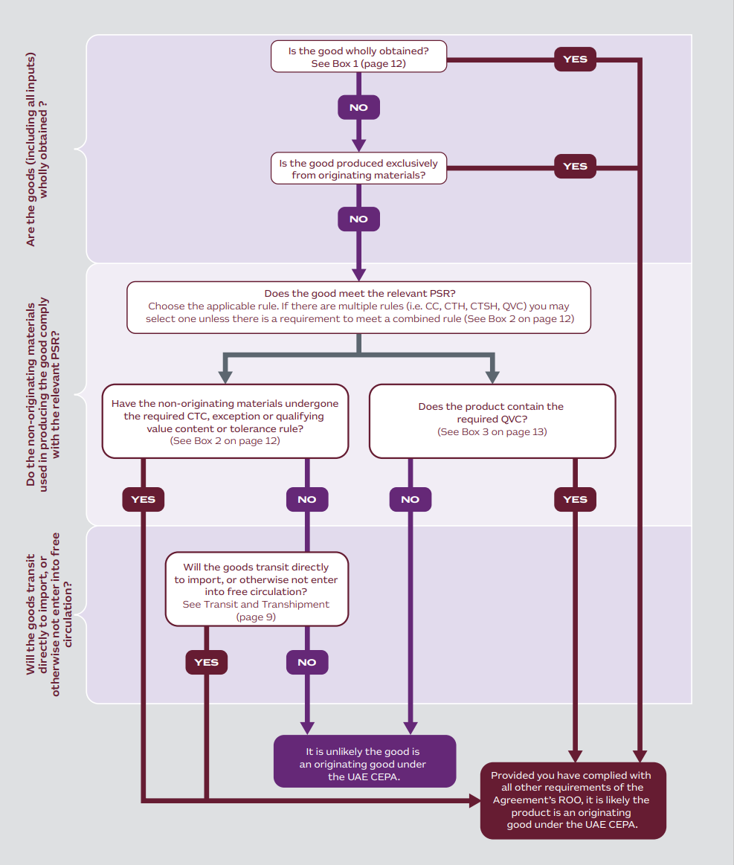

### Is the good wholly obtained or produced?

Wholly obtained goods from the territory of one or both of the parties (see Article 3.3)

* Plants, plant goods or fungus, grown, cultivated, harvested, picked, or gathered
* live animals born and raised in Australia or the UAE
* goods obtained from live animals in Australia or the UAE
* an animal obtained by hunting, trapping, fishing, gathering, or capturing there but not beyond the outer limits of a party’s territorial sea
* a good obtained from aquaculture there but not beyond the outer limits of a party’s territorial sea
* minerals or subsoil beyond the outer limits, but within the territory of Australia or the UAE by Australian or UAE flagged vessels
* fish, shellfish, and other marine life taken from the sea, seabed, or subsoil beyond the outer limits of but within the territory of Australia or the UAE by Australian or UAE flagged vessels
* goods produced on board a factory ship that is registered, listed, or recorded and entitled to fly the Australian or UAE flag
* a good other than fish, shellfish, and other marine life taken or extracted from the seabed or subsoil outside Australian territory and beyond areas over which non parties exercise jurisdiction provided that Australia or the UAE has the right to exploit that seabed or subsoil in accordance with international law
* waste or scrap derived from production or from used goods collected there, provided that those goods are fit only for the recovery of raw materials or
* a good produced in Australian territory, exclusively from goods referred to above, or from their derivatives.

### Does the good meet the relevant change in tariff classification rule?

Check the CTC rule applicable to the tariff classification for your goods at [Australia-UAE CEPA Chapter 3 Rules of Origin.](https://www.dfat.gov.au/trade/agreements/in-force/australia-uae-comprehensive-economic-partnership-agreement-cepa/australia-uae-cepa-official-text/chapter-3-rules-origin)

* CC - do the non-originating inputs that went into the product now come under a different chapter as part of the finished product (change in any of the first two digits of the tariff classification)?
* CTH - do the non originating inputs that went into the good now come under a different tariff heading as part of the finished product (change in any of the first four digits of the tariff classification)?
* CTSH - do the non originating inputs that went into the product now come under a different tariff subheading as part of the finished product (change in any of the six digits of the tariff classification)?
* FF - has the good undergone a change from fabric that is constructed but not further prepared or finished if it is dyed or printed and undergoes at least one preparatory or finishing processes in the UAE or Australia or both to render it directly usable?
* QVC - does the good have a qualifying value content as calculated under Article 3.4 of not less than the percentage specified under the PSR for your HS code when using the build up or build down method?

### Does the good comply with the Qualifying Value Content rule?

The QVC percentage of a good can be assessed using either of the following two methods.

**Indirect (Build-Down) method, based on the value of non-originating materials:**

QVC = (Exworks value or FOB – VNM/ Exworks value or FOB value) x 100

**Direct (Build-Up) method, based on the value of originating materials:**QVC = (VOM + direct labour cost + Direct overheard cost + profit + other costs)/Exworks value or FOB value x 100

* QVC is the qualifying value content, expressed as a percentage;
  + **VNM** is the value of non-originating materials used in the production of the good.
  + **VOM** is the value of originating materials used in the production of the good.

**Free-On-Board (FOB) Value** is the price actually paid or payable to the exporter for a good when the good is loaded onto the carrier at the named port of exportation, including the cost of the good and all costs necessary to bring the good onto the carrier.

**Ex-Works Price** means the price paid for the good ex-works to the manufacturer in the Party in who’s undertaking the last working or processing is carried out, provided the price includes the value of all the materials used, minus any internal taxes which are, or may be, repaid when the good obtained is exported.

* Consult your customs broker if you think there may be an issue in identifying the value of your goods.
* Further information on calculating the VNM and VOM is available in Chapter 3 Rules of Origin (Article 3.4).

# Step 4: Work with an issuer to prepare a certificate of origin for your goods

Once you have gone through the first three steps and determined that your goods will qualify for preferential tariff treatment under UAE CEPA, you will need to complete the appropriate documentation to demonstrate this, should you be asked to by the importing customs authority. This is done primarily by using a Certificate of Origin (COO) issued by the Australian Chamber of Commerce and Industry (ACCI), the Australian Industry Group (Ai Group), TradeWindow Origin (TWO), Ozdocs or WiseTech Global.

COOs must, as a minimum, include information set out in Chapter 3 (Rules of Origin) Art. 3.22 and Annex 3B (Certificate of Origin Minimum Information Requirements). The accompanying COO can be in a printed or electronic format.

This annex also acts as a template COO, reproduced at the end of this guide on page 18. Issuers can ask for additional information to assist them to make the decision about your goods.

COOs may cover one or more goods under one consignment provided that each good qualifies as an originating good. COOs remain valid for 12 months from the date of completion or issuance.

Exporters or producers must maintain all records necessary to demonstrate origin for 5 years after signing a COO. Chapter 3 (Rules of Origin) Art. 3.34 provides further detail on record keeping requirements.

## Waiver of declaration of origin (Article 3.25)

Customs authorities may occasionally need to verify the information contained in a COO/DOO.

Verification activities may involve:

* requests for information from the authorised body (ACCI, Ai Group, TWO, Ozdocs or WiseTech Global), the importer, the exporter, or the producer;
* requests for information from the exporting customs administration;
* or a request to undertake a verification visit to the premises or factory of the exporter or producer.

Where information is requested, an importer, exporter, producer or authorised body has 90 days to respond. When a visit is requested, an exporter or producer should provide written consent within 30 days from the receipt of notification. The approach followed for such processes is outlined in Chapter 3 (Rules of Origin) Art. 3.32 (Verification).

## Verification (Article 3.32)

Customs authorities may occasionally need to verify the information contained in a COO/DOO.

Verification activities may involve:

* requests for information from the authorised body (ACCI, Ai Group, TWO, Ozdocs or WiseTech Global), the importer, the exporter, or the producer;
* requests for information from the exporting customs administration;
* or a request to undertake a verification visit to the premises or factory of the exporter or producer.

Where information is requested, an importer, exporter, producer or authorised body has 90 days to respond. When a visit is requested, an exporter or producer should provide written consent within 30 days from the receipt of notification. The approach followed for such processes is outlined in Chapter 3 (Rules of Origin) Art. 3.32 (Verification).

## Review and Appeal (Article 4.14)

If you are unhappy with a decision made by a customs administration in seeking preferential treatment under the UAE CEPA, you may be entitled to appeal that decision under Chapter 4 Customs Procedures and Trade Facilitation (Article 4.14). You should consult your customs broker and legal adviser if you wish to pursue an appeal.

# Contacts for further information

**Australia**

**Department of Foreign Affairs and Trade**

For general questions concerning the UAE CEPA

Phone: 02 6261 1111

Email: [uaecepa@dfat.gov.au](mailto:uaecepa@dfat.gov.au)

Web: [www.dfat.gov.au/uaecepa](http://www.dfat.gov.au/uaecepa)

**Australian Border Force**

For all customs matters, advance rulings, questions about tariff classification, ROOs and DOOs

Email: [origin@abf.gov.au](mailto:origin@abf.gov.au)

Web: [www.abf.gov.au](http://www.abf.gov.au)

**Australian Trade and Investment Commission**

For general questions regarding exports to the United Arab Emirates Phone: 13 28 78

Email: [dubai@austrade.gov](mailto:dubai@austrade.gov)

Web: [Free trade agreements | Austrade](https://www.austrade.gov.au/en/how-we-can-help-you/australian-exporters/free-trade-agreements)

**Contact details for accredited issuers can be found at the following link.**

[How to obtain a Certificate of Origin](https://www.dfat.gov.au/trade/about-ftas/how-obtain-certificate-origin)

**United Arab Emirates Customs Services**

Web: [www.customs.gov.uae](https://uaecustoms.ae/Home.aspx?ReturnUrl=%2f)

# Annex: Sample Certificate of Origin

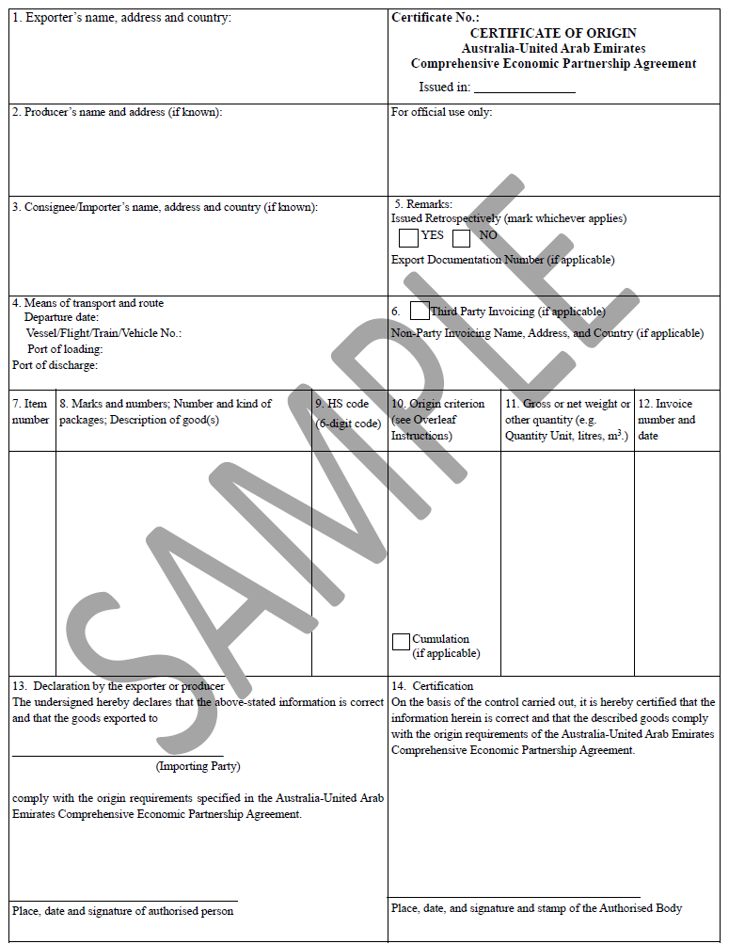

(SAMPLE ONLY- ORIGINALS TO BE SUPPLIED BY AUTHORISED BODIES)

##### Overleaf Instruction

Box 1: State the full legal name and address of the exporter in Australia or United Arab Emirates.

Box 2: State the full legal name and address (including country if different from the exporter) of the producer, if known, or if there are multiple producers, state “Various” or provide a list of producers. If the producer is unknown, it is acceptable to state "UNKNOWN".

Box 3: State the full legal name and address of the consignee/importer in Australia or United Arab Emirates, if known.

Box 4: Complete the means of transport and route and specify the departure date, transport vehicle number, and port of loading and discharge, if known.

Box 5: Confirm if COO is issued retrospectively by marking the box as appropriate. Provide an Export Documentation Number if applicable. The Customer’s Order Number, Letter of Credit Number, among others, may be included.

Box 6: In the case where invoices are issued by a company from a country that is not party to this agreement, the “third party invoice” box should be ticked (√) and such information as the name and address of the company issuing the invoice shall be indicated.

Box 7: State the item number.

Box 8: The number and kind of packages shall be specified. Provide a full description of each good. The description should be sufficiently detailed to enable the products to be identified by the Customs Officers examining them and relate it to the invoice description and to the HS description of the good. If the goods are not packed, state “in bulk”. When the description of the goods is finished, add “***” (three stars) or “ \ ” (finishing slash).

Box 9: For each good described in Box 8, identify the HS tariff classification (a six-digit code). If the HS Code is given in more than 6 digits, only the first 6 digits will be taken into consideration.

Box 10: For each good described in Box 8, state which criterion is applicable, according to the following instructions. The rules of origin are contained in Chapter 3 (Rules of Origin) and Annex 3A (Product Specific Rules of Origin) of the Australia-United Arab Emirates Free Trade Agreement.

|  |  |
| --- | --- |
| Origin Criterion | Insert in Box 8 |
| The good is “wholly obtained” in the territory of a Party in accordance with Article 3.3 (Wholly Obtained or Produced Goods). | WO |
| The good is produced entirely in the territory of one or both Parties, exclusively from materials whose origin conforms to the provisions of Chapter 3 (Rules of Origin). | WP(PE) |
| The good is produced in the territory of one or both Parties, using non-originating materials that comply with the applicable product specific rule; and meets the other applicable provisions of Chapter 3 (Rules of Origin). | PSR |

Box 11: State gross or net weight in kilograms or other units of measurement for each good described in Box 8. Other units of measurement (e.g. volume or number of items) which would indicate exact quantities may be used where customary.

Box 12: The invoice number and date should be shown here.

Box 13: box must be completed by the exporter or producer. Insert the place, date and the signature of a person authorised by the exporter or producer.

Box 14: The box must be completed, signed, dated and stamped by the authorised person of the authorised body. 20 Australia-United Arab Emirates Comprehensive Economic Partnership Agreement

(SAMPLE ONLY- ORIGINALS TO BE SUPPLIED BY AUTHORISED BODIES)

##### Certificate of Origin – Continuation Sheet

Australia-United Arab Emirates Comprehensive Economic Partnership Agreement Certificate No.:

|  |  |  |  |  |  |
| --- | --- | --- | --- | --- | --- |
| 7. Item number | 8. Marks and numbers; Number and kind of packages; Description of good(s) | 9. HS code (6-digit code) | 10. Origin criterion (see Overleaf Instructions) | 11.Gross or net weight or other quantity (e.g. Quantity Unit, litres, m3 .) | 12. Invoice number and date |
|  |  |  |  |  |  |
| 13. Declaration by the exporter or producer  The undersigned hereby declares that the above-stated information is correct and that the goods exported to ___________________________________ (Importing Party)  comply with the origin requirements specified in the Australia-United Arab Emirates Comprehensive Economic Partnership Agreement.  ___________________________________  Place, date and signature of authorised person | | | 14. Certification On the basis of the control carried out, it is hereby certified that the information herein is correct and that the described goods comply with the origin requirements of the Australia-United Arab Emirates Comprehensive Economic Partnership Agreement.  ___________________________________  Place, date, and signature and stamp of the Authorised Body | | |

# Appendix A – using rules of origin under the UAE CEPA (text version)

## Are the goods (including all inputs) wholly obtained?

1. Is the good wholly obtained? Refer to Is the good wholly obtained or produced

* YES → Provided you have complied with all other requirements of the Agreement’s ROO, it is likely the product is an originating good under the UAE CEPA.
* NO → Proceed to next question.

2. Is the good produced exclusively from originating materials?

* YES → Provided you have complied with all other requirements of the Agreement’s ROO, it is likely the product is an originating good under the UAE CEPA.
* NO → Proceed to next question.

## Do the non-originating materials used in producing the good comply with the relevant PSR?

3. Does the good meet the relevant Product Specific Rule (PSR)? Choose the applicable rules (i.e. CC, CTH, CTSH, QVC) you may select one unless a combined rule is required (See Box 2 on page 12).

* Have non-originating materials undergone required CTC, exception, QVC, or tolerance rule? Refer to Does the good meet the relevant change in tariff classification rule
  + YES → Provided you have complied with all other requirements of the Agreement’s ROO, it is likely the product is an originating good under the UAE CEPA.
  + NO → Proceed to next question
* Does the product contain the required QVC? (See Does the good comply with the Qualifying Value Content Rule)
  + NO → It is unlikely the good is an originating good under the UAE CEPA
  + YES → Provided you have complied with all other requirements of the Agreement’s ROO, it is likely the product is an originating good under the UAE CEPA.

## Will the goods transit directly to import, or otherwise not enter into free circulation?

4. Will the goods transit directly to import, or otherwise not enter into free circulation? See Transit and Transhipment (page 9)

* Provided you have complied with all other requirements of the Agreement’s ROO, it is likely the product is an originating good under the UAE CEPA.
* NO → It is unlikely the good is an originating good under UAE CEPA.