Membership proposal for the Australian Government Department of Foreign Affairs and Trade (DFAT)

For continued partnership with U4 Anti-Corruption Resource Centre for the period 2018-2020

Contents

1. Introduction 3

2. U4 partnership 4

- Supporting the objectives of DFAT 4

3. U4 strategy 2017-2021 8

- Theory of Change and U4’s outcome through four approaches 8

4. The outputs 11

Activities: 11

Research 11

Training and workshops 13

Communication and outreach 14

The U4 Website 15

Helpdesk 15

5. Organisation, risk and learning 15

Monitoring, Evaluation and Learning 15

Risk 16

Gender 16

Environment 16

Organisation and governance structure 16

Procurement 17

6. Funding request 17

List of Annexes 18

# Introduction

The U4 Anti-Corruption Resource Centre (U4) at the Chr. Michelsen Institute (CMI) [1] was established in 2002 with the aim of promoting a better understanding of anti-corruption issues and approaches in international development. U4 currently works in partnership with development agencies from eight countries: Australia, Denmark, Finland, Germany, Norway, Sweden, Switzerland and the UK. U4 occupies a distinctive niche in the anti-corruption world, characterised both by its close working relationship with the U4 Partner Agencies who shape and inform the agenda, and its simultaneous reach to the much broader world of development practitioners who use our research and information resources and participate in workshops.

U4 has a unique ability to ensure a relevant perspective for the anti-corruption community informed by development policy, donor concerns and the experiences of the broader community of development practitioners in governments, NGOs and academic institutions. U4 provides a unique combination of globally accessible information resources, and direct tailored services for Partner Agency staff.

U4 is embarking on a new strategy period of 2017-2021[2], working with a Theory of Change.U4’s work and services will provide the means and pathways to secure the outcome to “*Identify and communicate informed approaches to partners for reducing the harmful impact of corruption on sustainable and inclusive development*".

This funding proposal outlines the benefits of a partnership with U4, describes the extent of products and services provided by U4, and presents the relevant U4 services and products. It also outlines how U4 directly addresses and can contribute to DFAT meeting some of their key strategic priorities.

The requested funding period is three years, with a yearly funding level from DFAT of AUD 350.000. This comprises a total of AUD 1, 05 million over the contract period.

A draft budget for the initial year of this contract along with details on U4’s planned activities are in the 2018 Activity Plan document (Annex 3).[3]

The partnership with DFAT has been an essential element in U4’s ongoing relevance and success, and we look forward to our continued cooperation in the future.

# U4 partnership

* Supporting the objectives of DFAT

U4’s products and services benefit both our partners and the wider world of development practitioners. Our eight partners vary in size, shape, structure and have individual priorities for their development assistance. We aim to cater to these to the extent possible when developing our annual work plans and through knowledge development, capacity building, convening and innovation.

By studying the needs and priorities of DFAT through the official department website, ongoing projects and other documents,[4] we have identified a few specific areas where we believe we are in a position to add value to DFAT’s work.

To allow for maximum participation of DFAT staff, affiliates and partners, DFAT will be regularly updated and kept informed of U4 activities, as well as participating in discussions on scheduling of U4 workshops, trainings and meetings. Here, we will assist DFAT in communicating such activities to your various stakeholders, and likewise, inform other U4 partners about DFAT experiences, activities and plans.

We envisage that this will enhance DFAT’s anti-corruption efforts as they share strategic goals with other U4 partners, in particular the UK Department for International Development (DFID), the Norwegian Agency for Development Cooperation (Norad), the Swedish International Development Cooperation Agency (Sida) and the Swiss Agency for Development and Cooperation (SDC).

During 2017 and 2018, U4 is implementing a range of new initiatives that directly synchronise with DFAT’s priorities. We are further developing innovation and innovative thinking on anti-corruption efforts via the U4 Innovation Lab (chapter 3). We will systematise our monitoring, evaluation and learning (MEL) framework, enabling us to report on our outputs and outcomes and present the ways U4 have contributed to our partner’s efforts in reducing corruption. In addition, U4 is strengthening research in the areas of private sector development, and illicit financial flows.

We collaborate with a range of institutions that help expand our knowledge and reach, in order to constantly stay ahead in generating and testing new knowledge and innovation in the anti-corruption field. We have an active research community here at CMI, the largest Nordic development research institute, which involves researchers at the Norwegian School of Economics and the University of Bergen. Our close collaboration with Transparency International, and a range of international and national anti-corruption NGOs, provides us with constant updates on developments and contextual experiences. Here, we draw on insight and contacts from participation in various networks, such as the Corruption Hunters Network, and a range of research initiatives and evaluations.

In addition to this, U4 will continue to support DFAT in ways that can further develop and stimulate engagement in the Indo-Pacific region. We will do this in three ways.

1. U4 will commission research publications (issue papers, briefs, and practitioner insights) that examine corruption challenges and anti-corruption mechanisms in Indo-Pacific contexts. An issue paper on the influence of informal norms on corrupt behaviour in the context of the Solomon Islands is currently being drafted. We will use our connections with regional research groups and networks, such as Australian National University’s Transnational Research on Corruption (TRIC), to produce further research outputs of relevance for DFAT.
2. We will continue to encourage DFAT staff to take part in our online training courses, and will deliver at least one in-country workshop in the Indo-Pacific region.
3. We will reach out to DFAT staff, both to learn more about how U4 can assist DFAT staff with their anti-corruption programming (both internal and external) as well as to learn from and build on DFAT’s innovation exchange in implementing the new U4 Innovation Lab.

The table below lists specifically selected DFAT’s priority areas, identifies their relevance for anti-corruption, and presents selected relevant U4 services and products, such as our webpage, relevant trainings, selected publications and personnel (please find the U4 staffing profiles in annex 4 of this document).

|  |  |  |
| --- | --- | --- |
| **DFAT priority** | **Relevance for anti-corruption** | **U4’s relevant products and services** |
| **Effective governance: with focus on fragile states** | Fostering accountable and legitimate governance and the rule-of-law in fragile contexts is undermined by corruption. Weak institutional, legal and policy frameworks, together with high volumes of aid, mean that fragile states are particularly vulnerable to corrupt practices.  In turn, high levels of corruption can result in reduced trust in governments and institutions as well as continued or renewed conflict. Anti-corruption should be part of a “comprehensive approach” from the outset, but donors are still working on how best to operationalise these policy principles and coordinate their efforts.  Donors’ own reputational risk is also important when working in fragile states. Therefore, efforts need to be made to strengthen donors integrity and risk management systems.  ***Relevant U4 personnel:***   * Arne Strand * Saul Mullar | U4’s research and training work under the Fragile States theme focuses on what donors can do to address corruption.  We work closely with our partners, such as DFID’s anti-corruption team and its Stabilisation Unit, to provide policy guidance on the most relevant approaches to tackling corruption in these contexts. We have specifically focused on corruption risk assessment methods, both for donors’ own systems and those of government counterparts.  This is part of our general risk management focus under the Corruption and Aid theme, and our ongoing development of toolkits, such as “Fraud-in-a-Box”.  ***Webpage:*** <http://www.u4.no/themes/fragile-states/>  ***Relevant trainings*** *(see* [*www.u4.no*](http://www.u4.no) *):*   * Essentials of anti-corruption * Introducing anti-corruption approaches into sector work * In-country trainings * Self-paced module   ***Selected relevant publications:***   * [The New Deal as an anti-corruption tool? Don’t blame the policy, work with it](https://www.cmi.no/publications/5594-the-new-deal-as-an-anti-corruption-tool). U4 Brief 2015 * [Doing the wrong things for the right reasons? “Do no harm” as a principle of reform](http://www.u4.no/publications/doing-the-wrong-things-for-the-right-reasons-do-no-harm-as-a-principle-of-reform/). U4 Brief 2015 * [Political economies of corruption in fragile and conflict-affected states: Nuancing the picture](http://www.u4.no/publications/political-economies-of-corruption-in-fragile-and-conflict-affected-states-nuancing-the-picture/). U4 Brief 2013 * [Afghanistan: Corruption as a driver of conflict](http://www.u4.no/publications/corruption-and-decentralisation-in-afghanistan/). U4 Expert Answer 2015 * [Afghanistan: Overview of corruption and anti-corruption with a focus on development assistance](http://www.u4.no/publications/afghanistan-overview-of-corruption-and-anti-corruption-with-a-focus-on-development-assistance/). U4 Expert Answer 2016 |
| **DFAT priority** | **Relevance for anti-corruption** | **U4’s relevant products and services** |
| **Human rights and democracy with focus on gender equality** | Promoting human rights and democracy implies that actors and institutions in partner countries are accountable to their citizens. It also implies the strengthening of other societal actors (such as a free media) who act to counterbalance the potential misuse of political or administrative control. Values such as accountability, transparency and participation are all essential to a comprehensive approach to anti-corruption.  Development policies and cooperation must not be captured by particular interest groups, or distorted and diverted by corruption. Civil society plays a key role in holding governments to account. Work to strengthen gender equality and to ensure the rights of women and girls is central to achieving such goals. Emphasis is placed on strengthening efforts in the fight against tax loopholes, addressing illicit financial flows and promoting a fair taxation of natural resources in the world’s poorest countries.  ***Relevant U4 personnel:***   * Arne Strand * Fredrik Erikson * Monica Kirya | U4’s thematic research and outreach work on “People’s Engagement” addresses what can be done to safeguard human rights and strengthen democracy through active citizen engagement and use of social accountability mechanisms.  We are currently researching the gender dimension of corruption, and how gender can contribute to reducing corruption. We provide donors, NGOs and other actors a forum in which to discuss how people can shape policy, monitor the provision of services, and promote cooperation and lessons sharing.  ***Relevant trainings (see*** [***www.u4.no/training/***](http://www.u4.no/training/)***):***   * Understanding the UN Convention against Corruption * Money in politics * In-country trainings   ***Selected relevant publications:***   * [Collective donor responses: Barking or biting?](http://www.u4.no/publications/collective-donor-responses-barking-or-biting/) U4 Brief 2014 * [Anti-corruption programmes for young people in conflict and post-conflict countries.](http://www.u4.no/publications/anti-corruption-programmes-for-young-people-in-conflict-and-post-conflict-countries/) U4 Expert Answer 2015 * [The gendered impact of corruption: Who suffers more – men or women?](http://www.u4.no/publications/the-gendered-impact-of-corruption-who-suffers-more-men-or-women/) U4 Brief 2015 * [Are men and women equally corrupt?](http://www.u4.no/publications/are-men-and-women-equally-corrupt/) U4 Brief 2015 |
| **DFAT**  **priority** | **Relevance for anti-corruption** | **U4’s relevant products and services** |
| **Agriculture, fisheries and water** | Land governance (a crucial aspect of the agricultural sector), fisheries management and water services can be skewed or prejudiced by corrupt practices. Corruption in fisheries supply chains can lead to overfishing and undermine responsible stewardship.  Water services can be undermined by corrupt practices leading to inefficient hydration and sanitation particularly for vulnerable groups. Land tenure and contracts can also be severely impacted by corruption, leading to inefficient land ownership.  ***Relevant U4 personnel:***   * Aled Williams * Kendra Dupuy | U4’s research and training work on Natural Resource & Energy (NRE) investigates how corrupt practices affect different resource sectors, including extractive industries, water and sanitation, land, wildlife, fisheries, forestry, and renewable energy sectors.  Our work examines what donors can do to improve anti-corruption impacts in sector work, and provides guidance on how to perform sectoral corruption risk assessments. We work with colleagues at a range of institutions including the Peace Research Institute Oslo, the Natural Resource Governance Institute, and the University of British Columbia.  ***Selected relevant publications:***   * [The global participation backlash: Implications for natural resource initiatives.](http://www.u4.no/publications/the-global-participation-backlash-implications-for-natural-resource-initiatives/) U4 brief 2017 * [Deciding over nature: Corruption and environmental impact assessments](http://www.u4.no/publications/deciding-over-nature-corruption-and-environmental-impact-assessments/). U4 issue paper 2016 * [At the extremes: Corruption in natural resource management revisited](http://www.u4.no/publications/at-the-extremes-corruption-in-natural-resource-management-revisited/). U4 brief 2016 |

# U4 strategy 2017-2021

* Theory of Change and U4’s outcome through four approaches

Our strategy for the next five years emphasises quality improvement as a major strategic goal in all our areas of work. We will prioritise the continuous increase in the quality of our research and advice, workshops and online trainings, as well as other activities included in the four approaches. This will support our partners in an effort to enhance the impact of U4’s work on our partners’ efforts.

U4’s aim for the period is to continue to provide operationally relevant knowledge, based on high-quality[5] research findings and specialised capacity for U4 Partner agency staff. U4 will continue to make all published material available for the wider development practitioners as a global public good. In addition to this, U4 will revamp their website to strengthen and develop new channels of communication and share research findings with policy and practitioner audiences in a more targeted way.

In collaboration with its partners, U4 will develop innovative approaches and increase innovative thinking in the anti-corruption field though the new “Innovation Lab”. This will allow us to test ideas and research findings and to make our recommendations to our partners stronger.

U4 has developed a theory of change that outlines how U4 aims to achieve an outcome to “*identify and reduce the harmful impact of corruption on sustainable and inclusive development*”.

***Theory of change:***

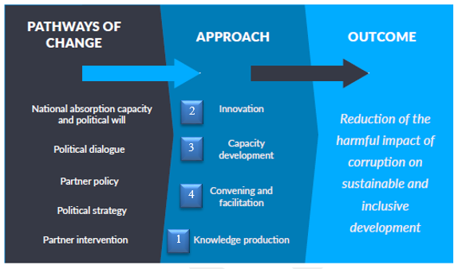

We will monitor, evaluate and report our efforts to our partners on a regular basis. To achieve the desired outcome, our mandate and direction will be to support partners’ work through following four main approaches:

***1. Produce and communicate knowledge on anti-corruption practice and policy***

Solid, practitioner-focused research is essential for ensuring the highest possible quality in U4’s outreach activities. Our work in this area will be channelled through:

* **High quality research,** under specific themes that have emerged mainly in response to U4 partners’ own strategic priorities. U4 is proactive and ambitious in researching and developing themes where demand for analysis has been relatively low, but where further research can be expected to advance knowledge in the field of anti-corruption.
* **Gender mainstreaming**, considering, identifying and addressing relevant gender concerns at every stage of the research and communication process. This will entail building gender expertise in research teams and including gender dimensions in research content and methodology.
* **The U4 Helpdesk**, a key service to U4 partner agencies offering a specialised form of knowledge production. Based at Transparency International (TI), it offers on-demand, desk-based research on corruption to individual partner agency staff. When a request is received, the Helpdesk staff provide a written response synthesising the state of knowledge on the requested topic within ten days.
* **Communications and outreach**, a key strategic goal for U4 is to develop targeted and effective communications that maximize the potential for impact.
* **The U4 website**, during the strategy period, a new U4 website will consolidate U4’s position as the go-to online resource centre for development practitioners and their partners.

***2. Generate and test innovative approaches to advance the field of anti-corruption practice and policy.***

Today, U4 has no designated area of work focused on finding and testing innovative solutions to identified problems with addressing corruption in different contexts. Furthermore, there is no structured approach to identifying potential solutions, either organisationally or as a research methodology. U4 recommendations are based on analysis of existing and original research and from practice insights. There is a certain level of risk in following the recommendations as they have not been tested in practice, therefore, their effectiveness is speculative.

The main priority for the U4 strategy period is to identify emerging thematic areas and develop existing ones to ensure our relevance to the further development of both the anti-corruption field and our partner agencies. Through the U4 Innovation Lab, which will be established during 2017 and 2018, we aim to test and verify potential approaches. This will allow us to provide donors with better advice on how to operationalise their anti-corruption programming and easier access through our new web pages.

The purpose of the Innovation Lab is to test recommendations, ideas, methodologies, hypotheses, and assumptions (test objects) derived from both a solid research base and practical experience. Possible methodologies include action research, innovative pilots, and formative research, etc. These interventions, or test projects, can be short or long-term, depending on the type test object involved. The common denominator is that they embrace the risk of testing the new, and aim to generate knowledge that can limit the risks of larger scale interventions, while achieving greater impact or alignment of expectations with test findings.

These test projects, identified in close consultation with U4 partners in the U4 Partner Forum, will allow us to collect empirical evidence on new and/or untested anti-corruption approaches. Through small-scale experimentation and action research, we can help close the learning loop, and feed findings and lessons learned into recommendations for partner agencies and future research. This will make a direct contribution to the evolving body of evidence on which anti-corruption interventions work, why and under which conditions.

The U4 Innovation Lab, along with details of the test projects and its findings and recommendations, will form an important part of the new U4 web.

***3. Build partner capacities for anti-corruption work.***

U4 contributes to capacity development through in-country workshops, online training and headquarter visits of partner agencies.

* **U4’s in-country workshops** provide a platform for determining how to approach concrete corruption challenges in context. We develop our workshops in close consultation with U4 partners at country level and tailor them to the specific country context, thus they provide a unique value to anti-corruption practitioners.
* **Online training,** U4 will evaluate partner training needs and courses offered by other providers to maintain and develop a dynamic menu of online training options. This may include additional self-paced modules, webinars and updated platforms for the current model of expert-led, more in-depth learning.
* **Headquarter visits** will continue to provide a useful arena for information sharing, internal capacity building and more in-depth dialogue on strategic issues and practical implementation challenges more generally or in specific countries/contexts. U4 will continue to prioritise such visits as an opportunity to better understand partner needs and to share knowledge on anti-corruption policies and interventions.

***4. Promote and facilitate dialogue, critical reflection and learning.***

An important role for U4 is to contribute to, convene and facilitate partner agency discussions on anti-corruption issues. U4 will take this forward through the following initiatives:

* **U4 partner forum**, U4 will create a regular forum for partners to discuss and develop strategies to improve the effectiveness of anti-corruption interventions
* **An anti-corruption hub in Bergen**, In order to generate a broader research network and raise the quality of our work to a higher level U4 will, in the upcoming strategy period, more systematically utilise and benefit from the rich and diverse research environment in Bergen in carrying out the U4 mandate.
* **Expanding and strengthening international networks,** In the new strategy period, U4 aims to seek out partnerships in aid-receiving countries on a thematic or event basis.
* **Engagement with DFAT throughout the period,** U4 will take an active role in keeping contact and maintaining a dialogue with DFAT throughout the period to ensure DFAT, and their partners, can have the best possible access to the different U4 activities and services. U4 will be proactive in communication through our newsletters, providing early information in deciding on time and location for the Steering Committee meetings, and presenting possibilities for joint initiatives and convene during relevant international and regional meetings.

# The outputs

* With a few informative statistics

## Activities:

The U4 programme is pursued and implemented in accordance with the U4 Strategy for 2017-2021 (Annex 2). The Strategy indicates that U4 will continue its practice of submitting annual Activity Plans to the Steering Committee. This approach to planning has created a successful track record of high-quality outputs and flexibility by allowing U4 to adapt to emerging policy issues, respond to changing demand for different types of training and workshops, and benefit from different funding and research opportunities.

U4 conducts a comprehensive annual survey, asking the users of U4 services questions about usefulness, relevance, quality and satisfaction with our services. The results of the 2016 annual survey show that:

* The majority of respondents (225 of 330) agree with the statement “the U4 Anti-Corruption Resource Centre is a leading source of ideas and expertise in the field”.
* The majority of respondents (207 of 330) stated that U4 resources have been beneficial to their work. An overwhelming majority of respondents had used U4 resources in the past year to inform their own understanding of anti-corruption issues.

## Research

Each year, U4 publishes Briefs, Issue Papers, Reports and Practice Insights focused on providing development practitioners with easily accessible and operationally relevant findings from research and practice in anti-corruption around the world. U4 actively works on the following thematic work areas, specific focus areas for publications are described in the 2018 Activity Plan:

|  |  |  |
| --- | --- | --- |
| **Natural Resources and Energy** | **Private Sector Development** | **Illicit Financial Flows** |
| **Evaluation and Measurement** | **Corruption and Aid** | **People’s Engagement** |
| **Justice Sector** | **Anti-Corruption Approaches in Sector Work** | **Fragile States** |
| **Corruption in Migration** | **Informal Contexts** | [**http://www.u4.no/themes/**](http://www.u4.no/themes/) |

Over the years, U4 has annually published from 12 up to 28 publications. During 2016, 135,000 people from more than 100 countries visited our web site, and our Briefs, Issue Papers, Practice Insights and Reports were accessed over 92,000 times,[6] indicating that in a majority of cases people find and download material on each visit to the U4 webpage.

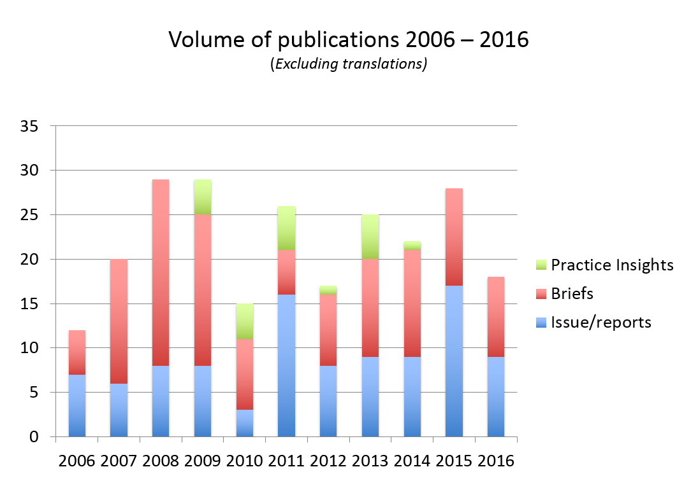

All U4 publications are free and openly accessible to download on the website, and are therefore provide a global public good to inform and advise anyone working on development issues. The table below presents the twenty countries that visited the U4 site most frequently during 2016 (figures in bold explain frequency):

|  |  |  |  |  |
| --- | --- | --- | --- | --- |
| 1. USA **17,688** | 2. UK **12,047** | 3. India **6,978** | 4. Norway **5,075** | 5. Kenya **4,667** |
| 6. Germany **4,351** | 7. Philippines **4,090** | 8.France **3,604** | 9. Australia **3,567** | 10. Canada **3,233** |
| 11.Pakistan **3,228** | 12.South Africa **2,791** | 13.Nigeria **2,382** | 14.Indonesia **2,246** | 15. Sweden **2,233** |
| 16.Netherlands **2,207** | 17. Tanzania **2,034** | 18.Uganda **1,893** | 19.Switzerland **1,625** | 20. Malaysia **1,625** |

## Training and workshops

In 2016, U4 organised five in-country workshops. Over 160 people attended, and over 60% of participants were from NGOs, host-country governments and other local stakeholders. In addition to this, U4 facilitated online trainings for over 300 U4 Partner Agency staff and invitees.[7] A headquarter visit, as undertaken in 2017, is another opportunity to provide U4 partners with updates on our thematic research and for exchange of information and experiences.

DFAT staff use the majority of online training platforms. Over the years, DFAT has also invited participants from UNDP, the Australian Crime Commission, the Australian Federal Police, Solicitor General's office, Senior Litigation Advisors, anti-corruption advisors, staff from the ministry of health (in Tonga) and Legal Policy Advisers.

In 2016, U4 developed a 45-minute interactive self-paced online module: “Managing corruption risks in development cooperation”. It introduces basic anti-corruption definitions and tools, complemented by a highly interactive game. The module has received positive reviews and so far, 177 partner staff have taken the module. This modulehas recently been made mandatory for SDC partner staff.<http://www.u4.no/partner/classroom/brick1/index.cfm> )

As agreed with the U4 Steering Committee, online trainings are only available to staff of Partner Agencies, with the exception of the self-paced module. In conjunction with the revamp of the U4 website late 2017, the self-paced course will be open for all interested.

Participation in in-country workshops is determined jointly with the host agency, based on the specific objectives of the workshop. In most cases, host-country government counterparts, civil society representatives, and other relevant donor agencies are included.

During 2017, U4 will transform the U4 Essentials of Anti-corruption course into a U4’s second self-paced module, Essentials 1, and a shorter facilitated course Essentials 2. We are working with our core anti-corruption experts on developing the content, and will be ready to pilot to partner agency staff by 2018. The graph below presents the variety of training types offered by U4, and the uptake by staff.

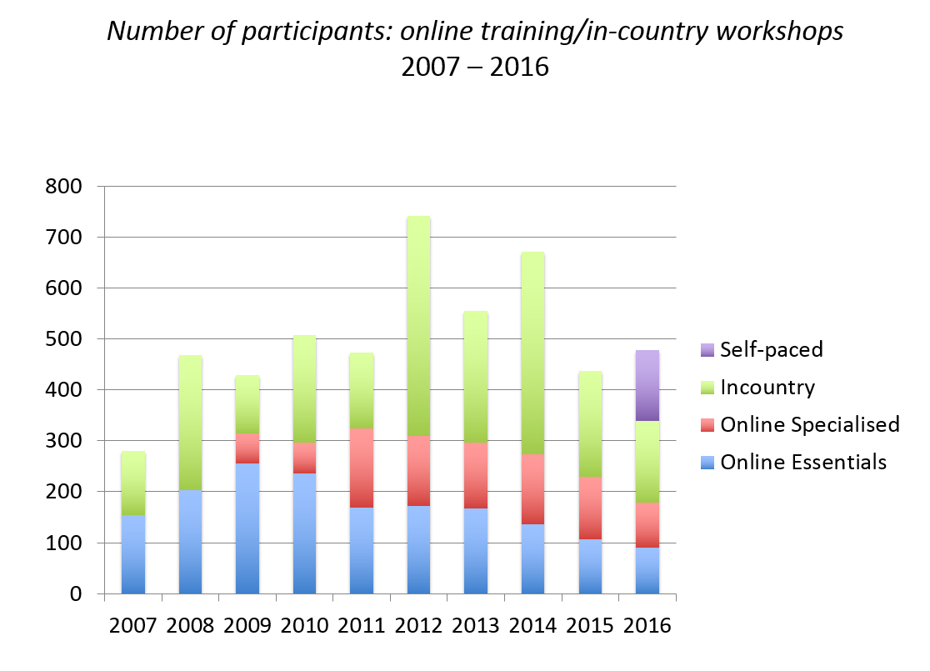

The three to five week long online courses have historically presented high dropouts and failure rates. The self-paced modules therefore will offer participants more flexibility in the learning cycle, and are aimed towards adapting to partners needs and priorities.

U4 will continue to offer both online training and in-country workshops throughout the strategy period. In 2018, U4 plans for seven in-country workshops and seven online trainings, covering a range of issues (see Activity Plan 2018, Annex 3).

## Communication and outreach

A key strategic goal for U4 is to develop our targeted and effective communications that maximise the potential for impact. The communication of research findings occurs in all aspects of U4’s engagement with partner staff, including headquarter visits, in-country workshops and online trainings.

Through newsletters, publications and presentations we will continue to ensure easy access to anti-corruption research and knowledge on different platforms. This requires continuous investment in advisors’ presentation and communication skills, as well as in digital tools needed to ensure the broadest possible distribution of U4 outputs to our target audience and other potential stakeholders. Communications and outreach will be reviewed to ensure that they are free from gender biases. To avoid overloading partners, we will prioritise the delivery of targeted information to specific audiences through ongoing development of our internal database.

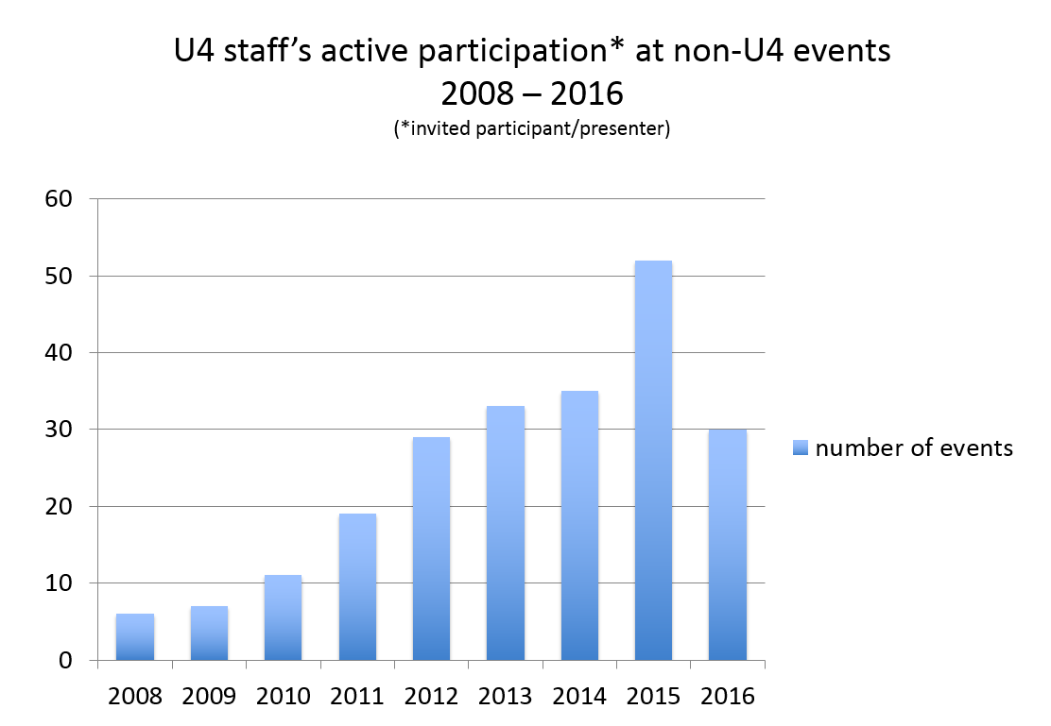

U4’s active participation at non-U4 events has increased dramatically during the past years. This correlates with our relevance and trust U4 has earned in the anti-corruption world. Despite being sought after at events, U4 prioritises its commitments to the partners though the approved annual Activity plan.

## The U4 Website

During the strategy period, a new U4 website will consolidate U4’s position as the go-to online resource centre for development practitioners and their partners. We will develop new platforms for presenting our research outputs in a clear, user-friendly way. U4 will adopt a digital first and mobile friendly policy. The website will also aim to present relevant materials from third-party sources. U4 will present the new website features at the Steering Committee meeting in Bergen, October 2017.

## Helpdesk

An important element of U4’s information services is the Helpdesk, operated through a partnership with Transparency International (TI). Providing a specialised form of knowledge production the U4 Helpdesk, it is a key service to U4 partner agencies. The Helpdesk offers on-demand, desk-based research on corruption to individual partner agency staff. Answers are further quality assured and published on the U4 and TI websites and contribute to a growing, publicly accessible knowledge bank. The Helpdesk will continue to be an important forum for disseminating our research findings, curating relevant resources from third parties, identify new issues of concern that can informing our research agenda.

# Organisation, risk and learning

## Monitoring, Evaluation and Learning

U4 is developing a monitoring, evaluation and learning (MEL) system, the system will be operational in throughout the strategy period. The system was designed based on guidance from a report by Scanteam for U4 (Annex 6). The system has two main components. We aim to improve our internal performance measurement system that will help U4 ensure quality, and constant monitoring and learning, and strengthen our reporting to our partners. U4 will report annually to partners on the intermediate outcomes directly related to the four work-streams presented in the theory of change:

* Knowledge production
* Innovation
* Capacity development
* Convening and facilitation

We will use system data, the U4 annual survey, google analytics and other quantitative data where possible and appropriate. We will also strengthen the qualitative part by conducting interviews, external reviews and other means to assess our work and services. We will present the new MEL system at the Steering Committee meeting in Bergen, during October 2017. For details of our results from 2012-2016, please see annex 5, the U4 performance log frame.

## Risk

U4 operates with a risk analysis and mitigation framework (annex 7). The framework highlights and acknowledges the types of risks we face and how we intend to manage them. The framework is a living document that the U4 team and CMI management will review systematically and present to partners in our standard reporting.

An integral part to this ongoing effort will be the monitoring, evaluation and learning approach, which will highlight and assess risks and their potential influence on our performance. U4 is well aware that efforts to address and reduce corruption might have the opposite effect, if not carefully calibrated and targeted to the specific context and programming aims. In this regard, we aim to highlight challenges in our research outputs and recommendations, and communicate this through our in-country workshops, online trainings and head quarter visits. The framework will be discussed at regular internal team meetings.

## Gender

Among CMI’s 80 employees, as of 31st of December 2016, 37 are women. Fifty percent of the members of the Board and the management team are women. CMI designed its wage system and welfare schemes to provide equal opportunities for wage and career development. The election rules for Board members selected among staff imply that each sex is represented. Traditionally, the institute has recruited from arenas with an equal representation of men and women, and therefore has not introduced quotas to achieve gender equality. CMI follows the Act relating to Gender Equality. (Annex 8)

U4 received specific support to further U4 staff knowledge on gender related issues during the previous contract cycle. This support has resulted in training, providing guidance and tools provided for U4 staff to enable them to incorporate gender analysis and gender mainstreaming in their work. This also provided U4 with an opportunity to incorporate a focused gender lens to the U4 strategy, in addition to appointing a focal point for gender at U4 and developing an implementation plan for the new strategic period.

## Environment

The Institute’s activities are not regulated by licenses or directives, and do not have a direct impact on the external environment. It should be noted, however, that extensive travel by our staff contributes to greenhouse gas emissions.

## Organisation and governance structure

The strategy and priorities of U4 are reviewed by the Steering Committee of donor agencies, together with our parent organisation, CMI. U4 is an autonomous management unit of CMI, and has no separate legal identity. Steering Committees meetings are held annually, in the form of a full day meeting where the U4 team presents the achievements to date, the status in relation to strategy, future activity plans along with any other updates and news. Since 2013, U4 staff have had modest flexibly to work outside the U4 core. The projects that fall under the flexibility are an opportunity for staff to take on assignments that contribute to the U4 team, its desired outcome and future institutional development. The advisors do not take on projects in their individual capacity, but rather through CMI. The current practice is that U4 advisors consult with U4 director before taking additional projects, to evaluate relevance and capacity on a case-by-case basis. The flexibility to work outside the U4 core is approved when director secures that U4 core work is prioritised and research topic matches U4 themes and priorities. This structure brings experience, output and outcome used for the U4 core. It is of high importance that U4 core is the priority for advisors, and that ad hoc work is catered to only when capacity allows.

## Procurement

CMI works with procurement guidelines and ensures the procurement of goods, works and services are carried out in accordance with the applicable legislation and internationally accepted principles and good procurement practices. CMI strives to follow procurement practices to ensure value for money and realise efficiencies and opportunities in our procurement processes. Our relationships with our suppliers should be fair, transparent, and should create value for all parties. If possible, at least three different suppliers should be considered in the procurement process, and all procurements should be according to CMIs standards where price, quality and availability are the three main factors to be considered, but cost alone does not provide an accurate assessment of value for money. U4 works with Ernst and Young as auditors, they operate with the accounting standard of ISA 805 (please find the ToR for audit in annex 9).

# Funding request

The requested funding period is three years with an annual funding level from DFAT of AUD 350.000.

Planned activities for 2018, with income and budget estimates can be found in the draft 2018 Activity Plan document [8](Annex 3). The 2017 Activity plan includes the estimated budget for the full strategic period (Annex 10).

The partnership with DFAT has been an essential element in U4’s ongoing relevance and success, and we look forward to our continued cooperation in the future.

## List of Annexes

Annex 1: CMI certification of registration

Annex 2: U4 Strategy for 2017-2021

Annex 3: U4 Activity Plan for 2018

Annex 4: U4 staff profiles

Annex 5: The U4 log frame 2015

Annex 6: Scanteam report

Annex 7: Risk framework

Annex 8: The act relating to gender equality

Annex 9: The ToR for audit

Annex 10: 2017 Budget and notes

Annex 11: CMI Quality Assurance System

Annex 12: CMI Code of Conduct and Business Integrity Policy

1. Please see annex 1, CMI’s certification of registration
2. Please see annex 2, U4 Strategy 2017-2021
3. The 2018 Activity plan will be presented for discussion and approval at the SC meeting in Bergen, October 2017.
4. <http://dfat.gov.au/aid/Pages/australias-aid-program.aspx>; <http://dfat.gov.au/about-us/publications/Pages/australian-aid-promoting-prosperity-reducing-poverty-enhancing-stability.aspx>
5. CMI quality assurance system, annex 7.
6. Numbers taken from Google analytics
7. Invitees refers to people invited by U4 partners, as partners have the possibility to allocate their training places to other stakeholders and representatives from civil society organisations.
8. The 2018 Activity plan will be discussed, revised if needed and approved during the Steering Committee Meeting in Bergen, 19th October 2017.