

Commonwealth of Austra lia

DFAT Administered (aid) Simple Grant Agreement

Chr. Michelsen Institute (CMD — Membership Proposal for the U4 Anti-Corruption

Resource Centre

Mr Ottar Mæstad

Chr. Michelsen Institute ('the Recipient')

Jektevikiksbakken 3 1 5006 Bergen NORWAY

Dear Ottar

I am pleased to advise that DFAT wishes to give your organisation (the Recipient) a grant to support it to implement the activity t'U4 Anti-Corruption Resource Centre — Membership Proposal for DFAT 2018-2020", described in Attachment B to this letter. The details of the grant are set out in

Attachment A. If the Recipient accepts the grant, it must comply with the terms and conditions set out in Attachment C.

Please read Attachments A, B and C ("the Agreement"). To accept the grant on behalf ofthe

Recipient, please sign below and return the original signed document (including the Attachments) to:

Ms Angela Hopkins Assistant Director Law and Justice Section (LJS)

Department of Foreign Affairs and Trade

John McEwen Drive BARTON ACT CANBERRA

Yours sincerely

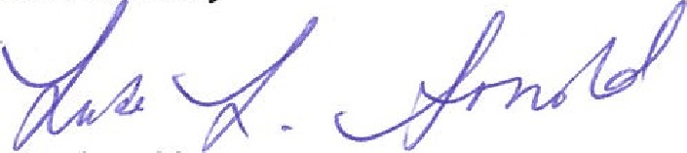

Luke Arnold

Delegate

November 2017

ACCEPTANCE OF GRANT

On behalf of the Recipient, I accept the grant offered by DFAT as described in Attachment A, to implement the Activity described in Attachment B, and on the terms and conditions set out in

(signature)

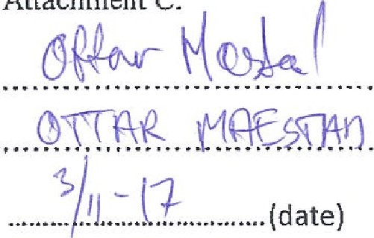

Attachment

C.

(print name)



ÀTTACHMENT A - GRANT DETAILS

|  |  |  |  |
| --- | --- | --- | --- |
| Grant | inclusive of GST  And any interest earned on the Grant or through exchange rate gains. | | |
| Tranches | Tranche Amount | Tranche Date |  |
| AUD $ 350,000.00 | Feb2018 |
| Al-JD $ 350,000.00 | Feb 2019 |
| AUD $ 350,000.00 | Feb 2020 |
|  |  |
| Total AUD $ |  |
| Tranche Conditions | DFAT will pay the Recipient an acquittable Grant up to a maximum of  IAUD $  inclusive of GST in tranches divided as follows:  DFAT will pay Tranche I within thirty (30) days of the date of this Agreement commencing and subject to receipt of a valid invoice as per clause 2 of Attachment C.  DFAT will pay subsequent tranches at the date indicated above subject to the Recipient providing:  submitting a valid invoice as per clause 2 of attachment c; and making satisfactory progress with implementation of the Activity as determined by DFAT. | | |
| Recipient | Chr Michelsens Institute (CMD for U4 membership | | |
| Activity | The Proposal and 2018 Activity Plan - described in Attachment B. | | |
| Activity Start Date | 01 January, 2018 | | |
| Activity End Date | 30 December, 2020 | | |
| DFAT Agreement No. | INM369 | | |
|  | Chr Michelsens Institute (CMI):  Jektevikiksbakken 31  5006 Bergen NORWAY Postal Address::  Email: Sara.ogm@cmi.no  Facsimile: | | |
|  | Name:Ms Angela Hopkins  Department of Foreign Affairs & Trade  John McEwen Crescent, BARTON ACT.  Email: Angela.Hopkins@DFAT.Gov.Au  Facsimile: N/A | | |



ATTACHMENT B - ACTIVITY PROPOSAL AND BUDGET

[Membership proposal and 2018 Activity Plan for the Australian Government Department of Foreign Affairs and Trade (DFAT) — For continued partnership with U4 Anti-Corruption Resource Centre for the period 2018-2020]

**See U4 Anti-Corruption – Project Document 2018-2020**