Tropical Cyclone Winston Education Response Evaluation

October 2017

# Acronym List

AMU

AQEP

AUD

CAPS

CVA

DEO

DFAT

EIE

ESSDP

FEG

FEMIS

ICS

MoEHA

M&E

NDMO

NDMP

NGO

SC

TC

TLS

UN

UNICEF

WASH

Assets and Monitoring Unit

Access to Quality Education Program

Australian Dollar

Community Awareness Program

Capacities and Vulnerabilities Analysis

District Education Office

Department of Foreign Affairs and Trade

Education in Emergencies

Education Sector Strategic Development Plan

Free Education Grant

Fiji Education Management Information System

Incident Control System

Ministry of Education, Heritage and the Arts

Monitoring and Evaluation

National Disaster Management Office

National Disaster Management Plan

Non-Government Organisation

Save the Children

Tropical Cyclone

Temporary Learning Spaces

United Nations

United Nations Children’s Fund

Water Sanitation and Hygiene

Cover Photo: At Nasinu District School, teachers and children sit outside after TC Winston while completing activity plans. Australia has now repaired Nasinu District School, allowing the children to return to the classrooms. C*redit: Australia’s Access to Quality Education Program*

Contents

Acronym List i

Executive summary 3

Acknowledgements 5

Management Response 6

Recommendations for Australia’s bilateral education assistance in Fiji 7

Recommendations for Australia’s humanitarian support for the education sector in the Pacific 9

introduction and background 12

Fiji’s education system and disaster management 12

Tropical Cyclone Winston 13

Australia’s support in the education sector following TC Winston 14

Evaluation Process 16

Evaluation Approach and Methodology 16

Limitations of the Evaluation 17

Key Findings 19

Relevance 19

Effectiveness 20

Community Engagement 24

National Leadership 25

Coordination 26

Recommendations and Conclusion 27

Recommendations for Australia’s bilateral education assistance in Fiji 27

Recommendations for Australia’s humanitarian support for the education sector in the Pacific 29

Annex 1: Terms of Reference 31

Annex 2: consultation/schools visited 37

Annex 3: Documents Reviewed 38

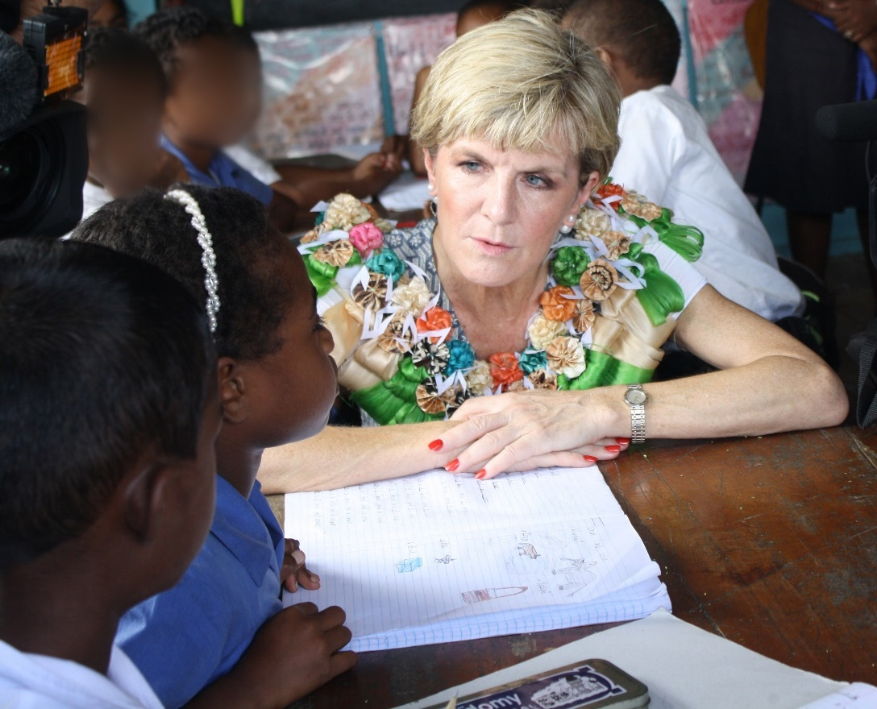

Australia’s Foreign Minister, The Hon. Julie Bishop, talks with children in March 2016 about the challenges they are facing after the cyclone. *Credit: Department of Foreign Affairs and Trade*

# Executive summary

Tropical Cyclone (TC) Winston caused widespread damage in Fiji on 20-21 February 2016. It is the strongest cyclone ever recorded in the southern hemisphere, causing 44 deaths and affecting more than 60 per cent of the population of Fiji (about 540,000 people)[1]. Working closely with the Fiji Government, Australia provided AUD15 million in immediate assistance to Fiji to support over 200,000 men, women and children with relief supplies such as shelter, water, food, hygiene items, emergency health care and access to education. Australia also continues to assist with the longer term [recovery and reconstruction efforts](http://dfat.gov.au/aid/topics/investment-priorities/building-resilience/humanitarian-preparedness-and-response/tc-winston/Pages/recovery-and-reconstruction.aspx) and has committed an additional AUD20 million to rebuild critical infrastructure and increase resilience to natural disasters.

Following the cyclone, damage to school infrastructure was extensive and reverberated throughout the entire Fijian school system. School supplies and support materials had been rendered unusable, and entire school communities saw their houses and livelihoods destroyed or severely compromised. Returning children in Fiji to school as quickly and safely as possible was a major priority of the Fiji Government, and was aligned with Australia’s key area of bilateral development assistance. As part of Australia’s immediate AUD15 million humanitarian investment, AUD4 million was allocated to support the response in the education sector.

Australia’s education support was predominantly provided by two partners: the United Nations Children’s Fund (UNICEF) and Save the Children Australia in cooperation with Save the Children Fiji. To complement this assistance, support was provided through Australia’s ongoing bilateral education program, the Access to Quality Education Program (AQEP). Activities were aligned with the Education in Emergencies (EiE) standard model[2] and included providing:

* temporary learning centres;
* education materials;
* school feeding programs;
* psychosocial support to students and teachers; and
* water and sanitation support in schools.

The evaluation found that Australia’s support to the education sector following TC Winston was highly relevant and the commitment of Australia to mobilise emergency support was timely and welcomed. The immediate response helped to re-open schools in Fiji within a relatively short period, in some cases within the two-week target set by the Fijian Ministry of Education, Heritage and Arts (MoEHA).

The response adhered to international humanitarian standards, and the twin objectives of a minimised disruption period and continuity of service delivery helped to stabilise communities. The EiE model implemented following TC Winston helped to introduce an element of stability in affected communities, with reopened schools and temporary learning spaces serving as entry points for a wider array of disaster response services such as nutrition, water, sanitation and hygiene (WASH) services and psycho-social counseling for affected children. One important measure of the success of these efforts in Fiji was that school enrolment returned to near pre-disaster levels within a relatively brief time-span.

**Key successes noted during the evaluation of Australia’s support to the education sector were:**

* the rapid deployment of temporary school resources allowed schools to reopen quickly;
* use of a flexible funding model gave Australia’s education sector response partners the capacity to procure assistance materials rapidly, based on initial needs assessments;
* leveraging the existing bilateral education assistance program as part of the overall sector response provided good outcomes; and
* support to the initial MoEHA-led needs assessment reinforced national leadership.

While the evaluation found that the response was timely, effective and appropriate in the immediate term, there was declining effectiveness over a one-year timeframe as needs evolved. What were intended to be temporary solutions to immediate needs were still being used a year on from TC Winston when schools were in need of a more permanent solution. While the response correctly followed the MoEHA’s lead on initial needs assessments, the targeting of the five activities in the standard EiE model were not entirely contextualised or adjusted to fit conditions as they evolved.

The key lesson is that the standard global model for EiE needs to be revisited based on on-going practice and findings. Emergency responses tend to work most effectively when they are phased and linked to long-term development programs and outcomes. This was proven during the response where the effectiveness of the intervention measures diminished when not adjusted over time. To its credit, the Australian education sector response did “pivot” in several areas, such as can be seen by the distribution of photocopiers and generators to schools three months after the cyclone and the shifting focus from WASH kits to WASH infrastructure. It also benefitted greatly from having a pre-existing education support program that understood the operating context. A more finely tuned preparatory phase would have only strengthened this.

Policy dialogue during the response was positive and contributed to a better response overall. The evaluation team did observe coordination challenges among implementing partners and the Fiji Government, resulting in some duplication of effort. National systems will continue to play a pivotal role moving forward and the strengthening of national disaster management and disaster risk management policies and strategies will drive a more coordinated and coherent approach. While Australia’s response recognised the strengths of national systems, it identified gaps. Moving forward, there is an opportunity to continue building engagement and coordination strategies and mechanisms that promote national leadership.

**Key lessons to inform future responses include:**

* the standard EiE model must be contextualised to ensure it is relevant for likely disasters in the Pacific;
* a phased implementation model, spanning initial response, early recovery to long-term recovery and sustainability would enable needs to be better addressed as they evolved over time; and
* partner selection must consider ability to operate in the context and organisational capacity to deliver, despite international organisational commitments.

Finally, while there is no ‘one size fits all’ model, lessons from TC Winston can help inform education in emergencies programming more generally and help to create a more contextualised model which may be better suited to disasters likely to impact the Pacific in the future.

### Recommendations for Australia’s bilateral education assistance in Fiji

Recommendation 1: Support Fiji’s Ministry of Education, Heritage and Arts (MoEHA) to develop a response plan which clearly articulates roles and responsibilities through multiple phases of the response, as well as expectations of partner interventions.

Recommendation 2: Support MoEHA to undertake risk mapping of schools and integrate this data into the Fiji Education Management Information System (FEMIS) to ensure the appropriate data is available to guide disaster preparedness and response efforts.

Recommendation 3: Provide continued support to MoEHA to strengthen ongoing data collection and management (including within FEMIS), and consider how the current system can be used for needs assessments and disaster preparedness.

Recommendation 4: Continue to support strengthened government and partner systems for more coordinated implementation, management and reporting of preparedness and response efforts.

### Recommendations for Australia’s humanitarian support for the education sector in the Pacific

Recommendation 5: Consider a phased disaster planning model, which accounts for evolving needs over time. This would help plan the response as relief, early recovery, and recovery to sustainability. Current flexibility should be kept but guided by defined phases and corresponding outcomes.

Recommendation 6: Support a ‘Pacific component capacity mapping’ exercise to understand key capacities for humanitarian partners.

Recommendation 7: Develop a monitoring and evaluation framework that accounts for evolving needs over time. It should include a unified reporting process linked to the overall emergency design concept and framework, agreed to by all partners.

## Acknowledgements

The evaluation team was comprised of Geoff Peterson (team leader) from Bamiyan Consulting Pty Ltd, Ty Morrissey (team member) from Morrissey Consulting International Pty Ltd and Alifereti Bulivou (team member), an independent Fijian consultant. Manoa Senikarawa, MoEHA, participated in the fieldwork.

The evaluation team would like to express its sincere thanks to the Fijian Ministry of Education, Heritage and Arts, Australian partners and beneficiaries for their participation and reflection of Australia’s assistance in the education sector following Tropical Cyclone Winston.

# Management Response

The recommendations made in this report concern Australia’s bilateral aid program in Fiji as well as Australia’s broader humanitarian support. They provide a valuable learning opportunity for future investments in humanitarian preparedness and response in both Fiji and across the Pacific region. Of the seven recommendations made by the evaluation team, Australia’s Department of Foreign Affairs and Trade (DFAT) agrees, at least in part, to all of them.

DFAT notes that some recommendations require the Fiji Government’s agreement and guidance. This is consistent with Australia’s commitment to respect and help strengthen leadership and decision-making by local and national actors in humanitarian action in order to address the needs of affected populations.

The action plan identified in this management response will be progressed by DFAT’s Humanitarian, NGOs and Partnerships Division (HPD) and Pacific Division (PAD), including Suva Post, in consultation with the Government of Fiji and relevant development and humanitarian partners.

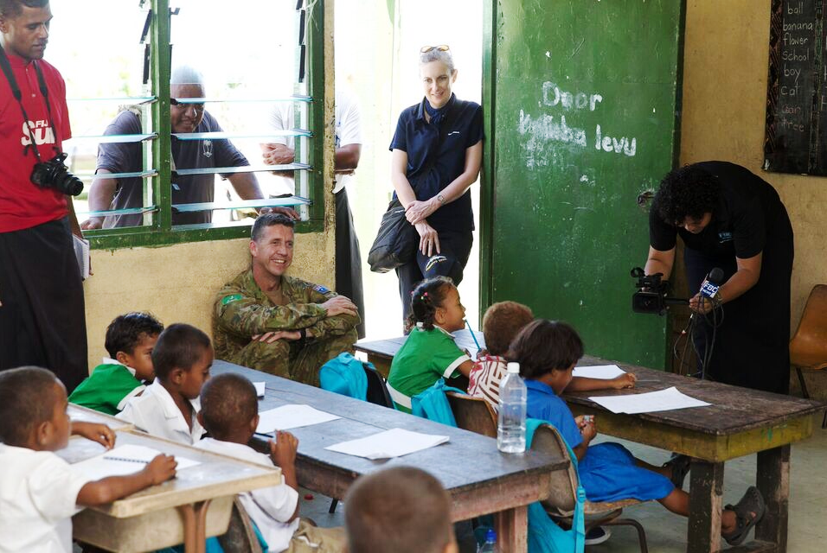

Australia’s High Commissioner to Fiji, Ms Margaret Twomey, and Australian Defence Force Joint Taskforce Commander Lt Col Scott Hill, observe classes running soon after Tropical Cyclone Winston. *Credit: Australian Department of Defence*.

## Recommendations for Australia’s bilateral education assistance in Fiji

| Recommendation | Response | Explanation | Action Plan | Timeframe, if practical |
| --- | --- | --- | --- | --- |
| Recommendation 1: Support Fiji’s Ministry of Education, Heritage and Arts (MoEHA) to develop a response plan that clearly articulates roles and responsibilities through all phases of the response, as well as expectations of partner interventions. | Agree in principle | A national response plan would be initiated and led by the MoEHA. On request, DFAT would consider assisting the MoEHA to develop a disaster management plan template and school emergency plans. | * Through the design phase of DFAT’s new bilateral education program in Fiji, we will offer assistance to help develop a multi-hazard response plan. Assistance could consider the dual purposing of schools as community evacuation centres (and continuity plans for education in the event of longer term displacement), links with the National Disaster Management Office (NDMO) during a response, the role of school grants to provide assistance in emergencies and a school-level emergency management plan template. * DFAT’s bilateral education team will continue to engage in the Fiji Education Cluster to help the MoEHA and partners develop and socialise any national emergency response plan. | Investigate these possibilities with MoEHA during design phase of bilateral education program (by December 2017) |
| Recommendation 2: Support MoEHA to undertake risk mapping of schools and integrate this data into the Fiji Education Management Information System (FEMIS) to ensure the appropriate data is available to guide disaster preparedness and response efforts. | Agree in principle | Any action would be guided by Fiji Government priorities. On request, DFAT would consider supporting risk or hazard mapping, yet recognises that this process would involve the participation of more than just Fiji’s school system. DFAT agrees to continue supporting the integration of data into FEMIS and improving its functionality. | * Through our multi-year partnership with the Global Facility for Disaster Reduction and Recovery (GFDRR; 2017-20), DFAT will support activities that generate data to better understand risks and take action to integrate disaster risk reduction into national planning and policies. This will contribute to safer and more resilient school infrastructure in the region, including Fiji. * DFAT will consult with Geoscience Australia to identify data of relevance to MoEHA from the “Development of Hazard Impact Scenario Mapping Capacity for the Pacific” initiative (2016-2019) * DFAT will work with relevant government counterparts (such as MoEHA, the NDMO and the Fiji Meteorological Services) to identify risk/hazard mapping needs. * Through DFAT’s bilateral education program, we will work with the MoEHA to strengthen the FEMIS as necessary for integration of data (refer recommendation 3). | GFDRR partnership activities ongoing until 2020  Geoscience Australia activities ongoing until 2019  Through DFAT’s bilateral education program (2017-22) |
| Recommendation 3: Provide continued support to MoEHA to strengthen ongoing data collection and management (including within FEMIS), and consider how the current system can be used for needs assessments and disaster preparedness. | Agree | DFAT agrees to continue to support the MoEHA with system strengthening, including for improved disaster preparedness. | * Through DFAT’s bilateral education program, we will continue to support the MoEHA to strengthen FEMIS to incorporate disaster preparedness and response needs. This will include ensuring that the information collected and stored in FEMIS is reflective of MoEHA policy priorities and linked to work activities. * DFAT will continue to support the ‘School Maintenance Handbook’ to guide asset management and minor infrastructure work, including through technical assistance provided by a specialist seconded to the MoEHA. This will help to provide a baseline on the state of school buildings, which can help to guide work required to increase resilience of schools. | Discuss with MoEHA during design phase of bilateral education program (by December 2017) |
| Recommendation 4: Continue to support strengthened government and partner systems for more coordinated implementation, management and reporting of preparedness and response efforts. | Agree | DFAT will continue to support Fiji Government’s preparedness and response measures, including system strengthening, in line with our commitment to localisation[3] of humanitarian responses. | * DFAT’s bilateral education program supports the Fiji Education Sector Strategic Development Plan 2015-18, including by providing technical assistance and system strengthening. * DFAT will continue to support Fijian authorities (including the NDMO) and their efforts to coordinate, implement and manage preparedness and response efforts, including through DFAT’s new Integrated Deployment Civilian Capability (IDCC). * DFAT has prioritised its support for localising humanitarian assistance in Fiji, and will test these priorities through dialogue with national and local stakeholders. * DFAT will ensure that reporting on partner response efforts will be shared with the MoEHA in an appropriate manner. * Australia and Fiji have agreed to co-host a regional civil-military workshop focused on disaster management to strengthen cross-agency cooperation within and between Pacific Island Countries on humanitarian and disaster response (HADR). | Pacific HADR civil-military workshop to be held in late 2017 |

## Recommendations for Australia’s humanitarian support for the education sector in the Pacific

| Recommendation | | Response | Explanation | Action Plan | Timeframe, if practical |
| --- | --- | --- | --- | --- | --- |
| Recommendation 5: Consider a phased disaster planning model, which accounts for evolving needs over time. This would help plan the response as relief, early recovery, and recovery to sustainability. Current flexibility should be kept but guided by defined phases and corresponding outcomes. | Agree | | Consistent with DFAT’s Humanitarian Strategy (2016), DFAT recognises the evolving needs over time in disasters through investing in resilience and risk reduction, disaster preparedness, response, early recovery and reconstruction. Each disaster will require its own strategy based on the particular context. | * DFAT will continue to advocate for appropriate, locally led responses to disasters and initiatives to reduce the impact of natural hazards. * DFAT will maintain flexibility in humanitarian programming, allowing a phased approach guided by monitoring and evaluation efforts (refer recommendation 7). * DFAT will draw on the findings of this evaluation to help inform the design of any future humanitarian support for the education sector, while noting the need for context-specific approaches. * The new Australian Humanitarian Partnership (AHP) will strengthen community capability to prepare for and respond to slow and rapid onset disasters in the Pacific and will emphasise the need for adaptive programming. * DFAT will investigate the feasibility of establishing a ‘social infrastructure panel’. This panel of pre-approved providers could supply pre-fabricated structures either to DFAT or directly to affected governments. Prefabricated structures would supplement, not replace, existing shelter approaches. * DFAT will continue to draw on civilian deployees to provide technical expertise as prioritised by Fiji Government. An example was the technical assistance provided to the MoEHA for recovery efforts following TC Winston. | AHP design finalised by December 2017  ‘Social infrastructure panel’ feasibility determined by mid-2018 |
| Recommendation 6: Support a ‘Pacific component capacity mapping’ exercise to understand key capacities for humanitarian partners. | Agree in principle | | DFAT is supporting mechanisms intended to enable partners to respond effectively and appropriately to humanitarian crises.  Noting this recommendation refers to the AHP, the new design will support an appropriately targeted ‘Pacific component capacity mapping’ exercise, focused on key non-government partners, including in Fiji.  Fiji’s MoEHA may wish to map the capacity of national and local education partners to contribute to a response. | * Through the AHP design process, DFAT will achieve a greater understanding of partners’ humanitarian capabilities across the five priority countries, including Fiji. * Specific efforts will be made under the DFAT-Australian Red Cross (ARC) Humanitarian Agreement to draw on lessons learned from TC Winston to strengthen disaster management programming at community and institutional level. * DFAT Pacific posts will systematically identify partnerships in their Crisis Action Plans (CAPs) and update information of in‑country suppliers annually. * DFAT will support Pacific Island country leadership to establish a portal through which partner governments can request assistance based on a pre-identified register of national and regional government capabilities and assets in the Pacific. * DFAT will continue to work with regional partners such as the Pacific Community (SPC) and the United Nations Office for the Coordination of Humanitarian Affairs (OCHA) to help understand response capacities, including through OCHA’s current pilot of a Country Preparedness Package in Vanuatu. * DFAT will share lessons from the ARC Pacific Humanitarian Challenge (PHC) mapping of private sector capabilities in Vanuatu with Pacific posts and partners, including Fiji. * DFAT will continue to find, test, share and scale innovative solutions to support educational outcomes in the region, including through the MIKTA (Mexico, Indonesia, Korea, Turkey and Australia) Education in Emergencies challenge. | AHP design finalised by December 2017  Activities to be undertaken over the course of 2017-18  Pacific portal of regional government capabilities to come into effect in 2018  ARC PHC lessons to be shared by December 2017 |
| Recommendation 7: Develop a monitoring and evaluation framework that accounts for evolving needs over time. It should include a unified reporting process linked to the overall emergency design concept and framework, agreed to by all partners. | Agree | | Consistent with DFAT’s Humanitarian Strategy (2016), DFAT strives to be accountable and continually learn from our actions to improve the quality of our work. | * DFAT is establishing a joint monitoring and evaluation framework with New Zealand (Joint MEF) for rapid onset disasters to provide guidance on reporting processes for partners undertaking response activities in the Pacific. The Joint MEF is expected to increase the timeliness, quality and consistency of reporting and will be used by DFAT to guide decision-making. * DFAT is committed to high standards of transparency in the management of Australia’s aid program, including through publishing aid program information on DFAT’s website. * DFAT will continue to require our partners to undertake in-depth monitoring and evaluation of activities and provide meaningful performance information to stakeholders. * The AHP will help facilitate shared learning and improvement, including through the introduction of a core set of shared indicators and evaluation questions, building on the Joint MEF and Core Humanitarian Standard on Quality and Accountability. Consideration will be given to developing specific indicators and questions to inform “education in emergencies” programming*.* * DFAT has developed a comprehensive approach to monitoring, evaluation, accountability and learning that will be implemented in the IDCC. This framework will monitor performance of individual deployments and their contribution to the achievement of end of program outcomes. | Joint MEF to be piloted during 2017-18 Pacific cyclone season  AHP design finalised by December 2017  IDCC to be launched in late 2017 |

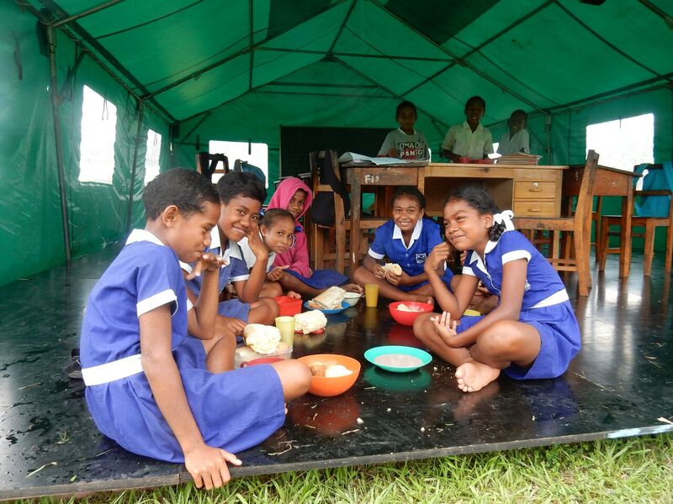

Children at Naweni District School in Cakaudrove enjoying their lunch as part of the Save the Children Fiji-run school feeding program. *Credit: Save the Children Fiji*

# introduction and background

Australia, through the Department of Foreign Affairs and Trade (DFAT), works in partnership with the Government of Fiji in support of Fiji’s development. It is particularly focused in key areas for improved human development and increased private sector development. The Australian Government is also committed to responding rapidly to international humanitarian crises in the Indo–Pacific region, with humanitarian assistance guided by DFAT’s Humanitarian Strategy, released in late 2016.

This report documents the main findings and conclusions of an independent evaluation of the Australian Government’s humanitarian support to the education sector following Tropical Cyclone (TC) Winston in Fiji. Fieldwork for the evaluation was undertaken in February 2017.

## Fiji’s education system and disaster management

The Fiji Ministry of Education, Heritage and Arts (MoEHA) is responsible for the design, implementation, monitoring and evaluation of education legislation, policies, accreditation standards, curriculum guidelines and programs. It provides the structures and support to ensure that the quality of service in schools is maintained at a high level. It is specifically tasked to conduct and deliver educational services to pre-schools, primary and secondary schools, special schools for children with special needs, vocational schools, teachers and school management and committees.

The MoEHA sits within a broader policy, institutional, and cultural context. The governing framework for MoEHA is the 2015-2018 Education Sector Strategic Development Plan (ESSDP). The ESSDP is aligned to the 2010-2014 Roadmap for Democracy and Sustainable Socio-Economic Development, the 2014 People’s Charter for Change, Peace and Progress and the United Nations Sustainable Development Goal Number 4.

The Asset and Monitoring Unit (AMU) within the MoEHA is responsible for realising the ESSDP key performance indicators on increasing awareness for disaster management. The key performance indicators also include review of OHS systems, infrastructure audits, and telecommunications issues at schools. School data is managed through the Fiji Education Management Information System (FEMIS) database.

For national disaster preparedness, the MoEHA is guided by a National Disaster Management Plan (NDMP) 1995, which remains the framework central disaster plan for Fiji. The NDMP broadly outlines roles and responsibilities for line ministries and disaster responders. The National Disaster Management Act was enacted in 1998 and established the National Disaster Management Office (NDMO) which has carriage over policies related to disaster preparedness, response, and recovery. During TC Winston, the NDMO sat within the Ministry of Rural & Maritime Development and National Disaster Management. The Fiji Education Cluster is used in humanitarian preparedness and response to improve the quality of responses in the education sector and address coordination or other gaps. It is chaired by the Permanent Secretary of MoEHA.

An Education in Emergencies (EiE) unit exists within the MoEHA, but a lack of resources and disaster preparedness policies and procedures is apparent. Emergency management plans are developed by schools but no formalised standard has been developed. There is a lack of policy clarity or guidance on the use of schools as evacuation centres.

There is a recognised urban-rural disparity in the system. Overall, 35 percent of Fijians are estimated to live below the poverty line, with a breakdown of 44 percent of rural Fijians and 26 percent of urban citizens below that line.[4] The equity issue is being addressed through MoEHA reform policies such as the 2014 Free Education Grant (FEG) scheme, transport subsidies, and school feeding programs for Year-One students.

The MoEHA faces significant logistical challenges due to Fiji’s geography as an island nation**.** The main island of Viti Levu is generally more accessible, yet still challenging in the interior. Outer islands such as those in the Lau group are also difficult to reach. This operating context makes pre-positioning of materials essential. Field coordination and communication is also critical to maintain as the costs of duplication or poor coordination are magnified by distances and transportation costs.

###### Table 1: School System Snapshot 2015

|  |  |
| --- | --- |
| General Population | 871,986 |
| Primary school children | 138,076**[5]** |
| Secondary school aged children | 68,659**[6]** |
| Total primary schools | 731**[7]** |
| TC Winston-affected schools | 495 |
| TC Winston-affected schools needing partial repair (<FJD800,000 repairs required) | 323 (65% of total) |
| TC Winston-affected schools requiring extensive rebuilding (>FJD800,000 repairs required) | 172 (35% of total) |

## Tropical Cyclone Winston

TC Winston hit Fiji on 20 February 2016 as a Category-5 (Cat-5) storm with average wind speeds of 233 km/ hour and wind gusts of up to 306 km/hour. It was the first Cat-5 cyclone to directly hit Fiji and one of the most powerful storms ever recorded in the Southern Hemisphere. A total of 540,000 Fijians, or roughly 62 percent of the population, were affected, over 30,000 houses damaged or destroyed and there were 44 fatalities[8]. The Government of Fiji’s Post Disaster Needs Assessment[9] states that a total of 495 schools were damaged or destroyed, at an estimated loss of 76.6 million Fijian dollars (AUD48.35 million).

The path of the storm did not allow for much advance warning but eventually made landfall in the northern and eastern outlying islands of Taveuni, Vanua Levu, Koro, and Ovalau. The storm then made direct contact on main island of Viti Levu, sparing the densely populated areas of Suva and Nadi from the worst of the cyclone, yet causing severe flooding and damage related to wind. The cyclone brought widespread flooding and storm surges as well, with some areas of Vanua Levu inundated as far as two hundred metres inland by surge water. A total of 80 percent of the island’s population lost power, and over 60 percent had their livelihoods compromised[10].

Schools were particularly vulnerable due to their location, age, and the standard to which they were built, with most unable to withstand the Cat-5 winds. A number of schools also sat atop raised areas making them particularly vulnerable to weather events. Several schools in locations such as Taveuni were near the water’s edge and were completely overwhelmed by storm surge flooding, destroying the vast majority of school supplies, administrative support tools, and classrooms. Wind damage to classrooms, school buildings, teachers’ quarters, and student dorms was extensive. While there were cases of conjunctivitis outbreaks, there were no reports of widespread health crisis and more serious water-borne diseases did not appear. There is some discrepancy with teacher reports on water borne diseases showing a slightly higher incidence than health centre records.

## Australia’s support in the education sector following TC Winston

Working closely with the Fiji Government following TC Winston, Australia provided AUD15 million in immediate assistance to Fiji to support over 200,000 men, women and children with relief supplies such as shelter, water, food, hygiene items, emergency health care and access to education. Of this, AUD4m was allocated for response activities within the education sector.

Australia’s education support was predominantly provided by two partners: the United Nations Children’s Fund (UNICEF) and Save the Children Australia in cooperation with Save the Children Fiji. Each partner undertook activities between February 2016 and March 2017, with the majority of activities complete by December 2016. To complement this assistance, support was provided through Australia’s ongoing bilateral education program, the then named Access to Quality Education Program (AQEP).

In order to support the MoEHA’s response to TC Winston and ensure an equitable and harmonised approach, the three partners agreed to provide a similar package of assistance to affected schools, which included:

* temporary learning centres;
* education materials;
* school feeding programs;
* psychosocial support to students and teachers; and
* water and sanitation support in schools.

Through this strategy, the aim was to help the most affected children return to normalcy as soon as possible. Australian implementing partners provided temporary learning spaces for over 15,000 students, school feeding programs for almost 10,000 and learning materials for over 50,000 children. Water, sanitation and hygiene (WASH) supplies were provided for over 20,000 students and facilities repaired in over 120 schools. Equipment such as photocopiers and generators were also supplied for 119 schools. Australia’s bilateral education program, AQEP, also provided 46 schools with food rations for teachers and students, literacy and numeracy kits, uniforms and school materials. In some schools, assistance to activate emergency access plans helped to normalise the situation and provide a routine to help children recover from cyclone-related trauma.

Australia has also committed to repairing or rebuilding 34 schools damaged by TC Winston as part of the AUD20 million recovery and reconstruction assistance in Fiji. Repairs to 16 schools in Savusavu, Rakiraki, Lautoka and Taveuni were completed in late 2016 and the rebuilding of the 18 schools that sustained more significant damage began in November 2016. Those being rebuilt include six schools on Koro Island and 12 schools in Ra, which are being rebuilt to be more resilient to future disasters. The rebuilding of schools was not covered in this evaluation, as it was not part of Australia’s immediate humanitarian assistance.

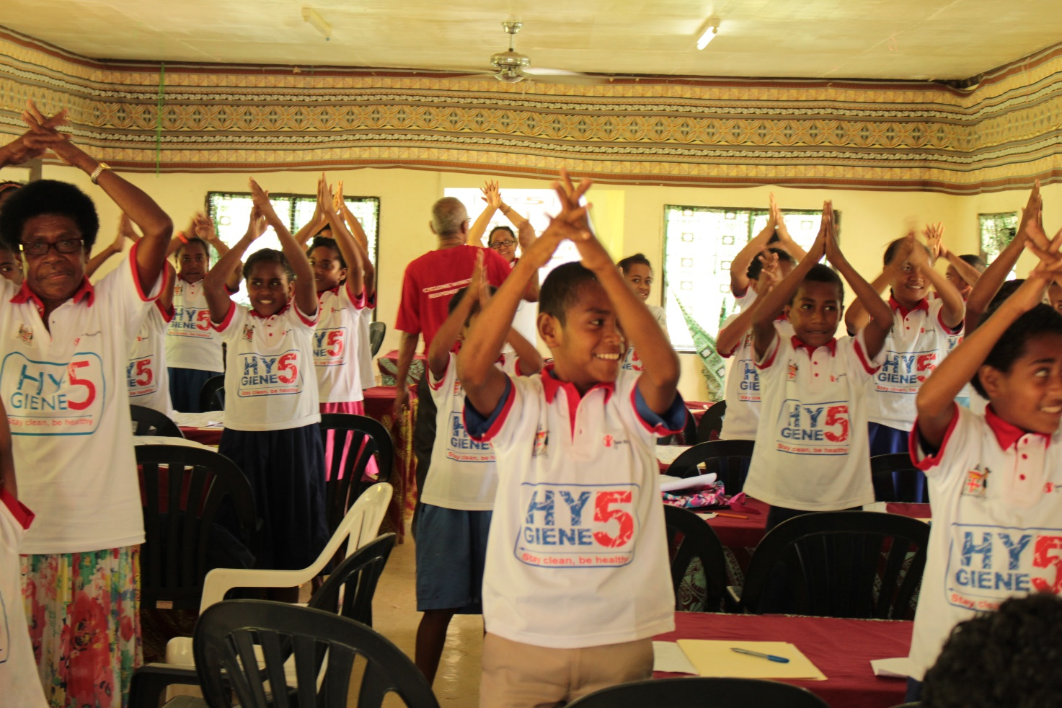

Children taking part in hygiene promotion training run by Save the Children Fiji in the Ra Province. The children then became hygiene promotors in their own schools. *Credit: Save the Children Fiji*

# Evaluation Process

The primary purpose of the evaluation was to assess whether Australia’s humanitarian investments in the education sector following TC Winston were timely, effective and appropriate. A secondary objective of the evaluation was to compile lessons and recommendations that can inform and shape DFAT’s future investments in education as a component of humanitarian responses, especially in the Pacific.

The evaluation team completed an initial document review and analysis of key reports and strategies. The team then completed the in-country component between 12-24 February 2017, which involved a series of face-to-face interviews and group discussions with key staff, program partners and associated external stakeholders including the MoEHA. The report was finalised in consultation with DFAT, partners and the Government of Fiji.

## Evaluation Approach and Methodology

The evaluation team adopted a utilisation-focused approach for the evaluation and ensured interviews, consultations and discussions were facilitated and planned in a participatory manner. The approach was primarily qualitative however reference was made to existing data sources and secondary data was also utilised to help inform some of the key findings. Key aspects of the methodology include:

* Desktop review of documentation relating to Australia’s education response and partner documentation.
* Fieldwork in Fiji, which included stakeholder interviews and guided a detailed beneficiary analysis, involving focus group discussions with communities.
* Data analysis and synthesis of findings into an evaluation report suitable for publication.

The first step in the evaluation process was a desk review to analyse project documents, progress reports and associated evaluation reports and studies. The evaluation documented key findings and issues that required further investigation and assessment.

Interviews were open-ended and semi-structured in nature. An interview guide was prepared and used. The evaluation applied a purposive sampling approach, whereby stakeholders and schools were selected from pre-defined locations that offer a variety of insights and information. Key informants interviewed included: DFAT, delivery partners, other donors, respective government agencies involved in the response, schools and associated school communities (see Annex 2). Consultations primarily involved a group interview methodology and, where appropriate and relevant, a focus group/”town-hall” methodology was employed in two instances. There was also acknowledgement of the special interests and needs of children in all interview and data gathering sessions. Given post-traumatic stress factors and other psychosocial developmental factors, the evaluation stressed appropriate data gathering methods, using the principles behind the UN Convention on the Rights of the Child as a general “do no harm” framework.

The interviewees were roughly 75 percent male, and 25 percent female and between the ages of 21-63. School administration officials, teachers, and school committee members make up the majority of those interviewed, (roughly 75 percent), with response partners, DFAT and MoEHA officials being roughly 15 percent. The remaining 10 percent were community “town hall” parent members, and these were 100 percent male despite requests to include female representation. Field notes and findings were consolidated and summarised at the end of each day to identify emerging key themes and issues.

For data processing and analysis team members reviewed the responses to the interview questions and developed a simple ranking framework to assist in developing findings. Findings were then consolidated and peer reviewed through internal team discussions to ensure all the key points were adequately and properly addressed. In discussion, facilitated by the Team Leader, the team identified topics where there were clear findings.

Importantly, the evaluation team ensured flexibility was built in to the evaluation as follows:

* While the overall evaluation mission schedule was prepared prior to the commencement of the in‑country mission, the team also responded to emerging issues and changing circumstances and, in some cases, visit schedules were adjusted.
* The evaluation team also allowed time without meetings or other formal evaluation activities, to provide time for team members to reflect and adjust activities and schedules in response to unexpected emerging issues.
* The detailed questions were structured, but the team also adjusted questions to follow up on unexpected issues (issues that emerged during the interviews).
* Interviews and group discussions were structured to be capable of completion in an hour. An hour was considered adequate to discuss questions without repetition. The time allowed in the overall schedule was somewhat flexible, to allow time for follow on questions, and in the case of group discussions, to ensure that all participants had the opportunity to express their views.
* The team members debriefed at the end of each day to share their findings and impressions, and to flag any unexpected issues. This allowed for discussion of potential changes of approach or priorities, as well as potential changes in schedule, questions to be asked or additional information to be sought.

## Limitations of the Evaluation

All evaluations and reviews have limitations. Many schools and communities affected by TC Winston are in more remote, harder to access locations. Fiji’s geography, island terrain, and level of development outside of urban areas placed a premium on pre-planning, logistics approaches, and the amount of time available for interviews and data gathering. Some high level limitations of the evaluation included:

* **Time and Resources:** the rigour of the data gathering analysis was constrained to some degree by the time available. The evaluation team was not in a position to meet with all key stakeholders, particularly for follow-up meetings and discussions.
* **List of questions:** The Terms of Reference contains a significant number of questions that needed to be prioritised and ranked. Given the limitation of time, some questions were merged. Two broad areas of priority were on effectiveness and timeliness of response, with a focus on appropriateness and the degree to which national leadership, priorities, and capacities were reinforced and prioritised.
* **Access to work sites**: Travel to the field for data collection was sometimes impeded by weather, availability of stakeholders and time constraints. One school had to be dropped due to access via road during heavy rain.
* **Judgements:** the time limitations meant that professional judgements were employed to interpret stakeholder perspectives.
* **Attribution**: Emergency response programs work in fluid and dynamic environments and many factors influence performance and operational efficiency. Defining and identifying specific areas of attribution remain challenging at best.

The team undertook the following mitigating actions to address these logistics and operational challenges:

* **Selection of key national partner:** in addition to their thematic areas of expertise and knowledge, a key consideration in selection was the degree to which they were familiar with the remote operating environment.
* **Use of national partner networks and proxy networks to organise field visits and schedule interviews**: these networks helped facilitate contacts with more remote school communities
* **Judicious selection of schools and limiting number of school sites by day**: the team aimed for two school sites per day, over ten days, in order to account for distances and locations of school. Where possible, up to four school sites a day were visited.
* **Creative use of school related associations such as principal’s networks and parent-school groups to gather information**: this involved convening groups of principals, where appropriate, or opportunistically using existing principal meetings to schedule group interviews (providing broader sector wide perspectives)
* **Acknowledgement of academic school calendar:** school visits considered possible limitations and capacities on stakeholders imposed by the business needs of school calendars, such as the start of the academic year and other critical core business functions of the Fiji school system, including disruptions experienced due to repair and rebuilding work.

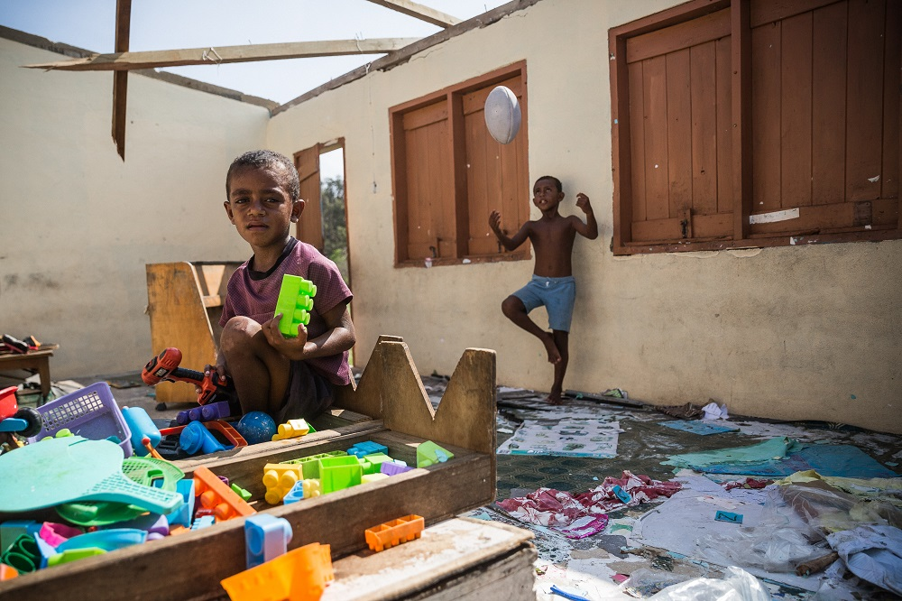

Students in the Yasawa Islands, Fiji, hang out in their damaged classroom after Tropical Cyclone Winston wreaked havoc. *Credit: UNICEF/2016/Sokhin*

# Key Findings

The evaluation findings are organised into key headings: relevance, effectiveness, community engagement, national leadership and coordination.

## Relevance

**The immediate response was relevant and addressed priority needs, reflecting a rapid response aligned to MoEHA priorities.**

Global practice and research on education in emergencies strongly supports the idea of school continuity and “normalisation” of school routine as quickly as possible. Schools are widely considered to be centrally linked to the communities they serve, providing a common space which can transcend education service delivery. Rehabilitating those centres quickly following a disaster allows for children to regain a sense of pre-disaster routine, and it provides a space for disaster related interventions in psychosocial counselling, feeding programs, and health/hygiene practice.

The need for support in schools after TC Winston was defined and shaped by MoEHA assessments, which provided the basis to assume missing school supplies, textbooks, and curricular support materials. The damage to infrastructure was also widespread, so repairs to classrooms and the provision of some form of temporary learning spaces were immediate priorities. There was also an imperative to re-open the schools within a two-week timeframe, set by the MoEHA.

Therefore, the rapid and widespread deployment of tents and tarpaulins as Temporary Learning Spaces (TLS) was well matched to the urgent need for classroom capacity. This was also true of school backpacks, teacher kits, “school in a box” packages, and general stationary provision. If these are the basic “bricks and mortar” of emergency response in the education sector, then the basic response package was appropriately tailored to need.

**While tents as temporary learning spaces, teacher kits, school backpacks, and other stationary were relevant and appropriate to need, other activities could have been more context specific.**

School feeding programs in the short-term were welcomed, and in every school that benefitted, enrolment numbers spiked rapidly following their introduction. However, while the Fiji Post Disaster Needs Assessment (PDNA) noted food security as an issue, key stakeholders interviewed at some schools visited in Taveuni, Vanua Levu, and the more accessible and urban Lautoka-Ba areas stated they did not see this as a priority, except as a short-term tool to boost enrolment and foster a sense of recovery. Disparities between the PDNA and schools visited suggest two possible reasons: one, food related livelihoods were less affected longer-term on Viti Levu (which has easier access to markets and infrastructure); and two, assessments erred on the side of caution when describing need and/or extrapolated from the neediest areas, such as Koro Island.

The need for increased psychological support was observed in most of the schools visited. It was a priority for those interviewed and, in some cases, second only to classroom repair. While partners provided support in this area, teachers interviewed stressed that their own needs had been largely overlooked.

The WASH response efforts were generally less relevant within the affected Fijian schools visited, except in a few cases where pre-disaster access to a water sources were vulnerable or problematic. Though generally appreciated, it was not a priority need expressed by most school employees interviewed given their more pressing infrastructure concerns. It must be noted, however, that broader infrastructure repair fell under the purview of the Fiji Government.

**Partner selection appears to have been driven by understanding of global organisational capacity, which not all local partners could adhere to.**

The findings suggest that the selection of partners also posed some challenges. In Fiji, there were limited partner options due to Fiji’s size and context and Australia’s partner selection was based on criteria such as the existence of pre-existing relationships, the partner’s ability to rapidly respond and procure at scale, and their experience in child-centred Disaster Risk Reduction (DRR). The assumptions made, often based on global experience, did not always align with partner capacities in Fiji. For example, some could procure and respond at scale more effectively than others, while others were more aligned with Fiji government systems and had more established relationships. The differential capacity of partners impacted upon the effectiveness of response efforts and speaks to the continued need to understand local organisational capacities.

## Effectiveness

**Overall, activities were effective in enabling the schools to reopen quickly, creating a broader sense of stability and continuity for the affected community.**

TC Winston had rendered the worst affected schools inoperable, with the loss of classrooms, teachers’ quarters, and learning materials being the highest priorities mentioned by informants in the schools visited. In over 90 percent of key informant interviews, there were general statements that the quick opening of schools provided relief and continuity in the community. Enrolment data provided by head teachers in the schools visited indicates that most school communities had returned to pre-disaster attendance levels a year later, with most rates returning to normal within the first 3-5 months.  Some longer-term changes have occurred, however, with some parents opting to change schools to a closer location if that was an available option. These changes do not appear related to the quality of the emergency response.

Flexibility in Australia’s emergency response also aided overall effectiveness. For example, partners were able to provide photocopiers and generators to schools three months after the cyclone once it was identified as an emerging need. The flexibility could have been even more useful had there been a phased design done initially, which included a joint monitoring and results plan linked to defined timeframes. It could have also increased effectiveness over time; while most of the activities were highly effective in the initial 3 to 6 months, they were less effective as time went on.

###### Table 2: Snapshot of EiE activity to which Australia contributed

|  |  |  |
| --- | --- | --- |
| Activity | Initial Effectiveness (1-6 months) | Medium-term (to one year) |
| Temporary Learning Spaces | Highly effective; enabled re-opening of schools and classrooms | Declining effectiveness observed: rain and weather conditions affecting tents, quality of learning conditions within tent spaces; sense of “delayed recovery” persists. |
| School Feeding | Highly effective; enabled enrolment to return to stable, pre-Winston levels | Less effective; food security in visited school communities not a major issue; duplication. |
| School Materials | Highly effective; responded to need and enabled school functioning | Less effective; needs met, evidence of duplication. Exception: Australian bilateral program provided materials were more effective over time (see below). |
| Psychosocial support | Moderately effective; timing (early but not sustained), variable in implementation | Variable effectiveness; evidence of positive impact difficult to document (counter-factual); teacher’s needs marginalised; time lag of psychosocial issues may not have been adequately planned for. |
| WASH | Variable to less effective; some disruptions to water supply observed but not majority, clean water access not a stated priority. | Variable to less effective; continued provision of WASH infrastructure not targeted to acute needs; highly variable implementation of training and instruction on hygiene kits. |

Tent provision was highly effective in providing TLS for schools to reopen. They were used by nearly every school visited, with an expectation that these were to be temporary structures. Over time, schools experienced problems with these tents and every school visited complained that usability became more burdensome. For example, some were damaged by wind events, or rendered unusable through wear and tear. Schools would often double up students in undamaged or repaired classroom buildings, but said that teaching and learning effectiveness was undermined through overcrowding, or having less than ideal age and behavioural mixes of primary school children to contend with. In most cases, damaged tents were replaced through requests to MoEHA who then sourced them through relevant partners, including those supported by Australia.

The evaluation team spent time in a tent classroom at the Nalawa Central School in the Ra District during what was labelled a “typical” rainstorm. They were unable to communicate with the children due to the noise and disruption. Children were observed to leave their desks and take positions around the tent to hold up the canvas to prevent rain from leaking in. Issues of heat, mud, and dust were commonly expressed. The combination of these smaller issues created the impression of continued disruption to schooling in those schools most dependent on temporary learning spaces. Where tents provided stability at the outset, they may have contributed to a sense of a prolonged or delayed recovery over time.

School feeding programs helped boost attendance rates, according to Head Teachers interviewed and parents in focus groups. For over 95 percent of responses to the standard question of “when did schools begin to have pre-TC Winston levels of attendance?”, the answer was that it occurred when the school feeding program was introduced. However, it appeared less relevant over time in the schools visited. Following the boost in enrolment figures and the initial three-month response period, the schools visited did not show evidence of continued food insecurity. Some school feeding programs were observed to have begun (or restarted) in the Ra District in Term 1 2017, despite the absence of clear need one year after TC Winston. In many schools, year-one MoEHA feeding programs were already in place, leading to duplication in some schools (albeit for year-one students). Community gardens were not established in all schools, which would have led to longer term benefits. It must be noted, however, that food insecurity was a much broader issue and not covered extensively in this evaluation. In some instances, school feeding was one of the only ongoing sources of livelihoods support provided to communities.

School materials were appropriate at the outset, yet distribution continued even when the need declined over time. Exceptions to this occurred where there was a strongly established presence and more targeted understanding of needs, which led to more targeted curricular support materials. For example, South Taveuni Primary School (a school supported through Australia’s bilateral education program) was observed to be well resourced in teacher aide materials. These included photocopiers and laminating machines that effectively mitigated delays in textbook supply and the scarcity of reading materials due to loss or damage. This allowed head teachers and school staff to develop their own materials suitable to the national curriculum and to their own localised needs and shortages. The identification of this need emerged in the medium term, after the first three months of the response.

The effectiveness of the psychosocial support provided was constrained by timing, targeting, and evenness of implementation issues. Counselling teachers to manage affected children and story-telling activities were appreciated but should have been repeated or extended over time. Teachers commonly reported to the evaluation team that children remained visibly distressed by strong wind or heavy rain. They were worried that this would go unaddressed over time, despite support at the outset. This concern may reflect expectations and quality of psychosocial support activities.

Further, there did not appear to be evidence of school “ownership” of psychosocial support activities, despite the use of a training of trainers model for teachers. They may not have been able to absorb these lessons to manage classrooms to a high degree of professional comfort. A second concern may have been the use of kindergarten teachers as newly trained counsellors, as these teachers are generally less qualified. In several schools, the view expressed was that while child-centred programming was critical, teachers’ needs were often forgotten or marginalised. Some of them had been present on school grounds in their quarters during TC Winston. Proximity to the site of a disaster can trigger psychosocial issues, and the schools continue to be their places of employment and residence, raising the issue of teacher wellbeing, and its impact on the student-teacher relationship. Some school staff felt that learning outcomes might have been negatively affected by teacher performance. A targeted intervention here would have been welcomed by teachers and could potentially have improved learning outcomes for children.

Learning outcomes as measured by the difference in 2015 to 2016 exam scores for Year 6 and Year 8 students were not observed to be significantly impacted. In only one school did no students pass the exam, although the community had suffered widespread damage. The evidence is anecdotal as 2016 scores were not publicly available by February 2017.

The resilience of local communities and children combined with tangible response efforts has supported positive learning environments. The provision of school textbooks was raised by schools as critical in getting students back into learning modes.

The WASH intervention had the highest variability in its effectiveness. There was evidence of a pre-TC Winston hygiene localised curriculum with education material highlighting the importance of cleanliness. Therefore response efforts such as the hygiene kits distributed post-TC Winston were appreciated but in many cases redundant given this emphasis on sound hygiene and hand washing practices. WASH instruction kits may have reinforced positive messages, but lacked a community-linked component. While school staff understood the theory of using schools as an entry point to spread good hygiene to communities, they said that in practice this was unrealistic. Those school staff and parent groups interviewed said that WASH instruction would have been more effective had they also been taught in local communities.

Lack of access to clean water or the prevalence of water-borne diseases prior to TC Winston was also not an overriding issue observed by school staff interviewed. After TC Winston, broken water mains meant temporary disruptions in a few schools that Australian partners were assisting to repair. In most cases, school representatives expressed an appreciation of WASH infrastructure, though most already had functioning taps and washing stations. There was considerable evidence of “WASH infrastructure overload”, which led informants in several schools to question why priority was given to these facilities and not classroom repair. In addition, because of the focus on WASH infrastructure repair, there may have been an expectation that other infrastructure needs would be met. However, repairs to classroom facilities was not in the scope of work of partners, it was to be handled by the Fiji Government or through other mechanisms such as Australia’s recovery support program.

**In general, weak or non-context specific pre-disaster planning hampered effectiveness across all agencies and schools.**

Education Cluster partners did not appear to have created cyclone specific planning and response scenarios in the preparedness phase. Such planning would have noted that a cyclone response was also partly a shelter response in the Fijian education context. Quicker reconstruction of partially damaged classrooms (those who lost the metal roofing for example) may have been possible had suitable materials been pre-positioned along with TLS tents.  While rebuilding and reconstruction needs are being addressed by the Fiji Government, additional preparedness and an understanding of existing water and food security issues would have allowed the cluster to better contextualise EiE according to likely Fijian conditions. Some of the contextualised data needed to improve preparedness planning is beyond the scope of the Education Cluster to gather, but that lack of information should be recognised as a preparedness condition and limitation.

Support to schools affected could have also been better prioritised by partners in consultation with the MoEHA’s initial needs assessment. There are significant equity issues with some small schools (less than 100 students) receiving considerable levels of funding and material support while other larger schools were, in some cases, under-resourced or serviced. The level of support appears not to match initial needs assessments, reducing effectiveness and efficiency.

## Community Engagement

**Engagement between responders and beneficiaries was robust in initial assessments but became less effective over time.**

Engagement began on a positive note with the MoEHA leading the needs assessment and making that information available through the Education Cluster. MoEHA assessment teams were noted as among the first to visit the schools, in most cases within a two-week timeframe depending on access conditions. Implementing partners were also actively engaging during the initial period, with interviewees stating that they received multiple visits during the first six weeks to three months of the response.

The views of school management were best reflected during this initial data gathering, while the perspectives of teachers, children and parents do not appear to have been systematically solicited. The perception of teachers interviewed was that their needs had been marginalised. This may be due to an over-reliance by needs assessors on interviewing school administration, school management committees, or head teachers rather than the teachers themselves. The assessment approach also relied largely on infrastructure needs, where a snapshot approach, using targeted questions around community food security, clean water access, and wider damage assessment around community housing and infrastructure, would have yielded a more solid evidence base for programming.

The initial MoEHA-led needs assessment and initial partner assessment period appears to have been the high water mark for school engagement. As noted above the WASH and school feeding programs in the schools visited had the highest variability in effectiveness and in some cases, relevance. They are also highly dependent on an effective engagement and monitoring system over time. However, based on feedback from head teachers and district education officers, engagement appears to have been weak and teachers, students and parents do not appear to have been consulted extensively. For example, more effective engagement with school and community stakeholders may have helped inform the duration of feeding programs and helped target WASH activities according to need. It would also have brought teacher needs, especially in the areas of targeted psychosocial interventions for teachers, more to the fore.

The issue of engagement was not evident in Australia’s bilateral education partner, which took a more proactive approach and included questions directed at the school-community linkages. Those schools benefitting appeared to have been consulted on a regular basis, with high program visibility, and observed responsiveness to needs, from repair to the type of teacher support materials supplied (e.g. photocopiers and other tools).

The issue of declining engagement quality over time by some partners is difficult to explain. It may reflect a view that, having met the initial urgent post-disaster needs, the partners could take a lighter approach as MoEHA was expected to take the lead on transitioning from response to longer-term recovery and repair. If that is the case, it may mean that having a phased design approach would have made such transition issues more explicit, clarifying roles, responsibilities, and accountabilities for issues such as monitoring and engagement over extended periods.

## National Leadership

**Policy dialogue between the Australian and Fijian governments contributed positively to the response plan, but could have supported government leadership more effectively had there been a clear “roadmap” and understanding of existing MoEHA capacity and expectation.**

Australia’s development cooperation is designed to align with the priorities of the Government of Fiji. It supports government-led reform initiatives and helps strengthen government policies, processes and systems. Policy dialogue occurs at multiple levels to ensure a constant exchange of information.

Positive policy dialogue on response priorities was reflected in several areas following TC Winston. Australia’s bilateral education program firmly addressed Fijian government policy concerns regarding equity and access as stipulated under the ESSDP. Australia’s bilateral education program was closely aligned to, and respectful of, MoEHA systems and authority. Due to strong existing and embedded relationships within the Ministry at the central, district, and school levels, program staff were able to facilitate information flow as required. For example, the education program had supported MoEHA reform initiatives such as the FEG and other critical subsidies to tuition, feeding and transport that are of high importance to the MoEHA’s policy agenda.

The second example was support to the initial needs assessment period and through the Education Cluster itself. With support of partners, the MoEHA took a strong leadership role in the immediate needs assessment and data collection effort. It set a two-week timeframe for reopening schools that partners helped to realise as best they could, even though in practical terms the worst affected schools did not have the ability to re-open effectively within that time. The lack of suitable learning spaces and materials in the first few days after the cyclone was one factor, as was the reality that many schools had served as community evacuation centres. Within this context, the initial needs assessment had limitations in the quality of data collected and analysed, such as a lack of data on school-community linkages over longer periods. This limitation did impact the ability to target activities based on needs, such as in the areas of WASH and food security. Also, some partners did not always inform education district officials of school visits or relied on information being passed from the central office to the school, which did not always happen. Where there was pre-established familiarity or relationships, partners were better able to align with MoEHA systems.

Despite strong capacity, MoEHA requires support to respond to a large-scale disaster. This context requires careful balancing to ensure the Australian Government and partners support MoEHA leadership where capacity gaps emerge. While the MoEHA has the institutional infrastructure required, it lacks more sophisticated policies, tools, and capacities with which to manage the school system in a disaster. Had DFAT and partners had a better understanding of MoEHA’s capacity to mobilise for a large needs assessment, it could have been supported pre-TC Winston to develop a more robust assessment framework and system.

**National leadership was largely marginalised in the case of data systems and management during the response.**

Despite support provided by the Australian Government to the MoEHA’s school data platform, FEMIS, it was not used sufficiently during the response. Instead, an external rapid mobile application was introduced to the MoEHA, which required adjustment in the MoEHA’s data collection practices. Training was conducted for MoEHA officials, but in reality, its use posed numerous challenges. The rapid mobile application collected wildly inaccurate data on student and teacher numbers – which was already held and available in FEMIS – producing conflicting results. The application also collected effectively unusable school condition data from operators with no engineering background, leading to unqualified damage assessments and inaccurate damage cost predictions. The application had an incomplete list of schools meaning some schools were not surveyed for some time and data was often entered against incorrect or non-existent school codes, increasing the time required to analyse data at a critical phase of the recovery.

While IT innovations in data collection are imperative, they must be Ministry-led to ensure they fit within existing systems. This was not entirely possible with the lack of accurate data available pre-TC Winston, and ultimately, the rapid provision of large quantities of unqualified data hampered recovery efforts. Alternatively, direct and sustained support over a longer period would help the MoEHA to develop a transparent and user-friendly system that collects the data needed to make assessments during disasters.

## Coordination

**The Education Cluster should be well positioned to take a leadership role in coordinating the emergency response, however, this was not realised during TC Winston.**

Due to competing priorities, Education Cluster meetings were arranged on an ad-hoc basis and often cancelled, particularly after the initial stages of the response. Despite this, where possible, individuals within the MoEHA did continue to coordinate meetings and relief assistance to schools. Therefore, partners’ main form of coordination with the MoEHA was via established relationships and direct approaches. DFAT established a regular meeting of its response partners to monitor implementation and, while the intention was not to duplicate the Education Cluster, it did cover areas that would have been better covered within the Cluster. In the future, a joint reporting mechanism among partners could be developed to facilitate communication and coordination and to ensure accountability and transparency to MoEHA. The Australian Government could also support the Education Cluster to take on this leadership role to a greater extent.

**While coordination at headquarters was fairly strong, significant duplication of resources provided to schools indicates that coordination, beyond headquarters, was weak.**

Initial coordination mechanisms between the Australian Government and implementing partners worked well with the establishment of targets and priority areas.  Meetings between partners were regular and provided an opportunity to engage, discuss issues and challenges, and present a united front to decision-making. All partners were involved in the establishment of targets and indicators and DFAT promoted enhanced coordination through personal engagement by Suva post staff and the implementation of flexible contracting arrangements.  In theory, this coordination appeared well organised, consultative and aligned to national priorities.

However, the field visits revealed that coordination was less evident with a high proportion of schools receiving multiple levels of support. In some cases, schools have received support from all Australian-funded partners at various stages over the past 12-months and there was evidence of duplication of resources. The duplication appears to have increased in frequency since December 2016 as partners move to close out the recovery phase. Therefore, while coordination was occurring at the national level it was not transferring to the field. Interviews with District Education Officers (DEOs) reveal consultation efforts from partners were generally limited.  DEOs had requested better coordination through existing systems (for example the Education Cluster) to help facilitate coordination processes, promote local ownership and leadership and to ensure resources are equally distributed according to need.

# Recommendations and Conclusion

The overall finding from the evaluation was that Australia and its partners responded immediately in a positive, proactive and engaging manner to identify needs and develop appropriate response mechanisms. The EiE model implemented following TC Winston helped to introduce an element of stability in affected communities, with reopened schools and Temporary Learning Spaces (TLS) serving as entry points for a wider array of disaster response services such as nutrition, water, sanitation and hygiene (WASH) services and psycho-social counseling for affected children. The response highlighted that there is capacity to do more robust preparedness, which would help to contextualise the standard global EiE model. Emergency responses tend to work most effectively when they are phased and linked to long-term development programs and outcomes, which was proven during the response where the effectiveness of the intervention measures diminished when not adjusted over time. The use of partners with established connections to the community was appropriate; however, the effectiveness and efficiency of the approaches were somewhat variable.

Based on the findings, there are a number of key lessons and recommendations that can be made. The recommendations in this report aim to:

* reduce risk exposure and support an education system in Fiji which is more resilient to natural hazards; and
* help Australia ensure its broader humanitarian support in the Pacific is able to respond to the local context.

## Recommendations for Australia’s bilateral education assistance in Fiji

##### Recommendation 1: Support Fiji’s Ministry of Education, Heritage and Arts (MoEHA) to develop a response plan that clearly articulates roles and responsibilities through multiple phases of the response, as well as expectations of partner interventions.

MoEHA capacity in disaster planning could be assisted on several fronts. Some of these are already underway, with revisions being made to the MoEHA’s School Maintenance Handbook and the approach to build back schools that are more resilient to future disasters. More systemic support could be offered however, such as providing specific guidance to the AMU on risk mapping, development of refined assessment tools to account for community linkages and needs during disasters, and creation of school-level disaster plan templates to guide schools in the development of their individual plans.

Assistance with Emergency Management Plan templates for schools would strengthen preparedness. These standardised plan templates would include guidance and checklists to ensure that local school risk was mapped and understood, location and hazard (risk) specific polices were outlined, and key personnel assigned to an Incident Control System (ICS—a “who does what” in an emergency staff plan). Such a template system would also allow MoEHA to know if their schools were compliant with their relevant polices, and national disaster management standards. Plans could be distributed through FEMIS and uploaded again at AMU for quick access when needed.

##### Recommendation 2: Support MoEHA to undertake risk mapping of schools and integrate this data into the Fiji Education Management Information System (FEMIS) to ensure the appropriate data is available to guide disaster preparedness and response efforts.

The FEMIS platform and input of post-disaster information could also be used to create a “risk map” over time. At present, the AMU has access to general location maps; these could be overlaid with FEMIS data and information gathered during recent emergencies to more effectively map out vulnerable areas. From this map, a “risk register” of the highest at risk schools could be developed and refined. Those schools nearest to shorelines are obvious first candidates for this risk register, while hilltop or exposed schools could be put on a wind event risk list. Such mapping would provide the evidence base for the elaboration of future polices and protocols related to emergency management and could be used to establish opportunities for insurance measures that transfer risk.

MoEHA also has a Community Awareness Program (CAPS) that encourages schools and communities to discuss issues of importance together. CAPS is a perfect vehicle for future development of information around school-community linkages and needs during an emergency. One way to do this would be to support CAPS and the AMU to conduct sample Capacities and Vulnerabilities Analyses (CVAs) to better understand the wider community context in which Fijian schools operate. A CVA looks at the possible social, financial, and physical “capital” available to schools before and after an emergency. These are meant to be indicative guides to help map out the truly vulnerable schools, which are usually those who lack networks of support or access to social capital. This lack of access may have an effect on school and community resilience. The problem observed was that some schools tended to be very well connected (urban Ba areas) while others (interior Ra) had fewer resources to draw from. This “map” would help the unit in charge of emergencies to better understand vulnerabilities, and prioritise assistance to the more isolated communities. This CVA type model would then be socialised through the Education Cluster and used as part of the planning to better contextualise and target disaster response activities managed by the cluster. Australia’s bilateral education program has a model for this work that could be replicated.

##### Recommendation 3: Provide continued support to MoEHA to strengthen ongoing data collection and management (including within FEMIS), and consider how the current system can be used for needs assessments and disaster preparedness.

The use of and observed importance of FEMIS during TC Winston is a key opportunity moving forward. There were alignment issues between FEMIS and externally created mobile applications for needs assessments. There are, however, technical fixes that could be implemented to ensure that the MoEHA could use existing systems to gain the required data needed during a disaster. Stronger linkages are required between DEOs, AMU and general asset management processes to ensure accurate ongoing recording of asset condition and value. Relationships should include detailed and transparent recording of asset improvement funding with linkages to budgeting processes and reconciliation reporting.

##### Recommendation 4: Continue to support strengthened government and partner systems for more coordinated implementation, management and reporting of preparedness and response efforts.

There are various opportunities for strengthened coordination, including by leveraging private sector partners and faith based agencies with links in school communities that could help to improve engagement and response. Vulnerability mapping could also help inform planning discussions with civil society groups such as Rotary Clubs or local faith based groups. The Education Cluster could host meetings in the preparedness phase and invite key civil society groups who have assisted in disaster response in the past.

## Recommendations for Australia’s humanitarian support for the education sector in the Pacific

##### Recommendation 5: Consider a phased disaster planning model that accounts for evolving needs of a response over time. This would help plan the response as relief, early recovery, and recovery to sustainability. Current flexibility should be kept but guided by defined phases and corresponding outcomes.

Developing an emergency design concept that accounted for evolving needs over time could have improved the effectiveness, relevance, monitoring and engagement during the response. A phased disaster planning model that allows for evolving needs of a response over time would also more accurately reflect a needs based approach. This model may be based on three-month periods, with a rapid real time monitoring assessment of needs at the end of each period. For example, emergency feeding programs could also have been phased out after an initial 3-6 month period in the schools visited (but not across the entire country, where food security remains an ongoing issue). If the food situation had stabilised by that review period, newer activities relevant to monitored needs could then be phased in, or existing activities prioritised and provided additional funds from the phased out activity.

The DFAT funding model, which was well received by partners, included flexibility as a key asset and an important design feature. Within that overall flexibility, a phased design would have provided more guidance within the flexible model. Such a phased approach, with potential, “pivoting” to new recovery activities, or newly prioritising existing ones, may also have driven a more robust monitoring regime among the partners. Partners would be forced to engage more at the community level to justify continuing with existing activities (such as school feeding over, for example, further psychosocial counselling). The challenge would be to balance the overall flexibility DFAT gave the partners with this phased approach (if needed) and not require burdensome or lengthy justifications to DFAT. The phases would be guideposts and signal a shared understanding that initial response needs will look different to those over the recovery period.

##### Recommendation 6: Support a ‘Pacific component capacity mapping’ exercise to understand key capacities for humanitarian partners.

Australia’s current prioritisation of drawing on local actors and capacities to respond to emergencies should reinforce the importance of ensuring partners support local systems during a response and contextualise approaches. The findings of this evaluation strongly support the design principles for the planned successor agreement with Australian NGOs (the Australian Humanitarian Partnership), which aims to build capacity across the Pacific to prepare for, respond to and recover from disasters, recognising the differentiated approaches need to be taken to ensure fit for purpose response to rapid onset crises. The design notes, “to support a shift towards localisation, there will be a focus on building the disaster management capacity and coordination of local Pacific-based NGOs; and strengthening the risk resilience of Pacific communities”[11]. The Australian Humanitarian Partnership can help address partner selection and suitability through a planned capacity mapping exercise to be undertaken as part of the Pacific component design process, and via regular planned annual reviews of partner activities and performance.

##### Recommendation 7: Develop a monitoring and evaluation framework that accounts for evolving needs over time. It should include a unified reporting process linked to the overall emergency design concept and framework, agreed to by all partners.

The implementation of a phased approach, combined with the development of design and implementation frameworks along with the application of different implementation modalities, would strengthen Australia’s ability as a source of support and expertise. The purpose of this approach means that rather than seeking to implement different components together, partners could look to implement interventions based on need and align this work to a defined assessment framework that can track progress and provide relevant feedback on progress and performance.

Ultimately, natural hazards will strike again. It is vital that all stakeholders within Fiji seek to learn from the experience of TC Winston and take tangible steps to promote closer coordination for the benefit of all communities. Having the tools and resources and using a mix of local knowledge and international best practice enables affected communities to rebound quickly.

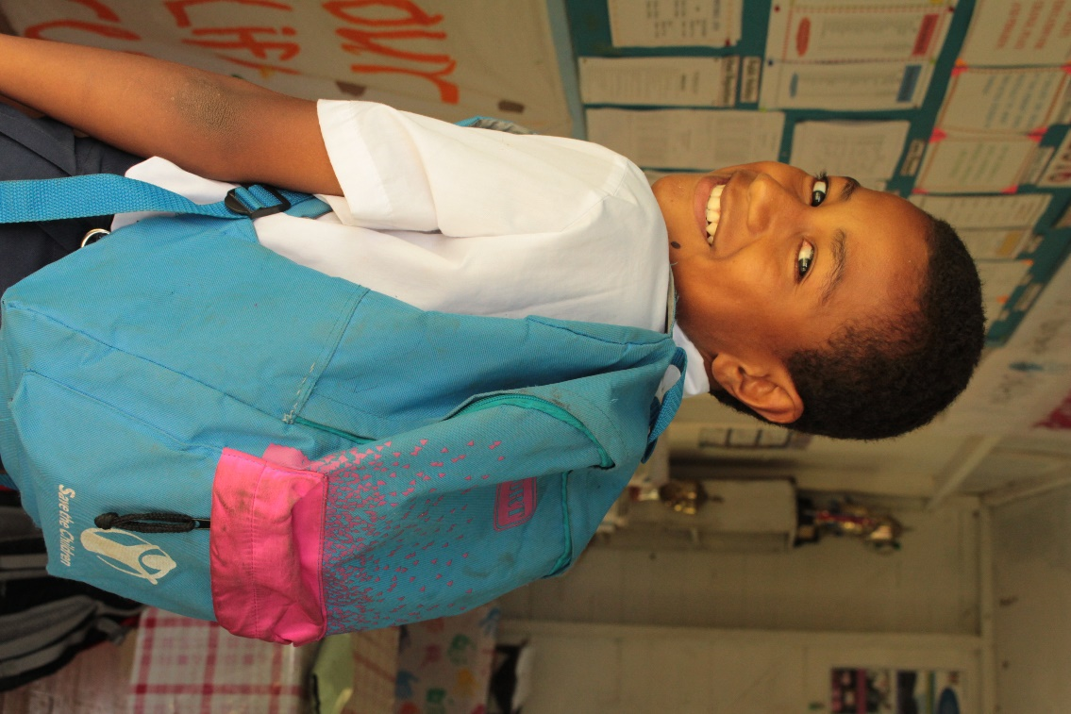

Students from Viani Primary School were recipients of Save the Children Fiji’s education assistance program, which included the provision of school bag kits. *Credit: Save the Children Fiji*

# Annex 1: Terms of Reference

### Purpose

The primary purpose of the evaluation is to assess whether Australia’s humanitarian investments in the education sector following Tropical Cyclone (TC) Winston were timely, effective and appropriate. A secondary objective of the evaluation is to compile lessons and recommendations that can inform and shape DFAT’s future investments in education as a component of humanitarian responses, especially in the Pacific.

### Background

The Australian Government is committed to responding rapidly to international humanitarian crises and is expected to lead or play a major response role in the Indo–Pacific region. Tropical cyclones are a serious recurrent threat for Pacific nations.

Tropical Cyclone Winston caused widespread damage in Fiji on 20-21 February 2016. It is the strongest tropical cyclone ever recorded in the southern hemisphere, causing 44 deaths and affecting more than two thirds (about 540,000 people) of the population of Fiji. Entire communities were destroyed by winds, flooding and tidal surges, and power and communications systems were damaged. Over 30,000 houses, 495 schools and 88 health clinics and medical facilities were damaged or destroyed. In addition, the cyclone destroyed crops on a large scale and compromised the livelihoods of almost 60 percent of Fiji’s population[12].

Working closely with the Fiji Government, Australia provided AUD15 million in immediate assistance to Fiji to support over 200,000 men, women and children with relief supplies such as shelter, water, food, hygiene items, emergency health care and access to education. Australia is now assisting with the longer-term [recovery and reconstruction efforts](http://dfat.gov.au/aid/topics/investment-priorities/building-resilience/humanitarian-preparedness-and-response/tc-winston/Pages/recovery-and-reconstruction.aspx) and has committed an additional AUD20 million to rebuild critical infrastructure and increase resilience to natural disasters.

As part of Australia’s immediate AUD15 million humanitarian investment, AUD4 million was allocated to support the response in the education sector. The purpose of this assistance was to help return Fiji’s children to school as quickly and safely as possible. This was a major priority of the Fiji Government following TC Winston, which aligned with Australia’s key area of existing bilateral development assistance. This funding was split between two partners: UNICEF and Save the Children Australia. The response incorporated five key areas, which partners assisted in to varying degrees depending on strengths. The five key areas were:

* temporary learning centres;
* provision of education materials;
* school feeding programs;
* psychosocial support to students and teachers; and
* water and sanitation support in schools.

Activities began on 21 February 2016 and will be complete by 31 March 2017.

To complement these efforts through Australia’s existing bilateral education program in Fiji – the Access to Quality Education Program (AQEP) – emergency grants were provided to affected schools so they could institute school feeding programs intended to restore attendance quickly.

Note: An end-of-program evaluation for Fiji’s bilateral education program (AQEP) is also planned for early 2017. Close coordination will be required for conducting consultations.

### Scope of the Evaluation

The evaluation should focus on effectiveness, appropriateness and timeliness of Australia’s humanitarian investments in the education sector. In order to do this, it should address the following issues:

Impact of TC Winston on Fiji’s education sector (situational analysis).

Appropriateness and relevance of Australia’s education response (scale, partner selection, activity selection, complementarity to bilateral program, planning for recovery).

Timeliness and effectiveness of Australia’s education response (considering results, value for money and efficiency)

Alignment with Fiji Government and community needs and priorities (including use of national systems, engagement with community and accountability to affected populations).

Co-ordination and complementarity of DFAT’s education response between implementation partners, with other donors, and Government of Fiji.

### Evaluation Methodology

The methodology will be refined in consultation with the selected consultants. It is likely that the evaluation will include:

Desktop review of documentation relating to DFAT’s education response and partner documentation.

Interviews with internal and external stakeholders involved in implementing the education response (e.g. DFAT desk and post, delivery partners, other donors, Government of Fiji, schools and school communities).

Fieldwork in Fiji (up to 10 days), which will include stakeholder interviews and will guide a detailed beneficiary analysis, possibly involving focus group discussions with communities including at least one in a remote location.

Data analysis and synthesis of findings into an evaluation report suitable for publication.

### Key Evaluation Questions

There are five key questions for the evaluation.

**Was our humanitarian education response appropriate and relevant?**

* To what extent were the partners and activities selected appropriate for the intended outcomes? For example, consider capacity of organisations to mobilise for the response.
* To what extent was information on needs and priorities addressed in the planning?
* Has the response adequately responded to needs assessment information provided (both initially and over the course of activities as needs have changed)?
* To what extent did the response align with DFAT’s existing and ongoing education development activities?
* To what extent did the response incorporate activities that promote recovery in the education sector?
* To what extend did the response align with DFAT’s Humanitarian Strategy objectives?

**Was our humanitarian education response timely and effective?**

* Were the targets and focus areas/activities set adequate to address priority education needs? To what extent have targets been achieved?
* To what extent have critical education needs been met through the response? For example, were all children able to access quality education opportunities? How do attendance and exam results compare pre and post disaster?
* Were SPHERE standards in education upheld during the response?
* Were there effective strategies to protect the safety, dignity and rights of affected people, promote gender equality and address barriers to inclusion?

**Did our humanitarian education response adequately engage with communities and the most vulnerable?**

* Has communication with teachers and students been effective during the response?
* Were teachers and students involved in the design of the response? To what extent did they influence any change to the response?
* Were the most vulnerable consulted in planning and implementation (including people with disabilities, women, children, minority groups)?
* Are there beneficiary feedback systems in place and have they been used? If so, were they acted on?
* How were monitoring tools useful in engaging beneficiaries, communicating and acting on feedback?

**Did our humanitarian education response align with and reinforce national leadership?**

* To what extent did policy dialogue with the Fiji Government contribute to the Australian response plan?
* To what extent were national priorities in education reflected in the planning and response? How was this reflected through the Education Cluster?
* To what extent did the response utilise national mechanisms or systems in the response?
* To what extent was the Fiji Ministry of Education consulted in the response?

**Was our humanitarian education response coordinated well and was it complementary?**

* To what extent were our response efforts reported to other partners, for example, through the Education Cluster?
* Was there any duplication of Australian-funded activities among partners (including with the Fiji Government)?
* Did the response adjust in relation to any other partner activities (including Fiji Government)?
* What impact did pre-disaster (preparedness and risk-reduction) activities have on the response?

### Outputs

Outputs should align with DFAT’s monitoring & evaluation standards. The outputs will include:

* Final Evaluation Plan. The plan will define the scope of the evaluation, articulate key evaluation questions, describe methodologies to collect and analyse data, propose a timeline linked to key milestones, propose a schedule for in-country field work, outline costs and a detailed breakdown of responsibilities of all team members. The plan will be developed in close consultation with Suva Post.
* An aide memoire which will present initial findings, seek verification of facts and assumptions and discuss the feasibility of initial recommendations. The will be a working (no more than 10 pages), and the audience for this document is internal.
* Draft evaluation report.
* Final Evaluation Report incorporating any agreed changes or amendments as requested by DFAT. The final Evaluation Report will include an executive summary (of no more than 2 pages), a clear summary of findings and recommendations (no more than 20 pages) and relevant attachments. This report should be suitable for publishing if required.

### Evaluation Timeline (indicative)

| **Activity** | **Days Allocated** | |  |  | |
| --- | --- | --- | --- | --- | --- |
|  | **Team Leader** | **Humanitarian Specialist** | | | **Local team member** |
| Document review and introductory brief with Post (via phone) | 3 | 2 | | | 0 |
| Evaluation plan | 2 | 1 | | | 0 |
| Evaluation plan due to DFAT | | | | |  |
| Evaluation Plan finalised based on DFAT’s feedback | 1 | 1 | | | 0 |
| Organise interviews and in-country mission) | 3 | 0 | | | 5 |
| In-country Mission | Up to 10 | Up to 10 | | | Up to 10 |
| Travel days | 2 | 2 | | | 0 |
| Report writing | 5 | 3 | | | 2 |
| Draft report to DFAT | | | | |  |
| Report finalised based on DFAT’s feedback | 3 | 2 | | | 0 |
| Final report due to DFAT | | | | |  |
|  | 29 days | 21 Days | | | 17 days |

### Team Composition

Two consultants are expected to conduct the evaluation. The required levels of expertise and experience are outlined below.

* Team Leader (Evaluation Specialist, with education sector experience): this position must have demonstrated expertise in the independent evaluation of education sector programs in a development or humanitarian context; preferably with experience of DFAT systems and monitoring and evaluation standards. The Evaluation Specialist should also have sound knowledge and understanding of aid effectiveness. Excellent writing/liaison/analytical skills (evidenced by significant high quality research outputs) are essential, and extensive knowledge and working experience in Fiji and/or the Pacific will be highly desirable. ARF classification: C4 (> 15 years’ experience).
* Humanitarian Specialist: this position should have a strong background in humanitarian preparedness and response and experience in managing humanitarian interventions. Experience in the education sector is an advantage. The Humanitarian Specialist should have sound knowledge of humanitarian standards and principles and an understanding of DFAT’s Humanitarian Strategy. ARF classification C3 (> 10 to 15 years’ experience).

The Team Leader (Evaluation Specialist) will:

* Plan, guide and develop the overall approach and methodology for the evaluation;
* Ensure that the evaluation team meets the requirements of the Terms of Reference and contractual obligations;
* Manage and direct evaluation activities; represent the evaluation team and lead interviews/consultations with evaluation participants;
* Collate and analyse data collected during the evaluation;
* Lead team discussions and reflection;
* Manage, compile and edit inputs from the other team members to ensure high quality of reporting outputs;
* Ensure that the evaluation process and report aligns with DFAT’s M&E Standards;
* Develop a succinct evaluation report.

The Humanitarian Specialist will:

* Liaise with the Team Leader in the preparation of the Evaluation Plan;
* Provide humanitarian specific insights and feedback to the Team Leader on in-country consultations and preparation of the final evaluation report;
* Participate in the in-country mission as directed by the Team Leader.
* A local team member will also be required to assist with the evaluation. Their terms of reference will be developed with the selected consultant and DFAT can assist to source this team member (if required).

### Key Documents

DFAT will make available to the team information, documents and particulars relating to DFAT’s humanitarian response to TC Winston. These will include but not be confined to the following documents. DFAT shall make available to the evaluation team any other reasonable requests for information and documentation relating to the evaluation. The evaluation team is also expected to independently source other relevant material.

* Government of Fiji Lessons Learned draft report (provided by Post)
* Key Lessons from the Education Response, Ministry of Education (provided by Post - TBC)
* DFAT After Action Review
* Save the Children mid-term report (received July 2016) and final report (due 31 January 2017)
* UNICEF Partner Updates (various)
* Education coordination meeting notes (provided by Post)
* DFAT cable reporting (classified and unclassified)
* Strategy for Australia’s aid investments in education 2015-2020
* Fiji Ministry of Education Strategic Plan 2015-2018
* DFAT M&E Standards
* DFAT Humanitarian Strategy
* DFAT Office of Development Effectiveness review of the response to Cyclone Pam
* Fiji Post Disaster Needs Assessment

# Annex 2: consultation/schools visited

**Representatives of the following organisations/positions were consulted in the preparation of this report:**

Access to Quality Education Program (AQEP)

Asset Management Unit, Fiji Ministry of Education, Heritage and Arts

Department of Foreign Affairs and Trade

Save the Children Fiji

Schools visited (see below) – including head teachers, school managers, teachers, parents and community representatives

Senior Education Officers and staff

United Nations Children’s Fund (UNICEF)

**Schools visited:**

* *Northern Division: Taveuni* 
  + Vuna District Primary School
  + South Taveuni Primary School
  + Lavena Primary School
* *Northern Division: Cakaudrove* 
  + Khemendra Bhartiya Primary School
  + Naweni Primary School
  + Savusavu Primary School
* *Western/Central Division: Ra and Interior*
  + Draunivi Primary School and Early Childhood Education Centre
  + Bayly Memorial Primary School
  + Nalaba District School
  + Nawaqavesi Primary School
  + Nalawa Central School
  + Nasau District School
  + Nailuva District School
  + Tokaimalo District School
* *Western Division: Ba and Lautoka*
  + Ami Chandra Memorial School
  + Raviravi Sangam School
  + Nakoroboya Primary School

# Annex 3: Documents Reviewed

|  |  |
| --- | --- |
| **Key Document Name** | **Source** |
| DFAT Consolidated Proposed Actions Education AQEP SC and UNICEF  Australia’s Humanitarian Support to UN Tropical Cyclone Winston Flash Appeal 11/03/2016  160719 Coordination Meeting Notes  Consolidated Education Activities AQEP SC-UNICEF 24 August 2016  Consolidated Education Activities AQEP SC-UNICEF 29 September 2016  Consolidated Education Activities AQEP SC-UNICEF 2 November 2016  Consolidated Education Activities AQEP SC-UNICEF 29 November 2016  Cyclone Pam Final Report November 2016  DFAT Consolidated Proposed Actions AQEP SC-UNICEF  Fiji Ministry of Education Strategic Plan 2015-2018  160905 Save the Children (SC) Fiji Cyclone Winston RTR Fiji Report  SC Fiji DFAT Revised Mid-term report  Funding Order March 2016  Newsletter TC Winston Response SC Fiji 16 November 2016  SC Final July 2016 Update  160602 SC TC Winston 3 Months On  SC Fiji Interim Report Revised November 14 2016  Education Case Study Viti Levu 13 November 2016  Grant 57867 Revision Request November 9 2016  SC Fiji Interim Report Revised  WASH Case Study Savusavu  WASH Monitoring Report  WASH Review Workshop  160714 UNICEF Accountability for DFAT May 2016  UNICEF AQEP Joint Strategy for Immediate Education Assistance  TC Winston Humanitarian Update 27/02/2016  TC Winston Response Update to DFAT 05/08/2016  TC Winston Response Update to DFAT 01/11/2016  TC Winston Response Update to DFAT 25/11/2016  TC Winston Response Update to DFAT 16/01/2017 | DFAT  DFAT  DFAT  DFAT  DFAT  DFAT  DFAT  DFAT  DFAT  MoEHA  SC  SC  SC (DFAT)  SC  SC  SC  SC  SC  SC  SC  SC  SC  SC  UNICEF  UNICEF  UNICEF  UNICEF  UNICEF  UNICEF  UNICEF |

1. Government of Fiji, 2016, TC Winston Post Disaster Needs Assessment 2016 ([available here](https://www.google.com.au/url?sa=t&rct=j&q=&esrc=s&source=web&cd=1&cad=rja&uact=8&ved=0ahUKEwjaltaukfPUAhXBy7wKHQuoCtsQFggtMAA&url=https%3A%2F%2Fwww.gfdrr.org%2Fsites%2Fdefault%2Ffiles%2Fpublication%2FPost%2520Disaster%2520Needs%2520Assessments%2520CYCLONE%2520WINSTON%2520Fiji%25202016%2520%2528Online%2520Version%2529.pdf&usg=AFQjCNFcBcbp80yBMlWjv3mlP_JuaiSAIw))
2. International Network on Education in Emergencies, 2010, Minimum Standards for Education: Preparedness, Response, Recovery ([available here](http://toolkit.ineesite.org/inee_minimum_standards/handbooks))
3. For Australia, localisation means recognising, respecting and strengthening leadership and decision-making by local and national actors in humanitarian action to address the needs of affected populations.
4. Government of Fiji, 2016, TC Winston Post Disaster Needs Assessment 2016 ([available here](https://www.google.com.au/url?sa=t&rct=j&q=&esrc=s&source=web&cd=1&cad=rja&uact=8&ved=0ahUKEwjaltaukfPUAhXBy7wKHQuoCtsQFggtMAA&url=https%3A%2F%2Fwww.gfdrr.org%2Fsites%2Fdefault%2Ffiles%2Fpublication%2FPost%2520Disaster%2520Needs%2520Assessments%2520CYCLONE%2520WINSTON%2520Fiji%25202016%2520%2528Online%2520Version%2529.pdf&usg=AFQjCNFcBcbp80yBMlWjv3mlP_JuaiSAIw))
5. Fiji Ministry of Education, Heritage and Arts Annual Report 2015 ([available here](http://www.education.gov.fj/index.php/resources/ministry-2012-annual-report)); 66,892 female/71,184 male students.
6. Fiji Ministry of Education, Heritage and Arts Annual Report 2015 ([available here](http://www.education.gov.fj/index.php/resources/ministry-2012-annual-report)); 35,112 female/33,547 male students.
7. Fiji Ministry of Education, Heritage and Arts Annual Report 2015 ([available here](http://www.education.gov.fj/index.php/resources/ministry-2012-annual-report))
8. Government of Fiji, 2016, TC Winston Post Disaster Needs Assessment 2016 ([available here](https://www.google.com.au/url?sa=t&rct=j&q=&esrc=s&source=web&cd=1&cad=rja&uact=8&ved=0ahUKEwjaltaukfPUAhXBy7wKHQuoCtsQFggtMAA&url=https%3A%2F%2Fwww.gfdrr.org%2Fsites%2Fdefault%2Ffiles%2Fpublication%2FPost%2520Disaster%2520Needs%2520Assessments%2520CYCLONE%2520WINSTON%2520Fiji%25202016%2520%2528Online%2520Version%2529.pdf&usg=AFQjCNFcBcbp80yBMlWjv3mlP_JuaiSAIw))
9. Government of Fiji, 2016, TC Winston Post Disaster Needs Assessment 2016 ([available here](https://www.google.com.au/url?sa=t&rct=j&q=&esrc=s&source=web&cd=1&cad=rja&uact=8&ved=0ahUKEwjaltaukfPUAhXBy7wKHQuoCtsQFggtMAA&url=https%3A%2F%2Fwww.gfdrr.org%2Fsites%2Fdefault%2Ffiles%2Fpublication%2FPost%2520Disaster%2520Needs%2520Assessments%2520CYCLONE%2520WINSTON%2520Fiji%25202016%2520%2528Online%2520Version%2529.pdf&usg=AFQjCNFcBcbp80yBMlWjv3mlP_JuaiSAIw))
10. Government of Fiji, 2016, TC Winston Post Disaster Needs Assessment 2016 ([available here](https://www.google.com.au/url?sa=t&rct=j&q=&esrc=s&source=web&cd=1&cad=rja&uact=8&ved=0ahUKEwjaltaukfPUAhXBy7wKHQuoCtsQFggtMAA&url=https%3A%2F%2Fwww.gfdrr.org%2Fsites%2Fdefault%2Ffiles%2Fpublication%2FPost%2520Disaster%2520Needs%2520Assessments%2520CYCLONE%2520WINSTON%2520Fiji%25202016%2520%2528Online%2520Version%2529.pdf&usg=AFQjCNFcBcbp80yBMlWjv3mlP_JuaiSAIw))
11. Source: DFAT March 2016 website (ww.dfat.gov.au)
12. Post Disaster Needs Assessment, Government of Fiji, May 2016