

AusAid Core Funding Review
Survey Results and Analysis
Author: Dr. Rebecca Spence

Strictly Confidential:
This report and any files transmitted with it are confidential and intended solely for the use of the individual or entity to whom they are addressed. If you have received this report in error please notify Dr. Rebecca Spence at rebeccaspence1@gmail.com. This report contains confidential information and is intended only for the individual/entity addressed. If you are not the named addressee you should not disseminate, distribute or copy this e-mail. Please notify the sender immediately by e-mail if you have received this report by mistake and delete this report from your system. If you are not the intended recipient you are notified that disclosing, copying, distributing or taking any action in reliance on the contents of this information is strictly prohibited.

Table of Contents
Introduction 3
Purpose of Survey 3
Response summary 5
Uses and percentages of Core Funding 6
Percentage by organisation: 9
How core funding enabled organisations to fulfill their mandate 15
Delivery of Services 17
Enhancing Organisational development processes 19
Approaches to monitoring and Evaluation 22
Organisational Growth and program diversification: 25
Expansion to rural and remote and underserved communities 27
Organisational Sustainability 29
Core funding results and impacts on service delivery 32
Core Funding and Cross cutting issues 34
Collaboration: 36
Areas needing improvement 37
Difficulties associated with Core Funding 39
Core funding as a leveraging tool 41
Individual leveraging responses 42
Future Funding Modalities 44
Appendix One – survey questions. 46

Introduction

This document presents results of the survey which forms part of the review of AusAID’s core funding arrangements with twelve civil society organisations in Fiji. The primary aims of the review are to build understanding of the effectiveness, efficiency and relevance of the core funding arrangement for civil society in Fiji; to conduct a thorough assessment of the organisations which have received core funding; to assess significant risks in continuing any core funding arrangements; to establish the role of core funding in supporting civil society in their capacity to deliver services to those most disadvantaged; and to identify other potential funding modalities.

Purpose of Survey

There are three main drivers for a review of AusAID’s core funding arrangements in Fiji.
First, there is varied understanding of the impact of core funding upon each organisation in terms of organisational development; the relationship between core funding and effective programming outcomes; and the leveraging potential of core funding.
Second, there are concerns about two of the organisations that have received substantial amounts of core funding. These concerns relate to impact and outcomes as well as development processes and best aid practices.
Third, as AusAID moves forward into a new iteration of Civil Society support this review will help inform strategic funding modalities for engaging with civil society into the future.
The survey was designed as a data collection tool to enable the review team to understand the issues associated with core funding from each organisation’s perspective. The survey consisted of qualitative and quantitative questions that provided the respondents with an opportunity to reflect upon how they had used core funding monies. The survey also provided CSO perspectives on the key impacts and issues associated with the core funding agreements.

Response summary

There were a total of 25 responses, representing a total of 13 organisations. Of these 13 attempted the survey and 12 completed the survey. The following table captures the collected results.

Representative of organisation completed survey | Representative of organisation attempted survey | No response
Transparency International (2)  FJN+ (2)  Live and Learn (1)  PCDF (2)  NCW (1)  PH (1)  FCOSS (1)  PCSS (2)  FRIEND (1) | Transparency International (2)  FJN+ (1)  PCDF (2)  FRIEND (2)  PCSS (4)  SCF (1)  CCF (2) | WAC  SSVM

Uses and percentages of Core Funding
The chart below illustrates how organisations utilised the core funding. What is immediately clear is that the majority of organisations spent the monies upon staff salaries (21). Administration (20), IT and office equipment (19), telephone, postage and fax (19); M&E (17) and Program Management and Financial Management and Audits (17) were also key areas.
The percentage chart shows how organisations prioritised the funds. Percentage charts are available for each organisation.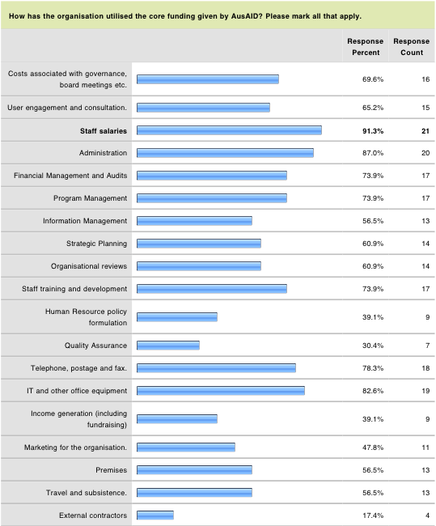

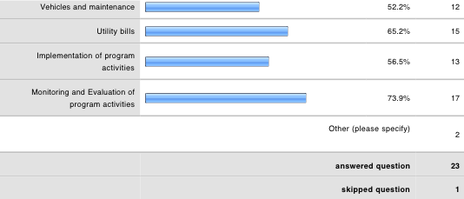

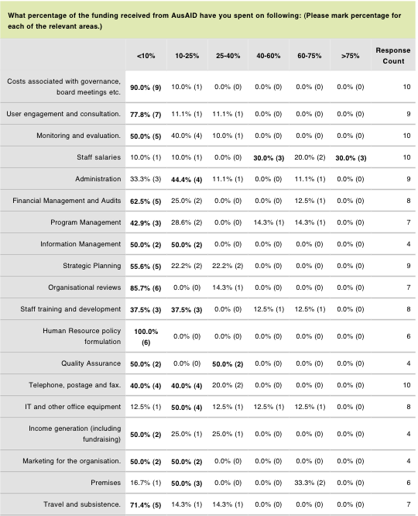

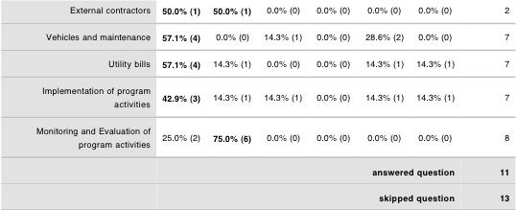

Percentage by organisation:

Transparency International:
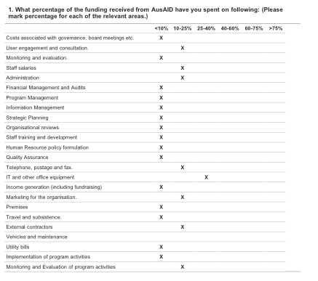
FJN+
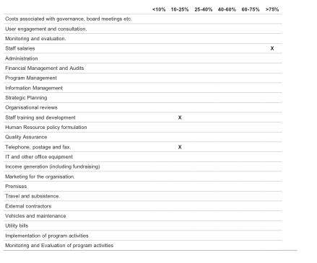
Live and Learn
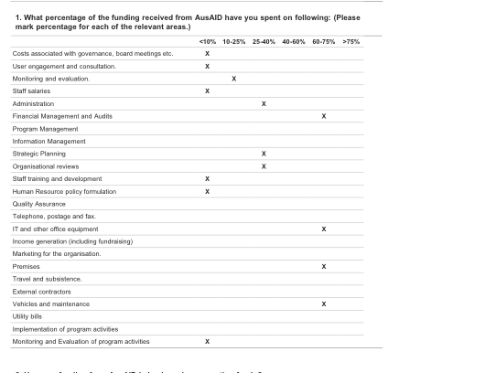
NCW:

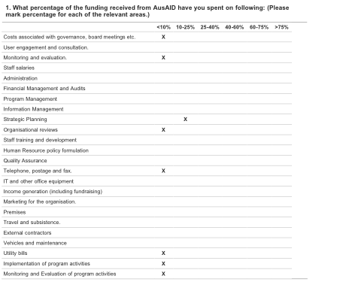

Project Heaven
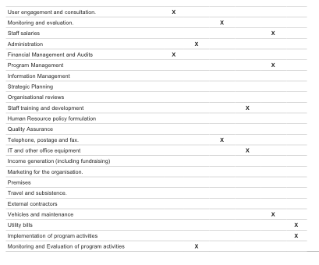
Partners for Community Development Fiji
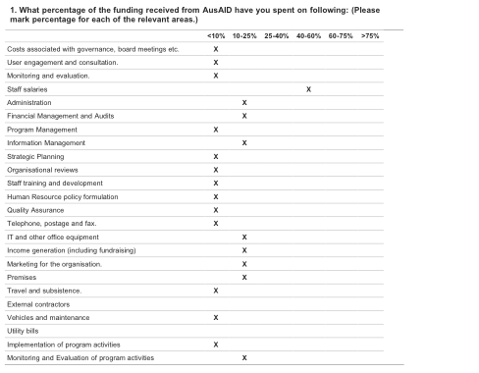
FCOSS:
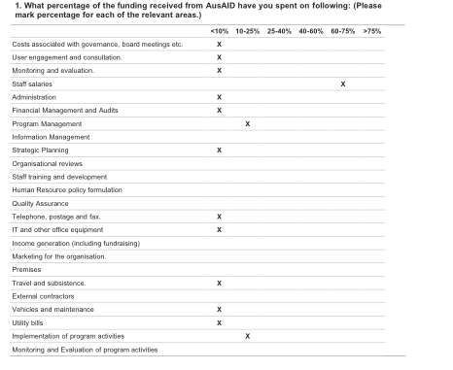

FRIEND:
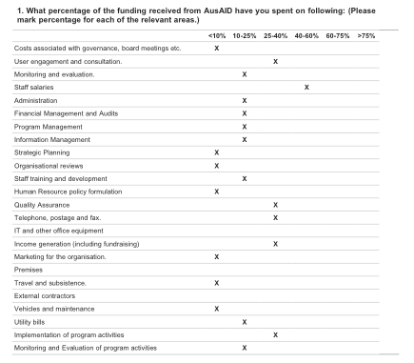

PCSS:
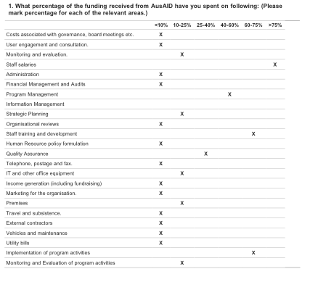

How core funding enabled organisations to fulfill their mandate

The following responses are coded by organisation.

Transparency International:
The core funding received by TI Fiji for a period of three year 2006 -2010 contributed towards the capacity building: that is the organization was able to cater for new staff, and maintain current staff , more effective Administration through capital expenditure such as office equipments. Effective media awareness gained the organization new members, the organization was able to move to a bigger and better premises with a secured contract of 5 yrs tenancy and a more centralized area. Ti Fiji was able to Strengthen TI Fiji’s partnership in global Anti corruption efforts engaging and meeting with other CSO’s.

TI Fiji was able to maintain its staff during the period of the funding. We were able to achieve a transparent financial system as TI Fiji was able to afford a well qualified Finance Officer.

With the core staff being maintained by the AusAid funds, we have been able to ensure that the activities were being carried out without any disturbances. 2007- 2010 had seen the employment of staff to lead the implementation of our awareness programmes, raising our profile, and ensuring that our core role was being adhered to. By providing the salaries for these core staff, ensured that our finances system and processes would be improved, our advocacy work was carried out well, and that the rent being paid ensured that the organisation could still operate.

FJN+:
Core funding has enabled FJN+ to: 1. Employ 4 core staff members (the majority of whom are HIV+) to undertake HIV education for the community which not only educates the community about HIV but also serves to reduce stigma and discrimination against HIV+ people. 2. Provide a safe space for HIV+ people to meet and support each other.

The core funding has enable FJN+ secretariat and its PLHIV members to reach out to more than 60000 people through our community awareness sessions. Furthermore the organisation finds the opportunity to build the capacity of positive people, increase its members from 35 PLHIV to 47 members, having HIV advocates established in the central and eastern division to name a few progress on the grant contribution. In essence the funding has allowed FJN+ to improve the lives of people living with HIV through the above mentioned activity.

Live and Learn:
Live & Learn's core goals are to: * develop and implement projects and programs for teachers, schools, communities and other target groups in the field of environmental and development education; * Encourage individual and community attitudes, values and actions that are ethical and environmentally sustainable; *Share knowledge, skills, learning experiences and resources with others for the benefit of the physical and human environment. *Promote the integration of environmental, human, cultural and peace concepts in all education projects and programs. The 3-year Strategic Plan for Live & Learn Fiji office has been developed to strengthen established Live & Learn educational and development programmes within Fiji. The principles and thematic areas of the Regional Strategic Vision are incorporated within the Live & Learn Fiji Strategic Plan 2007-2010. To date Live & Learn has been funded mainly from project funds. This reflects our focus on delivery and has ensured that we are a lean and efficient organisation. To sustain the organization and the quality of service provided to communities and others, it is important to steer from project funding to program funding that encompasses core funding and funding diversification. The Government of Australia has through AusAID, provided core funding to support the institutional strengthening of Live & Learn Fiji.

National Council of Women:

It has helped in the running of the office as well as the maintaining of contact with our affiliate organizations. We have been able to communication, educate and disseminate information with affiliates through support

Project Heaven:

If it was not for this funding, we would have closed up. It came in just at the most convenient and appropriate time.

PCDF:

It assist and facilitate to meet core objectives and activities of the organization

Core funding from AusAid has greatly assist in running the Organization in serving the people in remote communities.

FCOSS:
1. PROVIDED SOME FINANCIAL STABILITY IN THREE STAFF SALARIES FROM 2007-2009. AND TO 6 STAFF PERSONS IN 2010/2011. 2. ABLE TO REACH TO A GREATER NUMBER OF CSOs/NGOs with programme money.

FRIEND:
It has ensured financial stability to engage staff to be able to deliver consistent programs into the communities as well as monitoring and evaluations of these programs. Core funds has also ensured that we are able to pay managers and other expertise to help develop relevant programs and their implementation as well be able to pay for our utility bills without having to run and look for funds all the time.

PCSS:
The major uptake is the staff salary together with staff and organizational development. The nature of PCSS work requires more human resources as the basic tool for delivering services.

Enabled thousands of people across Fiji to access professional services, counselling,social work,IGP not covered by specific project funding. Allowed us to develop an infrastructure of professional counsellors throughout Fiji ,now training and assisting in 12 other regional countries to do the same for them. it has enabled us to plan ahead as far as HR needs are concerned and contributed towards the professional training of the staff and giving them career stability by paying salaries once graduated. has enabled us to implement systems to support clinical work such as professional supervision training and structure, internal accreditation system to ensure high quality service care for our practitioners. Also supported development of admin systems such as productivity tracking mechanisms, development of our comprehensive relational database, internal and external forms of monitoring and evaluation.

CCF:
ENABLED US TO RECRUIT STAFF FOR IMPLEMENTATION OF COMMUNITY EDUCATION PROGRAMME ON HUMAN RIGHTS, GOOD GOVERNANCE AND MULTICULTURALISM

Delivery of Services

The following responses are code by organisation:

Transparency International:
Organize training and development that is TI Fiji with collaboration with other organization was able to promote its objectives. Effective administration and management of information. Production and distribution of all publications such as brochures, newsletters, bulletin as well as a set up of TI Fiji website and media statements and interviews lead to more media awareness.

TI FIJI was effectively able to support its administration through the Ausaid core funds and was able to maintain its Assets.

FJN+:
The staff employed with core funding undertake fund raising to support the delivery of services such as counselling for FJN+ members, support FJN+ members to undertake income generation activities, and conduct a variety of community education activities.

The core funding has allowed the secretariat to provide a safe forum of discussion on a monthly basis for HIV+ people, provide education assistance to children of PLHIV, home visitation to the families of positive people, social welfare assistance, contributing to the success of PPTCT through HIV+ couples having children, capacity building trainings and through advocacy programs.

Live and Learn:
The core funding provided support for core organizational costs including rental, audit, vehicle maintenance and IT support. This core funding has contributed to strengthening the efficiency and capacity of Live & Learn to implement key activities with schools and communities.

NCW:
Has helped us to reach our affiliates as there is no help from government due to the current political position, the council has not engaged with government even though we were offered an office and salaries by the Ministry of Women

Project Heaven:
It has enabled us to be running smoothly again, for we had cut down on a lot of things so that we can have sufficient fund to keep afloat

PCDF:
The present Core Funding directly meet our organizational basic services.f or example, utilities - payment of bills in time that allow consistency in power supply, telephone and others to the office

More accessible in communication

Purchasing of equipments and salaries of staffs and other means did enable the us to provide efficient services to the communities and other stake holders.

FCOSS:
1. enabled us to do more activities in the districts and were able to do services with limited amount of funds provided.

FRIEND:
Staff development and steady staff employment has ensured consistency in service delivery as well as service outreach to the rural and under served areas.

PCSS:
The focus on staff and organizational development coupled with having a trained and professional workforce has very much impacted on the quality and standard of service delivered. As mentioned earlier our main tool for service delivery is Human resource and having professionally trained staff is important as this impacts on the quality and standard of service delivered. PCSS has filled in the gap which the government could not fill. The PCSS services is very important as reflected in the MOU between Fiji Ministry of Health, Fiji Department of Social Welfare as well as other government departments and NGO's.

Enabled us to deliver high quality services with positive reported outcomes for clients and allow opportunities for staff professional development that has led to very high staff retention rate, despite offering modest salaries. Allowed us to innovate and develop new programs and expand the reach of our programs so that we now have national coverage with regional training responsibilities

CCF:
WE HAVE PUT IN PLACE REPORTING MEASURES FOR US AT CCF TO KEEP TRACK OF FEED BACK AND THUS IMPROVE DELIVERY OF SERVICES

Enhancing Organisational development processes

The following responses are code by organisation:

Transparency International:
Capacity building with the organization- increase permanents staff New and more efficient office equipment. Public Awareness about TI Fiji. Effective participation in media against corruption. Awareness about TI Fiji around the world thought TI Fiji website Consultation of Civic awareness

Being more confident in implementing our roles and activities, as the staff were secure in their posts. This comforted the staff in their sense of belonging to the organisation, and in turn built on the organisations ability to move and progress in its work. The existence of core funds have assisted in the organisation's learning from its mistakes, and moving forward to build on these.

FJN+:
Prior to obtaining core funding, firstly from the AusAID-funded Pacific Regional HIV Program (2004 to 2007), and then from the AusAID Fiji NGO funding program, FJN+ consisted of two or three committed HIV+ individuals who were open about their status and who were invited by various organisations to "tell their stories" in order to "put a human face to HIV". Accessing core funding enabled this initial small group of HIV positive individuals to firmly establish the organisation, with core objectives and to expand those objectives to include provision of support services to HIV+ people, thus expanding the membership of the organisation. An important achievement of the development of the organisation is that FJN+ is now recognised as a key partner in the HIV response in Fiji and is involved in national planning and decision making processes - representing the HIV+ people. The organisation is also recognised as an important member of regional network of HIV+ people.

The funding has facilitated discussion and the need to have a strategic plan for the organisation and at the same time has exposed the need to conduct an organisational review. Currently FJN+ has a five years strategic plan 2010 - 2014 and a organisation review finding that aticulates the need to expand the capacity of the organisation and recognition as the nation umbrella of PLHIV. Moreover the expansion of the secretariat members from 5 staff to 7 staff and over a 100 volunteers and carers has been an overwhelming success.

Live and Learn:
The core funding has supported Live & Learn in review and realigning the Fiji office strategic vision with the overall organizational strategic vision 2020. This set out clear directions for the implementation of projects and programs within the organization.

NCW:
Has helped us to map a way forward with the new Strategic Plan and currently constitutional reviews and other governance issues are being reviewed in the constitution.New committees and program mapping has been possible with the core funding .

Project Heaven:
It has kept the organization going, otherwise we would have closed down.

PCDF:
Core Funding giving PCDF greater reach, improving our present and availability to provide services.

The core funding did boost the organization' development in terms of providing vital means and ways of improving services.

FCOSS:
1. Development of human resources of staff and CSOs in general 2. enhanced the training and capacity building. 3. ehanced governance.

FRIEND:
IT has allowed formulation of guiding policies like employment guideline, financial policy etc, be able to manage financial systems and have regular audits ensuring that the funds are well accounted for, admin support to be able to deliver regular services, transportation costs for outreach, staff employment salaries, regular meetings and evaluations within the organsiation for efficiency and self evaluations.

PCSS:
it had a tremendous impact. The focus on staff development has enabled PCSS to have a core of professionally trained staff with very high staff retention rate. This has increased organisational capacity for payment of salaries for senior staff members has resulted in development of layer of middle and exec management supported by well documented policies and procedures in clinical as well as administrative areas. Access to NGO management specialist through our link with AVI has seen development in our documentation of job descriptions, work contracts, contracts supporting ongoing learning, management training for many team members at several levels, development of appreciation of outcomes focused programs and operations, understanding of funding mechanisms and budgets trickling down to petty cash and the production of accurate ,transparent acquittals and reports where donor funds are shown to have achieved documented outcomes, despite the difficulty in measuring outcomes in this specialised area of capacity building people and their ability to cope with their life circumstances. uptake with services reaching almost every corner of Fiji.

CCF:
HIRING OF TWO STAFF ADDITIONAL WHICH HAS EXTENDED COVERAGE OF TTARGET AREAS OF COMMUNITY EDUCATION AND ALSO UNDERTAKE FLLOW UP IN ORDER TO MEASURE IMPACT

Approaches to monitoring and Evaluation
The following responses are coded by organisation:
Transparency International:
A Board report on the all activities carried out by TI Fiji and its impact on the targeted group on monthly basis.
The individual project officers assess their own performance, and this in turn in assessed by the supervisors. The Executive officer does an assessment on a weekly basis from the staff reports, and forwards this on a monthly basis to the Board. The M & E is done by the Board and when a Review is needed, the Programmes committee handles issues that arise. Egs of outcomes are the recruitment of Programme officer. the tasks are vetted by the Programmes committee and the Board, and when assessed positively, the decision is made. another eg. is the development of our finance and operational procedures and manuals.

FJN+:
FJN+ through its follow up strategy engages in MSC stories collection, the number of positive people coming out public from 3 to 11 HIV+ people. Collect data during monthly meetings, personal journals of each PLHIV member of the organisation, the increase in HIV+ membership and the number of BCC materials distributed during specials events and outreach activity. FJN+ has maximised on these opportunities as indication on the effectiveness and success of the organisation programs

Live and Learn:
Live & Learn using the Most Significant Change stories (MSCs) concept. This is qualitative form of documentation of stories. This process is facilitated over time and maximizes opportunities to measure impacts of the activities facilitated, over time.

NCW:
Evaluation from participants on workshops, as well as visitations and reports from coordinating officers or ME officers for particular projects

Project Heaven:
At the end of a day, each team fills in a report form on the work done during the day, making a note of the problems identified to be followed up at the end of 2 weeks. At the end of the month, the Field Supervisor sends the summary of those daily reports to the office to the Supervisor in the office to compile a monthly report to be submitted to the manager and to the Board, where activities are discussed thoroughly and comment and course of action relayed back to the Field for action-for improvement or acknowledgement and praise .

PCDF:
Finance reporting conducted monthly and quarterly within, 6 monthly and annually with Organization Annual reporting and audit to Board of Directors ( members at the AGM), and to Donors. Replacement of old server - frequent breakdown that affects the receiving and sending of emails. After purchasing and replacing done, big improvement seen as we're not experiencing mojor breakdown any more. All staff can access to emails anytime without major interruption.
Outcome indicators in terms of activities carried out in a month and its benefits: women, youths, children and others

FCOSS:
- Regular reporting to the Management Board. 2. reports to the Executive Committee and AGM 3. National CSO Forum 4. National Conf on Social Development every 2 years 5. Social Forum at national and District levels. 6. Outcome includes number of CSO officials trained, the development of CSOs themselves. one clear example is that the number of CSOs in community development has increased, the number of CSOs/CBOs requesting and receiving grants has increased many fold. More CSOs have fulltime staff and Admin office. -The National Policy Framework for the Elderly and the ageing. -The National Policy Framework for the NGOs Increase visibility of CSOs activities. - Representation of CSOs on government committees and donor consultancies
FRIEND:
- Strategic plan, program planning and evaluations every three months internally. 2. Staff observation reports/ before and after questionnaires. 3. M&E undertaken by USP Lautoka Campus ongoing for next three years. Results from this : more than 1000 backyard gardens established in 6 months, 70 community IGPs set up, 25 community disaster manager plans set up within a year, financial literacy and engagement with local governments in 15 communities, etc 4. Economic empowerment programs are evaluated by items produced and dollar distributed- through MYOB systems. 5. Number of product lines marketed by FRIEND 6. Within three years of core funding FRIEND has helped start 925 IGPs. 7. Youth Employment Network has indicated that 80% of youths trained under this program are in gainful employment.
PCSS:
PCSS has a very robust monitoring and evaluation system in Place. Conducting field visits, collecting most significant change stories, Getting feedback from stakeholders and partners are some of the strategies PCSS employs.
Every program in every department has built in monitoring and evaluation mechanisms. As mentioned we have weekly productivity logs from every site that track individual performance against targets, shows the overall performance of the branch ,shows the level of integration of our services within MOH facilities and alerts us quickly to any issues that need discussing. This allows Branch managers and clinical supervisors to analyse weekly the needs of their staff as far as support is concerned also if any performance management interviews are necessary and allows clinical supervisors to assess, observe and support clinicians in delivery of services at a high quality. Alerts us weekly to trends and possibilities of expansion and allows us to evaluate quickly the success of new initiatives. Our relational database developed by another AVI specialist mentor is an amazing tool for monitoring and evaluation. Extensive reports from every department are produced according to required reporting schedule, the reports contain demographic information, outcomes perceptions from clients and counsellors, gathering of behaviour change information that is then passed on to Ministry of Health for inclusion in national submissions and is also an amazing tool for research so that evidence based initiatives can be developed or expanded. For example in an external evaluation of our Sekoula Project (sex workers HIV initiative) showed that they had sufficient access and knowledge to our services to keep themselves and their clients safe but what they really wanted was the opportunity for alternative forms of income generation and capacity building. In response to this we approached SPC to get permission to include this innovation into a HIV program after 5 months of deliberation we were permitted to pilot income generation for the sex workers, now it is a vital and thriving department within PCSS and is assisting ex prisoners, sex workers and our most vulnerable social work clients. Income generation program is monitored by field officers with weekly follow ups to clients and accounts department producing weekly statements of monies owed and progress of loans. Due to PCSS accessing funds from Global fund and 4 out of the 5 streams of the response fund a 2 part external evaluation was commissioned by SPC. Part 1 looked at our regional training mechanisms, including content of our course and the follow up and evaluation of the in country training, the external consultant commended PCSS for their very robust monitoring and evaluation methods in relation to training. part 2 draft report is with SPC at , this looked at PCSS grant management and again the consultant commented that our day to day management was great. Contact Albert Conception from SPC to have access to these reports. Examples of outcome indicators would be : that 90% of pregnant women accessing antenatal services at major MOH facilities are referred to counsellors as part of routine antenatal services. 80% of their partners receive mens packs and are invited to access HIV counselling and testing and are provided with condoms. Other outcome indicators would be increased access to professional rehabilitation and reintegration services for prisoners sex workers have access to full range of social services including income generation and capacity building through courses More people have access to professional counselling and social work services Increased access to professional case management of child abuse cases through MOU with Social Welfare Increased access to quality services through establishment of policies and procedures ,example being the regionally accepted "essential standards" for HIV counselling and testing sites -region wide PCSS actually does progressive assessments and capacity building of these sites in 9 other countries and monitors the progress of the trained staff three months after initial training.

CCF:
WEEKLY STAFFMEETINGS HELD EVERY MONDAY OR TUESDAY FOR MONITORING. CCF HAS CHANGED THE COMMUNITY EDUCATION APPROACH BASED ON FEED BACK E.G. SEPARATEWORKSHOPS FOR INDO FIJIAN AND INDIGENOUS FIJIANDS AS MORE EFFECTIVE & WAYS OF IMPROVING RELATIONS WITH GOVERNMENT ADMINISTRATORS ND POLICE OVER ISSUE OF PERMITS TO ALLOW US TO ENTER INTO VILLAGE AND SETTLEMENTS; WE MONITORING AND RELATE COMPLAINTS TO GOVERNMENT OFFICERS WHEN NECESSARY; FEED BACK FROM WORKSHOPS IS USEFUL IN DESIGNING MATERIAL WE USE AS EXAMPLES WHEN WE CONDUCT RADIO TALK BACKS.

Organisational Growth and program diversification:
The following responses are coded by organisation:

Transparency International:
The organization grew in terms of adapting a better and effective financial management as latest accounting software was installed which provided financial information on all activities done by TI Fiji.

Core funding has assisted us in keeping our core expenses paid off, however, not so much diversification is done on our activities because of the little percentage of core funds that we get.

FJN+
FJN+ has been able to obtain funding from: 1. Fiji MOH for a variety of community HIV education events 2. UNICEF to develop and implement HIV and STI prevention activities for young people 3. Fiji Ministry of Social Welfare to establish income generation program for FJN+ members 4. Private sector and individual community members to establish a half-way home for members who become homeless

The funding has enabled FJN+ to increase its partnership and network such as Rentokil, FSPI, Digicel, etc. Hence the scale up of the divisional HIV advocates has allowed FJN+ to practically be effective at divisional level through MOH assistance.

Live ad Learn:
The core funding had ensured that organizational vehicles were in good condition and this reduced any chance of project implementation not being met, but ensuring project staff were able to reach out into the most remote communities. This also allowed the opportunity to gain more recognition from other partners and facilitate more projects

NCW:
Enabled us to review comments by affiliate organizations and plan programs to address concerns.

Project Heaven:
It has enabled us to continue on with our program

PCDF:

Enable Admin and Finance staff to support project staff during implementation.

Core funding did allowed us to increase our capacity of reaching out to other communities.

FCOSS:
- Enabled the setting up of Social Leadership Training Institute, -National Volunteer Centre -Voluntary Youth Network -CSO Capacity Building -Promoting Rural Womens Initiative, Development and Education.

FRIEND:
It has enabled recruitment of staff for long term contracts to be able to do service delivery in consistent manner. These staff have been able to do needs analysis and develop programs to meet these needs eg - active citizenship, disaster management, financial literacy programs, health outreach, youth development. Core funds enables access of money when needed for research, consultations, program development and delivery

PCSS:
To counselling we added social work, then we added income generation, also specialised forms of counselling such as HIV work and drug and alcohol and child counselling specialties. Initiatives such as "Mens antenatal services have been evidence based needs and hence we have accessed funds to increase available services to them. As mentioned professional supervision structure has been developed this has been addded to our cohort of training services. Application for recognition and registration with the higher education authority to teach the AIPC Diploma in professional counselling on a wider scale to external students, accreditation of our regional Reproductive Health Practitioner course by FSmed and cross crediting of our Diploma with significant points towards a degree in public health with FSmed is creating career paths and maximising benefits of the huge amount of training that is facilitated across the region. So from an initial core function of general counselling we now have whole departments for social work, HIV specialisation, Income generation and a training department that will enable us to generate some funds to help towards us becoming partially self supporting, also our recently developed research department will produce some Pacific based answers and questions so we will no longer have to rely on examples from regions that are vastly different to our own.

Expansion to rural and remote and underserved communities
The following responses are coded by organisation:
TI:
Campaigning for greater accountability and intergrity in the society starting from the grassroot level. More awareness workshops and advocacy work in rural communities. Involvement of effective participation of youths such as organizing appropriate training and development activities. More media awareness on TI Fiji services.
this would greatly expand the delivery of our services. As most of our work is aimed at getting youth in the rural and remote communities educated on anti- corruption work and the principles that we value, any core funds would push our objectives for the better.

FJN+
To date, FJN+ has mostly operated in Suva, with members in the Suva area benefiting most from the services provided by the organisation. Future core funding would enable the organisation to expand its services to other divisions, particularly the Northern Division.
The future funding is anticipated to review the current existence of the HIV divisional advocates and simultaneously look at opportunities and avenue to establish FJN+ branch at rural and remote areas. Furthermore the grant permits the organisation to continue to improve the quality of lives of people living with HIV through positive prevention, health and dignity program, engage and involved in the CoC framework, promoting Stepping stones, Life skills training within the HIV+ community and carers. In addition enhance the implementation of the organisation strategic plan that aims to promote the greater involvement of PLHIV (GIPA).

Live and Learn:
Live & Learn Fiji has seen the need to establish a training center to better meet the demands for the organizations services. Over the years, Live & Learn has strengthened it's capacity to implement Water Sanitation and Hygiene initiatives - set up infrastructure meeting ideal (and internationally recognized standards) eg. rainwater harvesting systems (providing an alternative safe drinking water source to communities and schools), setting up compost toilets, model organic farms/gardens, waste management systems. Developing a "training" center to model lessons learnt will provide Live & Learn the opportunity to share and build capacity of other partner organizations, educators to allow more replication of these actions, extending reach to a wider group - nationally, regionally and internationally. This center will also be showcased to other donor agencies, so that other grant beneficiaries can access training and use the demonstration centers as a starting point for project design, planning and replication.

NCW:
By having more access to rural communities. Have the means to have more effective and meaningful interaction with rural and remote communities.

PH:
It would enable us to de-centralize our program to have a team work in the north, a team in the west and a team in the Central division.

PCDF:
The present has improving our reach. With more and longer term commitment will definitely a big leap to services delivery to reach remove and vulnerable communities
Yes, future core funding will enable us to reach out and expand our scope of services particularly to the minority and marginalised groups in society.

FCOSS:
-Enhance the capacity of Rural District Networks. capacity Building of CBOs - Young Women's Rural Leadership -Social Leadership - Promoting Volunterism - Family Nuturing - Providing the Elderly Care Training - Providing Childcare training

FRIEND:
So far we have remained in Lautoka Ba and Labasa areas but now that we recognise our programs are effective from this year the plans are to go up to Rakiraki and Nadi in the West and further North in Vanua Levu. Having vehicles will also ensure we can go further rural into nthe hills as the roads in these areas are more difficult to manouevre without fw drives.

PCSS:
It already has, because of our location in all Major Ministry of Health facilities,over 60 % of our clients are from rural areas despite the facilities being in urban centres. Expansion of our services to Labasa has been met with much appreciation and demand from the Northern population that has access to very few professional services. Income generation especially in the North has been well received and utilised. Follow up of ex prisoners and income generation clients in rural areas is done by field officers. Included in our workplan for 2011 was expansion of our services to Sigatoka,S avusavu and also outer Suva however the changes stopped that. Despite this we have worked with MOH and have expanded our services to Valelevu Health centre and also Lami Health centre 2 centres that cover huge populations in the greater Suva area ,also in line with the MOH move to decentralise services away from CWM and other major facilities. Working with the Ministry of Health under our M is now being very productive however now that they see how much funding we have they have ceased all funding as they feel it is more needed in other areas, I forwarded a letter to Tim from Ausaid from the Minister for Health saying that they would endorse us and our services to allow us to continue accessing funding from agencies such as Ausaid , so in effect core funding has established our services within the Ministry of Health and will continue to pay for them as MOH wants the services but does not have the funds to pay for them, so while ever we can access core funds to sustain the services they are happy to work with us and expand our services to more of their facilities.

Organisational Sustainability
The following responses are coded by organisation:

TI:
In terms of capacity building, the organization was able to sustained staff who have been with the organization for more then two years, the office equipments have been maintained in the organization well after the completion of the funding and will be used in yrs to come. Development of Policies and Procedures manuals, Publications and other promotional materials has ensured TI Fiji to reach its objectives and maintain the continuity of this.
1.Maintaining the core staff. 2.Maintaining clean financial systems.

FJN+
FJN+ is still a relatively young organisation and would struggle to continue to without external funding.
FJN+ would like to think of the funding opportunity as a way to boost the image and credibility of HIV+ people and the organisation as a whole. This has strengthened and built the capacity of the organisation to have the agency to map out funding opportunities and future program donors that will help sustain the organisation.

Live and Learn:
The core funding has helped Live & Learn strategically plan out focus programmatic areas and the direction to best meet the demands of local communities and strategically improve human resource capacity. The core funding has also provided Live & Learn the opportunity to plan and seek expertise of local technical personnel to be represented in the Local Advisory Board. The core funding has also provided Live & Learn the opportunity to build staff capacity in Monitoring and Evaluation - through the M&E trainings facilitated in partnership with the New Zealand Aid Program and also report writing. Core funding has allowed Live & Learn the opportunity to establish a centralized information system (organizational server) and improved IT system, electronic communication has advanced and the support provided enables Live & Learn staff to keep in par with partners, and be kept versed with global events etc.

NCW:
Enabled us to pay volunteers/workers,pay office space, utilities as well as communicate, travel and meet with affiliate organizations. Basically helped us to function effectively as an organization.

PH:
It has enabled the organization to be kept afloat, with its 27 employees.

PCDF:
It has help PCDF financially to operate indefinitely into the future.

Consistency to deliver and play our role (PCDF), as partner to donors and to beneficiaries; rural / remove and vulnerable communities. Be there ( available ) to provide services when required. Leverage of time spend in fund raising.

The core funding has allowed PCDF to proudly serve the communities through equipments purchased and salaries of staffs.

FCOSS:
-Yes to some extent - Opportunities from SLTI programs –

FRIEND:
Core funds has ensured that we have steady policies in place which governs the organsiaton towards sustainability as well as employ staff who are long term and have been in training and have taken senior leadership roles ensuring sustainability of the organisation

PCSS:
As mentioned, services are now integrated into routine services available at all major hospitals and health facilities. Development of counsellors has led to the establishment of a specialised training department that will soon be recognised as a training institute and generate funds for PCSS so we can contribute to our own sustainability. Being the major stakeholder in the area of counselling and social services with over 70 professional staff has given us a profile that UN agencies and international NGOs that do not have service provision arms can work with. being a service provider does mean that it is us that has learned the lessons and adapted our programs accordingly so we do have differences with the philosophy of some international agencies and our strength as a service provider backed up by our research and huge amount of clinical data does mean that we can establish and integrate services that are relevant,culturally sensitive and based on a human rights approach, we have proven by our data collection that our models do promote behaviour change and that the way we present awareness and prevention messages is well received by the public at large. Development of our IT infrastructure and taking on a media agent has heightened our profile so that more people are aware of our services as are other stakeholders and donors in Fiji.

Core funding results and impacts on service delivery

The following responses are coded by organisation:

TI:
Awarness on Anti corruption. Within Targetted group tend promote integrity and accountablity within their own communities.
awareness work carried out in the different parts of Fiji totaling about 500-750 people. this work was carried out by the program staff who were paid for by the core funds.

FJN+
- Since 2004, membership of FJN+ has increased five-fold from 8 to 43, with 40% of people living with HIV in Fiji being members of the organisation. 2. FJN+ represents HIV+ positive people on NACA and other decision making bodies for the national HIV response in Fiji 3. FJN+ has reached over 80,000 people in more than 60 rural and urban communities with information about HIV and STI through their difference community education activities and events.
- The provision of the Half way home of those discriminated because of their HIV status from society. The half way project has accommodated 11PLHIV and have successfully reconcile them back to their individual families.

Live and Learn
Key results: Comprehensive staff reviews undertaken. Technical needs analysis drafted and in process of implementation. Two senior management staff members attend project management training and monitoring and evaluation training in response to technical needs analysis. All staff members attend 2.5- days staff retreat to strengthen team building and skills for overcoming obstacles, strategic planning and communication. Established community model sanitation parks and model organic farms in six pilot sites in Fiji. Lessons learnt on development of innovative educational tools shared with Ministry of Education, Citizenship Education Programme for collaboration on resource development. RiverCare and Project WET website established and on-line. Resources, approaches and lessons shared on website. Internal staff professional development on Gender and recognizing good gender outcomes in projects. Internal staff professional development on Human Rights and linkages to environmental perspectives Field staff technical skills gained on construction of alternative safe sanitary systems. Review on organizational good financial practices. Review of the Live & Learn financial manual. Reaching out to the rural (vulnerable) communities: Veinuqa, a community in the Tailevu province has a population of 299 people. For many years families in Veinuqa have faced challenges to sanitation and water availability. Part of Veinuqa is prone to flooding. During floods the current sanitary systems pose a threat to hygiene. This leaves the families living on the flood prone area of the village exposed to very unsafe living conditions. The effluent of their sanitary systems also poses probably contamination to their drinking water. The establishment of the compost toilets, as an initiative of AusAID facilitated by Live & Learn through the Modeling and Testing of Sanitation Marketing of Rural Communities in the Western Pacific in Veinuqa eliminates this problem. “Water is a great challenge here in the village for us all and especially the women. We have to walk to get water for daily chores and consumption, carting water for the water seal toilet. The toilet for our house is situated on the other side of the bank and this proves to be a challenge for us all, especially if we have to use the toilets in the evening or during times of heavy rain. Having this Compost Toilet installed and attached to our house is a blessing indeed. We don’t have to use water and the compost generated from the Compost Toilet my husband can use it in the farm after it has settled and decomposed well. A big vinaka vaka levu to AusAid and Live&Learn for installing a new Compost Toilet in our homes.” - Ms Eseta Banuve “I am so happy and blessed that our household was chosen for the installation of the compost toilet. Not only does it eliminate the use of water (in our community already having a problem with water) but I as a farmer can use the manure produced from it on my gardens. The price of fertilizers is very expensive it is $15 for a bag of chicken manure (money which can be used for other things). Living here in the village if your family doesn’t eat than it is a lazy family because you are lazy to plant. However it is an added bonus to have a Compost toilet because the manure gathered from here can be used in gardens. I intend to use it in my gardens, because it is good for the crops and I don’t have to pay anything. It is a true blessing indeed.”-Mr Joeli Ravualala

NCW:
Sponsored training visits and meetings. Helped in the interaction of women within affiliate organizations.
PH:
Spectacles were bought for some children. hearing aids were also bought for some other children. Families of PH employees rejoiced at the retaining of work for their father or mother etc..

PCDF:
Consistency to meet staff salaries - Admin and finance directly heir salaries comes from the fund. No work interruption to lay off as the fund is there to support them

FCOSS:
- Trained People - Shared Success stories -Secured Employment

FRIEND
Sustainable livelihoods generated for more than 900 families 25 communities have disaster management plans 5000 beneficiaries per year benefitting from all FRIEND programs of social and economic empowerment in North and Western divisions

PCSS:
Please see our statistical reports from 2010 for more info , however just looking at our general counselling clients from 2010 5503 new clients of which 41% stated that they felt they had made much progress towards their treatment goals with another 50% stating they had made some progress,less than 1% of these clients reported feeling they had made no progress towards therapeutic treatment goals. For the same clients counsellors were asked their perceptions of how far clients had come in achieving goals, 39% of the counsellors felt that the client had made much progress, 51% felt that they had made some progress and less than 1% felt that the client had made no progress. Please see booklet of success stories from our income generation program for more examples of how our clients have been positively affected.

Core Funding and Cross cutting issues
The following responses are coded by organisation:

TI:
It has always given priority to both male and females during its community outreach and any awareness it tends to do.

an aim to empower women has seen our awareness work being targeted to the rural women.

FJN+:
The organisation ensures that male and female members benefit equally from the services provided.

Through the stepping stones and life skills training conducted at community level. The promotion of gender equality on the governance committee of the organisation and the equal representation of gender during program level, activity level, meetings and conferences, etc.

Coordinating a project called Mental Health through Youth Champs for Mental Health. PCDF has experience managing a Mental Health project through FSPI

Live and Learn:
Yes, by allowing Live & Learn the opportunity to assess organizational strategies ensuring gender is mainstreamed (an organizational principle). Emphasis was also placed on ensuring that the local advisory board was gender balanced.

Live & Learn's guiding principles encompass and ensure inclusiveness and equal participation of all target audience.

NCW:
More brochures about women's issues have been produced. More information disseminated about women amongst women.
They are an affiliate organization so all activities in the council involve women with disabilities. Future literature will be written to benefit women with disabilities eg..audio versions of literature.

Project Heaven:
By having equal gender staff ratio.

Screening all schools irrespective of who are the school children. People with disabilities are always given free service and 1st preference when they come here.

PCDF:
The fund is organizational, who ever in the organization will directly benefit them. PCDF has more female staff (finance and admin) than male

FCOSS:

-In everyway as all programs has gender equality.
- Our programs are non discriminatory and fcoss programs are all inclusive

FRIEND:
Around 70 % of staff at FRIEND are women. Most of the programs are taken into the communities during day time hence 80% of outreach beneficiaries are also women. For youths and effort is being made to ensure 50% balance.

Our programs are holistic and is inclusive of people with special needs. We have offered sustainable livelihood opportunities to people with special needs including paraplegic and deaf youths. Sign language classes have been run for all staff so deaf youths working at work place feel included and everyone is able to communicate with each other.

PCSS:
It is amazing how assisting women through the income generation program has changed their status within their family and even their community, refer to IGP success stories for evidences of this. Core funding hass allowed us to have both male and female counselors

Many of clients both in counselling, income generation and especially social work have disabilities. We do provide our counselling and social work services for Tamavua Rehabilitation hospital as well as St Giles for those with mental deficits. Social workers spend a lot of their time in securing mobility aids such as wheelchairs, crutches and walking frames mainly for amputees(through the effects of diabetes) also it is maily clients with disabilities that our social workers liaise with social welfare to enable them to be placed on the family assistance program and to receive food rations. Again see social work report from 2010 for detailed breakdown.

Collaboration:
The following responses are coded by organisation:

TI:
TI Fiji collaborating with other organisation to promote its objectives in different sectors of Fiji.
regular meetings and exchanges with other NGO and private sector oganisations, have made this possible.

FJN+:
FJN+ works closely with Fiji Ministry of Health, UN Agencies, other NGOs in community HIV education activities
The core as mentioned before as allowed the organisation to build it partnership and network from grassroot level to policy making level.

Live and Learn:
Being part of trainings or forums organized by AusAID with other recipients of the AusAID funding.

NCW:
Helped us in travel to attend meetings and workshops and correspond with other organizations through training and communication networks.

PH:
it gives confidence to speak out boldly

PCDF:
Improving communication link, network to partner in certain activities. Sharing of expertise between, best practices and over resources,

FCOSS:

-Through the NCOS Forum - Other Forums - Other Workshops

FRIEND:
We have been able to develop strong partnerships with CBOs like Ba Senior Citizens Centre, Gold Foundation (Tavua) and NGOs like Women's Action for Change for outreach of services to the needed population as well as with corporate sector for work attachment of youths and marketing support of our products.

PCSS:

Integration of our services into MOH facilities has meant collaboration with MOH staff as well as other agencies that assist govt such as SPC, Unicef, OOSHMM to name a few. Our membership of several committees such as the new mental health alliance and the "old NACA subcommittees plus the western and northern committees for HIV/STI work mean that we are having constant input into strategic plans for significant areas in health and welfare in Fiji. MOU with social welfare ,impending MOU with dept of Youth and Sports are all examples of our collaboration with government entities. We do collaborate with NGOs and governments in 12 other countries through SPC and our regional training activities. Joint projects and collaboration with agencies such as FSmed, Albion Street Clinic Australia, ASHHMM and Australian Institute of Professional Counsellors are also important stakeholders that we collaborate with. Collaboration with AVI has seen us benefit from tyhe placement of 5 AVI specialist mentors and this has added much to building thecity of our staff and PCSS as A WHOLE.

Areas needing improvement
The following responses are coded by organisation:

TI:
Improve on securing staff and resources by securing long term funds
1.Strategic Plan development 2. Program management skills 3. governance system

FJN+:
Due to limited capacity (resources and skilled staff) within the organisation since its inception as well as limited funding opportunities in the past for organisational capacity building and core funding, FJN+ currently does not have any formal operational policies and procedures in place (and faces other key challenges which is discussed later in this section).

Live and Learn:
Strengthening local advisory board function. Human resource training and capacity building development.

NCW:
Need to travel to more rural and remote areas need to have more training done in rural and remote areas Need to have more support equipment to enable us to do training and provide literature for women from all sectors. Need to have support for salaries..Currently work is hindered as there is no full time salaried staff..For a big organization that serves 200000 women this is appalling.

PH:
The Board is very stingy with the spending of money.

PCDF:
Big improvement shown in the last 12 months and still PCDF to build and strengthen areas like a. Institutional infrastructure b. Staff development - responsibilities c. Project Monitoring and Evaluation d. Financial Management and

FCOSS:
- Institutional strengthening - Infrastructure development - Human Resource Development - Professionalisation - Having all staff salary above the poverty line

FRIEND
There are structural challenges within organisation as we the struggle remains when we transition communities from social to economic empowerment programs. Record keeping as we have storage limitations in the new site until we biuild further structure. IT and information systems as we have constant power fluctuations and need more streamlined systems. Upgrade of skills in research and analysis

PCSS:
Upskilling staff from diploma level to degree level Management training for middle management A crucial time for our NGO will be next June when I retire. We do have a transition plan in place and have a PRF developed with AVI for a facilitator to assist staff and the organisation transition through this change of leadership period.

Difficulties associated with Core Funding
The following responses are coded by organisation:

TI:
Because of high turnover of staff lack of information on the final stage of funding
1.non-continuity 2.non-assistance from desk officer 3.small percentage (25%) contribution which makes it difficult to assess

FJN+:
The amount of funding actually available to FJN+ from core funding only provides for partial funding of the organisation. The limited funding has meant that the organisation has not been able to employ people with the high level organisational management capacity, which has hampered the development of the organisation.

The limitation that core funding only fund the salary of staff and not crucial programs that enhance the mission and vision of the organisation.

Live and Learn:
Feedback reports provided to fund recipients.

NCW:
The small amounts and the delay in process which leads to delay in release of funds which hinders progress. eg if the amount for a year could be given early in the year and to work according to our plans. sometimes we hold work because funding is not available.

PH:
Nothing so far.

PCDF:
Nothing at the moment. To my experience with Core Funding, PCDF have no difficulties faced during my 12months in the organization

FCOSS:
- Lack of transparency from donors on the contents and the extent of core funding -Donors uni lateral decision by donors on reduction on the original request. - Complexities in relating to budget line

FRIEND
There have been long negotiations for short term. Some agreements have been too short and too much time is taken for further negotiations. Unclear communication and lack of feed back Unclear requirements for M&E Lack of feedback from consultations and reviews

PCSS:
We have accessed core funding from both Ausaid and NZ aid , NZaid liked their funding to be grouped so we used to put operational costs for all centres, management costs, social work costs and income generation and training costs under their core funding and because Ausaid was more flexible we would put the remainder the great majority being salaries for service providers under Ausaid, the 2 core funding agreements worked in tandem and we used to show both agencies our overall core funding workplan so there was an integrated approach. The difficulty with core funding was having all money tied to line items, however in the past we did get permission to utilise unspent funds in an unspecified category, this allowed flexibility and allowed us to act quickly when ideas come up during the year that are not forseeable in September the previous year when the budgets and workplans are being prepared. It would be great if 5 -10 year core funding agreements could be developed as this gives security especially for example if we want our clinicians to upskill to degrees and further studies. basically we have benefitted greatly from core funding as it does supplement project funding, it is amazing that our core business of counselling has never been covered by profunding unlike HIV counselling, social work or income generation, our counselling has always been made available through core funding and we thank you for that, hope it can continue.

Core funding as a leveraging tool

The table below demonstrates the importance of core funding as a leveraging tool. Each organisation chart below reports on the amounts leveraged and from whom.

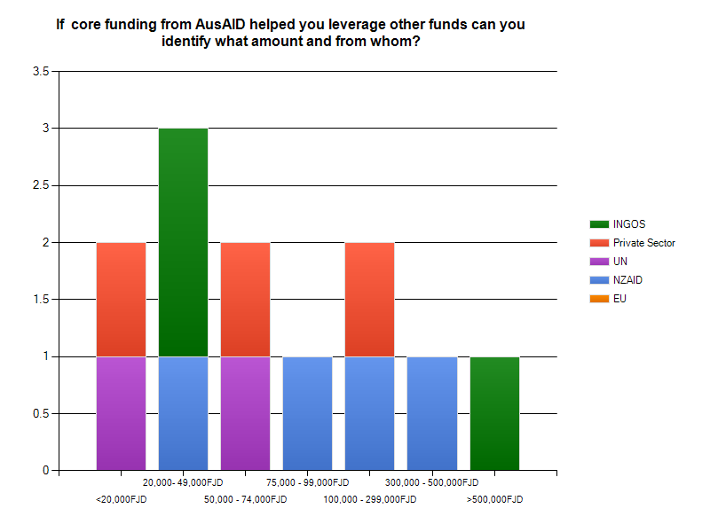

Individual leveraging responses
FJN+:
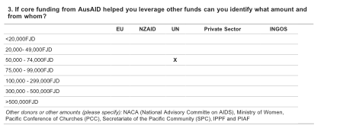

PH:
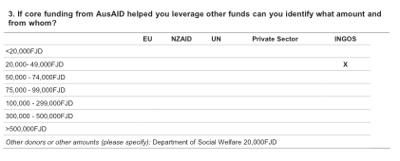
PCDF:
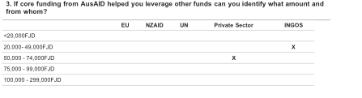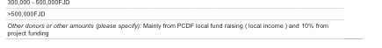
FCOSS:
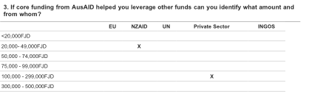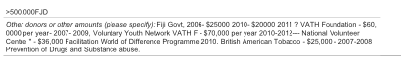

FRIEND:

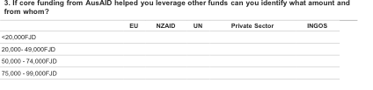

PCSS:

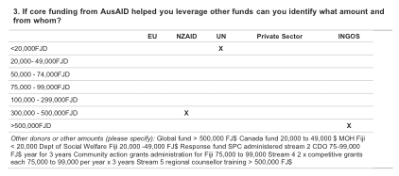

Future Funding Modalities

The following table identifies preferred options for funding mechanisms. Strategic partnership agreements and Program based approaches were identified as the preferred options.

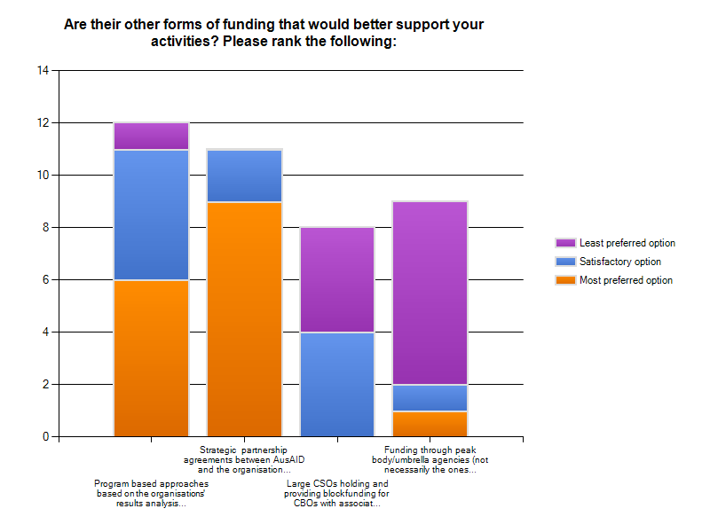

Appendix One – survey questions.
See attached Survey PDF.

