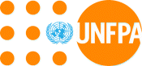UNFPA Pacific Sub Regional Office (PSRO)

**A Transformative Agenda for Women, Adolescents and Youth in the Pacific:**

**Towards Zero Unmet Need for Family Planning 2018- 2022**

|  |  |
| --- | --- |
| Programme Title | A Transformative Agenda for Women, Adolescents and Youth in the Pacific: Towards Zero Unmet Need for Family Planning |
| Programme Duration | 51 months (May 2018 to 30 August 2022) |
| Programme  Goal | Transformative change in the lives of women, adolescents and youth across the Pacific by 2022 |
| Programme  Objective | To move unmet need for family planning in the Pacific towards zero by 2022. |
| Programme Outcomes | 1. Increased and improved supply of integrated sexual and reproductive health (SRH) information and services, particularly for family planning 2. Increased demand for integrated SRH information and services, particularly for family planning 3. More conducive and supportive environment for people to access and benefit from quality SRH, especially contraceptive choice |
| Programme  Outputs | 1. Strengthened delivery of high quality, integrated SRH information, services for women, adolescents and youth across the development-humanitarian continuum 2. Strengthened health workforce capacities in health management and clinical skills for high-quality and integrated SRH services 3. Increased community engagement and leadership in support of SRH, especially contraceptive choice 4. Increased national capacity to design and implement community and school-based family life education programmes that promote human rights and gender equality 5. Expanded evidence-based legislation, public policy and programming that supports universal sexual and reproductive health and rights, especially for youth, violence survivors and persons with disabilities 6. Increased availability, analysis and use of high-quality, disaggregated nationally prioritized population and SRH data |
| Programme Budget | AUD 30,000,000 for the period June 2018 to 30 August 2022 |
| Programme Locations | Focus Countries: Fiji, Kiribati, Samoa, Solomon Islands, Tonga and Vanuatu. |
| Programme Partners | Implementing partners: Ministries of Health, Ministries of Youth, Ministries of Women, Ministries of Finance, Ministries of Education, National Statistical Offices, Secretariat of the Pacific Community, Nursing and Midwifery Schools, Teachers Colleges, Regional and National professional associations, Pacific Youth Council, Pacific Disability Forum, International Planned Parenthood Federation (including national member associations), Disabled Peoples Organisations, selected academic and other institutions as appropriate (eg. University of the South Pacific, Melbourne University, Marie Stopes International, John Snow International).  Strategic/technical partners: Pacific Islands Forum Secretariat, National Disaster Management Offices, WHO, UNICEF, UN Women, UNDP, UNOCHA, UNESCO, World Bank, ADB, EU, and others as identified during current and ongoing consultations. |

UNFPA’s Six Priority Countries for Implemention of the Transformative Agenda:

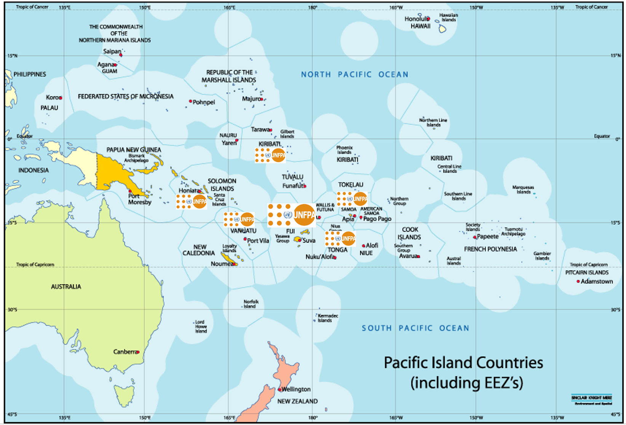

Table of Contents

Acronyms and Abbreviations: 7

1. Introduction 11

2. Rationale for Investing in Sexual and Reproductive Health in the Pacific 13

3. Situation Analysis: Sexual and Reproductive Health in the Pacific 16

3.1 Contraceptive prevalence rates and remaining unmet need 16

3.2 High Needs Among Adolescents and Youth 20

3.3 Contraceptive commodity supplies 22

3.4 Recent positive trends in Couple Years of Protection 23

3.5 Addressing the SRH needs of people with disabilities 24

3.6 Violence Against Women and Girls in the Pacific 25

3.7 Maternal Health 27

3.8 Cervical Cancer 29

3.9 Data and analysis 30

3.10 SRH in emergency and humanitarian situations 31

3.11 Demand Generation 31

3.12 Previous analysis of barriers and challenges 32

4. UNFPA and its Goals 34

4.1 UNFPA in the Pacific 34

4.2 UNFPA’s Comparative Advantage 35

4.3 Existing UNFPA Activities 36

4.4 Expanding UNFPA presence as a result of Lessons Learned from the Fifth Subregional Programme 2013-2017 37

5. Context for Transformative Agenda and Theory of Change 41

Theory of Change 41

6: Outputs, Outcomes and Activities to achieve them 43

Outcome 1: Supply 44

Output 1 45

Output 2 52

Outcome 2: Demand 57

Output 3 57

Output 4 60

Outcome 3: Enabling Environment 63

Output 5 64

Output 6 65

7. Governance and Management Arrangements 68

Joint DFAT and UNFPA Governance Mechanisms 69

Technical Governance 70

Administration and Reporting 71

DFAT’S Role 73

UNFPA’S Role 73

UNFPA Management and Administration 74

PRSO Level 74

Country Level Management 74

Country Level Steering/Coordinating Mechanisms 75

Level and Timing of DFAT disbursements 76

Risk Management 76

8. Budget 77

9. Monitoring and Evaluation 81

ANNEXES 91

Annex 1: Results and Resource Framework from Executive Board approved SRPD6 91

Annex 2: Summary of funding UNFPA receives for existing programmes 92

Annex 3: PSRO Proposed Organogram 94

Annex 4: DETAILS OF SRH SPECIALIST ROLE (DRAFT) 95

Annex 5: Summary Mapping of UNFPA PRSO for SRPD6 - Key SRP6 Deliverables by Country 97

Annex 6: Risk Matrix 98

Annex 7: UNFPA’s Results Based Management Plan and Calendar the Transformative Agenda 2018-2022 100

Acronyms and Abbreviations:

|  |  |
| --- | --- |
| ABR | Adolescent Birth Rate |
| ADB | Asian Development Bank |
| APRO | UNFPA Asia Pacific Regional Office |
| BCC | Behaviour Change Communication |
| CBO | Community Based Organization |
| CPR | Contraceptive Prevalence Rate |
| CSE | Comprehensive Sexuality Education |
| CSM | Contraceptive Social Marketing |
| CSO | Civil Society Organization |
| CYP | Couple Years of Protection |
| DFAT | Government of Australia’s Department of Foreign Affairs and Trade |
| DHS | Demographic Health Survey |
| DPOs  EC | Disabled Persons Organisations  Emergency Contraceptives |
| DRR | Disaster risk reduction |
| EIMS  ESP | Education Information Management System  Essential Services Package |
| FBO  FHSS | Faith Based Organization  Family Health Safety Study |
| FLE | Family Life Education |
| FP | Family Planning |
| FSM | Federated States of Micronesia |
| GBV | Gender Based Violence |
| GBViE | Gender Based Violence in Emergencies |
| HFRA | Health Facility Readiness Assessment |
| H6  HIS | UNFPA, UNAIDS, WHO, UNICEF, UN Women, World Bank partnership  Health Information Systems |
| HIV  HPV | Human Immunodeficiency Virus  Human Papillomavirus |
| ICPD | International Conference on Population and Development |
| IEC  IP | Information Education and Communication  Implementing Partner |
| IPPF | International Planned Parenthood Federation |
| IUD | Intrauterine device |
| JSI | John Snow International |
| LARCs | Long Acting Reversible Contraceptives |
| LGBTQI  LMIS | Lesbian, Gay, Bisexual, Trans, Queer and Intersex  Logistics Management Information System |
| M&E | Monitoring and Evaluation |
| MA | Member Association (IPPF) |
| MCH  mCPR | Maternal and Child Health  Contraceptive Prevalence Rate for modern methods |
| MDG | Millennium Development Goals |
| MDSR | Maternal Death Surveillance and Response |
| MICS  MISP | Multi-Indicator Cluster Survey  Minimum Initial Services Package |
| MOE  MOF | Ministry of Education  Ministry of Finance |
| MOH  MOW  MOY | Ministry of Health  Ministry of Women  Ministry of Youth |
| MSI | Marie Stopes International |
| NCD | Non-Communicable Disease |
| NDMO | National Disaster Management Office |
| NGO | Non Governmental Organization |
| NSO | National Statistics Office |
| OSSHAM | Oceania Society for Sexual Health and HIV Medicine |
| PDF | Pacific Disability Forum |
| PHC | Population and Housing Census |
| PICTs | Pacific Island Countries and Territories |
| PIFS | Pacific Islands Forum Secretariat |
| PSRH | Pacific Society for Reproductive Health |
| PSRO | UNFPA Pacific Sub-Regional Office |
| PYC | Pacific Youth Council |
| RH | Reproductive Health |
| RMI | Republic of Marshall Islands |
| RMNCAH | Reproductive, Maternal, Newborn, Child and Adolescent Health |
| RHCS | Reproductive Health Commodity Security |
| SDPs  SGBV  SIS  SOPs | Service Delivery Points  Sexual and Gender-based Violence  Strategic Information System  Standard Operating Procedures |
| SPC | Secretariat of the Pacific Community |
| SRH | Sexual and Reproductive Health |
| SRP | Subregional Programme |
| SRPD | Subregional Programme Document |
| STI | Sexually Transmitted Infections |
| TASC  TFR | Transformative Agenda Steering Committee  Total Fertility Rate |
| TPP  UNAIDS | Third Party Procurement  Joint United Nations Programme on HIV/AIDS |
| UNDAF | United Nations Development Assistance Framework |
| UNDP | United Nations Development Programme |
| UNESCO | United Nations Educational, Scientific and Cultural Organization |
| UNFPA | United Nations Population Fund |
| UNICEF | United Nations Children's Fund |
| UNJPO | United Nations Joint Presence Office |
| UNPS | United Nations Pacific Strategy |
| UNW | UN Women |
| USP | University of the South Pacific |
| WHO | World Health Organization |
| VAWG | Violence Against Women and Girls |
| YFHS/YAFHS | Youth Friendly Health Service/Youth and Adolescent Friendly Health Services |

**Executive Summary**

Sexual and Reproductive Health (SRH) and fulfilment of reproductive rights are essential for the health and wellbeing of women, adolescents and youth as well as for gender equality, women’s empowerment, women’s participation in the economy and for overall poverty reduction. At the national level, lower fertility rates decrease population growth rates and make achievement of the 2030 Agenda for Sustainable Development more attainable, more affordable and more sustainable. Investment in SRH services, notably family planning, is one of the most cost-effective investments for sustainable development.

The reality is, however, that six of the 14 Pacific Island Countries and Territories (PICTs) have a growing total fertility rate and that ten PICTs are now experiencing growing teenage pregnancy rates, contrary to the global pattern of decreasing rates. The region not only has low Contraceptive Prevalence Rates and some of the highest unmet needs for family planning compared to global averages, but also indicators that have been relatively static over the last 20 years. Previous surveys point to challenges that include: poor quality of services; variable SRH supplies availability and accessibility; weak governance mechanisms to translate existing policies into effective sustainable actions; and limited capacity to implement strategies and plans. Further, modern contraceptive uptake is challenged by myths, misconceptions and/or misinformation and misinterpretation of side effects.

Women’s economic empowerment and gender equality are priorities across Australia’s foreign policy and aid programme. The recently released White Paper on Foreign Policy places a strong emphasis on ensuring a whole of Department approach to strengthening these outcomes as key drivers in reducing poverty and increasing economic growth and stability.  Access to SRH services, particularly family planning, is central to achieving these objectives and their importance as key interventions is acknowledged in the White Paper as well as in DFAT’s ‘Women’s Economic Empowerment and Gender Equality Strategy’, and the ‘Health for Development Strategy 2015-2020’.

Meanwhile, UNFPA has been working in the Pacific region for over 30 years implementing SRH programmes in 14 countries and territories through the Pacific Subregional Office (PSRO) in Suva. It is the sole intergovernmental agency working substantively in the area of SRH and rights, with a focus on family planning. UNFPA’s overall regional program, across 14 PICTs, is articulated in its Sub-Regional Programme 6 (SRP6). The new DFAT investment articulated in this proposal sits within that overall effort. This proposal, a Transformative Agenda for Women, Adolescents and Youth in the Pacific (hereafter referred to as ‘the Transformative Agenda’) outlines significant investment in improving SRH in six priority countries: Fiji, Kiribati, Samoa, Solomon Islands, Tonga and Vanuatu. UNFPA’s key partners on the ground for pursuing this agenda will be the respective Ministries of Health, Ministries of Education and International Planned Parenthood Federation (IPPF) member associations.

This DFAT AUD 30 million investment over 51 months significantly scales up the resources of the PRSO to effect change across the region. Importantly, it will allow for a significantly increased UNFPA presence in its Field Offices in the six priority countries. UNFPA is currently implementing several programmes across the Pacific, all of which the Transformative Agenda will complement or build upon.

The DFAT investment through UNFPA aims to contribute to transformative change in the lives of women, adolescents and youth across the Pacific by 2022 with a Program Objective that is:

* To move unmet need for family planning in the Pacific towards zero by 2022.

PICTs with a high unmet need for family planning require both demand and supply side investments and promotion of a conducive environment that supports sustainable, evidence-based interventions. It is planned, therefore, that the overall Program Objective will be achieved through the delivery of three complementary and synergistic Program Outcomes:

* Increased and improved supply of integrated SRH information and services, particularly for family planning
* Increased demand for integrated SRH information and services, particularly for family planning
* More conducive and supportive environment for people to access and benefit from quality SRH, especially contraceptive choice

Although the Transformative Agenda has a focus on reducing unmet need for family planning, we know from the way people access services that reducing unmet for family planning requires broader investment in integrated SRH information and services and that will be the nature of the Transformative Agenda investment. Given the increase in teenage pregnancies, a focus on adolescents and youth is required. There are, however, additional groups that have particular SRH needs, including those who have experienced gender-based violence, those living with a disability and those faced with emergency and humanitarian situations. The needs of these groups are explicitly addressed.

Outcome 1 (supply) is predominantly about improving health systems and health service performance with a focus on: improving and expanding integrated SRH services; building the health workforce through training, guidelines and protocol provision and expanding scopes of practice; and working to make SRH supply systems more sustainable. It is assumed that activities under Outcome 2 (demand) will increase the number of people using SRH services, while improving the quality of SRH services will also increase service demand and use. It will engage and mobilize communities and their leaders across a range of SRH issues as well as improving the coverage and quality of Family Life Education for young people, including those with disabilities. Activities under Outcome 3 (enabling environment) will create quality policy and strategies that support SRH services, SRH financing, and ultimate sustainability of SRH information and service provision. It will include the deployment of influential analytical products for policy and programming in each of the six countries. A series of outputs and the strategic interventions and activities required to achieve those outputs are detailed, along with key partnerships, in Section 6 of this proposal.

As a United Nations agency, UNFPA’s fundamental approach is to work with in-country partners, primarily national governments, to expand their capacities and achieve locally sustainable responses to SRH needs. The next five-year SRP6 program and the Transformative Agenda are purposefully complementary to relevant national and sectoral development strategies. The Transformative Agenda will fully engage local health authorities and key national partners with careful consultation and planning in the early stages and subsequent agreement on implementation approaches and on performance monitoring frameworks and accountability requirements. The consultation will ensure that the approaches taken are feasible and acceptable, and that local ownership is built at the outset. Country level annual workplans will be developed between UNFPA, national government counterparts and NGO and others, as relevant, in each country in the last quarter of each calendar year, with government being required to approve those workplans as part of their annual planning and budgeting processes.

1. Introduction

Universal enjoyment of sexual and reproductive health (SRH) and fulfilment of reproductive rights are essential for the health and wellbeing of women, adolescents and youth as well as for gender equality and women’s empowerment, and for overall poverty reduction. Protecting sexual and reproductive health and rights is intrinsically linked to sustainable development and to supporting countries to achieve the 2030 Agenda for Sustainable Development and the 17 Sustainable Development Goals (SDGs). When women, adolescents and youth can exercise their right to make informed decisions on whether, when and how often to become pregnant, they enjoy better health, can achieve higher levels of education, expand their workforce opportunities, and generate more income for their families. This triggers a cycle of prosperity that carries well into future generations and contributes to poverty reduction and national economic growth, as demonstrated in Figure 1.

This proposal, a Transformative Agenda for Women, Adolescents and Youth in the Pacific (hereafter referred to as ‘the Transformative Agenda’) outlines significant investment in improving SRH in six priority countries, with a focus on reducing unmet need for family planning[1] [2]. The six priority countries, Fiji, Kiribati, Samoa, Solomon Islands, Tonga and Vanuatu, all show particularly alarming trends in SRH indicators and high levels of violence against women and girls (VAWG). The choice of these six countries builds on progress made under UNFPA’s fifth Multi-Country Programme (2013-2017), including existing engagement and relationships with national stakeholders. UNFPA already has a presence in all six countries, which allows greater understanding of the political, economic and social environment. In addition, these six countries are priorities for DFAT health sector engagement in the Pacific. Support to other Pacific island countries and territories (PICTs) will be provided through UNFPA’s regular programming as part of the approved Sub-Regional Programme 6 (SRP6) for 2018-2022, contingent upon available resources and UNFPA presence on the ground through the United Nations Joint Presence Offices (JPOs). Through PSRO, policy engagement and advocacy will be supported in all 14 PICTs.

UNFPA’s overall sub-regional program across 14 PICTs is articulated in SRP6 (summarized in Annex 1). This DFAT investment sits within that overall effort. The DFAT AUD 30 million investment significantly scales up the resources of UNFPA’s Pacific Sub Regional Office to effect change across the region. Whilst the DFAT contribution is the most significant, there are a number of resource streams contributing to SRP6 (see Annex 2) and any attempts to ringfence the activities, outputs and outcomes of SRP6 that can be attributed to DFAT would be artificial. Within the context of the broader UNFPA -led programme design, it has been agreed that, as a proxy, DFAT’s accountability focus will be on the difference that UNFPA can make in the six priority countries of Fiji, Kiribati, Samoa, Solomon Islands, Tonga and Vanuatu. Key outcome and impact information flowing from UNFPA’s regular and comprehensive internal reporting on the overall SRP6 (see Annex 1) will be distilled out for a particular focus on the difference the investment is making on reducing unmet need for family planning in the six priority countries (see Figure 21 in Section 9).

Figure 1. Transformative Change Through Investing in Integrated SRH Information and Services to Reduce Unmet Need for Family Planning/Contraception

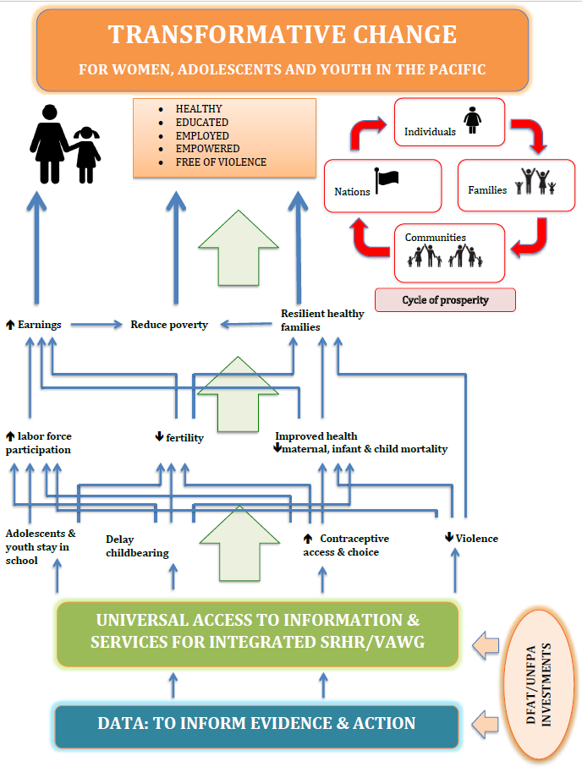

The Transformative Agenda outlined in this document proposes action that will increase demand for, and supply of, SRH services and information (particularly family planning) and create an enabling environment for their progress. As a United Nations agency, UNFPA’s fundamental approach is to work with in-country partners to expand their capacities and achieve locally sustainable responses to SRH needs.

The proposal is structured as follows. Section 2 provides the rationale for investing in reducing unmet need and providing integrated SRH information and services in the Pacific. Section 3 provides a situation analysis of SRH in the Pacific and Section 4 introduces UNFPA as the logical partner to support the introduction and development of sustainable mechanisms to reduce unmet need. Section 5 details the Transformative Agenda’s theory of change and programme logic and then Section 6 addresses the resultant Outcomes, Outputs and Activities to be undertaken to deliver them. Programme governance and high-level management arrangements comprise Section 7. Section 8 outlines the budget and workplan and, finally, Section 9 focuses on monitoring and evaluation.

2. Rationale for Investing in Sexual and Reproductive Health in the Pacific

This Section outlines the rationale for investing in ensuring that all Pacific women, couples and young people have the right to choose if and when to have children, and how many and how often.

**The development case**

The ability to decide freely the number, spacing and timing of one’s children is a fundamental human right and a key gender issue. Family planning is a means of enabling this right and contributes to women’s empowerment, women’s fulfilment of their own potential and women’s participation in the economy and society.

A smaller family size improves prospects for children’s education and opportunity; contributes to improved opportunities for women; and can help break cycles of poverty at the family level. At the national level, lower fertility rates decrease the population growth rate, contribute to poverty reduction and make development goals more achievable, more affordable and more sustainable.[3]

Family planning has many other proven benefits, including for the health of women and children. It decreases unintended pregnancies and their complications; lowers the risk of resultant unsafe abortions; and reduces the number of high risk births from pregnancies that are too early, too late, too many or too closely spaced. Globally, reducing the unmet need for contraception could prevent around 30% of maternal deaths and reduce child mortality by up to 20%.[4],[5]

Universal access to SRH services is a Sustainable Development Goal (SDG) target (target 3.7):

* By 2030 ensure universal access to sexual and reproductive health care services, including for family planning, information and education and the integration of reproductive health into national strategies and programs.

SDG target 5.6 refers to access to SRH and reproductive rights:

* Ensure universal access to sexual and reproductive health and reproductive rights as agreed in accordance with the Programme of Action of the International Conference on Population and Development and the Beijing Platform for Action and the outcome documents of their review conferences .

In addition, many of the other SDG goals and targets depend in part on removing the barriers that affect the ability of women, adolescents and youth to exercise their sexual and reproductive rights.

**The economic case**

We know that investments in family planning and integrated SRH services can create healthy, empowered, resilient and productive individuals and families, reduce poverty and contribute to economic growth through a demographic dividend.[6] The demographic dividend is the accelerated economic growth that may result from a decline in a country's mortality and fertility and the subsequent change in the age structure of the population.

Family planning is regularly cited as one of the most cost-effective global health and development interventions. It also has a high cost-benefit ratio. Evidence indicates that for every USD 1 invested in SRH there is an economic return of between USD20 (WHO 2013) and USD 120 (ICPD Taskforce 2015). Other analysis suggests that for every dollar spent to reduce the unmet need for family planning in the Pacific, between USD 10-23 would be saved in health and education costs.[7],[8] As a specific example, if a young girl in Fiji were to become unexpectedly pregnant as an adolescent, drop out of school and continue to have 3 or more children working in the informal sector and at home, she is not likely to generate any savings at all. On the contrary, if the same girl is able to remain in school, go on to get a tertiary education, earn two times the minimum wage, and chooses to begin her child-bearing after the age of 25 she could have an estimated 39,000 Fijian dollars (approximately USD 19, 000) saved by that time[9].

**Rationale for DFAT engagement in this agenda**

Women’s economic empowerment and gender equality are priorities across Australia’s foreign policy and aid programme.  The recently released Foreign Policy White Paper places a strong emphasis on ensuring a whole of Department approach to strengthening these outcomes as key drivers in reducing poverty and increasing economic growth and stability.  Access to sexual and reproductive health, particularly family planning, are central to achieving these objectives and their importance as key interventions is acknowledged in the White Paper as well as in the ‘Women’s Economic Empowerment and Gender Equality Strategy’, and the ‘Health for Development Strategy 2015-2020’.

At the 2017 London Family Planning Summit, Australia reaffirmed its commitment to supporting the goals of the Family Planning 2020 agenda to enable 120 million more women and girls to use contraceptives by 2020, with a renewed focus on improving access to SRH in the Pacific region.

The Pacific region’s population is generally young, with eight of the 14 PICTs having at least 30 per cent of their population below 15 years of age and 50 per cent under 25 years. The Pacific unmet need for family planning is among the highest in the world (Figure 2). There are concerns about increasing total fertility rates in six out of the 14 Pacific island countries and increasing adolescent birth rates in ten of the 14 Pacific island countries. These young people have significant SRH needs but, with access to contraceptives of their choice, in combination with quality education and employment, they will be well placed to reach their full potential and contribute productively to Pacific economies. Sexual and reproductive health and rights in the Pacific region, including family planning, is an unfinished agenda but an agenda to which DFAT is well placed to contribute and to provide leadership.

**Rationale for an integrated SRH approach**

While this proposal focuses on reducing unmet need for family planning, the nature of SRH means that integrated services are necessary to achieve unmet need reductions. Successfully meeting the needs of all women and girls is dependent on embedding family planning into broader, integrated SRH services for reasons of both efficiency and effectiveness. It can be difficult for an individual to ask for help- SRH issues are sensitive and personal. Therefore, the most must be made of any encounter that an individual has with a health service. Further, individuals’ needs are integrated, as the examples below illustrate.

* A woman in a violent relationship may experience limited choice over when she has sexual relations, but she may seek contraceptive advice to avoid an unwanted pregnancy. This means contraceptive services need to be equipped to screen women and girls at risk of VAWG, and provide appropriate VAWG services and referrals.
* A young woman may attend her local clinic to seek assistance with painful periods. This presents an opportunity for the health worker to also provide contraceptive counselling, information and services, and screen women and girls at risk of VAWG and refer, if necessary.
* Women attending antenatal care or post-partum care may wish to delay their next pregnancy, and offering education and contraception during their pregnancy and immediately after makes the most of their attendance at maternal health services.

Simultaneously, there are related issues that prevent people from seeking and using contraception. These issues include violence against women and girls, stigma and discrimination surrounding sexual and reproductive health, and a general lack of information and discussion about sexuality and sexual health. Therefore, to increase the use of family planning, UNFPA will invest in these broader areas.

Currently, the integration of complementary SRH services is suboptimal in the Pacific, with countries having, for example, Youth Friendly Health Services (YFHS), sexually transmitted infection (STI) services and cervical cancer prevention and screening services largely planned and implemented as vertical programmes. This is despite policy provisions for an integrated approach in some countries, and despite global evidence regarding the difficulty of scaling up and sustaining separate services in resource-constrained settings. Kiribati and Tonga have made relatively more progress on the integration of services. The Transformative Agenda will progress a more integrated approach to SRH across the six priority countries.

3. Situation Analysis: Sexual and Reproductive Health in the Pacific

The 14 PICTs covered by the UNFPA Pacific Subregional Office (PSRO) have a total population of 2.4 million peoplein an area that encompasses 15 per cent of the earth’s surface. There are key differences across the region in geography, size, history, language and culture. Wide-ranging economic, social, environmental and political challenges, plus the vulnerability of the Pacific to natural disasters, have affected the achievement of the Millennium Development Goals (MDGs) and continue to present challenges to the region’s development, including progress towards achieving the 2030 Agenda for Sustainable Development and its accompanying 17 SDGs. Universal access to SRH services is SDG target 3.7 but there are significant gaps in SRH service delivery across PICTs and especially so in non-urban areas. Across this region, SRH indicators show disturbing trends, including high unmet need for family planning and increasing adolescent birth rates in ten countries. Some of the data available and analysis of some of the key issues for SRH are presented below.

## 3.1 Contraceptive prevalence rates and remaining unmet need

Contraceptive Prevalence Rates (CPR) **[10]** in the Pacific show that only three out of the 14 countries for which data are available have a CPR above 40 percent. Most are under 30 percent. Six of the 14 PICTs have a growing total fertility rate and, alarmingly, ten of the 14 countries in the region are now experiencing growing adolescent birth rates, contrary to the global pattern of decreasing adolescent birth rates.

Figure 2 shows the percentage of women aged 15-49 years who were married or in a union, who used a contraceptive method or who had an unmet need for family planning in 1990 and 2010 by world, development group, and sub-regions. It can be seen that the ‘Melanesia-Micronesia-Polynesia’ sub-region not only has low CPR and high unmet need compared to global averages, but also that indicators have been relatively static over a span of 20 years.

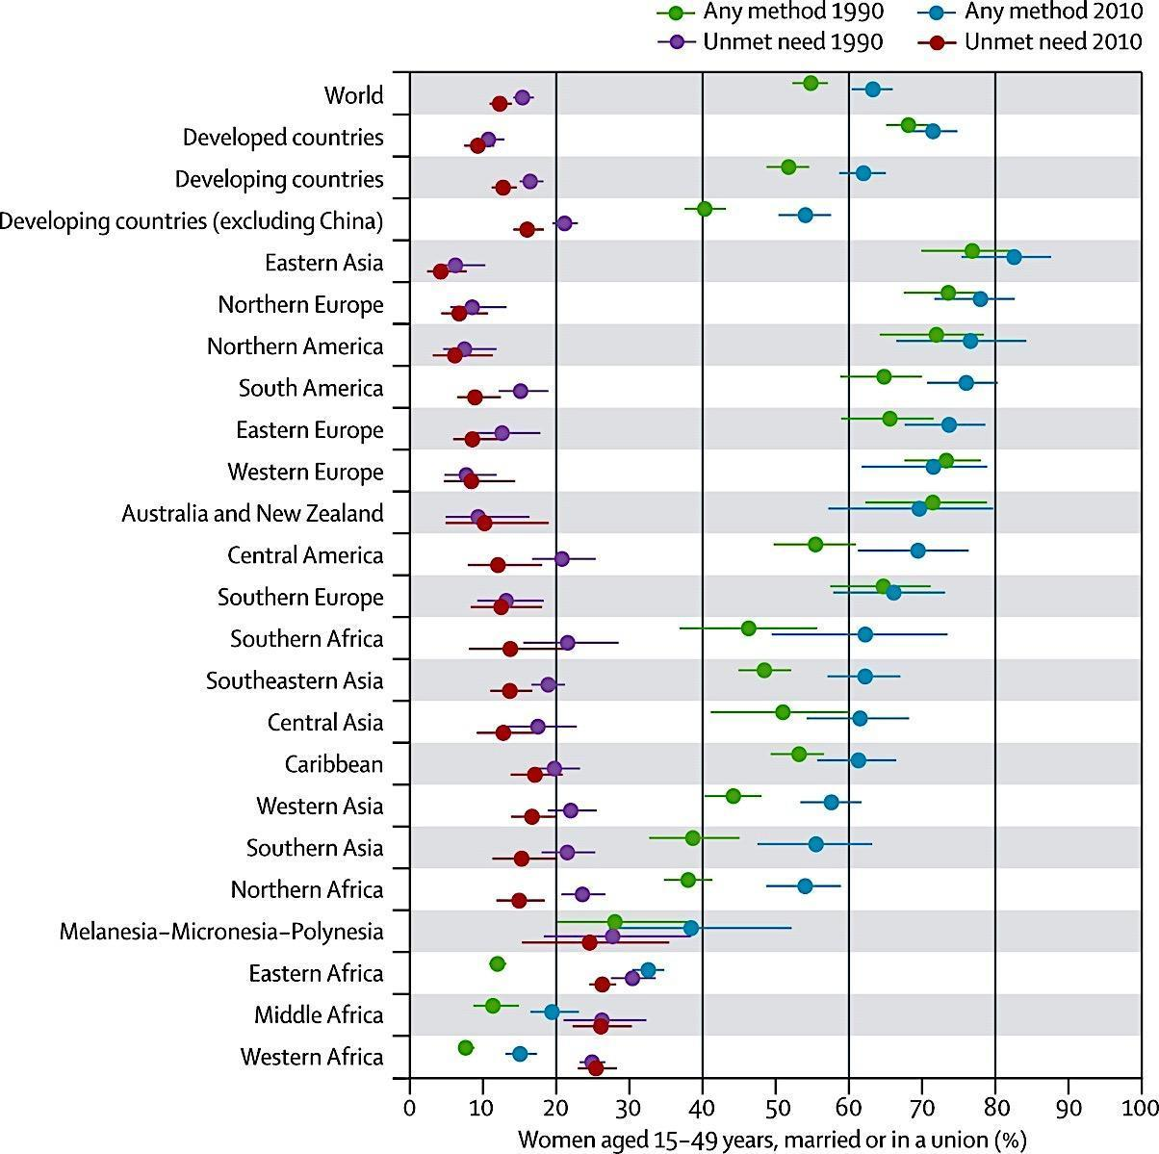

Figure 2[11]. Contraceptive Prevalence Rates and unmet need for family planning between 1990 and 2010

Figure 3 below reflects key SRH indicators for the 14 PICTs. There are sparse data available for unmet need for family planning but, where data are available, unmet need for family planning for married women aged 15-49 years is 20 per cent or above in nine of 14 PICTs (Fiji, Federated States of Micronesia (FSM), Kiribati, Nauru, Samoa, Solomon Islands, Tonga, Tuvalu and Vanuatu). For all countries, CPR for all methods remains below 50 per cent, with eight PICTs having a CPR for all methods below 30 per cent (Kiribati, Republic of Marshall Islands (RMI), Nauru, Niue, Palau, Samoa, Solomon Islands and Tonga). Of concern is the declining CPR trend observed in some of the Pacific countries (RMI, Solomon Islands, Tonga and Vanuatu), and lack of current data to enable trend analysis in seven countries.

Figure 3 also reflects demand for family planning satisfied with modern methods (met need)[12], which ranges from 35 per cent (Solomon Islands) to 58.4 per cent(Vanuatu). This is a useful measure of progress towards universal access to SRH and a benchmark target of 75 per cent by 2030 has been recommended for all countries[13]. It can be seen that there is still some way to go to achieve this 75 per cent benchmark in priority PICTs.

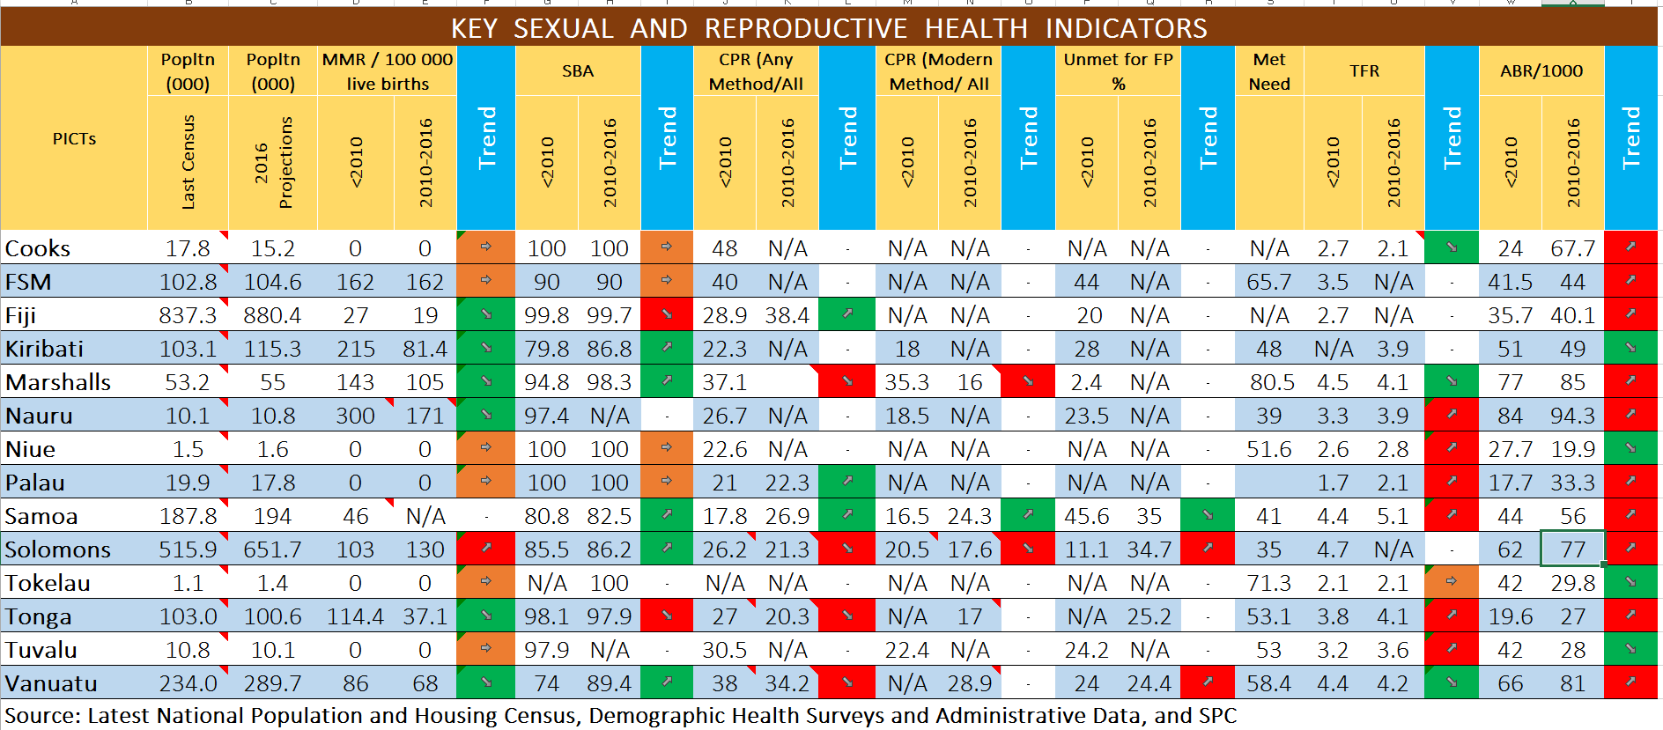

Figure 3. Key sexual and reproductive health indicators across 14 Pacific island countries and territories

|  |
| --- |
| The single most alarming fact is that  **Adolescent Birth Rates are increasing in 10 of 14 PICTs** |

## 3.2 High Needs Among Adolescents and Youth

While a growing proportion of young people in PICTs have reported being sexually active, Figure 4**[14]** shows that there is a large gap between CPR and unmet need for family planning for adolescents and youth, compared to married women, and that the CPR in the 15-19 year age group is almost negligible for some countries. For many other countries in the Pacific, data on unmet need for family planning for unmarried women, particularly for adolescents, youth and people with disabilities, are lacking.

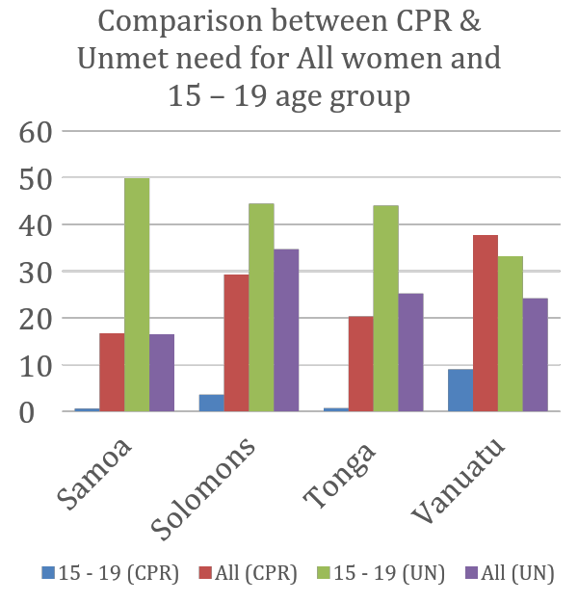

Figure 4. Comparison between CPR and unmet need for family planning

Despite the declining trend of the global birth rate among adolescent girls aged 15 to 19 from 59 births per 1,000 girls in 1990 to 51 births in 2015, in ten of the PICTs adolescent birth rates (ABR) show an upward trend. These rates range between 62 and 85 births per 1,000 adolescent girls 15-19 years old in five PICTs[15] (Figure 5) with Nauru, RMI and Vanuatu recording birth rates above 80 per 1,000 females 15-19 years old. This indicates a high unmet need for contraception for adolescents in these countries..

Adolescent pregnancy has profound implications for girls, with diminished education and employment prospects. Adolescent mothers are more vulnerable to poverty and exclusion, and more likely to experience health complications during pregnancy and childbirth, which are the leading causes of death among adolescent girls globally. [16],[17]

Figure 5. Adolescent Birth Rates in Pacific island countries and territories

As can be seen in Figure 6, between 13 and 63 per cent of pregnancies in 15-19 year olds are unintended. Additionally, high levels of sexual and gender-based violence (child sexual abuse ranges from 11 to 37 per cent in seven countries where data are available from Family Health and Safety Studies (FHSS)) and a growing prevalence of STIs have also been observed. Early marriage is also prevalent: in almost half of the fourteen PICTs, between 10 and 19 per cent of girls are married between 15 and 19 years of age. This is twice as many as compared to their male peers, which highlights ongoing gender inequalities and risks for unsafe early pregnancies.

Broadly, these indicators suggest that adolescents and youth have insufficient knowledge and life-skills to make informed and safe choices about their sexual and reproductive lives. There are major structural and sociocultural barriers for young people to overcome in accessing and using contraception. Persisting gender inequalities, discrimination against women and girls, and conservative social and cultural norms such as negative views regarding premarital sexual behaviour, create reluctance among healthcare workers to provide information or services to adolescents and youth[18]. This is particularly evident when it comes to provision of emergency contraception which, due to personal attitudes, is not being offered to adolescents and youth, except in the countries where there are more supportive policies (i.e. Fiji, Vanuatu, Solomon Islands, and Tonga). The education sector continues to be challenged with incorporating family life education (FLE) or integrating curricula that address SRH and rights, gender equality and violence against women and girls.[19]

Figure 6: Proportion of births (%) to adolescents 15 – 19 years that were unintended (unwanted and mistimed) 2006 – 2013[20]

## 3.3 Contraceptive commodity supplies

UNFPA Supplies, a thematic trust fund under UNFPA, is responsible for procurement and distribution of essential maternal, child and reproductive health commodities in target countries.  In the Pacific, UNFPA Supplies provides between 80 to 90 percent of contraceptive commodities which are distributed through national governments and key NGO partners (such as IPPF).  DFAT has concluded a new $10 million program of support with UNFPA Supplies which includes funding (approximately US$4.4 million), human resources and a results framework for UNFPA Supplies’ work in the Pacific for the same duration as the Transformative Agenda (UNFPA Pacific Engagement 2018 to August 2022). UNFPA’s work in commodity provision in the Pacific is not sustainable, particularly as Pacific countries graduate to MIC or LMIC status (thus becoming ineligible for UNFPA Supplies support). Under its Pacific Engagement strategy UNFPA Supplies will work to build national government commitment for sustainable funding and national capacity to source, procure and disseminate essential medicines.

The general arrangement in the Pacific is that UNFPA Supplies purchases and funds contraceptives, SRH supplies and equipment on behalf of governments for distribution through government-operated health facilities and through non-governmental organisations (NGOs), often IPPF affiliated Family Health Associations or members. These NGOs obtain some limited additional supplies through IPPF headquarters. In some PICTs, some contraceptives are procured directly by the governments and some are procured by pharmacies from wholesale suppliers based overseas. In addition, in seven PICTs, the United Nations Development Programme (UNDP) distributes condoms and lubricants for HIV prevention through the Global Fund to Fight AIDS, Tuberculosis, and Malaria.

As a result of UNFPA Supplies’ support, contraceptive choice over recent years has broadened from oral contraceptives, condoms and injectables to include emergency contraception (EC) pills, female condoms and long acting reversible contraceptive methods (LARCs), such as Jadelle®. Strengthening local capacities for supply chain management, forecasting and procurement has also been a focus area of UNFPA Supplies. Nevertheless, despite the resources invested in capacity development, there are still gaps in local capacity for forecasting and procurement, mostly due to lack of technical skills and lack of adequate and functioning Logistic Management Information Systems (LMIS), particularly at Divisional and Service Delivery Point (SDP) level. Stock management at the SDP is usually done manually and existence and use of stock cards is not widely adopted, thus preventing adequate forecasting.

## 3.4 Recent positive trends in Couple Years of Protection

More positively, the data above from periodic population-based surveys do not capture a recent unprecedented rise in Couple Years of Protection (CYP)[21] in the Pacific, as presented in Figure 7. This CYP data is drawn from LMIS sources over the last 48 months.

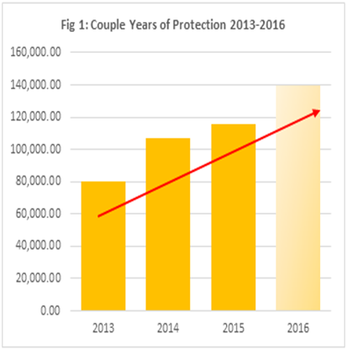

Figure 7. Estimated Couple Years of Protection across the 14 UNFPA PICTs (2013-2016)

This significant change in CYP is largely attributable to the programmatic efforts led by Solomon Islands, Fiji and Vanuatu in introducing and offering subdermal implants (a type of LARC such as Jadelle®), which are highly effective and efficient contraceptive methods.In particular, task sharing across different health cadres for LARC insertions has expanded access to this contraceptive. Through UNFPA-supported programs that were implemented during the 5th Sub-regional program cycle (2013-2017) and through the DFAT-funded “Upscaling Jadelle rollout in the Solomon Islands” project, nurse aides and health promoters received training to enable them to create awareness of family planning methods, including LARCs. Importantly, the Solomon Islands Nursing Council also increased the scope of practice of registered midwives and nurses to provide the service once certified to do so, thereby expanding access beyond doctor-led provision. Figure 8 highlights contraceptive contacts from 2011 to 2016 in Solomon Islands, showing dramatic increases in contacts for some provinces, mainly as a result of Jadelle® roll out. This example highlights that, despite health worker shortages, it is possible to expand existing practitioners’ scope of practice to subsequently expand access to various contraceptives. This must of course be done with careful consideration of existing workloads and supervision requirements, and in line with national health sector and workforce plans. Positive work to date on LARCs will be expanded and replicated through the Transformative Agenda.

Figure 8[22]: Contraceptive contacts between 2012-2016, disaggregated by province

## 3.5 Addressing the SRH needs of people with disabilities

An estimated 17 per cent of Pacific Island people live with a disability, out of which, approximately 193,000 are young people 15–24 years old. Approximately 58,000 young people live with a severe disability. Persons with disabilities experience severe discrimination when it comes to SRH and rights. They are often viewed as asexual, including by health workers, teachers and policymakers, and therefore not catered for with SRH information or services.[23],[24]

UNFPA’s 2013 assessment of the SRH needs of women with disabilities in Kiribati, Solomon Islands and Tonga[25] highlighted that specific actions are required to ensure women and girls with disabilities can realise their sexual and reproductive rights. Their engagement with health services came most often through pregnancy, and while this was at times uncomfortable and unsatisfactory, these encounters present opportunities to offer improved, integrated SRH services for women with disabilities. Some women interviewed had experienced physical and sexual violence, and some became pregnant as the result of rape, highlighting their need for emergency contraception, access to safe abortion, and broader VAWG services. Women with a disability living in institutions had particular needs and were at high risk of abuse, and some women with mental or intellectual disabilities experienced the most egregious discrimination and violence. Health workers, teachers and other social service staff need much greater education and support to build their confidence and skills in providing appropriate SRH information and services to persons with disabilities. Women with disabilities need support to understand their rights and their SRH needs, and to navigate access to services. Several IPPF member associations have begun work in this area in the Pacific.

## 3.6 Violence Against Women and Girls in the Pacific

Gender inequalities and their most brutal manifestation – violence against women and girls (VAWG) – are a barrier to accessing SRH services. Many women and girls in the Pacific find themselves in a vicious cycle of gender inequality and physical and sexual violence which, in turn, seriously restricts their access to SRH services.

Particular population groups are especially vulnerable to violence. UNFPA’s 2013 assessment of women with disabilities’ SRH needs in selected countries in the Pacific showed that women with disabilities are two to three times more likely to be survivors of physical and sexual abuse than those with no disabilities.[26] This abuse can happen in the family, the community or in institutions. Adolescents and youth are a key target population for VAWG prevention, as young people’s attitudes about relationships and sexual behaviour are still developing. It is crucial to create a strong linkage between family life education (FLE) (in and out of school) and SRH/VAWG response services to meet the needs of adolescents and youth who may have experienced violence.

National violence against women prevalence studies, also known as the Family Health and Safety Studies (FHSS), completed in ten PICTs between 2010-2014 (Figure 9), show that on average, two out of three women experience physical and/or sexual intimate partner violence during their lifetime. This is very high compared to global averages.[27]

Approximately one out of every three women had experienced physical or sexual violence, or both, by an intimate partner in the 12 months prior to the survey. In addition, the FHSS show that women in the Pacific mainly experience more severe forms of violence, and often for several years, with few options to escape. As seen in Figure 10, which represents the main findings from the FHSS, the patterns of VAWG in the Pacific appear to differ by violence type and perpetrator. Understanding specific patterns of violence is critical to ensuring effective policies and legal reform, as well as targeted prevention and response programming.

Caring for survivors of VAWG is not yet part of health care workers’ professional profile and most health care professionals are not adequately trained to provide this care. In addition, health providers’ attitudes to VAWG may be shaped by prevailing cultural norms, which do not regard VAWG as an important health issue and often place blame for the violence on the survivors, rather than on the perpetrators. All sectors involved in VAWG response suffer from lack of female professionals. Although health services for women and girls who have survived violence remain weak, they were identified in the FHSS as entry points for identifying survivors and for delivering referrals to health, police, justice and social services.

Some work has already been undertaken to address these needs, such as through the World Health Organization (WHO) Minimum Standards of Care for Survivors of Sexual and Gender-Based Violence (SGBV), which has been piloted in Solomon Islands. UNFPA has also been piloting the Essential Services Package (ESP) for women and girls subject to violence, in Kiribati and Solomon Islands. This Package promotes strong, coordinated inter-sectoral responses to VAWG, and will be expanded through the proposed Transformative Agenda.

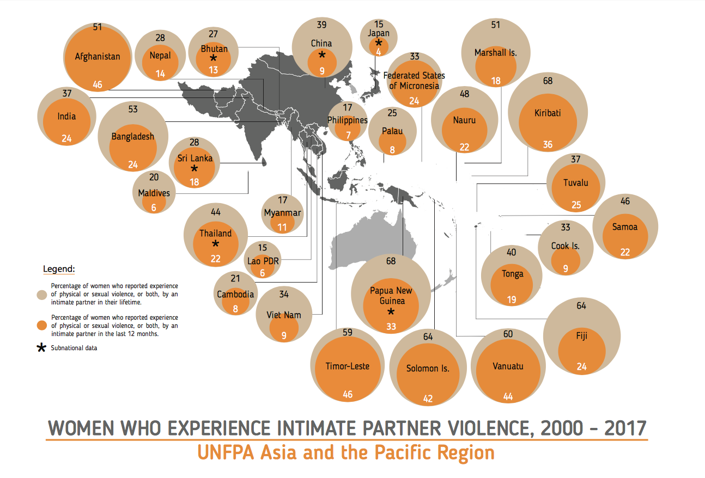

Figure 9. Percentage of women who reported experience of physical or sexual violence (or both) by an intimate partner in the last 12 months and in their lifetime.

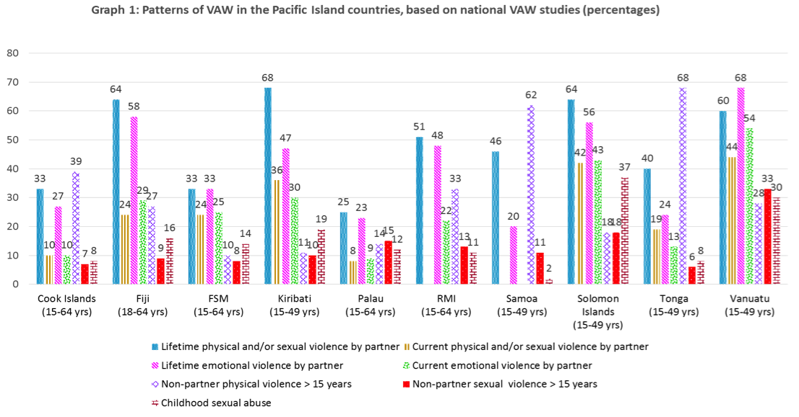

Figure 10. Patterns of violence against women and girls in Pacific island countries and territories

## 3.7 Maternal Health

Maternal health is one of the areas that made good progress under the MDGs in the Pacific[28] but a number of PICTs still have high stillbirth and neonatal mortality rates (Figure 11). These reflect inadequate quality of care in the antenatal period and during and after delivery, as well as poor access to contraceptives. Maternal Death Surveillance Reports (MDSR) are used in some PICTs to learn lessons and drive service quality improvements but further work is proposed under the Transformative Agenda to institutionalize these into systems and practices.

|  |  |  |  |
| --- | --- | --- | --- |
| **Country** | **MMR/100 000 live births** | **Stillbirth Rate/1000 births** | **Neonatal Mortality Rate/1000 live births[29]** |
| **Fiji** | 19.1 | 11.9 | 9 |
| **Kiribati** | 81.4 (2007 - 2011) | 16.3 | 23.7 |
| **Samoa** | 46 (2002 – 2006) | 11.1 | 9.5 |
| **Solomon Islands** | 130 (2013) | 17.6 | 12.2 |
| **Tonga** | 37.1 (2010) | 8.6 | 6.9 |
| **Vanuatu** | 86 (2013) | 13.9 | 11.6 |

Figure 11. Maternal Mortality Ratio, Stillbirth Rate and Neonatal Mortality Rate in selected PICTs[30]

Ensuring that pregnant and post-partum women can easily access family planning information and services will assist in improving both maternal health and contraceptive choice.

In terms of the health workforce, the Pacific faces several challenges in health workforce provision, which include both absolute shortages and uneven geographic distribution. The 2015 Pacific Regional MDGs Tracking Report highlighted understaffing as one of the key human resource challenges, with associated lack of specialized professionals such as obstetricians, particularly in rural areas, creating additional barriers to improved maternal health and SRH in general. A recent survey conducted in 12 PICTs highlighted considerable shortages of midwives in these countries.[31] Under the Transformative Agenda, UNFPA will provide policy advice on most appropriate ways of addressing these shortages.

Figure 12 shows the density of physician, nurses and midwives per thousand population against a recently set global benchmark and indicates that only Kiribati and Tonga meet the global benchmark of 4.45 physicians, nurses and midwives combined per 1000 population. The level at which the current workforce is able to meet reproductive, maternal, newborn, child and adolescent health (RMNCAH) needs at all levels of service delivery is, however, not known for most if not all countries in the Pacific. The 2014 State of the World Midwifery report estimated “potential met need” for midwifery services for Solomon Islands at only 33 per cent. There are also measurement challenges in that skilled birth attendants are not defined across all PICTs according to the joint WHO/UNFPA/UNICEF/World Bank statement. This means that it is difficult to know the exact extent to which appropriately skilled attendants are actually at births.

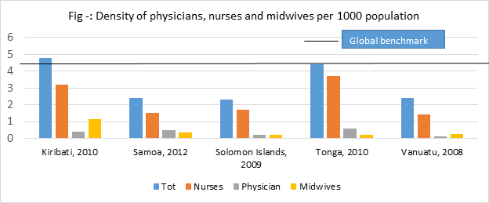

Figure 12 Density of selected health workforce per 1000 population in selected PICTs

## 3.8 Cervical Cancer

Cervical cancer incidence and deaths in the Pacific are high (Figure 13). Prevention efforts are rudimentary in most PICTs, with most screening opportunistic. Of the six focus countries, only Fiji has a national cervical cancer screening policy and none of the countries have an organized national screening programme. To varying extents, Human papillomavirus (HPV) vaccination programmes have been implemented in Cook Islands, Fiji, FSM, Kiribati, Palau and RMI. While cervical cancer interventions cannot be a focus of the Transformative Agenda, UNFPA will support the enabling environment for expanded cervical cancer and treatment through participation in the Cervical Cancer Working Group. UNFPA will work to ensure a strong referral process is set up as part of the Transformative Agenda’s work on strengthening guidelines and protocols for referrals in relation to SRH services. This programme will not itself directly support the expansion of clinical treatment. An additional focus of UNFPA’s engagement will be primary prevention of STIs, including HPV through barrier methods and through FLE regarding prevention.

|  |  |  |  |  |
| --- | --- | --- | --- | --- |
| **Incidence of cervical cancer and annual number of cervical cancer deaths compared to number of maternal deaths** | | | |  |
| **Country** | **Number of new cases /year[32]** | **Number of deaths[33]** | **Number of maternal deaths** |
| **Fiji** | 160 | 84 | 6 (2015) HIS |
| **Kiribati** | 3 | N/A | 2 (2015) HIS |
| **Samoa** | 13 | 5 | N/A |
| **Solomon Islands** | 57 | 31 | 14 (2016) HIS |
| **Tonga** | 17 | N/A | 1 (2015) HIS |
| **Vanuatu** | 19 | 8 | 8 (2013) HIS |

Figure 13. Incidence of cervical cancer and annual number of cervical cancer deaths compared to number of maternal deaths in selected PICTs

## 3.9 Data and analysis

Greater availability, accessibility, analysis and utilization of quality data are needed to better inform policy and programming decisions, including monitoring progress towards global and national development goals. There are sparse data available for unmet need for contraception and other key SRH indicators and, where data are available, they are often inconsistent or of poor quality, including a lack of disaggregation. This can be attributed to weak statistical institutions, weak administrative data systems and a lack of capacity in data gathering and management. However, the number of PICTs that regularly implement surveys is expanding and national population and housing censuses, in combination with survey and administrative data, have been identified as critical to providing high quality sex, age, and disability-disaggregated data. Key population surveys comprise Population and Housing Censuses (PHC) and Demographic Health Surveys (DHS).

Figure 14 shows the dates of the last Census and DHS conducted in each of the PICTs as well as the dates when the countries would ideally be conducting the next rounds. Secretariat of the Pacific Community (SPC) is taking an increasing role in gatekeeping and coordinating this type of work in the Pacific. These exercises require significant external technical and financial support at a level that could not be provided under the Transformative Agenda budget. The Transformative Agenda will, however, engage in the design of any Census or DHS work in the region and, in particular, ensure that SRH interests are adequately captured in their methodologies.

|  |  |  |  |  |  |  |
| --- | --- | --- | --- | --- | --- | --- |
| **Year /**  **Activity** | **Date of last activity** | **2018** | **2019** | **2020** | **2021** | **2022** |
| Census | FIJ 2017, KIR 2015  SAM 2016, SOI 2009  TON 2016, VAN 2016  NIU 2017, TUV 2017 | Fiji | FSM, Solomon Islands, | FSM, Kiribati, Palau | Cooks Samoa, Tokelau, Tonga  Vanuatu | Nauru, Tuvalu |
| DHS/  MICS[34] | KIR2009, SAM2014  SOI 2015, TON 2012  VAN2013 | Kiribati, Nauru, Tuvalu, Cook Islands, Palau, Vanuatu, | Fiji  Samoa,  FSM  Tokelau | Solomon Islands, Tonga  RMI, Niue |  | Vanuatu |

Figure 14. Schedule of planned Population and Housing Census and Demographic Health Surveys/Multi-Indicator Cluster Surveys: (2018-2022) in the PICTs

## 3.10 SRH in emergency and humanitarian situations

The Pacific region is among the most vulnerable in the world to the effects of climate change, such as tropical cyclones, droughts, heavy rainfall and floods. Eight of the fourteen PICTs are among the 20 countries in the world with the highest average annual disaster losses scaled by gross domestic product.[35] Vanuatu, Tonga, Solomon Islands and Fiji all have very high exposure to natural hazards and low or very low coping capacities.[36] Moving towards zero unmet need in this region needs to take account of this context to ensure that SRH and Gender based violence (GBV) information and services remain available and accessible even during humanitarian emergencies. This is particularly important given the disproportionate effect on women, girls and persons with disabilities during a crisis. Protecting and promoting their rights and health are an essential element of crisis preparedness, effective response and recovery.

The Minimum Initial Service Package (MISP) is a coordinated set of priority life-saving activities to respond to reproductive health needs at the onset of an emergency to prevent and manage the consequences of VAWG, prevent excess maternal and newborn morbidity and mortality, reduce HIV transmission and provide comprehensive SRH information and services. The desired results from the Transformative Agenda are to ensure implementation of MISP at the onset of a crisis, including clinical management of rape, and to prioritize SRH needs of persons with disabilities. These efforts will be complemented by the DFAT-supported regional pre-positioning initiative through provision of life-saving RH and dignity kits during MISP implementation, and delivered in close partnership with the IPPF SPRINT programme, also supported by DFAT. Joint advocacy efforts with regional and national partners will aim to raise awareness of the importance of prioritizing SRH and protection needs during disasters, and for these to be reflected in national action plans in all six priority countries.

## 3.11 Demand Generation

Demand generation for contraceptives in general, and condoms in particular, has been attempted in the Pacific over the course of the last decade. Lessons learned[37] from previous condom social marketing (CSM) projects have revealed a number of challenges. These include: lack of feasibility assessments conducted prior to implementation of social marketing; limited condom promotion due to lack of public understanding and awareness; Information, education and communication (IEC) materials that relied on English language literacy and did not adequately reflect local context and cultural sensitivities; and weak program management, planning, monitoring and evaluation by a dedicated project team. These lessons have been drawn upon in the design of the Transformative Agenda.

Comprehensive sexuality education, implemented in the Pacific as Family Life Education (FLE), is considered essential for addressing interconnected SRH issues, especially among adolescents and youth. The coverage and quality of FLE programmes remain low in many PICTs.[38] FLE curricula need to be reviewed and updated to include issues such as gender transformative approaches and the needs and rights of persons with disabilities. A general lack of understanding in PICTs as to what constitutes FLE and why it is important commonly results in misinformation regarding FLE programmes. As such, more comprehensive policy advocacy at both national and regional level is required to ensure that stakeholders and community members understand FLE and commit to supporting its implementation.[39]

Attitudinal surveys[40] supported by UNESCO in four PICTs (Fiji, Kiribati, Solomon Islands and Vanuatu), revealed that while the majority of teachers agreed to the importance of FLE, they had not received any FLE training and were not comfortable teaching the topics.

Another significant challenge identified was the difficulty in reaching out-of-school young people as well as young people living with disabilities. These groups are, however, the most vulnerable and would benefit greatly from comprehensive knowledge of SRH.

FLE cannot be implemented in isolation. Schools need to be able to link their students with SRH/VAWG response services and ensure that they themselves provide a safe environment. These broader social protective factors have not been well recognized historically in FLE provision and form a component of the Transformative Agenda that ensures that when students learn about SRH/VAWG, they are also provided with the information and linkages they need to put this new knowledge into practice.

## 3.12 Previous analysis of barriers and challenges

A high unmet need for family planning, rising adolescent birth rates in ten PICTs and an increasing total fertility rate in six PICTs indicate limited access to SRH and rights information and services across all age groups. Previous surveys point to factors contributing to high unmet need for family planning in the Pacific, including: poor quality of services; variable SRH supplies availability and accessibility; weak governance mechanisms to translate existing policies into effective sustainable actions; and limited capacity to implement strategies and plans. Further, modern contraceptive uptake is challenged by myths, misconceptions and/or misinformation, and misinterpretation of side effects. Figure 15 highlights some of the substantial barriers to increasing the modern CPR (mCPR) in Pacific countries.

Social norms take significant time and effort to change. People who can provide SRH information and services often hold prevailing societal beliefs about sexuality and reproduction which creates a double barrier for people seeking assistance. Not only do they have to overcome their concerns about what family and communities will think of them in accessing SRH information and services, but they may also meet prejudice at the health clinic or school. Discriminatory beliefs can also be enshrined in legislation and policy. For these reasons the proposed Transformative Agenda includes a strong focus on policy advocacy, health worker and teacher education, and community engagement.

The 2015 Pacific MDG Tracking Report highlighted similar challenges, including geographical constraints and population dispersion compromising effective service delivery; low demand for family planning services possibly associated with preference for large families; misconceptions and inadequate information on contraceptive choices; shortages of skilled family planning health personnel; and frequent shortages of SRH supplies at service delivery points in some countries. By needing to rely on surveys that are 5-10 years old, Figure 15 also highlights the need for updated Demographic and Health Surveys in the Pacific.

Figure 15. Stated reasons for not using family planning methods [41]

Ongoing efforts to understanding barriers and challenges include: demand and supply-side assessment of contraceptive uptake in five countries; FLE assessment of quality, implementation and policy climate in five countries; and the RMNCAH workforce assessment in 15 countries (14 PICT’s plus Papua New Guinea). Within the lifespan of the Transformative Agenda, UNFPA will further explore existing barriers, mainly through conducting health facility readiness assessments (further elaborated in Strategic Intervention 1.1) and through assessment of SRH and protection integration in the disaster risk reduction (DRR) plans in the six countries.

4. UNFPA and its Goals

## 4.1 UNFPA in the Pacific

UNFPA has been working in the Pacific region for over 30 years implementing SRH programmes in 14 countries and territories through the Pacific Subregional Office (PSRO) in Suva. Guided by the International Conference on Population and Development (ICPD) Plan of Action, and the SDGs, UNFPA PSRO provides technical and programme support to these 14 PICTs to: advocate for universal access to SRH information and services; collect, analyse and utilize data for population and development policies and programmes; empower young people to live to their full potential and women and girls to live dignified lives free of violence, including in humanitarian settings.

In the Pacific, PSRO covers the Cook Islands, Federated States of Micronesia, Fiji, Kiribati, Republic of the Marshall Islands, Nauru, Niue, Palau, Samoa, Solomon Islands, Tokelau, Tonga, Tuvalu and Vanuatu. The PSRO also provides technical assistance to Papua New Guinea. PSRO is supported in turn by the UNFPA Asia Pacific Regional Office (APRO) based in Bangkok, Thailand, and UNFPA Headquarters based in New York, USA.

As a United Nations agency, UNFPA’s *modus operandi* is to work with country partners, particularly governments, to expand their capacity. In all it does, UNFPA’s aim is to strengthen the ability of country partners to plan, implement, evaluate and improve their own SRH and population activities. The Transformative Agenda’s proposed activities are based on this principle.

Under SRP6 (see Annex 1), within which the Transformative Agenda is strategically nested, a core priority is strengthened access to quality, integrated SRH services for women, adolescents and youth with the aim of moving towards achieving zero unmet need for family planning. The priorities for SRP6 were carefully selected based on common country assessments, 14 country consultations and a systematic review of the preceding fifth cycle SRP from 2013-2017. SRP6 aligns directly with the new UNFPA Strategic Plan 2018-2022 and the United Nations Pacific Strategy (UNPS) 2018-2022, which is the United Nations Development Assistance Framework (UNDAF) for the Pacific. The UNPS 2018-2022 addresses six strategic priority areas of a) climate change, disaster resilience and environmental protection b) gender equality c) sustainable and inclusive economic empowerment d) equitable basic services e) governance and community engagement and f) human rights. The SRP6 and the Transformative Agenda will directly contribute to three outcomes (b, d, f) and indirectly to all six.

## 4.2 UNFPA’s Comparative Advantage

UNFPA is the sole intergovernmental agency working substantively in the area of SRH and rights, with a focus on family planning. UNFPA has the technical capacity and knowledge of international best practices in SRH to work with in-country government and non-government partners to build national and regional capacities, advocate for SRH including family planning, formulate SRH policies and strategies, and support availability of RH commodities to ensure universal access to SRH.

UNFPA’s global expertise in gender equality and VAWG also places the agency at the leading edge in formulating gender policies, developing guidelines for health system responses to VAWG, and advocating for evidence-based legislation, policies and programmes to prevent and respond to VAWG using research findings from the Pacific FHSS. As the sole leader of Gender Based Violence in Emergencies (GBViE) Area of Responsibility (AoR) at the global level, and co-leader of the GBV humanitarian sub-cluster in the Pacific (with UN Women), UNFPA is responsible for coordination and prioritization of GBV prevention and response services in humanitarian settings.

With the 2013 assessment of the SRH needs of women with disabilities in Kiribati, Solomon Islands and Tonga[42], UNFPA is the only Pacific agency to have generated information about the current situation for women with disabilities (in collaboration with local Disabled Persons Organisations (DPOs) in those countries and the Pacific Disability Forum). Globally, UNFPA has also implemented the WE DECIDE study to research the SRH needs of persons with disability in four non-Pacific countries. This work places UNFPA in a unique position to take action to improve the situation of young people and women with disabilities, based on solid information.

UNFPA is acknowledged as a key technical partner in supporting implementation of population-based surveys such as Population and Housing Census (PHS) and Demographic Health Surveys (DHS) and maintains a leadership role in providing quality support to countries to generate, analyse and utilize data from surveys. In addition, in the Pacific, UNFPA chairs the Data Management and Evaluation Group. This is a joint SDG working group on data that supports efforts on data analysis, availability, accessibility and utilization for evidence-based decision making and policy development, as well as objective monitoring and evaluation of national development frameworks.

PSRO’s long-standing partnerships with the 14 PICTs, regional development organizations such as Pacific Islands Forum Secretariat (PIFS) and SPC, and sister UN agencies, give UNFPA a comparative advantage to expand universal access to SRH and promotion of sexual and reproductive rights at national and regional levels, and secure regional political commitments for this, as done in the Moana Declaration, SAMOA Pathway and KAILA! Pacific Voice for Action on Agenda 2030. UNFPA is a recognized strong convener of a wide range of national, regional and international partners on key thematic issues, in particular those related to ICPD. It provides leadership in positioning the agenda of the ICPD at the forefront of Pacific regional strategies, policies and debates, in tandem with the 2030 agenda and SDGs.

## 4.3 Existing UNFPA Activities

UNFPA is currently implementing several programmes across the Pacific, all of which the Transformative Agenda (outlined in detail in Section 6) will complement or build upon. Details of these current programmes are provided below and a summary table can be found in Annex 2.

The **RMNCAH Programme** has been a joint UNFPA, UNICEF and WHO programme piloted in Kiribati, Solomon Islands and Vanuatu. RMNCAH’s aim has been to integrate UNFPA, UNICEF and WHO support to these countries, in close partnership with Ministries of Health. RMNCAH received AUD 6.9 million for an initial 2.5 year period (July 2015 to Dec 2017), with an additional costed extension of AUD $2million to December 2019. The RMNCAH model was adopted from successful ventures in other countries, where joint RMNCAH programmes benefitted from a lead agency, regular and substantial communication, a clear division of work among participating agencies, and a shared, quality monitoring and evaluation framework. Central to the RMNCAH approach is a national Steering Committee. This Committee functions to bring together all actors involved in RMNCAH in the country, and: makes recommendations on policy, budgets and activities; discusses strategic approaches and interventions to strengthen sustainable maternal, neonatal, child and young people’s health services within the existing health system; oversees reproductive, child and youth health strategies, annual plans and budgets, including annual reviews using monitoring and evaluation frameworks; and oversees joint participating UN agency actions in-country. This has proven to be a pivotal model that has had success in the pilot countries of Kiribati, Solomon Islands and Vanuatu. This success will be built upon in the Transformative Agenda, as detailed further in Section 6.

Realizing the need for a new approach to enhance demand for family planning in the Pacific, **contraceptive social marketing** (CSM) is being tested through funding support from DFAT (AUD 3 million over 2017-2020). The current ten-month design phase is conducting demand and supply side assessments in Fiji, Kiribati, Solomon Islands, Tonga and Vanuatu. During the subsequent 26-month implementation phase, UNFPA will be selecting one or two pilot countries (currently envisaged to be Vanuatu with possible extension to Solomon Islands), with extensive demand creation initiatives (guided by a Behaviour Change Communication (BCC) strategy), capacity building of health/family planning providers and a constant supply of commodities, while at the same time working on a longer-term sustainability strategy for RH commodities.

Under the **Joint UN Essential Services for Women and Girls Subject to Violence Programme** supported by DFAT**,** UNFPA PSRO is implementing the Essential Services Package (ESP) approach in two pilot countries, Solomon Islands and Kiribati. In support of the ESP inter-agency initiative and in partnership with UN Women and WHO, UNFPA PSRO leads the health sector component of the multi-sector coordinated response services in these two countries. Through the Transformative Agenda, UNFPA will continue this work in the two pilot countries, and using lessons learned from these pilot countries, consider expansion of the ESP approach to Vanuatu, Samoa and Tonga where levels of VAWG are high. The ESP approach promotes strong cross-sectoral coordination, including between health, police, justice and social services, across government and civil society organizations working in VAWG prevention and response.

At present, through **UNFPA Supplies**, UNFPA purchases and pays for contraceptives and other SRH supplies and equipment on behalf of governments in the region for distribution by government-operated health facilities. NGOs in the region also obtain supplies through PSRO at no cost. As a result of UNFPA Supplies’ support, contraceptive choice has broadened. UNFPA Supplies has worked in strengthening supply chain management, forecasting and procurement local capacities. However, as outlined earlier in section 3.3, supply chain management remains weak in all countries, and commodity supplies are unsustainable without UNFPA’s financial and technical assistance. The work of UNFPA Supplies in addressing supply side barriers to SRH/FP commodity security are set out in the DFAT-UNFPA Supplies Core Funding Agreement (2018-2022) and its annexes.

Drawing to a close in mid-2019, the New Zealand Ministry of Foreign Affairs and Trade (MFAT) has funded a 5-year (beginning 2014) **UNFPA Pacific SRH Programme (PRSRHP)** in Kiribati, Samoa, Solomon Islands, Vanuatu, and Tonga. PRSRHP supports local country partners to build an environment that empowers women and men to make informed choices about their SRH, particularly young people and key population groups. Focus is on improving clinical services (including integrating HIV and SRH services), education and health promotion, building an enabling environment through engaging with community leaders, and working to improve national policies and plans. The final evaluation will be conducted in late 2019, and lessons learned will be incorporated into the Transformative Agenda’s activities. Relationships with community leaders that have been forged under PRSRHP will be expanded upon in the Transformative Agenda.

Other existing programmes are:

* **Jadelle® roll-out** in the Solomon Islands, which will conclude in November 2018, funded by DFAT. This project aimed to increase Jadelle® uptake in the Solomon Islands through project support, procurement of supplies, training of health workers on Jadelle® insertion and removal, community outreach and awareness, and review and updating of the national family planning guidelines. The successes of this project have been integrated into the Transformative Agenda.
* DFAT-funded **Regional Humanitarian Prepositioning Initiative** in Fiji, Solomon Islands, Tonga and Vanuatu. This fund is managed through APRO and supports prepositioning of key SRH supplies and dignity kits, and capacity building activities. The Initiative runs from June 2016-June 2020.
* DFAT has recently approved funding for UNFPA to support the **Kiribati DHS**. This work will run from 2017-2019 and provide important data for use in Transformative Agenda work in Kiribati.

## 4.4 Expanding UNFPA presence as a result of Lessons Learned from the Fifth Subregional Programme 2013-2017

A review of the fifth Subregional Programme (SRP5) for UNFPA PSRO affirmed the value of a modest, yet strategic physical presence in eight PICTs (Fiji, FSM, Kiribati, RMI, Samoa, Solomon Islands, Tonga, and Vanuatu) resulting in strengthened partnerships and reduced transactions costs with Governments, United Nations agencies, civil society and donors. The review called for intensifying joint advocacy with the United Nations and regional partners and underscored the need to focus strategically on strengthening UNFPA’s active participation in joint programming and resource mobilization. It highlighted weaknesses in data collection and analysis; a limited reflection of the ICPD commitments in national plans; the need for strong linkages to gender equality in achieving SRH and realizing reproductive rights; and the insufficient linkages between reproductive health and non-communicable diseases, such as cervical cancer. During the next programme cycle of 2018-2022, PSRO aims to address these gaps in the delivery of the new programme, and the Transformative Agenda encompasses work to do so.

There is a clear need to strengthen UNFPA country presence with skill sets that will guarantee a high impact engagement at the policy, planning and management levels in order to deliver on the Transformative Agenda. The significant additional resources going into SRP6 from DFAT through this Transformative Agenda will allow for a significantly increased UNFPA presence in the UNFPA Field Offices of the six Transformative Agenda priority countries. With a combination of new DFAT support and core UNFPA resources a total of three positions will be filled in each of Kiribati, Solomon Islands, Vanuatu and Samoa – an internationally recruited SRH Specialist at P4 level, a nationally recruited Programme Specialist at NOC level and a Programme Assistant at G5 level. Meanwhile, Tonga will be staffed with a Programme Specialist and a Programme Assistant. The proposed new organogram for PRSO is attached at Annex 3 and details of the role of the SRH Specialist are attached at Annex 4. The expanded UNFPA staff presence, particularly the technical expert, will be utilized to support Ministry of Health efforts, facilitate and run trainings, and engage in advocacy and consultations with all stakeholders. Where present, local capacity will be utilized for training, advocacy and consultations. At times technical assistance will also be brought in to assist, depending on existing country capacity. The aim is to support, facilitate and stimulate local ownership and activity.

**4.5 UNFPA Partnerships for the Transformative Agenda**

A fundamental principle for UNFPA, and a critical enabler for the Transformative Agenda, is building national ownership through working in partnerships, primarily with national governments. Figure 16 below depicts UNFPA’s operating environment. Outlined across the top of the Figure are the key Pacific regional commitments UNFPA works to achieve, and partnerships to achieve them. The regional frameworks provide the potential for high-level political commitment, prioritization, mutual accountability and collective dialogue. They can also facilitate a Pacific voice at the global UN level or at the regional Asia Pacific level. The next five year SRPD6 program is complementary to national and sectoral development strategies and fully aligned with the UNFPA Global Strategic Plan, the UNPS 2018-2022, and the ICPD/SDG goals. UNFPA will work collaboratively with regional partners and national stakeholders. In Figure 16, the Transformative Agenda is then situated beneath these commitments and partnerships, with key national level partnerships outlined, including SDPs. On the whole, the partnerships outlined here are long-standing for UNFPA, and the proposed Transformative Agenda will build and expand on these.

There are a range of key partners and stakeholders that UNFPA will work with in implementing this programme. It should be noted that UNFPA aims to be inclusive and welcomes interactions with other organisations working to ensure SRH for all in priority countries and across the region. The RMNCAH coordination approach outlined earlier will be used in the Transformative Agenda, bringing together key stakeholders at the regional level, but more importantly, at the **national level**. In each of the six priority countries, a Country SRH Coordinating/Steering Mechanism (based on existing country mechanisms, and therefore using the existing name for the mechanism) will be established, to bring together all actors working to advance SRH, including for survivors of violence and persons with disability. Through this Coordinating Mechanism, planning and implementation can be coordinated, lessons learned shared, and the individual strengths of every actor harnessed to ensure maximum impact.

At the **regional level**, PRSO will engage with relevant regional actors. UNFPA will forge stronger relationships with the Council of Regional Organizations in the Pacific (CROP agencies) and take opportunities to progress and profile the Transformative Agenda at regional fora such as the Pacific Heads of Health meetings, the Women’s Triennial Conference and the Biennial Pacific Society for Reproductive Health (PSRH) Conference. Key regional

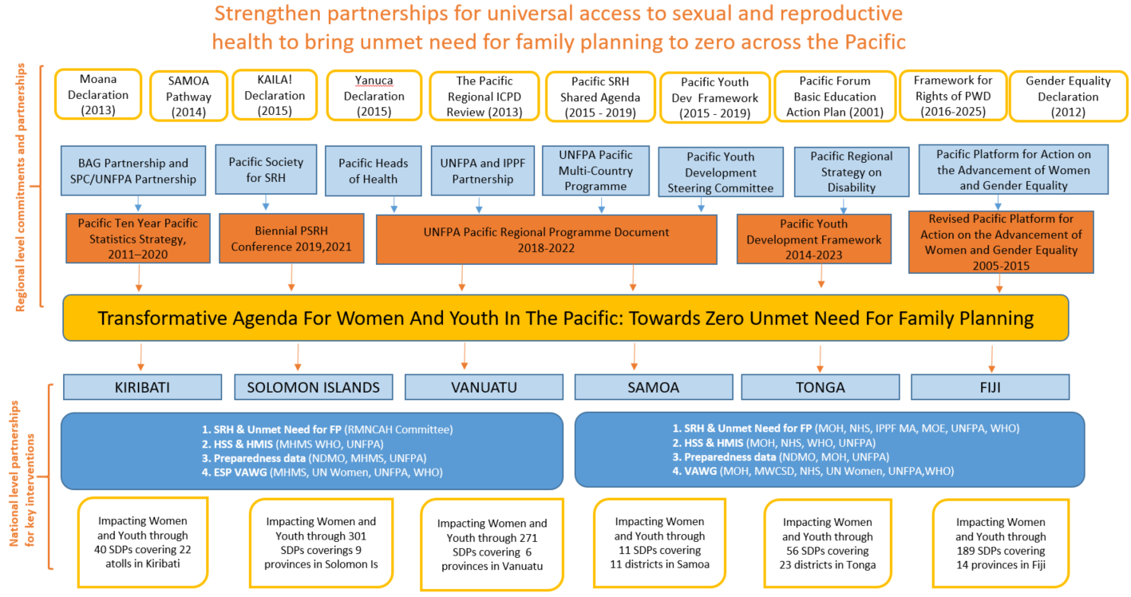

Figure 16. UNFPA’s operating environment for Transformative Agenda implementation

agencies that UNFPA will work with to achieve the Transformative Agenda include: CROP agencies, particularly SPC and PIFS, University of the South Pacific (USP) and its local centres, sister UN agencies, particularly the Global Health Partnership H6 (UNAIDS, UNFPA, UNICEF, UN Women, WHO and the World Bank Group), Asian Development Bank (ADB) (cervical cancer), Interagency Working Group on Youth, Shaping Pacific Women, Pacific Disability Forum, Pacific Youth Council, Pacific Women Shaping Pacific Development, and IPPF and its local associations.

For VAWG related work, National Councils of Women, Ministries of Women, and relevant civil society organisations (CSOs) are important partners. For integration of SRH into emergency responses, partners also include IPPF Subregional Office of the Pacific and local member associations, National Disaster Management Offices, Red Cross, and other relevant CSOs. For work to support persons with disability, local DPOs, other CSOs, and Ministry of Health Community-Based Rehabilitation programmes are crucial partners. These partners are not listed again under each output in Section 6, but the reader should keep in mind that UNFPA sees these organisations as central to successful implementation.

5. Context for Transformative Agenda and Theory of Change

**Context**

Before introducing the Theory of Change, it is important to outline the conceptual context within which the Transformative Agenda sits. UNFPA PSRO in Suva has already had broad endorsement from UNFPA New York for its Sub Regional Programme 6 (SRP6), being implemented from 2018-2022 across all 14 PICTs covered by PRSO. SRP6 in turn contributes to a broader United Nations Pacific Strategy Outcome: By 2022 more people in the Pacific, particularly the most vulnerable, have increased equitable access to and utilization of inclusive, resilient and quality basic services.

Whilst the DFAT AUD 30 million contribution to SRP6, through the Transformative Agenda, has enabled UNFPA to significantly scale up its ambition in the region, SRP6 is also supported by a number of other resources (see Annex 2). A summary Results and Resource Framework for the overall SRP6 is attached at Annex 1. An additional UNFPA-specific tool for SRP6 is attached at Annex 5: Summary Mapping of UNFPA PRSO for SRPD6 - Key SRP6 Deliverables by Country.

As explained in the introduction to this document, the Transformative Agenda has a narrower scope than SRP6, both in terms of its geographical coverage and its technical content. It is important to note, however, that the Transformative Agenda is clearly nested within SRP6 and directly contributes to the following SRP6 Outcomes (see Annex 1):

Outcome 1: Sexual and Reproductive Health

Outcome 3: Gender equality and women’s empowerment

Outcome 4: Population dynamics.

## 

## Theory of Change

Theory of change is a comprehensive description and illustration of how and why a desired change is expected to happen in a particular context. It is focused in particular on mapping out or “filling in” what has been described as the “missing middle” between what a programme or change initiative does (its activities or interventions) and how these lead to desired goals being achieved. It does this by first identifying the desired long-term goals and then works back from these to identify all the conditions (outcomes) that must be in place (and how these related to one another causally) for the goals to occur. These are all mapped out in an Outcomes Framework.

The Outcomes Framework then provides the basis for identifying what type of activity or intervention will lead to the outcomes identified as preconditions for achieving the long-term goal. Through this approach the precise link between activities and the achievement of the long-term goals are more fully understood. This leads to better planning, in that activities are linked to a detailed understanding of how change actually happens. It also leads to better evaluation, as it is possible to measure progress towards the achievement of longer-term goals that goes beyond the identification of program outputs.[43]

The Transformative Agenda theory of change is depicted below in Figure 17. To achieve the desired impact of the Program – ‘To move unmet need for family planning in the Pacific towards zero by 2022 – and thereby contribute to the goal of transformative change in the lives of women, adolescents and youth across the Pacific by 2022, the three outcomes are all necessary. In turn, to achieve the three outcomes, the underpinning outputs (and strategic interventions and associated activities as outlined in Section 6) are required. While some gains will be made if only some outputs are achieved, to have the greatest impact, advances on all outputs are desirable, as they combine synergistically to achieve the overall impact.

To achieve the Transformative Agenda, UNFPA will apply the principles of the 2030 Agenda for Sustainable Development, including protecting and promoting human rights, prioritizing “leaving no one behind” and “reaching the furthest behind first”, ensuring gender responsiveness, reducing risk and vulnerabilities, building resilience, strengthening cooperation and complementarity among development and humanitarian action, and above all, being efficient, accountable and transparent to all stakeholders. These principles form a foundation of the theory of change, as illustrated in Figure 17.

Also underpinning the theory of change are critical enablers. These include: fostering national ownership, working through partnerships, introducing and scaling-up innovative approaches and good practices, preparation for crisis situations, prioritizing adolescents and youth in national development plans and in regional high-level commitments in SRH. To some degree, these critical enablers are also assumptions, in that the achievement of the Transformative Agenda relies upon these enablers either being present, or able to be fostered in target countries. Beneath the critical enablers are barriers to progress. These have been discussed above in Section 3 and the Transformative Agenda contains actions to ameliorate these underlying challenges.

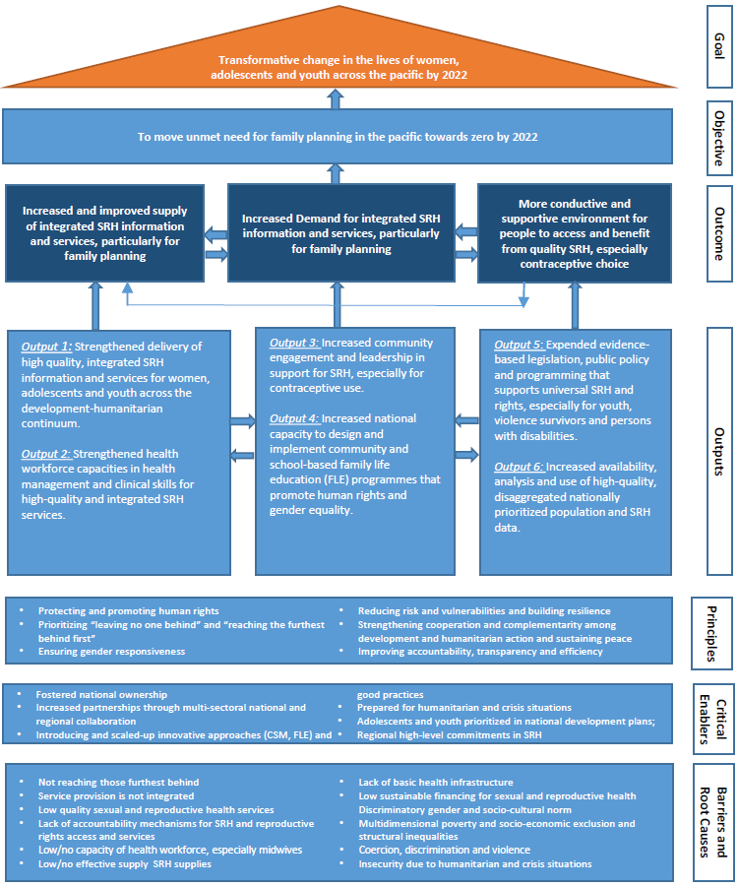

Figure 17. Transformative Agenda theory of change

6: Outputs, Outcomes and Activities to achieve them

This section details the three Transformative Agenda outcomes and their associated outputs. Strategic interventions and activities to deliver the outputs are based on the material in previous sections, including the situation analysis and assessment of past and current efforts, including UNFPA’s ongoing work. The strategic interventions and activities required to achieve each output are detailed, along with key partnerships. Partnerships will vary from country to country, depending upon the local context.

**Outcome 1** is predominantly about improving health systems and health service performance with a focus on: improving and expanding integrated SRH services; building the health workforce through training, guidelines and protocol provision and expanding scopes of practice; and working to make SRH supply systems more sustainable. (Other aspects of health systems, such as financing and leadership, are covered under Outputs 5 and 6). It is assumed that activities under **Outcome 2** (demand) will increase the number of people using SRH services, while improving the quality of SRH services will also increase service demand and use. Activities under **Outcome 3** (enabling environment) will create quality policy and strategies that support SRH services, SRH financing, and ultimate sustainability of SRH information and service provision.

## Outcome 1: Supply

|  |
| --- |
| **Outcome 1**  **Increased and improved supply of integrated SRH information and services, particularly for family planning** |

As highlighted in Section 3, to move towards zero unmet need for family planning, improved quality and availability of integrated SRH information and services is necessary. A particular focus on adolescents is required, given increasing ABRs, but needs exist amongst all women and young people, including those who have survived violence or have a disability. Health services, often SRH and maternal and child health services, are commonly the first contact point for women and girls who have experienced violence. Therefore, VAWG responses need to be integrated into SRH services. Similarly, women and girls with a disability tend to access health services for maternal and child health services, again indicating the need to integrate SRH services, including contraception, to increase access for these women. Thus, for the purposes of the Transformative Agenda, integration is understood to be the provision of several health care services (such as family planning; maternal, newborn, child and adolescent health care; response to GBV; STI prevention and treatment; HIV care and prevention; child immunization services; and cervical cancer prevention services) at the same facility or through referral to a higher level of care for services that are not offered in the facility.

Task sharing (enabling lower level health workers to provide basic services) is essential for increasing access to services. Enabling access to 3 methods of modern contraceptives in primary facilities and 5 in all others, (including LARCs and EC, both of which have a potentially transformative effect in the Pacific), in addition to referrals to the appropriate level for intrauterine devices (IUDs) and for sterilization, will be dependent on ensuring basic services are shifted down to nurse or midwife levels wherever practicable.

Completion and analysis of Maternal Death Surveillance Reports (MDSR) is critical to understand gaps in service delivery, quality and capacity. Gains have been made in MDSR completion and analysis in Kiribati, Solomon Islands and Vanuatu, based on a 2016 baseline survey. But more needs to be done, including in Samoa, Tonga and Fiji. A reproductive, maternal, neonatal, child and adolescent health workforce assessment is underway (funded through UNFPA core funds) in the 14 PICTs and PNG[44] and will provide information on the health workforce services gap in this area, based on the numbers and distribution of staff. Recommendations from the assessment will inform strategies for strengthening workforce in the targeted countries.

While family planning, health sector response to VAWG and disability inclusive services are the focus of this program, technical advice will also be provided to support national governments to address cervical cancer, with a focus on primary prevention through FLE and BCC interventions and secondary prevention through development of policy and guidelines. The Transformative Agenda will also support maternal health with a focus on life-saving interventions to prevent maternal death.

### Output 1

**Strengthened delivery of high quality, integrated sexual and reproductive health information and services for women, adolescents and youth across the development-humanitarian continuum.**

Output 1 involves four strategic interventions. UNFPA’s primary partner for this work is the Ministry of Health (MoH) in the six priority countries. Other implementing partners are: RMNCAH partners, IPPF associations, DPOs, other CSOs working in SRH service provision, VAWG service providers, provincial governments, nursing and Midwifery Councils and Societies (on task-sharing, in particular) and 868 SDPs across the six countries.

For the purposes of this design, an SDP is considered to be any health facility at any level which has publicly stated working hours and provides one or more SRH services. An initial inventory by UNFPA, validated by our field staff as well as MoHs, suggests that there are currently 868 SDPs across the six countries (although this number may be revised up or down by the end of the first quarter of 2019). The ongoing RMNCAH Health Workforce Assessment, will provide an opportunity to better understand the geographical coverage and reach of these SDPs in an effort to achieve universal health coverage for family planning in the six countries, and will also inform the final SDP number count.

Of the 868 SDPs, only 466 have in their scope the ability to provide 5 modern methods. Through the Transformative Agenda UNFPA will aim to ensure that all SDPs will be able to provide 3-5 modern methods. Additionally, and as one of the transformational results of this investment, in the remaining 402, staff will be trained and supported to provide emergency contraception (pills),[45] condoms (male/female), resupply oral contraception, and referral to a higher level facility for LARCs, injectables, sterilization and other SRH services. As a result of the training the staff at the 402 SDPs will be able to rule out pregnancy before EC pills are provided, advise women on possible side effects of EC and management of these, and provide counselling on initiation of regular forms of contraception.

UNFPA will support the six Ministries of Health with their partner engagement strategies and support them to develop their own workplans to include the activities of the Transformative Agenda. During missions to the six priority countries in 2017 and early 2018, UNFPA introduced both the SRP6 and the Transformative Agenda to ministries and national partners during stakeholder meetings. Subsequently, 2018 workplans that reflect the DFAT Transformative Agenda program will be jointly developed. UNFPA staff (in-country and regional) will provide support and technical assistance and further technical assistance will be contracted when necessary.

Health Facility Readiness Assessments (HFRA) will be undertaken in all six priority countries and will be essential to informing strategies for strengthening workforce capability to deliver quality integrated services. The assessments will be expected to commence in 2018 and will end in 2019.

The 5 year UNFPA Supplies program (2018-2022), supported by DFAT, will complement this output through ensuring availability and sustainability of quality SRH supplies and commodities.

**Strategic Intervention 1.1: Expanded and improved SRH service availability through strengthened policy and in-service training for existing health officers.**

The overall aim of this intervention is, by 2022, to ensure that all 868 SDPs in six countries have at least one member of staff available, fully trained in youth-friendly, disability-inclusive family planning services, and able to offer (depending on level of facility) 3-5 modern methods of contraception (condoms, pills, injectables, LARCs and EC). Effective service delivery calls for availability of staff in adequate numbers and with the right skill mix, competencies and flexibility to deliver high quality care.

UNFPA will support Ministries of Health and their national stakeholders such as NGOs and community based organisations (CBOs) to strengthen existing Community-Based Distribution (CBD) networks in each country in order to extend the reach of family planning services to certain communities (eg to people with disabilities and young people living in rural areas). The mechanism will differ by country according to what already exists. As an example, the Ministry of Health in Samoa is currently exploring the use of women’s community groups to provide SRH information, including information on available SRH services.

This intervention will focus on achieving this aim through (i) supporting the development of youth-friendly SRH services in all SDPs in each country, (ii) in-service training for existing health service providers to ensure all health facilities have at least one officer trained through the Transformative Agenda (iii) optimizing task-sharing and expanding scopes of practice with the objective of ensuring all health facilities at all levels have at least one worker able to provide at least three modern methods of contraception (iv) expanded opening hours in selected clinics to increase access.

Key activities under this strategic intervention are:

* Health facility readiness assessments (HFRAs) to be undertaken by UNFPA for all SDPs to underpin strategic development plans to strengthen capacity (linked with Output 2), with a focus on expanding contraception provision. The HFRAs assess the following:

i) Services offered at the facility and preference for opening hours by clients

ii) Skills mix of the health providers and the capacity needs for integrated SRH and VAWG

iii) Available equipment

iv) Infection prevention equipment

v) Drugs & supplies

vi) Point of care/on site testing kits

vii) Tools available such as guidelines & Protocols

viii) Quality assurance measures in place

ix) Identifies challenges and

x) Makes Recommendations.

* Strengthened in-service training: UNFPA will engage a high-quality service provider to provide upskilling to a sufficient number of health workers to ensure at least one upskilled health worker is available to provide required FP services in each of the 868 SDPs identified. There will be a one-off in-service training for all selected health workers and, simultaneously, pre-service curricula will also be reviewed and revised. The service provider will use a Training of Trainers cascade approach. Training will be integrated and include:
* human rights and client-centred approach to service delivery
* Skills to provide family planning counselling on all methods and provision of 3-5 modern methods of contraception (depending on the scope of practice) including at least one LARC and emergency contraceptives
* Capacity to screen women and girls at risk for VAWG, provide basic counselling and referrals
* Skills to provide quality services for people living with disabilities
* Knowledge of updated and existing guidelines and protocols and IEC materials
* Addressing the impact of personal values and attitudes among healthcare providers (i.e. around emergency contraception), which present as barriers for offering increased method mix.
* Expand access to contraceptive services through advocacy with national governments for optimized task-sharing and revised scope of practice for contraceptive services provision This will include extensive advocacy with national governments to amend local law or regulations to enable FP service provision to be shifted down as far as is practicable.
* Assess tertiary health facilities for accessibility for persons with disability and make recommendations to Ministry of Health for any improvements that need to be made.
* Engage with governments and key non-government service providers (such as IPPF’s Member Associations) to advocate to modify or expand health facility operating hours in line with client recommendations (from the HFRAs that will be conducted) to ensure clients are able to reach service providers as needed. UNFPA will aim to encourage all SRH SDPs to be open within a time period that clients will be most likely to access services with the objective of ensuring at least 50 per cent of national populations have access to a clinic in preferred hours.
* Advocate for and support government planning to ensure that, by the end of 2022, all mobile services in all countries include a health worker trained in youth friendly, disability inclusive SRH services able to provide 3 – 5 modern methods of contraception including LARCs and emergency contraception, to rural areas. The programme will aim to ensure that 100 per cent of outreach services provided include youth friendly SRH services, against a baseline of zero.
* In Year 1 of the program, UNFPA will also assess the potential to support IPPF or other identified CBD networks to deliver SRH services in hard-to-reach areas generally not serviced by government, under contract arrangements with governments. If feasible, UNFPA will engage with appropriate service providers and governments to develop contractual arrangements and implement shared SRH service program in years 2 – 4 to ensure that there is comprehensive service coverage. As mentioned above, CBD network membership will be trained in SRH with a focus on family planning, through a cascade Training of Trainers approach, with the level of training and content adapted to each country in consultation with the Ministry of Health.

**Strategic Intervention 1.2: Enhancing the operational standards and referral systems for improved access to integrated, disability inclusive and youth friendly SRH services.**

This strategic intervention focuses on strengthened integration of services through improving operational standards and referral systems to ensure that clients can either obtain these services at each SDP or can be referred to other SDPs to obtain the services required.

UNFPA’s work on improved integration will focus on policy engagement with government to mandate, fund, support and evaluate integrated services, and to provide direct support to key service delivery points in each country. These could include family planning, antenatal, delivery and post-partum services and well-child clinics and vaccination programmes which are already well attended in all priority countries. Where integration at the point of service delivery is not possible, UNFPA will focus on ensuring that robust referral pathways are developed and implemented. As part of the integrated approach, the ESP for Women and Girls Subject to Violence promotes strong cross-sectoral coordination, including between health, police, justice and social services, across government and civil society organizations working in VAWG prevention and response.

The capacity within each country to provide integrated services will differ and the nature and extent to which integration will be supported in each country will be determined through national level analysis and annual national workplans.

This Strategic intervention will result in (i) an agreed policy and operational standards for integrating services in each country, with operational guidelines developed and in use; (ii) robust referral systems developed and in use in health facilities (iii) coordination mechanisms established to ensure the health sector’s participation in national multi-sectoral ESP so that survivors of violence have access to appropriate health services.

Key activities under this strategic intervention are:

* Review and update the VAWG health sector assessments in Kiribati, Solomon Islands, Vanuatu and Fiji (initially conducted in the period 2013-2015) and conduct assessments in Samoa and Tonga. This activity will be completed in the first eighteen months of the programme and used to inform strategies for the inclusion of VAWG information and services into existing health worker upskilling interventions under this program.
* In collaboration with governments and stakeholders, determine the level of VAWG and SRH integration possible within each tier of health service facility in each country (both information and services). This will be done as a component of the Health Facility Readiness Assessment in each priority country.
* In each country, determine health facility prioritisation for integrating SRH information and services into existing services with the objective of targeting facilities that reach the highest number of women and girls with a likelihood of unmet need for family planning (e.g. maternal and child health clinics).
* Provide technical support to each national government to develop high quality, relevant contraceptive information (particularly for methods which are currently underutilized, such as emergency contraception) and VAWG prevention and response information for priority health facilities. This will include specific information on the provision of these services to support youth and people living with disabilities. Support for government will include a focus on ensuring ongoing financing for materials and clear strategies to ensure that materials are kept up to date, continuously stocked and distributed to all health facilities.
* In partnership with national governments and key NGO partners, support development and implementation of referral criteria, pathways and relevant tools, including innovative referral mechanisms to deal with geographic challenges in PICTs, and VAWG referral criteria and systems.
* Provide technical support to develop policy and guidelines for prevention of cervical cancer, in consultation with the Regional Technical Working Group (RTWG) (comprised of the UN Agencies UNFPA, WHO and UNICEF, PIFS, SPC, ADB and DFAT). The RTWG works to ensure Technical oversight and coordination of all cervical cancer related activities in the Pacific.
* Evaluate the ESP in the Solomon Islands and Kiribati, assess the feasibility of expanding the ESP, and expand as appropriate in new pilot countries (also see Output 2).

**Strategic Intervention 1.3: Strengthened mechanisms to evaluate the quality of SRH services at all levels and ensure lessons learned are applied to improved policy and regulatory frameworks**

This strategic intervention is designed to improve the quality of mechanisms to evaluate SRH service performance, and to improve national government analysis and application of findings to public health formulation for better SRH outcomes. It will draw on lessons learned from Fiji and other countries that have been seeking to improve SRH service quality through evaluation mechanisms.

This Strategic Intervention will result in (i) MDSR being institutionalized in all six national Ministry of Health work programmes, and (ii) strengthened quality of care mechanisms (such as regular internal and external assessment audits and client exit interviews).

UNFPA will build on the gains already achieved using MDSRs in the Pacific, lessons learned from the Fiji Mother Safe Hospital Initiative as well as family planning quality measurement practices from other countries to expand quality assurance programmes across target countries and ensure they align with WHO standards for Improving Quality of Maternal and Newborn Care in Health Facilities.

Key activities under this strategic intervention are:

* Based on recommendations from the MDSR reviews and lessons learned since its inception, provide support for the assessment and revision of the MDSR policy in Fiji, Kiribati, Solomon Islands and Vanuatu in consultation with national governments.
* Provide technical assistance to national governments in establishing an MDSR programme for Tonga and Samoa, drawing on existing MDSR guidance and training.
* Collate lessons learned on family planning quality of care measurement practices including lessons from Fiji’s quality of care activities, and share these with other countries through various mechanisms, including potentially a regional meeting on quality of care.
* Provide support for the development of mechanisms and tools to monitor and evaluate quality of care improvements for all priority countries and all services addressed under the Transformative Agenda.
* Support governments to introduce, roll out, monitor and evaluate a Quality of Care program for SRH services.
* Based on the Health Facility Readiness Assessments (Output 1.1), develop and implement specific appropriate activities to address identified shortcomings with regards to Quality of Care that are of relevance to the Transformative Agenda.

**Strategic Intervention 1.4: Ensuring continuity of services during natural disasters**

Given the frequency of natural disasters in the Pacific and recognizing that the need for reproductive health services, including contraception, does not halt during an emergency and the documented increased rates of SGBV in these settings it is important to ensure that disaster preparedness and response integrate and prioritize SRH/VAWG needs.

UNFPA will work in close partnership with IPPF to support their humanitarian work. Through the DFAT-supported SPRINT initiative, IPPF will be conducting MISP training through three different modules: the MISP outreach training module for service providers; the SRH Coordinators Trainer of Trainers module for SRH coordinators and program managers; and the advocacy module for policymakers and service providers. Combined, the modules aim to: build capacity of service providers and key stakeholders; strengthen coordination of SRH response in disasters and raise awareness on SRH in crises at the regional and national levels. Currently only Fiji and Samoa have SRH reflected in their national health disaster response plans.

IPPF plans to conduct 9 MISP training sessions in 2018 across the 5 Member Associations that they currently support in the Pacific[46] (5 service provider trainings, 1 service provider refresher, 2 SRH coordinator trainings and 1 policymaker training). UNFPA will be supporting these trainings in the capacity outlined below, and according to their annual workplans. Under the DFAT-funded Regional Prepositioning Initiative, UNFPA PSRO will be complementing the MISP in Fiji, Solomon Islands, Tonga and Vanuatu through provision of life-saving SRH kits, dignity kits and commodities in the event of a humanitarian crisis.

In the Pacific, the Regional Protection Cluster does not have any active sub-clusters. UNFPA PSRO is currently partnering with UN Women to start a regional GBV sub-cluster, to mainstream GBV preparedness and response during disasters.

The desired results from the activities under intervention 1.4 are (i) regional and national disaster preparedness and response mechanisms are able to assess and prioritize SRH and protection needs, (ii) to ensure implementation of the MISP at the onset of a crisis, including clinical management of rape, and (iii) to prioritize SRH needs of persons with disabilities during a humanitarian crisis.

Key activities under this strategic intervention are:

* Provide technical assistance and materials to support IPPF’s MISP training for all training modules.
* Convene policymakers and government level participants to MISP training modules, especially the IPPF MISP advocacy module which will be delivered jointly by IPPF and UNFPA.
* Provide technical assistance to review the MISP training modules and ensure that guidelines are updated and adapted to the Pacific context, and contents are suited for participant profiles (to be done jointly with UNFPA APRO).
* Provide technical assistance to IPPF to review the *SRH in Emergencies and People with Disabilities* module to ensure alignment with international best practice and adaptation to the Pacific context.
* Support governments, line ministries, IPPF and national NGOs in crisis response through provision of essential SRH kits and commodities where provision is not covered under the Prepositioning Initiative (Samoa, Kiribati).
* Provide support to IPPF in updating Memorandum of Understandings between Member Associations in the priority PICTs with their respective Ministries of Health, particularly to ensure that joint roles and responsibilities for emergency response are clearly outlined.
* Support IPPF and national NGOs in engaging with existing SRH adolescent and youth peer educators for community awareness on disaster preparedness/action, and review and update toolkits for training of, and use by, peer educators to reflect SRH/VAWG in disasters.
* Mainstream GBV preparedness into the GBV sub-cluster, the existing Protection cluster, and Pacific Humanitarian Team.
* Advocate for and support implementation of the ‘*Inter-Agency Standing Committee (IASC) Guidelines of Integration of Persons with Disability into Humanitarian Action’* (The IASC is currently developing guidelines based on a commitment made during the World Humanitarian Summit in 2016 to develop globally endorsed UN system-wide guidelines for inclusion of persons with disabilities. UNFPA PSRO recently participated in the Pacific consultation to provide input into development of the global guidelines, which will be finalized by December 2018).

### Output 2

**Strengthened health workforce capacities in health management and clinical skills for high-quality and integrated sexual and reproductive health services**

Output 2 involves five strategic interventions, and focuses on the health workforce, ensuring that definitions are agreed to enable uniform ‘counting’ of workforce capacity, and scopes of practice expanded in line with country regulations. Both pre-service and in-service education and professional development is targeted, to ensure a sustainable supply of appropriately skilled health professionals. Key partners for this output are the Ministry of Health, Ministry of Education, Nursing and Midwifery Schools, provincial governments, the Pacific Society for Reproductive Health (PSRH), academic institutions, and Nursing and Midwifery Councils and Societies. UNFPA will develop a workplan with each Ministry of Health to include these activities, building on what strengths are already present. UNFPA staff (in-country and regional) will provide support and technical assistance.

**Strategic Intervention 2.1: Assessment, adaptation/development and implementation of SRH guidelines and protocols aligned with International Standards, including for addressing VAWG**

Given there are various and multiple SRH guidelines and protocols present in the six priority countries, these need to be assessed against international standards. They also require updating in line with the work described above for integrated services. Health workers then require training in how to use them and to be able to actually access them in their workplaces. Specialist protocols for VAWG survivors and persons with disability are also needed.

This strategic intervention will (i) fully revise and update all guidelines and protocols relevant to quality integrated SRH service delivery.

Key activities under this strategic intervention are:

* Based on the HFRA (Output 1.1), evaluate the quality of current SRH guidelines and protocols, and their availability and use.
* Provide technical support to update and develop relevant SRH service provision guidelines and protocols, incorporating human rights approaches.
* Update current VAWG health sector assessments in Kiribati, Solomon Islands, Vanuatu, Fiji and RMI, and conduct assessments in Samoa and Tonga (alongside Output 1.2).
* In collaboration with DPOs, develop guidelines to support health workers to provide SRH/VAWG services for women and young people with disabilities.
* Roll-out the WHO Clinical Guidelines for Treating Sexual Assault Survivors.
* Conduct GBV/Clinical Management of Rape (CMR) and GBV Case management training for health service providers in partnership with line ministries, IPPF and national NGOs.
* Conduct training on GBV Minimum Standards for Programming, GBV Guiding Principles and Psychological First Aid to relevant providers of care as part of an integrated approach in line with the ESP model to strengthen VAWG response

**Strategic Intervention 2.2: Ensure pre-service curriculum and training manuals provide comprehensive education on contraception (to ensure increased method mix) and integrated SRH services (including youth friendly services, prevention and response to VAWG, services for people with disabilities, human rights, and humanitarian response).**

The Transformative agenda will support both pre-service and in-service education and professional development to ensure a sustainable supply of appropriately skilled health professionals in all SDPs across the six countries. Key partners for the training are the Ministry of Health, Ministry of Education, Nursing and Midwifery Schools, provincial governments, the Pacific Society for Reproductive Health (PSRH), academic institutions, and Nursing and Midwifery Councils and Societies.

To ensure sustainability of training for new health workforce professionals, SRH/VAWG competencies need to be embedded into health professional pre-service training, particularly for midwives and nurses. This training needs to be assessed against international standards, to contribute to quality service provision. This strategic intervention will work closely with schools of nursing and midwifery, and ministries of health and education, to incorporate appropriate SRH/VAWG education into pre-service curricula.

The desired results from this intervention are that graduates from nursing and midwifery schools have the basic competencies, or more advanced skills where appropriate, to provide quality, integrated SRH services that are youth-friendly and respond to the needs of persons with disabilities.

Key activities under this strategic intervention are:

* In partnership with nursing and midwifery schools, review existing curricula against international standards for education of health workers on providing integrated, youth friendly, human rights-based SRH services, including for persons with disabilities.
* Work with training schools to develop curricula and training manuals to support pre-service education on SRH, including human rights approaches to family planning, youth-friendly services, cervical cancer screening, MISP, basic maternal and infant health, and VAWG services.
* Train nursing and midwifery tutors on the new curricula, and assist the progressive roll out of the new curricula in the teaching institutions.

Review and updating of the curriculum will be contracted to an independent consultant who will work under direct guidance of UNFPA in consultation with the Ministries of Health, Ministries of Education, professional associations and regulatory bodies in each country.

**Strategic Intervention 2.3: Enhancing health worker in-service training mechanism for delivery of quality integrated SRH services including FP and quality counselling.**

Given the Transformative Agenda’s aim to expand integrated SRH service provision, particularly family planning, a key mechanism for this is to ensure that current health professionals have the ability to provide quality, integrated SRH services, including contraceptive method mix at appropriate levels of service delivery. Health workers require ongoing support on the job, particularly when integrating new skills- hence the need for mentoring and supervision, and for identifying VAWG champions among the health workforce (ie. those providing services to survivors of VAWG).[47] This is also because health professionals can hold prevailing social norms, so they need ongoing peer support to provide quality SRH services in sometimes challenging environments.

Key activities under this strategic intervention are:

* Build on existing, and develop new in-service health professional training packages and resource materials for integrated quality SRH service provision. These will include family planning counselling, family planning methods including contraceptive surgical procedures (such as non-scalpel vasectomy), human rights approaches, gender sensitivity and values clarification (to address unhelpful health worker attitudes), VAWG prevention and response, provision of adolescent and youth friendly health services, screening for cervical cancer, contraceptive surgical procedures and meeting the needs of people with disabilities.
* Services of an academic institution or professional association (such as the Pacific Society for Reproductive Health) will be engaged to conduct an initial training incorporating the above-mentioned areas in each country, followed by an annual refresher training to update the knowledge, share new and emerging approaches and fill in the gaps identified by the health care workers themselves as part of their professional development and needs on the ground. Based on the capacity needs assessments and in collaboration with the Ministries of Health the frequency and content of the refresher trainings will be determined.

• The same provider of training services above will support strengthening the follow-up post-training support on the job to provide individual and team guidance and to evaluate participants’ knowledge and skills to ensure that their learning becomes embedded into their health care practices. The provider will be expected to review and update support supervision guidelines, train supervisors, undertake periodic monitoring and supervision visits, routine performance evaluation and recommendations for upgrade of skills and knowledge in certain areas where gaps still exist.

* UNFPA will support governments to establish and implement mechanisms to regularly evaluate the effectiveness of training in ensuring quality youth friendly and disability inclusive SRH services are being delivered at SDPs and provide refresher training each year. This work will include:
* developing evaluation methodology, protocols and guidelines
* embedding into national government practice
* assisting in rolling out the evaluation
* assist in analysis of evaluation findings and application of findings to improving curriculum and teacher training
* provide refresher training to all targeted health workers. Based on capacity needs assessments, PRSO will determine the frequency and content of refresher training.

Desired results include functioning mentoring programmes in place, and health workers who are able to provide quality, expanded, integrated SRH/VAWG services, including for persons with disabilities.

**Strategic Intervention 2.4:**  **Expand in-country capacity to manage quality integrated SRH services including family planning, VAWG prevention and response and youth and disability inclusive services in development and humanitarian settings.**

Health service provision relies on quality management. Improved, integrated SRH services require management staff supportive of SRH within the context of the broader health system. UNFPA will collaborate with WHO to provide support to Ministries of Health in strengthening planning and implementation of integrated SRH services according to UNFPA’s and WHO’s standards[48] [49] within broader capacity building activities for the health sector.

Improved programme management will ensure that health professionals are supported to provide quality services and that central Ministry of Health staff and other policymakers have improved information regarding programme implementation, supporting better planning and use of resources. The aim of this strategic intervention is to ensure that national SRH coordinators and facility managers in all six countries receive in-service training to strengthen their facility management capacity with a focus on monitoring Quality of Care against WHO standards.

Key activities under this strategic intervention are:

• Review existing management training and revise and update or develop new training packages as needed.

• In coordination with Ministry of Health efforts, deliver training to strengthen the capacity of national and sub-national SRH coordinators to effectively manage and coordinate integrated services. This training will be based on WHO and UNFPA standards and will include:

- accountability and decision-making,

- improving feedback mechanisms,

- planning, monitoring and evaluation

- supportive staff supervision with a focus on inclusive rights-based service delivery,

- and increasing effective policy and strategy development and implementation.

- supply management and health information systems (HIS), where necessary (in line with the work of UNFPA supplies and 6.1), and

- MISP, in partnership with IPPF under the SPRINT program

• Develop/strengthen mechanisms and tools for monitoring and integrated supportive supervision (in line with Output 1.3).

## Outcome 2: Demand

|  |
| --- |
| **Outcome 2**  **Increased demand for integrated SRH information and services, particularly for family planning** |

As outlined in Section 3, one of the major challenges to contraceptive use are community norms, including gender stereotypes, preferences for large families, and general taboos about sexuality, particularly that of youth and people with disabilities. Misinformation and a lack of awareness about the full-range of contraceptive choices (including emergency contraception) also hinder demand. The fact that people do not use contraception even when it is available indicates there is a need to actively engage with communities, and community leaders, to promote the positive impacts of enabling women, couples and young people to manage their fertility as they choose. Further, gender equality, sexuality and relationships, and general SRH education is shown to be helpful in supporting young people to practice healthy SRH behaviours.[50] For this reason, UNFPA will invest in improving and expanding Family Life Education (FLE) in the six priority countries. As outlined above, DFAT has already provided funding for a contraceptive social marketing (CSM) to be implemented mostly likely in Vanuatu (and potentially some expansion to Solomon Islands). The work outlined here will complement this and use lessons learned from the CSM, wherever possible.

### Output 3

**Increased community engagement and leadership in support of SRH, especially for contraceptive choice.**

UNFPA will increase community engagement and leadership to support youth and disability inclusive SRH services, particularly contraceptive use, through two strategic interventions: (i) enhancing knowledge, attitudes and practices; and (ii) mobilizing and engaging communities.

Partners will include community and faith-based groups and leaders, youth groups, church groups (including the Council of Churches), IPPF member associations/family health associations, DPOs, and the media. This intervention will result in effective BCC strategies.

Some work has already been undertaken in this area, through the DFAT-funded CSM design phase, and this work will be built upon and implemented in 5 countries (not Vanuatu which is expected to be supported under the CSM).

BCC strategies in each country will need to be tailored for target audiences and messages. The first activity is to develop a solid understanding of target audiences. Key priority groups for targeted messaging are men (given the impact their behaviour has on women’s choices and well-being), youth, persons with disabilities, and survivors of violence. Whole-of-community messaging is also crucial to alter unhelpful social norms about SRH, gender equality, and persons with disabilities. Mass media will be engaged for broad coverage. UNFPA staff (regional and in-country) will coordinate and facilitate this work and provide technical assistance to the civil society organizations, NGO’s and other national partners that will be implementing these media strategies in country. Specialized technical assistance will also be sought where necessary.

**Strategic Intervention 3.1: Enhancing knowledge, attitudes, and practices related to youth and disability inclusive SRH and contraception among the general population, with special emphasis on specific target audiences**

This strategic intervention will assess community knowledge, attitudes and behaviours, and tailor audience-specific BCC tools and messages to improve knowledge of SRH and change attitudes and behaviours.

While difficult to attribute directly to BCC, this strategic intervention will ensure (i) demand for SRH services increases, (ii) more people are supportive of contraception and using contraception, particularly young people and persons with disability (iii) there is a greater utilization of health sector VAWG services.

UNFPA will work collaboratively with partners at regional and national levels which include, but are not limited to, Ministries of Health, WHO, UNICEF, IPPF Pacific Subregional office, IPPF affiliates, local NGOs, CBOs, and youth networks and groups working in respective countries in the implementation of this strategic intervention.

Key activities under this strategic intervention are:

* Actively engage community members in problem identification, prioritization and decision-making on the design, implementation and evaluation of BCC approaches.
* Establish a youth consultative committee (including youth with disabilities) to guide the development and implementation of a media campaign, considering possibilities via education, innovation labs and mobile phone communication.
* Building on what was already learned through the CSM assessments, assess the existing norms, behaviours, knowledge and practices surrounding the use of existing services for unmet need, and how this links to VAWG (analysis will focus on specific target populations of men, youth, persons with disabilities, journalists and faith-based and community leaders).
* With support from technical assistance and community consultative groups, develop a focused BCC strategy (including audience-specific tools and messaging) for different target audiences within each country, including men, young people, persons with disability, and survivors of violence, and general community members. Ensure messaging is based on human rights approaches.
* Implement the BCC strategy through mass media campaigns, including radio spots, TV soaps/drama, print media, mobile technology, and targeted community engagement.
* By the end of Year 2 of the program, develop a sustainability strategy to enable national governments to continue BCC approaches within national budgets.
* With the support of technical assistance (and integrated within the above BCC strategies), develop VAWG awareness messages including demand generation messages to promote utilization of Health ESP.

**Strategic Intervention 3.2: Mobilizing and engaging communities and increasing community leadership to improve knowledge and demand for SRH and family planning**

To complement BCC messaging, active engagement of individuals in particular communities is important. Having influential community leaders speak-out in support of human rights, SRH, contraception, gender equity and non-violence can help to change community norms and attitudes. Community health workers are active and well regarded in their communities, so they are well positioned to speak in support of SRH. UNFPA will grow a cadre of leaders, including journalists, who promote positive SRH messages. Targeted action is needed to support women with disabilities.

This Intervention will result in (i) a ‘critical mass’ group of influential people speaking in support of SRH and (ii) a yet to be determined number of Community Health Workers able to provide basic SRH and VAWG services and refer clients on where appropriate.

Key activities under this strategic intervention are:

* Identify, mobilise, train and support SRH and family planning champions (such as influential community leaders, teachers, parents and other key stakeholders) to publicly promote SRH issues, including family planning and contraception (with an emphasis on increased method mix), non-violence and assistance to survivors of violence. This activity, undertaken with support from CBOs and NGOs, will also include development of information materials to be used by the champions.
* Collaborate with media, civil society organizations, NGOs and other national partners and provide technical assistance to promote accurate and positive SRH, contraceptive and VAWG messages.
* In collaboration with DPOs, select priority recommendations from ‘A Deeper Silence’ report on women with disabilities’ SRH needs, and implement in Kiribati, Solomon Islands and Tonga. (And for WE DECIDE findings in other three countries, if available in time.)
* Train Community Health Workers in basic SRH/VAWG messages and services available so they can provide basic information to individuals. Community health workers include traditional birth attendants and are called village health workers in some countries (such as Tonga and Vanuatu). In partnership with CBOs and NGOs, current training will be reviewed and additional content on SRH/VAWG proposed where gaps are identified.

### Output 4

**Increased national capacity to design and implement community- and school-based family life education (FLE) programmes that promote human rights and gender equality**

Quality FLE is key to improving demand and expanding healthy SRH behaviours. FLE needs to be both in line with international standards, reflecting human rights and gender mainstreaming, and relevant to the local context.

Achieving this requires understanding and improving the quality of the existing FLE curriculum, strengthening of teaching methods and pedagogies employed to deliver FLE and providing teachers with adequate training on the new FLE Curriculum and methodologies.

To ensure that quality and comprehensive FLE is being implemented in the community/out-of-school setting, the strategic intervention will (i) align national school curricula with international guidance[51],[52] (ii) strengthen and standardize the community-based training package for out-of-school, marginalized adolescent and youth, such as young people with disabilities, and rural youth. (iii) develop and implement strong monitoring, evaluation and learning systems that allow continuous assessment and revision of FLE programmes to ensure long-term effectiveness and sustainability (iv) review and strengthen safe school policies and support government to ensure these are implemented effectively and continuously monitored (v) strengthen linkages between youth friendly health service provision and FLE programmes.

Within the current programme cycle, UNFPA is initiating a participatory assessment of the current FLE programmes in six PICTS. This will provide a comprehensive understanding of the policy context, the quality and the implementation of the programmes today and will set the priorities for investment in the coming years of the new programme.

Partners for this work include: schools, parents, teachers, Ministry of Education (including at provincial level), Ministry of Youth, teacher’s colleges, and the Ministry of Health (for potential technical input), UNESCO, SPC (RRRT) and UNICEF. Where IPPF member associations are working with out-of-school youth or in schools, UNFPA will forge partnerships with them. UNFPA staff (regional and in-country) will coordinate and facilitate this work and provide technical assistance where appropriate. Specialized technical assistance will also be sought, including from in country, where necessary.

**Strategic Intervention 4.1: Improving the quality and delivery of FLE programme delivered in schools and out-of-school through strengthened curricula, pedagogy, and teacher training.**

This intervention will ensure (i) FLE curricula in all six countries are of international standard, tailored to the country context, (ii) growing numbers of teachers (measured through school based surveys) express confidence in teaching the curricula (iii) a minimum of 40,000 out-of-school youth and those living with disability (and not attending school) will have received a community-based FLE education and (iv) schools have developed and are implementing safe school policies and referral systems to ensure students can access services easily.

Key activities under this strategic intervention are:

* Work with Ministry of Education, Ministry of Youth, teachers’ colleges, parents, teachers, youth groups, DPOs, and other key stakeholders to establish a FLE Committee in each country.
* Engage with existing school committees/boards/parent groups, to build their support for SRH (find champions) (alongside Output 3).
* Based on participatory assessments underway, provide technical assistance and quality assurance for national FLE curricula development, and its alignment with international standards, including strong integration of gender equality and human rights (including coverage of VAWG and meeting the needs of people with disabilities topics). In order to ensure institutionalization of capacity for curriculum review and development related to FLE, UNFPA will provide technical support and training for the curriculum development units (curriculum development officers and writers) of the Ministries of Education on FLE and the international best-practice and guidance which outlines the key concepts, topics and learning objectives of comprehensive FLE programmes.
* Map existing community-based organizations and FLE resources and tools aimed to reaching marginalized adolescents and youth, including those living with disability.
* Technical support to develop community-based FLE resources and tools for reaching marginalized adolescents and youth including those living with disability.
* Finalise and progressively roll out community-based resource tools/training package on SRH for marginalized adolescent and youth, including those living with disability.
* Engage with teachers’ colleges and universities (i.e. USP) and in-service professional development providers to support and train teachers to provide comprehensive FLE in line with international standards and reflecting a participatory pedagogical and learner-centred approaches to education. Teachers are central to the implementation of FLE. They need to have the confidence, commitment and resources to be able to teach FLE related topics. Teachers responsible for the delivery of FLE (either as a stand-alone subject or infused within few subjects) require training on the specific skills needed to address FLE accurately and clearly, as well as the use of active, participatory learning methods. UNFPA will support national teachers’ colleges and academic institutions in the region (i.e. USP) to develop curriculum for training pre-service and in-service teachers on the topics of FLE, participatory pedagogical methods and learner-cantered approaches. Tutors and mentors from these colleges who provide an ongoing support to teachers will be trained through a training of trainers on FLE in order to be able to provide on job support for teachers. An annual refresher training (which usually happens at the start of the school year) based on the capacity needs assessments conducted by the national teachers’ colleges, will also be supported through the Transformative Agenda in order to ensure continued capacity development and addressing the gaps which teachers will identify.
* Establish an innovation lab in Fiji for development of high quality technologies and tools for reaching adolescents and youth with SRH information, such as use of technology and mobile phones (linked to work under output 3).
* Explore existing linkages between schools and other SRH services and strengthen and expand referral pathways to ensure a wrap-around response to youth SRH needs. For example, the FLE curricula must provide information on all services available for adolescent youth in their communities. Some schools may have FLE corners where FLE trained teachers provide basic counselling and referrals to appropriate health services. In some contexts, school nurses may be available to provide more comprehensive services than the teachers themselves.
* Along with UNESCO, provide technical assistance to assist schools to strengthen their safe-school policies and programmes.
* Facilitate knowledge transfer between accredited global and existing regional institutions like USP, for sustainable provision of technical assistance in the area of FLE (in and out of schools).

**Strategic Intervention 4.2: Improving monitoring, evaluation and learning framework and the evidence base for FLE**

To ensure that a quality assurance system is in place, FLE needs robust monitoring and evaluation (M&E) mechanisms that are built into already established education information systems. Learning is also necessary to continue to improve FLE quality as student needs evolve. This Strategic Intervention will result in (i) an institutionalized planning, monitoring, learning and evaluation mechanism for FLE, (ii) FLE impact assessed, and (iii) lessons learned shared.

Key activities under this strategic intervention are:

* Technical support for establishment of a mechanism for monitoring and evaluating the quality and impact of FLE provision/programmes as part of education information systems. Students themselves can be part of this M&E through, for example, contributing to the design of school-based surveys.
* Work with UNESCO to ensure that indicators on FLE quality, impact and effectiveness are developed and integrated into Education Information Management Systems (EIMS).
* Later in the programme (Years 2 in Solomon Islands and Fiji where there is already more advanced FLE implementation and Year 4 elsewhere), research the impact of the school-based FLE implementation.
* Facilitate regional information sharing and lessons learned on FLE implementation and lessons learned held.

**Strategic Intervention 4.3: FLE is integrated into national and regional strategies, plans and policies.**

Alongside advocacy activities under Output 5.1, FLE-specific advocacy is necessary to ensure sustainability of the FLE programme. The participatory analyses conducted under UNFPA’s SRP5 and SRP6, and the research under Output 5.2, will all be used in advocacy efforts.

This strategic intervention will ensure (i) FLE concepts and related indicators are embedded in national policies, and (ii) the Pacific Regional Education Framework (2018-2030) includes FLE concepts consistent with international standards. (iii) Youth friendly health service guidelines and policies include information on FLE and clearly state the need for linkages and better coordination between the education and health sectors.

Key activities under this strategic intervention are:

* Complete a situation analysis (policy, quality, and implementation) of FLE programmes and share findings used for 4.1.
* Develop joint advocacy strategies for use by all relevant UN and non-UN agencies.
* Undertake advocacy for, and engagement in, policy discussions on FLE at national/regional level, with involvement of various stakeholders (policymakers, teachers, parents, young people and community leaders, and people with disabilities).
* Within the coordination committees under the Ministries of Health which oversee RMNCAH investments and plans in the countries, advocate for inclusion of Ministry of Education representatives in order to provide continued coordination and update of progress achieved in both health and education sectors in the six countries.

## Outcome 3: Enabling Environment

|  |
| --- |
| **Outcome 3**  **More conducive and supportive environment for people to access and benefit from quality SRH, especially contraceptive choice** |

This outcome underpins the previous two. Health and education service providers need a supportive environment to provide quality education and services, and individuals and families need an enabling environment to make decisions freely about their sexual and reproductive health.

Information is a powerful ingredient for building enabling environments. Knowing where the needs are, who has specific needs, and who is being left out, are all necessary to mobilize government attention, funding and action. In turn, policies, strategies and programmes are no use unless they are implemented. This requires active engagement by health and education service providers, and constant monitoring and feedback through information gathering, analysis and use.

Outcome 3 also aims to produce high quality evidence for policy development and decision-making, including targeted SRH responses during humanitarian situations. Deliverables will include reliable and timely analysis and products and their utilization.

### Output 5

**Expanded evidence-based legislation, public policy and programming that support sexual and reproductive health and rights, especially for youth, violence survivors and people with disabilities.**

Advocacy is required to achieve legislation, policy and programmes that support universal SRH and rights, including access to contraception. UNFPA will work to influence the development of SRH-supportive, gender empowering national policies and their implementation. Advocacy activities will be based on sound evidence drawn from population and SRH data. Available data from census, DHS/Multiple Indicator Cluster Survey (MICS) and HIS will allow for the identification of demographic disparities and social and economic inequities that affect women, adolescents and youths’ access to sexual and reproductive health.

A range of different partners will be engaged for advocacy efforts, both as targets for advocacy, and as advocates. These include the Ministry of Health, Ministry of Women, Ministry of Youth, Ministry of Education, Ministries of Finance and Planning, Department of Prime Minister and Cabinet, parliamentarians, donors, and other entities that are involved in producing, or influencing, national legislation, policy and programming.

UNFPA staff (regional and in-country) will coordinate and facilitate this work and provide technical assistance where appropriate. Additional technical assistance will also be sought where necessary. Specific advocacy strategies will be developed in each country, including the identification of key issues and target audiences for advocacy efforts.

**Strategic Intervention 5.1. Advocacy for, and influence within, policy discussions for key SRH, VAWG, disability and population issues including in disaster risk reduction policies and emergency preparedness and response**

This Strategic Intervention will support the inclusion of (i) integrated SRH services into national budgets, including for supplies; (ii) MISP into national disaster policies; (ii) FHSS recommendations into policies and programming (iii) SRH issues, into key policies and programmes.

Key activities under this strategic intervention are:

* In collaboration with key stakeholders, map the political landscape and analysis of the existing legislation and policy framework gaps in relation to SRH and rights (also using information from a Deeper Silence report, the VAWG FHSS analyses, and WE DECIDE studies to be conducted under 6.2 below).
* Based on these assessments, develop and implement a comprehensive advocacy strategy for each country.
* As part of the advocacy strategy, produce key policy briefs (alongside Output 6.2) for policymakers.
* Expand relationships with the Ministry of Finance and other key partners such as the World Bank, and influence efforts to ensure sustainable funding for integrated SRH services, including supplies (alongside the work of UNFPA Supplies).
* In partnership with DPOs, support government to engage with and use ‘A Deeper Silence’ report findings and recommendations in Kiribati, Solomon Islands and Tonga, and WE DECIDE recommendations in Fiji, Samoa and Vanuatu, when available.
* Under the leadership of Ministry of Health, UNFPA will engage with the World Bank and other partners to negotiate integration of SRH services into overall health sector workplans and budgets.
* Under the leadership of national SRH coordination mechanisms convened by Ministries of Health, UNFPA will support the development and costing of minimum package of integrated SRH services (including youth friendly health services, response and prevention of VAWG, RMNCAH) for different levels of care and for different age groups and disability status.

Alongside output 1.4:

* Conduct joint advocacy with IPPF and relevant partners to ensure prioritization of SRH and SGBV for disaster preparedness and response through the Health cluster, Protection cluster and all other relevant clusters. This will include sensitization and orientation on MISP, life-saving RH kits and dignity kits.
* Support governments, line ministries, health and protection clusters, IPPF and national NGOs in developing contingency plans for disaster scenarios and national action plans that integrate SRH and VAWG priorities.

### Output 6

**Increased availability, analysis and use of high quality, disaggregated, nationally prioritised population and SRH data**

This Output focuses on data collection and its subsequent use and dissemination. The Transformative Agenda seeks to strengthen country capacity to collect, compile, disaggregate, disseminate and use SRH, VAWG and adolescent and youth data in decision-making at all levels of the health system. It will achieve this by working as part of the SPC Regional Methods Board, and in line with the seven-year Pacific data collection plan, particularly to ensure that HIS, DHS, MICS) and census surveys provide relevant SRH, VAWG, disability and youth-related data, and to offer technical assistance as necessary.

SRH health data collected through the HIS, MICS and DHS, combined with population data collected through the census, will enable countries to monitor their SRH commitments related to the SDGs and to monitor regional commitments through the Pacific Sustainable Indicators and Health Islands Monitoring Framework. Key SRH indicators included in the Healthy Islands Monitoring Framework include maternal deaths SDG 3.3.1, Intimate partner violence SDG 5.2.1, cervical cancer screening, contraception prevalence linked to SDG 3.7.1, births attended by skilled health personnel SDG 3.1.2, adolescent birth rate 3.7.2, and antenatal care coverage.

Most of the PICTs are due for updated Census (PHS) and DHS/MICS surveys, and HIS require improvement to ensure that policymakers and service-providers have relevant, useful information upon which to make decisions and allocate resources. DFAT is currently funding a DHS in Kiribati, which should be complete by the end of 2019. To maximize efficiency and lessen the data collection burden on the National Statistics Offices (NSOs), UNFPA has engaged with UNICEF around the linkage of DHS and MICS, which have wide overlap in indicators collected. UNFPA is fostering an agreement that will ensure DHS-specific questions and modules can easily be incorporated into MICS surveys, including all SRH and VAWG related questions. Likewise, UNICEF will identify the questions and modules that can be incorporated into the DHS. Countries will be free to choose which data collection activity they would like to engage in without having to worry about giving up on collecting data on some indicators.

**Strategic Intervention 6.1: Strengthening capacity of the National Statistical Offices and Ministries of Health to collect and analyse RH and VAWG data through key data collection sources: HIS, DHS/MICS and Census.**

This Strategic Intervention will provide support to countries to ensure (i) HIS that incorporates nationally prioritized SRH and VAWG indicators which can be disaggregated by sex, age and sub-national level and where possible by other variables such as disability, rs, , through the use of well-designed, standardized data collection forms, at all service delivery points and data flow forms that are consistent with the data collection forms, and with extraction of annual reports from the aggregated data (ii), within a year of DHS/MICS fieldwork completion of , nationally prioritized disaggregated SRH and VAWG data are available, and after two years of census fieldwork completion, population projections are available (iii) data collection from all sources are aligned with SRH-relevant monitoring frameworks that PICTs already have in place in relation to Healthy Islands Monitoring Frameworks and Global SDGs.

Key activities under this strategic intervention are:

* Collaboration with partners supporting health management information systems strengthening, with a focus on the SRH/VAWG data components, including for disaggregation by gender, age, sub-national level, and where possible, disability.
* Conduct initial HIS assessments with a view to developing a comprehensive monitoring and evaluation framework, and data quality audit plan, including training of managers and health care providers to implement and monitor. (Alongside Output 2.5). Strategic intervention 2.5 addresses quality management of integrated SRH services. This activity would ensure that managers are all trained to use the HIS to extract the necessary information required to enhance their managerial work.
* Revisit and review existing data collection, supervision, and monitoring tools as necessary, to closely track programme indicators.
* Strengthen the capacity of health workers at all levels to collect, report, analyse, and use data to track RH progress, including family planning. Technical coordinators recruited through the Transformative Agenda, with technical support from the sub-regional office, will play a key role in capacity development within the MoH. This will include:

- training on changes made to registers and data collection forms to ensure health workers understand why the changes are needed to meet emerging data requirement as well as the methodological concerns;

- on-site guidance and supervision to ensure correct implementation of the new registers and data forms;

- monitoring and assessment of reports for timely and quality submissions;

- feedback to health workers on how to improve data flows.

Integrated throughout the process, health workers at all levels will be guided to engage on activities to use the data for their work at policy and technical work and for day to day monitoring of service delivery activities.

* Advocate for the use of technology (i.e GPS-enabled tablets) in data collection and dissemination and, where necessary, support its use to improve timeliness, quality of data and cross-referencing of data sources. This will include:
* Collaboration with Ministries of Health and other technical agencies to encourage the use of available technology to facilitate the collection and transmission of data to a central point (HIS Hub). This will ensure that, to the extent possible, registers and data collection forms are automated for quality control, data can be transmitted electronically to central points and be compiled on a timely basis for use;
* For large data collection activities such as censuses and surveys, introduce the use of tablets where countries have not yet used these by supporting the capacity building, testing and use during the data collection;
* Support the dissemination of data in attractive, useful and targeted format making use of available technology including geo-referencing;
* In partnership with SPC, provide oversight and quality assurance to ensure a coherent regional approach during DHS and Census design/preparation, and data analysis, dissemination and use, through development of country-level work plans that include all partners. [53]
* Provide technical support to sound data management, analysis, utilization and dissemination and use of results.
* As the key UN advocate and support agency for SRH/VAWG data, support the development of combined MICS/DHS methodology to ensure adequate SRH and VAWG data collection. As indicated above, the MICS/DHS initiative is a joint UNICEF and UNFPA undertaking under the 7-year data collection plan (SPC/UNICEF/UNFPA), agreed to at the 2017 Heads of Planning and Statistics meeting. The initiative was in response to a call by SPC and PICTs to limit data collection burden on countries.

**Strategic Intervention 6.2: Expanded use and dissemination of data and lessons learned to: report on progress of integrated SRH services, in particular family planning; and use in national and sectoral planning, policy, monitoring and evaluation.**

As noted elsewhere, a finding of the *Evaluation of UNFPA support to population and housing census data to inform decision-making and policy formulation 2005-2014* was that data were not fully analysed, and was used even less to guide in decision making and policy development. Policymakers need support to access and use existing and new HIS, Census and DHS data. This strategic intervention focuses on data use and dissemination, which supports all other outputs, however UNFPA wishes in particular to use data analysis for advocacy work (Output 5.1).

This Strategic Intervention will ensure that (i) user-friendly, accessible data and data analysis are available so that policymakers and programmers can use this information to assess progress in improving access to quality SRH and its flow-on effects on education and income for women and girls and (ii), influential analytical products are produced and effectively disseminated by UNFPA in each of the six countries.

Key activities are:

* Link data sources to enable in-depth analysis to produce applicable and targeted evidence.
* Expand policymakers’ capacity to use data to inform policy and programming through training, mentoring and coaching with various ministries and stakeholders. This includes preparation of thematic information packages based on existing data sources, working with stakeholders by thematic area to review data availability and using the data to formulate policy statements and related advocacy material. It will also entail ensuring that technical staff are aware of available data by thematic area and how to use this data for advocacy to decision and policy makers for improving service delivery and resource allocation.
* Engage with service providers to expand their ability to use results, including HIS data. This will include practical work with service delivery personnel to help them to prepare basic quantitative and qualitative tables summarizing their service delivery, interpreting the information thus generated in relation to service delivery targets set and using this to adjust targets and improve quality of service delivery.
* Build an influential evidence base for the investment case for SRH. A key priority will include the economic case for investing in family planning.
* Conduct the WE DECIDE study in Fiji, Samoa and Vanuatu (and use findings, as per Output 5.1 and 3.2).
* In collaboration with sister UN agencies and other stakeholders, undertake analysis of FHSS.
* Conduct VAWG and gender analysis of national policies and capacities to advance gender equality, empowerment of women and girls, SRH and protection from violence in all situations, including humanitarian contexts (alongside Output 5.1).

7. Governance and Management Arrangements

This Section outlines the overarching governance mechanisms for the Transformative Agenda, complemented by a description of how UNFPA will manage the programme at regional and country level and leverage collaborative gains from established partnerships. Administrative, reporting and financial requirements are described in accordance with the current Australia-UNFPA Framework of Agreement. Due to its complementarity with the Transformative Agenda, ongoing commitments and arrangements under the RMNCAH Programme currently implemented in Kiribati, Solomon Islands and Vanuatu are described. Figure 18 diagrammatically depicts the existing agencies, relationships and funding flows governing SRH work in the Pacific, and how the Transformative Agenda activities will build on lessons learned and be aligned with existing processes wherever possible. Funding will directly flow to select implementing partners (IP’s) who will be implementing Transformative Agenda program activities in each country, and with whom UNFPA has signed IP agreements.

## Joint DFAT and UNFPA Governance Mechanisms

DFAT and UNFPA will establish a Transformational Agenda Steering Committee (TASC) to provide strategic guidance and review the Transformative Agenda’s progress. Meetings will include:

* An annual face-to-face meeting in Suva every 12 months from the date of commencement of the funding agreement. This meeting will be organized back-to-back with the existing RMNCAH steering committee consultation and, ideally, coincide with regional heads of health meetings. Noting that the existing RMNCAH partnership will conclude at the end of 2019, key partners will be co-opted onto the Transformational Agenda Steering Committee in order to maintain continuity.
* Additionally, a second virtual TASC meeting will take place approximately six months after the last face-to-face meeting to follow-up and review the status of recommendations made on annual basis. All meetings will be hosted by UNFPA in Suva.

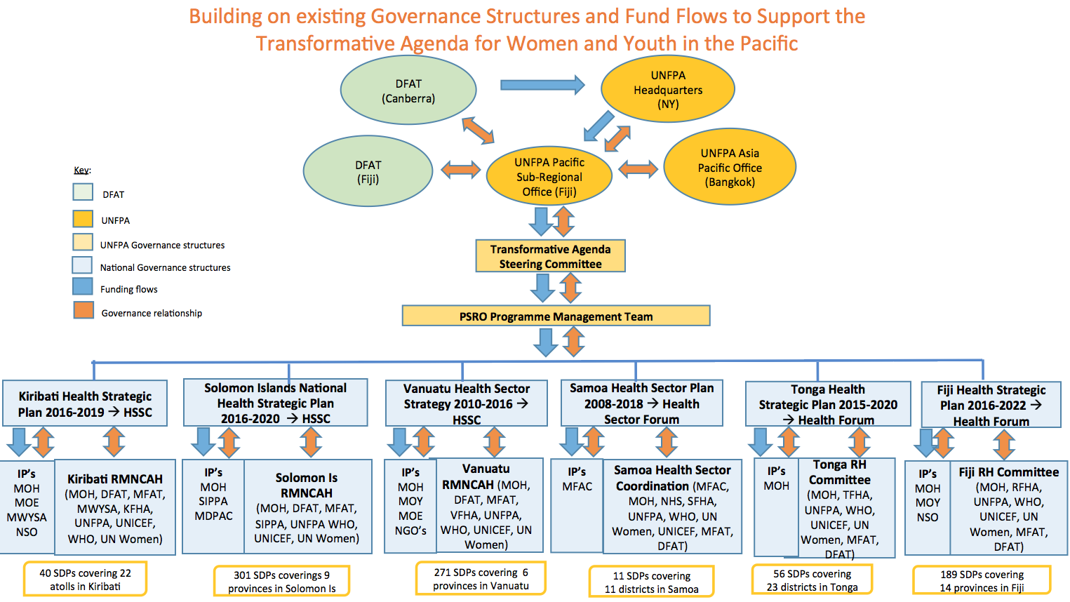

Figure 18

Membership of the TASC will include:

* DFAT (representatives of Health Policy Branch which has responsibility for the Transformative Agenda, Counsellor Development, Suva Post and other designated Suva Post officers); UNFPA (UNFPA’s Pacific PSRO Director and other designated PSRO officers)
* Other invited agencies involved in supporting the Transformative, as agreed between DFAT and UNFPA (e.g. Programme counterpart ministry representatives, representatives of collaborating NGOs and sister UN agencies). It should be noted that participation of these agencies on the Transformative Agenda Technical Working Group may suffice to ensure effective collaboration (see below).

Prior to the first TASC meeting, DFAT and UNFPA will finalise agreement on the composition, chairing arrangements and decision-making powers of each member. The TASC will be responsible for:

* providing strategic oversight of the Transformative Agenda’s progress and achievements ensuring Programme coherence and
* receiving updates on progress and issues (results of activities completed / ongoing).

At the Annual Meeting, the TASC will also:

* receive presentations of proposed activities (higher level interventions), budgets,
* agree priorities for the following 12-month period,
* endorse the Transformative Agenda’s Annual Report and Workplan, and
* review updates of the Transformative Agenda’s risk register.

## Technical Governance

The existing RMNCAH Technical Working Group (TWG) will continue to meet until the end of 2019. In 2018 and 2019, when TWG meetings are convened, UNFPA will also convene Transformative Agenda Technical Team (TATT) meetings (back to back wherever possible) and alongside the quarterly Health Partners’ Meeting whenever possible.

The RMNCAH TWG and the TATT will meet quarterly to oversee Transformative Agenda technical activities and ensure regional agencies’ technical capabilities are capitalized upon in a coordinated and efficient manner.

TATT meetings will comprise UNFPA Technical Advisers and Programme Specialists and DFAT representatives from Health Policy Branch. DFAT technical representation from Suva Post will also be invited. The role of the TATT is to oversee Transformative Agenda technical activities, and provide overarching technical governance and input into Transformative Agenda work. When TWG meetings end in December 2019, relevant business will be transferred to the TATT meetings.

In addition to the core membership mentioned above, the TATT will be complemented by co-opting UNICEF, WHO, IPPF, CROP agencies and MFAT as needed.

## Administration and Reporting[54]

(This section extracted directly from the Strategic Partnership Framework between the Australian Government and the United Nations Population Fund 2016-2020)

* Programme management and expenditures will be governed by the regulations, rules and policies and procedures of UNFPA
* UNFPA will maintain appropriate accounting records in accordance with UNFPA Financial Regulations and Rules, policies and procedures in respect of the receipt and utilisation of each DFAT contribution.
* UNFPA will submit the following reports to DFAT:
  + One progress report regarding the programme prior to each disbursement as provided in the relevant Subsidiary Arrangement,
  + One final progress report with regard to the programme within six (6) months of the date of operational completion of the programme or, in the event of termination of the Subsidiary Arrangement, following such termination
  + One annual financial statement regarding the contribution certified by an authorised official of UNFPA (finance branch, division for management services, UNFPA) as of 31 December of the year in question, to be submitted no later than 30 June of the following year.
  + One final financial statement regarding the contribution certified by an authorised official of UNFPA (Finance Branch, Division for Management Services, UNFPA) to be submitted no later than 30 June following the year in which the programme was operationally completed.
* The first two of the above reports will comprise narrative and interim (uncertified) financial information. Annual and final progress reporting will be results-oriented and evidence based, include a comparison of actual results with expected results at the Output, Outcome and Programme Objective level, with explanations for over or under-achievement. The final progress report will also contain an analysis of how the Outputs and Outcomes have contributed to the overall impact of the programme at the Programme Objective level.
* All statements will be expressed in US dollars.
* In addition to formal reporting arrangements stipulated above, UNFPA will keep DFAT informed of progress, challenges and key issues for the programme as they arise, through contact with the person named in the Subsidiary Arrangement.
* UNFPA will give DFAT prior notice in writing if it proposes to make any substantive changes to the program. If DFAT believes such proposed changes would significantly impair the development and/or humanitarian value of the programme, DFAT and UNFPA will consult on measures to address DFAT’s concerns. In the event such changes are implemented without DFAT’s consent, DFAT may modify or terminate its financial contribution to the programme, subject to the settlement, by UNFPA, of all the programmes outstanding commitments and liabilities which have been necessarily and reasonably incurred by UNFPA and which are properly chargeable to DFAT.

**Auditing[55]**

* The contribution will be subject exclusively to the internal and external auditing procedures provided for in UNFPA’s Financial Regulations and Rules, policies and procedures.
* Reports on the audit of the financial statements of UNFPA by the United Nations Board of Auditors become public documents by reason of being transmitted through the Advisory Committee on Administrative and Budgetary Questions to the United Nations General Assembly.

**Annual Workplan**: UNFPA will provide DFAT with an annual narrative and financial work plan within one month of the date of commencement of this Programme (Year 1), and in subsequent years, together with the Annual Report. This workplan will comprise of country level workplans and a regional workplan. The workplans include all funding sources recorded in our financial system and clearly indicate where Australian funds have been expended consistent with the Budget prepared in this Design Document.

Country level annual workplans will be developed between UNFPA, national government counterparts and NGOs/CBOs, as relevant, in each country in Q4 (Oct-Dec) of each year. Government will be required to approve the workplans. Preparations for the national level workplans will involve national consultations in the six countries with partners from each sector (health, education, statistics offices, youth, women and NGO partners) who are UNFPA’s implementing partners.

The workplan will include:

• the agreed strategic direction of the Transformative Agenda over the coming year

• policy and institutional context of the Transformative Agenda

• key investments for the year and their delivery modalities, implementing agencies, expected outcomes, timeframes and a detailed budget at Output level

• UNFPA’s plan for monitoring performance based on the results framework for the year

* operational risks and mitigation strategies.

**Annual Report:** UNFPA will provide an Annual Report to DFAT no later than three weeks prior to the agreed date of Annual Meetings. The Annual report will comply with DFAT reporting requirements. It is intended that the Annual Report will be a publically available document to build mutual understanding amongst all relevant partners engaged in SRH. The report will include a concise narrative and financial report providing the following information for the preceding reporting period:

* summary of the political economy context
* summary of the major achievements during the reporting period
* report against the Transformative Agenda’s Monitoring and Evaluation Framework
* progress against the Annual Work plan
* Transformative Agenda management – the goods and services provided
* the tranches and amounts received from DFAT during this period as per Agreement, financial summary, budget and expenditure and forward revenue and expenditure, financial audit and risk
* any problems encountered and the actions taken to resolve those problems and prevent re-occurrence
* lessons learned and recommendations for improvement
* updates and issues relating to the future delivery of goods and service, and
* tasks or jobs not completed in accordance with the Contract.

Key **Issues Brief**: UNFPA will also provide a summary (5 – 7 pages) ‘key issues’ brief to TASC members no later than three weeks prior to the agreed date of six monthly meetings. They key issues brief will highlight, for the preceding six months period: key successes; key challenges, delays or other issues affecting implementation; and outline approaches to addressing those issues, for review and approval by the TASC.

### DFAT’S Role

The Transformative Agenda will fall under the responsibility of the Health Programme and Performance Section (HPR), Health Policy Branch in DFAT Canberra. A DFAT HPR officer will oversee implementation of the Transformative Agenda. Specifically, the DFAT Programme Management Team will:

* provide strategic guidance and operational oversight of the Transformative Agenda
* manage DFAT’s relationship and agreement with UNFPA
* agree UNFPA’s annual work plan for the Transformative Agenda or otherwise request changes in writing (DFAT will take no more than 1 week to provide such a request in writing in order to minimise impacting program implementation)
* monitor the Transformative Agenda’s compliance with DFAT’s policies, including in relation to safeguards, risk, fraud and communication.

### UNFPA’S Role

UNFPA will be responsible for the day-to-day management and implementation of the Transformative Agenda in a manner that effectively and efficiently achieves the Transformative Agenda’s Programme Objective and Outcomes, and that is consistent with the requirements of the Strategic Partnership Framework 2016-2020. UNFPA will liaise directly with the nominated DFAT Programme manager in HPR Canberra and also engage with the Counsellor, Development Cooperation in Suva, as needed. The below outlines further detail regarding how UNFPA will manage the Transformative Agenda at the PRSO level and at country level. Also described are key financial management processes.

## UNFPA Management and Administration

### PRSO Level

As depicted in Annex 3, PSRO’s existing Senior Management Team has overall responsibility for operations in the Pacific, including the implementation of the SRPD6, which includes the Transformative Agenda. This is undertaken in full compliance with UNFPA’s regulations, policies and procedures. The Senior Management Team is supported by a dedicated Programme Management Team that includes senior level technical and programme advisors. This Programme Management Team provides technical and operational oversight for all of UNFPA’s programmes (including planning, monitoring and evaluation), funded through both core and non-core resources, in close coordination with UNFPA field staff in the relevant countries. Within this Programme Management Team is a strong Operations Team that ensures cost-effective delivery of programme support. Senior advisors in Suva ensure that all country-based teams are provided with high quality thought leadership in each of the areas of transformative intervention. They will work closely with country-based colleagues to adapt lessons learned from global experience to the Pacific context, and rigorously assess performance against agreed targets. For the Transformative Agenda, the PRSO Programme Management Team will provide substantive programme and technical oversight, financial management support, and undertake overall joint programme planning, monitoring and reporting, under the leadership of the Deputy Director of PSRO.

For routine UNFPA management across the Transformative Agenda, the following will be undertaken:

* regular programme meetings by teleconference with UNFPA country teams to facilitate progress updates and to identify any issues and bottlenecks that may require action from Suva
* Regular monthly integrated country focused teleconference consultations.
* Field visits, timed to coincide with development partners sectoral meetings, to provide support and dialogue with local partners such as Ministries of Health and Medical Services, Ministries of Education, Ministries of Youth, Ministries of Women, Ministries of Finance/NSO, Planning and Aid coordination and NGOs, in order to appraise progress of implementation.

In order to support the increased investment and throughput of resources, an international P2 level Quality assurance officer, a G5 national procurement assistant, and a G7 programme finance officer will support the operations team in Suva. To strengthen the analytic requirements and ensure results are carefully monitored and visualized, two national G6 research assistants will be recruited. Furthermore, and in order to ensure a rapid scale-up of overall programming capacity for the Transformative Agenda, a programme manager will be recruited on a contractual basis for the duration of the programme*.*

### Country Level Management

As described earlier, UNFPA aims to rapidly scale up the ability to support existing national systems to deliver on the mutually agreed Programme Objective, Outcomes and Outputs of the Transformative Agenda. Implementation at national and sub-national levels will take place predominantly through key government ministries (and NGOs as appropriate), supported by an expanded UNFPA field presence.

An important factor in the success of the Transformative Agenda will be effective engagement with Governments, under the latter’s leadership. The Transformative Agenda will fully engage the local health authorities and key national partners with careful consultation and planning in the early stages and subsequent agreement on implementation approaches and on performance monitoring frameworks and accountability requirements. The consultation will ensure that the approaches taken are feasible and acceptable, and that local ownership is built at the outset, especially as expansion to all SDPs is envisaged. Below are the agencies with which UNFPA will engage in formalized partnerships.

* The Ministry of Health and Medical Services, Ministry of Education, and Ministry Youth are the primary implementers with whom Letters of Agreements will be signed. They will work in partnership with the Departments for Women, WHO, UNICEF, UN Women and key NGO partners such as IPPF national member associations, and other relevant government sectors working on VAWG. The Ministry of Finance will be fully engaged as appropriate.
* The Ministry of National Planning and Aid Coordination, or whichever Ministry hosts the National Statistics Office, will be a key implementing partner working in close coordination with its provincial and sub-national offices and other key ministries.
* A Letter of Understanding will also be signed with SPC and UNICEF to exploit collaborative advantages and ensure maximum synergy in data related programmes, in particular the census, MICS and DHS.

In Kiribati, Solomon Islands, and Vanuatu, the health sector component of the Transformative Agenda will be managed under the current RMNCAH model, which streamlines support from UNFPA, UNICEF and WHO, reducing transaction costs for both government and the UN as funds flow through the one agency. This model will be explored for adaptation in Fiji, Samoa and Tonga, given its success in bringing key partners together in existing RMNCAH countries.

### Country Level Steering/Coordinating Mechanisms

**Kiribati, Solomon Islands and Vanuatu**: National RMNCAH Committees (within the broader health sector planning and coordination context), are in place in Kiribati, Solomon Islands and Vanuatu and will be continued for the duration of the Transformative Agenda as the country level steering committee mechanism for these three countries. The roles and functions of these existing national RMNCAH committees will be reviewed and expanded in liaison with partner countries to provide high level oversight for the additional investments that will be made. The committees may be expanded to consider the involvement of other sectors including NGOs as implementing partners.

**Fiji, Samoa and Tonga**: In Fiji, Samoa and Tonga, existing country SRH coordinating mechanisms will be utilized and expanded upon, led by local government and other stakeholders. These are:

* Fiji – Family Health Committee
* Tonga – SRH Coordinating Committee
* Samoa – SRH Coordinating Committee

UNFPA will build on these mechanisms in their capacity to provide coordination of country-level SRH activity, while also looking to strategically co-opt additional sectors such as education, women and youth. The country SRH steering/coordinating committees will meet quarterly, and their role will include:

* bringing together all country stakeholders involved in the provision of SRH information and services, or in SRH legislative, policy or budgetary activities
* sharing and discussing lessons learned, and ways to improve SRH services, information and the enabling environment
* addressing implementation issues, risks, and guiding implementation progress;
* making recommendations on initiatives and innovations to be considered for adoption, technical assistance requirements; and
* overseeing and planning monitoring implementation of the Transformative Agenda, including any needs for reprogramming.

UNFPA will provide secretariat support to each of the respective MOHs to convene and lead the Country SRH Coordinating/Steering Mechanism. The mechanism will be accountable to the Director General of Health, or equivalent, and will meet quarterly and ad hoc if necessary.

## Level and Timing of DFAT disbursements

As timely disbursement of funds is critical, an agreement between DFAT and UNFPA will be established during the Exchange of Letters. Additionally, as DFAT, UNFPA and various implementing partners have different financial and administrative calendars, it will be necessary to develop a clear schedule of when payments are envisaged:

 Payment Schedule:

|  |  |  |  |
| --- | --- | --- | --- |
|  | **Date payment is due** | **Currency/Amount:** | **Payment Trigger** |
| 1. | May 2018 | AUD7,500,000 | On signing of EOL |
| 2. | May 2019 | AUD7,500,000 | Acceptance by DFAT of Annual Report and Workplan |
| 3. | May 2020 | AUD7,500,000 | Acceptance by DFAT of Annual Report and Workplan |
| 4. | May 2021 | AUD7,500,000 | Acceptance by DFAT of Annual Report and Workplan |

## Risk Management

There are a number of important risks associated with implementing the Transformative Agenda. These are outlined in the Risk Matrix in Annex 6. Many of these risks are beyond UNFPA’s control, but strategies will be put in place to manage risks as they arise. For example, political opposition to SRH and family planning/contraception is a likely risk in some priority countries. UNFPA’s approach to this is to engage in high-level advocacy supported by strong metrics and infographics, and continue to make links between SRH and the SDGs, poverty reduction and the potential of a demographic dividend. These activities are built into the Transformative Agenda, but UNFPA will also undertake broader regional advocacy to mitigate this risk.

The challenging environments for SRH in several of the priority countries also pose a risk to achieving the Transformative Agenda’s outputs and outcomes. To mitigate this, UNFPA has designed the Transformative Agenda to include baseline assessments. In this way, subsequent action during implementation can target specific geographic areas or population groups with additional efforts to achieve objectives. This enables realistic action and avoids overly ambitious goal-setting.

UNFPA has internal systems that must be followed and UNFPA will take all precautions to ensure these do not impact negatively on progress. Top amongst these risks is the risk of delayed recruitment of key Transformative Agenda personnel. Risks will be regularly monitored during TASC meetings and the Transformative Agenda Working Group will also examine emerging risks to the technical integrity of the Transformative Agenda (as will country Coordinating Mechanisms). Furthermore, a robust formative evaluation alongside thematic evaluations, baseline data and rigorous monitoring of progress against desired results will assist in systematically identify challenges in a timely fashion and setting the stage for taking any required mitigating action.

**Child Protection**: Australia is a signatory to the United Nations Convention on the Rights of the Child and UNFPA will not engage in any practice inconsistent with the rights set forth in the Convention on the Rights of the Child. DFAT’s commitment to upholding the rights and obligations under this convention is reflected in the DFAT Child Protection Policy which UNFPA acknowledges. With respect to funds provided under the Transformative Agenda, UNFPA is responsible for protecting children from abuse in accordance with the principles set out under the UN Convention on the Rights of the Child and within its own governance and policy framework.  Globally, UNFPA itself is part of the Interagency Standing Committee (IASC) Task Force on Accountability to Affected Populations (AAP) and the Task Force on Prevention of Sexual Exploitation and Abuse (PSEA) which states zero tolerance of UNFPA and its partners to sexual abuse and exploitation. All UNFPA PSRO staff have recently completed the PSEA course as a mandatory exercise. The obligation to adhere to the AAP/PSEA code of conduct also extends to UNFPA’s partners.

1. Budget

A summary budget is presented below.

|  |  |  |  |
| --- | --- | --- | --- |
| **Cost Description** | | **Total DFAT Transformative Agenda 2018-2022 (in AUD)** | **UNFPA core resources**  **2018-2022**  **(in USD)** |
| Programme activities and operations | Outcome 1: Supply | $6,613,945 |  |
| Outcome 2: Demand | $5,095,420 |
| Outcome 3: Enabling environment | $5,985,160 |
| Planning, monitoring and evaluation | $833,333 |
| Total amount for programs | $18,527,778 | $7,000,000 |
| Human Resources | | $9,250,000 | $7,500,000 |
| Overhead/Indirect costs | | $2,222,222 | - |
| **TOTAL BUDGET** | | **AUD$30,000,000** | **$14,500,000** |
| **In US Dollars** | | **US$23,700,000** | **$14,500,000** |

The following should be noted:

* Total DFAT contribution for the 51-month Transformative Agenda is AUD $30 million.
* 8% will go towards overhead/indirect costs.
* Approximately one third of the contribution will go towards supporting a scaled up PSRO human resource structure with expanded field presence and expertise to ensure stronger programme management and to achieve greater impact.
* Approximately 3% will be dedicated to planning, monitoring and evaluation, including a pre-evaluability study, midterm and end-of-year evaluations.

During preparation of the SRPD6 for 2018-2022, a structured analysis of the requirements to deliver each of the designated 16 core output indicators was undertaken in the thematic areas of SRH, FLE, Gender and Population and Data. This analysis was conducted through common country assessments, country consultations and a systematic review of the preceding SRP5 2013-2017. Resource allocations required to achieve SRP6 outcomes were based on costing estimations for each of the interventions and activities plus staff cost.

This costing analysis was used as a reference for strategic allocation of DFAT’s funds to achieve the seven outputs under the three outcomes in the Transformative Agenda (Figure 19). In addition, annual budget allocations were based on milestones and deliverables per year. In line with the fiscal calendar year for DFAT, the first tranche disbursement of the Transformative Agenda funds is anticipated in mid-2018, with the 51-month programme cycle ending in June 2022. The budget allocated to the seven outputs will require flexibility for year-to-year adjustments based on midterm and annual evaluations of programme implementation and changing priorities of activities and interventions based on environmental and political scanning.

Budget allocation has also taken into consideration other resources and projects that will already be contributing to achievement of the seven outputs in the six priority countries, which have been described in Section 4.3 under ‘Existing UNFPA Activities’. For example, the Contraceptive Social Marketing project will be focusing on demand generation through BCC strategies and capacity building of service providers in one or two PICTs, which will contribute to Output 3, while the UNFPA Supplies programme will support SRH and contraceptive commodities in all PICTS, in addition to strengthening national supply chain management.

|  |  |  |  |  |  |  |
| --- | --- | --- | --- | --- | --- | --- |
| **Figure 19: WORK PLAN & BUDGET 2018-2022**  **\*Output allocations may vary year to year based on shifting priorities and roll-over amounts from previous year** | | | | | |  |
| **Outcomes and Outputs** | | **2018-2019** | **2019-2020** | **2020-2021** | **2021-2022** | **Total Amount (AUD)** |
| **Outcome 1: INCREASED AND IMPROVED SUPPLY OF INTEGRATED SRH INFORMATION AND SERVICES, PARTICULARLY FOR FAMILY PLANNING** | | | | | | |
| **OUTPUT 1 STRENGTHENED DELIVERY OF HIGH QUALITY, INTEGRATED SEXUAL AND REPRODUCTIVE HEALTH INFORMATION AND SERVICES FOR WOMEN, ADOLESCENTS AND YOUTH ACROSS THE DEVELOPMENT HUMANITARIAN CONTINUUM** | | | | | | |
| **SUB - TOTAL 1** | | **755,730** | **755,730** | **755,730** | **755,730** | **$3,022,920** |
| **OUTPUT 2 STRENGTHENED HEALTH WORKFORCE CAPACITIES IN HEALTH MANAGEMENT AND CLINICAL SKILLS FOR HIGH-QUALITY AND INTEGRATED SEXUAL AND REPRODUCTIVE HEALTH SERVICES** | | | | | | |
| **SUB - TOTAL 2** | | **897,737** | **897,737** | **897,737** | **897,734** | **$3,590,945** |
| **SUB-TOTAL OUTCOME 1** | | **1,653,467** | **1,653,467** | **1,653,467** | **1,653,464** | **$6,613,865** |
| **OUTCOME 2: INCREASED DEMAND FOR INTEGRATED SRH INFORMATION AND SERVICES, PARTICULARLY FOR FAMILY PLANNING** | | | | | | |
| **OUTPUT 3 INCREASED COMMUNITY ENGAGEMENT AND LEADERSHIP IN SUPPORT OF SRH, ESPECIALLY CONTRACEPTIVE CHOICE** | | | | | | |
| **SUB-TOTAL 4** | | **538,675** | **538,675** | **538,675** | **538,675** | **$2,154,700** |
| **OUTPUT 4 INCREASED NATIONAL CAPACITY TO DESIGN AND IMPLEMENT COMMUNITY- AND SCHOOL-BASED FAMILY LIFE EDUCATION (FLE) PROGRAMMES THAT PROMOTE HUMAN RIGHTS AND GENDER EQUALITY** | | | | | | |
| **SUB - TOTAL 5** | | **735,180** | **735,180** | **735,180** | **735,180** | **$2,940,720** |
| **SUB-TOTAL OUTCOME 2** | | **1,273,855** | **1,273,855** | **1,273,855** | **1,273,855** | **$5,095,420** |
| **OUTCOME 3: MORE CONDUCIVE AND SUPPORTIVE ENVIRONMENT FOR PEOPLE TO ACCESS AND BENEFIT FROM QUALITY SRH, ESPECIALLY CONTRACEPTIVE CHOICE** | | | | | | |
| **OUTPUT 5 EXPANDED EVIDENCE-BASED LEGISLATION, PUBLIC POLICY AND PROGRAMMING THAT SUPPORTS UNIVERSAL SEXUAL AND REPRODUCTIVE HEALTH AND RIGHTS, ESPECIALLY FOR YOUTH, VIOLENCE SURVIVORS AND PERSONS WITH DISABILITIES** | | | | | | |
| **SUB-TOTAL 6** | | **666,890** | **666,890** | **666,890** | **666,890** | **$2,667,560** |
| **OUTPUT 6 INCREASED AVAILABILITY, ANALYSIS AND USE OF HIGH-QUALITY, DISAGGREGATED NATIONALLY PRIORITIZED POPULATION AND SRH DATA** | | | | | | |
| **SUB-TOTAL 7** | | **829,400** | **829,400** | **829,400** | **829,400** | **$3,317,600** |
| **SUB-TOTAL OUTCOME 3** | | **1,496,290** | **1,496,290** | **1,496,290** | **1,496,290** | **$5,985,160** |
| **TOTAL FOR PROGRAM ACTIVITIES** | | **4,423,612** | **4,423,612** | **4,423,612** | **4,423,609** | **$17,694,445** |
| **Planning, Monitoring and Evaluation** | | **208,333** | **208,332** | **208,332** | **208,336** | **$ 833,333** |
| **Human Resources** | | **2,312,500** | **2,312,500** | **2,312,500** | **2,312,500** | **$9,250,000** |
| **TOTAL DIRECT COSTS** |  | **6,944,445** | **6,944,444** | **6,944,444** | **6,944,445** | **$27,777,778** |
| **Overhead/Indirect Costs** | | 555,555 | 555,556 | 555,556 | 555,555 | **$2,222,222** |
| **TOTAL BUDGET** | | **7,500,000** | **7,500,000** | **7,500,000** | **7,500,000** | **30,000,000** |

9. Monitoring and Evaluation

PSRO will oversee the Transformative Agenda of bringing unmet need towards zero in the Pacific by utilizing a robust results-based management (RBM) approach. As demonstrated in the Key Sexual and Reproductive Health Indicators (Figure 3), the best available data have been utilized to identify areas that require priority intervention, and a theory of change has been built around each relevant component (Figure 17). The outcomes and impact to be achieved are clearly defined (see Figure 20), and a series of outputs and strategic interventions have been articulated in Section 6.

|  |  |
| --- | --- |
| Programme  Goal | Transformative change in the lives of women, adolescents and youth across the Pacific by 2022 |
| Programme  Objective | To move unmet need for family planning in the Pacific towards zero by 2022. |
| Programme Outcomes | 1. Increased and improved supply of integrated SRH information and services, particularly for family planning  2. Increased demand for integrated SRH information and services, particularly for family planning  3. More conducive and supportive environment for people to access and benefit from quality SRH, especially contraceptive choice |

Figure 20. Expected Impact of the Transformative Agenda

UNFPA will deploy its own RBM tools to ensure effective management of the investment. Annex 7 presents some of the activities and tools by which they will do this. PSRO will work closely with the target countries and key stakeholders to jointly plan for, implement, monitor, report on and evaluate the programme.

DFAT’s M&E focus will be on demonstrated, measurable progress of impact at the Outcome, Programme Objective and Goal level. In this way, concrete and measurable progress toward positive transformation in the lives of women, adolescents and youth in the Pacific can be measured. UNFPA have developed a draft M&E framework for this purpose that will be central to all UNFPA-DFAT M&E discussions and activities during the life of the Transformative Agenda (Figure 21). Essentially, the approach taken will be that the litmus test of the investment will be progress with reducing unmet need, with progress on each of the three contributory outcomes also being monitored by a small number of relevant indicators. Meanwhile, monitoring at the lower, Output level will be more of a function of UNFPA’s management and less of a focus for DFAT’s strategic engagement with UNFPA on the Transformative Agenda.

The monitoring information generated will feed into four key evaluation questions that need to be asked irrespective of the type and scope of the evaluation: Is the transformative agenda doing the right thing; is it being done right; is it achieving its goals; and are there better ways of achieving them?

UNFPA have ensured that the indicators in the M&E Framework draw on indicators in the SRPD6 document. Wherever possible, indicators also align with those already being monitored by the PICTs in the context of SDG, ICPD and Healthy Islands frameworks. Baselines and targets are being established and it expected that the M&E Framework will continue to evolve over the first three months of implementation.

Given the critical results focus of the SRPD and Transformative Agenda, a minimum of 3% of available resources will be dedicated to a strategic selection of planning, monitoring and evaluation effort. Within this, PSRO envisages an Evaluability Study at the onset of programme investments, complemented by 2-3 prospective thematic evaluations that will bring evidence to bear on both the mid-term review as well as the final evaluation. The evaluability assessment will include a structured exercise to determine the overall readiness of the programme to be evaluated in a reliable and credible fashion and validate the coherence and logic of the programme. This assessment will clarify specifically what can be monitored and measured from the results framework on an annual, mid-term and end-of program cycle, as well as identify 2-3 areas for prospective thematic evaluation designed to better understand some of the underlying socio-cultural or systemic bottlenecks that may need to be addressed.

**Figure 21: Draft Monitoring and Evaluation Framework for the Transformative Agenda**

| Results | Indicators[56] | Desired Trend and Progression | Country | Baseline (2017 or Near) | Target (2022) | Methodology/ Means of Verification | Frequency of Data Collection |
| --- | --- | --- | --- | --- | --- | --- | --- |
| Programme Goal:  Transformative change in the lives of women, adolescents and youth across the Pacific by 2022 | Number of unintended pregnancies averted | ⬂ | Fiji | TBD | TBD | Impact 2 (v3) Model Software, Marie Stopes International, 2015. WHO One Health Tool. | Annual |
| Kiribati | TBD | TBD |
| Samoa | TBD | TBD |
| Solomon Islands | TBD | TBD |
| Tonga | TBD | TBD |
| Vanuatu | TBD | TBD |
| Adolescent birth rate (10-14, 15-19) per 1000 women in that age group. | ⬂ | Fiji | 40.1 | Reduce ABR | Demographic Health Survey/ DHS Final Report.  Multiple Indicator Cluster Survey (MICS)/ MICS Final Report  Country Health Management Information System (HMIS) and Reports | Fiji DHS/MICS – 2019  Kiribati DHS/MICS – 2018 Samoa DHS/MICS – 2019 Solomon Islands DHS/MICS – 2021 Tonga DHS/MICS – 2019  Vanuatu DHS/MICS – 2019  HMIS – Annual (TBC) |
| Kiribati | 49 | Reduce ABR |
| Samoa | 39 | Reduce ABR |
| Solomon Islands | 77 | Reduce ABR |
| Tonga | 27 | Reduce ABR |
| Vanuatu | 81 | Reduce ABR |
| Programme Objective:  To move unmet need for family planning in the Pacific towards zero by 2022 | Proportion of women of reproductive age (15-49) who have their need for family planning satisfied with modern methods. | ⬀ | Fiji | 68.16[57] | Increase PDS | Demographic Health Survey/ DHS Final Report.  Multiple Indicator Cluster Survey (MICS)/ MICS Final Report  Country Health Management Information System (HMIS) and Reports | Fiji DHS/MICS – 2019  Kiribati DHS/MICS – 2018 Samoa DHS/MICS – 2019 Solomon Islands DHS/MICS – 2021 Tonga DHS/MICS – 2019  Vanuatu DHS/MICS – 2019  HMIS – Annual (TBC) |
| Kiribati | 37.88 | Increase PDS |
| Samoa | 79.06 | Increase PDS |
| Solomon Islands | 36.07 | Increase PDS |
| Tonga | 47.89 | Increase PDS |
| Vanuatu | 51.33 | Increase PDS |
|  |  |  |  |  |  |  |
|  |  |  |
|  |  |  |
|  |  |  |
|  |  |  |
|  |  |  |
| Contraceptive Prevalence Rate (modern method) | ⬀ | Fiji | 49.1 | Increase CPR | Demographic Health Survey/ DHS Final Report.  Multiple Indicator Cluster Survey (MICS)/ MICS Final Report  Country Health Management Information System (HMIS) and Reports | Fiji DHS/MICS – 2019  Kiribati DHS/MICS – 2018 Samoa DHS/MICS – 2019 Solomon Islands DHS/MICS – 2021 Tonga DHS/MICS – 2019  Vanuatu DHS/MICS – 2019  HMIS – Annual (TBC) |
| Kiribati | 13.6 |  |
| Samoa | 15.1 (2014) | Increase CPR |
| Solomon Islands | 17.6 (2015) | Increase CPR |
| Tonga | 28.4 (2012) | Increase CPR |
| Vanuatu | 28.9 (2013) | Increase CPR |
| Programme Outcome 1:  Increased and improved supply of integrated SRH information and services, particularly for family planning | Couple-Years Protection (By method) | ⬀ | Fiji | TBD | Increase CYP | Country Health Management Information System (HMIS) and Reports | HMIS – Annual (TBC) |
| Kiribati | TBD | Increase CYP |
| Samoa | TBD | Increase CYP |
| Solomon Islands | TBD | Increase CYP |
| Tonga | TBD | Increase CYP |
| Vanuatu | TBD | Increase CYP |
| Number of new acceptors of modern methods of contraception by age | ⬀ | Fiji | 0 | 18499 | Demographic Health Survey/ DHS Final Report.  Multiple Indicator Cluster Survey (MICS)/ MICS Final Report  Country Health Management Information System (HMIS) and Annual Reports | Fiji DHS/MICS – 2019  Kiribati DHS/MICS – 2018 Samoa DHS/MICS – 2019 Solomon Islands DHS/MICS – 2021 Tonga DHS/MICS – 2019  Vanuatu DHS/MICS – 2019  HMIS – Annual (TBC) |
| Kiribati | 0 | 2920 |
| Samoa | 0 | 410 |
| Solomon Islands | 0 | 17030 |
| Tonga | 0 | 2563 |
| Vanuatu | 0 | 7116 |
| Percentage of 402 SDPs that are providing at least 3 modern methods of contraception (primary) on the day of assessment. | ⬀ | Fiji | TBD | 100% | Country Health Management Information System (HMIS) and Reports. Rapid Assessment | HMIS – Annual (TBC) |
| Kiribati | TBD | 100% |
| Samoa | TBD | 100% |
| Solomon Islands | TBD | 100% |
| Tonga | TBD | 100% |
| Vanuatu | TBD | 100% |
| Percentage of 466 SDPs that are providing at least 5 modern methods of contraception (secondary/tertiary) on the day of assessment. | ⬀ | Fiji | TBD | 100% | Country Health Management Information System (HMIS) and Reports. Rapid Assessment | HMIS – Annual (TBC) |
| Kiribati | TBD | 100% |
| Samoa | TBD | 100% |
| Solomon Islands | TBD | 100% |
| Tonga | TBD | 100% |
| Vanuatu | TBD | 100% |
| Percentage of SDP stock-out by family planning method or product (day of last visit/last 3 months). | ⬂ | Fiji | TBD[58] | 0% | Country Health Management Information System (HMIS) and Reports, Country Quarterly RHCS Reports | HMIS – Annual (TBC)  RHCS - Quarterly |
| Kiribati | TBD | 0% |
| Samoa | TBD | 0% |
| Solomon Islands | TBD | 0% |
| Tonga | TBD | 0% |
| Vanuatu | TBD | 0% |
| Percentage of SDPs providing quality-assured, adolescent friendly, integrated SRH services*.* | ⬀ | Fiji | 0% | ≥75% | Country Health Management Information System (HMIS) and Reports | HMIS – Annual (TBC) |
| Kiribati | 0% | ≥75% |
| Samoa | 0% | ≥75% |
| Solomon Islands | 0% | ≥75% |
| Tonga | 0% | ≥75% |
| Vanuatu | 0% | ≥75% |
| By 2022, all 868 SDPs have at least one member of staff available and fully trained in youth-friendly, disability-inclusive family planning service provision. | No->Yes | Fiji | No | Yes | Country Health Management Information System (HMIS) and Reports | HMIS – Annual (TBC) |
| Kiribati | No | Yes |
| Samoa | No | Yes |
| Solomon Islands | No | Yes |
| Tonga | No | Yes |
| Vanuatu | No | Yes |
| By 2022, all mobile services include one member of staff providing youth-friendly, disability-inclusive SRH service provision, able to deliver at least 3-5 modern methods of contraception. | No->Yes | Fiji | No | Yes | Country Health Management Information System (HMIS) and Reports | HMIS – Annual (TBC) |
| Kiribati | No | Yes |
| Samoa | No | Yes |
| Solomon Islands | No | Yes |
| Tonga | No | Yes |
| Vanuatu | No | Yes |
| By 2022, all six countries are conducting routine patient satisfaction surveys on the provision of SRH services and making the results publicly available. | No->Yes | Fiji | No | Yes | Country Health Management Information System (HMIS) and Reports | HMIS – Annual (TBC) |
| Kiribati | No | Yes |
| Samoa | No | Yes |
| Solomon Islands | No | Yes |
| Tonga | No | Yes |
| Vanuatu | No | Yes |
| Percentage of SDPs that are providing the ESP health services package for survivors of sexual violence. | ⬀ | Fiji | 0% | ≥25% | Country Health Management Information System (HMIS) and Reports |  |
| Kiribati | 0% | ≥25% |
| Samoa | 0% | ≥25% |
| Solomon Islands | 0% | ≥25% |
| Tonga | 0% | ≥25% |
| Vanuatu | 0% | ≥25% |
| Programme Outcome 2:  Increased demand for integrated SRH information and services, particularly for family planning | Number of in-school young people (disaggregated by disability status, sex, age and location) reached with Family Life Education. | ⬀ | Fiji | TBD | TBD | Country Education Management Information System and Reports; School surveys. | Quarterly, Annual |
| Kiribati | TBD | TBD |
| Samoa | TBD | TBD |
| Solomon Islands | TBD | TBD |
| Tonga | TBD | TBD |
| Vanuatu | TBD | TBD |
| Number of out-of-school young people (disaggregated by disability status, sex, age and location) reached with Family Life Education. | ⬀ | Fiji | TBD | TBD | Country Health Management Information System (HMIS) and Reports – FLE delivered through MOH Mobile clinic outreach and through YFHS Centres. Client/Participant information forms. FLE delivered through peer education. Pre and Post Training Survey of community participants. | Quarterly, Annual |
| Kiribati | TBD | TBD |
| Samoa | TBD | TBD |
| Solomon Islands | TBD | TBD |
| Tonga | TBD | TBD |
| Vanuatu | TBD | TBD |
| FLE delivered in all countries meets international standards (assess through spot checks and more systematic means) | No->Yes | Fiji | TBD | TBD | Country Education Management Information System and Reports – Survey and study of FLE implementation in country (Study will also include quality of teachers teaching FLE) | Annual |
| Kiribati | TBD | TBD |
| Samoa | TBD | TBD |
| Solomon Islands | TBD | TBD |
| Tonga | TBD | TBD |
| Vanuatu | TBD | TBD |
| Country has operationalized school based comprehensive FLE curricula in accordance with international standard. | No->Yes | Fiji | No | Yes | Country Education Management Information System and Reports – Survey and study of FLE implementation in country | Annual |
| Kiribati | No | Yes |
| Samoa | No | Yes |
| Solomon Islands | No | Yes |
| Tonga | No | Yes |
| Vanuatu | No | Yes |
| Proportion of young people and persons with a disability who state that they are aware of at least one BCC message over the past year. | ⬀ | Fiji | TBD | TBD | National Surveys; FLE (in-and-out of school) sessions pre-post-test; health services client questionnaires. | Annual |
| Kiribati | TBD | TBD |
| Samoa | TBD | TBD |
| Solomon Islands | TBD | TBD |
| Tonga | TBD | TBD |
| Vanuatu | TBD | TBD |
| Programme Outcome 3:  More conducive and supportive environment for people to access and benefit from quality SRH, especially contraceptive choice | By 2022, operational standards for integrated SRH services have been developed and are being implemented in all six countries [with key indicators for monitoring this to be agreed once guidelines developed] | No->Yes | Fiji | No | Yes | Survey of SOPs introduced by Ministry of Health 2018-2022 and their level of implementation, AWP Monitoring Tool/SOP document | Quarterly, Annual |
| Kiribati | No | Yes |
| Samoa | No | Yes |
| Solomon Islands | No | Yes |
| Tonga | No | Yes |
| Vanuatu | No | Yes |
| All countries have cervical cancer policies and guidelines and have taken steps to implement them. | No->Yes | Fiji | No | Yes | Country Health Management Information System (HMIS) and Reports – Survey of policies introduced by Ministry of Health 2018-2022 and their level of implementation | Quarterly Annually |
| Kiribati | No | Yes |
| Samoa | No | Yes |
| Solomon Islands | No | Yes |
| Tonga | No | Yes |
| Vanuatu | No | Yes |
| More people accept and support access to and use of contraception, including for youth and people living with disabilities | No->Yes | Fiji | No | Yes | Country Health Management Information System (HMIS) and Reports – National CPR Survey, Routine Patient Satisfaction Surveys | Annual |
| Kiribati | No | Yes |
| Samoa | No | Yes |
| Solomon Islands | No | Yes |
| Tonga | No | Yes |
| Vanuatu | No | Yes |
| Number of influential SRH analytical products - with potential to impact policy and practice - are produced and appropriately disseminated by UNFPA in each of the six countries. | ⬀ | Fiji | 0 | ≥2 | Review of UNFPA PSRO AWP Monitoring tool and Technical Support Plan Update/ Analytical products produced | Quarterly, Annual |
| Kiribati | 0 | ≥2 |
| Samoa | 0 | ≥2 |
| Solomon Islands | 0 | ≥2 |
| Tonga | 0 | ≥2 |
| Vanuatu | 0 | ≥2 |
| Policymakers use data and evidence on SRH to inform decision making related to policy and programming. | No->Yes | Fiji | No | Yes | Survey of policy makers in governments of these 6 countries – Ministry of Health, Ministry of Planning and other relevant policymakers related to UNFPA mandate Survey of policies introduced by Ministry of Health 2018-2022 and their level of implementation  - | Annual |
| Kiribati | No | Yes |
| Samoa | No | Yes |
| Solomon Islands | No | Yes |
| Tonga | No | Yes |
| Vanuatu | No | Yes |
| Countries have two data points for each of the core SRH Healthy islands Monitoring Framework and SDG indicators within the current 5 year timeframe (2018-2022) | No->Yes | Fiji | No | Yes | Desk Review Analysis and Stocktake of SRH Indicators/ UNFPA PSRO Database and SDG Updated Country Profiles, Country Demographic Health Surveys/ DHS Final Reports. | Annual and as per DHS schedule |
| Kiribati | No | Yes |
| Samoa | No | Yes |
| Solomon Islands | No | Yes |
| Tonga | No | Yes |
| Vanuatu | No | Yes |

ANNEXES

## Annex 1: Results and Resource Framework from Executive Board approved SRPD6

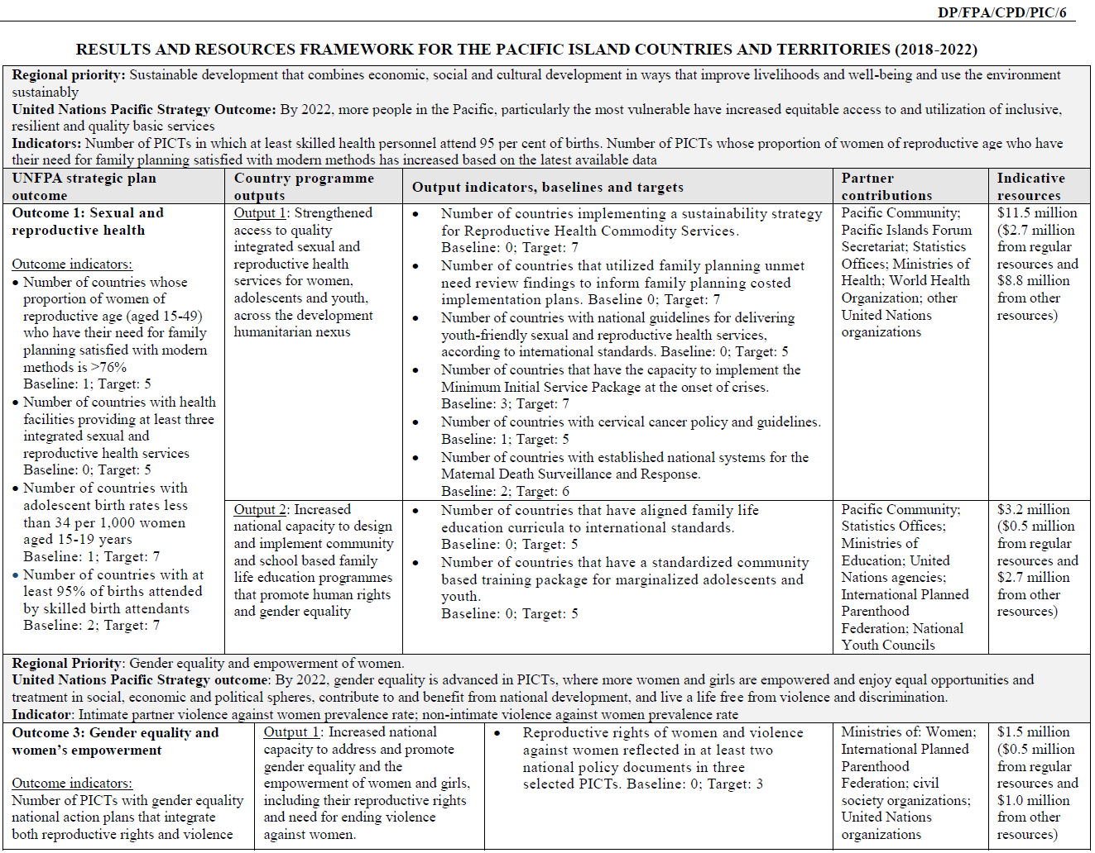

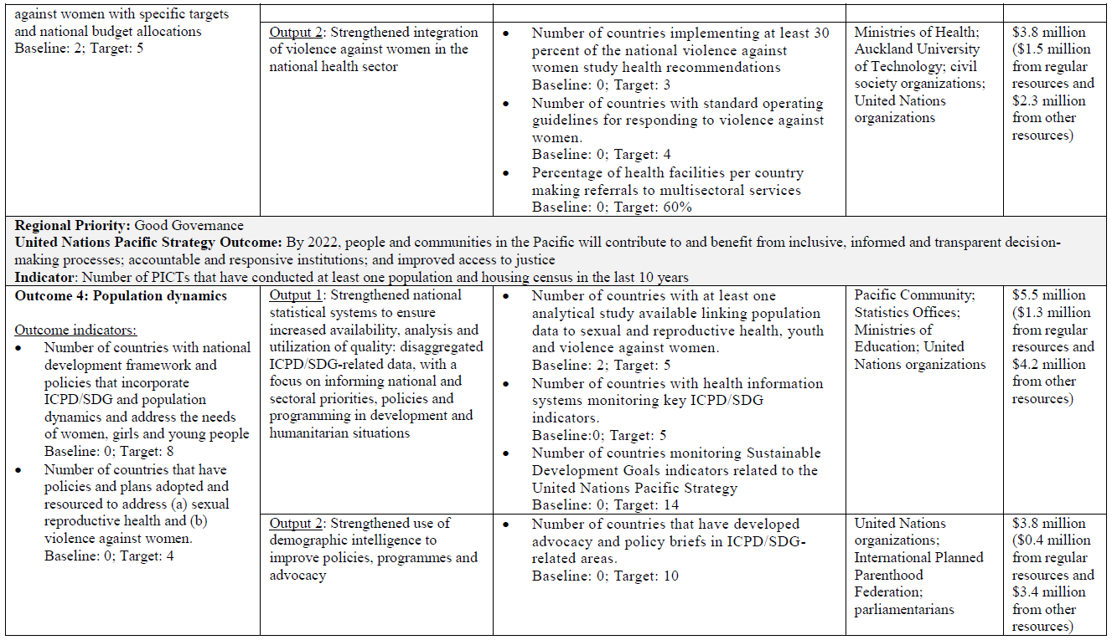

## Annex 2: Summary of funding UNFPA receives for existing programmes

|  |  |  |  |  |
| --- | --- | --- | --- | --- |
| **Project name** | **Funder** | **Focus countries** | **Amount** | **Funding year** |
| PRSRHP (Pacific Regional SRH Programme) | MFAT (NZ) | Kiribati, Solomon Islands, Vanuatu, Tonga, Samoa (5) | NZD $6,000,080 | Jun 2014-Jun 2019 |
| RMNCAH  *UNFPA is the lead programme management agency for the RMNCAH programme in Kiribati | DFAT (Aus) | Kiribati, Solomon Islands, Vanuatu (3) | AUD $6,900,000 | Jul 2015-Dec 2019 |
| Support for Jadelle® upscale and roll out | DFAT (Aus) | Solomon Islands | AUD $525,744 | Jun 2017-Nov 2018 |
| DHS Kiribati | DFAT (Aus) | Kiribati | AUD $1,000,000 | Jun 2017-Jun 2019 |
| Contraceptive Social Marketing | DFAT (Aus) | Fiji, Kiribati, Solomon Islands, Vanuatu, Tonga with focus on Vanuatu | AUD $3,000,000  ($500,000 for feasibility/design phase, $2.5 million for implementation phase) | Jun 2017-Jun 2020 |
| ESP Solomon Islands | DFAT (Aus) | Solomon Islands | USD $200,000 | Jul 2017-Jun 2019 |
| ESP Kiribati | DFAT (Aus) | Kiribati | USD $205,000 | Oct 2017-Jun 2019 |
| Pacific regional humanitarian prepositioning initiative | DFAT (Aus) | Fiji, Solomon Islands, Vanuatu, Tonga | AUD $3,000,000 for 8 countries in Asia Pacific | June 2016-June 2020 |
| Core/Regular resources | UNFPA | 14 PICTs | USD $2,900,000 per year | Jan 2018-Dec 2022 |
| UNFPA Supplies | DFAT[59] | 14 PICTs | Estimated USD $4.4 million | Apr 2018- Aug 2022 |

## 

## Annex 3: PSRO Proposed Organogram

**\***For indicative purposes only, based on internal UNFPA review processes

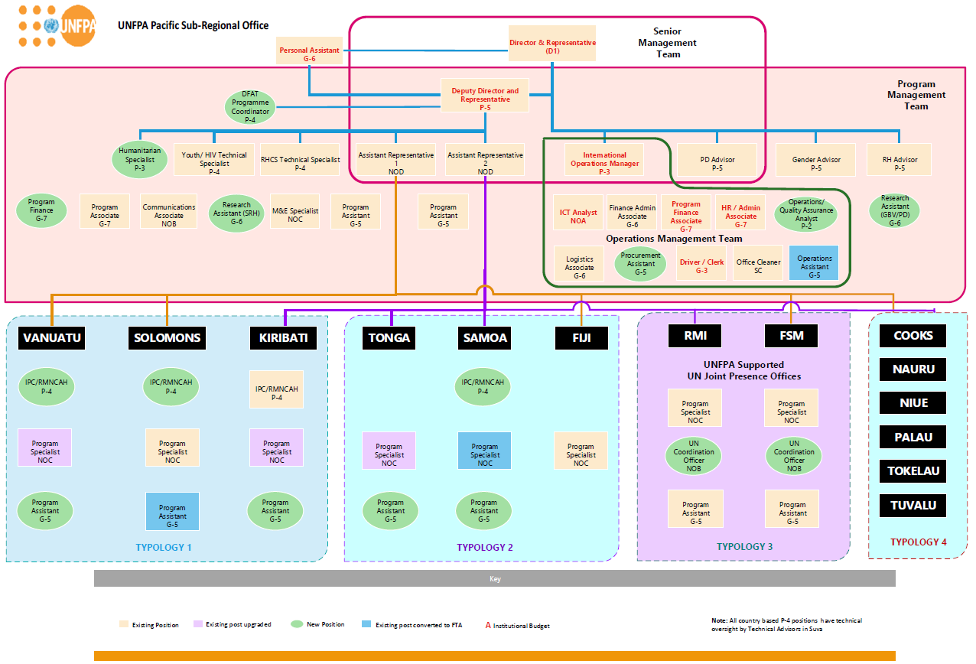

**UNFPAlogo**

## **Annex 4**: DETAILS OF SRH SPECIALIST ROLE (DRAFT)

**1. Organizational Location**

|  |
| --- |
| The SRH Specialist post is located in one of the UNFPA Field Offices of the Pacific (Kiribati, Solomon Islands, Vanuatu and Samoa), and reports directly to the Deputy Sub-Regional Director who provides overall leadership, and receives input from the Programme Management team based in Suva, on the overall programme strategy. S/he is part of an inter-disciplinary team, which provides integrated programme, technical and operational support in delivering the Transformational Agenda programme, supported by DFAT. |

**2. Job Purpose**

|  |
| --- |
| The SRH Specialist will work closely with partners to facilitate the coordination, management, monitoring and reporting of quality, timely and integrated technical and programme support to the country, ensuring that the agreed strategic interventions of the Transformative Agenda are implemented in the context of the UN Pacific Strategy and the UNFPA Pacific regional programme (SRPD) at the regional level and the UNFPA Country Programme at the national level, and in line with the 2030 Agenda for Sustainable Development, ICPD Programme of Action and UNFPA global Strategic Plan. More specifically, the interventions will contribute to measurably reduce unmet need for Family Planning through ensuring universal access to SRH information and services in the context of the national public health system supported where appropriate by civil society partners and the private sector. The successful candidate for this position will support the planning, implementation, monitoring, reporting, review and evaluation of country level program, technical and operational support for the Transformative Agenda, and will engage systematically with the Programme Management Team based in Suva and the DFAT post in the host country.  The position is expected to focus on engaging the Government line ministries (particularly the Ministry of Health), academic and research institutions, relevant NGOs and CBOs, DFAT local post and international development agencies to ensure SRH, Youth, VAWG, GBVie , and selected Population and Development priorities related to universal access to SRH and the overarching SDGs are integrated within national policy frameworks, while also creating visibility for the Transformative Agenda. The position is expected to have a strong capacity building component for local counterparts in the health ministry to ensure sustainable mechanisms and capacities are in place at the end of the Transformative Agenda supported period, 2018-2022.  **Key results expected of the SRH Specialist include:**   * Effective coordination and delivery of country level Transformative Agenda programme results, particularly a measurable reduction in unmet need for family planning; * Advocacy and positioning of universal access to SRH in national and sub-national policy dialogue; and * Effective planning, monitoring, reporting, review and evaluation of the Transformative Agenda at country level.   **The primary activities of the SRH Specialist are**:   * Support to Policy and Programme Development, Implementation and Coordination * Facilitation of a partnership framework in support of the Transformative Agenda under the leadership of the Ministry of Health; * Capacity development of the health sector workforce to deliver 5 modern methods of family planning, and selected SRH services * Regular spot checks, monitoring and reporting of the central pharmacy / medical stores and service delivery points at all levels, to ensure zero stock outs of RH commodities. * Evidence generation, analysis and utilization of data for planning, monitoring, review and evaluation of the Transformative Agenda * Programme Management and operational support and regular contact with the DFAT post in country   As focal point to the assigned field office, the SRH Specialist ensures that programme assistance and capacity development needs are met and technical assistance is delivered and managed effectively through appropriate modalities for the successful implementation of the Transformative Agenda |

**4. Work Relations**

|  |
| --- |
| In all activities, the SRH Specialist fosters collaboration within the PSRO, particularly within the Programme Management Team providing integrated programme and technical support; as well as facilitates communication and information exchange between field office and technical staff in PSRO.  External partners include staff of sister UN agencies at country level, working level contacts with national representatives of donors, especially of the DFAT local post, regional organizations and institutions including SPC, PIFS, IPPF, USP, CBOs/NGOs, academic and research institutions, professional associations, in order to: develop and maintain strategic partnerships, discuss joint programme activities and build capacity; and collaborate with other UN agencies and UN inter-agency initiatives.  Internal partners primarily include UNFPA field office staff, PSRO Programme Management Team and APRO, to ensure provision of timely integrated programme and technical support to the country including in humanitarian context; application of guidelines, knowledge sharing and resource mobilization and in ensuring that DFAT requirements for reporting are met on a timely basis through coordination with the PSRO. |

## Annex 5: Summary Mapping of UNFPA PRSO for SRPD6 - Key SRP6 Deliverables by Country

| Country  Deliverables | Outcome 1: Sexual and Reproductive Health | | | | | | | | Outcome 2: Gender Based Violence | | | | Outcome 3: Population Dynamics | | | |
| --- | --- | --- | --- | --- | --- | --- | --- | --- | --- | --- | --- | --- | --- | --- | --- | --- |
| Output 1.1: | | | | | | Output 1.2: | | Output 2.1 | Output 2.2 | | | Output 3.1 | | | Output 3.2 |
| RHCS Sustainability Strategy | Costed FP Implementation Plans | Youth Friendly Sexual and RH services guidelines | Stronger MISP Implementation Capacity | Cervical cancer policy and guidelines | Established MDSR Systems | FLE curricula aligned to global standards | Community based training package for young people | Reflection of RR and VAWG in policy documents | Implementation of FHSS Report Recommendations | SOP for VAWG health system response | Multi-sectoral services referral in place in health facilities | Analytical studies on SRH, youth and VAWG | Health information systems monitoring key ICPD/SDG indicators in place | UNPS indicators in SDGs monitored | Advocacy and policy briefs in ICPD/SDG related areas. |
| Indicator | 1.1.1 | 1.1.2 | 1.1.3 | 1.1.4 | 1.1.5 | 1.1.6 | 1.2.1 | 1.2.2 | 2.1.1 | 2.2.1 | 2.2.2 | 2.2.3 | 3.1.1 | 3.1.2 | 3.1.3 | 3.2.1 |
| Kiribati |  |  |  |  |  |  |  |  |  |  |  |  |  |  |  |  |
| Solomon Islands |  |  |  |  |  |  |  |  |  |  |  |  |  |  |  |  |
| Vanuatu |  |  |  |  |  |  |  |  |  |  |  |  |  |  |  |  |
| Samoa |  |  |  |  |  |  |  |  |  |  |  |  |  |  |  |  |
| Tonga |  |  |  |  |  |  |  |  |  |  |  |  |  |  |  |  |
| Fiji |  |  |  |  |  |  |  |  |  |  |  |  |  |  |  |  |
| Republic of the Marshall Islands |  |  |  |  |  |  |  |  |  |  |  |  |  |  |  |  |
| Federated States of Micronesia |  |  |  |  |  |  |  |  |  |  |  |  |  |  |  |  |
| Tuvalu |  |  |  |  |  |  |  |  |  |  |  |  |  |  |  |  |
| Nauru |  |  |  |  |  |  |  |  |  |  |  |  |  |  |  |  |
| Niue |  |  |  |  |  |  |  |  |  |  |  |  |  |  |  |  |
| Cook Islands |  |  |  |  |  |  |  |  |  |  |  |  |  |  |  |  |
| Palau |  |  |  |  |  |  |  |  |  |  |  |  |  |  |  |  |
| Tokelau |  |  |  |  |  |  |  |  |  |  |  |  |  |  |  |  |
| Total number of target countries per indicator | 7 | 7 | 5 | 7 | 5 | 6 | 5 | 5 | 3 | 3 | 4 | 4 | 5 | 5 | 14 | 10 |

## Annex 6: Risk Matrix

|  |  |  |  |  |  |
| --- | --- | --- | --- | --- | --- |
| **Potential risks** | **Impact** | **Mitigation** | **Likelihood\*** | **Consequence** | **Rating** |
| Political instability or sensitive political stance on areas of interventions, e.g. sensitivity around SRH/Family Planning | * Change in leadership could result in sudden policy shifts. * Programme leadership, priorities and delivery compromised | * Identify SRH champions at country level * Develop compelling evidence-based justification for increased access to SRH services and rights (e.g. disaggregated trend analysis of selected indicators, and strong infographics) * Continued engagement with new leadership through strong advocacy to identify linkages between TA investments, demographic dividend, SDGs and the goals of National Development Strategies | Medium | Medium | Medium |
| Difficulty in multi-sectoral coordination across related line ministries | * Bottlenecks in planning, fund flows, implementation, monitoring and reporting | * Strong advocacy at highest policy level of sectors taking leadership in these areas and ensuring ongoing transparent and regular communication and information sharing among all keys players * Map out opportunities for high level engagement, annual sectoral planning meetings, parliamentary budget hearings, annual review of NDS, etc. * Provision of support to IPs for administrative requirements | Likely | Medium | Medium |
| Reduction of agency core funding | * Sustainability of programme support * Inability to follow through with plans and commitments | * Advocate for increased investment in SRH by PICTs themselves * Advocate for stronger support from Executive Board members for the unique requirements of the Pacific * Mobilize resources from other donor partners (EU, WB, DFAT) | Likely | Medium | Medium |
| Constraints associated with national implementation and working on plan, on budget and on system | * Work may start off or progress slowly (e.g. financial system bottlenecks in Solomon Islands HSSP programme) * Over- optimistic planning, and weak absorptive capacity | * Upfront planning and agreement on ways of working * Strong support/direction from Heads of govt. sectors * Longer lead time for planning in order to ensure all partners are around the same table in order to reduce/eliminated overlap of activities * Additional human resources in the field to support counterparts | Likely | Medium | Medium |
| Timeliness of scaling up Human Resource Capacity and internal review processes | * Slow start-up, and delays in programme activities associated with complying with UNFPA policies and procedures * less first-year impact than anticipated | * To reduce the time required for recruitment, initiate all related processes prior to DFAT agreement signed * Advanced planning and coordination with APRO and DHR/HQ to comply with internal recruitment processes * Contract HR consultant to expedite review of JDs, advertising posts, shortlisting, interviews and placement | Possible | High | High |
| Non-performance of IPs and loss of future funding | * Weak capacity of implementing partners, with inadequate and fragmented coordination | * Integrated missions to countries twice per year in year 1 and 2 which will include IP capacity-building interventions. * Oversight by TASC and PSRO and regular monitoring and strong support from TWG in countries and Suva level * Annual IP review and planning meetings in countries can also be considered | Possible | High | High |
| Health Workforce capacity remains limited | * Increased access will be difficult to achieve without an appropriately skilled and equipped nurse/midwifery workforce | * Complete the RMNCAH workforce assessment, identify very specific gaps in skills and supplies and target specific cadres with appropriate in-service training, and rigorous follow-up. | Likely | Medium | Medium |
| Persevering weaknesses in supply chain management | * No product, no programme * Potential for stock outs and expired commodities | **Risk to be managed by complementary UNFPA Supplies investment:**   * Rigorous follow-up on supply chain management, quarterly reporting, and establishing a norm of 12 months stock available in every central warehouse at all times * Establish a “roving team” of supply chain trainers for central stores and sub-national facilities for capacity building in year 1 |  |  |  |
| Disaster Prone Region | * Shift of attention to humanitarian preparedness may undermine achievement of TA results when disasters occur | * Ensure that resilience and DRR are considered and integrated, where possible, as development activities are designed * Recruit humanitarian expertise and ensure all PSRO and IP staff are oriented to humanitarian preparedness, outlining exactly who does what in times of response * Develop Minimum Preparedness Action Plans | Possible | High | Medium |

**\* Likelihood: Unlikely, likely, possible; Consequence: High, medium, minor; Rating: Low, medium, high**

## **Annex 7**: UNFPA’s Results Based Management Plan and Calendar the Transformative Agenda 2018-2022

| Timeline | RBM Activity/ Function | | | | | |
| --- | --- | --- | --- | --- | --- | --- |
| **Planning** | **Implementation** | **Monitoring** | **Reporting** | | **Evaluation** |
| 2018 | * Finalize Transformative Agenda (TA) proposal with DFAT * Develop and finalize 2018 workplans for programme countries * Complete GPS Work Plan Entry * Complete SIS Planning Entry | - Finalize interventions and activities for SRP and TA  -Implement MYWP 2018-19 (IP Request for funds and expend for 2018) | - Review, develop and finalize Monitoring System and Plan for the SRP and for the TA  - Conduct Quarterly Joint Field Monitoring Visit and track expenditures for 2018 in programme countries | * Review, develop and finalize reporting requirements schedule and plan for the SRP and TA * 2018 Quarterly MYWP Progress Reports * SIS Monitoring Report * SIS Annual Report * UNPS reporting inputs * Donor progress reports | | * Review, formulate and finalize Evaluation plan for SRP and TA * Conduct Evaluability Assessment of SRPD/TA * Identify 2-3 specific areas for prospective thematic evaluation |
| 2019 | * Develop and finalize MYWP 2020-21 with IP for programme countries * Complete GPS Work Plan Entry * Complete SIS Planning Entry | Implement MYWP 2018-19 (IP Request for funds and expend for 2019 | Conduct Quarterly Joint Field Monitoring Visit and track expenditures for 2018 in programme countries | * 2018 Quarterly MYWP Progress Reports * SIS Monitoring Report * SIS Annual Report * UNPS reporting inputs * Donor progress reports | | Ongoing prospective thematic evaluation |
| 2020 | * Complete GPS Work Plan Entry * Complete SIS Planning Entry | Implement MYWP 2020-21 (IP Request for funds and expend for 2020 | Conduct Quarterly Joint Field Monitoring Visit and track expenditures for 2018 in programme countries | * 2018 Quarterly MYWP Progress Reports * SIS Monitoring Report * SIS Annual Report * UNPS reporting inputs * Donor progress reports | | * Ongoing prospective thematic evaluation * Mid-Term review and evaluation |
| 2021 | * Develop and finalize AWP 2022 for programme countries * Complete GPS Work Plan Entry * Complete SIS Planning Entry | Implement MYWP 2020-21 (IP Request for funds and expend for 2021 | Conduct Quarterly Joint Field Monitoring Visit and track expenditures for 2018 in programme countries | * 2018 Quarterly MYWP Progress Reports * SIS Monitoring Report * SIS Annual Report * UNPS reporting inputs * Donor progress reports | | Ongoing prospective thematic evaluation |
| 2022 | * Complete GPS Work Plan Entry * Complete SIS Planning Entry | Implement AWP 2022 (IP Request for funds and expend for 2022 | Conduct Quarterly Joint Field Monitoring Visit and track expenditures for 2018 in programme countries | |  | Ongoing prospective thematic evaluation and end of programme evaluation |
| RBM tools, applications & guide-lines | * CPD Formulation Tools and Guidance * UNFPA PPM on Development of Annual Work Plans | * FACE Advance Request Form * External Consultancy | Monitoring Tools/Templates   * BWP Progress Report Monitoring Tool * RHCS Monitoring Template * Capacity Building/ Training Monitoring Template * FACE Reporting Form   Online Monitoring Applications   * SIS Quarterly Monitoring * SRPD Indicators Management and Database Application (To be set up)   Monitoring Guidelines   * UNFPA PPM on Programme and Financial Monitoring | | Reporting Tools and Templates   * BWP Progress Report Template * UNPS Reporting Template * Donor Reporting Template   Online Reporting Applications   * SIS Quarterly Monitoring Report * SIS Annual Reporting | UNFPA Evaluation Handbook |

1. Throughout this document, family planning and contraception will be used interchangeably. Contraception is a more appropriate word to use in relation to youth, given the fact that they generally use contraception to avoid pregnancy, not to plan a family.
2. ‘Unmet need for family planning’ measures the proportion of women currently married or in union who are fecund and who desire to either terminate or postpone childbearing but who are not currently using a contraceptive method.
3. Osotimehin B. *Family Planning save lives, yet investments falter*. The Lancet, Volume 280, issue 9837, 82-93, 2012
4. S. Ahmed, Q. Li, L. Liu and A. Tsui. *Maternal deaths averted by contraceptive use: an analysis of 172 countries*, The Lancet, Volume 380, Issue 9837, 111-125, 2012
5. J. Stover and J. Ross. *How contraceptive use has reduced maternal mortality.* Maternal and Child Health Journal, vol. 14, no. 5, pp. 687-695, 2009
6. Starbird, Ellen, Maureen Norton, and Rachel Marcus. *Investing in Family Planning: Key to Achieving the Sustainable Development Goals.*Global Health: Science and Practice 4.2 (2016): 191–210. *PMC*. Web. 8 Apr. 2018.
7. COMPASS Policy Brief, December 2013. Sean Mackesy-Buckley, Sumi Subramaniam, Elissa Kennedy. The case for investing in family planning in the Pacific.
8. Family Planning New Zealand, 2014, *Investment in family planning in Kiribati: A cost-benefit analysis*, Family Planning New Zealand, Wellington, New Zealand.
9. UNFPA State of the World Population, 2016
10. Contraceptive prevalence is the percentage of women who are currently using, or whose sexual partner is currently using, at least one method of contraception, regardless of the method used. It is usually reported for married or in-union women aged 15 to 49 years.
11. National, regional and global rates and trends in contraceptive prevalence and unmet need for family planning between 1990 and 2015: a systematic and comprehensive analysis. Alkema, Leontine et al, The Lancet, Volume 381, Issue 9878, 1642-1652
12. Demand for FP satisfied with modern methods is defined as the proportion who use modern contraception divided by total demand for family planning (MCPR/[CPR+unmet need])
13. Fabic MS, Choi Y, Bongaarts J, Darroch JE,Ross JA, Stover J, et al. Meeting demand for family planning within a generation: the post-2015 agenda. http://www.thelancet.com/pdfs/journals/lancet/PIIS0140-6736(14)61055-2.pdf
14. National Minimum Development Indicators Version 2.0, Statistics for Development Division, Secretariat of the Pacific Community
15. <http://www.spc.int/nmdi/>
16. WHO. Global health estimates 2015: deaths by cause, age, sex, by country and by region, 2000–2015. Geneva: WHO; 2016
17. UNFPA (2004). State of World Population, 2004; <http://www.unfpa.org/swp/2004/english/ch9/page5.htm>; accessed 3/21/2007
18. UNFPA, UNESCO and WHO 2015. Sexual and Reproductive Health of Young People in Asia and the Pacific: A Review of issues, policies and programmes. Bangkok: UNFPA.
19. UNFPA Pacific Sub-regional FLE Situation Analysis: Report on Phase I (Assessment of Programme Content/Quality), Suva: UNFPA, 2018 (draft)
20. UNFPA, UNESCO and WHO 2015. Sexual and Reproductive Health of Young People in Asia and the Pacific: A Review of issues, policies and programmes. Bangkok: UNFPA.
21. The estimated protection provided by family planning (FP) services during a one-year period, based upon the volume of all contraceptives sold or distributed free of charge to clients during that period
22. Source: Solomon Islands Ministry of Health and Medical Services. 2016 Statistical Health Core Indicator Report
23. http://www.unescap.org/sites/default/files/SDD_PUB_Disability-Glance-2012.pdf
24. Esmail S, Darry K, Walter A, et al. Attitudes and perceptions towards disability and sexuality. Disabil Rehabil. 2010;32:1148–1155
25. UNFPA, *A Deeper Silence - The Unheard Experiences of Women with Disabilities - Sexual and Reproductive Health and Violence against Women in Kiribati, Solomon Islands and Tonga,* Suva, Fiji, 2013, p. 11
26. UNFPA, *A Deeper Silence - The Unheard Experiences of Women with Disabilities - Sexual and Reproductive Health and Violence against Women in Kiribati, Solomon Islands and Tonga,* Suva, Fiji, 2013, p. 11
27. WHO, Department of Reproductive Health and Research, London School of Hygiene and Tropical Medicine, South African Medical Research Council, *Global and Regional Estimates of Violence Against Women, Prevalence and health effects of intimate partner violence and non-partner sexual violence,* 2013
28. Pacific Island Forum Secretariat, 2015. 2015 Pacific Regional MDG Tracking Report, 2015
29. <http://apps.who.int/iris/bitstream/handle/10665/255336/9789241565486-eng.pdf?sequence=1>
30. Sources: MMR:<http://www.spc.int/nmdi/maternal_health>; SBR: Healthy Newborn Network, ‘Healthy Newborn Network’, 2015. [Online]. Available: https://www.healthynewbornnetwork.org/numbers/; NMR: United Nations, ‘SDG Indicators Global Database’, 2017. [Online]. Available: https://unstats.un.org/sdgs/indicators/database?indicator=3.1.1.
31. Homer C.S.E. et al., The State of midwifery in small island Pacific Nations, Women Birth (2017), http://dx.doi.

    org/10.1016/j.wombi.2017.02.012
32. Situation Analysis and Response of Cervical Cancer in the Pacific, 2014; Situation Analysis and Response of Cervical Cancer in the Pacific, 2016.
33. Ibid
34. Combined DHS/MICS methodology will be used during the 2018-2022 programme cycle. See Output 7 below for further explanation.
35. http://documents.worldbank.org/curated/en/354821468098054153/pdf/808690Revised000Box379874B00PUBLIC0.pdf
36. http://www.unescap.org/sites/default/files/publications/Disaster%20Report%202017_high_res_ver1.pdf
37. HIV/AIDS Prevention and Capacity Development in the Pacific, Appendix 3: Marie Stopes International, 2009
38. UNFPA Pacific Sub-regional FLE Situation Analysis: Report on Phase I (Assessment of Programme Content/Quality), Suva: UNFPA, 2018 (draft)
39. The Status of HIV Prevention, Sexuality and Reproductive Health Education; Fiji, Kiribati, Solomon Islands and Vanuatu, Suva: UNICEF, 2013
40. Attitudinal Survey Report on the Delivery of HIV and Sexual Reproductive Health Education in School Settings in Nauru, Niue, Palau and Samoa, Apia: UNESCO, 2015
41. Data used for graphs sourced from Country Demographic and Health Survey Reports (Kiribati, Marshal Islands, Nauru, Samoa, Solomon Islands, Tonga, Tuvalu and Vanuatu
42. UNFPA, A Deeper Silence - The Unheard Experiences of Women with Disabilities - Sexual and Reproductive Health and Violence against Women in Kiribati, Solomon Islands and Tong. Suva, Fiji, 2013.
43. http://www.theoryofchange.org/what-is-theory-of-change/
44. Cook Islands, Kiribati, Federated States of Micronesia, Fiji, Nauru, Niue, Palau, Papua New Guinea, Republic of the Marshall Islands, Samoa, Solomon Islands, Tokelau, Tonga, Tuvalu and Vanuatu.
45. WHO standards for EC counselling, administration and follow-up will be incorporated into the health service provider training
46. Samoa, Fiji, Tonga, Vanuatu, Solomon Islands
47. Health workforce 2030: towards a global strategy on human resources for health; WHO, 2015.
48. Improving Reproductive Health Care Within the Context of District Health Services: A Hands-on Manual for Planners and Managers
49. Family Planning: Global Handbook for Family Planning Providers, 2018 Update
50. International technical guidance on sexuality education: An evidence-informed approach. Paris, 2018 (UNESCO, UNAIDS Secretariat, UN Women, UNFPA, UNICEF)
51. UNESCO, International technical guidance on sexuality education – An evidence-informed approach (revised edition). Paris, France, 2018.
52. UNFPA, Operational Guidance for Comprehensive Sexuality Education - A focus on Human rights and Gender. New York, USA, 2014.
53. SPC has the overall coordination role on data collection activities including the 7-year data collection plan. They also provide oversight through the newly established Methods Board. Agencies have been assigned to lead the technical support to data collection activities in their technical areas of expertise, UNFPA in censuses, UNICEF/UNFPA in MICS/DHS, ILO in Labour Force Surveys, etc.
54. Extracted from the strategic Partnership Framework between the Australian Government and the United Nations Population Fund 2016-2020 pp.8-9 [Partnership Framework Agreement between DFAT and UNFPA  2016 -2020](https://www.myunfpa.org/Apps/RMBToolkit/documents/Australia_Strategic%20Partnership%20Framework_Nov2016_copy2.pdf)
55. Extracted from the strategic Partnership Framework between the Australian Government and the United Nations Population Fund 2016-2020 pp.8-9 [Partnership Framework Agreement between DFAT and UNFPA 2016 -2020](https://www.myunfpa.org/Apps/RMBToolkit/documents/Australia_Strategic%20Partnership%20Framework_Nov2016_copy2.pdf)
56. To be tracked in each of the six priority countries
57. UNFPA Estimate – CPR 2015=49.1 (2017), Unmet Need 20 mCPR=47
58. Refer to quarterly RHCS reports and country requests for the 6 countries
59. DFAT provides core funding to UNFPA Supplies; USD$4.4 is the estimated allocation within UNFPA Supplies for the Pacific