# 

# 1. Purpose

This document is a trip report prepared by Paul Tyndale-Biscoe of the Monitoring, Evaluation and Review Panel (MERP) concerning a project implemented by **WaterAid Australia in Timor-Leste,** funded through the Civil Society Water, Sanitation and Hygiene Fund (CS WASH Fund)—an investment by Australia’s Department of Foreign Affairs and Trade (DFAT). The trip took place during the period 7th to 13st May 2017. An annotated itinerary of the trip is attached as Appendix B. Appendix D is a management response provided by WaterAid.

# 2. Synopsis of WASH approaches

WaterAid (WA) in Timor-Leste implements in two municipalities (formerly districts) – Liquiça and Manufahi – and the CS WASH Fund supports activities in Liquiça. The project is multi-faceted, working at different levels and with a range of change agents and stakeholders. In communities, WaterAid supports local NGO partners to work with community management committees (GMFs) to build water supplies, promote sanitation through CLTS and support health and hygiene promotion— mainly through local health promoters (PSFs). In schools, the partners build water and sanitation infrastructure and work with child clubs (CCs) and parent-teacher associations (PTAs) to establish maintenance systems and promote improved hygiene behaviour amongst the students.

|  |  |  |
| --- | --- | --- |
| Monitoring Visit Report  WaterAid Timor-Leste |  | May 2017 |

The project also works at the municipal level by providing support and training to a range of subnational government counterparts, including sub-district facilitators (formerly SDFs and now FPAs), municipal health officers (DPHOs), and more generally the municipal water and sanitation service (DAA1), the municipal health department (DoH) and to a lesser extent the municipal education department (DoE). Through the decentralisation process, the project now also works closely with the Municipal Administration on a number of municipal-wide initiatives, including an ODF sustainability study and a new initiative to achieve ODF status across the municipality. The project has supported joint monitoring visits by all relevant municipal government departments to community and school WASH initiatives—both WA implemented and those implemented directly by the Government—as part of a general initiative to create stronger links between the municipal government and communities, and to improve accountability of the municipal government for WASH service delivery. To this end the project has also established an association of GMFs (AGMFs) at the municipal level to provide further support to GMFs and improve the links between GMFs and DAA.

1 The Municipal Water and Sanitation Authority, formerly called the District Water and Sanitation Service (SAS), and now the Municipal Service for Water, Sanitation and the Environment (SMASA). Throughout this report DAA is used as this is the acronym that has been used throughout the project implementation period.

*7 – 13 May 2017*

At the national level the project supports the national directorates for water and sanitation (DNSA and DNSB) and the Ministry of Health (MoH) with WASH related planning and coordination. Additionally, it has been promoting a range of social accountability, gender and social inclusion initiatives through resource development (including a community scorecard, a gender dialogue manual and disability facilitation materials) and training down to the municipal level through Government counterparts, its partners and municipal focal points. Lastly it has worked to establish and support supply chains for both water and sanitation spare parts from the capital, Dili, down to local kiosks close to communities.

# 3. Status of issues/recommendations since last visit

The first monitoring visit, conducted in May 2014, outlined four points for WA to consider to improve the sustainability of its efforts. These were to examine the profitability of the spare parts supplies through kiosks to ensure viability; address the lack of financial viability of the AGMFs; seek ways to more closely align WaterAid’s implementation approach with Government service delivery to avoid the possibility of undermining government service delivery; and to de-couple the project’s water supply and sanitation components to ensure that sanitation triggering efforts are not undermined by the promise of water supply infrastructure.

The project has sought to address the first of these by adjusting the parts stocked by kiosks to be fast moving and profitable, with the more expensive and slower moving parts made available either through the AGMF or shops in Liquiça. Whilst a kiosk stocking water supply parts was not visited during this visit, we did see a kiosk selling sanitation products (SaTo pans[1]) and the kiosk owner reported that they were selling well and are profitable. The lack of financial viability of the AGMFs was further reported in a paper produced by the project[2] and remains unresolved. Efforts by the AGMFs to generate income through soap production reportedly failed due to an inability to equitably deal with the profits, and so the project is continuing to seek support to the initiative through the Municipal Government.

The issue of working through versus working alongside the Government for WASH infrastructure and service delivery[3] remains somewhat unclear. The project asserts that provision of high quality infrastructure and a holistic approach is important to maintain its reputation that allows it to leverage influence more broadly in the sector, and, to a large extent, the MERP agrees with this. However, certainly for the construction activities, the project continues to do what is essentially direct (or partner) delivery in parallel to delivery by Government programs such as PNDS[4] (as do most of the other international CSOs implementing WASH in Timor-Leste), and at present the Government encourages this. There is no clear resolution to this as it is complex and the institutional environment in Timor-Leste is changing. A number of possible options that WaterAid could consider to address this were identified during the trip and are discussed in more detail in the sections that follow.

Regarding the issue of addressing water supply separately to sanitation, the project response to this recommendation was to indicate interest to examine the issue of sequencing, but also noted the limitations of taking a district-wide approach by a single organisation. Interestingly, the decentralisation process has created an opportunity for the project to work at municipal level towards achieving an ODF municipality and so have now essentially de-coupled sanitation from provision of water supplies.

# 4. Snapshot of project progress

At January 2017, all but one of the project’s deliverables were rated ‘A’ and just one—DRR training for municipal (district) level change agents—rated ‘B’. Ten of the project’s 44 deliverables were marked as completed in the most recent progress report, however during the process of completing the change agent assessment tool (CAAT – see below), the project reported that 29 of the 44 deliverables were 100% completed. This discrepancy has arisen perhaps due to the ambiguous way many of the project’s deliverables are worded, so whilst the project team are still monitoring activities and so listed as ‘ongoing’, the project’s judgement of the intent of the deliverable is assessed as fully delivered. Thus, the project is well on track to be delivered by the end of the implementation period (June 2017). Those deliverables still underway are shown in Table 1 below.

*Table 1 - Deliverables still ongoing*

|  |  |
| --- | --- |
| **Deliverable** | **Rating, % Complete** |
| Water |  |
| Water supply systems constructed/rehabilitated to provide for 4 schools | 75% |
| Facilitated community meetings in Liquiça on rights-based approaches to WASH (Citizen's Action) | 50% |
| Sanitation |  |
| CAP processes in 4 sub-district schools in Liquiça that engage the PTA and result in the nomination of a gender-balanced Child Club to manage sanitation promotion | 75% |
| Engage school users/children in design of school toilets, ensuring consideration for accessibility and gender, and construct appropriate facilities | 75% |
| Refresher trainings on sanitation delivered to 10 clusters of GMFs from 50 communities in Liquiça | 70% |
| Development of at least 2 new affordable and desirable improved latrine models with installation guidance and promotional material in simple package with existing businesses | 50% |
| Hygiene |  |
| CAP processes delivered in 4 sub-district schools in Liquiça that engage the PTA and result in the nomination of a gender-balanced Child Club to manage and promote hygiene behaviours | 75% |
| Gender & Social Inclusion |  |
| Annual training workshops for 3 local partner NGOs on MHM facility design and gender sensitive discussions to enable school consultation regarding MHM | 75% |
| MHM facilities provided in 4 sub-district schools in Liquiça | 75% |
| Environment, Climate Change & DRR |  |
| Trainings for local partner NGOs, the AGMF and district government on DRR planning delivered to 36 communities in Liquiça | B  50% |
| Knowledge & Learning |  |
| Lessons from program implementation documented and shared in Timor and more widely | 95% |
| Equity and Inclusion training materials translated into Tetum and delivered at sub-district facilitator (SDF) level | 95% |
| Quarterly District Coordination meetings held in Liquiça | 75% |
| Joint learning workshops held with other CSOs in Timor-Leste WASH sector | 95% |
| Six-monthly partner NGO workshops held (analysis of lessons coming from research, M&E) | 95% |

# 5. Breakdown of change agents involved in the approach

The project is working to influence government and private sector Change Agents (CA), as outlined in Table 2 below. The project team classifies the local partners as both part of the delivery team and change agents. This was discussed with the team during the CAAT process and it was agreed that for the core WASH components (water, sanitation and hygiene) the partner staff were essentially part of the delivery team as they are implementing directly in communities and schools under the direction of WaterAid. For the GeSI and ECD components the project is seeking to influence the partners to promote gender equity and inclusivity both within the project and generally in their work, as well as a broader awareness of environmental and disaster management issues, and so they fall more into the change agent category.

*Table 2 - Project Change Agents*

|  |  |  |
| --- | --- | --- |
| Change agent type | Change agent role/class (from PRT) | # (♂ / ♀) |
| Local CSO | Partner Staff  AGMF | 12 (8/4)  10 (7/3) |
| National Government | DNSA  MoH  Sanitation supply importer | 2 (2/0)  2 (1/1)  1 (1/0) |
| Sub-national Government | DAA  District Health Service  Focal points (Gender, Disability) | 6 (5/1)  4 (3/1)  2 (1/1) |
| Community change agent | GMFs  Child Clubs  Parent Teacher Associations Kiosk owners  PSFs | 438 (259/179)  80 (40/40)  10 (10/0)  7 (5/2)  221 (86/135) |

# 6. Change Agent performance gains and sustainability

During the visit the MERP conducted a workshop with the project team to complete the Change Agent Assessment Tool (CAAT). This section presents the results of the workshop and is structured around the series of charts that are generated by the tool (see box), aligned to the components of the operational plans.

# Water

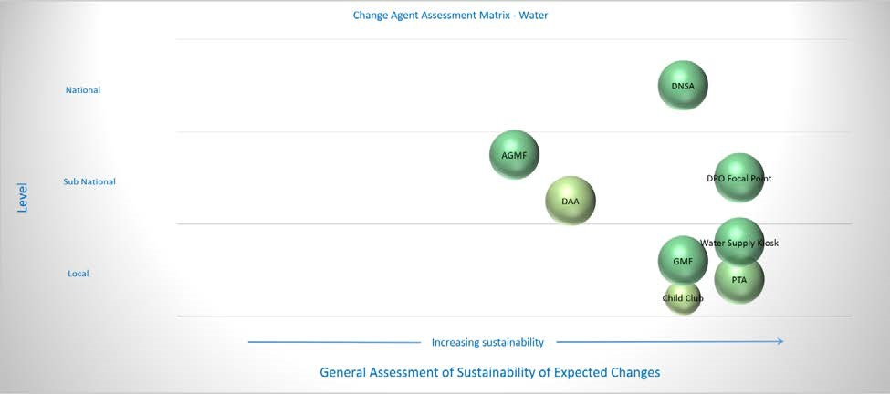

*Figure 1 - Change Agent Assessment Matrix for Water*

Most of the project’s efforts in the Water Supply component are focussed on ongoing operation and maintenance of facilities and establishing systems to support this. At the local level the project has supported the formation and functioning of GMFs and the high turnover spare parts supplies being made available in local kiosks; at the sub-national level it has fostered the AGMF and DAA to provide support to GMFs; and at the national level it has worked with DNSA to bring a greater emphasis on O&M. In schools, it has encouraged PTAs to take responsibility for the ongoing O&M of water supplies. O&M has been a major focus in the sector generally in Timor—certainly in the recently closed BESIK Program and to a lesser extent the current PHD program which is presently focussing on one district. This has been a significant sustainability issue in Timor-Leste and the project’s focus on it is appropriate.

|  |
| --- |
| The charts can be interpreted as follows:   * Each class of Change Agent is represented by a bubble on the charts. * The vertical axis reflects the level at which the Change Agent operates in the   administrative hierarchy (national Change Agents at the top of the chart, local/community Change Agents at the bottom).   * The horizontal axis is a measure of the sustainability of the changes in Change Agent performance (greater sustainability prospects are depicted to the right-hand side of the charts). * The colour of the circle is an indication of the extent to which the associated project deliverables are completed (red being behind schedule; yellow being somewhat progressed; and green being largely completed) * The size of the circle depicts the extent to which the Change Agents are currently displaying improved performance (measured against expectations).   Thus, large green bubbles on the right-hand side of the chart indicate that the project’s theory of change is being borne out and the level of sustainability is likely to be high. Conversely, small red circles on the left indicate that progress is minimal and  sustainability prospects are limited. Circles that are spread across all levels of the administrative hierarchy reflect a comprehensive engagement at all levels. |

The change agent assessment matrix for the water supply component shown in Figure 1 paints an optimistic picture in terms of the sustainability of the expected changes, particularly at the local level. The evidence seen during the monitoring visit generally confirms the GMFs are functioning, managing their facilities and undertaking minor repairs. However, when major breakdowns occur it is DAA (DAA) who bears responsibility for providing assistance and we heard a number of examples of this not happening, despite the efforts of both the GMFs and the AGMF. The link between the DAA in Liquiça and the communities is provided by the FPAs who are meant to visit all GMFs on a regular basis. In both meetings with GMFs we were told that they rarely see the FPAs, if ever. Even when a request reaches DAA—for example through the AGMF—it seems that budget constraints and a continuing emphasis on building new systems means that these breakdowns do not get addressed. Figure 1 illustrates this, with both the AGMF and DAA well to the left of the local change agents.

At present the AGMF’s existence is totally dependent on

WaterAid, and the success of the GMFs is likely due to WaterAid’s continued support through the implementing partners. DAA openly relies on organisations like WaterAid to provide the support to community water supplies, and appears unwilling to take on the responsibility of ongoing O&M. Were WaterAid to withdraw its support, the AGMF would likely fold, and DAA’s unresponsiveness would undermine the efforts of the GMFs, and so the sustainability of the expected changes at the local level are perhaps less optimistic than are represented in Figure 1.

The ability of organisations such as WaterAid to influence Government change agents such as DAA is limited, and most international NGOs working in the WASH sector in Timor face similar challenges. The BESIK program placed a strong emphasis on working through and strengthening national systems for WASH service delivery, and in recent years the Government has been the biggest investor in rural water supplies, and was increasingly taking the lead in the sector. With the closure of BESIK, DNSA appears to be once again relying on NGOs and programs such as PNDS to provide services and in this regard the sector appears to be somewhat fragmented. The project’s initiatives such as the joint monitoring committee and capacity building of FPAs have been influential and are to be applauded, as they align with the earlier national level approach. WaterAid could give consideration going forward to seeking ways to further strengthen Government service delivery rather than implementing alongside. Two possible ideas include:

* Aligning with the Government’s approach to implementing water supply projects, using contractors rather than local NGOs, supporting FPAs as the face of the program to communities rather than WaterAid or its partners. WaterAid could continue to provide the value-add services that are largely absent in Government projects, such as gender and social inclusion and environment, climate change and disaster risk reduction activities, through its local NGO partners.
* Re-model the AGMF so that it is a series of sub-district bodies rather than a single Municipal one, and firmly link each with the relevant FPA. This would enhance the FPAs’ reach to the more remote communities and remove the impression that the AGMF is a parallel or alternative GMF support mechanism to the FPAs. It would also reduce operational costs as the AGMFs would be located much closer to the communities.

# Sanitation

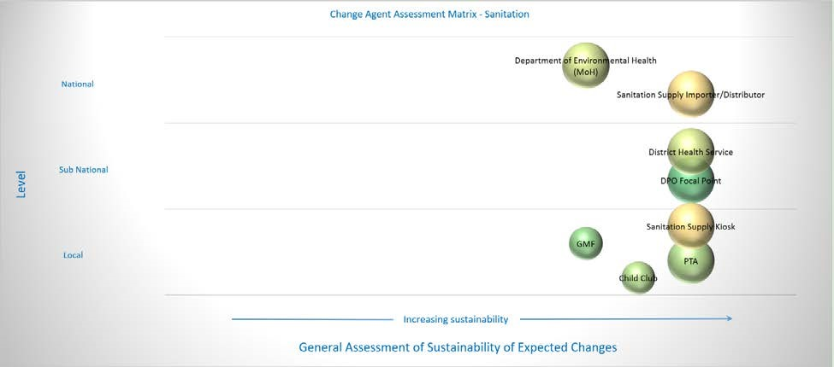

*Figure 2 - Change Agent Assessment Matrix for Sanitation*

The Change Agent Assessment Matrix for Sanitation (Figure 2) also paints a very optimistic picture of the sustainability prospects for the various change agents with whom the project works in the sanitation component. Apart from the GMFs and Child Clubs in schools at the local level, and the DoH at the national level, all are rated by the project team to be fully sustainable and likely to last beyond the project period.

WaterAid has recently signed an agreement with the Municipal Administration to work with the District (Municipal) Health Service to work towards an ODF Municipality—something that has been made possible in part due to the decentralisation process and so greater control of resources at the Municipal level. We saw great enthusiasm for this initiative and, whilst not directly related to the project’s original design, it does largely justify the project’s assessment above. This will also allow WaterAid to de-couple its water supply work from its sanitation approach which was a recommendation from the previous monitoring visit as the promise of a water supply can cloud the true motivation for households building latrines. As mentioned previously, the changing institutional environment has in part enabled this to be possible.

The project’s efforts to introduce the SaTo Pan (see header photo) to Timor and establish a supply chain from the factory in Bangladesh to local kiosks near its target communities is also a positive initiative that is likely to persist. Whilst at present there is just one importer in Dili, there are several kiosks selling the products and reporting good (and increasing) sales. Demand for these is growing and the initiative is profitable which means that were the importer to drop out of the chain, another would likely step in (see the Postcard in Annex B for further details of this initiative).

The GMFs focus on sanitation is rated to be less sustainable by the project team largely because sanitation is seen to be a household rather than a community responsibility. No tariffs are collected by GMFs for sanitation and so community action to promote and monitor sanitation is very much dependent on local leadership. The Municipal ODF campaign does present some opportunities for fostering local leadership through the GMFs—for example offering aldeia level incentives to achieving ODF status; equipping local leaders with smartphone monitoring tools or the like to foster a sense of competition and so on. Initiatives such as these have been used to great effect elsewhere and WaterAid is encouraged to draw on the experiences of other programs to bolster local leadership through GMFs.

At the national level, the project’s primary focus is with the MoH through the Department of Primary Health, rather than DNSB. It reports that the two Government staff responsible for CLTS and hygiene promotion in the MoH are very motivated and informed, but their status and level in the

Government hierarchy is not sufficient to be able to drive change or have much influence on policy. Whereas rural water (DNSA) and basic sanitation (DNSB) have representation at Directorate level in the Ministry of Public Works (DGAS), the Department of Environmental Health (DoEH) is one rung lower in the MoH. WaterAid continues to have good relations with the DoEH, and supports them through advocacy and awareness raising with Government more broadly, however the decentralisation process is likely to lead to a greater level of influence at the Municipal level.

Lastly, in schools the project again reports high sustainability of PTAs and (to a lesser extent) the child clubs. The rationale given for this is the high level of motivation of parents whilst their children are in school coupled with training and support provided to teachers who support both PTAs and CCs. We did not have the opportunity to meet with either groups during the monitoring visit, and so must take this assessment at face value. However, motivation to promote good sanitation in schools is underpinned by the sanitation facilities that they have. At the school that we visited, we inspected the new facilities provided by the project which consisted of a group handwashing station for primary school students and an accessible toilet with MHM facilities for the secondary school (see Figure 6). These were both of an adequate standard but the existing toilets in both campuses were in a very poor and dilapidated state. Both had just one or two functioning toilets for several hundred students, none had functioning handwashing facilities, and all were in a foul state. If the PTAs, CCs and indeed the school management themselves are unable or unwilling to maintain their existing facilities, then there is no reason to think they will maintain the new ones provided by the project. It is likely, therefore, that the sustainability prospects for these groups are less than indicated in Figure 2 above.

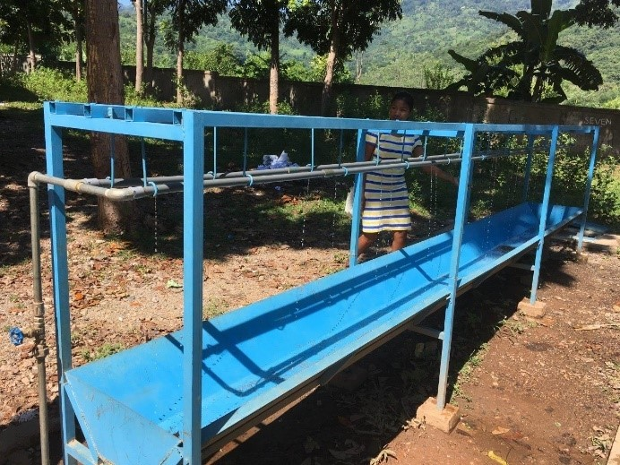

*Figure*

*3*

*-*

*Group Handwashing Facilities*

*Recommendation: In the remaining period of implementation, WaterAid should investigate the state of sanitation facilities in all the project schools, and identify all instances of unacceptable or degraded facilities. They should engage with the school management boards and PTAs to identify a strategy for addressing these and ensuring all facilities are adequately maintained at all times. In future, it is recommended that when working in schools, a holistic approach is taken to addressing sanitation issues, ensuring that all facilities meet national and/or international standards[5].*

# Hygiene

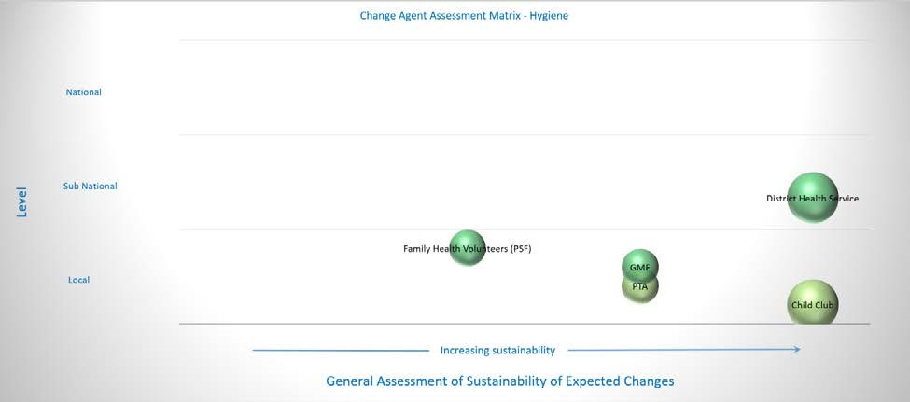

*Figure 4 - Change Agent Assessment Matrix for Hygiene*

Most of the project’s efforts with hygiene promotion are focussed at the local level, as illustrated in Figure 4 above. The exception to this is the support the project gives to the district health service (DHS) through the district health promotion officers (DPHOs). These people work through a network of primary and secondary health service providers including doctors and nurses in clinics, as well as the family health promoters (PSFs) at aldeia level, and so have good outreach. The project is very optimistic about their continued support to WASH related health and hygiene and cited as evidence an example of a recent video produced by the DHS promoting handwashing that was initiated and produced without project support. Interestingly the improved performance of the PSFs is not rated by the project to be sustainable—they are volunteers and apparently are generally reluctant to engage in activities unless they receive per diems. The DHS supports one PSF in each aldeia and the project has placed an additional PSF in the target aldeias—a structure that is unlikely to continue without project support. Given the reliance of the DPHOs on the PSFs to reach down to aldeia level, PSF performance is likely to undermine the sustainability of the gains made with the DPHOs. The analysis conducted during the monitoring visit did not distinguish between the DHS and project PSFs, but it would seem that bolstering the Government supported PSFs would likely lead to greater sustainability than supporting a parallel mechanism. WaterAid could give consideration in the remaining implementation period to how best it could support the existing PSF network.

The project has a very positive outlook about the continuing work of the child clubs to promote improved hygiene behaviours amongst school children. The combination of training provided by the project, support from motivated teachers and the provision of soap and other hygiene products by the school has been successful as evidenced by continued activities by the CCs two years after their formation. A risk to these gains, however, is presented by poorly maintained sanitation facilities in schools, as described in the preceding section. Both the GMFs and the PTAs are rated less sustainable by the project, mainly due to their focus on water supplies rather than sanitation or hygiene. Were the PTAs to place a greater emphasis on maintaining school sanitation facilities, the knock-on effects would greatly bolster the sustainability of the work of the CCs. Similarly, a greater focus on sanitation facilities by GMFs would support the work of the PSFs. This would seem to be an area that would benefit from additional project attention in the final months of implementation.

# Gender and Social Inclusion

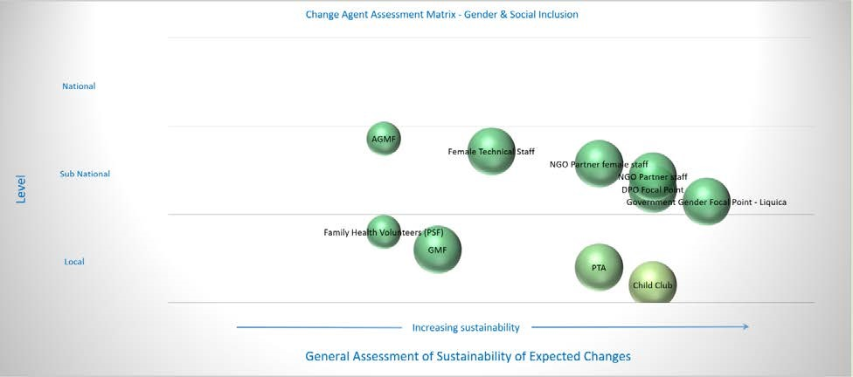

*Figure 5 - Change Agent Assessment Matrix for GeSI*

WaterAid’s Timor-Leste project places a lot of emphasis on gender and social inclusion and both the Government’s Gender Focal Points (GFP) and the Disability Focal Point (DFP) from the project’s DPO partner (RHTO) in Liquiça are significant change agents. The project sees its local partner staff as change agents in this component and through provision of training and resources to both the focal points and the partner staff, aim to reach down to a variety of Municipal and community change agents, as illustrated in Figure 5 above. The spread of the bubbles in Figure 5 illustrate the cascading approach the project takes – with good sustainability prospects given to the focal points and partner staff, but slower uptake amongst GMFs, PSFs and the AGMF. The Government has GFPs at both Municipal and Suco (village) level, and the observation that their performance is sustainable mostly relates to the Municipal GFP; the project reports that the performance of the Suco GFPs is much weaker.

The project has assessed the PTAs and the CCs progress with GeSI as highly sustainable, and this is likely linked in part to the sanitation facilities in schools that the project has provided. At the high school we visited we were shown a very nice and well-constructed accessible toilet with MHM facilities including an incinerator for menstrual hygiene products (Figure 6). The teachers who showed us the facilities were clearly proud of them and likely to promote their use amongst the students to ensure girls continue attending during their menses. Although we only visited one school we were told that the CCs had conducted accessibility and gender audits in all of the project schools which resulted in the construction of the facilities. The toilet we were shown had not yet been formally inaugurated and so was still in pristine condition. The challenge for the school (and the project) is to ensure that they are adequately managed and maintained into the future.

Another significant element to the project’s approach to GeSI is the production of IEC materials for both gender and disability. The project has produced a gender dialogue manual for facilitators that it hopes will be incorporated into the

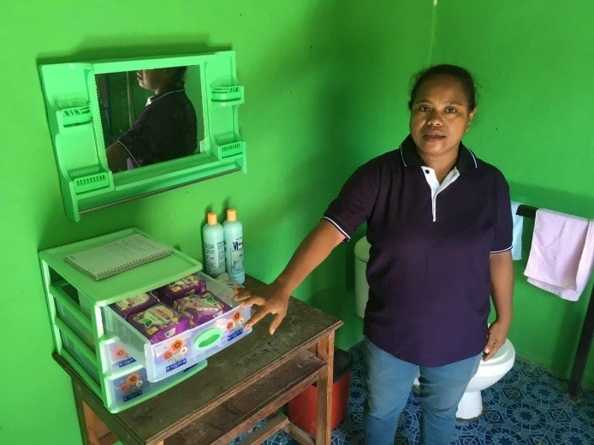

*Figure*

*6*

*-*

*M*

*HM Facilities in an Accessible School Toilet*

Government CAP manual, and so mainstreamed throughout the sector. It has been designed to align to and slot into the various CAP modules and has been formatted in a similar way. At the time of the visit it was being finalised and awaiting approval at the national level, and if successful has the potential to have a broader impact nationally. Similarly, the project has produced a series of flipbooks to use with households and communities that describe and illustrate accessible WASH facilities and how carers can assist PWD. Again, these have been designed to supplement existing manuals developed by BESIK and the project has been trialling the use of these in its target communities, and the project is working to have these adopted by the national Government.

# Environment, Climate Change and Disaster Risk Reduction

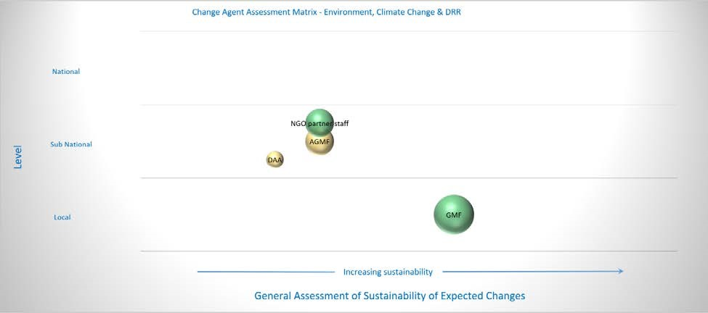

*Figure 7 - Change Agent Assessment Matrix for ECD*

The change agent assessment matrix for the environment, climate change and DRR component shown in Figure 7 reflects the struggle facing many of the projects across the Fund with achieving long term sustainable gains in terms of environmental management of WASH resources and disaster preparedness. The project has delivered training in water resource management to a range of change agents, and sought to link community level change agents with the relevant Municipal Government departments. However, as illustrated in Figure 7, increased knowledge or awareness does not necessarily lead to improved performance—at least not in the short term. However, there have been some concrete achievements that are starting to be reflected in change agent performance, particularly around GMF awareness of the importance of source protection and the need for careful management of their resources. In conjunction with the AGMF and partner staff, GMFs have been actively planting trees around springs as part of a general catchment management approach, and applying innovations such as the water tank level indicator to assist with the transparent management of water in the communities during the dry season.

Whilst these examples give rise to optimism, the lack of attention to environmental issues in Government represents a significant hurdle in making real gains in this area. For example, at present there are no staff with responsibility for water resource management at the municipal level, leaving just a small team in Dili trying to make progress across the country. There is a water resource management position in DAA at the municipal level but it is currently unfilled (in Liquiça at least). With the appointment of a new director at the national level, the project is optimistic that a greater focus will be brought to these issues, and WaterAid could use this opportunity to advocate for better resourcing and attention at the municipal level, and seek opportunities to support this, both in Dili and Liquiça.

# Knowledge and Learning

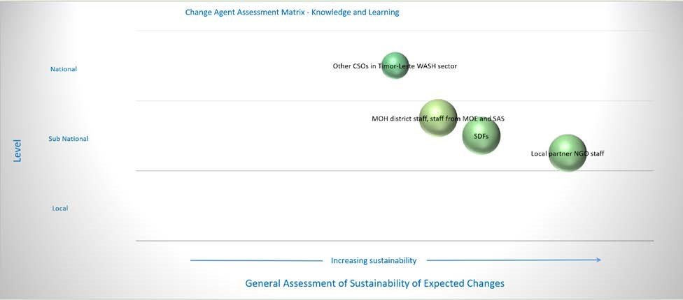

*Figure 8 – Change Agent Assessment Matrix for Knowledge & Learning*

WaterAid in Timor-Leste has positioned itself somewhat as an innovator in the WASH sector, and over the course of the project’s implementation has sought to introduce or continue testing a number of new initiatives to the sector in Timor. These include (but are not limited to):

* The joint sustainability monitoring of WASH projects by Municipal Government staff to assist with building ownership of activities within the Municipality by Government and to strengthen links between communities (GMFs) and Government.
* The formation of the Association of GMFs to support GMFs and help strengthen the links between communities and Government. This proceeds an earlier initiative to test the boundary rider concept to support O&M of WASH infrastructure.
* Trialling of various SanMark initiatives, including the recent efforts to introduce the SaTo Pan to Timor and establish a viable supply chain.
* Spearheading the introduction of CLTS to Timor, and conducting a study to test its efficacy. More recently WaterAid has piloted a smart subsidy voucher system to encourage poorer households to upgrade their latrines.
* Developing and piloting a smartphone monitoring system to track progress in the sector against key performance indicators. Supported through the Fund’s I&I Grant, the project is proposing to use this system to track progress towards a target of an ODF-Liquiça.
* Introducing a community scorecard system to enable communities to hold Government to account for WASH service provision.

Innovations such as these carry risk and not all are successful, but when approached in an open and systematic way can be extremely valuable to the sector in general as it struggles to overcome some of the key barriers to sustainable WASH service delivery. WaterAid has sought to document its learnings from these initiatives through conference papers, learning briefs, workshops and other fora, and the sector in Timor has benefited as a result. Change agents do not always take on board these lessons straight away, as illustrated in Figure 8 above, but it was clear on both this visit and the initial visit that WaterAid is a respected development partner of the Government, and in the sector more broadly.

## 7. Conclusions & Recommendations

WaterAid’s project in Timor-Leste has been a solid and steady performer throughout the Fund’s implementation period and is on track to deliver what it set out to achieve at Fund outset. At the community level, through its partners, it has delivered WASH services and supported GMFs to manage and maintain these. At the sub-national level WaterAid is a key development partner of Government, and the project’s efforts with Government change agents have resulted in many expected changes being realised. WaterAid has introduced or piloted several initiatives to address some of the sustainability issues facing the sector in Timor-Leste, with varied success. The challenge for WaterAid is to take its successes at the Municipal level up to National level and get them adopted throughout the sector. In some instances it has achieved this—for example its efforts with CLTS, and early indications with the gender dialogue manual and the community scorecard initiative—but in others, such as the AGMF it is struggling.

The enabling environment context in Timor-Leste is constantly changing which presents both challenges and opportunities for organisations working in WASH. WaterAid has shown itself to be flexible and adaptable which has bolstered its reputation and standing with both Government and the sector more broadly. Looking ahead to beyond the current Fund implementation period, it is recommended that WaterAid continue to critically assess its initiatives such as the AGMF and its approach to implementation in communities and seek where possible to integrate these into Government systems.

The limited time left for implementation in the current Fund restricts what can be done by the end of the Fund. It is however recommended that the project investigate the status of sanitation facilities in the schools in which it has worked—and in particular the existing facilities for which the project has not been responsible—and assess the extent to which these can be brought up to an acceptable standard so that they do not undermine the achievements of the project in these schools. The project should also seek to bolster the operation and maintenance arrangements for WASH facilities in schools to maximise their sustainability prospects.

# Appendix A: List of Acronyms

|  |  |
| --- | --- |
| AGMF | Association of GMFs |
| BESIK | Former Community Water, Sanitation and Hygiene Program |
| CA | Change Agent |
| CAAT | Change Agent Assessment Tool |
| CC | Child Club |
| CLTS | Community Led Total Sanitation |
| CSO | Civil Society Organisation |
| DAA | District (Municipal) Water and Sanitation Authority |
| DFP | Disability Focal Point |
| DoEH | Department of Environmental Health |
| DGAS | Ministry of Public Works |
| DHS | District Health Service |
| DNSA | National Directorate for Water Supply |
| DNSB | National Directorate for Basic Sanitation |
| DPO | Disabled Persons Organisation |
| DRR | Disaster Risk Reduction |
| DoE | Department of Education |
| DoH | Department of Health |
| DPHO | District (Municipal) Health Promotion Officer |
| ECD | Environment, Climate Change and DRR |
| FPA | Sub District Facilitators |
| GeSI | Gender and Social Inclusion |
| GFP | Gender Focal Point |
| GMF | Facility Management Group or Community Management Committee |
| I&I | Innovation and Impact (Grant) |
| MERP | Monitoring, Evaluation and Review Panel |
| MHM | Menstrual Hygiene Management |
| O&M | Operation and Maintenance |
| ODF | Open Defecation Free |
| PHD | Partnership for Human Development Program |
| PNDS | Decentralised Infrastructure Development Program |
| PRT | Project Reporting Tool |
| PSF | Family Health Promoter |
| PTA | Parent Teacher Association |
| PWD | Person with a Disability |
| RHTO | Ra’es Hadomi Timor Oan (National DPO in Timor-Leste) |
| SanMark | Sanitation Marketing |
| SAS | Former name for District Water and Sanitation Service |
| SaTo | Sanitary Toilet – a type of squat plate |
| SDF | Sub District Facilitator |
| SMASA | Municipal Water, Sanitation and Environment Service |
| WA | WaterAid |
| WASH | Water, Sanitation and Hygiene |

# Appendix B: Monitoring Visit Annotated Itinerary

|  |  |  |  |
| --- | --- | --- | --- |
| **Date** | **Interview/meeting** | **Key Points** | |
| 7/5/17 | Travel Melbourne to Dili | | |
| 8/5/17 | WaterAid Office | * Update on key project deliverables * Overview of progress against expected changes * Update on initiatives such as Gender Dialogue Manual, Disability Flipcharts and community scorecard initiative | |
|  | Project Team, Dili | • Completed Change Agent Assessment Tool | |
| 9/5/17 | District Water Office (CAA – formerly SAS) | * Met with Sr Miguel Da Cruz, Director CAA * Overview of WaterAid’s relationship with CAA, update on Municipal coverage, overview of differences between WaterAid approach and Gov approach to WASH service provision * Update on implications of de-centralisation process; opportunities such as initiative to get Liquiça ODF | |
|  | District Water Office (CAA – formerly SAS) | * Met with FPAs (formerly known as Sub-District Facilitators or SDFs) – Luciano dos Santos Lopez, Hermanio da Costa Soares * Overview of their roles in supporting GMFs; support provided by WaterAid * Main challenges and issues, and general recommendations. | |
|  | Community Visit – Aldeia Kaimegahou  Suco Mau Metan | * Met with members of GMF and community responsible for Guanana Water System * They gave overview of GMF structure, description of how well the system is functioning; description of sanitation initiatives in community * Described their responsibilities for O&M of facilities into the future | |
|  | Community Visit – Aldeia Asorlema  Suco Metagau | * Meeting with GMF members – predominately women from 1 family * Description of roles and responsibilities * Overview of technical issues they are facing, including major issue with lack of water at end of line. No money collected; issue with implementing partner (no longer partner of WaterAid); no visits by SDFs | |
| 10/5/17 | District Health  Office | * Meeting with DPHOs – Bento da Silva Soares; Adriano da Jesus – and former Vice Director DoH – Alberto Marcel Robeiro * Overview of roles and responsibilities – including those of PSFs * Description of WaterAid support to DoH – to both DPHOs and PSFs * Overview of new initiative to get whole Municipality ODF, including how DoH and WaterAid will work together * Implications of decentralisation for DoH | |
|  | AGMF meeting,  WaterAid Office,  Liquiça | * Meeting with AGMF – Paulino alves dos Santos; Olga dos Santos; Domingos Utomo; Caesar Alvos dos Santos * Description of AGMF roles and responsibilities; mode of operation etc * Overview of issues such as diminished number (6 members now down from 12); loss of office (now working out of WaterAid office); challenges of transport; trust in communities; lack of response by CAA when they facilitate request from GMFs * Need for continued donor support. They want more $$ from WaterAid | |
|  | Kiosk, Suco Gugleur, Maubara Sub District | * Met with Augusto Seraim, owner of kiosk in market place, Aldiea Caicassa Kiosk. * Observed SaTo Pans for sale in kiosk * Presented sales figures (>100 sold in past 4 – 5 months) and described profitability (he makes $1.50 on each pan) * Described supply chain from Dili to his kiosk * Inspected his SaTo Pan installation | |
| 11/5/17 | Project Team, WaterAid Office | • | Continued work on Change Agent Assessment Tool |
|  | DPO meeting, WaterAid Office | •  • | Met with Paolo da Silva Neves, DPO focal point for Liquiça for RHTO Description of their initiatives in WASH – particularly around equity and inclusion – both in project and more broadly; advocacy at national level |
|  |  | • | Overview of support provided by WaterAid and strategic partner CBM |
| 12/5/17 | DNSA, Dili | • | Meeting with Martinhus Nahuk, Director |
|  |  | • | Overview of relationship between DNSA and WaterAid |
|  |  | • | Description of changing context with closure of BESIK and new PHD program |
|  |  | • | Description of DNSA’s Sectoral Planning Tool, and highlighting of WaterAid’s role in their national overview; importance of WaterAid’s work in Liquiça and Manufahi |
|  |  | • | Update on the social audit – community scorecard initiative – being piloted in 8 locations. Has approval of PM. |
|  |  | • | Highlighting some issues such as reduced focus on O&M in new PHD; high level of investment in WASH by PNDS but no consideration given to sustainability issues (ie no formation of GMFs) |
|  | School Visit  Escola Barrio Bogoro  Bazartete sub-district | •  •  • | Visited both primary and secondary campuses  Inspected group handwashing facilities in primary school – initiative by project partners to encourage handwashing by children after playing and before eating  Observed poor condition of existing (non-project) latrines; 2 latrines for 300 pupils; no handwashing facilities at toilets |
|  |  | • | Inspected new accessible toilet built by project with MHM facilities; not yet inaugurated |
|  |  | • | Noted existing toilets in poor condition as per above. No handwashing facilities and poorly maintained. |
| 13/5/17 | Return to Melbourne |  |  |

# Appendix C: Postcard from the Field: Where demand meets supply: the ingredients for sustainable sanitation

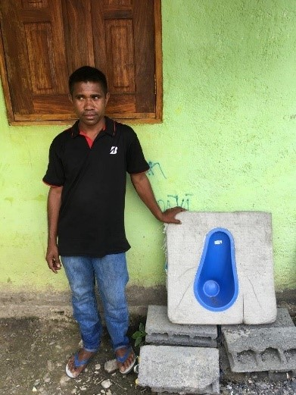Senior Augusto Seraim is a young entrepreneur running a kiosk in Suco Gugleur in Liquiça Municipality in Timor-Leste. As a successful small-business owner he knows the importance of good supply chains and the profitability of his stock. WaterAid in Timor-Leste have introduced the SaTo Pan and are supporting Augusto and other kiosk owners in Liquiça to stock it in their shops. Manufactured in Bangladesh, they are available for around $1.50 per unit (ex-factory). WaterAid have teamed up with an importer in Dili to bring them in and make them available for $4.50—which includes a margin for the importer. Augusto sells them for $6 each which is affordable for a rural family in Liquiça. He buys them as part of his normal weekly trip to Dili to re-stock his kiosk and so the $1.50 he makes on each sale is

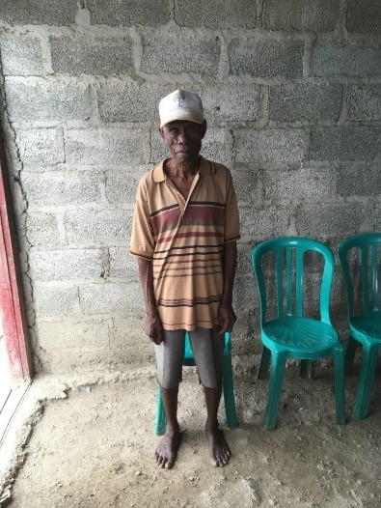pure profit. Over the past 4 months Augusto has sold well over 100 units and he reports that every market day people come into his kiosk and ask about them.

Not far away from Augusto’s kiosk is Aldeia Kaimegahou, where WaterAid and partners have conducted CLTS triggering. Every household in Kaimegahou has a basic toilet now, and the village has a reliable water supply. Senior Julio built a basic toilet as part of this process but wants to install a pour-flush toilet because they are superior to the simple pit latrine he built.

“*I asked the Chefe Suco ten times to give me a new toilet*”, Sr Julio told us with a grin. “*But he said to me that I work hard to*

*earn money to buy food, which I eat, but then it all comes out again. So why won’t I also spend my money on a new toilet?*”

Sr Julio is now saving money to buy himself a new pour flush toilet. He did not yet know about the SaTo Pan, which costs significantly less than the conventional ceramic pan. However, the word is spreading about this new, cheap toilet option. So there, in the hills above Liquiça town, are all the ingredients for a viable and sustainable market for improved household sanitation.

# Appendix D: WaterAid Management Response

WaterAid Timor-Leste appreciate the MERP’s observations and recommendations and found the visit to be a useful process. This report and visit has informed our thinking and reinforced some of our reflections as our CSWASH funded Programme draws to a close. As we look to future programming and collaborations we will continue to shift the thinking of our delivery partners and change agents towards a sector strengthening and district-wide approach that is increasingly focused on sustaining WASH service delivery rather than increasing coverage with WASH services.

During the 2013-2017 period of the CS WASH programme we have increased our focus on supporting and working through government systems, where we can, to support the Community Management Committee (GMFs) and the government outreach workers (FPAs) with continuing to provide on-going services. We phased out the WaterAid boundary rider position and directed follow-up support through the GMF Association (AGMF) with the engagement of the FPA. We have then pushed the AGMF and FPA to collaborate and undertake integrated work. All the water supply construction work and sanitation ODF work has been inspected and verified by the local government and ownership of any completed infrastructure taken on by local government and communities in official signing and handover ceremonies.

An illustration of our shift in programming focus has been the reduction in the number of water supplies constructed in Liquiça Municipality during this period from over 20 in previous years to 12 in the last year and a significant increase in our work to reform and retrain failing GMFs with the local government FPAs.

PNDS is a government led CDD programme, however it is largely focused on building rural infrastructure and does not yet have strong systems for O&M of the infrastructure, as well as not supporting or creating GMFs for the rural water supply infrastructure being built. WaterAid’s CSC work and advocacy has helped to highlight this issue and informed government and DFAT with regards to collaboration between the PNDS program and DGAS to help ensure GMFs are set-up and sustainable systems for operations and maintenance are a focus for the PNDS built water supply infrastructure. These sustainable service delivery systems will be an increasing focus of WaterAid’s work.

As of February 2017, we have adopted a district-wide approach to sanitation with Behaviour Change Communications and monitoring systems lead by local government established and supported with a target date of ODF Liquiça by 19th Nov 2017. Sanitation work is now largely de-coupled from water supply provision. It has taken most of this CS WASH period to influence the thinking of the sector and our delivery partners with regards delivery of sanitation programmes.

With regards the WASH-in-schools work, WATL has been working in close collaboration with the Municipal education department. For the school where the monitoring visit took place work started in the school in April 2016 and the demonstration block with MHM facilities and handwashing facilities were completed in January 2017. The Municipal Education Department had planned to rehabilitate the main school sanitation block during 2016-17, however the decentralisation process that started in January 2017 introduced new municipal structures and procedures that delayed this work. We are currently following-up with the Education Department to understand if they have the budget and plan to carry-out this work during 2017, and will continue to work on having any sanitation blocks that were not refurbished in target schools improved as well as strengthen the school, CHC and PTA systems for operation and maintenance of the WASH infrastructure.

With regards our work in the area of Environment, Climate Change and Disaster Risk Reduction***,*** there is no expected change in WATL’s CSWASH fund PRT at the National level in this area. However, we have successfully completed research on Supporting the WASH Sector to access Climate Change Finance and managed to develop and strengthen linkages and collaboration between the Climate Change Working Group and the Water Sector National Forum. We then expect to see a significant increase in support for the WASH sector from the Climate Resilience sector.

As we look to the development of future phases of our programming in Timor-Leste we will certainly be reviewing our approach to sustainable service delivery, including the role that the AGMF can play, and how we can share the programme’s successes at the national level, including working with gender and disability sectors on collaboration for scale-up of the gender, equity and social inclusion WASH work.

1. The SaTo Pan is an innovative squat plate developed by American Stand Brands as part of the Bill and Melinda Gates Foundation’s *Reinvent the Toilet* initiative. It is an inexpensive plastic squat plate that dramatically reduces water use compared with conventional squat plates.
2. Lockwood, H., Grumbley, A. & Casey, V. Supporting sustainable water supply services in difficult operating environments: a case study from Timor-Leste. [www.wateraid.org/ppa.](http://www.wateraid.org/ppa) 2017.
3. The project asserts that the service delivery aspects have been largely through Government systems, through their support to GMFs, strengthening WaterAid, Government and other agency GMFs with the FPA as well as the AGMF to continue on-going services. They claim that all projects are verified and inspected by the government and ownership of infrastructure taken by the DAA/local government.

  
4. Programs such as PNDS and PDIM only build water supply infrastructure and do not provide support for ongoing operation and maintenance, including supporting or creating GMFs. WaterAid state they have been working with local government to fill this gap.
5. See Appendix D for WATL’s response to this issue.