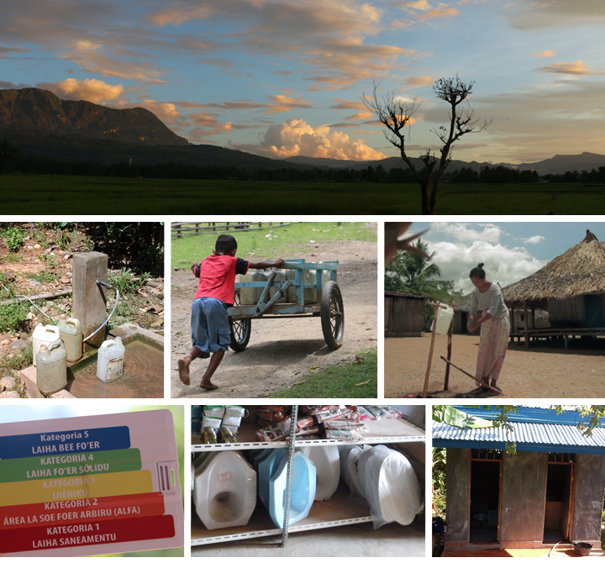

**Comfortable, Safe and Proud**

A Mixed Method Study of Value Exchanges, Behavioural Determinants, Market Segmentation and Case Studies on Sanitation and Hygiene in Bobonaro, Timor Leste

**Report Draft 1**

**PARTNERSHIP FOR HUMAN DEVELOPMENT**

**TIMOR LESTE**

**2017**

**Table of Content**

**Part One: Introduction**

* 1. Commision for this report 1
  2. Background 1
  3. Objectives 3
  4. Research questions 4

**Part Two: Literature Review**

* 1. Situation in Timor Leste 5
  2. Technologies, products and services in Timor Leste 5

**Part Three: Methodology**

3.1 Sample and recruitment method 7

3.2 Data collection methods 7

3.3 Inclusion and exclusion criteria 8

3.4 Framework and methods for analysis 8

3.5 Ethics 12

**Part Four: Results**

4.1 Households sample characteristics 13

4.2 Water facilities in Bobonaro Municipality 17

4.3 SaniFOAM Framework 23

4.4 Suppliers 54

4.5 Masons 72

4.6 Value exchanges 76

4.7 Handwashing 82

**Part Five: Discussion**

5.1 Water access in Bobonaro Municipality 91

5.2 SaniFOAM 93

5.3 Handwashing with soap 101

5.4 WaSH marketing exchange 104

5.5 Segmentation 108

**Part Six: Conclusions and Recommendation** 115

References 118

Appendices 121

**APPENDICES**

Appendix 1. Informed Consent 122

Appendix 2. Sample Household Log Sheet Using Stratified Systematic Sampling 123

Appendix 3. Household survey (English Version) 126

Appendix 4. Suppliers survey (English Version) 144

Appendix 5. Masons survey (English Version) 154

Appendix 6. Household survey (Tetum Version) 163

Appendix 7. Suppliers survey (Tetum Version) 181

Appendix 8. Masons survey (Tetum Version) 191

**PART ONE**

**INTRODUCTION**

* 1. **Commission for this report**

The Partnership for Human Development (PHD) represents Australia’s long-term vision for enhancing human development in Timor-Leste. It brings together the Government of Australia’s diverse activities in health, education, water, sanitation, nutrition, gender equality, disability and social protection into a single program to maximise effectiveness, relevance and performance. Improved human development will ensure that coming generations of Timorese people are better able to lead, contribute to and benefit from their nation’s economic and social development.

The Partnership for Human Development (PHD) is working with the national government, local authorities, civil society and communities to achieve two levels of sanitation improvement as specified in the Timor-Leste National Basic Sanitation Policy. First is “Open Defecation Free” (ODF) status: excreta-free open spaces, drains, water bodies and institutional buildings. Second is “Hygienic Status”: 100% coverage of hygienic toilets and handwashing stations with soap; and universal safe disposal of infant and child faeces. Timor-Leste has made some significant gains in ending open defecation and improving sanitation and hygiene behaviours. However, the young nation remains off course from reaching Sustainable Development Goal (SDG) 6 and national targets of “equitable and appropriate sanitation for all” by 2030. Over half the population does not have access to adequate sanitation, significantly increasing the risk of diseases and malnutrition, especially for women and children.

* 1. **Background**

The importance of safe drinking water, sanitation and hygiene (WASH) has long been recognized for its positive impact on public health. Diseases related to poor water, sanitation, and hygiene are major causes of mortality and morbidity (Prüss-Ustün et al., 2014). It is estimated that poor sanitation and hygiene account for 7% of deaths in low and middle-income countries (Prüss-Üstün, Bos, Gore, & Bartram, 2008). A number of studies have shown association between inadequate sanitation and the increased risk of diarrhoea among children aged under five years of age (Cronin et al., 2016, Semba et al., 2011, & Sara and Graham, 2014). Use of improved sanitation has also been found to reduce morbidity and mortality, especially among children (Sara & Graham, 2014).

This research will focus specifically on sanitation and hygiene aspects of WASH in Timor Leste. Sanitation concerns technologies, services and behaviours that serve to safely prevent human contact with excreta. Hygiene is commonly used to mean washing with soap at critical times, e.g. after defecation and before eating (Cumming & Cairncross, 2016). When combined with water, these public health interventions together form an interlocking set of barriers that prevent exposure to disease-causing organisms via ﬁve transmission pathways: water (fluids), flies, food, soil (fields) and hands (fingers) (Cumming & Cairncross, 2016).

The provision and promotion of low-cost WASH technologies and products at the individual, household, or community-level combined with hygiene promotion is a widely practiced approach to prevent disease, malnutrition and other problems in resource poor settings (Dreibelbis et al, 2013; Howitt, 2012). Examples of household-level technologies include handwashing stations to encourage handwashing with soap (Watt, 1988); household-based water treatment with filters or chemical purifiers; and improved latrines (Clasen et al, 2010 Arnold et al, 2007). In order for these interventions to result in significant improvements in health, behaviours and technologies must be adopted and maintained over time and taken to scale, but evidence of sustained adoption of new practices is mixed. While some studies have reported significant increases in behavioural outcomes, others have demonstrated a weakening of initially improved practices and health impact over time. This limited success with sustained adoption may reflect, in part, our still developing understanding of the factors that influence WASH behaviour change and sustained adoption of improved practices (Dreibelbis et al, 2013).

* 1. **Objectives**

This study aims to assess the current and potential market for sanitation and hygiene products, services and behaviours in rural areas of Bobonaro Municipality, including:

1. Assess the value chain for private sector products and services;
2. Assess behavioural determinants affecting household demand for sanitation improvements;
3. Produce recommendations to strengthen community access to sanitation and hygiene improvements;
4. Produce data to enable the development of a hygienic status brand marketing strategy, including brand platform and 4Ps - product, price, place and promotion.
5. Assess capacity and willingness of the private sector to participate in a voucher scheme.
6. Understand how and why people including people with disabilities (PWS) currently access, use and practice sanitation products, services and behaviours, including building toilets and handwashing stations.
   1. **Research Questions**
7. What is the market for sanitation and hygiene products and services, including product, price, place and promotion?
8. What are the features of the value chain for hygiene and sanitation products and services?
9. What is the household demand for sanitation and hygiene improvements?
10. What are the determinants that affect the private sector’s support for access to sanitation and hygiene improvements?
11. What are supplier perceptions of the barriers and opportunities for success of a voucher scheme for the sanitation program?
12. What benefits and attributes of hygiene and sanitation products, services and behaviours should be used to develop the hygienic status brand marketing strategy?

**PART TWO**

**LITERATURE REVIEW**

* 1. **Situation in Timor Leste**

Timor-Leste has made some good progress in ending open defecation, and improving sanitation and hygiene behaviours through engaging municipalities and communities. The Timor‐Leste Strategic Development Plan (SDP) 2011‐2030 commits the government to achieving the water and sanitation MDGs by 2020 and describes the aim that “by 2030, all citizens will have access to clean water and improved sanitation” (Government of the Democratic Republic of Timor Leste, 2011). However, Timor-Leste remains off course from reaching Sustainable Development Goal (SDG) 6 and national targets of ‘equitable and appropriate sanitation for all’ by 2030. Over half of the Timor-Leste population still does not have access to adequate sanitation, significantly increasing the risk of diseases and malnutrition, especially for women and children.

The ODF Timor-Leste Initiative piloted in Bobonaro Municipality in 2015-16 successfully improved household toilet coverage from 47% to 92% in eleven months. ODF verification results indicate that 70% of houses in ODF communities have improved toilets, indicating that 30% of toilets remain ineffective at preventing faeces from entering the environment and contaminating people (Clark and Willets, 2016). The Hygienic Initiative, therefore, will target ensuring that all 30% houses have improved sanitation in order to create communities free from pathogens and thus healthier to live in. One form of support planned by PHD, to facilitate communities in achieving hygienic status, is a voucher targeted at vulnerable households that they can redeem at local stores and kiosks for products that can be used to improve their sanitation.

**2.2 Technologies, products and services in Timor Leste**

A 2014 BESIK Report explored the availability of products and services in four districts (Dili, Bobonaro, Baucau and Likisá) during a six-month period, covering 66 suppliers and 3 producers of sanitation products (Empreza Di’ak, 2014). The 2014 BESIK report stated that 78% of suppliers were located in Dili and 22% in other districts (Baucau, Likisa, and Bobonaro). The main suppliers of the sanitation products are from Indonesia and China, with Sen-Diak as the main Timorese supplier.

The 2014 BESIK Report defined “improved toilets” as those which ensure hygienic separation of human excreta from human contact. They are considered private, convenient and safe. The superstructure materials included bamboo, brick, piku, wood clapboard, tin shed, and coconut leaf. The sanitation products available in the study were squat pans (plastic, ceramic and cement), ceramic poor flush sitting bowl, and ceramic automatic flush sitting bowl. The tools available for construction were the crowbar, shovel and trowel. The available building materials were cement, PVC pipe, PVC pipe elbow, wood, iron bar, sand, thin wire, and nails. The transportation modes used to deliver the sanitation products were trucks (junior and EDS truck), *angunna*, mikrolet and motor vehicle (Empreza Di’ak, 2014).

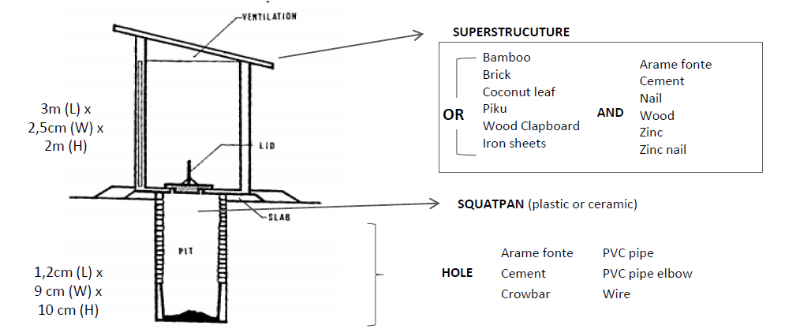

**Figure 1. Toilet design and materials used in Timor Leste (adapted from the 2014 BESIK Report)**

**PART THREE**

**METHODOLOGY**

* 1. **Sample and recruitment methods**

The target participants for the study were households from verified ODF communities and sanitation product supply actors in Bobonaro Municipality. For the household survey, the sample was calculated based on this formula: N = t2PQ/d2, where t = the statistic of t-distribution, P= prevalence, Q = 1 − P, and d is the margin of error. With a t-value of 1.96 at 95% confidence, the Open Defecation Free (ODF) coverage of 70% of households, and a margin of error of 5%, the total sample needed for this study was 322 households from four administrative posts in Bobonaro Municipality – Maliana, Cailaco, Atabae, and Balibo.

To determine the number of houses selected in each administrative post, *suco*, and *aldeia*, the stratified sampling method was utilized. This method, also sometimes called proportional random sampling, is where the study population is divided into strata or subgroups. For this study, the strata were the *suco* and *aldeia* in the four administrative posts in Bobonaro. Then a simple random method was used to select the sample for each strata (*aldeia*). The sample number selected in each *aldeia* was calculated based on proportional sampling (See Appendix 1 for the sample household log sheet using stratified systematic sampling).

For the community stores and kiosks selling toilet products and toilet-related construction materials, as well as the masons constructing the toilets, a snowball sampling method was utilized. Snowball sampling is a non-probability (non-random) sampling method used when characteristics to be possessed by samples are rare and difficult to find. We used the method to locate suppliers and masons with the help from the *Chefe Aldeia* and households.

* 1. **Data collection methods**

There are two data collection methods in this study: a quantitative method using surveys and qualitative method using in-depth interviews.

For the quantitative study, survey-style interviews with the households and suppliers were conducted by the enumerators. The enumerators consisted of ten *Universidade da Paz* (UNPAZ) public health students. The survey took approximately 50-60 minutes to complete. The enumerators used tablets to collect the data using the mWater application. The enumerators were divided into two teams: eight enumerators were responsible for collecting household data and two enumerators were responsible for collecting the supplier data. The enumerators were responsible for completing all of the information in the survey form on the tablet. For the qualitative study, in-depth interviews with the households and masons were conducted. Participants were told that all information taken will be kept securely and that any personal details taken be kept private and not be shared with anyone outside of the research group.

Prior to data collection, training for the enumerators and pilot testing was conducted. The enumerator training aimed to ensure the uniformity of the data collection and that the enumerators followed the research protocol. The pilot testing aimed to analyse the level of understanding of the participants of the questionnaire and to improve the interviews. Pilot testing with ten selected households, one mason and one construction material supplier was conducted in Holsa, Maliana.

* 1. **Inclusion and exclusion criteria**

The inclusion criteria for the household survey is those who live in the four selected administrative posts in Bobonaro Municipality. The inclusion criterion for the suppliers is those who operate their business in Maliana, Cailaco, Atabae and Balibo.

* 1. **Frameworks and methods for analysis**

This study uses a mixed methods study design of quantitative and qualitative data collection techniques. Four frameworks were then applied to the analysis of the data: behavioural determinants, value exchanges, segmentation and case studies.

*3.4.1 Behavioural determinants*

The behavioural determinants for sanitation and hygiene were analysed using the Opportunity-Ability-Motivation framework. This framework provides an analysis of the individual, interpersonal and social dynamics affecting issues such as toilet purchase and use as well as handwashing practices. The framework used was based on the World Bank’s SaniFOAM (Devine, 2009).

For the quantitative analysis, the survey questions were grouped based on each of the three themes of the SaniFOAM Framework. The data was analysed using SPSS version 22 for PC. The sample characteristics was presented first. Descriptive statistics, Chi-square analyses and Fisher’s Exact Test then were used to explore the comparisons of each theme of the SaniFOAM framework, by administrative post where possible. Bivariate and multivariable logistic regression analyses were used to assess the impact of demographic variables on the SaniFOAM themes. The following is the SaniFOAM framework and the description of topic that will be explored in the data analysis.

**Table 3.1** *SaniFOAM framework and data analysis*

|  |  |  |
| --- | --- | --- |
| **Opportunity** | **Ability** | **Motivation** |
| **Access/availability**  Access to and availability of sanitation facility. | **Knowledge**  Knowledge of hygiene and sanitation, knowledge of various toilet models, knowledge of toilet design, materials, and construction process, and health related knowledge. | **Attitudes and beliefs**  Reasons for toilet building and upgrade. |
| **Product attributes**  Product attributes of toilets. | **Skills and self-efficacy**  Skills to design and build toilets. | **Values**  Values for good sanitation. |
| **Social norms**  Embarrassment felt by households. | **Social support**  Social support to build toilets, support for those who have difficulty in using a toilet, support in transporting materials, support in providing advice for poor people and support with information. | **Emotional/physical/social drivers**  Emotional drivers which contribute to the motivation to upgrade a toilet. |
| **Sanctions/enforcement** | **Roles and decisions**  Those who clean the toilet, those who make decision to install, improve or upgrade the toilet and factors affecting these decisions. | **Competing priorities**  Household competing interests. |
|  | **Affordability**  Affordability of building a toilet. | **Intention**  Interest in and intention to upgrading toilet in the next 12 months. |
|  |  | **Willingness to pay** |

This study also assessed the predictors for intention in upgrading or improving the toilet in the next 12 months and the predictors for handwashing with soap practice using logistic regression analyses to consider the impact of demographic variables, self-reported sanitation and hygiene related knowledge, attitudes, and behaviours. Univariate and multivariable logistic regression models were used. Those variables which were not already binary were recoded so that:

* The ‘I don’t know’ response category was combined with the ‘No’ category for a number of variables such as experiencing water interruptions, having funding to improve or upgrade toilet, having interest in taking loan, seeking advice, and having interest in upgrading or building toilet.
* Those who had attended school was combined and were compared with those who did not attend school (‘no schooling’).
* Monthly income level was divided into ‘low’ (below USD 100) and ‘middle and high’ (above USD 100);
* Number of families in the household was divided into ‘1 family’ and ‘>1 family’;
* Water availability was divided into ‘daily’ and ‘other’;
* Age of the toilet was divided into ‘< 3 years’ and ‘> 3 years’;
* Toilet distance was divided into ‘< 5 meters’ and ‘>5 meters’
* Sanitation facility was divided into ‘improved toilet’ and ‘unimproved toilet’;
* Person constructing the toilet was divided into ‘self’ and ‘other’; and
* The satisfaction level with current toilet was divided into ‘yes’ (satisfied/very satisfied) versus ‘no’ a combination of the neutral or dissatisfied/very dissatisfied.
* Handwashing with soap was divided into ‘yes’ (always, sometimes, rarely) and ‘no’ (never). Those classified in the ‘always’ response category were those who reported they practiced handwashing with soap at all five times: (1) after defecating, (2) after cleaning child, (3) before feeding child, (4) before preparing food, and (5) before eating. Those classified as ‘sometimes’ were those who reported they practiced handwashing with soap 3-4 times while those who only answered 1-2 times were classified as ‘rarely’.

For the qualitative analysis, the data from the interviews was entered into the QSR NVivo software. The data from the interviews was classified, sorted and arranged based on the three themes of the SaniFOAM framework – Opportunity, Ability and Motivation. Nodes were created in NVivo and the tallies counted to provide a descriptive analysis of the frequency with which these were recorded in the interviews. The tagging enable the authors to extract more detailed examples and references to the overall themes covered in the interviews by the respondents. The tagging used the themes of both the behavioural determinants as well the value exchange frameworks. Furthermore, relationships in the data were examined. The results from the quantitative and qualitative studies were triangulated to examine the value chain for sanitation products in Bobonaro Municipality.

*3.4.2 Value exchanges*

Value exchanges help us to understand what value people will give in order to receive something of benefit to them. Value exchanges helps us understand the confluence of supply and demand, with both sides of the exchange giving and receiving something of value. Within any one community, people will enter into different types of value exchanges to gain access to improved sanitation and hygiene, sometimes to the same WASH products or services. If we understand the exchanges that people are prepared to enter so they can access sanitation and hygiene improvements, we can better support those exchanges and the human development outcomes in Timor Leste. A framework was developed (based on Barrington et al, 2016), which classified exchanges into four archetypes: market-based, non-market based, command-based, and culturally determined.

* *Market-based exchange*: a system occurs willingly between sellers and buyers through transaction in products and services on the basis of a pricing mechanism established by competitive markets or negotiation.
* *Non-market-based exchange*: a supplier donates products or services to help in some circumstance of disadvantage and receives no explicit payment, e.g. donations, charitable or philanthropic exchanges.
* *Command-based exchange*: a regulated institutional authority makes available products and designs prices and services by a provision motive.
* *Culturally-determined exchange*: a provider and recipient exchange value in ways sanctioned by local traditions and social norms.

For the quantitative and qualitative analysis of value exchanges, both the descriptive data and the data from the interviews – related to the four archetypes above – was analysed. This included, for example, questions about who paid for toilet construction, who carried it out, as well as the exchange of information on construction and materials between households and other actors in the value chain. The categories for value exchanges were produced and then compared with the four used by Barrington et al. (2016).

*3.4.3 Segmentation*

There is a saying in marketing that when we target everyone, we will likely reach no one. It is almost impossible to reach every person in a population, and very few organisations have enough resources to do it. Segmentation, and the personas which represent them, help managers make decisions about the priorities for intervention. Deeper segmented approaches focus on what ‘moves and motivates’ the target audience. Personas are fictional profiles that represent groups of similar people (segments) within the target audience (or market). Each persona will describe a group’s attitudes, lifestyle and behaviours, and hopefully provide insights into how interventions can positively influence their lives.

In this study, the segments to be based on defecation place, intention to improve/upgrade/build a toilet in the next 12 months, access to water in the household, availability of specific place to wash hands with soap and handwashing practice (whether they wash their hands with soap at the correct times). The combination from variables above was produced. The number of households that fall into each segment was calculated.

The next step of the analysis was to discover what other qualities these segments have in common. This will be important for each segment. The demographics data, psychographic, and self-reported sanitation and hygiene related knowledge, attitudes, and behavior among households for each segment were analysed to explore those in common in each segment.

*3.4.4 Case studies*

To complement the surveys of households, suppliers, and masons, four mini case studies based on the in-depth interviews were developed. There were four major themes: value exchanges, building sanitation skills, slippage back to open defecation, and handwashing with soap. To support the case studies, the findings from the quantitative study will also be utilised. These case studies will enable a deeper dive into the “real” lives of household, suppliers and masons in terms of toilet purchase and use, as well as handwashing practices, which will help us develop future interventions.

* 1. **Ethics**

This study was approved by the National Institute of Health (*Institutu Nasional da Saúde, Gabinete Diretor Ezekutivo INS)* from the Ministry of Health (*Ministério Da Saúde*). The ethics approval then was sent to the President of Bobonaro Municipality to inform them about the research. The President of Bobonaro Municipality then informed Chefe de Suco and Chefe de Aldeia.

**PART FOUR**

**RESULTS**

In total, there were 349 households, 36 masons, and 13 suppliers who participated in the study. The sample characteristics are presented by administrative post.

**4.1 Households sample characteristics**

Of 349 households surveyed, the proportion of households from Maliana Administrative Post was 48.1% (n= 168), 6.7% (n=22) from Cailaco, 23.5% (n=82) from Atabae, and 22.1% (n=77) from Balibo. Proportionate stratified sampling was used in the study so that the proportion of sample needed was calculated based on the number of households in each administrative post.

**Table 4.1** Target sample number for each administrative post[1]

|  |  |  |  |  |
| --- | --- | --- | --- | --- |
| **Administrative post** | **Suco sampled in this study** | **Number of houses in *aldeia*** | **Target number of houses to sample** | **Actual number of houses sampled** |
| Maliana | Holsa, Odomau, Lahomea, Ritabou, Raifun, Tapo Memo | 3,522 | 151 | 168 |
| Cailaco | Manapa, Purugoa, Guenulai | 414 | 18 | 22 |
| Atabae | Hataz, Atabae, Rarirobo, Aidabaleten | 1,793 | 77 | 82 |
| Balibo | Balibo Vila, Batugade, Leohitu, Sanirin | 1,796 | 77 | 77 |
| **Total** | | **7525** | **323** | **349** |

The questionnaire was administered to the mother or primary caregiver in the household. When the mother was not available, the questionnaire was administered to another adult female. When a female adult was not available then it was administered to the male head of the household. 41.5% (n=145) of the sample surveyed was the mother or primary caregiver, 36.7% (n=128) was the head of household, 13.2% (n=46) was an adult female in the house and 6.6% (n=23) was the adult male. More than half of the sample surveyed (57.3%, n=200) was female, and 42.7% (n=149) was male. Almost a third of the sample surveyed (27.8%, n=97) was aged 25-34 years, 23.5% (n=82) aged 35-44 years, and 15.8% (n=55) aged 45-54 years.

More than half of the households (64.8%, n=226) worked in agriculture or fishing, 13.8% (n=48) worked in the government sector or NGO, and 11.7% (n=41) worked in household business. The findings in this study were similar with the findings from the 2015 Timor-Leste Population and Housing Census where the percentage of those who worked in the government sector and NGO (including those in state owner enterprise, embassies, bilateral institutions, United Nations and International Specialised Organisations) was 12.6%, and those who worked as self-employed farmer was 74.1% and 12.5% worked in the private owned business or farm and self-employed non-farmer. This study used different employment sector classification from the 2015 Census.

More than half of respondents (72.5%, n=253) reported that they had monthly income below USD 100 per month whilst 17.2% (n=60) had monthly income between USD 100-200, and 10.3% (n=37) had monthly income more than USD 200. Regarding the education level, most of the respondents did not go to school (47.9%, n=167) and 32.4% (n=113) had secondary education level whilst 13.2% (n=46) had primary education level and 6.6% (n=23) had university or other tertiary education level. Almost all respondents (95.7%, n=334) lived in their own house whilst 3.4% (n=12) lived with their parents/in-law/family and only 0.9% (n=3) lived in a rented house.

**Table 4.2** *Sample characteristics by administrative posts*

|  |  |  |  |  |  |
| --- | --- | --- | --- | --- | --- |
| **Variables** | **Overall N (%)** | **Maliana N (%)** | **Cailaco N (%)** | **Atabae N (%)** | **Balibo N (%)** |
| **Person interviewed:**   1. Primary caregiver 2. Other adult female 3. Household head 4. Other adult male 5. Other | N=349  145 (41.5)  46 (13.2)  128 (36.7)  23 (6.6)  7 (2) | N=168  75 (44.6)  20 (11.9)  58 (34.5)  10 (6)  5 (3) | N=22  7 (31.8)  4 (18.2)  8 (36.4)  3 (13.6)  0 (0) | N=82  38 (46.3)  15 (18.3)  23 (28)  5 (6.1)  1 (1.2) | N=77  25 (32.5)  7 (9.1)  39 (50.6)  5 (6.5)  1 (1.3) |
| **Gender**   1. Male 2. Female | N=349  149 (42.7)  200 (57.3) | N=168  67 (39.9)  101 (60.1) | N=22  11 (50)  11 (50) | N=82  28 (34.1)  54 (65.9) | N=77  43 (55.8)  34 (44.2) |
| **Age**   1. Under 18 years 2. 18 to 24 years 3. 25 to 34 years 4. 35 to 44 years 5. 45 to 54 years 6. 55 to 64 years 7. Age 65 or older | N=349  9 (2.6)  22 (6.3)  97 (27.8)  82 (23.5)  55 (15.8)  49 (14)  35 (10) | N=168  6 (3.6)  11 (6.5)  50 (29.8)  38 (22.6)  21 (12.5)  21 (12.5)  21 (12.5) | N=22  0 (0)  2 (9.1)  6 (27.3)  3 (13.6)  3 (13.6)  5 (22.7)  3 (13.6) | N=82  1 (1.2)  6 (7.3)  21 (25.6)  16 (19.5)  21 (25.6)  8 (9.8)  9 (11) | N=77  2 (2.6)  3 (3.9)  20 (26)  25 (32.5)  10 (13)  15 (19.5)  2 (2.6) |
| **Education**   1. No schooling 2. Primary 3. Secondary 4. University or other tertiary | N=349  167 (47.9)  46 (13.2)  113 (32.4)  23 (6.6) | N=168  76 (45.2)  16 (9.5)  61 (36.3)  15 (8.9) | N=22  9 (40.9)  3 (13.6)  6 (27.3)  4 (18.2) | N=82  46 (56.1)  11 (13.4)  22 (26.8)  3 (3.7) | N=77  36 (46.8)  16 (20.8)  24 (31.2)  1 (1.3) |
| **Main source of income**   1. Household business 2. Agriculture / Fishing 3. Salary (government, NGO) 4. Private sector 5. Worker/Tradesman 6. Laborer in a shop/company 7. Subsidy/pension from the government 8. Others / Donation / charity / present from family | N=345  41 (11.9)  226 (65.5)  48 (13.9)  5 (1.4)  9 (2.6)  4 (1.2)  10 (2.9)  2 (0.6) | N=166  20 (12)  95 (57.2)  30 (18.1)  4 (2.4)  7 (4.2)  1 (0.6)  8 (4.8)  1 (0.6) | N=22  2 (9.1)  15 (68.2)  5 (22.7)  0 (0)  0 (0)  0 (0)  0 (0)  0 (0) | N=81  8 (9.9)  61 (75.3)  10 (12.3)  0 (0)  1 (1.2)  1 (1.2)  0 (0)  0 (0) | N=76  11 (14.5)  55 (72.4)  3 (3.9)  1 (1.3)  1 (1.3)  2 (2.6)  2 (2.6)  1 (1.3) |
| **Monthly income**   1. Less than USD 100 2. USD 100-200 3. USD 200-300 4. More than USD 300 | N=349  253 (72.5)  60 (17.2)  21 (6.0)  15 (4.3) | N=168  108 (64.3)  39 (23.2)  9 (5.4)  12 (7.1) | N=22  14 (63.6)  5 (22.7)  2 (9.1)  1 (4.5) | N=82  66 (80.5)  10 (12.2)  5 (6.1)  1 (1.2) | N=77  65 (84.4)  6 (7.8)  5 (6.5)  1 (1.3) |
| **Type of home ownership**   1. Owned 2. Rented 3. Parents/in-law/family | N=349  334 (95.7)  3 (0.9)  12 (3.4) | N=168  160 (95.2)  1 (0.6)  7 (4.2) | N=22  21 (95.5)  1 (4.5)  0 (0) | N=82  78 (95.1)  1 (1.2)  3 (3.7) | N=77  75 (97.4)  0 (0)  2 (2.6) |
| **Number of families in the house**   1. One family 2. Two families 3. Three families | N=349  254 (72.8)  85 (24.4)  10 (2.9) | N=168  122 (72.6)  40 (23.8)  6 (3.6) | N=22  20 (90.9)  1 (4.5)  1 (4.5) | N=82  54 (65.9)  26 (31.7)  2 (2.4) | N=77  58 (75.3)  18 (23.4)  1 (1.3) |
| **Persons with difficulty**   1. Difficulty in seeing 2. Difficulty in hearing 3. Difficulty walking or climbing steps 4. Difficulty remembering or concentrating 5. Difficulty with self-care such as washing or dressing 6. Difficulty to understand or being understood | N=349  39 (11.2)  18 (5.2)  20 (5.7)  4 (1.1)  11 (3.2)  1(0.3) | N=168  23 (13.7)  8 (4.8)  11 (6.5)  1 (0.6)  6 (3.6)  0 (0) | N=22  2 (9.5)  1 (4.5)  1 (4.5)  1 (4.5)  1 (4.5)  0 (0) | N=82  8 (9.9)  5 (6.1)  1 (1.2)  2 (2.4)  1 (1.2)  1 (1.2) | N=77  6 (7.8)  4 (5.2)  7 (9.1)  0 (0)  3 (3.2)  0 (0) |
| **Number of houses with family member who has difficulty[2]** | 54 (15.5) | 29 (17.3) | 2 (9.1) | 10 (12.2) | 13 (16.9) |

*People with difficulty in the household*

Table 4.1 above has presented the proportion of persons with difficulty in seeing, hearing, walking or climbing steps, remembering or concentrating, with self-care such as washing or dressing, and difficulty to understand or being understood. In relation with the use of the toilet, we limit the description of persons with difficulty as persons who may have difficulty in accessing and using toilet. Thus, in this study we will highlight those who have difficulty in seeing, walking or climbing steps, and difficulty with self-care such as washing or dressing.

When asked about any family member who lived in the house who have difficulty seeing, 88.8% of respondents (n=308) reported that there was no family member who had difficulty seeing, whilst 8.9% (n=31) reported that they had family member who had a little difficulty seeing and 2.3% (n=8) had a lot of difficulty seeing. Of the total households, 94.3% of respondents (n=329) reported that there was no family member who had difficulty walking or climbing, whilst 3.7% (n=13) reported that they had family member who had a little difficulty walking or climbing steps, 1.4% (n=5) had a lot of difficulty and 0.6% (n=2) cannot do it at all. The proportion of respondents who reported that there was a family member who has a little and a lot difficulty with self-care such as washing or dressing was 2.3% (n=8) and 0.9% (n=3) whilst 96.8% reported that there was no family member who have such difficulty.

Then the number of houses where there was any family member with difficulty seeing, walking or climbing step, and with self-care was calculated. If one household had family member with more than one difficulty above, it was only calculated as once. In total, the proportion of houses with family member having such difficulty was 15.5% (n=54). 17.3% (n=29) from Maliana Administrative Post, 9.1% (n=2) from Cailaco Administrative Post, 12.2% (n=10) from Atabae Administrative Post, and 16.9% (n=13) from Balibo Administrative Post.

*Household possessions*

Regarding the household possession that they have, 97.7% (n=341) reported having mobile phone, almost half of the respondents (48.1%, n=168) owned a television, 39% (n=136) owned a radio, 30.4% (n=106) owned a motorbike, and only 2.9% (n=10) and 1.7% (n=6) who reported having a computer and a car. When asked about how they communicated with friends and family, almost all respondents (96.8%, n=338) reported communicated with others using mobile phone calls and SMS, while only 11.5% (n=40) reported having communication through social media (e.g. Facebook and WeChat). Regarding the house composition, more than half of the respondents (72.8%, n=254) live with only one family, whilst 24.4% of respondents (n=85) lived with two families at one house, and 2.9% (n=10) lived with three families at one house. The average people living in a house was 6-7 people.

**4.2 Water facilities in Bobonaro Municipality**

Access to and availability of water for domestic use

There are several water sources for domestic use such as washing, handwashing and cleaning. Almost a third of respondents (27.8%, n=97) reported using water from public/communal tap/standpipe for domestic use whilst 24.1% reported that the main source of water for domestic use was piped water into dwelling. The findings in this study were different from those from the 2015 Census. The 2015 Census data shows that Bobonaro Municipality only has 3% piped water to dwelling, 7% to the yard, and 57% to a public tap.

The other main sources of water for domestic use in four administrative post in Bobonaro Municipality were protected dug well (14%, n=49), piped water to yard/plot (9.2%, n=32), unprotected dug well (8.6%, n=30) and borehole/tubewell (8%, n=28). Figure 1 shows the main source of water for domestic use in Bobonaro Municipality. There was no significant difference in terms of availability of water for domestic use by administrative post.

**Figure 2. Main source of water for domestic use in Bobonaro Municipality by administrative post (N=349)**

Regarding the availability of water for domestic use, more than half of households (53.6%, n=187) reported that water available daily, 24 hours a day, whilst 20.9% (n=73) reported that water is available daily but only at certain hours. When the availability of water is classified as “**available daily**” (daily, 24 hours and daily at certain hours) and “**others**”, there was a significant difference between the water availability for domestic use by administrative post. The households in Maliana Administrative Post (35.7%) were three times more likely to report that the water was not available daily than in Atabae Administrative Post (15.9%). Regarding the time needed to collect water, more than half of respondents (53%, n=185), reported that it took less than 15 minutes; 21.5% (n=75) reported that it took between 15 and 30 minutes to collect water and 16% (n=56) reported that the water was located inside the house (water source on premises).

Water collection

When asked about the family member who usually goes to collect the water for the households, more than a half (67.6%, n=236) of respondents reported that the adult woman (aged 18 years and above) were responsible to collect water, 33.0% (n=115) reported that the adult men were in charge of collecting water. Female children (25.8%, n=90) and male children (17.8%, n=62) under 18 years old were also responsible to collect water. There were significant differences between the adult women who were responsible to collect water by administrative post. Adult women who lived in Atabae Administrative Post (74.4%) were two times more likely to collect water compared to adult women who lived in Maliana Administrative Post (58.9%), while adult women in Balibo Administrative Post (80.5%) were three times more likely compared to those who lived in Maliana Administrative Post (58.3%). Female child who lived in Atabae Administrative Post (32.9%) were 2.3 times more likely to collect water compared to female child who lived in Maliana Administrative Post (17.3%), while female child in Balibo Administrative Post (39.0%) were three times more likely compared to those who lived in Maliana (17.3%). There was no significant difference between adult men and male child by administrative post in terms of responsibility to collect water.

Access to and availability of water for drinking purpose

When asked whether the location of the main water source for domestic use the same as drinking water, 88.5% (n=309) reported that they had the same water source, whilst 10.9% (n=38) reported that they have different source of water for drinking purpose. The type of water source or technology specified by the household is used as an indicator for whether the drinking-water is of suitable quality. Using the UN Joint Monitoring Program definitions, water sources likely to be of suitable quality, or “**improved**”, are: a piped water supply into the dwelling; piped water to a yard/plot; a public tap/standpipe; a tube well/borehole; a protected dug well; a protected spring; and rainwater collected in closed containers. Water sources that are “**unimproved**” are: an unprotected dug well; an unprotected spring; a cart with a small tank/drum; a water tanker-truck; and surface water.

Of those who reported that the water source for domestic use as the same as the drinking water source, 86.1% (n=266) households in four administrative posts in Bobonaro Municipality used improved water as the main source for drinking water. On the other hands, 13.9% (n=43) of households still used the unimproved water for drinking. Figure 2 shows the main source of drinking-water for members of the household (i.e. the water source that supplies most of the household drinking-water needs) in Bobonaro Municipality.

**Figure 3. The main source of drinking water in Bobonaro Municipality by administrative post (N=309)**

**(*: improved water source)**

Of those who reported that the water source for domestic use as the same as the drinking water source, most of the households (28.5%, n=88) reported that they obtain drinking water from public/communal tap whilst 21.7% (n=67) reported that they obtain drinking water from piped water into dwelling. It was reported that some householhd sill used unimproved water for drinking such as from unprotected dug well (8.7%), surface water (2.9%), and unprotected spring (1.6%).

Water supply problems in Bobonaro Municipality

When asked whether the household had experienced interruptions/breakdowns of the water supply for domestic use from the main source during the last six months, 74.2% (n=259) reported that they did not experience the interruption. On the other hand, 18.6% of households (n=65) reported that they had experienced water interruptions. The most common causes of water interruption/breakdowns were pipes breaking down (36.9%, n=24) and turbidity during the rainy season (23.4%, n=15). Households reported that pipes breaking down was caused by various factors such as landslides and sabotage. Turbidity was caused by water mixed with soil because of heavy rain. The other causes of interruption was drying up of water during the dry season (21.5%, n=14) so that water supply was not sufficient for all households. Some of households reported that during this time they went to the river to access water.

**Figure 4. The main causes of water interruptions by administrative post (N=65)**

The average days of water not being available during the interruption varies based on the main cause. For the problem of pipes breaking down, the number of days of the interruption varied from 1 to 61 days. The median number of days that water was not available is 7 days and the average is 16 days. Turbidity during rainy seasons caused a range of 1 to 30 days of water interruptions with an average of 6 days and a median of 2 days.

When asked about who people usually ask for help about a problem related to water source, 45.0% (n=157) reported that they did not tell or ask help from anybody, while 19.2% (n=67) reported that they told the problem or asked help from the community leader, while 8.6% (n=30) asked help from the mason/plumber, and 7.4% (n=26) reported the problem to the local government. When the response variables of asking for help were classified by whether the households asked for help versus not asking for help, there was a significant difference between administrative posts. Households in Maliana Administrative (56.1%) were 2.2 times more likely to ask for help during the water interruptions compared to those in Atabae Administrative Post (36.6%).

70.2% (n=106) of requests for help, resulted in the water problem being resolved, while 20.5% (n=31) reported that the problem was not resolved. . There was no significant difference by administrative post in term of solving the problem. There was no significant difference between whether water problem was solved or not by the actors that households contacted (refer to Figure 8).

**Figure 5. People whom households contacted during the water interruptions (N=151)**

When asked whether they paid for accessing the water from any source, 82.8% (n=289) reported that they did not pay for the water, while 13.2% (n=46) reported that they paid for the water. Of those who paid for water, 65.2% (n=30) reported that they paid monthly while 8.7% (n=4) paid for water weekly.

Willingness to pay for improving water supply service

Most of households surveyed (72.5%, n=253) were interested in improving water supply service in their area. When asked whether they were willing to pay to improve their water supply, 52.4% (n=183) reported that they were not willing to pay, while 37.2% (n=130) reported that they were willing to pay. Out of those who had interest in improving water supply service, almost half of the households (46.6%, n=118) reported that they were willing to pay for the improvement. There was a significant association between interest in improving water system and willingness to pay for improvement. Those with interest in improving water system were six times more likely to report that they were willing to pay for improving the water supply service

**4.3 SaniFOAM Framework**

The SaniFOAM Framework was used to analyse sanitation behaviours to design effective interventions. This framework provides a deeper analysis of the individual, interpersonal and social dynamics affecting issues such as toilet purchase and use including handwashing practices. The framework used in this study was based on the World Bank’s SaniFOAM framework (Devine, 2009). In the acronym SaniFOAM, FOAM stands for Focus, Opportunity, Ability and Motivation. When the focus of the sanitation behaviours and target groups was defined and determined, the behavioural determinants were examined using the Opportunity, Ability and Motivation framework.

**4.3.1 Focus**

Focus refers to the need to identify the desired behaviour and the target populations where this behaviour is to be promoted. The primary target group in this study are households who lived in four administrative posts in Bobonaro Municipality which have been declared ALFA (suco or aldeia with the Open Defecation Free coverage is more than 70%). Sucos and aldeias that have not achieved the ALFA status were excluded from the study. The desired sanitation behaviours in this study were improving or upgrading one’s sanitation facility, and correctly disposing of children’s excreta.

**4.3.2 Opportunity**

Opportunity is a category of four factors that can affect an individual’s chance to perform the target behaviour including structural and institutional factors (e.g., social norms, fines or sanctions, and access to products and services). Under this category, there are four determinants: access/availability, product attributes, social norms, and sanctions/enforcements.

*4.3.2.1 Access to and availability of sanitation facilities*

Access to—and availability of— hygiene and sanitation products and services represents a key external or environmental factor. Most of households (84.5%, n=295) reported that they used their own toilet to defecate while 3.7% (n=19) and 0.9% (n=3) reported that they used neighbour’s toilet and shared toilet. The proportion of households who reported that they still open defecated were 8.9% (n=31) where they defecated in the bush/field and 0.6% (n=2) defecated in a hanging toilet.

**Figure 6. Places where households usually go for defecation by administrative post (N=349)**

Most of households (80%, n=248) reported that the distance between the defecation place to the house were less than 5 meters whilst 17.4% (n=54) reported that the distance were between 5 and 10 meters.

*Children access to and use of sanitation*

More than half of households (60.2%, n=210) reported that there were any family members aged 5 years old or younger living in the house. This study also will highlight the sanitation behaviours towards the disposing of children’s excreta correctly. However, even in households that have access to toilet, children’s faeces are often not collected nor disposed of safely in toilet. This creates an issue even in houses with sanitation facilities as ensuring an environment free of faecal pathogens is required to prevent the transmission of faecal-oral diseases such as diarrhoea. The faeces of children may be particularly important in faecal-oral transmission as children are more susceptible to these diseases and are often defecating in areas where other children could be exposed (such as the ground in the compound or house).

Most of those who have children under 5 years living in the house (47.6%, n=100) reported that the last time he or she passed stool, he or she went in the yard or outside the house to defecate whilst 31.0% (n=65) reported that they defecated in the toilet and 14.3% (n=30) reported that they used diapers when defecated. Of those who went to yard to defecate, 47% (n=47) reported that they disposed the excreta in the yard, whilst 18% (n=18) reported that they washed the excreta away, water discharged outside, and only 3% (n=3) who disposed it into solid waste garbage, and 11% (n=11) reported that they did not do anything and left the excreta in the yard. Of those who reported that the children defecated in the toilet, 72.3% (n=47) reported that they dropped the excreta into toilet facility whilst 9.2% (n=6) reported that the excreta was washed away into toilet facility.

*4.3.2.2 Product attributes of toilet*

The products and services mentioned above must not only be available and readily accessible, they must also have the level of quality and other attributes sought after by the target population. Of those who reported that they have their owned toilet or used neighbour’s toilet or shared toilet, 82.6% (n=256) of toilet observed were using pour flush water sealed to offset pits, whilst 9.4% (n=29) used pour flush to pit, and 5.2% (n=16) used pit latrine without slab or open pit.

**Figure 7. Type of toilet observed (N=310)**

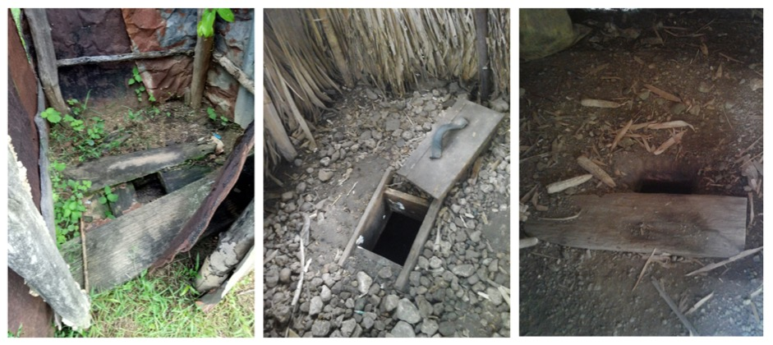

**Figure 8. Pit latrine without slab/open pit observed**

Regarding the floor type, 73.9% (n=229) of toilet observed using cement, and 18.1% (n=56) using stones or soil and only 6.1% (n=19) using ceramic.

**Figure 9. Type of toilet floor (N=310)**

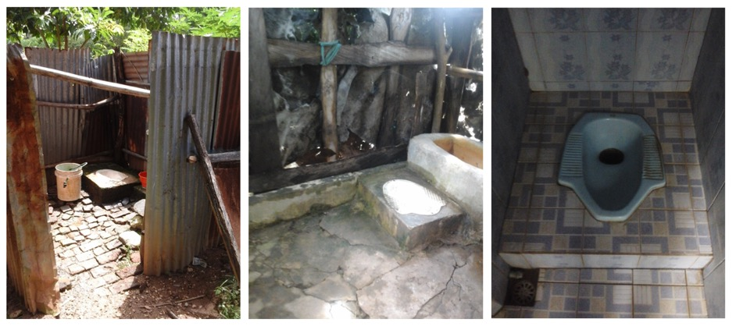

**Figure 10. Type of toiler floor observed**

Squat pan were most favourites pans used in Bobonaro Municipality as 51.6% (n=160) of toilet observed used squat pan or cement, 26.5% (n=82) used plastic squat pan, and only 1.6% (n=5) used ceramic pour flush sitting bowl. 8.7% (n=27) of observed toilet was made by the households using cement whilst 11.6% (n=36) was toilet without slab/open pit.

**Figure 11. Type of toilet pan/bowl (N=310)**

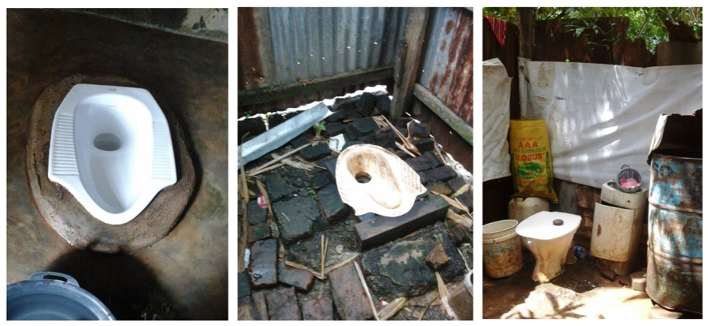

**Figure 12. Type of toilet pan/bowl observed**

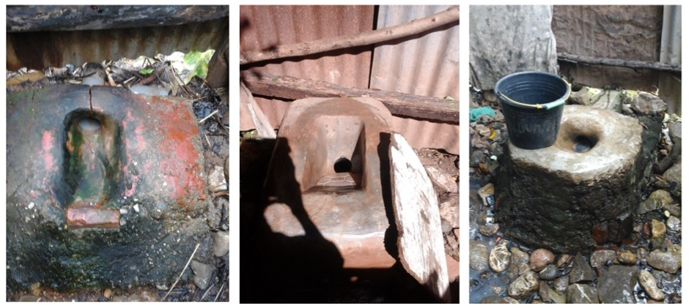

**Figure 12. Type of cement toilet pan/bowl observed (self-made by households)**

Regarding the toilet superstructure, 33.8% (n=105) of toilet observed used concrete block, whilst 28% (n=87) used corrugated zinc sheets as toilet wall. The use of wood/bebak as the local main materials for toilet wall was also high, 19.6% (n=61) of total: 27.3% (n=6) in Cailaco Administrative Post, 44.1% (n=30) in Atabae Administrative Post and 30.9% (n=19) in Balibo Administrative Post.

**Figure 13. Type of toilet wall/superstructure (N=310)**

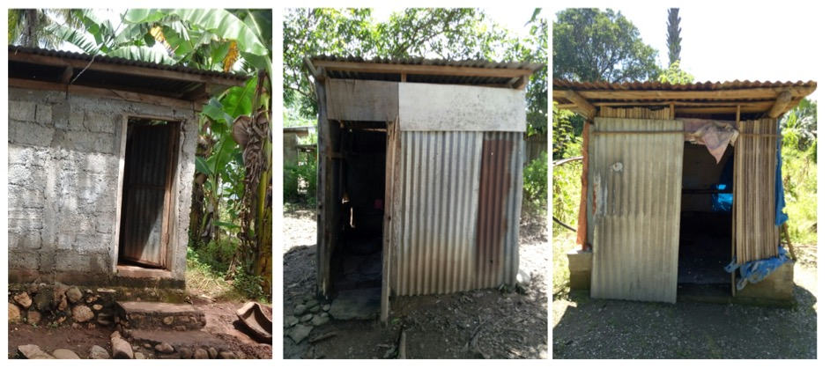

**Figure 14. Type of toilet wall/superstructure observed (concrete(left), corrugated zinc sheets (middle) and combination of bebak and corrugated zinc sheets (right)**

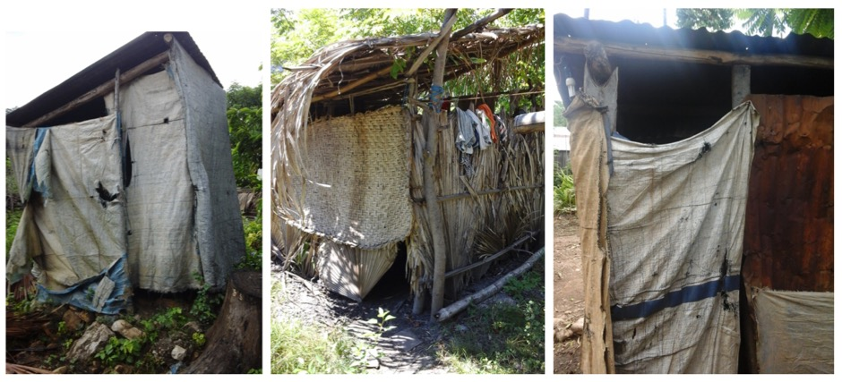

**Figure 15. Type of toilet wall/superstructure observed (terpal (left), palm leaves (middle), and combination of terpal and corrugated zinc sheets (right)**

Regarding the toilet roof, 65% (n=202) of toilet observed used corrugated zinc sheets and 24.8% (n=77) of toilet observed did not have roof.

**Figure 16. Type of toilet roof (N=310)**

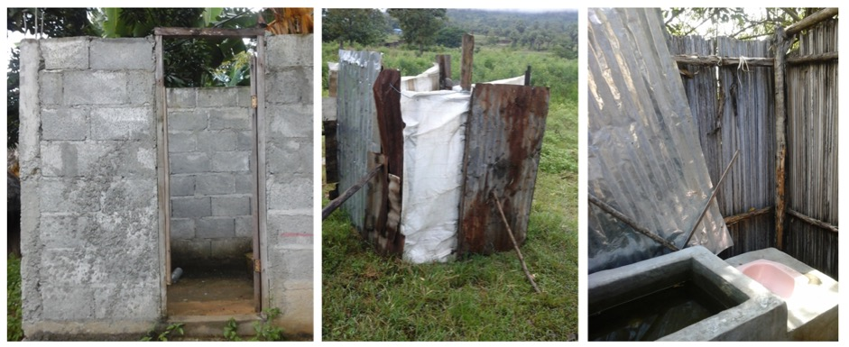

**Figure 17. Toilet without roof**

Of those who reported that the toilet did not have roof (n=77), 49.4% (n=38) used corrugated zinc sheets as the toilet wall, whilst 14.3% used palm leaves as toilet wall and 9.1% (n=7) who used concrete and 2.6% (n=3) who used bricks as toilet wall also reported that they did not have roof.

**Figure 18. Type of toilet wall used by household who reported that their toilet did not have roof (N=77)**

*Toilet modification for those with difficulties*

Most of the households (95.9%) reported that there were no any family members in the households who has difficulty using toilet such as elderly, very ill, physically disabled, and heavily pregnant women, whilst 3.1% (n=9) reported that there was someone in the house who has such difficulty. When asked whether they did some modification to the toilet so that the toilet can be used by person who has difficulty, 13.2% (n=39) reported that they had made some modification to the toilet including 1% (n=3) of those who reported that there was someone in the house who has any difficulty, whilst 80% (n=236) reported that they did not make such modification. The most common modification made by households were *use of* plastic chair with a hole in it (9.2%, n=32), make a wide pathway for easy access) (2%, n=7).

*Maintaining sanitation facility (emptying pit and cleaning toilet)*

More than half of respondent (58.3%, n=172) reported that the pit had not become full, while 15.6% (n=46) reported that the pit had become full after more than five years. 87% (n=40) of households who reported that their pit become full after five years reported that they built a new pit whilst 8.7% (n=5) reported that they emptied the pit by themselves. When asked about the family member who were responsible for cleaning the toilet, 50.1% (n=175) reported that it was adult female in the house who cleaned the toilet whilst 33.2% (n=116) reported that it was everyone’s responsibility in the house.

*Household level of satisfaction towards their current toilet*

When asked about households’ level of satisfaction toward the current toilet, 78% (n=230) of households reported that they were very satisfied and satisfied with the current toilet, whilst 10.9% (n=30) reported that they were dissatisfied and very dissatisfied with the current toilet.

When we analysed against the type of toilet, of those who reported that they were very dissatisfied/dissatisfied with the current toilet (n=30), 53.3% (n=16) used pour flush water sealed to offset pit, 66.7% (n=20) used cement as the toilet floor and 33.3% (n=10) used stones or soil as toilet floor, 40% (n=12) used squat pan ceramic or cement, and 30% (n=9) used other type of toilet pan (including those with open pit), and 20% (n=6) used self-made toilet pan. Regarding the type of wall, those who were very dissatisfied/dissatisfied with the current toilet were those who used corrugated zinc sheets (46.7%, n=14) and plastic sheeting/terpal (23.2%, n=7) and those who used corrugated zinc sheets as toilet roof (50%, n=15) and those who have no toilet roof (43.3%, n=13).

We explored what they liked about their current toilet, and the common toilet attributes that they like were: more private (72.2%, n=252), safe, especially at night (59.3%, n=207), healthier (47.6%, n=166) and cleaner (40.7%, n=142). On the other hand, the most common toilet attributes that they dislike about their own toilet were dirty (63.3%, n=221), smell (56.2%, n=196), and unhealthy (23.8%, n=83).

* + - 1. *Social norms*

Social norms are the rules that govern how individuals in a group or society behave. Any behaviour outside these norms is considered abnormal. From the qualitative study, we found that some households reported that they still go to the river to defecate particularly when there was a problem with the water supply (water interruption). Even though the administrative posts selected in the study, have been declared as ALFA, there was a slippage rate 8.9% where people still defecate in the open area including bushes. Having a toilet has become a new social norm, as it was enforced by the government and the community leader.

**4.3.3 Ability**

Ability is a category of factors related to an individual’s skills and capacity to perform the target behaviour. Under this category is a set of five determinants: knowledge, skills and self-efficacy, social support, roles and decisions, and affordability.

* + - 1. *Knowledge*

Knowledge is acquired through learning and may pertain to objects or products, behaviours and even outcomes. In this section, we will explore the health knowledge related to hygiene and sanitation practices.

*Diarrhoea prevalence and knowledge related to diarrhoea*

A small proportion of households (5.7%, n=20) reported that there was someone in the households who had diarrhea in the past 7 days. Diarrhea is defined as 3 or more loose stools in 24 hours. 7.1% was in Maliana, 5.2% was in Balibo, 4.5% was in Cailaco and 3.7% was in Atabae. When asked about factors that cause diarrhoea, most of households (71.3%, n=249) reported that it was caused by bad or dirty water, whilst 52.4% (n=183) reported that it was caused by dirty hands and 50.7% (n=177) reported that it was caused by bad or dirty food.

**Figure 19. Factor causing diarrhoea by gender (N=349)**

There was a significant difference in terms of knowledge in factors causing diarrhoea by gender. In terms of knowledge that diarrhoea was caused by bad or dirty food, females were 1.6 times more likely to report that diarrhoea was caused by this problem compared to males. Females were also 1.5 times more likely to report that diarrhoea caused by dirty hands compared to males, and females were 1.7 times more likely to report that diarrhoea was caused by flies.

There was a significant difference in terms of households’ knowledge regarding factors causing diarrhoea by administrative post. In terms of knowledge that diarrhoea was caused by bad or dirty food, compared to those in Cailaco Administrative Post, those in Atabae Administrative Post were 3 times more likely to report that diarrhoea was caused by bad or dirty food, and those in Balibo Administrative Post were 5 times more likely. On the other hand, compared to those in Maliana Administrative Post, those in Atabae Administrative Post were 2 times more likely to report that diarrhoea was caused by bad or dirty food, and those in Balibo Administrative Post were 4 times more likely.

**Figure 20. The most common factors causing diarrhoea by post administrative (N=349)**

When asked whether diarrhoea can be prevented or avoided, 90% reported that it can be prevented. The most common factors to prevent diarrhoea reported by households were washing hands (75%), using toilet to defecate (60%), and using soap (55%).

**Figure 21. Knowledge in preventing diarrhoea (N=20)**

When asked how communities could contribute to the prevention of diarrhoea, 79.7% (n=278) reported that clean water is one of the solutions, whilst 54.2% (n=189) reported that community support to construct toilets could help prevent diarrhoea.

**Figure 22. Diarrhoea prevention in the community level (N=349)**

There was a significant difference in household reporting that communities could contribute to diarrhoea prevention through helping with toilet construction by administrative post. Compared to those who lived in Cailaco Administrative Post, those in Maliana Administrative Post were 3 times more likely to report diarrhoea prevention through helping toilet construction, while those in Atabae Administrative Post were 3.6 times more likely and those in Balibo Administrative Post were 4 times more likely.

When asked about the main source of information about personal and household hygiene, 69.6% (n=243) reported television as the main source and 45% (n=157) reported the chefe de suco or community leader as the main source.

**Figure 23. Main source of information about personal and household hygiene by gender (N=349)**

There was a significant difference in terms of main source of information towards personal and household hygiene by gender. Female were 1.7 times more likely to report radio as the main source compare to male, and 2.3 times more likely to report school as the main source of personal and household hygiene. On the other hand, males were 2 times more likely to report the community leader or chefe de suco as the main source of personal and household hygiene information.

There was also a significant difference in terms of main source of information towards personal and household hygiene by post administrative. Those who lived in Maliana were 2.8 times more likely to report radio as main source of hygiene information compared to those who live in Balibo, and 3 times more likely compared to those in Atabae.

**Figure 24. Main sources of information about hygiene by post administrative (N=349)**

*Awareness of Toilet Options in Bobonaro Municipality*

A high proportion of households (92.3%, n=322) reported that they were not aware of the toilet options that were available in Bobonaro Municipality.

*Source of Information to upgrade toilet*

When asked where households obtain information to build or improve toilet including toilet design, and materials, 75.1% (n=262) reported that it was from their general knowledge, whilst 33.5% (n=117) reported that it was from the chefe de suco or other government leader and 25.8% (n=90) reported that it was from NGO guidance.

**Figure 25. Information source to build toilet including toilet design and materials (N=349)**

There was a significant difference by administrative post in terms of information source. In terms of general knowledge regarding the toilet improvement including materials needed, compared to those in Balibo Administrative Post, those in Maliana Administrative Post were 3 times more likely to report that they already have general knowledge related to toilet. Compared to those who live in Balibo Administrative Post, those in Atabae Administrative Post were 4 times more likely to report that they already have general knowledge related to toilet and those in Cailaco Administrative Post were 7.5 times more likely than those in Balibo Administrative Post.

**Figure 26. The most common source information to build toilet by administrative post (N=349)**

In terms of toilet-related knowledge obtained from the chefe de suco or other government leader, there was a significant difference by administrative post. Compared to Maliana Administrative Post, those who lived in Atabae Administrative Post were 2 times more likely to report that they got information from the chefe de suco or other government leader, whilst those in Balibo Administrative Post were 3 times more likely to report that they got information from the chefe de suco or other government leader in terms of toilet related knowledge.

* + - 1. *Skills and self-efficacy*

In this section we will explore knowledge needed to adopt a behaviour such as building/upgrading a toilet (skills) and confidence in one’s ability to carry out a behaviour (self-efficacy).

*Improving and upgrading toilet*

70.1% (n=141) of households reported that adult males were the primary decision makers to build or upgrade toilets , whilst only 13.4% (n=27) reported that the decision is made by both the adult male and female in the household. Of those who reported that they plan to install/upgrade a toilet, 73.3% (n=148) reported that they will upgrade the toilet by themselves, 14.9% will seek help from the family, whilst only 7.4% (n=15) will ask a local artisan or mason to upgrade the toilet.

* + - 1. *Social support*

Social support is the physical and emotional comfort given to individuals by family, community members, friends, co-workers and others. In this section, we will highlight the social support obtained by households related to information for improving toilet.

When asked whether they would seek other people advice regarding the materials they need to build or upgrade toilet, most of the households (71.1%, n=248) reported that they would not seek other people advice, whilst 13.2% (n=46) reported that they seek other people advices. Of those who reported that they would seek for advice, the most common people whom they most like to talk to for information and advice about technical options including materials were neighbour with toilet (50%, n=23), family member with toilet (43.5%, n=20), local mason (34.8%, n=16), and community leader (23.9%, n=11). Only 4.3% reported that they would seek advice from the material suppliers.

**Figure 27. Seeking other people advice about technical options in building or improving toilet (N=46)**

* + - 1. *Roles and decisions*

Household decisions regarding sanitation behaviours are numerous. In this section, we will explore the function of person(s) within the household/community who makes decisions or can influence behaviour.

Those who paid for the construction of the toilet were: households itself (88.1%, n=260) while 6.1% (n=18) reported NGO as the one who paid for the construction, and 4.1% (n=12) reported that it was a family member. When asked about those who constructed the toilet, 72.9% (n=215) reported that it was the household, and 14.9% (n=44) reported that it was the family and 9.5% (n=28) reported that a mason had built the toilet.

Of those households who built toilet by themselves, only 14.0% (n=30) reported that somebody helped, only 16.7% of which were paid to help. The average financial remuneration for this help ranged between USD5 (n=3) and USD10 (n=2). The main reasons why households volunteered to help other households build toilets were: because they were family so that they help each other (54.2%, n=13) and because they worked in a group so that they helped each other (37.5%, n=9). Other reported reasons included they do not have ability to do it and they will use the toilet together (toilet shared with neighbour).

When we asked households whether or not they had helped other households, only 12.3% (n=43) reported that they had helped another house build a toilet. Only 14% (n=6) of these respondents were paid. The average money that the household received when they help others to build the toilet varied: USD5 (n=1), USD10 (n=2), USD100 (n=1), USD150 (n=1), and USD250 (n=1). The most common reasons why thes respondents volunteered to build toilet were: helping family (50%, n=18) and helping others (50%, n=18).

The materials to build toilet were transported to the house by several transportation modes: car (37.8%, n=109), truck (29.9%, n=86), motorbike (10.4%, =30), and public transport (9.4%, n=27).

**Figure 28. Transportation mode to deliver the materials (N=288)**

Those who used truck to transport materials to build their toilet reported that truck was provided by suppliers/loja, and that they also rent the truck (varied from USD40 to USD60). Some of them also reported that the materials were delivered by NGO (2.4%, n=7): 57.1% (n=4) from Maliana Administrative Post, 28.6% (n=2) from Atabae Administrative Post, and 14.3% (n=1) is from Balibo Administrative Post.

*Improving and upgrading toilets*

The family member who will make decision to build or upgrade toilet were adult male in the household (70.1%, n=141) whilst only 13.4% (n=27) who reported that the decision will be made by both adult male and female in the household. Of those who reported that they will install/upgrade the toilet, 73.3% (n=148) reported that the will upgrade the toilet by themselves and 14.9% will ask help from the family, whilst only 7.4% (n=15) who will ask local artisan or mason to upgrade the toilet.

*Source of materials to improve/upgrade toilet*

More than half of households that reported intentions to buy materials to upgrade their toilet reported that they will obtain materials from suppliers located in the same area where they lived. However, looking at the data more carefully, the majority of these households intend to purchase sanitation supply from Maliana Administrative Post. 86.7% (n=85) of households that intend to make an upgrade in Maliana Administrative Post reported that they will buy materials in Maliana Administrative Post. 80% (n=12) of households in Cailaco reported that they will purchase the materials in Maliana Administrative Post. Almost half of the houses that intend to make an upgrade in Atabae Administrative Post plan to buy materials from Atabae Administrative Post (45.5%, n=15) with 42.2% (n=14) planning to buy from Maliana Administrative Post. The majority of households in Balibo Administrative Post (59.1%, n=26) reported that they will buy materials in Balibo, whilst 9.1% (n=4) reported plans to procure materials from Maliana Administrative Post.

**Figure 29. Location of suppliers where households will buy materials (N=190)**

The most common transportation options available include truck (34.6%, n=66) and public transport (31.4%, n=?). Those who mentioned public transport as transportation mode reported the use of anggunas and buses to transport the materials. 12% (n=23) of households will use a motorbike to transport materials including ojek services and tricycle motorbikes.

**Figure 30. Transportation mode to deliver the materials to upgrade toilet (N=191)**

* + - 1. *Affordability*

Affordability refers to one’s ability to pay for a sanitation product or service or to engage in a sanitation behaviour.

*Funding to upgrade toilet*

When asked whether they already have funding source to build or improve their toilets, 81.0% (n=281) reported that they did not have a current funding source or they did not know. Of the 19% (n=66) who reported already having a source of funds for toilet upgrades, 63.6% (n=42) indicated that the source came from their own income, which was generally raised from selling animals and other local products, such as vegetables. 16.7% (n=11) reported that they would depend upon their family for the funds.

81.1% (n=283) reported that they were not interested in taking a loan or some other credit to build or improve their toilets. Only 10.3% (n=36) reported that they were interested in taking a loan. There is significant difference between administrative posts around interest in loans for toilet upgrades, with 52.8% (n=19) in Maliana AP, 11.7% (n=9), Balibo AP, 8.5% (n=7) in Atabae AP and 4.5% (n=1) in Cailaco AP indicating interest in taking a loan. Of those who were interested in improving toilet, only 13% (n=28) were interested in taking a loan. Those who were interested in improving/upgrading their toilet were 2.3 times more likely to take a loan.

*Additional funding from external*

When asked what materials they wanted to buy if they had additional USD 40 from an external source, 43.6% (n=151) reported that they will buy cement, 36.1% (n=125) reported that they will buy corrugated zinc sheets whilst 10.7% (n=47) reported that they will use it to buy blocks and 10.1% (n=35) reported that they will buy toilet pans. A considerable number of respondents either did not know what materials to buy (14.5%, n=79) or felt that USD 40 was not sufficient to purchase what was needed (11.2%, n=10).

**Figure 31. Materials to buy if households had additional funding USD40 (N=346)**

When asked whether they negotiated when they buy materials for building or upgrading their toilets, 73.2% reported that they negotiated whilst 24.5% (n=85) did not. The usual negotiations generated cheaper prices (68.3%, n=237). Regarding the payment preference, 98.3% (n=343) reported that they preferred cash up front as payment. Most of them also reported that they did not obtain credit from the material suppliers.

* + 1. **Motivation**

Motivation is a category of factors that affect an individual’s desire to perform the target behaviour including their beliefs and values and social, physical, or emotional drivers. Under this column is a set of six determinants: attitudes/beliefs, values, emotional/physical/social drivers, competing priorities, intention, and willingness to pay.

*4.3.4.1 Attitudes and beliefs*

Attitudes and beliefs relate to an individual’s understanding and perceptions of sanitation products and services, of sanitation behaviours themselves, and of those who engage in them.

*Good sanitation*

When asked what good sanitation meant to them, 75.6% (n=264) reported that good sanitation meant increased comfort, whilst 34.1% (n=119) reported that it meant increased safety for women, especially at night and for children. 32.7% (n=114) reported that it meant reduced smell and flies. There was a significant difference by gender in terms of good sanitation related health. Females (26.5%) were more likely to report that good sanitation meant good health in a very broad cultural sense, which often linked to disgust, avoidance of excreta, and bad air smell compared to males (16.1%). Another significant difference between males and females was that 32.2% of males reported that good sanitation meant peace of mind compared to 14.0% of females.

**Figure 32. The meaning of good sanitation for households (N=349), *) significant difference by gender**

* + - 1. *Values*

Values are related to beliefs. Whereas attitudes and beliefs lie mostly at the individual level, values operate at the collective level. Similar with social norm which operates in the community level, values are influenced by social norm. It is related to the program ALFA in the community level where every household needs to have their own toilet.

* + - 1. *Emotional/physical/social drivers*

Drivers are strong internal thoughts and feelings that motivate behaviour. Emotional/physical/social drivers also include feelings of pride, disgust, or shame from doing or not doing a behaviour.

*Desired toilet qualities*

The most common households’ preferred toilet qualities and its desired attributes were: no smell of urine and excreta (76.2%, n=266), durable and long lasting (62.8%, n=219), no sight of excreta (44.7%, n=156), and easy to clean surfaces (32.1%, n=112). There was a significant difference by post administrative and by gender in terms of durability as a key toilet attribute. Females (68.55%, n=137) were two times more likely to report that they preferred a durable, long-lasting toilet than males (55.0%, n=82), and households in Balibo were two times more likely to report that they preferred this attribute compared to those in Maliana (71.4% vs 57.1%). Females were 1.6 times more likely to report that they preferred the absence of the sight of excreta compared to males (49.5% vs 38.3%). On the other hand, households in Maliana were almost three times more likely to report that they preferred no smell of urine and excreta as a key toilet attribute compared to those in Balibo (82.1% vs 63.3%).

**Figure 33. Preferred toilet attributes (N=349)**

* + - 1. *Competing priorities*

Households and individuals face many competing demands when it comes to spending; the lower the income, the more these competing demands will influence behaviour.

The competing household demands and priorities for spending on a new/upgraded toilet were education for children (67.6%, n=236) and healthcare (65.3%, n=228). As healthcare and education are supposed to be free in Timor Leste, there are hidden costs in the education system and healthcare system, which were not explored in this study. There was a significant difference by gender in terms of healthcare as a competing interests, where males (71.8%) were more likely to report healthcare as the main priority than spending on a new toilet/improving toilet.

**Figure 34. The competing household priorities for spending on a new or upgraded toilet (N=349)**

* + - 1. *Intention*

Intention represents an individual’s plan on whether or not to engage in a certain behaviour.

*Intention to use water friendly toilet products*

When asked whether they were interested in building/improving the toilet with a water friendly pour flush system, 67.9% (n=237) reported that they were interested whilst 32.1% (n=112) reported that they were not interested or did not know. One of toilet products using small amount of water is SatoPan. A couple of suppliers in Bobonaro Municipality were found to be selling the Sato Pan product.

*Interest in upgrading toilet and likelihood to upgrade toilet in the next 12 months*

A high proportion of households (61.9%, n=216) reported that they were interested in improving or modifying their toilet facilities. The most common reasons for doing the improvements were: emotional benefits (48.3%, n=97) such as more comfort, safety, health, and ease of use; repairing the toilet (20.9%, n=42) because it had been broken, damaged, old, full pit; and durability (20.4%, n=41) to extend the life of the toilet by building a permanent one.

**Figure 35. The main reasons for improving or upgrading toilet by administrative post (N=201)**

When asked how likely it is that they will build/upgrade their toilet in the next 12 months, 55.3% (n=193) reported that they were very likely and likely. Of those who had interest in improving their toilet, 73.1% (n=141) reported that they were very likely and likely to improve the toilet in the next 12 months.

Of those who were very likely/likely to upgrade their toilet in the next 12 months, 85.8% (n=151) used pour flush water sealed to offset pit whilst 5.7% (n=10) used pit latrine without slab/open pit; 71.6% (n=126) used cement as toilet floor, and 18.8% (n=33) used stones or soil as toilet floor; 50.6% (n=89) used squat pan ceramic or cement, 25.6% (n=45) used squat pan plastic, and 13.6% (n=24) used other type of pan including those with open pit without slab; 34.5% (n=61) used concrete blocks and 30.5% (n=54) used corrugated zinc sheets. 83.3% (n=10) of those who used palm leaves as toilet wall and 80% (n=4) of those who had no wall reported that they were very likely and likely to upgrade the toilet in the next 12 months. In term of toilet roof, of those who were very likely and likely to upgrade toilet in the next 12 months, 67.2% (n=119) used corrugated zinc sheets, and 19.8% (n=35) did not have toilet roof. 62.5% (n=10) of those who used palm leaves as toilet roof reported that they were very likely and likely to upgrade the toilet in the next 12 months.

When asked about which part of the toilet that they wanted to upgrade or improve, 35.2% (n=74) reported that they wanted to improve toilet superstructure as their first priority whilst 17.6% (n=37) reported that wanted to upgrade the toilet platform as the first priority. The most common reasons for the first priority were durability (47.4%, n=100), security and safety (17.6%, n=37) and health (16.7%, n=35).

**Figure 36. The main reasons for the first priority of upgrading toilet by administrative post (N=210)**

The most common reasons of improving toilet for those whose first priority was upgrading superstructure were durable so that it can be used for a long time and that it has complete toilet components (59.5%), and secure or safe (20.3%) whilst the most common reason for upgrading the toilet platform were: durable and complete components (45.9%) and healthy (37.8%).

**Figure 37. The main reasons for first priority of upgrading toilet (N=210)**

Predictors of upgrading or improving toilet in the next 12 months

This section will examine the predictors for upgrading/improving a toilet in the next 12 months by using logistic regression analyses by analysing impact of demographic variables, sanitation facilities, self-reported sanitation and hygiene related-knowledge, attitudes, and behavioural on households’ intention to upgrade toilet.

**Table 4.3a** *Predictors of upgrading toilet in the next 12 months (demographics)*

|  |  |  |  |  |  |  |  |  |
| --- | --- | --- | --- | --- | --- | --- | --- | --- |
| **Variables** | **Category** | **Likelihood to build or upgrade toilet in 12 months** | | **P Value** | **Univariate Odds-ratio (95% CI)** | **P Value** | **Multivariate Odds-ratio (95% CI)** | **P Value** |
| **Yes N (%)** | **No N (%)** |
| **Gender** | Male  Female | 98 (65.8)  95 (47.5) | 51 (34.2)  105 (52.5) | 0.001 | 2.1 (1.4-3.3)  1 (Ref) | 0.001 |  |  |
| **Education level** | No schooling  Schooling | 81 (48.5)  112 (61.5) | 86 (51.5)  70 (38.5) | 0.014 | 1 (Ref)  1.7 (1.1-2.6) | 0.015 |  |  |
| **Income level** | <USD 100  >USD 100 | 129 (51)  64 (66.7) | 124 (49)  32 (33.3) | 0.009 | 1 (Ref)  1.9 (1.2-3.1) | 0.009 |  |  |
| **Age** | <45 years  >45 years | 107 (51.0)  86 (61.9) | 103 (49.0)  53 (38.1) | 0.045 | 1 (Ref)  1.6 (1.0-2.4) | 0.045 | 1 (Ref)  2.4 (1.2-5.0) | 0.013 |
| **Status in household** | Head of HH  Other | 84 (65.6)  109 (49.3) | 44 (34.4)  112 (50.7) | 0.003 | 2.0 (1.3-3.1)  1 (Ref) | 0,003 |  |  |
| **Number of family in the household** | 1 family  >1 family | 140 (55.1)  53 (55.8) | 114 (44.9)  42 (44.2) | NS |  |  |  |  |
| **Having small children** | Yes  No | 116 (55.2)  77 (55.4) | 94 (44.8)  62 (44.6) | NS |  |  |  |  |
| **Water availability** | Available daily  Other | 142 (54.6)  51 (57.3) | 118 (45.4)  38 (42.7) | NS |  |  |  |  |
| **Experiencing water interruption in the last 6 month** | Yes  No | 36 (55.4)  157 (55.3) | 29 (44.6)  127 (44.7) | NS |  |  |  |  |
| **Type of sanitation facility** | Improved  Unimproved | 171 (58.4)  22 (39.3) | 122 (41.6)  34 (60.7) | 0.009 | 2.2 (1.2-3.9)  1 (Ref) | 0.010 | 4.3 (1.1-16.7)  1 (Ref) | 0.034 |
| **Age of toilet** | <3 years  >3 years | 79 (45.4)  95 (56.2) | 47 (37.3)  74 (43.8) | NS |  |  |  |  |
| **Toilet distance from the main house** | <5 meters  >5 meters | 156 (62.9)  20 (32.3) | 92 (37.1)  42 (67.7) | <0.001 | 3.6 (2.0-6.4)  1 (Ref) | <0.001 | 3.8 (1.8-8.3)  1 (Ref) | 0.001 |
| **Having funding** | Yes  No | 54 (81.8)  137 (48.8) | 12 (18.2)  144 (51.2) | <0.001 | 4.7 (2.4-9.2)  1 (Ref) | <0.001 | 2.5 (1.1-5.6)  1 (Ref) | 0.032 |
| **Person construction toilet** | Self  Other | 132 (61.4)  42 (52.5) | 83 (38.6)  38 (47.5) | NS |  |  |  |  |
| **Having interest in taking loan** | Yes  No | 24 (66.7)  169 (54.0) | 12 (33.3)  144 (46.0) | NS |  |  |  |  |
| **Seeking advice from other people** | Yes  No | 28 (60.9)  165 (54.5) | 18 (39.1)  138 (45.5) | NS |  |  |  |  |
| **Satisfaction level towards current toilet** | Yes  No | 151 (65.7)  23 (35.4) | 79 (34.3)  42 (64.6) | <0.001 | 3.5 (2.0-6.2)  1 (Ref) | <0.001 | 3.9 (2.0-7.6)  1 (Ref) | <0.001 |
| **Having interest in upgrading or building a new toilet** | Yes  No | 141 (65.3)  52 (39.1) | 75 (34.7)  81 (60.9) | <0.001 | 3.0 (1.9-4.6)  1 (Ref) | <0.001 | 5.4 (2.9-9.9)  1 (Ref) | <0.001 |

*NS: p Value > 0.05 (Not significant)*

**Table 4.3b** *Predictors of upgrading toilet in the next 12 months (sanitation related attitudes and beliefs)*

|  |  |  |  |  |  |  |  |  |
| --- | --- | --- | --- | --- | --- | --- | --- | --- |
| **Variables** | **Category** | **Likelihood to build or upgrade toilet in 12 months** | | **P Value** | **Univariate Odds-ratio (95% CI)** | **P Value** | **Multivariate Odds-ratio (95% CI)** | **P Value** |
| **Yes N (%)** | **No N (%)** |
| **Dislike the current toilet because it is dirty** | Yes  No | 155 (70.1)  38 (29.7) | 66 (29.9)  90 (70.3) | <0.001 | 5.6 (3.5-9.0)  1 (Ref) | <0.001 | 3.0 (1.3-6.8)  1 (Ref) | 0.010 |
| **Dislike the current toilet because it is smell** | Yes  No | 137 (69.9)  56 (36.6) | 59 (30.1)  97 (63.4) | <0.001 | 4.0 (2.6-6.3)  1 (Ref) | <0.001 |  |  |
| **Sales promotion as factor affecting decision to build toilet** | Yes  No | 27 (73.0)  166 (53.2) | 10 (27.0)  146 (46.8) | 0.022 | 2.4 (1.1-5.1)  1 (Ref) | 0.025 |  |  |
| **Access to materials as factor affecting decision to build toilet** | Yes  No | 8 (25.8)  185 (58.2) | 23 (74.2)  133 (41.8) | 0.001 | 1 (Ref)  4.0 (1.7-9.2) | 0.001 |  |  |
| **Emulate others as the reasons for building toilet** | Yes  No | 62 (67.4)  131 (51.0) | 30 (32.6)  126 (49.0) | 0.007 | 2.0 (1.2-3.3)  1 (Ref) | 0.007 |  |  |
| **Increased privacy as the meaning of good sanitation** | Yes  No | 46 (69.7)  147 (51.9) | 20 (30.3)  136 (48.1) | 0.009 | 2.1 (1.2-3.8)  1 (Ref) | 0.010 |  |  |
| **Peace of mind as the meaning of good sanitation** | Yes  No | 61 (80.3)  132 (48.4) | 15 (19.7)  141 (51.6) | <0.001 | 4.3 (2.4-8.0)  1 (Ref) | <0.001 |  |  |
| **Neighbour as the source of information to build toilet** | Yes  No | 52 (71.2)  141 (51.1) | 21 (28.8)  135 (48.9) | 0.002 | 2.4 (1.4-4.1)  1 (Ref) | 0.002 | 3.9 (1.5-10.0)  1 (Ref) | 0.004 |
| **Community leader as the source of information to build toilet** | Yes  No | 75 (64.1)  118 (50.9) | 42 (26.9)  114 (49.1) | 0.019 | 1.7 (1.1-2.7)  1 (Ref) | 0.019 |  |  |
| **Husband or wife as the source of information to build toilet** | Yes  No | 31 (91.4)  161 (51.3) | 3 (8.6)  153 (48.7) | <0.001 | 10.1 (3.0-33.8)  1 (Ref) | <0.001 | 9.4 (1.9-46.7)  1 (Ref) | 0.006 |
| **Television as the main source of information about personal and household hygiene** | Yes  No | 147 (60.5)  46 (43.4) | 96 (39.5)  60 (56.6) | 0.003 | 2.0 (1.3-3.2)  1 (Ref) | 0.003 |  |  |
| **Community leader as the main source of information about personal and household hygiene** | Yes  No | 101 (52.3)  92 (47.9) | 56 (35.7)  100 (52.1) | 0.002 | 2.0 (1.3-3.0)  1 (Ref) | 0.002 |  |  |
| **Local government as the main source of information about personal and household hygiene** | Yes  No | 31 (77.5)  162 (52.4) | 9 (22.5)  147 (47.6) | 0.003 | 3.1 (1.4-6.8)  1 (Ref) | 0.004 |  |  |

Univariate logistic regression analyses were undertaken with the following significant results:

* Male are 2.1 times more likely to report that they were likely and very likely to upgrade toilet in the next 12 months;
* Those who had attended school are 1.7 times more likely compared to those who had never attended school;
* Those with middle and high income level (> USD100) are 1.9 times more likely compared to those with low income level (<USD 100);
* Heads of households are 2 times more likely to report that they were likely and very likely to upgrade toilet in the next 12 months compared to those with other status in the household;
* Those aged 45 years and above are 1.6 times more likely;
* Those already with an improved toilet were 2.2 times more likely compared to those with an unimproved toilet;
* Those whose toilet distance is < 5 meters from the house are 3.6 times more likely to report that they were likely and very likely to upgrade toilet in the next 12 months compared to those whose toilet distance is more than 5 meter;
* Those who reported having a source of funds are 4.7 times more likely;
* Those who were satisfied and very satisfied with their current toilet are 3.5 times more likely to report that they were likely and very likely to upgrade toilet in the next 12 months;
* Those who had interest for improving toilet were 3 times more likely to report that they are very likely or likely to upgrade in the next 12 months;
* Those who reported that they dislike the current toilet because it is dirty are 5.6 times more likely;
* Those who reported that they dislike the current toilet because it is smell are 4 times more likely;
* Those who reported that sales promotion as main factor affecting decisions in building toilet are 3 times more likely;
* Those who did not report that access to materials as a main factor affecting decisions in building toilet are 4 times more likely;
* Those who reported that they emulate others as the reasons for building toilet are 2 times more likely;
* Those who reported increased privacy as the meaning of good sanitation are 2.1 times more likely;
* Those who reported peace of mind as the meaning of good sanitation are 4.3 times more likely;
* Those who reported their neighbour as the source of information to build toilet are 2.4 times more likely;
* Those who reported their husband or wife as the source of information to build toilet are 10.1 times more likely;
* Those who reported television as the main source of information about personal and household hygiene are 2 times more likely;
* Those who reported community leader as the main source of information about personal and household hygiene are 2 times more likely;
* Those who reported local government as the main source of information about personal and household hygiene are 2 times more likely to report that they were likely and very likely to upgrade toilet in the next 12 months.

Multivariable logistic regression analysis revealed that the following variables remained significant in terms of upgrading toilet in the next 12 months:

* Those aged 45 years and above are 2.4 times more likely;
* Those with improved toilet were 4.3 times more likely compared to those with unimproved toilet;
* Those whose toilet distance is < 5 meters are 3.8 times more likely;
* Those who reported having funding are 2.5 times more likely;
* Those who were satisfied and very satisfied with current toilet are 3.9 times more likely;
* Those who had interest for improving toilet were 5.4 times more likely;
* Those who reported they dislike the current toilet because it is dirty are 3 times more likely;
* Those who reported that their husband or wife as the main source to build/upgrade toilet were 9.4 times more likely; and
* Those who reported that their neighbour as the source of information to build toilet are 3.9 times more likely.

**4.4 Suppliers**

**4.4.1 Sample characteristics**

The total number of suppliers interviewed in this study was 13 suppliers (six suppliers were from Maliana, three suppliers were from Atabae, and four suppliers were from Balibo).

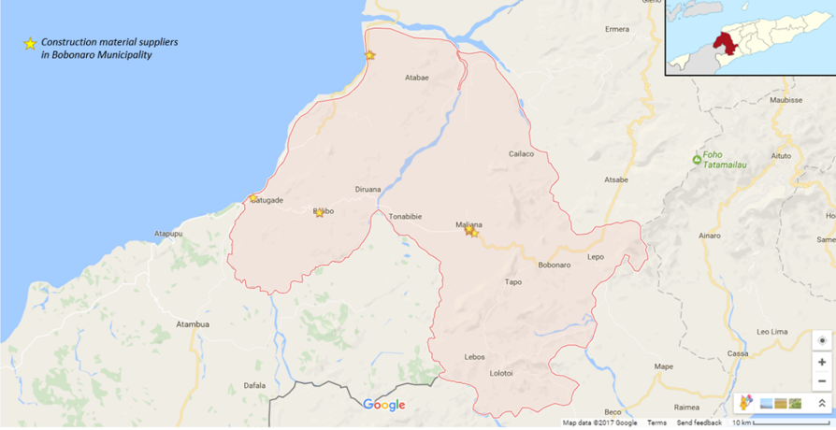

**Figure 38. Suppliers mapping in Bobonaro Muncipality (N=13)**

**Table 4.4** *List of suppliers*

|  |  |  |  |  |  |
| --- | --- | --- | --- | --- | --- |
| **Administrative Post** | **Suppliers** | **Suco** | **Aldeia** | **GPS Coordinates** | **Contact** |
| Maliana | Moris Kmanek | Lahomea | Lahomea | 8°59'20.9"S 125°13'17.0"E  -8.989136, 125.221385 | 77234289 |
| Hong Dashang | Lahomea | Lahomea | 8°59'22.8"S 125°13'15.9"E  -8.989679, 125.221072 | 77299966 |
| Yang Fa | Lahomea | Lahomea | 8°59'22.8"S 125°13'16.6"E  -8.989668, 125.221290 | 77250727 |
| Afu Lay | Raifun | Raifun Vila | 8°59'17.8"S 125°13'13.4"E  -8.988266, 125.220395 | 77261378 |
| Crescendo | Lahomea | Lahomea | 8°59'28.3"S 125°13'13.2"E  -8.991206, 125.220327 | 77255439 |
| Argo Iris | Lahomea | Maliana | 8°59'35.9"S 125°13'37.3"E  -8.993296, 125.227029 | 77437944 |
| Atabae | Naroman | Aidabaleten | Tutu Baba | 8°46'58.5"S 125°06'04.7"E  -8.782922, 125.101297 | 77250341 |
| Anjo | Aidabaleten | Tutu Baba | 8°46'57.1"S 125°06'04.7"E  -8.782518, 125.101310 | 77150320 |
| Leohara | Aidabaleten | Tutu Baba | 8°46'59.5"S 125°06'14.1"E  -8.783200, 125.103929 | 77289559 |
| Balibo | Leo Atsabe | Balibo Vila | Balibo Vila | 8°58'10.7"S 125°02'31.4"E  -8.969631, 125.042069 | 77274027 |
| Leo Kase | Balibo Vila | Balibo Vila | 8°58'11.0"S 125°02'30.9"E  -8.969717, 125.041903 | 75568476 |
| Balibo Furak | Balibo Vila | Balibo Vila | 8°58'10.5"S 125°02'32.8"E  -8.969592, 125.042433 | 77276284 |
| Maharani | Batugade | Batugade | 8°57'05.4"S 124°57'46.7"E  -8.951508, 124.962983 | 76960122 |

Maliana Administrative Post

There are six suppliers interviewed in Maliana Administrative Post. One supplier from Maliana Administrative Post refused to be interviewed.

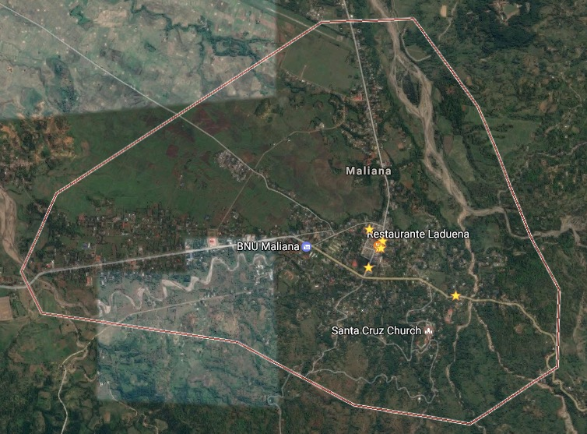

**Figure 39a. Suppliers mapping in Maliana Administrative Post**

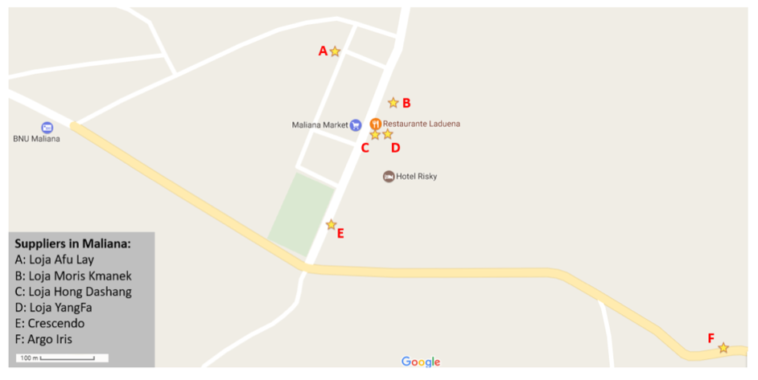

**Figure 39b. Suppliers mapping in Maliana Administrative Post**

As shown on the map above, five suppliers in Maliana Administrative Post are located close to each other around the Maliana Market. Loja Moris Kmanek, Hong Dashang, and Yangfa are in the same location whilst Loja Afulay is located in Raifun Villa, though still close to Maliana Market. Loja Crescendo, is located around 100 meter from the Maliana market. Loja Argo Iris is located in Aldeia Maliana. The nearest administrative post, Cailaco Administrative Post, has no suppliers.

Atabae Administrative Post

There are three main suppliers in Atabae Administrative Post: Loja Naroman, Loja Anjo, and Loja Leohara, which are all located in Aidabaleten. Loja Anjo and Loja Naroman are located on the main street whilst Loja Leohara is located approximately 300 meter from the main street.

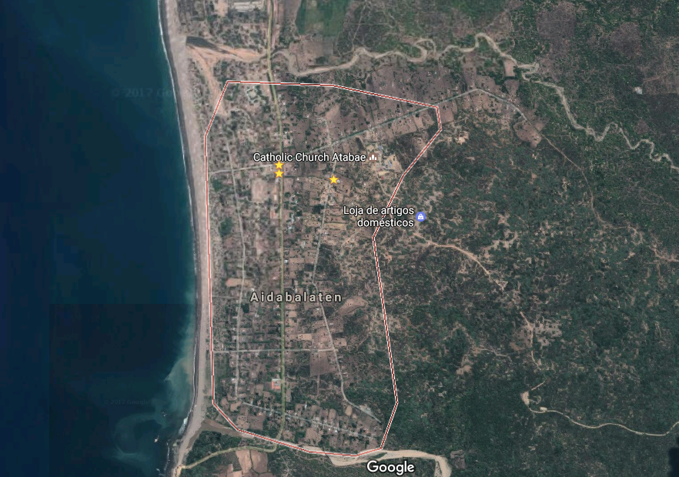

**Figure 40a. Suppliers mapping in Atabae** **Administrative Post**

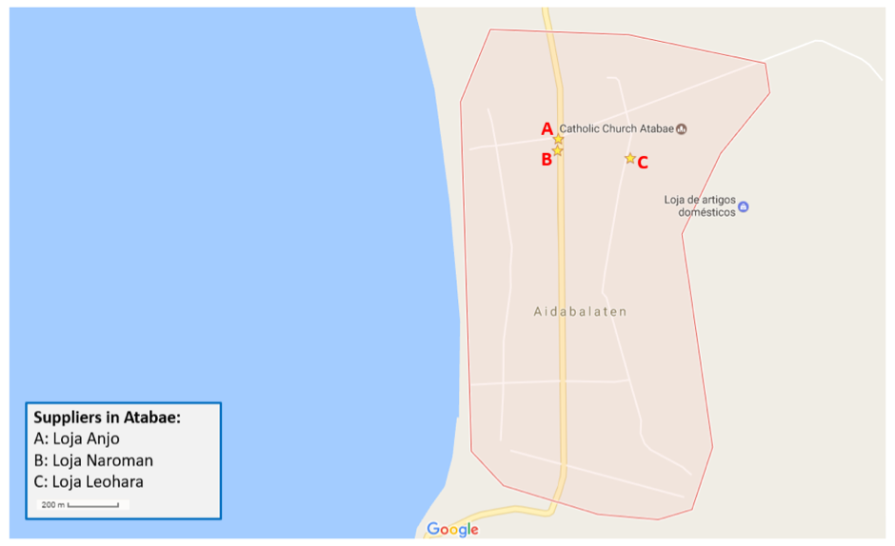

**Figure 40b. Suppliers mapping in Atabae Administrative Post**

Balibo Administrative Post

There are four main suppliers in Balibo Administrative Post. Three suppliers are located at the market in Balibo Villa, while one supplier is in Batugade, on Jalan Lintas Batas, near the border with Indonesia.

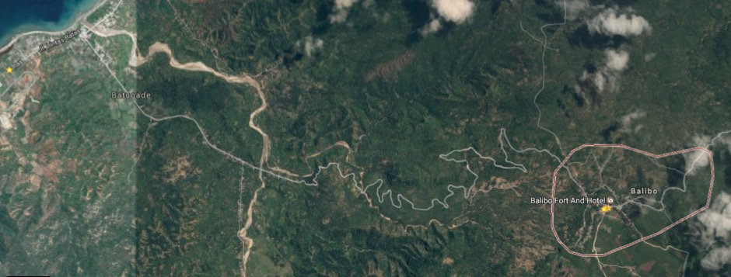

**Figure 41a. Suppliers mapping in Balibo** **Administrative Post**

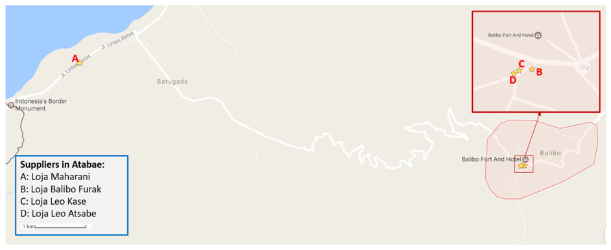

**Figure 41b. Suppliers mapping in Balibo Administrative Post**

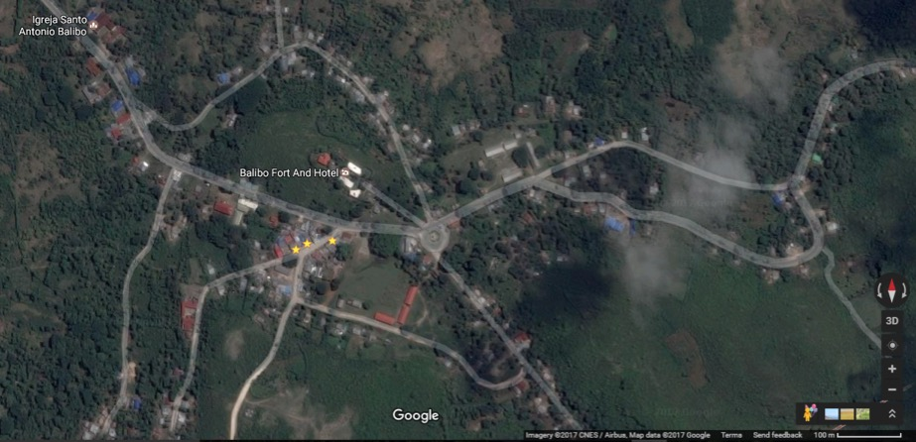

**Figure 41c. Suppliers mapping in Balibo Vila at the market area**

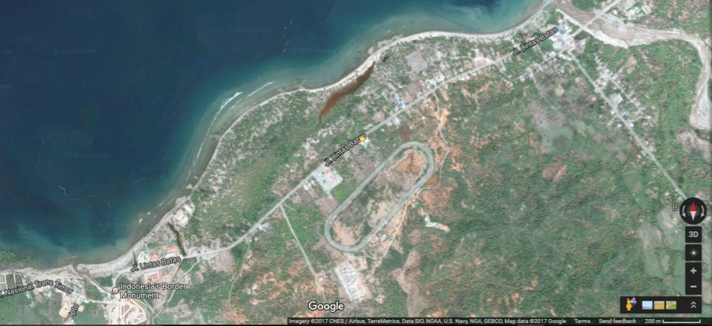

**Figure 41d. Suppliers mapping in Batugade**

*Business training*

When asked whether they had ever participated in any type of business training, 46.2% (n=6) reported that they had. Type of business trainings that they have attended were on: taxation (66.7%, n=4), marketing (66.7%, n=4), accounting and finance (50%, n=3), and business permit from Câmara de Comércio e Industria de Timor Leste (CCI-TL) (33.3%, n=2).

*Source of funding*

A high proportion of respondents (53.8%, n=7) reported that they personally generated the capital to start their business by saving money whilst 30.8% (n=4) reported that it was a loan from family or friends. All respondents reported that their business had been registered. 53.8% (n=7) reported that they have other business activities besides selling construction materials, including: selling household daily needs (groceries) (100%, n=7), concrete production (14.3%, n=1), and automotive services (14.3%, n=1). 69.2% of suppliers (n=9) reported that they managed the business finances themselves, whilst 30.8% (n=4) reported that it was their wife who managed the business finances.

A high proportion of suppliers (69.2%, n=9) of respondents reported that they had never borrowed money from banks or other sources. Only four buisnesses reported ever borrowing funds, with 23.1% (n=3) borrowing from banks (BNCTL and Bank China) and 7.7% (n=1) borrowing from the Cooperative (Moris Rasik). These funds were used to purchase other materials.

**4.4.2 Products**

The most common toilet pans/bowl people usually buy were ceramic or cement squat pans (84.6%, n=11), and plastic squat pans (15.4%, n=2). The most common brand for squat pan ceramic or cement were Chelsea and INA. 76.9% (n=10) of suppliers reported that there was no difference throughout the year with toilet product sales.

**Figure 42. The most selling toilet pans/bowls (N=13)**

The most commonly purchased ceramic/cement squat pan were obtained from Atambua (30.8%), and plastic squat pans were obtained from Dili (53.8%).

**Figure 43. Main suppliers for toilet pans/bowl (N=13)**

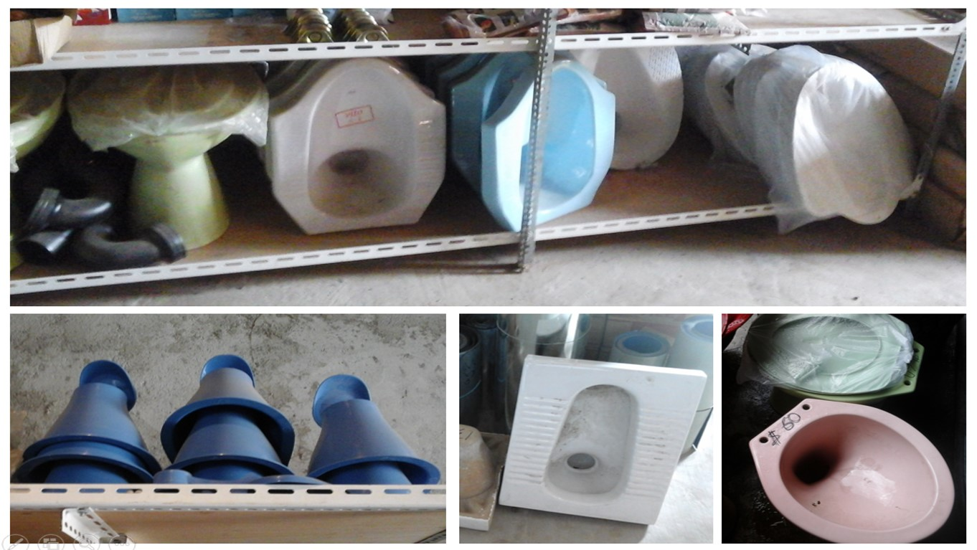

**Figure 44. Type of toilet pan available in Bobonaro Municipality**

Cement was obtained mostly from Atambua (59.2%), and corrugated zinc sheets were obtained from Dili (46.2%) and Atambua (23.1%). Most wood was obtained locally (38.5%).

**Figure 45. Main suppliers for toilet construction materials (N=13)**

A high proportion of suppliers (76.9%, n=10) reported that they have regular main suppliers for their products, with only 2 stores in Maliana Administrative Post reporting seeking different suppliers. Cement (46.2%, n=6) and iron bar (30.8%, n=4) were generally obtained from regular suppliers.

The main reason they bought the products from the same suppliers were to obtain cheaper price (76.9%, n=10), to obtain discount for bulk purchases (7.7%), to obtain credit (7.7%) and because there was only one main supplier available. Most suppliers (92.3%, n=12) reported a dfference in quality from different suppliers.

**4.4.3 Pricing Information**

61.5% (n=8) of suppliers reported that prices had increased compared to last year. Of those who reported that there has been an increase, 75% (n=6) reported cement and 25% (n=2) ceramic squat pans being more expensive than last year.

84.6% (n=11) of suppliers reported that customers can and do negotiate the price of their products, most commonly around cement (81.8%, n=9), toilet pans (particularly squat pans ceramic or cement) (27.3%), iron bar (27.3%), and zinc (27.3%). Customers usually negotiate to obtain cheaper price (92.3%, n=12) and discount for bulk purchases (7.7%, n=1).

*Inventory system and record*

Regarding the stock systems, 61.5% (n=8) reported that they did not have a documented stock system. Regular inventory checks indicate the need to re-order materials for thises suppliers. On the other hand, 38.5% reported that they have created simple stock systems (Moris Kmanek, Argo Iris, Leohara). The following are some examples of the stock system records used in the store:

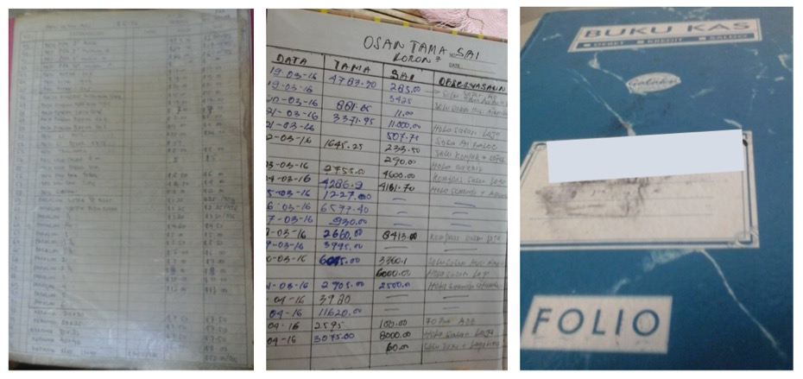

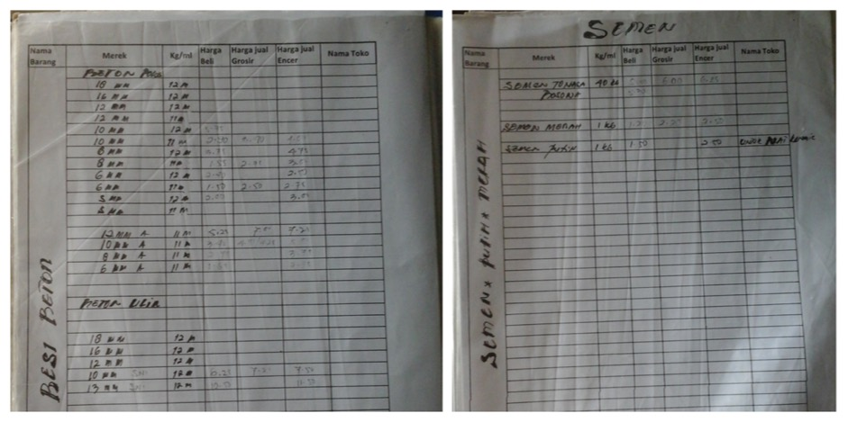

**Figure 46. Inventory record**

**Table 4.5** *Sanitation related materials and products available in Bobonaro Muniicipality*

|  |  |  |
| --- | --- | --- |
| **Itemsand Brand name** | **Unit** | **Sale Price Average (Range) (USD)** |
| Squat pan plastic Maspion | Pcs | 9.71 (8.00-12.50 |
| Squat pan plastic SatoPan | Pcs | 5.50 (5.00-6.00) |
| Squat pan ceramic Chesea, INA, VITO | Pcs | 15.73 (11.00-25.00) |
| Ceramic pour flush sitting bowl OLO or INA | Pcs | 59.40 (42.00-90.00) |
| Wood 5x7 | Pcs | 4.67 (4.00-6.00) |
| Wood 5x10 | Pcs | 7.08 (5.50-9.00) |
| Zinc 0.2cm | Sheet | 4.25 (3.50-5.50) |
| Zinc 0.3cm | Sheet | 3.17 (2.25-5.50) |
| Cement | Bag | 4.95 (4.50-5.50) |
| PVC Pipe 4 inch | Pcs | 10.33 (6.50-13.50) |
| PVC Pipe 3 inch | Pcs | 10.00 |
| PVC Pipe 2.5 inch | Pcs | 8.00 |
| PVC Pipe Elbow 4 inch | Pcs | 3.20 (2.50-4.00) |
| PVC Pipe Elbow 3 inch | Pcs | 3.00 |
| PVC Pipe Elbow 2.5 inch | Pcs | 2.50 |
| Sand | Truck | 20.00-50 .00( transportation costs) |
| Iron Bar 4mm | Pcs | 2.50 |
| Iron Bar 6mm | Pcs | 2,45 (1.50-4.00) |
| Iron Bar 8mm | Pcs | 3.67 (2.50-6.00) |
| Iron Bar 10mm | Pcs | 4.58 (3.75-7.00) |
| Nails | Kg | 1.84 (1.00-2.50) |
| Thin Wire | Roll | 1.57 (1.00-4.00) |
| Crowbar | Pcs | 6.2 (5.00-10.00) |
| Shovel | Pcs | 5.46 (4.00-8.00) |
| Trowel | Pcs | 2.55 (1.50-3.50) |
| Blocks/concrete | Pcs | 0.57 (0.50-0.60) |
| Wood clapboard | Sheet | 6.00 |
| Tiles | Box | 8.38 (6.00-14.00) |
| Water hose 30m | Roll | 24 (15.00-42.00) |
| Water hose 50m | Roll | 30.00 |
| Handwashing facility | Pcs | 42 (19.50-65.00) |

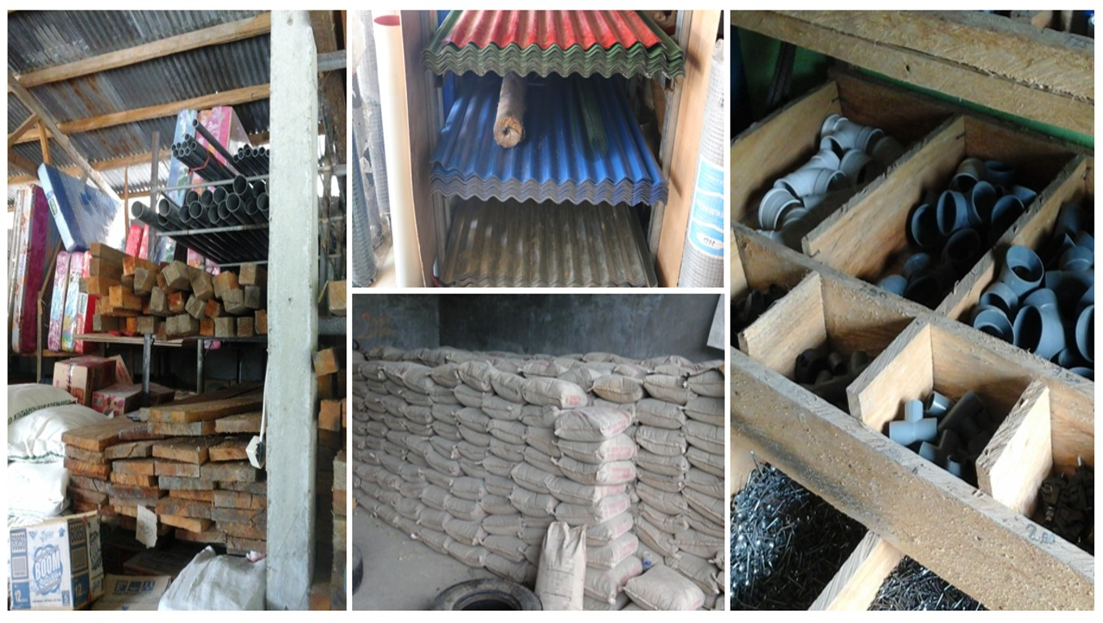

**Figure 47. Construction materials available in Bobonaro Municipality**

In terms of payment 76.9% (n=10), suppliers preferred cash up front, whilst 23.1% (n=3) reported that they accepted cash over time (step by step). 76.9% (n=10) reported that they did not provide credit to their customers.

**4.4.4 Customers**

All suppliers (100%, n=13) reported that the primary customers buying toilet-related products and materials were households. When asked where their customers came from, 84.6% (n=11) reported they came from the same administrative post as their store, whilst 15.4% mentioned that their customers were also from other post administrative post. One supplier in Maliana Administrative Post mentioned that their customers were also from Bobonaro Administrative Post. One supplier in Atabae Administrative Post reported that their customers were also from other administrative posts such as Balibo Administrative Post, Liquica Administrative Post (Maubara) and Ermera Administrative Post (Hatolia). One supplier in Atabae Administrative Post reported that they also covered customers from Liquica Administrative Post (Loes) as they were located close to this supplier.

76.9% (n=10) reported that they customers had asked for their advice regarding the materials they need to build toilet. All of those who had this experience reported toilet pans (100%, n=10) as toilet product which customers usually asking for recommendation, while 50% (n=5) mentioned cement, and 20% (n=2) mentioned corrugated zinc sheets and pipe.

*Marketing promotion*

Regarding the marketing promotion, 76.9% (n=10) reported that their main suppliers gave them marketing materials to promote their products. When asked whether they did any promotion or marketing of toilets or sanitation products, only 30.8% (n=4) who reported that they did any promotion.

When asked how customers obtain information about products or services they provided, 38.5% (n=5) reported that customers got it from words of mouth, whilst 15.4% (n=2) reported that they got information from banner, information from the shop owner (15.4%), and information government told the households to build toilet (15.4%). 7.7% (n=1) reported that the customers got information from radio (one supplier in Maliana Administrative Post (YangFa), Facebook (one supplier from Maliana Administrative Post (Afu Lay), and because it was only shop available at the aldeia (Batugade).

*Using market day and mobile store to sell products*

92.3% of suppliers (n=12) reported that they did not use market day to sell the materials, whilst one supplier (7.7%) used this market day to sell materials (Atabae Administrative Post (Loja Anjo). This suppliers sell materials in Aldeia Tasimean every week at the bazar (every market day) and reported that there was any influence on sales and revenue as they sell materials in this bazar.

Almost all of suppliers (92.3%, n=12) have not had experience in using mobile store to sell the toilet products and construction materials. One supplier from Atabae Administrative Post (Loja Anjo) reported that they have had this experience by selling materials in Atabae, Hataz, Maubara, Liquica. They used truck to sell the materials.

**4.4.5 Transportation services**

All of loja in three administrative posts (100%, n=13) reported that their main suppliers (in Atambua, Dili, etc) who provided them products and materials, provided transportations for them to deliver the materials.

Regarding the transportation services for the customers, 69.2% (n=9) reported that they provided this services whilst 30.8% (n=4) did not have this service. Those who had the transportation service (n=9) reported that they had minimum order to get this service (55.6%, n=5). The minimum order to get this service varied from USD500 to USD1000. Whilst other mentioned that they provided free service for delivering materials in the nearby area. When customers buy a large quantity of materials, 69.2% (n=9) reported that they gave special offers such as cheaper price and discounts (88.9%, n=8) and free delivery (11.1%, n=1).

**Table 4.6** *List of suppliers who provided transportation and summary of their condition for service*

|  |  |  |
| --- | --- | --- |
| **Administrative Post** | **Suppliers** | **Conditions for Service** |
| Maliana Administrative Post | Hong Dashang | No minimum order (“because they buy materials in our shop”) |
| Moris Kmanek | There is a minimum order, for example 2 toilet pans (“transportation cost is paid by the shop owner”) |
| Crescendo | No minimum order “Loja like helping their customers”) |
| Atabae Administrative Post | Leohara | No minimum order |
| Anjo | For purchase more than USD 1000, they will provide transport |
| Naroman | No minimum order, but depends on the distance |
| Balibo Administrative Post | Leo Kasae | There is a minimum order |
| Balibo Furak | There is a minimum order, USD 25 |
| Maharani | There is minimum order, if the purchase for bulk orders |

**4.4.6 Suppliers strength, business constraints and opportunity**

46.2% (n=6) reported that customers chose them over the competitors because of price (they stated that they have cheaper prices than my competitors), whilst 38.5% (n=5) reported that it was because they provided delivery to the customers and because of its location (30.8%, n=4).

**Figure 48. Factors contributing to customers preference in purchasing materials (N=13)**

The main constraints to the construction materials business were costs of inputs to purchase the materials (46.2%, N=6), access to finance (38.5%, n=5) and bad roads (23.1%, n=3).

**Figure 49. The main constraints to the business (N=13)**

Most of suppliers (61.5%, n=8) reported that the changing in materials price as the most common problems in supplying materials whilst 15.4% (n=2) reported that there was an inconsistent availability in construction materials.

**Figure 50. Problems related to the supply of materials (N=13)**

Most of suppliers (53.8%, n=7) suggested providing information on sanitation to customers to increase growth of their related toilet business whilst 30.8% (n=4) suggested to improve the quality of products.

**Figure 51. Improving Business (N=13)**

*Selling products in remote communities*

When asked whether they will be prepared to sell more to remote or poor communities, 69.2% (n=9) reported that they were not ready to sell more in remote communities. The main reasons for those who were note ready were: they still focused on the existing store (55.6%, n=5), there was no potential customer in the remote communities (11.1%, n=1), they still waited for the opportunity (11.1%, n=1), there was no profit selling in the remote communities (11.1%, n=1), and they did not want to destroy/compete with small business in the rural community (11.1%, n=1).

For those who agree to sell more in the remote area (30.8%, n=4) (i.e., Moris Kmanek, Anjo, Naroman, and Maharani), the reasons were: helping this vulnerable group because they do not have ability to buy at a high price (22.2%, n=2), selling more in remote communities as an opportunity to increase profits (11.1%, n=1), and one supplier is still preparing a plan to set up a store in some remote area (11.1%, n=1).

**4.4.7 Sato Pan**

A Sato (Safe Toilet) pan is a low cost hygienic toilet that uses a simple water seals to close off pit latrines from the open air. A trap door blocks the sight and smell of the pit below and can be opened easily to get rid of waste. We can rinse the pan clean with a very small amount of water

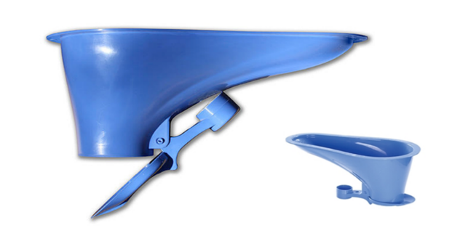

**Figure 52. Safe Toilet (SaTo) Pan**

When we asked about SatoPan product to suppliers, 76.9% (n=10) of suppliers reported that they have not heard about SatoPan, whilst 23.1% (n=3) reported that they know this product. Those who know Sato Pan reported that they got the information from the government and NGO BESIK. Government brought Sato Pan to the store to sell. People bought this produce and they like it because of water-efficient. They also reported that SatoPan was affordable (cheap) and easy to clean and water-efficient.

When asked whether they were interested in selling Sato Pan in the store, 61.5% (n=8) reported that they were interested whilst 38.5% (n=5) reported that they were not interested. Those who had interest in selling SatoPan were reported that they wanted to sell it because it is water-efficient (62.5%, n=5), cheap (50%, n=4), easy to use (25%, n=2), and it is the right choice for vulnerable people (with limited access to water or poor) (25%, n=2). Those who did not have interest in selling SaTo pan reported that they still have a lot of toilet pans in the inventory, and it is because the community has a lot of water supply so that the suppliers thinks SatoPan is not the right products in the area, and that customers prefer to use ceramic pan.

**4.4.8 Voucher system**

Support to poor households can be provided in the form of sanitation vouchers, which allow them to purchase a sanitary toilet at a discounted price. There is a government program that is developing a system for providing coupons / vouchers to houses in this community that they could use to purchase sanitation related products so that they can improve sanitation in their homes. This would mean that the store would allow them to choose items from the store up to a specific value and that are sanitation related in return for the coupon. On a monthly basis, the program representatives would check the stock distributed and the vouchers received and pay the store for those items.

None of the suppliers had used such a system before. When asked whether they were interested in using this system to attract and engage customers, 92.3% (n=12) reported that they were interested. 84.6% (n=11) also reported that voucher system will help to increase their sales. The most common reasons they want to use the voucher system were: it can help improve the store to grow bigger (58.3%, n=7), it will be beneficial for the store as long as it has right deal (16.7%, n=2), there will be no loss for the store so that is okay (16.7%, n=2), and because it can help vulnerable people (8.3%, n=1).

**4.5 Masons**

**4.5.1 Sample characteristics**

The total masons interviewed in this study was 36 people: 58.3% (n=21) was from Maliana, 8.3% (n=3) was from Cailaco, 22.2% (n=8) was from Atabae, 11.1% (n=4) was from Balibo. Most of masons (47.2%, n=2) were aged between 35 and 44 years, 30.6% (n=10) was aged between 25 and 34 years, and 19.4% (n=7) was aged between 45 and 54 years. Regarding the education level, 41.7% (n=15) of masons did not go to school, 38.9% (n=14) of masons had primary level education, and 19.5% (n=7), had secondary level education.

72.2% (n=26) of masons reported that they have any other business activities besides becoming masons. 94.4% (n=34) of masons reported that their main source of income was house construction, 63.9% (n=23) of masons reported that their main source of income was being farmers. 91.7% (n=33) of masons reported that their wives were the one who managed their finance.

Most of masons (63.9%, n=23) reported that they worked with other masons, whilst 26.1% (n=13) reported that they worked alone. The average years of them being masons was 17 years. 44.4% (n=16) got money to start the business to become masons from their saved money, whilst 22.2% (n=8) obtain the money from loan from family or friends. 52.8% (n=19) of masons reported that they work mostly during the dry season whilst 44.4% (n=16) reported that there was no seasonality to their work.

**4.5.2 Training**

66.7% (n=24) of masons reported that they were trained to do the works. Of those who reported that they got the training, 36.1% reported that they got the training from other masons while doing the work, whilst 13.9% (n=5) reported that they got it from NGO program. When asked whether they have staff, 86.1% (n=36) of masons reported that they have assistants that help doing the work. 58.1% (n=18) reported that their staff got training. Their staff usually got training from: the other masons (41.7%, n=15) and training from NGO (8.3%, n=3).

**Figure 53. Type training obtained by masons (N=24) and assistant mason (N=18)**

All masons interviewed reported that customers supplied all the products. 47.2% (n=17) of masons reported that they usually construct the toilet for people that are building a new house, whilst 38.9% (n=14) reported that they construct the toilet for those who had no toilet. Regarding the type of toilet that they can construct, 69.4% (n=25) reported that they can build the pour flush to offset pit, 27.8% (n=10) reported that they can construct pit toilet with slab, 16.7% (n=6) reported that they can construct pit toilet without slab. Most of masons (54.3%, n=19) reported that they gave advice/suggestion of any type of toilet to their customers. 33.3% (n=12), reported that they recommend any materials to build toilet to their customers.

*Mason fee*

Most of masons (57.6%, n=19) reported that their service fee remained the same compared to last year, and 30.3% (n=10) reported that their fee has increased. When asked about the customers’ reaction on their service fee, 47.2% (n=17) of masons reported that their service fee was cheap and 41.7% (n=15) reported that their service fee was reasonable. When asked whether customers negotiated the service fee, 60% (n=21) reported that customers negotiated the cost of your service. Regarding the experience in providing free service, 44.4% (n=16) reported that they have given free service for their customers. The free service that they provided was usually for the family member who asked for help to build house or toilet (37.5%, n=6).

Regarding the number of toilet built, there were 98 toilet built in 2014 (n=22), 53 toilet in 2015 (n=18), and 42 toilet in 2016 (n=15). The service fees for building toile vary from one mason to another. For the pit digging, the fee varied from USD 20 to USD 250 (modus: USD 50, n=23). For the construction of superstructure, the fee varied from USD 55 to USD 500 (modus: USD 250, n=18).

In terms of type of payment on which they preferred, 41.7% (n=15) reported that they preferred cash up front whilst 38.9% (n=14) reported that they preferred cash over time. 19.4% (n=7) reported that they accept payment through goods barter. 88.6% of masons (n=31) reported that they did not provide credit to their customer.

**4.5.3 Customers**

Most of masons (66.7%, n=24) reported that their main customers were households whilst 25% (n=9) reported that their main customers were local NGO including donor funded projects (13.9%, n=5). 77.8% (n=28) of masons reported that the area they usually covered for the works was in the same suco as they lived, whilst 19.4% (n=7) reported that they mostly worked in the different suco. Only 30.6% (n=11) of masons who reported that they charge more when they worked far away from their house.

When asked how their customers know their service, 36.4% (n=12) reported that customers know their service from other people in the community and through NGO projects, and 15.2% (n=5) reported that t=it was their family who introduced them to the customers whilst 18.2% (n=6) reported that it was because of their good work quality so that customers know their services (based on other people recommendation).

**4.5.4 Strength, business constraints and opportunities**

97.2% (n=35) of masons seen other mason as their competitors. Most of mason (86.1%, n=31) reported that other masons who lived in the same area also working in the same area as them. 48.6% (n=17) reported that they know other masons fee. 69.4% (n=25) reported that they did not have any agreement with other masons such as deciding together price and 80% (n=28) reported that have not ever paid any commission to middleman in order to find new customers.

When asked about factors contributing to customer preference in choosing masons, 52.8% (n=19) of masons reported that it was the connections with the customers, whilst 27.8% (n=10) of masons reported that the customers chose them because of their work quality and 25% (n=9) of masons reported that they chose them because of their price.

**Figure 54. Factors contributing to customers preference in choosing masons (N=36)**

The main constraints for the masons were: bad roads (38.9%, n=14), availability of materials (27.8%, n=10), and customer not paying (27.8%, n=10).

**Figure 55. Main constraints to the business (N=36)**

**4.6 Value Exchanges**

Analysis of value exchanges help us describe the ways people gain access to improved water, sanitation and hygiene. Analysing exchanges also helps us understand the confluence of supply and demand for products, services and behaviours. The following Table 4.6 sets out the results of value exchange analysis using the four types, based on Barrington et al, 2016.

**Table 4.7** *WASH exchanges observed in Bobonaro Municipality (Water)*

|  |  |  |  |  |  |
| --- | --- | --- | --- | --- | --- |
| **Descriptions of WASH exchange** | **Exchange archetype** | | | | **Data** |
| **Market-based** | **Non market-based** | **Command-based** | **Culturally determined** |
| **WATER** | | | | | |
| People pay cash for bottled drinking water | **Y** |  |  |  | “The water that we collect by jerry cans is just for domestic use such as cooking and washing. We use **bottled water (gallon) as our drinking water**. First we buy the container and the water, it costs 9 dollar, and then 2 dollar for every refill” (Umakain008, Balibo) |
| People pay cash for domestic water use (including those for drinking purpose) | **Y** |  |  |  | When asked whether the location of the main water source for domestic use the same as drinking water, 88.5% (n=309) reported that they had the same water source.  **13.2% (n=46) reported they paid for domestic water use. Of those who paid, 65.2% (n=30) reported they paid monthly while 8.7% (n=4) paid weekly.** 82.8% (n=289) reported they did not pay for domestic water use.  “I pay $2 monthly but the water is not running well” (Umakain004, Maliana).  “For water, we pay yearly. It is $6.00/year” (Umakain001, Cailaco)  “We pay for the water every six months for $6. So, it is $12 a year. We pay to CVTL through Bank.” (Umakain002, Cailaco).  “I pay 5 dollar for 50 jerry cans, then they will deliver the jerry cans.” (Umakain008, Balibo). |

|  |  |  |  |  |  |  |  |  |  |  |
| --- | --- | --- | --- | --- | --- | --- | --- | --- | --- | --- |
| **Descriptions of WASH exchange** | **Exchange archetype** | | | | | | | | | **Data** |
| **Market-based** | | **Non market-based** | | **Command-based** | | **Culturally determined** | | |
| **WATER** | | | | | | | | | | |
| Domestic water supplied by government utility | |  | |  | | **Y** | |  | **Almost a third of respondents (27.8%, n=97) reported using water from public/communal tap/standpipe for domestic use whilst 24.1% reported that the main source of water for domestic use was piped water into dwelling.** Other sources of water for domestic use in four administrative post in Bobonaro Municipality were protected dug well (14%, n=49), **piped water to yard/plot (9.2%, n=32),** unprotected dug well (8.6%, n=30) and **borehole/tubewell (8%, n=28).**  **“The well (at our house)** dried out totally during drought. Since it only contained mud we had to walk with a push cart to get good water in front of the Social Office. It is quite far from here.(Fortunately) this well never dries up” (Umakain003, Maliana). | |
| Community managed water systems | |  | |  | |  | | **Y** | “**The priest asked me to help build the water system for the church**. I did it all, digging the soil, putting the hose, everything, but the other people were just watching me do all of that, not even offering any help. I did not even get paid for helping the priest.” (Badain004, Atabae).  “When the water is not available from the source for a week we normally have to check the line to make sure it gets back into the pipe. The main water source is quite far (in the forest area). It is **usually the men in our neighbourhood who go there to fix the problem**” (Umakain005, Ritabou). | |

|  |  |  |  |  |  |  |  |  |  |  |
| --- | --- | --- | --- | --- | --- | --- | --- | --- | --- | --- |
| **Descriptions of WASH exchange** | **Exchange archetype** | | | | | | | | | **Data** |
| **Market-based** | | **Non market-based** | | **Command-based** | | **Culturally determined** | | |
| **WATER** | | | | | | | | | | |
| Water source owned by one household shared with others | |  | |  | |  | | **Y** | “I own the well over there and it is used by 5 households in the neighbourhood” (Badain004, Atabae). | |
| Infrastructure provision for water systems | |  | | **Y** | |  | |  | **“They (CVTL) installed tap water into homes**. The toilet was just built in 2010 because there was a program implemented by CVTL which came here and asked us to build toilet and not to defecate in public.”  (Badain004, Atabae)    “Another example is when I got another project to build 16 wells. The NGO gave the free cement, sands, and stones and asked them to build their own wells. Do you know what happened? They sold all the materials. In the end, there was no well”. | |

*Y: Yes*

**Table 4.8** *WaSH exchanges observed in Bobonaro Municipality (sanitation facilities)*

|  |  |  |  |  |  |
| --- | --- | --- | --- | --- | --- |
| **Descriptions of WaSH exchange** | **Exchange archetype** | | | | **Data** |
| **Market-based** | **Non market-based** | **Command-based** | **Culturally determined** |
| **SANITATION FACILITIES** | | | | | |
| Toilets shared between households |  |  |  | **Y** | Most of households (84.5%, n=295) reported that they used their own toilet to defecate while 3.7% (n=13) and 0.9% (n=3) reported that they used neighbour’s toilet and shared toilet.  “The toilet uses ceramic squat pan. When the CVTL came, they did not give the toilet pan (just other materials). So he borrowed the toilet pan from another neighbour. They have been using it until now” (Badain002, Cailaco). |
| Donations or subsidies of toilet infrastructure including the installation of toilet |  | **Y** | **Y** |  | **6.1% (n=18) reported NGO as the one who paid for the construction**  Some of them also reported that the **materials were delivered by NGO** (2.4%, n=7).  “**CVTL who supported us with 2 sheets of zinc, 2 sacks of cement, and 4 iron bars for building this toilet.** We bought the other materials in Maliana, Bangun Jaya” (Umakain002, Cailaco).  “For the materials for this toilet, the palm leaves were arranged by me meanwhile cement, wood and the zinc were given by CVTL” (Umakain007, Cailaco).  When asked about those who constructed the toilet, 72.9% (n=215) reported that it was the household, and 14.9% (n=44) reported that it was the family and 9.5% (n=28) reported that it was mason who were responsible to build their toilet, **whilst 1.7% (n=5) reported that it was NGO who constructed the toilet.** |
| Purchasing materials for toilet construction | **Y** |  |  |  | All of suppliers (100%, n=13) reported the **main customers buying toilet-related products and materials was households.** When asked where their customers came from, 84.6% (n=11) reported that their customers came from the same post administrative post as their store located, whilst 15.4% mentioned that their customers were also from other post administrative post.  “…..We bought the other materials in Maliana, Bangun Jaya” (Umakain002, Cailaco).  “The materials were bought at Moris Kmanek store (in Maliana)” (Umakain003, Maliana).  “We usually buy materials in Bangun Jaya. All materials are sold in this shop” (Umakain004, Maliana). |
| Suppliers provided transportation service for delivering materials | **Y** | **Y** |  |  | The materials to build toilet were transported to the house by several transportation mode: car (37.8%, n=109), truck (29.9%, n=86), motorbike (10.4%, =30), and public transport (9.4%, n=27).  Those who used truck to transport materials to build their toilet reported that **truck was provided by suppliers/loja, and that they also rent the truck (varied from USD40 to USD60)**. Some of them also reported that the materials were delivered by NGO (2.4%, n=7).  **Regarding the transportation services for the customers, 69.2% (n=9) reported that they provided this services** whilst 30.8% (n=4) did not have this service. Those who had the transportation service (n=9) reported **that they had minimum order to get this service (55.6%, n=5).** The minimum order to get this service varied from USD500 to USD1000. Whilst other mentioned **that they provided free service for delivering materials in the nearby area** *(non-market based exchange).* |
| Mason built toilet for household | **Y** |  |  | **Y** | When asked about those who constructed the toilet…..**9.5% (n=28) reported that it was mason who were responsible to build their toilet.**  “There were two persons assisting my husband (in building toilet. They were paid because they are not relative” (Umakain004, Maliana).  “I hired a mason to build the toilet. It took 4 days to complete. I paid him $50 for 4 days. The mason provided the designs, size, and gave me some suggestions. He was the one who construct everything including the septic tank. He is from Ermera, very far away from here. It was my neighbour (who introduce him to me). I did not know the mason. My neighbour contacted the mason” (Umakain008, Balibo).  “It was my husband who built the toilet when we were still staying with my sister’s family. He is a mason” (not getting paid since it was his family) (Umakain004, Maliana) |
| People help other household/neighbor to build toilet | **Y** |  |  | **Y** | Of those households who built toilet by themselves, only **14.0% (n=30) reported that there was someone who help building the toilet.** Of those who got help from someone, **only 16.7% (n=5) who reported that they paid this person** *(market-based exchange).*  **83.3% reported that they did not pay those who help them built toilet** *(culturally-determined exchange).* The main reasons of why households still help others to build toilet without getting paid were: **because they were family so that they help each other** (54.2%, n=13) |

*Y: Yes*

**4.7 Handwashing**

**4.7.1 Access to and availability of hygiene and handwashing facility**

When asked where the members of household usually bath, 84.5% of the households (n=295) reported using bathroom in their own house whilst 8.6% of the households (n=30) reported that they usually take a bath in the surface water such as river, stream, and pond, and 4.9% (n=17) used neighbour’s bathroom, and only 2.6% (n=9) use public bathroom. When asked whether all household members use the same area as for bathing, 77.5% (n=245) reported that they use the same bathing location, while 22.3% (n=77) reported that they use different bathroom to take a shower. 70.9% (n=246) of households reported that the location of bathing facility was less than 5 meters from the main dwelling or house. 18.7% (n=65) reported that the bathing house located between 5 and 10 meters from the dwelling or house.

We made observations in the house towards handwashing facility and toilet components. Based on the observation, there was no handwashing facility in 69.2% (n=240) of houses, while 29.1% (n=101) of households had handwashing facility. Of those who had handwashing facility, 48.5% (n=49) of handwashing facility was located in the bathing area, whilst 28.7% (n=29) was located in the toilet and 12.9% was located in the kitchen area. Of those who had handwashing facility, water was available in the handwashing facility in 83.2% (n=84) of houses observed. Of those who had handwashing facility, soap and soap substitute was available in the 77.2% (n=78) of houses, while there was no soap and its substitute in 20.8% (n=21) of houses observed.

Access to and use of soap

Most of households (95.0%, n=330) reported that they have used soap today and yesterday and 4.3% (n=15) reported that they have not used soap today or yesterday. When asked about what the soap was for, 78.2% reported that they used soap for washing clothes (78.2%, n=273), washing body (71.9%, n=251), washing cooking utensils and dishes (58.7%, n=205), washing child’s bottom (42.7%, n=149), and washing child’s hands (39%, n=136).

**Figure 56. The use of soap for various needs (n=349)**

Type of soap

The common type of soap used by households to wash hands were bar soap (87.5%, n=305), and powder soap (6%, n=21). Only 3.4% (n=12) of households who reported that they did not use soap to wash their hands. For bathing, 90.5% (n=316) reported that they used bar soap and 5.2% (n=18) reported that they used powder soap. For wash dishes and clothes, 71.9% (n=251) of households reported that they used powder soap while 12.6% (n=44) reported that they used liquid soap and 12.3% (n=43) used bar soap. They usually buy the soap in the loja or kiosk that were nearby to their house or in the market. The median of amount of time needed to buy soap in Maliana was 15 minutes, in Cailaco was 5 minutes, in Atabae was 15 minutes and in Balibo was 15 minutes. The median distance of the kiosk or loja where they buy soap in Maliana was 2 km, in Cailaco was 1 km, in Atabae was 1.5 km and in Balibo was 1 km.

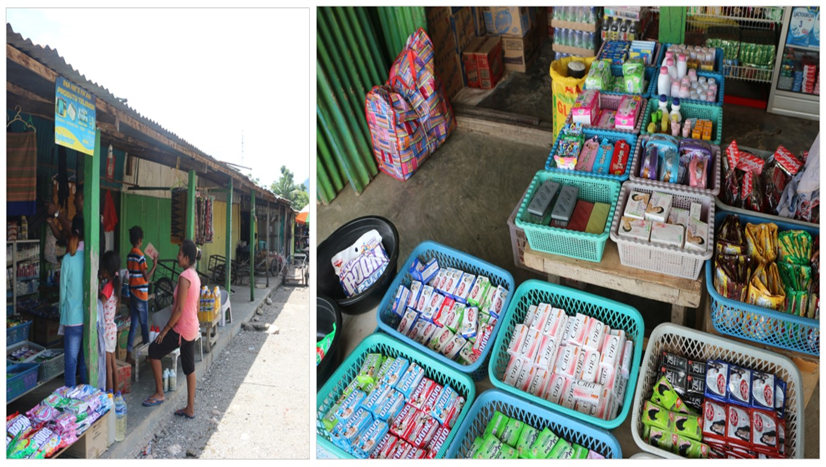

**Figure 57. Type of soap available at Maliana Market**

The most favourite soaps for handwashing were Citra (31.6%, n=104), and Nuvo (27.1%, n=89). The most favourite soaps for bathing were Citra (37.8%, n=129) and Nuvo (27.7%, n=94).

**Figure 58. The most favourite soap brands for handwashing (N=329) and bathing (n=339)**

On the other hand, the most favourite soap brands for washing clothes or dishes were Rinso (48.2%, n=163) and Daia (26%, n=88).

**Figure 59. The most favourite soap brands for washing and bathing (n=338)**

Availability of soap and other hygiene and sanitation products at local suppliers

When asked whether the soaps they usually wanted were always available at the shop, 94% (n=328) reported that they were always available. On the other hand, 4.6% (n=16) reported that the soaps were not always available and 93.8% of the households (n=15) reported that even though the soaps they wanted were not always available, the got the soap substitute. In the loja or kiosk where they usually buy soaps, the most common products that were available in these places were shampoo (83.4%, n=291), toothpaste (80.5%, n=281), toilet tissue (33%, n=115), floor liquid cleaner (22.3%, n=78), and toilet liquid cleaner (18.9%, n=66).

**4.7.2 Attitudes and beliefs related to handwashing**

Attitudes and beliefs relate to an individual’s understanding and perceptions of sanitation products and services, of sanitation behaviours themselves, and of those who engage in them.

When asked when it is important for a young child to wash her/his hands or have her/his hands washed, the most common answers were wash hands before eating (93.7%, n=327) and after defecating (62.2%, n=217).

**Figure 60. Health knowledge related to handwashing practice (N=349)**

**4.7.3 Emotional/physical/social drivers to handwashing**

Drivers are strong internal thoughts and feelings that motivate behaviour.

*Handwashing practices*

There was a significant difference in terms of washing hands practice after defecating by availability of specific handwashing facility. Those who have specific handwashing facility (35.6%, n=36) were more likely to practice handwashing after defecating compared to those who did not have it (21.5%, n=53). They were two times more likely to practice handwashing after defecating compared to those who did not have it.

There was also significant difference in terms of washing hands practice before preparing food in terms of water availability and soap availability in the handwashing facility. Those with water available at the handwashing facility (26.2%, n=22) were more likely to practice hand washing before preparing food compared to those without water at the handwashing facility (0%). Furthermore, those with soap (26.9%) were more likely to practice hand washing before preparing food compared to those without soap available at the handwashing facility (4.3%). They were 8.1 times more likely to practice hand washing before preparing food compared to those without soap available at the handwashing facility.

There was a significant difference in terms of washing hands practice before eating by availability of specific handwashing facility, availability of water, and availability of soap. Those who have specific handwashing facility (41.6%, n=42) were more likely to practice handwashing before eating compared to those who did not have it (19.1%, n=47). Those who had handwashing facility were three times more likely to practice handwashing before eating.

In terms of water availability at the handwashing facility, those with water available (48.8%) were more likely to practice handwashing before eating compared to those who did not have it (5.9%). They were 15 times more likely to hand wash their hands. In terms of soap availability, those with soap available at the handwashing facility (48.7%) were more likely than those who did not have it (17.4%). They were 4.5 times more likely to wash their hands before eating. When we analysed the main predictors for handwashing practice before eating by using multivariable logistic regression, availability of water and availability of soap remained significant as predictors for handwashing practice before eating. Those with water available were 12 times more likely and those with soap available were 3.5 times more likely after adjusting the handwashing facility.

There was a significant difference in terms of washing hands practice before going out by availability of specific handwashing facility. Those who have specific handwashing facility (10.9%) were more likely to practice handwashing before going out compared to those who did not have it (2.0%). They were six times more likely to practice handwashing before going out.

Those who have water available at the specific handwashing facility were also more likely to practice washing their child’s hands (46.4%) compared to those who did not have water available at the handwashing facility (11.8%). They were 6.5 times more likely to wash their child’s hands compared to those who did not have water available at the handwashing facility.

* + 1. **Predictors for handwashing practice**

This section will examine the predictors for handwashing with soap by using logistic regression analyses by analysing impact of demographic variables, sanitation facilities, self-reported sanitation and hygiene related-knowledge, attitudes, and behavioural on households’ intention to wash their hands with soap.

The handwashing with soap practice was divided into ‘yes’ (always, sometimes, rarely handwashing with soap) and no (never handwashing with soap). Those classified in ‘always’ response category were those who self-reported that they practice handwashing with soap in all five responses: (1) after defecating, (2) after cleaning child, (3) before feeding child, (4) before preparing food, and (5) before eating. Those classified in ‘sometimes’ response category were those who self-reported that they practice handwashing with soap in three to four responses above while those who only answered one to two responses, they were classified in ‘rarely’ response.

**Table 4.9** *Prevalence of handwashing with soap practice by administrative posts*

|  |  |  |  |  |  |
| --- | --- | --- | --- | --- | --- |
| **Variables** | **Overall N (%)** | **Maliana N (%)** | **Cailaco N (%)** | **Atabae N (%)** | **Balibo N (%)** |
| **Handwashing practice**   1. Never 2. Rarely 3. Sometimes 4. Always | N=349  192 (55.0)  102 (29.2)  23 (6.6)  32 (9.2) | N=168  94 (56.0)  52 (30.9)  12 (7.1)  10 (6.0) | N=22  15 (68.2)  5 (22.7)  2 (9.1)  0 (0) | N=82  40 (48.8)  23 (28)  4 (4.9)  15 (18.3) | N=77  43 (55.8)  22 (28.6)  5 (6.5)  7 (9.1) |

**Table 4.10a** *Predictors of handwashing practice by demographics variable and sanitation facility*

|  |  |  |  |  |  |  |  |  |
| --- | --- | --- | --- | --- | --- | --- | --- | --- |
| **Variables** | **Category** | **Handwashing with soap** | | **P Value** | **Univariate Odds-ratio (95% CI)** | **P Value** | **Multivariate Odds-ratio (95% CI)** | **P Value** |
| **Yes N (%)** | **No N (%)** |
| **Gender** | Male  Female | 61 (40.9)  96 (48.0) | 88 (59.1)  104 (52.0) | NS |  |  |  |  |
| **Education level** | No schooling  Schooling | 65 (38.9)  92 (50.5) | 102 (61.1)  90 (49.5) | 0.029 | 1.6 (1.0-2.5)  1 (Ref) | 0.030 |  |  |
| **Income level** | <USD 100  >USD 100 | 109 (43.1)  48 (50.0) | 144 (56.9)  48 (50.0) | NS |  |  |  |  |
| **Age** | <45 years  >45 years | 103 (49.0)  54 (38.8) | 107 (51.0)  85 (61.2) | NS |  |  |  |  |
| **Status in household** | Mother  Other | 64 (44.1)  93 (45.6) | 81 (55.9)  111 (54.4) | NS |  |  |  |  |
| **Number of family in the household** | 1 family  >1 family | 112 (44.1)  45 (47.4) | 142 (55.9)  50 (52.6) | NS |  |  |  |  |
| **Having small children** | Yes  No | 95 (45.2)  62 (44.6) | 115 (54.8)  77 (55.4) | NS |  |  |  |  |
| **Water availability** | Available daily  Other | 118 (45.4)  39 (43.8) | 142 (54.6)  50 (56.2) | NS |  |  |  |  |
| **Experiencing water interruption in the last 6 month** | Yes  No | 34 (52.3)  123 (43.3) | 31 (47.7)  161 (56.7) | NS |  |  |  |  |
| **Type of sanitation facility** | Improved  Unimproved | 139 (47.4)  18 (32.1) | 154 (52.6)  38 (67.9) | 0.035 | 1.9 (1.0-3.5)  1 (Ref) | 0.037 |  |  |
| **Availability of specific place to handwashing** | Yes  No | 63 (62.4)  94 (38.2) | 152 (61.8)  38 (37.6) | <0.001 | 2.7 (1.7-4.3)  1 (Ref) | <0.001 | 2.8 (1.7-4.5)  1 (Ref) | <0.001 |
| **Availability of soap or soap substitute at handwashing facility** | Yes  No | 63 (62.4)  94 (38.2) | 152 (61.8)  38 (37.6) | NS |  |  |  |  |

*NS: p Value > 0.05 (Not significant)*

**Table 4.10b** *Predictors of handwashing practice by hygiene related attitude and behaviours*

|  |  |  |  |  |  |  |  |  |
| --- | --- | --- | --- | --- | --- | --- | --- | --- |
| **Variables** | **Category** | **Handwashing with soap** | | **P Value** | **Univariate Odds-ratio (95% CI)** | **P Value** | **Multivariate Odds-ratio (95% CI)** | **P Value** |
| **Yes N (%)** | **No N (%)** |
| **Newspaper as the main source of information about hygiene** | Yes  No | 19 (65.5)  138 (43.1) | 10 (34.5)  182 (56.9) | 0.020 | 2.5 (1.1-5.6)  1 (Ref) | 0.024 |  |  |
| **School as the main source of information about hygiene** | Yes  No | 34 (64.2)  123 (41.6) | 19 (35.8)  173 (58.4) | 0.002 | 2.5 (1.4-4.6)  1 (Ref) | 0.003 |  |  |
| **Family or friends as the main source of information about hygiene** | Yes  No | 20 (62.5)  137 (43.2) | 12 (37.5)  180 (56.8) | 0.037 | 2.2 (1.0-4.6)  1 (Ref) | 0.040 |  |  |
| **Church as the main source of information about hygiene** | Yes  No | 25 (67.6)  132 (42.3) | 12 (32.4)  180 (57.7) | 0.003 | 2.8 (1.4-5.9)  1 (Ref) | 0.005 |  |  |
| **Belief that diarrhoea is caused by bad or dirty water** | Yes  No | 128 (50.6)  31 (31.0) | 123 (49.4)  69 (69.0) | 0.001 | 2.3 (1.4-3.7)  1 (Ref) | 0.001 |  |  |
| **Belief that diarrhoea is caused by bad or dirty food** | Yes  No | 95 (53.7)  62 (36.0) | 82 (46.3)  110 (64.0) | 0.001 | 2.1 (1.3-3.2)  1 (Ref) | 0.001 |  |  |
| **Belief that diarrhoea is caused by poor hygiene** | Yes  No | 59 (53.6)  98 (41.0) | 51 (46.4)  141 (59.0) | 0.028 | 1.7 (1.1-2.6)  1 (Ref) | 0.028 |  |  |
| **Belief that diarrhoea is caused by faeces or defecating in the open** | Yes  No | 29 (64.4)  128 (42.1) | 16 (35.6)  176 (57.9) | 0.005 | 2.5 (1.3-4.8)  1 (Ref) | 0.006 |  |  |
| **Belief that diarrhoea is caused by dirty hands** | Yes  No | 102 (55.7)  55 (33.1) | 81 (44.3)  111 (66.9) | <0.001 | 2.5 (1.6-3.9)  1 (Ref) | <0.001 | 7.7 (1.4-51.5)  1 (Ref) | 0.036 |
| **Belief that diarrhoea is caused by flies** | Yes  No | 88 (58.7)  69 (34.7) | 62 (41.3)  130 (65.3) | <0.001 | 2.7 (1.7-4.1)  1 (Ref) | <0.001 |  |  |
| **Belief that good sanitation can increase comfort** | Yes  No | 127 (48.1)  30 (35.3) | 137 (51.9)  55 (64.7) | 0.039 | 1.7 (1.0-2.8)  1 (Ref) | 0.040 | 6.8 (1.1-41.7)  1 (Ref) | 0.039 |
| **Belief that it can reduce smell** | Yes  No | 77 (67.5)  80 (34.0) | 37 (32.5)  155 (66.0) | <0.001 | 4.0 (2.5-6.5)  1 (Ref) | <0.001 | 13.7 (2.1-87.7)  1 (Ref) | 0.006 |
| **Belief that good sanitation means good health** | Yes  No | 46 (59.7)  111 (40.8) | 31 (40.3)  161 (59.2) | 0.003 | 2.1 (1.3-3.6)  1 (Ref) | 0.004 |  |  |
| **Belief that good sanitation can reduce illness** | Yes  No | 59 (66.3)  98 (37.7) | 30 (33.7)  162 (62.3) | <0.001 | 3.3 (2.0-5.4)  1 (Ref) | <0.001 |  |  |

Univariate logistic regression analyses were undertaken with the following significant results:

* Those who had attended education at school are 1.6 times more likely to report that they wash their hands using soap compared to those who had never attended school;
* Those who had improved toilet facility are 1.9 times more likely;
* Those who had specific place to handwashing are 2.7 times more likely;
* Those who reported newspaper as the main source of information about hygiene are 2.5 times more likely;
* Those who reported school as the main source of information about hygiene are 2.5 times more likely;
* Those who reported family and friends as the main source of information about hygiene are 2.2 times more likely;
* Those who reported church as the main source of information about hygiene are 2.8 times more likely;
* Those who had belief that diarrhoea is caused by bad or dirty water are 2.3 times more likely;
* Those who had belief that diarrhoea is caused by bad or dirty food are 2.1 times more likely;
* Those who had belief that diarrhoea is caused by poor hygiene are 1.7 times more likely;
* Those who had belief that diarrhoea is caused by faeces or defecating in the open area are 2.5 times more likely;
* Those who had belief that diarrhoea is caused by dirty hands are 2.5 times more likely;
* Those who had belief that diarrhoea is caused by flies are 2.7 times more likely;
* Those who had belief that good sanitation can increase comfort are 1.7 times more likely;
* Those who had belief that good sanitation can reduce smell are 4 times more likely;
* Those who had belief that good sanitation means good health are 2.1 times more likely; and
* Those who had belief that good sanitation can reduce illness are 3.2 times more likely to report that they wash their hands with soap.

Multivariable logistic regression analysis revealed that the following variables remained significant in terms of handwashing with soap:

* Those who reported that they have specific place to wash their hands at home are 2.8 times more likely;
* Those who had belief that diarrhoea is caused by dirty hands are 7.7 times more likely;
* Those who had belief that good sanitation can increase comfort are 6.8 times more likely; and
* Those who had belief that good sanitation can reduce smell are 13.7 times more likely to report that they wash their hands with soap.

**PART FIVE**

**DISCUSSION**

**5.1 Water access in Bobonaro Municipality**

Water is valuable because it is the baseline for surviving and thriving. Access to clean water is fundamental to human health. The importance of water to human health and wellbeing is encapsulated in the Human Right to Water, reaffirmed by the United Nations in 2010, which entitles everyone to “sufficient, safe, acceptable and physically accessible and affordable water for personal and domestic uses” (Bain et al., 2014).

In Timor Leste, the Timor‐Leste Strategic Development Plan (SDP) 2011‐2030 commits the government to achieving the water and sanitation MDGs by 2020 and describes the aim that “by 2030, all citizens will have access to clean water and improved sanitation” (Government of the Democratic Republic of Timor Leste, 2011). This study revealed that most of households in Bobonaro Municipality (86.1%) reported to be obtaining water for domestic use and drinking water from an improved source or protected source, such as public tap/standpipe, piped water supply into the dwelling, piped water to a yard/plot, borehole, protected dug well, protected spring, and rainwater collected in closed containers.

Empirical evidence suggests that these protected sources provide higher quality water, and studies have shown that these sources are associated with reduced child morbidity (Bain et al., 2014). Bain et al. (2014) reported that access to an ‘‘improved source’’ provides a measure of sanitary protection but does not ensure water is free of faecal contamination nor is it consistent between source types or settings. Water from improved sources is less likely to contain faecal contamination than unimproved sources, but they are not consistently safe.

As most of households in Bobonaro Municipality reported that they obtained water from an improved water source, an enhanced monitoring strategy which combine indicators of sanitary protection with measures of water quality is needed. As 13.9% of households still obtain water from an unimproved source, the water access intervention is needed to address their needs. Thus, by reducing the number of household who access this source, it can contribute to reduce the prevalence of health-related problems caused by unsafe water.

Water collection

This study revealed that adult women were the primary collectors of water for domestic use (67.6% of households. Female children also contribute to the water collection as 25.8% of households reported that their female children were responsible to collect water. The findings are consistent with a study from Graham, Hirai, and Kim (2016) who reported that adult females were the primary collectors of water across all 24 Sub-Saharan African countries, ranging from 46% in Liberia to 90% in Cote d’Ivoire. Women in Bobonaro Municipality have an important role in providing water for family as they are responsible for collecting and managing water for domestic use and at household level. There is a need to consider accessibility to water, water collection by children, and gender ratios for water collection as key indicators for measuring progress in the water, sanitation and hygiene sector.

Perception of how to solve problems and opportunity to encourage reporting if there is a problem

The study revealed that almost half of households (45.0%) did not tell or ask help from anybody whilst 19.2% reported that they told the problem or asked help from the community leader, 8.6% asked help from the mason/plumber, and 7.4% reported the problem to the local government. Of those who told the problem about water interruptions and asked for help, 70.2% reported that the water problem was solved after they contacted them, while 20.5% reported that the problem was not solved. This study suggest that there is a need to promote this 70% responses to fix problems related to water supply and monitor the water access and supply issue.

As only low proportion of households in Bobonaro Municipality reported the water problem to the government or water authority (i.e., SAS), the water management services need to be improved particularly focusing on the customer service as the main issue with water supply is not only about access and infrastructure but also about service to customer. Communication protocols needs to be reviewed and developed as both internal and external communications often get complicated and even convoluted. However, customer service should remain a top priority.

Willingness to pay has potential among early adopter group

When asked whether they were willing to pay to improve their water supply, 52.4% of households reported they were not, while 37.2% reported that they were willing to pay. Higher among those who had interest in improving water supply service as almost half of the households (46.6%) reported that they were willing to pay for the improvement. This study revealed that there is no significant different between the willingness to pay for water improvement variable by experiencing water interruption in the last 6 months variable and type of water source (unimproved vs improved).

**5.2 SaniFOAM**

Traditional approaches to improving sanitation which are aimed at building facilities have not resulted in significant and sustained sanitation coverage (Devine, 2009). SaniFOAM framework can be used to help analysing households’ sanitation behaviours to design effective sanitation interventions.

**5.2.1 Focus**

The desired sanitation behaviours in this study were improving or upgrading one’s sanitation facility, and correctly disposing of children’s excreta. These issues reflect a combination of once-off “purchase” or “adoption” behaviours, as well as “habit” behaviours repeated frequently and regularly. Part of the challenge for this assessment is to identify the interconnectedness, common issues across all of these behaviours, as well as those that require attention for just one WASH aspect.

**5.2.2 Opportunity**

*Access*

Most households (84.5%) reported they used their own toilet to defecate while 4.6% reported they used their neighbour’s toilet and shared toilet. The proportion of households which reported they still did the open defecation practice was 8.9%. Slippage is one of the main bottlenecks of achieving full coverage of water and sanitation services. While there will likely always be a residual population who practices open defecation, it’s worth understanding why this population continues the practice. It’s likely to be a combination of factors such as facility not built, or degradation of toilet.

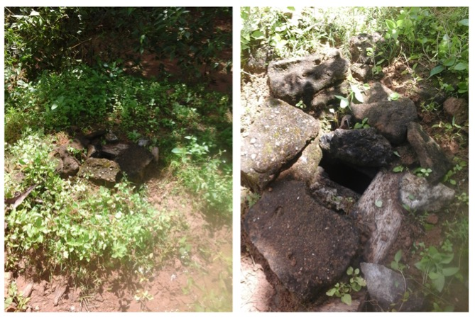

**Figure 61. One of ‘toilet’ observed in Bobonaro Municipality**

One example is the distance between the home and work, especially for those working in fields far from their homes. A study from Abdi (2016) gave some example of enabling factors to open defecation. For example, when people are away from home and unable to find toilet, they will consider open defecation is acceptable. However, they will consider open defecation is not acceptable when they are near home as there is a sense of shame or feeling embarrassed about being seen as they defecating in the open area.

Also the sharing of the toilet can be socially problematic, especially by younger women sharing a house with an older man who is not a blood relative, e.g., a young woman living in her father-in-law’s house. From the qualitative study, water interruption is one of main factors that contributes to open defecation practice.

Children defecation practice remains a major problem

This study revealed that a high proportion of households (47.6%) who have children below 5 years still let their children defecate outside. They went in the yard or outside the house to defecate. Of those who went to yard to defecate, 58% reported that they disposed the excreta in the yard including did not do anything and left the excreta in the yard, and only 3% (n=3) who disposed it into solid waste garbage.

Even though adults defecate in the toilet, the habit of open defecation by children in Bobonaro Municipality remains high. The unsafe disposal of child faeces may represent a more significant health risk than that of adults. This is because young children have the highest incidence of enteric infections and their faeces are most likely to contain infectious agents (Ngure et al., 2013). Young children are more likely to defecate in places where susceptible children could be exposed. This exposure is worse for other young children due to the amount of time they spend on the ground and their exploratory behaviours including putting fingers in their mouths (Moya, Bearer, & Etzel, 2004). Furthermore, they have common behaviours such as geophagia (intentional consumption of earth) with was associated with gastrointestinal problem such as diarrhoea (Ngure et al., 2013; Young et al., 2011).

It is an urgent call to develop sanitation interventions aiming to improve the safe collection or disposal of faeces of children aged below five years in order to decrease direct or indirect human contact with such faeces. According to Majorin, Torondel, Ka Seen Chan, and Clasen (2014), interventions can include the provision of sanitation products (for example, nappies (diapers), potties, faecal collection devices, cleaning products to hygienically remove faeces, child-friendly squatting slabs or toilet used by children), or provision of information on the correct disposing children’ excreta (for example, promotion of safe disposal practices), or both.

*Product Attributes*

There is a need to promote correct toilet use and toilet cleaning. The common toilet attributes that household like were: more private (72.2%), safe, especially at night (59.3%), healthier (47.6%) and cleaner (40.7%). On the other hand, the most common toilet attributes that household dislike about their own toilet were dirty (63.3%), smell (56.2%), and unhealthy (23.8%). This finding with regard to the most common toilet attributes is similar to that of Abdi (2016) who reported that health; privacy and security; shame, disgust, pride or fear were toilet attributes that affect household decision to build or repair their toilet.

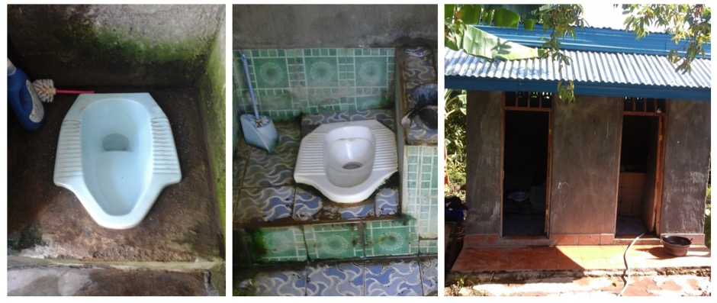

**Figure 62. Toilet observed in Bobonaro Municipality**

There is a need to promote the perceived benefits: more private, safe especially at night, healthier and cleaner to the households who still defecate in the open area including those who have unimproved toilet.

*Social Norms*

Since the ODF Initiative was conducted in Timor Leste, there has been a strong shift from open defecation to household toilets. Even though our study revealed that there was 8.9% slippage rate where some households still defecate in the open area including bushes, having toilet has become a new social norm, as it was also enforced by the government and the community leader. Gaya, Balfour, and Thomas (2015) argued that the slippage rate can be viewed as a failure to change social norms of open defecation in community which can lead to failure in the sanitation development program.

A study of open defecation free sustainability in Liquica Municipality by Abdi (2016) reported that there seems to be a change in norm around when open defecating is socially acceptable and when it is not appropriate. Particularly when people are away from home and unable to find toilet, they tend to defecate in the bushes or other open area. To reduce the slippage rate in Bobonaro Municipality, sanitation intervention focusing on behaviors needed. Providing infrastructure does not ensure use when there are significant behavioral barriers to using toilet.

**5.2.3 Ability**

Knowledge

Households’ knowledge on diarrhoea is high. When asked whether diarrhoea can be prevented or avoided, 90% reported that it can be prevented. The most common factors to prevent diarrhoea reported by households were washing hands (75%), using toilet to defecate (60%), and using soap (55%). On the other hands, households had low knowledge on toilet options. A high proportion of households (92.3%) reported that they were not aware of the toilet options that were available in Bobonaro Municipality. Lack of knowledge in toilet options available in Bobonaro Municipality can also be main factor that hinder households’ ability in building or upgrading toilet.

Skills and self-efficacy

Having skills in building toilet is one of main determinants in sanitation improvement. This study revealed that households in Bobonaro Municipality were more likely to build their own toilet (72.9%) whilst only 9.5% who reported that it was mason who built their toilet. Regarding the plan in upgrading toilet, 73.3% of households reported that they will upgrade or install the toilet themselves and only 7.4% who reported that they will ask help from mason.

Lack of skills in building facilities has been considered as one of the main factors that hindered households in building or upgrading toilet (Abdi, 2016; Hernandez, Dejene, & Faris, 2009). Households’ lacking of skills means that they need to rely on outside help to construct or upgrade their toilet. No-capability to build a toilet is also one of de-motivators in building or upgrading toilet. De-motivator is caused by lack of support and capability from within the household or community to manage the construction or upgrade the toilet.

Social support

While this study did not further explore what kind of households’ skills and ability particularly ability in building sanitation facility, this study suggests that the intervention in building or upgrading toilet is needed particularly intervention on the information to build toilet. This study revealed neighbours’ role as one of the significant predictors in upgrading toilet in the next 12 months. 50% of households who seek advice from other people cited their neighbour as the main source of information and advice about technical options including materials. One of interventions that can be developed is providing information on toilet options available including guidance to build toilet (practical guide to build and maintain toilet). Households can learn about various option of toilet available including specific sanitation materials needed for each of type toilet. A decision tree model on which best toilet option for households can be developed and introduced to households (i.e., considering water supply and access, affordability, etc.). SaTo pan as a low cost hygienic toilet that uses a simple water seals to close off pit latrines from the open air can be introduced in this intervention.

Roles and Decisions

This study revealed a number of household level decision making in building toilet from designing to decision on person who will be in charge for building. A high proportion of households reported that they were the one who paid for building the toilet (88.1%) including bought the materials, and they were the one who built the toilet (72.9%). Only 14.0% of households reported that there was someone who help them building the toilet. This study also found that men have strong role in decision making as 70.1% of households reported that the family member who make decision to build or upgrade toilet were adult male and only 13.4% who reported that the decision will be made by both adult male and female in the household.

Affordability

This study revealed that those who have funding were 2.5 times more likely to report that they will upgrade toilet in the next 12 months. However, the proportion of households who reported that they did not have funding at the moment to upgrade toilet was high (81%) and only 19% who reported that they have funding to do the toilet improvement. In relation with funding, a high proportion of households (82.2%) reported cost of materials as the main factors affecting their decision in building or upgrading toilet. Sales promotion is also one of significant factor affecting decision in building or upgrading toilet in the univariate analysis. Those who reported that those who get sales promotion on sanitation products were 2.4 times more likely to upgrade toilet in the next 12 months.

This study also found that there is an opportunity to develop sanitation loans scheme to households in Bobonaro Municipality. While a high proportion of households (81.8%) did not have interest in taking a loan, 10.3% reported that they were interested in taking a loan. This study found that there was a significant association between having interest in improving toilet and taking loan. Those who have interest in improving/upgrading toilet were 2.3 times more likely to take a loan. Sanitation loans have a strong social impact for borrowers and their families, it allows households to more easily access critical sanitation services (Ikeda & Arney, 2015). In this study, most of household who were interested in taking loan were based in Maliana Administrative Post (52.8%) and Balibo Administrative Post (11.7%).

Sanitation loans can be a potential scheme in improving households’ sanitation and hygiene status. A study by Barenber (2009) about sanitation loan in India reported that micro­finance principles can be successfully applied to the water and sanitation sector. Allowing borrowers to repay loans close to where they live increases the likelihood of interest in taking loan. As the additional external funding USD40 program has potential to promote households in their upgrading toilet, it can also be combined with sanitation loans program to increase households’ interest in improving their sanitation facility.

**5.2.4 Motivation**

The motivation subheading in the SaniFOAM framework is to explore whether the individual wants to perform the desired behaviour and what behaviour determinants that have impact on households decision to perform the new behaviour. The households’ motivation in building or upgrading toilet is influenced by a number of determinants such as social values, their sanitation related attitudes and beliefs, and competing household demand and priorities.

Values

This study revealed that the households’ main motivators in building toilet or drivers that motivate them to build or upgrade the toilet came from social values such as aesthetics, convenience and comfort. As open defecation free program has been set as a new standard of sanitation and hygiene status, it also changes social norm of defecation practice in the community. Sanitation popularity did not come from health perspective first, but it came from social perceptions. It came from its appeal to social values such as cleanliness, comfort, aesthetics, civilization good manners, moral purity, godliness, status and prestige (van der Geest, 2015). The following sections will further detail these values.

Attitudes and Beliefs

This study found that a high proportion of households (75.6%) reported that good sanitation meant increased comfort, whilst 34.1% reported that it meant increased safety for women, especially at night and for children, 32.7% reported that it meant reduced smell and flies. This findings support the study from Abdi (2016) who reported convenience and comfort and privacy and security as one of main motivators for open defecation free households.

Emotional/physical/social drivers

This study revealed that aesthetics, durability and convenience are the three most common households’ preferred toilet qualities and its desired attributes. A high proportion of household reported that they preferred toilet with no smell of urine and excreta (76.2%), durable and long lasting (62.8%), no sight of excreta (44.7%), and easy to clean surfaces (32.1%). This finding is similar with the study from Abdi (2016) who reported shame, disgust, pride, or fear; and convenience and comfort as one of main motivators for open defecation free households.

The disgust felt from using dirty toilet, disgust at the smell or at the sight of excreta from dirty or unimproved or toilets that are not well maintained can be one of strong motivators that influenced households’ decision to upgrade or conversely to abandon toilet and go back to open defecation. A number of studies have shown that if sanitation facilities are poorly maintained or inappropriately used, it is difficult to guarantee the health of the users and the convenience of using the facilities (Tumwebaze, Niwagaba, Günther, & Mosler, 2014).

This study is also consistent with a study in rural Benin by Jenkins and Curtis (2005) who reported that at least one active drive (desire for change or dissatisfaction) is needed to motivate toilet adoption. While Jenkins and Curtis (2005) did not analysed whether the driver will be similar with those needed to sustain toilet usage including maintaining and upgrading toilet, the households’ drivers can be similar as most of these drivers are derived from social values (e.g., aesthetics, convenience and comfort). Health promotion intervention focusing in these drivers can be developed to improve sanitation and hygiene status among households in Bobonaro Municipality.

Competing priorities

This study revealed that in Bobonaro Municipality, the competing household demands and priorities for spending on a new/upgraded toilet were education for children (67.6%) and healthcare (65.3%). This finding is similar with the study from Abdi (2016) who reported that in Liquica Municipality, household prioritising committing funds to construction of their house or pay school fees over toilet construction.

As healthcare and education are supposed to be free in Timor Leste, there are possibility some hidden costs in the education system and healthcare system that are not explored in this study. The hidden costs in education system are expenditure on education which is not covered under education scheme yet parent have to pay for them, for example, expenditure on school uniform, school supplies, textbook, meals, parent teachers association levies, and transportation to and from school (Williams, Abbott, & Mupenzi, 2015). Transportation cost, on the other hand is one example of hidden costs in the healthcare system (e.g., travel to hospital).

Predictors of upgrading toilet

This study revealed that there are a number of significant predictors of upgrading toilet in the next 12 months: age, type of sanitation facility, toilet distance, availability of funding, satisfaction level towards current toilet, having interest in improving toilet, disliking current toilet because it is dirty, and reporting husband or wife and neighbour as the source of information to upgrade or build toilet.

This study revealed that those with improved toilet were 4.3 times more likely compared to those with unimproved toilet to report that they will upgrade or build toilet in the next 12 months. In this study, those who still defecate in the open were classified as part of those who still used unimproved toilet. It means that households who still practice open defecation were less likely to build a new toilet in the 12 months and they were more likely to continue their open defecation practice. It can be a significant health issue as these households were less likely to improve their sanitation related behaviours that will influence their health status. There is an urgent need to focus on this group.

These study also found that toilet distance to the main house is a significant factors to upgrading toilet.

Those having toilet was relatively close to the main house (less than 5 meters) are 3.8 times more likely compared to those whose toilet distance is more than 5 meters. Regarding the source of information in building or upgrading toilet, husband or wife and neighbour are the main source of information to build or upgrade toilet which contribute to the households’ decision in upgrading toilet. This study revealed that those who reported that their husband or wife as the main source to build/upgrade toilet were 9.4 times more likely to upgrade toilet in the next 12 months whilst those who reported that their neighbour as the source of information to build toilet are 3.9 times more likely. This study did not analyse what kind of influencing factors from neighbour that have impact on households’ decision in upgrading toilet. However, the social values can be one of the determinants that contribute to the decision.

This study revealed that one of significant predictors in upgrading toilet was related to well-being and cleanliness drivers as those who reported that they dislike the current toilet because it was dirty were three times more likely to report that they will upgrade toilet in the next 12 months. This study is consistent with the study from Jenkins and Curtis (2005) who reported that cleanliness is one of significant drivers to build toilet. Human’s excreta, especially adults’, were considered very dirty especially when they were still recognisable. Smelling or seeing them could cause physical or psychological illness (Jenkins & Curtis, 2005). Even though Jenkins and Curtis (2005) did not analyse whether the driver will be the same as those to maintain or sustain toilet including upgrading toilet, this study suggest that there might be a similarity between predictors in adopting toilet for the first time and maintaining the toilet (including upgrading the toilet).

* 1. **Handwashing with soap practice**

Hygiene promotions enhance the effectiveness of water and sanitation programme in most of the developing countries (Sijbesma & Christoffers, 2009). Hygienic behaviours can play an important role in the prevention of diseases related to water and sanitation. Hand washing is considered as one of the most effective hygiene promotion activities for public health particularly in developing countries (Rabbi & Dey, 2013). The handwashing practice measured in this study were handwashing with soap practice after defecating, after cleaning child, before feeding child, before preparing food, and before eating.

Predictors of handwashing with soap

This study revealed a number of significant predictors of handwashing with soap practice in Bobonaro Municipality: having specific place for handwashing at home, having knowledge that diarrhoea is caused by dirty hands, and having a good attitude toward sanitation and hygiene. Regarding association between handwashing facility and handwashing practice, those who reported that they have specific place for handwashing at home are 2.8 times more likely to wash their hands compared those who did not have specific place to handwashing. Regarding the sanitation and hygiene-related knowledge, those having knowledge that diarrhoea is caused by dirty hands are 7.7 times more likely to wash their hands. Regarding the attitude and belief towards sanitation and hygiene practice, those who reported that good sanitation can increase comfort are 6.8 times more likely; and those who had belief that good sanitation can reduce smell are 13.7 times more likely to report that they wash their hands with soap.

In this study, education level, type of sanitation facility, and access to media (newspaper) are significantly associated with handwashing with soap practice in the univariate analyses, but they are not a significant predictors in multivariable analyses after adjusting demographic variables. Those who had attended school were 1.6 times more likely to report that they handwashing with soap compared to those who had never attended school. Those who had improved sanitation facility were also 1.9 times more likely compared to those who had unimproved sanitation facility. Those who reported newspaper as their main source of information about personal hygiene were also 2.5 times more likely to report that they wash their hands with soap.

This finding supports a study by Rabbi and Dey (2013) reported that access to media and socio economics factors including education of household head and respondent has a strong positive association with handwashing with soap. Other significant predictors for handwashing with soap from Rabbi and Dey (2013) were water availability. In this study, water availability (available daily vs not available daily) is not a significant predictor for handwashing with soap.

The finding of this study where availability of improved toilet was a significant predictor in the univariate analysis also supports the study by Dobe, Mandal, and Jha (2013) reported that access to a sanitary toilet was a significant predictor of good handwashing behaviour. The other significant predictors for good handwashing practice reported by Dobe et al. (2013) were availability of soap and water at handwashing place, availability of water at home, higher income level were

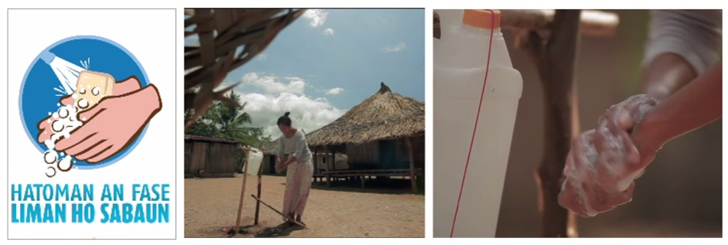

**Figure 63. “Hatoman an Fase Liman ho Sabaun” campaign in Timor Leste**

Timor Leste has already national handwashing with soap program “Hatoman An Fase Liman ho Sabaun”. In this study, we did not evaluated the effectiveness of the campaign, however, the proportion of those who reported that they did not handwashing with soap was high (55% of households). The further intervention to promote handwashing with soap is needed to increase the community awareness and habit adoption of handwashing practice.

**5.4 WaSH Marketing Exchange**

In this study, exchanges of all four archetypes were present including the combination of different archetypes. The following figure and table gives details of the exchange systems related to water and sanitation facilities in Bobonaro Municipality.

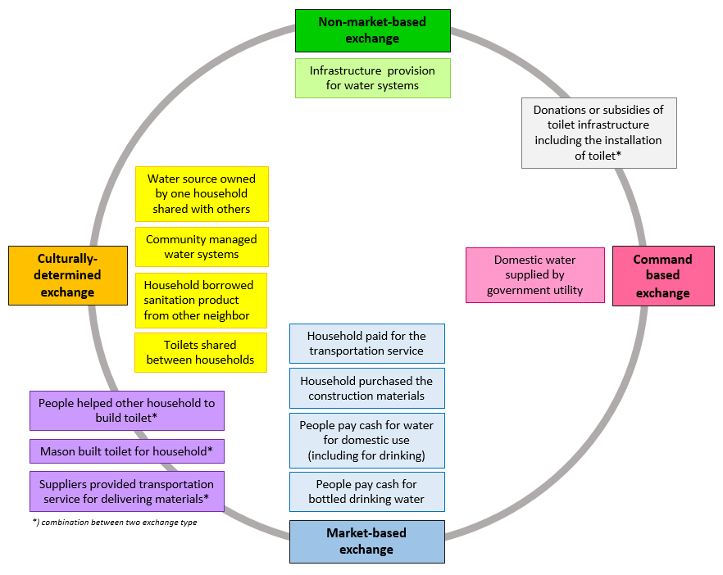

**Figure 64. WaSH Exchanges in Bobonaro Municipality**

The WasH exchange in this study is consistent with the exchange by Barrington et al. (2016) and support his findings where conceptions of WaSH exchange as purely profit oriented or communally oriented are likely inaccurate. The exchange cannot be classified as single type of exchange but there are combination of different archetypes. It can be used to analyse the social relationships in the supply chain of sanitation products and services in Bobonaro Municipality and also the WaSH needs in the community level. As it provides a supply chain mapping of sanitation products and services, it can be used to develop and design a WaSH intervention.

The combination between market-based and culturally determined exchange.

The first exchange observed is households helping other to build toilet. There are households who pay those who help them build the toilet (market-based exchange), but there are also household who help building toilet without getting paid. 83.3% reported that they did not pay those who help them built toilet (culturally-determined exchange). Considering other household as part of family (including friends, neighbours) is one of main determinants in helping other building toilet. The main reasons of why households still help others to build toilet without getting paid were: because they were family so that they help each other. The other reasons were because they do not have ability to do it and because they also use the toilet (shared toilet with neighbour).

The second exchange observed is that mason build toilet for household. It can be classified as market based as those household who need masonry services to build or repair toilet need to pay them. On the other hand, mason can also provide free service for other household. Family is one of the reason that this mason provide service without getting paid. The third exchange observed is that suppliers provide transportation service for delivering materials. It can be market-based exchange as some suppliers will only provide the service with some minimum purchase order whilst some suppliers will give it for free as for example they are already familiar with the customer (culturally determined exchange).

*The combination between non-market-based and command based*

One of case study observed in this study for this type of exchange is donations or subsidies of toilet infrastructure including the installation of toilet. This study found that a number of NGO (coordinated with government) contributed in providing sanitation materials for households.

*Limitations of the WaSH exchange*

The limitations of the marketing exchange is that the exchange does not provide detail analysis on the information exchange to address the needs of the community in terms of improving sanitation products and services. Households with little exposure to toilet information including designing and building toilet or to a range of toilet alternative available, who may cite high cost as a barrier, often have an inflated perception of costs from lack of good information. As most of the households build their own toilet, provision to build toilet can contribute to the improving in the sanitation and hygiene status. The provision to build toilet program does not only focus on mason but it can be expanded to the household level (with head of household as the participant).

*Voucher system in the WaSH exchange*

Vouchers provide access to pre-defined commodities or services. They can be exchanged in designated shops or in fairs and markets. There is a government program that is developing a system for providing coupons/vouchers to houses in the community that they could use to purchase sanitation related products so that they can improve sanitation in their homes. This would mean that the store would allow them to choose items from the store up to a specific value and that are sanitation related in return for the coupon. On a monthly basis, the program representatives would check the stock distributed and the vouchers received and pay the store for those items.

From the households’ perspective, the voucher system can be classified as non-market based exchange as the voucher is part of donation program from government to the community. Households will redeem the voucher or coupon to purchase sanitation products. Suppliers who get the voucher will redeem the voucher to the government or those who is in charge of the program. However, it can also be classified as market-based exchange from supplier’ perspective as they will redeem the voucher to the voucher management agency. It is possible that the value of the voucher will not cover all the households’ need to upgrade the sanitation facility. Thus, households may add some money to purchase the additional materials needed.

The system of denominating vouchers varies. They may be denominated either in cash, commodity or service value. These are described respectively as value-based, commodity-based or service-based vouchers. Combined vouchers also exist. By applying this denominating system, the vouchers are not only for purchasing products but it can also be applied for accessing sanitation services for example for hiring WaSH attendant/mason and for making repairs to WaSH infrastructure. It will contribute to address the community needs.

A high proportion of suppliers (92.3%) reported that they were interested in the voucher system program and most of the suppliers (84.6%) also reported that voucher system will help to increase their sales. Suppliers also stated that it will be beneficial for the store as long as it has right contract/deal/agreement. The following is the flow of voucher scheme adopted from Menotti and Farrell (2016) that can be used. The type suppliers can be extended, not only suppliers who sell sanitation products, but also those who provide sanitation-related services such as masons (not only commodity based but also service-based voucher).

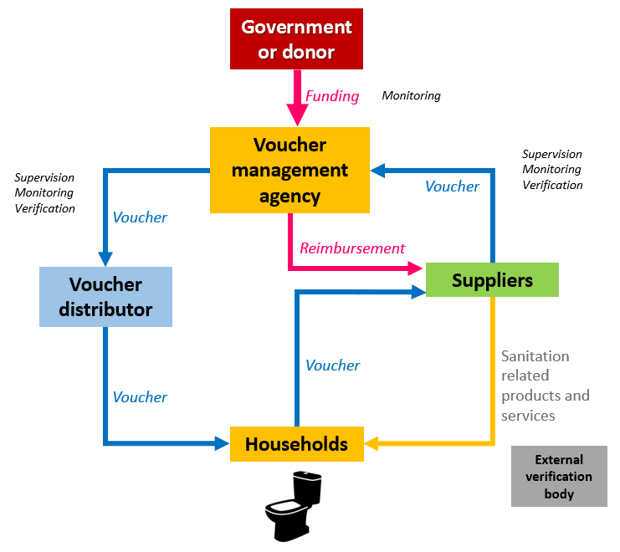

**Figure 65. Flow diagram of voucher transaction for sanitation products and services**

**(Adopted and modified from Menotti and Farrell (2016) p.385)**

Regarding the additional funding from external source, this study also found that a high proportion of households at least cited one materials to buy when they were asked about what materials that they wanted to buy if they had additional funding USD40 from external source. Almost half of respondent (43.6%) reported that they will buy cement, 36.1% reported that they will buy corrugated zinc sheets, and 10.7% reported that they will use it to buy blocks and 10.1% reported that they will buy toilet pans.

On the other hands 25.7% of households did not know what materials including those who mentioned that USD40 was not enough to buy materials they need (11.2%). The provision of information can be provided to the households, for example, the toilet options available, the costs to build a certain type of toilet, and the materials to build a certain type of toilet. Thus, households can choose which type of toilet they want to have/improve and use the additional funding to address their need.

Voucher system has a number of advantages such as reducing financial and households barriers to accessing sanitation product and services, allow government and donors to target households in need, such as those who are still vulnerable to the sanitation and hygiene issue, allow resources to be directed toward key of high impact sanitation intervention, and can stimulate demand for sanitation product, service and behaviours.

On the other hand, voucher system require development of systems and processes to monitor its effectiveness in addressing community needs. Targeting of which household that will received voucher can be another main issue. It requires a comprehensive analysis to make decision on which target group that will be the beneficiaries of the voucher program. Targeting every household to receive voucher will be impossible. The other challenge is whether the voucher can be distributed effectively in the target areas to minimize the risk of fraud and leakage of voucher to the general population or non-poor.

In the section below, we provide segmentation of households based on sanitation and hygiene behaviours. It can be used as a guidance to determine which households that need the sanitation intervention.

**5.5 Segmentation**

Segmentation aims to help managers make decisions about the priorities for interventions and how to most effectively promote programs, services, products and behaviours to different groups. Demographic and geographic data is important, however for segmentation to be most targeted it should be primarily based on behaviours as well as psychographics (attitudes, aspirations, and other psychological criteria). In this analysis, segments were developed based on a combination of sanitation and hygiene behaviours to support PHD’s integrated WASH approach.

The behavioural variables[3] included were: (1) type of defecation place (unimproved toilet vs improved toilet), (2) intention to improve or build toilet in the next 12 months (yes or no), and (3) availability of handwashing facility at home (yes or no). The availability of water was excluded in the analysis as based on the finding in this study, water availability is not a significant predictor in improving/upgrading toilet and handwashing practices (See the Predictors section).

There were a total of eight segments developed based on the combination of the three variables. The number of households that fall into each segment then was counted. The following table presents the results for each segment.

**Table 5.1** *WASH Segmentation in Bobonaro Municipality*

|  |  |
| --- | --- |
| **Segments** | **N (%)** |
| Unimproved toilet without plan; no HW facility | 26 (7.5)* |
| Unimproved toilet without plan; having HW facility[4] | 8 (2.3) |
| Unimproved toilet with plan; no HW facility | 11 (3.2) |
| Unimproved toilet with plan; having HW facility | 9 (2.6) |
| Improved toilet without plan; no HW facility | 96 (27.7)* |
| Improved toilet without plan; having HW facility | 26 (7.5)* |
| Improved toilet with plan; no HW facility | 113 (32.6)* |
| Improved toilet with plan; having HW facility | 58 (16.7)* |

*\*) selected group for further analysis*

In order to determine the priority segments that will be analysed further, the groups with the largest population sizes were selected. There are five segments that would be the main target group priorities for intervention.

* + - * Group A: Households with an improved toilet and having a plan to upgrade, and have specific place for handwashing at home.
* Group B: Households with an improved toilet, do not have a plan to upgrade, but they have specific place for handwashing at home.
* Group C: Households with an improved toilet and plan to upgrade, but do not have specific place for handwashing at home.
* Group D: Households with an improved toilet, but no plan to upgrade and no specific place for handwashing at home.
* Group E: Households with an unimproved toilet, no intention to improve/upgrade and no specific place for handwashing at home.

Characteristics were then selected from the survey data to enable a more detailed description of each segment’s behavioural, psychographic, demographic and geographic qualities. These characteristics are summarised in Table X below.

**Table 5.2** *Sample characteristics of WASH segments in Bobonaro Municipality*

|  |  |  |  |  |  |
| --- | --- | --- | --- | --- | --- |
| **Variables** | **Group A**  **Champions** | **Group B**  **Rising Stars** | **Group C**  **Aspirational** | **Group D**  **Slow Performers** | **Group E**  **Vulnerable** |
| **Administrative post**   1. Total 2. Maliana 3. Cailaco 4. Atabae 5. Balibo | 58 (16.6)  31 (53.4)  3 (5.2)  15 (25.9)  9 (15.5) | 26 (7.4)  11 (42.3)  2 (7.7)  7 (26.9)  6 (23.1) | 113 (32.4)  59 (52.2)  9 (8)  21 (18.6)  24 (21.2) | 96 (27.5)  49 (51)  6 (6.3)  20 (20.8)  21 (21.9) | 26 (7.4)  9 (30)  1 (3.3)  14 (46.7)  6 (20) |
| **Gender of respondents\***   1. Male 2. Female | 27 (46.6)  31 (53.4) | 10 (38.5)  16 (61.5) | 63 (55.8)  50 (44.2) | 31 (32.3)  65 (67.7) | 8 (30.8)  18 (69.2) |
| **Age of respondents**   1. Under 18 years 2. 18 to 24 years 3. 25 to 34 years 4. 35 to 44 years 5. 45 to 54 years 6. 55 to 64 years 7. Age 65 or older | 1 (1.7)  2 (3.4)  13 (22.4 10 (17.2)  12 (20.7)  15 (25.9)  5 (8.6) | 0 (0)  2 (7.7)  8 (30.8)  5 (19.2)  5 (19.2)  6 (23.1)  0 (0) | 4 (3.5)  6 (5.3)  26 (23)  30 (26.5)  21 (18.4)  11 (9.7)  15 (13.3) | 3 (3.1)  7 (7.3)  35 (36.5)  22 (22.9)  9 (9.4)  10 (10.4)  10 (10.4) | 1 (3.8)  3 (11.5)  5 (19.2)  6 (23.1)  2 (7.7)  5 (19.2)  4 (15.4) |
| **Education\***   1. No schooling 2. Primary 3. Secondary 4. University or other tertiary | 21 (36.2)  7 (12.1)  22 (37.9)  8 (13.8) | 15 (57.7)  1 (3.8)  9 (34.6)  1 (3.8) | 49 (43.4)  14 (12.4)  42 (37.2)  8 (7.1) | 44 (45.8)  20 (20.8)  28 (29.2)  4 (4.2) | 21 (80.8)  0 (0)  5 (19.2)  0 (0) |
| **Main source of income**   1. Household business 2. Agriculture / Fishing 3. Salary (government, NGO) 4. Private sector 5. Worker/Tradesman 6. Laborer in a shop/company 7. Subsidy/pension 8. Others / Donation / charity / present from family | 4 (6.9)  32 (55.2)  14 (24.1)  1 (1.7)  1 (1.7)  2 (3.4)  3 (5.2)  0 (0) | 4 (15.4)  16 (61.5)  4 (15.4)  0 (0)  0 (0)  0 (0)  2 (7.7)  0 (0) | 16 (14.2)  71 (62.8)  18 (15.9)  2 (1.8)  4 (3.5)  0 (0)  0 (0)  0 (0) | 11 (11.5)  64 (66.7)  10 (10.4)  2 (2.1)  2 (2.1)  1 (1)  5 (5.2)  1 (1) | 5(19.2)  19 (73.1)  1 (3.8)  0 (0)  0 (0)  0 (0)  0 (0)  0 (0) |
| **Monthly income**   1. Less than USD 100 2. USD 100-200 3. USD 200-300 4. More than USD 300 | 32 (55.2)  15 (25.9)  4 (6.9)  7 (12.1) | 19 (73.1)  3 (11.5)  4 (15.4)  0 (0) | 81 (71.7)  19 (16.8)  9 (8)  4 (3.5) | 73 (76)  17 (17.7)  4 (4.2)  2 (2.1) | 25 (96.2)  1 (3.8)  0 (0)  0 (0) |
| **Type of home ownership**   1. Owned 2. Rented 3. Parents /in-law/family | 57 (98.3)  0 (0)  1 (8.3) | 26 (100)  0 (0)  0 (0) | 102 (90.3)  3 (2.7)  8 (7.1) | 95 (99)  0 0)  1 (1) | 25 (96.2)  0 (0)  1 (3.8) |
| **Number of families in the house**   1. One family 2. Two families 3. Three families | 42 (72.4)  12 (20.7)  4 (6.9) | 15 (57.7)  10 (38.5)  1 (3.8) | 84 (74.3)  28 (24.8)  1 (0.9) | 73 (76)  20 (20.8)  3 (3.1) | 19 (73.1)  8 (26.7)  1 (3.3) |
| Number of households with family member with any difficulties[5] | 6 (10.3) | 6 (23.1) | 20 (17.7) | 20 (20.8) | 8 (30.8) |
| **Households possessions**   1. Mobile phone* 2. Radio* 3. TV* 4. Motorbike* 5. Car 6. Computer* | 58 (100)  26 (44.8)  33 (56.9)  25 (43.1)  1 (1.7)  4 (6.9) | 26 (100)  5 (19.2)  14 (53.8)  13 (50)  0 (0)  3 (11.5) | 110 (97.3)  37 (32.7)  48 (42.5)  27 (23.9)  2 (1.8)  3 (2.7) | 96 (100)  51 (53.1)  55 (57.3)  31 (32.3)  3 (3.1)  0 (0) | 23 (88.5)  11 (42.3)  10 (38.5)  4 (15.4)  0 (0)  0 (0) |

*\*) pValue<0.05*

1. **WASH Champions (Group A)**

Looking at their behaviours, this group of households can be regarded as “WASH Champions” for their current behaviours and future plans. This means they used an improved toilet to defecate and have a plan to upgrade or improve their toilet in the next 12 months. These households also have specific place for handwashing at home. Most of households in this group used a pour flush toilet sealed to offset pit (89.7%), using cement (72.4%) and ceramic (17.2%) as toilet floor, using squat pan ceramic and cement (60.3%). Regarding the type of toilet wall, 43.1% of households used concrete and 24.1% used corrugated zinc sheet. 72.4% used corrugated zinc sheet as toilet roof whilst 17.2% reported that the toilet does not have roof. Regarding the handwashing practice, 58.6% of households in this group reported that they wash their hands with soap including those who were always handwashing rarely (53.4%).

For their demographics, this is the third largest of the five selected segments with 58 households (16.6%), The segment has an older population (55.2% aged 45 years and above). The majority of households in this group work in agriculture or fishing (55.2%), and in government or NGOs (24.1%). They have the least households in the lower income group (55.2% below USD100), with the highest share of people in the highest income bracket (12.1% earning USD300 or more). Every household in this group owns a mobile phone (100%), has one of the highest ownership levels of TVs (56.9%), motorbikes (43.1%), and radios (44.8%). They have the lowest level across the segments of people identified as living with a difficulty (10.3%). Almost all of these households (98.3%) own their own home and have the highest level of computer ownership of all groups.

1. **WASH Rising Stars (Group B)**

Focusing on their behaviours, this group of households can be described as the “WASH Rising Stars” as they are practicing almost all of the desired behaviours but they do not (yet) have plans to upgrade their toilets. This group includes households who used an improved toilet to defecate and they have specific place to do handwashing at home (whereas most Champions do not), but they do not have plan to upgrade/improve the toilet in the next 12 months (whereas most Champions do). Every household in this group used a pour flush toilet sealed to an offset pit, 88.5% used cement as the toilet floor. Most households used a ceramic or cement squat pan (57.7%) or plastic squat pan (30.8%). For the toilet wall, 50% used concrete and 15.4% used corrugated zinc sheet. 80.8% used corrugated zinc sheet as the toilet roof. 80.8% of households reported they wash their hands with soap including those who were always handwashing (42.3%), rarely (23.1%) and sometimes (15.4%).

Looking at their demographics, this is the equal smallest of the five selected segments with 26 households (7.4%). The segment has a more typical spread of population by age. The majority of households in this group have no education (57.7%), second lowest only to the “WASH Vulnerables”. The majority of households work in agriculture and fishing (61.5%), with the largest number receiving a government subsidy or pension (7.7%). 73.1% had a monthly income below USD100. Every household in this group owns their own home (100%), however they have the highest level of 2-family homes (38.5%). Every household in this group owns a mobile phone, the majority of households own TV (53.8%). This group has the highest ownership of motorbikes (50%) and computers (11.5%). They have the second highest level across the segments of people identified as living with a difficulty (23.1%).

1. **WASH Aspirational (Group C)**

Based on their behaviours, this group can be described as “WASH Aspirational” as they practice most, but not all, good behaviours now and have an intention to change. These households used an improved toilet to defecate and have a plan to upgrade in the next 12 months. However, they do not have specific place for handwashing at home. Most of households in this group used pour flush toilets sealed to an offset pit (85.8%), with cement (72.6%) and stones (19.5%) as the toilet floor, using a squat pan ceramic and cement (55.8%). Regarding the type of toilet wall, 32.7% of households used concrete and 31.9% used corrugated zinc sheet. 64.6% used corrugated zinc sheet as toilet roof whilst 23.9% reported that the toilet does not have roof. On handwashing practices, only 31% of households in this group reported that they wash their hands with soap including those who were handwashing rarely (23.9%).

Looking at their demographics, this is the largest of the five chosen segments with 113 households (32.4%) with a large number in their prime adult years (67.5% aged 25-54 years). However, this group has the largest share of people with the lowest monthly income (71.7% below USD100). The majority of households also work in agriculture or fishing (62.8%), slightly higher than the WASH Champions. Also, the majority of households own a mobile phone (97.3%), however TV (42.5%), and radio (32.7%) ownership is among the lowest of the groups.

1. **WASH Slow Performers (Group D)**

Based on their behaviours, this group can be described as “WASH Slow Performers” as they practice only some of the desired behaviours now and have little intention to change. This group includes households who used an improved toilet to defecate but they do not have plan to upgrade in the next 12 months. They also do not have a specific place for handwashing at home. 81.3% of households in this group used a pour flush toilet sealed to an offset pit. 76% used cement and stone (16.7%) as materials for the toilet floor. Most of the households used a ceramic or cement squat pan (45.8%) and ceramic pour flush sitting bowl (32.3%). Regarding the type of toilet wall, 35.4% of households used concrete and 29.2% used corrugated zinc sheet. 59.4% used corrugated zinc sheet as toilet roof whilst 30.2% reported that the toilet does not have roof. 51% of households in this group reported that they wash their hands with soap including those who were always handwashing (14.6%), and rarely (27.1%).

Regarding their demographics, this is the second largest of the five selected segments with 96 households (27.5%). The segment has a more typical spread of population by age. The majority of households work in agriculture or fishing (66.7%), which is the second overall largest share of the segments. This group has the second highest share of low income households, 76% with a monthly income below USD100 and 17.7% between USD100-200. Almost all of these households (99%) own their own home and they have the highest level of one family homes (76%). Every household in this group own a mobile phone, and this group has the highest level ownership of TVs (57.3%), radios (53.1%), motorbikes (32.3%) and cars (3.1%).

1. **WASH Vulnerables (Group E)**

Grouped on their behaviours, this segment can be described as “WASH Vulnerables” as they practice very few of the desired behaviours now and have little intention to change. Only 34.6% reported they used an (unimproved) toilet to defecate which means that 65.4% of households in this group practiced open defecation. They also do not have intention to improve, upgrade or build a toilet in the next 12 months. Furthermore, this group also do not have specific place to do handwashing at home, with only 26.9% of households reporting they wash their hands with soap including those who were handwashing rarely (15.4%) and sometimes (11.5%). Of those who defecate in the toilet, 44.4% reported that the toilet is a pit latrine without slab or open pit, whilst 22.2% reported the toilet as flush/pour flush. The type of toilet floor was cement (44.4%), and stones (16.7%), and the type of pan was the cement squat pan (33.3%). The roof was corrugated zinc sheet (55.6%).

Focusing on their demographics, this is the equally smallest of the five selected segments with 26 households (7.4%). The segment has the highest percentages of young people, with 3.8% under 18 years and 11.5% aged 18-24 years, as well as the highest share of the oldest group aged 65 and older (15.4%) – all three combined can be considered the least productive age groups. They have the worst education outcomes – 80.8% with no education and only 19.2% finishing secondary school. This group had the highest levels of households working in agriculture or fishing (73.1%) and home businesses (19.2%), with the lowest levels of work in government and NGOs (3.1%), none (0%) in the private sector, workers, tradesmen and shop or company labourers. This group has the highest percentages of low income households, 96.2% had a monthly income below USD100 and only 3.8% between USD100-200, with none earning any higher. Almost all of these households (96.2%) own their own home and almost a third (30%) have two or three families living with them. They have the lowest ownership levels across all the surveyed household possessions - mobile phones (still high at 88.5%), radios (42.3%), TVs (38.5%), motorbikes (15.4%), car (0%) and computers (0%). They have the highest level across the segments of people identified as living with a difficulty (30.8%).

**PART SIX**

**CONCLUSIONS AND RECOMMENDATIONS**

This study has added to the evidence for the value chain of supply and demand for sanitation and hygiene products services and behaviours in Bobonaro, Timor Leste. It documents the effects of the ODF pilot in Bobonaro and the impact on people’s perceptions and practices. The study reveals what benefits are sought by consumers of sanitation and hygiene products and services, as well as what the barriers are to their supply.

The analysis of value exchanges shows that interventions should consider a mix of support for different combinations of exchanges. A priority combination to be tested would be combining a non-market exchange of free or subsidised materials with encouragement for people to seek family or neighbours to help them build or improve the toilets and handwashing facilities. Having sanitation “working bee” weeks may also encourage the social norm effects revealed in the data.

Most households in Bobonaro obtained water for domestic use and drinking water from an improved source or protected source. An enhanced monitoring strategy which combine indicators of sanitary protection with measures of water quality is needed. For those who still obtain water from an unimproved source, the water access intervention is needed to address their needs. Thus, it can contribute to reduce the prevalence of health-related problems caused by unsafe water.

Only a low proportion of households in Bobonaro reported the water problem to the government or water authority. However, a high proportion of household reported that the water problem was solved after they contacted them. Reporting water problem is part of the monitoring of water system. Promoting households to report when they experience water system can help monitoring process of water supply in the community. Furthermore, the water management services need to be improved particularly focusing on the customer service as the main issue with water supply is not only about access and infrastructure but also about service to customer.

Most of households in Bobonaro defecate in an improved toilet. However, there is slippage where some households still use an improved toilet and practice open defecation. It is an urgent call to develop sanitation intervention focusing in this vulnerable group.

Even though most of adults defecate in the toilet, the habit of open defecation by children in Bobonaro Municipality remains high. As the unsafe disposal of child faeces may represent a more significant health risk than that of adults, it is an urgent call to develop sanitation interventions aiming to improve the safe collection or disposal of children’s excreta.

Training provision to masons. Training to build standard toilet can be provided to households and also masons such as training on appropriate construction techniques. As the proportion of households who build their own toilet is high. Besides benefiting communities who haven’t built toilets yet, masons who are now trained in how to construct sanitation units are getting more work and are better paid.

Based on the Opportunity-Ability-Motivation analysis of behavioural determinants and the data showing the majority of households build their own toilets, it’s clear that enhancing ability would be considered for support. An intervention could provide information on toilet options available including guidance to build toilet (practical guide to build and maintain toilet). Households can learn about various option of toilet available including specific sanitation materials needed for each of type toilet. A decision tree model on which best toilet option for households can be developed and introduced to households (i.e., considering water supply and access, affordability, etc.). SaTo pan as a low cost hygienic toilet that uses a simple water seals to close off pit latrines from the open air can be introduced in this intervention.

The marketing strategy should be tailored to each of the segments identified and developed. The WASH Champions may be used as early adopter change agents to act as models for their communities. The WASH Rising Stars are similar to the Champions and may only need a light intervention to encourage them to make plans for improvement and execute them. The WASH Vulnerables will need immediate and intensive support as not only are they lacking with many of the desired behaviours, they have the potential to bring the community down with them. The WASH Aspirationals should be a major focus given the size of the segment and the potential for change. The WASH Slow Performers, while in need, may not be a priority for support given the low likelihood of change.

A branded behaviour change communication intervention should be developed to focus on aesthetics, safety, convenience and comfort to improve sanitation and hygiene status.

An intervention should consider how to engage households to ensure that the sanitation facilities used are appropriately cleaned and maintained.

Toilet and building material suppliers are highly receptive to the idea of a voucher system. However, given their complete lack of experience with vouchers, an intervention should engage them early in the development process, communicate the benefits clearly and ensure the verification burden is not too high.

This study revealed a number of significant predictors of handwashing with soap practice: having a specific place for handwashing at home, having knowledge that diarrhoea is caused by dirty hands, and having a good attitude toward sanitation and hygiene. The further intervention to promote handwashing with soap is needed to increase the community awareness and habit adoption of handwashing practice.

~~~~~~~~

**REFERENCES**

Abdi, R. (2016). Open Defecation Free Sustainability Study in East Timor 2015-2016. Dili: Water Aid.

Arnold B, Colford J (2007), Treating water with chlorine at point-of-use to improve water quality and reduce child diarrhea in developing countries: A systematic review and meta-analysis, *American Journal of Tropical Medical Hygiene*, 76(2):354–364.

Bain, R., Cronk, R., Wright, J., Yang, H., Slaymaker, T., & Bartram, J. (2014). Fecal Contamination of Drinking-Water in Low- and Middle-Income Countries: A Systematic Review and Meta-Analysis. PLoS Medicine, 11(5), e1001644. http://dx.doi.org/10.1371/journal.pmed.1001644

Barenber, A. (2009). Microfinance for water and sanitation: A case study from Tiruchirappalli, India34th WEDC International Conference, held in Addis Ababa, Ethiopia,

Barrington, D. J., Sridharan, S., Saunders, S. G., Souter, R. T., Bartram, J., Shields, K. F., … Hughes, R. K. (2016). Improving community health through marketing exchanges: A participatory action research study on water, sanitation, and hygiene in three Melanesian countries. Social Science & Medicine, 171, 84–93. https://doi.org/10.1016/j.socscimed.2016.11.003

Clark, K. and Willetts, J (2016) Evaluation of Bobonaro Open Defecation Free (ODF) Initiative, Prepared by Institute for Sustainable Futures, University of Technology Sydney for Aurecon/BESIK, June 2016

Clasen T, Schmidt WP, Rabie T, Roberts I, Cairncross S (2007), Interventions to improve water quality for preventing diarrhoea: systematic review and meta-analysis, *British Medical Journal*, 334(7597):782.

Clasen TF, Bostoen K, Schmidt WP, Boisson S, Fung IC, Jenkins MW, Scott B, Sugden S, Cairncross S (2010), Interventions to improve disposal of human excreta for preventing diarrhea, *Cochrane Database Systematic Review*, (6):CD007180.

Cronin AA, Sebayang SK, Torlesse H, Nandy R. Association of Safe Disposal of Child Feces and Reported Diarrhea in Indonesia: Need for Stronger Focus on a Neglected Risk. Int J Environ Res Public Health. 2016;13(3).

Cumming, O., & Cairncross, S. (2016). Can water, sanitation and hygiene help eliminate stunting? Current evidence and policy implications. Maternal & Child Nutrition, 12, 91-105. http://dx.doi.org/10.1111/mcn.12258

Devine, J. (2009). Introducing SaniFOAM: A Framework to Analyze Sanitation Behaviours to Design Effective Sanitation Programs. Washington, DC: World Bank. Retrieved from http://www.wsp.org/sites/wsp.org/files/publications/GSP_sanifoam.pdf

Dobe, M., Mandal, R. N., & Jha, A. (2013). Social Determinants of Good Hand-Washing Practice (GHP) Among Adolescents in a Rural Indian Community. Fam Community Health, 36(2), 172-177. http://dx.doi.org/10.1097/FCH.0b013e318282ac42

Dreibelbis et al (2013), The Integrated Behavioural Model for Water, Sanitation, and Hygiene: a systematic review of behavioural models and a framework for designing and evaluating behavior change interventions in infrastructure-restricted settings, *BMC Public Health*, 13:1015.

Empreza, Di’ak. (2014). Innovative Action - Research Conclusions’ Report 28 January 2014, Dili: BESIK.

Gaya, S., Balfour, N., & Thomas, A. (2015). Using Social Norms Theory to Strengthen CLTS in Southern Madagascar. Geneva: Retrieved from https://www.unicef.org/esaro/UNICEF-FN-CLTS-Madagascar-low-res.pdf

Government of the Democratic Republic of Timor Leste. (2011). Timor‐Leste Strategic Development Plan 2011‐2030, version submitted to the national parliament, July 2011. Dili: Government of the Democratic Republic of Timor Leste.

Graham, J. P., Hirai, M., & Kim, S.-S. (2016). An Analysis of Water Collection Labor among Women and Children in 24 Sub-Saharan African Countries. PLoS One, 11(6) http://dx.doi.org/10.1371/journal.pone.0155981

Hernandez, O., Dejene, M., & Faris, K. (2009). Potential motivators behind household toilet adoption: Results from a study in Amhara, Ethiopia34th WEDC International Conference, held in Addis Ababa, Ethiopia: WEDC.

Howitt P, Darzi A, Yang GZ, Ashrafian H, Atun R, Barlow J, Blakemore A, Bull AM, Car J, Conteh L, et al (2012), Technologies for global health, *Lancet*, 380(9840):507–535.

Ikeda, J., & Arney, H. (2015). Financing Sanitation For the Poor. New Delhi: World Bank.

Jenkins, M. W., & Curtis, V. (2005). Achieving the ‘good life’: Why some people want latrines in rural Benin. Social Science & Medicine, 61(11), 2446-2459. http://dx.doi.org/http://dx.doi.org/10.1016/j.socscimed.2005.04.036

Majorin, F., Torondel, B., Ka Seen Chan, G., & Clasen, T. F. (2014). Interventions to improve disposal of child faeces for preventing diarrhoea and soil-transmitted helminth infection. Cochrane Database of Systematic Reviews,(4) http://dx.doi.org/10.1002/14651858.CD011055

Menotti, E. P., & Farrell, M. (2016). Vouchers: A Hot Ticket for Reaching the Poor and Other Special Groups With Voluntary Family Planning Services. Global Health: Science and Practice, 4(3), 384-393. http://dx.doi.org/10.9745/GHSP-D-16-00084

Moya, J., Bearer, C. F., & Etzel, R. A. (2004). Children's behavior and physiology and how it affects exposure to environmental contaminants. Pediatrics, 113, S996+.

Ngure, F. M., Humphrey, J. H., Mbuya, M. N. N., Majo, F., Mutasa, K., Govha, M., . . . Stoltzfus, R. J. (2013). Formative Research on Hygiene Behaviors and Geophagy among Infants and Young Children and Implications of Exposure to Fecal Bacteria. The American Journal of Tropical Medicine and Hygiene, 89(4), 709-716. http://dx.doi.org/10.4269/ajtmh.12-0568

Prüss-Ustün, A., Bartram, J., Clasen, T., Colford, J. M., Cumming, O., Curtis, V., . . . Cairncross, S. (2014). Burden of disease from inadequate water, sanitation and hygiene in low- and middle-income settings: a retrospective analysis of data from 145 countries. Tropical Medicine & International Health, 19(8), 894-905. http://dx.doi.org/10.1111/tmi.12329

Prüss-Üstün, A., Bos, R., Gore, F., & Bartram, J. (2008). Safer water, better health: costs, benefits and sustainability of interventions to protect and promote health. Geneva: World Health Organization.

Rabbi, S. E., & Dey, N. C. (2013). Exploring the gap between hand washing knowledge and practices in Bangladesh: a cross-sectional comparative study. BMC Public Health, 13(1), 89. http://dx.doi.org/10.1186/1471-2458-13-89

Sara, S., & Graham, J. (2014). Ending open defecation in rural Tanzania: which factors facilitate toilet adoption? Int J Environ Res Public Health, 11(9), 9854-9870. http://dx.doi.org/10.3390/ijerph110909854

Semba RD, Kraemer K, Sun K, de Pee S, Akhter N, Moench-Pfanner R, et al. Relationship of the presence of a household improved latrine with diarrhea and under-five child mortality in Indonesia. Am J Trop Med Hyg. 2011;84(3):443-50.

Sijbesma, C., & Christoffers, T. (2009). The value of hygiene promotion: cost-effectiveness analysis of interventions in developing countries. Health Policy and Planning, 24(6), 418-427. http://dx.doi.org/10.1093/heapol/czp036

Tumwebaze, I. K., Niwagaba, C. B., Günther, I., & Mosler, H.-J. (2014). Determinants of households' cleaning intention for shared toilets: Case of 50 slums in Kampala, Uganda. Habitat International, 41, 108-113. http://dx.doi.org/https://doi.org/10.1016/j.habitatint.2013.07.008

van der Geest, S. (2015). Hygiene and sanitation: medical, social and psychological concerns. CMAJ : Canadian Medical Association Journal, 187(17), 1313-1314. http://dx.doi.org/10.1503/cmaj.150588

Williams, T. P., Abbott, P., & Mupenzi, A. (2015). ‘Education at our school is not free’: the hidden costs of fee-free schooling in Rwanda. Compare: A Journal of Comparative and International Education, 45(6), 931-952. http://dx.doi.org/10.1080/03057925.2014.938611

Young, S., xa, L, Sherman, P., xa, W, . . . Rowe, L. (2011). Why On Earth?: Evaluating Hypotheses About The Physiological Functions Of Human Geophagy. The Quarterly Review of Biology, 86(2), 97-120. http://dx.doi.org/10.1086/659884

**Comfortable, Safe and Proud**

A Mixed Method Study of Value Exchanges, Behavioural Determinants, Market Segmentation and Case Studies on Sanitation and Hygiene in Bobonaro, Timor Leste

**APPENDICES**

**Appendix 1. Consent Form**

In this study, the informed consent form has been integrated with the mWater Application. The following is the content of the informed consent in Tetum.

**Bondia! Diak ka lae. Hau nia naran… Hau servisu hamutuk ho ekipa saude, bee, no saneamentu no hau hanesan ema nebe ajuda atu foti informasaun kona ba saneamentu iha uma. Informasaun sira ne’ebe mak ami atu husu ami se la fo sai ba ema seluk. Ami bele husu ita nia tempo mais ou menus horas ida atu koalia hamutuk ho ita. Se ita konkorda ita bele hatan atu koalia ho hau. Se ita la konkorda obrigada ba ita nia tempo koalia ona ho hau. Ami ba uma kain seluk. Obrigada.\***

**❑ Konkorda**

**❑ La Konkorda**

The print screen from the mWater App:

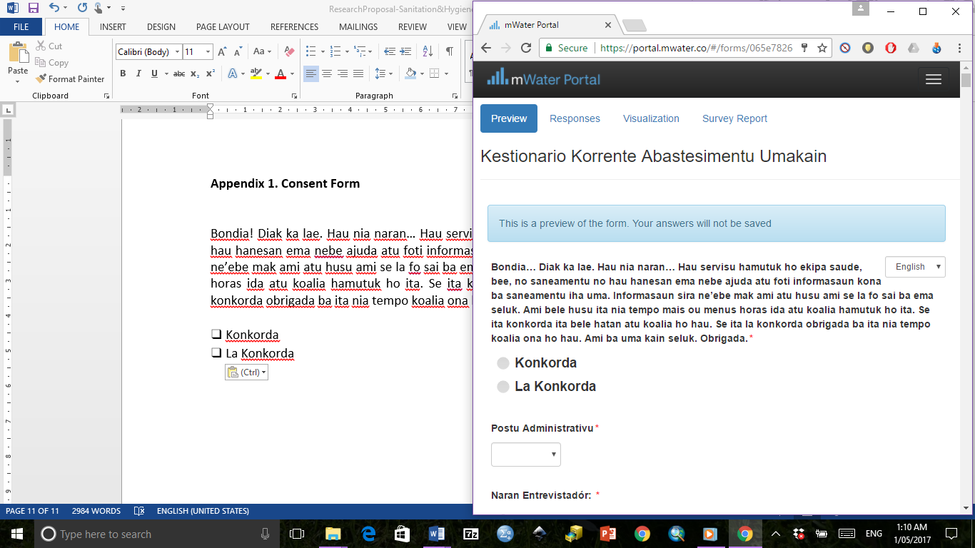

**Appendix 2. Sample Household Log Sheet Using Stratified Systematic Sampling**

|  |  |  |  |  |
| --- | --- | --- | --- | --- |
| **List of Suco and Aldeia** | **Number of HHs in Aldeia** | **Percent of total number HH** | **Target number of HH to sample** | **Actual number of HHs sampled** |
|
| **4. MALIANA** | | | | |
| **4.1 Holsa** |  |  |  |  |
| Solu Golo | 201 | 0.027 | 9 | 13 |
| Op Legul | 189 | 0.025 | 8 | 8 |
| Tas | 53 | 0.007 | 2 | 2 |
| Bili Cou | 121 | 0.016 | 5 | 5 |
| Lolo Oa | 151 | 0.020 | 6 | 1 |
| Secar | 74 | 0.010 | 3 | 3 |
| **4.2 Odomau** |  |  |  |  |
| Genoha'an | 157 | 0.021 | 7 | 7 |
| Rai Maten | 162 | 0.022 | 7 | 7 |
| Rocon | 60 | 0.008 | 3 | 3 |
| Ana Hun | 49 | 0.007 | 2 | 3 |
| **4.3 Lahomea** |  |  |  |  |
| Maliana | 161 | 0.021 | 7 | 8 |
| Laho Mea | 123 | 0.016 | 5 | 5 |
| Galosapulu | 27 | 0.004 | 1 | 3 |
| Genu Ha'an | 92 | 0.012 | 4 | 6 |
| Hatu Laca | 172 | 0.023 | 7 | 7 |
| **4.4 Ritabou** |  |  |  |  |
| Ritabou | 107 | 0.014 | 5 | 5 |
| Uat | 54 | 0.007 | 2 | - |
| Maganutu | 45 | 0.006 | 2 | 6 |
| Dai Tete | 57 | 0.008 | 2 | 2 |
| Ma'a Hui | 35 | 0.005 | 1 | - |
| Riti Udo | 20 | 0.003 | 1 | 1 |
| Mole Ana | 87 | 0.012 | 4 | 4 |
| Hale Cou | 58 | 0.008 | 2 | 2 |
| Cor Luli | 31 | 0.004 | 1 | 1 |
| Same Laun | 110 | 0.015 | 5 | 5 |
| Diru Aben | 72 | 0.010 | 3 | 3 |
| Timatan | 270 | 0.036 | 12 | 13 |
| **4.5 Raifun** |  |  |  |  |
| Raifun Vila | 270 | 0.036 | 12 | 13 |
| Raifun Foho | 36 | 0.005 | 2 | - |
| Nunu Tanan | 29 | 0.004 | 1 | - |
| **4.7 Tapo Memo** |  |  |  |  |
| Hulu Atin | 145 | 0.019 | 6 | 8 |
| Pip Galag 1 | 135 | 0.018 | 6 | 6 |
| Tunu Bibi | 120 | 0.016 | 5 | 6 |
| Manu Aman | 49 | 0.007 | 2 | 2 |
| TOTAL | | | 151 | 168 |

|  |  |  |  |  |  |  |  |  |
| --- | --- | --- | --- | --- | --- | --- | --- | --- |
| **List of Suco and Aldeia** | | **Number of HHs in Aldeia** | | **Percent of total number HH** | | **Target number of HH to sample** | **Actual number of HHs sampled** | |
|
| **3. CAILACO** | | | | | | | | |
| **3.2 Manapa** |  | |  | |  | | |  |
| Tapo Meac | 80 | | 0.011 | | 3 | | | 10 |
| Tate Lori | 30 | | 0.004 | | 1 | | | - |
| Lugu Luli | 52 | | 0.007 | | 2 | | | - |
| **3.3 Purugoa** |  | |  | |  | | |  |
| Lesu Pu | 67 | | 0.009 | | 3 | | | 5 |
| Heda | 76 | | 0.010 | | 3 | | | 2 |
| **3.5 Guenulai** |  | |  | |  | | |  |
| Bia Boro | 48 | | 0.006 | | 2 | | | 2 |
| Tiri Moso | 41 | | 0.005 | | 2 | | | 2 |
| Mele Maga | 20 | | 0.003 | | 1 | | | 1 |
| TOTAL | | | | | 18 | | | 22 |
| **1. ATABAE** | | | | | | | | |
| **1.1 Hataz** |  | |  | |  | | |  |
| Aidabasalala | 57 | | 0.008 | | 2 | | | 2 |
| Boloi | 95 | | 0.013 | | 4 | | | 4 |
| Hataz | 65 | | 0.009 | | 3 | | | 3 |
| Aidabaleten | 85 | | 0.011 | | 4 | | | 4 |
| **1.2 Atabae** |  | |  | |  | | |  |
| Faturesi | 87 | | 0.012 | | 4 | | | 4 |
| Lolocolo | 25 | | 0.003 | | 1 | | | 1 |
| Hel-Leso | 149 | | 0.020 | | 6 | | | 5 |
| Saburapo | 11 | | 0.001 | | 0 | | | 1 |
| Made Bau | 65 | | 0.009 | | 3 | | | 3 |
| **1.3 Rarirobo** |  | |  | |  | | |  |
| Limanaro | 88 | | 0.012 | | 4 | | | 4 |
| Faturase | 60 | | 0.008 | | 3 | | | 3 |
| Vila Maria | 28 | | 0.004 | | 1 | | | 1 |
| Rairobo | 60 | | 0.008 | | 3 | | | 3 |
| **1.4 Aidabaleten** |  | |  | |  | | |  |
| Tasi Mean | 277 | | 0.037 | | 12 | | | 13 |
| Tutu Baba | 211 | | 0.028 | | 9 | | | 10 |
| Suli Laran | 120 | | 0.016 | | 5 | | | 5 |
| Biacou | 87 | | 0.012 | | 4 | | | 4 |
| Meguir | 66 | | 0.009 | | 3 | | | 3 |
| Harame | 95 | | 0.013 | | 4 | | | 4 |
| Adaba Leten | 62 | | 0.008 | | 3 | | | 4 |
| TOTAL | | | | | 77 | | | 82 |

|  |  |  |  |  |  |  |  |
| --- | --- | --- | --- | --- | --- | --- | --- |
| **List of Suco and Aldeia** | **Number of HHs in Aldeia** | | **Percent of total number HH** | | **Target number of HH to sample** | **Actual number of HHs sampled** | |
|
| **2. BALIBO** | | | | | | | |
| **2.1 Balibo Villa** |  |  | |  | | |  |
| Fatululic | 128 | 0.017 | | 5 | | | 5 |
| Fatuc Laran | 80 | 0.011 | | 3 | | | 3 |
| Amandato | 102 | 0.014 | | 4 | | | 4 |
| Belola | 77 | 0.010 | | 3 | | | 3 |
| Bui Lecun | 98 | 0.013 | | 4 | | | 4 |
| Atara | 47 | 0.006 | | 2 | | | 2 |
| Balibo Vila | 79 | 0.010 | | 3 | | | 3 |
| **2.2 Batugade** |  |  | |  | | |  |
| Batugade | 209 | 0.028 | | 9 | | | 9 |
| Nu Badac | 94 | 0.012 | | 4 | | | 4 |
| Lotan | 139 | 0.018 | | 6 | | | 6 |
| **2.4 Leohitu** |  |  | |  | | |  |
| Rai Ulun | 76 | 0.010 | | 3 | | | 3 |
| Mohac | 152 | 0.020 | | 7 | | | 7 |
| Ai-Assa | 104 | 0.014 | | 4 | | | 4 |
| Falo Ai | 68 | 0.009 | | 3 | | | 3 |
| **2.6 Sanirin** |  |  | |  | | |  |
| Palaca | 77 | 0.010 | | 3 | | | 3 |
| Suba Lesu | 107 | 0.014 | | 5 | | | 5 |
| Cacu | 159 | 0.021 | | 7 | | | 7 |
| TOTAL | | | | 77 | | | 77 |

**Appendix 3. Household survey (English Version)**

|  |  |  |  |  |
| --- | --- | --- | --- | --- |
| **SUPPLY CHAIN QUESTIONNAIRE**  **HOUSEHOLDS** | | **Interviewer Name: ________________** | **Interview Date: ______________** | |
| **A. GENERAL INFORMATION** | | | |
| **Household Location** | | | |
| Administrative Post: |  | | |
| Suco: |  | | |
| Aldeia: |  | | |
| **House’s Head** | | | |
| Name |  | | |
| Age | ❑ Under 18 years  ❑ 18 to 24 years  ❑ 25 to 34 years  ❑ 35 to 44 years  ❑ 45 to 54 years  ❑ 55 to 64 years  ❑ Age 65 or older | | |
| What is the highest level of education received by house’s head? | ❑ No schooling  ❑ Pre-primary  ❑ Some Primary  ❑ Completed primary  ❑ Pre-secondary  ❑ Some secondary  ❑ Completed secondary  ❑ University or other tertiary | | |

|  |  |
| --- | --- |
| *The questionnaire is to be administered to the mother/primary caregiver of the household. If she is not available, administer to another adult female or if no such person is available then the head of the household.* | |
| Name of person interviewed: |  |
| Person Interviewed | ❑ Mother/Primary caregiver  ❑ Other adult female  ❑ Household head  ❑ Other (please specify__________________) |
| Gender | ❑ Male  ❑ Female |
| Age | ❑ Under 18 years  ❑ 18 to 24 years  ❑ 25 to 34 years  ❑ 35 to 44 years  ❑ 45 to 54 years  ❑ 55 to 64 years  ❑ Age 65 or older |
| What is the main source of household income? | ❑ Household business  ❑ Agriculture / Fishing  ❑ Salary (government, NGO)  ❑ Private sector  ❑ Worker/Tradesman  ❑ Shop owner/ Company owner  ❑ Laborer in a shop/company  ❑ Subsidy/ pension from the government  ❑ Others / Donation / charity / present from family  ❑ Don’t know  ❑ No response |
| What is monthly income of the house’s head? |  |
| What is the highest level of education received by respondent (main caregiver)? | ❑ No schooling  ❑ Pre-primary  ❑ Some Primary  ❑ Completed primary  ❑ Pre-secondary  ❑ Some secondary  ❑ Completed secondary  ❑ University or other tertiary |
| What type of home ownership you are in now? | ❑ Owned  ❑ Rented  ❑ Parents/in-law/family |
| Which household possession that you have from the following items? (Select all that apply) | ❑ Mobile phone  ❑ Radio  ❑ TV  ❑ Satellite  ❑ Motorbike  ❑ Car  ❑ Computer |
| How do you communicate with friends and family? (Select all that apply) | ❑ Mobile phone calls and SMS  ❑ Social media (e.g. Facebook, WeChat)  ❑ Social events (e.g. birthdays, weddings etc)  ❑ Face-to-face meetings (please specify _______________) |

|  |  |  |
| --- | --- | --- |
| **House’s Composition** | | |
| Number of families in this house | ❑ 1  ❑ 2  ❑ 3  ❑ More than 3 families (Specify ___________) | |
| Number of people in the households |  | |
| Number of adults |  | |
| Number of children under 18 years |  | |
| **Persons with disabilities (PWD)** | | |
| Do you have any member in your household who have difficulty seeing? | ❑ No, no family member with any difficulty  ❑ Yes, this person has a little difficulty  ❑ Yes, this person has a lot of difficulty  ❑ Yes, this person cannot do it at all | If yes, who is this person? |
| Do you have any member in your household who have difficulty in hearing? | ❑ No, no family member with any difficulty  ❑ Yes, this person has a little difficulty  ❑ Yes, this person has a lot of difficulty  ❑ Yes, this person cannot do it at all | If yes, who is this person? |
| Do you have any member in your household who have difficulty walking or climbing steps? | ❑ No, no family member with any difficulty  ❑ Yes, this person has a little difficulty  ❑ Yes, this person has a lot of difficulty  ❑ Yes, this person cannot do it at all | If yes, who is this person? |
| Do you have any member in your household who have difficulty remembering or concentrating? | ❑ No, no family member with any difficulty  ❑ Yes, this person has a little difficulty  ❑ Yes, this person has a lot of difficulty  ❑ Yes, this person cannot do it at all | If yes, who is this person? |
| Do you have any member in your household who have difficulty with self-care such as washing or dressing? | ❑ No, no family member with any difficulty  ❑ Yes, this person has a little difficulty  ❑ Yes, this person has a lot of difficulty  ❑ Yes, this person cannot do it at all | If yes, who is this person? |
| Do you have any member in your household who have difficulty to understanding or being understood? | ❑ No, no family member with any difficulty  ❑ Yes, this person has a little difficulty  ❑ Yes, this person has a lot of difficulty  ❑ Yes, this person cannot do it at all | If yes, who is this person? |

|  |  |  |
| --- | --- | --- |
| 1. **WATER SUPPLY FOR DOMESTIC USE** | | |
| Q1. What is your main source of water used by your household for domestic use such as cooking and personal hygiene such as washing, handwashing, and cleaning? | ❑ Piped water into dwelling  ❑ Piped water to yard/plot  ❑ Public/communal tap/standpipe  ❑ Borehole/tubewell  ❑ Protected dug well  ❑ Unprotected dug well  ❑ Protected spring  ❑ Unprotected spring  ❑ Rainwater collection in closed containers  ❑ Rainwater collection in open containers  ❑ Small-scale vendor (cart with small tank/drum)  ❑ Tanker truck  ❑ Surface water (river dam, lake, pond, stream, canal, irrigation channels)  ❑ Others (please specify ____________)  ❑ Don’t know | |
| Q2. How frequently was the water for the domestic use available to your household during the last two weeks? | ❑ Daily, 24 hours a day  ❑ Daily, at certain hours  ❑ Three – five days a week  ❑ One – two days a week  ❑ Less frequent than once a week  ❑ Don’t know | |
| Q3. How long does it take someone to walk to the water source, collect water and come back? | ❑ It’s inside house (water source on premises)  ❑ < 15 minutes  ❑ 15-30 minutes  ❑ 30 minutes – 1 hour  ❑ > 1 hour (please specify)  ❑ Don’t know | |
| Q4. Who usually goes to this source to collect the water for your household? | ❑ Adult woman (age 18+ years)  ❑ Adult man (age 18+ years)  ❑ Female child (under 18 years)  ❑ Male child (under 18 years)  ❑ Other (please specify_______________________)  ❑ Don’t know | |
| Q5. Is the location of the main water source for domestic water the same drinking? | ❑ Yes  ❑ No  ❑ Don’t know | |
| Q6. Did your household experience interruptions/ breakdowns in the water supply for domestic use from the main source during the last six months? | ❑ Yes 🡪 Go to Q6a  ❑ No 🡪 Go to Q8  ❑ Don’t know 🡪 Go to Q8 | Q6a. If YES, what was the main cause of the interruptions? |
| Q7. During these interruptions/ breakdown, how many days was water not available from the main source? | Number of days:__________________ | |
| Q8. Do you pay for water from any source? | ❑ Yes 🡪 Go to Q8a  ❑ No 🡪 Go to Q9  ❑ Don’t know 🡪 Go to Q9 | Q8a. If YES, when do you pay?  ❑ Every day  ❑ Every week  ❑ Every month  ❑ By volume/container/water meter  ❑ Other (specify__________)  ❑ Don’t know |
| Q8b. How much do you pay per load or per volume unit? |
| Q9. When there is a problem with your main water source, who do you tell or ask for help? | ❑ Nobody 🡪 Go to Q10  ❑ Local government 🡪 Go to Q9a  ❑ Community leader 🡪 Go to Q9a  ❑ Local mason/plumber 🡪 Go to Q9a  ❑ Other (specify________)  ❑ Don’t know 🡪 Go to Q10 | Q9a. Was the problem solved?  ❑ Yes  ❑ No  ❑ Don’t know |
| Q10. Are you interested in improving your water supply service? | ❑ Yes  ❑ No  ❑ Don’t know | |
| Q11. Are you willing to pay to improve your water supply? | ❑ Yes 🡪 Go to Q11a  ❑ No 🡪 Go to Q12  ❑ Don’t know 🡪 Go to Q12 | Q11a. If YES, how much are you willing to pay to improve your water supply? |
| Q12. Where does your household’s domestic waste water discharge to (i.e. water from cooking, washing, cleaning, but not include toilet waste water)? | ❑ Septic system  ❑ Pour into toilet  ❑ Soak pit  ❑ Street drain  ❑ Throw on road  ❑ Throw on garden /yard  ❑ Pour into creek, stream  ❑ Other (specify_______________________)  ❑ Don’t know | |

|  |  |  |
| --- | --- | --- |
| 1. **HANDWASHING AND HYGIENE** | | |
| Q13. What do the household members use to clean their anus after defecating? | ❑ Water  ❑ Toilet paper  ❑ Used waste paper (e.g. newspaper)  ❑ Sticks  ❑ Leaves  ❑ Stone  ❑ Nothing  ❑ Others (please specify _____________________)  ❑ Don’t know | |
| Q14. Where do members of your household usually bath? | ❑ House bathroom  ❑ Neighbor’s bathroom  ❑ Public bathroom  ❑ Surface water (river, stream, pond)  ❑ Other (please specify _________________________) | |
| Q15. Do all household members use this area for bathing? | ❑ Yes  ❑ No  ❑ Don’t know | |
| Q16. How far is the bathing facility from the main dwelling/house? | ❑ <5 meters  ❑ 5-10 meters  ❑ 11-15 meters  ❑ >15 meters  ❑ Other (please specify __________________________) | |
| Q17. Have you used soap today or yesterday? | ❑ Yes 🡪 Go to Q18  ❑ No 🡪 Go to Q19  ❑ Don’t know 🡪 Go to Q19 | |
| Q18. When you used soap today or yesterday, what did you use it for? (select all that  apply) | ❑ Washing clothes  ❑ Washing cooking utensils and dishes  ❑ Washing my body  ❑ Washing child’s bottom  ❑ Washing child’s hands  ❑ Washing hands after defecating  ❑ Washing hands after cleaning child  ❑ Washing hands before feeding child  ❑ Washing hands before preparing food  ❑ Washing hands before eating  ❑ Washing hands before going out  ❑ Washing hands before receiving visitors  ❑ Other (please specify _________________________)  ❑ Don’t know | |
| Q19. When do you think is it important for a young child to wash her/his hands or have her/his hands washed for her/him? (select all that apply) | ❑ Before eating  ❑ After eating  ❑ After defecating  ❑ Before going out  ❑ Before receiving visitors  ❑ Other (please specify _________________________)  ❑ Don’t know | |
| Q20. What type of soap do you use to wash your hand? | ❑ Bar soap  ❑ Powder soap  ❑ Liquid soap  ❑ I don’t use soap  ❑ Don’t know | *If you use soap, what is the brand?* |
| Q21. What type of soap do you use to bath? | ❑ Bar soap  ❑ Powder soap  ❑ Liquid soap  ❑ I don’t use soap  ❑ Don’t know | *If you use soap, what is the brand?* |
| Q22. What type of soap do you use to wash the dishes and clothes? | ❑ Bar soap  ❑ Powder soap  ❑ Liquid soap  ❑ I don’t use soap  ❑ Don’t know | *If you use soap, what is the brand?* |
| Q23. Where do you usually buy the soap? (Name of the store/owner of the store) |  | |
| Q24. How long does it take to go to the store? (minutes) |  | |
| Q25. How far the store from your house? (km) |  | |
| Q26. Is the soap do you want to buy always available at the soap? | ❑ Yes 🡪 Go to Q27  ❑ No 🡪 Go to Q26a  ❑ Don’t know 🡪 Go to Q27 | Q26a. If NO, do you get the substitute?  ❑ Yes  ❑ No  ❑ Don’t know |
| Q27. What kind of other hygiene and sanitation products that you find there? (select all that apply) | ❑ Toilet tissue  ❑ Toilet cleaner  ❑ Floor cleaner  ❑ Toothpaste  ❑ Shampoo  ❑ Other (specify________________) | |

|  |  |  |  |
| --- | --- | --- | --- |
| 1. **SANITATION** | | | |
| Q28. Where do members of your household usually go for defecation? | ❑ Own toilet 🡪 Go to Q33  ❑ Neighbor toilet 🡪 Go to Q29  ❑ Shared toilet 🡪 Go to Q29  ❑ Bucket 🡪 Go to Q40  ❑ Hanging toilet 🡪 Go to Q40  ❑ Open air/bush/field🡪 Go to Q40  ❑ Other (please specify_______________) | | |
| Q29. If you use neighbor’s toilet or shared toilet, how many households in total use this toilet facility including your households? | ❑ Number of households ______ | | |
| Q30. If you use neighbor’s toilet, who is the name of the toilet owner? | ❑ Name: ________________ | | |
| Q31. Do you know those who share the neighbor’s toilet? | ❑ Yes  ❑ No  ❑ Don’t know | | |
| Q32. Do you pay for using the toilet facility? | ❑ Yes 🡪 Go to Q32a  ❑ No 🡪 Go to Q33  ❑ Don’t know 🡪 Go to Q33 | | Q32a. If YES, how much do you pay? |
| Q33. How far is the toilet facility from your place? | ❑ < 5 meters  ❑ 5-10 meters  ❑ 11-15 meters  ❑ > 15 meters | | |
| Q34. How long does it take to reach the toilet? | ❑ Inside or attached to the house  ❑ < 15 minutes  ❑ 15-30 minutes  ❑ 30 minutes – 1 hour  ❑ > 1 hour (Please specify______________________) | | |
| Q35. Is there any member of the household who has difficulty using toilet e.g., elderly, very ill, physically disabled, heavily pregnant women? | ❑ Yes 🡪 Go to Q35a  ❑ No 🡪 Go to Q37  ❑ Don’t know 🡪 Go to Q37 | Q35a. If yes, why is that? | |
| Q36. Did you do some modification to the toilet so that it can be used by this person? | ❑ Yes 🡪 Go to Q36a  ❑ No 🡪 Go to Q37  ❑ Don’t know 🡪 Go to Q37 | Q36a. If yes, what kind of modification? (select all that apply)  ❑ Uza kadeira plastiku no halo kuak iha kalen  ❑ Uza kadeira au  ❑ Kaer buat ruma atu balansu  ❑ Uza ai tonka  ❑ Halo dalan halis atu bele asesu ho diak  ❑ Seluk (specify_____________) | |
| Q37. If you use pit or septic tank, how frequently does it become full? | ❑ More than once a year  ❑ Once per year  ❑ Every couple of years  ❑ Every three years  ❑ More than five years  ❑ Never  ❑ Don’t know | | |
| Q38. What did you do the last time the pit/septic tank was full? | ❑ Built a new pit or septic tank  ❑ Household emptied it  ❑ Private company emptied it  ❑ Government service emptied it  ❑ Other (specify____________________)  ❑ Don’t know | | |
| Q39. Who is responsible for cleaning the toilet? (select all that apply) | ❑ Adult male in household  ❑ Adult female in household  ❑ Male child in household  ❑ Female child in household  ❑ Everyone in household  ❑ No one  ❑ Other (specify________________)  ❑ Don’t know | | |

|  |  |  |
| --- | --- | --- |
| **Children and Sanitation** | | |
| Q40. Are there small children living in the household (5 years old or younger) | ❑ Yes 🡪 Go to Q40a  ❑ No 🡪 Go to Q43  ❑ Don’t know 🡪 Go to Q43 | Q40a. How many children under 5 years? |
| Q41. The last time he/she passed stools, where did she/he defecate? | ❑ Use the toilet  ❑ Used potty  ❑ Used diapers  ❑ Went in yard  ❑ Went outside the premises  ❑ Went in her/his clothes  ❑ Other (please specify__________________________)  ❑ Don’t know | |
| Q42. The last time he/she passed stools, where were the feces disposed? | ❑ Dropped into toilet facility  ❑ Washed away into toilet facility  ❑ Washed away into sink or tub  ❑ Washed away, water discharged outside  ❑ Disposed into solid waste garbage  ❑ Disposed in the yard  ❑ Disposed outside premises  ❑ Buried  ❑ Did nothing/let it there  ❑ Other (please specify______________________________)  ❑ Don’t know | |

|  |  |
| --- | --- |
| **Attitude toward Toilet** | |
| Q43. In general, how satisfied are you with your current toilet? | ❑ Very satisfied  ❑ Satisfied  ❑ Neither satisfied nor dissatisfied  ❑ Dissatisfied  ❑ Very dissatisfied |
| Q44. What do you like about the toilet? (select all that apply) | ❑ More private  ❑ Convenient, can use anytime  ❑ Safety, especially at night  ❑ Easier for elderly, sick, children, pregnant women, disabled  ❑ Healthier  ❑ Cleaner  ❑ Modern/suitable for urban living  ❑ Don’t have to share with others  ❑ No shame/embarrassment  ❑ Reduce conflict  ❑ Other (specify___________________________)  ❑ Don’t know |
| Q45. What do you dislike about the toilet? (select all that apply) | ❑ Nothing  ❑ Dirty  ❑ Smell  ❑ Unhealthy  ❑ Too far away from house  ❑ Not safe  ❑ Have to share with others  ❑ Have to wait to use/queue up  ❑ It was expensive  ❑ Overflow when rains  ❑ Use too much water  ❑ Animals come in  ❑ Using sticks and stones in toilet  ❑ Bush, difficult access  ❑ Pit fills up quickly  ❑ Careless use of toilet/improper disposal of sanitary pads  ❑ Conflict/argument with other people who use the toilet  ❑ Sometimes not enough water for flushing  ❑ Others don’t use toilet properly  ❑ Neighbors use toilet without permission  ❑ Pooling of waste around house  ❑ Pooling around neighbor’s house  ❑ Other (specify_______________)  ❑ Don’t know |
| Q46. What are the main factors affecting your decisions in terms of the type of toilet you want to build? (select all that apply) | ❑ Cost of materials  ❑ Sales promotions  ❑ Emulate others  ❑ Other family members influence  ❑ Quality of materials  ❑ Materials that match the house  ❑ Materials that will last the longest  ❑ Physical accessibility of materials  ❑ Other (specify___________________) |
| Q47. What do you think is the main reason for you to build a toilet? (select all that apply) | ❑ Emulate others  ❑ Regulations  ❑ Good health  ❑ Convenience/comfort  ❑ Cleanliness  ❑ Privacy/dignity  ❑ Safety  ❑ Education program  ❑ Other family members influence  ❑ Sales promotions  ❑ Other people influence (e.g., chef de suco or other government leader)  ❑ Other (specify___________________) |

|  |  |  |
| --- | --- | --- |
| **Designing, Building and Improving Toilet** | | |
| Q48. Which year was your toilet constructed? |  | |
| Q49. Who paid for the construction of your toilet? | ❑ Self  ❑ NGO project  ❑ Government project  ❑ Community project  ❑ Family member  ❑ Others | |
| Q50. Who constructed your toilet? | ❑ Self → Go to Q51  ❑ Family → Go to Q52  ❑ Friend/neighbor → Go to Q52  ❑ Local artisan → Go to Q52  ❑ NGO project → Go to Q52  ❑ Government project → Go to Q52  ❑ Community project/support → Go to Q52  ❑ Others | |
| Q51. Did anyone help you build it? | ❑ Yes → Go to Q51a  ❑ No → Go to Q52 | Q51a. If yes, did you pay them?  ❑ Yes → Go to Q51b  ❑ No → Go to Q51c |
| Q51b.If YES, how much did you pay them? |
| Q51c. If no money, why did they help you? |
| Q52. Have you helped anyone else build their toilet? | ❑ Yes → Go to Q52a  ❑ No → Go to Q53 | Q52a. If yes, did you get pay?  ❑ Yes → Go to Q52b  ❑ No → Go to Q52c |
| Q52b. If YES, how much did you get? |
| Q52c. If no money, why did you help them? |
| Q53. How did you transport those materials to your place? *(Specify the name of the transportation mode)* |  | |

|  |  |  |
| --- | --- | --- |
| **Good sanitation and Toilet Preferences** | | |
| Q54. What does good sanitation mean to you? (select all that apply) | ❑ Increased comfort  ❑ Increased privacy  ❑ Increased convenience  ❑ Increased safety, for women, especially at night, and for children  ❑ Pride and social status  ❑ Increased cleanliness, in terms of personal hygiene, and domestic cleanliness  ❑ Reduce smell and flies  ❑ Less embarrassment with visitors  ❑ Reduced conflict with neighbours  ❑ Good health in a very broad cultural sense, often linked to disgust and avoidance of faeces, bad “air” smells  ❑ Reduced illness and accidents  ❑ Peace of mind  ❑ Increased property value  ❑ Increased rental income  ❑ Eased restricted mobility from illness, old age  ❑ Passing on good habits and a better future to children (aspirational legacy)  ❑ Other (specify_______________________) | |
| Q55. Which one of the followings are your preferred toilet qualities and its desired attributes? (select all that apply) | ❑ No smell (of urine or faeces)  ❑ No sight of faeces  ❑ Durable, long lasting  ❑ Easy to clean surfaces  ❑ Solid and safe platform  ❑ Safe for children  ❑ Provides good privacy for women, girls for menstrual hygiene management  ❑ Aspirational (pleasant, beautiful)  ❑ Makes me proud  ❑ Easy to operate and use  ❑ Comfortable (pleasant to use)  ❑ Doesn’t fill up fast  ❑ Does not require constant maintenance and repair  ❑ Water-based (cultures using water for anal cleansing)  ❑ Dry system (places where water is scare / expensive) | |
| Q56. Are you aware of the toilet option available in Bobonaro? | ❑ Yes → Go to Q56a  ❑ No → Go to Q57  ❑ Don’t know → Go to Q57 | Q56a. If YES, could you mention the toilet options available? |

|  |  |  |  |  |  |
| --- | --- | --- | --- | --- | --- |
| **Plan on Toilet Improvement** | | | | | |
| Q57. Are you interested in improving/modifying your toilet facilities? | ❑ Yes → Go to Q57a  ❑ No → Go to Q63  ❑ Don’t know → Go to Q63 | | Q57a. Why do you want to do the improvement? | | |
| Q58. Of the following options for a new toilet, which ones do you prefer?  A: Superstructure  B: Toilet platform  C: Door  D: Pans/bowl/closet  E: Roof  F: Option for those who have disability  G: Handwashing facility | Priority | Why do you want to improve/upgrade this part? | | What do you like about this option? | What do you dislike about this option? |
| Priority 1  ❑ A  ❑ B  ❑ C  ❑ D  ❑ E  ❑ F  ❑ G |  | |  |  |
| Priority 2  ❑ A  ❑ B  ❑ C  ❑ D  ❑ E  ❑ F  ❑ G  ❑ No more priority |  | |  |  |
| Priority 3  ❑ A  ❑ B  ❑ C  ❑ D  ❑ E  ❑ F  ❑ G  ❑ No more priority |  | |  |  |
| Q59. If you decided to build/upgrade a toilet who in your household would make the final decision to build or upgrade? | ❑ Adult male in household  ❑ Adult female in household  ❑ Both adult male and adult female together  ❑ Children in household  ❑ Other (specify_______________)  ❑ Don’t know | | | | |
| Q60. Who will install/upgrade your toilet? | ❑ Self  ❑ Family  ❑ Friend/neighbor  ❑ Local artisan/mason  ❑ NGO project  ❑ Government project  ❑ Community project/support  ❑ Others | | | | |
| Q61. Where will you buy materials for toilet improvement/upgrade? (Specify the name of Loja) |  | | | | |
| Q62. How did you transport those materials to your place? (Specify the name of the transportation mode) |  | | | | |
| Q63. How likely do you think it is that you will build a new toilet or improve your toilet in the next 12 months? | ❑ Very likely  ❑ Likely  ❑ Unlikely  ❑ Very unlikely  ❑ Don’t know | | | | |

|  |  |  |
| --- | --- | --- |
| **Funding** | | |
| Q64. How much can you afford to contribute towards constructing/improving your toilet? | ❑ Can afford anytime  ❑ Can afford every month  ❑ Can afford by saving every 2 months  ❑ Can afford by saving per year  ❑ Can never afford | |
| Q65. Do you have funding source to build a new toilet/upgrade toilet? | ❑ Yes 🡪 Go to Q65a  ❑ No 🡪 Go to Q66  ❑ Don’t know 🡪 Go to Q66 | Q65a. If YES, where does the funding come from? |
| Q66. If it was possible, would you be interested in taking a loan or some other credit to build/improve your toilet? | ❑ Yes  ❑ No  ❑ Don’t know | |
| Q67. If you had $40 to improve sanitation in your home, what would you want to buy? |  | |
| Q68. Where do you get this information to build/upgrade toilet? (select all that apply) | ❑ General knowledge  ❑ My neighbor  ❑ My parents or parents-in-law  ❑ My children  ❑ The chef de suco or other government leader  ❑ My wife/husband  ❑ Local mason  ❑ From suppliers/store  ❑ NGO guidance  ❑ Poster, leaflet or other printed materials  ❑ Community meeting  ❑ Other (please specify ________) | |
| Q69. Do you seek other people advice regarding the materials you need to build/upgrade toilet? | ❑ Yes 🡪 Go to Q70  ❑ No, I already know how to build/upgrade toilet 🡪 Go to Q71  ❑ Don’t know 🡪 Go to Q71 | |
| Q70. If you seek other people advice, who would you most like to talk to for information and advice about technical options, product, cost, etc? (select all that apply) | ❑ Neighbor with toilet  ❑ Family member with toilet  ❑ Community leader  ❑ Local level government  ❑ NGO  ❑ Local mason, builder, plumber  ❑ Hardware shop  ❑ Other (specify_____________________)  ❑ Don’t know | |
| Q71. When you buy materials for materials to build/upgrade toilet, do you negotiate the price of the products? | ❑ Yes, negotiate to obtain cheaper price  ❑ Yes, negotiate to obtain discounts for bulk orders  ❑ Yes, negotiate to get free delivery service  ❑ No  ❑ Other (specify_____________________) | |
| Q72. What do you prefer in terms of payment? | ❑ Cash up front  ❑ Cash over time (step by step)  ❑ Goods (barter) up front  ❑ Goods (barter) over time | |
| Q73. Do you obtain credit from the suppliers/retailers? | ❑ Yes  ❑ No  ❑ Don’t know | |
| Q74. If you have limited access to water, are you interested in building a toilet that uses a pour flush system? | ❑ Yes  ❑ No  ❑ Don’t know | |
| Q75. What are the competing household demands and priorities for spending on a new toilet? (select all that apply) | ❑ Healthcare  ❑ New roof for the house  ❑ New furniture for the house  ❑ New television  ❑ School for the children  ❑ New tools for work  ❑ Mobile phone  ❑ Other | |
| Q76. What do you think is the best way that the poorest households in your community could be helped to get their own toilet? |  |  |

|  |  |  |  |  |
| --- | --- | --- | --- | --- |
| **F. HEALTH** | | | | |
| Q77. Has anyone in your household had diarrhea in the past 7 days?  *PS: Diarrhea is defined as 3 or more loose stools in 24 hours* | ❑ Yes 🡪 Go to Q78  ❑ No 🡪 Go to Q79  ❑ Don’t know 🡪 Go to Q79 | | | |
| Q78. If yes, please indicate the following | **Status in the family** | **Gender** | **Age** | **Disability Status** |
|  | ❑ Male  ❑ Female |  | ❑ Yes  ❑ No |
|  | ❑ Male  ❑ Female |  | ❑ Yes  ❑ No |
|  | ❑ Male  ❑ Female |  | ❑ Yes  ❑ No |
|  | ❑ Male  ❑ Female |  | ❑ Yes  ❑ No |
| Q79. What do you think can cause diarrhea? (select all that apply) | ❑ Bad/dirty water  ❑ Bad/dirty food  ❑ Poor hygiene  ❑ Feces/defecating in the open  ❑ Dirty hands  ❑ Germs  ❑ Flies  ❑ Other (specify________________________)  ❑ Don’t know | | | |
| Q80. Do you think diarrhea can be prevented or avoided? | ❑ Yes 🡪 Go to Q81  ❑ No 🡪 Go to Q82  ❑ Don’t know 🡪 Go to Q82 | | | |
| Q81. If YES, how do you think diarrhea can be prevented or avoided? (select all that apply) | ❑ Wash hands  ❑ Use soap  ❑ Use toilet facility to defecate  ❑ Dispose children’s feces in toilet facility  ❑ Bury feces  ❑ Drink clean water  ❑ Store water safely  ❑ Treat water (boil, filter, chlorinate)  ❑ Prepare food hygienically/protect  ❑ Dispose of garbage properly  ❑ Breast feeding  ❑ Good nutrition  ❑ Other (specify__________________________)  ❑ Don’t know | | | |
| Q82. When can the community as a whole, not just you do to prevent or avoid diarrhea? (Select all that apply) | ❑ Provide clean water  ❑ Help to construct toilets  ❑ Make materials for toilet construction available at low cost  ❑ Make soap available at low cost  ❑ Make water disinfectant available at low cost  ❑ Clean village campaigns  ❑ Train promoters  ❑ Other (specify___________________________)  ❑ Don’t know | | | |
| Q83. What is your main source of information about personal and household hygiene? (select all that apply) | ❑ Television  ❑ Radio  ❑ Newspaper  ❑ Community leader (chef de suco)  ❑ School  ❑ Workplace  ❑ Family or friends  ❑ Church  ❑ Women’s group  ❑ Youth group  ❑ Local government  ❑ NGO  ❑ Internet  ❑ Nobody  ❑ Other (specify___________________)  ❑ Don’t know | | | |

|  |  |
| --- | --- |
| **OBSERVATION** | |
| Q84. Is there a specific place to wash hands? | ❑ Yes  ❑ No  ❑ Don’t know |
| Q85. If YES, where is the location of handwashing facilities? | ❑ Toilet  ❑ Bathing area  ❑ Kitchen area  ❑ Public tap  ❑ Water pump  ❑ Spring  ❑ Other (please specify ________________________)  ❑ Don’t know |
| Q86. Is water present at the specific place to wash hands? | ❑ Yes  ❑ No  ❑ Don’t know |
| Q87. Is soap/detergent/or locally used cleansing agent available at the specific place for handwashing? | ❑ None available  ❑ Soap  ❑ Soap substitute (Please specify______________________)  ❑ Don’t know |
| Q88. What kind of toilet does your household use? | ❑ Pour Flush water sealed to offset pit or septic tank  ❑ Pour flush to pit  ❑ Flush/pour flush to elsewhere  ❑ VIP/pit latrine with slab  ❑ Pit latrine without slab/open pit  ❑ Other (please specify_________________) |
| Q89. Toilet substructure construction: | ❑ Unlined pit  ❑ Concrete ring  ❑ Brick lined  ❑ Other (specify__________________) |
| Q90. Toilet slab construction: | ❑ Open hole –mud floor  ❑ Open-hole-wooden floor  ❑ Open-hole concrete floor  ❑ Plastic slab-mud floor  ❑ Plastic slab-wooden floor  ❑ Plastic slab-concrete floor  ❑ Other (specify__________________) |
| Q91. Toilet superstructure wall construction: | ❑ Concrete blocks  ❑ Brick  ❑ Zink  ❑ Wooden  ❑ Mud  ❑ Grass  ❑ Plastic sheeting  ❑ No wall  ❑ Other (specify__________________) |
| Q92. Toilet roof construction: | ❑ Corrugated iron sheets  ❑ Tiles  ❑ Grass thatch  ❑ Wooden  ❑ Plastic sheeting  ❑ No roof  ❑ Other (specify__________________) |
| Would you kindly show the toilet to me? Could we please take a photo of your toilet? |  |

**Appendix 4. Supplier survey (English Version)**

|  |  |  |
| --- | --- | --- |
| **SUPPLY CHAIN QUESTIONNAIRE**  **SUPPLIERS/RETAILERS/KIOSK** | **Interviewer Name: ________________** | **Interview Date: ______________** |

|  |  |
| --- | --- |
| **A. GENERAL INFORMATION** | |
| **Suppliers Location** |  |
| Administrative Post |  |
| Suco: |  |
| Aldeia: |  |
| **Contact Information** |  |
| Name: |  |
| Phone number: |  |
| Address: |  |
| Age: | ❑ Under 18 years  ❑ 18 to 24 years  ❑ 25 to 34 years  ❑ 35 to 44 years  ❑ 45 to 54 years  ❑ 55 to 64 years  ❑ Age 65 or older |
| What is the highest level of education received by the head of the store? | ❑ No schooling  ❑ Pre-primary  ❑ Some Primary  ❑ Completed primary  ❑ Pre-secondary  ❑ Some secondary  ❑ Completed secondary  ❑ University or other tertiary |

|  |  |  |  |  |
| --- | --- | --- | --- | --- |
| **B. BACKGROUND INFORMATION** | | | | |
| Q1. What is your position in the business? | ❑ Owner (with staff)   Self-employed   Hired   Other (specify) | | | |
| Q2. How many years have you been in this business? |  | | | |
| Q3. How large is the business? (number of staff) |  | **Male** | | **Female** |
| Permanent |  | |  |
| Semi-permanent |  | |  |
| Occasional |  | |  |
| Total |  | |  |
| Q4. If you are the owner or self-employed, where did you get the capital to start the business? | ❑ Saved money   Loan from bank   Loan from family/friends   Loan from other source   Village development fund   Support from donor funded   Other (specify) | | | |
| Q5. How much of your business is toilet related? (Approximate %) |  | | | |
| Q6. Do you have any other business activities? | ❑ Yes 🡪 Go to Q6a   No 🡪 Go to Q7 | | Q6a. If Yes, what are they? | |
| Q7. Is your business registered? | ❑ Yes   No | | Q7a. Why/Why not? | |

|  |  |  |  |  |  |  |  |  |
| --- | --- | --- | --- | --- | --- | --- | --- | --- |
| **C. PRODUCT** | | | | | | | | |
| Q8. Who are your main/key suppliers for the following sanitation products, tools and toilet building materials? | **Item** | | | **Main suppliers** | | **Country of origin** | | |
| Squat pan plastic | | |  | |  | | |
| Squat pan ceramic | | |  | |  | | |
| Squat pan cement | | |  | |  | | |
| Ceramic pour flush sitting bowl | | |  | |  | | |
| Ceramic automatic flush sitting bowl | | |  | |  | | |
| Grass / thatch | | |  | |  | | |
| Wood | | |  | |  | | |
| Zinc | | |  | |  | | |
| Cement | | |  | |  | | |
| PVC Pipe | | |  | |  | | |
| PVC Pipe Elbow | | |  | |  | | |
| Sand | | |  | |  | | |
| Iron Bar (Rebar) | | |  | |  | | |
| Nails | | |  | |  | | |
| Thin Wire | | |  | |  | | |
| Crowbar | | |  | |  | | |
| Shovel | | |  | |  | | |
| Trowel | | |  | |  | | |
| Bamboo | | |  | |  | | |
| Bricks | | |  | |  | | |
| Coconut leaf | | |  | |  | | |
| Piku / Bebok | | |  | |  | | |
| Wood clapboard | | |  | |  | | |
| Tiles | | |  | |  | | |
| Water Filter | | |  | |  | | |
| Water hose | | |  | |  | | |
| Handwashing facility | | |  | |  | | |
| Q9. Is there quality difference in the different suppliers of materials? | ❑ Yes 🡪 Go to Q9a   No 🡪 Go to Q10 | | | Q9a. Can you explain why? | | | | |
| Q10. Do you have regular suppliers for your products? | ❑ Yes 🡪 Go to Q10a   No 🡪 Go to Q11 | | | Q10a. If YES, which products in particular? | | | | |
| Q10b. If YES, why? (select all that apply)   Cheaper price/item   Discount for bulk purchases   Credit   Relationship (you have always purchased from them?)   Selling on consignment (agreement to pay after goods are sold)   There is only one supplier   Other (please specify ________________________) | | | | |
| Q11. What kind of pans/bowls do people most commonly buy? | ❑ Squat pan plastic   Squat pan ceramic   Squat pan cement   Ceramic pour flush sitting bowl   Ceramic automatic flush sitting bowl   Other (please specify _____________________) | | | Q11a. What is the most favourite brand of this type of pans/bowl? | | | | |
| Q12. Can you please show the quantities of **pans/bowls** sold in the following years? | **Items and brands** | **2014** | | **2015** | | **2016** | | |
|  |  | |  | |  | | |
|  |  | |  | |  | | |
|  |  | |  | |  | | |
|  |  | |  | |  | | |
|  |  | |  | |  | | |
|  |  | |  | |  | | |
|  |  | |  | |  | | |
| Q13. What are the main factors affecting households’ decisions in terms of the type of toilet they want to have? (select all that apply) | ❑ Cost of materials  ❑ Sales promotions  ❑ Emulate others  ❑ Other family members influence  ❑ Quality of materials  ❑ Materials that match the house  ❑ Materials that will last the longest  ❑ Physical accessibility of materials  ❑ Other (specify__________________) | | | | | | | |
| Q14. What do you think is the main reason for households to build a toilet? (select all that apply) | ❑ Emulate others   Regulations   Good health   Convenience/comfort   Cleanliness   Privacy/dignity   Safety   Education program   Other family members influence   Sales promotions   Other (specify________________) | | | | | | | |
| Q15. Which one of the following is the toilet that your customers usually build? | ❑ Part of building a new house   The first toilet for house that had no toilet at all   Rebuilding collapsed toilet   Upgrade to an improved toilet   Other (specify________________) | | | | | | | |
| Q16. When do you sell the most toilet supplies? | ❑ No difference throughout the year with sales   Dry season   Wet season   Holidays/special occasions | | | | | | | |
| Q17. How much do you pay to buy the following sanitation products, tools, and toilet building materials (specify quantity, quality and price) and how much do you sell them for? | **Item** | | **Brand** | **Quantity in stock** | **Purchase Price** | | **Sale Price** | **Photos** |
| Squat pan plastic A | |  |  |  | |  |  |
| Squat pan plastic B | |  |  |  | |  |  |
| Squat pan plastic C | |  |  |  | |  |  |
| Squat pan plastic D | |  |  |  | |  |  |
| Squat pan plastic E | |  |  |  | |  |  |
| Squat pan ceramic A | |  |  |  | |  |  |
| Squat pan ceramic B | |  |  |  | |  |  |
| Squat pan ceramic C | |  |  |  | |  |  |
| Squat pan ceramic D | |  |  |  | |  |  |
| Squat pan cement A | |  |  |  | |  |  |
| Squat pan cement B | |  |  |  | |  |  |
| Squat pan cement C | |  |  |  | |  |  |
| Ceramic pour flush sitting bowl A | |  |  |  | |  |  |
| Ceramic pour flush sitting bowl B | |  |  |  | |  |  |
| Ceramic pour flush sitting bowl C | |  |  |  | |  |  |
| Ceramic pour flush sitting bowl D | |  |  |  | |  |  |
| Grass/thatch | |  |  |  | |  |  |
| Wood | |  |  |  | |  |  |
| Zinc | |  |  |  | |  |  |
| Cement | |  |  |  | |  |  |
| PVC Pipe | |  |  |  | |  |  |
| PVC Pipe Elbow | |  |  |  | |  |  |
| Sand | |  |  |  | |  |  |
| Iron Bar | |  |  |  | |  |  |
| Nails | |  |  |  | |  |  |
| Thin Wire | |  |  |  | |  |  |
| Crowbar | |  |  |  | |  |  |
| Shovel | |  |  |  | |  |  |
| Trowel | |  |  |  | |  |  |
| Bamboo | |  |  |  | |  |  |
| Bricks | |  |  |  | |  |  |
| Coconut leaf | |  |  |  | |  |  |
| Piku | |  |  |  | |  |  |
| Wood clapboard | |  |  |  | |  |  |
| Tiles | |  |  |  | |  |  |
| Water filters | |  |  |  | |  |  |
| Water hose | |  |  |  | |  |  |
| Handwashing facility | |  |  |  | |  |  |

|  |  |  |  |
| --- | --- | --- | --- |
| **D. PRICING INFORMATION** | | | |
| Q18. Has the price of construction materials changed in the past year? | ❑ No material price increased 🡪 Go to Q20   Some material prices increased 🡪 Go to Q18a   All material price increased 🡪 Go to Q18a | *Q18a. Which Item?* | *Q19. By what % (in average)* |
| Q20. Do customers negotiate the price of your products? | ❑ Yes 🡪 Go to Q20a   No 🡪 Go to Q21 | Q20a. If YES, on what products mostly? | |
| Q21. What do the customers negotiate about? | ❑ Cheaper price   Discounts for bulk orders   Free Delivery   Other (specify_____________________) | | |
| Q22. What do you prefer in terms of payment? | ❑ Cash up front   Cash over time (step by step)   Goods (barter) up front   Goods (barter) over time | | |
| Q23. What do your customers usually prefer? | ❑ Cash up front   Cash over time (step by step)   Goods (barter) up front   Goods (barter) over time | | |
| Q24. Do you provide credit to your customer? | ❑ Yes   No | | |
| Q25. Who manages your business finances? | ❑ Self   Wife   Manager   Other (Specify__________________) | | |
| Q25a. Ask them to provide books and their stock systems to review the current stock (if possible obtain the photos) | ❑ Yes   No | | |

|  |  |  |  |
| --- | --- | --- | --- |
| **E. CUSTOMER** | | | |
| Q26. Who are the main customers buying toilet-related products? | ❑ Households   Wholesalers   Retailers   Construction company   Local NGO/government projects   Other (specify) | | |
| Q27. Where do your customers come from? |  | **Mostly** |
| *Administrative post:* |  | |
| *Sucos:* |  | |
| *Aldeia:* |  | |
| Q28. Do customers know what materials they need to build toilet? | ❑ Yes   No | | |
| Q29. Do they seek your advice regarding the materials they need to build toilet? | ❑ Yes 🡪 Go to Q30   No 🡪 Go to Q31 | Q30. What kind of advice do you usually give them/what materials you recommend them? | |
| Q31. Approximately how many customers of toilet products did you have in the last year? |  | | |
| Q32. Do your suppliers give you marketing materials to promote their products? | ❑ Yes   No | | |
| Q33. Do you do any promotion or marketing of toilets/sanitation products? | ❑ Yes   No | | |
| Q34. How do customers obtain information about products/services you provide? |  | | |

|  |  |  |  |  |
| --- | --- | --- | --- | --- |
| **F. SERVICES** | | | | |
| Q35. Who provides transportations for the goods provided by your supplier? | **Who provides transportations** | | **Price of transportations** | **Km** |
|  | |  |  |
|  | |  |  |
|  | |  |  |
|  | |  |  |
| Q36. Have you ever borrowed money from banks / other sources? | ❑ Never 🡪 Go to Q39   Yes, money lender 🡪 Go to Q37   Yes, bank (specify _______________) 🡪 Go to Q37 | | | |
| Q37. What was this loan for? |  | | | |
| Q38. Please specify the credit conditions | Q38a. Interest rate: | |  | |
| Q38b. Duration: | |  | |
| Q38c. Other requirements (collateral, guarantee): | |  | |
| Q39. Who are your main competitors in supplying toilet products? |  | | Q39a. Where are they? | |
| Q40. Do you have any agreement with your competitors (e.g. deciding together price, etc)? | ❑ Yes   No | | | |
| Q41. Do you have sales agents? | ❑ Yes 🡪 Go to Q41a   No | | Q41a. If YES, how do you pay them?   Salary 🡪Go to Q41b   Commission 🡪Go to Q41b   For free 🡪Go to Q42 | |
| Q41b. How much do you pay them? | |
| Q42. Do you provide transport of materials to your customers or communities | ❑ Yes 🡪 Go to Q43   No 🡪 Go to Q44 | | | |
| Q43. If YES, do you have minimum order to get this service? | ❑ Yes  (specify how much_________)   No | | Q43a. If YES, do you charge for this service?   Yes (specify how much)   No | |
| Q43b. If No, why is that? | |
| Q44. Do you have special offers/deals when your customers buy a large quantity? | ❑ Yes 🡪 Go to Q44a   No 🡪 Go to Q45 | | Q44a. If YES, what kind of offers/deals you give to customers?   Cheaper price   Discounts for bulk orders   Free Delivery   Other (specify _______________) | |
| Q45. Have you used mobile store to sell the sanitation products, tools, and other toilet building materials? | ❑ Yes 🡪 Go to Q45a   No 🡪 Go to Q46 | | Q45a. If YES, what area that you covered? | |
| Q45b. What kind of transportation did you use to sell the products? | |
| Q46. Do you use market days to sell products? | ❑ Yes 🡪 Go to Q46a   No 🡪 Go to Q47 | Q46a. If YES, Please specify Aldeias and day of the week that the market is held! | Q46b. If you sell products on the market days, is there any influence on sales?   Yes   No | |
| Q46c. If YES, why? | |
| Q47. Have you heard about **SaTo Pan product**? (the new technology of sanitation products) | ❑ Yes 🡪 Go to Q47a   No 🡪 Go to Q48 | | Q47a. If YES, how did you get the information about the SaTo Pan product? | |
| Q48. Are you interested in selling the SaTo Pan in your store?  *(If the respondent has not heard about the SaTo Pan show them a sample and explain: A Sato pan is a low cost hygienic toilet that uses a simple water seals to close off pit latrines from the open air. A trap door blocks the sight and smell of the pit below and can be opened easily to get rid of waste. You can rinse the pan clean with a very small amount of water There is a supplier that is selling them in Dili at USD40.50 for a box of 9 pans, which is USD4.50 per pan.)* | ❑ Yes   No | | Q48a. WHY? | |
| Q49. Why do customers choose you over competitors? (select all that apply) | ❑ Price (I have cheaper prices than my competitors)   Quality (I have better products than my competitors)   Reliability (I always have all the materials they need)   Location   Delivery   Bulk discounts   Other service   Connections   Other (specify____________________________) | | | |
| Q50. What are the main constraints to your business in low income segment of the market/community? (select all that apply) | ❑ Access to finance   Cost of inputs   Availability of labour   Availability of material   Bad roads   Corruption   Government fees/regulations   Insufficient demand   Customer not paying   Staff   Training of staff   Other (specify_________________) | | | |
| Q51. What are the problems related to supply of materials? (select all that apply) | ❑ Inconsistent availability   Changing prices   Exchange rate   Financing the purchase of inputs   Transportation problems   Long distances travelled   Other (specify_________________) | | | |
| Q52. What can you do to grow your toilet-related business? (select all that apply) | ❑ Providing information to customers on sanitation   Providing information to customers on sanitation   Improve the quality of products   Lower cost of product   Advertisements   Other (specify_________________) | | | |
| Q53. Would you be prepared to sell more to remote or poor communities? | ❑ Yes   No | | Q53a. WHY is that? | |
| Q54. Have you ever provide materials or service for government or NGO? | ❑ Yes   No   Don’t know | | | |
| Q55. In what ways does government help your business? |  | | | |
| Q56. How could the government help your business grow? |  | | | |
| Q57. How could the government improve sanitation coverage in rural areas? |  | | | |
| Q58. Do you have/have you ever done any of these types of plans? If yes, can you please give us the details? | **Business plan**   Yes   No | | | |
| **Marketing plan**   Yes   No | | | |
| **Financial Plan**   Yes   No | | | |
| Q59. Have you ever participated in any type of business training before? | ❑ Yes   No | | Q59a. If YES, can you give us details (book keeping, marketing, etc) | |

|  |  |  |
| --- | --- | --- |
| **G. VOUCHER SYSTEM** | | |
| Q60. *There is a government program that is developing a system for providing coupons / vouchers to houses in this community that they could use to purchase sanitation related products so that they can improve sanitation in their homes. This would mean that the store would allow them to choose items from the store up to a specific value and that are sanitation related in return for the coupon. On a monthly basis the program representatives would check the stock distributed and the vouchers received and pay the store for those items.*  Would you be interested in using voucher system to attract and engage customer? | ❑ Yes   No | |
| Q61. Have you used the voucher system as your promotion program before? | ❑ Yes 🡪 Go to Q62   No 🡪 Go to Q63 | |
| Q62. If YES, how was the response of your customer to the program? |  | Q62a. Did it increase your sales?   Yes   No |
| Q63. Do you think the new voucher system will increase your sales? | ❑ Yes   No | Q64. If YES, why is that? |

**ADDITIONAL OBSERVATION:**

|  |
| --- |
|  |

**Appendix 5. Mason survey (English Version)**

|  |  |  |
| --- | --- | --- |
| **SUPPLY CHAIN QUESTIONNAIRE**  **MASON** | **Interviewer Name: ________________** | **Interview Date: ______________** |

|  |  |
| --- | --- |
| **A. GENERAL INFORMATION** | |
| **Mason Location** | |
| Administrative Post |  |
| Suco: |  |
| Aldeia: |  |
| **Contact Information** | |
| Name: |  |
| Gender: | ❑ Male  ❑ Female |
| Age | ❑ Under 18 years  ❑ 18 to 24 years  ❑ 25 to 34 years  ❑ 35 to 44 years  ❑ 45 to 54 years  ❑ 55 to 64 years  ❑ Age 65 or older |
| Phone number: |  |
| Address: |  |
| **Socioeconomic** | |
| What is the highest level of education received? | ❑ No schooling  ❑ Pre-primary  ❑ Some Primary  ❑ Completed primary  ❑ Pre-secondary  ❑ Some secondary  ❑ Completed secondary  ❑ University or other tertiary |

|  |  |  |
| --- | --- | --- |
| **B. BACKGROUND** | | |
| Q1. Are you working alone or working with other masons? | ❑ Alone   With other masons | |
| Q2. How many years have you been in this business? |  | |
| Q3. Where did you get money to start the business? | ❑ Saved money   Loan from bank   Loan from family/friends   Loan from another source   Village development fund   Support from donor funded   Other (specify) | |
| Q4. Why did you decide to become a mason? |  | |
| Q5. Were you trained to do this type of work? | ❑ Yes   No | |
| Q6. If yes, who trained you? | ❑ College/training institute   NGO   Faith based organisation   Family member   People in community   Government   Apprentice/on the job   A donor-funded project training programme   Other (specify) | |
| Q7. Training in what? |  | |
| Q8. How long were you trained for? |  | |
| Q9. Do you have staff? | ❑ Yes 🡪 Go to Q9a   No 🡪 Go to Q10 | Q9a. If you have staff, are your staff trained?   Yes 🡪 Go to Q9b   No 🡪 Go to Q10 |
| Q9b. If YES, who trained them? In what subject/areas?   College/training institute   NGO   Faith based organisation   Government   Apprentice/on the job   A donor-funded project training programme   Other (specify) |
| Q10. Do you have any other business activities? | ❑ Yes   No | If Yes, what are they? |
| Q11 What are your sources of income? (select all that apply) | ❑ Construction of houses   Construction of other structures   Construction of only toilets   Farmer   Other family member   Other (specify) | |
| Q12. Who manages your finances? | ❑ Self   Wife   Manager   Other (please specify) | |
| Q13. Have you ever participated in any type of business training before? | ❑ Yes 🡪 P13a   No 🡪 P14 | Q13a. If YES, can you give us details (book keeping, marketing, etc) |
| Q14. In terms of toilets, which kind of service you can provide? | ❑ Build full toilet (underground and superstructure)   Build only underground   Build only superstructure | |
| Q15. Which kind of underground structure? | ❑ Pit with bricks   Pit with concrete rings   Pit with bamboos   Other (please specify______________________) | |
| Q16. Which kind of superstructure? (Select all that apply) | ❑ Bamboo   Bricks   Concrete blocks   Floor with tiles   Roofing (zinc sheet and other)   Concrete water tank   Other (specify____________________) | |

|  |  |  |  |  |
| --- | --- | --- | --- | --- |
| **C. PRODUCT** | | | | |
| Q17. Who purchase the materials you use for building a toilet? | ❑ Customers supplied all the products 🡪 Go to Q18   Customers supplied some of the products 🡪 Go to Q18   I supply all the products 🡪 Go to Q19   Other (specify) 🡪 Go to Q19 | | | |
| Q18. Which materials usually provided by the customers? (select all that apply) | ❑ Squat pan plastic   Squat pan ceramic   Squat pan cement   Ceramic pour flush sitting bowl   Ceramic automatic flush sitting bowl   Grass/thatch   Wood   Zinc   Cement   PVC Pipe   PVC Pipe Elbow   Sand   Iron Bar   Nails   Thin Wire   Crowbar   Shovel   Trowel   Bamboo   Bricks   Coconut leaf   Piku   Wood clapboard   Tiles | | | |
| Q19. What types of toilet can you construct? (select all that apply) | ❑ Flush/pour flush to piped sewerage systems   Flush/pour flush to septic tank   Flush/pour flush to pit toilet   Pit toilet with slab   Pit toilet without slab/open pit   Dry toilet   Composting toilet   Other (specify) | | | |
| Q20. What is the most common type of toilet you build? | **Features** | | **Detail** | |
| Size | |  | |
| Dry/Wet | |  | |
| Type of wall | |  | |
| Type of superstructure | |  | |
| Type of floor | |  | |
| Q21. For the following materials please show the quantities used and current cost per item for a typical toilet | **Item** | **Quantity** | | **Cost** |
| Squat pan plastic |  | |  |
| Squat pan ceramic |  | |  |
| Squat pan cement |  | |  |
| Ceramic pour flush sitting bowl |  | |  |
| Ceramic automatic flush sitting bowl |  | |  |
| Grass/thatch |  | |  |
| Wood |  | |  |
| Zinc |  | |  |
| Cement |  | |  |
| PVC Pipe |  | |  |
| PVC Pipe Elbow |  | |  |
| Sand |  | |  |
| Iron Bar |  | |  |
| Nails |  | |  |
| Thin Wire |  | |  |
| Crowbar |  | |  |
| Shovel |  | |  |
| Trowel |  | |  |
| Bamboo |  | |  |
| Bricks |  | |  |
| Coconut leaf |  | |  |
| Piku |  | |  |
| Wood clapboard |  | |  |
| Tiles |  | |  |
| Q22. Do you advise/suggest any type of toilet to your customer? | ❑ Yes 🡪 Go to Q22a   No 🡪 Go to Q23 | Q22a. If YES, what do you usually suggest? | | |
| Q23. Do you recommend any materials to build toilet to your customer? | ❑ Yes 🡪 Go to Q23a   No 🡪 Go to Q24 | Q23a. If YES, what do you usually recommend? | | |
| Q24. What are the main factors affecting your customers/households’ decisions in terms of the type of toilet they want to have? (select all that apply) | ❑ Cost of materials  ❑ Sales promotions  ❑ Emulate others  ❑ Other family members influence  ❑ Quality of materials  ❑ Materials that match the house  ❑ Materials that will last the longest  ❑ Physical accessibility of materials  ❑ Other (specify) | | | |
| Q25. What do you think is the main reason for households to build a toilet? (select all that apply) | ❑ Emulate others   Regulations   Good health   Convenience/comfort   Cleanliness   Privacy/dignity   Safety   Education program   Other family members influence   Sales promotions   Other (specify) | | | |
| Q26. What types of materials are not readily available? | **Item** | **Furthes km** | | **Days wait** |
| Squat pan plastic |  | |  |
| Squat pan ceramic |  | |  |
| Squat pan cement |  | |  |
| Ceramic pour flush sitting bowl |  | |  |
| Ceramic automatic flush sitting bowl |  | |  |
| Grass/thatch |  | |  |
| Wood |  | |  |
| Zinc |  | |  |
| Cement |  | |  |
| PVC Pipe |  | |  |
| PVC Pipe Elbow |  | |  |
| Sand |  | |  |
| Iron Bar |  | |  |
| Nails |  | |  |
| Thin Wire |  | |  |
| Crowbar |  | |  |
| Shovel |  | |  |
| Trowel |  | |  |
| Bamboo |  | |  |
| Bricks |  | |  |
| Coconut leaf |  | |  |
| Piku |  | |  |
| Wood clapboard |  | |  |
| Tiles |  | |  |
| Q27. Is there any seasonality to your work as mason? | ❑ No seasonality   Dry season   Wet season   Holidays/special occasions | | | |

|  |  |  |  |  |  |  |
| --- | --- | --- | --- | --- | --- | --- |
| **D. PRICE** | | | | | | |
| Q28. Can you please specify how much do you charge, how many people and how much time is required to do the following? | ***Item*** | ***Price for the customer*** | | ***Number of Workers*** | ***Number of Days*** | ***Worker salary (total)*** |
| Pit digging |  | |  |  |  |
| Pit lining (concrete rings) |  | |  |  |  |
| Pit lining (bricks) |  | |  |  |  |
| Pan and slab (specify which) and pipe installation |  | |  |  |  |
| Superstructure (specify which kind) |  | |  |  |  |
| Q29. How have your service fee changed in the past year? | ❑ Increased   Remained the same   Decreased | | | | | |
| Q30. What is the reaction of customers to the fee you charge for building a toilet? | ❑ Expensive   Unfair   Reasonable   Cheap   Other (please specify) | | | | | |
| Q31. Have you given free service for your customers? | ❑ Yes 🡪 Q31a   No 🡪 Q32 | | Q31a. If YES, WHY? | | | |
| Q32. Do the customers negotiate the cost of your service (building a toilet) | ❑ Yes   No | | | | | |
| Q33. What do you prefer in terms of payment? | ❑ Cash up front   Cash over time (step by step)   Goods (barter) up front   Goods (barter) over time | | | | | |
| Q34. What do your customers usually prefer? | ❑ Cash up front   Cash over time (step by step)   Goods (barter) up front   Goods (barter) over time | | | | | |
| Q35. Do you provide credit to your customer? | ❑ Yes   No | | | | | |

|  |  |  |  |  |
| --- | --- | --- | --- | --- |
| **E. CUSTOMER** | | | | |
| Q36. Who are the main customers of your services? (select all that apply) | ❑ Households   Government department/agencies   Donor funded projects   Local business   Local NGO   Other (specify) | | | |
| Q37. How many toilet customers did you build? | **2014** | **2015** | | **2016** |
|  |  | |  |
| Q38. Where do your customers come from? |  | | ***Mostly*** | |
| *Administrative post:* | |  | |
| *Sucos:* | |  | |
| *Aldeia:* | |  | |
| Q39. What is the furthest distance that you have travelled to construct a toilet? |  | | | |
| Q40. When you go far away from your house, do you usually charge more because of the distance? | ❑ Yes 🡪 Go to Q40a   No 🡪 Go to Q41 | | Q40a. If YES, how much? | |
| Q41. When you construct a toilet, who do you usually construct the toilet for? (select all that apply) | ❑ For people that are building a new house   For people that had no toilet at all   For people with collapsed toilet   For people with full toilet pits   Vulnerable groups and poor households (supported by government or NGOs)   Other (specify) | | | |
| Q42. How do people know about your services? |  | | | |

|  |  |  |  |
| --- | --- | --- | --- |
| **F. MAINTENANCE AND IMPROVEMENT** | | | |
| Q43. Can you please specify which kinds of intervention are you able to do and how many have you done in the last year? | **Item** | **Able/not able** | **Number in the last year** |
| Repair/fixing |  |  |
| Emptying |  |  |
| Upgrading |  |  |
| None |  |  |
| Other (specify) |  |  |
| Q44. What is the most common improvements made? (select all that apply) | ❑ New pit   Line pit   New (not cement) slab   Cement slab   Permanent superstructure   Other (specify) | | |
| Q45. Which of the following toilet options available that you know? | ❑ Flush to septic tank   Pour flush   Offset pit   Dry toilet   Other | | |
| Q46. Do you think your customers know about toilet options available? If yes, how they know? | ❑ They do not know   Verbal descriptions   Pictures   Physical   Other (specify) | | |

|  |  |  |
| --- | --- | --- |
| **G. BUSINESS OPPORTUNITY** | | |
| Q47. Do you regularly go to certain material retailers over others to purchase the materials you need? | ❑ Yes 🡪 Go to Q47a   No 🡪 Go to 48 | Q47a. If YES, why? |
| Q48. Do material retailers give you credit? | ❑ Yes 🡪 Go to Q48a   No 🡪 Go to Q49 | Q48a. If YES, please specify the credit conditions:   Interest rate   Duration   Other requirements (collateral, guarantee) |
| Q49. Do shops give you incentives to purchase from them? | ❑ Yes 🡪 Go to Q49a   No 🡪 Go to Q50 | Q49a. If YES, can you please specify details? |
| Q50. Do you have many competitors in constructing toilet? | ❑ Yes 🡪 Go to Q50a   No 🡪 Go to Q52 | Q50a. How many? |
| Q51. Are they working in the same area? | ❑ Yes   No | |
| Q52. Do you know the prices they charge? | ❑ Yes 🡪 Go to Q52a   No 🡪 Go to Q53 | Q52a. If Yes, how different is from yours? |
| Q53. Do you have any agreement with other masons (e.g. deciding together price etc.) | ❑ Yes 🡪 Go to Q53b   No 🡪 Go to Q53a | Q53a. If No, why not? |
| Q53b. If Yes, what are the agreements? |
| Q54. Have you ever paid any commission to middleman in order to find new customers? | ❑ Yes 🡪 Go to Q54a   No 🡪 Go to Q55 | Q54a. If YES, how much? And what are the conditions? |
| Q55. Why do you think customers would go to you rather than someone else? (select all that apply) | ❑ Price (I have cheaper prices than my competitors)   Quality (I have better products than my competitors)   Reliability (I always have all the materials they need)   Location   Delivery   Bulk discounts   Other service   Connections   Other (specify__________________) | |
| Q56. What are the main constraints to your business? (select all that apply) | ❑ Access to finance   Cost of inputs   Availability of labour   Availability of material   Bad roads   Corruption   Government fees/regulations   Insufficient demand   Customer not paying   Staff   Training of staff   Other (specify): | |
| Q57. How can you stimulate demand? (select all that apply) | ❑ Educating customer on sanitation   Educating customer on toilet options   Improve the quality of products/services   Lower cost of product/services   Advertisements   Other (specify): | |

|  |  |  |
| --- | --- | --- |
| **Skills, Ability and Capacity** | | |
| Q58. How many days does it take for you to build a complete toilet? |  | Q58a. How many people? |
| Q58b. How much faster can it be built if you have 1 more person? |
| Q59. How many toilets can you improve/upgrade in a month? (maximum) |  | |
| Q60. If customer numbers increase, how will you cope with the extra demand? |  | |
| Q61. What opportunities do you have to improve your skills and knowledge? |  | |
| Q62. In what ways does government help your business? |  | |
| Q63. How could the government help your business grow? |  | |

**Additional Observation:**

|  |
| --- |
|  |

**Appendix 6. Household survey (Tetum Version)**

|  |  |  |  |  |
| --- | --- | --- | --- | --- |
| **KESTIONÁRIU KADEIA ABASTESIMENTU**  **UMAKAIN** | | **Naran Entrevistadór: ________________** | **Data Entrevista: ______________** | |
| **A. INFORMASAUN JERÁL** | | | |
| **Lokál Umakain** | | | |
| Postu Administrativu: |  | | |
| Suku: |  | | |
| Aldeia: |  | | |
| **Xefe Família** | | | |
| Naran |  | | |
| Otas | ❑ Tinan 18 mai-kraik  ❑ Tinan 18 to’o 24  ❑ Tinan 25 to’o 34  ❑ Tinan 35 to’o 44  ❑ Tinan 45 to’o 54  ❑ Tinan 55 to’o 64  ❑ Tinan 65 ka liu | | |
| Xefe família nia nivel edukasaun a’asliu maka saida? | ❑ La eskola  ❑ Pre-primária  ❑ Primária balu  ❑ Kompleta primária  ❑ Pré-sekundária  ❑ Sekundária balu  ❑ Kompleta sekundária  ❑ Universidade ka edukasaun tersiáriu seluk | | |

|  |  |
| --- | --- |
| *Kestionáriu ne’e atu uza ba inan/kuidadora primária família nian. Karik nia laiha, bele uza ba feto adultu seluk ka karik ema ne’e laiha maka halo ba xefe umakain.* | |
| Naran ema ne’ebé simu entrevista: |  |
| Ema ne’ebé Hetan Entrevista | ❑ Inan/Kuidadóra primária  ❑ Feto adultu seluk  ❑ Xefe umakain  ❑ Seluk (favór espesífika __________________) |
| Jéneru | ❑ Mane  ❑ Feto |
| Otas | ❑ Tinan 18 mai-kraik  ❑ Tinan 18 to’o 24  ❑ Tinan 25 to’o 34  ❑ Tinan 35 to’o 44  ❑ Tinan 45 to’o 54  ❑ Tinan 55 to’o 64  ❑ Tinan 65 ka liu |
| Rendimentu fulafulan xefe família nian saida? |  |
| Fonte rendimentu prinsipál família nian saida? | ❑ Negósiu familiár  ❑ Agrikultura/Peska  ❑ Saláriu (governu, ONG)  ❑ Setór privadu  ❑ Traballadór/komersiante  ❑ Loja na’in/kompañia na’in  ❑ Traballadór iha loja/kompañia  ❑ Subsídiu/pensaun hosi governu  ❑ Seluk/Doasaun/ karidade/ prezente hosi família  ❑ La hatene  ❑ Laiha resposta |
| Respondente (kuidadór prinsipál) nia nivel edukasaun a’asliu maka saida? | ❑ La eskola  ❑ Pre-primária  ❑ Primária balu  ❑ Kompleta primária  ❑ Pré-sekundária  ❑ Sekundária balu  ❑ Kompleta sekundária  ❑ Universidade ka edukasaun tersiáriu seluk |
| Uma ne’ebé agora ita hela ba ne’e sé nian? | ❑ Rasik  ❑ Aluga  ❑ Inan-aman/banin/família nian |
| Sasán hirak-ne’e, saida de’it maka uma ne’e iha? (hili resposta sira ne’ebé aplika) | ❑ Telemovél  ❑ Rádiu  ❑ TV  ❑ Satelite  ❑ Motór  ❑ Karreta  ❑ Komputadór |
| Oinsá maka Ita komunika ho kolega no família sira? (hili resposta sira ne’ebé aplika) | ❑ Uza telemovél no SMS  ❑ Mídia sosiál (e.g. Facebook, WeChat)  ❑ Eventu sosiál (e.g. aniversáriu, kazamentu, etc.)  ❑ Enkontru oin-ho-oin (favór espesífika______________) |

|  |  |  |
| --- | --- | --- |
| **Uma nia Kompozisaun** | | |
| Família hira maka hela iha uma ida-ne’e | ❑ 1  ❑ 2  ❑ 3  ❑ Liu família 3 (Espesífika ___________) | |
| Ema na’in hira maka hela iha uma ne’e |  | |
| Adultu na’in hira |  | |
| Labarik tinan 18 mai-kraik na’in hira |  | |
| **Ema ho defisiénsia (EhD)** | | |
| Iha Ita-nia família ne’e iha membru ruma maka iha difikuldade ho haree? | ❑ Lae, laiha membru ida maka ho difikuldade nune’e  ❑ Iha, nia iha difikuldade uitoan  ❑ Iha, nia iha difikuldade tebes  ❑ Iha, nia labele haree liu kedas | Karik iha, nia ne’e sé? |
| Iha Ita-nia família ne’e iha membru ruma maka iha difikuldade ho rona? | ❑ Lae, laiha membru ida maka ho difikuldade nune’e  ❑ Iha, nia iha difikuldade uitoan  ❑ Iha, nia iha difikuldade tebes  ❑ Iha, nia labele rona liu kedas | Karik iha, nia ne’e sé? |
| Iha Ita-nia família ne’e iha membru ruma maka iha difikuldade la’o ka hakat sa’e eskada? | ❑ Lae, laiha membru ida maka ho difikuldade nune’e  ❑ Iha, nia iha difikuldade uitoan  ❑ Iha, nia iha difikuldade tebes ❑ Iha, nia labele la’o liu kedas | Karik iha, nia ne’e sé? |
| Iha Ita-nia família ne’e iha membru ruma maka iha difikuldade hanoin hetan ka konsentrasaun? | ❑ Lae, laiha membru ida maka ho difikuldade nune’e  ❑ Iha, nia iha difikuldade uitoan  ❑ Iha, nia iha difikuldade tebes  ❑ Iha, nia labele liu kedas | Karik ih, nia ne’e sé? |
| Iha Ita-nia família ne’e iha membru ruma maka iha difikuldade kuidadu-an hanesan fase ka hatais? | ❑ Lae, laiha membru ida maka ho difikuldade nune’e  ❑ Iha, nia iha difikuldade uitoan  ❑ Iha, nia iha difikuldade tebes  ❑ Iha, nia labele liu kedas | Karik ih, nia ne’e sé? |
| Iha Ita-nia família ne’e iha membru ruma maka iha difikuldade atu kompriende ka atu ita kompriende? | ❑ Lae, laiha membru ida maka ho difikuldade nune’e  ❑ Iha, nia iha difikuldade uitoan  ❑ Iha, nia iha difikuldade tebes  ❑ Iha, nia labele liu kedas | Karik ih, nia ne’e sé? |

|  |  |  |
| --- | --- | --- |
| 1. **BEE BA UZU UMALARAN** | | |
| Q1. Fonte bee prinsipál ne’ebé Ita-nia família uza ba nesesidade umalaran hanesan tein no ijiene pesoál hanesan fase, fase-liman, hamoos hosi ne’ebé? | ❑ Bee kanaliza tama ba hela-fatin  ❑ Bee kanaliza tama ba kintál/uma oin  ❑ Torneira públiku/komunál  ❑ Bee furra/posu-tubulár  ❑ Posu kee protejidu  ❑ Posu kee la protejidu  ❑ Bee-matan protejidu  ❑ Bee-matan la protejidu  ❑ Udabeen rai iha kontentór ne’ebé taka metin  ❑ Udabeen rai iha kontentór ne’ebé nakloke  ❑ Vendedór ki’ik (karoxa ho tanke ki’ik/bidon)  ❑ Karreta tanke  ❑ Bee rai-leten (mota, lago, kolan, kadalak, bee-dalan, kanál irigasaun)  ❑ Seluk (favór espesífika ____________)  ❑ La hatene | |
| Q2. Bee ba nesesidade umalaran durante semana rua ikus ne’e mai beibeik oinsá? | ❑ Loroloron, oras 24 loron ida  ❑ Loroloron, oras la hatene tuir  ❑ Loron tolu to’o lima iha semana ida  ❑ Loron ida to’o rua semana ida  ❑ Menus liu semana ida dala ida  ❑ La hatene | |
| Q3. Lori tempu hira ba ema ida atu la’o ba bee matan, kuru bee no fila fali? | ❑ Bee iha uma laran de’it (bee matan iha kintál laran)  ❑ < minutu 15  ❑ Minutu 15-30  ❑ Minutu 30 – ora 1  ❑ > ora 1 (favór espesífika)  ❑ La hatene | |
| Q4. Sé maka baibain bá kuru bee atu uza ba Ita-nia umalaran? | ❑ Feto adultu (otas tinan 18+)  ❑ Mane adultu (otas tinan 18+)  ❑ Labarik feto (tinan 18 mai-kraik)  ❑ Labarik mane (tinan 18 mai-kraik)  ❑ Seluk (favór espesífika _______________________)  ❑ La hatene | |
| Q5. Fatin ba fonte prinsipál bee atu uza iha uma hanesan mós fonte bee hemu nian ka? | ❑ Sin  ❑ Lae  ❑ La hatene | |
| Q6. Durante fulan neen ikus ne’e Ita-nia família esperiénsia interupsaun/aat ruma ba abastesimentu bee atu uza ba nesesidade umalaran iha fonte prinsipál ka lae? | ❑ Sin 🡪 Q6a  ❑ Lae 🡪 Q8  ❑ La hatene 🡪 Q8 | Q6a. Karik SIN, kauza prinsipál ba interupsaun maka saida? |
| Q7. Durante interupsaun/aat iha fonte prinsipál, loron hira nia laran maka Ita labele hetan bee? | Loron hira:__________________ | |
| Q8. Ita selu bee hosi fonte ruma ka lae? | ❑ Sin 🡪 Q8a  ❑ Lae 🡪 Q9  ❑ La hatene 🡪 Q9 | Q8a. Karik SIN, bainhira maka ita tenke selu?  ❑ Loroloron  ❑ Semana-semana  ❑ Fulafulan  ❑ Tuir volume/kontentór/ metru bee  ❑ Seluk (espesífika________)  ❑ La hatene |
| Q8b. Hira maka Ita selu púr karada ka púr unidade volume? |
| Q9. Bainhira mosu problema ruma ho fonte prinsipál bee, Ita hato’o ba sé? | ❑ Laiha ema ida 🡪 Q10  ❑ Governu lokál 🡪 Q9a  ❑ Lidér komunidade 🡪 Q9a  ❑ Badaen/kanalizadór lokál 🡪 Q9a  ❑ Seluk (espesífika ________)  ❑ La hatene 🡪 Q10 | Q9a. Problema ne’e konsege rezolve duni ka lae?  ❑ Sin  ❑ Lae  ❑ La hatene |
| Q10. Ita iha interese atu hadi’ak liután Ita-nia serbisu abastesimentu bee ka lae? | ❑ Sin  ❑ Lae  ❑ La hatene | |
| Q11. Ita prontu selu atu hadi’ak liután Ita-nia abastesimentu bee ka lae? | ❑ Sin 🡪 Q11a  ❑ Lae 🡪 Q12  ❑ La hatene 🡪 Q12 | Q11a. Karik SIN, hira maka ita prontu selu atu hadi’ak liután ita-nia abastesimentu bee? |
| Q12. Imi soe imi-nia bee fo’er umalaran nian (i.e. bee hosi tein, fase, hamoos, maibé la inklui bee foer hosi sentina) ba ne’ebé? | ❑ Sistema séptiku  ❑ Fakar tama ba sentina  ❑ Rai-kuak  ❑ Valeta estrada  ❑ Soe ba estrada  ❑ Soe ba to’os/kintál  ❑ Soe ba mota, kadalak  ❑ Seluk (espesífika _______________________)  ❑ La hatene | |

|  |  |  |
| --- | --- | --- |
| 1. **FASE LIMAN NO IJIENE** | | |
| Q13. Ita-nia membru família sira uza saida atu hamoos sira-nia kidun hafoin sentina? | ❑ Bee  ❑ Suratahan sintina  ❑ Suratahan uzadu (e.g. jornál)  ❑ Ai-sanak  ❑ Ai-tahan  ❑ Fatuk  ❑ Laiha  ❑ Sira seluk (favór espesifika _____________________)  ❑ La hatene | |
| Q14. Ita-nia membru família ba hariis baibain iha-ne’ebé? | ❑ Haris fatin rasik  ❑ Haris fatin fizinu nian  ❑ Haris fatin publiku  ❑ Bee rai leten (kolan, mota, kadalak)  ❑ Seluk (favór espesífika _________________________) | |
| Q15. Ema hotu-hotu iha uma ne’e uza área ida-ne’e ba hari’is ka? | ❑ Sin  ❑ Lae  ❑ La hatene | |
| Q16. Do’ok oinsá fatin hariis nian hosi uma/hela-fatin? | ❑ < Metru 5  ❑ Metru 5-10  ❑ Metru 11-15  ❑ > Metru 15  ❑ Seluk (favór espesífika __________________________) | |
| Q17. Ohin ka horiseik Ita uza ona sabaun ka lae? | ❑ Sin 🡪 Q18  ❑ Lae 🡪 Q19  ❑ La hatene 🡪 Q19 | |
| Q18. Bainhira ohin ka horiseik uza sabaun (hili ne’ebé di’ak de’it) | ❑ Fase hena  ❑ Fase sasán tein nian no bikan  ❑ Fase ha’u-nia isin  ❑ Fase labarik nia kidun  ❑ Fase labarik nia liman  ❑ Fase liman hafoin bá sentina  ❑ Fase liman hafoin hamoos labarik  ❑ Fase liman molok fó haan labarik  ❑ Fase liman molok prepara hahán  ❑ Fase liman molok haan  ❑ Fase liman molok la’o sai  ❑ Fase liman molok simu bainaka  ❑ Seluk (favór espesífika _________________________)  ❑ La hatene | |
| Q19. Bainhira maka Ita hanoin importante ba labarik ki’ik ida atu fase ninia liman ka Ita fase ninia liman? (hili resposta sira ne’ebé aplika) | ❑ Molok haan  ❑ Hafoin haan tiha  ❑ Hafoin tee  ❑ Molok la’o sai  ❑ Molok simu bainaka  ❑ Seluk (favór espesífika _________________________)  ❑ La hatene | |
| Q20. Sabaun tipu saida maka Ita uza ba fase Ita-nia liman | ❑ Sabonete  ❑ Omu  ❑ Sabaun been  ❑ Ha’u la uza sabaun  ❑ La hatene | *Karik Ita uza sabaun, nia marka saida* |
| Q21. Sabaun tipu saida maka Ita uza ba hariis? | ❑ Sabonete  ❑ Omu  ❑ Sabaun been  ❑ Ha’u la uza sabaun  ❑ La hatene | *Karik Ita uza sabaun, nia marka saida?* |
| Q22. Sabaun tipu saida maka Ita uza ba fase bikan no hena sira? | ❑ Sabonete  ❑ Omu  ❑ Sabaun been  ❑ Ha’u la uza sabaun  ❑ La hatene | *Karik Ita uza sabaun, nia marka saida?* |
| Q23. Ita baibain ba sosa sabaun iha-ne’ebé? (Loja/loja na’in nia naran) |  | |
| Q24. Lori tempu hira la’o to’o ba loja? (minutu) |  | |
| Q25. Hosi uma ba loja do’ok oinsá? (km hira) |  | |
| Q26. Sabaun ne’ebé Ita sosa ne’e iha loja sempre iha ka lae? | ❑ Sin 🡪 Q26a  ❑ Lae 🡪 Q27  ❑ La hatene 🡪 Q27 | Q26a. Karik LAE, Ita sosa seluk ka?  ❑ Sin  ❑ Lae  ❑ La hatene |
| Q27. Produtu ijiene no sanitáriu nian saida de’it maka ita hetan iha-ne’ebá? (hili resposta sira ne’ebé aplika) | ❑ Tisu sentina  ❑ Limpadór ijiéniku  ❑ Pembersih lantai  ❑ Pasta gigi  ❑ Sampoo  ❑ Seluk (espesifika____________________________) | |

|  |  |  |
| --- | --- | --- |
| 1. **SANEAMENTU** | | |
| Q28. Ita-nia membru umalaran baibain ba tee iha-ne’ebé? | ❑ Sentina rasik 🡪 Q33  ❑ Sentina viziñu nian 🡪 Q29  ❑ Uza sentina hamutuk ho ema seluk 🡪 Q29  ❑ Balde 🡪 Q40  ❑ sentina ne’ebé halo a’as 🡪 Q40  ❑ Fatin luan/ai-laran/to’os 🡪 Q40  ❑ Seluk (favór espesífika _______________) | |
| Q29. Karik Ita uza viziñu nia sentina, umakain hira inklui Ita-nian maka uza mós sentina ne’e? | ❑ Númeru umakain ______ | |
| Q30. Karik Ita uza sentina viziñu nian, nia na’in naran saida? | ❑ Naran: ________________ | |
| Q31. Ita hatene ema sé de’it maka uza mós sentina viziñu nian? | ❑ Sin  ❑ Lae  ❑ La hatene | |
| Q32. Ita tenke selu atu uza fasilidade sentina ne’e ka? | ❑ Sin 🡪 Q32a  ❑ Lae 🡪 Q33  ❑ La hatene 🡪 Q33 | Q32a. Karik sin, Ita selu hira? |
| Q33. Sentina ne’e hosi Ita-nia uma do’ok oinsá? | ❑ < metru 5  ❑ Metru 5-10  ❑ Metru 11-15  ❑ > metru 15 | |
| Q34. Lori tempu hira atu to’o ba sentina? | ❑ Iha uma-laran ka rabat uma  ❑ < minutu 15  ❑ minutu 15-30  ❑ minutu 30 – ora 1  ❑ > ora 1 (favór espesífika ______________________) | |
| Q35. Ema ruma iha umalaran maka iha difikuldade uza sentina ne’e e.g. katuas/ferik, moras todan, defisiénsia fízika, isin-rua todan ka? | ❑ Sin 🡪 Q35a  ❑ Lae 🡪 Q37  ❑ La hatene 🡪 Q37 | Q35a. Karik sin, tansá maka nune’e? |
| Q36. Ita halo ona modifikasaun ruma atu nune’e sentina ne’e ema bele uza ka lae? | ❑ Sin 🡪 Q36a  ❑ Lae 🡪 Q37  ❑ La hatene 🡪 Q37 | Q36a. Karik sin, modifikasaun oinsá?  ❑ Uza kadeira plastiku no halo kuak iha kalen  ❑ Uza kadeira au  ❑ Kaer buat ruma atu balansu  ❑ Uza ai tonka  ❑ Halo dalan halis atu bele asesu ho diak  ❑ Seluk (espesifika_____________) |
| Q37. Karik Ita uza fosa ka tanke séptiku, to’o bainhira maka nia sai nakonu? | ❑ Liu tinan ida  ❑ Tinan ida-ida  ❑ Tinan rua-rua  ❑ Tinan tolu-tolu  ❑ Liu tinan lima  ❑ Nunka  ❑ La hatene | |
| Q38. Iha dala ikus bainhira tanke/fosa nakonu saida maka Ita halo? | ❑ Halo fosa ka tanke séptiku foun  ❑ Ami hamamuk de’it  ❑ Kompañia privada ida maka mai hamamuk  ❑ Serbisu governu nian maka mai hamamuk  ❑ Seluk (espesífika____________________)  ❑ La hatene | |
| Q39. Sé maka toma konta ba hamoos sintina? (hili resposta sira ne’ebé aplika) | ❑ Mane adultu iha umalaran  ❑ Feto adultu iha umalaran  ❑ Labarik mane iha umalaran  ❑ Labarik feto iha umalaran  ❑ Ema hotu iha umalaran  ❑ Laiha ema ida  ❑ Seluk (espesífika________________)  ❑ La hatene | |

|  |  |  |
| --- | --- | --- |
| **Labarik no Saneamentu** | | |
| Q40. Labarik ki’ik sira (tinan 5 ka nurak liu) iha família ne’e iha ka lae? | ❑ Sin 🡪 Q40a  ❑ Lae 🡪 Q43  ❑ La hatene 🡪 Q43 | Q40a. Labarik na’in hirak maka tinan 5 mai-kraik? |
| Q41. Dala ikus bainhira nia so’e liur-bo’ot, nia bá iha-ne’ebé? | ❑ Uza sentina  ❑ Uza balde  ❑ Uza popok  ❑ So’e iha liur  ❑ So’e iha kintál liur  ❑ So’e iha nia roupa  ❑ Seluk (favór espesífika __________________________)  ❑ La hatene | |
| Q42. Dala ikus bainhira nia tee, Ita bá so’e iha-ne’ebé? | ❑ So’e tama iha sintina laran  ❑ Fakar tama iha sintina laran  ❑ Fakar tama ba iha lavatóriu ka bañeira  ❑ Fakar, bee so’e ba liur  ❑ So’e tama iha lixu rezíduu sólidu  ❑ So’e iha kintál  ❑ So’e ba iha liur  ❑ Hakoi  ❑ La halo buat ida/husik de’it iha ne’ebá  ❑ Seluk (favór espesífika______________________________)  ❑ La hatene | |

|  |  |  |
| --- | --- | --- |
| **Atitude hasoru Sentina** | | |
| Q43. Em jeral, ita-boot satisfas oinsa ho ita-boot nia sentina? | ❑ Satisfas tebes  ❑ Satisfas  ❑ Satisfas uitoan la satisfas  ❑ La satisfas uitoan  ❑ La satisfas tebes |
| Q44. Saida maka Ita hakarak hosi sentina? (hili hirak-ne’ebé serve) | ❑ Privadu liu  ❑ Konveniente, bele uza kualkér tempu  ❑ Seguru  ❑ Fasíl ba ferik-katuas, ema moras, labarik, feto isin-rua no defisiénsia sira  ❑ Saudável liu  ❑ Moos liu  ❑ Modernu/propria ba moris sidade  ❑ La presiza fahe ho ema seluk  ❑ La moe  ❑ Hamenus konflitu  ❑ Seluk (espesífika___________________________)  ❑ La hatene | |
| Q45. Saida maka ita la hakarak kona-ba sentina? (hili hirak-ne’ebé serve) | ❑ Laiha buat ida  ❑ Fo’er  ❑ Iis  ❑ La saudável  ❑ Do’ok liu hosi uma  ❑ La seguru  ❑ Tenke fahe ho ema seluk  ❑ Tenke hein atu uza  ❑ Karun  ❑ Naresin bainhira udan  ❑ Uza bee barak liu  ❑ Animál sira tama  ❑ Uza ai-sanak ka fatuk  ❑ Ai-laran, difisíl asesa  ❑ Fosa nakonu lailais  ❑ La kuidadu uza sentina/la propria soe pensu  ❑ Konflitu/istória-malu ho ema seluk bainhira uza sentina  ❑ Dalaruma bee la natoon atu rega  ❑ Siraseluk la uza sentina ho loloos  ❑ Viziñu sira uza sentina lahó lisensa  ❑ Habutuk resídiu iha uma  ❑ Habutuk iha viziñu nia uma  ❑ Seluk (espesífika _______________)  ❑ La hatene | |
| Q46. Fatór sira prinsipál ne’ebé afeta ita-nia desizaun entermus tipu sentina ne’ebé ita hakarak atu harii maka saida? (hili resposta ne’ebé serve) | ❑ Kustu ba materiál sira  ❑ Promosaun komersiál  ❑ Haree tuir ema seluk membru família seluk nia influénsia  ❑ Kualidade materiais  ❑ Materiais ne’ebé serve ho uma  ❑ Materiais ne’ebé sei dura kleur liu  ❑ Asesibilidade fízika ba materiais  ❑ Seluk (espesífika ___________________) | |
| Q47. Tuir ita, razaun bo’ot ba ita atu halo sentina maka saida? (hili resposta ne’ebé serve) | ❑ Haree tuir ema seluk  ❑ Regulamentu  ❑ Saúde di’ak  ❑ Sente hakmatek  ❑ Ambiente moos  ❑ Privasidade/dignidade  ❑ Protesaun  ❑ Programa edukasaun  ❑ Membru família seluk mak influénsia  ❑ Promosaun produtu  ❑ Ema seluk influénsia (e.g. xefe suku ka autoridade governu seluk)  ❑ Seluk (espesífika ___________________) | |

|  |  |  |
| --- | --- | --- |
| **Dezeñu, Harii no Hadi’ak Sentina** | | |
| Q48. Ita-nia sentina ne’e halo sá tinan? |  | |
| Q49. Bainhira halo ita-nia sentina ne’e sé maka selu? | ❑ Mesak  ❑ Projetu ONG  ❑ Projetu governu  ❑ Projetu komunitáriu  ❑ Membru família  ❑ Siraseluk | |
| Q50. Sé maka halo Ita-nia sentina? | ❑ Mesak → Hakat ba Q51  ❑ Família → Hakat ba Q52  ❑ Kolega/viziñu → Hakat ba Q52  ❑ Badaen lokál → Hakat ba Q52  ❑ Projetu ONG → Hakat ba Q52  ❑ Projetu governu → Hakat ba Q52  ❑ Projetu/apoiu komunitáriu → Hakat ba Q52  ❑ Siraseluk → Hakat ba Q52 | |
| Q51. Ema ruma tulun ita harii ka lae? | ❑ Sin → Hakat ba Q51a  ❑ Lae → Hakat ba Q52 | Q51a. Karik sin, Ita selu sira ka lae?  ❑ Sin  ❑ Lae |
| Q51b.Karik SIN, Ita selu sira hira? |
| Q51c. Karik lae, tansá mak sira tulun Ita? |
| Q52. Ita tulun ona ema seluk halo sira-nia sentina ka lae? | ❑ Sin → Hakat ba Q52a  ❑ Lae | Q52a. Karik sin, ema selu ita ka?  ❑ Sin  ❑ sLae |
| Q52b. Karik SIN, ita hetan hira? |
| Q52c. Karik la selu, tansá mak Ita tulun sira? |
| Q53. Oinsá Ita lori materiál hirak-ne’e to’o mai iha Ita-nia fatin? *(meius transporte saida)* |  | |

|  |  |  |
| --- | --- | --- |
| **Saneamentu Di’ak no Preferénsia sira ba Sentina** | | |
| Q54. Tuir ita, saneamentu di’ak katak saida? (hili sira hotu ne’ebé aplika) | ❑ Hakmatek liu  ❑ Iha privasidade liu  ❑ Aumenta konviniénsia  ❑ Seguru liután, ba feto sira, liu-liu iha kalan, no ba labarik sira  ❑ Orgullu no estadu sosiál  ❑ Moos liután, entermus ijiene pesoál no uma-laran.  ❑ Ladún iha iis-dois no lalar  ❑ Ladún sente moe bainhira iha bainaka  ❑ Konflitu ho viziñu sira sai menus  ❑ Saúde di’ak iha sentidu kulturál ne’ebé luan liu, baibain liga ba hakribi no iis tee, “anin” dois  ❑ Ladún iha moras no asidente  ❑ Neon hakmatek  ❑ Aumenta valór ba propriedade  ❑ Rendimentu aluger aumenta  ❑ Hamenus movimentu ba ema ne’ebé moras, kbahen (ferik-katuas)  ❑ Hatutan toman di’ak no futuru ne’ebé di’ak ba labarik sira (eransa aspirasaun)  ❑ Seluk (espesífika _______________________) | |
| Q55. Kualidade sira sentina no ninia atributu sira tuirmai ne’e ida-ne’ebé maka Ita hakarak (hili hirak ne’ebé serve) | ❑ La dois (ho mii ka tee)  ❑ Laiha tee  ❑ Dura, tahan kleur  ❑ Fasíl atu hamoos nia leten  ❑ Plataforma metin no seguru  ❑ Seguru ba labarik sira  ❑ Fó privasidade di’ak ba feto, labarik-feto sira ba jestaun ijiene menstruál  ❑ Aspirasionál (hakmatek, furak)  ❑ Halo ha’u sente orgullu  ❑ Fasíl atu halo operasaun no uza  ❑ Konfortável (hakmatek atu uza)  ❑ La nakonu lailais  ❑ La presiza manutensaun no hadi’ak beibeik  ❑ Uza bee (kultura uza bee ba hamoos kidun)  ❑ Sistema maran (ba fatin sira ne’ebé bee menus/karun)  ❑ Seluk (espesifika_______________) | |
| Q56. Ita iha konhesimentu konaba opsaun sentina ne’ebe bele hetan iha munisipiu Bobonaro? | ❑ Sin 🡪 Hakat ba Q56a  ❑ Lae 🡪 Hakat ba Q57  ❑ La hatene 🡪 Hakat ba Q57 | Q56a. Se SIN, bele fo hatene hau kona ba opsaun ne’e? |

|  |  |  |  |  |  |
| --- | --- | --- | --- | --- | --- |
| **Planu kona-ba Hadi’ak Sentina** | | | | | |
| Q57. Ita iha interese atu hadi’ak/modifika Ita-nia fasilidade sentina ka lae? | ❑ Sin  ❑ Lae  ❑ La hatene | | Q57a. Tansá Ita hakarak halo melloramentu? | | |
| Q58. Hosi opsaun hirak tuirmai ba sentina foun, hirak-ne’ebé maka ita prefere? (Hatudu foto)  A: Superstruktura  B: Rai ba sintina  C: Odamatan  D: Sintina  E: Kakuluk  F: Opsaun bae ma ho difisiensia  G: Fasilidade fase liman | **Prioridade** | **Tambasa hakarak hadiak ne’e?** | | **Saida maka ita gosta kona-ba opsaun ne’e?** | **Saida mak ita la gosta kona-ba opsaun ne’e?** |
| Prioridade 1  ❑ A  ❑ B  ❑ C  ❑ D  ❑ E  ❑ F  ❑ G |  | |  |  |
| Prioridade 2  ❑ A  ❑ B  ❑ C  ❑ D  ❑ E  ❑ F  ❑ G  ❑ Laiha prioridade |  | |  |  |
| Prioridade 3  ❑ A  ❑ B  ❑ C  ❑ D  ❑ E  ❑ F  ❑ G  ❑ Laiha prioridade |  | |  |  |
| Q59. Karik Ita deside atu hari’i/hadi’ak sentina ida iha Ita-nia umakain sé maka halo desizaun finál kona-ba ne’e? | ❑ Mane adultu iha umalaran  ❑ Feto adultu iha umalaran  ❑ Mane adultu no feto adultu hamutuk  ❑ Labarik sira iha umalaran  ❑ Seluk (espesífika_______________)  ❑ La hatene | | | | |
| Q60. Sé maka sei monta/hadi’ak ita-nia sentina? | ❑ Mesak  ❑ Família  ❑ Kolega/viziñu  ❑ Badaen lokál  ❑ Projetu ONG  ❑ Projeto governu  ❑ Projetu/apoiu komunitáriu  ❑ Siraseluk | | | | |
| Q61. Iha ne’ebe ita sei material atu hari/hadi’ak ita-nia sentina? (Loja/loja nain nia naran/lokasi) |  | | | | |
| Q62. Oinsá Ita tula materiál hirak-ne’e ba Ita-nia fatin? (temin to’ok meius transporte saida) |  | | | | |
| Q63. Tuir ita hanoin, posivél ka lae ita bele halo sentina foun ka hadi’ak ita-nia sentina iha fulan 12 tuirmai? | ❑ Posivél tebes  ❑ Posivél  ❑ Laiha posibildiade  ❑ Laiha liu posibilidade  ❑ La hatene | | | | |

|  |  |  |
| --- | --- | --- |
| **Finansiamentu** | | |
| Q64. Osan hira maka Ita bele hetan atu kontribui ba harii/hadi’ak Ita-nia sentina? | ❑ Bele hetan kualkér tempu  ❑ Bele hetan kada fulan  ❑ Bele hetan liuhosi rai osan kada fulan rua-rua  ❑ Bele hetan liuhosi rai osan kada tinan  ❑ Nunka bele hetan | |
| Q65. Ita iha fonte finansiamentu ruma atu bele harii/hadi’ak sentina ka? | ❑ Sin 🡪 Q65a  ❑ Lae 🡪 Q66  ❑ La hatene 🡪 Q66 | Q65a. Karik SIN, fundu mai hosi ne’ebé? |
| Q66. Karik ne’e posivél duni, Ita iha interese atu foti empréstimu ka kréditu ruma atu harii/hadi’ak Ita-nia sentina ka lae? | ❑ Sin 🡪 Q66a  ❑ Lae 🡪 Q67  ❑ La hatene 🡪 Q67 | Q66a. Tansá maka Ita hanoin nune’e? |
| Q67. Karik Ita iha $40 atu hadi’ak saneamentu iha ita-nia uma, saida maka Ita hakarak sosa? |  | |
| Q68. Ita hetan informasaun kona-ba harii/hadi’ak sentina ne’e hosi ne’ebé? (hili resposta ne’ebé serve) | ❑ Koñesimentu jerál  ❑ Ha’u-nia viziñu  ❑ Ha’u-nia inan-aman ka banin sira  ❑ Ha’u-nia oan sira  ❑ Xefe suku ka autoridade lokál  ❑ Ha’u-nia feen/laen  ❑ Badaen lokál  ❑ Hosi fornesedór/loja  ❑ Konsellu hosi ONG  ❑ Poster, follete ka matéria promosaun seluk  ❑ Enkontru komunitária  ❑ Seluk (favór espesífika ________) | |
| Q69. Ita buka ema seluk nia konsellu kona-ba materiál sira ne’ebé Ita presiza ba halo/hadi’ak sentina ka lae? | ❑ Sin 🡪 Q70  ❑ Lae, ha’u hatene oinsá atu halo/hadi’ak sentina 🡪 Q71  ❑ La hatene 🡪 Q71 | |
| Q70. Karik ita buka ema nia konsellu, sé maka Ita sei hakarak liu ko’alia ho atu hetan informasaun no konsellu kona-ba opsaun sira téknika, produtu, kustu, etc? | ❑ Viziñu ne’ebé iha sentina  ❑ Membru família ne’ebé iha sentina  ❑ Lidér komunitária  ❑ Autoridade lokál  ❑ ONG  ❑ Badaen, pedreiru, kanalizadór  ❑ Loja materiál konstrusaun  ❑ Seluk (espesífika _____________________)  ❑ La hatene | |
| Q71. Bainhira ita sosa material sentina nian ita negosia? | ❑ Sin, atu hetan folin baratu  ❑ Sin, atu hetan deskontu ba sosa barak  ❑ Sin, atu hetan tual gratuitu  ❑ Lae  ❑ Seluk (espesifika_______________________) | |
| Q72. Kona-ba pagamentu, Ita prefere maka saida? | ❑ Osan fó kedas  ❑ Osan fó tuir faze  ❑ Sasán (barter) fó kedas  ❑ Sasán (barter) fó tuir faze | |
| Q73. Ita hetan kréditu hosi fornesidór/negosiante ka lae? | ❑ Sin  ❑ Lae  ❑ La hatene | |
| Q74. Karik ita iha asesu limitadu ba bee, Ita iha interese duni atu halo sentina ida ne’ebé uza sistema rega ho bee ka? | ❑ Sin  ❑ Lae  ❑ La hatene | |
| Q75. Saida maka sai hanesan kompetisaun ba nesesidade no prioridade sira família ida nian atu gasta osan ba sentina foun? | ❑ Tratamentu saúde  ❑ Kakuluk foun ba uma  ❑ Mobiliáriu foun ba uma  ❑ Televizaun foun  ❑ Eskola ba labarik sira  ❑ Ferramentas foun ba serbisu  ❑ Telemovél  ❑ Seluk (espesifika______________________) | |
| Q76. Tuir ita hanoin, dalan di’ak liu atu ema ki’ak sira iha ita-nia komunidade mós bele hetan tulun atu sira mós iha sentina rasik maka saida? |  | |

|  |  |  |  |  |
| --- | --- | --- | --- | --- |
| **F. SAÚDE** | | | | |
| Q77. Iha ema ruma iha ita-nia umalaran hetan diarea iha loron 7 ikus ka?  *PS: Diarea define nu’udar soe liur boot dala 3 ka liu iha oras 24 nia laran* | ❑ Sin 🡪 Q78  ❑ Lae 🡪 Q79  ❑ La hatene 🡪 Q79 | | | |
| Q78. Karik sin, favór indika to’ok buat sira tuirmai | **Estadu iha família** | **Jéneru** | **Otas** | **Estadu Defisiénsia** |
|  | ❑ Mane  ❑ Feto |  | ❑ Sin  ❑ Lae |
|  | ❑ Mane  ❑ Feto |  | ❑ Sin  ❑ Lae |
|  | ❑ Mane  ❑ Feto |  | ❑ Sin  ❑ Lae |
|  | ❑ Mane  ❑ Feto |  | ❑ Sin  ❑ Lae |
| Q79. Tuir Ita hanoin saida maka hamosu diarea? | ❑ Bee ladi’ak/fo’er  ❑ Hahán ladi’ak/fo’er  ❑ Ijiene ladi’ak  ❑ Tee iha fatin nakloke  ❑ Liman fo’er  ❑ Mikróbiu  ❑ Lalar  ❑ Seluk (espesífika________________________)  ❑ La hatene | | | |
| Q80. Ita hanoin ita bele prevene ka hado’ok-an hosi diarea ka lae? | ❑ Sin 🡪 Q81  ❑ Lae 🡪 Q82  ❑ La hatene 🡪 Q82 | | | |
| Q81. Karik SIN, oinsá maka Ita hanoin diarea ita bele prevene ka hado’ok? | ❑ Fase liman  ❑ Uza sabaun  ❑ Uza fasilidade sentina atu tee  ❑ So’e labarik sira nia tee ba iha fasilidade sentina  ❑ Hakoi tee  ❑ Hemu bee moos  ❑ Rai bee ho seguru  ❑ Trata bee (nono, ta’es, hamate kutun ho klorin)  ❑ Prepara/proteje hahán ho ijiene  ❑ So’e foer iha nia fatin  ❑ Fó-susubeen-inan  ❑ Nutrisaun di’ak  ❑ Seluk (espesífika__________________________)  ❑ La hatene | | | |
| Q82. Bainhira maka komunidade enjerál, la’ós de’it ita-nia an, bele halo atu prevene ka hado’ok-an hosi diarea? | ❑ Fornese bee moos  ❑ Tulun harii sentina sira  ❑ Halo materiál sira ba konstrusaun sentina nian disponivél ho folin barratu  ❑ Halo sabaun disponivél ho folin barratu  ❑ Halo aimoruk hamate bee kutun sira disponivél ho folin barratu  ❑ Halo kampaña suku moos  ❑ Treina promotór sira  ❑ Seluk (espesífika ___________________________)  ❑ La hatene | | | |
| Q83. Ita-nia fonte prinsipál informasaun kona-ba ijiene pesoál no familiár maka saida? (hili hirak ne’ebé aplika) | ❑ Televizaun  ❑ Rádiu  ❑ Jornál  ❑ Lidér komunidade (xefe suku)  ❑ Eskola  ❑ Serbisu fatin  ❑ Família ka kolega sira  ❑ Igreja  ❑ Grupu feto  ❑ Grupu joven  ❑ Governu lokál  ❑ NGO  ❑ Internet  ❑ Laiha ema ida  ❑ Seluk (espesífika___________________)  ❑ La hatene | | | |

|  |  |
| --- | --- |
| **OBSERVASAUN** | |
| Q84. Iha fatin espesífiku ruma atu fase liman ka? | ❑ Sin  ❑ Lae  ❑ La hatene |
| Q85. Karik SIN, fasilidade sira ba fase liman maka iha-ne’ebé? | ❑ Sintina  ❑ Hariis-fatin  ❑ Dapur  ❑ Torneira públika  ❑ Mota- bomba  ❑ Mota  ❑ Seluk (favór espesífika ________________________)  ❑ La hatene |
| Q86. Fatin ne’e bee iha ka lae ba fase liman? | ❑ Sin  ❑ Lae  ❑ La hatene |
| Q87. Sabaun/omu/ka sasán lokál ne’ebé uza ba fase disponivél iha fatin espesífiku ba fase liman ka lae? | ❑ Laiha liu  ❑ Sabaun  ❑ Substitutu sabaun (Favór espesífiku ____________________)  ❑ La hatene |
| Q88. Sentina modelu saida maka Ita-nia família uza? | ❑ Sentina rega bee ladireta ba rai-kuak  ❑ Sentina rega bee direta ba rai-kuak  ❑ Sentina rega bee ba fatin seluk  ❑ Sentina VIP/rai-kuak ho laje  ❑ Sentina rai-kuak lahó laje/kuak nakloke  ❑ Seluk (favór espesífika_________________) |
| Q89. Sentina nia konstrusaun sub-estrutura: | ❑ Kuak la hada  ❑ Betaun kadeli  ❑ Hada ho bloku  ❑ Seluk (espesífika __________________) |
| Q90. Konstrusaun sentina nia plataforma: | ❑ Kuak nakloke –nahe ho rai  ❑ Kuak nakloke- nahe ho ai  ❑ Kuak nakloke –nahe ho betaun  ❑ Basiu plástiku – nahe ho rai  ❑ Basiu plástiku – nahe ho ai  ❑ Basiu plástiku – nahe ho betaun  ❑ Seluk (espesífika__________________) |
| Q91. Sentina nia didin halo hosi saida? | ❑ Bloku  ❑ Tijolu  ❑ Zinku  ❑ Tahu  ❑ Du’ut  ❑ Ai  ❑ Lona  ❑ Laiha didin  ❑ Seluk (espesífika __________________) |
| Q92. Sentina nia kakuluk halo hosi saida? | ❑ Zinku  ❑ Tella  ❑ Du’ut  ❑ Ai  ❑ Lona  ❑ Laiha kakuluk  ❑ Seluk (espesífika __________________) |
| Bele hatudu to’ok sentina mai ha’u? ami bele hasai Ita-nia sentina nia foto? |  |

**Appendix 7. Supplier survey (Tetum Version)**

|  |  |  |
| --- | --- | --- |
| **KESTIONÁRIU KORRENTE FORNESIMENTU**  **FORNESEDÓR/RETALLISTA/KIOSKE** | **Naran Entrevistadór: ________________** | **Data Entrevista: ______________** |

|  |  |
| --- | --- |
| **A. INFORMASAUN JERÁL** | |
| **Fornesedór nia Fatin** |  |
| Postu Administrativu |  |
| Suku: |  |
| Aldeia: |  |
| **Informasaun Kontaktu** |  |
| Naran: |  |
| Telemovel: |  |
| Fatin Hela: |  |
| Idade: | ❑ Tinan 18 mai kraik  ❑ Tinan 18 to’o 24  ❑ Tinan 25 to’o 34  ❑ Tinan 35 to’o 44  ❑ Tinan 45 to’o 54  ❑ Tinan 55 to’o 64  ❑ Tinan 65 ba leten |
| Nivel edukasaun boot liu ne’ebé xefe loja simu mak saida? | ❑ Laiha eskola  ❑ Pré-eskola  ❑ Primáriu balun  ❑ Remata primáriu  ❑ Pré-sekundáriu  ❑ Sekundáriu balun  ❑ Remata sekundáriu  ❑ Universidade ka tersiáriu seluk |

|  |  |  |  |  |
| --- | --- | --- | --- | --- |
| **B. INFORMASAUN ISTÓRIA** | | | | |
| Q1. Ita-nia pozisaun saida iha negósiu ida-ne’e? | ❑ Na’in (ho empregadu)   Auto-empregadu   Kontratadu   Seluk (espesifika) | | | |
| Q2. Tinan hira ona mak ita halo negósiu ida-ne’e? |  | | | |
| Q3. Negósiu ne’e boot ka ki’ik? (Númeru empregadu? |  | **Mane** | | **Feto** |
| Permanente |  | |  |
| Semi-permanente |  | |  |
| Kazuál |  | |  |
| Totál |  | |  |
| Q4. Se ita mak na’in ka auto-empregadu, ita hetan kapitál hosi ne’ebé hodi hahú negósiu ne’e? | ❑ Osan poupansa   Empréstimu hosi banku   Empréstimu hosi família/belun sira   Empréstimu hosi fonte seluk   Fundu dezenvolvimentu suku   Apoiu hosi fundu doadór nian   Seluk (espesifika) | | | |
| Q5. Ita-nia negósiu ne’e hira mak relasionadu ho sentina? (% maizumenus) |  | | | |
| Q6. Ita iha atividade negósiu sira seluk? | ❑ Sin   Lae | | Q6a. Se Sin, saida? | |
| Q7. Ita-nia negósiu rejistadu ka lae? | ❑ Sin   Lae | | Q7a. Tanbasá/Tanbasá lae? | |

|  |  |  |  |  |  |  |  |  |
| --- | --- | --- | --- | --- | --- | --- | --- | --- |
| **C. PRODUTU** | | | | | | | | |
| Q8. Sé mak ita-nia fornesedór prinsipál sira ba produtu saneamentu, ferramenta no materiál harii sentina sira tuirmai ne’e? | **Item** | | | **Fornesedór Prinspál sira** | | **Nasaun Orijen** | | |
| Bidé plástiku tuur-hakru’uk | | |  | |  | | |
| Bidé serámiku tuur-hakru’uk | | |  | |  | | |
| Bidé simentu tuur-hakru’uk | | |  | |  | | |
| Bidé serámiku tuur-loos rega ho bee | | |  | |  | | |
| Bidé serámiku tuur-loos rega automátiku | | |  | |  | | |
| Du’ut /kakuluk sukun | | |  | |  | | |
| Ai | | |  | |  | | |
| Zinku | | |  | |  | | |
| Simentu | | |  | |  | | |
| Kanu PVC | | |  | |  | | |
| Kanu PVC Kurva | | |  | |  | | |
| Rai-henek | | |  | |  | | |
| Besi betaun | | |  | |  | | |
| Pregu | | |  | |  | | |
| Arame lotuk | | |  | |  | | |
| Besi/bidi-dikur | | |  | |  | | |
| Kanuru | | |  | |  | | |
| Kanuru-ki’ik | | |  | |  | | |
| Au | | |  | |  | | |
| Bloku | | |  | |  | | |
| Nuu tahan | | |  | |  | | |
| Piku / Bebak | | |  | |  | | |
| Ai-kabelak | | |  | |  | | |
| Azulejus | | |  | |  | | |
| Filtru bee | | |  | |  | | |
| Mangeira | | |  | |  | | |
| Fatin fase liman | | |  | |  | | |
| Q9. Iha diferensa kualidade ka lae materiál sira hosi fornesedór diferente sira-ne’e? | ❑ Sin 🡪 Q9a   Lae 🡪 Q10 | | | Q9a. Bele esplika tanbasá? | | | | |
| Q10. Ita iha fornesedór regulár ba ita-nia produtu sira? | ❑ Sin 🡪 Q10a   Lae 🡪 Q11 | | | Q10a. Se SIN, ba produtus saida iha partikulár? | | | | |
| Q10b. Se SIN, tanbasá? (hili ne’ebé aplika)   Folin/item baratu liu   Diskontu ba sosa barak   Kréditu   Relasaun (ami sempre sosa hosi sira?)   Fa’an iha konsignasaun (akordu atu selu depois sasán fa’an ona)   Iha de’it fornesedór ida   Seluk (favór espesifika ________________________) | | | | |
| Q11. Bidé/sanita tipu sida mak ema sosa barak liu? (Husu foto) | ❑ Bidé plástiku tuur-hakru’uk   Bidé serámiku tuur-hakru’uk   Bidé simentu tuur-hakru’uk   Bidé serámiku tuur-loos rega ho bee   Bidé serámiku tuur-loos rega automátiku   Seluk (favór espesifika _____________________) | | | Q11a. Kliente sira-nia marka favoritu? | | | | |
| Q12. Favór bele hatudu kuantidades **bidé/sanita** ne’ebé ita fa’an ona iha tinan hirak-ne’e? | **Item no marka sira** | **2014** | | **2015** | | **2016** | | |
|  |  | |  | |  | | |
|  |  | |  | |  | | |
|  |  | |  | |  | | |
|  |  | |  | |  | | |
|  |  | |  | |  | | |
|  |  | |  | |  | | |
|  |  | |  | |  | | |
| Q13. Saida mak fatór prinsipál sira ne’ebé afeta umakain sira-nia desizaun kona-ba tipu sentina saida mak sira hakarak? (hili hotu-hotu ne’ebé aplika) | ❑ Kustu materiál sira  ❑ Promosaun fa’an nian  ❑ Halo tuir ema seluk  ❑ Membru família sira seluk nia influénsia  ❑ Kualidade materiál sira  ❑ Materiál sira ne’ebé hanesan ho uma  ❑ Materiál sira ne’ebé sei dura kleur liu  ❑ Asesibilidade materiál fízika sira  ❑ Seluk (espesifika) | | | | | | | |
| Q14. Ita-nia hanoin saida mak razaun prinsipál umakain sira harii sentina ida? (hili hotu-hotu ne’ebé aplika) | ❑ Halo tuir ema seluk   Regulamentus   Saúde di’ak   Konveniénsia/konfortu   Moos   Privasidade/dignidade   Seguransa   Programa edukasaun   Membru família sira seluk nia influénsia   Promosaun fa’an nian   Seluk (espesifika________________) | | | | | | | |
| Q15. Tuirmai ne’e ida ne’ebé mak razaun ita-nia kliente sira baibain harii sentina? | ❑ Parte hosi harii uma foun ida   Sentina primeiru ba uma ne’ebé laiha sentina ida   Harii hikas fali sentina ne’ebé monu aat   Hadi’ak ba sentina ida di’ak liu   Seluk (espesifika________________) | | | | | | | |
| Q16. Bainhira mak ita fa’an materiál sentina barak liu? | ❑ Laiha diferensa fa’an iha tinan laran tomak   Tempu bailoron   Tempu udan   Feriadus/okaziaun espesiál | | | | | | | |
| Q17. Ita selu hira hodi sosa produtu, ferramenta saneamentu no materiál konstrusaun sentina (espesifika kuantidade, kualidade no folin) no ita fa’an ba hira? | **Item** | | **Marka** | **Kuantidade iha Inventóriu** | **Folin Sosa** | | **Folin Fa’an** | **Foto** |
| Bidé plástiku tuur-hakru’uk A | |  |  |  | |  |  |
| Bidé plástiku tuur-hakru’uk B | |  |  |  | |  |  |
| Bidé plástiku tuur-hakru’uk C | |  |  |  | |  |  |
| Bidé plástiku tuur-hakru’uk D | |  |  |  | |  |  |
| Bidé plástiku tuur-hakru’uk E | |  |  |  | |  |  |
| Bidé serámiku tuur-hakru’uk A | |  |  |  | |  |  |
| Bidé serámiku tuur-hakru’uk B | |  |  |  | |  |  |
| Bidé serámiku tuur-hakru’uk C | |  |  |  | |  |  |
| Bidé serámiku tuur-hakru’uk D | |  |  |  | |  |  |
| Bidé simentu tuur-hakru’uk A | |  |  |  | |  |  |
| Bidé simentu tuur-hakru’uk B | |  |  |  | |  |  |
| Bidé simentu tuur-hakru’uk C | |  |  |  | |  |  |
| Bidé serámiku tuur-loos rega ho bee A | |  |  |  | |  |  |
| Bidé serámiku tuur-loos rega ho bee B | |  |  |  | |  |  |
| Bidé serámiku tuur-loos rega ho bee C | |  |  |  | |  |  |
| Bidé serámiku tuur-loos rega ho bee D | |  |  |  | |  |  |
| Du’ut /kakuluk sukun | |  |  |  | |  |  |
| Ai | |  |  |  | |  |  |
| Zinku | |  |  |  | |  |  |
| Simentu | |  |  |  | |  |  |
| Kanu PVC | |  |  |  | |  |  |
| Kanu PVC Kurva | |  |  |  | |  |  |
| Rai-henek | |  |  |  | |  |  |
| Besi betaun | |  |  |  | |  |  |
| Pregu | |  |  |  | |  |  |
| Arame lotuk | |  |  |  | |  |  |
| Besi/bidi-dikur | |  |  |  | |  |  |
| Kanuru | |  |  |  | |  |  |
| Kanuru-ki’ik | |  |  |  | |  |  |
| Au | |  |  |  | |  |  |
| Bloku | |  |  |  | |  |  |
| Nuu tahan | |  |  |  | |  |  |
| Piku / Bebak | |  |  |  | |  |  |
| Ai-kabelak | |  |  |  | |  |  |
| Azulejus | |  |  |  | |  |  |
| Filtru bee | |  |  |  | |  |  |
| Mangeira | |  |  |  | |  |  |
| Fatin fase liman | |  |  |  | |  |  |

|  |  |  |  |
| --- | --- | --- | --- |
| **D. INFORMASAUN FOLIN** | | | |
| Q18. Folin materiál konstrusaun muda ka lae iha tinan ida ikus ne’e? | ❑ Laiha aumentu folin materiál 🡪 Q20   Folin materiál balun sa’e 🡪 Q18a   Materiál hotu-hotu folin sa’e 🡪 Q18a | *Q18a. Item saida?* | *Q19. Ho % hira (iha médiu)* |
| Q20. Kliente sira negoseia ita-nia produtu nia folin ka lae? | ❑ Sin 🡪 Q20a   Lae 🡪 Q22 | Q20a. Se SIN, liuliu ba produtu ida ne’ebé? | |
| Q21. Kliente sira negoseia kona-ba saida?? | ❑ Folin baratu   Diskontu ba enkomenda barak   Tula gratuitu   Seluk (espesifika) | | |
| Q22. Kona-ba pagamentu saida mak ita prefere liu? | ❑ Osan selu kedas   Osan selu tuir tempu (etapa ba etapa)   Sasán (barter) iha oin kedas   Sasán (barter) fó tuir tempu | | |
| Q23. Ita-nia kliente sira baibain prefere ida ne’ebé? | ❑ Osan selu kedas   Osan selu tuir tempu (etapa ba etapa)   Sasán (barter) iha oin kedas   Sasán (barter) fó tuir tempu | | |
| Q24. Ita fó kréditu ba ita-nia kliente ka lae? | ❑ Sin   Lae | | |
| Q25. Sé mak jere ita-nia finansas negósiu ne’e? | ❑ An rasik   Ferik-oan   Jestór(a)   Seluk (favór espesifika) | | |
| Q25a. Husu sira atu fó livru konta sira no sistema inventóriu hodi revee inventóriu atuál (se bele husu nia foto) |  | | |

|  |  |  |  |
| --- | --- | --- | --- |
| **E. KLIENTE** | | | |
| Q26. Sé mak kliente prinsipál sira ne’ebé sosa produtu sentina nian? | ❑ Umakain sira   Grossista   Retallista   Kompañia konstrusaun   ONG lokál/governu nia projetus   Seluk (espesifika) | | |
| Q27. Ita-nia kliente sira mai hosi ne’ebé? |  | **Maioria** |
| *Postu Administrativu:* |  | |
| *Suku:* |  | |
| *Aldeia:* |  | |
| Q28. Kliente sira hatene ka lae materiál saida hodi harii sentina? | ❑ Sin   Lae | | |
| Q29. Sira husu ita-nia konsellu kona-ba materiál sira ne’ebé presiza hodi harii sentina? | ❑ Sin 🡪 Q30   Lae 🡪 Q31 | Q30. Konsellu saida mak baibain ita fó ba sira/materiál saida mak ita rekomenda ba sira? | |
| Q31. Maizumenus kliente produtu sentina nain hira mak ita simu iha tinan ida ikus ne’e? |  | | |
| Q32. Ita-nia fornesedór sira fó ita materiál promosaun kona-ba sira-nia produtu ka lae? | ❑ Sin   Lae | | |
| Q33. Ita halo promosaun ka merkadória ruma ba produtu sentina/saneamentu sira? | ❑ Sin   Lae | | |
| Q34. Oinsá mak kliente sira hetan informasaun kona-ba produtus/servisus ne’ebé ita fó? |  | | |

|  |  |  |  |  |
| --- | --- | --- | --- | --- |
| **F. SERVISUS** | | | | |
| Q35. Sé mak fó transporte ba sasán sira ne’ebé ita-nia fornesedór fornese? | **Sé mak fó transporte** | | **Folin ba transporte** | **Km** |
|  | |  |  |
|  | |  |  |
|  | |  |  |
|  | |  |  |
| Q36. Ita empresta ona osan hosi banku/ fonte sira seluk? | ❑ La empresta 🡪 Q39   Emprestadór Osan 🡪 Q37   Banku (espesifika__________________) 🡪 Q37 | | | |
| Q37. Empréstimu ida-ne’e ba saida? |  | | | |
| Q38. Favór espesifika kondisaun kréditu | Q38a. Funan hira:  Q38b. Durasaun:  Q38c. Rekizitu sira seluk (kolaterál, garantia) | | | |
| Q39. Sé mak ita-nia kompetidór prinsipál iha fornesimentu produtu sentina nian? |  | | Q39a. Sira iha ne’ebé? | |
| Q40. Ita iha akordu ruma ho ita-nia kompetidór sira (e.g. deside hamutuk folin, etc)? | ❑ Sin   Lae | | | |
| Q41. Ita iha ajente ba fa’an nian? | ❑ Sin 🡪 Q41a   Lae | | Q41a. Se SIN, oinsá ita selu sira?   Salariu 🡪Q41b   Komisaun 🡪Q41b   La selu 🡪Q42 | |
| Q41b. Selu hira? | |
| Q42. Ita fó ka lae transporte tula sasán ba ita-nia kliente ka komunidade sira? | ❑ Sin 🡪 Q43   Lae 🡪 Q44 | | | |
| Q43. Se SIN, ita iha enkomenda mínimu hodi hetan servisu ida-ne’e? | ❑ Sin (espesifika hira________)   Lae | | Q43a. Se SIN, ita kobra osan ba servisu ida-ne’e ka lae?   Sin (espesifika hira)   Lae 🡪 Q43b | |
| Q43b. Se Lae, tanbasá nune’e? | |
| Q44. Ita iha ofertas/bargañas wainhira ita-nia kliente sira sosa iha kuantidade boot? | ❑ Sin 🡪 Q44a   Lae 🡪 Q45 | | Q44a. Se SIN, ofertas/bargañas saida mak ita fó ba kliente sira?   Folin baratu   Diskontu ba sosa barak   Tula gratuitu   Seluk (espesifika _______________) | |
| Q45. Ita uza ona loja movel hodi fa’an produtu, ferramentu saneamentu no materiál harii sentina sira seluk? | ❑ Sin 🡪 Q45a   Lae 🡪 Q46 | | Q45a. Se SIN, ita kobre ona área ne’ebé? | |
| Q45b. Transporte tipu saida mak ita uza ona hodi fa’an produtu sira? | |
| Q46. Ita uza loron merkadu hodi fa’an produtu sira? | ❑ Sin 🡪Q46a   Lae 🡪 Q47 | Q46a. Se SIN, Favór espesifika aldeia no loron merkadu ne’e! | Q46b. Se ita fa’an produtu sira iha loron merkadu nian, iha influénsia ruma ba fa’an ka lae?   Sin   Lae | |
| Q46c. Se SIN, tanbasá? | |
| Q47. Ita rona ona kona-ba **produtu** **SaTo Pan**? (teknolojia foun ba produtu saneamentu nian) | ❑ Sin 🡪 Q47a   Lae 🡪 Q48 | | Q47a. Se SIN, hanu’usá mak ita hetan informasaun kona-ba produtu SaTo Pan ne’e? | |
| Q48. Ita interese atu fa’an produtu SaTo Pan iha ita-nia loja?  (Se respondente seidauk rona kona-ba SaTo Pan hatudu ba sira amostra ida no esplika. Sato pan mak sentina ijiéniku kustu ki’ik ida ne’ebé uza *leher angsa* simplés hodi taka bidé kuak. Bidé kuak ne’e mos iha matan ida ne’ebé taka labele haree no iis la sai no nakloke fasil hodi fakar fo’er. Ita bele solur bidé ne’e ho bee oituan. Iha fornesedór ida mak fa’an produtu ne’e iha Dili ho folin USD40.50 kaida ida ho bidé 9, ne’ebé hetan USD4.50 kada bidé.) | ❑ Sin   Lae | | Q48a. TANBASÁ? | |
| Q49. Tanbasá kliente sira hili ita duké ita-nia kompetidór sira? (hili hotu-hotu ne’ebé aplika) | ❑ Folin (ha’u iha folin baratu liu fali ha’u-nia kompetidór sira)   Kualidade (ha’u iha produtu di’ak liu duké ha’u-nia kompetidór sira)   Konfiabilidade (ha’u sempre iha materiál hirak ne’ebé sira presiza)   Fatin   Tula   Diskontu se sosa barak   Servisu seluk   Ligasaun sira   Seluk (espesifika____________________) | | | |
| Q50. Saida mak sai sasatan boot ba ita-nia negósiu iha parte merkadu/komunidade ho rendimentu ki’ik? (hili hotu-hotu ne’ebé aplika) | ❑ Asesu ba finansas   Kustu produtu sira   Disponibilidade ba traballu sira   Disponibilidade materiál sira   Estrada aat   Korrupsaun   Governu nia kustu/regulamentu sira   Prokura la sufisiente   Kliente la selu   Empregadu   Treinamentu ba empregadu   Seluk (espesifika_____________________) | | | |
| Q51. Saida de’it mak problema sira relasionadu ho fornesimentu materiál sira? (hili hotu-hotu ne’ebé aplika) | ❑ Disponibilidade la konsistente   Folin sira muda   Taxa troka osan nian   Finansiamentu ba sosa produtu sira   Problema transporte sira   Distánsia viajen dook   Seluk (espesifika________________) | | | |
| Q52. Saida mak ita bele halo hodi haburas ita-nia negósiu fa’an produtu sentina ne’e? (hili hotu-hotu ne’ebé aplika) | ❑ Fó informasaun ba kliente sira kona-ba saneamentu   Fó informasaun ba kliente sira kona-ba saneamentu   Hadi’ak kualidade hosi produtu sira   Hatuur kustu produtu   Anúnsiu   Seluk (espesifika_________________) | | | |
| Q53. Ita sei preparadu atu fa’an tan ba komunidade remota ka ki’ak sira? | ❑ Sin   Lae | | Q53a. TANBASÁ nune’e? | |
| Q54. Durante ne’e ita servisu hamutuk ho governu/NGO ka lae? | ❑ Sin   Lae   La hatene | | | |
| Q55. Iha maneira saida mak governu tulun ita-nia negósiu? |  | | | |
| Q56. Oinsá mak governu tulun haburas ita-nia negósiu? |  | | | |
| Q57. Oinsá mak governu bele hadi’ak kobertura saneamentu iha área rural sira? |  | | | |
| Q58. Ita iha/halo ona tipu planu sira hanesan ne’e? Se sin, favór fó detallus ba ami? | **Planu negósiu**   Sin   Lae | | *Detallus* | |
| **Planu merkadoria**   Sin   Lae | | *Detallus* | |
| **Planu finanseiru**   Sin   Lae | | *Detallus* | |
| Q59. Uluk ita partisipa ona iha treinamentu negósiu ruma? | ❑ Sin 🡪 Q59a   Lae 🡪 Q60 | | Q59a. Se SIN, ita bele fó detallus mai ami (livru kontabilidade, merkadoria, etc) | |

|  |  |  |
| --- | --- | --- |
| **G. SISTEMA KUPAUN** | | |
| Q60. Iha governu nia programa ne’ebé dezenvolve sistema ida hodi fó kupaun / vale ba uma sira iha komunidade ida-ne’e ne’ebé sira bele uza hodi sosa materiál saneamentu nian atu nune’e sira bele hadi’ak saneamentu iha sira-nia uma. Ida-ne’e signifika katak loja sei husik umakain sira hili item sira relasionadu ho saneamentu hosi loja ne’e to’o folin espesífiku no troka ho kupaun. Fulfulan reprezentante programa ne’e sei verifika inventóriu ne’ebé fa’an ona no kupaun sira ne’ebé simu ona no selu fali loja ba item sira-ne’e.  Ita interese ka lae atu uza sistema kupaun ne’e hodi atrai no envolve kliente sira? | ❑ Sin   Lae | |
| Q61. Uluk ita uza ona sistema kupaun ne’e nu’udar ita-nia programa promosaun ka lae? | ❑ Sin 🡪 Q62   Lae 🡪 Q63 | |
| Q62. Se SIN, oinsá resposta hosi ita-nia kliente kona-ba programa ne’e? |  | Q62a. Aumenta ita-nia fa’an ka lae?   Sin   Lae |
| Q63. Ita hanoin sistema kupaun foun ne’e sei aumenta ita-nia fa’an? | ❑ Sin 🡪 Q64   Lae | Q64. Se SIN, tanbasá nune’e? |

**OBSERVASAUN ADISIONÁL:**

|  |
| --- |
|  |

**Appendix 8. Mason survey (Tetum Version)**

|  |  |  |  |  |
| --- | --- | --- | --- | --- |
| **KESTIONARIU KORRENTE**  **BADAIN** | | **Naran Entrevistador: ________________** | **Data Entrevista: ______________** | |
| **A. INFORMASAUN JERÁL** | | | |
| **Fornesidórnia Fatin** |  | | |
| Postu Administrativu |  | | |
| Suku: |  | | |
| Aldeia: |  | | |
| **Informasaun Kontaktu** |  | | |
| Naran: |  | | |
| Jéneru: | ❑ Mane  ❑ Feto | | |
| Idade: | ❑ Tinan 18 to’o 24  ❑ Tinan 25 to’o 34  ❑ Tinan 35 to’o 44  ❑ Tinan 45 to’o 54  ❑ Tinan 55 to’o 64  ❑ Tinan 65 ka liu | | |
| Númeru telefone: |  | | |
| Fatin Hela: |  | | |
| **Sosio-ekonómiku** |  | | |
| Nivel edukasaun a’asliu maka saida? | ❑ La eskola  ❑ Pre-primária  ❑ Primária balu  ❑ Kompleta primária  ❑ Pré-sekundária  ❑ Sekundária balu  ❑ Kompleta sekundária  ❑ Universidade ka edukasaun tersiáriu seluk | | |

|  |  |  |
| --- | --- | --- |
| **B. INFORMASAUN ISTÓRIA** | | |
| P1. Ita bo’ot servisu mesak ka ho badain seluk? | ❑ Mesak   Ho badain seluk | |
| P2. Tinan hira ona mak ita halo negósiu ida-ne’e? |  | |
| P3. Se ita mak na’in ka auto-empregadu, ita hetan kapitál hosi ne’ebé hodi hahú negósiu ne’e? | ❑ Osan poupansa   Empréstimu hosi banku   Empréstimu hosi família/belun sira   Empréstimu hosi fonte seluk   Fundu dezenvolvimentu suku   Apoiu hosi fundu doadór nian   Seluk (espesifika) | |
| P4. Tamba sa deside sai badain? |  | |
| P5. Ita hetan treinamentu atu halo servisu badain? | ❑ Sin   Lae | |
| P6. Se sin, ita hetan treinamentu hodi sai badain? | ❑ Eskola badain   ONG   Igreja   Membru familia   Ema seluk iha komunidade   Governu   Tuir badain seluk   Programa hosi doador   Seluk tan (spesifiku) | |
| P7. Treinamentu kona ba saida? |  | |
| P8. Treinamentu ba semana hira? |  | |
| P9. Ita iha pessoal servisu ho ita? Bantu | ❑ Sin 🡪 Q9a   Lae 🡪 Q10 | P9a. Se sin, pessoal tuir treinamentu? Bantu   Sin 🡪 Q9b   Lae 🡪 Q10 |
| P9b. Se sin, se mak for treinamentu ba sira?   Eskola badain   ONG   Igreja   Membru familia   Ema seluk iha komunidade   Governu   Tuir badain seluk   Programa hosi doador   Seluk tan (spesifiku) |
| P10. Ita iha atividade negósiu sira seluk ruma ka lae? | ❑ Sin 🡪 P10a   Lae 🡪 P11 | P10a. If Yes, what are they? |
| P11. Ita boot hetan osan hosi ne’ebe ? | ❑ Harii uma   Harii fatin seluk   Harii sentina deit   Agrikultor   Membru família seluk   Seluk (espesífika) | |

|  |  |  |
| --- | --- | --- |
| P12. Sé maka jere ita-nia osan? | ❑ Mesak   Feen   Jerente   Seluk (favór espesífika) | |
| P13. Antes ne’e ita partisipa ona iha kualkér tipu treinamentu negósiu ka? | ❑ Sin 🡪 P13a   Lae 🡪 P14 | Q13a. Karik SIN, ita bele fó to’ok detallu sira ne’e mai ami ka? (livru rejistu finansas*,* komersializasaun*,* etc.) |
| P14. Iha relasaun ho sentina, ita bele halo saida? | ❑ Sentina kompletu (inklui rai kuak no uma)   Rai kuak deit   Harii sanplat deit   Uma deit | |
| P15. Ita boot halo rai kuak tipo saida? | ❑ Rai kuak ho bricks   Rai kuak ho betaun kadeli   Rai kuak ho au   Seluk tan (Seluk (espesífika)______________________) | |
| Q16. Tipu uma ba sentina saida? | ❑ Au   Bricks   Blok betaun   Rai ho ceramic   Leten (zinc? Seluk?)   Tanke bee ho betaun   Seluk (espesífika) | |

|  |  |  |  |  |
| --- | --- | --- | --- | --- |
| **C. PRODUCT** | | | | |
| P17. Se mak sosa materias ne’ebe uza atu harii sentina? | ❑ Umanain sosa hotu 🡪 P18   Umanain sosa materias sorin 🡪 P18   Hau sosa materias hotu 🡪 P19   Seluk (espesífika) 🡪 P19 | | | |
| P18. Umanain bainbain organiza materias saida? (hili hotu-hotu ne’ebé aplika) | ❑ Kloset plástiku   Kloset serámiku   Kloset simentu   Sentina serámiku tuur-loos rega ho bee   Sentina serámiku tuur-loos rega automátiku   Du’ut / kakuluk sukun   Ai   Zinku   Simentu   Kanu PVC   Kanu PVC Kurva   Rai-henek   Besi betaun   Pregu   Arame lotuk   Besi / bidi-dikur   Kanuru   Kanuru-kiik   Au   Bloku   Nuu tahan   Piku / Bebak   Ai Kabelak   Azulejus / Ceramic | | | |
| P19. Ita bele harii sentina tipo saida? (hili hotu-hotu ne’ebé aplika) | ❑ Sentina rega bee ladireta ba rai-kuak  ❑ Sentina rega bee direta ba rai-kuak  ❑ Sentina VIP/rai-kuak ho sanplat  ❑ Sentina rai-kuak lahó sanplat/kuak nakloke   Sentina popok  ❑ Seluk (favór espesífika_________________) | | | |
| P20. Baibain ema hakarak setina tipo saida? | **Karakteristika** | | **Detallhu** | |
| Medida | |  | |
| Uza bee / la uza bee | |  | |
| Tipo didin | |  | |
| Tipo uma | |  | |
| Tipo rai | |  | |
| Q21. Tuir materias iha lista, favour hatudu quantidade uza no folin tuir atu harii sentina. | **Item** | **Quantity** | | **Cost** |
| Kloset plástiku |  | |  |
| Kloset kerámiku |  | |  |
| Kloset simentu |  | |  |
| Sentina serámiku tuur ho rega bee |  | |  |
| Sentina tuur ho rega bee automátika |  | |  |
| Du’ut /kakuluk sukun |  | |  |
| Ai |  | |  |
| Zinku |  | |  |
| Simentu |  | |  |
| Kanu PVC |  | |  |
| Kanu PVC Kurva |  | |  |
| Rai-henek |  | |  |
| Besi betaun |  | |  |
| Pregu |  | |  |
| Arame lotuk |  | |  |
| Besi/bidi-dikur |  | |  |
| Kanuru |  | |  |
| Kanuru-ki’ik |  | |  |
| Au |  | |  |
| Bloku |  | |  |
| Nuu tahan |  | |  |
| Piku / Bebak |  | |  |
| Ai-kabelak |  | |  |
| Azulejus / Keramiku |  | |  |
| P22. Sira husu ita-nia konsellu kona-ba materiál sira ne’ebé presiza hodi harii sentina? | ❑ Sin 🡪 P22a   Lae 🡪 P23 | P22a. Konsellu saida mak baibain ita fó ba sira/materiál saida mak ita rekomenda ba sira? | | |
| P23. Ita fo rekomendasaun ruma kona ba nesesidade materias hodi harii sentina ba kliente? | ❑ Sin 🡪 P23a   Lae 🡪 P24 | P23a. Se SIN, saida mak ita rekomenda ba sira? | | |
| P24. Saida mak fatór prinsipál sira ne’ebé afeta umakain sira-nia desizaun kona-ba tipu sentina saida mak sira hakarak? (hili hotu-hotu ne’ebé aplika) | ❑ Kustu materiál sira  ❑ Promosaun fa’an nian  ❑ Halo tuir ema seluk  ❑ Membru família sira seluk nia influénsia  ❑ Kualidade materiál sira  ❑ Materiál sira ne’ebé hanesan ho uma  ❑ Materiál sira ne’ebé sei dura kleur liu  ❑ Asesibilidade materiál fízika sira  ❑ Seluk (espesifika) | | | |
| P25. Tuirmai ne’e ida ne’ebé mak razaun ita-nia kliente sira baibain harii sentina? (hili hotu-hotu ne’ebé aplika) | ❑ Halo tuir ema seluk   Regulamentus   Saúde di’ak   Konveniénsia/konfortu   Moos   Privasidade/dignidade   Seguransa   Programa edukasaun   Membru família sira seluk nia influénsia   Promosaun fa’an nian   Seluk (espesifika________________) | | | |
| P26. Materias saida mak susar atu hetan? | **Item** | **Place** | | **Time wait**  ***(Berapa lama menunggu)*** |
| Kloset plástiku |  | |  |
| Kloset serámiku |  | |  |
| Kloset simentu |  | |  |
| Sentina serámiku tuur-loos rega ho bee |  | |  |
| Sentina serámiku tuur-loos rega automátiku |  | |  |
| Du’ut /kakuluk sukun |  | |  |
| Ai |  | |  |
| Zinku |  | |  |
| Simentu |  | |  |
| Kanu PVC |  | |  |
| Kanu PVC Kurva |  | |  |
| Rai-henek |  | |  |
| Besi betaun |  | |  |
| Pregu |  | |  |
| Arame lotuk |  | |  |
| Besi/bidi-dikur |  | |  |
| Kanuru |  | |  |
| Kanuru-ki’ik |  | |  |
| Au |  | |  |
| Bloku |  | |  |
| Nuu tahan |  | |  |
| Piku / Bebak |  | |  |
| Ai-kabelak |  | |  |
| Azulejus / Keramiku |  | |  |
| P27. Bainhira mak ita harri sentina barak liu? | ❑ Laiha diferensa fa’an iha tinan laran tomak   Tempu bailoron   Tempu udan   Feriadus/okaziaun espesiál | | | |

|  |  |  |  |  |  |  |
| --- | --- | --- | --- | --- | --- | --- |
| **D. INFORMASAUN FOLIN** | | | | | | |
| P28. Bele esplika folin ba servisu, ema nain hira halo servisu, no gasta loron hira atu kompletu servisu. | ***Servisu*** | ***Folin ba Klient*** | | ***# Pessoal Servisu*** | ***# loron atu kompletu*** | ***Worker salary (total)*** |
| Ke rai kuak |  | |  |  |  |
| Betaun kadeli |  | |  |  |  |
| Blok Kadeli |  | |  |  |  |
| Kloset no sanplat (Fahe detallhu kona ba tipo) |  | |  |  |  |
| Harii uma sentina (espesifika kona ba tipo) |  | |  |  |  |
| P29. Ita-nia folin ba servisu muda tiha halo nusá iha tinan kotuk? | ❑ Sa’e   Nafatin hanesan   Tún | | | | | |
| P30. Kliente sira hanoin saida kona ba folin ba ita nia servisu harii sentina? | ❑ Karu   La diak   Diak   Baratu   Seluk (espesífika) | | | | | |
| P31. Ita harii setnina ba kliente no la husu ba pagamentu? | ❑ Sin 🡪 P31a   Lae 🡪 P32 | | P31a. Se SIN, TAMBA SA? | | | |
| P32. Kliente sira halo negosiasaun folin ba Ita-nia produtu betaun sira ka? | ❑ Sin   Lae | | | | | |
| P33. Entermus pagamentu, Ita prefere maka saida? | ❑ Osan selu kedas   Osan fó tuir faze   Sasán (barter) fó kedas  ❑ Sasán (barter) fó tuir faze | | | | | |
| P34. Ita-nia kliente sira baibain prefere saida? | ❑ Osan selu kedas   Osan fó tuir faze   Sasán (barter) fó kedas  ❑ Sasán (barter) fó tuir faze | | | | | |
| P35. Ita fó kréditu ba Ita-nia kliente ka? | ❑ Sin   Lae | | | | | |

|  |  |  |  |  |
| --- | --- | --- | --- | --- |
| **E. KLIENTE** | | | | |
| P36. Sé mak kliente prinsipál sira ne’ebé sosa produtu sentina nian? (hili hotu-hotu ne’ebé aplika) | ❑ Umakain sira   Governu   Projeitu doador   Fornesidor lokal   ONG lokal   Seluk (espesifika) | | | |
| P37. Ita harii sentina hira iha tinan sira kotuk? | **2014** | **2015** | | **2016** |
|  |  | |  |
| P38. Ita-nia kliente sira mai hosi ne’ebé? |  | | **Maioria** | |
| *Postu Administrativu:* | |  | |
| *Suku:* | |  | |
| *Aldeia:* | |  | |
| P39. Saida mak distansia dook liu katak ita ba ita nia servisu? |  | | | |
| P40. Bainhira ita ba dook hosi ita nia uma, ita husu ba pagamentu boot liu tamba dook? | ❑ Sin 🡪 P40a   Lae 🡪 P41 | | P40a. Se SIN, folin saida ita aumenta? | |
| P41. Tuirmai ne’e ida ne’ebé mak razaun ita-nia kliente sira baibain harii sentina? (hili hotu-hotu ne’ebé aplika) | ❑ Parte hosi harii uma foun ida   Sentina primeiru ba uma ne’ebé laiha sentina ida   Harii hikas fali sentina ne’ebé monu aat   Bainhira sentina mak nakonu   Ba uma vulnerabel (suporta hosi governu ka ONGs)   Seluk (espesifika________________) | | | |
| Q42. Tuir ita nia hanoin oinsa ema hatene kona ba ita nia servisu? |  | | | |

|  |  |  |  |
| --- | --- | --- | --- |
| **F. HADIA SENTINA NO MAINTENANSAUN** | | | |
| P43. Bele fo informasaun spesifiku kona ba servisu harii sentina katak ita halo no tinan ida liu ba halo hira? | **Servisu** | **Bele halo / la bele halo** | **# iha tinan ida liu ba** |
| Hadia sentina |  |  |
| Hasai foer bo’ot hosi kuak |  |  |
| Hadiak sentina / Mellerado |  |  |
| La halo |  |  |
| Seluk (espesifika___________) |  |  |
| P44. Iha jeral ita halo saida atu hadia sentina bainbain? | ❑ Rai kuak foun   Hadia rai kuak   Sanplat foun   Sanplat semente   Uma permanente   Seluk (espesifika________________) | | |
| P45. Tipo sentina saida mak ita bele halo? | ❑ Rai kuak   Sentina rega bee ladireta ba rai-kuak  ❑ Sentina rega bee direta ba rai-kuak  ❑ Sentina VIP/rai-kuak ho sanplat  ❑ Seluk (espesifika________________) | | |
| P46. Tuir ita nia hanoin, ita nia kliente hatene kona ba opsaun sentina diferente no oinsa sira hatene? | ❑ La hatene   Deskripsaun verbal   Gambar   Haree tipo diferente   Seluk (espesifika________________) | | |

|  |  |  |
| --- | --- | --- |
| **G. OPORTUNIDADE NEGOSIU** | | |
| P47. Ita dala rum aba loja/forneseidor atu hetan materias nebe nesesidade ba ita nia servisu? | ❑ Sin 🡪 P47a   Lae 🡪 P48 | P47a. Se SIN, tamba sa? |
| P48. Fornesidor boot fo ita kreditu | ❑ Sin 🡪 P48a   Lae 🡪 P49 | P48a. Se SIN, favór espesifika kondisaun kréditu:   Funan hira:   Durasaun:   Rekizitu sira seluk (kolateral, garantia): |
| P49. Loge / Fornesidor fo insentivu atu sosa sasan hosi sira nia loge? | ❑ Sin 🡪 P49a   Lae 🡪 P50 | P49a. Se SIN, bele fo espesifiku? |
| P50. Iha badain seluk besik iha ne’e katak harii sentina | ❑ Sin 🡪 P50a   Lae 🡪 P52 | P50a. Hira? |
| P51. Sira servisu iha suku hanesan? | ❑ Sin   Lae | |
| P52. Ita hatene sira nia folin ba servisu harii sentina? | ❑ Sin 🡪 P52a   Lae 🡪 P53 | P52a. Se SIN, oinsa folin diferente duke ita nia folin? |
| P53. Ita iha konkordansa ruma ho badain seluk kona ba servisu (e.g. deside konkorda ba folin spesifiku ba servisu harii sentina…) | ❑ Sin 🡪 P53b   Lae 🡪 P53a | P53a. Se LAE, tamba sa? |
| P53b. Se SIN, saida mak konkordansa? |
| Q54. Ita dala ruma selu osan ba ajente atu ajuda hetan kliente? | ❑ Sin 🡪 P54a   Lae 🡪 P55 | P54a. Se SIN, folin saida ita selu? No konidsaun ba servisu saida? |
| P55. Tanbasá kliente sira hili ita duké badain seluk? (hili resposta sira ne’ebé aplika) | ❑ Folin (ha’u iha folin baratu liu fali ha’u-nia kompetidór sira)   Kualidade (ha’u iha produtu di’ak liu duké ha’u-nia kompetidór sira)   Konfiabilidade (ha’u sempre iha materiál hirak ne’ebé sira presiza)   Fatin   Tula   Diskontu se sosa barak   Servisu seluk   Ligasaun sira   Seluk (espesifika): | |
| P56. Saida mak sai sasatan boot ba ita-nia servisu badain? (hili resposta sira ne’ebé aplika) | ❑ Asesu ba finansas   Kustu produtu sira   Disponibilidade ba traballu sira   Disponibilidade materiál sira   Estrada aat   Korrupsaun   Governu nia kustu/regulamentu sira   Prokura la sufisiente   Kliente la selu   Empregadu   Treinamentu ba empregadu   Seluk (espesifika):___________________________________ | |
| P57. Saida mak ita bele halo hodi haburas ita-nia servisu harii sentina ne’e? (hili resposta sira ne’ebé aplika) | ❑ Fó informasaun ba kliente sira kona-ba saneamentu   Fó informasaun ba kliente sira kona-ba saneamentu   Hadi’ak kualidade hosi produtu sira   Hatuur kustu produtu   Anúnsiu   Seluk (espesifika_____________________) | |

|  |  |  |
| --- | --- | --- |
| **Kapasidade no Abilidade** | | |
| P58. Ita uza loron hira atu harii sentina (tipo sentina?) |  | P58a. Uza ema nain hira? |
| P58b. Se aumenta ema 1 tan atu ajuda harii sentina, han loron hira atu kompletu? |
| P59. Ita bele hadia/hadiak sentina hira iha fulan ida? |  | |
| P60. Se iha kliente barak liu mai husu ba ajuda, oinsa ita bele aumenta ita nia servisu? |  | |
| P61. Ita iha oportunidade saida atu haforsa ita nia kapasidade no koniesimentu? |  | |
| P62. Iha maneira saida mak governu tulun ita-nia negósiu? |  | |
| P63. Oinsá mak governu tulun haburas ita-nia negósiu? |  | |

**Observasaun Adisional:**

|  |
| --- |
|  |

1. Not all *aldeia* in each post administrative post was sampled. Only *aldeia* with 100% ODF status were included.
2. Difficulty in seeing, walking and or with self-care. In this section, if one household had family member with more than one difficulty above, it was only calculated once.
3. Those classified in the ‘unimproved toilet’ group includes those who used a hanging toilet and those who practiced open defecation.
4. Having a specific place for handwashing in the home.
5. Difficulty in seeing, hearing, walking or climbing steps, remembering or concentrating, with self-care such as washing or dressing, and difficulty to understand or being understood