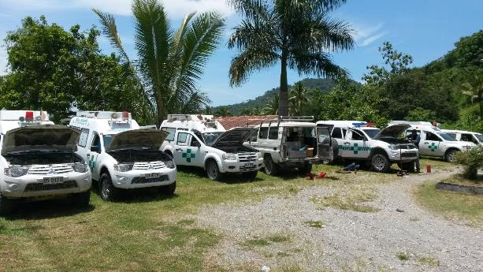

**Annual Report Health Transport 2014**

1. **Executive Summary – Annual Report**

In 2014, the Health Transport Team undertook to repair and stabilize the Ministry of Health’s fleet of Ambulances and Multifunctions. These vehicles are used to transfer patients and also undertake logistical tasks in support of the health service.

When the project first commenced, fleet availability was 56% nationally. A lack of available vehicles resulted in adverse patient outcomes, poor access to health care and criticism from both the community and media.

*By December, every Ambulance location had at least one operational vehicle resulting in 100% coverage. Multifunction availability reached 85%.*

The health transport system is needed to provide access to health care for some of the most vulnerable members of the Timorese community:

1. 32% of all ambulance trips are for Obstetric emergencies (27% Childbirth, 2.75% Haemorrhage, 2.25 Obstetric-other).
2. 4.86% of all calls are for Obstetric emergencies **and** were classified as ‘critical’ (life threatening).
3. 60% of all patients are female.
4. 4.25% of all calls were for domestic violence.
5. There are more critically ill female patients by almost 2:1 transported by the ambulance service:
   * 10.35% of **all** calls were classified as ‘critical’ (life threatening) with a female patient.
   * 5.86% of **all** calls were classified as ‘critical’ (life threatening) with a male patient.

There are a number of potential causes of poor vehicle availability and access to health transport. These include the following:

* + Lack of maintenance capacity within the Ministry of Health.
  + 60% of all maintenance requests originating from the districts are incorrect or incomplete resulting in multiple problems not being addressed.
  + Lack of maintenance capacity in the districts – basic consumables and service facilities are not available in almost all 13 districts.
  + Decentralization of maintenance has been undertaken without creating supporting infrastructure and processes.
  + Inappropriate selection of vehicle and use of poorly modified vehicles.
  + Use of low-quality service / maintenance providers.
  + Lack of basic training for drivers in maintenance and driving techniques.
  + Limited supervision and discipline of drivers who do not maintain their vehicles.
  + Lack of transport options for remote and rural health posts.

The Health Transport project together with counterparts from the Ministry of Health, has taken a practical approach to restore service as rapidly as possible whilst building capacity. The project has been structured with two primary areas of focus:

* **Maintenance:** Build maintenance capacity, address tactical issues and support the Ministry to maintain fleet availability.
* **Clinical:** Develop and deliver clinical training and build capacity to improve the provision of ambulance care to patients.

**Maintenance Program**.

The team responded by using external service providers as well as building two workshops at Ministry of Health locations. The first of these workshops is located in Caicoli and has now serviced or repaired over 67% of all vehicles seen by the project team.

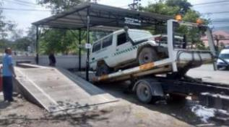

*Ambulance transported to the Caicoli workshops for repair.*

In-house servicing has been performed at 50% of the cost, at a higher quality level than external providers. The two external providers used most frequently, had an average “repair-completeness” of 70%, versus a project average of 85%. Providers currently used by the Ministry were not deemed suitable after an assessment of quality and cost.

In-house servicing has helped enhance awareness of the maintenance process and the need to retain internal expertise to assess and diagnose vehicle faults. The Ministry have now hired two of their own mechanics to supplement the project team.

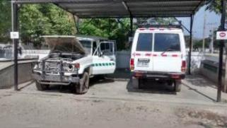

*Example of a refurbished land cruiser (Right, Suai) and a land cruiser that is not viable for repair (Left, Viqueque)*

The following summary from May 2014- February 2015 illustrates the project’s maintenance workload:

* 188 in-house service and repair events. 20% of these have been conducted in the districts.
* 51 vehicle transfers via flat-bed truck from across the country.
* 82 vehicles repaired or serviced by the project team: 55 in-house, 27 at external providers. This represents 60% of the entire multifunction and ambulance fleet.

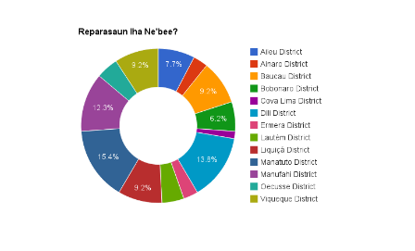

*Repair Location*

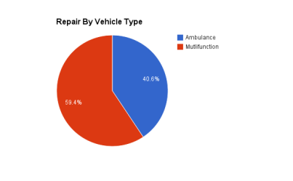

*Repair Type*

The team has also commenced a mobile mechanic service which responds to emergency and routine vehicle faults in the districts. This includes both road-response and the use of MAF where the need is perceived to be urgent. Servicing and maintenance in-situ helps break the cycle of being reliant on moving a vehicle to Dili for repairs and in effect brings the workshop to the districts. Whilst this service is still very tactical, it is hoped that with Ministry support and resources, this program can be embedded and sustained.

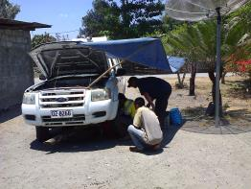

*Mobile Mechanic Team Repairing a multifunction in Manufahi*

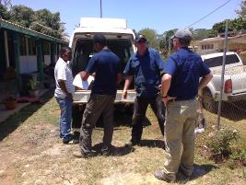

*Assessing a multifunction in Ramaxiu*

*By December, 2014 A total of $200,000 USD has been spent to repair both multifunction and ambulance vehicles. Ambulance availability has increased to* ***100%*** *in all locations. All districts now have at least 1 if not two operational ambulances. A limited pool of reserve ambulances are also now available in Dili to respond to Districts in need.*

*10 troop carriers previously deemed as un-repairable have been restored and returned to service. This was achieved at a cost of $5,000-$10,000 per vehicle versus a quotation of $25,000 per vehicle from an external provider.*

*Multifunction availability at the end of 2014 had reached* ***85%****, although this will vary due to ongoing issues with road conditions, vehicle age and limited supervision and management of drivers.*

A number of vehicles have been deemed as unsuitable for repair. These are predominantly KIA Ambulances which are unsuitable for the road conditions in Timor-Leste. In addition spare parts cannot readily be sourced. The estimated cost of repairing these vehicles is $150,000. A recommendation has been made to the Ministry **not** to undertake restoration of these ambulances.

**Clinical Program.**

The project developed a Ministry approved training program for ambulance personnel. This includes a paramedic certificate program. Training has commenced in Dili and in 2015 will continue to the districts. This course enhances skills in trauma, medical, disaster and emergency child birth.

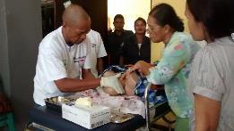

*Emergency Obstetric Training Being Delivered in Association with Ministry of Health Midwives*

Over 300 training hours and approximately $50,000 in associated costs have been provided by partner organizations to help deliver training. This includes Careflight, Australian Catholic University, St. John of God, Hadiak, Ministry of Health, Pacific Partnership 2014 (US, Australia Military) and volunteers from Australian Ambulance Services.

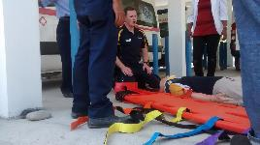

*Trauma Training Delivered by Care Flight Australia*

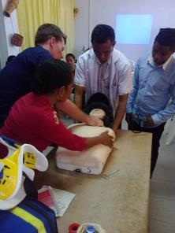

*Trauma Training Delivered for CHC Doctors and Nurses*

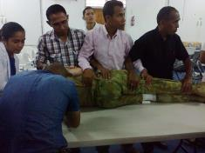

*First Responder training delivered with the Australian and US Military as part of Pacific Partnership*

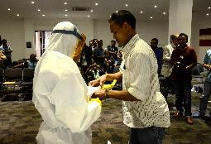

*Ambulance personnel trained by Project Staff demonstrate to the Media in preparation for Ebola*

**Finance**

In 2014, the project spent $426,000 on its activities, with 47% of all funds spent on vehicle repairs. This was against an allocated budget of $438,000. The remaining budget was spent on infrastructure, training and equipment.

In 2015, the project’s focus will begin to shift towards capacity building and sustainability. Overall access to transport is still very limited for many Timorese in rural areas. Whilst efforts will continue to enhance maintenance capacity, the project will also seek opportunities to partner with other NGOs and organizations to look at options to improve transport.

We have received excellent support from our counterparts and are particularly indebted to Dr Horacio Sarmento Da Costa, Fransisco Borges, Dr Nuno V Soares, and Jose Maher. Their enthusiasm and commitment have been inspiring.

**B. Analysis of context and risks in Timor, ongoing relevance of the project for Australia and Timor-Leste Governments**

**Context**

Transport is fundamental to improving access to healthcare for Timorese. The health system is structured between different levels of care from health post to community health clinic to hospital. At each level patients are often delayed due to a lack of transport, inadequate treatment facilities and lack of referral protocols and facilities. These issues impact patient morbidity and mortality:

*“The Timor-Leste Demographic and Health Survey 2009-10 (TLDHS 2009-10) revealed that maternal mortality was estimated at 557 deaths per 100,000 live births[1], one of the highest figures in the world. The main reported causes are postpartum hemorrhage (PPH), accounting for around 40% of the deaths, pre-eclampsia and eclampsia (P/E-E), and other causes such as obstructed labor and sepsis” (Hadiak, 2015).*

The health transport project has been designed to support the Ministry of Health to provide efficient and appropriate transport to patients. The project has a practical, hands-on approach to ensure that investment is maximized and leads to improved fleet availability and maintenance practice. Whilst transport options in many locations remain limited, maintenance and vehicle preparedness is a key cause of lack of transport. Without regular maintenance and care of the fleet, transfers at each level of healthcare cannot be facilitated.

The following list summarizes some of the key issues encountered by the project:

* **Fleet Availability**: When the project commenced, fleet availability overall was 56%. Availability in Liquisa was 25%. In many instances, relatively minor issues were preventing vehicle use.
* **Maintenance Process**: At least 60% of maintenance requests were incomplete or inaccurate resulting in prolonged outages and lack of availability.
* **Fleet Management**: The lack of centralized fleet management has created an overly complex system with several layers of approval before repairs can commence. In a number of the districts fleet management is split between the referral hospital (ambulances) and district health (multifunctions). This creates unnecessary complexity, reduced cooperation and inconsistent maintenance.
* **Vehicle Workload**: A number of vehicles from districts such as Lautem, Bobonaro, Baucau and Viqueque have extremely high workloads with distances travelled in excess of 4000KM per month. These vehicles require monthly maintenance. The facilities and processes did not exist within the ministry to support this.
* **Vehicle Choice**: The Ministry has a mixed fleet of Toyota Landcruisers, Mitsubishi Tritons and Ford Rangers. The Rangers and Tritons are modified in Indonesia to be used as multifunctions and Ambulances. The modified build-quality of these vehicles is poor resulting in multiple faults after relatively limited use (electrics, chassis, locks, windows). In addition the vehicles are often used in locations suited to a more rugged platform such as the Landcruiser.

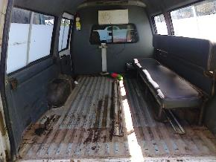

Example of Ford Ranger Multifunction Interior

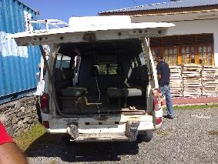

Example of Ford Ranger Multifunction Interior

The table below, using project data illustrates the difference in cost of ownership between the vehicle platforms:

|  |  |  |  |  |  |  |  |  |  |  |  |
| --- | --- | --- | --- | --- | --- | --- | --- | --- | --- | --- | --- |
|  | **1** | **2** | **3** | **4** | **5** | **6** | **7** | **8** | **9** | **10** | **Total Cost of Ownership** |
| **Landcruiser** | 81,000 | 1,000 | 1,000 | 1,000 | 6,000 | 1,000 | 1,000 | 1,000 | 6,000 | 1,000 | **$ 100,000** |
| **Mitsubishi** | 35,000 | 1,000 | 1,000 | 1,000 | 35,000 | 1,000 | 1,000 | 1,000 | 35,000 | 1,000 | **$ 112,000** |
| **Ford Ranger** | 35,500 | 1,500 | 1,500 | 1,500 | 35,500 | 1,500 | 1,500 | 1,500 | 35,500 | 1,500 | **$ 117,000** |
| **Notes** | *Average Maintenance Cost Annually $1,500 for Ranger* | | | | | | |  |  |  |  |
|  | *Average Maintenance Cost Annually $1,000 for Landcruiser and Triton* | | | | | | | |  |  |  |
|  | *Refurbish Landcruiser every 5 years* | | | |  |  |  |  |  |  |  |
|  | *Lifespan of up to 5 years for Tritons and Fords due to poor body build and road conditions* | | | | | | | |  |  |  |

The selection of a more appropriate platform such as the Landcruiser will result in a more reliable, cost-effective fleet.

* **Vehicle Care**: There were no standard processes to conduct vehicle checks or inspections. Relatively minor faults such as dirty air filters have caused significant damage to multifunction’s from Ramaixu, Baucau and Viqueque.

**Challenges**

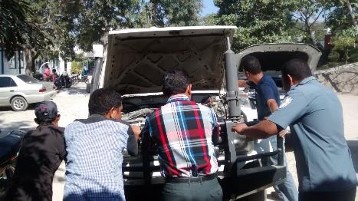

*Push starting a vehicle in Baucau*

The project has encountered a number of challenges in pursuing its objectives;

* **Work Location:** When the project commenced, a work location including desk space was not available. One member worked on a shared desk in the ambulance crew room, whilst the other worked from the LTF’s home. A portable structure with IT, water, electricity and secure storage was rapidly built in the car parking lot of the national ambulance center. This was then followed up with a covered workshop to assess vehicles and a lockable store room.
* **Safety and Health:** An initial audit by the embassy indicated substantive safety issues including lack of running water for hygiene, toilet facilities, chemical and oxygen storage. All of these issues had to be addressed before work could commence. In addition the team has had to undergo sharps awareness training. Clinical waste including sharps are regularly found in vehicles brought in for inspection.
* **Counterparts:** There are a number of stakeholders in health transport including 13 ambulance locations, 13 district logistic managers, a national ambulance directorate and a national logistics directorate. In addition there were numerous executive stakeholders. Building a consensus for action and consulting widely was challenging.
* **Vehicle Location:** Broken down vehicles were found across the country, this often meant driving in difficult conditions and carrying supplies in the back of the work vehicle. Within one week it was not unusual for the team to travel from one end of the country to the other. The team has slept in dormitories, hotels, ambulance stations and directors’ homes.

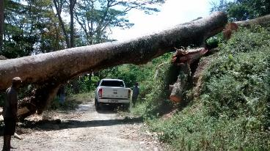

*Traveling to Bazartete*

* **Procurement:** Rapidly responding to multiple vehicle faults has created pressure on procurement to ensure that the project was seen to be active in restoring service. Delays in procurement at times impacted the project’s credibility and ability to function.
* **Theft**: The project has had material and equipment stolen including tools, a laptop and vehicle keys. It is very likely that these thefts occurred with ‘inside knowledge’. The project has responded by continuing to work as normal and is now beginning to see more Ministry staff step forward to openly criticize poor behavior.
* **Driver Attitude:** The staff has encountered both support and hostility. Most drivers have appreciated the support, however we have encountered a lack of cooperation from a small minority. This appears to be related to fraudulent practices related to fuel use and vehicle repair. There is substantial evidence that fuel is misused and also repair requests falsified to inflate the value of repairs. In both instances Ministry staff receive a benefit from fraudulent practices. Project activities have reduced the scope for fraud, and as such has been perceived by some as a hindrance.
* **Performance Management:** Many of the vehicle issues encountered by the project are in part caused by driver error or misuse. An effective management framework has yet to be implemented that actively addresses these issues.

**Successes**

The project has worked collaboratively with the Ministry of Health to directly address some of the key issues impacting vehicle availability. Some of the key successes in 2014 include the following:

* **Fleet Availability**: A dramatic improvement in fleet availability through rapid and mobile response to address vehicle faults.
* **Maintenance Facilities**: Working with the Ministry to build two facilities to conduct inspections, maintenance and repair.
* **Inspection:** Embedding an inspection process that is used by both ambulance and logistics (multifunctions) fleet managers to assess vehicles prior to repair.
* **Training:** The creation of a paramedic training program.
* **Maintenance Capacity:** Recruitment by the ministry of an additional two skilled mechanics.

**Risks**

* **Sustainability:** Whilst the project is building maintenance infrastructure and assisting to maintain the ambulance fleet, there is an inherent risk that the Ministry becomes dependent upon the project to maintain its fleet. The project initially was tasked with resolving and substituting maintenance. The effect of this work has been to restore service but also demonstrate effective maintenance. As of February 2015, there is still a considerable amount of capacity to be built to ensure that service can be maintained. In effect the project is building the infrastructure, the next phase of the project will be to position Ministry of staff with the new resources and build capacity. Some of the steps taken to manage this risk include the following:
  + Most maintenance is done in-house rather than externally. This helps demonstrate good fleet management practices. It has also enabled the project to build capacity by engaging Ministry managers in all aspects of the process including ordering, inspection and problem resolution.
  + ‘Heavy maintenance’ has now been transferred back to the ministry and private providers with the project beginning to move to a consultative model rather than service provision only. The reality of this process though is it will take time to train and build the capacity of our counterparts
  + Defined scope of maintenance engagement to reduce dependency (Appendix A)
  + Handing over the INS maintenance facility directly to the Ministry of Health
  + Seeking Ministry support to procure consumables.
  + Ministry hiring and funding additional maintenance staff directly (two recruited already).
* **Vehicle Selection**: The ongoing selection of cheaper, low-quality vehicles will continue to result in an increased maintenance workload and reduced availability.
* **Discipline and Supervision**: The project is dependent upon the Ministry actively managing its staff and drivers to ensure that vehicles are not damaged deliberately or through neglect. Where issues with performance are identified, the team escalates these for review and action.
* **Project Reputation:** In 2015, the project will hand back “heavy” maintenance to the ministry of health. As this occurs and the project seeks to improve sustainability, it is likely that vehicle availability will decline. Mitigants include the following:
  + Retaining funding and expertise to support capacity building over a prolonged period.
  + Ensuring that maintenance facilities are appropriately equipped.
  + Jointly ordering consumables to maintain a reserve stock.
  + Ensuring the Ministry retains overall responsibility for maintenance.
* **Health and Safety:** Vehicle repair has an inherent risk of injury. Mitigants include the following:
  + All staff are equipped with PPE.
  + All staff attend first aid, health and safety training.
  + Availability of safety equipment at repair locations.
  + Appropriate signage at repair locations.
    1. **Relevance of Project**

The project was initiated as the result of a request from the Ministry of Health to assist in the rehabilitation and maintenance of the health transport fleet.

The project initially had a tactical approach to repair and restore broken down ambulances and multifunctions to fulfill this request. Longer term, the project’s hopes to build maintenance and managerial capacity, as well as improve clinical outcomes for patients through training in first aid and ambulance care. These goals are recognized and endorsed by the Ministry of Health.

The project is very practically oriented and directly embedded within the Ministry of Health. We have established joint relationships built on shared experience and commitment to improving outcomes for patients. Working alongside drivers, managers and patients provides us with the ability to directly support and advocate for changed practice.

The project has significant ongoing relevance for the Australian Government for the following reasons:

* **Value for Money;** Investment is directly targeted at improvements in training and transport availability. The results are tangible and patients benefit almost immediately.
* **Collaborative**; The project requires a close, integrated working relationship with Ministry counterparts. The project is focused not just on repairing vehicles but building maintenance capacity.
* **High Profile**; The repair and maintenance of ambulances is a high-profile initiative that has received recognition within the community and media.



*Media Coverage of the opening of the Australian Aid Program*

* **Capacity Building**; In 2015, the project will be focused on building capacity in both Dili and the districts. We also have a predominantly Timorese team which ensures that we are building skills both inside and outside the project team.
* **Engagement with Australia;** the project has established links with a number of groups from Australia who have provided their expertise at no charge to the project. This includes St John Ambulance WA, Careflight, NCCTRC, Australian Catholic University, St John of God Healthcare, Rotary (WA), and Pacific Partnership. Over 300 hours of training support have been provided by these organizations in 2014 as well as $50,000 in associated travel and administrative charges to support the program’s objectives – this has all been provided at no cost. The project’s objectives have a broad appeal and ensure that Australia’s contribution is multifaceted with opportunities for engagement for appropriately skilled partners.

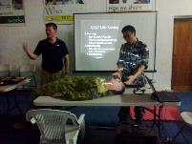

*Training with ADF Officers as part of Pacific Partnership 2014*

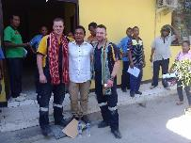

*Training with Careflight Australia*

The project is also relevant for the Government of Timor- Leste:

* **Capacity:** Maintenance capacity within the Ministry of Health is limited and the provision of health transport is considered to be a priority. The project team is able to supplement and build this capacity.
* **Treatment and Access:** Timorese have limited access to healthcare in remote areas. Without a fully comprehensive aerial evacuation service, the community is dependent upon its ambulances being able to reach remote locations.
* **Vulnerability and Need;** Improvements to health transport and ambulance care ultimately lead to improved access for the most vulnerable members of the Timorese Community. Without a more assured transport system, vulnerable patients cannot get timely access to health care and treatment. The project has become a trusted advisor and supporter of the Ministry’s efforts to improve transport services.

**Progress against outcomes defined in the M&E Plan**

The M&E plan was designed to assess tangible improvements in vehicle availability and patient care. The plan is presented in a traffic light format so that it is simple to understand and can readily be shared with stakeholders to identify areas of concern.

Overall, the project is tracking well with all activities progressing to plan. Delays have been experienced in training, but these are being resolved and activities are underway. The team anticipates ongoing district activity including establishing remote maintenance hubs in 2015. The INS site has been opened, but is still awaiting supplies before work commences. It is anticipated that work will commence in May on these sites.

The M&E is presented below with current measures. In following summary comments can be made:

* **Measures 1,2**: In 2014, the project’s primary focus has been on the first two measures which relate to maintenance and vehicle availability. Dramatic improvements have been made for both Ambulances and Multifunctions.

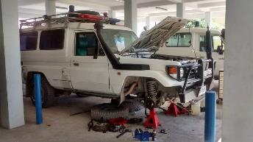

* **Measure 3**: Driver training has yet to commence. A full curriculum has been developed. The project is awaiting commencement dates from Ministry counterparts. In the meantime a plan is being developed to produce a short training film which can be given to district drivers. Drivers have also been included in paramedic training.

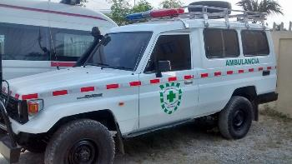

* **Measure 4**: Paramedic training has commenced with workshops held in Trauma, Disaster, Obstetrics and Medical. This program has been sponsored by INS.
* **Measure 5**: Ambulances continue to be overhauled to meet minimum standards. Additional basic equipment is being purchased for ambulance nurses.

|  |  |  |  |  |  |
| --- | --- | --- | --- | --- | --- |
| **Measure** | **Baseline** | **Improvement** | **Ambulance** | **Multifunction** | **Komentariu** |
| Kareta 75% hetan manutensaun regulár iha fulan 3 laren | 10% | ↑75% Ambulance  ↑40% Multifunction | 85% | 50% | Maintenance levels for all vehicles continue to increase. |
| Kareta 90% prontu iha fatin atu responde ba moras | 56% | ↑44% Ambulance  ↑29% Multifunction | 100% | 85% | Ambulance locations are maintaining full coverage. Multifunction availability has continued to increase towards the target of 90%. |
| Kondutor 75% hetan ona treinamentu kona ba sira nia servisu | 0% | ↔ | 0% | 0% | Driver training is now scheduled for February 2015. |
| Enfermeiru 75% hetan ona treinamentu kona ba sira nia servisu | 0% | ↑20% | 20% | N/A | Training curriculum has been submitted to INS. Training has commenced |
| Lokasi 50% tuir estandarte minimu ba ekipamentu | 0% | ↑25% | 25% | N/A | A number of ambulances have been overhauled to meet minimum specifications. Additional equipment including PPE is being ordered to ensure that all locations have minimum equipment. |
|  |  |  |  |  |  |

The project also actively monitors response times for ambulances in Dili. These are an indicator of service performance and efficiency. The project has set a target of 12 minutes. This is relatively aggressive. Generally most calls are responded to within 14 minutes, however these may be extended when Dili is called out to support Liquisa or Manatutu. The use of response times is also a tools to start building capacity with ambulance managers around service planning and strategy.

|  |  |  |  |  |
| --- | --- | --- | --- | --- |
|  |  | **Code 1 Average Response Time** | **Code 2 Average Response Time** |  |
| Sentru Operasaun Responde ba 90% emerjénsia <12 mins | N/A | 14.40 | 12.15 | - Code 1 response times have improved marginally  - Code 2 response times have worsened marginally  - Primary causes for delays include supervision, communications, vehicle location and staffing levels |

The following steps are being taken to improve response times:

* Refurbish a dedicated work environment for telephone operators. The previous area was hot and ill-suited for the task.
* Re-wire telephones to allow for a more reliable in-bound call.
* Use of GPS by phone operators to dispatch the closest vehicle.
* Advocacy to install additional ambulance sites at Tibar and Hera
* Installation of a radio network together with the Ministry to improve dispatch.
  + 1. **Adequacy of output delivery and quality of implementation approach**

**Implementation Approach**

The project has established itself within the Ministry of Health working alongside Ministry counterparts. The team has focused on being fully engaged, on-site and sharing the difficulties of providing transport services. This has meant frequent travel and often working in difficult and uncomfortable locations.

The team works out of a converted 20ft container based at the Ambulance station in the parking lot, next to the workshop we have built. This approach enables us to engage with drivers, managers and nurses on a daily basis and ensure that we are integrated into operations. All of our training, manuals, work practices, presentations and engagement is in Tetun and predominantly using Timorese technicians. We are in essence trying to create an Australian-funded, Timorese solution to the issues we face.

The style of the project is hands-on and focused on practical outcomes rather than abstract recommendations. The project has tried to build capacity by demonstrating and doing rather than by advising alone.

The effect of this implementation approach has been to enable the project to directly intervene with our counterparts to help resolve critical issues.

**Quality**

Quality of project outputs has been maintained throughout, with the following measures taken:

* **Consultant Mechanic**: Recruit a consultant mechanic to assess repair procedures and provide oversight of maintenance standards.
* **Inspection Process**: Development of an inspection process to assess vehicle status and associated faults. Ensure that issues are identified, recorded and addressed.
* **External Providers**: All external providers were assessed against standard criteria prior to selection.
* **Process Improvement**: Where process errors are identified, these are addressed within the project team to ensure safety standards are maintained and repairs are conducted to a high standard.
* **Repair Quality**: Assessment of repaired vehicles to ensure that quality standards are met for vehicles repaired in-house as well as externally. The following chart summarizes the cost and quality performance of in-house and external repair facilities. The chart compares cost against a comparable set of repair items and the completeness of repairs against pre-specified faults. As can be seen, the use of in-house facilities for repair and maintenance has resulted in improved quality and reduced cost
* **Training Quality**: All training has been submitted for endorsement by INS and has been given under INS supervision. Only qualified partners are engaged to provide training support.
  + 1. **Progress against activity plan and budget**

**Activity Plan**

The project’s activity plan is based on three strategic areas; Training, Maintenance and Management. Within each of these areas three priorities have been defined. The plan is presented below and color coded based on progress

* **Green**: Activities are proceeding as planned.
* **Amber**: Activities are proceeding as planned, but delayed.
* **Red**: Activities are significantly delayed.

|  |  |  |  |  |
| --- | --- | --- | --- | --- |
| **ELEMENTU ESTRATÉJIKU** | **PRIORIDADE 1** | **PRIORIDADE 2** | **PRIORIDADE 3** | **Komentáriu** |
| **Treinamentu / Kompetensia** | Kursu Kondutor  Kursu Enfermeiru | Monitorizasaun ba kondutor no enfermeiru sira | SOP | * Dezenvolve Kursu baziku ba kondutor no enfermeiru sira. * Implementa sistema monitorisasaun (cek liste, surat pasiente). * Suporta MS atu implementa SOP ambulánsia. |
| **Manutensaun / Ekipamentu** | Hadia kareta nebé’e a,at ona too estandarte minimu | Mobile Mekanik | Dezenvolve Estandarte Minimu ba transporte Ambulansia / Saùde | * Suporta MS atu hadia kareta nebé’e aat ona. * Dezenvolve no implementa sistema mobile mekanik * Suporta MS implementa estandarte minimu ba manutensaun / ekipamentu |
| **Jestaun** | Sistema Informatika (Kareta) | Prepara proposta atu implementa sentru operasaun | Kapasita xefi sira atu maneja servisu ambulancia | * Halo dezeñu no implementa sistema informatika atu maneija kareta sira. * Prepara proposta kona ba sentru operasaun * Halo avaluasaun kona ba sistema transporte saùde nian. * Suporta xefi sira atu maneja rekursos ambulancia. |

* **Training:** Training activities are underway and course material has been developed. Courses have been delivered for nurses and drivers in Dili, largely around clinical skills. SOPs have been produced and submitted, however there has to date been limited ability to implement these. The project will continue to advocate for ambulance SOPs
* **Maintenance:** Maintenance activities continue as planned. Heavy maintenance or vehicle restoration is now largely completed, and the team is now seeking to deliver a regular maintenance service. The ministry has commenced handing activities back to its suppliers under project supervision.
* **Management:** Activities in support of managerial capacity continue. A simple Ambulance operations room has been built and training will commence shortly for operators and shift managers.

**Budget Commentary**

The project undertook its activities within the budget allocated to it. In 2014, there was a forecast savings of $11,000 against an overall project budget of $438,000 (*although this may be reduced as a result of the effect of the decline in the value of the $AUD*).

*Budget vs Actual Spend to Date*

The two charts below indicate the breakdown of the project budget by functional area. In 2014, the focus was overwhelmingly towards tactical maintenance and the establishment of basic infrastructure. This equaled 47% of all funds spent.

In 2015, the focus of the project will shift towards capacity building activities, in particular training and support. The project will also reduce the use of third party facilities to conduct heavy maintenance and hand this back to the ministry.

*The emphasis of project finances on training activities appears somewhat reduced with an uplift of 1% shown only. The project predominantly uses partners to support training. This is almost exclusively provided at no cost to the project or the Ministry*.

* + 1. **Adequacy of management systems for the project – including procurement, financial systems, human resources/performance management, governance, planning, and M&E**
* **Procurement;** The project set an aggressive time frame to respond to the Ministry’s need to restore its fleet to operational order. This resulted in 82 vehicles being serviced and repaired within 6 months. 110 “call-offs” were generated in addition to direct petty cash expenditure. Procurement was often complex and involved both on-shore and off-shore providers. This placed significant stress on procurement systems:
  + **Low Value Procurement;** the ability to process the volume of low value work.
  + **Procurement Facilities;** the creation of supply arrangements with key suppliers to better manage cash flow and ensure timely procurement.
  + **Capacity;** awareness of the local market place and ability to undertake support services.

The project encountered substantial difficulties using the procurement facilities provided by PLSF. A number of activities were placed at risk as a result of a number of issues. A file note was submitted to the embassy and is provided as an attachment in Appendix B.

The transition to a single point of contact within PLSF has improved procurement. This combined with a reduced procurement workload in 2015 should alleviate pressure on project activities.

* **Financial Systems**; The project uses financial systems provided by PLSF for reimbursement and tracking. Reimbursements are prepared and submitted based on budget line. The project administration officer maintains responsibility for financial data entry and also scanning of all receipts. All original receipts are kept for audit and review. The project has required the use of a $7,000 petty cash float to maintain activities. The use of petty cash has been reduced by reverting to an account system with two approved suppliers. This facility uses a purchase order system that can only be authorized by the LTF.

To ensure activities are tracked and managed, the project maintains a detailed budget that is divided by activity areas. Where an activity is commenced (e.g. Mobile Mechanic), a business case is submitted to the project sponsor for review and authorization prior to implementation.

* **Human Resources / Performance Management**; The project has outsourced human resource functions to a third party. All 4 project staff are provided as labor-hire. This ensures that all requirements under the Timorese labor code are met including contract, working hours, health and safety, annual / sick leave, 3rd party liability insurance, death and disability insurance and payroll. This reduces the administrative workload for the LTF and is provided at a total cost to the project of $2,700 per annum.

All project staff have received training in First Aid and Occupational Health and Safety. There have been no work place accidents and no lost time as a result of injury.

There has only been one staff member leave the project and this was at the commencement of the project due to misconduct. The staff member was dismissed within their probationary period following the provisions of the Timorese labor code.

Project staff benefits include salary, communications / transport allowance, sick / annual leave, uniform / PPE and professional development. To ensure that appropriately skilled mechanic staff are retained their salary, is on average within the top tenth percentile for similar positions.

The project has head-count to recruit one additional mechanic and anticipates completing this in March. It is hoped that additional recruitment of mechanical staff will be completed by the Ministry of Health. These staff members will be recruited on private contracts. Where possible the project will offer basic training and support to ensure that Ministry contracted staff are able to work safely.

* **Governance**

The project has undertaken the following steps to ensure that activities are controlled:

* **Project and Budget Planning**: A detailed project and budget plan is maintained that defines all activities. This is available for review. Activities within the plan are commenced only upon acceptance of a business case by the project sponsor.
* **Quality**: Repair quality is maintained by the review of repaired vehicles by a senior mechanic.
* **Data**: Data is maintained to record vehicle inspections and repairs.
* **Business Case**: All activities are captured in a business case.
  + 1. **Summary of lessons for the year**

Key lessons for the project include the following:

1. **Impact of Drivers;** The impact of drivers on vehicle availability is significant. This includes driving technique and willingness to maintain their own vehicle. At least 50% of all vehicles inspected by the project team do not meet minimum standards for cleanliness and hygiene. Drivers are rarely disciplined for vehicle misuse or not maintaining a vehicle in good working order.
2. **Administrative Complexity;** Decentralization and the separation of ambulance and multifunction’s into different directorates creates a complicated structure with shared and diluted accountability. Districts are nominally responsible for their own multifunction fleet, but may also exert managerial control over the ambulance service. Instead of having one structure to build capacity, there are effectively thirteen, each with their own issues and personalities. The system of ‘pedido’ and maintenance request processing is complex and non-responsive.
3. **Decentralization;** Decentralisation of ambulance and multifunction maintenance is not effective. At least 60% of all maintenance requests originating from the districts are incorrect and routine maintenance is not undertaken for at least 50% of the total fleet. To maintain an emergency transport service, control has to be centralized for basic functions including operations, supply and vehicle maintenance. Once this is in place, regional service hubs can support individual districts. *In all of the districts, except Dili, basic consumables including filters and oils are not available for purchase*. Until local options are available, maintenance has to be managed from Dili:
   1. In Los Palos a local Bengkel using unskilled mechanics and incorrect parts caused over $5,000 in damage and a vehicle outage of 4 months.
   2. At least 4 vehicles have required differential replacements at a cost of $18,000 due to incorrect oil being used.
4. **Capacity;** Fleet management and maintenance capacity within the ministry are being developed. Both Jose Maher and Franscisco Borges are skilled and effective. The addition of resources and rapid decision making has empowered them and enabled a more ready response to critical issues.
5. **Maintenance Quality and Cost;** The project has clearly demonstrated that maintenance cost is dramatically reduced and quality improved when maintenance is conducted in-house. The use of external low-cost providers by the Ministry has resulted in vehicle outages and has worsened outcomes. This includes the replacement of 4 rear multifunction differentials at a cost of USD $18,000 due to the use of cheaper non-standard differential oil by a Ministry-contracted supplier.
6. **Ambulance Coverage;** The separation of ambulance and multifunctions has created a less responsive emergency service. The functions need to be integrated and brought into a single directorate. This will provide coordination and central management of resources, standards and response. In addition ambulance locations need to be expanded to provide more regional coverage. For example
   1. In Emera, there is only one ambulance location in Gleno. Additional coverage is required for other centres including Letefoho.
   2. In Dili there is no ambulance coverage in areas with significant ambulance callouts. At least 30% of calls in Dili are in areas in excess of 20 minutes drive from the Dili Centre. This includes Dare, Hera, Metinario and Tibar.

**Appendix A: Service Scope Maintenance** 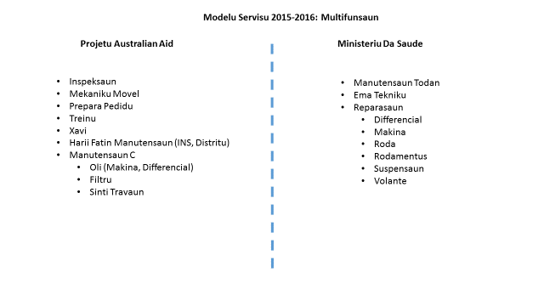 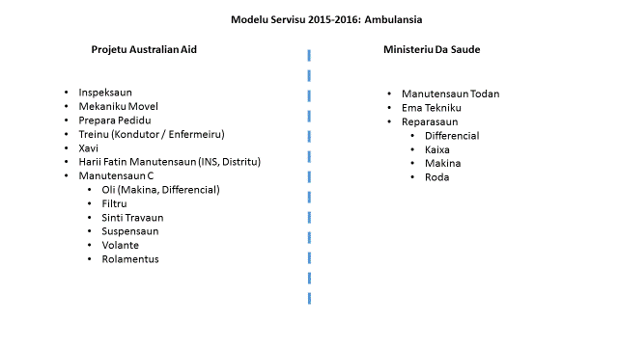

**Appendix B: Charles Kendall File Note**

**Program Requirements**

* Up to 25 call off’s issued per month
* Responsive service required to maintain ambulance availability.
* Sourcing of parts onshore and offshore
* 2 sites being built with contract values up to $50,000

**Project Issues**

* Delays in transferring funds
  + $8,000 of reimbursements submitted on November 4th, as of November 14th, no transfer received.
* Delay in procurement of items;
  + 3 months to ship an Ambulance from Perth. Initial PO and purchase failed. Limited contract follow up and management. Required intervention and escalation to resolve.
  + 4 weeks to order $1500 of parts and tools from Premier Hardware in Dili
  + 6 weeks to order $5000 of parts and tools from Repco
  + Mitsubishi differential call off created 16/10/14. No follow up with supplier. 11/11/14 contacted supplier ourselves to inquire status. Delay of at least a month to repair a car.
* Inability to procure;
  + Unable to procure $1500 of PPE from Protector Alsafe in Australia – referred to LTF to procure himself
  + Unable to procure $1500 of Sheds from Cheap Sheds in Australia - referred to LTF to procure himself
  + London based funds transfer system does not reflect local payment requirements, delays in reimbursements
  + Lack of credit card facility or similar to complete payments
  + RFQ issued to procure a vehicle – no follow up of bid responses, only 2 respondees, 2 unaware of RFQ (Toyota and Dragon)
* Lack of staff awareness of procurement procedures and capacity
  + Unaware of shipping procedures to import material to Timor Leste
  + Variable quoting requirements including variance in obtaining 3 quotes for projects over $5000
* IT
  + LTF suggested procurement of project IT offshore via Dell – two laptops in country for $1,800. CK stated procurement had to be done locally – completed at approx. $5,000 (an additional cost of $3200).
* Resourcing
  + Unable to maintain procurement capacity to match project schedule – November 2 procurement specialists on leave and 1 procurement assistant with no backfill. Reduced resourcing at critical phase of project
* Development Awareness
  + Lack of awareness and integration with development objectives.
  + Lack of alignment to project imperatives.
  + “Obstructive” behavior
  + Lack of integration between parties within CK to share information regarding project objectives

**General Comments**

Over 4 months, I have tried to work within the CK procurement system. This includes various meetings to align project objectives to procurement realities. During that time I have found the CK system to be unresponsive, inflexible, over administered and delayed.

Procurement is prolonged and in many instances I am required to complete significant purchases myself. I have found the attitude of some staff uncooperative and a general lack of capacity regarding logistics and the Timor environment. They have not retained staff with a developed understanding of the market place and commercial realities.

Significant delays in the procurement of basic items has placed my program at risk and reduced our ability to respond to the Ministry of Health’s requirements. This in turn has directly affected the credibility of the program and its ability to function. I see CK as a significant risk to the delivery of my project objectives.

1. Ministry of Finance, Democratic Republic of Timor-Leste. 2010. Demographic and Health Survey 2009-10 (TLDHS 2009-10).