Sustaining water
Module length: 4 × 60 minutes

Summary
In this cross-curricular module, students explore water challenges faced by communities in the Indo-Pacific region, and learn how Australia and its regional partners are working together to find sustainable solutions through innovation and collaboration.
Students begin by considering the importance of water in Australia and analysing ‘water stories’ to build their understanding of the importance of reliable access to safe water. Through this, students expand their geographical vocabulary and develop an understanding of water as a precious natural resource that can be managed. Next, students engage in hands-on activities to deepen their understanding of water challenges in the Indo-Pacific and the effects of these challenges on Indo-Pacific communities, with a focus on health impacts. They then explore some of the science behind Australian Government–funded technological interventions that are helping communities develop and manage their water resources in innovative and sustainable ways. Finally, students apply their learning to the water challenges identified in the water stories.
In addition to deepening students’ knowledge of water as a valuable resource, the module supports students’ development as active and informed global citizens who understand how Indo-Pacific communities and the Australian Government are working collaboratively to solve shared water challenges. Students learn to consider local and regional needs, analyse challenges and evaluate the potential of technical solutions. In doing so, they practise the skills of empathy, critical thinking and problem-solving.

Success criteria
At the end of this module, students should be able to:
- discuss water resources using age-appropriate geographical and scientific terms
- describe a water challenge in the Indo-Pacific and analyse its effect or effects on communities
- explain a link between a water challenge and a technological solution.

Organising ideas
The organising ideas are global relationships, global responsibilities and global futures. These reflect the Australian Government’s aims to build genuine partnerships to jointly tackle global challenges, protect international rules, promote Australia’s international interests, and sustain a peaceful and prosperous future to keep our region stable.
© Department of Foreign Affairs and Trade

Prior knowledge
i
n
e
r
a
p
e
/
s
m
- Geography: the countries of the Indo-Pacific region and their climates; the importance of water to the environment and to sustaining the lives of people and animals.
It would be useful if Lesson 1 of the unit ‘Our Indo-Pacific community’ is taught or revisited before this module as it serves to build students’ knowledge of the region.
- Science: if the water cycle has been covered, this knowledge can be reviewed and used to strengthen students’ understanding of water as a resource and the science behind water interventions.

Key terminology

disease/germs
hygiene
prevention
reliable
sea water
surface water
sustainable
underground water
water management
water resources
water storage
water treatment

Further resources
Teacher background information on water challenges and related partnership programs:
- UN Water – Water scarcity
- Water for Women Fund
- Australia’s assistance for water
Videos highlighting local programs: Beyond Awesome videos provide contextual information for teachers and should be reviewed for student suitability:
- Kiribati WASH in Schools
- Philippines WASH in Schools
- Beyond Awesome (iView login required)
Student resources to support students’ understanding of water. Log in to Scootle and search by code:
- Are we living sustainably? Year 4 Science – Waterwise QLD (A003816)
- The water cycle for kids – US Geological Survey (M013846)
- The water cycle – ABC Education (A008858)
- Global water crisis – ABC Education (A008893)
- Australian Water Association curriculum toolkit (A009213)

Picture books to support students’ understanding of the social and spiritual importance of water in Australia and the Pacific Islands:
- Balla, T. (2014). Rivertime. Allen and Unwin.
- Casey, P. (2016). My ocean home Fiji. Kindle Publishing.
- Chapman, R. (2020). Bila’s big dance. Boolarong Press.
- MacGregor, J. (2012–2020). Children of the Pacific [series]. Puriri Paddocks.
- Murphy, J. and Kelly, A. (2019). Wilam: A Birrarung story (L. Kennedy, Illus.). Walker Books Australia.
- Webber, B. (2017). Big fella rain. Magabala Books.

Curriculum links
The table below lists the Knowledge and understanding content descriptions explicitly addressed in this cross-curriculum module, which connects Geography, Science and Health, and prioritises STEM skills and dispositions. The module also offers entry points for prolonged engagement with key concepts of these curricula – for example, further exploration of the relationship between climate, environmental features (Geography) or the water cycle (Science). Potential connections with other curriculum areas are noted throughout.

Geography
Year 3: the similarities and differences between places in Australia and neighbouring countries in terms of their natural, managed and constructed features AC9HS3K05
Year 4: the importance of environments, including natural vegetation and water sources, to people and animals in Australia and on another continent AC9HS4K05
Year 4: sustainable use and management of renewable and non-renewable resources, including the custodial responsibility First Nations Australians have for Country/Place AC9HS4K06

HASS skills
Years 3 and 4: analyse information and data, and identify perspectives AC9HS3S04 AC9HS4S04
Years 3 and 4: propose actions or responses to an issue or challenge that consider possible effects of actions AC9HS3S06 AC9HS4S06
Years 3 and 4: present descriptions and explanations, using ideas from sources and relevant subject-specific terms AC9HS3S07 AC9HS4S07

Science
Year 4: identify sources of water and describe key processes in the water cycle, including movement of water through the sky, landscape and ocean; precipitation; evaporation; and condensation AC9S4U02
Year 3: follow procedures to make and record observations, including making formal measurements using familiar scaled instruments and using digital tools as appropriate AC9S3I03 AC9S3I04
Years 3 and 4: consider how people use scientific explanations to meet a need or solve a problem AC9S3H02 AC9S4H02

HPE
Years 3 and 4: investigate and apply behaviours that contribute to their own and others’ health, safety, relationships and wellbeing AC9HP4P10

General capabilities
Creative and Critical Thinking: The module guides students to interpret concepts and problems, draw conclusions, and evaluate how solutions contribute to resilient and sustainable systems. It also encourages students to imagine possibilities and consider alternatives.
Literacy: The module places emphasis on introducing students to new vocabulary to support their development of geographical and scientific knowledge of water as a resource that can be managed (collected, stored, treated and transported).
Intercultural Understanding: Over the module, students will need to consider unfamiliar cultural contexts and describe the similarities and differences between communities within the Indo-Pacific.

Cross-curriculum priorities
Asia and Australia’s Engagement with Asia: Students will explore the Australian Government’s development programs that involve partners in the Indo-Pacific region.
Sustainability: Students will assess how partnerships and resources can build sustainable water systems that communities can maintain and adapt over time. These help make communities resilient to drought, floods and changing environments.

Water as a valuable resource
Learning intentions | Materials
- To think about why water is important in Australia and other Indo-Pacific countries.  - To learn how water resources are managed. | - PowerPoint: Sustaining water (slides 4–17)  - Water stories hand-out  - Worksheet: Analysing water needs  - Mini-whiteboards and markers

Introduction (15 min)
- Share the module learning intentions on slide 2 and explain the module’s focus, which is exploring water challenges and solutions in the Indo-Pacific region. Then, share the lesson’s learning intentions on slide 5.
- Begin by asking ‘Why is water important?’ and record responses. Introduce the term ‘resource’ in relation to water – a resource is ‘something we use’ and we use water for …
The concept of water as a resource can be extended by a discussion of the social and/or spiritual importance of water and the need to care for it. Picture books to support this can be found in the ‘Further resources’ section.
- Organise students into small groups and ask them to create three columns on a mini whiteboard with the headings ‘How?’ ‘Why?’ ‘Where?’ Brainstorm responses to the following questions:
- How do we use water in our own daily lives? For example, to wash ourselves.
- Why? For example, to stay clean and healthy.
- Where does this water come from? For example, a shower.
- Share and discuss responses. It is likely that ‘from a tap’ will be a common response to the third question. Ask students if they know where the water in our taps comes from.
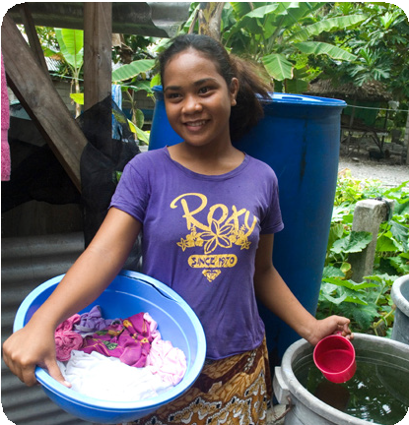
© Department of Foreign Affairs and Trade

Guided instruction (10 min)
The purpose of this activity is to develop students’ understanding of water resources – where they come from, how they are managed, and why it is important they are clean and safe. This provides the basis for understanding some of the water challenges of the Indo-Pacific region and envisioning solutions in the lessons that follow. It may be helpful to revisit the content over the module to help students embed the concepts.
- Tell students that there are three main groups of water sources and that you will give them some clues to guess each group. Share slides 6 to 8 from the Sustaining water PowerPoint and elicit/direct responses. The sources are surface/fresh water, sea water and water found underground. Further information about the water types can be found in the notes sections of the slides.
- Share slide 9 and ask students to identify each of the three sources. If the water cycle has been covered previously, slide 10 can be used to link the water cycle to the sources.
- Explain that in Australia most tap water is surface water, and ask students if they can predict why. Answers may include that it is fresh (not salty) so we can drink it and wash with it, and it is easier to access than underground water because it can be collected from rain and rivers.
- Use slide 11 to begin developing a shared vocabulary of water technologies for storage and transportation.
- Ask if students can see any problems with relying on surface (rain) water. Students might identify local droughts or areas where there is little rainfall and therefore fewer and more unreliable lakes and rivers. They might also raise issues of pollution and water quality.
- Share slide 12 and ask students what the images tells us about the water that we use. Lead students to understand that to make sure our tap water is safe, it gets treated before we use it. Pretending to offer a glass of dirty water to a student would stimulate a good discussion of the need for treatment. This Waterwise video can also be used to explain the cleaning process.

Guided learning (25 min)
This activity uses 15 ‘water stories’ to help students explore the different ways children from the Indo-Pacific region experience water resources. Each story includes a localised positive and negative experience of water and creates an opportunity for thinking about a change.
- Explain that in Australia, most of us turn on a tap and get clean and safe water. Our water supply is generally safe and reliable – as a country, we have the money, materials and skills needed to build and maintain water storage, treatment and transport facilities that are strong and long lasting. These allow us to collect and protect our water resources. Explain that this is not always the case in other Indo-Pacific countries, particularly in poorer countries and rural areas. It may be helpful to draw parallels with rural locations in Australia where water supplies can also be less reliable and more impacted by climate events such as drought and flood.
- If needed, share the map on slide 13 to remind students of the countries in the Indo-Pacific region. Then, share the images on slides 14–17 to introduce students to different experiences of water, and to extend their vocabulary of water technologies.
It is important that both positives and negatives are covered when discussing the images. For example, well (underground) water is a good source of water in places with unreliable rainfall, but shared water means community members do not have an immediate supply.

- Hand out the Indo-Pacific water stories. Model analysing the Australian story that highlights a rural challenge, paying particular attention to articulating a 'wonder' that builds on from the story. For example, I wonder if they could build a bigger dam.
- Hand out the ‘Analysing water’ worksheets and ask students to fill out the relevant information from the story and illustrate an aspect.
- When finished, ask students to find another student with the same story and have them compare illustrations and water wonders. Alternatively, students could develop an Australian story that highlights another area and different experiences of water – for example, a child living in Darwin, Perth or Tasmania.

Learning review (10 min)
- Share the water stories and ‘wonders’ as a class. Discuss which wonders are shared across countries and which are not ones we tend to think of in Australia. The point of the activity is to reinforce our common dependence on water, but also to identify challenges students may not have considered before. Save the worksheets and water stories as they will be returned to in later lessons.

Analysing water needs
- Read your water story. Write the key information below and add a water ‘wonder’ for the person.
My name is
and I live in
I love

However,

I wonder if

- Draw a picture to illustrate part of the story.
.

Why do we need safe and clean water for our health?
Learning intentions | Materials
- To learn about health challenges caused by unsafe or unreliable water resources.  - To think about who is most affected by limited access to clean water and why. | - PowerPoint: Sustaining water (slides 18–21)  - Hand sanitiser, hand soap, paper towels, water spray bottle, water, jug and bucket  - Vegetable or baby oil, hundreds and thousands (or equivalent)  - Water stories hand-out

Introduction (5 min)
- Share the learning intentions (slide 19) with students and ask them if they have experienced times when clean and safe water was not available. Students might identify water restrictions during periods of drought or times when the water supply was turned off temporarily. Discuss how this affected them and their family.
- Explain that in Australia schools are not allowed to open if teachers and students cannot access safe and clean water. Ask students to predict why. While some students might find the idea of school closures appealing, draw out the academic and social implications of an interrupted education.
- Explain that in some Indo-Pacific countries, particularly in rural areas, it can be a challenge for schools to make sure their students have reliable access to safe and clean water. Ask students to think about their water stories from the previous lesson and suggest reasons for this. Answers may include lack of rainwater, problems with pipes and taps, shared facilities making it difficult to access water on demand.

Guided learning (30 min)
This section of the lesson uses two simple activities to explore a common health challenge associated with unreliable access to clean, safe water: the inability to wash hands safely. The activities could be run either as a group task or a class demonstration. It is important that all health protocols are modelled and followed carefully.
- Share slide 20. Ask why the students in the image might be excited about washing their hands.
- Ask students to privately rate and record the importance of handwashing from 0 (not important at all) to 5 (very important). Call on volunteers for reasons why handwashing is important. ‘To kill germs’ is a likely response.
- Ask students to ‘think, pair, share’ a definition of germs and create a shared one. For example, germs are living things that are too small to see with our eyes. They can get into our bodies and make us sick. Ask students what they know about how germs spread. If needed, explain that sneezing, coughing and touching are the most common pathways. Share slide 21 and ask students to name the diseases they think could be spread through these pathways. Are they surprised these diseases could be spread this way?

Patient zero experiment
- Have students thoroughly wash and dry their hands and ensure they do not touch anything after they have done so. Organise students into circles of 5 or 6. Ask each group to choose one of the diseases to ‘model’ and select a student in each group to be ‘patient zero’ (the first infected with the disease’s germs).
- Spray patient zero’s hand with water and ask them to shake hands with the next person in the circle. Students continue to shake hands around the circle, counting each handshake until they no longer feel any dampness. Ensure students wash and dry their hands thoroughly afterwards.
- Discuss the results. Were the students surprised at how long the dampness could be felt and therefore how many of the disease’s germs might have been passed on?
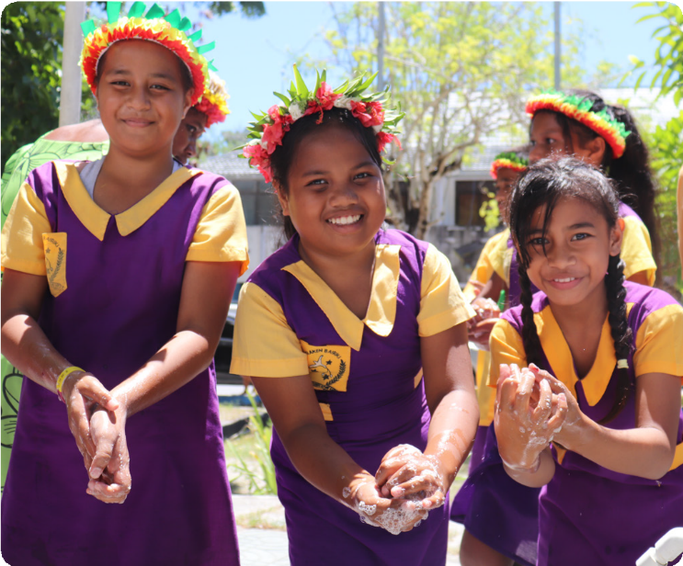
© UNICEF / Department of Foreign Affairs and Trade, CC BY

Hand-washing experiment
- Explain that all the diseases on slide 21 can be prevented or have the risk of their transmission reduced by thorough handwashing. Ask three volunteers to help you show this. Direct each volunteer to wash and dry their hands. Smear one of their hands with some oil and then sprinkle the hand with hundreds and thousands or an equivalent (for example, sand or confetti) to represent the germs.
- Explain to the class the three different strategies that each volunteer will use, and ask them to predict whose hands will be cleanest:
- Volunteer 1 – ‘dip and go’ (volunteer quickly dips their hand into a bucket of water, shakes it dry, and then pats it once or a twice with a towel when reminded).
- Volunteer 2 – ‘sanitise’ (volunteer uses hand sanitiser).
- Volunteer 3 – ‘run water and scrub’ (volunteer washes their hand with soap and running water for at least 20 seconds, including between fingers and backs of hands, and dries them carefully with paper towel).
As a class, watch as each student cleans their hands and assess the results. Alternatively, you could time students to see how long it takes to be ‘germ free’ using the assigned method.
- Ask students to revisit the number they assigned to the importance of handwashing and to write down their new number. These could be stored to provide data for a maths graphing lesson at a later date. Ask for volunteers to explain any changed rankings.

Learning review and extension (15 min)
- Ask students to revisit their water stories and identify other examples where a lack of access to clean and safe water causes similar health challenges, both in and outside of schools. Answers may include skin infections due to polluted water, dehydration due to thirst, danger of disease from unflushed toilets or polluted rivers.
- Discus and make a list of groups most at risk or challenged by a lack of easy access to clean, safe water. The water stories highlight pregnant women, babies, older people and people with disabilities and can be used to highlight issues of exclusion and inclusion. They also draw attention to the crucial role women play in collecting and using water for household tasks. For each group, ask students to predict why these groups are at risk or challenged by lack of easy access to clean, safe water, drawing attention to both health dangers and labour challenges. Explain to students that in the next lesson they will be looking at ways the Australian Government works in partnership with Indo-Pacific communities to develop solutions to these challenges.
- To close, re-share slide 20 and ask students to imagine what one or more of the students might be saying about handwashing. Getting students to role-play or write responses on a sticky note offers an opportunity for informal assessment.
Students could explore other problems associated with a lack of water at schools.
For example, students may have to bring in all their water for the day as the water taps ‘don’t work’. This raises issues around access to water and learning disruption.

Introducing partnership projects and their solutions for water challenges
Learning intentions | Materials
- To find out how Australians work in partnerships with Indo-Pacific communities to create reliable and sustainable solutions to water challenges.  - To understand how water cleaning technologies work. | - PowerPoint: Sustaining water (slides 22–29)  - Worksheet: Treating water using the sun  - Worksheet (optional): Filtering water  - Equipment outlined in worksheets

Introduction (5 min)
- Share the first learning intention on slide 23, checking that students understand the meaning of reliable and sustainable (long lasting and adaptable). Explain that the Australian Government is working with local partners to help improve access to reliable, clean and safe water for drinking, washing, cleaning and going to the toilet – now and in the future.
- Share the second learning intention. Explain that in this lesson students will be learning about some of the water cleaning technologies used in these solutions to water challenges. These reflect real technologies co-designed and adapted with local partners through regional development cooperation and partnership programs, such as Water for Women.
Water for Women was delivered over seven years from 2018 to 2024 in 16 Asia-Pacific countries and supported over 4.4 million people. The projects in the program depend on technology, community involvement, local maintenance and planning for changing conditions – all features of reliable and sustainable systems. You might share and discuss this Water for Women video with students.
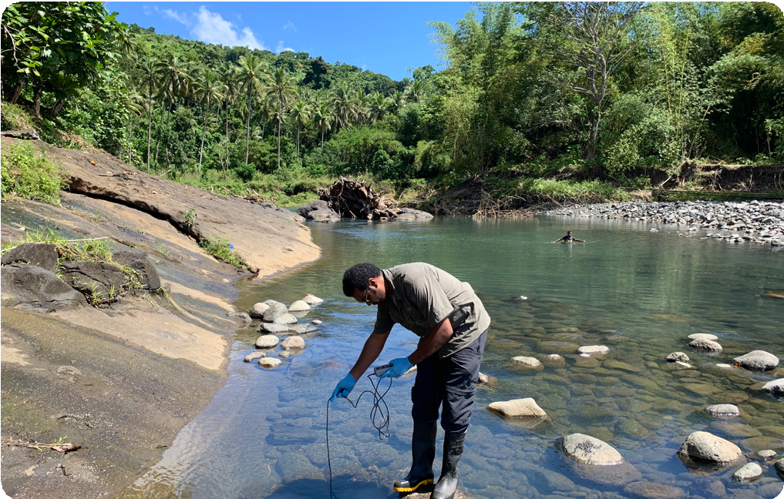
© University of Sydney and WISH Fiji.

Concept revision and partnership project application (10 min)
- Revisit the water vocabulary from Lesson 1:
- Water resource: surface water (river, lake, creek, stream, rain), underground water (spring, basin), sea water (ocean, sea)
- Water storage: rainwater tank, well, bore, dam, reservoir, catchment
- Water transport: pipe, gutter, pump, bucket, tap
- Water treatment: clean, filter, treat, disinfect
- Share animated slides 24–29 in the Sustaining water PowerPoint. Discuss the local projects, modelling the use of water vocabulary and pausing before clicking to reveal so students can predict the solutions and results.

Guided inquiry (40 min)
This inquiry uses a simple water distillation experiment to illustrate how one of the water solutions being mobilised in the partnerships projects works – that is, how the sun can be used to clean and/or desalinate water. The experiment can be run as a whole-class demonstration or in groups or pairs. Note that the results of the experiment will take a few hours, depending on weather conditions and the positioning of the tub. A second water filtering experiment, using the Filtering water worksheet, could also be run, depending on time and resources.
- Explain that water treatment is often an essential part of water solutions. Revisit slides 24–29 in the Sustaining water PowerPoint and ask students which of the projects involved water cleaning (slides 25 and 28). Explain that they will be learning how the sun can be used to treat water, as achieved by the community in Fiji.
- Use the Treating water using the sun worksheet to step through the process with students. Then undertake the experiments in the chosen form (whole group, small group or pairs).

Learning review (10 min)
- When the experiment has been completed, discuss the results with students. A suggested explanation is:
- the sun heats up the water, which starts to evaporate – it turns into steam / water vapour
- the steam rises and touches the cling wrap, leaving the salt or colour behind
- when the steam cools down, it condenses – it turns back into tiny drops of clean water
- drops of clean water slide down into the small container
If the water filtering experiment is conducted, a suggested explanation of the process is:
- the layers act like a team of cleaners
- they filter the water by first removing the big things such as leaves and rubbish and then dirt and tiny bugs.
- Reiterate that Indo-Pacific communities are working in partnerships with Australian universities and other organisations to solve challenges using science, technology, innovation and cooperation. Explain that to make sure they come up with useful long-lasting solutions, communities have formed working groups to think through their solutions. In the next lesson, students will revisit their water stories and work in groups to see if they can come up with possible solutions for the challenges and ‘I wonders’. Ask students to start thinking of ideas.

Treating water using the sun

You will need:
- one large clean container and one small clean container (for example, a family-sized ice-cream container and a small yoghurt container)
- a jug of warm water mixed with 2 tablespoons of salt OR food colouring
- a small weight, such as a coin or a small stone
- cling wrap
- Blu Tack
- large rubber band and drinking straws (optional)

What to do
- Collect your equipment.
- Place the small container inside the large container and stick it to the base of the large container with Blu Tack.
- Pour a little of the salty or coloured water into the large container to a depth of 1 cm to 2 cm. If you dare, use a straw to taste it! (Teacher note: ensure the liquid is potable.)
- Cover the large container loosely with cling wrap. Place a weight in the middle of the cling wrap, above the small container. If needed, use a rubber band to seal the edges.
- Carefully carry the container to somewhere warm and flat and where it will not be bumped. A spot in front of a sunny window is a good place. Make sure no water has spilled into the small container.
- Leave the container for an hour, or longer if you can, especially if it is a cold, dark day.
- Check the containers from time to time to see what is happening.
- Take the small container out of the large container and use a straw to taste the water. What do you notice?
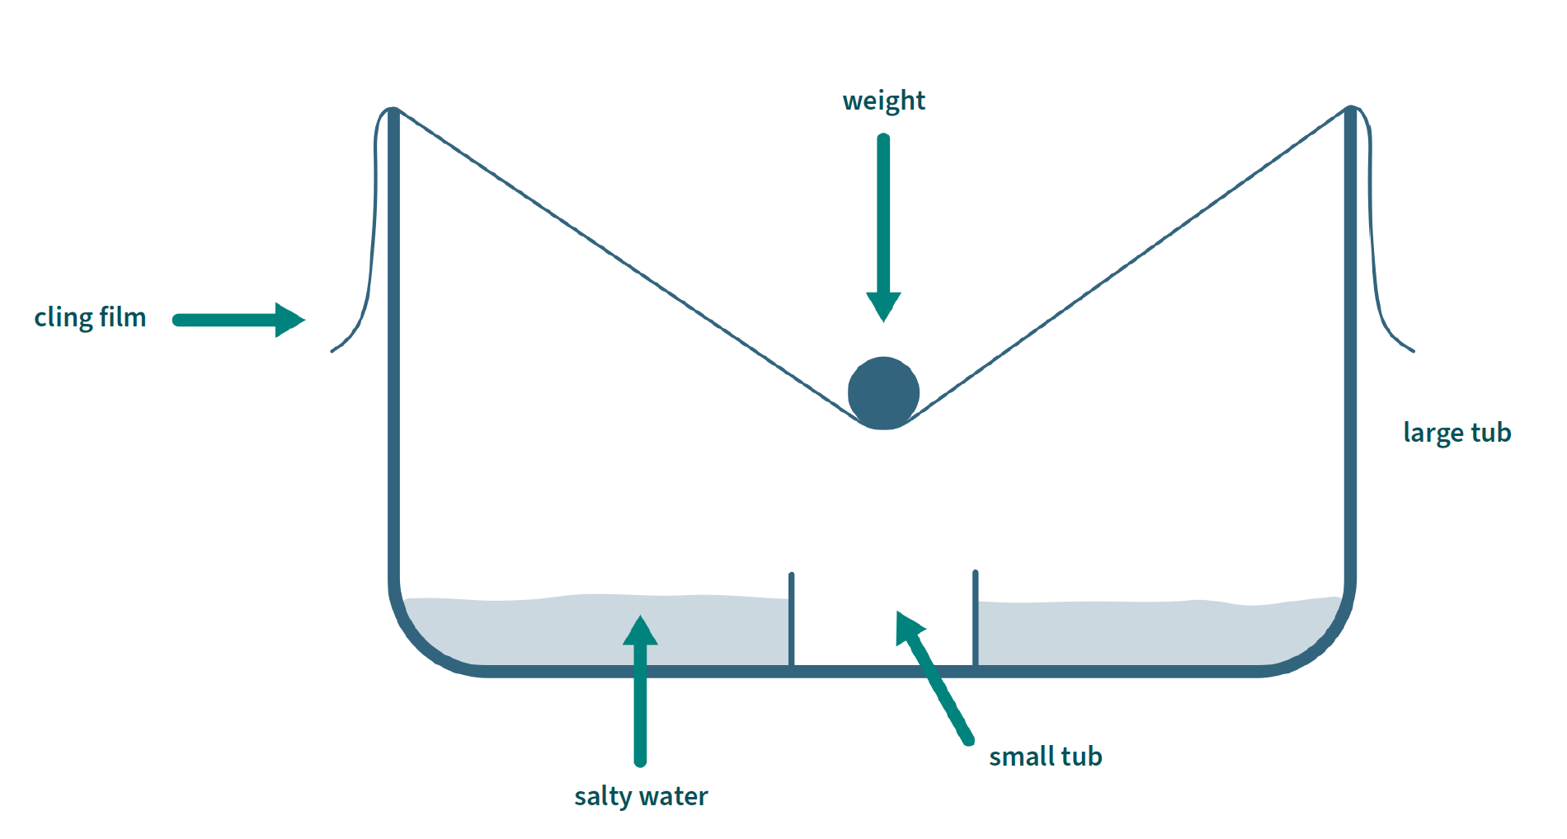

Filtering water

You will need:
- a 1- or 2-litre PET bottle with the top cut off and put together as shown in the diagram – make sure you take the lid off
- a cup with dirty water (make your own using dirt, water, leaves and small bits of rubbish)
- material such as coffee filter paper, cotton wool, sand, gravel and stones

What to do
- Layer in the materials, starting with the coffee filter paper and finishing with the stones. (It doesn’t matter if you don’t have all the materials listed; just make sure you start with the material that leaves the smallest gaps and finish with the one that leaves the largest gaps.)
- Give your dirty water a rating from 1 (a little brown, but still clear) to 5 (really brown, can’t see through it at all). Make your water at least a 3.
- Carefully pour the water into the top of the bottle and watch it flow through to the bottom section.
- Give the filtered water in the bottom section a rating from 1 to 5. Don’t taste the water, even if it looks clean!
- Carefully take your materials out and inspect them. How dirty is each layer?
- If there is enough time and materials left over, try your experiment again and see if you can make the filtered water even cleaner.
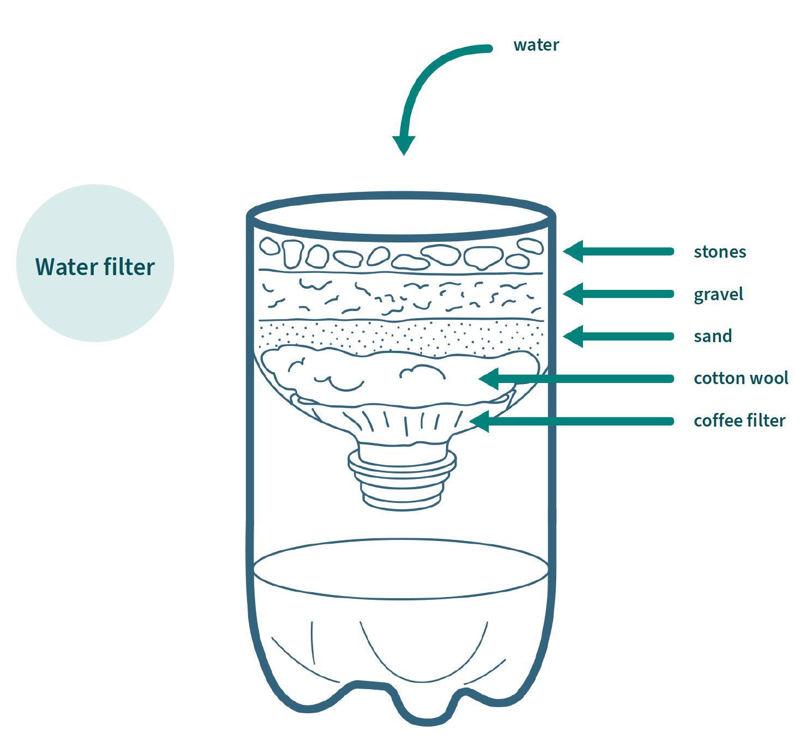

Imagining sustainable solutions for water challenges in the Indo-Pacific
Learning intention | Materials
- To imagine a sustainable and reliable technological solution for a water challenge in an Indo-Pacific community. | - Water stories hand-out  - PowerPoint: Sustaining water (slides 30 to 32)  - Animation: What is a partnership? (primary version,  3 minutes)  - Worksheet: Imagining solutions to a water challenge graphic organiser  - (Optional): Construction materials

Introduction (10 min)
- Share the learning intention on slide 31. Review Lesson 3 and remind students that their task is to imagine a possible solution for a water challenge facing the characters in the water stories. They will need to ‘think differently’ and take on the role of an expert advisor working with the local community in a partnership project. Explain that the best solutions are sustainable, and include community decision-making and participation – as demonstrated by the examples in Lesson 3.
- Share slide 24 and ask students to identify the structure given to the partnership project solutions (location, challenge, solution, result). Revisit a few of the projects in slides 24–29 and as a group identify where examples of community participation and sustainability can be seen. For example, slide 27 shows sustainability, as there are now two water sources. In slide 24, the women in the community were involved in the tank installation.
- Read through the water stories again and organise students into groups. Students can pair up with another student who has the same story, or form small groups to explore a shared issue such as rubbish in water sources or accessibility issues. Students can build on their ‘I wonder’ statements or take a new approach to addressing the challenge.
- Share the Australian water story example and model the analysis process (see slide 32), making sure to use terms such as ‘might’ and ‘maybe’ rather than ‘will’. Think out loud options that might involve alternative water sources. For example:
- Location: Flinders Ranges – a rural and dry area.
- Challenge: the problem is not enough water in the dam. This probably means the town relies on surface (rain) water.
- Solution(s): Maybe we could build another dam to collect more rain when it does fall. Or maybe we could pipe in sea water from Port Augusta that has had the salt removed – like we did in our experiment – and store that in the dam. I think that might be a good idea because having another dam won’t help if there is no more rain and Port Augusta is pretty close to the Flinders Ranges. What about we explore this with the town council. We would need to think about …
- Result: the town would have another water source so there is still water if there is no dam (surface) water.

Problem-solving (20 min)
- Provide each group with the Imagining solutions to a water challenge graphic organiser worksheet, and give them 20 minutes to think of a way that the challenge might be addressed. It may be helpful to provide each group with the relevant country fact file and encourage them to use the geographical section to inform their thinking.
- Remind students that they will need to predict a result based on their chosen solution and encourage them to imaginatively ‘involve’ their character and/or community members if they can.
Differentiation: This activity could also be developed using a hands-on approach, in which students construct models of their solutions using a range of design and/or technology materials.

Learning review (15 min)
This review session offers teachers the opportunity to assess students against the module success criteria:
- Discuss water resources using age-appropriate geographical and scientific terms.
- Describe a water challenge in the Indo-Pacific and analyse its effects on communities.
- Explain a link between a water challenge and a technological solution.
- Ask student groups to share their imagined solutions. After each presentation, ask other students to identify the geographical and/or scientific terms used in the presentation. Have students offer feedback on the strength of the solution, structuring this as ‘I like … I think they might have …’
- To conclude, watch the animation: What is a partnership? (primary version) and use it as a springboard for the question: ‘How could Australia and our neighbours keep working together to make sure everyone in our region has safe, clean water for the future?’ Encourage students to think of opportunities for connections through organisations such as universities and non-government organisations (such as World Vision, Care, Save the Children, Tearfund Australia), as well as the Australian Government.

Imagining solutions to a community water challenge

Location

Challenge

Possible solutions

Possible results

