Analysing water needs
- Read your water story. Write the key information below and add a water ‘wonder’ for the person.
My name is
and I live in
I love

However,

I wonder if

- Draw a picture to illustrate part of the story.
.

Treating water using the sun

You will need:
- one large clean container and one small clean container (for example, a family-sized ice-cream container and a small yoghurt container)
- a jug of warm water mixed with 2 tablespoons of salt OR food colouring
- a small weight, such as a coin or a small stone
- cling wrap
- Blu Tack
- large rubber band and drinking straws (optional)

What to do
- Collect your equipment.
- Place the small container inside the large container and stick it to the base of the large container with Blu Tack.
- Pour a little of the salty or coloured water into the large container to a depth of 1 cm to 2 cm. If you dare, use a straw to taste it! (Teacher note: ensure the liquid is potable.)
- Cover the large container loosely with cling wrap. Place a weight in the middle of the cling wrap, above the small container. If needed, use a rubber band to seal the edges.
- Carefully carry the container to somewhere warm and flat and where it will not be bumped. A spot in front of a sunny window is a good place. Make sure no water has spilled into the small container.
- Leave the container for an hour, or longer if you can, especially if it is a cold, dark day.
- Check the containers from time to time to see what is happening.
- Take the small container out of the large container and use a straw to taste the water. What do you notice?
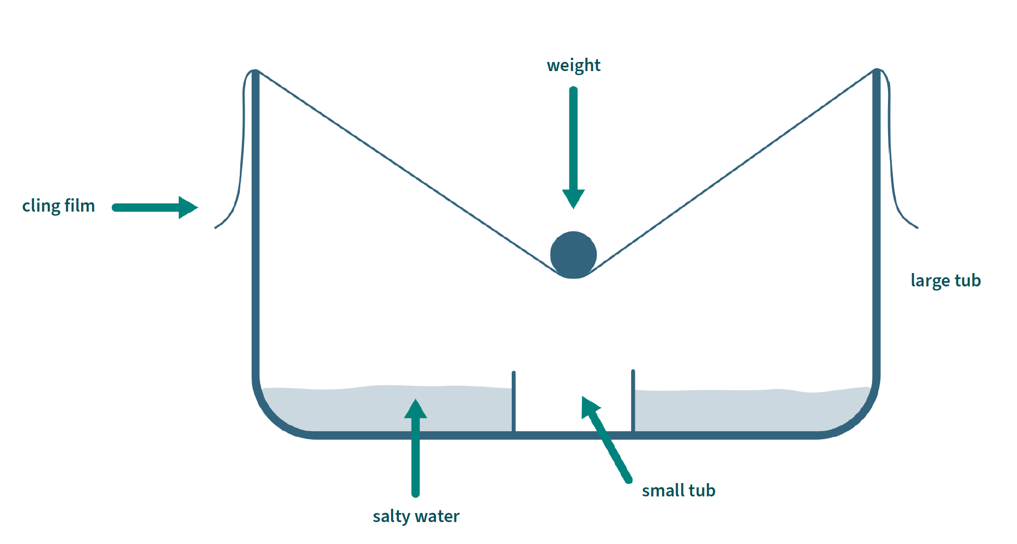

Filtering water

You will need:
- a 1- or 2-litre PET bottle with the top cut off and put together as shown in the diagram – make sure you take the lid off
- a cup with dirty water (make your own using dirt, water, leaves and small bits of rubbish)
- material such as coffee filter paper, cotton wool, sand, gravel and stones

What to do
- Layer in the materials, starting with the coffee filter paper and finishing with the stones. (It doesn’t matter if you don’t have all the materials listed; just make sure you start with the material that leaves the smallest gaps and finish with the one that leaves the largest gaps.)
- Give your dirty water a rating from 1 (a little brown, but still clear) to 5 (really brown, can’t see through it at all). Make your water at least a 3.
- Carefully pour the water into the top of the bottle and watch it flow through to the bottom section.
- Give the filtered water in the bottom section a rating from 1 to 5. Don’t taste the water, even if it looks clean!
- Carefully take your materials out and inspect them. How dirty is each layer?
- If there is enough time and materials left over, try your experiment again and see if you can make the filtered water even cleaner.
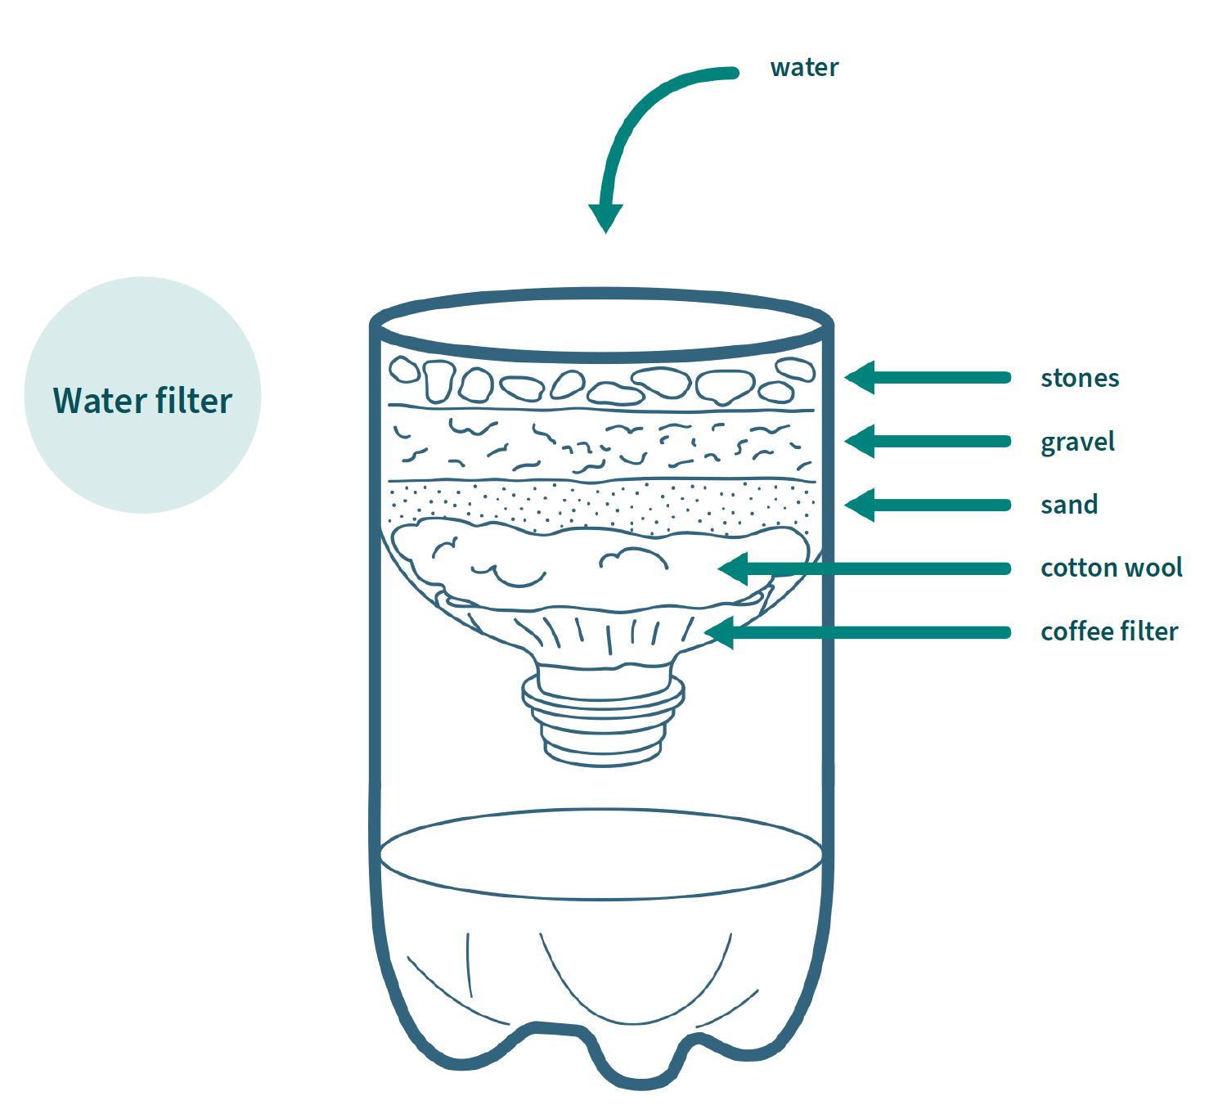

Imagining solutions to a community water challenge

Location

Challenge

Possible solutions

Possible results

