Sustainable enterprises
Module length: 3 × 60 minutes

Summary
This module investigates how Australia’s economic partnerships, through trade investment, and development cooperation support shared regional prosperity and stability. Students will explore how macroeconomic and microeconomic strategies, such as blended finance and microfinance, are implemented at a global, regional and local scale to tackle challenges that nations cannot solve alone. This module focuses on how Australia and countries within the Indo-Pacific region work together to achieve the United Nations (UN) Sustainable Development Goals. It introduces case study examples to demonstrate how economic progress can improve a community’s lifestyle, wellbeing and sense of independence. Students will learn about a range of global stakeholders. Each lesson will introduce economic concepts, such as supply and demand, risk, loans, interest, insurance, entrepreneurs and philanthropy, and apply them to real-world situations.

Success criteria
At the end of this module, students should be able to:
- understand how Australia’s regional partnerships are working towards achieving prosperity within the Indo-Pacific region
- distinguish between macroeconomics and microeconomics and the stakeholders involved at each level
- explain how financial strategies and investments help the global pursuit to achieve the Sustainable Development Goals by 2030.

Organising ideas
The organising ideas are global relationships, global responsibilities and global futures. These reflect the Australian Government’s aims to build genuine partnerships to jointly tackle global challenges, protect international rules, promote Australia’s international interests, and sustain a peaceful and prosperous future that keeps our region stable.
© Ahmad 'deNy' Salman/Department of Foreign Affairs and Trade, CC BY

Prior knowledge
i
n
e
r
a
p
e
/
s
m
- A basic understanding of economics and key principles such as employment, growth, inflation, globalisation and trade.
- An awareness of the risks involved with financial decision-making.
- An understanding of the United Nations and how it assists global development.

Key terminology

blended finance
demand
economics
entrepreneur
equity
grants
insurance
interest
investment
loan
macroeconomics
microeconomics
microfinance
non-government organisation
partnership
philanthropy development
poverty
prosperity
repayments
stakeholder
supply
sustainable

Further resources
- Blended finance – Australian Government Department of Foreign Affairs and Trade
- Sustainable Development Goals (SDGs) – UN Office for Sustainable Development
- World’s largest lesson – Introduction to SDGs – UNICEF (video)
- Difference between macro and microeconomics (video)
- Microfinance vs. macrofinance: key differences explained – Investopedia
- Philanthropy – Centre for Sustainability and Business, Melbourne Business School
- Blended finance for climate initiative – Centre for Sustainability and Business, Melbourne Business School
- Making blended finance work for the sustainable development goals – OECD

Curriculum links
The table below lists the Australian Curriculum V9 content descriptions explicitly addressed in this module.

Economics and Business

Knowledge and Understanding
Year 9: the role of Australia’s financial sector and its effect on economic decision-making by individuals, businesses and global markets AC9HE9K01
Year 9: how economic decision-making involves the interdependence of consumers, businesses, the financial sector and government AC9HE9K02
Year 9: how individuals and businesses manage consumer and financial risks and rewards AC9HE9K05
Year 10: processes that businesses use to manage the workforce and improve productivity, including the role of entrepreneurs AC9HE10K05

Skills
Years 9–10: locate, select and analyse information and data from a range of sources AC9HE9S02 AC9HE10S02
Years 9–10: interpret information and data, explaining economic and business issues, trends and economic cause-and-effect relationships, and make predictions about consumer and financial impacts AC9HE9S03 AC9HE10S03
Years 9–10: create descriptions, explanations and arguments, using economic and business knowledge, concepts and terms that incorporate and acknowledge research findings AC9HE9S05 AC9HE10S05
Civics and Citizenship

Knowledge and Understanding
Year 9: how and why individuals and groups, including community, religious and cultural groups, participate in and contribute to civic life in Australia and to global citizenship AC9HC9K05
Year 10: the Australian Government’s role and responsibilities at a regional and global level AC9HC10K02
Year 10: how Australia’s international legal obligations shape Australian law and government policies, including those relating to First Nations Australians, and the issues related to the application of these obligations AC9HC10K04
Year 10: the challenges to and ways of sustaining a resilient democracy and a cohesive society in Australia and/or in our region or globally AC9HC10K05

Skills
Years 9–10: evaluate the methods or strategies related to making decisions about civic participation AC9HC9S04; AC9HC10S04

Geography

Knowledge and Understanding: Geographies of human wellbeing
Year 10: the methods used to measure spatial variations in human wellbeing and development, and how these can be applied to determine differences between places at the global scale AC9HG10K05
Year 10: responses of international and national government and non-government organisations to improve human wellbeing in Australia, within India and another country in the Pacific AC9HG10K08

General capabilities
Critical Thinking: Students are required to connect or adapt complex ideas based on unfamiliar situations.
Intercultural Understanding: Students will need to consider unfamiliar cultural contexts and appreciate the values, practices and perspectives of other cultures.

Cross-curriculum priorities
Asia and Australia’s engagement with Asia: As this module has a global focus, students will research topics or examples of Australia’s development programs that involve partners in the Asia-Pacific region. Global education clearly emphasises the interdependent nature of relationships and the importance of developing mutual understanding and accepting diversity.
Sustainability: This module explores many of the organising ideas within this priority. Students will gain an understanding of sustainable development and the interdependence of social, economic and environmental factors.

How is global human development financed?
Learning intentions | Materials
- To identify the United Nations (UN) Sustainable Development Goals.  - To compare the role of both macro- and microeconomics in financing global human development. | - PowerPoint: Sustainable enterprises (slides 1–8)  - Worksheet: Prosperous partnerships  - Animation: What is a partnership? (secondary version 3 min)

Introduction (10 min)
This module will firstly identify the role of different stakeholders involved with global human development. You may need to define the term ‘stakeholder’ for students as a person or group with an interest or concern in something.
- Outlined are a series of prompting questions to help guide an initial class discussion and gauge students’ prior knowledge of non-government organisations, countries, private corporations and businesses. It may be useful to collate student answers to use in future lessons as a recap.
- What are some examples of organisations that work with communities around the world to address shared challenges?
Students may mention organisations such as Red Cross, World Vision, United Nations (or the UN) or Amnesty International.
- What do each of these various organisations do?
Depending on student answers, you may provide further examples, such as religious groups, medical groups, charities, crowd-funding ventures and so on.
- What do we collectively label these organisations?
The answer is ‘non-government organisations’ (NGOs). For an explanation of this term and the types of NGOs, visit the website: What different types of NGOs exist?
- Sometimes these organisations can also be classified as not-for-profit. What does that phrase mean?
- What organisations are excluded from the acronym NGO?
- Do the excluded organisations also support human development? If so, in what ways?
Students should consider the role of countries, large corporations and businesses.
- Explain that this module will be exploring the cooperation required to finance global human development between all the mentioned stakeholders.
- Outline the learning intentions to the class on slide 2 of the Sustainable enterprises PowerPoint.

Guided instruction (25 min)
- Ask students what they believe global human development might mean? Suggest they break down the term to further unpack the meaning.
- Survey students on whether they have heard of the United Nations and discuss its role in improving global human development (slides 3 and 4).
- Using slide 5, conduct a ‘think, pair, share’, where students consider what all the icons might represent for the United Nations Sustainable Development Goals (SDGs). Write a list on the board of what the class thinks each icon may represent. Some could symbolise more than one SDG. Then reveal the actual goals on slide 6.
- Show the short video (2 min 12 sec) outlining the Sustainable Development Goals on slide 7, and then read through slide 8.
Further discussion: There is opportunity to extend this task into another lesson by exploring how the world is progressing against each of the 17 Sustainable Development Goals, which can be tracked online through many websites. Students could decide which goals are most important to them and why, possibly even holding their own roundtable debate.
- Hand out the Prosperous partnerships worksheet to students and ask them to complete Activity 1.
- Show students the animation: What is a partnership?, which explains partnerships and the role Australia plays within the Indo-Pacific region.
- A key question for the class to consider following the animation is: How might all the different stakeholders mentioned at the start of this lesson work together to fund the Sustainable Development Goals?

Independent practice (15 min)
- To assist students with answering this tricky question, have them proceed to Activity 2: Financing development on the worksheet. This activity explains how working towards sustainable development requires the management of economics at varying scales and introduces the terms ‘macroeconomics’ and ‘microeconomics’.
- Students should complete Tasks 1 and 2, which provide an explanation of macroeconomics and microeconomics and require students to identify the differences between the two.

Learning review (10 min)
- Ask students how macroeconomics and microeconomics work together to finance global human development. Students could create a flowchart or tree diagram to show how the two terms are related.
- Alternatively, ask the question: How do macro-level decisions on aid, trade and investment affect individual entrepreneurs and families (micro) in our region? Consideration of this question connects scale and human impact, and links economics to wellbeing and inclusion.
- Inform students that in the next lesson they will be exploring in more detail how macroeconomics can support development.
- Students have learnt many new economic terms as well as the term ‘stakeholder’. As an exit ticket for each student, you could ask them to identify a type of stakeholder or an economic term used in the lesson.
For example:
- Name an NGO that supports global health.
- What does ‘supply’ mean in economics?
- What is an example of prosperity?
- Outline a sustainable development goal focused on families.

Prosperous partnerships

Activity 1: A prosperous future
In 2015 all United Nations (UN) member countries agreed to work together as one global community on 17 goals of sustainable development. They want to achieve these goals by 2030. These Sustainable Development Goals (SDGs) take action on areas of critical importance for the world. They are classified under the five Ps: people, planet, prosperity, peace and partnership.
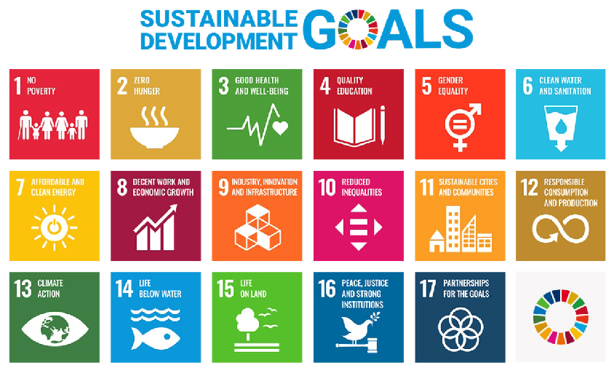
United Nations Sustainable Development Goals www.un.org/sustainabledevelopment. The content of this publication has
not been approved by the United Nations and does not reflect the views of the United Nations or its officials or Member States.
- Define ‘prosperity’:

- List 4 or 5 Sustainable Development Goals that you believe focus on the aim for global prosperity. Include the goal number and its description.

- Create a flowchart or cycle diagram to show how a global focus on human development can improve people’s prosperity.
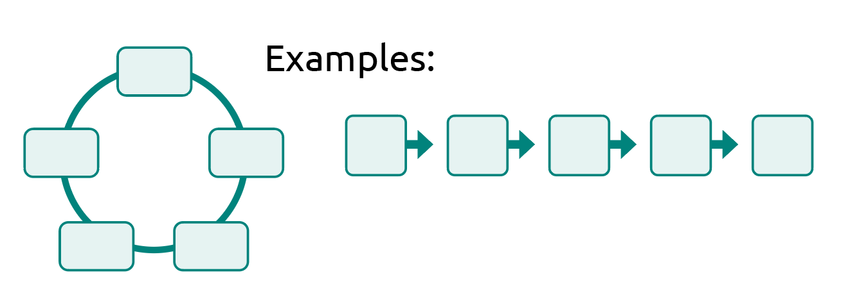
Which goal do you believe is the most important for achieving prosperity? Explain why.

Activity 2: Financing development
This lesson will explore how global cooperation and partnerships are helping to finance human development from a local scale to a global scale. Such an investigation sits within the subject of Economics: the study of how individuals, businesses and governments make choices in allocating resources to satisfy their needs. Economics determines how resources are produced, distributed and consumed in order to maximise output. Economics can be divided into two categories – macro and micro. Both are relevant to the financing of human development projects that boost prosperity, but their scope and size differ.
Macroeconomics studies the progress, behaviour and performance of the economy at a national, regional or international scale. It focuses on how variables interact to affect productivity. These variables include employment, economic growth, inflation, globalisation and trade. The aim is to provide widespread benefits that may help entire populations gain work through new industries. For example, two countries may sign a free trade agreement to encourage exports and build industry, offering more jobs to society.
An example of a macroeconomic partnership exists between the Australian Government and the Manila Angel Investors Network. In 2022, together they invested in 1Export, which is a female-founded company focused on supporting the reach of Filipino brands in the global market. The photo shows their chief marketing officer, who works on improving product visibility and reach both online and overseas.
Microeconomics considers the choices made by individual consumers and businesses, such as the supply and demand for goods and services in a marketplace. It focuses on changes in a situation based on the existing conditions.
For example, the price of fruit and vegetables may increase if the food crop has been damaged due to a weather event such as a flood. In this instance, the supply has been reduced so the demand is high. When the supply is low and demand is high, producers will often increase the price per unit. Fruit and vegetable prices fluctuate regularly.
Most importantly, these two types of economics – macro and micro – are interdependent. The Australian Government supports countries in our region through trade and cooperation, which means everyday products such as fruit and vegetables, rice and clothing are available and affordable in Australia. This highlights the economic participation and interconnection between consumers, businesses and governments.

Chief marketing officer of 1Export.
© Flordeliz Ranola/Department of Foreign Affairs and Trade

Josh Estey/Department of Foreign Affairs and Trade

- Can you identify which features are macroeconomics and which are microeconomics:
Criteria | Macroeconomics or microeconomics?
Studies individual, household and business trends to assist with the marketing of goods and services.
Considers the health of the overall economy.
Can provide credit to small groups of borrowers to assist with cash flow for a small business.
Aims for individuals to achieve self-reliance.
Focuses on smaller local scales and internal issues.
Covers several market sections and can relate to both environmental and external issues.
Supports projects that focus on entire societies or regions.
Provides tax benefits to certain industries to promote hiring workers and supporting the region.
Focuses on how product pricing, consumption and production factors might impact a market.
Considers and assesses government strategies and suggests strategies for unemployment, national income, inflation and poverty.
Arranges partnerships between government and private companies to commence large infrastructure projects.
Focuses on assisting families out of poverty through providing loans and training in necessary skills.
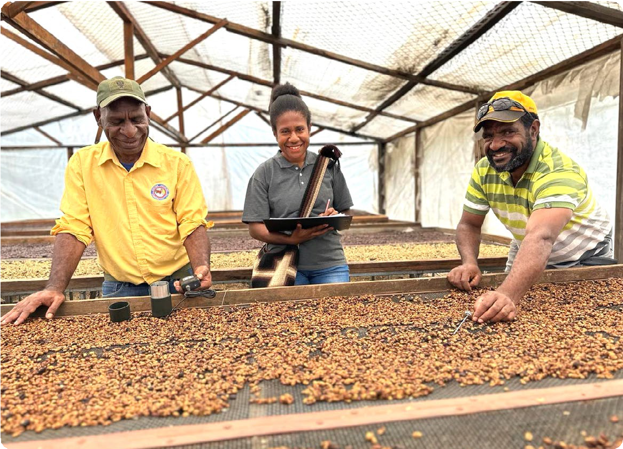
© Department of Foreign Affairs and Trade

- Identify whether the following scenarios involve macroeconomics or microeconomics. Briefly explain why, using a variety of the reasons outlined in the table to support your answer.
Scenario 1: Countries base their budget for future financial contribution to UN-led bodies, such as the World Health Organization, on global contexts.

Scenario 2: A cashew farmer in Indonesia learns how to conduct a market analysis to ensure he receives a fair trade amount for each kilo of cashews he produces.

Scenario 3: A $100 loan is made to a villager to buy the necessary equipment for making ceramics to sell at a weekly market stall aimed at tourists coming off cruise ships.

Scenario 4: A country seeks a debt swap from the World Bank towards a development project, such as improving schools or protecting forests.

Scenario 5: A group of coffee-bean growers form a collective to rent machinery and improve the quality of their crop so they can raise their prices.

Scenario 6: Non-government organisations work alongside countries to provide humanitarian aid and redevelopment to a country affected by an earthquake.

Scenario 7: Four local councils work together with a modern energy supplier to provide electricity to remote communities.

Scenario 8: A new partnership project finances a road construction, creating jobs for hundreds of local bricklayers and removing taxes on local concrete suppliers.

Scenario 9: Countries within a geographical region sign an alliance to help fund environmental conservation projects that will protect threatened species.

Scenario 10: A group of people working as stitchers are given a credit loan to begin their own small business stitching unique upholsteries for furniture. They invest in a sewing machine.

Scenario 11: A community decides to increase the price of rice to improve profits for growers and match the market value of other districts.

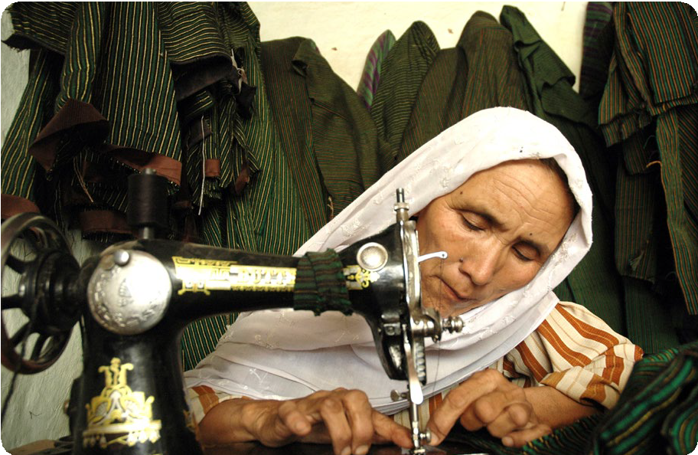
© Imal Hashemi, Afghanistan Reconstruction Trust Fund/Department of Foreign Affairs and Trade

How does blended finance help large development projects?
Learning intentions | Materials
- To explain how blended finance relies on economic partnerships to lower risk.  - To describe the types of development projects blended finance can support within the Indo-Pacific region. | - PowerPoint: Sustainable enterprises (slides 9–17)  - Worksheet: Blended finance  - Video: Palau solar plant investment  - Video (Optional): PNG and Australia Coral Sea Cable Project

Introduction (5 min)
- Recap the different stakeholders that support human development from Lesson 1. Review any key terms that were learnt, such as macroeconomics and microeconomics.
- Explain that this lesson will focus on a macroeconomic strategy towards reaching the UN Sustainable Development Goals (SDGs).
- Outline the learning intentions for this lesson on slide 10 of the Sustainable enterprises PowerPoint.

Guided instruction (25 min)
For students to understand blended finance and its purpose, they need to gain an awareness of financial risk and the role this plays in development. Therefore, students will first explore how risk can affect even their personal finances. Through exploring the purpose and function of insurance and loans, there is an opportunity to further highlight the rights and responsibilities of consumers.
- Ask students what they know about insurance and why people may buy insurance. Encourage them to provide examples of when insurance may be needed, such as for a car, a house, health or travel. The aim here is for students to understand the economics behind assessing risk and to link this to real-world examples.
- Display slide 11 on the Sustainable enterprises PowerPoint for a definition of insurance.
- Another type of financial risk occurs when applying for a loan. Ensure students understand what a loan is. Using the PowerPoint (slides 12–14), ask students to consider the questions that are posed. Slide 14 relates financial risk to development funding for low-income countries.
- Introduce blended finance (slides 15–16) to outline three major stakeholders: governments, philanthropic organisations and private companies. Ensure students understand the word ‘philanthropy’. Explain to students philanthropy involves giving back to others through a goodwill gesture, which supports shared development goals. Most often this is shown through donations from charities or non-government organisations.
- Show students the video on Palau solar plant investment (3 min 49 sec). Ask students to pay attention to the two stakeholders that are mentioned and how the project will help achieve any of the UN’s SDGs. After watching the video, ask the class to recall key facts and write these on the board for students to refer to in their next task. If time permits, you could also show students another video example: PNG and Australia Coral Sea Cable Project (1 min 44 sec).
- Explain to students that when the Australian Government helps to build things such as solar power and internet cables in nearby countries, it also serves our national interest to keep the region peaceful and strong.

Independent practice (20 min)
- Provide students with the Blended finance worksheet, and ask them to read and complete the six questions. For Question 6, remind students of the notes made on the board.
Extension: The worksheet provides an extra activity for students who wish to further investigate how blended finance works.

Learning review (10 min)
Student should have broadened their perspectives on Australia’s role in supporting global human development during this lesson. Show slide 17 and ask students if they can identify the different stakeholders involved. They may conduct a quick search on those not known. Use this image to reflect on the importance of partnerships. A thinking routine such as, ‘I used to think, but now I think …’ or ‘Connect, Extend, Challenge’ would be a great way for the class to consolidate their learning.

Blended finance
Blended finance is a partnership between various financial stakeholders that helps to lower the risk of kickstarting large-scale development projects in low-income countries. Blended finance attracts private companies and financial institutions to invest, which boosts local employment and helps to work towards the Sustainable Development Goals (SDGs). The input from governments is considered catalytic. This means, their input is a catalyst for encouraging private companies to invest in a public good, bridging the gap between commercial returns and social impact. Without the partnership, it is unlikely such a project would occur.
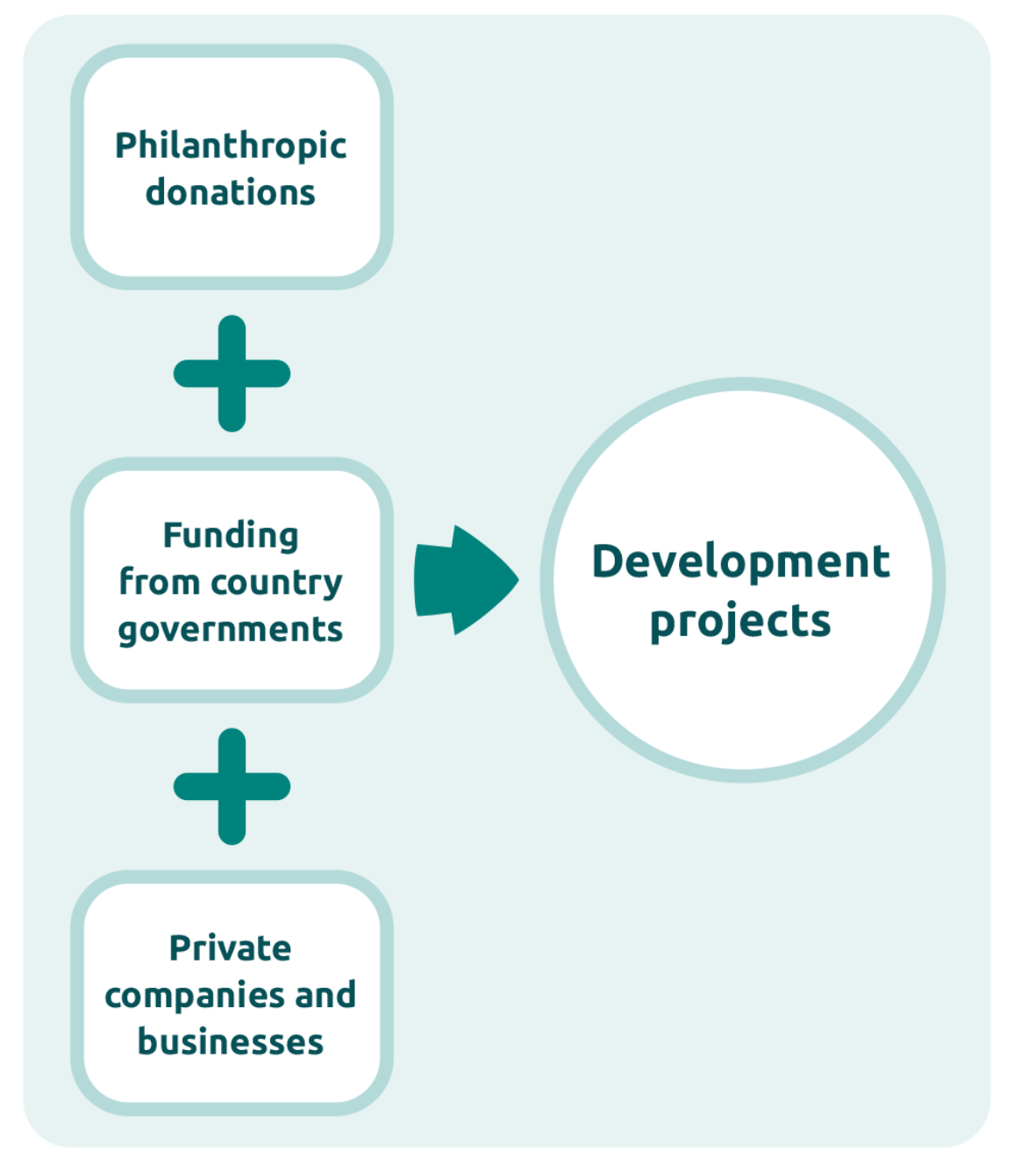
Blended finance is an example of macroeconomics, influencing large infrastructure and growth projects that can provide major employment opportunities, new skills and training, and encourage external investment. All of these together help to build a stronger economic market.
Development projects could include:
- telecommunications network infrastructure installation
- modern energy installations
- healthcare companies
- new technology startups
- water management infrastructure, such as dams, reservoirs and sewerage systems, and desalination.
Australian development investments have attracted $160 million in private investment since 2020. They aim to expand enterprises in the Indo-Pacific region that drive climate and gender outcomes. The funding helps to build markets, create jobs through innovation, and deliver important goods and services to communities. One dollar of funding from the Australian Government leverages $6 in private company investment.
Find out more about Australia’s development investments, projects and blended finance on the DFAT website.
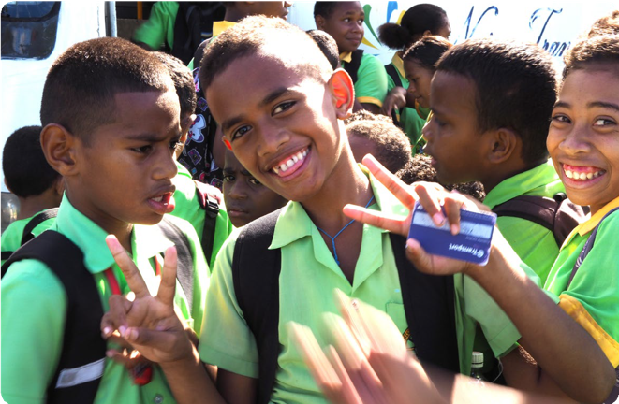
An infrastructure partnership between Australia and Fiji restored roads and allowed these children to catch a bus to school, improving accessibility and reducing daily travel time.
Image credit: © Talei Tora / Department of Foreign Affairs and Trade

Answer the following questions:
- Why are interdependencies between economic stakeholders important in a blended finance model? Think about the various risks present in low-income countries.

- What role do country governments and philanthropic organisations play in the decision-making process of private sector businesses?

- Some of the ways that risk is lowered by a government in a blended finance arrangement are shown below. Working in pairs, research the terms below and write a description of what each one means:
- Loans with lower than market interest rates

- Zero interest rate

- Extended repayment periods

- Grace periods

- Providing grants

- Providing equity

- Why would philanthropic organisations support blended finance? Think about their contribution to global citizenship.

- How is Australia upholding its global responsibilities towards the SDGs by establishing blended finance?

- Write a paragraph outlining the purpose, stakeholders and human development benefits of Palau’s solar energy investment (video length 3.49 mins ). Refer to specific SDGs from Lesson 1 and include facts and figures.

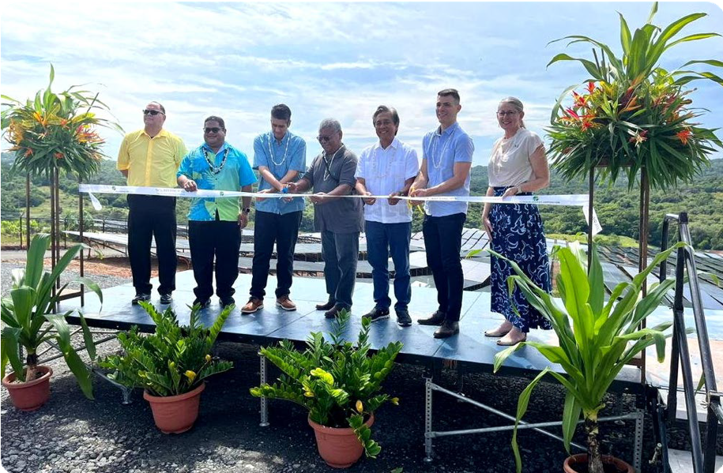
© Department of Foreign Affairs and Trade

Extension activity
If you are interested to understand how blended finance partnerships are encouraged, take a look at the information on the following two webpages. The first is a media release about a new health initiative. The second is a call for proposals.
- Investing in a stronger, healthy region – Australian Minister for Foreign Affairs
- Regional health partnerships – Call for Proposals – Indo-Pacific Centre for Health Security
After reading the media release and the call for proposals, outline what this new initiative is hoping to achieve and what SDGs it may assist.

How is microfinance promoting local economic growth?
Learning intentions | Materials
- To explain how microfinance can support female entrepreneurs and prosperity.  - To outline how microfinance partnerships contribute towards achieving the Sustainable Development Goals (SDGs). | - PowerPoint: Sustainable enterprises (slides 18–20)  - Worksheet: Empowering communities  - Worksheets: Microfinance case studies 1–3

Introduction (5 min)
- Explain that the focus of this lesson will be on microeconomics. To revise the concept of microeconomics, ask students what they recall from Lesson 1. Who do they believe are the stakeholders involved at the microeconomic level, compared to the macroeconomic level?
- Outline the learning intentions for this lesson on slide 19 of the Sustainable enterprises PowerPoint, and then ask students:
- What is an entrepreneur?
- How might an entrepreneur be influential in driving change within their local context?

Guided instruction (20 min)
- Provide students with the Empowering communities worksheet. As a class, read the explanation of microfinance and answer Question 1.
- Read through Activity 1 and ensure students understand the poverty cycle and how microfinance may assist families. Slide 20 contains the Cycle of Poverty diagram and an infographic produced by the United Nations (UN).
- Students should complete the task outlined in Question 2.

Independent research (25 min)
Activity 2 on the Empowering communities worksheet allows for a jigsaw activity where small groups of students work together on a case study and then the groups divide and switch to another group to share their knowledge.
- Students work in pairs or groups of four and read one of five suggested case studies. They will then use the information they have learnt to complete one row of the table in Question 3.
Mixed abilities: The case studies can cater to different student abilities. This may assist with the initial grouping of students or the allocation of case studies.
- A shorter article for students needing support: Increasing financial inclusion in Cambodia (see Microfinance case study worksheet)
- Enhancing sustainable coastal communities in the Pacific (see Microfinance case study worksheet )
- Supporting women experiencing vulnerability into housing (see Microfinance case study worksheet)
- Urban migrant entrepreneur capital in Vietnam – Business Partnerships Platform
- A more advanced read with video: Empowering women entrepreneurs in Fiji through fintech – Business Partnerships Platform
- Groups then divide in half and switch to form a new group of four to share their case study with other class members. They must also listen and take notes about another case study from the new group members. Remind students to use the shared case studies to continue completing their table with examples of how microfinance has assisted communities. This process is repeated until all students have an understanding of 3 case studies.
- Students should now use the information in the filled-in table on their worksheet to individually answer Question 4. There is also an extension question available.

Learning review (10 min)
- Discuss as a class how the flow-on effects of microfinance could help communities break out of the poverty cycle and sustain a cohesive society. Students should recall the quote in the Worksheet Activity 1 and the role of women in development progress.

Module wrap-up
These suggested activities and questions could be used as a form of assessment relating to the success criteria.
- Students have learnt many economics terms and knowledge in this module. Ask a key question that relates back to the success criteria:
Which type of economics do you believe will lead to greater human development progress and prosperity: microeconomics or macroeconomics?
Human Graph: To answer this question, students could create a human graph to show their weighting preferences ranging from 0–100% for each type of economics. From there, you could raise questions to specific groups of students on why they see one type of economics as more important, or why they see both as equally important and interdependent.
- Ask a final question for the module to further check student achievement against the success criteria:
Why is goal 17 of the SDGs ‘partnerships’ so important for achieving all other goals by 2030?
With this question it is important to include why Australia benefits from partnerships, as partnerships create a safer, fairer and more sustainable region.

Empowering communities
Microfinance provides financial assistance to individuals who lack access to a formal banking service. It is a form of microeconomics and plays an important role in encouraging entrepreneurship
in low-income countries, where there may be more barriers to starting a business. The services provided can include small loans, a savings account and insurance, as well as business training, mentoring and networking to promote sustainable businesses. The aims of microfinance are:
- to build independence and empowerment through generating income that can overcome household poverty
- to create opportunities for innovation and encourage people to explore their talents, new ideas and potential markets
- to foster social and economic development for communities by creating jobs, building productivity and reducing inequality
- to promote inclusivity and diversity for the poorest social groups, who may be considered high risk by banking institutions.
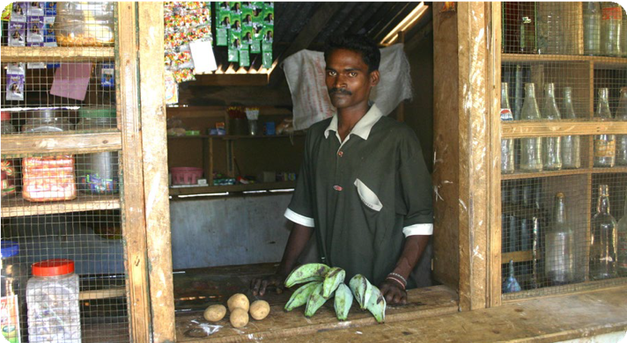
© Peter Davis/Department of Foreign Affairs and Trade
- Which United Nations (UN) Sustainable Development Goals (SDGs) are strongly supported by microfinance?

Activity 1: Supporting women entrepreneurs
Microfinance has considerable benefits for women in low-income countries, where it is often seen as a way to break out of the poverty cycle. Read this passage from microfinance researchers to understand why:
One of the first effects observed from women’s access to credit was the improvement of income and, consequently, the overall economic condition … This has had positive repercussions not only on the family but also on the strengthening of women’s social role. In fact, in addition to improving living conditions, women reinforce their position and role both within the family and in the community to which they belong …
The increase in women’s economic capacity influences the internal decision-making process within the family and contributes to an improvement in consumption, covering basic needs and savings. As women are more likely to spend their income on family-related matters, this also leads to improvements in their nutrition, health, education of children, and living conditions. Women’s access to credit enables them to initiate activities and manage the money according to their own wishes. This ultimately instils them with greater strength and confidence …
Source: Del Sarto, N., Bocchialini, E., Gai, L., & Ielasi, F. (2023). Microfinance, microcredit, and women’s empowerment: an exploration of the Grameen Bank experience for social inclusion. Journal of Accounting and Finance, 23.
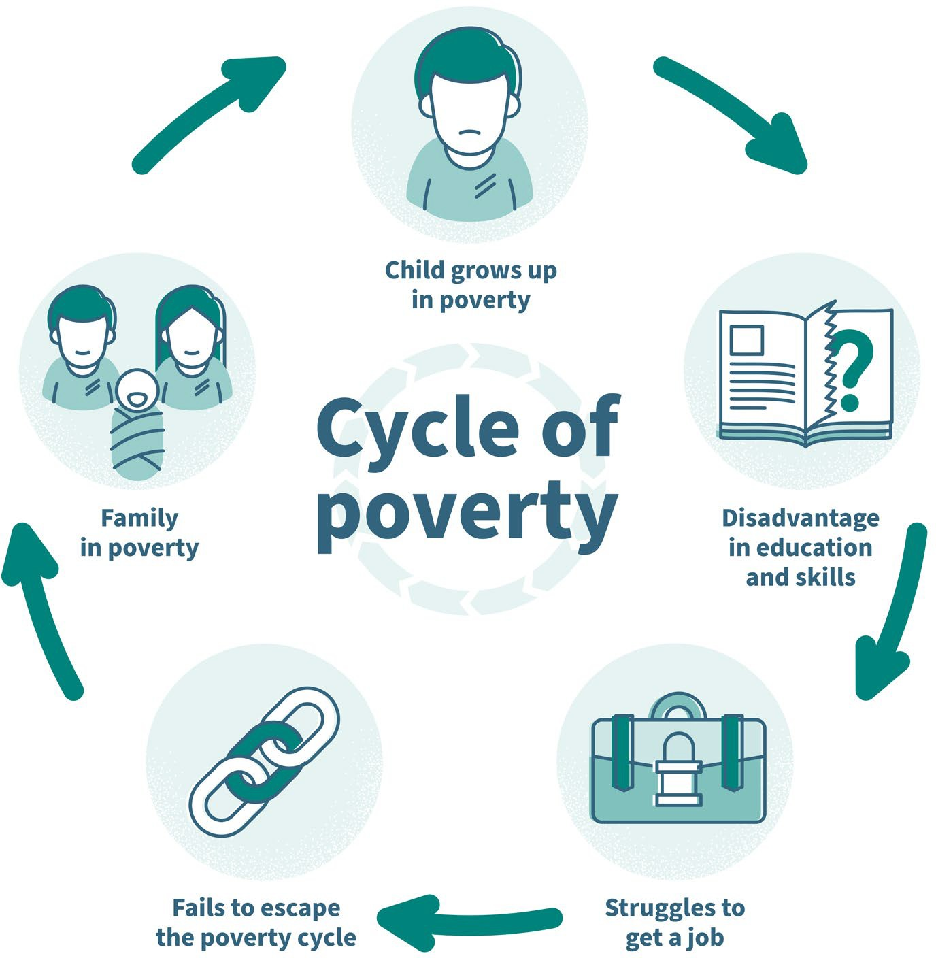
Adapted from: © VectorMine/Shutterstock
- Create your own cycle diagram or flowchart to show how a small microfinance loan could positively impact a family and possibly the wider community.

Activity 2: Microfinance partnerships
The effect that microfinance can have on the day-to-day lives of small communities is often best understood through case studies. Below are five examples of projects that have required partnerships between various stakeholders discussed in Lesson 1. You will read one article and complete one row of the table. You will then need to verbally summarise your knowledge to other people in the class. Explore a map of the country where the project is based and some demographic data, such as a population pyramid, to gain a more detailed understanding about the country and its future population needs.
- Enhancing sustainable coastal communities in the Pacific (worksheet provided)
- Supporting women experiencing vulnerability into housing (worksheet provided)
- Increasing financial inclusion in Cambodia (worksheet provided)
- Urban migrant entrepreneur capital in Vietnam – Business Partnerships Platform
- A more advanced read with video: Empowering women entrepreneurs in Fiji through fintech – Business Partnerships Platform
- After reading and summarising one article in the first row, switch groupings to find out about two more case studies in the list.
Case study details (where, what, who) | What financial support was received and what stakeholder partnerships enabled the project? | How did the project improve the livelihoods and lifestyles of communities, families or individuals? Can you relate the project to any specific SDGs?
- From your case study research, explain why countries such as Australia support investments in microfinance. Hint: think about the further benefits these investments bring to Australia, and consider how these investments reflect Australian values and our commitment to global citizenship and upholding UN responsibilities.

Extension question
- How is Australia upholding macroeconomic policies by encouraging regional microfinance enterprises?

Microfinance: Solomon Islands

Enhancing sustainable coastal communities in the Pacific
WWF-Pacific (Solomon Islands) is improving the sustainability of fisheries and the management of natural resources in the country’s Western Province through an integrated Sustainable Coastal Communities Programme.
One component of this program is the Sustainable Livelihoods and Women’s Empowerment project. The project understands that long-term conservation is best achieved by enhancing sustainable and equitable livelihood opportunities for the people who depend most on the natural environment.
In Solomon Islands, where 80% of women live in rural areas and rely on informal fisheries and agriculture-based economies for their livelihoods, this requires a special focus on facilitating sustainable economic opportunities for women.
Through the financial inclusion component of the program, WWF helps establish women’s microfinance savings clubs; conducts training in financial literacy, business planning, governance and leadership; and trains savings club members to become trainers themselves, to extend the financial inclusion work to neighbouring islands and communities. Working with more than 940 women across 33 communities, the financial inclusion component has seen more than 120 women-led business initiatives – all underpinned by strong business, social and environmental sustainability criteria – emerge in just over three years.
In addition to the direct economic benefits to these women, their families and communities, there are early indications that the income generated through these initiatives is reducing household dependency on overexploited coastal fisheries. Furthermore, in a country where women continue to face systematic discrimination and numerous structural obstacles to their participation, the financial inclusion component is an important stepping stone to encourage the involvement of women in community decision-making mechanisms that affect their lives.
This program is co-delivered by WWF-Australia and local partners, with support from Australia through the Australian NGO Cooperation Program (ANCP). It is also supported by John West Australia. The program is being implemented by WWF-Pacific (Solomon Islands), with support from WWF-Australia.
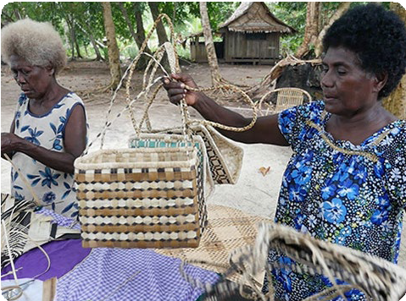
Through the financial inclusion component of WWF’s Sustainable Coastal Communities Programme, Grace Rano has improved the profitability of her basket-weaving business. She now employs other women in the community to help her grow her business and meet the growing demand from buyers in the Solomon Islands’ capital, Honiara.
© WWF-Australia/Wade Fairley

Microfinance: Nepal

Supporting women experiencing vulnerability into housing
Microfinance is a general term to describe financial services to low-income individuals or to those who do not have access to typical banking services. Microfinance is also the idea that low-income individuals are capable of lifting themselves out of poverty if given access to financial services.
Habitat for Humanity Australia (HFH; an accredited NGO) is supporting female-headed households experiencing vulnerability into adequate housing through the Eastern Nepal Community Development project (an ANCP funded project). The project has been working with families experiencing poverty, including female-headed households, to support them to build houses through low-cost microfinance loans. The project has been working to develop local Microfinance Institutions (MFI) capacity to manage a housing loan program, providing technical training to enable MFIs to support construction of low-cost durable housing. Due to poverty, the MFIs’ clients are not able to access formal financing, and these affordable housing solutions with financing enable working low-income families to achieve adequate housing for their families.
Urmila is a widow whose husband died five years ago, leaving her to raise two children alone. Her son is 10 years old, and her daughter is 15. They moved into their new house in November 2014. The former house was very basic and small. Its walls and roof were made of straw and it was not weatherproof. Urmila took a loan several years ago to buy land, and now she has been able to build a house. She borrowed 80,000 ($1,000), contributed 10,000 of her own savings, and received some subsidy from HFH to build her new house. In return she provided voluntary labour. She plans to pay off her loan in less than two years. She earns her living working in the nearby jute factory, as well as from animal rearing and making rice wine.
Living in a new house with a new toilet has changed Urmila and her family’s life. Urmila feels safer and more secure and is not so worried for her teenage daughter. Now they don’t need to go out in the dark at night to go to the toilet in the forest.
In 2014–15 through the ANCP, Australian aid supported nine NGOs to deliver 19 projects in 12 countries focusing on microfinance.
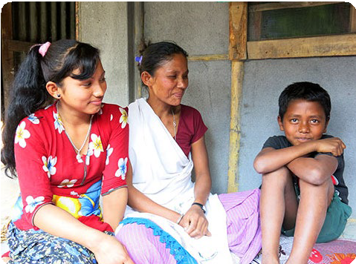
Urmila and her children outside their new house.
© Habitat for Humanity Australia

Microfinance: Cambodia

Increasing financial inclusion in Cambodia
In rural Cambodia, the Credit Union Development program run by Credit Union Foundation Australia (CUFA) provides villagers with safe and affordable access to financial products and services.
Over the past five years, CUFA has established 21 credit unions in rural Cambodia, allowing people to open village bank accounts and gain access to financial education and self-help groups. Credit union members are able to apply for microfinance loans to develop small businesses.
The program also supports rural farmers through livelihood groups, offering training in a variety of skills, including marketing, business management and financial literacy.
The program is key to reducing poverty and boosting economic prosperity in Cambodia.
CUFA is supported by the Australian Government through the Australian NGO Cooperation Program.
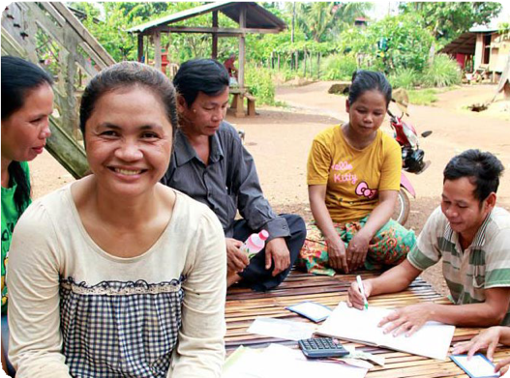
Harn is one of many Cambodians who has benefited from credit unions.
© CUFA

