Prosperous partnerships

Activity 1: A prosperous future
In 2015 all United Nations (UN) member countries agreed to work together as one global community on 17 goals of sustainable development. They want to achieve these goals by 2030. These Sustainable Development Goals (SDGs) take action on areas of critical importance for the world. They are classified under the five Ps: people, planet, prosperity, peace and partnership.
A grid of 17 brightly colored square icons representing the United Nations Sustainable Development Goals, each numbered and labeled with its goal title. The icons include symbols such as people, books, water drops, buildings, leaves, fish, and circular arrows, arranged in rows beneath the heading “Sustainable Development Goals” with a multicolored circular SDG emblem.
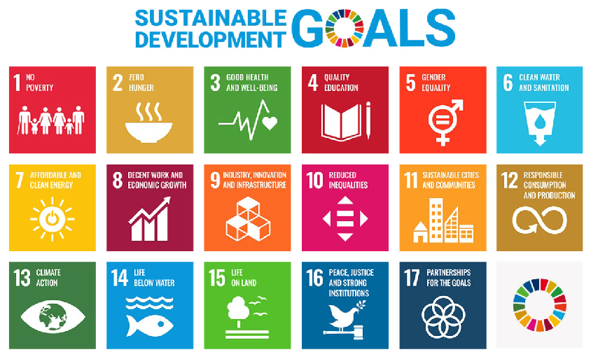
United Nations Sustainable Development Goals www.un.org/sustainabledevelopment. The content of this publication has
not been approved by the United Nations and does not reflect the views of the United Nations or its officials or Member States.
- Define ‘prosperity’:

- List 4 or 5 Sustainable Development Goals that you believe focus on the aim for global prosperity. Include the goal number and its description.

- Create a flowchart or cycle diagram to show how a global focus on human development can improve people’s prosperity.
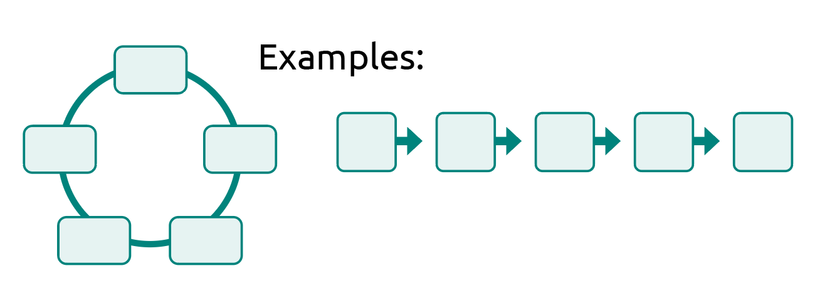
Which goal do you believe is the most important for achieving prosperity? Explain why.

Activity 2: Financing development
This lesson will explore how global cooperation and partnerships are helping to finance human development from a local scale to a global scale. Such an investigation sits within the subject of Economics: the study of how individuals, businesses and governments make choices in allocating resources to satisfy their needs. Economics determines how resources are produced, distributed and consumed in order to maximise output. Economics can be divided into two categories – macro and micro. Both are relevant to the financing of human development projects that boost prosperity, but their scope and size differ.
Macroeconomics studies the progress, behaviour and performance of the economy at a national, regional or international scale. It focuses on how variables interact to affect productivity. These variables include employment, economic growth, inflation, globalisation and trade. The aim is to provide widespread benefits that may help entire populations gain work through new industries. For example, two countries may sign a free trade agreement to encourage exports and build industry, offering more jobs to society.
An example of a macroeconomic partnership exists between the Australian Government and the Manila Angel Investors Network. In 2022, together they invested in 1Export, which is a female-founded company focused on supporting the reach of Filipino brands in the global market. The photo shows their chief marketing officer, who works on improving product visibility and reach both online and overseas.
Microeconomics considers the choices made by individual consumers and businesses, such as the supply and demand for goods and services in a marketplace. It focuses on changes in a situation based on the existing conditions.
For example, the price of fruit and vegetables may increase if the food crop has been damaged due to a weather event such as a flood. In this instance, the supply has been reduced so the demand is high. When the supply is low and demand is high, producers will often increase the price per unit. Fruit and vegetable prices fluctuate regularly.
Most importantly, these two types of economics – macro and micro – are interdependent. The Australian Government supports countries in our region through trade and cooperation, which means everyday products such as fruit and vegetables, rice and clothing are available and affordable in Australia. This highlights the economic participation and interconnection between consumers, businesses and governments.

Chief marketing officer of 1Export.
© Flordeliz Ranola/Department of Foreign Affairs and Trade
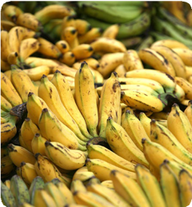
Josh Estey/Department of Foreign Affairs and Trade

- Can you identify which features are macroeconomics and which are microeconomics:
Criteria | Macroeconomics or microeconomics?
Studies individual, household and business trends to assist with the marketing of goods and services.
Considers the health of the overall economy.
Can provide credit to small groups of borrowers to assist with cash flow for a small business.
Aims for individuals to achieve self-reliance.
Focuses on smaller local scales and internal issues.
Covers several market sections and can relate to both environmental and external issues.
Supports projects that focus on entire societies or regions.
Provides tax benefits to certain industries to promote hiring workers and supporting the region.
Focuses on how product pricing, consumption and production factors might impact a market.
Considers and assesses government strategies and suggests strategies for unemployment, national income, inflation and poverty.
Arranges partnerships between government and private companies to commence large infrastructure projects.
Focuses on assisting families out of poverty through providing loans and training in necessary skills.
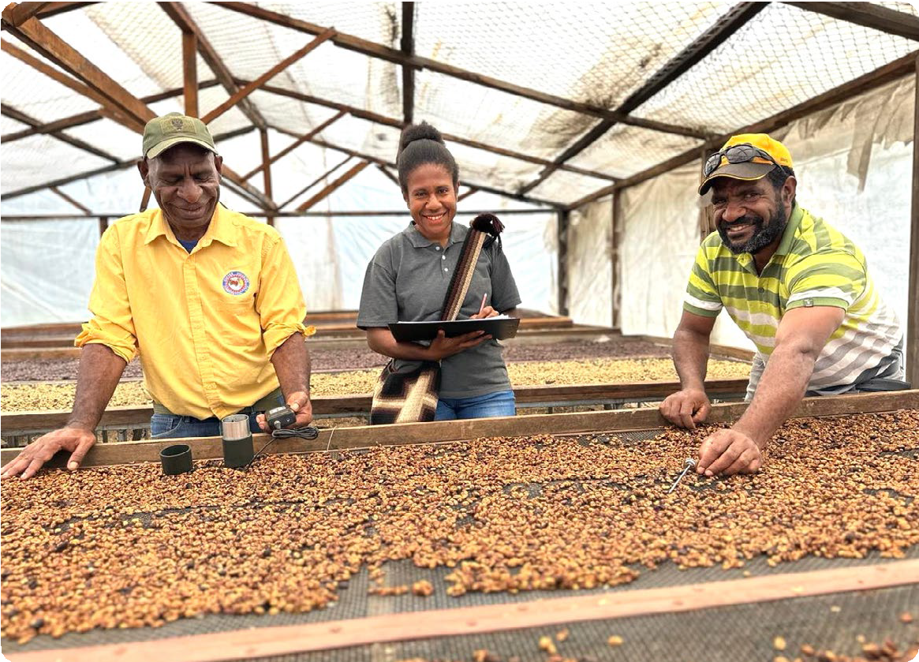
© Department of Foreign Affairs and Trade

- Identify whether the following scenarios involve macroeconomics or microeconomics. Briefly explain why, using a variety of the reasons outlined in the table to support your answer.
Scenario 1: Countries base their budget for future financial contribution to UN-led bodies, such as the World Health Organization, on global contexts.

Scenario 2: A cashew farmer in Indonesia learns how to conduct a market analysis to ensure he receives a fair trade amount for each kilo of cashews he produces.

Scenario 3: A $100 loan is made to a villager to buy the necessary equipment for making ceramics to sell at a weekly market stall aimed at tourists coming off cruise ships.

Scenario 4: A country seeks a debt swap from the World Bank towards a development project, such as improving schools or protecting forests.

Scenario 5: A group of coffee-bean growers form a collective to rent machinery and improve the quality of their crop so they can raise their prices.

Scenario 6: Non-government organisations work alongside countries to provide humanitarian aid and redevelopment to a country affected by an earthquake.

Scenario 7: Four local councils work together with a modern energy supplier to provide electricity to remote communities.

Scenario 8: A new partnership project finances a road construction, creating jobs for hundreds of local bricklayers and removing taxes on local concrete suppliers.

Scenario 9: Countries within a geographical region sign an alliance to help fund environmental conservation projects that will protect threatened species.

Scenario 10: A group of people working as stitchers are given a credit loan to begin their own small business stitching unique upholsteries for furniture. They invest in a sewing machine.

Scenario 11: A community decides to increase the price of rice to improve profits for growers and match the market value of other districts.

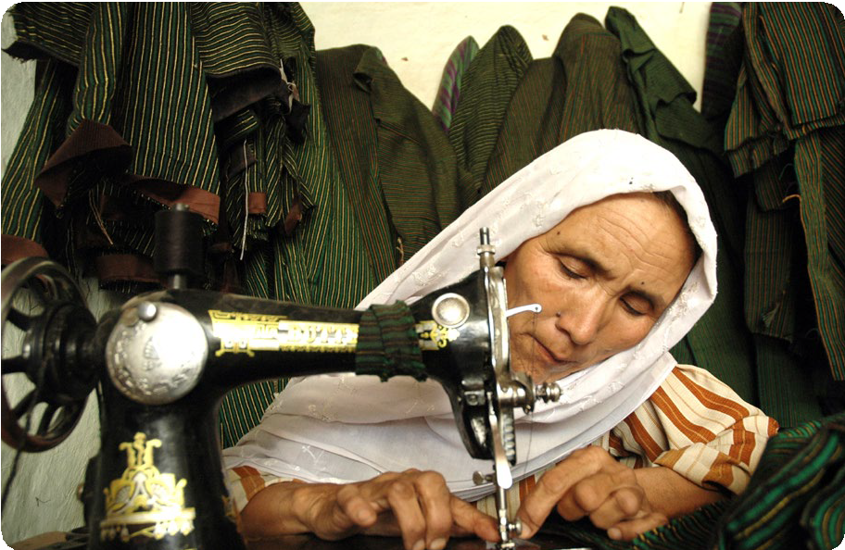
© Imal Hashemi, Afghanistan Reconstruction Trust Fund/Department of Foreign Affairs and Trade

Blended finance
Blended finance is a partnership between various financial stakeholders that helps to lower the risk of kickstarting large-scale development projects in low-income countries. Blended finance attracts private companies and financial institutions to invest, which boosts local employment and helps to work towards the Sustainable Development Goals (SDGs). The input from governments is considered catalytic. This means, their input is a catalyst for encouraging private companies to invest in a public good, bridging the gap between commercial returns and social impact. Without the partnership, it is unlikely such a project would occur.
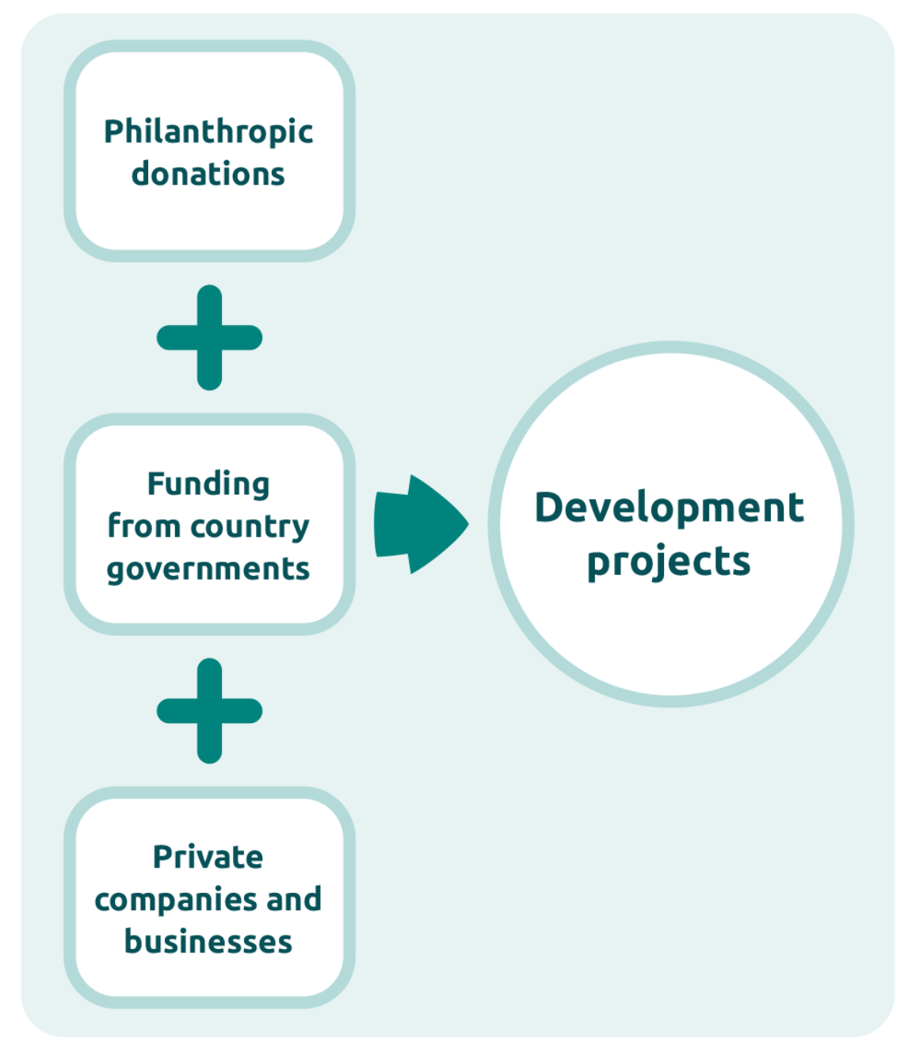
Blended finance is an example of macroeconomics, influencing large infrastructure and growth projects that can provide major employment opportunities, new skills and training, and encourage external investment. All of these together help to build a stronger economic market.
Development projects could include:
- telecommunications network infrastructure installation
- modern energy installations
- healthcare companies
- new technology startups
- water management infrastructure, such as dams, reservoirs and sewerage systems, and desalination.
Australian development investments have attracted $160 million in private investment since 2020. They aim to expand enterprises in the Indo-Pacific region that drive climate and gender outcomes. The funding helps to build markets, create jobs through innovation, and deliver important goods and services to communities. One dollar of funding from the Australian Government leverages $6 in private company investment.
Find out more about Australia’s development investments, projects and Blended financej.
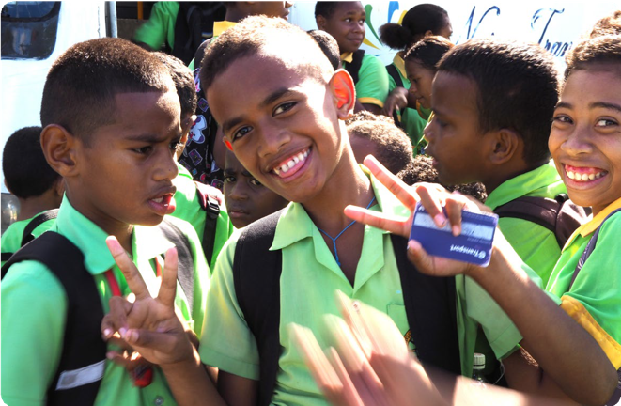
An infrastructure partnership between Australia and Fiji restored roads and allowed these children to catch a bus to school, improving accessibility and reducing daily travel time.
Image credit: © Talei Tora / Department of Foreign Affairs and Trade

Answer the following questions:
- Why are interdependencies between economic stakeholders important in a blended finance model? Think about the various risks present in low-income countries.

- What role do country governments and philanthropic organisations play in the decision-making process of private sector businesses?

- Some of the ways that risk is lowered by a government in a blended finance arrangement are shown below. Working in pairs, research the terms below and write a description of what each one means:
- Loans with lower than market interest rates

- Zero interest rate

- Extended repayment periods

- Grace periods

- Providing grants

- Providing equity

- Why would philanthropic organisations support blended finance? Think about their contribution to global citizenship.

- How is Australia upholding its global responsibilities towards the SDGs by establishing blended finance?

- Write a paragraph outlining the purpose, stakeholders and human development benefits of Palau’s solar energy investment. Refer to specific SDGs from Lesson 1 and include facts and figures.

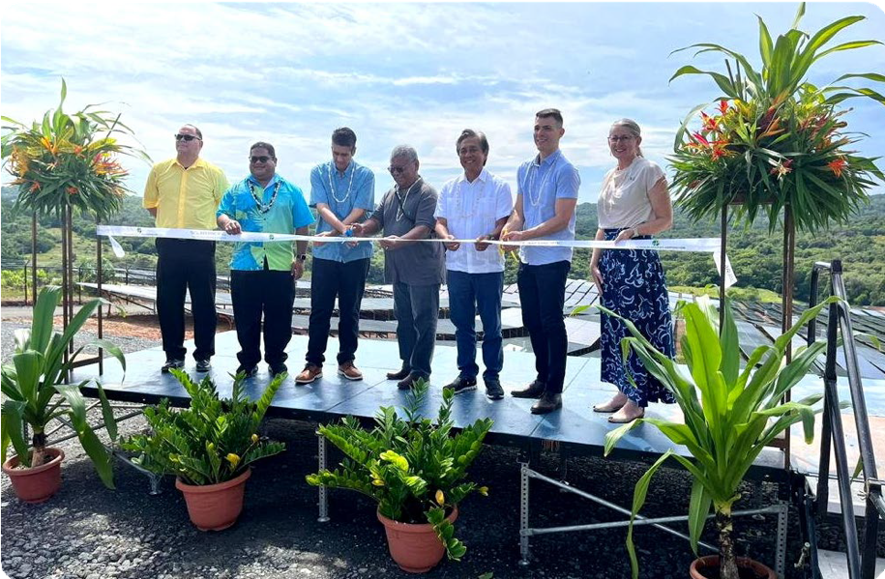
© Department of Foreign Affairs and Trade

Extension activity
If you are interested to understand how blended finance partnerships are encouraged, take a look at the information on the following two webpages. The first is a media release about a new health initiative. The second is a call for proposals.
- Investing in a stronger, healthy region – Australian Minister for Foreign Affairs
- Regional health partnerships – Call for Proposals – Indo-Pacific Centre for Health Security
After reading the media release and the call for proposals, outline what this new initiative is hoping to achieve and what SDGs it may assist.

Empowering communities
Microfinance provides financial assistance to individuals who lack access to a formal banking service. It is a form of microeconomics and plays an important role in encouraging entrepreneurship
in low-income countries, where there may be more barriers to starting a business. The services provided can include small loans, a savings account and insurance, as well as business training, mentoring and networking to promote sustainable businesses. The aims of microfinance are:
- to build independence and empowerment through generating income that can overcome household poverty
- to create opportunities for innovation and encourage people to explore their talents, new ideas and potential markets
- to foster social and economic development for communities by creating jobs, building productivity and reducing inequality
- to promote inclusivity and diversity for the poorest social groups, who may be considered high risk by banking institutions.
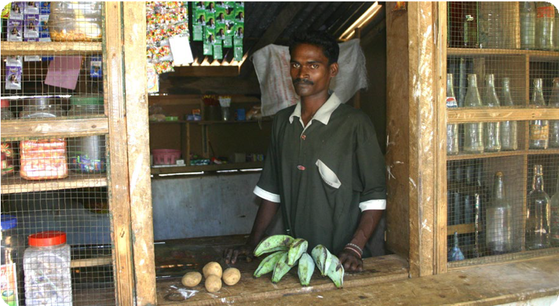
© Peter Davis/Department of Foreign Affairs and Trade
- Which United Nations (UN) Sustainable Development Goals (SDGs) are strongly supported by microfinance?

Activity 1: Supporting women entrepreneurs
Microfinance has considerable benefits for women in low-income countries, where it is often seen as a way to break out of the poverty cycle. Read this passage from microfinance researchers to understand why:
One of the first effects observed from women’s access to credit was the improvement of income and, consequently, the overall economic condition … This has had positive repercussions not only on the family but also on the strengthening of women’s social role. In fact, in addition to improving living conditions, women reinforce their position and role both within the family and in the community to which they belong …
The increase in women’s economic capacity influences the internal decision-making process within the family and contributes to an improvement in consumption, covering basic needs and savings. As women are more likely to spend their income on family-related matters, this also leads to improvements in their nutrition, health, education of children, and living conditions. Women’s access to credit enables them to initiate activities and manage the money according to their own wishes. This ultimately instils them with greater strength and confidence …
Source: Del Sarto, N., Bocchialini, E., Gai, L., & Ielasi, F. (2023). Microfinance, microcredit, and women’s empowerment: an exploration of the Grameen Bank experience for social inclusion. Journal of Accounting and Finance, 23.
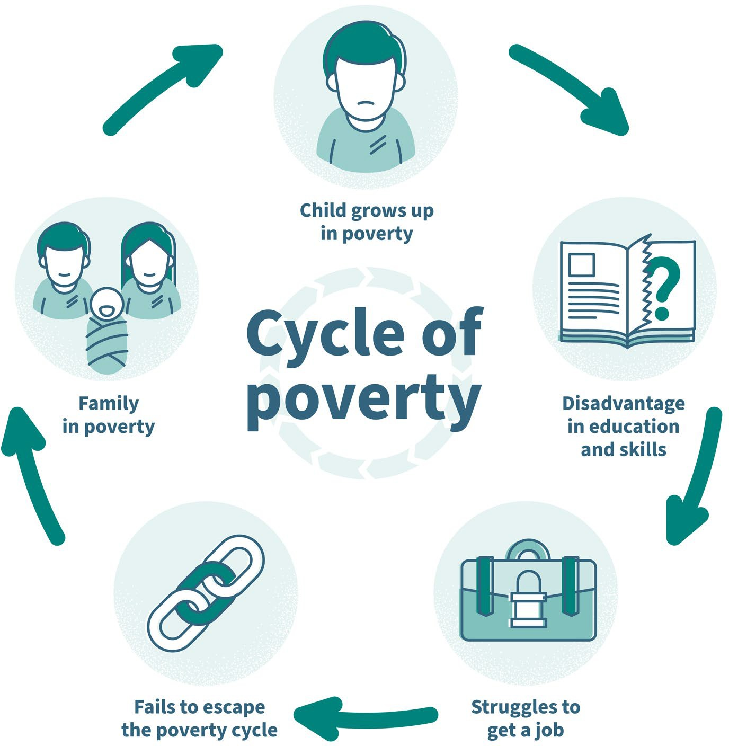
Adapted from: © VectorMine/Shutterstock
- Create your own cycle diagram or flowchart to show how a small microfinance loan could positively impact a family and possibly the wider community.

Activity 2: Microfinance partnerships
The effect that microfinance can have on the day-to-day lives of small communities is often best understood through case studies. Below are five examples of projects that have required partnerships between various stakeholders discussed in Lesson 1. You will read one article and complete one row of the table. You will then need to verbally summarise your knowledge to other people in the class. Explore a map of the country where the project is based and some demographic data, such as a population pyramid, to gain a more detailed understanding about the country and its future population needs.
- Enhancing sustainable coastal communities in the Pacific (worksheet provided)
- Supporting women experiencing vulnerability into housing (worksheet provided)
- Increasing financial inclusion in Cambodia (worksheet provided)
- Urban migrant entrepreneur capital in Vietnam – Business Partnerships Platform
- A more advanced read with video: Empowering women entrepreneurs in Fiji through fintech – Business Partnerships Platform
- After reading and summarising one article in the first row, switch groupings to find out about two more case studies in the list.
Case study details (where, what, who) | What financial support was received and what stakeholder partnerships enabled the project? | How did the project improve the livelihoods and lifestyles of communities, families or individuals? Can you relate the project to any specific SDGs?
- From your case study research, explain why countries such as Australia support investments in microfinance. Hint: think about the further benefits these investments bring to Australia, and consider how these investments reflect Australian values and our commitment to global citizenship and upholding UN responsibilities.

Extension question
- How is Australia upholding macroeconomic policies by encouraging regional microfinance enterprises?

Microfinance: Solomon Islands

Enhancing sustainable coastal communities in the Pacific
WWF-Pacific (Solomon Islands) is improving the sustainability of fisheries and the management of natural resources in the country’s Western Province through an integrated Sustainable Coastal Communities Programme.
One component of this program is the Sustainable Livelihoods and Women’s Empowerment project. The project understands that long-term conservation is best achieved by enhancing sustainable and equitable livelihood opportunities for the people who depend most on the natural environment.
In Solomon Islands, where 80% of women live in rural areas and rely on informal fisheries and agriculture-based economies for their livelihoods, this requires a special focus on facilitating sustainable economic opportunities for women.
Through the financial inclusion component of the program, WWF helps establish women’s microfinance savings clubs; conducts training in financial literacy, business planning, governance and leadership; and trains savings club members to become trainers themselves, to extend the financial inclusion work to neighbouring islands and communities. Working with more than 940 women across 33 communities, the financial inclusion component has seen more than 120 women-led business initiatives – all underpinned by strong business, social and environmental sustainability criteria – emerge in just over three years.
In addition to the direct economic benefits to these women, their families and communities, there are early indications that the income generated through these initiatives is reducing household dependency on overexploited coastal fisheries. Furthermore, in a country where women continue to face systematic discrimination and numerous structural obstacles to their participation, the financial inclusion component is an important stepping stone to encourage the involvement of women in community decision-making mechanisms that affect their lives.
This program is co-delivered by WWF-Australia and local partners, with support from Australia through the Australian NGO Cooperation Program (ANCP). It is also supported by John West Australia. The program is being implemented by WWF-Pacific (Solomon Islands), with support from WWF-Australia.
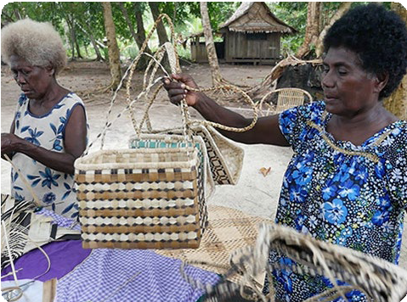
Through the financial inclusion component of WWF’s Sustainable Coastal Communities Programme, Grace Rano has improved the profitability of her basket-weaving business. She now employs other women in the community to help her grow her business and meet the growing demand from buyers in the Solomon Islands’ capital, Honiara.
© WWF-Australia/Wade Fairley

Microfinance: Nepal

Supporting women experiencing vulnerability into housing
Microfinance is a general term to describe financial services to low-income individuals or to those who do not have access to typical banking services. Microfinance is also the idea that low-income individuals are capable of lifting themselves out of poverty if given access to financial services.
Habitat for Humanity Australia (HFH; an accredited NGO) is supporting female-headed households experiencing vulnerability into adequate housing through the Eastern Nepal Community Development project (an ANCP funded project). The project has been working with families experiencing poverty, including female-headed households, to support them to build houses through low-cost microfinance loans. The project has been working to develop local Microfinance Institutions (MFI) capacity to manage a housing loan program, providing technical training to enable MFIs to support construction of low-cost durable housing. Due to poverty, the MFIs’ clients are not able to access formal financing, and these affordable housing solutions with financing enable working low-income families to achieve adequate housing for their families.
Urmila is a widow whose husband died five years ago, leaving her to raise two children alone. Her son is 10 years old, and her daughter is 15. They moved into their new house in November 2014. The former house was very basic and small. Its walls and roof were made of straw and it was not weatherproof. Urmila took a loan several years ago to buy land, and now she has been able to build a house. She borrowed 80,000 ($1,000), contributed 10,000 of her own savings, and received some subsidy from HFH to build her new house. In return she provided voluntary labour. She plans to pay off her loan in less than two years. She earns her living working in the nearby jute factory, as well as from animal rearing and making rice wine.
Living in a new house with a new toilet has changed Urmila and her family’s life. Urmila feels safer and more secure and is not so worried for her teenage daughter. Now they don’t need to go out in the dark at night to go to the toilet in the forest.
In 2014–15 through the ANCP, Australian aid supported nine NGOs to deliver 19 projects in 12 countries focusing on microfinance.
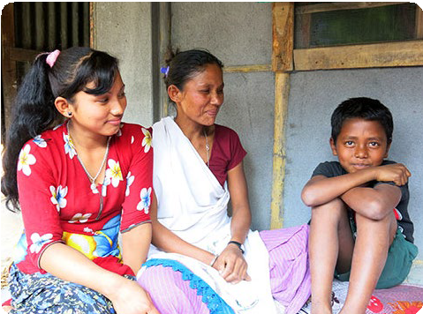
Urmila and her children outside their new house.
© Habitat for Humanity Australia

Microfinance: Cambodia

Increasing financial inclusion in Cambodia
In rural Cambodia, the Credit Union Development program run by Credit Union Foundation Australia (CUFA) provides villagers with safe and affordable access to financial products and services.
Over the past five years, CUFA has established 21 credit unions in rural Cambodia, allowing people to open village bank accounts and gain access to financial education and self-help groups. Credit union members are able to apply for microfinance loans to develop small businesses.
The program also supports rural farmers through livelihood groups, offering training in a variety of skills, including marketing, business management and financial literacy.
The program is key to reducing poverty and boosting economic prosperity in Cambodia.
CUFA is supported by the Australian Government through the Australian NGO Cooperation Program.
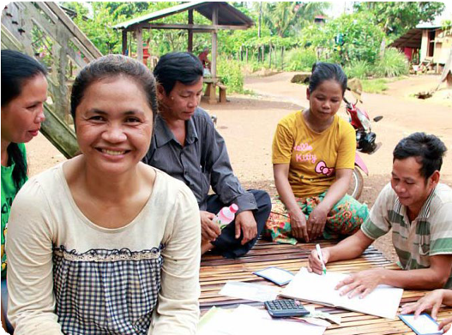
Harn is one of many Cambodians who has benefited from credit unions.
© CUFA

