WH AT WORKS BEST IN EDUC ATION FOR



DEVELOPMENT: **A SUPER**

**SYNTHESIS OF THE EVIDENCE**

A TOOL FOR DECISION MAKERS: A SUPER SYNTHESIS OF WHAT WORKS IN EDUCATION FOR DEVELOPMENT

All education decision makers want essentially the same thing: to know what works in meeting education’s greatest challenges. Those challenges revolve around three main issues: (1) how to get all children into school;

1. how to keep all children in school while ensuring that each child benefits from a meaningful education; and
2. how to ensure that all children, young people and adults have the knowledge, skills and abilities to make a positive difference in their own lives and in the lives of others.

A great many interventions and initiatives have been applied within education systems in developing countries. This ‘Super Synthesis’ of the evidence draws from 18 systematic reviews, meta-analyses and comparative reviews of ‘what works’ in education for development. By condensing this vast literature into an operational guideline, the Super Synthesis identifies which interventions have been shown to have the greatest impact on education quality and participation in a development sector context.

Two overarching themes emerged. First, the research clearly shows that the success of any intervention is dependent upon understanding the challenge to be addressed, and having a solid appreciation of the country context. Second, the evidence shows that any single intervention will only be successful if implemented in accordance with larger education sector dynamics, given the many inter-connecting parts of a functional education system; in other words, ensuring a systems-based approach to program implementation.

The Super Synthesis groups the evidence visually to enable decision makers—national governments, development partners and involved stakeholders—to easily assess possible interventions by the degree of their impact on education quality and participation, and their likely associated costs.

# METHODOLOGY AND FINDINGS

This Super Synthesis draws together 18 systematic reviews, meta-analyses and comparative reviews of ‘what works’ in education for development (see References). These reviews bring together key findings from more than 700 rigorous studies and their supporting research.

The source reviews analyse studies primarily from South Asia, Sub-Saharan Africa and South and Central America with a smaller proportion drawn from the Pacific and South-East Asia.

These reviews synthesised the available evidence, interpreted the results of primary research, and critically discussed the reasons why some education interventions are more effective than others. The majority of the reviews noted a high degree of variation across contexts, and in the duration and quality of the research included. Nevertheless, some broad patterns emerged which informed the compilation of this Super Synthesis of the available evidence.

In general, programs that focus on teacher performance and aligning teacher practice to school contexts indicate improved student learning outcomes. Well-designed curricula and assessment programs are also related to improved student learning outcomes.

In some contexts, system-level interventions such as teacher performance-based contracts and conditional cash transfers to families are related to positive improvements in student performance. Interventions that focus on educational infrastructure are costly, but strongly relate to increasing access and participation in schools. At the same time, additional infrastructure appears to have a limited effect on quality outcomes. Thus, an intervention that may have beneficial effects on student participation may have a negligible effect on education quality, or vice versa.

For the purposes of organising this Super Synthesis, the research was grouped according to intervention domains focusing on education quality and participation.

### Quality

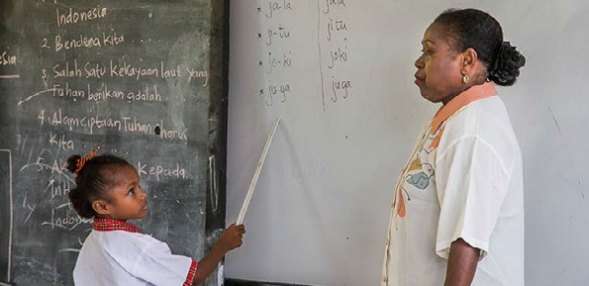

Quality of education can have a broad meaning and may encompass aspects of children’s health, their environment and the connections a child has to their community. The focus of this Super Synthesis, with regard to the quality of education, is on student learning outcomes and the specific factors that influence children’s learning.

### Participation

Participation in education relates to inclusion, access, enrolment, retention and transition from primary education through to secondary, technical-vocational and higher education.

While much is now known about ‘what works’ in education, a number of the source reviews underline that there is significant need for additional research on interventions and their effectiveness, especially as they relate to the development sector.

Despite this gap, the available research confirms that understanding context is the key critical factor in the effectiveness of an intervention in education—having a comprehensive understanding of the issues and problems at hand will ensure that the most effective intervention for that context is selected.

# HOW TO USE THE SUPER SYNTHESIS: STRENGTHS AND CAVEATS

The Super Synthesis identifies which interventions have the greatest impact on quality and participation (including associated costs), while underlining that impacts vary across contexts. Due to the nature of meta-analyses and systematic reviews, the data also represents an average of averages. The result is that Intervention Type scores within Domains look largely similar as results are drawn towards the centre. While there is a clear differentiation of ‘what works’ in terms of quality and participation between Domains, within Domains there is little variance in the impact of interventions (see for example the ‘Health care/Nutrition’ Domain). If practitioners are interested

in what works at the Domain level—infrastructure, school management, teacher workforce and so on—this tool provides a catalogue of similarly effective interventions to choose from, as best suits their context. If practitioners are interested in what works in enabling student participation and/or for improving education quality standards, this tool provides an illustrative guide. It also provides indicative unit cost information, organised by the point of investment (per community, per school, per teacher, and per student).

This Super Synthesis cannot and will not provide all the answers. Rather, it assists in asking informed questions about the country context, of implementing agencies, and with partner governments. Here is an example of a situation a practitioner may face, seen from two perspectives, with a suggestion of how this tool can inform decision making:

**An organisation proposes a major infrastructure investment—**

the Super Synthesis tells you that infrastructure investments are generally very good for access, but less good for improving quality standards. That helps you decide whether to consider the proposal or not, based on the challenges in your focus country.

**You want to do something about access—** the Super Synthesis tells you that some infrastructure investments are generally very good for access, but less good for improving quality standards. That helps you decide whether to investigate if an infrastructure shortage actually exists. It also highlights that infrastructure investments will not automatically solve student learning challenges; a combined approach will be necessary.



3

# DO SYSTEM-LEVEL INVESTMENTS ‘WORK’?

### Interpreting the ‘Sector Planning/Domain’

The weight of evidence summarised in the Super Synthesis shows that the lowest ‘evidence of impact’ is in the ‘Sector Planning/Financial Reform’ Domain. Does that mean that it is not worth investing in Education Sector Plans, or strengthening Education Monitoring Information Systems, or supporting the professional skills of Ministry of Education personnel? Not at all. Detailed sector planning, robust education statistics and skilled personnel represent the critical backbone of a well-functioning education system.

The challenge with a tool like this is in drawing a clear causal link from core investment in an education system, to how that resourcing directly makes a difference in student participation and education quality.

It always makes sense to plan well, to have the data to inform policy and budget priorities, and to have the personnel to implement effectively.



This is true for all sectors, and for all public policy making. It simply remains difficult for researchers to identify the direct and causal connection of core system investments to outcomes

like student retention and improved learning. This is because ‘backbone’ investments are mediated by the many inter-connecting parts of functional education systems.

So should we invest in sector planning and financial reform? Where an analysis of the local context shows that these areas need strengthening, then absolutely, yes.

understanding context is the key critical factor in the effectiveness of



an intervention in education—having a comprehensive

understanding of the issues and problems at hand will ensure that the most effective intervention for that context is selected.

HOW THE SUPER SYNTHESIS IS ORGANISED

**Intervention Domains**

Based on the evidence in the source reviews, each intervention has been grouped into one of seven domains (see diagram).

The main table shown on the following pages indicates the **indicative effectiveness** of each intervention organised by domain category.

Educational programs

Health care/ Nutrition

School management/ communities/ classrooms

Intervention Domains

Economic incentives

Sector planning/ Financial reform

### Likely Standardised Costs

The main table captures the likely standardised cost of

Teacher workforce

Infrastructure/ supplies/ facilities

each individual intervention type.

The following likely standardised costs (used within the following main table) are standardised per:

**Student-Level Investment** Costings shown beside this icon portray a likely unit cost per student.

**Teacher-Level Investment** Costings shown beside this icon portray a likely unit cost per teacher.

### Levels of Impact on Participation and Quality

Individual interventions are grouped by the level of assessed impact on **Education Participation and Quality.**

Four levels of impact have been established, from the lowest level of impact - Level 1 ‘May show promise, but limited evidence’ - to the highest level of impact - Level 4 ‘Evidence of high impact’ (see diagram below).

**Please note** that the lowest level - Level 1 ‘May show promise but Limited Evidence’ - is not to be disregarded as a possibility as future research may indicate higher levels of impact.

**School-Level Investment** Costings shown beside this icon portray a likely unit cost per school/institution.

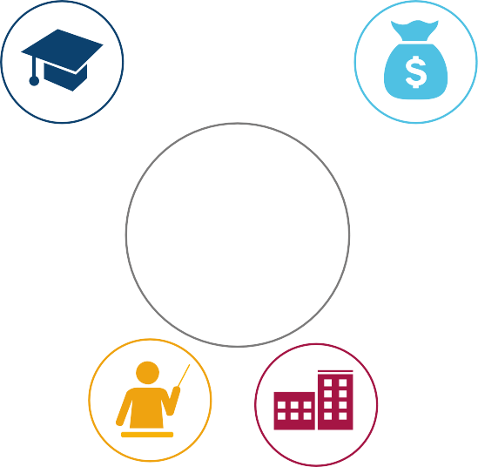

#### Local-Level Investment

Costings shown beside this icon portray a likely unit cost per community/town/ village.

= likely costs up to AUD $100

= likely costs between AUD $100–$300

= likely costs over AUD $300

**Level 4** Evidence of High Impact

**Level 3** Shows Promise of High Impact

#### Level 2

Limited Impact

#### Level 1

May Show Promise but Limited Evidence

Participation Quality

Participation Quality

Participation Quality

Participation Quality

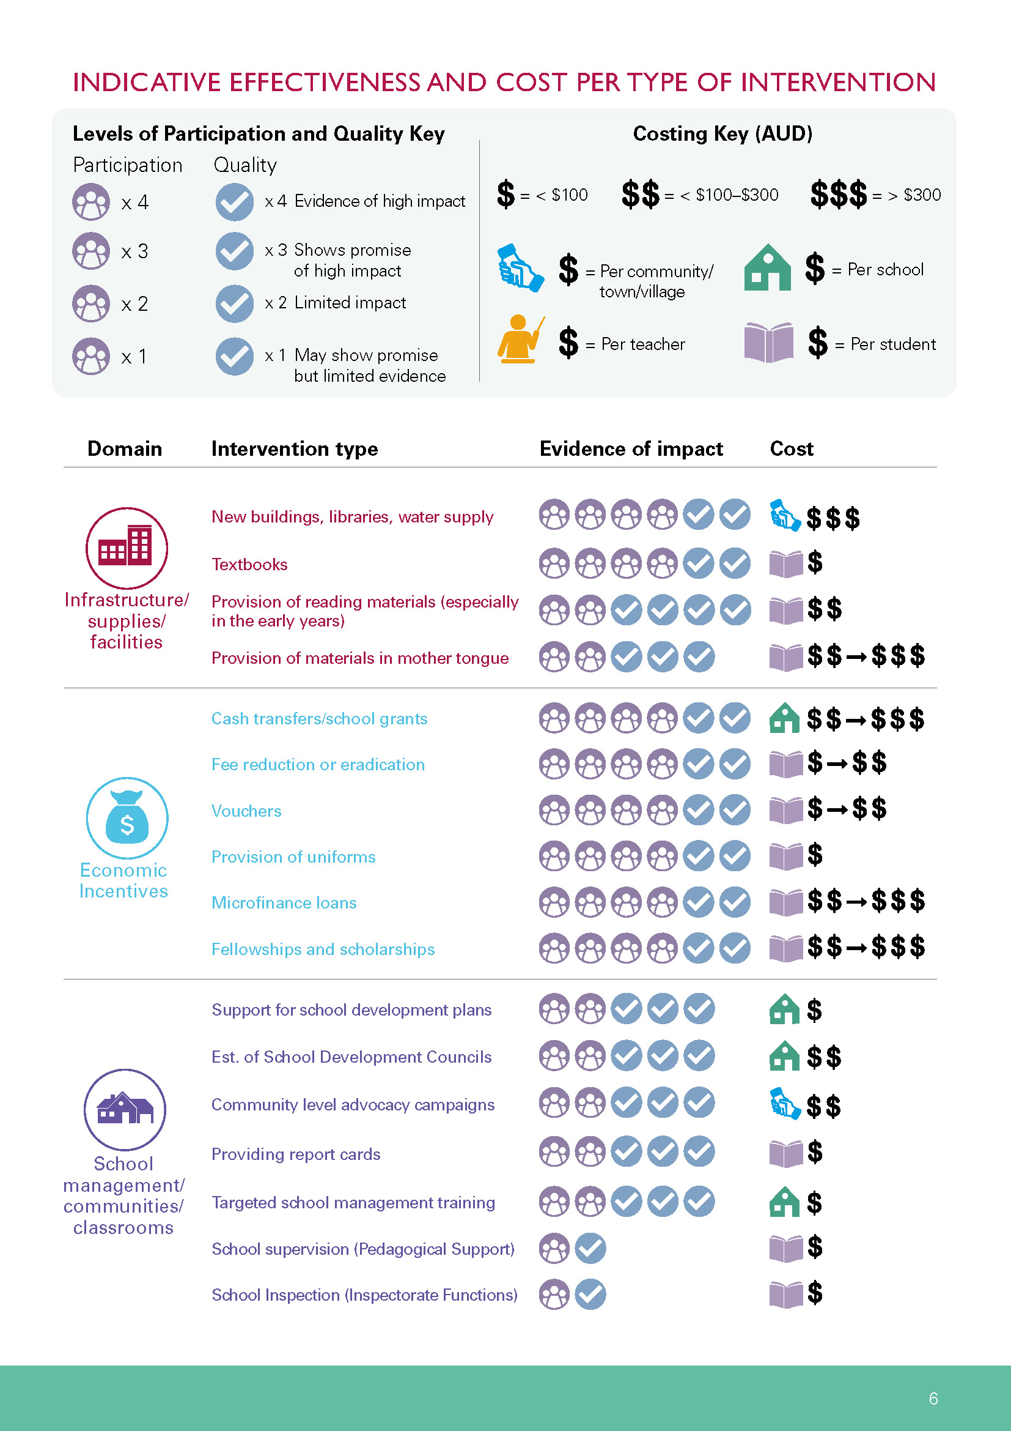

# C:\Users\acerdenahya\AppData\Local\Microsoft\Windows\Temporary Internet Files\Content.Outlook\9DK6BG28\DFAT_Super_Synthesis_Report_v8_Page_2.jpg

# REFERENCES

Angrist, N., Angrist, N., Patrinos, H. A., & Schlotter, M. (2013). *An expansion of a global data set on educational quality: A focus on achievement in developing countries*. (Policy Research Working Paper No. WPS6536). doi.org/10.1596/1813-9450-6536

Asim, S., Chase, R.S., Dar, A., & Schmillen, A. D. (2015). *Improving education outcomes in South Asia: Findings from a decade of impact evaluations*. (Policy Research Working Paper No. WPS7362). Retrieved from [http://documents.worldbank.org/curated/](http://documents.worldbank.org/curated/en/254411468188375892/pdf/WPS7362.pdf) [en/254411468188375892/pdf/WPS7362.pdf](http://documents.worldbank.org/curated/en/254411468188375892/pdf/WPS7362.pdf)

Baird, S., Ferreira, F., Özler, B., & Woolcock, M. (2014). *Conditional, unconditional and everything in between: A systematic review of the effects of cash transfer programmes on schooling outcomes*. Journal of Development Effectiveness, 6(1), 1-43. Retrieved from <http://www.tandfonline.com/doi/full/10.1080/19439342.2014.890362>

Bartlett, S. (2010). *Improving learning achievement in early primary in low-income countries: A review of the research*. Retrieved from [http://www.akdn.org/sites/akdn/files/media/publications/2010\_-\_akf\_-\_improving\_learning\_achievement\_in\_early\_primary\_](http://www.akdn.org/sites/akdn/files/media/publications/2010_-_akf_-_improving_learning_achievement_in_early_primary_in_low-income_countries.pdf) [in\_low-income\_countries.pdf](http://www.akdn.org/sites/akdn/files/media/publications/2010_-_akf_-_improving_learning_achievement_in_early_primary_in_low-income_countries.pdf)

Best M., Knight P., Lietz, P., Lockwood, C., Nugroho, D., & Tobin, M. (2013). *The impact of national and international assessment programmes on education policy, particularly policies regarding resource allocation and teaching and learning practices in developing countries*. Final report. Retrieved from [http://research.acer.edu.au/cgi/viewcontent.cgi?article=1016&context=ar\_misc](http://research.acer.edu.au/cgi/viewcontent.cgi?article=1016&amp;context=ar_misc)

Elango, S., García, J. L., Heckman, J.J., & Hojman, A. (2015). *Early childhood education*. (NBER Working Paper No. 21766). Retrieved from <http://www.nber.org/papers/w21766.pdf>

Evans, D., & Popova, A. (2015). *What really works to improve learning in developing countries?: An analysis of divergent findings in systematic reviews*. (Policy Research Working Paper No. WPS7203). Retrieved from [http://documents.worldbank.org/curated/](http://documents.worldbank.org/curated/en/516191468172488103/pdf/WPS7203.pdf) [en/516191468172488103/pdf/WPS7203.pdf](http://documents.worldbank.org/curated/en/516191468172488103/pdf/WPS7203.pdf)

Evans, M.D.R., Kelley, J., Sikora, J., & Treiman, D.J. (2010). *Family scholarly culture and educational success: Books and schooling in 27 nations*. Research in Social Stratification and Mobility, 28(2), 171-197. doi.org/10.1016/j.rssm.2010.01.002

Glewwe, P., & Muralidharan, K. (2016). *Improving school education outcomes in developing countries: Evidence, knowledge gaps, and policy implications*. Handbook of the Economics of Education, 5, 653-743. doi.org/10.1016/B978-0-444-63459-7.00010-5

Krishnaratne, S., White, H., & Carpenter, E. (2013). *Quality education for all children? What works in education in developing countries*’. (3ie Working Paper No. 20). Retrieved from <http://www.3ieimpact.org/media/filer_public/2014/11/19/wp_20_1.pdf>

McEwen, P. J. (2015). *Improving learning in primary schools of developing countries: A meta-analysis of randomized experiments*. Review of Educational Research, 85(3), 353-394. Retrieved from [http://academics.wellesley.edu/Economics/](http://academics.wellesley.edu/Economics/mcewan/PDF/meta.pdf) [mcewan/PDF/meta.pdf](http://academics.wellesley.edu/Economics/mcewan/PDF/meta.pdf)

McKinsey (2010). *How the world’s most improved school systems keep getting better*. Retrieved from [https://mckinseyonsociety.](https://mckinseyonsociety.com/downloads/reports/Education/How-the-Worlds-Most-Improved-School-Systems-Keep-Getting-Better_Download-version_Final.pdf) [com/downloads/reports/Education/How-the-Worlds-Most-Improved-School-Systems-Keep-Getting-Better\_Download-version\_Final.pdf](https://mckinseyonsociety.com/downloads/reports/Education/How-the-Worlds-Most-Improved-School-Systems-Keep-Getting-Better_Download-version_Final.pdf)

Perlman Robinson, J., & Winthrop, R. (2016). *Millions learning: Scaling up quality education in developing countries*. Retrieved from [https://www.brookings.edu/research/millions-learning-scaling-up-quality-education-in-developing-countries/](https://www.brookings.edu/research/millions-learning-scaling-up-quality-education-in-developing-coun)

Petrosino, A., Morgan, C., Fronius, T., Tanner-Smith, E. E., & Boruch, R. F. (2014). *What works in developing nations to get children into school or keep them there? A systematic review of rigorous impact studies*. Retrieved from [http://journals.sagepub.](http://journals.sagepub.com/doi/pdf/%2010.1177/1049731514524837) [com/doi/pdf/%2010.1177/1049731514524837](http://journals.sagepub.com/doi/pdf/%2010.1177/1049731514524837)

Psacharopoulos, G. (2015). *Benefits and Costs of the Education Targets for the Post-2015 Development Agenda: Post- 2015 Consensus*. Retrieved from [http://www.copenhagenconsensus.com/sites/default/files/education\_assessment\_-\_](http://www.copenhagenconsensus.com/sites/default/files/education_assessment_-_psacharopoulos_0.pdf) [psacharopoulos\_0.pdf](http://www.copenhagenconsensus.com/sites/default/files/education_assessment_-_psacharopoulos_0.pdf)

Snilstveit, B., Stevenson, J., Menon, R., Phillips, D., Gallagher, E., Geleen, M., Jobse, H., Schmidt, T., & Jimenez, E. (2016). *The impact of education programmes on learning and school participation in low- and middle-income countries: A systematic review summary report*. Retrieved from [http://www.3ieimpact.org/en/publications/systematic-review-publications/3ie-](http://www.3ieimpact.org/en/publications/systematic-review-publications/3ie-systematic-review-education-effectivenes-srs7) [systematic-review-education-effectivenes-srs7/](http://www.3ieimpact.org/en/publications/systematic-review-publications/3ie-systematic-review-education-effectivenes-srs7)

Sperling, G. B., & Winthrop, R. (2016). *What works in girls’ education: Evidence for the world’s best investment*. Retrieved from ht[tps://www.brookings.edu/wp-content/uploads/20](http://www.brookings.edu/wp-content/uploads/2016/07/whatworksingirlseducation1.pdf)1[6/07/what](http://www.brookings.edu/wp-content/uploads/2016/07/whatworksingirlseducation1.pdf)w[orksingirlseducation](http://www.brookings.edu/wp-content/uploads/2016/07/whatworksingirlseducation1.pdf)1[.pdf](http://www.brookings.edu/wp-content/uploads/2016/07/whatworksingirlseducation1.pdf)

Westbrook, J., Durrani, N., Brown, R., Orr, D., Pryor, J., Boddy, J., & Salvi, F. (2013). *Pedagogy, curriculum, teaching practices and teacher education in developing countries: final report*. Retrieved from [http://eppi.ioe.ac.uk/cms/Portals/0/PDF%20](http://eppi.ioe.ac.uk/cms/Portals/0/PDF%20reviews%20and%20summaries/Pedagogy%202013%20Westbrook%20report.pdf?ver=2014-04-24-121331-867) [reviews%20and%20summaries/Pedagogy%202013%20Westbrook%20report.pdf?ver=2014-04-24-121331-867](http://eppi.ioe.ac.uk/cms/Portals/0/PDF%20reviews%20and%20summaries/Pedagogy%202013%20Westbrook%20report.pdf?ver=2014-04-24-121331-867)

# FURTHER READING

*Education Endowment Foundation* (n.d.) Teaching & Learning Toolkit. Retrieved from <https://educationendowmentfoundation.org.uk/resources/teaching-learning-toolkit>

*Evidence for Learning* (n.d.) Teaching & Learning Toolkit. Social Ventures Australia. Retrieved from <http://evidenceforlearning.org.au/the-toolkit/>

This synthesis was produced by the Education Analytics Service (EAS).The Department of Foreign Affairs and Trade, through the Education Section, has established the EAS to improve the extent and quality of evidence and expertise used to inform its education policy and programs. The



EAS is managed by the Australian Council for Educational Research and Cardno International Developments.

For more information on the synthesis,

contact [**eas@acer.edu.au**](mailto:eas@acer.edu.au)