Final report | november 2019

Mid Term Review of the Strategy for Australia’s Aid Investments in Education 2015-2020

Executive Summary

The “Mid Term Review of the Strategy for Australia’s Aid Investments in Education 2015-2020” was commissioned by the Department of Foreign Affairs and Trade (DFAT) to determine the extent to which the Strategy has influenced the development and implementation of education investments. Specifically, the review tested the assumption that effective, appropriate and policy-aligned programming results emerge from centrally-issued guidance.

Methodology

The review was conducted between September 2018 and March 2019 by an independent team of two evaluators. It was guided by a review framework and used the following data collection methods:

* Interviews with DFAT managers and staff based in Canberra and Australia-based (AB) and locally-engaged staff (LES) at Post: Of the 56 stakeholders contacted, 32 were interviewed.
* Portfolio review: The review team conducted desk portfolio reviews of 19 countries and regions in which Australian education aid investments were made.
* Online survey of 161 in-country DFAT staff identified by DFAT: 78 staff responded (48 per cent).

Findings

Finding 1: The Strategy was designed in conjunction with the 2014 Aid Policy and remains aligned with the 2017 Foreign Policy White Paper.

Finding 2: The extent to which investments in education are consistent with the principles set in the Strategy is mixed and varies across countries. (Q1.2)

Finding 3: The Strategy is generally seen and used as a background document and a good reference tool but has had marginal influence in informing Australian education aid investments at country level.

Finding 4: Overall, the level of awareness of the Strategy’s guidance notes is low but, for those who use them, they can be a useful complement to the Strategy.

Finding 5: The potential usefulness of support for effective strategy implementation provided to Posts by the Education Section in DFAT’s Development Policy Division is limited by low resourcing of technical capacity. (Q2)

Finding 6: The process of developing the Strategy was mainly consultative and well communicated at its launch. Thereafter, communication has been insufficient to ensure general awareness.

Finding 7: The Strategy is a guidance document rather than a compliance document and there is no mechanism for DFAT staff to be held accountable for the Strategy's delivery. (Q3.4)

Finding 8: The principles of the Strategy are relatively durable as they are based on ways of working with partners that remain relevant over time. (Q3.3)

Conclusions

The 2015 Strategy fully aligns with the 2014 Australian Aid Policy and remains consistent with the 2017 Foreign Policy White Paper. However, as there is no mechanism to ensure that country programs invest in education at any particular level, the Strategy serves only to provide guidance rather than direction.

The Strategy has had modest influence on the development and implementation of education investments although it is a useful reference point to frame the relevance of investments in the Aid Quality Checks and in the design of new investments.

In testing the assumption that effective, appropriate and policy-aligned programming results emerge from centrally-issued guidance, the review found that factors other than the Strategy had greater influence. Country priorities are paramount and there is no explicit requirement to consider the Strategy or consult with the Education Section or Development Policy Division in general when developing Aid Investment Plans, although this is considered best practice.

Some DFAT staff reported difficulty in making the case for education within a broader foreign policy context. There is strong support for education where it demonstrably supports peace, security and people-to-people agendas but many staff at Post find it very difficult to justify investment in education, especially in the face of cuts to the global and country budget.

The review did not seek to assess staff capacity but the subject was raised in almost all interviews. At Post some staff feel ill-prepared to engage in policy dialogue about technically and institutionally complex issues of education reform. The Strategy is strong on the principles of being fit for purpose and taking a systems-based approach but it is no substitute for technical education experience or deep understanding of the country’s education institutions. At Canberra level, the Education Section is also aware of its limited capacity, which has declined over the years. It nominally has a role in promoting the Strategy but lacks a mechanism and a budget through which to do it. Without specialist capacity, Australia cannot have influence at the policy table commensurate with its financial investment.

The subject of the review was the principles of the Strategy, not the priorities. The principles are based on sound evidence about what works in education and on globally agreed principles of aid effectiveness. They are therefore durable and stand the test of time. In contrast, although the priorities are also based on evidence of what makes the most difference in education outcomes globally, the place for priority setting and decision making is the country. The strength of the Strategy is therefore in its guidance about how to work rather than what to do.

There is room to improve awareness of the Strategy and to update it to reflect the context of Sustainable Development Goals and latest evidence about what works in education. However, for education to be a realisable priority for DFAT, it needs the kind of political leadership that has been given to gender and disability inclusion.

Maintaining a Strategy is a good investment of time and resources: it sets direction and priorities; facilitates communication within DFAT and with partners about what DFAT stands for; simplifies decision-making in Canberra and at Post; increases accountability; and can mitigate risk. However, DFAT has multiple strategies and there is a question about whether these can be more usefully combined. A single multisectoral strategy would not only improve clarity within DFAT but might facilitate greater strategic engagement with partner governments about how to tackle multidimensional disadvantage and inequality in a way that single sector strategies cannot. On the other hand, a multisectoral strategy may be less efficient in practical implementation because of the challenges in trying to work across the bureaucratic silos of donor and partner. Whether single or multisectoral, the process of priority-setting must be led by partner countries and therefore the strategy needs to be flexible. Critically, the realisation of any strategy depends on technical capacity to engage meaningfully in policy dialogue.

Recommendations

We make the following recommendations to improve the effectiveness of the Strategy at two levels, strategic and operational. At the strategic level, Recommendation 1 is addressed to the Senior Leadership at DFAT. The second recommendation is addressed to the Education Section as it considers approaches to increase the influence of the Strategy. But regardless of how diligent the Education Section is in implementing operational recommendations, if Recommendation 1 is not addressed seriously, the influence of the Strategy will probably remain minimal.

Senior leaders and Policy makers at DFAT should define the relative priority of education in relation to other sectors.

The review noted several institutional shortcomings that have prevented the Strategy from gaining traction. First, there are no targets for education or other sectors in *Making Performance Count: enhancing the accountability and effectiveness of Australian aid.* DFAT leaders must take action to enhance the accountability of its staff for education investments, include education in the accountability framework, and raise the profile and the importance of education as a whole.

The Education Section should take actions to update the Strategy in the context of the SDGs

Evidence emerging from the review confirm the importance of having an Education Strategy as a guiding framework describing what DFAT stands for in education. As it considers a next iteration of the Strategy, the Education Section should take the opportunity to review the content of the Strategy in the context of SDG 4 (Quality Education) to see if it aligns sufficiently with the 10 SDG targets in education and update the content to reflect latest evidence about what works in education investment.

Senior leaders at DFAT should increase the accountability for education investments and address the capacity implications for realising the principles of the Strategy.

The review highlighted an institutional shortcoming related to capacities to implement the Strategy in a context where the organization has been depleted of its technical expertise and largely relies on generalists to manage investments. The review found that the staffing pattern in countries is not conducive for evidence-based investment decisions, or to engage in policy dialogue at a level that can maximise effective results.

The Education Section should deploy more effective mechanisms to communicate the Strategy and disseminate the Guidance Notes to support the implementation of the Strategy.

The review demonstrated that awareness of the Strategy and Guidance Notes was low overall. Many staff were not aware of the existence of such materials or indicated that they were not easy to find. In light of these conclusions, the Education Section should plan for more systematic dissemination of the Strategy and Guidance Notes. For these mechanisms to be effective, they must also get the backing of DFAT leadership to reiterate the importance of education.

Acronyms

|  |  |
| --- | --- |
| AB | Australia-based (staff) |
| AIP | Aid Investment Plan |
| APPR | Aid Program Performance Report |
| AQC | Aid Quality Check |
| AusAID | Australian Agency for International Development |
| BRAC | Bangladesh Rural Advancement Committee |
| DFAT | Department of Foreign Affairs and Trade (Australia) |
| ECD | Early Childhood Development |
| EMIS | Education Management Information System |
| GPE | Global Partnership for Education |
| LE | Locally engaged (staff) |
| MIC | Middle-Income Country |
| ODE | Office of Development Effectiveness |
| PNG | Papua New Guinea |
| SABER | Systems Approach for Better Education Results |
| SDG | Sustainable Development Goals |
| TOR | Terms of Reference |

Contents

Executive Summary i

1 Introduction 1

2 Methodology 2

3 The Education Strategy 4

4 Evaluation Findings 6

4.1 Relevance and Alignment of the Strategy with National Frameworks 6

4.2 Influence and use of the Strategy and its Guidance Notes in education investment decision-making 9

4.3 Processes for Managing the Strategy 21

4.4 Reflections on the purpose of the Strategy 25

5 Conclusions and Recommendations 28

5.1 Conclusions 28

5.2 Recommendations 29

Figures

Figure 3.1 Investment in education 2014-2018 in AUD 5

Figure 4.1 Survey responses to questions on alignment of education aid investments to principles of the Strategy (N=65) 10

Figure 4.2 Survey responses on the usefulness of the Strategy and/or its guidelines (N=36) 15

Figure 4.3 Survey responses on extent to which Strategy has informed AIPs (N=66) 15

Figure 4.4 Survey responses on awareness of Strategy’s guidance notes (N=72) 17

Figure 4.5 Survey responses to question on whether respondent has read the Strategy’s guidance notes 17

Figure 4.6 Survey responses to question on DFAT additional technical advice (N=66) 19

Figure 4.7 Survey responses to question on additional technical advice from an external resource (N=66) 20

Figure 4.8 Survey responses on level of communication of the Strategy (N=65) 22

Figure 4.9 Survey responses on source of awareness of the Strategy (N=42) 23

Tables

Table 4.1 Strategic Performance Targets for Australian Aid 9

Appendices

Appendix I Terms of Reference (TOR) 31

Appendix II Review Matrix 41

Appendix III Interview Protocol 44

Appendix IV List of Stakeholders Consulted 46

Appendix V List of Documents Reviewed 49

Appendix VI Survey Results 55

# Introduction

We are pleased to present this report on the “Mid Term Review of the Strategy for Australia’s Aid Investments in Education 2015-2020” to the Department of Foreign Affairs and Trade (DFAT).

Objectives of the Review

As per the Terms of Reference (TOR) presented in Appendix I, the review served the dual objectives of accountability and learning. The key objective was to determine the extent to which the Strategy has influenced the development and implementation of education investments. Specifically, the review tested the assumption that effective, appropriate and policy-aligned programming results emerge from centrally-issued guidance.

Accordingly, the review sought to explore:

* How useful the Strategy[1] has been as a guide to program/investment design and implementation, especially with regards to:
* the factors enabling or preventing adoption by program areas of the approaches/responses suggested in the Strategy and supplementary guidance notes
* The strengths, weaknesses and appropriateness of the Strategy and implementation processes. In examining this, the review established:
* the extent to which the Strategy’s suggested approaches have been appropriate and effective in those settings where the suggested solutions have been adopted.

The review also makes recommendations for a future DFAT education strategy.

The review does not include an examination of the effectiveness of the education programming of DFAT nor does it examine the influence of the Strategy on the Scholarships and Awards program supported by DFAT.

Organization of the Report

Following this introduction, the report is organized as follows:

* Section 2 outlines the methodology and limitations of the review and how the team mitigated these
* Section 3 provides the context/description of the Strategy
* Section 4 presents the findings of the mid-term review
* Section 5 presents the conclusions and recommendations of the review team.

# Methodology

Overview of the Methodology

The review was conducted between September 2018 and March 2019 by an independent team of two evaluators. This review took a summative and a formative approach. Emphasis was placed on the relevance of the Strategy and its alignment with national frameworks, preliminary results of the usefulness of the Strategy’s principles in decision-making for education aid investments, and the processes for managing the Strategy.

The review was guided by a review framework, presented in Appendix II, outlining key review questions, sub-questions, indicators and data collection methodologies. The review team used the following data collection methods and analysis.

**Interviews with DFAT managers and staff based in Canberra and Australia-based (AB) and locally-engaged staff (LES) at Post**: The review team conducted individual and small group interviews with selected global stakeholders and the members of the review reference group representing different areas of DFAT. A first series of individual and group interviews was conducted from 10-12 September 2018 in Canberra and with a group of NGOs in Melbourne. Following this, stakeholders were consulted in telephone interviews. A total of 66 stakeholders were consulted for this review. See Appendix III for the interview protocol and Appendix IV for a list of consulted stakeholders.

**Portfolio review:** The review team conducted desk portfolio reviews of 19 countries[2] and regions[3] in which Australian education aid investments were made. These portfolio reviews were informed by an analysis of relevant country level documents, including Aid Quality Checks (AQCs), Aid Investment Plans, investments mapping, etc., to assess the extent to which the portfolio of investments reflects the principles and approaches of the Strategy. See Appendix V for a list of documents reviewed.

**In-depth country reviews:** Due to the unavailability of country Posts to host field missions from the review team, the review instead conducted desk-based document review and interviews with DFAT staff via telephone. The review team explored factors that support or limit the use of the Strategy for country level educational investments, and the extent to which DFAT’s education investments at the country level have been informed by the Strategy.

**Survey of in-country DFAT staff:** The review team administered an online survey to 161 DFAT staff who were identified by DFAT. A total of 78 staff responded to the survey (48 per cent response rate), of which 64 per cent were AB staff and 36 per cent were LES. The survey collected information that informed questions on the extent to which the Strategy is known and used, the guidance notes are found useful, as well as the extent to which the education investments are aligned with the Strategy’s principles, among others. Survey results are presented in Appendix VI.

Limitations and mitigation strategies

The main limitations of the review are outlined below, along with brief mitigation strategies.

The original approach to the evaluation included field visits to three countries. However, further to multiple exchanges with Posts these missions were cancelled due to the involvement of Posts with other missions and the limited availability to accommodate a mission for the review. This limitation accounts for the lack of country perspective that was initially envisaged. To mitigate this limitation, the review team conducted additional telephone interviews with designated development partner stakeholders at the country level, including in one instance (Myanmar) with a government representative. A second limitation faced by the review team was the inaccessibility of some interviewees, as seen in the low response rate of DFAT staff to interview requests (28 out of 56 were interviewed). This was in spite of multiple email requests for interviews. However, the response rate to the review’s survey was relatively high (48 per cent) and provided the review team with a viable source of data to complement the interview data.

# The Education Strategy

Strategy priorities and principles

The Strategy for Australia’s aid investments in education (2015-2020) was launched in September 2015. It sits under the overarching development policy framework of 2014, Australian aid: promoting prosperity, reducing poverty, enhancing stability, in which education was identified as a priority sector. It commits Australia to invest in better education outcomes for all children and youth across the Indo-Pacific region, to contribute to reduced poverty, sustainable economic growth, and enhanced stability.

The Strategy sets out how the Australian government will work with partner countries to help them deliver comprehensive and high-quality education services. It has four strategic priorities:

* **Getting the foundations right:** participating in Early Childhood Development
* **Learning for all:** improving learning outcomes and improving the quality of education
* **Universal participation:** with a particular focus on including girls and children with disabilities
* **Skills for prosperity:** improving access to high-quality, post-secondary education and training.

The effectiveness of investments in the priority areas is to be achieved by the application of four principles:

* **Be fit for purpose**: grounded in the context and priorities of partner countries, taking into account economic, political and social drivers and constraints
* **Take a systems based approach**: recognising the complex and interdependent nature of education systems and understanding the impact on the whole
* **Engage in policy dialogue and reform for greatest leverage**: strengthening policy to lay the foundations for sustained improvement through politically informed dialogue and technical support
* **Prioritise the use of evidence for decision-making**: promoting good quality evidence to inform policy and practice.

Australia’s investment in education

**Australian aid investments in education have decreased steadily since 2015, when the Strategy was released.** The amount Australia has invested in education aid investments has decreased from AUD1,072 million in 2014/15 to AUD643.4 million in 2017/18 (see Figure 3.1).[4] The budget estimate for 2019/20 is AUD619.1 million.[5] Within the allocation, the tertiary sector Australia Awards were increased from 40 to 47 per cent. At the same time, compared with 16 high-level technical advisors in education in 2013, there were five in 2015, only one of whom was an ongoing DFAT employee. The 2014/15 Education Sector Snapshot stated that this reduced capability to influence national policy processes and guide international development decisions.

Figure 3.1 Investment in education 2014-2018 in AUD[6]

Between 2014-2017 the overall aid budget to education was reduced by 40 percent. This particularly affected South-East and East Asia, notably Indonesia and the Philippines and there were sizable reductions in other regions. In South Asia, education investment in Afghanistan reduced considerably in 2016 and in Nepal in 2018.

**The manner in which reductions to overall aid allocations resulted in less funding to education aid and the reasons for this, varied across countries.[7]** In some cases, such as Indonesia, the impact of the reduction in aid allocations was wide ranging and difficult to manage. In Afghanistan, the reductions entailed the closing of a large single investment in education. In other cases, reductions to aid allocations were more easily absorbed for different reasons. In Bangladesh, a decision was made to not enter into the next phase of a sector wide program due to challenges to achieving results, while in Timor-Leste, a dedicated education program has been incorporated into a broader human development program. Despite having a large education sector program, PNG also received substantial reductions in education aid investments.

**The reductions in overall aid expenditure has been high for the education sector.** In 2014/15, education represented the largest sector expenditure at 22.4 percent of ODA.In2017/18 it fell to 18 per cent, second to governance (22 per cent). In the 2018/19 financial year, education constituted 16 per cent and lagged fourth behind effective governance, infrastructure and trade, and building resilience.[8]

# Evaluation Findings

## Relevance and Alignment of the Strategy with National Frameworks

The Strategy was designed in conjunction with the 2014 Aid Policy and remains aligned with the 2017 Foreign Policy White Paper.

**Box 1: Australia’s Foreign Policy White Paper**

On 23 November 2017, Australia released its first Foreign Policy White Paper since 2003. The paper is a comprehensive framework grounded in a commitment to the values and institutions which uphold national foundations of freedom, equality, rule of law and mutual respect. It has a strong focus on linking economic and security interests to stability, especially in the Indo-Pacific region. The White Paper retains the focus of the 2014 Aid Policy that development aid investment should be in Australia’s national interest; promote inclusive growth and reduce poverty; add value and leverage partner funding; and deliver results and value for money.

Alignment with the Foreign Policy White Paper

In Australia’s 2017 White Paper (see Box 1), education is mentioned frequently as relevant to stability, prosperity and other themes. As such it is aligned with the priorities of the Strategy. The section of the paper most relevant to the Education Strategy is on promoting sustainable development. The White Paper commits to working with the international community in support of the 2030 Agenda for Sustainable Development and the Sustainable Development Goals (SDGs), of which education is an important one. Australia also gives high priority to gender equality and disability inclusive development. Its approach to the empowerment of women includes funding development programs that support improved access to education.

In the White Paper’s section on Australia’s commitment to respond to the long-term challenge of the world’s displaced people, education is mentioned as part of the humanitarian response in the Syrian and Iraqi crises and in support of the Comprehensive Refugee Response Framework in Uganda to equip refugees with skills and training.

The main geographic focus of the White Paper is the Pacific, where Australia has three priorities: promoting economic cooperation and greater integration, including through labour mobility; tackling security challenges, with a focus on maritime issues; and strengthening people-to-people links, skills and leadership. Education is cited as a factor that binds nations:

The stability and economic progress of Papua New Guinea, other Pacific island countries and Timor–Leste is of fundamental importance to Australia. Our ties with these neighbours are long-standing and will be enduring. We are bound by migration, education and, in many cases, historical ties.[9]

Working with governments in the Pacific to improve education is cited as one response, along with addressing climate change, bolstering resilience, strengthening emergency responses and improving governance, health and gender outcomes*.*[10]

More broadly, education is mentioned frequently in the White Paper, with an emphasis on the soft power of the Australian education system, especially at tertiary level and in relation to international students:

Our commitment to education, training and research exchanges will remain central to Australia’s soft power. These exchanges build influence and strengthen people-to-people links and mutual understanding.[11]

Therefore, although the Education Strategy preceded the White Paper, and the orientation of the two documents is different, there is alignment between them.

Strong Alignment with Australia’s Aid Policy

**Box 2: Australia’s Aid Policy (2014)**

The Aid Policy aims to shape a new development paradigm in recognition of the fact that aid flows are dwarfed by foreign direct investment, equity flows and remittances, and that countries increasingly have capacity to devote their own domestic resources. It places Australian national interests centre-stage and focuses the aid program on the Indo-Pacific region, which is Australia’s neighbourhood and where it believes it can make the most difference.

The Policy aims to change what Australia does by using aid as a catalyst to promote economic growth and poverty reduction. The decision to integrate management of the aid program into the Department of Foreign Affairs and Trade (DFAT) by absorbing the semi-autonomous AusAID aimed to improve aid delivery by aligning diplomatic, trade, and development efforts and putting economic diplomacy at the heart of Australia’s interactions with the world.

Economic development is presented as the route to sustainable economic growth and poverty reduction. Within this, a central objective is empowering women and girls, in recognition of the significant benefits that flow to whole communities from women’s participation.

The Strategy is highly aligned with Australia’s overarching development policy framework *Australian aid: promoting prosperity, reducing poverty, enhancing stability* (released by the Minister of Foreign Affairs, June 2014). The Aid Policy (see Box 2) stands as the main reference point for the Strategy, and education is mentioned as an area of focus in the policy. Moreover, the priorities of the Strategy are identical to the education priorities within the policy.

Education is one of six investment priorities[12] with the balance of investments being determined by Australian national interest and the country context. The rationale for education is that access to quality education remains a persistent challenge in the region and systems are constrained by inadequate financial and human resources. It places the quality of learning as the critical issue, with many young people leaving school without the skills they need to get a job and participate fully in society. In particular, women, girls and people with a disability are particularly disadvantaged by poor quality and inadequate education services.

Therefore, the primary focus of investment in education is on supporting systemic change to the systems and policies in order to deliver better education. The intention is that development assistance will be catalytic, leveraging other sources of financing for development, particularly domestic tax revenues and private sources of funding.

The description of what the aid program will invest in, as per the Aid Policy, is identical to the Education Strategy, aiming to:

* get the foundations right to ensure children are healthy, safe and ready to learn by supporting early childhood development
* promote learning for all with a special focus on girls, disadvantaged children and those with disability, through teacher training, curriculum development and education infrastructure
* prioritise skills for growth to enable people to be job-ready and adaptable, by improving access to quality assured technical education and training, which matches the needs of the local private sector
* innovate for learning and improve education outcomes by working with the private sector and civil society to develop creative solutions to persistent education challenges
* continue to enable students from our partner countries to undertake tertiary study in Australia, enhance cross-cultural understanding through people-to-people links and build their capacity to contribute to development in their countries.

Aid Policy performance framework

Central to the Aid Policy is a performance framework *Making Performance Count: enhancing the accountability and effectiveness of Australian aid.* This incorporates rigorous benchmarks and mutual accountability, and commits Australia to measure effectiveness, learn from mistakes and adjust or cancel programs that are not achieving results.

The four tests to guide strategic choices in aid investment are: whether it is in Australia’s national interest, whether it promotes inclusive growth and reduces poverty; whether Australia’s contribution adds value and leverages partner funding; and whether it delivers results and value for money. These same tests are reiterated in the 2017 Foreign Policy White Paper (see Box 1). They are used to guide aid allocation decisions at global levelas part of the Government’s annual budget process as well as at the country level through Aid Investment Plans(AIPs).

The ten key strategic performance targets set for the Australian aid program as outlined in the Aid Policy are shown in Table 4.1. What is notable about the targets is that none relate directly to education (or any other sector). At this level, therefore, there is no mechanism for prioritising education investments.

Table 4.1 Strategic Performance Targets for Australian Aid

| Key target | Target |
| --- | --- |
| 1. **Promoting prosperity** | Promote economic development by increasing Australia’s aid for trade investments to 20 per cent of the aid budget by 2020 |
| 1. **Engaging the private sector** | All new investments will explore innovative ways to promote private sector growth or engage the private sector in achieving development outcomes3 |
| 1. **Reducing poverty** | By July 2015, all country and regional programs have Aid Investment Plans that describe how Australia’s aid will promote economic growth in ways that provide pathways out of poverty. |
| 1. **Empowering women and girls** | More than 80 per cent of investments, regardless of their objectives, will effectively address gender issues in their implementation. |
| 1. **Focusing on the Indo-Pacific region** | Increase the proportion of country program aid that is spent in the Indo–Pacific region to at least 90 per cent from 2014/15. |
| 1. **Delivering on commitments** | From July 2015, progress against mutual obligations agreed between Australia and its key partner governments and organisations will form part of program performance assessments. |
| 1. **Working with the most effective partners** | By July 2015, design and apply new systems to assess the performance of the aid program’s key delivery partners and ensure stronger links between performance and funding. |
| 1. **Ensuring value-for-money** | Deliver high standards of value-for-money in at least 85 per cent of aid investments. Where standards are not met and improvements are not achieved within a year, investments will be cancelled. |
| 1. **Increasing consolidation** | Reduce the number of individual investments by 20 per cent by 2016/17 to focus efforts and reduce transaction costs. |
| 1. **Combatting corruption** | Develop and implement new fraud control and anti–corruption strategies for all major country and regional programs by July 2015. |

## Influence and use of the Strategy and its Guidance Notes in education investment decision-making

Consistency of aid investment with the Strategy’s principles

The extent to which investments in education are consistent with the principles set in the Strategy is mixed and varies across countries. (Q1.2)

Both interview data and survey responses confirm that the degree to which DFAT investments in education reflect the four principles of the Strategy[13] is mixed, as depicted in Figure 4.1.

Figure 4.1 Survey responses to questions on alignment of education aid investments to principles of the Strategy (N=65)

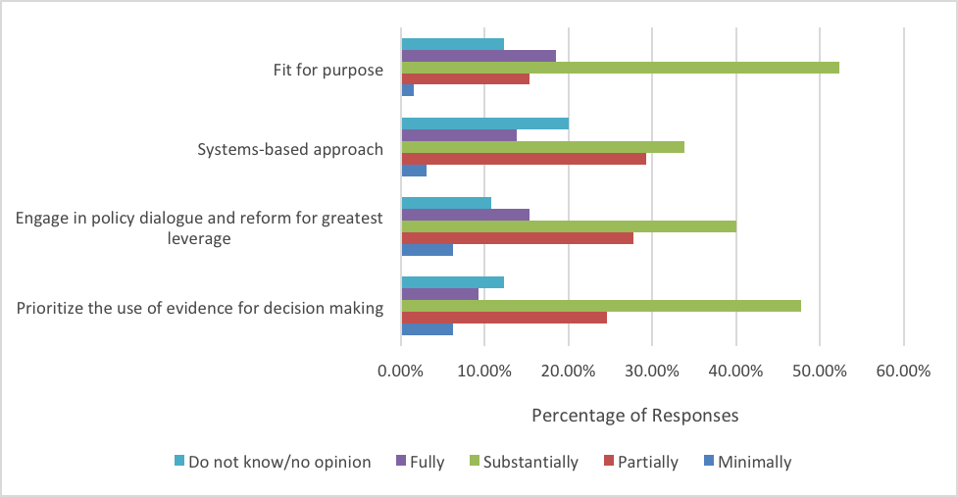

#### Fit-for-Purpose

Key to this principle is that investments made as part of Australian development assistance are based in the national priorities and contextual realities of its partner countries, which range from small island-states, middle-income countries (MICs) and conflict-affected or fragile countries. As such, Australian aid investments in education are envisaged to consider key economic, political and social challenges specific to each country context, and utilize appropriate aid modalities according to the context.

Overall, investments were found to be consistent with the Strategy’s principle of making fit-for-purpose investments. All interviewed stakeholders noted that their investment decisions were grounded in the contexts and priorities of their respective countries of operation. Additionally, 71 per cent of survey respondents believed that the education aid investments in their countries were substantially or fully fit-for-purpose. This was significantly higher than the proportion of respondents who believed that such investments were substantially or fully in line with the Strategy’s other principles (see Figure 4.1). This high level of alignment of investments with the principle of fit-for-purpose was also seen in DFAT’s own internal assessment of its portfolio, in which 60 out of 70 ongoing and ended investments were rated as in line with the Strategy’s principle of fit-for-purpose.[14]

It should be noted, however, that interviewed stakeholders did not attribute investment choices to the Strategy itself. They suggested instead that the national sector priorities of countries themselves, as well as the level of commitment to education sector reform among government actors, more directly influenced decision-making on aid investment.

Systems-Based Approach

Regarding the Strategy’s principle of taking a systems-based approach, Australia’s investments are envisioned to be made with an awareness of connections between specific reforms and the impact such interventions may have on an education system as a whole. Additionally, adopting a systems-based approach to investment entails working towards complementarity or synergy of investments made by different donors in their collective effort to strengthen the education system of a country. In this regard, the Strategy notes Australia’s support of the Systems Approach for Better Education Results (SABER), a World Bank initiative to collect and analyse policy data on education systems globally, as a way Australia contributes to collaboration among partner countries to collectively plan and prioritize sector reforms.

The extent to which investments were found to be consistent with this principle of the Strategy was almost equally split, with 48 per cent of survey respondents indicating that the education investments in their countries substantially or fully take a systems-based approach. The extent to which stakeholders interviewed expressed consistency between investments and the Strategy’s principle of taking a systems-based approach also varied across countries. Two factors emerged from interviews to explain this variation:

* **Whether the investment is in the form of a sector program:** When investments are for a sector program, as opposed to a project, the programmatic focus of the investment is more likely to consist of system-wide objectives, and as such is more likely to be aligned with the systems-based approach of the Strategy.
* **Level of commitment of governments to system reform:** The extent to which investments were effective in taking a systems-based approach was affected by the level of commitment by national governments to education system reform. Interviewed stakeholders note that countries with high levels of political will for reform or where the education system is in the process of reform provide enabling environments for DFAT to respond to country-led agendas, and to more effectively engage in investments oriented towards impact at the system level. This was especially noted in countries where the government sees education as central to peace, such as Myanmar and the Philippines, which provide contexts in which there is greater alignment between the national interests of partner countries and the Strategy’s view of education participation as “breeding peace.”[15]

Policy Dialogue and Reform

According to the Strategy’s principle of engaging in policy dialogue and reform for greatest leverage, Australian investment is envisioned to work towards laying the foundations for sustained, long-term change in partner countries through strengthening policy dialogue, technical support and promoting mutual accountability. Key to this is recognizing the significant role national institutions and local commitment to reform play in leading positive change, with development funding seen as playing a “catalytic role” in incentivizing such change.[16]

Based on stakeholders interviewed and surveyed, DFAT investments in education aim, by and large, to support policy dialogue and reform, but these efforts are often dependent on a mix of the following four factors:

**Box 3: Myanmar – education as a flagship**

Education is the flagship of the Myanmar program, accounting for around 40 per cent of bilateral development assistance. Since the change of government in 2016 the policy and legislative framework has improved, and this has had the effect of making the investment more relevant (fit for purpose) and more effective in terms of using a system-based approach. In this case it is not the Strategy that has had influence on the investment but rather that the changing context has demonstrated the value of the Strategy.

Three investments have proved useful for engaging in policy dialogue. One provides grants to every school, which provides a platform to discuss equity in terms of which schools qualify and what schools really need. Another works with the monastic and complementary education systems, providing a platform to work towards an inclusive national education system. The third works towards a teacher education competency framework and has a research component that provides real data to anchor the sometimes-unpopular reform.

The six education investments in Myanmar are each aligned with the Strategy and the Strategy is helpful as a reference. However, in trying to ensure that the component parts of the education program are coherent as a whole, the Strategy is less useful and access to specialist advice is necessary.

* **Extent to which the country’s education system is undergoing reform:** Engagement in policy dialogue is effective in countries where the government is committed to reform, or where the education system is already engaged in change. Myanmar is a prime example of such an enabling context (see Box 3). Countries where education systems are stagnant were less likely to provide environments in which investments were able to support meaningful engagement in policy dialogue among national government actors.

**Box 4: Philippines – capacity addition of in-house adviser**

In the Philippines Aid Investment Plan, education is not a pillar in its own right but is incorporated under the economic development and peace and security pillars. The Education Pathways to Peace in Muslim Mindanao program was designed in the wake of the Strategy and, as one of the authors was closely involved, the principles of the Strategy are centre stage. The investment is central to policy dialogue on the peace process for Mindanao and is an opportunity for Australian soft power.

Retaining a contract Education Adviser has been important in a context where a credible technical voice is essential at the policy table. As a middle-income country, the government has less a need for additional funding and more the desire to have technical expertise to assist with the ‘how to do it’ question. This applies both to national reforms and to the specific challenges in the Bangsamoro Autonomous Region in Muslim Mindanao, where the human development indicators are much lower and recognised to be an important underlying cause of militancy. Australia’s engagement over several decades has built a relationship of trust and strong technical cooperation. Given the receptiveness of the Philippine Government to Australian support on priority reforms, it is critical that the technical advice Australia provides is strongly evidence based.

* **Level of country government capacities for policy dialogue:** Low capacities among national government staff to engage in policy dialogue remains a key limiting factor for investments to support this principle. In this regard, both individual capacities (to design and formulate policies) as well as organizational capacities (to implement, monitor and report back on policy effectiveness) remain significant hurdles in the less developed countries of the region.
* **Level of DFAT capacity for policy dialogue:** Generalist stakeholders are aware that they lack capacity to meaningfully engage in debates that require technical knowledge of issues such as curriculum reform as well as institutional knowledge of the education system.
* **Whether investments support research components:** Investments that supported a research component played an important role in strengthening policy dialogue and local commitment to reform in the long term (see section below on Evidence for Decision-Making). The development of research outputs as part of investments does provide tangible data and information that is difficult to ignore and that bolsters national commitment to reform during times where such reform may be politically unpopular or sensitive.

It is worth noting that stakeholders consulted for the review showed a strong appetite for more guidance on effective policy dialogue and on best practices on when such dialogue should take place, the rationale behind the choice of policy focus, and the expected behaviour change of government actors as a result of engaging in dialogue.

Evidence for Decision-Making

In recent years there has been increased global focus on the quality of aid and the importance of the evidence-based approach to decision making, which focuses on ‘what works’, is seen as a way of improving the efficiency and effectiveness of policy making processes. Key to the Strategy’s principle of prioritising the use of evidence for decision-making is envisioning the role of Australian investment in supporting improvements in data availability, quality and use in partner countries, to inform education sector policies and practices. The Strategy highlights improvements in partner countries’ Education Management Information Systems (EMISs) and learning assessment systems as ways in which Australian investment can support the use of evidence in decision-making among partner countries. Robust M&E systems are also cited as an essential part of Australian aid investments in their role of collecting data to inform program performance management.

**Box 5: Office of Development Effectiveness (ODE) teacher development evaluation in Timor-Leste**

The Strategy has had limited use in Timor-Leste. The country’s inclusion in the ODE Investment in Teachers longitudinal study to evaluate the effects of teacher development on teacher knowledge, teacher practice, and student learning is noted as having been more useful than the Strategy in policy dialogue. The study is highlighted as providing a depth of evidence on learning outcomes that the country program would never have had the resources for. It is noted as having opened the door for policy dialogue at Ministerial-level and the evidence-base provided by the study is seen as an important tool to engage critical opinion leaders.

On the one hand, our review data showed encouraging signs of application of this principle in Australia education investments, with close to 60 per cent of survey respondents confirming the use of evidence in investment decision-making. Interviews offered an opportunity to gather further evidence on the application of this principle with various examples of investment to support the development of EMISs, feedback loops and training.

Two interesting examples should be noted. The first is Timor-Leste’s participation in a multi-year Office of Development Effectiveness (ODE) study that is of great interest to the Minister of Education and research of this quality could not have been undertaken by Post (see Box 5).[17]

The second example is the Strengthening Pre-Service Teacher Education in Myanmar (STEM) project, implemented by UNESCO. This project, supported by DFAT, DFID and the Government of Finland, aims at developing a new curriculum based on internationally-accepted education standards. See Box 6.

**Box 6:** [**Strengthening Pre-Service Teacher Education in Myanmar**](http://www.unescobkk.org/education/teacher-education-and-training/news/article/raising-the-quality-of-teaching-in-myanmar-through-teacher-competency-standards/)

The overall objective of the project is to develop new curriculum components for 25 national Teacher Education Colleges (ECs) to support ECs educators. Through this pre-service teacher education project, UNESCO is supporting the Ministry of Education in developing curriculum for the new ECs degree. This work began in 2015-2016 with a review of the current curriculum used in ECs and the development of a Curriculum Framework for a competency-based curriculum for a 4-year degree program, in line with modern international standards (and based on global data on what constitutes a good competency-based curriculum), with primary and middle school teacher specialisation tracks.

On the other hand, there is general recognition among many stakeholders interviewed that aligning investments with the evidenced-based principle remains a challenge. DFAT is not the only agency experiencing such a challenge, nor is the education sector the only sector in which this remains a challenge.

There are various reasons for this. Those responsible for making investments may lack the skills or the knowledge to understand empirical evidence in education. This is particularly challenging in contexts where there is limited or no sector expertise. One development partner observed that donor staff have a greater tendency to respond to evidence where the case is simple to understand and less interest or ability where the evidence is complex or more difficult to understand.

Another reason is that staff may not be aware that the research exists. Implementing an evidence-based approach requires the person making the investment to ask the right questions about education, select the most relevant information from the literature, and make an informed judgment about the relevance of the evidence to support the investment.

The Strategy is generally seen and used as a background document and a good reference tool but has had marginal influence in informing Australian education aid investments at country level.

Usefulness as a background document

According to survey (see Figure 4.2) and interview data, the Strategy remains a useful background reference tool supporting education work at the country level. The Strategy has been used as a leveraging tool during negotiations in justifying the continued support of the four education priority areas of the Strategy or to re-affirm education priorities related to the Global Partnership for Education (GPE); the Strategy provides a base document to ensure investments in GPE and GPE policies match up with the priorities outlined in the Strategy. The Strategy has also been helpful in shaping some aspects of program design as is the case in Bangladesh, Laos, the Philippines, and Vanuatu. The motivation of the user is an important determinant of its use.

Figure 4.2 Survey responses on the usefulness of the Strategy and/or its guidelines (N=36)

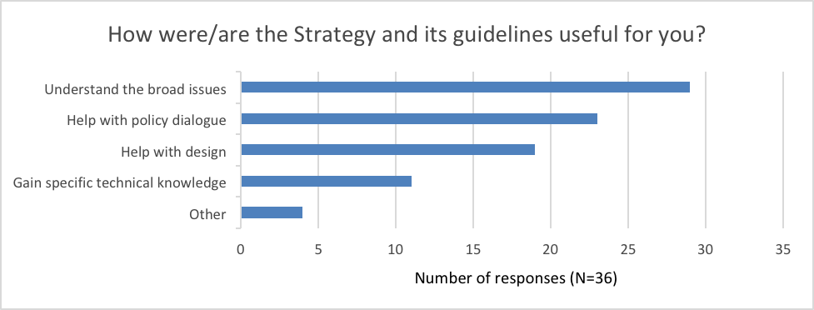

Limited influence in informing AIPs

The extent to which the Strategy is perceived as a source of guidance for decision-making on education investment in a given issue- or context-specific situation remains low overall. And, as evidenced in Figure 4.3, and further detailed in Box 7, the Strategy is seen as having limited influence in informing country AIPs. Only 9 percent state that it fully or substantially influences AIPs and 24 percent say that it has partial influence. The larger proportion - 20 percent saying that it minimally influences and 35 percent either not knowing or having no opinion - is larger.

Figure 4.3 Survey responses on extent to which Strategy has informed AIPs (N=66)

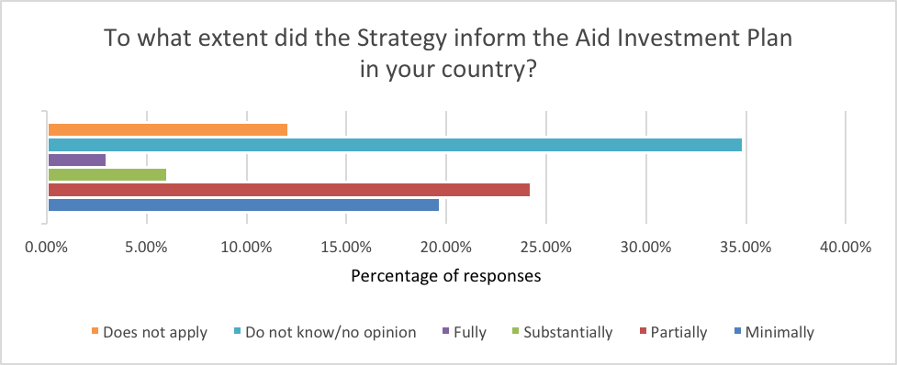

**Box 7: The Relative Lack of Usefulness of the Strategy in the Indonesian Context**

Education investment in Indonesia has faced a series of cuts since 2015 and the aid budget environment remains uncertain. The Strategy is less useful as an aid to decision-making as all the education investments are aligned with the Strategy and there is no guidance about whether any priorities take precedence over others. The approach of the education team instead has been to commission independent reviews of all the investments and use performance-based evidence to decide what should be continued.

The context of Indonesia is significant. With the country’s status as a middle-income country there have been questions about the role and purpose of Australian aid, despite the various challenges still faced by the Indonesian government in tackling education inequality and improving learning outcomes. Within Australia’s education portfolio in Indonesia it is therefore important to understand which areas are most critical to focus on from both the Indonesian viewpoint and from Australia’s strategic perspective, including which partners are the most appropriate to work with, in a context where visibility is highly important.

Key factors influencing AIPs

Respondents agreed on the two major factors influencing AIPs, namely country government priorities, in particular country education sector plans, and Australia’s political priorities.

Overall, the level of awareness of the Strategy’s guidance notes is low but, for those who use them, they can be a useful complement to the Strategy.

To complement and support the implementation of the Strategy document, a series of on-line learning modules were developed in 2013 and five guidance notes were published in 2015 and 2016.[18] The overarching purpose of the guidance notes was to assist DFAT officers in programming decisions on five different focus areas. The guidance notes typically contained information on the background and policy context of a given focus area, the key issues to be considered, and the key priorities for investment choices to be made in that focus area.

Figure 4.4 Survey responses on awareness of Strategy’s guidance notes (N=72)

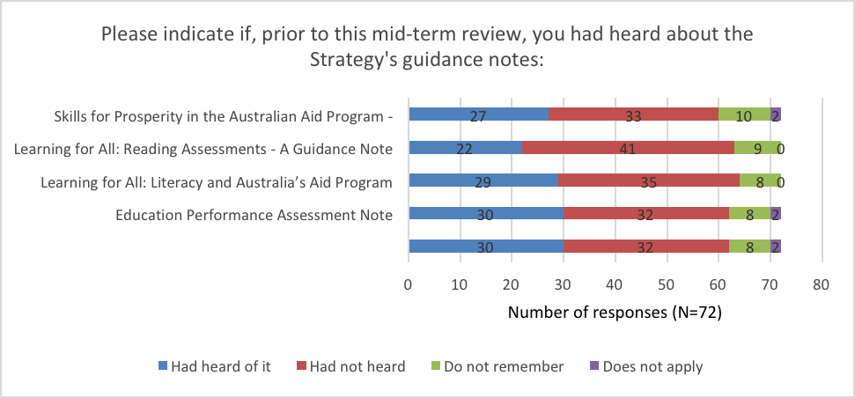

Among those who had heard of the guidance notes, the level of readership was especially high for the guidance notes on skills development and early childhood development,[19] as shown in Figure 4.5).

Figure 4.5 Survey responses to question on whether respondent has read the Strategy’s guidance notes[20]

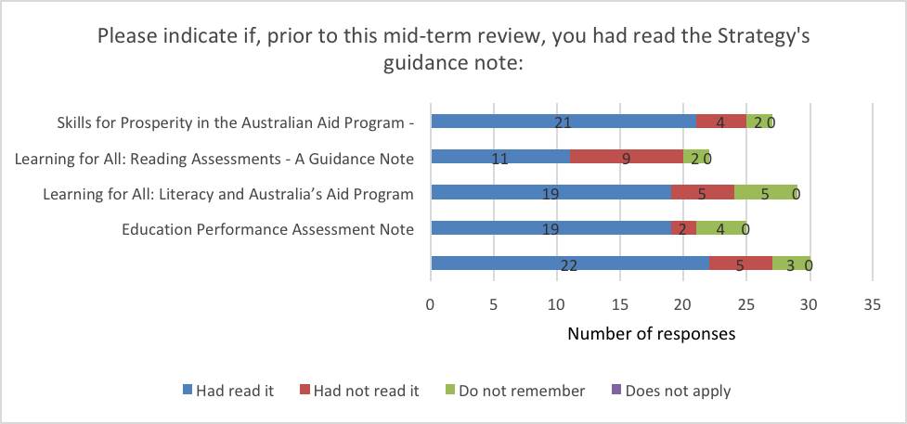

Despite the low level of awareness of the guidance notes, interviewed stakeholders commented positively on their usefulness in providing an overview of the education sector and of Australia’s priorities in education aid investment.

Online Learning Modules

At the time of their release the 40 online learning modules developed by the Education Section generated strong interest and several stakeholders who had completed the courses cited them as useful complements to support the implementation of the Strategy. An evaluation in 2014 reported a positive response from learners to both the content and relevance of modules with 84 percent of those who completed stating that they would be able to apply what was learnt in their work. 93 percent indicated they would recommend the modules to their colleagues. By August 2019, DFAT records report a total number of 229 people had enrolled in 682 modules - 68 percent female, 32 percent male; 66.8 percent from Canberra and 33.2 from Posts. Records indicate a completion rate of 42.2 percent. Though it is not possible to assess why all of those who enrolled did not complete the course, the modules were specifically designed to allow staff to access them as an information resource. Overall, there was a positive response to the usability and appearance of the modules from users across the whole range of modules, with the most positive feedback on the Basic Education Awareness module.

As time has passed, as with the other forms of guidance and the Strategy itself, awareness of the modules has faded.

The potential usefulness of support provided to Posts by the Education Section in DFAT’s Development Policy Division is limited by low resourcing of technical capacity. (Q2)

The Education Section is a small team of generalists and one specialist technical adviser situated in the Development Policy Division of DFAT. With a small budget, the team provides support to Posts and manages a Community of Practice for interested managers at Post and in Canberra. The Section also has responsibility for managing a portfolio of investments that are global in orientation and do not fit under country management. One person has responsibility for performance and reporting, which allows only the basic requirements to be met. The Education Adviser cannot possibly meet the needs of all country programs proactively and works in a responsive ‘on demand’ way, mainly at key points in design and review.

The review found varying perceptions of the benefits of technical support from the Education Section. In the survey, 41 per cent of respondents believed that additional technical advice and/or analysis would “substantially” or “fully” benefit their program, while 42.4 per cent believe such technical advice would only “minimally” or “partially” benefit it (see Figure 4.6).

Figure 4.6 Survey responses to question on DFAT additional technical advice (N=66)

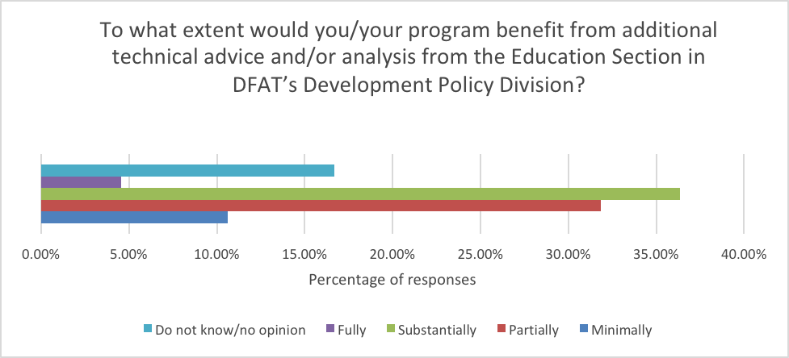

When asked about usefulness of the Strategy, several interviewed stakeholders commented that being able to talk directly to the Education Section is just as important, if not more important, than reading the Strategy document itself. This was especially true for those who were around at the launch of the Strategy, who were keen to get advice about how to adapt it for their country context. They appreciated the quality of advice because it came directly from staff who had authored the Strategy and knew it very well.

However, much of the feedback among stakeholders consulted regarding their experience in soliciting technical advice from the Education Section indicates a degree of dissatisfaction. Multiple interviewed stakeholders cited the relative lack of specialist expertise in the Education Section as the reason for not using it. Respondents at Posts noted that their need for education programming was for high quality technical expertise rather than general support provided by non-technical staff. The Section’s lack of technical expertise therefore appears to be a key factor in the demand for its advice.

In 2013 there were three education specialists based in Canberra and 15 employed on contract at Posts. Subsequently, the number at Post has steadily declined and Posts have either managed without specialists or used alternative contracting mechanisms to meet their priority needs. Respondents believe that the value of a specialist adviser derives from their technical knowledge of education and their often deep understanding of the country’s education system. This gives them credibility in the often-technical policy arena that cannot be matched by a generalist and enables them to open doors to senior government officials. In the absence of a specialist, DFAT’s ability to engage meaningfully in policy dialogue is less than optimal.

Another factor limiting the desire of approximately a third of respondents to seek advice, and the retention of that advice for programming, is the high turnover rate among DFAT staff which can affect the Section’s institutional memory.

In addition to advice from the Education Section, survey respondents were asked whether they would benefit from technical advice from an external source. In this case, 50 percent of respondents believed their program would “substantially” or “fully” benefit (see Figure 4.7). This is 10 per cent higher than the proportion of responses to the question on perceived benefits of DFAT Education Section technical advice (Figure 4.6).

Figure 4.7 Survey responses to question on additional technical advice from an external resource (N=66)

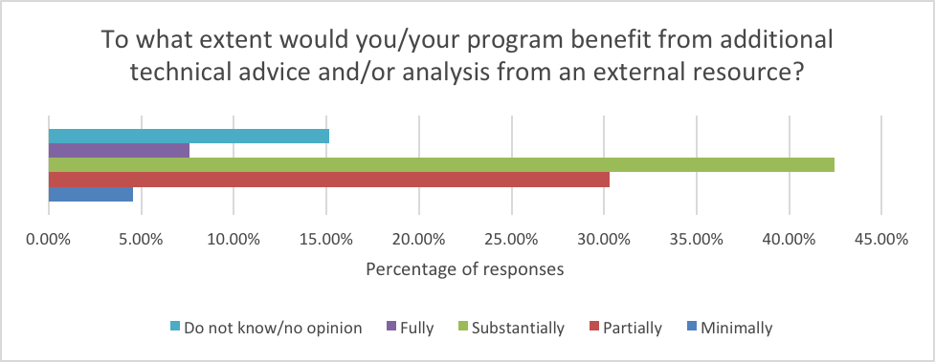

Rather than seeking advice from within DFAT, respondents cited other sources of information, including in-country technical advisors of other donors. These specialists know the country context and have the analytical capacity to probe deeply into key issues that are being discussed at policy level. For the generalist, this kind of immediate and relevant knowledge is ‘on target’.

In Bangladesh, in the face of a major decision about whether to cut a sector program, locally contracted technical expertise was used in a highly targeted way. The example in Box 8 shows a best-case scenario of use of resources for decision-making.

**Box 8: Use of Strategy in decision-making in Bangladesh**

In Bangladesh, the DFAT country Post faced a major decision about whether to cut a longstanding but underperforming sector program. As development partners had not moved forward with a planned evaluation, there was no strong evidence base for decision-making and it was not clear what was working and what was not.

The principles of the Strategy, and the advice to do political economy analysis, were used to develop terms of reference for a detailed study. The analysis showed that the program aligned with the Strategy at the level of intended outcomes but that the approaches to achieve those outcomes were inadequate. The evidence was discussed with the government and, following a lengthy process, it became clear that commitment to the necessary reform was weak and that opportunities for policy dialogue about reform were limited.

Use of technical assistance was very important in refining the analysis. Generalist staff used the Strategy as the framework for the TOR and the detailed analysis was done by a technical Education Adviser on contract whose strong knowledge of Bangladesh enabled a deep analysis of the technical and institutional issues. Post also had an Economic Adviser whose input enabled a distinction to be made between technical economic and political economic factors. Overall, the dialogue with government and in-depth analysis showed that the environment for partnership was deteriorating.

The final step, after the huge analytical task was completed, was to consult with the Education Section in Canberra on the draft recommendation. This helped to fine-tune the case for closure before submitting to the Head of Mission for approval.

For senior stakeholders in Canberra, the acknowledged weakness of the Education Section has to be seen in the context of weak and ill-defined roles for all sectors. Political and economic power is held by country Desks, which control the budget. There has been ongoing debate about whether to reinstate the role of Principal/Chief Education Adviser with a key argument being that this will raise the status of education within DFAT and provide leadership for the Strategy. The counter view is that no technical specialist, however senior, is likely to have influence at political level where priorities are decided.

Viewed in this context, the existence of a Strategy does not guarantee that it will have the active political backing to realise it. At country level, where political priorities drive the allocation of aid investment, there is no requirement to consider any of the strategies in development of the Aid Investment Plan.

## Processes for Managing the Strategy

In evaluating the management of the Strategy, this review examined four key processes:

* The extent to which the process of developing the Strategy was consultative
* Whether there was adequate communication and dissemination of the Strategy and its guidance notes after its finalization
* The level of monitoring and oversight of the implementation of the Strategy
* Whether the Strategy was evaluated for its achievement of results and its durability.

The process of developing the Strategy was mainly consultative and well communicated at its launch. Thereafter, communication has been insufficient to ensure general awareness.

The development phase of the Strategy was found to be, by and large, consultative. Some in the non-government community participated in consultation and felt that their interests were reflected in the priorities but that the principles were too heavily weighted to system reform focused on governments.

There is evidence to suggest that the Strategy and its accompanying guidance notes were well communicated at the time of their launch but insufficiently communicated in subsequent years. Many stakeholders had low awareness of the guidance notes (see Finding 4). The majority of survey respondents (69 per cent) indicated that they “minimally” or “partially” considered the Strategy and its guidelines well communicated (see Figure 4.8).

Figure 4.8 Survey responses on level of communication of the Strategy (N=65)

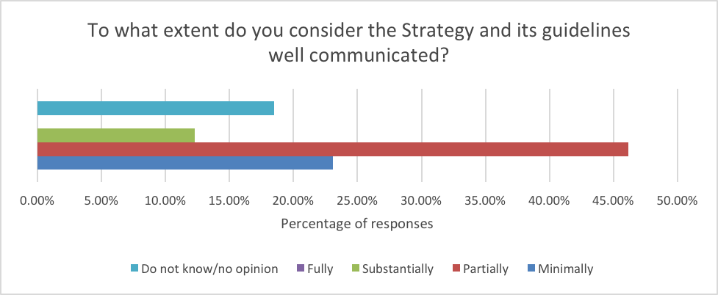

Three quarters of survey respondents (57) had heard about the Strategy. As shown in Figure 4.9, they knew about it through various means of communication.

Figure 4.9 Survey responses on source of awareness of the Strategy (N=42)

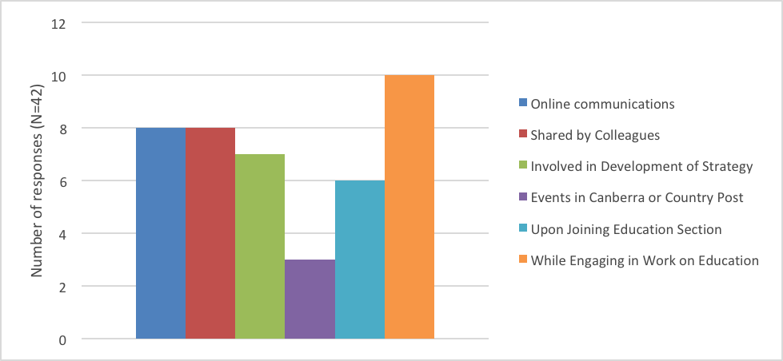

Two development partners raised the question of whether the Strategy is adequately communicated to the private sector managing contractors that implement much of DFAT’s investment in education. They perceived that DFAT utilises contractors to a greater extent than other donors and believed this was related to the limited staffing and technical expertise of DFAT. As DFAT staff manage the contractors, unless they are familiar with the Strategy and value it themselves, the likelihood of its principles being properly communicated is low. One also mentioned that in their experience DFAT makes insufficient use of lessons learned from working across countries to inform its work, attributing this to poor knowledge management.

The Strategy is a guidance document rather than a compliance document and there is no mechanism for DFAT staff to be held accountable for its delivery. (Q3.4)

The Strategy states that DFAT’s Education Section will monitor the overall performance of the portfolio of education sector investments. It will assess the relevance, efficiency, effectiveness, sustainability and impact, identifying lessons learned and examples of good practice. This assessment is to be guided by three key evaluative questions:

1. To what extent have Australia’s development efforts increased access, improved learning outcomes and strengthened education systems at all levels?
2. To what extent have Australia’s development efforts reduced disadvantage in participation in education, as a result of disability, gender, socio-economic status or other factors?
3. To what extent have Australia’s development efforts supported the use of evidence to inform decision-making in education?

The role set out for the Education Section in monitoring performance of the portfolio of investment has largely not been realised, and it is unlikely that it will be with the current level of capacity. Although the team believes it has a role in influencing decision-making about education, the mechanism or levers through which they can do so is limited.

At the time of writing, the authors of the Strategy were realistic about it appropriately being a guidance document. Decisions about allocation of resources are made at country level based on the Aid Investment Plan. The processes for developing the AIP and the Annual Program Performance Reporting are generally led by the geographical Desk in Canberra and there is no formal requirement to consult with the DFAT Development Policy Section in general or the Education Section specifically on education, although this consultation is widely acknowledged as good practice, and the Education Section contributes actively to the peer review of annual performance reports.

Staff reported that the Strategy has no other formal status in decisions about investment or in monitoring quality. In their view those involved in decision-making at country-level have no accountability on reporting the extent to which they are implementing the Strategy through decision-making on education aid investments. However, the Aid Policy does have status and reflects the same education priorities and principles as in the Strategy.

This mid-term review stands as a useful mechanism to provide a perspective on the extent to which the Strategy has been implemented in decision-making for Australian education aid investments and represents a step towards creating a feedback mechanism for decision-makers.

The principles of the Strategy are relatively durable as they are based on ways of working with partners that remain relevant over time. (Q3.3)

The Strategy is a well written document containing high level principles that are applicable to all contexts and understandable by a range of audiences. Users find it helpful to position country programs within the wider framework of what Australia is trying to achieve. For those who use the Strategy, the sections that translate principles into what it means in practice are essential and considered relatable for the predominantly generalist staff of DFAT.

There is a correlation between use of the Strategy and being involved at the time of the launch. In 2015, the profile of the Strategy was high and interviewed stakeholders who attended the events surrounding the launch greatly appreciated being brought together with staff from different country offices to talk about it. This suggests that the usefulness of the Strategy is linked with its immediacy, being most useful when it is new and well communicated, and less practically useful over time. Other than reference in the relevance section of the AQCs,[21] the Strategy seems to be rarely invoked now.

Interviewed stakeholders who were involved in development of the Strategy understood that it was a tool of its time and needed to be written for the post-integration environment in which the majority of DFAT staff who worked for DFAT, rather than AusAID, prior to integration were unlikely to have experience in development assistance and project management. The decision to write for an intelligent, generalist audience was viewed as appropriate, as was the emphasis on the basic principles of development. Compared with the priorities of the Strategy, which may not align with the needs of a partner country and may change, the principles are durable because they are about the way in which Australia wishes to work. These principles remain broadly in line with international best practice.

For some interviewed stakeholders, the Strategy does not answer the key question of who it is for. Written in the language of public diplomacy, it can be effective as a declaration to an external audience about how DFAT works and can resonate with diplomats because it presents aid in a language they are familiar with. If it is intended to be a broad justification of Australia’s education expenditure to a sceptical public, it may be less effective. For those who think it should provide advice to managers about how to make program decisions, the Strategy is seen as weak. In particular, interview data suggests that for some staff, the strategy does not equip them to justify expenditure on education to a Head of Mission who may have to balance different priorities in country as well as competing priorities from Canberra. For this, high level influence is necessary and, unlike priorities such as economic development, gender and disability, there has been no senior political and senior executive level leadership advocating for education.

Above all, country level strategies and aid allocations are determined at Post where education may be a top priority, one of several, or not a priority at all. In the case of the Pacific, some stakeholders stated that the guiding strategy is the regional one and that any sector strategies, including education, sit below this. In other countries, there is a lack of clarity about whether there is a hierarchy of strategies and where education fits within it. Education has many mentions in the White Paper, but the overarching emphasis is on economic development. This highlights the point that the durability of the Education Strategy is linked to its status. Currently DFAT has 12 thematic/sector strategies and various Ministerial statements, which most interviewed stakeholders believe are too many.[22] Where they sit alongside each other in silos, they become practically unmanageable and potentially redundant.

For a strategy to be durable it needs to speak to the current time. Since 2015, the Sustainable Development Goals have been agreed but are not reflected. Other initiatives such as the Human Capital Index moves forward thinking about quantifying the contribution of health and education to the productivity of the next generation of workers.

## Reflections on the purpose of the Strategy

Why do Organizations and Departments need a strategy?

There are several reasons why developing a Strategy remains a good investment of time and resources.

**First**, a Strategy allows DFAT to set direction and priorities, as well as any specific principles or approaches to its education agenda.

**Second**, in a context of donor harmonization, a Strategy facilitates communication within the organization and with partners about what DFAT stands for.

**Third,** the existence of a Strategy simplifies decision-making in Canberra and at Post. Given the current limited education expertise in Posts, staff will need a framework to make context-led investment decisions in education. Priorities well defined in a Strategy make it easier to say no to distracting initiatives.

**Fourth** having a Strategy increases accountability and supports results measurement. Once priorities and objectives are articulated, they serve as a guide allowing DFAT to track progress and be held accountable for achieving its results.

**Fifth,** having a Strategy allows decision makers to make realistic assumptions about investments (people, money, data technology) required to achieve results.

**Finally**, if done well, developing a Strategy is a risk mitigation exercise particularly in periods of economic uncertainties. The Strategy development process requires assessment of current conditions, resources, strengths, weaknesses and niche. This will equip DFAT to minimize its investment risks.

How important is a sector strategy?

In a context where most stakeholders in DFAT believe there are too many strategies, and where the evidence presented in this report indicates low usage and usefulness of the Strategy, there is a question about the need for and value of single sector strategies compared with an overarching multisectoral one.

Of five development partners interviewed, two saw advantages of a multisectoral strategy. For New Zealand, moving away from global sectoral strategies has paved the way for more strategic engagement with partner governments about the outcomes they want to achieve for the country. This is especially valuable in small Pacific Island States where sector strategies had tended to frame policy dialogue and constrain broader thinking about how to address ‘wicked’ problems. In education, it has led to a change in priorities. For UNICEF, the advantage of a multisector strategy is that it enables thinking about multidimensional disadvantage. This is especially useful in addressing early childhood development which requires responses across sectors.

One stakeholder acknowledged that a multisectoral strategy had theoretical advantages but doubted that it could serve as a guide to practical implementation because of the bureaucratic nature of countries and donors. Both have complicated administrative procedures that are challenging and inefficient to manage in terms of coordination and communication even within sector silos. To try to work multisectorally could be a step too far.

Where stakeholders supported the value of a global education strategy, they qualified that it should not commit to specific priorities because the process of priority-setting must be led by partner countries. An example given was that donors tend to prioritise basic education based on global evidence about early years learning, whereas some countries, especially in the Pacific, have a strong preference for secondary education and TVET. Such dissonance helps to explain why several DFAT informants at Post shared the preference for basic education and struggled to make the case for it where countries preferred to focus on skills development. This highlights the importance of a flexible strategy.

Strategy and technical capacity

When asked whether DFAT discussed the Strategy with development partners in country, four responded that they did not. Various reasons were given, mostly relating to the absence of a technical person in DFAT to talk to, inconsistent views about strategic issues, and a lack of clarity about where and how decisions arising from strategy discussion would be made.

For the Strategy to have any influence in policy dialogue with the partner government, development partners observed that credible education expertise at Post is essential. Compared with DFID, where there is an education expert in country who leads policy level dialogue, DFAT has weak capacity to engage on technical issues and often relies on the staff of managing contractors to engage with governments. These same points were made by DFAT respondents, who are well aware of their technical limitations.

Aid effectiveness was raised by one development partner who could not understand why DFAT provides such significant funding, especially in the small countries of the Pacific, but fails to back it up with the technical capacity that would make the investment more effective. This relates to other observations from development partners as well as DFAT staff that, in countries such as the Philippines and Indonesia, where the governments have their own resources, the demand for high quality technical expertise is greater than that for funding.

Two development partners asked whether the Strategy addresses the staffing implications of delivering on the education objectives. One asked whether there was a human resource plan and whether financial resources were invested to get the necessary expertise. Alternatively, if DFAT is not prepared to invest more in technical capacity, the Strategy could identify the role of the Education Division as that of a convener and influencer rather than technical adviser.

# Conclusions and Recommendations

## Conclusions

The 2015 Strategy fully aligns with the 2014 Australian Aid Policy which names education as one of six priorities. By 2017, the Foreign Policy White Paper placed Australian national interest centre stage and placed the greatest emphasis on economic development. During the 2014-2017 period, there was strong attention to accountability. However, in the ten benchmarks of the accountability framework *Making Performance Count*, neither education nor any other sector feature. In the eyes of many stakeholders, this weakens the status of education.

The Strategy has some influence on the development and implementation of education investments but it is modest. It is useful as a reference point to frame the relevance of investments in the Aid Quality Checks and in the design of new investments but, from a point of high awareness of the Strategy when it was launched, awareness is now lower.

In testing the assumption that effective, appropriate and policy-aligned programming results emerge from centrally-issued guidance, the review finds that factors other than the Strategy have greater influence. The process to develop Aid Investment Plans is led at country level and does not require either consideration of the Strategy or formal consultation with the Education Section. This applies to all sector strategies and the Development Policy Division in general. To some extent this is to be expected in a development context in which the priorities of the country are paramount.

Some DFAT staff reported difficulty in making the case for education within a broader foreign policy context. There is strong diplomatic support for Australia Awards, which are valued for their soft power. There is also strong support for education where it demonstrably supports the peace, security and people-to-people agendas. However, staff in some Posts find it very difficult to justify investment in education, especially in the face of reductions to the global and country budget. Investment in skills for development, with its more tangible relationship to economic development and often greater political support, is easier to justify than basic education which is perceived to have a long return on investment. But staff, who are predominantly generalists without an education or development background, are aware that their ability to make the case is weak. Although the Strategy is useful in making the general case, it does not (and should not) go into the level of technical detail that staff would need to influence investment decisions where there is competition for resources.

The review did not seek to assess technical capacities, but the subject was raised in almost all interviews with DFAT and development partners. At Post it came out most strongly in relation to policy dialogue where staff are aware that the issues, which are technically and institutionally complex, are beyond their capacity. The Strategy is strong on the principles of being fit for purpose and taking a systems-based approach, and it underlines the importance of political economy analysis to inform design of investments. This is helpful but it is no substitute for technical education experience or deep understanding of the country’s education institutions. Without this, Australia cannot have influence at the policy table and cannot maximise the return on investment.

At Canberra level, the Education Section is also aware of its limited capacity, which has declined over the years with only one technical specialist. The Education Section nominally has a role in promoting the Strategy but lacks a mechanism and a budget through which to do it.

The subject of the review was the principles of the Strategy, not the priorities. The principles are based on sound evidence about what works in education and on globally agreed principles of aid effectiveness. They are therefore durable and stand the test of time. In contrast, although the priorities are also based on global evidence of what makes the most difference in education outcomes, the place for decision making is the country and partner government priorities are the most important consideration. Priorities cannot be set globally or in Canberra. The strength of the Strategy is therefore in its guidance about how to work rather than what to do.

There is room to improve awareness of the Strategy and to update it to reflect the context of Sustainable Development Goals and latest evidence about what works in education. However, for education to be a realisable priority, it needs the kind of political leadership that has been given to gender and disability inclusion. It also needs to be included in the accountability framework. And, critically for effectiveness, it needs to be backed up by credible technical expertise.

## Recommendations

The review concluded that the influence of the Strategy on aid investments has been modest. We make the following recommendations to improve the effectiveness of the Strategy at two levels, strategic and operational. At the strategic level, Recommendation 1 goes beyond the scope of the Education Section and is addressed to the Senior Leadership at DFAT. The second recommendation is addressed to the Education Section as it considers approaches to increase the influence of the Strategy. But regardless of how diligent the Education Section is in implementing these operational recommendations, if Recommendation 1 is not addressed seriously, the influence of the Strategy will probably remain minimal.

Senior leaders and Policy makers at DFAT should define the relative priority of education in relation to other sectors.

The review noted several institutional shortcomings that have prevented the Strategy from gaining traction. First, there are no targets for education or other sectors in *Making Performance Count: enhancing the accountability and effectiveness of Australian aid.* DFAT leaders must take action to enhance the accountability of its staff for education investments, include education in the accountability framework, and raise the profile and the importance of education as a whole.

The Education Section should take actions to update the Strategy in the context of the SDGs

Evidence emerging from the review confirm the importance of having an Education Strategy as a guiding framework describing where DFAT stands for in education. As it considers a next iteration of the Strategy, the Education Section should take the opportunity to review the content of the Strategy in the context of SDG 4 (Quality Education) to see if it aligns sufficiently with the 10 SDG targets in education and update the content to reflect latest evidence about what works in education investment.

Senior leaders at DFAT should increase the accountability for education investments and address the capacity implications for realising the principles of the Strategy.

The review highlighted an institutional shortcoming related to capacities to implement the Strategy in a context where the organization has been depleted of its technical expertise and relies on generalists to manage investments. The review found that the staffing pattern in countries is not conducive for evidence-based investment decisions, or to engage in policy dialogue at a level that can maximise effective results.

The Education Section should deploy more effective mechanisms to communicate the Strategy and disseminate the Guidance Notes to support the implementation of the Strategy.

The review demonstrated that awareness of the Strategy and Guidance Notes was low overall. Many staff were not aware of the existence of such materials or indicated that they were not easy to find. In light of these conclusions, the Education Section should plan for more systematic dissemination of the Strategy and Guidance Notes. For these mechanisms to be effective, they must also get the backing of DFAT leadership to reiterate the importance of education.

Terms of Reference (TOR)

**Terms of Reference  
Midterm review  
Strategy for Australia’s aid investments in education 2015-2020**

1. Overview/Context

1.1 Australia’s aid investments are shaped by Australia’s development policy, *Australian aid; promoting prosperity, reducing poverty, enhancing stability.* The policy identifies education as a priority sector. Education is a critical enabler of development; it contributes directly to poverty reduction, economic growth and enhanced stability. In 2017/18, it is estimated that education expenditure (including scholarships[23]) will total $675.3 million.

1.2 Since 2015, there have been significant changes in both the internal and external context and operational requirements. Australia’s new Foreign Policy White Paper reinforces the importance of security and stability and offers opportunities to maximise links between education and human development. It also directly flags a focus on skills in the Pacific – linked specifically to the Pacific step-up.

1.3 Within this context, the types and extent of support provided to enable staff to make sound investment decisions is of critical importance. In particular, there is emerging senior management attention on the proliferation of internal guidance, with strong interest in understanding the relevance of that guidance and extent of its application.

1.4 Strategy for Australia’s aid investments in education 2015-2020

1.4.1 In September 2015, the Minister for Foreign Affairs released the *Strategy for Australia’s aid investments in education 2015-2020.* The Strategy outlines how Australia will work with partner countries to help develop stronger education systems. Strong systems are those able to provide the high quality, fit-for-purpose education services that enable citizens to realise their capabilities, and create and access opportunities to lead productive lives. The Strategy has four pillars:

* Getting the foundations right: participating in early childhood development (ECD)
* Learning for all: improving learning outcomes and improving the quality of education
* Universal participation: with a particular focus on girls and children with a disability
* Skills for prosperity: improving access to high quality post‑secondary education and training.

1.4.2 Supported by global evidence and consensus, the four pillars prioritise areas for strategic investment. Together with detailed supplementary investment guidance notes, learning modules, and technical and policy advice from Development Policy Division, the Strategy supports DFAT (Department of Foreign Affairs and Trade) country offices to make value-for-money, high impact, context-appropriate investment choices within a given budget envelope. The Strategy and guidance notes step officers through key issues and analytical processes, and provide menus of suggested interventions. A Performance Assessment Note (PAN) similarly provides detailed instructions to help staff measure the performance of education investments. Used appropriately, the PAN offers initial direction on where to start when designing a new education investment (in addition to its particular focus on sector-specific monitoring and evaluation).

1.4.3 The Strategy and its complementary investment guidance notes support a strong focus on performance (driven through *Making performance count: enhancing the accountability and effectiveness of Australian aid)*, and they promote a number of principles and approaches to enhance the effectiveness of education investments. Accordingly, education programs are expected to:

* Be fit-for-purpose
* Adopt a systems-based approach
* Engage in policy reform for maximum leverage
* Prioritise, promote and support the use of evidence to inform policy and practice
* Engage or enable the private sector
* Innovate for results
* Promote gender equity and participation for all*.*

1.5 Education support is provided across all subsectors through bilateral, regional and global investments in diverse and complex operating environments including fragile and emergency contexts and countries affected by conflict. Significant programs are delivered in Indonesia, Papua New Guinea, the Philippines, Myanmar and Bangladesh.

1.6 A wide range of interventions is applied across the education portfolio. This includes establishment of early childhood centres and strengthening systems for education planning, policy development and budgeting in Myanmar; supporting teacher training, curriculum reform and improved learning assessment in Kiribati’s primary and junior secondary schools; refurbishing school facilities in disadvantaged regions of Pakistan; and training aligned to Pacific labour market needs through the Australia-Pacific Training Coalition.

1.7 Given the scale and value of the education program, it is critical that the performance of individual investments and the overall effectiveness of the Strategy is rigorously assessed. Respective program areas will assess individual investments. However, the Education Section of Development Policy Division is responsible for evaluating the effectiveness of the Strategy in influencing the direction and shape of education programming.

1.8 An independent review of all sectoral/thematic strategies is a mandatory DFAT requirement. The Education Section is now commissioning an external team to undertake a review of Strategy implementation.

2. Background

2.1 The DFAT Education Strategy is non-prescriptive and does not articulate a theory of change. However, it does provide a framework to guide decision-making. Accordingly, DFAT is interested in the degree to which the Strategy has guided the development and implementation of education investments. An understanding of decisions taken and their rationales is important for accountability purposes and to help inform future policy and strategy documents.

2.2. Given the diverse range of contexts, investment initiatives and funding modalities utilised across varied country policy settings and the absence of a standard theory of change, this exercise will not be a traditional evaluation. An Evaluability Assessment undertaken in 2016 recommended a focus on the Strategy principles rather than the four priorities/pillars. However, given the complex and rapidly changing context outlined at 1.2 and 1.3 above, a broader approach that reviews decision-making within the existing environment is now warranted. It is expected that methodological consistency applied across the review of decision-making processes and investment/education outcomes should ensure that the review team can aggregate results against both the key principles and pillars articulated in the Strategy.

2.3 *Reference Group* - A representative Reference Group to oversight the review has been convened by the Education Section. The group includes staff across levels, from desks and posts; the Office for Development Effectiveness; Aid Management and Performance Branch; Health and Education Funds; Investment Design Section; and Scholarships and Alumni Branch. The mix of staff (Assistant Secretaries, Directors, and operational level program managers) is ensuring a broad based perspective.

3. Purpose

3.1 The key objective of this review is to determine the extent to which the Education Strategy has influenced the development and implementation of education investments. Specifically, the review will test the assumption that effective, appropriate and policy-aligned programming results from centrally-issued guidance.

3.2 The review will focus on the *relevance* and *effectiveness* of the Strategy as a guidance tool. It will therefore be important to determine the degree to which investments align with the Strategy. The review is designed to satisfy accountability requirements. Lessons and review findings are expected to inform decisions on future strategy development.

3.3 While the Strategy is framed around generalised sets of subsectoral or thematic challenges and their potential solutions, key learnings from this review should identify specific conditions in the particular settings faced by DFAT programs. DFAT is interested in understanding why certain aspects of policy intent are not being reflected in programming. Accordingly, the review will seek to explore:

a) how useful the Strategy has been as a guide to program/investment design and implementation. It is important to determine:

i. the factors enabling or preventing adoption by program areas of the approaches/responses suggested in the Strategy and supplementary guidance notes

b) the strengths, weaknesses and appropriateness of the Strategy and implementation processes. In examining this, the review should establish:

i. the extent to which the Strategy’s suggested approaches have been appropriate and effective in those settings where the suggested solutions have been adopted.

3.4 In assessing relevance and effectiveness, it is expected that the review will determine whether there have been shifts in –or at least movement toward - programming in line with the Strategy priority areas over the life of the Strategy.

*3.5 Relevance -* In determining relevance, the review will assess the extent to which the Strategy:

* is relevant to Australia’s national interest, partner development contexts and partner priorities
* is consistent with the Foreign Policy White paper (noting the sequencing of the Education Strategy relative to the White Paper)
* aligns with the objectives of DFAT policy frameworks and whether they are still valid
* promotes and allows appropriate modalities to achieve objectives
* enables flexibility and adaptability
* facilitates demonstration of Australia’s value add.

*3.6 Effectiveness -* The assessment of effectiveness will determine:

* the extent to which the broad objectives outlined in the Education Strategy have been achieved, or are likely to be achieved
* whether investments are consistent with the objectives of the Strategy
* the major factors influencing attainment or non-achievement of objectives and investment alignment with the Strategy.

3.7 The review will identify lessons and make recommendations for future DFAT education policy and strategy.

4. Scope and key questions

4.1 Recognising the breadth of the Strategy, this section provides further guidance and some additional parameters to ensure greater clarity on the scope of the review.

4.2 Views on the effectiveness of the Australia Awards scholarship program is outside the scope of this review. Likewise, the review team will not assess GPE (Global Partnership for Education) and ANCP (Australian and NGO Cooperation Program) investments. However, the review may comment on relevant in-country bilateral and regional education investment intersections with GPE, ANCP and the Australia Awards where appropriate. It may also be relevant to comment on synergies between bilateral and regional approaches, and on the balance of bilateral, regional and multilateral expenditure.

4.3 In both undertaking the review analysis and developing the key questions, the review team should respectively recognise, and incorporate consideration of the following fundamental issues:

* within current contexts, a realistic expectation of the Strategy
* the degree of clarity and coherence inherent in the Strategy’s rationale, logic and priorities, including the extent to which the specified priorities and principles-based structure of the Strategy is fit for purpose
* potential different/new priorities (subsectoral, thematic, geographic) and emerging cross-cutting issues such as climate change and resilience
* the extent to which innovative approaches and/or education technology have been adopted – and outcomes
* evidence on what education programming is demonstrating about the strengths and weaknesses of different modalities (e.g.; facilities, multidonor approaches, direct financing) and partners (e.g.: NGOs, private sector, multilaterals, partner governments)

4.4 In focussing on the efficacy of the Education Strategy as a guidance tool, the review will give equal emphasis to the four pillars and the four key principles. In attempting to address the *effectiveness* issue at 3.3(b) above, the review will adopt a ‘light touch’ approach, utilising secondary data, to establish a broad sense of aggregate achievements across investments. Without limiting areas for exploration, paragraph 4.3 suggests areas that may generate useful contextual insights.

4.5 The Strategy operates within a broader framework. This decision-making framework includes processes and mechanisms such as budget allocations, Aid Investment Plans, Sector Investment Plans/designs, the Aid Governance Board (and its predecessor oversight committees) and peer reviews. Determining the extent of the Strategy’s relevance and influence means that it will be necessary to explore the issues, attitudes, systems, processes and mechanisms that impact decision-making on allocations to, and prioritisation of education expenditure. The review should examine how these are applied at local level (including country context), program level (post and desk), and agency level (including whole of government issues). Recommendations should include suggestions on how a future education strategy could acknowledge and interact within broader decision-making frameworks.

4.6 Indicative methodology

4.6.1 The review will apply an iterative process of analysis. It is expected that much of the work could be conducted through desk-based review of DFAT and partner country documentation, and through consultation with DFAT staff and other stakeholders, including NGOs. Internal consultation will include a mix of staff at posts and desks, including Minister Counsellors Development, education and mixed duty Counsellors at select posts, locally engaged staff and program managers. Through desk-based data mining and analysis of existing data, the review team may identify key issues for further exploration through case study approaches.

4.6.2 DFAT sees value in the review team undertaking a limited number of country visits where these allow targeted study of specific approaches or investments. These approaches should be representative of the entire education portfolio.

4.6.3 Selection of country visits/case study options will be determined through consultation between the review team and the Reference Group based on a documented rationale prepared by the review team. A matrix of education investments highlighting individual characteristics will be provided by the Education Section to help guide selection. Case study/in-country reports will include detailed recommendations to address gaps or weaknesses in programming or decision making processes.

4.6.4 The overall proposed approach to the review will be outlined in a Review Work Plan to be prepared by the review team. Using the preliminary issues and questions identified above as a starting point, the Plan will include a set of final key review questions. The Review Reference Group will consider and approve the Review Work Plan.

5. Review team

5.1 The core review team will consist of two consultants with the mix of the evaluation and education expertise and knowledge specified in Table 1 below. The Team Leader will be the specialist with the most extensive and appropriate evaluation expertise. DFAT notes, however, that education specialisation is equally critical to this review.

**Table 1 – Team Member Professional Requirements**

|  |  |
| --- | --- |
| **Requirements** | |
| Evaluation expertise | * Substantial experience designing and undertaking complex policy, strategy or program level evaluation including multidonor engagements * Ability to lead multidisciplinary evaluation teams |
| Education expertise | * Knowledge of education system strengthening approaches and issues * Core technical education expertise at subsectoral level and/or specialisation in education planning and management and/or expertise in the areas of learning, quality or access to education * Experience working with ministries at central, provincial and district level * Understanding of complex education programming * Extensive experience in monitoring and evaluating education programs * Familiarity with the education context in at least one country from each of the three groups in the list at Table 3 below * Sound knowledge of exclusion factors and the challenges of providing education support that is inclusive and addresses marginalisation |
| Generic requirements | * Excellent analytical and communication (verbal and written) skills * Ability to think strategically * Understanding of political economy analysis approaches or ability to quickly acquire * Understanding of aid program management and delivery * Knowledge of DFAT’s systems and policies or ability to quickly acquire |

5.2 The DFAT review manager will be the key point of contact between the review team and the Reference Group and will participate in team activities to the extent appropriate for a mid-term review. This will ensure effective coordination, and facilitate informed dissemination of review findings and ‘take up’ of recommendations. Indicative responsibilities are identified in Table 2 below.

**Table 2 – Indicative Team Members**

|  |  |
| --- | --- |
| **Position** | **Responsibilities** |
| Team Leader | * Lead on the overall approach and methodology * Prepare and implement the Strategy Review Plan * Attend key meetings * Produce draft and final reports that are consistent with this Terms of Reference and the agreed review plan * Ensure overall quality of inputs and outputs |
| Team Member 2 | * Under the broad direction of the team leader, provide inputs to the overall approach and evaluation methodology * Provide high quality technical critique and analysis * Attend key meetings * Contribute to the draft and final report in accordance with requirements in the review plan |
| DFAT Review Manager | * Manage the review and coordinate team activities including liaison with DFAT * Support Reference Group function * Provide information and source material as required * Participate in key meetings and discussions * Contribute to analysis and reporting as required |

Note that:

* DFAT may consider addition of appropriate partner country nationals to supplement the team in support of selected in depth case studies or country visits.

**Table 3**

|  |  |
| --- | --- |
| **Partner countries with bilateral (including multidonor) education programs** | |
| Group 1 – largest programs | Indonesia, Papua New Guinea, Philippines, Myanmar, Bangladesh |
| Group 2 – Pacific | Solomon Islands, Fiji, Kiribati, Vanuatu, Tonga, Samoa, Tuvalu, Nauru |
| Group 3 – Asia | Laos, Timor-Leste, Sri Lanka, Nepal, Pakistan, Afghanistan |

6. Outputs

6.1 The review team will deliver the following outputs:

6.2 Milestone 1: Review Work Plan – submitted by xxxx 2018. In consultation with the review manager, the review team will develop a draft Review Work Plan for consideration by the Reference Group. The plan, in no more than five A4 pages (plus annexes if necessary), should succinctly and clearly:

* summarise the approach to be adopted;
* outline the key review questions;
* provide additional detail on methodology (and sampling) to guide data collection; and
* outline a timeline of review-related events from inception to completion.

Based on Reference Group feedback, the review team will finalise the plan and use it to guide subsequent activity.

6.3 Milestone 2: Key emerging issues from data mining - submitted by xxxx 2018. Depending on the review methodology and agreed review plan, the review team may be required to submit a report outlining up to five key issues worthy of further ‘deep dive’ exploration through a case study approach and/or in-country mission. The issues must be of strategic importance in relation to Strategy effectiveness. The report will be no more than eight A4 pages and will include feasibility ratings and the rationale for country visits.

6.4 Milestone 3: Case studies/Country visit aides-memoire - submitted by xxxx 2018. Following approval of proposed case studies and/or in-country missions by the Reference Group, the review manager will liaise with the review team on scheduling of each study/mission and report length, structure and submission dates. Where in-country missions are involved, the team will prepare and present to stakeholders an aide-memoire at the conclusion of the visit.

6.5 Milestone 4 and Milestone 5: draft and final Review report – submitted by xxxx 2018. This report, in plain language and in no more than 30 A4 pages (excluding annexes) should set out the key findings of the review, and analyse what implications this may have for preparation of future education policy and strategy. The body of the report will be split into five main sections:

* An Executive Summary, of no more than two A4 pages, suitable for briefing management, that is able to exist as a stand-alone document.
* A Summary of the Review Purpose, Methodology and Approach in no more than one A4 page.
* A Statement of Findings that documents whether and how the Education Strategy influences programming and investment decision-making. In particular, the review will articulate the degree to which investments are aligned with the Strategy, and the processes which have, or have not, impacted on the degree of alignment. This section will provide a narrative, supported by evidence, that responds to the key overarching issues outlined in this Terms of Reference and the key questions set out in the Review Plan.
* A Conclusion, in no more than three A4 pages, that includes recommendations for future strategy development and content.
* Annexes that at least list key references used and the people and organisations consulted in this review. Case study reports may be attached as Annexes.

7. Timing and duration

7.1 DFAT expects the review to commence in June 2018 and be completed by the end of November 2018.

7.2 Indicative inputs are set out in the following table.

|  |  |  |  |  |
| --- | --- | --- | --- | --- |
| **Task and timing** | | **Upper limit of inputs (days)** | | |
| **Team Leader** | **Team Member 2** | **Total** |
| Start-up briefing, preliminary document review | | 5 | 5 | 10 |
| Preparation of the Draft and Final Review Plan | | 5 | 3 | 8 |
| Emerging issues analysis – from data mining | | 9 | 9 | 18 |
| Case Study reports | Ideally, these activities should happen concurrently, noting that country missions however, are likely to occur sequentially. | 25 | 30 | 55 |
| Draft Review Report | 20 | 15 | 35 |
| Final Review Report | | 5 | 3 | 8 |
| Total | | 69 | 65 | 134 |

8. Reference material

8.1 The Education Section will provide the review team with relevant documents including but not limited to Aid Investment Plans; Delivery Strategies and Designs, background papers; completion reports, reviews and evaluations; and other relevant analytical reports. Where relevant, appropriate data from DFAT and/or partners will also be provided. Preliminary resources are listed below (with links to those documents currently publically available):

* *Australian aid; promoting prosperity, reducing poverty, enhancing stability,* June 2014 (<http://dfat.gov.au/about-us/publications/Pages/australian-aid-promoting-prosperity-reducing-poverty-enhancing-stability.aspx>)
* *Making performance count: enhancing the accountability and effectiveness of Australian aid (*[*http://dfat.gov.au/about-us/publications/Pages/making-performance-count-enhancing-the-accountability-and-effectiveness-of-australian-aid.aspx*](http://dfat.gov.au/about-us/publications/Pages/making-performance-count-enhancing-the-accountability-and-effectiveness-of-australian-aid.aspx)*)*
* *2017 Foreign Policy White Paper (*[*https://www.fpwhitepaper.gov.au/*](https://www.fpwhitepaper.gov.au/)*)*
* *Strategy for Australia’s aid investment in education 2015-2020 (*[*http://dfat.gov.au/about-us/publications/Documents/strategy-for-australias-aid-investments-in-education-2015-2020.pdf*](http://dfat.gov.au/about-us/publications/Documents/strategy-for-australias-aid-investments-in-education-2015-2020.pdf)*)*
* Getting the Foundations Right: Early Childhood Development and Australia’s Aid Program – Investment Guidance Note
* Learning for All: Literacy and Australia’s Aid Program - A Guidance Note
* Learning for All: Reading Assessments - A Guidance Note
* Skills for Prosperity in the Australian Aid Program – Investment Guidance Note
* Education Performance Assessment Note
* *Investing in Teachers* Office of Development Effectiveness evaluation, 2014 (<http://dfat.gov.au/aid/how-we-measure-performance/ode/Documents/teacher-development-evaluation.docx>)
* *Evaluability Assessment of the DFAT Strategy for Australia’s aid investments in education 2015-2020*
* Matrix of education investments
* Australia Awards Tracer Studies and Case Studies will be made available as necessary

Review Matrix

| Key question | sub-questions | Indicators | Data Collection Methods | Sources of Information |
| --- | --- | --- | --- | --- |
| 1. How useful has the Education Strategy been as a guide to Australia’s investment in education? | 1.1 How aligned is the Strategy with the Foreign Policy White Paper and DFAT Aid Policy frameworks? | * Degree of alignment of the Strategy with the Foreign Policy White Paper * Degree of alignment with the Aid Policy and strategic plans * Staff perceptions of alignment | Document review  Interviews  Survey | Aid Quality Checks  Strategy documents  DFAT policy documents  DFAT Staff |
| 1.2 Are investments in education consistent with the principles set in the Strategy? | * Degree of alignment or investments in education with the principles of the Strategy (at country, regional, and global levels)? * Evidence of application of Principles (fit for purpose; systems-based approach; engagement in policy dialogue; encouragement of use of evidence for decision making) * Relative investment priorities and budgets at country level (evidence and opinion) | Portfolio review | Program documents  Aid Quality Checks  Publicly available website data |
| 1.3 To what extent does the Strategy influence decision making about Aid Investment Plans? | * Degree of awareness and use of DFAT staff of the Strategy and its features * Perception of the relevance of the Strategy in the country context and its influence on Aid Investment Plans * Evidence of factors enabling or preventing implementation of the Principles of the Strategy at country level | Interviews  Survey | DFAT staff  Aid Investment Plans |
| 2.0 How useful is the guidance[24] provided to support delivery of the Strategy? | 2.1 How useful is guidance to:  a. Design of an investment?  b. Policy dialogue?  c. Evaluation?  d. Help make education investments in light of other donors’ investments in the sector? | * Level of satisfaction of DFAT staff with the amount, quality, accessibility and applicability of currently available internal guidance * Expressed need of DFAT staff for further or alternative guidance on implementation * Quality and quantity of guidance on implementation modalities and choice of implementing partners * Evidence of use of DFAT staff (and stakeholders) of the Strategy and its features * Evidence of the influence of the strategy in enhancing gender and disability considerations across the Australian aid program * Evidence of the influence of the Strategy in contributing to the creation of linkages/coherence between bilateral programming, regional activities and multilateral engagement (including with the GPE) | Survey  Interviews  Document review | DFAT Staff  All material provided to DFAT staff as guidance to Strategy delivery |
| 3. How appropriate are processes for managing the Strategy? | 3.1 How consultative was the Strategy development process? | * Level of satisfaction of DFAT staff and external stakeholders with the Strategy consultation process | Survey  Interviews | DFAT staff  External stakeholders (NGO community)  Document |
| 3.2 How appropriate were/are communication processes about the Strategy? | * Evidence of awareness of DFAT staff (and stakeholders) of the Strategy and its features * Degree of satisfaction of DFAT staff with communication processes | Survey  Interview | DFAT staff  Education Community of Practice |
| 3.3 How durable is the Strategy? | * Timeliness of the Strategy development process with the external context of SDGs | Document review  Interview  Surveys | DFAT staff |
| 3.4 To what extent are DFAT staff accountable for effective delivery of the Strategy? | * Clarity of results framework and monitoring mechanism * Nature and quality of data to assess progress towards outcomes | Interviews  Survey | DFAT staff  Strategy Documents |

Interview Protocol

Introduction

The Strategy for Australia’s aid investments in education 2015-2020, released in September 2015, outlines how Australia will work with partner countries to help develop stronger education systems*.*

Universalia and OPM have been mandated by DFAT to conduct the mid-term review of the Strategy for Australia’s aid investments in education 2015-2020. The objectives of the review are to assess the extent to which the strategy has guided the development and implementation of Australia’s education investments. Emphasis is being placed on assessing the design of the strategy and its suitability for DFAT’s changing internal and external context, and on an assessment of its preliminary results in terms of influencing the development and implementation of education investments.

Thank you for agreeing to contribute to the evaluation. This interview will take about 30 minutes. Please note that we treat information deriving from all interviews confidential, which means that, for example, we will not attribute specific statements to individuals, but rather report on stakeholder views in aggregated form.

* Name & Position
* Education portfolio in country (theme, size, changes)
* To what extent has the Strategy influenced decisions in Education aid investments?
* Degree of alignment with Strategy’s principles

|  |  |
| --- | --- |
| Be fit-for-purpose | To what extent are investment choices specific to the regional and/or country context (small island states, middle-income countries and conflict-affected or fragile countries).  Can you please provide concrete examples of context-specific education challenges? |
| Take a systems-based approach | To what extent do investment choices target weak points or gaps in system performance (e.g. World Bank’s “STEP” framework, support for SABER, GPE, system-level partnerships)? |
| Engage in policy dialogue and reform for greatest leverage | To what extent do investment choices engage in policy dialogue and reform for greatest leverage? The Strategy advocates for the use of funding to incentivize development of country institutions and policies (by using the model of performance-linked investment in all partner countries). |
| Prioritize the use of evidence for decision-making | To what extent do investment choices invest in improving the availability, quality and use of data for effective policy. |

* What factors, other than the Strategy (if any), have influenced decisions?
* Guidance notes were: ECD guidance note, Education Performance Assessment Note, Literacy Guidance Note, Reading Assessments Guidance Note, Skills for Prosperity Guidance Note
* How useful were the Strategy’s guidance notes (to understand the broad issues, help with policy dialogue, help with design, gain specific technical knowledge, etc.)? Please explain by providing specific examples.
* Looking into the future what could / should be changed to reinforce the role of the Education Strategy in decisions made on education aid investments? (Prompt on capacity)

List of Stakeholders Consulted

|  | Title | Location |
| --- | --- | --- |
|  | 1. First Secretary, DFAT Bangladesh | Bangladesh |
|  | 1. Senior Program Manager | Bangladesh |
|  | 1. Director, Investment Design | Canberra, Australia |
|  | 1. Assistant Director, Health and Education Funds | Canberra, Australia |
|  | 1. Assistant Director, Humanitarian Preparedness & Response | Canberra, Australia |
|  | 1. Assistant Secretary, Gender Equality | Canberra, Australia |
|  | 1. Chief Economist – Development | Canberra, Australia |
|  | 1. First Assistant Secretary, Contracting and Aid Management | Canberra, Australia |
|  | 1. Director – Communications and Engagement Section Scholarships and Alumni Branch | Canberra, Australia |
|  | 1. Principal Sector Specialist Governance | Canberra, Australia |
|  | 1. Principal Sector Specialist Health | Canberra, Australia |
|  | 1. Director Health and Educations Funds | Canberra, Australia |
|  | 1. Assistant Secretary Development Policy and Education Branch | Canberra, Australia |
|  | 1. Director Education Section | Canberra, Australia |
|  | 1. Senior Education Advisor | Canberra, Australia |
|  | 1. Assistant Director, Education Section | Canberra, Australia |
|  | 1. Assistant Director, Education Section | Canberra, Australia |
|  | 1. Policy officer, Education Section | Canberra, Australia |
|  | 1. Assistant Director, Education Section | Canberra, Australia |
|  | 1. Assistant Director, Education Section | Canberra, Australia |
|  | 1. Assistant Director. Governance | Canberra, Australia |
|  | 1. Assistant Director, Governance | Canberra, Australia |
|  | 1. Director, Poverty and Social Transfers | Canberra, Australia |
|  | 1. Assistant Director, Disability Inclusive Development Section | Canberra, Australia |
|  | 1. Director Scholarships and Alumni | Canberra, Australia |
|  | 1. Policy Officer Indonesia Section | Canberra, Australia |
|  | 1. Policy Officer Indonesia Section | Canberra, Australia |
|  | 1. Assistant Director Evaluation Section | Canberra, Australia |
|  | 1. Director Pacific Aid Coordination & Effectiveness Section | Canberra, Australia |
|  | 1. Assistant Secretary Aid Management and Performance Branch | Canberra, Australia |
|  | 1. Director Indonesia Strategy and Performance Section | Canberra, Australia |
|  | 1. Assistant Director, Development Policy | Canberra, Australia |
|  | 1. Director Protracted Crises and Refugees | Canberra, Australia |
|  | 1. Director Gender Strategy Effectiveness and Performance Unit | Canberra, Australia |
|  | 1. Member, Independent Evaluation Committee | Canberra, Australia |
|  | 1. Counsellor, Regional Development Cooperation | Fiji |
|  | 1. Program Manager | Fiji |
|  | 1. First Secretary Development | Indonesia |
|  | 1. Unit Manager, Human Development Section | Indonesia |
|  | 1. Counsellor, Human Development Section | Indonesia |
|  | 1. Development Program Specialist | Kiribati |
|  | 1. Program Manager | Kiribati |
|  | 1. Program Manager, Plan International Australia | Melbourne, Australia |
|  | 1. **ACFID Education Community of Practice** | Melbourne, Australia |
|  | 1. First Secretary, Education | Myanmar |
|  | 1. Director General, Department of Basic Education | Myanmar |
|  | 1. Counsellor, Embassy of Finland | Myanmar |
|  | 1. Second Secretary, Development Cooperation (Education) | Papua New Guinea |
|  | 1. Chief of Education, UNICEF | Papua New Guinea |
|  | 1. **Senior Education Advisor, ChildFund Australia** | Sydney, Australia |
|  | 1. Second Secretary, Education | Solomon Islands |
|  | 1. Second Secretary, Development | Solomon Islands |
|  | 1. Counsellor Development | Solomon Islands |
|  | 1. First Secretary, Education | The Philippines |
|  | 1. Education Specialist/Advisor | The Philippines |
|  | 1. Principal Education Specialist, Asian Development Bank | The Philippines |
|  | 1. First Secretary, DFAT Timor-Leste | Timor-Leste |
|  | 1. Deputy High Commissioner | Tonga |
|  | 1. Scholarship Program Manager | Tonga |
|  | 1. Senior Program Manager (Private Sector Development, Tonga Skills & Climate Change) | Tonga |
|  | 1. Education Specialist | United Kingdom |
|  | 1. Senior Education Specialist, DfID | United Kingdom |
|  | 1. Senior Program Manager, Education | Vanuatu |
|  | 1. Chair, Independent Evaluation Committee | Washington DC, USA |
|  | 1. Senior Education Specialist, World Bank | Washington D.C., USA |
|  | 1. Lead Advisor, Education. Ministry of Foreign Affairs and Trade, New Zealand | New Zealand |

List of Documents Reviewed

Aid Investment Plans (AIPs)

* Afghanistan. 2015-16 to 2017-18.
* Bangladesh. 2015/16 – 2018/19.
* Fiji. 2015-16 to 2018-2019.
* Indonesia. 2015/16 to 2018/19.
* Kiribati. 2015/16 – 2018/19.
* Laos. 2015-16 to 2019-20.
* Myanmar. 2015-2020.
* Nauru. 2015-16 to 2018-19.
* Nepal. 2016-2020.
* Pacific Regional. 2015-16 to 2018-19.
* Pakistan. 2015/16 to 2018/19.
* Papua New Guinea. 2015-16 to 2017-18.
* The Philippines. 2015/16 to 2017/18.
* Samoa. 2015-16 to 2018-19.
* Solomon Islands. 2015-16 to 2018-19.
* Tonga. 2015/16 – 2018/19.
* Tuvalu. 2016-17 to 2019-20.
* Vanuatu. 2015-16 to 2018-19.

Aid Program Performance Reports (APPRs)

* Afghanistan. 2016-17.
* Bangladesh. 2017-18.
* Fiji. 2016-17.
* Indonesia. 2017-18.
* Kiribati. 2016-17.
* Laos. 2017-18.
* Myanmar. 2017-18.
* Nauru. 2017-18.
* Pacific Regional. 2016-17.
* Pakistan. 2016-17.
* Papua New Guinea. 2017-18.
* The Philippines. 2017-18.
* Samoa. 2016-17.
* Solomon Islands. 2017-18.
* Sri Lanka. 2017-18.
* Timor-Leste. 2017-18.
* Tonga. 2016-17.
* Vanuatu. 2016-17.
* Vanuatu. 2017-18.

Aid Quality Checks (AQCs)

Afghanistan

* INI510 - Afghanistan Reconstruction Trust Fund
* INJ806 - CARE - Empowerment through Education
* INJ857 - Uruzgan Health & Education Program

Bangladesh

* INJ579 - The Strategic Partnership Arrangement with BRAC
* INJ957 - Support to PEDP 3

Fiji

* INJ515 - Access to Quality Education Program, Fiji

Global

* INK277 - All Children Reading
* INK838 - Systems Approach for Better Education Results
* INL898 - Research on Improving Systems of Education (RISE)

Indonesia

* INJ648 - Australia's Education Partnership
* INJ859 - Building Relation through Intercultural Dialog III
* INL086 - UNICEF Papua Rural & Remote Education
* INL512 - Innovation for Indonesia’s School Children-INOVASI
* INL672 - Education Technical Assistance Program – Indonesia
* INL931 - World Bank TF - Teaching and Education

Kiribati

* INI620 - Priority Outcome 1: Improved Basic Education
* INL921 - Priority Outcome 2: Kiribati Facility

Laos

* INK284 - Basic Education School Meals & WATSAN Program
* INL332 - Basic Education Quality & Access in Laos

Myanmar

* INK545 - Burma Basic Education
* INL347 - Decentralising Funding to Schools Project
* Exemption approval from Aid Quality Check (INM088 – Myanmar Education Quality Improvement Program)
* INM211 - Myanmar Education Consortium (MEC) Phase II

Nauru

* INI950 - Nauru Improved Education

Nepal

* INH602 - Nepal Education Program
* INL754 - Building Back Safer Schools for All

Pacific Regional

* Exemption approval from Aid Quality Check (INI462 - Pacific Education Management and Review)
* INJ054 - University of the South Pacific Partnership
* INK578 - Pacific Benchmarking Education Quality for Results
* INK983 - Education Management Information Systems (EMIS)

Pakistan

* INK420 - Khyber Pakhtunkhwa Education Sector Program

The Philippines

* INJ223 - Basic Education Sector Transformation (BEST) Prog
* Exemption approval from Aid Quality Check (INL791 - Education Pathways to Peace in Mindanao [PATHWAYS])
* INH947 - Basic Education Assistance for ARMM
* Exemption approval from Aid Quality Check (INH947 - Basic Education Assistance for ARMM)
* INI294 - Human Resource Organisational Development Facility
* Exemption approval from Aid Quality Check (INI294 - Human Resource Organisational Development Facility)
* INI428 - Philippines Social Protection
* INI632 - Australia-WB Philippines Development Trust Fund

Papua New Guinea

* INJ761 - PNG Education Program
* Exemption approval from Aid Quality Check (INL430 – JU Education)

Samoa

* INI456 - Samoa Inclusive Education Demonstration Program
* INK306 - Samoa Education Sector Support Program

Solomon Islands

* INL129 - Education Sector Program 2

Sri Lanka

* INK500 - Transforming School Education Project (TSEP)

Timor-Leste

* INL910 - Timor-Leste Human Development Program

Tonga

* INK888 - Tonga Education Support Program 2 (TESP2)
* INL899 - Skills for Inclusive Economic Growth (Tonga)

Tuvalu

* INJ878 - Tuvalu Education Support Program

Vanuatu

* INK210 - Vanuatu TVET Program Phase 3
* INK372 - Vanuatu Education Support Program
* INM038 - Vanuatu Skills for Economic Growth (phase IV)

DFAT Policy Documents

* Australian Government (2017). 2017 Foreign Policy White Paper.
* DFAT (undated). Australia’s new development policy and performance framework: a summary.
* DFAT (2014). Australian aid: promoting prosperity, reducing poverty, enhancing sustainability.
* DFAT (2014). Making Performance Count: enhancing the accountability and effectiveness of Australian aid. June 2014.
* DFAT (2018). Aid Programming Guide. May 2018.
* DFAT (2018). Organisational Structure. July 2018.

Early Childhood Development (ECD) Mapping

* EAS (2018). Overview of DFAT Skills Development Investments. June 2018.
* DFAT (2019). Overview of Australian Investments in Early Childhood Development (2015-2018). March 2019.

Evaluations

* ACER (2017). Review of Technical Assistance funded by bilateral Development Partners for PEDP3 Implementation: Final Report. May 2017.
* ADB (2015). Samoa: Education Sector Project II.
* DFAT (2015). Investing in teachers. December 2015.
* DFAT (2018). Performance of Australian Aid 2016-17. May 2018.
* Education Resource Facility (2014). Kiribati Education Improvement Program: Evaluation Report. September 2014.
* Emmott, S. and McIntosh, R. (2015). Tonga Education Sector Project II (TESP II) Independent Progress Review: Final Report. September 2015.

Governance Documents

* Aid Governance Board Terms of Reference. Undated.
* Aid Governance Board, Quality and Risk Assurance Unit (QRAU) Proposed Terms of Reference. Undated.
* Development Policy Forum (DPF) Terms of Reference. Undated.
* DFAT (2017). Implementation Schedule – Aid Program Health Check. August 2017.
* DFAT (2019). Workforce Plan – International Development (Phase 1). March 2019.

Strategy for Australia’s aid investments in education 2015-2020 and Guidance Notes

* DFAT (2015). Education Performance Assessment Note.
* DFAT (2015). Evaluability Assessment of the DFAT Strategy for Australia’s aid investments in education 2015-2020.
* DFAT (2015). Getting the Foundations Right: Early Childhood Development and Australia’s Aid Program. September 2015.
* DFAT (2015). Learning for All: Literacy and Australia’s Aid Program. October 2015.
* DFAT (2015). Learning for All: Reading Assessments, October 2015.
* DFAT (2015). Skills for Prosperity in the Australian Aid Program. November 2016.
* DFAT (2015). Strategy for Australia’s aid investments in education 2015-2020. September 2015.

Miscellaneous

* DFAT (undated). Education for Development: Towards 2030.
* DFAT (undated). Education Sector Snapshot 2014-2015.
* DFAT (2016). Education Aid fact sheet. August 2016.
* DFAT (2017). Education Aid fact sheet. October 2017.
* DFAT (2018). Education Aid fact sheet. May 2018.
* Investment Matrix for MTR. Undated.

Survey Results

The survey response rate was 48%, with 78 responses out of a population of 161 surveyed DFAT Staff.

Please indicate whether you are:

* An Australia-based staff
* A locally engaged staff (76 answered, 2 skipped)

Please indicate if, prior to this mid-term review, you had heard about the Strategy for Australia’s aid investments in education 2015-2020. (76 answered, 2 skipped)

If yes, please indicate how did you hear about the Strategy? (42 answered, 34 skipped)

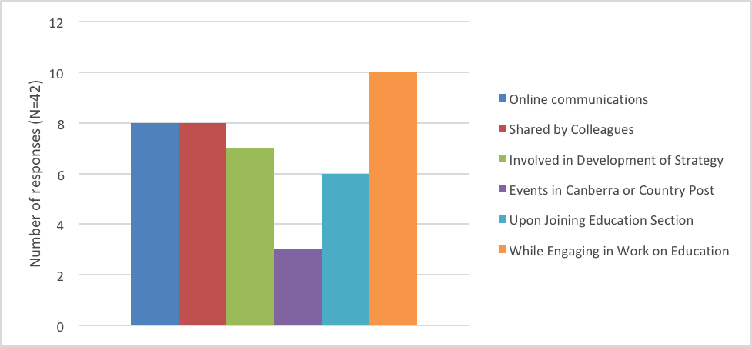

Please indicate if, prior to this mid-term review, you had read the Strategy for Australia’s aid investments in education 2015-2020. (55 answered 23 skipped)

4 – 8. Please indicate if, prior to this mid-term review, you had heard about the Strategy’s guidance note: (72 answered, 6 skipped)

* Getting the Foundations Right: Early Childhood Development
* Education Performance Assessment Note
* Learning for All: Literacy and Australia’s Aid Program
* Learning for All: Reading Assessments - A Guidance Note
* Skills for Prosperity in the Australian Aid Program - Investment Guidance Note

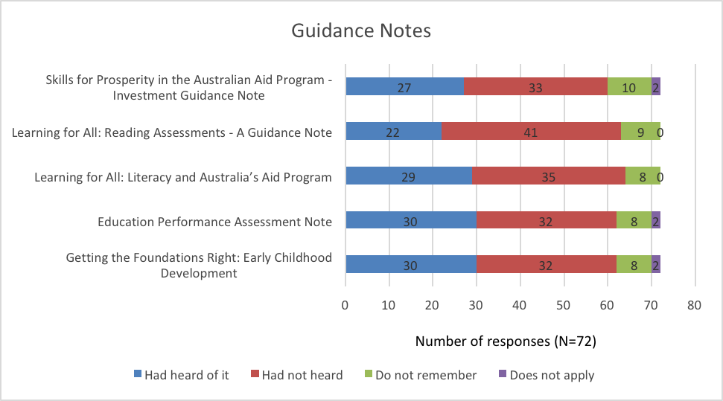

9 – 13. Please indicate if, prior to this mid-term review, you had read the Strategy’s guidance note:

* Skills for Prosperity in the Australian Aid Program - Investment Guidance Note (27 answered, 51 skipped)
* Learning for All: Reading Assessments - A Guidance Note (22 answered, 56 skipped)
* Learning for All: Literacy and Australia’s Aid Program (29 answered, 49 skipped)
* Education Performance Assessment Note (25 answered, 53 skipped)
* Getting the Foundations Right: Early Childhood Development (30 answered, 48 skipped)

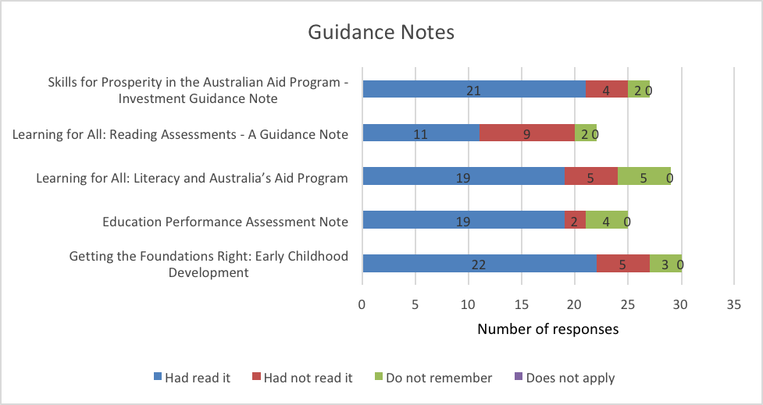

14. Did you find the Strategy and/or its guidelines useful for your work at the country level? (72 answered, 6 skipped)

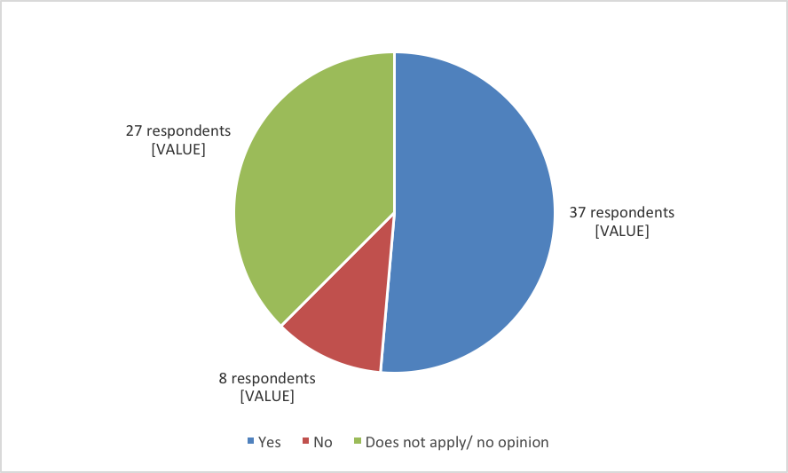

15. How were/are the Strategy and its guidelines useful for you? Please select all that apply (36 answered, 42 skipped)

* Understand the broad issues
* Gain specific technical knowledge
* Help with design
* Help with policy dialogue
* Other



Comments from those who selected “Other”

|  |
| --- |
| Responses |
| Providing the policy foundation for the education program in Myanmar |
| Good to have an overarching policy framework |
| Helped in aligning country specific strategies to the DFAT strategy |

16. What in the Strategy/Guidelines did you find useful? (36 answered, 42 skipped)

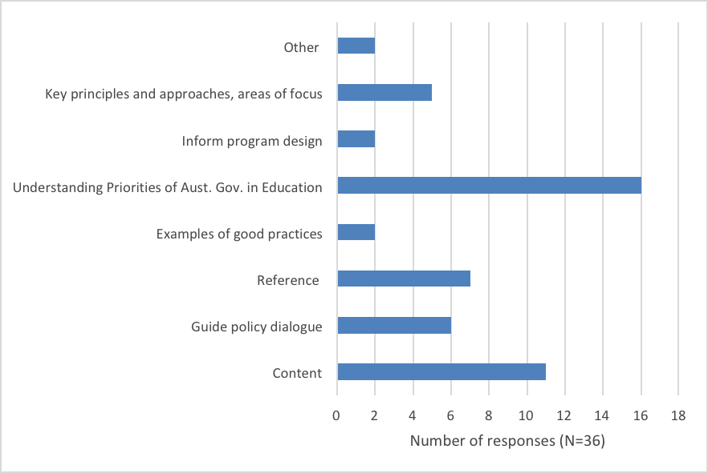

When asked “What in the Strategy/Guidelines did you find useful?” 36 DFAT staff provided responses: Sixteen (16) respondents indicated that the Strategy/its Guidelines were useful to understand the priorities of Australian government in education: “Good to have broad guidelines about what matters from a policy perspective for DFAT - and then select from this what was most important for our context”. Nine (9) respondents indicated that the content that they provided was useful (on systems-based approach, emphasis on teachers, emphasis on literacy development, evidence for decision making). Seven (7) respondents indicated that the Strategy/Guidance notes were useful as a guide or reference “I found the guiding principles on how to engage witty partner governments particularly useful “, “Helpful to prompt thinking around what to consider”. Six (6) indicated that they were useful to guide policy dialogue “It also helps shape bilateral program and helps with policy dialogue with countries.”

However, two respondents compared the Strategy to a regional framework that they found more useful and adapted to the local context: “Yes but the Pacific's PESDA framework was more useful because it connected policy with priorities for the region - this was our guiding document.” “Note that the strategy covers a wide range of areas/interventions, and this was in contradiction to the "sharpening focus" proposed in the PESDA.”

17. If you indicated that the Strategy and its guidelines were not useful for your work at the country level. Please select all that apply: (8 answered, 70 skipped)

* Lack of time
* Did not look important
* Content not useful
* Too long
* Too technical
* Other

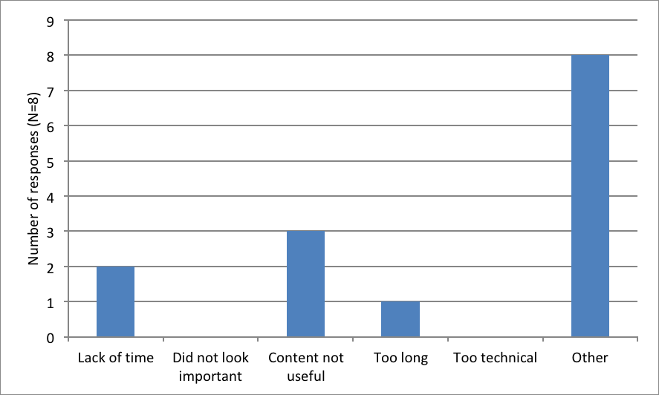

50% of the 8 respondents who indicated that the Strategy was not useful found that it was not adapted to the country context and “too broad and generic to influence our country level decisions”. Another respondent indicated that “different countries are so diverse that there cannot an overarching strategy is either overly proscriptive (which no one wants) or so general as to be irrelevant. I think the current strategy is the latter - so broad it doesn't really guide country investments. It's an unnecessary document. A chapter on education in the broader aid strategy would be sufficient, a separate education strategy isn't useful.”

18. What are the factors that influence your decision making at the country level in terms of education aid investments? (Please provide a detailed answer). (58 answered, 20 skipped)

When asked about the factors that influence their decision making at the country level in terms of education aid investments, out of 66 respondents, Gov. Priorities and appetite and requests for assistance is the most cited factor (34), followed by Australia's interests and priorities / Country and regional aid investment plan / Foreign White Policy Paper/ Australia's niche (24), Australia’s comparative advantage compared to what others agencies are doing in country, funding gaps and potential synergies (19); Evidence / gap analysis, local political economy analysis, and education indicators (15) ; Country context, laws, policies and security environment, the National education strategy, and the Education sector plan (15). Australia’s Education Aid Investments Strategy was mentioned 4 times.

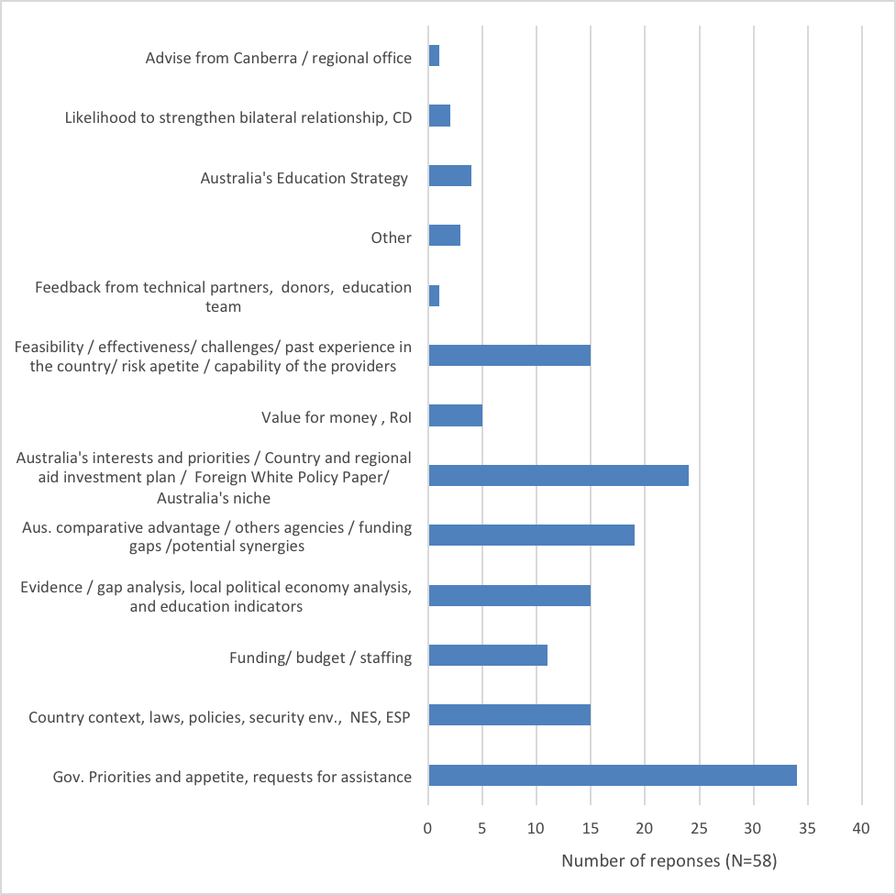

19. To what extent did the Strategy inform the Aid Investment Plan in your country? (66 answered, 12 skipped)



How? Why? Please explain:

| Responses |
| --- |
| It provided a framework for decision making but was only one of many factors which were considered. |
| I think it has been used to set parameters within which the country program can operate. I don't believe it has guided us in deciding what we need to do in the sector. The local context plays a greater role in informing in-country investments. |
| We aligned with it but the PESDA and the partner government's key policy priorities were more important |
| Priorities are taken into consideration |
| Decisions made mostly by senior management, especially HOMs and DHOMs, who may have limited understanding of development and sectors. Things like White Paper priorities inform decisions, politically driven priorities with the partner government and how much advocacy sectors get by other senior people. |
| The strategy provides guidance on a broad range of potential sub-sector support, the AIP is more informed by country-level priorities |

To what extent do you need further guidance for the planning, implementation and monitoring of education aid investments in your country of work? (66 answered, 12 skipped)

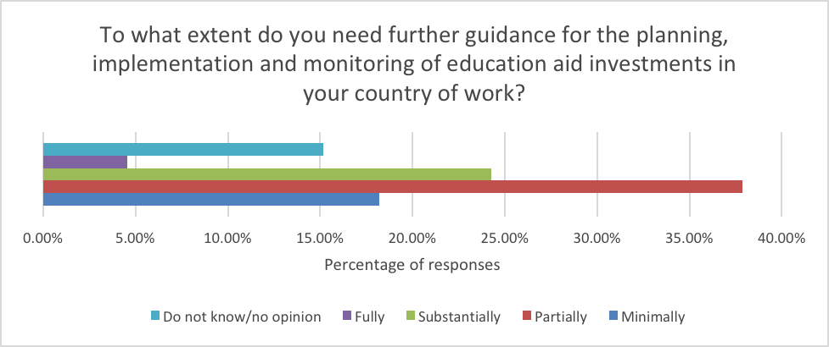

To what extent would you/your program benefit from additional technical advice and/or analysis from the Education Section in DFAT’s Development Policy Division? (66 answered, 12 skipped)



To what extent would you/your program benefit from additional technical advice and/or analysis from an external resource? (66 answered, 12 skipped)



Please identify up to 5 issues, if any, where you/your program could benefit from additional technical advice and/or analysis? (e.g.: teacher deployment policies and mechanisms to support effective deployment; public private partnerships; language of instruction; girls’ access to secondary education etc.) (66 answered, 12 skipped)

Survey respondents provided detailed responses on matter where they would benefit from technical assistance. The responses were summarized in umbrella categories in the figure below. However, given the level of detail of the provided responses, it can be concluded that tailored advice in response to issues raised by country programs is key, not 'off the shelf' guidance.

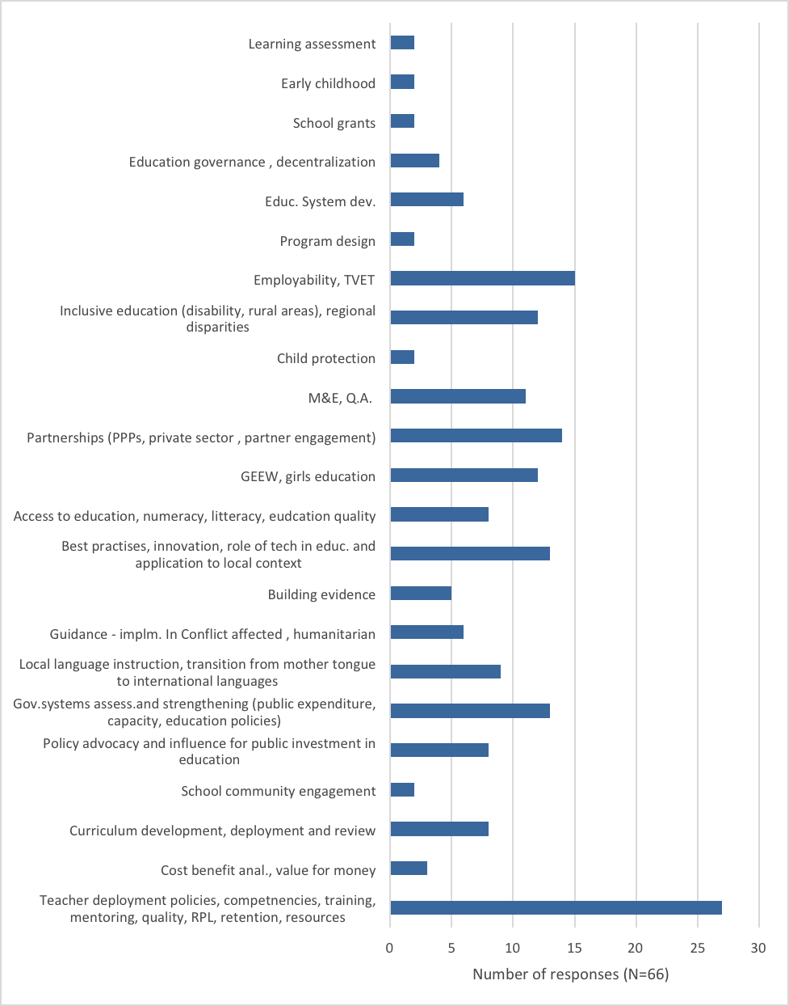

What other support would you need to better inform your aid investment plan? (56 answered, 22 skipped)

| Area for potential Support | Responses |
| --- | --- |
| Policy dialogue – **2 responses** | Further insights on how to better work politically particularly on advocating the evidence for policy influence.  Assistance in policy dialogue particularly internally within DFAT to advocate about the importance of education and what specifically we should invest in within education |
| Sharing of best practices among Posts – **4 responses** | The community of practice which the education section manages provides a useful mechanism for sharing information. However it would also be useful for Posts to have opportunity to share experiences in face to face setting - Education Forum held in 2017 was good in this regard.  it would be beneficial for us if the each of post can learn from each other - perhaps we have bi-yearly regional discussion forum (teleconference) or annual meeting?  thematic guidelines; info on what other posts are doing; samples of best practices |
| Increased support and communication from Canberra to Posts – **6 responses** | Support to connect the relevant policy areas in Canberra with the work underway at Post and facilitate useful and constructive input; build awareness and understanding of the work underway at work and build allies/champions for the work  I personally think there is a lack of communication between Canberra and Post as well as between the Senior Management at Post and the Basic Education Unit. It would be beneficial for all parties if communications between relevant stakeholders are intensified to ensure Canberra understands the local contexts and for Post to comprehend the directions of Canberra.  Guidance from Canberra in operationalising any upcoming strategy from the relevant Ministers into the in-country programs/contexts.  We would require support to understand to what extent Dhaka Post need to work in the education sector, particularly with the partner government. This is an important area and I believe that we should continue our support to primary education sector and work closely with the government.  More engagement and support from Canberra on implementation. We barely hear from desks at post...  We received nil/minimal responses from the education section in Canberra regarding our bilateral education MTR. |
| Increased staff capacities, increased technical expertise – **6 responses** | * Major support is staffing - strong and experience local staff members and Australian staff with some development expertise. It is people not guidance that is needed. * expertise in the education sector, someone with actual experience in the education sector * more dedicated education specialists posted in-country * Access to an education economist who could support analysis * As indicated above, responsive advice is best rather than 'off the shelf' guidance. Having experts on hand who can provide advice over the phone, email or by visits in-country is the most valuable support posts need. * Aid management expertise and leadership. |
| Increased technical support – **5 responses** | * Assistance with developing performance frameworks. * political economy analysis * Technical support during program design * Scholarship designs support - and to decategorise scholarships from education. They are currently conflated and it muddies the issues. * support on setting ambitious but realistic benchmarks in our Performance Assessment Framework |
| Research and analytics – **2 responses** | * Analytical work on supporting provincial reach and access * research and analytics |
| M&E - **2 responses** | * Strong M&E * Monitoring and Evaluation plan |
| Advocacy for why Australia should invest in education – **4 responses** | * Identifying a need to invest in education, with a rationale for why Australia should invest in education, is sufficient. Specific support re: education would inform design / implementation / review of the education program." * Interpretation of the 2017 Foreign Policy White Paper to inform educational investments * internal advocacy to senior decision makers especially re: importance of education in white paper. Evidence e..g analysis/strategies etc. doesn't carry much weight in internal decisions. * Advocacy with Pacific division to maintain investments in education and resource management. |

25 – 28. In your opinion, to what extent are education aid investments in your country (65 answered, 13 skipped)

* Fit for purpose
* Taking a systems-based approach
* Engaging in policy dialogue and reform for greatest leverage
* Prioritizing the use of evidence for decision-making



29. If you were able to set the direction for future Australian education assistance, what would you prioritize as the key policy areas to be addressed? (65 answered, 13 skipped)

| Policy area category | Responses |
| --- | --- |
| Teachers and education personnel – **16 respondents** | * Teachers and education personnel pre-service reform - particularly on the content material. * Teachers and education personnel management and deployment. * Teacher training / qualifications, * reforming teaching practice. * teacher qualification and promotion, alternative delivery models/alternative learning systems, systems in linking graduates to employment/business * Staffing and expertise * Teacher deployment * Quality of teachers in the classrooms through pre-service and in service training * teacher standards * Around factors that affect learning outcome, eg teacher quality (teacher deployment, teacher assessment, teacher support system, student assessment, etc.) * Teacher development * teachers * teacher training * I would invest less in systems level policy work and more in trialing approaches that actually work on the ground in the relevant context. e.g. forget about trying to develop gold standard policies and focus on how to improve learning with the capacity levels and resourcing that exists on the ground. * Productivity and human capital as a policy umbrella for why we invest in education. * Quality teacher training and support |
| Education Quality – **11 respondents** | * Quality of teaching and learning * Strengthening basic education * inclusion, quality, early learning * Education quality and improved relevance of education to the workforce * learning quality * This would be strongly guided by evidence and identified by the host country as a priority. Based on current dialogue, quality education would be a priority. * education quality improvement, systems capacity development, ethnic education quality improvement, peace education, education and humanitarian nexus policy discussion, inclusion (gender, disability, indigenous interests such as mother-tongue teaching) * Quality education - in terms of all levels, e.g literacy at the lower levels, skills development at the secondary level, job-ready skills at the tertiary level, teacher education at the tertiary level too. * Quality education is the first and foremost thing that I consider as the priority that needs to be addressed in our Post. * a greater focus on quality assurance system and mutual recognition to enable better regional mobility of the work force; more engagement of industry partners in education to improve training match and employability of graduates. * Universal quality early education. |
| Inclusive education – **12 responses** | * Access to regional disparities * inclusion, quality, early learning * improved access / retention for girls and people with disabilities, links with the labour market. * targeted and differentiated support for the most marginalised. * disparity issues * basic education to address inequality * disability, gender, * quality and access * Focus on GEDSI (Gender Equality, Disability and Social Inclusion); Focus on least advantaged; * disability inclusive education, * inclusive education approaches * mainstreaming inclusive education program (including teacher training and support) |
| Policy making and education reform – **10 responses** | * Improving evidence-based policy making * "Continuing support to the ministry of education and training to implement its education reform especially in the early years of education with a strong focus on literacy, and transition to French and English. Skills for Growth - demand driven program fit for purpose with partnerships with various departments (increasing what we are already doing) * Policy and alignment * Education budget * improve budget efficiency * System reforms * allocation to schools. * language of instruction * Education reform that relates with the quality of education - a reform that contribute to the improvement of human capital discourse * Capacity, resourcing and governance of the education sector |
| Basic Education – **10 responses** | * Access and quality of education especially basic education * Improving literacy and numeracy * improving teaching quality * education budgeting, * basic education * Basic Ed * basic education/foundational literacy and numeracy, * early learning * linking basic education to viable career pathways for school leavers and contributions to the economy * Universal quality early education. |
| Early Childhood Development and Education – **9 responses** | * Early Childhood Education and Skills * early childhood and basic education * Emphasis quality ECE and Early Grades * ECE * Early childhood education and education in crisis. * Early Childhood education * ECE * Early childhood development * Early childhood development and school readiness; and learning outcomes throughout primary and secondary. Critically important to get these right in order to feed post-secondary skills for economic growth, leadership and labour mobility in our region. Without the foundations we will fail on the skills and TVET end. |
| Demand-driven skills programs – **6 responses** | * TVET and employment pathways * Demand-driven skills programs * TVET * TVET/skills for labour shortages and labour mobility, * linking basic education to viable career pathways for school leavers and contributions to the economy * Skills for work; equality of access to higher education; |
| Access and retention, transition – **5 responses** | * support for out of school children and NFE programs in emergencies * access * improved access / retention for girls and people with disabilities, links with the labour market. * Access for all to basic education * Literacy and numeracy |
| Emergencies – **3 responses** | * Education in emergencies, fragile contexts * WASH in school * The nexus between humanitarian (EiE) and development ... ensuring there is alignment as communities transition out of emergency relief and protracted crises. |
| Girls education – **3 responses** | * secondary girls education * improved access / retention for girls and people with disabilities, links with the labour market. * gender |
| Quality assurance – **1 response** | * Quality assurance on implementation of pre-service and in-service training - moving towards a reflective and learning process rather than just a compliance approach. |
| Educational assessment – **1 response** | * Assessment on literacy and numeracy in the early grades |
| Governance – **1 response** | * Establish integrated governance |
| Public-private partnerships – **1 response** | * Public-private partnerships |
| Scholarships – **1 response** | * scholarships - graduates that meet international standards |
| Other responses | * Support should focus on strategic priorities of the partner government as well as sustainability of investments. Support should also be long-term and not through a series of discrete programs/projects with disparate end of program objectives * I would focus on country-level priorities * Deeper investments in the Indo Pacific in the following areas: supporting education systems development with a focus on primary and secondary education service delivery; a specific focus on teacher education in the region; better linking Australia's tertiary education comparative advantage and interests with aid program investments. * This Q is too broad to answer at a global level - needs to be contextually appropriate for each country. Having said that, improving basic literacy and numeracy in Vanuatu should continue to be a key focus along with better management of the education system (eg. information management; teacher training / deployment; rationalisation of schools; performance management). * Prioritisation of key areas does not necessarily enable design of fit-for-purpose programming in bilateral contexts. Areas that were relevant for our Pacific-based program were 1) literacy (first language, and English); 2) linkages between early childhood education and nutrition, but we had little agency to engage, 3) linkages between primary and vocational pathways, and 4) ensuring a policy/strategic foundation to continue to focus, support and improve primary level education. Clearer guidance on education infrastructure (to do or not to do) would be valuable, while noting that policy shifts can happen within months. |

30. To what extent do you consider that the Strategy and its guidelines were well communicated? (65 answered, 13 skipped)



1. As determined by DFAT the review focuses on the extent to which the Principles of the Strategy have informed investment design and implementation.
2. Countries included: Afghanistan, Bangladesh, Fiji, Indonesia, Kiribati, Laos, Myanmar, Nepal, Pakistan, the Philippines, Papua New Guinea, Samoa, Solomon Islands, Sri Lanka, Timor-Leste, Tonga, Tuvalu, Vanuatu.
3. Australian aid investments in education were also made at the Global-level and for the Pacific region.
4. 2017/18 data Australia’s Official Development Assistance Statistical Summary, 2017–18
5. Australian Aid Budget Summary 2019-20. DFAT
6. Data used in Figure 3.1 includes all aid to education. Of this, around half – rising from 47 per cent in 2015 to 53 per cent in 2018 - is classified as multisector education and training, which mostly comprises Australia Awards. The source of data for 2016-17 and 2017-18 are the respective Australia’s Official Development Assistance Statistical Summary. Earlier years are from the 2019 Aid Fact Sheet.
7. Assessing how and why education cuts were made at country level is beyond the scope of this review.
8. Education Expenditure Extract. August 2018
9. Foreign Policy White Paper, p. 99
10. Ibid
11. Foreign Policy White Paper, p. 111
12. The investment priorities are infrastructure, trade facilitation and international competitiveness; agriculture, fisheries and water; effective governance; education and health; building resilience: humanitarian assistance, disaster risk reduction and social protection; gender equality and empowering women and girls.
13. 1) Fit-for-Purpose, 2) Systems-Based approach; 3) Policy Dialogue and Reform; 4) Evidence for Decision-Making
14. Investment Matrix provided by DFAT’s Education Section
15. DFAT (2015). Strategy for Australia’s aid investments in education 2015-2020, p.4.
16. Ibid, p. 13.
17. This arose out of a recommendation of the evaluation *Investing in Teachers* undertaken by ODE 2015
18. These included: 1) Skills for Prosperity in the Australian aid Program – Investment Guidance Note; 2) Learning for All: Reading Assessments – A Guidance Note; 3) Learning for All: Literacy and Australia Aid’s Program; 4) Education Performance Assessment Note; 5) Getting the Foundations Right: Early Childhood Development.
19. Skills for Prosperity in the Australian Aid Program; Getting the Foundations Right: Early Childhood Development.
20. Number of responses for each guidance note as follows: Skills for Prosperity in the Australian Aid Program - Investment Guidance Note (N=27); Learning for All: Reading Assessments - A Guidance Note (N=22); Learning for All: Literacy and Australia’s Aid Program (N=29); Education Performance Assessment Note (N=25); Getting the Foundations Right: Early Childhood Development (N=30)
21. AQCs assess the performance of investments with a total value of AUD3 million and above during their implementation. As part of this, investments are reviewed according to criterion such as effectiveness, efficiency, relevance, gender equality, M&E, sustainability, and risk.
22. There is also the Aid Programming Guide, which lists more than 70 resources and has several hundred pages of guidance.
23. Investment in human capacity development through the Australia Awards scholarships program is an important complementary modality to Australia’s education investments.
24. Including Guidance notes, e-training, technical support provided by the Education Division