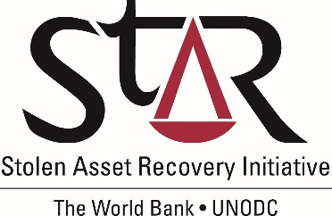

Proposal for the department of

foreign affairs and trade (dfat)

australia

1. **Asset recovery- a Fundamental Principle**
   1. **Why Asset Recovery is important**

Developing countries lose between USD 20 to USD 40 billion each year through corruption.[1] Much of the proceeds of corruption find “safe havens” in the world’s financial centres. This has a devastating impact on societies as it undermines democracy and the rule of law, and seriously erodes the quality of life.

Effective asset recovery will support the efforts of countries to redress the worst effects of corruption while sending a message to corrupt officials that there will be no place to hide their illicit assets. Asset recovery is a particularly important issue for many developing countries where high-level corruption has plundered the national wealth, and where resources are badly needed for reconstruction and the rehabilitation of societies.

The United Nations Convention against Corruption (UNCAC) entered into force in 2006 and is the only global instrument in the fight against corruption. The asset recovery provisions contained in Chapter V of the UNCAC were hailed at the time of the adoption of the Convention as a major breakthrough in the area of international cooperation. Not only did they regulate the recovery and return of corruption proceeds, but they recognised the return of assets as a fundamental principle of the Convention.

The Sustainable Development Goals of the United Nations as well as the Addis Abeba Action Agenda of the 3rd International Conference on Financing for Development recognized the need to strengthen the recovery and return of stolen assets.

* 1. **StAR: a joint partnership**

The Stolen Asset Recovery Initiative (StAR) is a partnership between the [World Bank Group](http://www.worldbank.org/) and the [United Nations Office on Drugs and Crime](http://www.unodc.org/) (UNODC) that supports international efforts to end safe havens for corrupt funds. StAR works with developing countries and financial centers to prevent the laundering of the proceeds of corruption and to facilitate more systematic and timely return of stolen assets. The StAR Secretariat is based in Washington D.C. and draws on the expertise of its two partner organizations to assist in the implementation of Chapter V of the Convention.

In its initial phase from 2007 to 2011, StAR focused on setting up its activities with emphasis on policy work and knowledge development, while initiating country support. Following its external review in 2010, StAR’s second phase from 2011 to 2014 increased its focus on country engagements and influencing the global agenda on asset recovery. Through a Theory of Change exercise undertaken from 2013, StAR developed new key objectives that are clustered in the five workstreams: country engagements; policy influence; knowledge development; communications; and, partnerships. This led to an extension of StAR until 2020, with a new workplan and results framework.

* 1. **Asset recovery- selected highlights**

Examples and highlights of StAR assistance are contained in the annual progress reports made available to donors and interested parties. For the 2015 period, new requests were received from a number of countries (e.g. Guyana, Paraguay, and Sri Lanka) with activities initiated such as legislative assistance and capacity-building. In addition, existing country engagements evolved for example in providing greater assistance on domestic asset recovery (e.g. Tanzania below) that provided the building blocks for States to be able to cooperate effectively at the international level. Another example of work to build capacity to engage with other jurisdictions is StAR”s engagement with Tunisia, that has yielded concrete returns and in 2015, StAR undertook a workshop at the request of the Tunisian authorities to train prosecutors, judges and investigators in asset recovery techniques, including in dealing with foreign jurisdictions.

StAR has also developed a body of knowledge on asset recovery that is used by practitioners and policymakers, including publications such as the Asset Recovery Handbook (2011) and a study on Barriers to Asset Recovery (2011), as well as thematic publications on settlements (Left out of the Bargain- 2013), civil remedies (Public Wrongs, Private Actions- 2014) and a recent publication on financial disclosures.

In reporting on previous activites for StAR’s internal review, the following figures emerged from StAR’s country engagements.



1. **Goals and objectives of StAR assistance**

**2.1          StAR’s overall objectives**

StAR underwent a theory of change exercise that enabled it to define its vision, mission and goal. This led to the development of a workplan and results framework that are in furtherance of the ten objectives identified for StAR activities.

**StAR Vision, Mission, and Goal**

**Ten StAR Objectives**

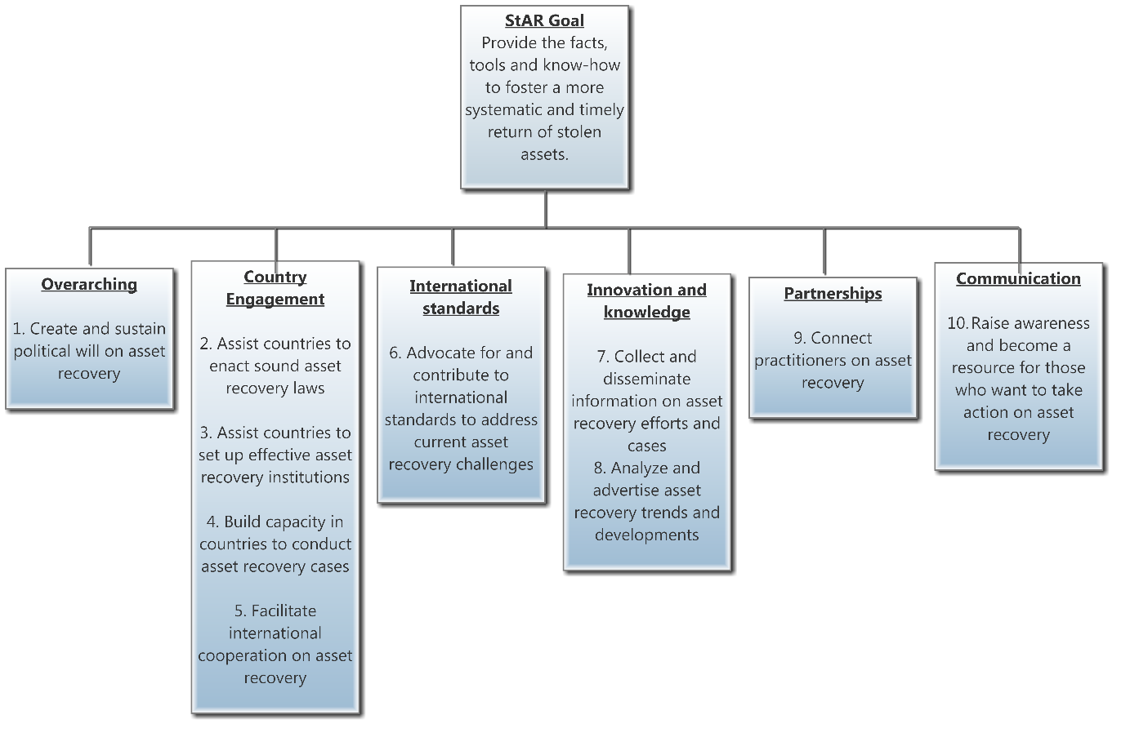

* 1. **Proposed activities**

The StAR workplan and results framework encompasses the objectives laid out above, and several specific proposed activities within these objectives are proposed. While there is great potential for StAR activities in the Indo-Pacific region, country engagements have been quite limited so far. Currently StAR has two active country engagements in the region with Mongolia and Sri Lanka, dating back to 2012 and 2015 respectively. Requests for assistance have also been received from Afghanistan, India and Timor Leste, for generic support with limited activities carried out.

There are however, a number of opportunities to step up StAR activities in the region:

*a. Second Cycle of UNCAC Review*

The Second Cycle of UNCAC Review which started in 2016 focuses on Chapter V on asset recovery. The Review will bring more attention to legal and institutional requirements for implementation of Chapter V. It will also identify gaps technical assistance needs of countries under review, who will need support in addressing their implementation gaps. StAR was involved in the first training on Second Cycle of UNCAC Review for government experts and focal points from Asia and the Pacific region which was held in October 2016 in Kuala Lumpur. Many practitioners in the region expressed interest in technical support related to implementation of Chapter V.

*b. Existing World Bank and UNODC anti-corruption/AML engagement in the region*

Both World Bank and UNODC have been involved in related anti-corruption or anti-money laundering activities in the region through experts who work closely with StAR.

For example, since 2014 the World Bank—through the same unit where StAR Initiative is housed—has been implementing a project to strengthen the anti-money laundering (AML) framework in the ASEAN region (“Strengthening the Framework to Combat Dirty Money and Implementing a Risk Based Approach”) and has contributed to several AML national risk assessments across the Indo-Pacific region.

UNODC—also through the same organizational unit which is in charge of StAR—is involved in regional anti-corruption initiatives in Indo-Pacific region (supported by DFAT), through which it has placed Regional Anti-Corruption Advisers in South-Asia, Southeast Asia and the Pacific (based in Bangkok and Suva) and has established very strong contacts with anti-corruption and asset recovery authorities across the region during the past several years.

StAR team has drawn on and partnered with these existing initiatives to conduct limited asset recovery activities in the region. For example, in Timor Leste, where StAR did not have specific resources to respond to a government request for assistance, a capacity building workshop was conducted in collaboration with World Bank and UNODC projects and drew on their resources.

*c. Regional networks*

StAR has also stepped up its collaboration with Asset Recovery Inter-Agency Network for Asia and the Pacific (ARIN-AP) during 2016, contributing to a regional capacity building workshop, as well as meetings of the steering group and the annual general meeting of ARIN-AP. StAR is continuing discussions with ARIN-AP Secretariat, and subject to availability of resources, can contribute to the future ARIN-AP initiatives at the regional level. This contribution can include drawing on StAR’s experience in conducting regional capacity building activities, and producing knowledge products and tools focusing on or tailor-made for the region/sub-regions.

World Bank—through the same team which is involved in StAR activities—has also been involved in annual meetings of the Asia-Pacific Group on Money Laundering (APG), which could be another avenue for promoting StAR activities in the region.

StAR has also been involved in other related regional activities. Most recently (February 2017) StAR facilitated the asset recovery and AML working group at a meeting on fast-tracking implementation of UNCAC in ASEAN region (supported by DFAT). In the outcome document of the meeting participants identified several challenges related to AML and asset recovery in the region. They also made commitments to take specific steps—several of which requires technical assistance—to strengthen their asset recovery efforts.

StAR has also regularly contributed to meetings on mutual legal assistance for Asia-Pacific and ASEAN organized by the Korean Ministry of Justice as well as the first ASEAN-China anti-corruption meeting.

* 1. **Partnerships**

StAR continues to build networks of practitioners—both governmental and non-governmental—which share similar goals to influence both policy and assist with the asset recovery process. Some critical partners for StAR are the OECD, AFAR partners, Interpol, the Egmont Group, ICAR and the Qatari Rule of Law Center. StAR’s engagement in partnerships over the last years has focused on practitioners’ related partnerships and networks, notably the Global Focal Points and the Regional Networks of Asset Recovery Practitioners. As a result, StAR is now actively engaged with the Global Focal Points, CARIN, RRAG, ARINSA, ARIN-EA, ARIN-AP.

Beyond partnerships with networks of practitioners, another key partnership related activity for the Initiative in recent years has been collaboration with civil society organizations (CSOs) in support of their advocacy objectives (through leverage of policy work, influence and representation), as well as in terms of capacity building.

* 1. **Considerations for assistance**

The risks to the proposed program on substance have been assessed with regard to previous engagements and overall progress on asset recovery since StAR’s inception. These include:

* Political Risks. Asset recovery usually takes place in sensitive political environments, and StAR runs the risk of being perceived as impartial. Much attention has been paid to assessing and managing those risks over the last years while building a clear delineation of what StAR can and cannot do.
* Expectation Management. This is relevant both for asset recovery as well as StAR activities. A lot of progress has been made over the last years to bolster the understanding of what asset recovery really encompasses and to collect more facts to better inform that discussion. As noted above, political will is also essential to the practical results. StAR’s much improved results framework coupled with the clarification provided by the theory of change are expected to assist in better managing this risk.
* Loss of Momentum on Asset Recovery. Given the importance of political will and international mobilization in favor of asset recovery, a turnaround of the progress achieved over the last years would be a significant challenge for StAR. For these reasons, the program emphasizes political at the forefront.

1. **Implementation arrangements**

**3.1 Funding requirements**

The present proposal reflects the work program described above. The country engagement part also includes provisions of business development/scoping missions (which includes early stages of engagement). In order to assess the funding needs to support the proposed work program, StAR has reviewed the cost of activities over the last three years (to reflect the delivery under the most recent strategic directions and organization of the Initiative).

The experience over the last years has demonstrated the country engagements are volatile particularly the case-related ones. They are very susceptible to factors outside of StAR control such as political developments; delays in international cooperation; delays in asset tracing, and so forth. Because of this, expenditure planning for country engagement is particularly challenging. In addition, the funding needs reflect a resumption of knowledge development work and an increased attention to monitoring and evaluation. Based on preliminary discussions with Australia, the funding request below includes all costs (variable, staffing) and also reflects transfers to UNODC to partially cover its contribution to the delivery of the work program.

(A) By June 30, 2017 – AUD 420,000

(B) By June 30, 2018 – AUD 600,000

(C) By June 30, 2019 – AUD 500,000

* 1. **Partnership with DFAT**

StAR’s Partnership Charter establishes a Donor Coordination Group to provide strategic guidance to StAR. It includes contributors to the MDTF (currently US, Switzerland, Norway) as well as past donors or observers (Australia, UK, France, Japan, Liechtenstein, Luxembourg, Canada). The Group meets annually to discuss priorities and provide guidance on the basis of StAR’s progress report, and it also receives the accompanying financial and audit information through the WB and UNODC’s donor information portals. StAR also provides information and materials on an ad hoc basis between meetings of the Group and organizes regular bilateral meetings with individual donors.

Specifically for the case of Australia, it is suggested that regular bilateral calls or meetings on the margins of other occasions such as the G20 or UNCAC processes be organized, given constraints due to travel and time differences. These would be in addition to the annual Donor Group meeting and scheduled communications.

In addition, and as is the case with other current StAR donors, StAR undertakes to brief DFAT stakeholders such as Australian missions abroad, in particular in those countries where StAR has ongoing country engagements (within confidentiality requirements). Specific arrangements on communications and provision on information may be discussed further in order to highlight how the Australian contribution has enabled StAR to advance work on asset recovery in country engagements, policy influence and knowledge development. In particular, bilateral calls and meetings between Australia and StAR may focus on the activities outlined in the Trust Fund agreement as donor preferences, namely work in the Indo-Pacific region. This work includes country engagements (such as Sri Lanka, which is also a GFAR focus country) and regional-level engagement through StAR’s work in the ARIN-AP network.

1. Add reference.