

Sports Diplomacy
Title: Sports Diplomacy 2030
Publication Number: 12405
Copyright 2019 ©
Commonwealth of Australia as represented by the Department of Health.
This work is copyright. You may copy, print, download, display and reproduce the whole or part of this work in unaltered form for your own personal use or, if you are part of an organisation, for internal use within your organisation, but only if you or your organisation:
(a) do not use the copy or reproduction for any commercial purpose; and
(b) retain this copyright notice and all disclaimer notices as part of that copy or reproduction.
Apart from rights as permitted by the Copyright Act 1968 (Cth) or allowed by this copyright notice, all other rights are reserved, including (but not limited to) all commercial rights.
Requests and inquiries concerning reproduction and other rights to use are to be sent to the Communication Branch,
Department of Health,
GPO Box 9848, Canberra ACT 2601,
or via e-mail to copyright@health.gov.au.

Contents
Sports Diplomacy 1
Joint Ministerial Foreword 5
Australia’s Rich Sporting Culture 8
Economic Power of Sport 8
Sport as a Diplomatic Asset 9
Early Wins for Australian Sports Diplomacy 10
Capitalising on Our Sporting Legacy 12
Renewal of the Sports Diplomacy Strategy 12
Sports Diplomacy 2030: Global Strategy with a Pacific Focus 12
Strategic Priorities and Initiatives 15
Sports Diplomacy 2030: Plan on a Page 16
Empower Australian Sport to Represent Australia Globally 18
Build Linkages with our Neighbours 20
Maximise Trade, Tourism and Investment Opportunities 23
Strengthen Communities through Sport in the Indo-Pacific AND BEYOND 26
Implementing for Success 28
Acknowledgements 31
Portfolio Agencies 32

Joint Ministerial Foreword

Senator the Hon Marise Payne
MINISTER FOR FOREIGN AFFAIRS

Senator the Hon Bridget McKenzie
MINISTER FOR SPORT
Sport has the power to unite and excite people in every corner of the globe. From grassroots clubs right through to Olympic gold medallists, for Australians sport is very much a part of our DNA. For a nation of our size, we have achieved so much in sport, both on and off the field of play.
Australia is a successful global leader and innovator in sport. We are equally known as an active and healthy sporting nation, producing a broad range of athletes and sports administrators with integrity and character.
Our love and dedication to sport can provide us with unique opportunities to engage our neighbours, and advance our national interests. Sport allows us to build and extend our influence in our region and beyond. We also use our love of sports as an expression of who we are and what we stand for as an open trading partner to the globe.
This strategy works to bring the Government’s first national sports plan, Sport 2030, to an international stage. Australia recognises the power of sport to bring people and nations together. In 2015, when Australia released its first sport diplomacy strategy, we were a pioneer in the field. Sports Diplomacy 2030 is the second Australian sport diplomacy strategy, building on the success of the first strategy.
While the focus of our sports diplomacy is global, at its heart this strategy is about engaging with our neighbourhood – continuing to open up pathways for elite athletes to benefit from experience playing in Australia, supporting the further development of sports in our region and letting us connect with other nations and other cultures over shared sporting experiences. For example, the new Australia Pacific Sports Linkages Program announced by the Prime Minister in November 2018 will help us nurture the natural talent of Pacific teams and athletes. It will not only enrich our own sporting codes, but assist Pacific athletes to compete on the international stage.
A key element of the strategy will be to use the power of sport to strengthen communities across our region. We know that sport plays a unique role in our region. Through the new Australian Sports Partnerships Program, sporting organisations will be able to partner with civil society and the private sector in the Indo-Pacific to find innovative ways to tackle social issues. The program will work specifically to empower women, strengthen disability inclusion and create leadership pathways. The Australian Government will also provide additional funding dedicated specifically to addressing barriers to the participation of women and girls in sports in the Pacific.
Australia will seize the opportunity to step up our international sports engagement. Sports Diplomacy 2030 paves a clear path for how we will do that. We will support the great work of the sport industry and athletes as they engage across the world, and provide them with the skills and networks to support our broader diplomatic efforts.
The development of this strategy owes much to the work of the sports industry – engagement with these and other key individuals and organisations has made this a better strategy.
Sports Diplomacy 2030 is the next key step towards unlocking the opportunities off-field between Australia and the global sports community.
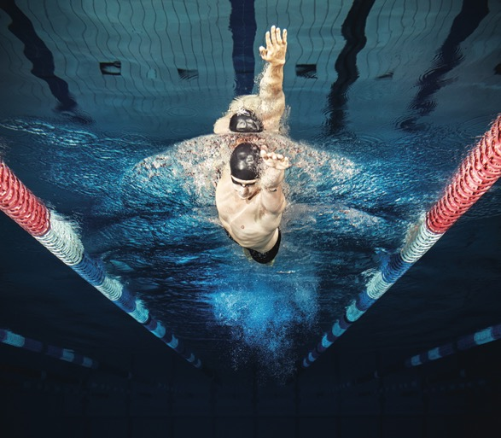

Australia’s Rich Sporting Culture
Australia is recognised the world over as a high performing and passionate sporting nation. Sport is deeply embedded in our culture and identity. Australians love to play, watch, volunteer and excel in sport at all levels – within our own communities, across Asia and the Pacific, and on the global stage. Every year 11 million Australian adults and 3 million children participate in sport. Some 8 million Australians attend live sporting events, 220,000 Australians are directly employed by the sports industry and 1.8 million Australians volunteer every year at sports clubs and competitions.
Australians excel in sports. We consistently rank among the top ten medal winners in the Summer Olympic Games and have maintained a top five position in the Paralympics since the 1996 Atlanta Paralympic Games. Australia currently boasts 45 world champion teams and individuals with 21 of those representing Paralympics events. Australia is renowned as a host and destination of choice for sporting events. Our proven track record in hosting major multi-sport events such as the Olympic and the Commonwealth Games, cricket, rugby and netball world cup events and world-class tournaments like the Australian Open, reinforce our sporting credentials.

Economic Power of Sport
Sport generates substantial business and attracts significant investment for Australia. We have established a reputation for excellence across all aspects of the sport industry, including competition and performance, event management, sport science, technology and innovation, design and construction, media and broadcasting.
Australia’s national sport plan – Sport 2030 – recognises sport’s contribution to Australia’s economic growth and wellbeing. It is estimated that sport contributes A$50 billion a year in direct economic, productivity and volunteering benefits. The wider value of sport to our communities is even greater, contributing an estimated A$83 billion in combined economic, health and educational benefits for the nation each year with a return on investment of A$7 for every A$1 spent. The sports sector employs over 220,000 people, which represents 1.9 per cent of the Australian workforce. A further 1.8 million committed volunteers donate 158 million hours to sport each year.
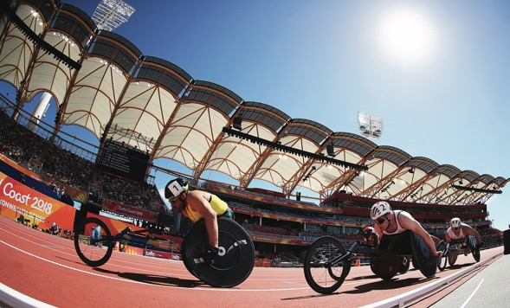

Sport as a Diplomatic Asset
Sport is widely recognised as a universal language that can break down cultural barriers. Sport can help Australia advance our national interests, project Australia’s values and identity and serve as a bridge between peoples. It speaks to who we are and what we stand for, and amplifies Australia’s reputation on the global stage. The Australian Government uses sport in diplomacy to bring people together, generate goodwill and cultivate partnerships for Australia across the world.
Sports diplomacy allows us to bring people, communities, nations and regions together to help build security and prosperity through a shared love of sports.

Nelson Mandela famously made the point:
“Sport has the power to change the world. It has the power to inspire. It has the power to unite people in a way that little else does. It speaks to youth in a language they understand. Sport can create hope where once there was only despair. It is more powerful than government in breaking down racial barriers.”
Sports diplomacy is an increasingly important aspect of diplomatic practice. Australia’s region, the Indo-Pacific, is a dynamic environment and changing in profound ways. Australia’s Foreign Policy White Paper confirms that “in the decades ahead Australia will have to work harder to sustain our influence and secure our interests”. Sport is one of Australia’s key soft power assets and can play a leading role in strengthening partnerships and promoting our national brand.

Early Wins for Australian Sports Diplomacy
In 2015, Australia released its first Sports Diplomacy Strategy. That strategy recognised the capacity of Australian sport to advance Australia’s national interests, deepen Australia’s people-to-people and institutional links and advance development outcomes in the region. It celebrated Australia’s sports capabilities and credentials, our leadership in sport innovation and integrity and the ways in which sport strengthened our diplomatic influence and global reputation.
The first strategy achieved significant wins. We delivered two sports for development programs – one in the Pacific and the other in Asia. The Pacific Sport Partnerships (PSP) used over 50 partnerships to enable 1.5 million participations in sporting activities and helped address inequalities experienced by women, girls and people living with disability. We strengthened sporting linkages in the Asian region, by negotiating sport cooperation arrangements with India, Japan, Malaysia, Singapore and Sri Lanka. The Australian Government awarded ten sports fellowships improving the capacity of individuals and institutions to deliver quality grassroots sport in our region. We piloted a volunteer’s initiative connecting skilled Australians with regional sporting organisations to support media and communications, disability and health outcomes in Fiji, Tonga and Vanuatu.
Memoranda of Understanding on Sport Cooperation between governments create mutually beneficial opportunities for the advancement of sport in participant countries and strengthen diplomatic relations. They promote collaboration across the international sports sector, including in relation to: hosting major sporting events; sharing information on athlete training and welfare; high performance coaching; maintaining sports integrity; inclusion through sport; and promoting active and healthy lifestyles.
The Australian Government will continue to pursue mutually beneficial sports partnerships that advance these goals, particularly with our Indo-Pacific neighbours.

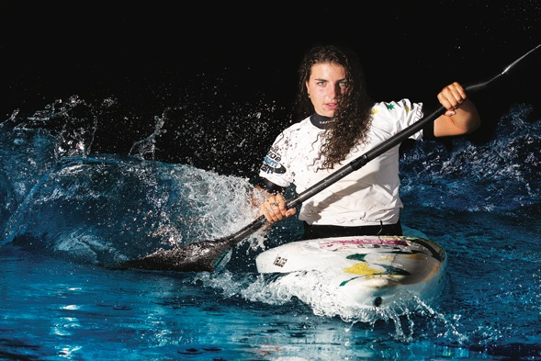

Capitalising on Our Sporting Legacy
A renewed sports diplomacy strategy presents an opportunity to showcase Australia’s hard earned reputation for sporting excellence. Australian sports are well represented and well recognised on the world stage. We play in international competitions and our own events include sporting talent from around the globe. Our sports expertise is highly regarded, including within international sporting federations and bodies. We are cultivating trade and investment opportunities with other countries across the Indo-Pacific seeking to achieve sporting success. Many of our sports people are highly regarded within our region and play an important role in promoting a positive image of Australia. Australian sporting initiatives encourage participation, train the next generation of coaches, commentators and administrators, build people-to-people connections and contribute to community development outcomes, including the empowerment of women.

Renewal of the Sports Diplomacy Strategy
The Australian Government engaged an expert panel to assist with the renewal of the strategy. The work of the panel was complemented by an Australia-wide consultation process involving a series of roundtables and a public submission process. The high quality and breadth of stakeholder engagement highlighted the Australian sport industry’s interest in renewing the Sports Diplomacy Strategy and the opportunities it could deliver.

Sports Diplomacy 2030: Global Strategy with a Pacific Focus
Sports Diplomacy 2030 is global with a strong focus on the Pacific. This recognises the global reach of the sports industry and the significance of sport, while placing special emphasis on the vital connection between Australian and neighbouring Pacific communities. Australia and our Pacific neighbours already share a common passion for sport and strong sporting connections, including a large number of Pacific athletes participating in Australian sporting codes.
At least half of all junior rugby union players in Western Sydney are of Pacific Island origin. Close to half of all players in the National Rugby League competitions have Pacific heritage. The PNG Hunters play in the Queensland Cup Rugby League competition with other Pacific teams looking to join Australian professional competitions in the future. Australian sports also have a high profile across the Pacific, with the National Rugby League and Super Rugby competitions broadcast live on many Pacific TV channels. Programs funded by the Australian Government and delivered by Australian sporting organisations have encouraged thousands of Pacific women and girls to participate in a wide range of sports, from grassroots to elite level.
Indeed sport has been a longstanding element of Australia’s development program in the Pacific. Since 2006 we have supported community development through sport to address primary risk factors associated with non-communicable diseases, particularly physical inactivity, and address inequalities experienced by women, girls and people living with disability. The A$4 million per annum PSP program has been Australia’s flagship sport for development program in the Pacific since 2009. Australia has also supported the efforts of our region to promote sport as an important contributor to the United Nations’ Sustainable Development Goals (SDGs).
A successful PSP program is Oceania Football Confederation’s Just Play program, supported by Football Federation Australia. The program uses interactive football sessions to engage children with social messages integrated into all activities. Children increase their school and community engagement and learn healthy lifestyle habits while learning about gender equality and disability inclusion. The program received the Union of European Football Association Foundation for Children Award in 2016 – recognising improvements it is making to the lives of children in the Pacific.
Sport has been a natural partner for Australia’s diplomatic efforts across the world. This ranges from Australia’s preparations for Dubai Expo 2020 where we are supporting promotional sporting events, to the India Economic Strategy, and the funding of diverse community building sporting activities through our overseas missions.
The Australian Government has funded free football coaching clinics for girls in vulnerable communities in Delhi and Mewat in India. This project has delivered positive outcomes for participants including increasing their engagement with outdoor activities and improving school retention rates. The project has helped these girls build their confidence and leadership skills and has contributed to reducing gender-based discrimination in these communities.

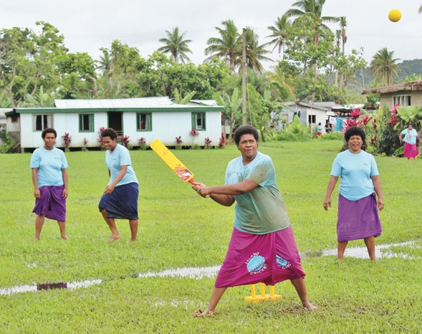
Image Cricket, once unknown in Fiji, has become a part of village life. Credit ABC – Aaron Kearney

Strategic Priorities and Initiatives
Sports Diplomacy 2030 envisages closer collaboration between the Australian sports codes, industry and government to leverage the nation’s sporting excellence in ways that advance our national interests and enhance Australia’s influence and reputation. To help deliver these goals, the strategy is organised around four strategic priority areas and identifies a range of practical initiatives.

Sports Diplomacy 2030: Plan on a Page

Sports Diplomacy 2030

OUR VISION
To strengthen Australian sport and opportunities for athletes globally and unlock their full potential to support our national interests.
The first phase of this strategy (2019-2022) will focus on four strategic priorities:
- Empower Australian Sport to Represent Australia Globally
- Build Linkages with our Neighbours
- Maximise Trade, Tourism and Investment Opportunities
- Strengthen Communities in the Indo-Pacific and Beyond

Our strategic priorities will be delivered through the following initiatives:
Enhance Australian sports leaders’ knowledge, skills and connections to represent Australia on the global stage.
Leverage Australia’s strong sporting brand to enhance our global reputation and to build enduring relationships.
Increase Australia’s representation on international sporting bodies and associations.
Develop tools to share knowledge, expertise and successes of sports diplomacy across government and with the sport industry.

Develop pathways for elite Pacific athletes and teams to participate in Australian and international sporting competitions.
Facilitate access for emerging Pacific athletes to participate in high performance training in Australia.
Develop pathways for Australian sporting codes to increase their presence in the Pacific.
Identify targeted opportunities to strengthen diplomatic and economic relationships through sport across the Indo-Pacific.

Showcase Australia’s capability in sport governance, integrity, high performance, technology and other areas in key global markets.
Promote Australia as a host of choice for major international sporting events and leverage associated legacy opportunities.
Connect Australian sports through our diplomatic and trade networks to unlock the potential of global markets for Australian business.
Engage high-profile sporting personalities to promote Australia, including through trade missions and targeted sports diplomacy initiatives.

Create leadership pathways and increase the participation of women and girls in sport.
Harness the power of sport to promote gender equality, disability inclusion, social cohesion and healthy lifestyles.
Support good governance policies, practices and systems to help build safe, fair and accessible sport.
Support global efforts to increase awareness of the contribution of sport to the Sustainable Development Goals.

Implementation
The Government will partner with the Australian sport industry to implement Sports Diplomacy 2030. A newly established Sports Diplomacy Advisory Council will guide government on leadership, coordination, communication, monitoring and evaluation of sports diplomacy across the sport industry.

Empower Australian Sport to Represent Australia Globally
Australia has an impressive sporting diaspora and Australians play a prominent role in international sports leadership and governance.
Australian athletes, teams, coaches, administrators, scientists, and entrepreneurs are representing Australia abroad – building relationships, shaping business opportunities, and contributing to better community outcomes in the region. These sporting representatives embody Brand Australia, projecting a confident, creative and outward looking nation.
Our global sporting network is a largely untapped diplomatic resource. In the past, the success of Australian sports diplomacy has relied mainly on the interests and enthusiasm of key individuals working within Australia’s diplomatic network and sports industry. Through this strategy we want sports diplomacy to be recognised and leveraged as a component of Australia’s diplomatic tradecraft. With the right knowledge, skills and networks Australian sports diplomats and representatives can help deliver sports outcomes that also advance Australia’s foreign and trade policy objectives.
Many of Australia’s sporting executives and administrators are well placed to facilitate relationships for Australian governments with influential political, business and community leaders, and build enduring connections in non-traditional arenas. Likewise, the Australian Government can draw on its resources and networks to advocate for Australia’s sporting interests, provide support for Australian athletes to safely travel the globe, and facilitate connections, including within international federations and multilateral bodies. The goal is to better position Australia as a respected leader and influencer in international sport, promote greater opportunity, fairness and integrity in sports decision making and support our broader diplomatic interests.
International federations, governing bodies, and inter-governmental organisations play a key role in setting the direction of the international sporting environment. As decision making bodies they have a significant impact on the development and effectiveness of governance, can drive more inclusive sports outcomes, and make important decisions about major international sporting events. Bringing Australia’s voice to the international table is critical to ensuring that global sport is underpinned by best practice governance. We can help advocate for sport to be conducted on an even playing field for all participants, free from corruption or undue influence. Ensuring Australia’s sporting representatives are equipped to play a greater leadership role on the world stage will enhance the visibility and influence of Australian sport over time.
Through Sports Diplomacy 2030 the Australian Government will:
- enhance Australian sports leaders’ knowledge, skills and connections to represent Australia on the global stage;
- leverage Australia’s strong sporting brand to enhance our global reputation and to build enduring relationships;
- increase Australia’s representation on international sporting bodies and associations; and
- develop tools, including a digital portal, to share sports diplomacy knowledge, expertise and successes across government and with the sport industry.



Build Linkages with our Neighbours
The Indo-Pacific region shares with Australia a passion for sports. In our region there is extensive interest and talent across a wide variety of sports. Highly talented Pacific athletes have been excelling in Australian competitions for decades.
The Asian Games attracts tens of thousands of athletes from 45 countries and is the world’s second largest multi-sport event after the Olympics. The Pacific Games incorporates 22 island nations and, in many sports, offers an important qualifying platform for Olympic and Commonwealth Games. Since 2015, Australia has also been participating in selected sports at the Pacific Games. Australia’s sporting rivalry with its Asian neighbours provides some of the strongest sports competition and interest in our region.
We have rich international sporting connections in the Pacific. The two rugby codes (league and union) have traditionally dominated as spectator and participation sports in many Pacific countries. Football and netball also resonate, while cricket is increasingly popular. Athletics is important to nations that have experienced medal success at the Pacific Games and creates pathways for individual athletes to compete in regional and international tournaments, while beach volleyball teams have captured global attention.
Sport lies at the heart of Australia’s engagement with the Pacific – bringing people, communities and countries together. To build on this shared passion for sport, Australia will launch a new flagship sports initiative in 2019 – the Australia Pacific Sports Linkages Program.
Part of a package of initiatives to boost Australia’s engagement with the Pacific, the program will deepen sporting ties between Australia and the Pacific by bringing our talented athletes together to play in high level sports competitions in Australia and the region.
Activities will encourage Australian sporting codes and athletes to increase their presence in the Pacific whether it be through matches, building local skills or improving the quality of coaching and officiating. To promote two-way exchange, the program will also develop pathways for professional Pacific teams to play in high level Australian sports competitions.
Through the program, Australian sports and athletes will act as ambassadors to help build Australia’s standing in the region and strengthen relationships. Activities will also support Australian sports to engage with emerging Pacific athletes who will be supported to access high performance training.
Australia excels at many of these sports and, over the years, we have shared our expertise to help build sporting capacity across Asia and the Pacific. This assistance has extended to improving governance and administration, as well as the quality of coaching and officiating. There is more that we can do to develop opportunities and pathways that help athletes channel their natural talent and potentially help them gain access to a wider range of competitions, training facilities and audiences.
In 2019, the Australian Government will launch a new Australia Pacific Sport Linkages Program to deepen and enrich our sporting connections, by creating opportunities for new and diverse talent to play in Australian sporting competitions while supporting the development of professional sport in the Pacific. This program will see Australian sporting teams spend more time in Pacific countries, provide greater opportunities for Pacific athletes and teams to compete in Australia, and provide Australian support for Pacific teams to compete internationally. The program will open up opportunities for emerging Pacific athletes to benefit directly from participating in high performance training in Australia.
From a diplomatic perspective, Australia’s growing sporting linkages with the region offer unique opportunities to deepen people-to-people connections and mutual understanding through a shared passion for sport.
Through Sports Diplomacy 2030 the Australian Government will:
- develop pathways for elite Pacific athletes and teams to participate in Australian and international sporting competitions;
- facilitate access for emerging Pacific athletes to participate in high performance training in Australia;
- develop pathways for Australian sporting codes to increase their presence in the Pacific; and
- identify targeted opportunities to strengthen diplomatic and economic relationships through sport across the Indo-Pacific.
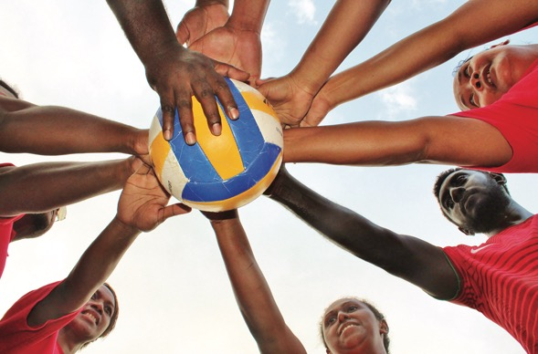
Image A display of team unity during the quarter finals of the Government Workers’ Volleyball competition in Honiara, Solomon Islands. Credit ABC – Aaron Kearney

Maximise Trade, Tourism and Investment Opportunities
Australia’s sport industry is a significant contributor to the Australian economy.
The industry spans:
- professional and amateur sports;
- grassroots recreational participation;
- sports management and marketing;
- sports tourism and major sporting events;
- design and construction;
- sporting technology;
- products and apparel; and
- volunteers and administrators.
The Australian Government’s global trade network and promotion of a Brand Australia approach can play a role in facilitating business introductions and networking, and sharing industry knowledge to amplify trade and economic opportunities for Australia’s sporting industry on the global stage.
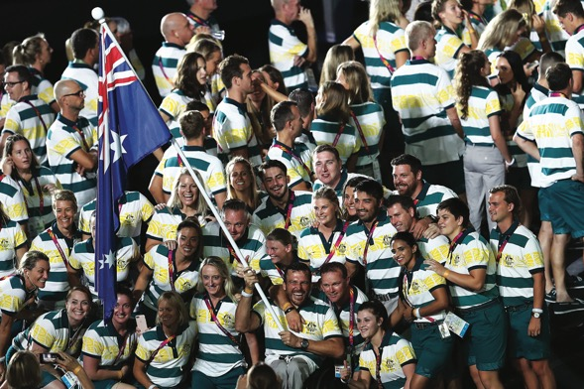
Australia has achieved success in bidding for, hosting, and participating in major sporting events. These events can serve as an economic multiplier with wider trade and investment opportunities for a city, region, state and the nation. They provide unique opportunities to showcase Australian excellence and expertise across a range of sports and non-sport related sectors. Not only does Australia have globally-recognised expertise in hosting major sporting events, we excel at delivering opening and closing ceremonies, arts and cultural programs and engaging communities around major events. This expertise can play a pivotal role in enabling other nations, especially across Asia and the Pacific, to host major international sporting events that enhance their global image and offer lasting impacts.
Australia’s high performing athletes and sports representatives are influencers in their own right with extensive and often global followings. They are an untapped resource who can assist government and business cultivate relationships to support our foreign and trade policy interests. When they are equipped with the right skills, knowledge and resources, these sports ambassadors can play an important role representing Australia and shaping perceptions of our nation.
Through Sports Diplomacy 2030 the Australian Government will:
- showcase Australia’s leadership and excellence in sport governance, high performance, technology and other areas in key global markets;
- promote Australia as a host of choice for major international sporting events and ensure that we leverage the wider economic opportunities;
- connect Australian sports through our diplomatic and trade networks to unlock the potential of global markets for a wider array of Australian businesses and companies; and
- identify, educate and empower high-profile athletes and sports representatives to promote Australia, including through trade missions and targeted sports diplomacy initiatives.

Strengthen Communities through Sport in the Indo-Pacific AND BEYOND
Australia is a recognised global leader in using sports to strengthen communities. Sport offers excellent opportunities to bring people and communities together from grass roots level through to regional and global levels.
Australia will continue to develop sports partnerships with civil society, governments, the private sector and other key stakeholders to empower and promote the social, economic and political inclusion of all people, irrespective of age, sex, disability, ethnicity, religion or economic status. Sport has the ability to drive positive, physical, mental, emotional and social health outcomes.
The Australian Government through programs such as the Australian Sports Outreach Program, PSP and Asian Sports Partnerships Program has demonstrated how sport can make positive social change. Building on the success of these programs, we will launch a new Indo-Pacific sport for development program to commence in late 2019. The Australian Sports Partnerships Program (ASPP) will be valued at A$6 million per annum and will use multi-sectoral partnerships between sporting, development and government organisations to deliver safer, more inclusive sports programs that support gender equality, disability inclusion and create leadership pathways for participants. ASPP will initially focus on six Pacific countries (Fiji, Nauru, Papua New Guinea, Samoa, Tonga and Vanuatu) in addition to four Asian countries (India, Indonesia, the Philippines, and Sri Lanka).
Australian Sports Partnerships Program
The new Australian Sports Partnerships Program builds on more than a decade of Australian investment in sport for development in the Indo-Pacific region, using the power of sport to bring together communities and address social issues.
The program will generate opportunities for sports organisations and athletes to engage meaningfully in our region through involvement in programs and activities that create positive social change. For sports, this will be an opportunity to increase their engagement with communities in Asia and the Pacific. The program’s development sector partners will help harness and showcase the full potential of sport, beyond on-field entertainment to off-field impact.
Activities will provide an opportunity for athletes to become international ambassadors for their sport and inspire others. For those with Indo-Pacific heritage, it presents a chance to engage or re-engage with their home country and share the story of their sporting journey with the wider community.

From 2019 the Australian Government will increase its sport for development funding by A$3 million per year to help more women and girls participate in sport at the grassroots level in the Pacific. The program will work with regional sports institutions and governments to improve gender equality. Australia’s sporting partnerships will help create safe, fair and accessible sporting environments in which participants can develop, learn and share experiences. This extends to building the capacity of staff and coaches to embrace diversity and inclusion, while focusing on gender equality, women’s leadership and issues such as gender-based violence.
Australia is recognised regionally and internationally as a leading advocate for sports integrity and possessing well-developed sports integrity expertise. This capability is leveraged to support and influence international efforts to protect sport from corruption threats, including through close formal engagement by dedicated Australian sports integrity bodies with international sporting bodies, law enforcement agencies and government partners.
Sport can make significant contributions towards the United Nations’ SDGs. It can help encourage healthy lives, education and learning, gender equality and peaceful and inclusive societies. Australian sports diplomacy can help advocate for the role that sport can play in the achievement of the SDGs domestically and internationally.
Through Sports Diplomacy 2030 the Australian Government will:
- create leadership pathways and increase participation of women and girls in sport in the Pacific;
- harness the power of sport to promote gender equality, disability inclusion, social cohesion and healthy lifestyles;
- support institutional policies, practices and systems to help build safe, fair and accessible sport; and
- support global efforts to increase awareness of the contribution of sport to the United Nations’ SDGs.

Image The #ENDviolence campaign is working with football players throughout the Pacific and globally to create generational change, including through the Just Play program in PNG. Credit UNICEF Pacific/2016/Palombi

Implementing for Success
The Australian Government will partner with the sports industry and other nations to implement this strategy. These partnerships will extend across all levels of government with business and the community to promote our complementary interests and to deliver mutual benefits.
The Australian Government will review and update Sports Diplomacy 2030 every four years in line with Sport 2030. The review will be based on how effectively the strategy contributes to:
- building the diplomatic capacity of Australian sports and the impact they have in advancing our national interests;
- increasing the engagement between Australian and Pacific sports and enhancing Australia’s standing in the Pacific and with our other neighbours;
- improving the international profile of Australia’s sport industry and unlocking export opportunities for other sectors; and
- building stronger communities in the region by addressing issues of gender equality, disability inclusion and social cohesion.
The success of Sports Diplomacy 2030 will be determined by a range of indicators including increased numbers of:
- Australians involved in international sporting bodies and associations;
- Pacific athletes and teams that participate in Australian sporting competitions;
- Australian athletes and teams that increase their presence in the Pacific;
- emerging Pacific athletes that receive high performance training in Australia;
- women and girls participating in sport in the Pacific;
- athletes who promote gender equality, disability inclusion and healthy lifestyles in their communities; and
- sporting organisations creating safe, fair and accessible sporting environments.
A newly established Sports Diplomacy Advisory Council will support government to develop an implementation plan for the delivery of Sports Diplomacy 2030. The Council will guide government on leadership, coordination, communication, monitoring and evaluation of sports diplomacy across sports, the sport industry and communities. Sports Diplomacy 2030 will draw on established consultation mechanisms to promote and develop Australia’s sports diplomacy capacity and to review and report on strategy success.
Through the national sport plan – Sport 2030 – the Australian Government has committed to establishing an annual ministerial roundtable to bring together Commonwealth and State and Territory Ministers who value sport as a vehicle to deliver policy outcomes. Sport 2030 further commits to establishing an inter-departmental committee on sport, recreation and physical activity.
The Australian Government is committed to partnering with Australian sports, the sports industry and the broader community through Sports Diplomacy 2030 to enhance our international engagement through sport and advance Australia’s national interests.
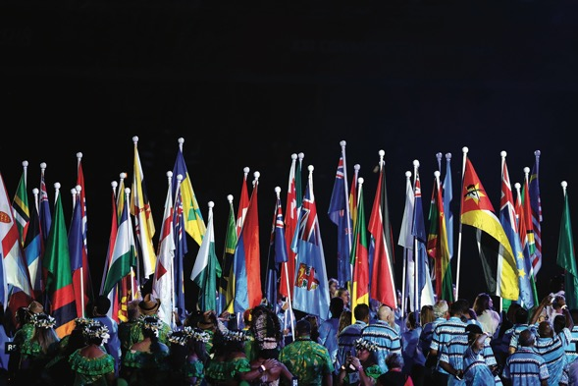
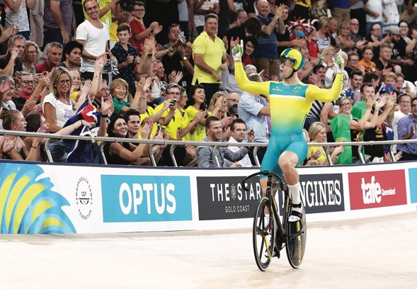

Acknowledgements
Sports Diplomacy 2030 was developed with input from an expert panel engaged by the Australian Government. The panel was led by Professor Caitlin Byrne, Director of the Griffith Asia Institute, Griffith University. It included Associate Professor Stuart Murray, International Relations and Diplomacy, Faculty of Society and Design, Bond University and Global Fellow, Academy of Sport, Edinburgh University; and Associate Professor Emma Sherry, Chair Management and Marketing, Swinburne Business School, Swinburne University of Technology.

Portfolio Agencies

www.dfat.gov.au

www.health.gov.au

www.tourism.australia.com
www.sportaus.gov.au

www.austrade.gov.au

For more information
dfat.gov.au/sportsdiplomacy

AusPlay National Data Tables - October 2015 to September 2016.
ABS Spectators in Sport (2006-10); BCG Economic Modelling of Sport, 2016.
ABS General Social Survey, 2014.
Australian Institute of Sport, Sports Tally for the Year 1996.
Australian Institute of Sport, Intergenerational Review of Australian Sport 2017, Boston Consulting Group 2017.
Ibid.
Ibid.
Nelson Mandela, Speech delivered at the opening of the Rugby World Cup, South Africa, 1995.

