2019-20 South Asia Regional development program progress report

|  |  |
| --- | --- |
| **Program Budget** | **2019-20 Budget Estimate ($m)\*** |
| Bilateral | - |
| Regional | 13.5 |
| Global | 4.8 |
| Other Government Departments | 3.3 |
| **Total Australian ODA to South Asia Regional** | **21.6** |

*Actual expenditure is expected to be available in December 2020

Infrastructure and trade – 29%
Agriculture, fisheries and water – 64%
Governance – 0%
Education – 5%
Health – 0%
Building resilience – 1%
General development support – 1%
Due to rounding total percentage may not add up to 100 per cent


**COVID-19 Development Response**

* The South Asia Water Security Initiative design was pivoted to target access to safe and reliable water for sanitation for those living in South Asian mega cities.
* The South Asia Regional Trade Facilitation Program (SARTFP) will assist governments manage a spike in homeward migration caused by COVID-19 labour displacement in guest worker economies.
* The Sustainable Development Investment Portfolio re-directed resources to analyse the impacts of COVID-19 on food security in South Asia.

**Other program highlights**

In 2019-20 the South Asia Regional Program:

* Commenced investments under the South Asia Regional Infrastructure Connectivity (SARIC) Initiative via the World Bank and IFC trust funds to help South Asia plan and prepare energy and transport infrastructure investments to better link the region.
* Provided a framework for developing cross‑border value chains between India and Bangladesh to support employment of women and the poor.
* Partnered with the International Finance Corporation to develop and publish a Cumulative Impact Assessment of hydropower in Nepal to promote sustainable development of the sector.
* Supported 30,950 households across the Eastern Gangetic Plains in the use of improved agricultural techniques, saving water, improving food security, and reducing greenhouse gas emissions.
* Supported 599 scholarship and short course recipients, more than 50 per cent women and 6 per cent with a disability, to successfully complete tertiary education and training programs delivered by Australian providers.
* Supported 234 people from Afghanistan, Sri Lanka, Nepal, Bangladesh, Pakistan and the Maldives to participate in 22 targeted professional development opportunities.

## Progress against 2019-20 performance indicators

| **title of strategic OBJECTIVE** | **Performance assessment framework indicator/benchmark** | **Brief summary of progress against indicator/benchmark** |
| --- | --- | --- |
| Objective 1.  Increased water, food and energy security in South Asia to facilitate economic growth and improve the livelihoods of the poor and vulnerable (particularly women and girls) | 1.1 New tools and approaches for inclusive and sustainable water resource management have been collaboratively developed and endorsed by key institutions.  1.2 New knowledge raises awareness of the impacts of climate change on water‑energy-food security and is beginning to be incorporated into policy and practice.  1.3 Private sector finance is increasingly being mobilised for both large-scale grid connected and rooftop solar projects (may include PPPs).  1.4 Private firms have improved understanding and technical capacity to implement resource efficiency measures that accommodate gender and/or climate change considerations.  1.5 Gender-responsive tools and approaches for cross-border management of floods and other water‑related disasters (including from the impacts of climate change) have been developed.  1.6 Small-holder farmers (25 per cent women) utilising sustainable agricultural practices (including CASI) to increase resource efficiency and improve climate resilience in the Eastern Gangetic Plains. | ~ Newly developed guidelines on dam safety, based on international good practice, have been accepted by the Royal Government of Bhutan and will inform the design of new hydropower projects (World Bank).  ~ A rapid assessment of water resources and an Action Plan for improving water resource management in the North East Region (India), has this year led to design of a new World Bank multi-phased programmatic approach ($500m, over ten years) - which aims to improve water security in Assam.  ~ The Asia Foundation‘s South Asia Green Energy (SAGE) Summit identified constraints to private sector investment in renewable energy in India.  ~ IFC launched the first ‘Made in India’ solar powered torch, and successfully trained nearly 10,000 women to become renewable energy retailers and distributors.  ~ Salinization studies in the Sundarbans landscape have brought new information and evidence on the impact of climate change and sea level rise on the nutritional and health status of women and children (World Bank).  ~ An additional 30,950 households across the Eastern Gangetic Plains began using Conservation Agriculture Sustainable Intensification (CASI) techniques (ACIAR). |
| Objective 2.  Increased regional connectivity through trade facilitation and infrastructure | 2.1 New knowledge and approaches adopted by Government of India to strengthen transport projects and policies.  2.2 Knowledge generated influences the World Bank to integrate gender in its larger inland waterways projects with the Governments of India and Bangladesh. | ~ The Inland Waterways Authority of India, introduced climate resilient and resource efficient commercial navigation and environment friendly dredging techniques.  ~ The findings of a SARTFP study on *Gender Inclusive Inland Water Transport and Trade Facilitation* was integrated into the World Bank’s $150 million *Assam Inland Water Transport Project.* |

## 

## ANNEX A: Program Quality

### Investment Monitoring Report ratings

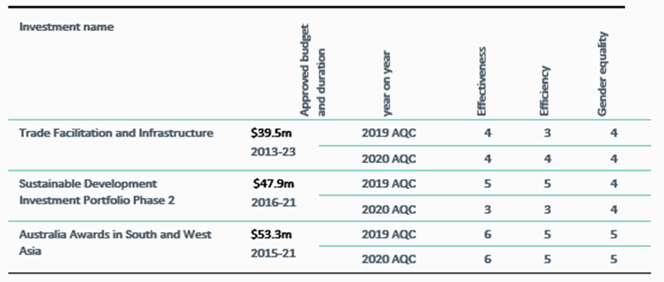

**Definitions of rating scale:**

**Satisfactory (4, 5 and 6)**

**6 = Very good; satisfies criteria in all areas. 5 = Good; satisfies criteria in almost all areas.**

**4 = Adequate; on balance, satisfies criteria; does not fail in any major area.**

**Less than satisfactory (1, 2 and 3)**

**3 = Less than adequate; on balance does not satisfy criteria and/or fails in at least one major area.**

**2 = Poor; does not satisfy criteria in major areas. 1 = Very poor; does not satisfy criteria in many major area.**