|  |  |
| --- | --- |
| Assessment for 2012: Final Report | Solomon Islands – Australia  Partnership for Development  Independent  Performance Assessment  Panel  Assessment for 2012  Conducted March 2013  Final Report |

Solomon Islands – 2011 World Bank Data

*(Australia’s data for comparison in brackets)*

Income level: Lower middle *(High)*

GNI (PPP dollars current internat’l): 1.31 billion *(823.02 billion)*

GNI per capita (PPP dollars): 2,360 *(35,783)*

GDP (USD): 838 million *(1.37 trillion)*

GDP annual growth: 9% *(1.9%)*

Population: 552,300 *(22,620,600)*

Population growth rate: 2.6% *(1.4%)*

Life expectancy at birth: 68 years *(82 years)*

__________________

Exchange Rate[1]: AUD 1.00 ≅ SBD 7.50

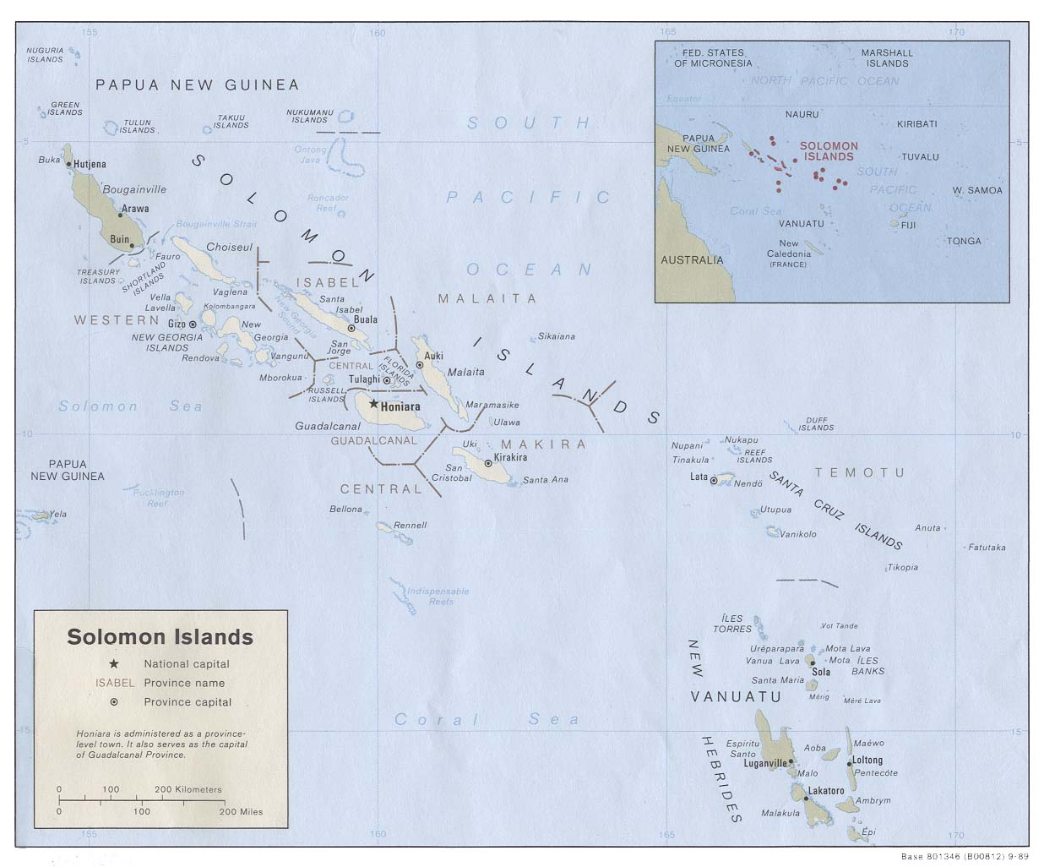

Abbreviations and Acronyms

|  |  |
| --- | --- |
| ADB | Asian Development Bank |
| APTC | Australia-Pacific Technical College |
| AUD | Australian Dollar |
| AusAID | Australian Agency for International Development |
| CEWG | Core Economic Working Group |
| CLIP | Cocoa Livelihoods Improvement Program |
| DHIS | Digital Health Information System |
| DPMS | Domestic Maritime Support Project |
| EU | European Union |
| GDP | Gross Domestic Product |
| GNI | Gross National Income |
| HSSP | Health Sector Support Program |
| IMF | International Monetary Fund |
| JICA | Japan International Cooperation Agency |
| KGA | *Kastom Gaden* Association |
| MAL | Ministry of Agriculture and Livestock |
| MDG | Millennium Development Goal |
| MDPAC | Ministry of Development Planning and Aid Coordination |
| MEHRD | Ministry of Education and Human Resource Development |
| MHMS | Ministry of Health and Medical Services |
| MID | Ministry of Infrastructure Development |
| MoFT | Ministry of Finance and Treasury |
| NEAP | National Education Action Plan |
| ODE | Office of Development Effectiveness, AusAID |
| PacMI | Pacific Malaria Initiative |
| PAF | Performance Assessment Framework |
| PEFA | Public Expenditure and Financial Accountability |
| PfD | Partnership for Development |
| P/O | Partnership Priority Outcome |
| PPP | Purchasing Power Parity |
| QAI | Quality at Implementation |
| RAMSI | Regional Assistance Mission to Solomon Islands |
| RDP | Rural Development Program |
| ROC | Republic of China (Taiwan) |
| SBD | Solomon Island Dollar |
| SIACWSI | Solomon Islands Access to Clean Water and Sanitation Initiative |
| SICHE | Solomon Islands College of Higher Education |
| SIG | Solomon Islands Government |
| SIRIP | Solomon Islands Road Improvement Project |
| SISTA | Solomon Islands Standardised Test of Achievement |
| SOE | State-Owned Enterprise |
| SPC | Secretariat of the Pacific Community |
| SSCSiP | Strengthening Specialised Clinical Services in the Pacific program |
| SWAp | Sector-Wide Approach |
| TSDP | Transport Sector Development Project |
| TVET | Technical and Vocational Education and Training |
| UNFPA | United Nations Population Fund |
| UNICEF | United Nations Children’s Fund |
| USD | United States Dollar |
| WASH | Water Sanitation and Hygiene |
| WHO | World Health Organisation |

Solomon Islands – Australia Partnership for Development

Independent Performance Assessment Panel

Assessment for 2012

Conducted March 2013

Final Report

Part 1: Introduction and Overview

This is the fourth annual progress report on the Solomon Islands – Australia Partnership for Development. The assessment was carried out this year during a single visit, in March 2013, by the same Independent Performance Assessment Panel[2] that has reported on previous years’ progress.

The assessment is based on the self-reported *Quality at Implementation* narratives of the various AusAID-funded programs and initiatives, on mostly off-the-record interviews with SIG and AusAID teams and senior managers, through discussions with other development partners in Honiara, and on supplementary data[3] provided to the Panel. A short field visit, this year to Isabel Province, allowed the Panel to see how services supported by the Partnership are being delivered on the ground.

Terms of Reference

The Panel’s terms of reference, which differed slightly from previously, this year emphasised:

Performance (Part 2 of this report):

* Against Priority Outcomes;

Relationships (Part 3 of this report):

* The principles of partnership and the qualities of the relationship.

Policy (Part 4 of this report):

* The quality and status of, and capacity for, policy dialogue;
* The utility of the Partnership for Development in facilitating change, public policy, and policy processes;

Some conclusions and recommendations are provided in Part 5 of this report

The Panel’s consultations are listed at Annex 1.

Origins and evolution of the Partnership

The Partnership for Development, signed in early 2009, predates most current appointments in the AusAID and SIG teams. It is worth reflecting on its origins and evolution.

The Partnership’s origins lie in an important political intent to recalibrate Australia’s aid relationships in the Pacific and improve aid effectiveness by better supporting Pacific island countries’ own direction of development in a more focused, mutually prioritised way, by pursuing mutual accountability for results, and by honouring the principle of mutual respect.

The ‘principles of partnership’ that were adopted largely reflect the international consensus emanating at the time from the Paris and Accra high-level forums on aid-effectiveness.

Since the Partnership’s inception the Panel has witnessed significant shifts in the bilateral program’s ways of working and its relationships. Each year the Panel has been able to congratulate SIG and AusAID on its progress, while setting the bar ever higher in terms ‘where next’. The partnership has taken AusAID and SIG teams to new levels of discourse and informed programming, but has also often challenged the *status quo* – with SIG increasingly often assuming the lead in such challenges.

Early in the Partnership, the Panel encouraged a deeper, more empathetic, AusAID dialogue with SIG. This has largely been achieved, in the Panel’s view.

Throughout, the Panel has also emphasised the need for a greater focus on outcomes and impacts (as opposed to inputs and activities), and on the need to configure the Partnership in the context of a longer-term vision of what is trying to be achieved – in terms of both the process and the function of development assistance – as the country emerges from its troubled past.

Most recently, the Panel has encouraged AusAID and SIG to look beyond the often all-preoccupying processes of aid management and question what it is that really makes a difference to people’s lives and livelihoods in rural areas in the country, and – in particular – the impact of the quantity and quality of funds flowing down to service delivery units at the community level.

Overview of progress in 2012

During 2012, nearly AUD 49 million (or about SBD 368 million) was provided under Australia’s bilateral program in support of the priorities established under the Partnership for Development. Almost half of this total was allocated to two key sectors: infrastructure (AUD 11.9m, or 24%) and health (AUD 11.1m, or 23%). Education (AUD 7.7m, or 16%), support to economic and fiscal reforms (AUD 4.7m, or 10%) and livelihoods (AUD 3.7m, or 8%) continued to constitute the other Partnership priority areas. A further AUD 9.5m, or 19% of the bilateral spend, was allocated to scholarships, emergency and humanitarian responses, and to civil society programs. (Pie chart, next page.)

Over its four-year life now, the total spend allocated to the Partnership for Development is approaching AUD 200 million (SBD 1.5 billion). So it is time to be discussing outcomes and impacts.

Once again, the Partnership has strengthened and deepened – in terms of the relationship between AusAID and SIG (as noted previously) and now in terms of a greater focus on the results and transformations that are required to deliver tangible outcomes for citizens.

These transformations are most noticeable in the health sector, which builds on foundations laid and relationships established much earlier than in other sectors (demonstrating the long-term nature of the challenge), and a tangible increase in the quality and quantity of public funding reaching service delivery units at field level.

But elsewhere there are relatively few data that demonstrate that people’s lives and livelihoods are yet changing for the better as a result of the partnership’s contribution.

(Although there are some limited data to suggest that transport infrastructure investments are also having an impact.)

This is not to say that the Partnership is doing the wrong things: we think it is probably doing the right things. But the point is raised to highlight the worrying persistence of the “too early to say”, and the predominant focus on central systems and public sector management issues. Issues which certainly need to be resolved, but the resolution of which may not in itself be sufficient to bring about development at scale.

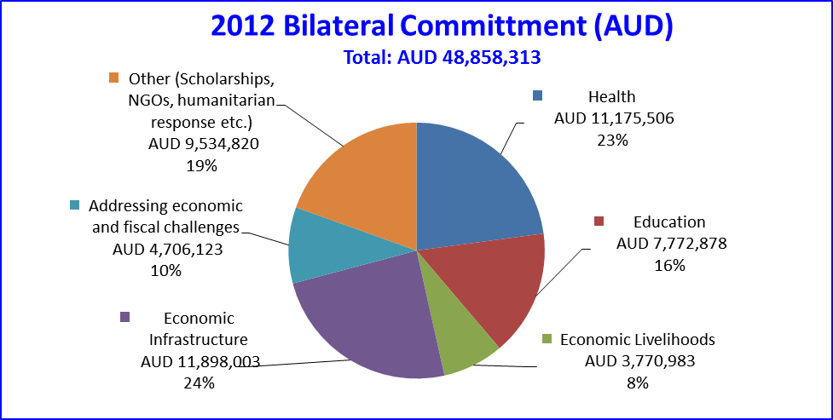

Part 2: Progress towards Priority Outcomes

Priority Outcome 1a: Improved Service Delivery – Health

Approximate expenditure on health in 2012: AUD 11.2m or SBD 84.0m

Under the Partnership, Australia supports the Ministry of Health and Medical Services (MHMS) to provide health services to all Solomon Islanders. Australia does this through a Sector-Wide Approach (SWAp) which provides earmarked budget support for jointly agreed priorities including health sector strengthening activities, maternal and child health, malaria and other disease control priorities and funds to provide rural access to clean water, basic sanitation and hygiene awareness[4]. AusAID-funded regional programs and health interventions also contribute to the partnership[5]. AusAID’s support comprised approximately 37% of funding for the public health sector in 2012.

**Priority Outcome 1a: Health**

**Aim:** The Partnership will strengthen public health functions that are responsive to community health needs and improve progress towards the MDG targets by 2015.

**Agreed Partnership Outcomes**

* Increased percentage of population with access to a health facility staffed by a health care worker and stocked with appropriate medicines.
* Reduced malaria incidence and deaths and progress towards emanation in selected provinces
* Increased access to water and basic sanitation.
* Reduced maternal and infant mortality.

Is the health program delivering outcomes for Solomon Islanders?

Since the beginning of the Partnership (in 2009) the work in health has concentrated on improving systems, strengthening capacity and improving public financial management. Steady progress has been made in improving systems and in 2012 the Ministry developed a core set of performance indicators to track key results against the strategic plan and a digital health information system (DHIS) is now operational. Health systems have slowly been strengthened and recurrent budgets to provincial services have increased. As a result of the partnership, promising indications of progress towards sustained health outcomes are emerging for Solomon Islanders.

**Tracking Health Outcomes for Solomon Islanders** 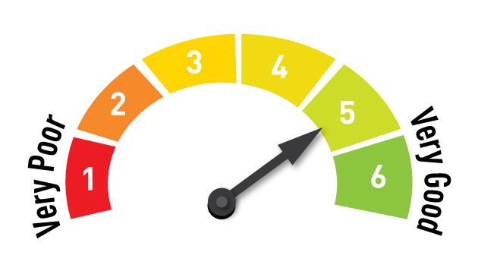

**Outcome score: 5 – Good progress**

* Access to appropriate health facilities and stocked with medicines

In 2012 the availability of critical drugs and consumables at the national level increased to 91%. This is up from 74% in 2010 and 81% in 2011. Access to, and satisfaction with, health services was not measured in 2012 due to the People’s Survey becoming a biannual event[6].

* Reduced malaria in high endemic provinces and improved treatment in confirmed cases

The control and elimination of malaria in Solomon Islands is a significant achievement. The malaria program has been successful in reducing both the incidence of malaria and malaria mortality rates. The incidence of malaria has fallen from 82 cases per 1,000 head of population in 2008 to 75 cases per 1,000 in 2010, to less than 45 cases per 1,000 in 2012. The number of malaria-related deaths has remained relatively stable at three deaths per 100,000 (down from 7 deaths per 100,000 in 2007)[7].

(Although these recent improvements need to be set in the context of a much longer-term downward trend, from significantly higher incidence rates seen in the early nineties[8].)

* Increased access to clean water and sanitation

During 2012, 44 water systems were completed in rural provinces providing access to safe drinking water to over 10,000 people (including over 3,700 women and 3,000 children). However, lack of access to clean water and proper sanitation remains a major issue undermining health across the Solomon Islands. The estimated coverage of functioning water supply is only 35-40%, and only 18% of villages have access to basic sanitation.

* Reduced maternal and infant mortality rates

Good progress continues to be made to reduce infant and maternal mortality. The infant mortality rate dropped from 36 deaths per 1,000 births in 2010 to 27 in 2011 with early indicators suggesting the number of infant deaths in 2012 has continued to decline[9]. Across the Solomon Islands over 85% of deliveries were, it is reported, managed by a skilled birth attendant and the estimated maternal mortality rate fell from 143 per 100,000 live births in 2009 to 138 per 100,000 live births in 2011, with a further decline in the absolute number of maternal deaths in 2012[10]. These results indicate that Solomon Islands is on target to meet the MDG (5a) target of 127 deaths per 100,000 deliveries.

Priority Outcome 1b: Service Delivery – Education

Approximate expenditure on Education in 2012: AUD 7.7 m or SBD 57.8m

AusAID has been formally engaged in the Solomon Island education sector for two years. Working alongside New Zealand (the lead donor in the sector) Australia provides earmarked support through a SWAp led by the Ministry of Education and Human Resource Development (MEHRD), to deliver its National Education Action Plan (NEAP). Australia is committed to providing long-term funding which supports MEHRD to provide quality basic education for all, with a focus on literacy and numeracy in the early years, and on improving the employability of young people.

**Priority Outcome 1b: Education**

**Agreed Partnership Outcomes in PAF**

* **To achieve equitable access to educatio**n for all people in the Solomon Islands: All children in the Solomon Islands regardless of gender, ethnicity, religion or location have access to basic education.
* **Improved Access to Skills Training**: People in the Solomon Islands regardless of gender, ethnicity, religion, location or disability have improved access to relevant, demand-orientated community, technical vocational or tertiary education.
* **Improved Quality.** All levels and dimensions of the Solomon Islands education system consistently demonstrate standards of excellence and deliver a quality education.
* **Improved management.** The management of the Solomon Islands education system is effective and efficient.

Is the education program delivering outcomes for Solomon Islanders?

The education SWAp is still in its early stages. Since the beginning of the partnership, work in education has focused on improving systems, particularly public financial management and procurement, and strengthening the core capacity of administrative functions. It will take time before the benefits of the education SWAp impact on the lives of Solomon Islanders. While progress has been made administratively, outcomes for Solomon Islanders are hard to gauge due to the paucity of monitoring data.

* Improved Access to Basic Education

Predicable partnership funding to the education sector supports the Ministry of Education in continuing to provide school operating costs, reducing school fees and therefore enabling access to the 145,000 children in basic education.

* Improved Access to Skills Training.

**Tracking Educational Outcomes for Solomon Islanders**

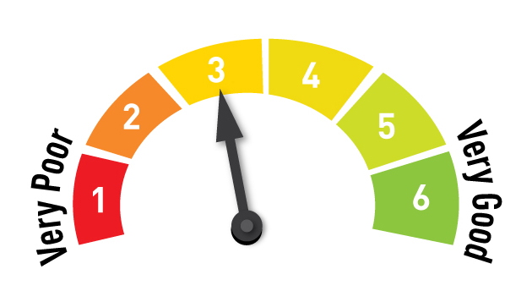

**Outcome score: 3 – A little progress**

405 Solomon Islanders have graduated from APTC[11] courses since 2009. The APTC undertook an assessment to establish a campus in Solomon Islands and in 2012, and SIG took steps to establish a national university.

* Improved Quality of Education.

The quality of education across the Solomon Islands remains unacceptably low, although slight changes in Year 4 results have been recorded. Improvements (2-4%) in literacy and numeracy rates were recorded for Year 4 students in 2010[12] compared to 2004/5. Longstanding problems remain of teachers being absent from the classrooms (as they have to travel to receive their salaries) as well as the need for further teacher training.

* Improved Management of the Education System.

Most progress has been made in strengthening core MEHRD systems. MEHRD now has a procurement plan and a procurement specialist, the internal audit unit is now providing rigorous audits to senior managers and an expenditure analysis in 2012 provided MEHRD and its partners with information to discuss future strategic priorities.

Priority Outcome 2: Economic Livelihoods

Approximate expenditure on livelihoods in 2012: AUD 3.8m or SBD 28.5m

The Partnership’s Outcome 2 addresses economic livelihoods, focusing particularly on sustainable agriculture, financial inclusion and improved operation of the markets for the benefit of rural households. In 2012 the partnership agreement was signed defining strategic work under this priority outcome area. The new joint SIG-AusAID partnership schedule includes:

**Priority Outcome 2 – Livelihoods**

**Aim:** The Partnership will support more productive and sustainable use of agricultural land, increased access to financial services and the improved operation of markets for the benefit of rural households.

**Agreed Partnership Outcomes**

* Continued per capita growth in agricultural production.
* Over 60% of villages with improved access to effective agricultural services.
* An additional 70,000 of people accessing appropriate and affordable financial services.
* Continued support for SIG and the World Bank-led Rural Development Program (RDP) which focuses on community-led small-scale rural infrastructure, building capacity in the Ministry of Agricultural and Livestock (MAL), and assisting rural businesses with access to finance.
* Strengthening key systems in MAL including supporting strategy development, cocoa production, veterinary supervision and biosecurity.
* Partnership with the Central Bank to bring appropriate financial services to an additional 70,000 rural people by 2015.
* Continued support to Kastom Gaden Association (KGA) to strengthen family food security and income generation.

Is the livelihoods program delivering outcomes for Solomon Islanders?

Partnership work under this Priority Outcome area is just beginning (other than AusAID’s longstanding co-financing of RDP). There are therefore few impacts yet – with the exception of those associated with RDP’s small-scale projects – for Solomon Islanders. Furthermore, data on the outcomes of the provision of services (e.g. agricultural extension) or rural infrastructure are currently unavailable. Nevertheless this priority outcome is gaining momentum and the benefits of mobile banking and financial inclusion work look promising.

**Tracking Livelihood Outcomes for Solomon Islanders** 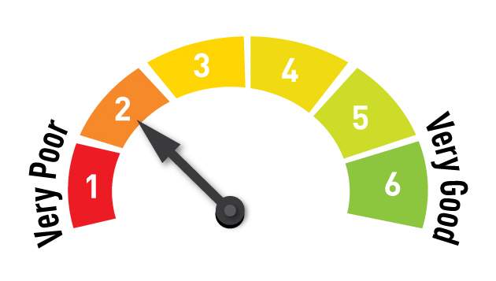

**Outcome score: 2 – Initial progress (*)**

**(*)** Because the Panel’s assessment is tracking progress towards outcomes that impact on citizens’ lives and livelihoods, this attracts a low score at present (as work has only just got started, and it has been four years in preparation). However the Panel is impressed with how this outcome area has now been redefined through productive dialogue between AusAID and SIG, and is optimistic for the future.

* Continued per capital growth in agricultural production

After record results in 2011, cocoa exports fell in 2012 to 4,478 tons due to bad weather and low prices. This is back on par with the 2003-09 export average of 4,447 tons (post-tensions and prior to CLIP)[13].

* Over 60% of villages have access to effective agricultural services

During 2012, MAL continued its reach into rural communities, providing agricultural services to 8,763 farmers in eight provinces. To date 22,661 farmers have been involved in MAL training and research activities with about one third being women. By the end of 2012, 5,880 households (almost 30% of cocoa farming households) applied integrated pest and disease management practices on their farms. In 2012, Kastom Gaden Association conducted training and research with over 6,400 farmers. Activities included the distribution of plant materials, establishing crop trials, pest and disease management etc.

* An additional 70,000 people accessing appropriate and affordable financial services.

AusAID support for the Central Bank’s work on access to financial services is yet to begin. However component three of RDP has supported 62 businesses with SBD 7.7m in supplemental equity, leveraging SBD 31.4m in recipient equity and bank loans. The outcomes from these loans will be assessed in 2013.

_______________

The question has arisen “Surely RDP is impacting on people’s livelihoods?”. Yes: it is. But the Panel has always been cautious about billing RDP as something that is genuinely transformational – in terms of the extent (scale and speed) to which the lives and livelihoods of the 450,000 rural population of Solomon Islands are being turned around. RDP does valuable things, not least in demonstrating that there is some solid development going on in rural areas, but RDP (and KGA) is really about delivering foci of benefits to communities and businesses, not wholesale reform. Neither is it about providing universal access to – for example – subsidies, inputs and services[14].

Perhaps the upcoming Household Income and Expenditure Survey (a very valuable thing to be supporting) will demonstrate otherwise and help us to understand better if or how rural lives and livelihoods are changing. But *in the meantime* it is difficult to say what development outcomes – at the level and scale implied by the Partnership’s objectives in this area – can be considered the result of the 2009 reconfiguration of the bilateral program. But the Panel is confident that will change over time.

Priority Outcome 3: Economic Infrastructure

Approximate expenditure on infrastructure in 2012: AUD 11.9m or SBD 89.3m

Priority Outcome 3 is supported through several joint programs covering transport, telecommunication, urban water and electricity in partnership with multilateral and bilateral donors. During 2012 Australia provided AUD 7m to support SIG to improve infrastructure, including through contributions to the National Transport Fund. This marks the second year of transition from ‘project support’ towards a sector-based approach managed and led by the Ministry of Infrastructure Development (MID).

**Priority Outcome 3: Infrastructure**

**Agreed Partnership Outcomes**

* Increased proportion of the rural population with reliable transport access to markets and services.
* Growth in household incomes in areas targeted by transport programs.
* Increased proportion of the populations with access to reliable and affordable energy.
* Increased proportion of rural population with access to affordable telecommunications.
* Increased proportion of the urban population with access to reliable water supply.

AusAID’s funding for transport also included contributions to the multi-donor supported Solomon Islands Road Improvement Project (SIRIP) and the Solomon Islands Domestic Maritime Support Project (DMSP)[15]. Furthermore AusAID supported infrastructure development through providing regional funding to the World Bank-led Rapid Employment Project (REP) and continued to support the Solomon Island’s Telecommunications Commission, the Solomon Islands Water Authority and the World Bank-led initiative to provide hydroelectricity to Honiara.

**Tracking Infrastructure Outcomes for Solomon Islanders** 

**Outcome score: 5 – Good progress**

Is the infrastructure program delivering outcomes for Solomon Islanders?

Economic infrastructure is a major constraint to economic growth in the Solomon Islands. Progress across each of the sectors (roads, shipping, aviation, telecommunications, energy and water supply) is slow and reliable monitoring data is still unavailable, nevertheless proxy information indicates that, over the years, the Partnership is making important progress that is leading to outcomes for Solomon Island people.

* Increased rural population with reliable transport, access to markets and services

The Ministry of Infrastructure Development maintained 344 km of road network in 2012 and work is underway to rehabilitate 11 wharves under the Domestic Maritime Support Project. Australia (through the National Transport Fund) has not yet been involved in the aviation sector, however SIG undertook some of the maintenance of all airstrips that have scheduled traffic in 2012. An absence of nation-wide data renders an accurate assessment of impact impossible but localised surveys suggest that where roads and wharfs are improved, people have greater access to services. A community study in Makira Province indicates that improved roads and bridges significantly reduced travel costs to market, schools, health centres and hospitals. It also led to people opting to travel by land rather than sea, due to safety[16]. In the areas surveyed some 71% of males and 66% of females surveyed made at least one weekly trip to the market in the provincial capital, compared to 28% and 24% before road improvements[17].

* Growth in household incomes in areas targeted by transport programs

At this stage there are insufficient data to tell if increased access to transportation is leading to a widespread growth in household income. However, small studies indicate a strong correlation between road and bridge rehabilitation and household income. In communities in Makira Province a before-and-after study indicated that average monthly household income from cocoa increased by 88%, copra increased by 48% and market sales increased by 38%[18], [19]. Furthermore the road maintenance programs have created at least 207,000 person-days of work for Solomon Islanders with around 55% of work opportunities taken up by women.

* Increased access to reliable and affordable energy

Access to affordable energy remains a constraint to economic growth in the Solomon Islands. In 2011, nearly 42% of Solomon Islanders had no electricity[20]. The World Bank-led Tina River hydro-electricity project remains in its early stages (a Phase Three feasibility study should take place in 2013) and is now expected to generate hydroelectricity for Honiara from the 2016-17 wet season.

* Increased affordable telecommunications

Further improvements in communications are being felt by Solomon Islanders. By the end of 2012, mobile phone coverage had increased to 80% of the population (compared to 20% in 2010). The cost of calls continued to fall in 2012 with local mobile calls 19% cheaper than in 2011. Furthermore the deregulation of the market in 2011 means that subscriber numbers rose while costs fell. Mobile internet subscribers rose four-fold from 8,205 in 2010 to 35,826 in 2012 while costs fell 50% between 2011 and 2012[21]. Internet access remains constrained though with internet subscriptions equivalent to only 6.5% of the population. There could be significant development benefits from further access to digitalised technology across Solomon Islands.

* Increased urban population with access to reliable water supply

Access to clean water has been a persistent problem in urban areas in the Solomon Islands. However improvements have been made in both the reliability of flow and purity of water in Honiara. By the end of 2012, an average of 25% samples were biologically impure compared to over 50% in 2011, and three areas of Honiara that had less than eight hours of water per day in 2011 now have 24-hour supply. However, more remains to be done in improving access to reliable water in urban areas.

Priority Outcome 4: Economic and Fiscal Challenges

Approximate expenditure in 2012: AUD 4.7m or SBD 35.3m

The fourth Priority Outcome is to assist Solomon Islands to manage expected economic and fiscal challenges and to improve the environment for fiscal certainty. Under this priority outcome Australian bilateral staff work closely with SIG institutions[22] and five other donors[23] (through the Core Economic Working Group, CEWG) to support the implementation of economic reforms. These reforms are guided by a matrix of economic and fiscal improvements. During 2012, emphasis was placed on the Ministry of Finance and Treasury (MoFT) developing this matrix, ensuring that priority actions are aligned with MoFT’s Corporate Plan and monitored through its monthly ‘traffic light’ report.

**Priority Outcome 4**

**Agreed Partnership Outcomes**

* An affordable and sustainable budget that improves Government decision-making processes and focuses on development goals.
* Structural reform that makes Solomon Islands an attractive and reliable place for businesses to invest.

Is the economic and fiscal program delivering outcomes for Solomon Islanders?

The CEWG has become an important, although fragile, mechanism for policy dialogue between SIG and donors. After four years of reforms, significant gains have been made, particularly in MoFT, which will have lasting benefits. However the Partnership outcomes have long time horizons and will be the result of structural and sustained reforms across the whole of government, including line agencies. Current change is promising but there remains work to be done, against agreed partnership outcomes, to create the opportunity for donors to engage in more substantive and more efficient forms of development assistance, such as greater use of budget support.

**Tracking economic and fiscal outcomes** 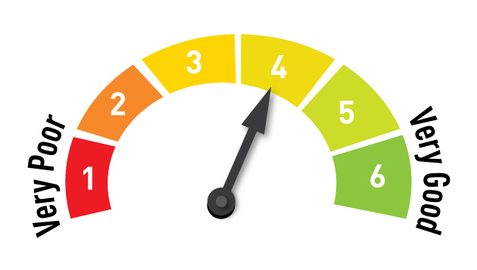

**Outcome score: 4 – enough progress**

* An affordable and sustained budget that improves government decision-making processes and focuses on development goals

The Solomon Islands remains highly vulnerable to external conditions. Strong economic growth continued in 2012 with logging income higher than expected (but gold production somewhat lower). A weakened fiscal position reflects shortfalls relative to the 2012 budget and higher recurrent spending associated with the Festival of Pacific Arts, as well as higher spending on tertiary education and utility bills[24]. On the positive side the country retained its World Bank/IMF debt sustainability risk rating of ‘moderate risk’, with total public debt at 22% of GDP at the end of 2011, and approved a new debt management strategy endorsed by Cabinet in May 2012. The country also saw a strengthening of accountability and transparency around the use of public resources, including a more detailed presentation of the annual budget and deepening consultations between MoFT, MDPAC and line ministries around budget submissions[25].

However, on some indices there remains work to be done. Improving the quality of government expenditure – including on essential services for citizens such as health and education – is a key partnership objective. The allocation of the budget is an inherently political issue, not a technical issue. However the difference between actual SIG expenditure and planned SIG expenditure continues to differ. This undermines the effectiveness of the budget as a planning tool[26].

* Structural reform that makes Solomon Islands an attractive and reliable place for businesses to invest

2012 saw improvements in the private sector investment climate. This includes improvements in the time to register new companies and land transitions. Since the Companies Act come into force in 2010 there has been a near doubling of the number of new companies incorporating each year, indicating that simplified processes with lower fees have encouraged greater participation in the formal private sector. The Solomon Islands *Doing Business Indicators* has seen a consistent shift in ranking from 106th in 2010, to 81st in 2011, to 74th in 2012[27].

A key success of SIG's reform programme has been on-going state-owned enterprise reform, especially the resolution of the solvency and debt issues surrounding key SOEs. The resolution of the solvency and debt issues of the Solomon Islands Water Authority and the Solomon Islands Electricity Authority has been a major achievement. These utilities can now focus on long-overdue improvements to efficiency and service delivery that affect all businesses.

Part 3: Partnership Relationship

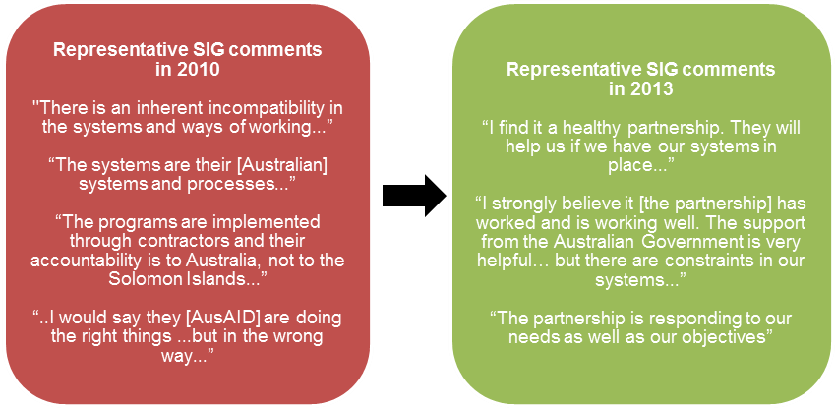Over the four years of the Partnership the nature of the relationship between AusAID and key sectors within SIG has changed substantially. The quotes (below) illustrate progression over time. In 2010, the Partnership was generally perceived with cynicism. Over time, as the ways of working have changed - including better day to day discussions between sector teams and the recognition of culture and power in the relationship - a level of trust has developed, in most sectors, between SIG and their Australian counterparts.

Discussing and scoring the key partnership principles – ownership, harmonisation, alignment, managing for results, mutual accountability and gender – has been an important process for some teams[28]. While an inexact science, scoring provides an empirical ‘rating’ on the extent to which the principles of partnership are being achieved. More importantly, the process provides the opportunity for discussion about ‘the ways of working’ which are fundamental to partnership. Inevitably the relationship between partner teams in some sectors is stronger than others. Sector relationships have started at different points in time and are progressing along their own trajectory. Stronger partnership relationships have particularly been developed in health and infrastructure. An overview of general progress against each principle is provided below.

* Promoting Solomon Islands ownership of development processes is not just a political ideal, but is a prime determinant of sustainability. The sense of ownership appears to have improved across all sectors of the partnership. In some sectors there remains a need for more regular dialogue (particularly the newly developing Priority Outcome 2) and overall there is an imperative for SIG to take a stronger lead in clearly articulating its policy and priorities (both nationally and at sector level) and communicating these with development partners.
* Harmonisation between donors is important not just to provide coherence across the national aid effort but also to reduce SIG’s transaction costs in absorbing and managing and making best use of aid flows. Harmonisation is also perceived as being improved across the partnership although SIG still bares considerable transaction costs of aid, and there is still need for better integration of AusAID Pacific regional programs with Government priorities[29].
* There has been a significant improvement in alignment with SIG systems since the beginning of the partnership. AusAID’s health and education programs support SIG through (effectively) ear-marked budget support and its infrastructure program supports SIG’s National Transport Fund. Although progress has been made, there is more to be done in aligning partnership work with SIG systems, at a higher level, in ways which strengthen not just sector Ministries but centralised policy-making and budgeting systems.
* Mutual accountability is seen to have improved particularly among higher performing Ministries where a level of trust has developed over time – between SIG and AusAID at least. However, despite strengthened processes around the presentation of the annual budget, overall accountability to the Solomon Island people for the use of public resources remains low.
* Despite some improvements, managing for results remains less than adequate. While significant progress has been made in some areas (e.g. the health sector developing a Health Information System) and while increased partnership support for national statistics is promising[30], the current availability of national-level outcome data across the partnership remains poor. The use of results to inform strategic decision-making is low.
* The integration of gender within the partnership program currently remains patchy. While some Priority Outcome areas have included gender analysis into programing and in some monitoring (e.g. health and infrastructure), the strong articulation of how to improve outcomes for Solomon Island women, as well as men, and the systematic tools to monitor this, remain some way off.

The Panel was encouraged by the directions on gender emerging from a recent AusAID scoping exercise.

It should be noted that the Partnership is not always about agreement. Strong partners have robust discussions based on mutual trust and engagement. In some areas there will inevitably be disagreement. It is important to have those substantive discussions particularly around policy-making and planning. The maturing of the Solomon Islands–Australia partnership allows for those more substantive discussions to be held.

Branding

The Partnership has been more visibly ‘branded’, through public advertisement, over the last year. It is not for the Panel to judge the value of this. However a couple of emergent issues were raised by others as regards the impact this may have on wider relationships:

* The value AusAID attaches to coalitions within the donor community; and
* The more subtle issue as to the extent to which citizens recognise their own government, as opposed to somebody else’s government, as the driver of national development.

Part 4: Policy Dialogue

This year the Panel was asked to look at policy dialogue under the Partnership, and to comment on its utility in facilitating change and improved public policy.

What is ‘policy dialogue’?

The allocation of time and effort to policy dialogue was a noticeable development in the reporting of AusAID activities under the Solomon Islands bilateral program in 2012, as it has been across AusAID more widely. However, again as elsewhere, what is meant by ‘policy dialogue’ varies.

The current emphasis on policy dialogue across many development agencies is founded on the principle that social and economic development at the scale implied by the MDGs and beyond requires fundamental shifts in the ‘rules of the game’ that ultimately determine the nature and quality of poor people’s lives and livelihood opportunities. Such transformation might be brought about through public expenditure choices and the efficiency and effectiveness of public expenditure, or through the regulatory environment and the norms and standards that a government – or society more widely – pursues.

‘Policy’, therefore, is fundamentally about ‘values’ – or, one might say, the things that those who have it in their power to adjust the ‘rules of the game’ see as important. ‘Policy dialogue’, therefore, is a discussion about the relative importance – or values – that different stakeholders (for example a government and its development partners) attach to different policy positions, processes and outcomes.[31]

Not necessarily ‘influencing’, but understanding

Any two parties with differing values will naturally wish to influence the other, particularly if the expression of the other party’s values might impinge on one’s own values. However, policy dialogue is much more than ‘influencing’ – particularly in the unique context of aid being provided to support another, sovereign, country’s development efforts. For it is the sovereign expression of values by an independent government that shapes and defines a country’s identity and its interpretation of political, social and economic progress.

Thus policy dialogue for a development partner has – in the first instance – to be about understanding the government’s values, and perhaps helping the expression of those values through the generation of solid, locally-owned, evidence and public policy processes.

… and not just ‘aid management’

What cannot be termed ‘policy dialogue’ is, simply, the regular negotiation and administration of programs. These are processes that inevitably consume much time and effort, but they are not about ‘values’, except in a rather bureaucratic sense.

Policy dialogue under the current Partnership

There’s an important discussion about values to be had

Although there is a quip that policy-making processes in Solomon Islands are sometimes difficult to describe and capture, particularly at the political level, it is nonetheless clearly a fact that SIG does express values and does make policy. The expression of those values reflects the emergence of a tangibly reinvigorated nation with priorities and aspirations that have moved on considerably – even since the Partnership was signed. (For example, in the areas of tertiary education and health care.)

Policy dialogue under the Partnership therefore needs to keep abreast of these emergent values, understand them, and – where appropriate – adapt to them.

Indeed, it is hugely important to recognise the opportunity of the ‘policy window’ that exists now, with a reform-minded government and conditions of relative political stability. Such policy windows need to be jumped through with alacrity.

The question was raised, however, as to whether policy dialogue (about political values and aspirations) is driving aid programming, or whether aid programming is driving policy dialogue. SIG’s conclusion was that it is perhaps the latter. That needs to change, although SIG also accepts that it is not always good at making clear its policy positions and priorities.

Thus, in a changing policy context, ‘policy dialogue’ must not be unduly preoccupied with ‘compliance’ with previous plans but rather, whether legitimate values being expressed by government are captured in those plans.

To some extent (as elsewhere in the Pacific) the extent to which policy dialogue tends to be officials-led also makes the assessment of truly political values more complex.

Priorities for, and good practice in, policy dialogue

In looking at policy dialogue, as we were asked to do, the Panel would emphasise two issues raised in an earlier, and now this, partnership assessment:

* Firstly, that there needs to be real and explicit clarity of intent[32] about the longer-term role and function of development assistance in Solomon Islands if policy dialogue is to be directed towards its most productive ends. What constitutes the urgent for now does not necessarily establish, or translate into, the important for the longer term.

Perhaps that clarity or intent is contained in higher-level country strategy assessments to which not all are privy, but that opacity in itself compromises the ability to assume such a longer-term perspective in policy dialogue.

* Secondly, that policy dialogue needs to focus on outcomes and whether they are being achieved, and to consider *all* that is needed to bring about those outcomes. Will strengthening systems and public sector management issues be enough in itself, or are more fundamental adjustments to how services are funded and delivered required if citizens are to see a difference, for example?

Incremental change in systems and processes (as we have reported in this and earlier assessments) is important, but it is only valid if it is set in the context of what wider change is sought.

Those discussions are likely to extend across sectors and programs, and – in the aid context – to involve the efforts of multiple development partners and actors.

Policy dialogue quality and capacity

The Solomon Islands Core Economic Working Group (CEWG) was used as a case study in ODE’s evaluation of policy dialogue and was reviewed favourably. The CEWG epitomises many aspects of good practice in policy dialogue processes – both by SIG and by its development partners – including clarity of intent, the formation of a coalition of a partners with common goals, the support provided to SIG to express its values, the mixture or formal and informal platforms for dialogue … and other features too.

But it is less clear that such a developed form of policy dialogue is yet to emerge in many other sectors, although there are certainly examples of some key policy issues being debated.

As the Panel has noted previously, it is important that the space and time is created and maintained for senior managers to engage in ‘real’ policy dialogue (as opposed to, simply, the administration of the aid program) and that AusAID invests in supporting SIG’s (and its own) ability to pursue sound, evidence-based, policy processes – together with its development partners – in the kind of way that the CEWG model has allowed.

Part 5: Conclusions and Recommendations

Once again the Panel is very encouraged by the progress being made, particularly the progress that is evident – through the Panel’s privileged position of witnessing year-on-year change over the life of the Partnership – in:

* + The strengthening and deepening of the aid relationship;
  + The increasing focus on *transformational* investments (i.e. investments that bring about a change in the ‘rules of the game’ that ultimately shape the nature and quality of people’s lives and livelihood opportunities), and on the quality and level of funding;
  + The increasingly confident leadership of development processes by SIG;

And most importantly:

* + Signs, in some sectors at least, that citizens’ lives are improving as result of the combined efforts of SIG and its development partners, including the AusAID bilateral program.

And once again the Panel encourages raising the bar. It recommends:

1. **Greater** s**trategic focus on addressing impediments to service delivery**. This means extending the Partnership’s focus on systems and public sector management centrally to the analysis and correction of the *fundamental impediments to service delivery* at the level of the community. Is the focus of the development effort, and are the approaches being adopted, ‘the right thing in the right place” to achieve the higher-level ambitions of national development, its priorities and political urgencies?

This might involve, for example, a critical reflection on:

* + What adequate levels of service delivery look like *and must ultimately cost* (especially in rural areas) and how they can be provided and funded more efficiently and effectively;
  + What are the non-fiscal impediments to efficient and effective service delivery, and are they being adequately addressed? (For example teacher absenteeism, dysfunctionalities in school governance arrangements, dysfunctionalities in public and private sector supply chains, etc.)
  + New technology – particularly information and communication technology – in correcting asymmetries of information (including transparency in governance matters), market access, financial inclusion, literacy and numeracy, etc.

2. **Both partners agree clarity of intent.** Australia andSIG should develop real clarity of intent about the long-term role of development assistance in Solomon Islands – not least as part of the process of defining the renewed Partnership for Development – and devoting a part of the Partnership’s resources to building and serving that longer-term function;

* + But this is not just about short sound-bites. It needs to relate to an open and shared discussion of the political, social (including security in its widest sense) and economic environment, of future national development scenarios, and how aid should best be configured as a resource available to SIG to help it get where it needs to go. Without that clarity of purpose, it will be very difficult to ensure that short-term, year-on-year, programming decisions are adding up to a relevant longer-term configuration of aid.

3. **Ensure ‘policy dialogue’ focuses on the exploration of *values.*** Both AusAID and SIG should ensure that policy dialogue focuses on the exploration of *values* and how best to deliver on them with the support of the Partnership, as opposed to any tendency for aid programming to drive policy dialogue. For example:

* + Understanding, and developing a shared evidence-base for the costs and benefits (including the political benefits) of, the government’s priorities for tertiary education and health services;
  + Continually reflecting on what kind of economic infrastructure development will best serve the government’s priorities for rural growth;
  + Debating issues in terms of the underlying economic policy as opposed to their projectisation – for example how CLIP is/was fundamentally about incentivising production through input subsidies: an issue of public policy and expenditure choices and priorities, as opposed to a technical debate.

4. **SIG should take a stronger lead in articulating its policies & priorities.** To realise the potential of the Partnership for Development it is important that SIG becomes increasingly clear as to what its policy positions and priorities are, and itself drive the partnership harnessing the allocation of resources towards those ends.

5. **Ensure greater accountability.** Although mutual accountability has improved within the Partnership, accountability to the Solomon Island people for the use of public resources remains low. It is important that SIG invest more in its accountability to citizens for what the Partnership is achieving – through the robust assessment of the impacts of its public policy and expenditure choices.

These sort of questions seem, to the Panel, to be central to the debate as the current Partnership for Development heads towards the conclusion of its initial five-year horizon, and as thoughts turn towards a renewed partnership agreement. They imply a genuinely cross-sectoral analysis and a discourse about ‘what needs to change to reach the country’s legitimate, political, ambitions?’ as opposed to, simply, measuring what the current program is delivering sector by sector. “Too early to say” is reaching its sell-by date in some areas of the Partnership’s priority outcome areas.

______________

Acknowledgements

The Panel is very grateful indeed to the SIG and Australian government officials, and many other stakeholders too, who kindly provided their time and insights during our discussions, meetings and visits. Particular thanks to all those involved in so efficiently arranging our meetings and our visit to Isabel.

____________________

Annex 1: Consultations

| **February 2013** |  |
| --- | --- |
| Monday 18 | * Australian High Commissioner and AusAID Counsellor * AusAID Education team * AusAID Livelihoods team * AusAID Minister Counsellor and Counsellors * AusAID Health team * AusAID senior management team |
| Tuesday 19 | * AusAID Economic and Fiscal Challenges team * AusAID Gender team * Permanent Secretary, Health * Under Secretary, Ministry of Infrastructure Development * Permanent Secretary and Under Secretaries, Education |
| Wednesday 20 | * Under Secretaries, Ministry of Agriculture |
| Thursday 21 | * Development partners’ round-table: ADB, Japan, New Zealand, UNDP, WHO, World Bank * National Statistics * Commissioner, Telecommunications Commission Solomon Islands |
| Friday 22 | *Isabel Province*   * Premier of Isabel Province * Provincial Health Officer and staff * Provincial Education Officer and staff * Provincial Livelihoods Officer and staff * Visit Provincial hospital |
| Saturday 23 | *Isabel Province*   * Church of Melanesia representative * Mothers’ Union representative * Visit Buala school * Visit village malaria eradication work |
| Sunday 24 | Preparation of conclusions, Aide-Mémoire and feedback |
| Monday 25 | * AusAID Counsellor * Permanent Secretary, Ministry of Finance and Treasury * Feedback to AusAID Senior Management * Feedback to Head of Mission and AusAID Counsellor |
| Tuesday 26 | * Feedback to MDPAC, PS Ministry of Infrastructure Development, U/S MEHRD, Directors Women Youth and Children’s Affairs. |

1. Commonwealth Bank of Australia midrate, April 2013
2. Peter Bazeley and Rosalind David. Tarcisius Tara Kabutaulaka was unable to join the review as envisaged, but provided a desk-based commentary.
3. SIG’s own sector-wide monitoring data is also becoming increasingly important – notably in the health sector.
4. Other development partners in the SWAp are WHO, World Bank, UNFPA, UNICEF, SPC, JICA and ROC (Taiwan) informally.
5. These include the Pacific HIV/STI response fund managed by SPC, the Pacific Islands Program (PIP) for specialist care managed by the Royal Australasian College of Surgeons and the Strengthening Specialist Clinical Services in the Pacific Program (SSCIP) run by the Fiji School of Medicine.
6. However in 2011 reported access to health centres improved significantly with 96% Solomon Islanders being able to reach a health facility within two hours.
7. MHMS Core Indicator Report April 2013
8. For example in Isabel Province there were 450 cases of malaria per 1,000 head of population in 1992.
9. Source: Digital Health Information System (DHIS).
10. The 2012 results only factor in 70% of the total DHIS data and there are also difficulties with recall bias and sometimes incomplete birth registration.
11. Australia-Pacific Technical College in the Solomon Islands.
12. 2011 SISTA (Solomon Island Standardised Test of Achievement) report revised in 2012. This is prior to AusAID’s partnership with MEHRD.
13. Cocoa Livelihoods Improvement Program.
14. Which is what CLIP was fundamentally about.
15. SIRIP and DMSP are led by the ADB in partnership with SIG with co-financing from Australia, the EU and New Zealand.
16. There was a significant increase in truck hire (76%) and sharp drop in boat hire (77%) after the roads and bridges were improved.
17. Solomon Islands Road Improvement (Sector) project. Before and After comparison Report, Makira Province. July 2012. Ministry of Infrastructure Development.
18. Ibid p.10.
19. It is not clear whether these data have been adjusted to reflect increasing commodity prices.
20. The People’s Survey 2011. Australia National University, Canberra. SIG/RAMSI p.78-79.
21. The price of the cheapest 3G internet plan per megabyte was 50% less at the end of 2011 compared to October 2012.
22. Key institutions include the Ministries of Finance and Planning, the Office of the Prime Minister and the Central Bank of Solomon Islands.
23. Six donors are represented on the Core Economic Working Group – Australia, New Zealand, Asian Development Bank, European Commission, World Bank and the Regional Assistance Mission to the Solomon Islands (RAMSI).
24. Joint IMF/World Bank Sustainability Analysis. November 14th 2012.
25. Report of the Economic and Financial Reform Program. Third Annual Joint Review. The Solomon Islands Core Economic Working Group. July 2012.
26. Public Expenditure and Financial Accountability (PEFA) scores have not been updated since 2008.
27. Report of the Economic and Financial Reform Program. Third Annual Joint Review. The Solomon Islands Core Economic Working Group. July 2012.
28. See the ‘Scorecard for Partnership Principles’ based on the aid effectiveness principles set out in the Paris Declaration and the Accra Agenda for Action.
29. This is especially true in the health sector e.g. Water Sanitation and Health (WASH), Pacific Island Program (PIP) and Strengthening Specialised Clinical Services in the Pacific Programs.
30. Partnership support to National Statistics, in particular a Household Income and Expenditure Survey, should provide a future basis for evidence based policy decisions.
31. See ODE’s recent evaluation of policy dialogue for further discussion of these concepts.
32. ‘Clarity of intent’ was found to be a key feature of good policy dialogue in ODE’s evaluation.