

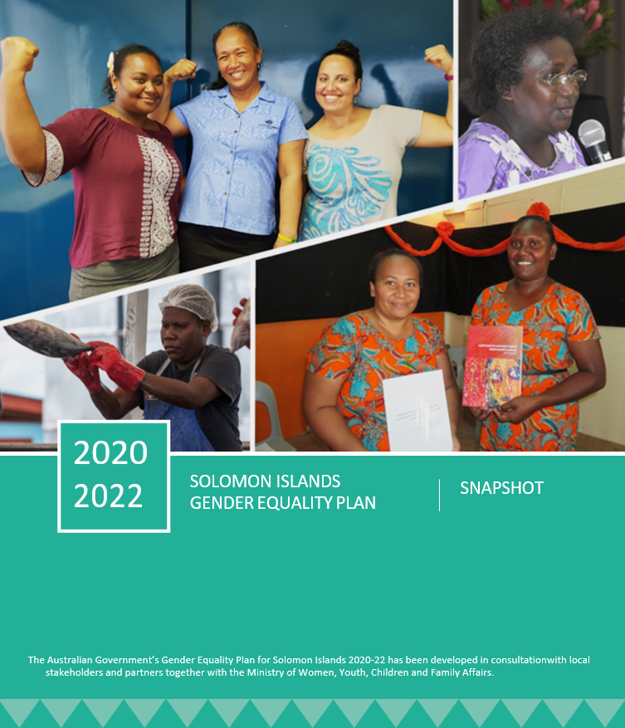**Overview**

**The Solomon Islands Gender Equality Plan outlines the approach and investments of the Australian Government’s Gender Equality Program for the period 2020–22.** The Gender Equality Plan bridges the final period of Australia’s Pacific Women Shaping Pacific Development (Pacific Women) program and the transition to Australia’s next phase of support for gender equality programming in the Pacific region.

Through a 10-year commitment announced in 2012, Pacific Women connects more than 170 gender equality initiatives supported by Australia and implemented by over 160 partners across 14 Pacific Island countries, including Solomon Islands. It works toward four outcomes:

* Women’s Leadership and Decision Making
* Ending Violence against Women
* Economic Empowerment
* Enhancing Agency.

With Pacific Women drawing a close at the end of 2021, Australia is looking at how to strengthen its gender equality support and respond quickly and flexibly to the emerging needs of the COVID-19 pandemic. At a regional level, a design is underway for a new regional program expected to commence in mid-2021, with a six-month transition from Pacific Women. Building on the strong foundations and relationships of Pacific Women, the new program will target support for women’s health (including women’s reproductive rights and growth of women’s sport); women’s economic security and leadership; and women’s safety. Bilaterally, the Gender Equality Plan outlines Australia’s gender equality program in Solomon Islands until 2022.

**The Gender Equality Plan takes into account the Australian Government’s development response to the COVID-19 pandemic outlined in the Partnerships for Recovery document.** The Partnerships for Recovery strategy focuses on three core action areas, which reflect shared interests with partner governments: health security; stability; and economic recovery, underpinned by a strong emphasis on protecting the most vulnerable, especially women and girls. Women’s leadership and participation is a cross-cutting theme in the Partnerships for Recovery document.

**The activities supported by the Gender Equality Plan relate to specific, earmarked bilateral funding for gender equality.** In addition, there are projects funded through Australia’s regional gender equality budget that undertake activities in Solomon Islands; gender initiatives implemented through Australia’s sector aid programs; and political, diplomatic and corporate activities undertaken by the Australian High Commission in Solomon Islands.

## Program Rationale

**Funding for successful projects implemented under Pacific Women will be extended.** Funding for the Family Support Centre and the Christian Care Centre – the country’s key crisis service providers – will continue, with organisational support from International Women’s Development Agency (IWDA). Supporting activities to prevent violence against women and girls and improve service provision responds to findings that long-term support to partners that provide holistic care for women and girls affected by violence is a key strength of Australia’s approach to ending violence against women in the region and must be continued.

Funding will continue for World Vision’s work with faith and other community leaders and churches; and Oxfam’s work through a community-based approach. These initiatives seek to change behaviours and attitudes toward violence against women.

Funding will continue to directly support the Ministry of Women, Youth Children and Family Affairs (MWYCFA), with some shift of focus to providing more technical support to the MWYCFA to realise its role to lead on gender policy and implementation across the Solomon Islands Government. Funding will also support the MWYCFA (via UN Women’s Pacific Partnership) to roll out the national SAFENET domestic violence network and the Domestic Violence Counselling Guidelines and counselling register in all provinces. These activities continue Australian investment in areas where Australia has strong relationships, partnerships and expertise and align to the priorities of the Solomon Islands Government.

An investment in the second phase of UN Women’s Markets for Change program is planned (subject to the design for Australia’s future regional investment). The first phase of Markets for Change made markets in Honiara, Auki and Gizo safer and more inclusive, improved governance practices and increased the capacity of women vendors to earn and control income. A second phase will continue and expand this work and respond to the impact of COVID-19 on market vendors’ livelihoods.

**A new, proven leadership activity will be funded, to ensure support is being provided strategically across all Pacific Women outcomes and the Partnerships for Recovery strategy.** IWDA and Women’s Rights Action Movement (WRAM) have been working together in Solomon Islands to influence change in women’s voice and leadership. The partnership was instrumental in lobbying provincial governments to introduce special temporary measures, which is likely to pass into national law in the next year. Their Women’s Voice and Leadership project will amplify women’s voices in decision making forums, including responding to the impact of the COVID-19 pandemic.

**Activities will bolster the voice of women in decision making forums and in Australia’s sector aid programming.** This support is designed to enable the women’s movement to address more deeply the underlying contextual drivers and factors necessary to advance gender equality. In Pacific Island countries, women’s organisations and movements have led the action to end violence against women and girls. For 30 years, they have largely been responsible for getting the issue onto the public agenda. The Office of Development Effectiveness asserts the need for Australian support for NGOs to continue so that they can drive change in decision making forums.

Projects funded under the Gender Equality Plan support women’s groups that are recognised change makers: Family Support Centre; Christian Care Centre; National Council of Women and Provincial Councils of Women; market vendor associations; and WRAM. Targeted core and operational funding will support two additional groups that enable and empower women’s voices in public discourses: Solomon Islands Women in Business Association and People with Disabilities Solomon Islands.

In addition, a panel of Solomon Islands women will be recruited who will be available to work with all of Australia’s sector aid programs in Solomon Islands, including for key design and monitoring and reporting activities such as annual Aid Quality Checks. This will be a formal mechanism for Solomon Islands women to engage with Australia on policy issues, provide feedback on programming and identify priorities and actions for support. It is an innovative approach with the potential for the Australian High Commission in Solomon Islands to be a leader in including women’s voice across aid programming.

**Funding will support coordination of all of Australia’s gender equality investments in Solomon Islands, through annual reflection activities and improved monitoring, evaluation and learning systems.** These monitoring, evaluation and learning activities will foster cooperative monitoring, evaluation and reflection to build a collective evidence base to build momentum for change.

**The outcomes sought by the Gender Equality Plan are taken directly from Pacific Women’s program- level long-term outcomes.** This reflects the timing of the Gender Equality Plan falling in the final years of Pacific Women’s 10-year timeframe whilst Australia is developing the framework and transitions to a new era of gender equality programming.

## References:

Australian Department of Foreign Affairs and Trade (2020). Solomon Islands Gender Equality Plan 2020-22: https://www.dfat.gov.au/geo/solomon-islands/development-assistance/development-assistance-in-solomon-islands

Australian Department of Foreign Affairs and Trade (2020). Partnerships for Recovery; Australia’s COVID-19 Development Approach, Australian Department of Foreign Affairs and Trade. <https://www.dfat.gov.au/sites/default/files/partnerships-for-recovery-australias-covid-19-development-response.pdf>

## Proposed activities to be funded under the Gender Equality Plan 2020–2022

### Ending Violence against Women (prevention)

| Activity | **Partner** | **Activity description** |
| --- | --- | --- |
| Channels of Hope – Phase 3 | World Vision | Working with churches and community leaders to positively transform people’s beliefs, attitudes and behaviours regarding gender relations to reduce violence against women. |
| Let’s make our families safe (Safe Families) – Phase 2 | Oxfam | Supporting existing and new community level action to prevent violence from happening in the home. Helping to establish coalitions between the civil society groups, services providers, churches and government agencies that are working to prevent family violence. |

### Ending Violence against Women (services)

| Activity | **Partner** | **Activity description** |
| --- | --- | --- |
| Responding to Violence against Women | IWDA  (with the Family Support Centre and the Christian Care Centre) | Providing core funding, technical support and capacity building to the Christian Care Centre and Family Support Centre, two key organisations providing emergency shelter, first aid, counselling and legal advice services to survivors of violence. This includes funding to explore options (including through property construction, purchase or long- term rental) for ensuring that the Family Support Centre has permanent location in Honiara to provide services to survivors of violence. |
| Pacific Partnership to End Violence Against Women and Girls | UN Women (with the MWYCFA) | Promoting gender-equitable social norms that prevent violence and ensure survivors can access quality response services by assisting the MWYCFA to roll out SAFENET to all provinces and develop and implement the Solomon Islands National Counselling Framework. |

### Economic Empowerment

| Activity | **Partner** | **Activity description** |
| --- | --- | --- |
| Markets for Change  – Phase 2 | UN Women | Improving market governance, management, infrastructure and access to financial services to increase women's economic empowerment. Ensuring markets are more sustainable, accessible and safe for women vendors in Honiara, Auki and Gizo in Solomon Islands. Respond to the impact of COVID-19 on market vendors. |

### Enhancing Agency

| Activity | **Partner** | **Activity description** |
| --- | --- | --- |
| Supporting the Ministry of Women, Youth, Children and Family Affairs (MWYCFA) | MWYCFA | Supporting the MWYCFA with its role of working across the Solomon Islands Government on gender equality policy and implementation, including research, policy development and gendered impacts of COVID-19 and activities arising from the review of the *Family Protection Act 2014*. This includes through technical support and support for coordinator positions and flexibility to fund activities identified throughout the year. |
| Supporting the Solomon Islands women’s movement | SIWIBA, PWDSI, WRAM | Core support is provided to the Family Support Centre, Christian Care Centre, National Council of Women, Provincial Councils of Women, market vendor associations and WRAM through specific projects under the Gender Equality Plan.  In addition, funding to SIWIBA and PWDSI ensures that Australia is supporting a suite of women’s groups that enable and empower women’s voices in public discourses across the portfolio of activities. |
| Consultation Panel of Solomon Island women for DFAT sector programs | Solomon Islands Support Unit | Establishing a panel of Solomon Islands women who provide input and feedback on DFAT sector programs, including designs, monitoring and evaluation processes, Aid Quality Check meetings and specific pieces of analysis. |

### Program support, monitoring, evaluation and learning

| Activity | **Partner** | **Activity description** |
| --- | --- | --- |
| Solomon Islands Support Unit | Solomon Islands Resource Facility | Supporting grant management, procurement of services and logistics under the Gender Equality Plan.  Hosting an annual county reflection workshop for all partners funded by Australia’s gender equality program operating in Solomon Islands (bilateral and regional), gender equality partners from DFAT’s sector programs and other stakeholders. Providing a forum to share learnings and understand monitoring and evaluation practices for gender equality investments in Solomon Islands.  Providing remote, short-term monitoring, evaluation and learning assistance to support country-level reporting.  Re-starting a quarterly meeting of donors supporting gender equality activities in Solomon Islands to ensure coordinated approaches to support MWYCFA and NGOs. |