.

AVI

Solomon Islands Medical Partnership for Learning, Education and Research (SIMPLER)

Independent Review
October 2023
Prepared by:
Glenn Cummings
Dr Ade Prastyani
Savina Nongebatu

Acknowledgements
The review team are grateful to AVI for support and guidance throughout this assignment. We also thank all those informants, both in Australia and Solomon Islands, who kindly made time to talk with us and provide information and insights.

Disclaimer
The opinions expressed are those of the review team, and do not necessarily reflect those of AVI personnel. Responsibility for the opinions expressed in this report rests solely with the authors.

Table of Contents

Executive summary 4
Introduction 7
Overview of the Solomon Islands health system 9
Key health policies and strategies 10
Key Findings 12
Relevance 12
Effectiveness 14
Efficiency 21
Coherence 22
Gender, Disability and Social Inclusion 23
Sustainability 23
Program management and reporting 24
Conclusions and recommendations 26
Overall conclusions 26
Recommendations 26
Annex 1: List of Key Organisations Consulted 28
Annex 2: Case Studies 29
Annex 3: SIMPLER* Theory of Change 34
Annex 4: Excerpts from the National Health Strategic Plan 2022-2031 35

Executive summary
The Solomon Islands Medical Partnership for Learning, Education and Research (SIMPLER) is a five year program that places Australian volunteer health professionals in the National Referral Hospital (NRH) in Honiara to work with local colleagues. SIMPLER supports the Solomon Islands Ministry of Health and Medical Services (MHMS) to achieve its objectives by increasing the capacity and capability of the country’s health workforce and strengthening systems in the NRH. SIMPLER’s efforts all align with the MHMS’ Role Delineation Policy and the two National Health Strategic Plans that have operated over the past five years (2016-2020 and 2022-2031).
The third phase of SIMPLER started in April 2019 with an end date of May 2023. This was extended to March 2024 due to the delays resulting from the COVID-19 pandemic.
SIMPLER is a very effective, flexible, value-for-money program. Despite considerable challenges, the program has had a significant, positive impact on the Solomon Islands health system through its ongoing support for medical students returning from overseas and the intern program, as well as the support and technical assistance provided to management and staff at the NRH. The COVID-19 pandemic had a significant impact on SIMPLER, which meant that it only fully achieved one of its objectives. During the COVID period, strengthening systems and protocols – such a patient flows in the Emergency department - became the most important objective as managing the outbreak whilst keeping the hospital as safe as possible for all patients became the main priority in the country. Objectives that were important during the design phase, such as professional pathways through graduate certificates and decentralisation efforts became lower priorities and as such were not achieved during this reporting period. But this does not diminish the value of the contribution SIMPLER has made to the Solomon Islands health system or its future potential to positively impact the system, indeed it highlights the value of a flexible delivery modality that has established professional links with Australian experts.
During the height of the COVID pandemic, volunteers working remotely and the strong relationships that existed between former volunteers and staff at the NRH allowed for crucial advice and guidance to be provided that supported the NRH. For example, despite being repatriated a number of volunteers remotely developed and delivered online teaching for the NRH’s bridging and internship training program, supported heavily by the one volunteer who remained in-country. The Emergency Department was also heavily supported remotely by repatriated and former volunteers as it dealt with the new challenges presented by COVID.
SIMPLER supports the Solomon Islands Government’s strategic plans for the health sector. This is despite operating in a dynamic, challenging context.
It does this by supporting a number of key strategic outcomes identified by the MHMS:
- Supporting the training needs of new medical graduates to increase their capacity and therefore increase doctor numbers in the country, both through mentoring on the wards and formal delivery of training sessions
  - 83 new doctors (Registrars) graduated from the intern program since 2019
    - This adds to the 26 graduated in previous iterations of SIMPLER since 2016
- Promoting equitable access to treatment by supporting the development (and potentially in the future the delivery) of the Postgraduate Diploma in Rural Generalist Medicine, better equipping doctors to function effectively in provincial hospitals and area health clinics
  - Curriculum developed for some modules of the Postgraduate Diploma in Rural General Medicine
- Improving leadership, management and clinical governance at the NRH through developing and updating standard treatment protocols and guidelines, establishing networks with medical colleges in Australia and deploying senior health officials to work with the hospital executive
  - Standard treatment protocols and guidelines developed or updated for the Emergency Department, Paediatrics, and Obstetrics and Gynaecology departments
  - Bed management plan developed, based on a previous patient flow study
  - National program in diabetic footcare management developed (Luk Afterem Legi).
  - A scoping analysis developed on planning for an intensive care / high dependency unit at NRH
In short, SIMPLER has made a significant contribution to the NRH and increasingly the wider health system in Solomon Islands and has built a very strong reputation as a result. The program is very well regarded and highly valued by department heads at the NRH. The arrival of a new CEO after the program started combined with weak internal hospital reporting systems and slow program reporting systems have lessened the public diplomacy impacts at the highest levels within the hospital, but not affected the program operationally.
A strengthened reporting and strategic communications element could further enhance the visibility of its achievements at the highest levels in the NRH and the MHMS.
With an annual budget of approximately $1million, SIMPLER represents excellent value for money. It is unlikely that an alternative delivery modality would be able to replicate the success of SIMPLER given the resource envelope available. Qualified health professionals are highly paid people. The volunteering modality allows multiple professionals to be in-country all year round.
SIMPLER operates in an increasingly crowded health sector with a number of bilateral and international NGOs providing support to the NRH and provincial hospitals across the country. SIMPLER’s operations to date have remained within the NRH, but potential to support the Solomon Islands Government’s decentralisation agenda may require volunteer placements in the provinces. Improving coordination, particularly with other Australian NGOs sending medical specialists to the Solomon Islands will become increasingly important.
With an established office in Honiara, and the central operational role SIMPLER plays at the NRH, AVI is well placed to play a coordination role across all Australian NGOs providing technical assistance to the medical sector. The role would maximise the benefit of Australian NGOs efforts by avoiding duplication, improve transparency and accountability to the Solomon Islands Government and could play a significant public diplomacy role as the breadth of Australian efforts in the health system are better captured and understood.
As with all programs, there are areas for improvement. The following recommendations are made to improve program performance and improve communications and visibility of the program among senior health officials:
- DFAT should seek to establish a coordination function with other Australian not-for-profit organisations supporting the Solomon Islands health system to ensure the coherence of volunteer and technical assistance provided and alignment with the National Health Strategic Plan.
- DFAT and AVI should establish systems to ensure all proposed volunteer assignments are aligned with the National Health Strategic Plan priority areas, such as decentralisation, and other Australian health sector investments.
- Reporting against higher level outcomes of the program should be standard, with succinct six monthly reports provided directly to the NRH Executive highlighting the key program achievements for the period. Reporting systems, including DFAT approval processes need to be streamlined to ensure this happens on a timely basis.
- All outcome-focused program reporting should be structured so that it specifically identifies which Strategic Objectives and Priorities in the National Health Strategic Plan the outcome is contributing to.
- AVI should work with the Australian High Commission in Honiara to develop a calendar of strategic communications, highlighting the contribution that SIMPLER is making to the Solomon Islands health system and maximising the public diplomacy benefits derived from the program.
- Adequate program funding and resources should be provided in both Solomon Islands and Australia to effectively manage the program, including key stakeholder relationships and the production of quality outcome-based reports.
- Pre-departure training should be tailored, or an additional day added for SIMPLER volunteers that talks specifically about the context that SIMPLER operates in and leverages the expertise of previous volunteers, providing volunteers with as much program-specific information as possible.
- A fund should be established that volunteers can access for relatively small amounts of money that can be used to support their work.
SIMPLER provides Australia with a well-respected program within a key pillar of the Solomon Islands health system. It provides an operational complement to other strategic, systemic Australian support to the health system. With additional resources to strengthen program management and improve communications and stakeholder engagement in Solomon Islands, including better coordination with other NGOs operating in the sector, SIMPLER will also realise improved public diplomacy benefits.

Introduction
The Solomon Islands Medical Partnership for Learning, Education and Research (SIMPLER) is a five year program that places Australian volunteer health professionals in the National Referral Hospital (NRH) in Honiara to work with local colleagues. SIMPLER supports MHMS to achieve its objectives by increasing the capacity and capability of the country’s health workforce and strengthening systems in the NRH. SIMPLER’s efforts all align with the MHMS’ Role Delineation Policy and the two National Health Strategic Plans that have operated over the past five years (2016-2020 and 2022-2031).
The third phase of the program started in April 2019 with an end date of May 2023. This has since been extended to March 2024 due to the delays as a result of the COVID-19 pandemic.
SIMPLER is a collaboration between AVI, the Australian Volunteers Program, the Australian Department of Foreign Affairs and Trade (DFAT), the Solomon Islands Ministry of Health & Medical Services (MHMS) and the National Referral Hospital (NRH), Honiara.
SIMPLER builds on two previous iterations of the program (then known as the Solomon Islands Graduate Intern Supervision and Support Project) or SIGISSP. initiated in 2015 in response to the challenges faced by NRH and the MHMS in providing internships for the large number of Cuban-trained medical graduates returning to the country.
Under SIGISSP, the Intern Bridging program, one of the key pillars of SIMPLER, was created. Relationships with key NRH staff were established and AVI developed its understanding of the operating context at the NRH. The two most important achievements from SIGISSP’s volunteers at the NRH were:
- the development of a monitoring and evaluation system of internship program trainees’ adherence to assessment requirements, which resulted in the Improving Performance Assessment Plan
- successful internal advocacy to secure the NRH’s infrastructure allocation for the Medical Training Centre which has become a space for trainees’ teaching and learning activities.
SIGISSP laid a strong foundation from which SIMPLER has continued to grow.
Program objectives
The Theory of Change for SIMPLER (Annex 3) articulates the highest order objective of the program as:
Through the placement of skilled medical professionals, (SIMPLER) will support the Solomon Islands Ministry of Health and Medical Services (MHMS) in the training and capacitation of the country’s medical workforce to improve service delivery and support the achievement of universal health coverage as aligned with the National Health Strategic Plan 2016-2020 (NHSP) and the Role Delineation Policy (RDP) for Solomon Islands.
Program elements
The SIMPLER model comprises five pillars:
- Bridging program
  - Supports foreign-trained medical graduates to consolidate, expand and apply their knowledge and skills under close supervision, through clinical immersion and regular, structured education sessions
- Intern training program
  - The two-year program allows medical graduates (either directly from university or after completing the Bridging Program) to complete the prescribed minimum standards in a range of clinical disciplines in order to become fully registered doctors
- Systems strengthening and medical governance
  - Developing and strengthening systems in the NRH to improve systems in clinical support functions such as laboratories and the pharmacy, and developing standard treatment protocols and guidelines for different NRH departments
- Post-registration training
  - Volunteers help develop a Postgraduate Diploma in Rural Medicine and supporting candidates undertaking the Postgraduate Diploma in Emergency Medicine
- Opportunities for Australian medical professionals to build their knowledge
  - Australian professionals learn from experienced specialists in the Pacific
Box 1: What makes SIMPLER unique?
SIMPLER is different from other volunteer programs, including the Australian Volunteers Program (AVP) which is also managed by AVI. There are four main reasons for this:
1. Professional networks: Partnerships, both through formal agreements and informal arrangements, with Australian-based medical colleges such as the Australasian College for Emergency Medicine (ACEM) and the Royal Australian and New Zealand College of Obstetricians and Gynaecologists (RANZCOG) provides not only a pipeline of qualified applicants, but an ongoing collegial support network for Solomon Islands doctors even after the volunteers leave the country.
2. Continuity: To date, all SIMPLER volunteers are deployed to the NRH. This allows for a build-up of knowledge and a contextual understanding that can be passed on to new volunteers attached to the same or related Departments/Units. It also allows new volunteers to build upon the work of previous volunteers and ensuring systemic changes are embedded and sustainable.
3. Health sector: The sector, particularly in a hospital setting, is well-suited to having multiple volunteers over many years. Health sectors are often under-resourced, and support is welcome. Importantly, clinical governance is often neglected, giving space for numerous standard treatment protocols and guidelines to be developed. These are ideal-sized discrete projects for volunteers.
4. Strong capacity development role: Training is a core function in most hospitals, ensuring the next generation of doctors are well equipped to take over when required. The genesis of SIMPLER was the Bridging Program; the Internship Training Program is now also a central part of the program. SIMPLER volunteers play a crucial role in the ongoing capacity development of young Solomon Island doctors.

SIMPLER and COVID
In-country implementation of SIMPLER was significantly impacted by the COVID-19 pandemic. All volunteers but one had to leave Solomon Islands at very short notice as the pandemic spread. The one remaining volunteer eventually started another related role in the health sector in Solomon Islands, albeit not as part of the SIMPLER program.
Alternative volunteering modalities were adopted to support the program, such as remote volunteering.
Existing relationships between NRH staff and former volunteers deployed under SIMPLER (and its predecessor SIGISSP) were also relied upon to provide expert support during this difficult period. For example, despite being repatriated, a number of volunteers remotely developed and delivered online teaching for the NRH’s bridging and internship training program, heavily supporting the one volunteer who remained in-country. The Emergency Department was also heavily supported remotely by repatriated and former volunteers as it dealt with the new challenges presented by COVID.

Review features
The Task
The review covers the period from April 2019 to present.
The SIMPLER Theory of Change (Annex 3) articulates a number of ‘Intermediate Impacts’ it expects the program will achieve. These differ slightly from the proposed program outcomes articulated in the original project proposal submitted to DFAT. The Theory of Change presents a clearer, more thought through articulation of the program that includes inputs, activities, outputs and outcomes. All objectives that were included in the original proposal are included in the Theory of Change, although some have rightly been reclassified as activities or outputs.
AVI confirmed that intermediate impacts as articulated in the Theory of Change are equivalent to what are often referred to as end of program outcomes and should be what program performance is measured against.
These are:
- Options for continued medical education in speciality areas are established through the Postgraduate Diplomas of Emergency Medicine, and Rural Generalist Medicine
- Management and leadership skills of key NRH personnel are strengthened and developed
- MHMS/ NRH take management and oversight of the Bridging Program and the Intern Program
- Hospital systems, policies and protocols are improved
- Clinical practices and service delivery at the NRH, Kilu’ufi and Gizo Hospitals are strengthened to support provincial rotations of the Intern Program
- Regional links are developed and strengthened with key stakeholders

The review gathers evidence to determine whether the program has met its stated objectives for the period under review.
Our approach
The review process used a mixed methods approach that included a detailed document review and independent research of the Solomon Islands health system, key stakeholder interviews both in Australia and in Solomon Islands with people involved in implementing the program and others with an interest in the program, and where available analysis of quantitative program data.
A list of stakeholders consulted is included at Annex 1.

Overview of the Solomon Islands health system
Solomon Islands is a geographically dispersed country, consisting of over 900 islands, and many rural communities are located in remote or isolated areas that can be difficult to access. Approximately 25 per cent of Solomon Islands’ 700,000 population live in urban areas, with Honiara home to the largest urban population of around 92,000 people. The remaining 75 per cent of the population lives in rural or remote areas, with the majority of the rural population located in the outer islands of the country³. As a result, access to health services in these areas can be limited, and the health outcomes for people living in rural and remote areas tend to be poorer compared to those living in urban areas.
While the life expectancy of Solomon Islanders has increased (from 57 years in 1990 to 70.5 years in 2016), the Global Burden of Disease study report in 2010 indicated the country’s population faces a transition of health burden, where non-communicable diseases (diabetes mellitus, stroke, and ischemic heart diseases) are fast becoming part of the top five causes of premature deaths, shifting some infectious diseases (lower respiratory infections, tuberculosis, and especially diarrhea) from their previous top ranks. Tackling maternal and child mortality and morbidity continues to be a national health priority.
The health system in Solomon Islands consists of a range of multi-tiered health facilities. Each level of the hierarchical health facilities has a designated package of services listed in the Role Delineation Policy (see below for detail). The Health Care Services Division of the MHMS governs all health care facilities, except for the National Referral Hospital, whose CEO sits at the same level as Deputy Secretary for Health Care Services.
Solomon Islands’ health workforce faces a combination of challenges, namely shortages (there are 2.4 doctors and 17.8 nurses per 10,000 population in 2021), maldistribution (84 per cent of doctors and 53 per cent of nurses are based in Honiara, primarily at NRH), and poor staff attendance.
The Ministry of Health and Medical Services (MHMS) is responsible for overseeing the health system in the Solomon Islands. The ministry sets policies, develops plans, and regulates the provision of health services in the country. It is also responsible for managing the budget for health services. The government provides the majority of funding for health services through the national budget, with substantial contributions from NGOs and faith-based organisations, and little role of the private sector. Meanwhile, Solomon Islands MHMS is a beneficiary of international development assistance and donor agencies.
Other operational development actors
A number of other development actors offer similar technical assistance support to that offered by volunteers under the SIMPLER program.
Other bilateral partners also support volunteers in the health sector in the Solomon Islands. Whilst the small number of volunteers that New Zealand places at the NRH have historically been more focused on corporate services, there is currently a New Zealand volunteer nurse at the NRH, and it is understood an additional clinical role is being considered. Australian and New Zealand volunteers have recently coordinated when developing guidelines for different aspects of emergency care. A second technical assistance team from China is currently at the NRH. Comprising of up to four clinicians, the Chinese teams tend to work more independently and are not involved in training the interns but have worked side by side with Solomon Island specialists in surgery. The Chinese Government has also provided pieces of medical equipment and drugs to the NRH. The Japanese Government has also supported volunteers across the Solomon Islands health sector.
In terms of Australian NGOs working in the health sector, the Fred Hollows Foundation is very active, having constructed and now providing ongoing support to the national eye centre at the NRH. Outside of the NRH, NGOs provide short-term technical assistance to provincial hospitals. For example, Doctors Assisting in South Pacific Islands (DAISI) visit Gizo hospital for one week each month and work alongside the local surgeon in performing complex surgeries. A number of other NGOs, such as Interplast (plastic and reconstructive surgery, nurse education) and the John James Foundation (range of medical specialists) also operate in Solomon Islands.

Key health policies and strategies
The current phase of SIMPLER has spanned two National Health Strategic Plans. The first five year plan covering the period from 2016-2020 was succeeded by a ten-year plan that covers the period 2022-2031. Although the new strategic plan was developed after the current phase of SIMPLER started, due to COVID, more in-country volunteer placements have taken place since it was launched as occurred under the previous plan. The new strategy provides a useful framework for SIMPLER to test whether the program remains relevant to the priorities of the Solomon Islands Government. A brief overview of the current strategy and the MHMS’ Role Delineation Policy, a key policy around decentralising the health system follows.
Solomon Islands National Health Strategic Plan 2022-2031
The Solomon Islands Ministry of Health and Medical Services (MHMS) released its 10-year strategic plan in 2022. The previous strategy expired in 2020 with COVID limiting the capacity to develop a new plan in a timelier fashion.
On launching the plan, the Minister for Health described it as identifying “WHAT services will be available and WHERE, including HOW the Ministry will be reformed to deliver the commitment in the plan to prevent disease, restore and promote health and well-being to the communities and peoples of our country”.
The plan highlights three strategic objectives, each with intermediate results, a set of associated priorities and identified strategies:
- Strategic Objective 1: Better governance of the health sector
  - Five intermediate results
  - 14 priorities
  - 14 identified strategies
- Strategic Objective 2: Our systems and resources meet our needs and are responsibly managed
  - Five intermediate results
  - Seven priorities
  - 18 identified strategies
- Strategic Objective 3: All Solomon Islanders have equitable access to fully implemented, quality health care programs
  - Six intermediate results
  - 10 priorities
  - 15 identified strategies
Role Delineation Policy - 2018
In an effort to improve equity of access to health care, the MHMS developed the 2018 Role Delineation Policy (RDP). The policy document defines “packages of care” to be provided at different levels of health service provision in the country. With the mission of achieving better health closer to the people’s homes, the main objective of this document is to be a tool for planning a range of health services appropriate to available staffing, infrastructure, and other operational resources as close as possible to the population, to overcome health inequity from financial hardship to reach health services.
The RDP adheres to principles of primary health care, in which essential health care is provided at different levels, along which clients and patients follow a referral pathway in accordance with their health care needs. The six levels of service start at the Community Centres, followed by Rural Health Centres, which will refer to either two levels of Area / Urban Health Centres, then to General Hospitals at the provincial level, and the top level of referral is at the National Referral Hospital in Honiara. Each level of the health system is designed to deliver a specific, limited list of public health and clinical services, known as a ‘Service Delivery Package’.
Along with the National Health Strategic Plan, the RDP is the background policy context against which health workforce skills development is designed, including SIMPLER’s support to establish continuing medical education programs.

Key Findings

Relevance
SIMPLER remains a highly relevant program for the Solomon Islands health system. SIMPLER has been supporting a number of the intermediary results, priorities and strategies identified in the National Health Strategic Plan for a number of years already and is well placed to continue to do so into the future.
SIMPLER is an operational program; it delivers practical technical assistance to the country’s largest hospital. The National Health Strategic Plan is aimed at the entire Solomon Islands health system, from policy and regulatory settings at government and MHMS level, through to service delivery. SIMPLER is one tool that the Australian Government uses to support the Solomon Islands Government in implementing the National Health Strategic Plan. Given the program’s operational nature, the support it provides aligns more closely with the operational strategic objective (Strategic Objective 3). Other elements of Australia’s support to the health system will provide more support to the objectives focused on policy and the regulatory environment.
The table below compares selected program outcomes and outputs to the National Health Strategic Plan. Details of specific volunteer projects and activities are provided in the following section.
Table 1: SIMPLER’s contribution to objectives of National Health Strategic Plan
Strategic objective | Examples of support
1. Better governance in the health sector | - Management and leadership support by experienced volunteers to senior NRH staff
2. Our systems and resources meet our needs and are responsibly managed | - Supported research, published evidence-based pieces in journals providing insight into issues affecting sector performance  - Supporting Quality Committee and systems in NRH Labs  - Patient flow planning to maximise use of existing resources and infrastructure
3. All Solomon Islanders have equitable access to fully implemented, quality health-care programs | - Contribution to clinical governance standards at the NRH through various guidelines and standard treatment protocols  - Developed and implementing significant national diabetes program around foot and wound care  - Ongoing mentoring and teaching for bridging students and interns  - Developing Postgraduate Diploma in Rural General Medicine
The most obvious support provided since program inception is the establishment and ongoing support of the Bridging and Intern programs. These integrated initiatives established under SIMPLER (and its predecessor programs) over the past eight years have directly supported, and continue to support, the development of the health workforce in Solomon Islands.
The below table details the number of bridging and regular interns that have been trained under the two programs during the current iteration of SIMPLER.
Table 2: Trainees by category, sex disaggregated (source: Solomon Islands Medical and Dental Board)
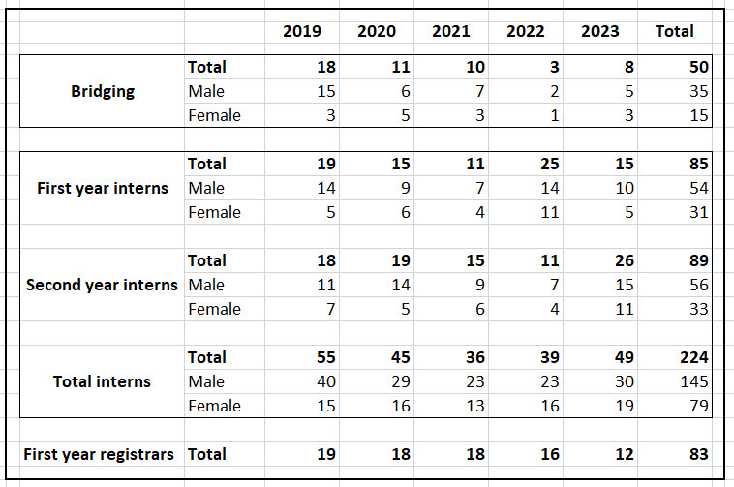
Under the SIMPLER program, 50 medical students have returned to Solomon Islands and completed the Bridging program, ensuring that they are equipped to transition into the Solomon Islands system. Graduates from the Bridging program join other medical graduates from medical schools including Fiji National University and the University of Fiji in the Internship program. A total of 85 people have started the Internship program under SIMPLER. Under the five years of SIMPLER program, 89 people have been supported through the intern program and graduated to receive their practising medical certificates, of which 83 have become first year registrars at the NRH. This builds on the 26 graduated in previous iterations of SIMPLER (SIGISSP).
The MHMS estimates the number of doctors per 10,000 population in Solomon Islands to be 2.4 doctors per 10,000 people. This is a boost from the last official measure of this statistic in 2016 which was 1.95 doctors for every 10,000 people in Solomon Islands. The next challenge faced by the Solomon Islands health sector, as noted in Strategic Objective 3 of the National Health Strategic Plan, is to ensure equitable coverage across the country. Currently doctors are largely concentrated at the NRH, resulting in a reactive health system where late-stage cases are presented, rather than a more preventative primary care-oriented health system.
The ongoing support provided by SIMPLER towards the development of the Postgraduate Diploma in Rural General Medicine is intended to directly support the decentralisation of health service by training doctors who are able to work independently in provincial settings. This approach is consistent with the Role Delineation Policy and will lead to more equitable access to health services by locating a greater range of capable doctors who are able to provide acute medical service in provincial hospitals and area health centres. This shift will greatly increase access to quality health care and result in earlier and definitive intervention as well as treatment of preventable conditions.

Effectiveness
Evidence has been gathered by the review team to assess whether SIMPLER has been effective in meeting its objectives as defined in the program’s theory of change.
An overview is provided below using a standard traffic light system (Red – not achieved; Orange – partially achieved; Green – fully achieved).
1. | Options for continued medical education in speciality areas are established through the Graduate Diplomas of Emergency Medicine, and Rural Generalist Medicine
2. | Management and leadership skills of key NRH personnel are strengthened and developed
3. | MHMS/ NRH take management and oversight of the Bridging Program and the Intern Program | 
4. | Hospital systems, policies and protocols are improved
5. | Clinical practices and service delivery at the NRH, Kilu’ufi and Gizo Hospitals are strengthened to support provincial rotations of the Intern Program
6. | Regional links are developed and strengthened with key stakeholders
Whilst the overview paints a relatively negative picture of the program in that only one of its stated objectives was fully achieved, much of this can be attributed to the significant impact of COVID-19 on the program. Not only did this result in all but one active volunteer leaving the country, but it also diverted all resources of the health system towards fighting the pandemic. Strengthening systems and protocols – such a patient flows in the Emergency department - became the most important objective as managing the pandemic whilst keeping all patients in the hospital as safe as possible became the main priority in the country. Objectives that were important during the design phase, such as professional pathways through graduate certificates and decentralisation efforts became lower priorities and as such were not achieved during this reporting period. But this does not diminish the value of the contribution SIMPLER has made to the Solomon Islands health system or its future potential to positively impact the system, indeed it highlights the value of a flexible delivery modality that has established professional links with Australian experts.
It should also be noted that some of the program objectives are very broad, and it is very difficult to prove the objective has been fully met.
The detailed discussion of each objective that follows highlights that SIMPLER not only made a significant contribution towards strengthening the Solomon Islands health system, but also contributed to Solomon Islands’ efforts to combat the COVID-19 outbreak.
Options for continued medical education in speciality areas are established through the Graduate Diplomas of Emergency Medicine, and Rural Generalist Medicine
Medical training pathways are fledgling in Solomon Islands. Aspiring doctors must move abroad to study as there are no undergraduate medical degrees offered in Solomon Islands. Returning degree holders are required to complete many post-graduate steps to become a qualified doctor and only some of them are currently available within the country. For example, the Postgraduate Diploma in Emergency Medicine can currently be completed at the NRH, with all teaching undertaken remotely from Fiji National University or the University of PNG. With international borders re-opening post-COVID, this remote teaching arrangement may be reviewed requiring students to travel overseas to complete the diploma. To become a Consultant requires spending multiple years overseas completing a Masters degree.
The Bridging and Intern programs developed under previous iterations of SIMPLER are now well established. A significant issue now facing the Solomon Islands health system is the ongoing lack of medical practitioners in the provinces with a very high proportion of Registrars remaining at the NRH. This is because they lack the breadth of skills and experience to be able to function on their own at an Area Health Centre and still require a significant level of supervision if posted to a provincial hospital.
One solution that has widespread support among heads of departments at the NRH is the development of a Postgraduate Diploma in Rural Medicine. The proposal for a diploma has been approved by the appropriate authorities at Solomon Islands National University (SINU) and MHMS, although SINU does not have the technical expertise to teach the course. Whilst there is an assumption that the Consultants at NRH will deliver the course, there is very little capacity amongst this group to take on additional teaching responsibilities.
Development of course materials also remains an issue. A broad curriculum has been agreed that covers the main skills required to work unsupervised in a regional setting. This includes skills in Surgery, Emergency Medicine, Anaesthetics, Orthopaedics, and Obstetrics and Gynaecology. The current curriculum will require 2.5 years to be completed, which is considered long for this type of qualification.
A SIMPLER volunteer was recruited in May 2022 to liaise with a local Advisory Committee and NRH Technical Working Group and to develop the curriculum and teaching program. The volunteer withdrew from the assignment in October 2022 due to a lack of progress being made in curriculum development. Before their assignment concluded, the volunteer provided a review paper which recommended reducing the scope and duration of the program to between 12-18 months, bringing it in line with other similar diploma courses. This input was rejected by the Advisory Committee.
Opinion among Heads of Department at the NRH is divided on how long the course should be. Although the most senior staff at the hospital support a shorter course, it is unclear how the course will be reduced in length as each specialty is keen to retain as much material in the curriculum as possible.
In an attempt to continue the process, four former SIMPLER volunteers who are also members of SIMPLER partner the Australasian College of Emergency Medicine (ACEM), travelled to Solomon Islands in November 2022 to help develop course materials for the Emergency Medicine component of the diploma. A comprehensive curriculum was developed for the Emergency Medicine module of the diploma during the trip. However, it may have had the unintended consequence of promoting the view that the course needed Australian expertise to help design it rather than being locally designed.
No other specialty has developed course material that is ready to be taught. A former volunteer who is a member of the Royal Australian and New Zealand College of Obstetricians and Gynaecologists (RANZCOG) has been in discussions with NRH colleagues about developing material, but this has not progressed as yet.
SINU was expecting the course to start in the second half of the 2023, with six prospective students ready to be enrolled, four with scholarships from the Ministry of Education to cover the program’s tuition fee. It was anticipated that the six month emergency medicine syllabus be taught first while other specialties are being developed. AVI sought DFAT approval for an external consultant to complete the course development. However, approval was not granted. The NRH’s senior management is set to defer the program, along with the four scholarships, until 2024 while a search for a local lead for the course is attempted.
Management and leadership skills of key NRH personnel are strengthened and developed
Evidence exists that the management and leadership skills of key NRH personnel have been strengthened as a direct result of SIMPLER activities and the relationship built between volunteers and their Solomon Islands colleagues.
These activities can be best split into two categories: direct and indirect.
Management and leadership skills have been directly strengthened through the placement of volunteers whose role is explicitly capacity development of senior staff in these areas. Since the start of the program in 2015, SIMPLER has extended its scope to include broader health system strengthening and consequently recruited volunteers from beyond the clinical sector. The most notable example of this was the short-term placement in April 2023 of Professor Stephen Duckett, one of Australia’s most respected health system professionals and a former Secretary of the Federal Department of Health. The ability of SIMPLER to recruit a volunteer of this calibre is impressive. While this specific deployment was concluded early due to unforeseeable circumstances, the mechanisms to recruit and deploy volunteers by SIMPLER could also be utilised to support other strategic Australian health initiatives in country. DFAT and AVI should work more closely together around future placements like this to ensure maximum impact is achieved for the Solomon Islands health system.
SIMPLER has also successfully established an administrative management leadership model within NRH’s medical training unit. This volunteer role of Intern Training Program Coordinator has had multiple iterations (another will start in May 2023) and over this time developed governance processes to monitor and supervise medical trainees. A handbook was completed by a SIMPLER volunteer in 2021 to provide a resource to guide local staff taking over this role. Most significantly, this role modelled administrative traits such as timeliness, transparency, follow-up and adherence to rules and practices. These are important in ensuring the medical training program in NRH developed a strong reputation for integrity and rigour.
Management and leadership skills are also being strengthened on an ongoing basis indirectly through the professional networks developed by NRH Heads of Departments through their SIMPLER volunteers. For example, one Department Head at the NRH noted that they maintain a social messaging group with a number of recent volunteers who have been placed in the Emergency Department through SIMPLER (recruited via ACEM and are Fellows of ACEM). It was noted that they relied on this network of professionals for remote advice, especially during the onset of the COVID pandemic when most volunteers had been evacuated. During this period, they were in daily contact with the group seeking advice on how to organise the Emergency Department to minimize cross-infection and other such issues. Over time, as they became more confident in their decision-making and leadership, they have relied less on the network for day-to-day matters, but still consult with them on more difficult cases or new issues they have not encountered before.
A detailed case study of the importance of this relationship is included at Annex 2.
MHMS/ NRH take management and oversight of the Bridging Program and the Intern Program
The NRH Medical Training Committee took over the management and oversight of the Bridging program and the Intern Training program during the COVID period. The programs were run largely under the supervision of the Deputy Chairperson of the Medical Training Committee with coordination of allowances and general administrative support provided by the Secretariat of the Medical and Dental Board within the MHMS.
However, the NRH has requested that a SIMPLER volunteer be recruited to coordinate the two programs again due to the unsustainable pressure that the program management placed on the Deputy Chairperson, who is also a Specialist in Internal Medicine at the NRH, and the Secretariat staff at the MHMS.
It should also be noted that while the NRH managed the two programs during COVID, former SIMPLER volunteers provided ongoing technical input into the programs and current SIMPLER volunteers continue to support the programs by delivering technical sessions and providing some management support.
The COVID period demonstrated that is it is possible for ownership and management of the two programs to be handed over to Solomon Island counterparts. Whether this happens on a permanent basis is a matter of priorities for the NRH.
Table 3 provides an overview of the training support provided by current and former (remote) volunteers since 2019.
Table 3: Training support provided by SIMPLER volunteers
Activity | Department | Comment
Standardised exam questions developed | Emergency | Developed remotely during COVID by volunteers
Multiple choice question banks developed | Emergency | Developed remotely during COVID by volunteers
Weekly WhatsApp quiz for current interns rotating through the Emergency Department | Emergency | Operational – implemented by Emergency Nurse volunteer
Emergency care (nursing) training modules developed | Emergency | Awaiting finalisation and approval
Quarterly assessment via video link case-based discussion with ACEM Fellows (former volunteers) | Emergency | Targeting 16 Registrars
Draft guidelines for training and assessment developed | Paediatrics | Awaiting finalisation and approval
Ongoing capacity development on wards / bedside teaching of interns | All departments with volunteers | Key component of all clinical placements, often includes delivery of some theory modules with support from NRH Specialists

Box 2: Support for the Bridging and Intern program
The Intern program is largely managed by the NRH Medical Training Committee, with teaching and on-ward mentoring support from SIMPLER volunteers. The Bridging program has historically required greater support from volunteers in terms of both co-ordination and technical teaching.
The COVID period demonstrated that it is possible for the programs to be run locally provided sufficient resources are made available and with some ongoing technical inputs from SIMPLER volunteers both in person and remotely.
The timeline below highlights the evolution of the Bridging program since its inception in 2015:
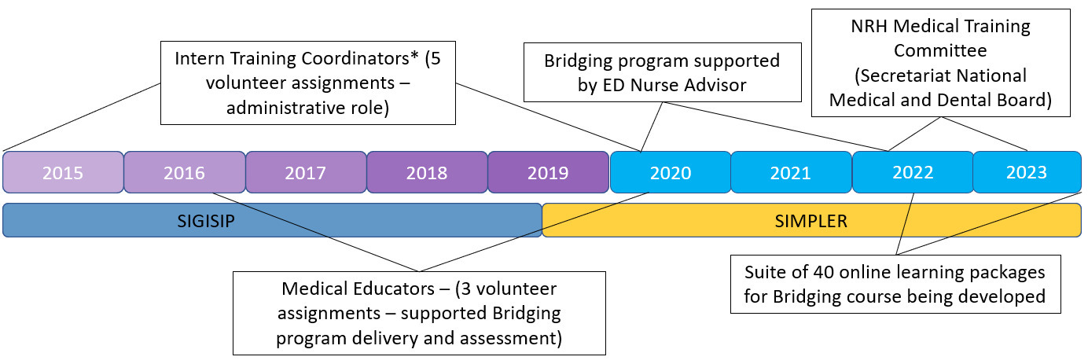
* - Two Intern Training Coordinators also took on broader workforce planning roles for MHMS.
An example of one module from the online learning platform that is being developed to support the Bridging program is shown below. The online tools are developed by former SIMPLER volunteers, and are tailored to the NRH context and are culturally appropriate.
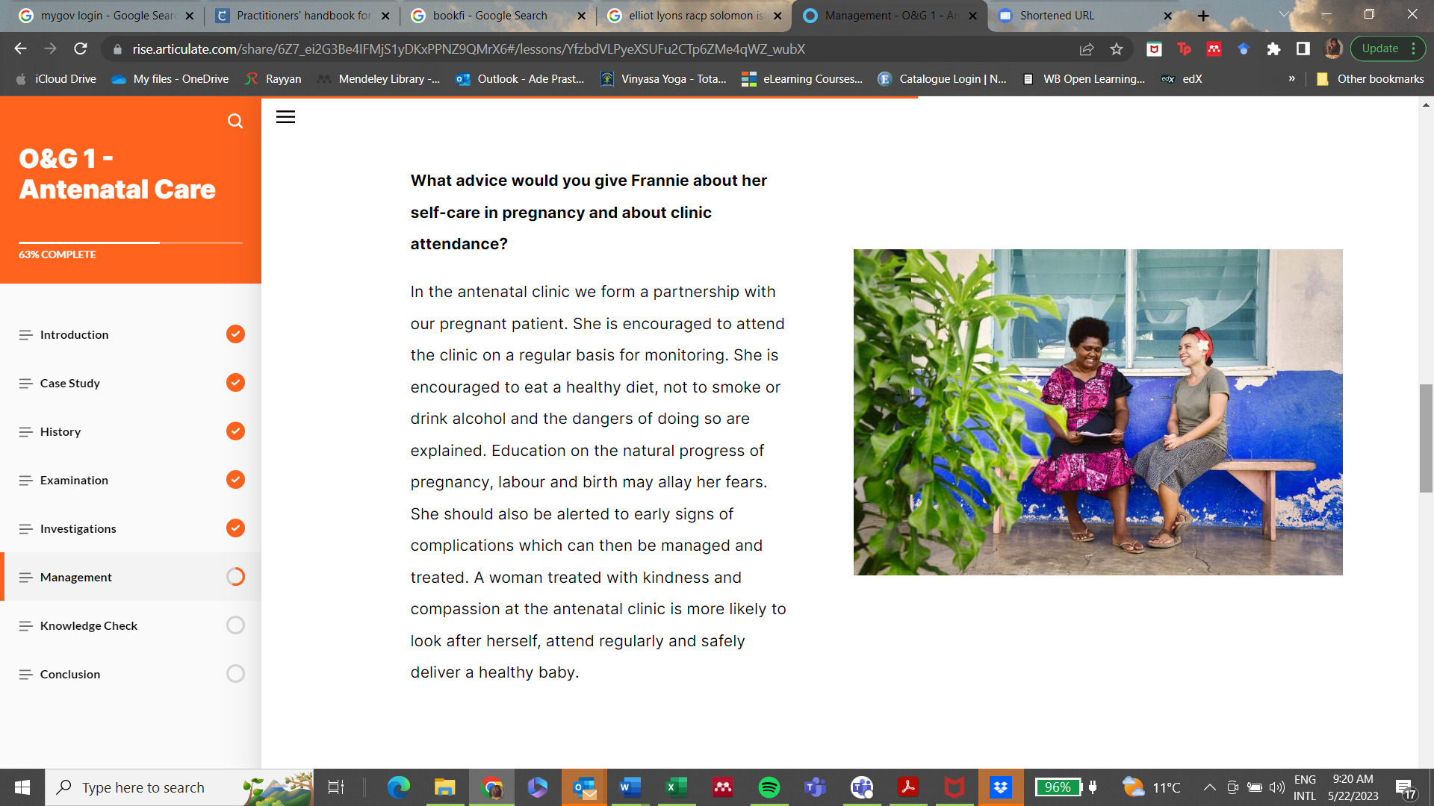

Hospital systems, policies and protocols are improved
Hospitals, and health systems more generally, rely on strong systems to ensure effective treatment of patients. This includes direct clinical systems such as standard treatment protocols and clinical guidelines, and clinical support systems such laboratory and pharmacy procedures, and patient management systems.
SIMPLER volunteers have made a significant contribution to both direct clinical and clinical support systems since 2019. As the two types of support are often linked, the following table provides an overview of these contributions arranged by NRH department. It should be noted that some of these activities were commenced in the previous phase of SIMPLER and have either been completed or continue to be refined by subsequent volunteers or supported remotely by former volunteers. It should also be noted that like many comparable health systems, data quality remains an issue. It was not possible for the review team to quantify the impact of these changes on patient outcomes. It was possible to confirm with multiple sources the status of implementation of the different initiatives and the perception of staff implementing the new system or guideline that they were having a positive effect on patient management.
Table 4: Clinical and systems support provided by SIMPLER volunteers
System / guideline | Department | Status (if known)
Registry database of patients in Emergency Department maintained | Emergency | Operational
Solomon Islands three-stage triage scale finalised (in conjunction with registry database)  - First in the Pacific (prior to WHO developing a similar tool) | Emergency | Operational
Emergency treatment standards and protocols developed and refined | Emergency | Some immediate changes made, other recommendations yet to be implemented
Bed Management plan developed  - Based on patient flow review | Emergency | New position created to manage patient flow and bed management
Asthma action plans developed and completed prior to discharge of patients | Emergency | Operational
Procedure instruction manual for blood culture to prevent contamination in the NRH context developed | Internal Medicine | Approved, awaiting printing
Solomon Islands Obstetrics and Gynaecology Standard Treatment Guidelines (Red Book 2nd edition)  (Third edition due for release late 2023) | Obstetrics and Gynaecology | Second edition edited by SIMPLER volunteer; third edition supported remotely by same SIMPLER volunteer
Monitoring system for maternity deaths maintained; regular review implemented | Obstetrics and Gynaecology | Operational
Neo-natal guidelines for Paediatrics created (volunteer assisted) | Paediatrics | Operational
Quality Committee in Laboratory established - to close gaps in system identified during first major outreach exercise into the wards | Laboratory | Volunteer supporting remotely, another visit scheduled for May 2023 to embed systems
Cross-departmental fortnightly meeting established to discuss diabetic foot cases | National Diabetes Centre / Surgery / Emergency | Commenced in April 2023, multi-disciplinary case management is shown to potentially reduce amputations by between 50-80%
Scoping analysis on planning for an intensive care / high dependency unit | New unit | Planning still being undertaken (by DT Global)
Along with the above completed or near completed systems strengthening activities, a number of current projects are expected to have long-term benefits for the NRH and the Solomon Islands health system more broadly.
- Development of Paediatric treatment guidelines
  - Current volunteer is developing treatment guidelines under the supervision of the head of the Paediatrics department
    - Will be the first approved treatment guidelines for the Department
  - Consistent with other similar guidelines it is expected these will remain operational and effective after the volunteer had departed
- Development of Diabetic Foot Care clinical protocols and curriculum (see case study - Annex 2)
  - Current volunteer who is an allied health professional (podiatrist) attached to the National Diabetic Centre developed the National Diabetic Foot Care Protocol, as well as service forms for wound management, foot mobility screening, referral and discharge forms for daily clinical use, and is still developing the diabetic footcare and rehabilitation project (Luk Afterem Legi)
- The same volunteer is co-developing with the Solomon Islands National University (SINU) curriculum to formally upskill nurses in diabetic foot care to be integrated into the existing undergraduate diploma study program as well as a new 1-year graduate diploma.

Clinical practices and service delivery at the NRH, Kilu’ufi and Gizo Hospitals are strengthened to support provincial rotations of the Intern Program
SIMPLER continues to support the Role Delineation Policy and strengthening provincial health systems through ongoing work on the Postgraduate Diploma in Rural Generalist Medicine and mentoring and support to interns and Registrars in Honiara with a view to preparing them for placements in provincial hospitals and area health clinics.
However, intern rotations are not currently undertaken in any provincial hospital.
The review team visited Gizo Hospital in Western Province. A specialist surgeon is based at Gizo, although there is no anaesthetist which limits operations that can be undertaken to only those under local anaesthetic which the surgeon is able to administer himself. It may be possible for interns to do a surgical rotation in Gizo.
For interns and Registrars to be based in the provinces, they must be able to be supervised by a Consultant. A number of factors were raised that constrain Consultants, Registrars and interns from being based in the provinces such as a lack of suitable housing and the relative lower quality of schools in the provinces compared to Honiara which deters people with families from relocating or returning to their home regions.
All of these factors are beyond the control of SIMPLER.
Volunteer placements that support technical systems across the health network may be one way to strengthen systems and encourage provincial rotations. For example, rolling out support to Labs across all provincial hospitals, or support to pharmacies across all hospitals may provide more comfort to Registrars that support is available in provincial hospitals.
Regional links are developed and strengthened with key stakeholders
Relationships and networks are a key element of health systems globally. The wide range of specialisations and improvements in practices and techniques coupled with new technology and drugs makes it impossible for any one person to be an expert on everything. Building professional networks that can be drawn on when required is critically important, especially in low resource settings.
SIMPLER has become one key avenue for Solomon Islands-based medical professionals to build international networks. An example was provided under and earlier objective, the associated case study is at Annex 2.
Regional links have been established with other universities in the Pacific, most notably Fiji National University and University of Papua New Guinea (UPNG), as part of the efforts to improve career pathways for Solomon Islands doctors through remote and in-country participation in Postgraduate Diplomas and Masters programs. Cross-accreditation for a Postgraduate Diploma in Emergency Medicine was agreed with University of Papua New Guinea, but the course was never actually delivered. Cross accreditation for the Postgraduate Diploma in Rural Generalist Medicine is yet to be agreed.
A further example of strengthened regional links can be seen through research that has been published by Solomon Islands specialists, either jointly or with support from SIMPLER volunteers. Two pieces that have been published recently:
- In December 2022 Dr Leeanne Panisi – Head of Obstetrics and Gynaecology at the NRH - co-authored with a former SIMPLER volunteer a research paper on the incidences and causes of stillbirth at the NRH
  - The paper uses data drawn from the monitoring system developed whilst the SIMPLER volunteer was in country
  - The research represents the first systematic study of causes of stillbirth ever undertaken in the Solomon Islands
- In June 2020 Dr Trina Sale – Head of the Emergency Department at the NRH – co-authored with a former SIMPLER volunteer a research paper proposing a methodology for assessing the needs of facility-based emergency care in the Pacific region
  - The study draws on needs assessments from three Pacific countries, including Solomon Islands
- Dr Sale also co-authored a paper published in March 2019 that examined the success of the initial pilot period of the newly developed three-step triage system in the NRH Emergency Department
Comments on the effectiveness of volunteering model

SIMPLER demonstrates the impact that placing highly skilled medical practitioners in a resource constrained health system can have. The relationships developed between SIMPLER volunteers and NRH staff proved critical to providing remote support to overwhelmed NRH department heads and managers during the pandemic. This strength of this relationship and commitment to ongoing support is not likely to develop from shorter term technical advisors.
Spending an extended period of time in the NRH setting also allows for a thorough understanding of the operating environment and constraints faced by the hospital. This ensures that process and procedures are fit for purpose and technical solutions possible given the available equipment and resources.
But there are limitations to the model. Volunteers generally have limited access to other resources that could be used to help implement, or increase the impact of, their work. For example, it is understood that some clinical guidelines that had been approved for use had not been published due to a lack of funds. AVI does maintain a small pot of money that volunteers can access, but it is limited.
Whilst SIMPLER should not become a grants program, it is possible that a fund be established for volunteers to access that can be used to cover relatively modest costs associated with their work. Such a fund could be directly administered by AVI or tied into an existing mechanism in another Australian-supported health program in Solomon Islands. Either way, guidelines would have to be developed that clearly establish the types of costs that would and would not be covered. For example, equipment purchases up to a fixed dollar amount, or costs to refit a ward to new patient flow requirements may be approved if it is considered that would help ensure that changes are made and continue into the future. The administrative burden on applicants would have to be relatively low to ensure people saw value in applying for funding. Requests should be made jointly by volunteers and their heads of department.

Efficiency
With an annual budget of approximately $1million, SIMPLER represents excellent value for money.
SIMPLER is placing senior Registrars, health system professionals and experienced health leaders and managers into the NRH to support the Solomon Islands health system. It is a highly valued program by department heads at the NRH and places Australian support at the centre of the Solomon Islands health system.
Some volunteers deployed under SIMPLER may be paid an enhanced allowance – an allowance that is more than usual Australian Volunteers Program living allowance for volunteers. Known as SIMPLER Enhanced, this still represents excellent value for money.
SIMPLER is able to leverage the fact that AVI is also the managing contractor for DFAT’s Australian Volunteers Program (AVP). For example, SIMPLER volunteers utilise AVP’s recruitment, onboarding and mobilisation processes as well as in-country support to volunteers. This provides SIMPLER with economies of scale that it would not be able to achieve if it were not implemented by AVI. However, it is also important that AVI has clarity about the distinction between the two funding streams and is allocating costs appropriately and commensurate with resources used by each program.
Project Management costs, primarily project staff, represent approximately 20% of the annual budget. This is considered reasonable given the relatively low cost of volunteers (approximately one-third of annual budget). If anything, additional in-country program management support could help address a gap in strategic communications and public diplomacy efforts of the program with senior NRH and MHMS staff.
It is unlikely that an alternative delivery modality would be able to replicate the success of SIMPLER given the resource envelope available. Qualified health professionals are highly paid people. The volunteering modality allows multiple professionals to be in-country all year round. If people placed in the NRH were being paid Australian market rates through the program, only one or two people would be able to be placed in the NRH in any given year. This would significantly limit the benefits of the program.

Coherence
SIMPLER is internally coherent as a program. It provides technical support to key departments in the NRH. As demonstrated by the program effectiveness, volunteer roles have generally built on the work of previous volunteers; guidelines and standard treatment protocols are updated as required by new volunteers in conjunction with Solomon Islander colleagues. Emerging needs, such as assisting in combatting the prevalence of non-communicable diseases, are responded to in support of MHMS priorities.
The coherence of SIMPLER as it relates to other Australian support to the health system could be improved. For example, the Australian High Commissioner to Solomon Islands recently officially opened a molecular biology laboratory at the NRH. A hybrid volunteer has been working with the Laboratory Department, but additional technical and system support to this department over the coming years would ensure the equipment is appropriately used and systems to support testing and results dissemination are in place. SIMPLER should ensure it is aware of where the wider Australian health program is investing and coordinate with that investment wherever possible whilst also ensuring it remains responsive to NRH and MHMS needs. Future role assignment should consider other ongoing Australian investments in the health sector also.
As noted earlier, there is a significant number of Australian NGOs providing technical assistance in the Solomon Islands. It is understood that the MHMS is concerned about the transparency and accountability of these efforts. Additional resources would be required to improve coordination and transparency of all Australian technical support being provided. With an established office in Honiara, and the central operational role SIMPLER plays at the NRH, AVI is well placed to play a coordination role across all Australian NGOs providing technical assistance to the medical sector. Any coordination role would need the support of the Australian High Commission, and work closely with MHMS to ensure all efforts are aligned to the National Health Strategic Plan. The role would not have coercive powers over other NGOs but could coordinate timing and targeting of efforts across the country. The role would maximise the benefit of Australian NGOs efforts by avoiding duplication, improve transparency and accountability to the Solomon Islands Government and could play a significant public diplomacy role as the breadth of Australian efforts in the health system are better captured and understood.

Gender, Disability and Social Inclusion
SIMPLER has made significant efforts to improve health outcomes for women and people with disabilities in Solomon Islands. As noted earlier, placements made in the Obstetrics and Gynaecology department as the NRH have resulted in improved clinical governance procedures being introduced. The register of maternal deaths that was introduced by a SIMPLER volunteer is a fully operational part of the department systems with data informing improved, safer practices for women giving birth. The development and revision of the National Obstetrics and Gynaecology Standard Treatment Guidelines also targets the health outcomes of women.
The increased incidence in diabetic foot in Solomon Islands is a major cause of disability in the country. The program developed by a SIMPLER volunteer to try to prevent diabetic foot is a significant initiative that will not only prevent some amputations in the first place, but also support those who have had an initial amputation of (say) a toe or a foot, from requiring additional amputations which is often the case currently due to a lack of treatment. This often results in multiple amputations further along the leg as the condition worsens.
Since 2019 SIMPLER has contracted more female volunteers (14) than male (9). This includes both in country volunteers and those who have worked remotely during the COVID period. SIMPLER has promoted that work of women doctors in the NRH through a ‘Women in Medicine’ video. The video profiles leading women doctors in the NRH. It was posted online 4 months ago and has been viewed more than 4,000 times.
No volunteers have identified as having a disability. Some shortlisting of volunteers is undertaken by Australian partner organisations, such as ACEM. Whilst all job advertisements encourage application from a diverse range of stakeholders, including people of all abilities and First Nations backgrounds, AVI should undertake a review of job advertisements and selection criteria to ensure that they do not inadvertently discriminate against applicants with a disability. The review should also consider where job advertisements are placed with a view to reaching as wide a range of potential applicants as possible.
The NRH has some issues with accessibility which may limit the ability of someone with a disability to be deployed under the program. For example, not all areas of the hospital are wheelchair accessible. The NRH is planning to undertake an accessibility audit which may identify areas for improvement. AVI has indicated that it would work with the NRH to make reasonable adjustments to support a volunteer with a disability.
Although beyond the control of the program, nearly twice as many interns are male as female. Students who study at Fiji and Papua New Guinea Universities are generally chosen on merit. There is greater discretion applied to those who are selected to study in Cuba and other international destinations.
Also beyond the control of the program is the number of females in decision making positions within the NRH. These numbers appear to reasonably well balanced with females holding key positions in the hospital including Medical Supervisor, who oversees all clinical functions in the hospital, and heads of several departments. It was noted by a number of heads of department, both male and female, that there is a need for provisions to encourage more women into management roles.
SIMPLER volunteers have provided support to both male and female doctors and department heads throughout the hospital equally.

Sustainability
SIMPLER, with its focus on training Solomon Islander doctors, and increasingly on systems strengthening, is proving to be a sustainable model. This is particularly the case if a long-term view of sustainability is considered and is defined as a functioning, capable Solomon Islands health system.
Examples of how SIMPLER is contributing to this system have been discussed above, the following summarises key features of the program that are resulting in a legacy of a stronger health care system:
- Ongoing support, mentoring and training of bridging and intern program students, assist to increase the number of qualified health professionals in Solomon Islands
- Developing and updating standard treatment protocols and other clinical guidelines to assist with treatment of patients and improve clinical governance
  - Largely focused on the NRH to date, but discussion beginning around tailoring standard treatment protocols and clinical guidelines to provincial hospitals and area health clinics in the future in support of decentralisation objectives
- Strengthened regional and international networks, developed through connection with current and former volunteers, provide remote support and technical assistance in both leadership and management, and technical clinical areas
  - Supports improved systems and levels of care at the NRH, and has potential to provide similar support to doctors located in provincial hospitals and area health clinics where less technical assistance from colleagues may be available
- Training of local trainers used where appropriate to support roll out of national programs to provinces
  - Two nurses (one surgical, one diabetes clinic) trained to deliver footcare training to other nurses and doctors to improve outcomes for people suffering from diabetic foot
  - Nurses have delivered training to health professionals in Guadalcanal province (and for colleagues in Alotau, PNG) and will roll the training out across the country with the support of a SIMPLER volunteer
  - See case study at Annex 2
The fact that the two training programs were managed locally but have subsequently reverted to being managed by a SIMPLER volunteer suggests issues with the program’s sustainability. In an ideal scenario local management of the program’s would have continued post-COVID. However, given the limited capacity, freeing up an Internal Medicine Specialist to practice, rather than manage the program makes sense. Taking a longer-term view of sustainability, that is the sustainability of the Solomon Islands health system, maintaining the training programs through volunteer placements is important in the short term. Reverting back to a volunteer manager does not imply the program in not sustainable, or it could not be managed locally if required, it means that a lack of capacity across the Solomon Islands health systems results in political choices needing to be made by the government about how to best use their limited resources.

Program management and reporting
Program management
SIMPLER has important program functions in both Australia and Solomon Islands. The current program management arrangements are inadequate to maximise the potential benefits of SIMPLER, especially around strategic communications and stakeholder engagement in Solomon Islands.
The following splits those functions according to where they are currently undertaken:
- Australia
  - Stakeholder relationship building and management with Australian medical colleges
  - Volunteer recruitment and pre-departure training – in conjunction with AVP
  - Volunteer support and logistics – in conjunction with AVP
  - Donor liaison and reporting
- Solomon Islands
  - Stakeholder relationship management – NRH / DFAT / MHMS
  - Volunteer support and logistics – delivered by AVI’s in-country team
As noted earlier, SIMPLER leverages AVP systems and processes with regard to volunteer recruitment, pre-departure training and deployment. Since 2022, all SIMPLER volunteer allowances are paid by the program. Prior to this, SIMPLER volunteers’ basic allowances were paid by AVP, with the Enhanced element discussed earlier covered from the SIMPLER budget. SINCE 2019, SIMPLER has paid more than half of total volunteer allowances of their volunteers, with AVP contributing the balance.
The SIMPLER Program Manager is currently based in Melbourne, Australia. There is an AVI Country Office in Solomon Islands. Staff at that office primarily work on AVP. Half of one Program Officer in the AVI office in Honiara is dedicated to the SIMPLER program. Their role is limited to volunteer logistics and support, with this function also supplemented by in-country AVP staff in line with the in-country team’s responsibility for management and support to all in-country Australian volunteers. The Regional Director based in Honiara is responsible for managing AVP in Solomon Islands, Vanuatu and Kiribati. The Regional Director is involved in AVI’s internal coordination mechanism between SIMPLER and AVP, with strategic communications being led from Melbourne.
This arrangement is working well with SIMPLER volunteers generally pleased with the level of support they are receiving. AVI needs to ensure full transparency in how it is allocating costs between SIMPLER and AVP as the two programs are funded from different sources within DFAT.
Despite regular travel to Solomon Islands (when borders are open) by the Program Manager, there is a lack of visibility at the highest levels within the NRH, especially with the CEO, of the SIMPLER program and the support its volunteers are providing to the hospital. More regular senior level meetings with NRH staff would help increase visibility, as well as transparency and accountability of the program.
Either an increase in the level of resources in-country so a more senior person can manage the relationship with the NRH, or an increased travel budget for the program so the Australian-based Program Manager can spend longer periods of time in country building and maintaining relationships with NRH executives and senior MHMS staff is required.
Pre-departure training
Pre-departure training for SIMPLER volunteers is undertaken with other AVP volunteers. This is appropriate for general induction modules that are applicable for all volunteers moving to a new country and adjusting to life in a new culture and environment.
An opportunity exists to provide more context-specific induction for SIMPLER volunteers. The program has been operating for eight years, always based out of the NRH. A significant amount of knowledge has been built up over the years. A significant number of former volunteers are based in Melbourne, where AVI is based and where pre-departure training takes place.
An additional day of SIMPLER specific pre-departure training should be developed to help volunteers transition more easily into their new role. The curriculum for the additional day should be developed using the information from debriefs with returning volunteers or similar sources. If necessary, a former volunteer could be contracted to assist with identifying key topics that would be most beneficial.
Program reporting
Program reporting could be strengthened. Whilst the program is well-respected and valued by the heads of the departments where volunteers are placed, the NRH CEO was largely unaware of the contribution that SIMPLER is making in the hospital. There are two reasons for this. The first is beyond the control of the program and that is weakness in internal hospital reporting systems. The second reason is slow, output-based reporting systems that require DFAT approval before being shared with NRH executive. Approval processes could be streamlined to ensure timely information is provided. This will also have public diplomacy benefits; the NRH CEO was surprised and impressed by the program’s achievements when they were shared with him by the review team as part of the visit debrief.
Program reporting should be reviewed to ensure that the NRH executive, especially the CEO, receives succinct, timely reports that highlight key outputs and outcomes attributable to SIMPLER. As a number of these will involve standard treatment protocols and other medical guidelines developed by volunteers in conjunction with their department head, providing a regular summary to the NRH executive also acts as a check on the hospitals internal systems as their newly established Clinical Governance group establishes itself and signs off on all such protocols and guidelines. Strengthened clinical governance is one of the intermediary result areas identified under Strategic Objective 1 of the National Health Strategic Plan.
Public diplomacy
As noted above, weaknesses in the reporting system are limiting potential public diplomacy benefits at senior leadership levels.
SIMPLER has made progress during the period in promoting the program to the wider Solomon Islands public, most notably through a series of six short videos profiling the different departments in the hospital. These videos have attracted between five hundred and one thousand views since being posted four months ago. As noted earlier, another SIMPLER video posted at the same time that profiles women doctors in the NRH has attracted over four thousand views during the same period.

Conclusions and recommendations

Overall conclusions
SIMPLER is a very effective, flexible program that provided valuable support to the Solomon Islands during the COVID-19 pandemic through the professional links developed by during the program. Going forward, SIMPLER will help support the Solomon Islands Government’s strategic plans for the health sector by supporting a number of key strategic outcomes identified by the MHMS:
- Supporting the training needs of new medical graduates to increase their capacity and therefore increase doctor numbers in the country, both through mentoring on the wards and delivery of formal training sessions
- Increasing equitable access to treatment by supporting the development (and potentially in the future the delivery) of the Postgraduate Diploma in Rural Generalist Medicine, which will provide a career pathway for suitably trained and equipped junior doctors to take up positions in provincial hospitals and area health clinics
- Improving leadership, management and clinical governance at the NRH through developing and updating standard treatment protocols and guidelines, establishing networks with medical colleges in Australia and deploying senior health officials to work with the hospital executive
SIMPLER also provides Australia with a well-respected, valued program within the NRH. It provides an operational complement to other strategic, systemic Australian support to the health system. There remain significant untapped public diplomacy benefits from the SIMPLER program, especially at senior levels within the MHMS, including the CEO of the NRH.

Recommendations
Strategic
- DFAT should seek to establish a coordination function with other Australian not-for-profit organisations supporting the Solomon Islands health system to ensure the coherence of volunteer and technical assistance provided and alignment with the National Health Strategic Plan.
- DFAT and AVI should establish systems to ensure all proposed volunteer assignments are aligned with the National Health Strategic Plan priority areas, such as decentralisation, and other Australian health sector investments.
- Reporting against higher level outcomes of the program should be standard, with succinct six monthly reports provided directly to the NRH Executive highlighting the key program achievements for the period. Reporting systems, including DFAT approval processes need to be streamlined to ensure this happens on a timely basis.
- All outcome-focused program reporting should be structured so that it specifically identifies which Strategic Objectives and Priorities in the National Health Strategic Plan the outcome is contributing to.
- AVI should work with the Australian High Commission in Honiara to develop a calendar of strategic communications, highlighting the contribution that SIMPLER is making to the Solomon Islands health system and maximising the public diplomacy benefits derived by the program.

Operational
- Adequate program funding and resources should be provided in both Solomon Islands and Australia to effectively manage the program, including key stakeholder relationships and the production of quality outcome-based reports.
- Pre-departure training should be tailored, or an additional day added for SIMPLER volunteers that specifically covers the context that SIMPLER operates in and leverages the expertise of previous volunteers, providing volunteers with as much program specific information as possible.
- A fund should be established that volunteers can access for relatively small amounts of money that can be used to support their work.

Annex 1: List of Key Organisations Consulted

Australian organisations / people consulted
- Australasian College of Emergency Medicine
- Australian Volunteers International
- Royal Australian and New Zealand College of Obstetricians and Gynaecologists
- Barwon Health
- Ten current or returned volunteers
Solomon Islands organisations / people consulted
- Key personnel at the National Referral Hospital
  - CEO and Executive team
  - Medical Supervisor
  - Chair, Medical Training Committee
  - Heads of six key departments
  - Deputy Head of Medical Training Unit
  - Lead Orthopaedic surgeon
  - Nurses trained in Diabetic foot wound care

- Key personnel from the Ministry of Health and Medical Services (Honiara)
  - Deputy Secretary Health Care
  - National Head of Nursing
  - Head of Community Based Rehabilitation team
  - Gender focal point for MHMS

- Western province health officials (Gizo)
  - Director – Western Provincial Health Service
  - Surgeon – Gizo Hospital
  - Head of Nursing – Gizo Hospital

- People With Disabilities Solomon Islands

- Solomon Islands National University Faculty of Medicine and Health Services

- AVI Regional Director – Solomon Islands, Vanuatu and Kiribati, and program officer

- DT Global staff (implementing partners for Australian health program in Solomon Islands)

- Australian High Commission staff

Annex 2: Case Studies

Case Study 1: NRH National Diabetes Centre

Relevant NHSP Area: Strategic Objective 3 (Equitable Access to Fully Implemented Quality Health-care Programmes), Priority 3.5 (Whole of Government and Partnerships Approach to Address NCDs and Associated Risk Factors)

Relevant AVI-SIMPLER's Intermediate Impact Area 2 (Strengthening of management and leadership skills of key NRH personnel) and 4 (Improvement in hospital systems, policies and protocols)

AVI-SIMPLER volunteer's NRH Unit/Department attachment: National Diabetes Centre, General Surgery Department

Solomon Islands has a high burden of diabetes. The country's Ministry of Health and Medical Service (MHMS), with the support of the WHO, has developed a community-based intervention program to tackle the problem, where a Non-Communicable Disease (NCD) Program Coordinating Unit in the MHMS oversees the application of SolPEN (Solomon Islands Package of Essential Noncommunicable Disease). At the same time, it is evident that a substantial portion of Solomon Islanders living with diabetes have developed severe complication which resulted in physical disability. It is approximated that around half of all General Surgery Department's inpatient admissions to the country's National Referral Hospital (NRH) in the capital city of Honiara are related to minor (limited to ankle joint and below) and major (below-knee and above-knee) limb amputation procedures due to diabetic complications, with the hospital's surgeons performing around two to three amputations per week.

To answer this need, the NRH's National Diabetes Centre was established to provide clinical services to people living with diabetes. Staffed by registered nurses, it provides preventative and promotive care such as dietary consultation, and early detection of diabetic complications such as diabetic eye. Furthermore, two clinical consultation rooms were dedicated to diabetic wound care.

Under the request of local NRH consultants, and with particular mention of Dr Rooney Jagilly as the NRH's Head of General Surgery Department, an AVI-SIMPLER volunteer role (Clinical Lead Diabetes Foot Care) was created to recruit an allied health professional with experience in diabetic foot management. The objective of the role is to build a continuum of care, providing early foot care in the Centre with the aim of reducing the rate of diabetes-related amputations, and identifying cases that require referrals to surgical consultants. The recruited podiatrist has since been instrumental in working with the NRH personnel not only to develop the Centre's diabetic footcare database, clinical protocols (e.g. National Diabetic Foot Care Protocol, as well as clinical service forms for wound management, foot mobility screening, referral and discharge forms, and multidisciplinary review forms) and project workplan (Luk afterem Legi diabetic footcare and rehabilitation project). He has also upskilled the nurses in early detection, debridement (cleaning and removing nonviable tissues), wound dressing, as well as foot offloading - a technique to mitigate repetitive pressure on the affected foot - using locally-available foot sole pads. With the Centre being the host for a revolving doors of nursing students from Solomon Islands National University (SINU) School of Nursing, this knowledge and skills have also been imparted to the undergraduate diploma students.

The placement of the AVI-SIMPLER volunteer in the Centre has also created a ripple effect in the development of health workforce for diabetic foot care in Solomon Islands. With the support of Dr Rooney Jagilly, the SIMPLER volunteer provided intensive mentoring to two early-career female registered nurses, one from the NRH's NDC and one from the NRH's General Surgery Department, to further their diabetic wound care knowledge and skills, and to prepare them to be able to teach fellow nurses and nursing students.

Drawing on the AVI-SIMPLER volunteer's professional network and project management experience, the Centre was able to secure funding opportunities. One of the fundings supported the two nurses alongside the SIMPLER volunteer who were invited to deliver a workshop on diabetic foot care in Papua New Guinea in February 2023, which was attended by medical doctors and nurses; their travel was funded by Interplast Australia and New Zealand, through the Canadian Governments' Canadian Funding for Local Initiatives (CFLI). The experience of delivering clinical skill training is reported to not only consolidate the nurses' knowledge and skills but also raise their own clinical confidence.

Building on the momentum, more initiatives on upskilling of nurses in diabetes management are developing across the country. A collaborative effort between the AVI-SIMPLER volunteer, the National Diabetic Centre, and SINU School of Nursing received funding support from the MHMS through its NCD Coordinating Unit to deliver a workshop on diabetic foot care and the use of clinical management protocols for health personnel from NRH, Honiara City Council, other provinces, and SINU. The collaboration network is also currently working on concept notes to integrate diabetic foot care and SolPEN into the nursing undergraduate program's curriculum, and a proposal to introduce a one year study program of Postgraduate Diploma of Podiatry for nurses.

In addition, a long-term hospital-level initiative is also taking shape. A multidisciplinary work group with a focus on high-risk diabetes management have recently been set up between various departments and units (including the National Diabetes Centre, the General Surgery Department, the Internal Medicine Department, and the Rehabilitation Department), in which the AVI-SIMPLER podiatrist is a work group member. Supported by NRH's budget, the work group is designed to hold fortnightly multidisciplinary meetings, where group members discuss clinical case management of identified individual patients as well as relevant hospital-level system development issues.

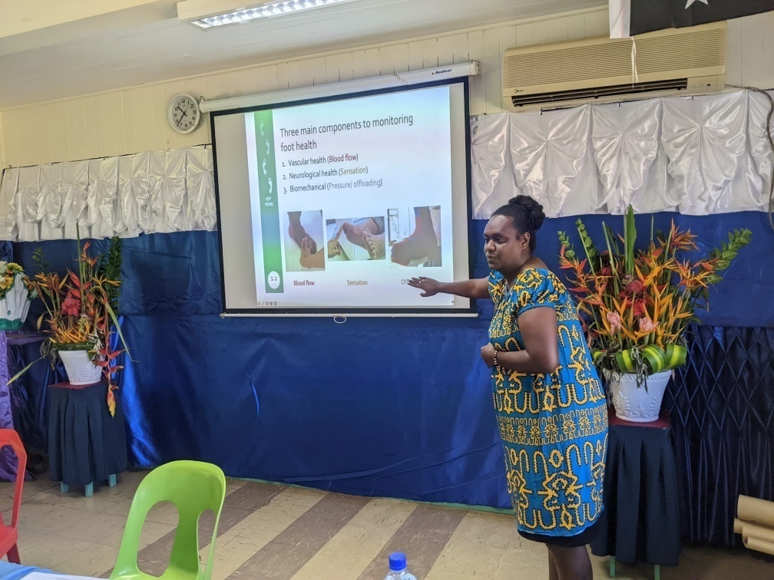
Figure 1. Jordanna Laejama, a registered nurse at NRH National Diabetes Centre, who has received intensive mentoring from an AVI-SIMPLER volunteer podiatrist, is delivering a lecture on diabetic foot care during a workshop in Papua New Guinea, February 2023.
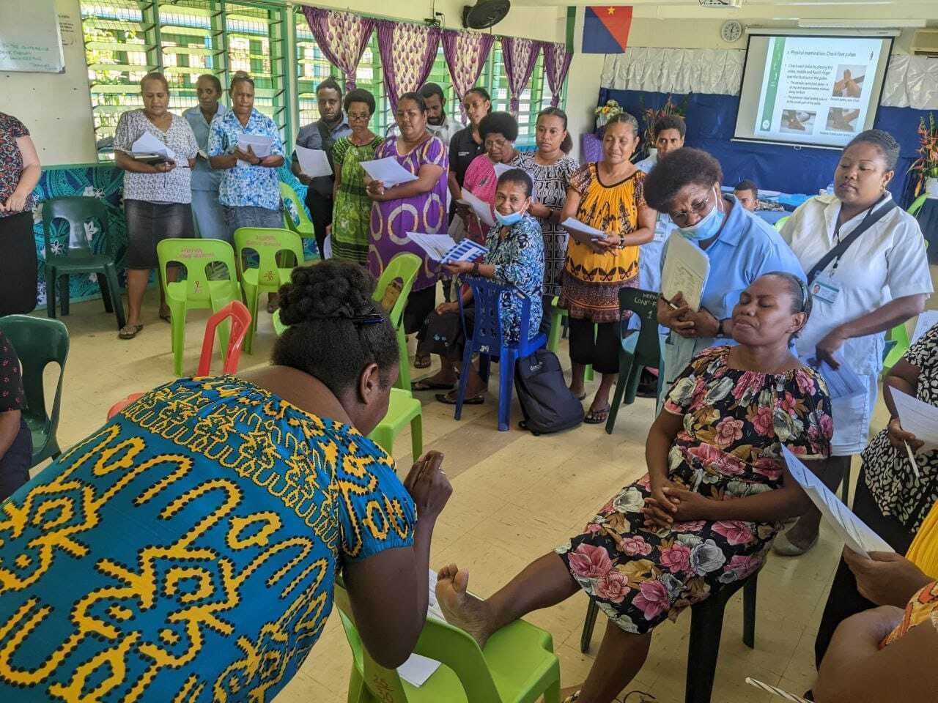
Figure 2. During the same workshop, Nurse Laejama is leading a session to simulate clinical examination of the foot.
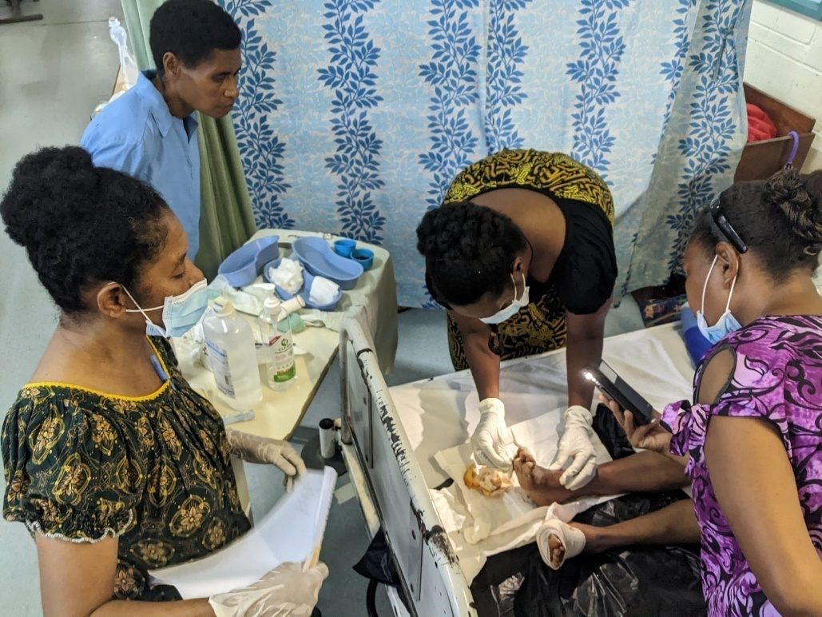
Figure 3. Roselyn Mataki Solowara, a registered nurse at NRH General Surgery Department, is delivering bed-side teaching on diabetic foot care in a ward setting.
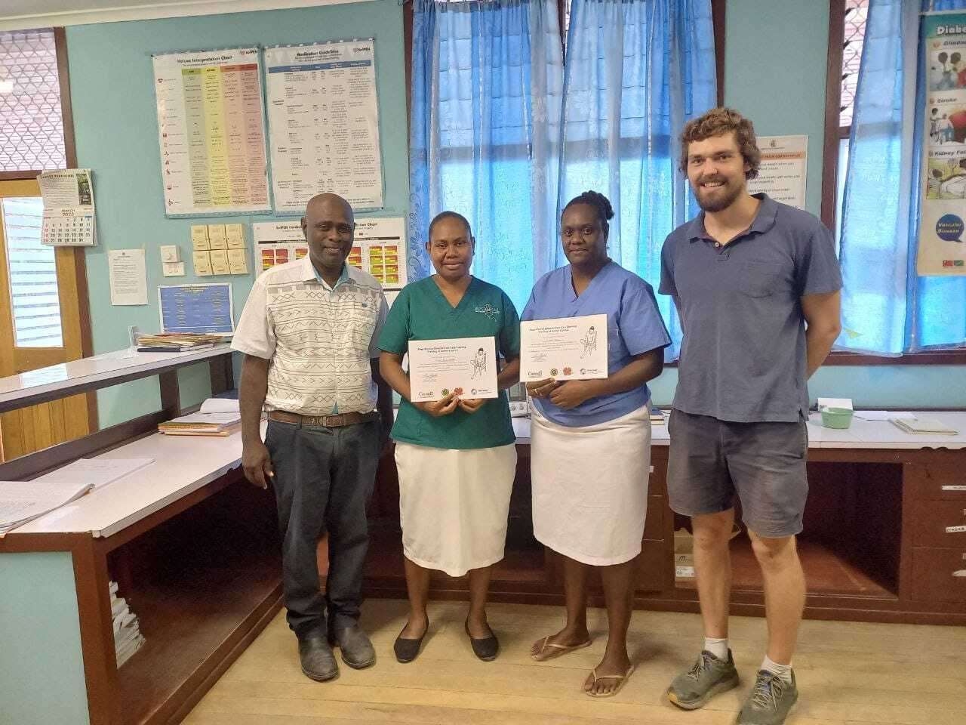
Figure 4. Dr Rooney Jagilly (Surgical Consultant and NRH’s Head of General Surgery Department), Roselyn Mataki Solowara (Registered Nurse, General Surgery Department), Jordanna Laejama (Registered Nurse, National Diabetes Centre), and Tom Fitzpatrick (Podiatrist, AVI-SIMPLER volunteer) at the NRH National Diabetes Centre.
Case Study 2: AVI-SIMPLER volunteer's NRH Unit/Department attachment: Emergency Department

Relevant NHSP Area: Strategic Objective 3 (Equitable Access to Fully Implemented Quality Health-care Programmes), Priority 3.2 (Health Service Utilization and Equity) and Priority 3.3 (Clinical Governance)

Relevant SIMPLER's Intermediate Impact Area 1 (Establishment of continued medical education options), 2 (Strengthening of management and leadership skills of key NRH personnel), and 4 (Improvement in hospital systems, policies and protocols)
In a system struggling to keep up with the nation's high population growth and rising demand for health care, the Emergency Department (ED) of Solomon Islands' National Referral Hospital (NRH) becomes integral to the country's health system, facing high burden of admissions of acute and complicated chronic disease presentations. A whole-of-system approach to health care withstanding, the strengthening of emergency care thus becomes a natural priority. On the other hand, a favourable and effective training environment for medical interns requires a health facility which adopts a culture of teaching and clinical excellence, including in emergency care setting. AVI's SIMPLER volunteers attached to the NRH's ED have been strategically positioned to support this process, with contributions from AVI beginning in 2014.
AVI’s strategic decision to enter into a Record of Understanding with ACEM, and with funding attached to support for NRH's ED was very appropriate as it enables the building of existing nascent network between Australian and Solomon Islands' Emergency Medicine specialists and trainees. Through the Australasian College for Emergency Medicine (ACEM)'s Global Emergency Care (GEC), Senior Fellows of ACEM (FACEMs) - such as Dr Georgina Phillips and Dr David Symmons - have held the roles of being de-facto mentors to the Pacific region's postgraduate training in Emergency Medicine. They have been involved in the curriculum development, teaching delivery, and assessments/examinations of emergency physician trainees in University of Papua New Guinea (UPNG) and Fiji National University (FNU), from which NRH’s Emergency Medicine Consultants graduated. The relationship between these FACEMs and their former trainees is a strong foundation for trust and collegiate culture. Moreover, GEC's principle to develop a multidisciplinary Emergency Care (EC) enables recruitment of AVI-SIMPLER volunteers from emergency care nurses in their network.
SIMPLER-ACEM Partnership
ACEM is an official Australian Partner Organisation of SIMPLER. This partnership’s achievements have reached beyond volunteer recruitment and into system development for the NRH’s Emergency Department. Below are some noteworthy achievements:
- ACEM facilitated an agreement with UPNG to allow Solomon Islands' postgraduate medical trainees in Emergency Medicine to remain in-country
- Former volunteers and Consultants who are members of ACEM developed standardised student assessments for BP/ITP trainees rotating through ED
- Despite uncertain commencement of the program, ACEM Consultants who are experienced in curriculum development contributed significantly to Emergency Medicine modules for the designed Postgraduate Diploma in Rural Medicine
- Clinical protocols, including Solomon Islands Triage Scale and patients’ Asthma Action Plan, co-created by NRH ED Consultants and ACEM Consultants, improving service in NRH’s ED.
- ACEM Consultants nurtured the NRH ED’s Consultants’ skills to conduct and publish academic research
- The collegiate relationship between ACEM and NRH’s ED has enabled various opportunities for NRH’s ED Consultants to be linked to regional networks, for meaningful leadership enrichment

The following are the various themes of past and long-lasting contributions which AVI-SIMPLER volunteers have contributed to NRH ED.
Theme 1: Interns, Registrars, and Postgraduate Training
SIMPLER volunteers attached in the NRH ED, who are senior trainees of ACEM, were heavily involved in Department's teaching and bed-side trainings targeted for trainees of various levels, namely interns (seven week rotation in ED), Solomon Island service Registrars attached in the ED as well as registrar trainees enrolled in the Emergency Medicine Postgraduate Diploma (through FNU or UPNG but studying in NRH’s ED). The latter arrangement was also facilitated by senior FACEMs, in order to solve the dilemma of NRH's ED losing trainees for many years to accomplish their training overseas.
The ED's Head of Department, Dr Trina Sale, remarked the AVI-SIMPLER volunteers’ indispensable role in the development of clinical teaching and lecture materials, standardisation of student assessment/examination, and creation of an MCQ bank for the interns' rotation.
Furthermore, the former AVI-SIMPLER volunteers and senior FACEMs worked together with Dr Sale to formulate the two Emergency Medicine modules (EM-1 and EM-2) as part of the Postgraduate Diploma in Rural Generalist Medicine.
Theme 2: Clinical Protocols and Emergency Care System Development
The SIMPLER volunteers’ immersion in the department's clinical governance efforts resulted in long-lasting impact. Firstly, an AVI-SIMPLER Emergency Care Nurse volunteer (during the previous phase of the SIMPLER program) and the NRH ED Consultant co-developed Solomon Islands Triage Scale (SITS), a ground-breaking work for clinical triage protocol for all admissions into the department. Subsequent SIMPLER volunteers in ED helped translate the data collected through the triage forms into a retrospective database of NRH ED admissions, with positive impact on the department's regular reporting and management. This triage protocol became a valuable lesson for other countries' emergency care in the region and preceded the WHO’s development of a similar triage protocol.
Other examples of clinical governance outputs are the post-discharge Asthma Action Plan, and sepsis awareness campaign. Furthermore, a comprehensive Patient Flow Review of the Emergency Department was conducted and presented to the NRH's executive leaders, identifying the access blockage and delays in various levels: from ED triage and treatment, to inpatient wards’ admission, to patient discharge. This report proposed several tangible recommendations, one of which was the creation of a Patient Flow Coordinator role in the hospital, with the objective of improving the efficiency of patient triage, admission, as well as discharge. (SIMPLER is currently seeking to recruit a volunteer Patient Flow Development Mentor, to support NRH’s role.)
Theme 3: Research Skills Development and Collaborative Research Project
Academic research and writing is another area which AVI-SIMPLER volunteers attached to the NRH's ED have contributed significantly. The volunteers collaborated with ED staff to publish manuscripts in established journals, namely in 2019 in Emergency Medicine Australasia on the SITS and in the BCH Health Services Research (2020) on the ethnographic approach to Emergency Care need assessment to reflect the unique context of emergency care in the Pacific Island Countries (PIC).
Theme 4: Leadership, Collegiate Network, and Lifelong Learning
The most meaningful yet intangible contribution from AVI-SIMPLER to NRH's ED is the collegiate network between Solomon Islander and Australian peers. This network, sustained and expanded by continued attachment of AVI-SIMPLER volunteers to the Department over the years, has enriched the dynamic of the medical and nursing personnel who work in one of the most fast-paced, high-load health care setting in the country. The interactions (of formal and informal nature), knowledge resources, and moral support from Australian counterparts resulting from the network were attributed by Dr Trina Sale to "break[ing] the monotony of work" and "alleviat[ing] burnouts", especially in the height of COVID-19 pandemic experienced in Solomon Islands from 2021.

Annex 3: SIMPLER* Theory of Change
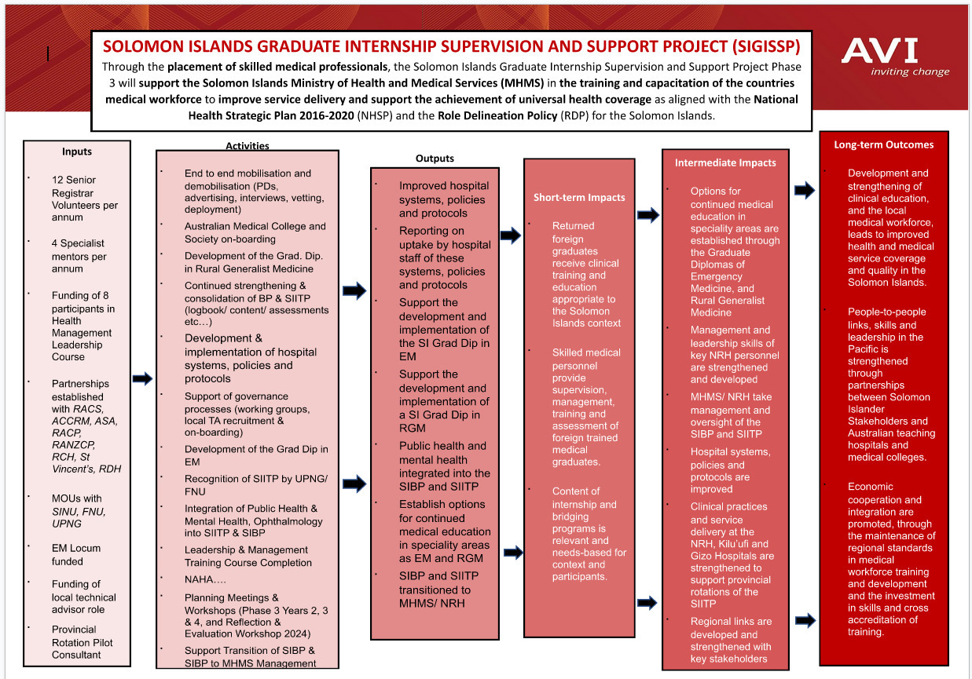
* SIGISSP was rebranded as SIMPLER after the theory of change was developed. It is still applicable to the rebranded program.

Annex 4: Excerpts from the National Health Strategic Plan 2022-2031

Figure A4: High level Goal, Strategic Objectives and Intermediary Results (page 14)

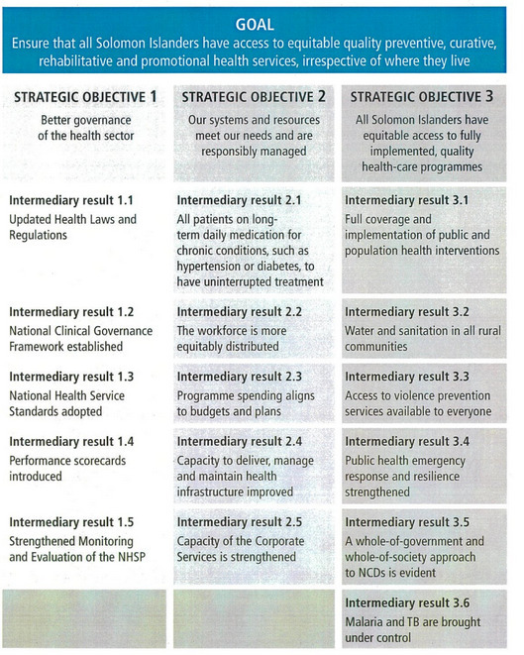

Figure A4.1: Strategic Objective 1 – Priorities and Strategies (page 20 and 21)

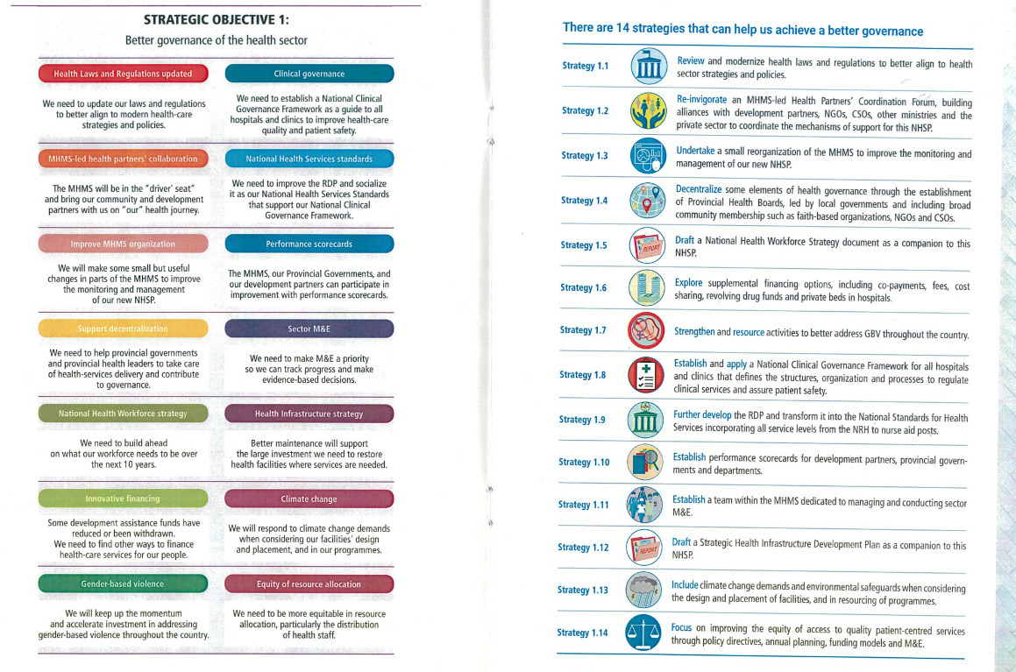
Figure A4.2: Strategic Objective 2 – Priorities and Strategies (page 32 and 32)
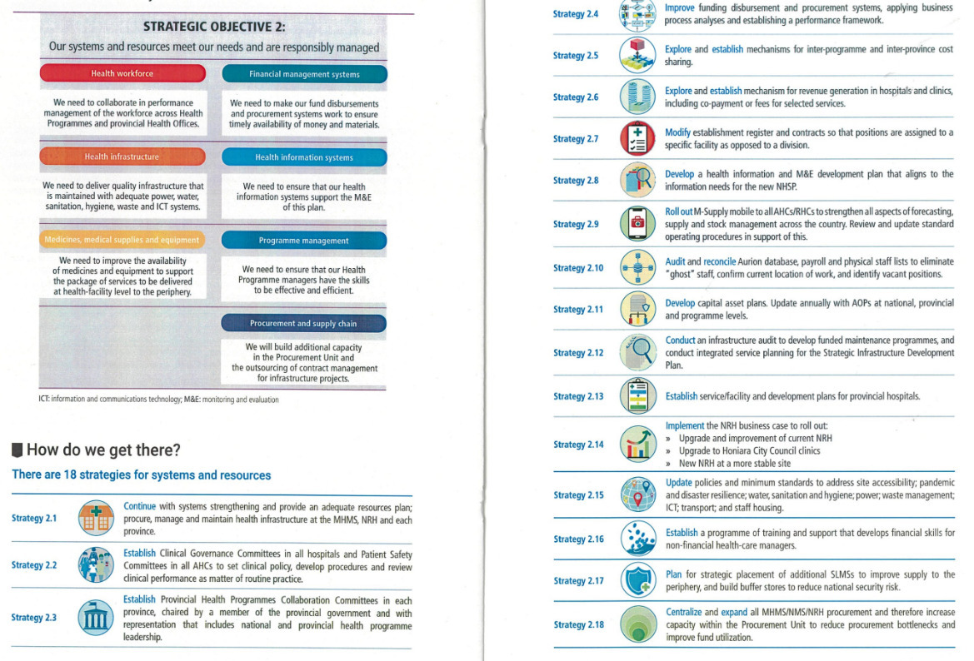

Figure A4.3: Strategic Objective 3 – Priorities and Strategies (page 39 and 40)
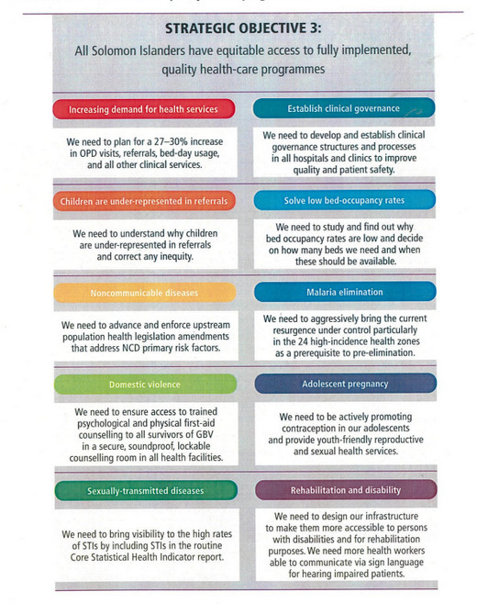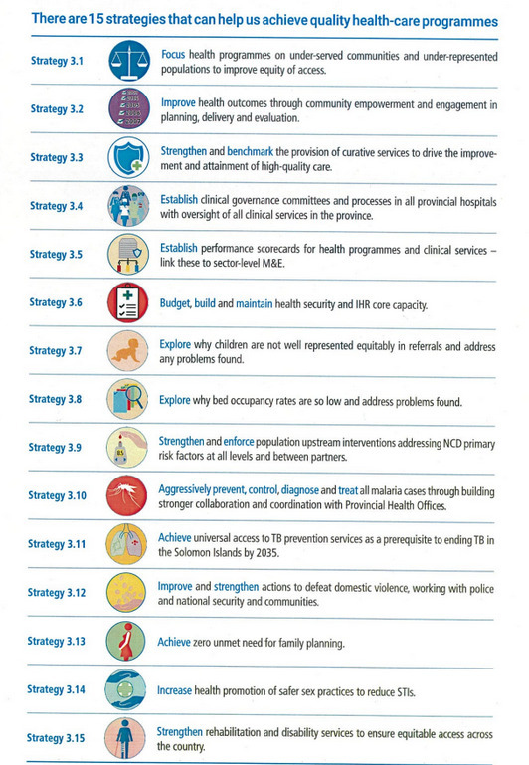

The World Bank Data, available from https://data.worldbank.org/indicator/SP.URB.TOTL.IN.ZS?locations=SB
Solomon Islands National Statistics Office, Projected population by province 2010-2025, available from https://www.statistics.gov.sb/statistics/social-statistics/population
World Bank’s 2018 Solomon Islands Health Financing System Assessment – Spend Better, available from https://documents.worldbank.org/en/publication/documents-reports/documentdetail/481931528443850077/spend-better
Institute of Health Metrics and Evaluation, Global Burden of Disease Study 2010, available from https://www.healthdata.org/sites/default/files/files/country_profiles/GBD/ihme_gbd_country_report_solomon_islands.pdf
Solomon Islands Ministry of Health and Medical Services, National Health Strategic Plan 2022-2031: A Healthy Future for All, 2022
WHO Solomon Islands Health System Review 2015, available from https://apps.who.int/iris/bitstream/handle/10665/208212/9789290616931_eng.pdf?sequence=1&isAllowed=y
Solomon Islands Ministry of Health and Medical Services, National Health Strategic Plan 2022-2031: A Healthy Future for All, 2022
www.solomons.gov.sb/national-health-strategic-plan-2022-2031-launched/
Excerpts from the National Health Strategic Plan the show the full list of priorities and strategies are provided at Annex 4.
MHMS Role Delineation Policy for Solomon Islands, available from https://solomons.gov.sb/wp-content/uploads/2020/02/MHMS-Role-Delineation-Policy.pdf
WHO Feature Stories “Moving health closer to home”, 11 November 2018, available from https://www.who.int/westernpacific/news-room/feature-stories/item/moving-health-closer-to-home
In Australian, medical job title terminologies for doctors in training vary between States or Territories, but generally “Interns” refer to doctors in their first postgraduate year while "Registrars” refers to medical staff member who have enrolled in specialist medical colleges’ training programs. During consultations in Solomon Islands, all doctors in training who have completed internship training and are working in the hospital were referred to as “Registrars”, regardless of their enrolment status. This report uses the Solomon Islands understanding of the term Registrar to describe any doctor who has completed the Internship program.
Solomon Islands Ministry of Health and Medical Services, National Health Strategic Plan 2022-2031: A Healthy Future for All, 2022
De Silva MS, Panisi L, Manubuasa L, et al. Incidence and causes of stillbirth in the only tertiary referral hospital in the Solomon Islands: a hospital-based retrospective cohort study. BMJ Open 2022;12:e066237. doi:10.1136/ bmjopen-2022-066237
www.researchgate.net/publication/342317333_A_Pacific_needs_analysis_model_A_proposed_methodology_for_assessing_the_needs_of_facility-based_emergency_care_in_the_Pacific_region/link/5fc23fcb299bf104cf883dbf/download
www.researchgate.net/publication/331720159_Effective_triage_in_the_Pacific_region_The_development_and_implementation_of_the_Solomon_Islands_Triage_Scale_SOLOMON_ISLANDS_TRIAGE_SCALE

