PATTAF
PAPUA NEW GUINEA – AUSTRALIA
TARGETED TRAINING FACILITY

Scholarship Baseline Data Analysis

2003-2010

Contents
1 Introduction 1
1.1 Methodology 1
1.2 Limitations 2
1.3 Selected History 2
2 Australian Development Scholarships Applications 4
2.1 Total Applications 4
2.2 Men and Women Applicants 4
2.3 Categories of Award Applicants 6
2.4 Level of Study 6
2.5 Age of Applicants 9
2.6 Sectors of Study 10
2.7 Conclusions regarding ADS Applications 11
3 Australian Development Scholarships Awards 13
3.1 Total Awards 2003-2010 13
3.2 Gender Equity in Total Awards 14
3.3 Award Category 15
3.4 Level of Study 16
3.5 Sector of Study 16
3.6 Age of Scholars 17
3.7 Family Profile 19
3.8 Province of Residence 19
3.9 Gender Equity in Award Categories 21
3.10 Gender Equity in Level of Study 22
3.11 Sectors of Study for Men and Women 22
3.12 Conclusions regarding Awards 23
4 Australian Development Scholarships Performance 24
4.1 Completion and Failure Rates 27
4.2 Failure by Gender 27
4.3 Failure by Category 28
4.4 Failure by Level of Study 29
4.5 Failure by Sector of Study 30
4.6 Failure by Family Status 30
4.7 Failure by Age of Scholar 31
4.8 Failure by Institution 32
4.9 Completion at a Lower Level 32
4.10 Total Variations 32
4.11 Total Variations by Gender 34
4.12 Termination Variations 34
4.13 Termination Variations by Gender 35
4.14 Termination Variations by Category 36
4.15 Termination Variations by Level 36
4.16 Extension Variations 37
4.17 Extensions by Gender 37
4.18 Extension Variations of One Semester or More 38
4.19 Extension Variations costing more than $10,000 39
4.20 Extension Variations leading to Termination 40
4.21 Extension Variations Resulting in Lower Level Qualification 41
4.22 Extensions resulting in Graduation at Lower Level 2003-2009 by Gender 41
5 Australian Leadership Awards 43
5.1 ALA Performance 43
6 Conclusions 45
6.1 Looking forward to the PNG Scholarships Program M&E 46
Annex 1: Additional Data 47
Awards by Category 47
Awards by Level of Study 50
Awards by Study Level by Year 53
Awards by Sector of Study 57
Extension Variations by Year 59

Figures
Figure 1. Total Applications 4
Figure 2. Men and Women Applicants 5
Figure 3. Men and Women Applicants as % total Applications 5
Figure 4. Applications by Category of Award 6
Figure 5. Applications by Level of Study 7
Figure 6. Applications by Category and Level 7
Figure 7. Applications by Age Group 8
Figure 8. Women Applicants by Age 9
Figure 9. Male Applicants by Age 9
Figure 10. Applications by Sector of Study 10
Figure 11. Gender Equity in Total Awards 14
Figure 12. Total Awards by Category 14
Figure 13. Awards by Level of Study 15
Figure 14. Awards by Sector of Study 16
Figure 15. Awards by Age at Entry 17
Figure 16. Awards by Age at Entry and Gender 17
Figure 17. Family Profile 18
Figure 18. Awards by Province of Residence 19
Figure 19. Awards by Category to National Capital District 19
Figure 20. Public Awards by Gender 20
Figure 21. Open Awards by Gender 20
Figure 22. Level of Study for Men and Women 21
Figure 23. Health Awards by Gender 22
Figure 24. Infrastructure Awards by Gender 22
Figure 25. Failure Rates 27
Figure 26. Failure by Gender 28
Figure 27. Total Failure Rates by Gender and Category 28
Figure 28. Annual Number of Failures by Category 29
Figure 29. Success and Failure by Family Status 31
Figure 30. Failure by Age 31
Figure 31. Completion at a Lower Level 32
Figure 32. Total Variations 34
Figure 33. Total Variations by Gender 34
Figure 34. Terminations (with Reasons) by Gender 35
Figure 35. Terminations by Year and Gender 36
Figure 36. Terminations by Level of Study and Gender 37
Figure 37. Extension Variations 37
Figure 38. Extensions by Gender 38
Figure 39. Extensions of One Semester or More 39
Figure 40. Extensions costing more than $10,000 40
Figure 41. Total Cost of Extensions Costing More than $10, 000 from 2003-2010 40
Figure 42. Average Cost of High Cost Extensions 40
Figure 43. Extensions leading to Graduate at a Lower Level 41
Figure 44. Graduation at Lower Level after Extension by Gender 42
Figure 45. Men and Women ALA Awards 43
Figure 46. Diploma Awards 50
Figure 47. Undergraduate Awards 51
Figure 48. Postgraduate Awards 52
Figure 49. Doctoral Awards 53

Tables
Table 1. Men and Women Applicants 5
Table 2. Total Applications 8
Table 3. Applications by Age Group 9
Table 4. Applications by Age 10
Table 5. Total Awards 2003-2010 14
Table 6. Total Awards by Category 16
Table 7. Awards by Age at Entry 18
Table 8. Sectors of Study by Gender 22
Table 9. Student Achievement by Year, Level of Study and Gender 25
Table 10. Failure and Completion Rates 27
Table 11. Total Failure Rate by Gender 27
Table 12. Failure by Category 28
Table 13. Failure Rate by Level of Award 2003-2009 29
Table 14. Failure by Level and Gender 2003-2009 29
Table 15. Failure by Sector of Study and Gender 30
Table 16. Success and Failure by Family Status 31
Table 17. Failure by Age 32
Table 18. Total Variations 33
Table 19. Termination Variations 35
Table 20. Terminations by Level 36
Table 21. Terminations by Gender and Level 36
Table 22. Extensions by Gender 38
Table 23. Extensions leading to Termination 41
Table 24. ALA Awards 43
Table 25. ALA Performance by Gender 43
Table 26. Diploma (TAFE) Awards 50

Introduction
As a component under the Phase D extension of the Papua New Guinea-Australia Targeted Training Facility (PATTAF) management of the Australian Scholarships in PNG, AusAID added a baseline reporting requirement to the outputs of the scholarship program. This baseline data analysis reports on the cohorts of scholars from 2003 to 2010 inclusive, and builds on previous reports, such as the June 2009 Trends in Student Achievement under ADS report (Milestone 2.10) and the PATTAF Performance Assessment ADS report (Milestone 1.8). It seeks to provide a documented statistical analysis of the scholarships program under PATTAF, and to provide a baseline and benchmarks leading into the establishment of monitoring and evaluation arrangements for the new Scholarships PNG Program, which commenced in June 2010.

Since 2003 there have been 1033 awards under Australian Development Scholarships. Scholars have studied at Australian tertiary institutions including universities, and TAFE institutes, completing qualifications from Diploma to PhD level. Men and women scholars have been drawn from the public and private sectors, from throughout PNG, to study in a range of sectors. The report is structured in three main sections, addressing three stages of the ADS scholarship program: Applications, Awards and Performance.

Since its launch in 2007, the Australian Leadership Awards program has awarded 44 ALA scholarships to PNG citizens. These are awarded through the Australian Scholarships Group at AusAID in Canberra, with PATTAF only providing support to the process. As a result, PATTAF has very limited access to data regarding ALAs, and can only provide limited analysis and reporting. This reporting is in Section 5.

Methodology
Data has been analysed according to a number of specified variables, in order to report descriptive aspects of Australian Scholarships over the period, and to identify important trends or clusters of data as a means to better understand the program. This analysis was undertaken by a short-term adviser working closely with the PATTAF staff. The data in this report were extracted from the Facility’s Training Records System (TRS) and directly from AusAID’s student database system including OASIS and SIMON. PATTAF staff undertook considerable manual data extraction and manipulation, and analysis and charting was undertaken in MS Excel.

The variables used are listed below, with clarification regarding definitions used (where necessary):
- Gender: male/ female.
- Category of award: Public (only open to public service employees); Open (open to the general public) and, until 2006, Private. For the purposes of the report, Open and Private category awards are treated as a single Open category.
- Level of study: refers to the academic level of study, namely Diploma (TAFE); undergraduate, postgraduate or doctoral (PhD) studies.
- Province of Residence: available for applications data only.
- Family Profile: specifies whether a scholar is single or married and indicates how many dependents in the family (for awards data).
- Family Status: specifies whether a scholar was accompanied or unaccompanied during their scholarships studies (for performance data only).
- Age: the age of the scholar at the time of their application (for applications data) or on commencement of their award (for awards data).
- Sector of study.
Further details regarding variables are provided where relevant in the subsequent sections of the report.

Limitations
The M&E system for PATTAF, and its supporting database structure, has evolved over the life of the program. It has also evolved in line with the expansion of the scope of the program through its numerous amendments. This has resulted in some inconsistencies in data (particularly between applications and awards data) and has meant that there is not always an ideal level of internal consistency in the data structure. This is highlighted, for example, by different definitions of sector of study between applications and awards data. The forthcoming PNG Scholarships Program provides the opportunity to address these historic anomalies in the database and the M&E system.

As noted above, there is very little scope to analyse or report ALA data as it is held separately by AusAID in Canberra. PATTAF has had no direct access and limited indirect access.

Finally, data analysis in this report is primarily through simple inspection. There has been no scope to undertake statistical analysis; for example correlation analysis, or significance testing with cross tabulations. Again, the PNG Scholarships Program provides the opportunity to ensure that, if desired, database arrangements are built so as to enable such simple statistical analysis.

Selected History
A number of significant policy changes were made over the life of PATTAF, resulting in changes to applications, awards and performance. The impact of these changes is evident in the data and the analysis, so a brief summary of these decisions is necessary:

Year | Changes endorsed by Facility Coordinating Group/ Facility Advisory Board
2004 | Direct articulation of TAFE awards to Degree awards was removed. Scholars were no longer able to complete a Diploma and proceed directly to an undergraduate award; they were now required to return to PNG for at least two years before applying again for a subsequent award.
2004 | Quotas for Postgraduate awards were increased relative to Undergraduate and TAFE awards
2005 | Grade 12 school leavers we no longer eligible to apply for ADS.
2005 | Assessment criteria for Postgraduate applicants were adjusted to lower required academic grades from B to C average, but to increase the emphasis on work experience and performance
2005 | Public servants declared ineligible for Open category awards; they could only apply under Public category
2005 | Tertiary courses provided in PNG became ineligible for ADS awards
2006 | Unemployed applicants no longer eligible
2006 | Applicants now required to demonstrate at least two years of work experience in the area of study applied for.
2006 | Private category removed as a separate category; Open and Public categories remain.
2006 | The higher stipend for accompanied scholars (those with accompanying dependent children or spouse) was removed, to apply to new awards from 2007 onwards.
2006 | The National Training Council was given the responsibility of coordinating the scholarship applications for the Open category. This meant that an applicant identified to undergo further training under the scholarship program had to be nominated by an agency with submitted training plans
2009 | PATTAF took a more pro-active role advertising ADS for both Public and Open category awards, working in consultation with DPM and NTC.

Australian Development Scholarships Applications
In analysing applications data over the period 2003-2010, this report aims to answer, among other things:
- What are the patterns and trends in application numbers, what can we learn from them, and what implications might they have for future program promotion and targeting activities?
- Did the removal of the accompanied stipend in 2006 have any impact on the numbers of applications from any groups of applicants, such as women, or applicants of particular age groups? This was identified by the 2009 Independent Completion report as an emerging phenomenon of concern.

Total Applications
There have been around 21,000 applications for ADS awards since 2003. Total applications data shows a notable reduction in applications from 2006 onwards. The policy decision in 2005 and 2006 to exclude school leavers, the unemployed and those with less than two years of work experience clearly had an impact, reducing the pool of applicants very substantially. Since then, a pool of around 1000-1500 applicants has been received each year, although with some important characteristics which are explored further in subsequent sections.
- Total Applications
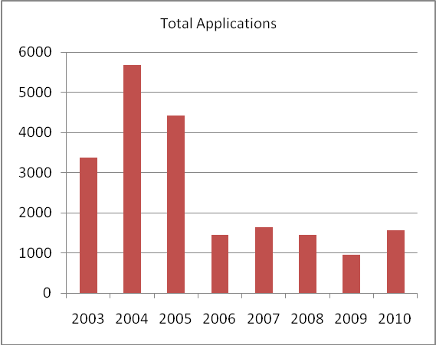

Men and Women Applicants
PATTAF has always targeted equal number of men and women in its awards of scholarships. However itis evident from Figures 2 and 3 below that there has consistently been a significant difference in the numbers of men and women applying for scholarships, both in absolute numbers and as a proportion of total applications.

Disaggregated data also enables us to examine whether the removal of the accompanied stipend – which had been expected to disadvantage women applicants as they were more likely to have dependents – had an impact on women applicants. The 2009 Independent Completion Report for PATTAF suggested that there was a worrying decline in the numbers of women applicants, possibly in response to this change. However these data show that the dramatic change in number of women applicants (as of men) occurred in 2006 after the changes in eligibility for young and unemployed people. There is no evidence of a significant subsequent, additional drop in numbers after the removal of the accompanied stipend, although what we cannot determine is any possible change in the quality of applications from women (or from men).
- Men and Women Applicants
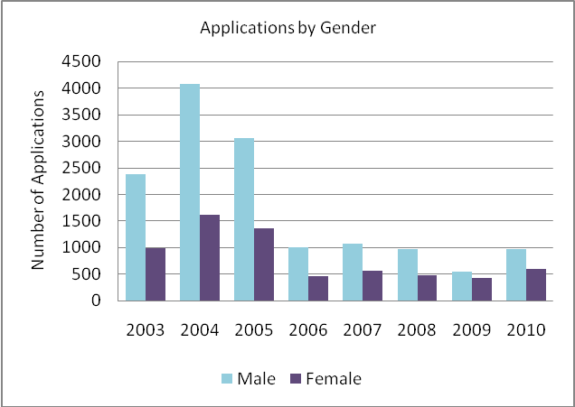
- Men and Women Applicants
 | 2003 | 2004 | 2005 | 2006 | 2007 | 2008 | 2009 | 2010
Male | 2378 | 4077 | 3066 | 999 | 1070 | 974 | 541 | 969
Female | 995 | 1613 | 1354 | 459 | 565 | 478 | 419 | 598
Total | 3373 | 5690 | 4420 | 1458 | 1635 | 1452 | 960 | 1567

Over the entire period of 2003-2010 men have comprised 68% of all ADS applicants and women 32% (n=6,481). The greatest proportion of women was 44% in 2009. Until this time men had fairly consistently represented more than 65% of applicants (conversely, women were less than 35% of applicants). It is worth noting that the low numbers of applicants in 2009 resulted from a particularly difficult period in DPM and its key stakeholders.
- Men and Women Applicants as % total Applications
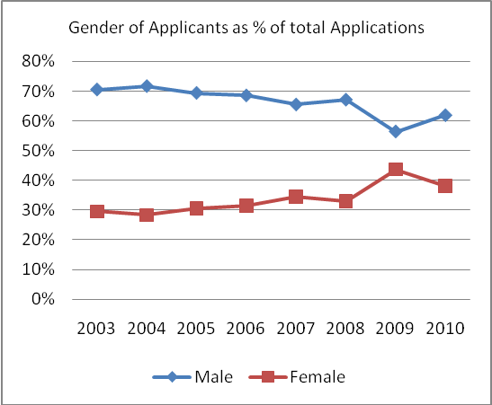

Categories of Award Applicants
ADS applications are classified into two categories. The Public category applies to applicants who are employed in the public service and statutory organisations. The Open/private category applies to applicants employed by private sector organisations, non government organisations, church and voluntary organisations and self employed. Applications for the Public category are coordinated by the Department of Personal Management, and (since 2006) the National Training Council coordinates the Open category applications. All applicants must be endorsed by the applicant’s employer, whether in the public or private sector. The two agencies submit screened applications to the Papua New Guinea-Australia Targeted Training Facility (PATTAF) for assessment and selection.

PATTAF has always received many more Open category applications than Public applications. The source population is far larger and not restricted to any one employer, there is generally better promotion through the National Training Council and application processes are generally less complex. There has been progress, however, since 2006, in increasing the numbers of Public applications, including increased liaison with DPM and NTC for targeted promotions and support efforts in 2009 and 2010. The 2010 promotional campaign targeted people in provinces, women and people living with disabilities.
- Applications by Category of Award
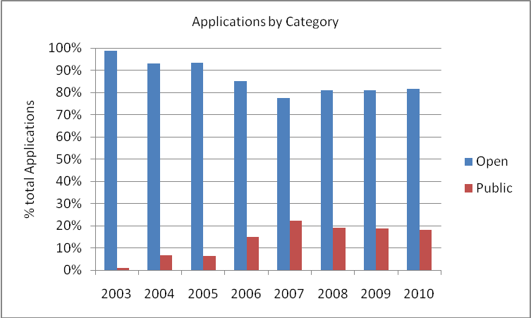

Level of Study
In response to changing eligibility rules, particularly regarding school leavers, the unemployed, and the newly employed; and in response to lower academic requirements and increasing quotas for postgraduate study (previous year’s quotas are made public as an indicative guide to the numbers of awards in each category) there has been a gradual increase in applicants’ preference for postgraduate studies. After declining in 2006 and 2007, undergraduate studies have steadily increased as a proportion of applications since 2008, offset by the decrease in diploma level applications. PhD applications have remained relatively steady at a very small proportion of applications, no doubt due to the small pool of potential applicants, and the limited number of awards available.
- Applications by Level of Study
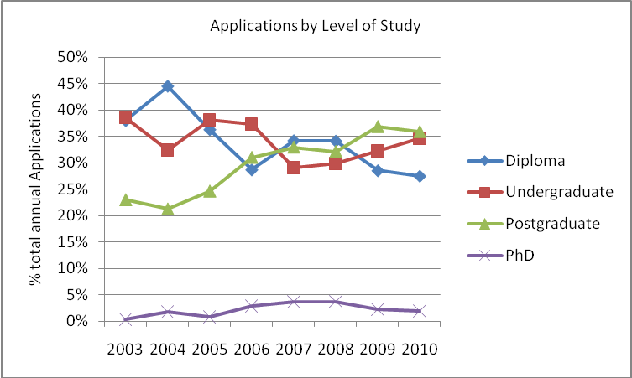

Once applications are disaggregated further by both category and level of study, it is clear that there is a changing mix of levels, in line with the changing rules governing eligibility for award. There have been fewer applications for Diplomas in the Open category, while all other levels of study have increased.
- Applications by Category and Level
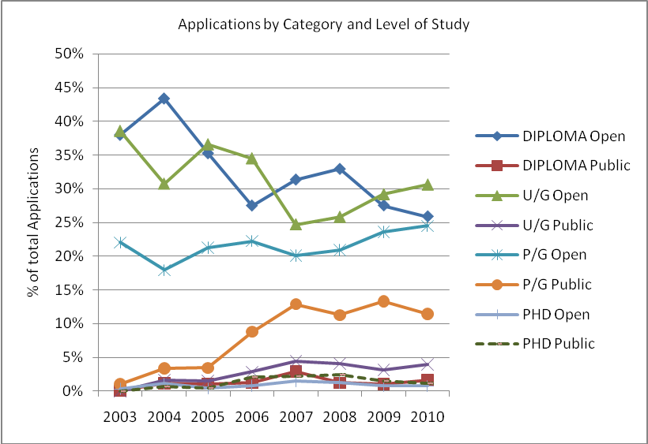

Once data are disaggregated by both category and gender, it is clear that there has always been an extremely small number of women applicants in the Public category. That number trended down between 2007 and 2009, before increasing somewhat in 2010 thanks to increased targeting of promotions by DPM.
- Applications by Category and Gender
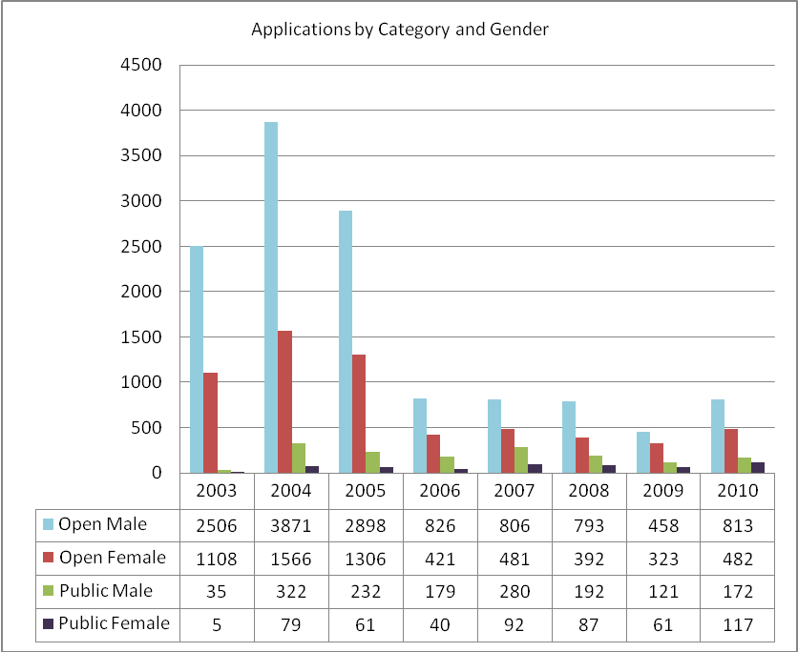

- Total Applications
 |  | 2003 | 2004 | 2005 | 2006 | 2007 | 2008 | 2009 | 2010
DIPLOMA | Open Male | 960 | 1750 | 1038 | 245 | 312 | 303 | 158 | 248
DIPLOMA | Open Female | 427 | 781 | 547 | 158 | 208 | 179 | 107 | 162
DIPLOMA | Public Male | 2 | 48 | 40 | 14 | 32 | 11 | 8 | 15
DIPLOMA | Public Female | 0 | 20 | 8 | 4 | 16 | 7 | 2 | 11
U/G | Open Male | 940 | 1260 | 1140 | 345 | 251 | 268 | 159 | 294
U/G | Open Female | 470 | 535 | 506 | 161 | 159 | 110 | 122 | 191
U/G | Public Male |  | 77 | 52 | 28 | 47 | 39 | 16 | 35
U/G | Public Female | 0 | 20 | 18 | 14 | 26 | 21 | 14 | 28
P/G | Open Male | 600 | 811 | 707 | 227 | 225 | 207 | 135 | 259
P/G | Open Female | 205 | 236 | 248 | 99 | 108 | 99 | 92 | 129
P/G | Public Male | 32 | 164 | 125 | 111 | 169 | 117 | 85 | 107
P/G | Public Female | 5 | 32 | 30 | 18 | 45 | 48 | 43 | 74
PHD | Open Male | 6 | 50 | 13 | 9 | 18 | 15 | 6 | 12
PHD | Open Female | 6 | 14 | 5 | 3 | 6 | 4 | 2 | 0
PHD | Public Male | 1 | 33 | 15 | 26 | 32 | 25 | 12 | 15
PHD | Public Female | 0 | 7 | 5 | 4 | 5 | 11 | 2 | 4
GRAND TOTAL |  | 3,654 | 5,838 | 4,497 | 1,466 | 1,659 | 1,464 | 963 | 1,584

Age of Applicants
The age of applicants appears from Figure 7 to be trending upwards over time. The mean age of applicants has certainly increased, from 27 years of age over 2004-2006 to 33 years since 2009. The small proportion of applicants aged under 20 fell to almost zero from 2006 onwards (1%), showing that, as the overall numbers of applications fell, the numbers fell more significantly from younger applicants.
- Applications by Age Group
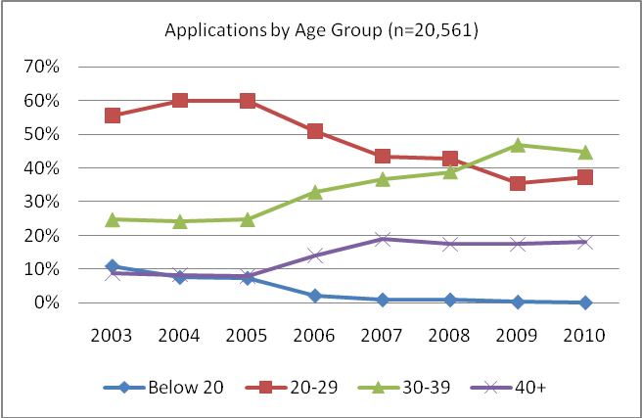
- Applications by Age Group
 | 2003 | 2004 | 2005 | 2006 | 2007 | 2008 | 2009 | 2010
Below 20 | 369 | 433 | 326 | 32 | 16 | 14 | 3 | 2
20-29 | 1878 | 3415 | 2651 | 743 | 711 | 622 | 340 | 584
30-39 | 832 | 1369 | 1091 | 478 | 600 | 564 | 450 | 700
40+ | 299 | 473 | 353 | 205 | 308 | 252 | 167 | 281
Total | 3378 | 5690 | 4421 | 1458 | 1635 | 1452 | 960 | 1567

In order to examine the age characteristics of men and women applicants, and to answer the question: ‘do women applicants tend to be older?” data has been disaggregated by gender and by age. As Figures 8 and 9 show, there has in fact been a very similar trend in the mix of applicant ages for both women and men. Applicants aged 20-29 have steadily trended down for both women and men, and under-20s have almost disappeared. Applicants aged between 30-39 have become increasingly common for both men and women, while applicants aged over 40 have been between 15% and 25% of applicants for both men and women.

There appear to be some slight shifts in age for women and men applicants in 2010 data, with proportionally more older men (over 40) and proportionally fewer older women with more aged in their twenties. However it is too early to determine whether this is the start of a new trend, or a one-off anomaly. This is something to be monitored in the new PNG Scholarships program.

- Women Applicants by Age
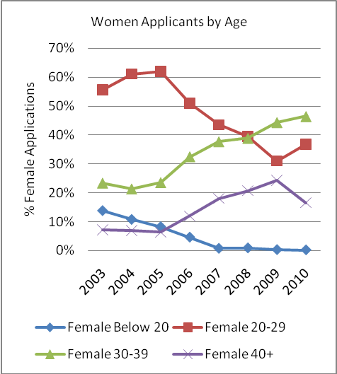
- Male Applicants by Age
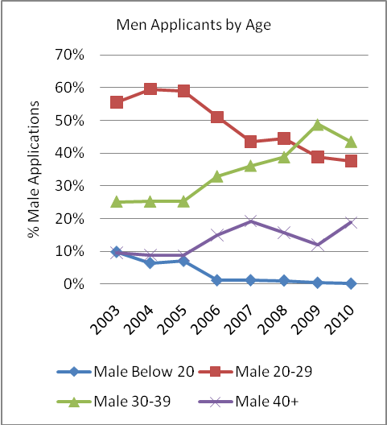

- Applications by Age
 |  | 2003 | 2004 | 2005 | 2006 | 2007 | 2008 | 2009 | 2010
Male | Below 20 | 231 | 260 | 215 | 11 | 12 | 10 | 2 | 1
Male | 20-29 | 1322 | 2429 | 1811 | 510 | 465 | 433 | 210 | 364
Male | 30-39 | 598 | 1026 | 773 | 329 | 387 | 378 | 264 | 422
Male | 40+ | 227 | 362 | 267 | 149 | 206 | 153 | 65 | 182
Female | Below 20 | 137 | 173 | 111 | 21 | 4 | 4 | 1 | 1
Female | 20-29 | 554 | 986 | 839 | 234 | 246 | 189 | 130 | 220
Female | 30-39 | 232 | 343 | 318 | 149 | 213 | 186 | 186 | 278
Female | 40+ | 72 | 111 | 86 | 55 | 102 | 99 | 102 | 99
Total |  | 3373 | 5690 | 4420 | 1458 | 1635 | 1452 | 960 | 1567

Sectors of Study
The PATTAF Training Records System classifies applicants according to the sector of study proposed. Applications are classified into Administration, Education, Governance, Health, Infrastructure, Rural Development and Social and Human Development studies.

Administration has consistently remained the predominant sector of interest for ADS scholars as shown in Figure 10. At its highest (in 2004), more than 60% of scholars applying for Administration studies; and there have never been fewer than 38% (in 2005) of a cohort applying to study in this sector. Other sectors have remained relatively steady as a proportion of each cohort of applicants, with the exception of Infrastructure, which leapt in 2005 and has since remained the second-most popular sector of study.

Comparison of applications by sector with awards by sector would highlight whether applicants in some sectors are more likely to succeed in securing a scholarship. However the differing classification of sectors between applications and awards data makes this impossible (see Section 1.2). The PNG Scholarships Program should consider this in structuring its new M&E arrangements.
- Applications by Sector of Study
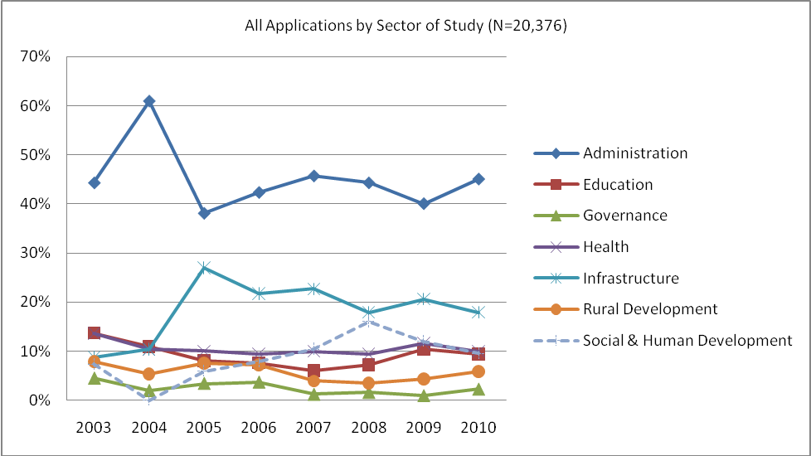

Conclusions regarding ADS Applications
Over the life of PATTAF there is one very striking point of change in applications data: the dramatic drop in applications from both women and men once eligibility was removed for school leavers and the unemployed, and once the quota for public awards was increased to 50%. Also as a result of these policy changes, the mean age of applicants increased by around five years. Analysis of awards data in Section 3 examine whether the changing mix of applicants has translated into similarly changed cohorts of scholars.

There have been peaks and troughs in the levels of interest by sector of study, but overall the sectors remain in a relatively consistent order of interest, with Administration the most popular and Governance the least. Scholarships PNG should structure M&E arrangement to enable monitoring of success rates in sectors of study from applications to awards to performance and onwards. It will also be important to monitor the extent to which applications respond to changes in targeting and promotions by Scholarships PNG.

It will be important to continue to monitor applications trends in Scholarships PNG, particularly because qualitative investigation in the Independent Completion Report highlights significant concern about a fall in women applicants. While this isn’t evident in these data, it is essential to monitor closely, and to develop effective means to measure the quality of applications, not just the numbers. Without sufficient good quality women applicants it will be impossible for Scholarships PNG to achieve gender equity in its awards.

It is evident that applicants are getting older. Section 3 examines whether this is also being reflected in the age of successful awardees, and Section 4 looks at performance while on award. The key question here is whether older applicants are also more likely to secure awards, and to go on to perform better while on award.

Looking ahead, Scholarships PNG will need to continue to monitor applications data across these and other variables, in case 2010 was the start of some new trends. It will also be essential to better align the definitions of variables throughout the scholarships cycle so performance trends can be monitored throughout.

Australian Development Scholarships Awards
The selection of applicants for an ADS award is made by a Joint ADS Selection Committee (the JASC), which includes Government of PNG, PATTAF and AusAID representatives. Awards are usually made within a pre-agreed set of quotas for each study level that target an overall equal allocations between Public and Open categories; between men and women (always aiming for gender equity overall); and between level and sector of study.

Awards data are held in a PATTAF Training Records System, which captures extensive detail about each scholar, including their gender, level and category of award, provinces of residence and birth, employment details, family profile and (since 2007) their age at entry into the program. As such, it is possible to profile scholarships cohorts according to many different variables. However it is important to note that, unlike applications– which represent the response of the PNG community to the scholarships opportunity – awards are made by JASC under the PATTAF program. Therefore, it is to be expected that (within the limitations of applications received) much greater equity can be achieved, and that the awards will reflect prevailing program priorities, targets and quotas. It should be noted, however, that Public awards were made after screening by DPM, which in effect limited the scope for PATTAF to draw from the entire population, and in some cases delivered poor selection outcomes (see th ePATTAF Activity Completion Report for a fuller discussion).

As outlined in this section, awards have been analysed according to a specified set of variables:
- Gender: male/ female.
- Category of award: Public (only open to public service employees); Open (open to the general public) and, until 2006, Private. For the purposes of the report, Open and Private category awards are treated as a single Open category.
- Level of study: refers to the academic level of study, namely Diploma (TAFE); undergraduate, postgraduate or doctoral (PhD) studies.
- Family Profile: specifies whether a scholar is single or married and indicates how many dependents in the family.
- Age: the age of the scholar on commencement of their award (for awards data).
- Sector of study.

Total Awards 2003-2010
Over the life of the Papua New Guinea-Australia Targeted Training Facility (PATTAF) a total of 1033 Papua New Guinea (PNG) citizens have received awards under the Australian Development Scholarship Program. Table 5 provides the total numbers of awards.

- Total Awards 2003-2010
 | TAFE |  |  |  | UNDERGRADUATE |  |  |  | POST GRADUATE |  |  |  | PHD |  |  |  | TOTAL
 | Public |  | Open/ Private |  | Public |  | Open/ Private |  | Public |  | Open/ Private |  | Public |  | Open/ Private
Intake Year | F | M | F | M | F | M | F | M | F | M | F | M | F | M | F | M
2003 | 0 | 1 | 17 | 16 | 0 | 1 | 25 | 22 | 4 | 7 | 18 | 14 | 0 | 1 | 2 | 1 | 129
2004 | 2 | 2 | 25 | 25 | 1 | 4 | 12 | 9 | 6 | 12 | 16 | 11 | 1 | 0 | 1 | 1 | 128
2005 | 1 | 4 | 25 | 22 | 3 | 7 | 10 | 6 | 9 | 7 | 15 | 15 | 2 | 1 | 0 | 1 | 128
2006 | 1 | 3 | 17 | 15 | 7 | 10 | 4 | 0 | 9 | 27 | 24 | 8 | 2 | 2 | 0 | 0 | 129
2007 | 5 | 3 | 13 | 15 | 7 | 9 | 3 | 1 | 12 | 26 | 22 | 9 | 1 | 2 | 1 | 0 | 129
2008 | 0 | 3 | 15 | 12 | 2 | 6 | 6 | 2 | 19 | 26 | 21 | 14 | 2 | 2 | 0 | 0 | 130
2009 | 0 | 1 | 15 | 14 | 0 | 1 | 8 | 7 | 18 | 30 | 22 | 10 | 1 | 3 | 0 | 0 | 130
2010 | 3 | 1 | 12 | 14 | 1 | 3 | 7 | 5 | 21 | 14 | 19 | 25 | 2 | 2 | 0 | 1 | 130
Total Cat. | 30 |  | 272 |  | 62 |  | 127 |  | 247 |  | 263 |  | 24 |  | 8 |  | 1033
Total Level | 302 |  |  |  | 189 |  |  |  | 510 |  |  |  | 32

Whether the total of awards (130) is achieved for each cohort was dependent on the total number of applications received from the Open and Public Category, total number of applications received from male and females, in the study level and most importantly the quality of applications received. In some intake years awardees may drop out during the mobilisation process, for a range of different reasons (e.g. change in employment, family commitment, health reasons contributing to non issuance of student visas). While a reserves list of back-up candidates is used in these circumstances, in some years it has not been possible to fill the final one or two places. This explains the discrepancies in annual totals in Table 5 and throughout this report.

Gender Equity in Total Awards
PATTAF has always aimed for gender equity in its awards: 50% men and 50% women. There has been a consistent level of achievement towards this gender equity target over the life of PATTAF. Gender equity over time has been very close to equal (in fact with more women than men in some years), as shown in Figure 11. This level of gender equity is superior to many other ADS programs.

There is an indication that a trend away from 50% women may have begun since 2008 (possibly following the removal of the accompanied stipend) but it is too early to reach this conclusion, and the change is very modest (in 2009 and 2010 the cohorts were 49% women and 51% men). However it will be important to monitor this closely in the PNG Scholarships Program.

In any case, as long as there are sufficient good quality women applicants, it is within the program’s control to sustain gender equity. As discussed in Section 2.2, there does not appear to have been an appreciable drop in the overall numbers of women applicants, although there has been a decline in Public category women applicants. However the quality of applications cannot be ascertained from existing PATTAF data, and anecdotally there are indications that the quality is falling. It will be essential to continue to monitor this in the PNG Scholarships Program, and to maintain targeted promotions and support for women applicants if it is necessary to ensure that women continue to submit strong applications. A greater linking of applications data with awards data in the new M&E system would assist with this, so that it is possible, for example, to examine success rates for men and women.
- Gender Equity in Total Awards
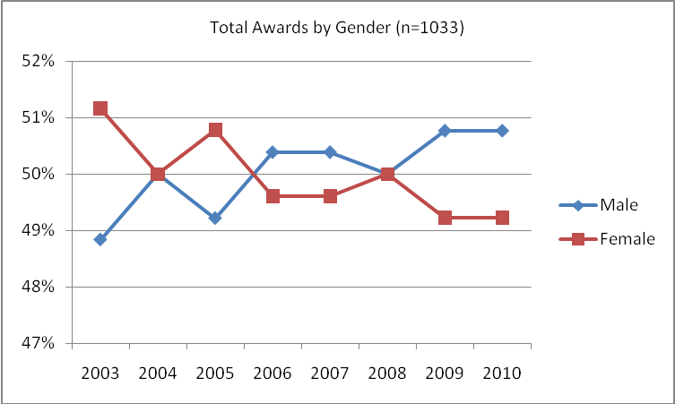

Only in one year (2003) was there more than a 2% difference between the numbers of men and women in the cohort. The picture is less equitable, however, when we disaggregate the data by categories of award, and by level of study (see Sections 3.9 and 3.10 below).

Award Category
During the first years of PATTAF (2003-2005), the Open/Private category represented a much higher proportion of ADS awards. This was partly due to high school leavers being eligible to apply for an award with no work experience, and the absence of quotas for categories of award. With the removal of this eligibility, and the 2005 decision to target 50:50 split between Public and Open/Private, the split of awards between categories changed dramatically. Figure 12 charts the relative share of each year’s total cohort in each category of award:
- Total Awards by Category
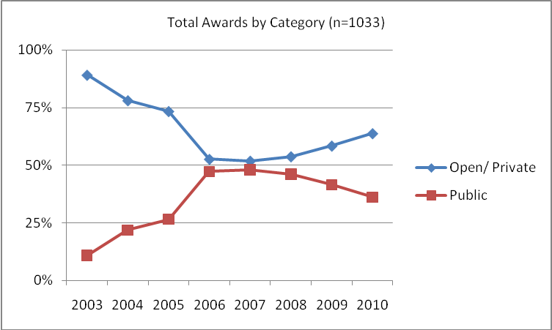

Only in the three years immediately after the policy change (i.e. 2006, 2007 and 2008) did the program achieve close to an equal split between Public and Open/Private awards. In 2010 the gap continued to widen. PATTAF has struggled to meet the target of 50% awards to the Public category, for a number of reasons, centred on the substantial differences in the pool of applications from which to make awards. The number of Public category applicants, particularly women, is always lower (see section 2.3). Reasons for this include the restriction on applying for study courses that were also offered in PNG, the low representation of women in many public sector organisations, and less than effective promotion and targeting at the provincial level.
- Total Awards by Category
 | 2003 |  | 2004 |  | 2005 |  | 2006 |  | 2007 |  | 2008 |  | 2009 |  | 2010 |  | Total
 | M | F | M | F | M | F | M | F | M | F | M | F | M | F | M | F | Total
Open | 53 | 62 | 46 | 54 | 44 | 50 | 23 | 45 | 25 | 42 | 28 | 42 | 31 | 45 | 45 | 38 | 673
Public | 10 | 4 | 18 | 10 | 19 | 15 | 42 | 19 | 40 | 22 | 37 | 23 | 35 | 19 | 21 | 26 | 360
 | 63 | 66 | 64 | 64 | 63 | 65 | 65 | 64 | 65 | 64 | 65 | 65 | 66 | 64 | 66 | 64 | 1033

Level of Study
In their applications for scholarship, applicants nominate their proposed level of study: Diploma (TAFE), undergraduate, postgraduate and PhD (doctoral) studies. The proportion of each cohort studying at these levels has varied over time, in accordance with quotas set by the JASC, the changing mix of applicants, and the shift to target a more even split between Public and Open categories. For example, the quota for postgraduate awards was increased in 2004, having an immediate impact on the number of awards at that level, as seen in Figure 13, and since 2008 the postgraduate quota has been 80 awards out of the total of 130 awards per annum.

Doctoral studies are offered only to applicants from tertiary and research institutes. Up to four awards are offered each year through a highly competitive selection process that incorporates assessment additional to other ADS applicants, including an interview and the involvement of an external assessor. The very high standard required to secure a PhD award means that in some years fewer than four have been given. More detailed annual data are provided in Annex 1.
- Awards by Level of Study
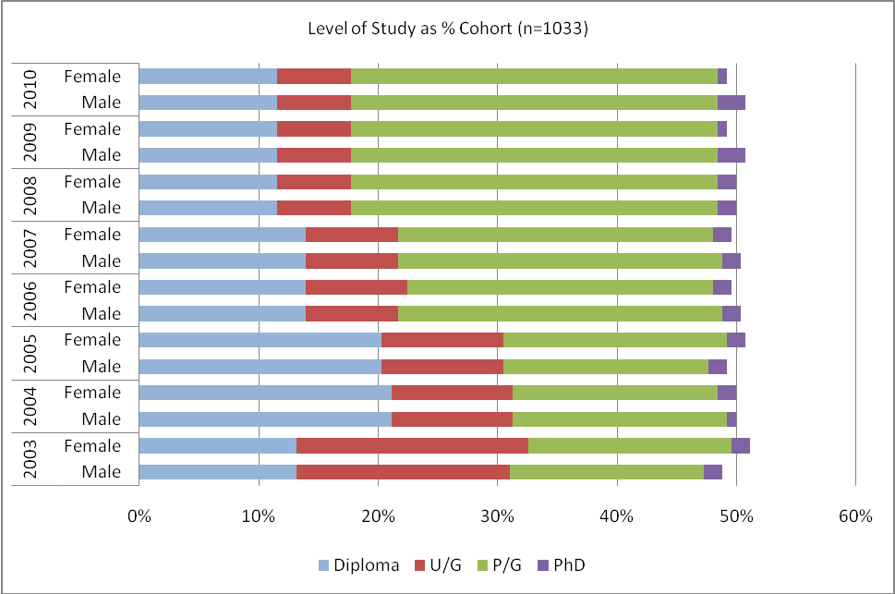

Sector of Study
Under the bi-lateral agreement between the Government of Australia (GoA) and the Government of Papua New Guinea (GoPNG) the ADS program considers the country strategies of both governments in making awards for study in different sectors. Selection for an ADS award is based significantly on the GoPNG Medium Term Development Strategy (MTDS) and the GoA Development Co-operation Strategy (DCS). The identified GoPNG Sectors are Corporate Services, Infrastructure, Health, Finance, Rural Development, Law & Justice and Education.

Corporate Services (including studies in human resources, information technology, marketing and management) have always dominated ADS awards, increasing dramatically to more than 50% of awards since 2008. Since 2007 Infrastructure has represented the next largest proportion of awards, followed by Health, Education, and Finance.
- Awards by Sector of Study
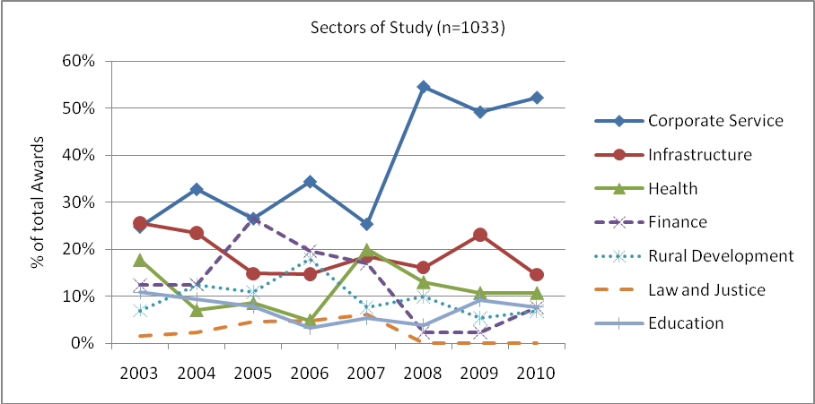

It is noted that the PATTAF TRS data uses slightly different categorisations of sector of study between applications data, and awards data (see section 2.6). This is a historical anomaly that will be important to address in M&E arrangements for the PNG Scholarships Program, so there can be effective monitoring of the link between applications in various sectors, and the success of those applications in securing awards (as a measure of quality of applications by sector).

Age of Scholars
The age of scholars has only been recorded in PATTAF data since 2007, limiting the extent of analysis possible compared to other variables. Over that time, the mean age of scholars has remained steady at 34.5 years old, slightly higher than the mean age of applicants, suggesting that older applicants are marginally more likely to be successful. This is also likely to a result of the shift away from diploma and undergraduate level studies. It is possible to see from Figure 15, however, that since 2007 scholars are most commonly aged 31-35. Next most commonly scholars are aged 26-30 or 36-40. Women tend to be proportionally a little older than men (see Figure 16).
- Awards by Age at Entry
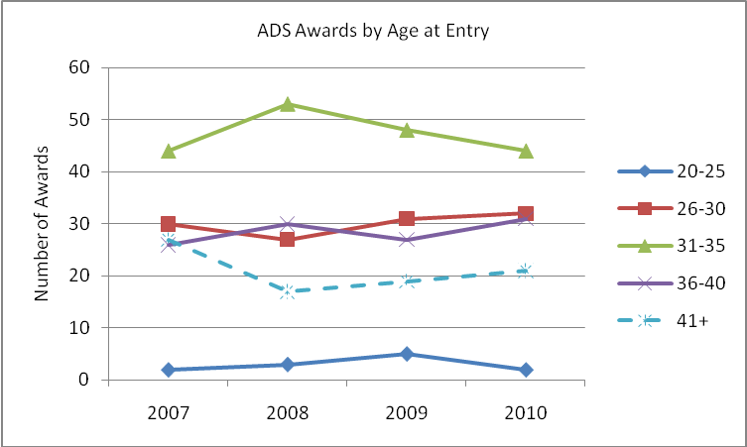
- Awards by Age at Entry and Gender
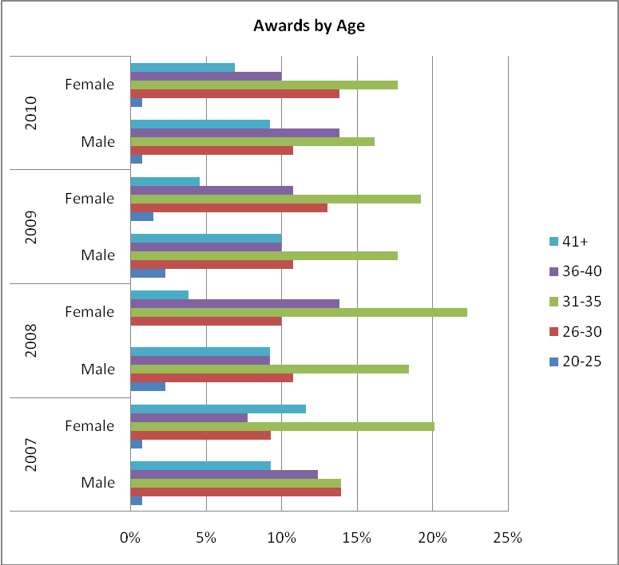
- Awards by Age at Entry
Category | 2007 |  | 2008 |  | 2009 |  | 2010
Category | Male | Female | Male | Female | Male | Female | Male | Female
20-25 | 1 | 1 | 3 | 0 | 3 | 2 | 1 | 1
26-30 | 18 | 12 | 14 | 13 | 14 | 17 | 14 | 18
31-35 | 18 | 26 | 24 | 29 | 23 | 25 | 21 | 23
36-40 | 16 | 10 | 12 | 18 | 13 | 14 | 18 | 13
41+ | 12 | 15 | 12 | 5 | 13 | 6 | 12 | 9
Totals | 65 | 64 | 65 | 65 | 66 | 64 | 66 | 64
Totals | 129 |  | 130 |  | 130 |  | 130

Family Profile
As noted, the removal of the accompanied stipend was a controversial decision, and it is important to assess the impact it may have had on different types of scholars. Awards are made in line with policy targets for gender, level of study and category, but the family profile of scholars is not considered. Therefore, examining family profile over time could shed some light on whether stipend changes have disadvantaged any groups of applicants on the basis of their family profile. Simple inspection of Figure 17 below shows that there has been no appreciable impact on the numbers of families comprising married couples with two or more children. In fact married couples with two or more children have continued to be the most common family profile amongst ADS scholars, for both men and women.

What is also evident in Figure 17 is that the numbers of single scholars has never been as high as it was in 2003 and 2004. Again, this is the result of the significant policy changes in 2005 and 2006 to remove eligibility for unemployed and school leavers and to increase awards to Public applicants.
- Family Profile
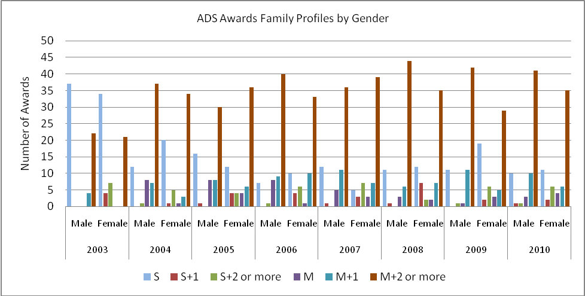

It should be noted that family profile data do not tell us whether the scholar went on to become an ‘accompanied’ or ‘non-accompanied’ scholar. Some scholars choose to leave their families and dependents in PNG, while others take them to Australia. Performance data in Section 4.5 examines this more closely, but this is another point at which differences in variable definition make it difficult to conduct analysis across the stages in the scholarships cycle.

Province of Residence
PATTAF records both province of residence and province of origin for each scholar, although province of residence is of greatest significance in analysing the geographic distribution of ADS awards. As expected, there is a very large proportion of awards given to residents of Port Moresby. Since 2003 the smallest proportion of awards going to Port Moresby was 58% (in 2004), and as many as 72% of awards went to Port Moresby residents in 2008.
- Awards by Province of Residence
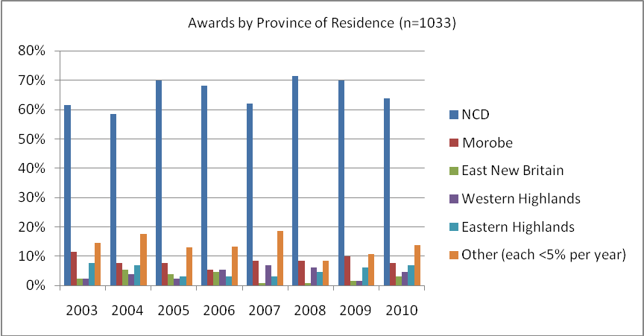

It would be unsurprising for Public awards to be concentrated amongst NCD residents, with Port Moresby as the centre of government in PNG. This is despite the fact that there are around 70,000 provincial public servants (who have never been successfully targeted for ADS by DPM, until recently). Therefore it is important to examine whether there is a difference in the geographic distribution of awards between Public and Open categories; there may be a greater representation of non-NCD residents amongst Open awards. However clearly from Figure 19 this is not the case:
- Awards by Category to National Capital District
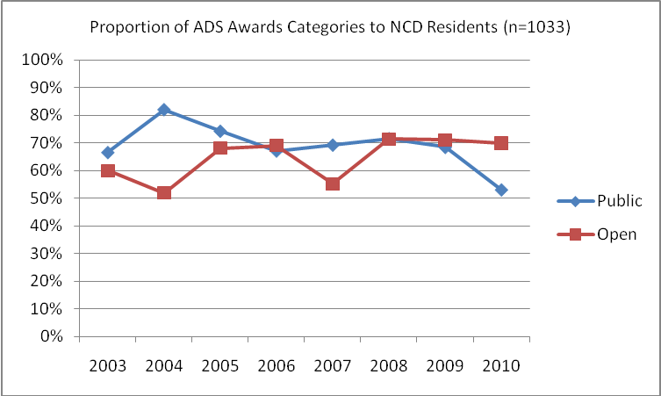

Both Public and Open categories of awards are concentrated in NCD, with never less than half of a category (e.g. Open awards in 2004) and sometimes more than 80% (e.g. Public awards in 2004) going to NCD residents. In fact 2004 was the year with the greatest divergence between categories; for most years they have been similar in their degree of concentration in NCD. In 2008 and 2009 both categories awarded around 70% of scholarships to NCD residents, although in 2010 Public awards were more evenly distributed around PNG, with only 53% going to NCD. This is a result of improved targeting by DPM who have responded well to Facility concerns about the lack of coordination in provincial targeting and promotion.

Gender Equity in Award Categories
As reported in Section 3.2, PATTAF has always achieved very close to gender equity in the allocation of ADS awards. It has also generally achieved close to equity between Public and Open categories of awards. However once data is disaggregated by both category and gender, the picture is less equal. Women outnumber men in Open awards; men outnumber women in Public awards, and this has been the case for every cohort 2003 – 2009.
- Public Awards by Gender
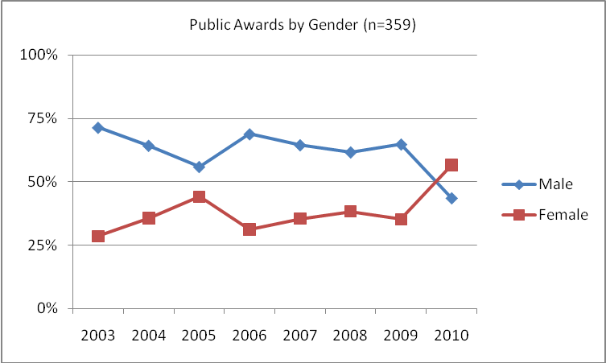

Public awards achieved more than 50% women for the first time in 2010, and conversely, Open awards were more than 50% men, also for the first time. In 2009 PATTAF worked closely with DPM on a promotional campaign to encourage women in the public sector to apply for ADS awards in the 2010 intake. It is reasonable to conclude that this effort contributed to the evident change, despite the fact that the number of Public women applicants actually fell – suggesting that those who did apply submitted higher quality applications. Additional year-by-year data is available in Annex 1.
- Open Awards by Gender
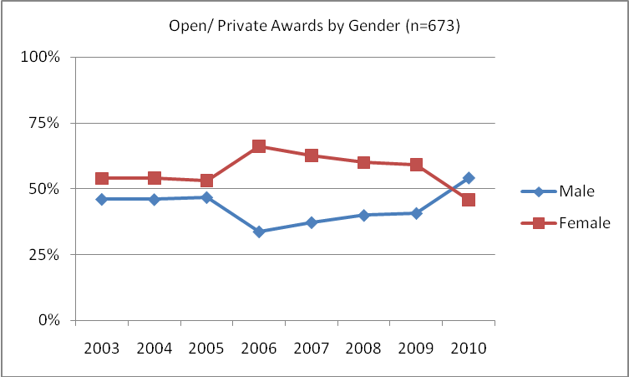

There are far fewer women in public sector employment than men. This inevitably reduces the pool of women applicants for Public awards, and increases the difficulty in achieving gender equity in Public awards. However there has obviously been scope for PATTAF to achieve overall gender equity in scholarships by disproportionately awarding Open scholarships to women to counteract the under-representation of women in Public awards (and in Public applications), thereby achieving the remarkable consistency in overall gender equity in PNG ADS.

Gender Equity in Level of Study
Disaggregating level of study data by gender shows that PATTAF has achieved good equity between men and women within each level of study. This has been achieved through deliberate effort and specific quotas targeting equal representation of men and women at each level. Additional detail and year-by-year data is available in Annex 1.
- Level of Study for Men and Women
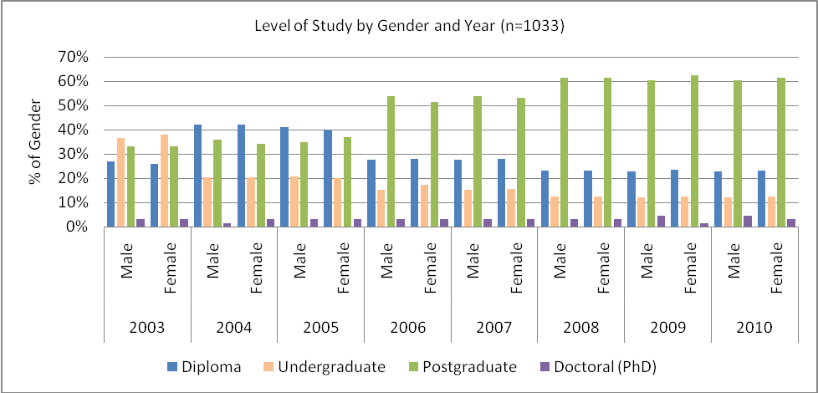

Sectors of Study for Men and Women
While gender equity has been achieved overall, and within levels of study, there are some sectors of study that have very different proportions of men and women scholars, as shown in Table 8:
- Sectors of Study by Gender
 | 2003 |  | 2004 |  | 2005 |  | 2006 |  | 2007 |  | 2008 |  | 2009 |  | 2010
 | M | F | M | F | M | F | M | F | M | F | M | F | M | F | M | F
Corporate Service | 18 | 14 | 21 | 21 | 19 | 15 | 19 | 21 | 16 | 17 | 37 | 34 | 30 | 34 | 34 | 34 | 384
Infrastructure | 18 | 15 | 19 | 11 | 14 | 5 | 13 | 3 | 17 | 7 | 11 | 10 | 19 | 11 | 13 | 6 | 192
Health | 6 | 17 | 4 | 5 | 2 | 9 | 4 | 7 | 7 | 19 | 6 | 11 | 6 | 8 | 3 | 11 | 125
Finance | 8 | 8 | 7 | 9 | 11 | 23 | 13 | 13 | 11 | 11 | 2 | 1 | 1 | 2 | 5 | 5 | 130
Rural Development | 9 | 0 | 7 | 9 | 9 | 5 | 12 | 7 | 8 | 2 | 8 | 5 | 6 | 1 | 7 | 2 | 97
Law and Justice | 0 | 2 | 1 | 2 | 5 | 1 | 3 | 2 | 4 | 4 | 0 | 0 | 0 | 0 | 0 | 0 | 24
Education | 4 | 10 | 5 | 7 | 3 | 7 | 1 | 11 | 3 | 4 | 1 | 4 | 4 | 8 | 4 | 6 | 82
TOTAL | 129 |  | 128 |  | 128 |  | 129 |  | 130 |  | 130 |  | 130 |  | 130

For example, in sectors that have a strong traditional gender bias, such as health (for women) and infrastructure (for men), there is a corresponding variance in the numbers of men and women enrolling for studies in those sectors, as shown in Figure 23 and Figure 24.

Figure 22. Health Awards by Gender Figure 23. Infrastructure Awards by Gender
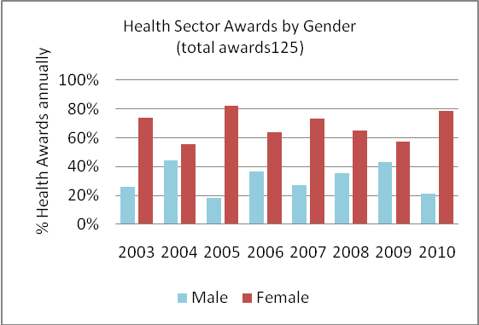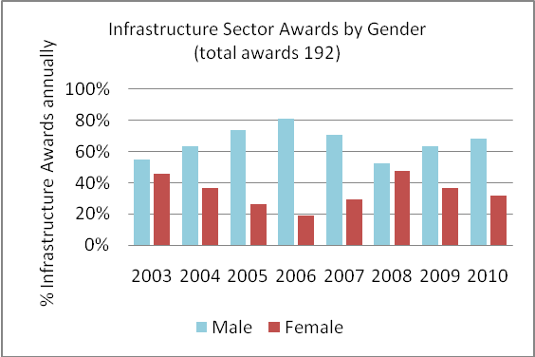

By comparison, numbers of men and women studying in Corporate Service are quite even, never differing more than 46% men and 44% women (in 2005).

Conclusions regarding Awards
As noted, the composition of each cohort of awards is largely with the control of JASC , as long as a sufficient pool of applications is received to fill the various category, gender and study level quotas. Awards data suggests that this has generally been possible, with good equity between men and women overall, and between categories and levels of study. In some cases, however, it has been necessary to put extra effort into supporting and encouraging the necessary level of applications, especially from women in the public sector. This has been a reasonable response to the limited number of women applicants in the Public category, in order to still achieve overall equity. Achieving equity within levels of study is also an important marker of gender equity within the ADS program.

The change in the ages and family profiles of scholars changed after the major policy changes in 2005 and 2006, in a similar patter to the change in applications. There are more scholars who are married with two or more children, even since the removal of the accompanied stipend – although whether that change affected performance will be examined in Section 4.

Two areas of gender difference are evident. There is a differential representation of men and women within the Public and Open categories of awards, and within individual sectors of study there are some differences between the representation of men and women. The extent to which this should be considered gender inequity when there is good equity overall, and at levels of study, is a matter for program judgement now and into the future with the PNG Scholarships Program.

Australian Development Scholarships Performance
Analysing the performance of scholars while on award is an essential part of monitoring ADS performance. In this section, the report endeavours to explore these and other questions:
- What characteristics of scholar tend to have better completion or lower failure rates?
- Did anything change in completion rates after 2006 change in levels of study (i.e. the increase in postgraduate studies)?
- Did anything change in completion rates or performance after the removal of the accompanied stipend?

ADS scholars experience one of three broad outcomes: they either graduate, graduate at a lower level than originally enrolled, or fail to complete their studies. Within these three broad outcomes there are additional variations. For example, failure to complete can by due to academic failure, or withdrawal by the scholar for any number of reasons both personal and professional.

For the purposes of this report, success (completion) is generally defined as graduation at any level – i.e. whether at the level of the original enrolment, or at a lower level of qualification. Success is examined in more detail regarding graduation at or below level in section 4.9. Failure is considered to be non-completion of the course, whether through academic failure or other reasons.

This section of the report generally excludes the 2010 cohort, as most have only just commenced their studies in Australia. As such, inclusion of their data in performance analysis would be distortionary. The total population is, therefore, only 903 for this section unless otherwise reported. In fact in selected sections below, the 2009 cohort is also excluded where it adds meaning to the analysis or presentation of data.

It is important to note that analysis of failure and completion rates has an additional time lag that case appear to bias the data. More recent cohorts, particularly from 2007 onwards, have increasingly large proportions of ongoing scholars, making the analysis of proportional performance less and less meaningful. For this reason, the following analysis includes somewhat less disaggregation than other sections in order to ensure some meaningful conclusions can still be drawn, and where relevant, the proportion of ongoing scholars is reported. Frequency data is, however, still disaggregated to the greatest extent possible.

It has been widely acknowledged, most recently in the PATTAF Independent Completion Report (September 2009), that PNG scholars have an unusually high rate of failure (low rate of successful completion) compared to scholars from all other ADS countries.

Table 9 provides the overall set of data on student achievement for each cohort of men and women ADS scholars.

- Student Achievement by Year, Level of Study and Gender
 |  | Selected |  | Success |  | Success at Lower Level |  | Failure |  | Ongoing |  | M/F Total
Level of Study | Cohort | M | F | M | F | M | F | M | F | M | F | M | F
PhD | 2003 | 2 | 2 | 1 | 2 |  |  | 1 |  |  |  | 2 | 2
PhD | 2004 | 1 | 2 | 1 | 1 |  |  |  | 1 |  |  | 1 | 2
PhD | 2005 | 2 | 2 | 1 | 1 |  |  | 1 |  |  |  | 2 | 2
PhD | 2006 | 2 | 2 |  |  |  |  |  |  | 2 | 2 | 2 | 2
PhD | 2007 | 2 | 2 |  |  |  |  |  |  | 2 | 2 | 2 | 2
PhD | 2008 | 2 | 2 | 0 | 0 |  |  |  |  | 2 | 2 | 2 | 2
PhD | 2009 | 3 | 1 | 0 | 0 |  |  |  |  | 3 | 1 | 3 | 1
PhD | Sub Total | 14 | 13 | 3 | 4 | 0 | 0 | 2 | 1 | 9 | 7 | 14 | 13
Masters | 2003 | 21 | 22 | 16 | 18 | 4 | 2 | 1 | 2 |  |  | 21 | 22
Masters | 2004 | 23 | 22 | 21 | 22 | 1 |  | 1 |  |  |  | 23 | 22
Masters | 2005 | 22 | 24 | 18 | 23 | 2 | 1 | 2 |  |  |  | 22 | 24
Masters | 2006 | 35 | 33 | 30 | 29 | 1 | 3 | 4 |  | 0 |  | 35 | 33
Masters | 2007 | 35 | 34 | 30 | 26 | 3 | 3 | 2 | 2 |  | 1 | 35 | 34
Masters | 2008 | 40 | 40 | 31 | 30 |  | 1 | 1 |  | 4 | 4 | 40 | 40
Masters | 2009 | 40 | 40 | 8 | 2 |  |  | 1 |  | 31 | 38 | 40 | 40
Masters | Sub Total | 216 | 215 | 154 | 150 | 11 | 10 | 12 | 4 | 35 | 43 | 216 | 215
Undergraduate | 2003 | 23 | 25 | 12 | 19 | 1 |  | 10 | 6 |  |  | 23 | 25
Undergraduate | 2004 | 13 | 13 | 7 | 10 | 1 | 2 | 5 | 1 |  |  | 13 | 13
Undergraduate | 2005 | 13 | 13 | 9 | 11 | 1 | 1 | 3 | 1 |  |  | 13 | 13
Undergraduate | 2006 | 10 | 11 | 7 | 11 |  |  | 3 |  |  |  | 10 | 11
Undergraduate | 2007 | 10 | 10 | 8 | 7 |  |  | 1 | 2 | 1 | 1 | 10 | 10
Undergraduate | 2008 | 8 | 8 | 2 | 2 |  |  | 1 | 1 | 5 | 5 | 8 | 8
Undergraduate | 2009 | 8 | 8 | 0 | 0 |  |  |  | 1 | 8 | 7 | 8 | 8
Undergraduate | Sub Total | 85 | 88 | 45 | 60 | 3 | 3 | 23 | 12 | 14 | 24 | 85 | 88

 |  | Selected |  | Success |  | Success at Lower Level |  | Failure |  | Ongoing |  | M/F Total
Level of Study | Cohort | M | F | M | F | M | F | M | F | M | F | M | F
TAFE | 2003 | 17 | 17 | 7 | 14 | 4 | 2 | 6 | 3 |  |  | 17 | 17
TAFE | 2004 | 27 | 27 | 15 | 25 | 5 | 1 | 7 | 1 |  |  | 27 | 27
TAFE | 2005 | 26 | 26 | 21 | 21 | 2 | 2 | 3 | 3 |  |  | 26 | 26
TAFE | 2006 | 18 | 18 | 14 | 15 | 1 | 1 | 3 | 2 |  |  | 18 | 18
TAFE | 2007 | 18 | 18 | 15 | 15 | 1 |  | 1 | 2 | 1 | 1 | 18 | 18
TAFE | 2008 | 15 | 15 | 14 | 15 | 1 |  |  |  |  | 3 | 15 | 15
TAFE | 2009 | 15 | 15 |  |  |  |  |  |  | 15 | 15 | 15 | 15
TAFE | Sub Total | 136 | 136 | 86 | 100 | 14 | 6 | 20 | 11 | 16 | 19 | 136 | 136
Total M / F |  | 451 | 452 | 288 | 315 | 24 | 16 | 57 | 28 | 74 | 82 | 451 | 452
Total Combined |  | 903 |  | 603 |  | 40 |  | 85 |  | 156 |  | 903

Completion and Failure Rates
As reported in the Independent Completion Report and elsewhere, PNG ADS scholars have the highest rate of failure (non-completion) of any ADS scholars in the world. The analysis below examines failure rates as a proportion of completed awards (i.e. excluding ongoing scholars).
- Failure and Completion Rates
 | 2003 | 2004 | 2005 | 2006 | 2007 | 2008 | 2009
Ongoing | 0 | 0 | 1 | 17 | 34 | 51 | 118
Success | 102 | 112 | 114 | 104 | 86 | 76 | 10
Failed | 29 | 16 | 13 | 12 | 10 | 3 | 2
Failure as a % Total Completed Awards | 22% | 13% | 10% | 10% | 10% | 4% | 17%

Excluding 2008 and 2009 cohorts because of their high proportion of ongoing scholars, it is clear in Figure 25 that, after a dramatic drop in 2004, and a further decline in 2005, failure rates have remained steady at 10%.
- Failure Rates
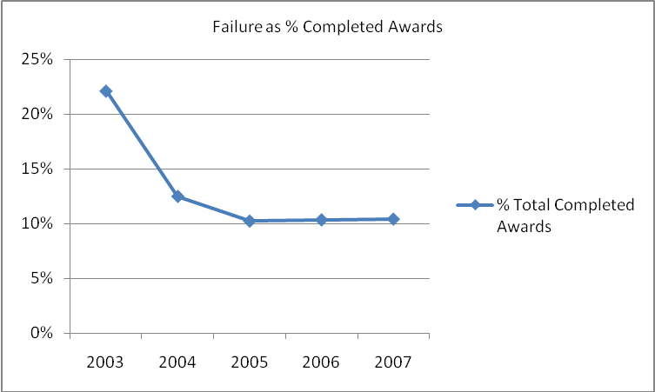

Failure by Gender
Men have failed to complete their awards, for whatever reason, at more than double the overall rate than women: 13% of male scholars over 2003-2009 failed, compared to 6% of female scholars. This represents the most substantial difference between men and women of any variable in the ADS data (noting that it includes the high failure rates amongst the 2003 and 2004 cohorts).
- Total Failure Rate by Gender
 | Total 2003-09 | Failed | % Gender
Male | 451 | 57 | 13%
Female | 452 | 28 | 6%

As shown in Figure 26 below, year by year men have generally tended to have higher failure rates than women, when shown as a proportion of men or women who have completed their studies. There has, however, been a trend of reducing failure rates for men, particularly since 2006, down to 5% of men in the 2008 cohort. Women have consistently failed less often than men, with the exception of the 2007 cohort. However their failure rates are not trending down as men’s are, and were higher than men’s for the first time in 2008 amongst those who have completed their awards.
- Failure by Gender
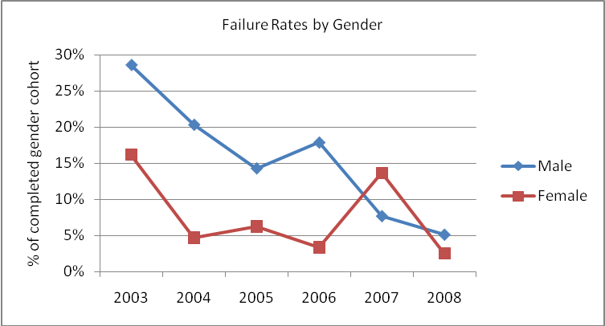

The corollary of this is of course that women have generally had somewhat higher rates of success, although the extent to which men and women have succeeded at the level of enrolment, or at a lower level, will be examined further below.

Failure by Category
Overall, 9% of Open category scholars (60 out of 673), and 7% of Public category scholars (25 out of 360) failed to complete their awards and graduate with a qualification.
- Failure by Category
 | 2003 |  | 2004 |  | 2005 |  | 2006 |  | 2007 |  | 2008 |  | 2009 |  | TOTAL | Total | % Category
 | M | F | M | F | M | F | M | F | M | F | M | F | M | F | TOTAL | Total | % Category
Open | 10 | 9 | 10 | 2 | 7 | 1 | 4 | 5 | 1 | 4 | 4 | 2 | 0 | 1 | 60 | 673 | 9%
Public | 4 | 1 | 2 | 2 | 0 | 1 | 3 | 1 | 5 | 0 | 5 | 0 | 1 | 0 | 25 | 360 | 7%
TOTAL | 24 |  | 16 |  | 9 |  | 13 |  | 10 |  | 11 |  | 2 |  | 85

Within both categories of award, men are more likely to have failed than women overall, as shown in Figure 27 below.
- Total Failure Rates by Gender and Category
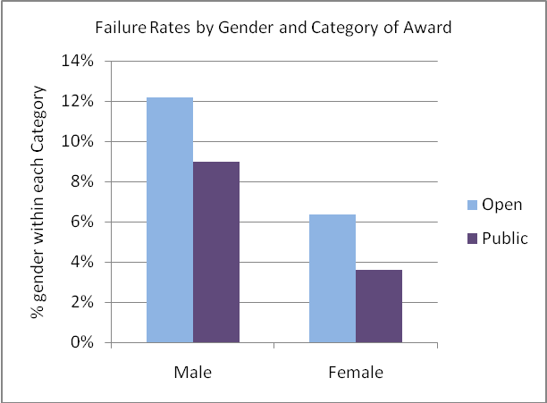

Clearly, after the changes in the mix of awards after 2005, excluding school leavers and unemployed applicants and increasing Public awards, there was a dramatic drop in failure rates. Scholars were older, and more likely to be employed. Beyond this it is difficult to identify other strong trends in failure rates, particularly because recent cohorts (2007 onwards) contain increasing numbers of ongoing scholars.
- Annual Number of Failures by Category
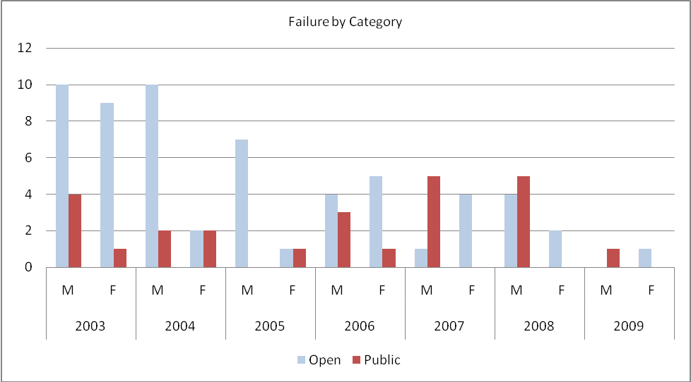

Failure by Level of Study
Over the life of PATTAF, undergraduate scholars have been most likely to fail; 19% of undergraduate awards over 2003-2009 have resulted in failure. Diploma level scholars have performed better (10% total failure rate) as have doctoral scholars (9%). There is a strikingly better overall success rate for postgraduate scholars however: only 3% of the 511 awards at this level resulted in failure, meaning that 97% of postgraduate scholars successfully graduate at either Masters level or at a lower level (see section 4.10 below).
- Failure Rate by Level of Award 2003-2009
 |  | total | %
Diploma | 31 | 302 | 10%
Undergraduate | 36 | 189 | 19%
Postgraduate | 16 | 511 | 3%
PhD | 3 | 32 | 9%

There is also a significant variation between the failure rates of men and women within each level of study. Because we know (from section 3.2) that there have been relatively even numbers of men and women awarded scholarships at each level of study, it is meaningful to examine the differences in the numbers of men and women failing at each level. Table 14 shows that male failure rates a notably higher than female at every level of award.
- Failure by Level and Gender 2003-2009
 | M | F
Diploma | 20 | 11
Undergraduate | 23 | 13
Postgraduate | 12 | 4
PhD | 2 | 1

Failure by Sector of Study
Table 15 below shows the rates of failure by men and women scholars studying in each sector of study. Clearly many more students in Corporate Service have failed – both women and men – compared to Law and Justice, but as reported in section xxx above, many more awards have been given in Corporate Service, so the comparison of absolute frequencies are not valid as a basis to compare performance.
- Failure by Sector of Study and Gender
 | 2003 |  | 2004 |  | 2005 |  | 2006 |  | 2007 |  | 2008 |  | 2009 |  | TOTAL
 | M | F | M | F | M | F | M | F | M | F | M | F | M | F | TOTAL
Corporate Service | 5 | 3 | 6 | 1 | 1 |  | 2 | 2 | 1 | 1 | 3 |  | 1 |  | 26
Education |  | 2 | 1 |  | 1 |  |  | 1 |  |  | 2 |  |  |  | 7
Finance | 5 | 1 | 2 | 1 | 1 | 1 | 3 |  | 2 |  | 1 | 1 |  |  | 18
Health |  | 1 |  |  |  |  |  |  | 1 |  |  |  |  |  | 2
Infrastructure | 2 | 3 | 2 |  | 2 | 1 | 1 | 1 |  | 1 | 1 |  |  |  | 14
Law and Justice |  |  |  |  |  |  | 1 | 1 | 1 | 1 | 1 | 1 |  | 1 | 7
Rural Development | 1 |  |  | 2 | 1 |  |  |  |  | 1 |  |  |  |  | 5
Social and Human Development | 1 |  | 1 |  | 1 |  |  | 1 | 1 |  | 1 |  |  |  | 6
TOTAL | 24 |  | 16 |  | 9 |  | 13 |  | 10 |  | 11 |  | 2 |  | 85

However it is not possible to compare failure rates within each sector of study, of within the cohorts of men and women in each sector, because AusAID and PATTAF databases categorise data by slightly different sector titles (as noted earlier in this report). Therefore it is not possible to undertake calculations across stages in the scholarships cycle for some variables (e.g. between awards data and performance data). Thus it is not possible to ascertain whether one sector of study is more likely to result in success (or failure) than another, nor whether men or women scholars in various sectors have differing rates of success or failure. Ensuring that level of analysis is possible in future is something to consider in the development of M&E arrangements for the new PNG Scholarships Program.

Failure by Family Status
As noted earlier in this report, a critical change in policy was the 2006 removal of the accompanied stipend for scholars who take dependent family members with them to Australia on award. While it is not evident that this change had a dramatic impact on either total numbers of women applying for ADS (see section 2.2), nor on the family composition of successful applicants (see section 3.7), it is also important to investigate whether this policy change made it more difficult for accompanied scholars to successfully complete their studies.

The data suggests that there has not been an appreciable negative impact on the success rates of accompanied scholars. In fact, as shown in Figure 29 below, accompanied scholars tend to have slightly higher rates of success than non-accompanied scholars. There could be any number of explanations for this, which we cannot determine from these data: accompanied scholars may be more emotionally supported; have fewer concerns about being absent from family responsibilities and connections; or may feel a greater sense of responsibility to succeed with their family witnessing their life in Australia. These factors may all outweigh the additional stress and financial strain that has been reported in the Independent Completion Report and elsewhere as resulting from the removal of the additional stipend support.
- Success and Failure by Family Status
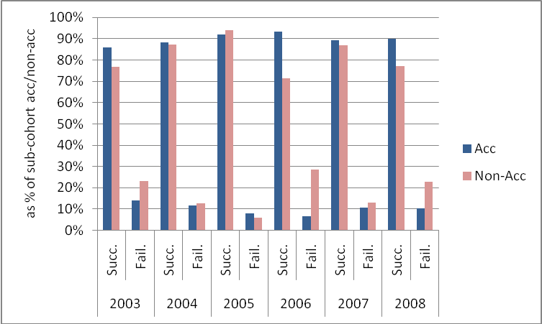
- Success and Failure by Family Status
 | 2003 |  | 2004 |  | 2005 |  | 2006 |  | 2007 |  | 2008 |  | 2009
 | Succ. | Fail. | Succ. | Fail. | Succ. | Fail. | Succ. | Fail. | Succ. | Fail. | Succ. | Fail. | Succ. | Fail.
Acc | 86% | 14% | 88% | 12% | 92% | 8% | 93% | 7% | 89% | 11% | 90% | 10% | 78% | 22%
Non-Acc | 77% | 23% | 87% | 13% | 94% | 6% | 71% | 29% | 87% | 13% | 77% | 23% | 100% | 0%

Failure by Age of Scholar
Over time there has not been a substantial difference between the numbers of scholars of different age groups who fail their studies. Figure 30 below makes this clear, with the exception of 2003, when, as reported in section 3.6 above, there was an especially high number of young scholars – and also an especially high number of failures.
- Failure by Age
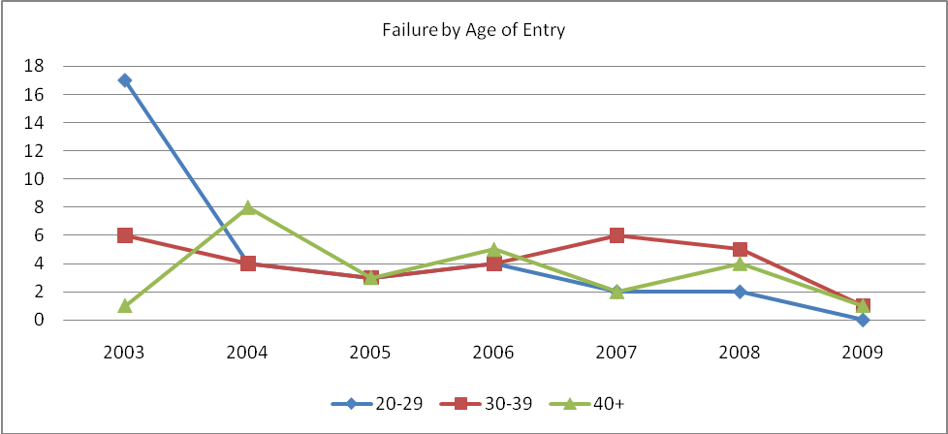
- Failure by Age
 | 2003 | 2004 | 2005 | 2006 | 2007 | 2008 | 2009 | TOTAL
20-29 | 17 | 4 | 3 | 4 | 2 | 2 | 0 | 32
30-39 | 6 | 4 | 3 | 4 | 6 | 5 | 1 | 29
40+ | 1 | 8 | 3 | 5 | 2 | 4 | 1 | 24
TOTAL | 24 | 16 | 9 | 13 | 10 | 11 | 2 | 85

It would be more meaningful to examine failure rates within each age group over time, particularly as previous assessments have suggested that younger scholars are more likely to struggle to successfully complete their awards. However because of differences in age categories between the various databases held by PATTAF and AusAID, it has not been possible to undertake this analysis. Again this is a matter to resolve in the structure of the new M&E system for the PNG Scholarships Program.

Failure by Institution
Scholars under ADS awards at all levels and from both categories have studied at a large number of academic institutions in Australia. As a result, the numbers of scholars at each institution is too small, and the variety of programs of study at each institution too large, to meaningfully assess failure rates between institutions.

Completion at a Lower Level
As noted above, some scholars find that for academic reasons they are only able to complete their studies at an academic level below that of their original enrolment. A small number of scholars withdraw early for other reasons, also graduating with a lower level qualification than originally sought. For example, a Masters scholar might graduate with a Postgraduate Diploma, or a Diploma-enrolled scholar with a Certificate qualification. While this is still considered success, it is useful to examine the extent to which PNG scholars have been graduating at a lower level. In the data below, scholars are shown according to the level of their original enrolment.
- Completion at a Lower Level
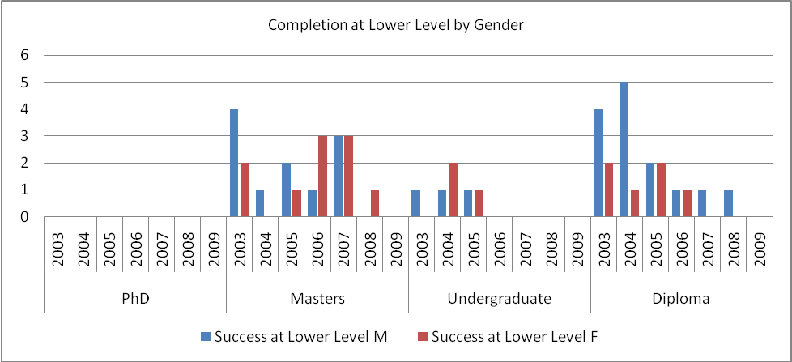

Total Variations
Variations in ADS awards are many and varied and can range from a simple administrative correction (which is nevertheless recorded as a variation) to the early termination of an award. Clarification of variation terminology is therefore important:
- A variation for Termination arises when a student is deemed incapable of completing the study program due to academic failure, medical or personal issues. A student whose scholarship is terminated is required to return to their home country as soon as practicable.
- A variation for Extension lengthens the duration of the award. The primary reason is academic failure in one or more subjects that have to be repeated. Other minor causes include changes in course design, program suspension due to medical or personal issues.
- A variation for Suspension is defined by AusAID as “the temporary cessation of a student’s study program and financial support from AusAID, normally due to illness, pregnancy or family emergency. The student returns home for the period of the suspension and is responsible for meeting his/her own travel cost.
- A variation for Transfer occurs when a student changes from one course to another at the same institution; when a student changes from one institution to another institution, or when a student changes from a course at a certain level to a course at a lower level (i.e. downgrades). A transfer is usually the result of academic failure or change of course structure by the institution. In some cases the student transfers to another course when they find that the subject matter of one program is not what they expected or wished to undertake.
- A variation for Reduction is a result of students completing earlier than originally forecast and returning to PNG. A possible reason for the reduction of student’s award is downgrading to lower course resulting in early completion. For instance, if a student is enrolled into a three year degree program and as a result of non success after the first year is downgraded to a Diploma, they would finish earlier. Additionally, recognition of student’s credits points from previous courses may contribute to this type of variation. Students may also complete their studies earlier due to high performance result.

AusAID cross-country comparisons have recently found that PNG has the highest number of variations amongst ADS countries.
- Total Variations
 | 2003 | 2004 | 2005 | 2006 | 2007 | 2008 | 2009 | 2010 | total
Terminations | 28 | 16 | 14 | 13 | 9 | 10 | 12 | 0 | 102
Extensions | 35 | 25 | 57 | 29 | 62 | 33 | 38 | 5 | 284
Suspensions | 9 | 10 | 4 | 2 | 8 | 7 | 6 | 2 | 48
Transfers | 8 | 12 | 21 | 14 | 18 | 12 | 16 | 0 | 101
Reduction | 9 | 9 | 3 | 6 | 2 | 7 | 3 | 1 | 40
Course Detail Change | 0 | 0 | 2 | 4 | 0 | 35 | 23 | 24 | 88
Supplementary Support | 0 | 0 | 0 | 0 | 0 | 0 | 14 | 0 | 14
Total Variations | 89 | 72 | 101 | 68 | 99 | 104 | 112 | 32 | 677

Figure 32 below shows a reducing number of variations as a proportion of total awards over the period of PATTAF. While this does show a trend of gradual reduction in variations, it is important to note that recent cohorts include increasing numbers of ongoing scholars, so the number of variations for recent cohorts may be expected to increase as each cohort concludes. It will be important that Scholarships PNG continues to monitor this closely.
- Total Variations
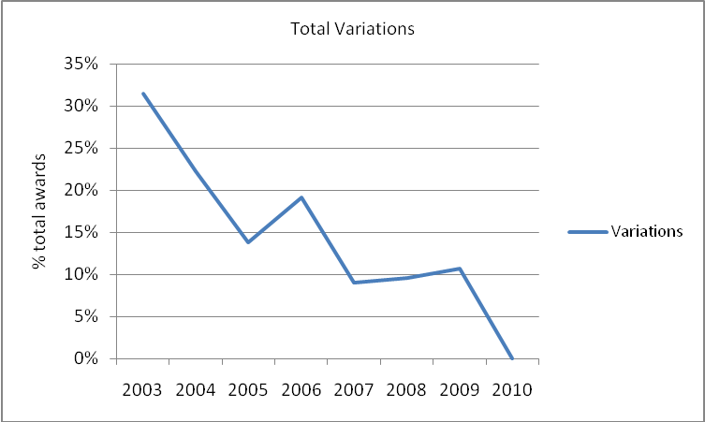

Total Variations by Gender
In most cohorts, women have required slightly more variations than men. However total variation numbers for men and women have followed a very similar trend up and down over the life of PATTAF. There is, therefore, no real difference between women and men regarding total variations.
- Total Variations by Gender
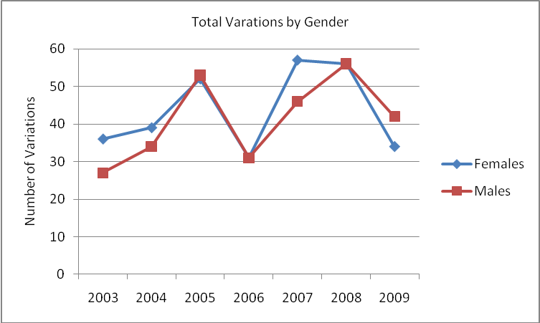

Termination Variations
An ADS award is terminated when a scholar is deemed incapable of completing the study program due to academic failure, medical or other concerns such as breach of conditions. Terminations could be considered the most serious of variations, resulting in the non-completion of the scholarship award. Overall the numbers of terminations are small, limiting the extent of possible analysis. Overall there have been 31 terminations over the period 2003-2009, the majority (74%) for academic failure (see Table 19 below). There is no clear trend or pattern in the data, although it is notable that the 2004, 2006 and 2007 cohorts had no terminations.
- Terminations (with Reasons) by Gender
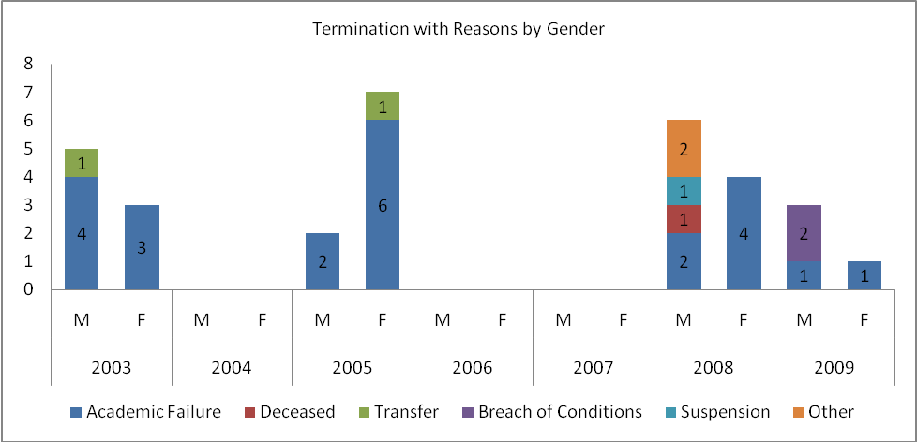
- Termination Variations
 | 2003 |  | 2004 |  | 2005 |  | 2006 |  | 2007 |  | 2008 |  | 2009 |  | Total | % Total
 | M | F | M | F | M | F | M | F | M | F | M | F | M | F | Total | % Total
Academic Failure | 4 | 3 |  |  | 2 | 6 |  |  |  |  | 2 | 4 | 1 | 1 | 23 | 74%
Deceased |  |  |  |  |  |  |  |  |  |  | 1 |  |  |  | 1 | 3%
Transfer | 1 |  |  |  |  | 1 |  |  |  |  |  |  |  |  | 2 | 6%
Breach of Conditions |  |  |  |  |  |  |  |  |  |  |  |  | 2 |  | 2 | 6%
Suspension |  |  |  |  |  |  |  |  |  |  | 1 |  |  |  | 1 | 3%
Other |  |  |  |  |  |  |  |  |  |  | 2 |  |  |  | 2 | 6%
Total | 8 |  | 0 |  | 9 |  | 0 |  | 0 |  | 10 |  | 4 |  | 31 | 100%

Termination Variations by Gender
Men and women have had their awards terminated in almost equal numbers overall: 16 men and 15 women over the period 2003-2009. There have been substantial differences between men and women terminated from each cohort, as shown in Figure 33, and in the most recent cohorts (2008 and 2009) there have been proportionally more men terminated than women. This will be an important variable to monitor through the life of the PNG Scholarships Program to ensure this is not the start of a continuing trend of gender difference in terminations.
- Terminations by Year and Gender
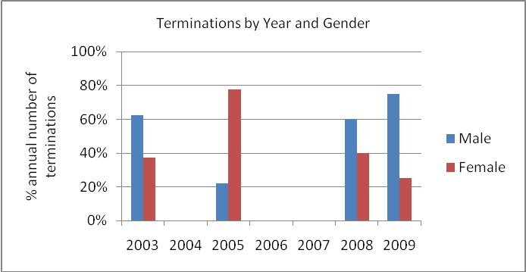

Termination Variations by Category
The current structure of databases does not allow analysis of terminations by category of award, so it is not possible to ascertain whether there is a difference in termination rates between Public and Open category scholars. Scholarships PNG should ensure that this analysis is possible in future.

Termination Variations by Level
There are some substantial differences in the rates at which scholars studying at the various levels experience terminations of award. Undergraduate scholars have, overall, had a much higher rate of termination (9% of total undergraduate awards) than other scholars; while only two postgraduate scholars out of 511 have had their award terminated – effectively a 0% termination rate. This is primarily due to students who were at risk completing at a lower level of post-graduate award thus avoiding the need for termination or costly extension.
- Terminations by Level
 | Terminations | Total Awards | % Awards at Level
Diploma | 11 | 302 | 4%
Undergraduate | 17 | 189 | 9%
Postgraduate | 2 | 511 | 0%
PhD | 1 | 32 | 3%

Both men and women follow similar patterns in their (small numbers of) terminations, as seen in Table 21 below. For both women and men, it is those studying at undergraduate level who have most commonly had their awards terminated, while no postgraduate women scholars have had their awards terminated.
- Terminations by Gender and Level
 | Male Terminations | % Male Awards | Female Terminations | % Female Awards
Diploma | 5 | 3% | 6 | 4%
Undergraduate | 7 | 8% | 10 | 10%
Postgraduate | 2 | 1% | 0 | 0%
PhD | 0 | 0% | 1 | 7%
- Terminations by Level of Study and Gender
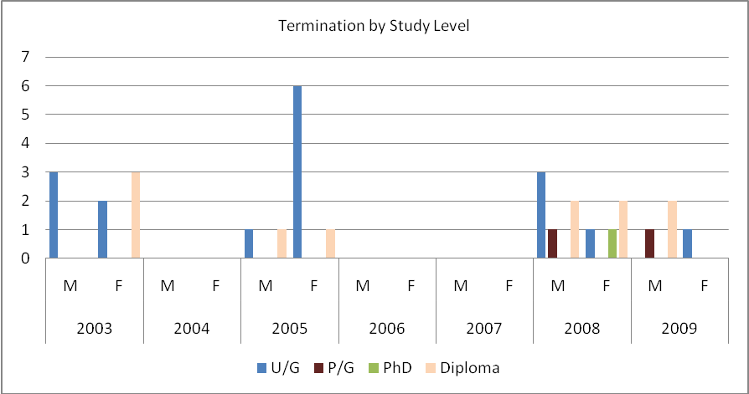

Extension Variations
Of all the variations described above, extension variations are the most significant and warrant the greatest attention. Extensions are sought (and often granted) for a range of reasons. Most commonly they are required to address academic reasons: to allow a scholar to repeat or undertake additional subjects in order to meet course completion requirements.. Extensions are also sometimes required to accommodate changes in course details, to correct enrolment errors, to accommodate delays in research programs (due to supervisor changes, or lost or stolen data); or to address administrative or visa requirements.

Over the period 2003-2010 there have been 284 extensions granted to ADS scholars from PNG. As Figure 37 shows, there has been little consistency in the number of extensions provided to each cohort of scholars, with the 2010 at a low level of extensions because they have only just commenced their awards.
- Extension Variations
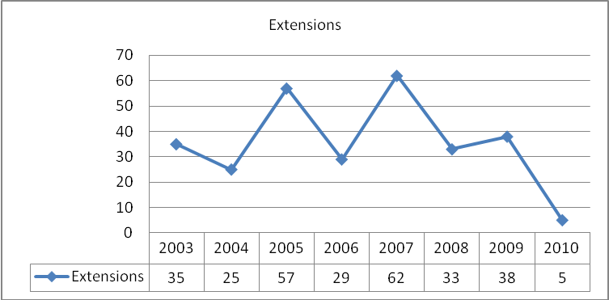

ADS Guidelines now allow for only one semester of extension for each scholar during their award, a substantial reduction from the previous allowance of up to three semesters. It will be important to monitor the impact of this policy change on performance and completion rates during the PNG Scholarships Program. It may be that this stricter limit on extensions will result in an increase in failure rates, and/or an increase in graduations at a lower level. There is emerging evidence that this stricter policy and reduced tolerance of poor performance is already having an impact on the number of extensions: in 2009 there were 22 extensions granted; the lowest of any cohort.

Scholarship extensions have serious implications for scholars’ employers too. They are required to do without their staff for an even longer period than the already-substantial absence on scholarship, and in many cases in the public sector they are also required to accommodation the additional cost of paying salary to the scholar for the extended period. So not only are cost implications for AusAID a concern, but also for the scholar’s employer in PNG. Cost implications are discussed in more detail in section 4.19.

Extensions by Gender
Men have historically represented proportionally more of the extensions compared to women, 54% (a total of 154) compared to 46% (a total of 134) of total extensions over the list of PATTAF. However 2009 and 2010 has seen this trend reverse. In the last two cohorts women have represented almost 60% of extensions granted. This change aligns with the change in stipend policy, which could suggest that while the numbers of women applicants have not been affected, and there is still gender equity in awards, and women are still successfully completing their studies at the same rate, there may be an emerging trend of women needing more time to complete their studies. This may be as a result of the increasing financial pressures on them as a result of the stipend change, assuming that more women than men are accompanied by their dependent families. Again it will be important to monitor this closely in the PNG Scholarships Program.
- Extensions by Gender
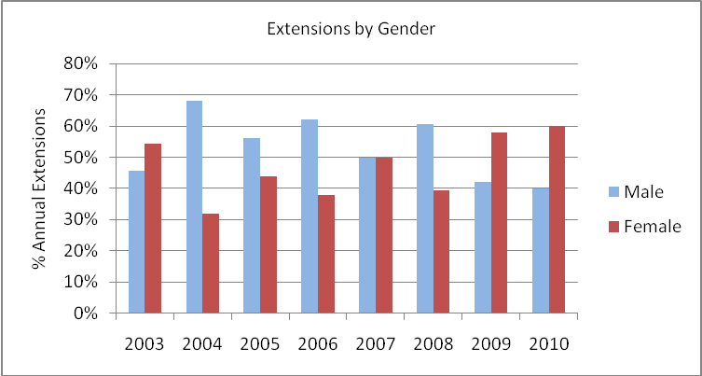
- Extensions by Gender
 | 2003 |  | 2004 |  | 2005 |  | 2006 |  | 2007 |  | 2008 |  | 2009 |  | 2010 |  | Total
 | M | F | M | F | M | F | M | F | M | F | M | F | M | F | M | F | Total
Extensions | 16 | 19 | 17 | 8 | 32 | 25 | 18 | 11 | 31 | 31 | 20 | 13 | 16 | 22 | 2 | 3 | 284

Extension Variations of One Semester or More
As noted in section 4.16, it is now standard practice to limit extensions to one semester only. Figure 39 shows the frequency of extension of one or more semester; in future it is to e expected that one semester extensions will be the maximum extension granted, except perhaps in highly exceptional circumstances. Evidently there is not a substantial difference between men and women generally, although men far outnumbered women in this category in 2005, and in the 2009 cohort women outnumbered men quite significantly (almost twice as many). As with some other variables highlighted above, it will be important that Scholarships PNG monitors this to ascertain whether this is the start of a trend of women requiring more extension support than men.
- Extensions of One Semester or More
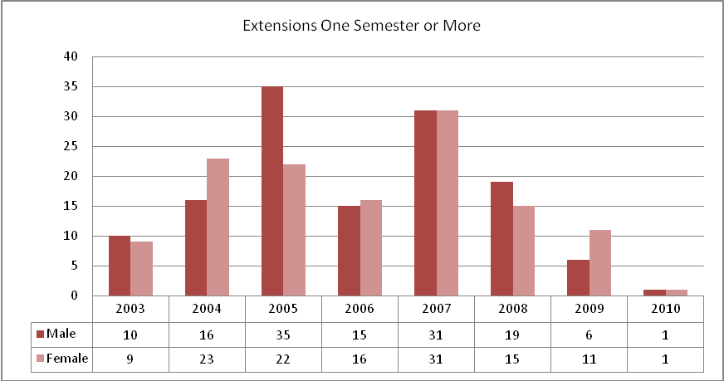

Extension Variations costing more than $10,000
Minor extensions with minimal cost are of relatively little significance for the scholarships program. However extensions that involve substantial cost – of $10,000 or more – require careful management and effort to reduce. With the exception of the 2005 cohort, men and women have secured extensions costing more than $10,000 in very similar numbers. With overall gender equity in the cohorts this means that there is not a substantial gender difference in the frequency of high cost extensions. While there appears to be a steady downward trend in high cost extensions from the 2007 cohort onwards, this should continue to be monitored, noting that the more recent cohorts have a higher proportion of ongoing scholars, who may still require high cost extensions before completing their studies. AusAID has moved recently (2009) to limit the number of extensions to one Semester per awardee and only after the awardee has progressed 80% through the course of study. This requirement is monitored by the Institution at which the scholar is studying.
- Extensions costing more than $10,000
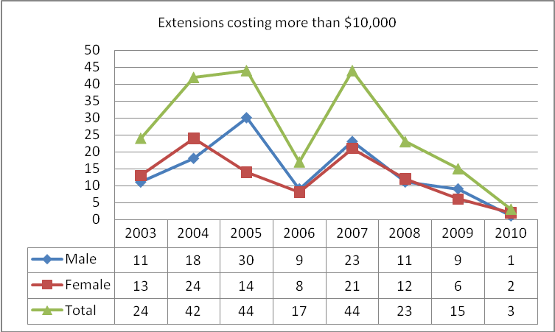

The total cost of high cost extensions follows a very similar pattern, as shown in Figure 41:
- Total Cost of Extensions Costing More than $10, 000 from 2003-2010
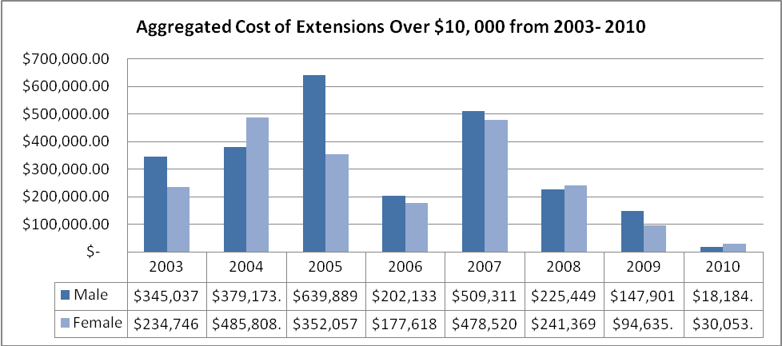

The average cost of these high cost extensions remained fairly steady at between $20,000 and $24,500 each until the 2009 cohort, as shown in Figure 42. For the two most recent cohorts – 2009 and 2010 – the average cost has fallen dramatically, to almost $16,000 each. There is a much stricter administration of extension requests now, resulting in this substantial decrease in average cost.
- Average Cost of High Cost Extensions
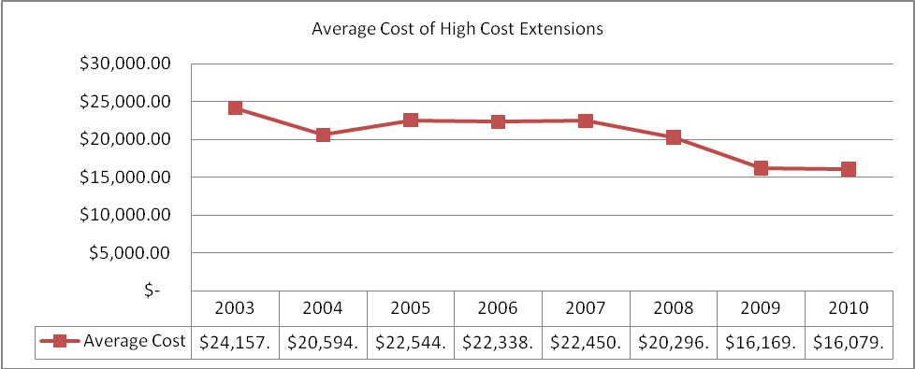

Extension Variations leading to Termination
It is important to examine the performance of scholars who have their awards extended. Extensions represent an additional investment in a scholar, both financially and in their time away from PNG (and their workplaces). So the extent to which success follows an extension is a crucial question.

First amongst this is to examine the termination rates of scholars who have been extended. As Table 23 shows, there is a very low rate of scholars being terminated following a variation extension: over the entire period 2003-2009 only six scholars (four men and two women) have fallen into this category. In other words, only 2% of extensions (six out of 284) resulted in termination.
- Extensions leading to Termination
Year | Male | Female | Total
2003 | 0 | 0 | 0
2004 | 0 | 0 | 0
2005 | 1 | 1 | 2
2006 | 0 | 0 | 0
2007 | 0 | 0 | 0
2008 | 1 | 1 | 2
2009 | 2 | 0 | 2
Total |  |  | 6

Extension Variations Resulting in Lower Level Qualification
Some scholars graduate with a lower level qualification, even after their award has been extended. The additional time is still not enough to enable them to complete the original enrolment, for any number of reasons. Figure 43 shows that, as a proportion of each cohort’s extensions, there is a trend (shown by the trend line) of extensions increasingly resulting in graduation at a lower level. In other words, scholars are seeking and securing an extension, and then still not completing their original enrolment.
- Extensions leading to Graduation at a Lower Level
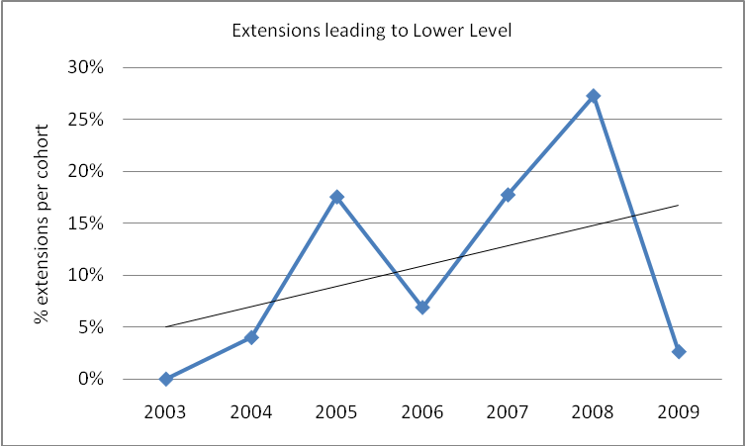

Extensions resulting in Graduation at Lower Level 2003-2009 by Gender
Figure 43 shows that, while men receiving extensions have graduated at a lower level less and less often over the life of PATTAF, until 2007 women receiving extensions continued to graduate at a lower level at relatively steady rates.

With the insertion of trend lines in Figure 44, it is clear that the trend of increasing graduation at a lower level is relatively similar for both men (the dashed line) and women (the solid line): both are increasing gradually.
- Graduation at Lower Level after Extension by Gender
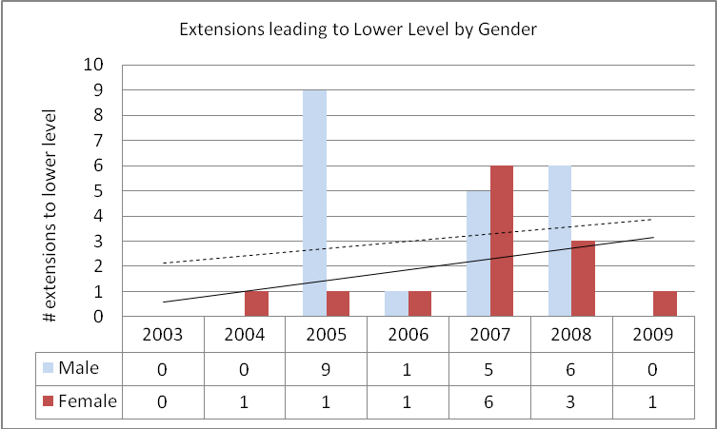

Australian Leadership Awards
Over the fours years since the start of the ALA program PNG scholars have received a total of 44 ALA awards – between seven and fourteen each year. Because the ALA program is administrated by AusAID’s Australian Scholarships Group in Canberra, PATTAF has very limited access to data and can undertake only limited reporting. Analysis is further constrained by the small number of awards and the relatively young nature of the program, meaning it is not possible at this stage to identify strong trends.
- ALA Awards
 | 2007 | 2008 | 2009 | 2010
Male | 6 | 10 | 4 | 4
Female | 6 | 4 | 3 | 7
Total | 12 | 14 | 7 | 11
Grand Total | 44

More men than women have secured ALA scholarships: 25 men and 20 women over the four year period in which the program has been operating. As shown in Figure xxx below, 2010 was the year in which women scholars outnumbered men for the first time, however it is too early to draw any conclusions about a changing trend in the gender mix of ALA awards.
- Men and Women ALA Awards
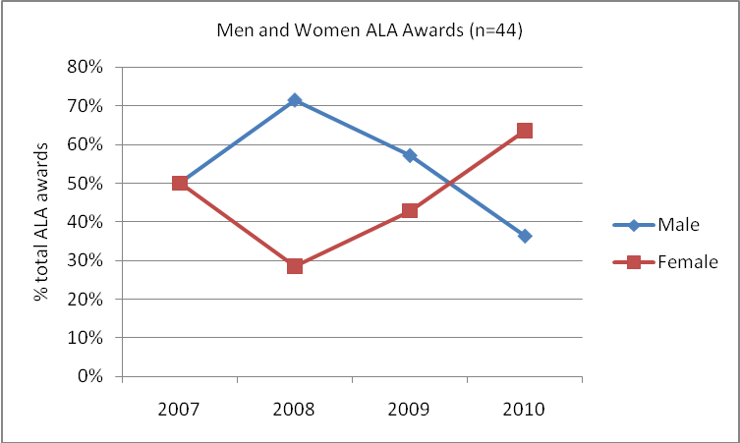

ALA Performance
As shown in Table 25, many ALA scholars are still on award: overall 48% have completed and 48% are still studying, while one has yet to commence and one was terminated. There are no notable differences in performance between men and women ALA scholars: they have completed at comparable rates.
- ALA Performance by Gender
 | Male |  | Female
 | Count | % Male | Count | % Female
Completed | 12 | 50% | 9 | 45%
Ongoing | 11 | 46% | 10 | 50%
Terminated | 1 | 4% | 0 | 0%
Still to Commence | 0 | 0% | 1 | 5%
Total | 24 |  | 20 | 100%

PATTAF does not have access to any more detailed peformance data on which to compare the performance of ALA scholars with ADS scholars, or to identify patterns of performance within ALA cohorts.

Conclusions
This baseline data analysis has highlighted some important points, and reinforced some of the findings of earlier analysis such as the 2009 Assessment of the trends of PNG student achievements under the ADS Program report. It has also raised some questions about the quantitative implications of some more recent policy changes that have emerged as very serious negative impacts through other, qualitative research.

- The 2005/2006 changes in eligibility rules, and the shift to a 50:50 category split between Open and Public awards, had a dramatic impact on ADS applications, awards and performance rates. This was the most significant change in the history of PATTAF.
- There is no evidence of a dramatic quantitative impact on the participation of women, nor of scholars with dependents (both men and women), in ADS applications or awards following the removal of the accompanied stipend. This is despite strong qualitative evidence suggesting that the opposite is the case, and that women are being disadvantaged as a result of the change.
- There is greater uncertainty about the impact of this change in stipend policy on performance. Accompanied scholars (both male and female) appear to still have consistent performance, and are more commonly succeeding than those who are non-accompanied. But there are early indications of a possible new trend towards higher rates of extensions and of failures amongst women in the most recent cohorts. Women receiving extensions are still succeeding in their studies at higher rates than men, however. This complex mix of factors should continue to be monitored closely, in case it represents an increase in difficulties for women scholars. This monitoring should examine whether the difficulties are the result of financial pressures or other factors that Scholarships PNG can respond to.
- Men have overall failed their academic studies more than twice as much as women throughout PATTAF. However there has been a trend downwards in male failure rates, while (as noted above), women’s failure rates may be beginning to increase.
- The performance of very young scholars, especially young men, was clearly poor in the early years of PATTAF, but with the changing demographic mix of scholars after 2005, this performance difference became less marked.
- Scholars at undergraduate level are substantially more likely to fail, or have their award terminated, than scholars at other levels. Postgraduate scholars have a very high success rate, while PhD and diploma level scholars succeed at a similar, but lower, rate.
- It is clear that the additional, targeted effort by PATTAF management in 2009 and 2010 has led to a stronger field of applicants from Public sector women, enabling a much better (though still not equal) gender balance within Public and Open awards categories for the first time.
- Overall, men have failed twice as much as women in ADS. However they have been steadily closing this gap, and in 2008 women failed more than me for the first time.

The manual data extraction and manipulation required to complete this baseline analysis, particularly with performance data from the AusAID system, has led to some data inconsistencies and gaps. While these are not considered substantial enough to negate the analysis and the conclusions drawn, they do point to weaknesses in the system that should be rectified to protect the validity of ongoing data collection, management and analysis.

Looking forward to the PNG Scholarships Program M&E
A number of key issues arise out of this, and other, data analysis for PATTAF, that should be considered in developing the monitoring and evaluation arrangements for Scholarships PNG:

- The analysis of ADS data is hampered by the multiple databases that hold these data, shared between AusAID, the institutions, and PATTAF, and the inconsistency between these databases. This has necessitated time-consuming and onerous manual data manipulation, also raising the risks of data errors.
- In addition, there are some inconsistencies in the definition of variables such as sector of study, family profile/ status, and the age groups of applicants and scholars. Addressing these inconsistencies in the new M&E arrangements for Scholarships PNG will greatly enhance the capacity to examine performance across the stages in the scholarships cycle.
- ADS data analysis is further limited by the absence of detailed information about on-award performance from institutions. This was discussed in detail in the 2009 Assessment report.
- Analysis of ALA awards is constrained by the very limited access PATTAF had to ALA data. If Scholarships PNG will continue to have monitoring responsibilities for ALA scholars then this may require further consideration so as to enable more complete performance assessment.
As noted in the ICR, the entirety of this PATTAF data is largely process and output focussed. There was no outcome monitoring built into the design of the program, nor into the foundation of the M&E system. While PATTAF did introduce some additional post-award, qualitative evaluation tools, much more can be done. With the commencement of Scholarships PNG, there is now a great opportunity to enhance the M&E arrangements for ADS so we can examine the outcomes of scholarships for graduates, their employers and more broadly. This will provide valuable richness of information to complement the extensive quantitative data that provides a strong foundation for evaluation of scholarships for PNG.

Annex 1: Additional Data
The following are more detailed presentations of selected awards data, for reference purposes.

Awards by Category

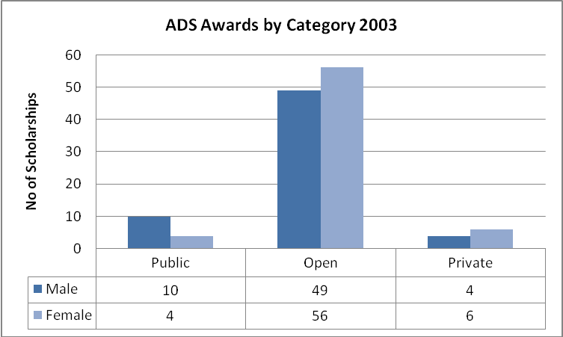

The open category females benefited more from the scholarship program with 43% of awards while 38% awards went to males in the open category. Private category received less awards with a total of 8%. The high number in the open category was due to school leavers being eligible to apply for a scholarship, and public sevants applying under the open category.

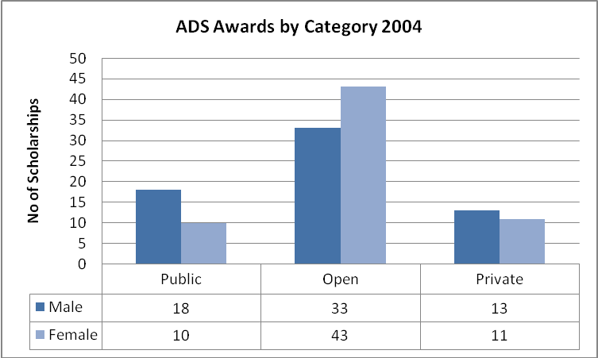

The number of awards granted in the open category decreased by 22% in 2004, while the public and private category awards increased by 11% respectively. The overall total for 2004 was one less award compared to 2003. The quotas for awards increased for the Post Graduate study level over the Undergraduate and Diploma study level. This meant the number of school leavers applying in the open category for diploma programs were gradually declining.

The number of awards to the private sector increased compared to 2004 while the number of awards to the open catgegory decreased. Gender equity was achieved across the overall program.
Policy changes implemented in 2005 were:
- Public Sector/Open Sector balance shifted from 20/80 to 50/50.
- Public Service applicants no longer eligible via the Open Category.
- School leavers were no longer eligible to apply for a scholarship.

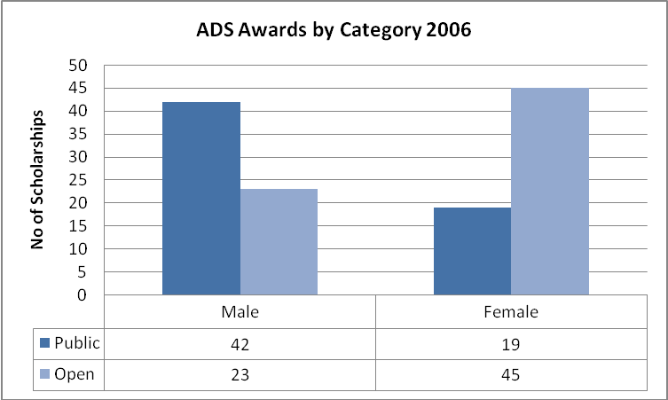

The total number of awards given increase in 2006 for public males by 33% while the open females increased by 35%. The open category continued to receive a larger number of awards than the public category in 2006. The private category ceased to be used in 2006. Gender equity was achieved across the overall program.

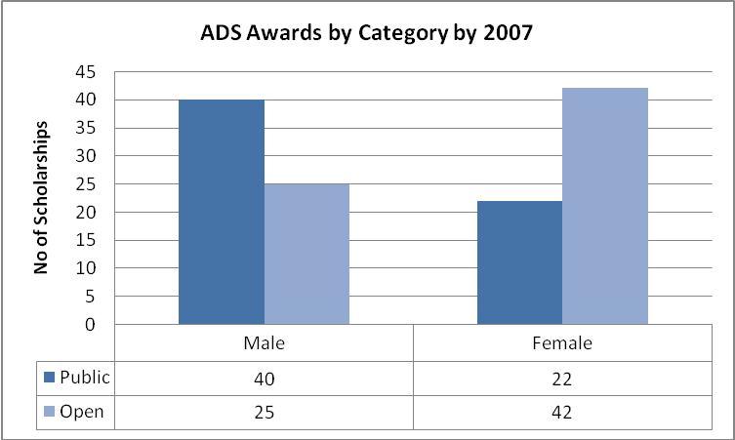

The total number of awards given to males in the public category and females in the open category remained high. This is due to the varying quality and number of Expression of Interest Forms (EOI) and Bid Forms received by DPM and NTC each year. Awards decreased by 3% for open category female and 4% for public category male. Number of awards for public category females increased by 2% and open category male by 1%.

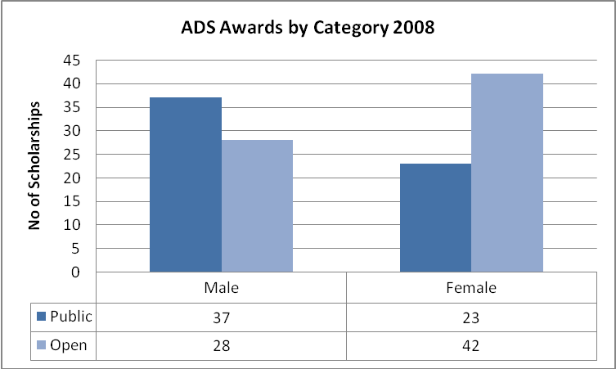

The trend continue in 2008 where there was a decline in the number of awards in the public category male, by 2%. The open category female remained consistent while increase in awards for open category male and public category female. Gender equity was achieved across the overrall program for this year.

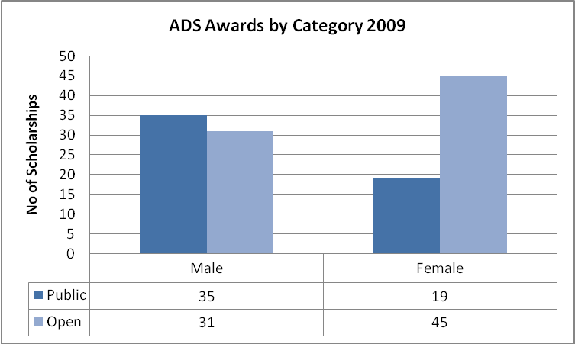

There was a significant decrease in the number of awards in the public category female. This was a result of the low number of Bid Forms received from DPM for females. A promotional campaign to target more women in the public sector to apply was put in place for 2010 ADS. The open category again received a larger number of awards than the public category in 2009 compared to 2008. Gender equity was achieved across the overall program.

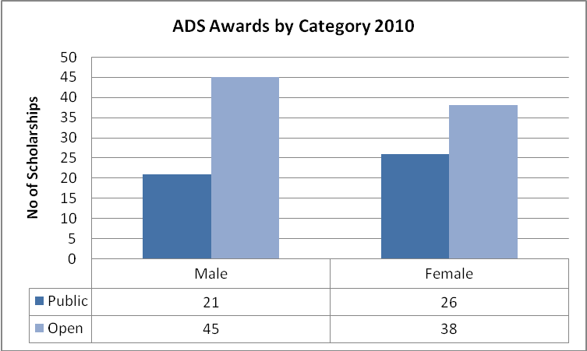

In 2010, the open category (82) again received an increased number of awards than the public category (47) compared to 2009. Gender equity was achieved across the overall program.

Awards by Level of Study
- Diploma Awards
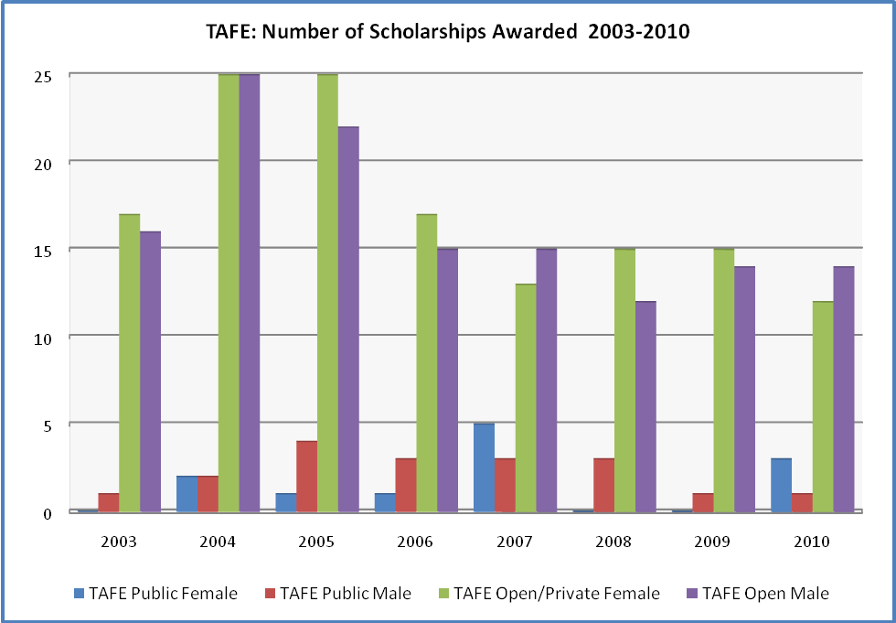
- Diploma (TAFE) Awards
 | Public Female | Public Male | Open Female | Open Male | Total
2003 | 0 | 1 | 17 | 16 | 34
2004 | 2 | 2 | 25 | 25 | 54
2005 | 1 | 4 | 25 | 22 | 52
2006 | 1 | 3 | 17 | 15 | 36
2007 | 5 | 3 | 13 | 15 | 36
2008 | 0 | 3 | 15 | 12 | 30
2009 | 0 | 1 | 15 | 14 | 30
2010 | 3 | 1 | 12 | 14 | 30
Total | 12 | 18 | 139 | 133 | 302

For the period 2003-2010, a total of three hundred and two awards were allocated at the Diploma study level. Thirty awards (F=12, M=18) were allocated to the Public Category and two hundred and seventy two (F=139, M=133) allocated to the Open Category.

- Undergraduate Awards
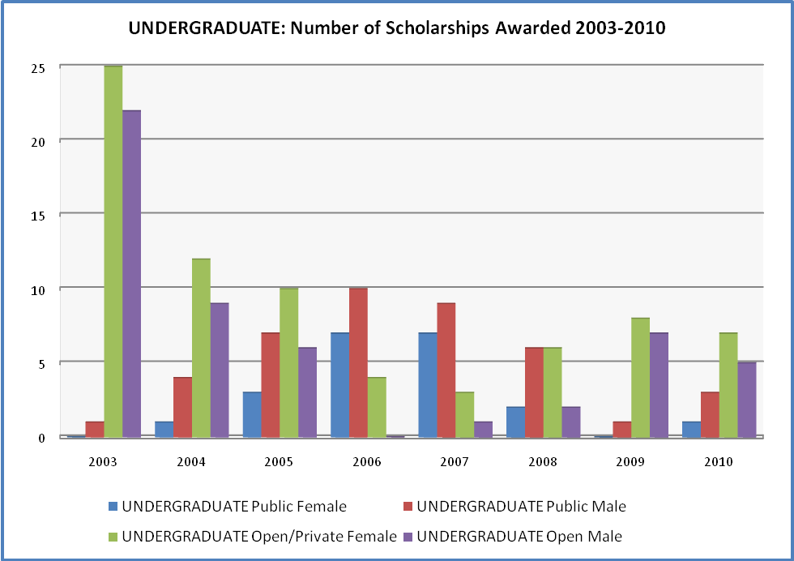

 | Public Female | Public Male | Open Female | Open Male | Total
2003 | 0 | 1 | 25 | 22 | 48
2004 | 1 | 4 | 12 | 9 | 26
2005 | 3 | 7 | 10 | 6 | 26
2006 | 7 | 10 | 4 | 0 | 21
2007 | 7 | 9 | 3 | 1 | 20
2008 | 2 | 6 | 6 | 2 | 16
2009 | 0 | 1 | 8 | 7 | 16
2010 | 1 | 3 | 7 | 5 | 16
Total | 21 | 41 | 75 | 52 | 189

- Postgraduate Awards
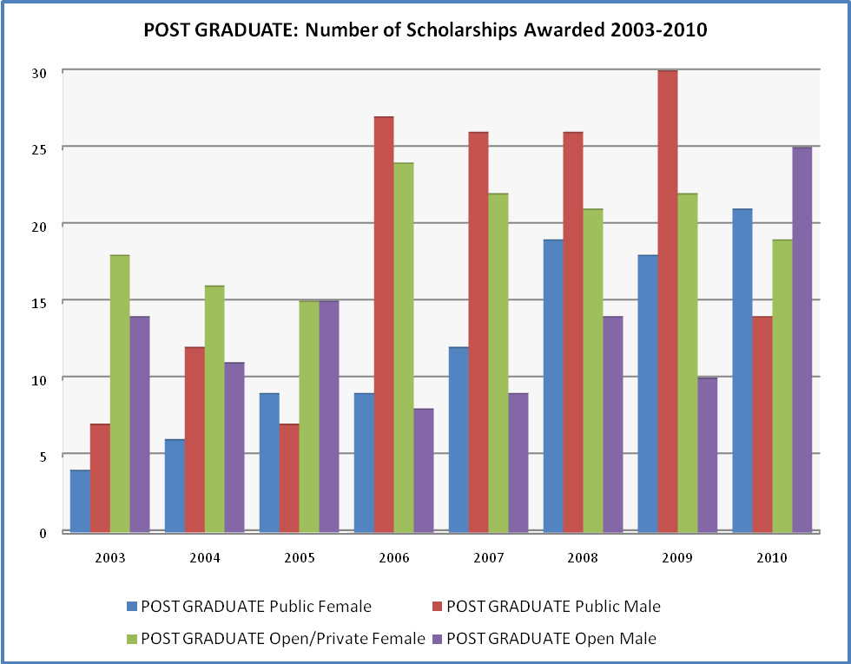
 | Public Female | Public Male | Open Female | Open Male | Total
2003 | 4 | 7 | 18 | 14 | 43
2004 | 6 | 12 | 16 | 11 | 45
2005 | 9 | 7 | 15 | 15 | 46
2006 | 9 | 27 | 24 | 8 | 68
2007 | 12 | 26 | 22 | 9 | 69
2008 | 19 | 26 | 21 | 14 | 80
2009 | 18 | 30 | 22 | 10 | 80
2010 | 21 | 14 | 19 | 25 | 79
Total | 98 | 149 | 157 | 106 | 510

A total of 510 Papua New Guineans have benefited from Post graduate level awards under the ADS program from 2003-2010. Each year since 2008 a total of eighty awards have been given to those who meet all requirements to study at the Post Graduate level at an Australian University of their choice. The Public sector has received a total of two hundred and forty seven awards. Of this total, ninety eight have been females and one hundred and forty nine have been males. The Open category has been given a total of two hundred and sixty three awards, of which one hundred and fifty seven have been females and one hundred and six have been males.

- Doctoral Awards
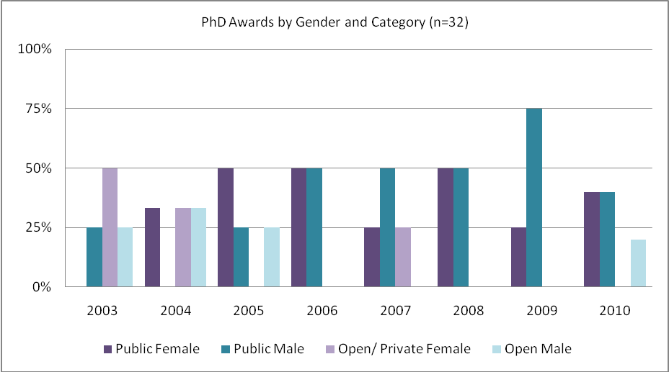
 | Public Female | Public Male | Open Female | Open Male | Total
2003 | 0 | 1 | 2 | 1 | 4
2004 | 1 | 0 | 1 | 1 | 3
2005 | 2 | 1 | 0 | 1 | 4
2006 | 2 | 2 | 0 | 0 | 4
2007 | 1 | 2 | 1 | 0 | 4
2008 | 2 | 2 | 0 | 0 | 4
2009 | 1 | 3 | 0 | 0 | 4
2010 | 2 | 2 | 0 | 1 | 5
Total | 11 | 13 | 4 | 4 | 32

Doctoral studies are offered to applicants from tertiary and Research Institutes only; mainly in the public sector. On an annual basis four awards are offered to Papua New Guineans who are highly qualified and meet all the selection criteria. Selection process for doctoral studies is very competitive in which short listed applicants undergo a separate interview process conducted by an external assessor to identify suitable PhD candidates under the ADS program. In some years, no suitable candidates apply, so no awards are made at PhD level.

Awards by Study Level by Year
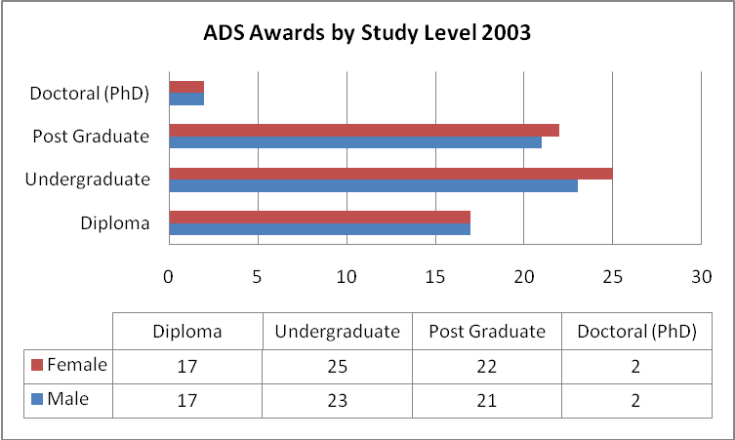

The highest number of awards were in the Undergraduate, Post Graduate and Diploma levels. A high level of gender equity was achieved across all awards.

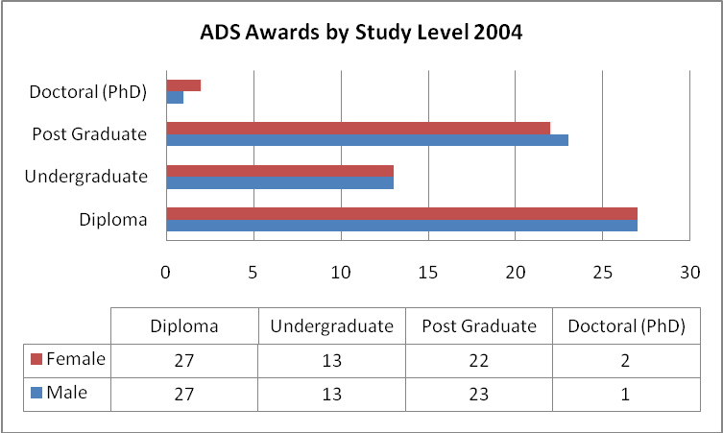

The number of undergraduate awards decreased and the number of diploma awards increased from 2003 to 2004. A high level of gender equity was again achieved across all awards. Direct articulation from diploma to undergraduate awards was removed from the selection criteria. There was an increase in awards for the the post graduate study level in 2004.

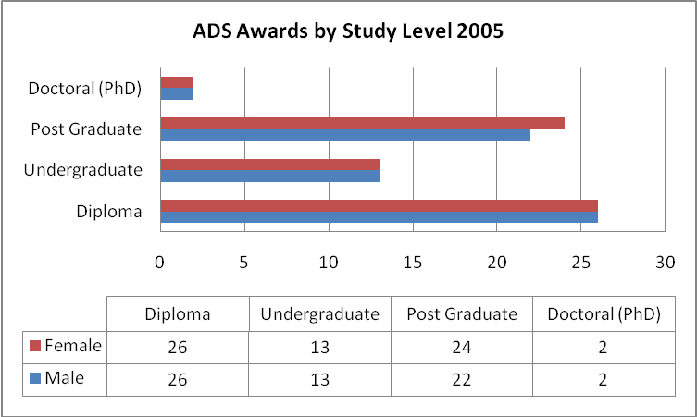

The relative number awards between the different levels remaining similar to that in 2004. A high level of gender equity was again achieved across all awards. A change to the selection criteria incorporated the recommendation to have applications endorsed by nominating agencies rather than a selection based on individual merit and set quotas were recommended for each of the four study levels. As shown in the graph above, an equal number of awards was given to males and females in this year.

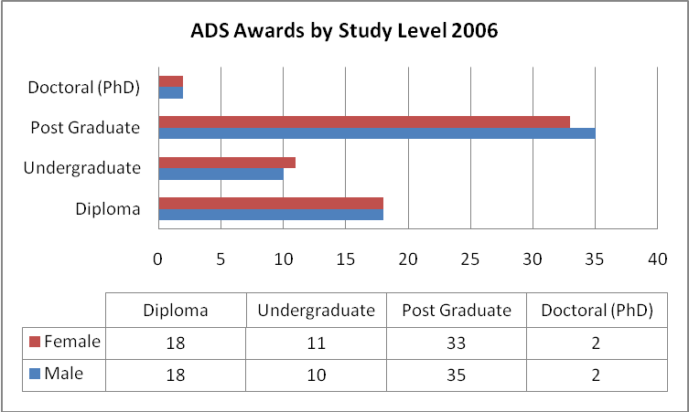

There is a significant shift in the relative number of awards to different levels in 2006. The number of awards to Diploma and Undergraduate levels decreased and the number of awards to Post Graduate level increased by the same amount. The number of awards at Doctoral level remained steady. A high level of gender equity was again maintained across award levels.

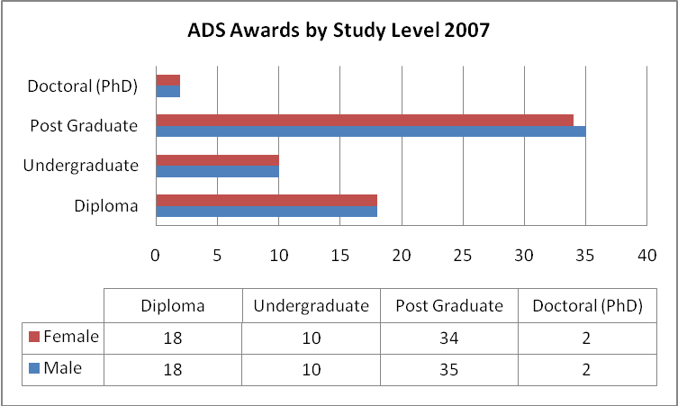

The policy of awarded fewer scholarships to Diploma and Undergraduate levels and more scholarship to Post graduate level continued in 2007. The number of awards at Doctoral level once again remained steady. A high level of gender equity was again maintained across levels.

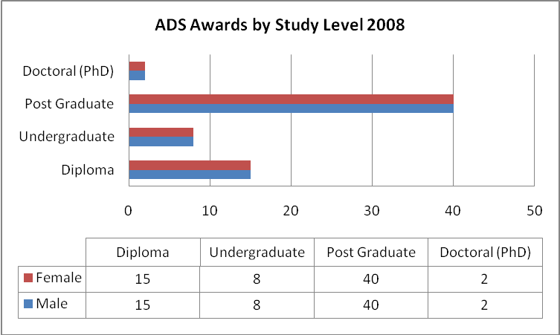

The policy of awarding fewer scholarships to Diploma and Undergraduate levels and more scholarship to Post graduate level continued in 2008. More awards were made at Post Graduate level than in 2007 though the total number of awards was the same as 2007. The number of awards at Doctoral level once again remained steady. A high level of gender equity was again maintained across award levels.

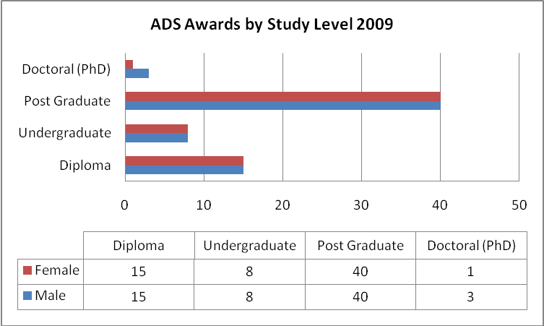

The policy of awarding fewer scholarships to Diploma and Undergraduate levels and more scholarship to Post graduate level continued in 2009. The total number of awards was the same as 2007 and 2008. The number of awards at Doctoral level once again remained steady though more awards were made to males. A high level of gender equity was again maintained across other award levels.

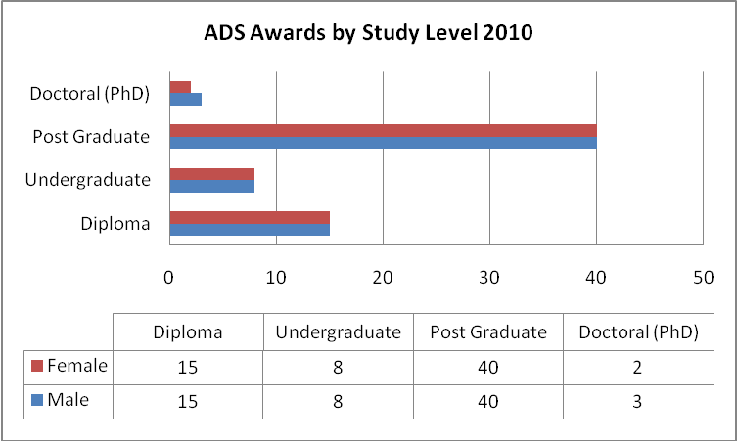

The total number of awards for the Diploma, Undergraduate and Post Graduate study level remained the same as 2009. The total number of awards at Doctoral level was more in 2010 due to a female priority awardee withdrawing from her ADS award and accepting an Australian Leadership Award.

Awards by Sector of Study
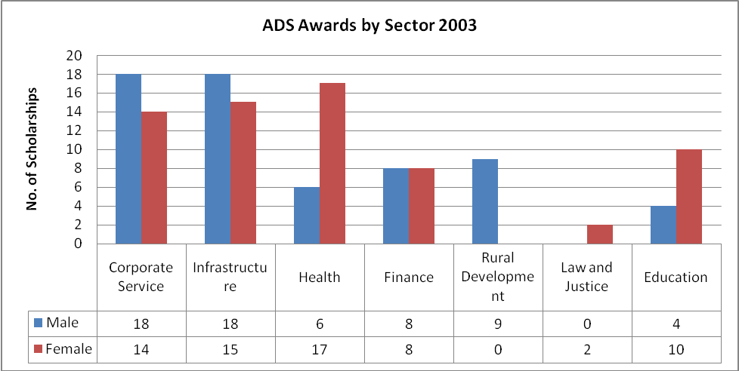

In 2003 50% of awards were in the Corporate Services and Infrastructure sectors (65/130) and more females secured awards in the Health sector than males by a ratio of 3:1. No females were awarded scholarships in the Rural Development sector and no males in the Law & Justice sector. Law & Justice Sector had two female awardees which is the lowest amongst all the sectors in this period. The allocation of awards was also based heavily on the quality of applications received from all sectors participating in the program.

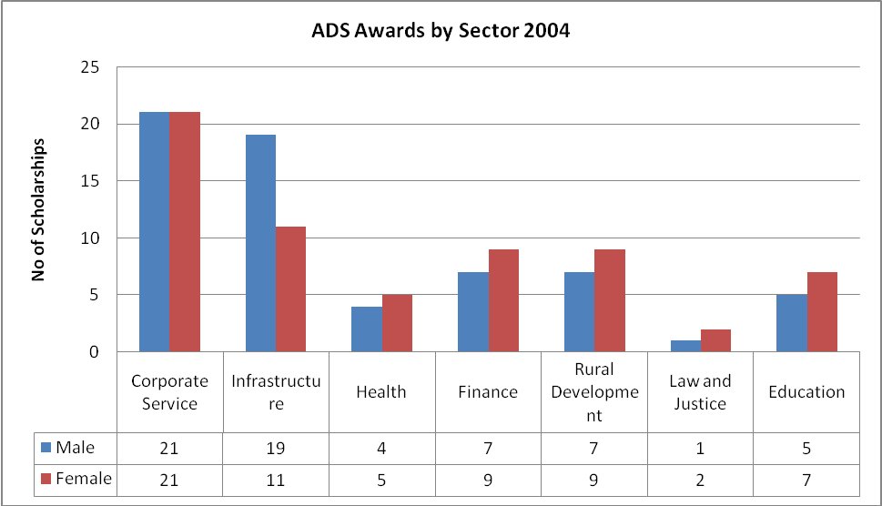

There was an increase in allocation of awards at all sectors except for Health and Education. Corporate Services had equal distribution of awards between males and females in 2004.

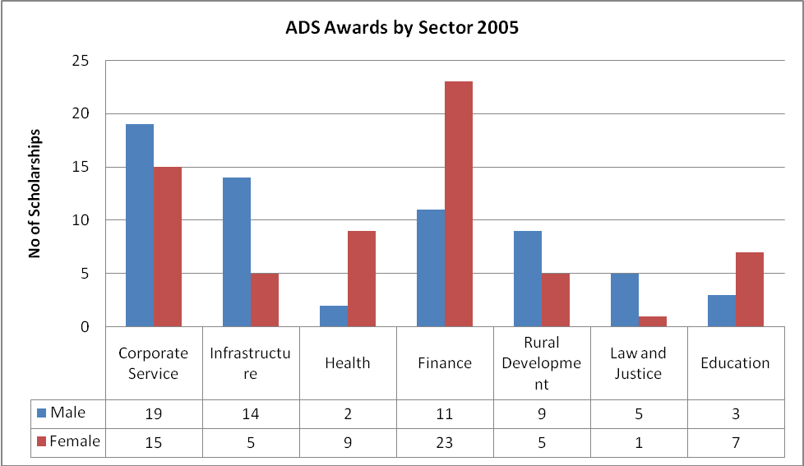

In 2005 128 awards were allocated comprising 63 males and 65 females. There was a significant increase of awards allocation to the Finance Sector with 11 males and 23 females. Law & Justice sector had an increase by 3 awards in this year.

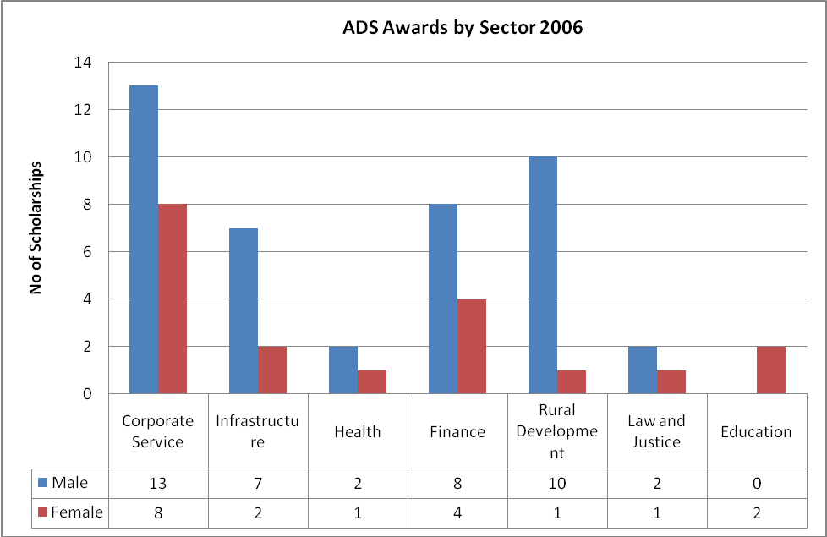

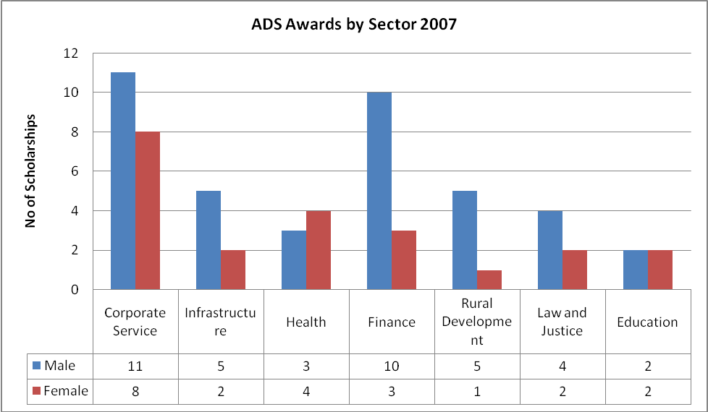

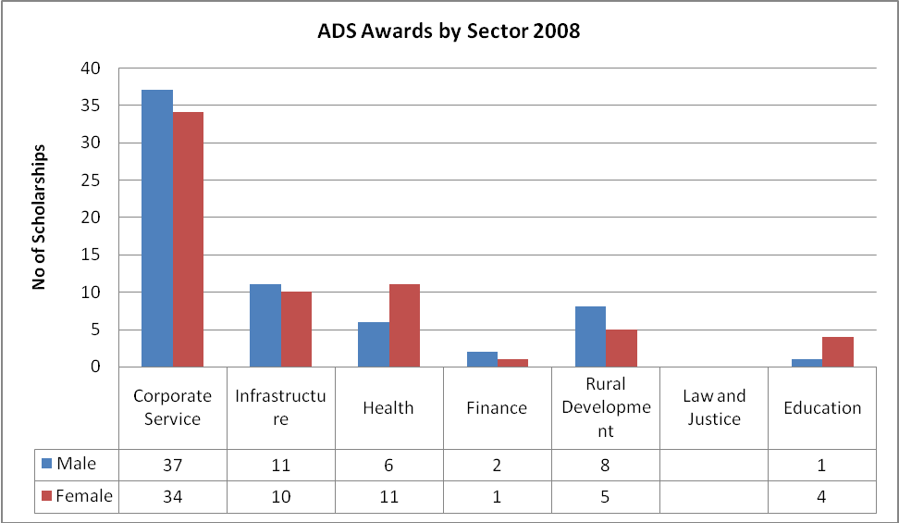

Unlike previous years, there is much greater gender equity in awards in most sectors. Only in the Health sector were more scholarahips awarded to females.

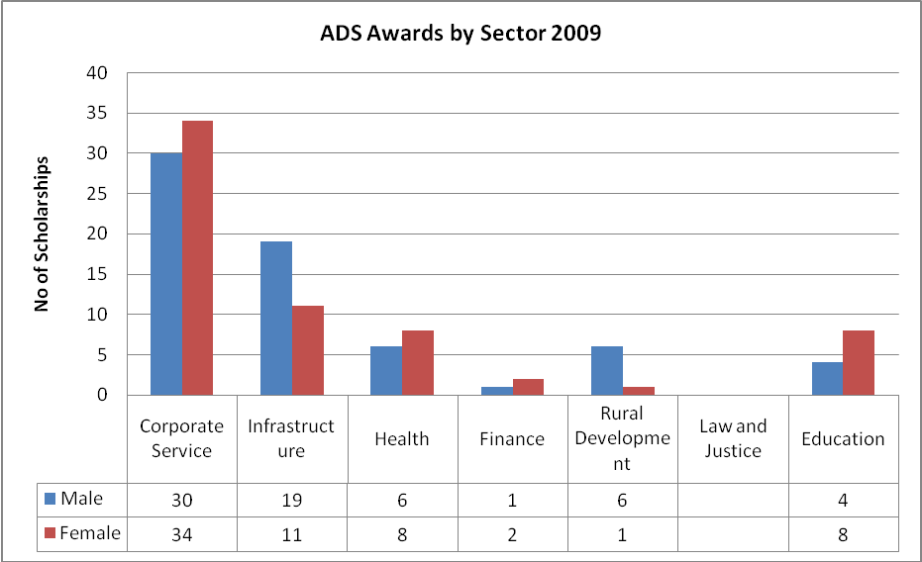

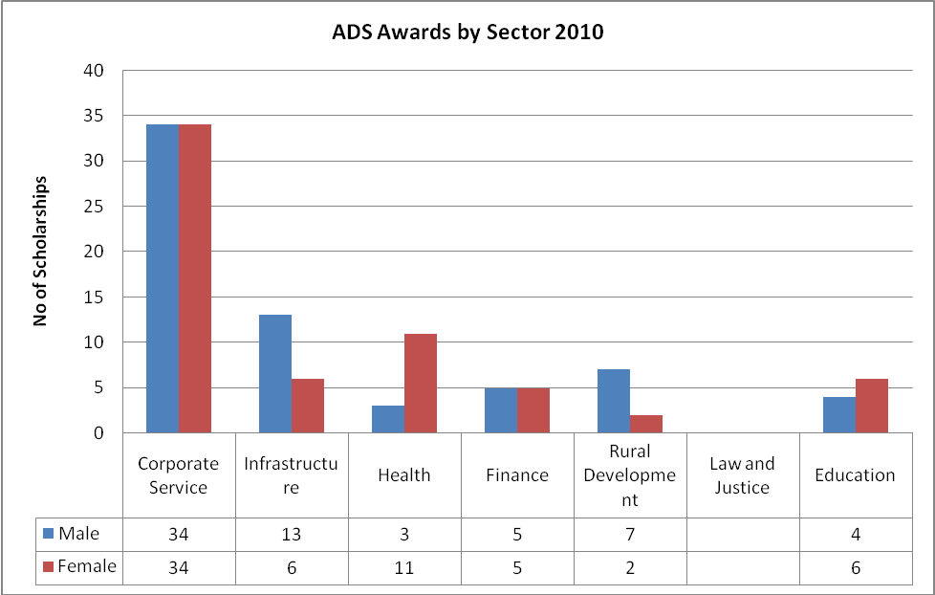

The number of awards across all sectors remained steady from 2009 to 2010. Overall, gender equity was achieved across the sectors with the majority of awards again being given in the areas of Corporate Services and Infrastructure.

Extension Variations by Year
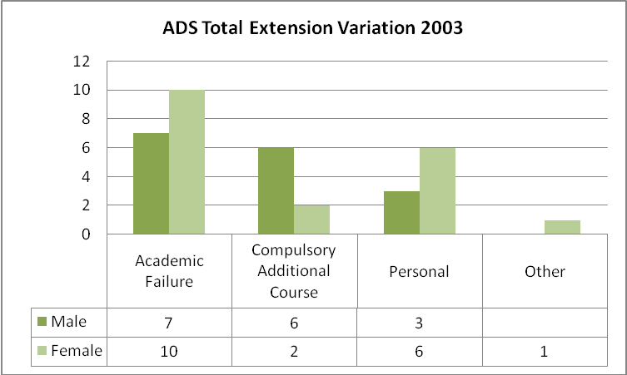

More females received variation than males in all categories in 2003.

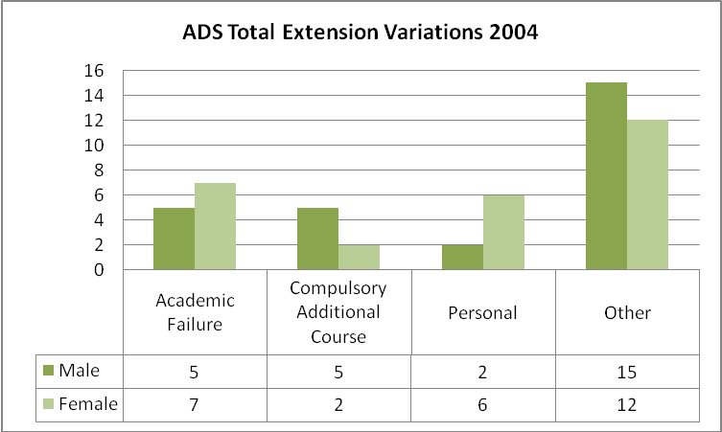

The number of variations increased from 2003 to 2004. Number of males and females receiving variations was the same.

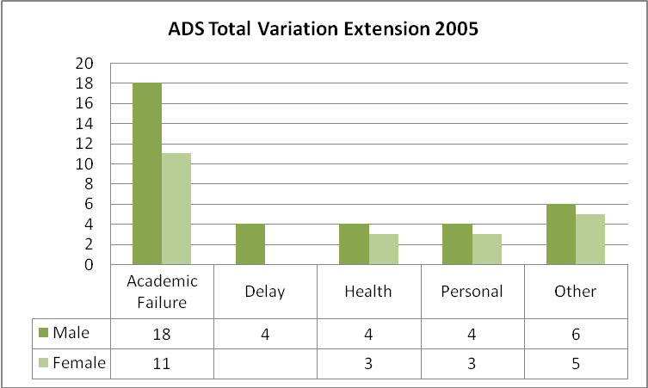

The total number of variations in 2005 was again greater than in previous years More males received variations than females

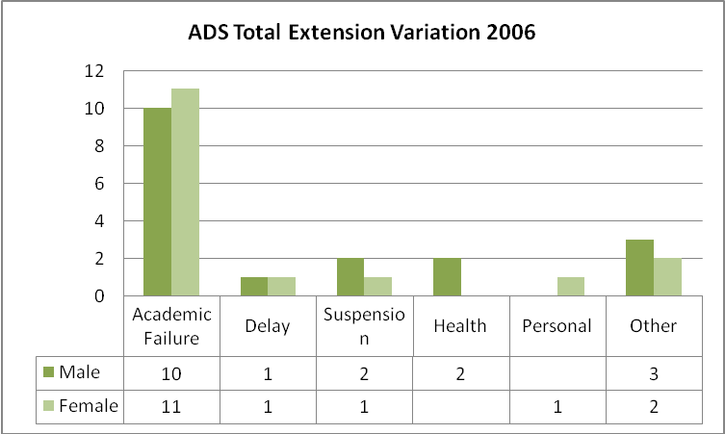

The number of variations for both male and females decreased from 2005 to 2006. More males received variations Indicating a reversal of earlier trends

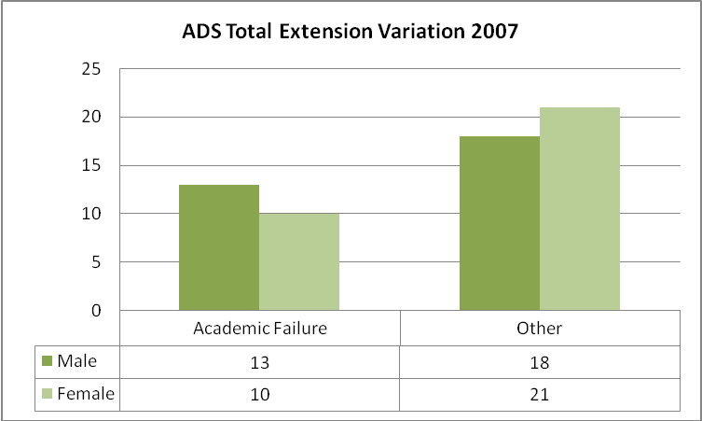

The number of variations in 2007 increased compared to 2006.The number was the same for both males and females.

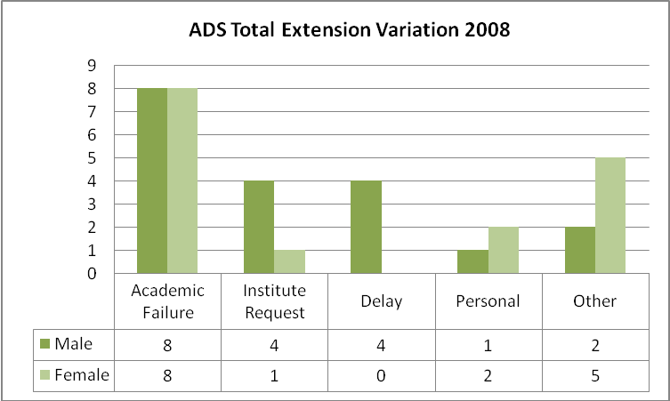

The number of variations in 2008 decreased compared to 2007. More males than females received variations.

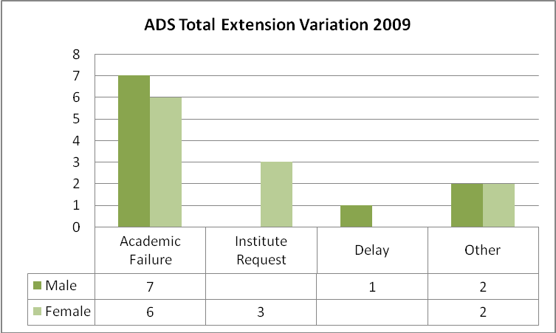

The number of variations in 2009 again decreased the previous year . Males than females received a similar number of variations.

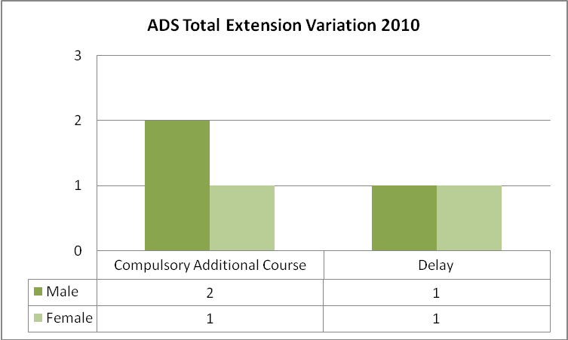

The number of variations in 2010 is significantly lower than in previous year. Males and females received a similar number of variations.

In recent years the Facility also attempted to report against AusAID’s 4 Pillars classifications, as seen in various PATTAF Trends/Selection/Quarterly reports.
Originally this restriction was instituted at the request of GoPNG in order to protect PNG universities from competing with Australian institutions for good quality students. The restriction has now been removed.
PATTAF introduced this more accurate classification of sectors but did not revise applications data sectors to match. This will be rectified in Scholarships PNG M&E arrangements.
For this analysis, 2009 data are excluded as the majority are ongoing scholars.
It should be noted that with a total of only 32 PhD awards there is a much smaller denominator on which to base analysis of performance.
As reported in PATTAF ICR, September 2009

