Samoa country case study

AusAID Pacific social protection series: poverty, vulnerability and social protection in the Pacific

March 2012

© Commonwealth of Australia 2012

Published by the Australian Agency for International Development (AusAID), Canberra, March 2012.

This document is online at www.ausaid.gov.au/publications

The principal authors of this report are Desmond Amosa and Michael Samson.

**Disclaimer:** The views expressed in this publication are those of the authors and not necessarily those of AusAID.

For further information, contact:

AusAID GPO Box 887 Canberra ACT 2601

Phone (02) 6206 4000   
Facsimile (02) 6206 4880   
Internet www.ausaid.gov.au

1. Introduction to the research

Pacific Island countries (PICs) have varying social protection systems, informal and traditional. These systems are important in supporting the most vulnerable members of society and those affected by personal and natural disasters. In the Pacific Islands social protection has typically been an area of low government involvement. Knowledge about formal social protection in the region is limited, and there have been no studies on the impact of such schemes on poverty, human development and economic growth.

There is no one agreed definition of social protection, but this body of research—commissioned by AusAID—uses the term to refer to the set of public actions aimed at tackling poverty, vulnerability and social exclusion, as well as providing people with the means to cope with major risks they may face throughout their life.

Social protection’s core instruments include regular and predictable cash or in-kind transfers to individuals and households. More broadly, social protection includes instruments that improve people’s access to education, healthcare, water, sanitation, and other vital services.

Traditional social protection in the Pacific Islands is stretched by new challenges, most recently the 2008–09 global food, fuel and financial crisis. This has led to greater attention to innovative social protection mechanisms that tackle chronic poverty, mitigate the impact of shocks, improve food security and overcome financial constraints to accessing social services. This attention has been driven by the success of mechanisms in other parts of the world.

In an environment with limited or conflicting information about patterns of poverty and vulnerability, knowing whether social protection represents a sound, or even appropriate, policy choice is difficult. This research looks at poverty, vulnerability and social protection across the dimensions of health and education, gender, social cohesion, economic growth, and traditional protection networks in the Pacific Islands. It aims to improve the evidence base on formal and informal social protection programs and activities in the Pacific region and make recommendations on support for strengthening and expanding social protection coverage so it can contribute to achieving development outcomes.

The research was conducted by social protection experts and is based on case studies in Kiribati, Samoa, Solomon Islands and Vanuatu—representing the three sub-regions of Melanesia, Micronesia and Polynesia—and a review of secondary literature. It also commissioned a set of research papers:

> an overview of poverty and vulnerability in the Pacific, and the potential role of social protection

> a briefing on the role of social protection in achieving health and education outcomes

> a life-cycle approach to social protection and gender

> an assessment of the role of social protection in promoting social cohesion and nation-building in the Pacific

> an assessment of the relationship between social protection and economic growth

> a review of the strengths and weaknesses of informal social protection in the Pacific

> a micro-simulation analysis of social protection interventions in Kiribati, Samoa, Solomon Islands and Vanuatu.

2. About this research paper

**2.1. Study objectives**

This research paper, ‘Samoa country case study’ presents the findings of a mission[1] to Samoa. It assesses Samoa’s experience, highlighting achievements and underscoring areas where further progress will reinforce inclusive development. The study aims to build an evidence base on hardship, vulnerability and social protection that can be used to support more effective policy interventions by the Government of Samoa and its development partners, and highlight areas in which Samoa serves as a role model for the region.

The research paper starts by giving a country profile of Samoa. It then looks at the country’s hardship, vulnerability and inequality. It examines the traditional social protection system in depth and then reviews government and non-state social protection programs. The research paper next examines health and education services and outlines the country’s demographic change. It outlines crises and shocks affecting Samoa and a micro-simulation analysis of potential social protection instruments. The research paper ends with recommendations.

**2.2. Study methodology**

The methodology included key elements of a case study approach. The initial stage was a comprehensive review of existing literature and an analysis of relevant studies. The next stage was further research involving extensive consultations with government officials, development partners, academics, journalists, and representatives of non-government organisations (NGOs) and the private sector. It also included in-depth interviews with community members. A partial list of the consultations held is in Annex C. These informed the next stage—analysis of Samoa’s 2002 and 2008 Household Income and Expenditure Survey (HIES) household survey data. Finally, in the micro-simulation analysis, the 2008 HIES was used to assess the impact of five hypothetical social cash transfer interventions.

**2.3. Country profile**

Samoa shares with its Pacific island neighbours a vulnerability to natural and economic shocks, as well as challenges of social transformation. Over the past several decades Samoa has weathered these storms, progressively strengthening essential service delivery while improving the wellbeing of those facing the greatest hardship. At the millennium, Samoa was poised to move beyond least developed country status. The United Nations (UN) recommended that Samoa move to developing country status in 2003, and the island nation was to officially graduate in 2011. However, on 29 September 2009 a tsunami swept over the nation’s coastal regions, killing 143 people, destroying infrastructure and devastating the nation’s vital tourism industry. Losses were estimated at US$106 million, equal to 17 per cent of annual gross domestic product (GDP).[2] It was the worst natural disaster to hit Samoa since Independence.

The 2009 tsunami and its effects indicate just how extremely vulnerable the island nation remains to natural disaster and other external shocks. This vulnerability is compounded by substantial structural economic challenges and the social stresses of transitioning to a modern economy. Understanding the external threats, economic constraints and social challenges facing Samoa today is critical for identifying the most vulnerable groups and analysing and strengthening the country’s social protection systems.

The Independent State of Samoa is a small archipelago in the centre of the South Pacific, approximately halfway between New Zealand and Hawaii. Samoa consists of two main islands (Savai’i and Upolu) and several smaller islands and uninhabited islets, with a land area of 2934 square kilometres and an exclusive economic zone of 98 500 square kilometres, the smallest in the Pacific. Samoa differs from other PICs in that its population is concentrated on only two islands that have relatively developed road and communications infrastructure. However, there are significant gaps between the two major islands, with Savai’i lagging behind Upolu in both economic growth and human development indicators.[3]

The strong development pattern that has emerged across Samoa is one in which rural and urban villages are located in close proximity to the coast, along the fringing plains. Approximately 98 per cent of the population lives in these narrow coastal plains, which include the capital city of Apia on the island of Upolu. Apia is the only true city in Samoa, with a population of approximately 38 000 (2006 census). Traditional districts run from the mountains down to the developed coastal plain. Samoa’s 11 districts encompass 330 villages. The population is largely homogenous, with an estimated 93 per cent native Samoan.

Present-day Samoa was created in 1900 when the archipelago was divided between Germany and the United States of America. Following the defeat of Germany in World War II, Samoa became a mandate of New Zealand. Samoa gained its Independence from New Zealand in 1962, becoming the first Pacific island nation. It was known as Western Samoa until 1997 and is a separate country from American Samoa, which remains an unincorporated territory of the United States. Since Independence Samoa has experienced relative peace and stability compared to other PICs. The government blends traditional and democratic institutions and processes. The unicameral national legislative assembly has 49 members—47 are *matai* (chiefs) and two represent the part-Samoan and non-Samoan population. Elections are held every five years for both Parliamentarians and the Prime Minister. The Human Rights Protection Party has been the dominant party since 1982. The 1990 Village Fono Act gives village councils authority over village law and order, land disputes and health and social issues. Decision-making structures are largely decentralised, a result of the island nation’s geography and the strength of traditional culture.

**Table 1. Gross domestic product composition**

|  |
| --- |
| Agriculture and fishing 12% |
| Industry 28% |
| Services 61% |

Source: UN Statics Division

Samoa has a small, open economy driven by agriculture, fisheries, tourism, remittances and, increasingly, the service sector. Subsistence agriculture and fishing are integral to Samoan livelihoods; more than two-thirds of households are engaged in these activities, accounting for 12 per cent of GDP for 2007.[4] Root crops (largely taro) and small-scale animal husbandry are the main traditional agricultural activities, but the scope of production is diversifying. While they have historically composed a large share of Samoa’s GDP, the importance of agriculture and fishing is declining. Between 1994 and 2006, agriculture declined from 15 per cent to 7 per cent of GDP, leading to lost employment opportunities in rural areas.[5]

Samoa’s economic activity is increasingly concentrated in construction, commerce, transport and communication, as well as public and private services. Samoa has a small but nascent private sector, primarily comprising firms with five or fewer employees (80 per cent of all firms).[6] Tourism plays a dominant and expanding role in the private sector, accounting for nearly 20 per cent of annual GDP in 2009.[7] The majority of tourists come from Australia, New Zealand and American Samoa, with an increasing number from China and Japan. The Samoan Government has focused on tourism as an area for significant future income-generation and growth. In 2009 the Samoa Tourism Authority launched the ambitious Samoa Tourism Development Plan 2009–13, aiming to increase visitor arrivals by 50 per cent over this period. However, the 2009 tsunami proved a setback to this goal, and the tourism sector remains vulnerable to exogenous factors including natural disasters, economic health of major tourist source countries, transportation links to these countries and exchange rates.

Samoa’s manufacturing sector mainly processes agricultural products such as coconut and tuna. From 2002 to 2008 manufacturing’s share of GDP fell from 18 per cent to 12 per cent, a result of smaller business closures.[8] Heavy-manufacturing is limited to a factory producing automobile harnesses for export to Australia. Samoa’s main merchandise exports are fish, kava, coconut products, automobile harnesses and garments. Export goods remain a small share of overall economic activity, less than 5 per cent.[9] Overall economic activity is concentrated in urban areas—in 2001 the Asian Development Bank (ADB) estimated that 70 per cent of Samoa’s domestic economic activity took place in the Apia urban area.[10]

A reform program launched in 1993 shaped Samoa’s transition to an open economy with liberalised financial markets and macroeconomic and fiscal stability. In recent years the government has increased priority to stimulating private sector development. As a result, in 2006, the UN Development Programme (UNDP) described the Samoan economy as ‘one of the few bright spots in the Pacific region in terms of economic policy and institutional reforms’.[11] Samoa had an annual GDP of $1.063 billion tālā in 2009 (US$558 million) and a GDP per capita of $5857 tālā (US$3077).[12] GDP growth rates have been high by regional standards, accelerating to between 2.25 per cent and 7.0 per cent annually from 2002 to 2009.[13] However, the international financial crisis contributed to economic contraction in 2009, with growth falling to –4.9 per cent.[14]

The International Monetary Fund (IMF) projects a negative growth rate for 2010 (–2.8 per cent), but a rise to 3.0 per cent per annum for the period 2010–15.[15]

Macroeconomic figures alone can be misleading in the case of Samoa. In what the UN Conference on Trade and Development has referred to as the ‘island paradox’, despite having relatively high per capita GDP, Samoa and other small island developing states are at serious risk from adverse external shocks and natural disasters.[16] Samoa also faces substantial structural economic challenges. Constraints to economic development include a narrow natural resource base, limited infrastructure in rural areas, small domestic markets, isolation from international markets and a heavy dependence on fuel imports. Its geographical remoteness from its main markets contributes to relatively high transportation costs and few producers achieve the economies of scale necessary to compete in foreign markets. Distance from foreign markets also increases the cost of imported goods, contributing to a weak industrial base. Additionally, the overexploitation of natural resources, including forestry and fisheries, is threatening sustainable management and growth of these key sectors. Unsustainable fishing practices may be a factor in a cyclical rise and fall in the fishing catch. Overall, Samoa’s economy remains heavily dependent on foreign aid and government borrowings overseas, contributing to a negative balance on current account, a projected –20.1 per cent of GDP for 2010.[17] The Strategy for the Development of Samoa 2008–12 enumerates these constraints, indicating awareness within Samoa of the unique economic challenges facing PICs.

Samoa’s development strategy outlines seven national development goals for 2008–12:

> sustained macroeconomic stability

> private sector-led economic growth and job creation

> improved education outcomes

> improved health outcomes

> community development (improved village governance and improved economic and social wellbeing)

> improved governance in the public sector

> environmental sustainability and disaster risk reduction.

The national development plan also accounts for urban and rural differences, distinguishing between shared priorities and additional urban priorities (such as access to housing assistance) or rural priorities (such as improved access to basic services and infrastructure). Overall, economic vulnerability remains Samoa’s main obstacle to both graduating from least developed country status and achieving a durable, improved standard of living for Samoan citizens.

**2.4. Demographic profile**

Samoa’s population of 192 000 people is projected to rise to 245 000 by 2050.[18] More than half of the population is below 20 years of age. As at 2004, nearly a quarter of the population was between the ages of 15 and 29.[19] Population projections for Samoa estimate that the youth population will increase over the next 20 years (it is declining in most Pacific countries). These statistics illustrate the importance of providing meaningful job opportunities to youth.

Approximately 23.4 per cent of the population lives in the Apia urban area, an increase from 21.2 per cent in 1990.[20] As a result of continued rural-to-urban migration and a high percentage of the population at reproductive age, the urban population will likely continue to increase. Samoa must focus on the economic and social impacts of urbanisation, as well as implications for service delivery and infrastructure development.

**2.5. Summary of findings**

Samoa faces vulnerabilities to natural and economic shocks, as well as the challenges of social transformation. The government’s successful management of these risks has included the progressive strengthening of the delivery of essential services and measures to improve the wellbeing of those facing the greatest hardship. This report assesses Samoa’s experience, highlighting achievements and underscoring areas where further progress will reinforce inclusive development.

Samoa’s population of approximately 192 000 people is projected to rise to 245 000 people by 2050. An estimated 23 per cent of the population lives in urban areas. The overall labour force participation rate of 58 per cent is disaggregated to 74 per cent for men and 38 per cent for women.

Samoa’s natural resources and traditional social protection systems contribute to a low incidence of food insecurity. The 2008 Samoa HEIS reports a 61 per cent reduction in the rate of food poverty (severe hardship) from 2002 to 2008. However, the country has achieved less progress in reducing basic needs poverty (hardship). Global trends and external shocks have dampened progress in improving livelihoods for subsistence farmers and households depending on informal sector activity. This is consistent with fieldwork observations, which identified very few cases of food insecurity but highlighted increasing concern with diminishing opportunities for improved livelihoods.

The extended family system provides the most important contribution to social protection. Access to land and remittances contributes substantially to protecting people’s livelihoods. Land rights follow a parental lineage and are overseen by a village chief. Remittances are an extension of cultural collectivism and duty to the family. International remittances represent 32 per cent of national income, as measured by GDP, and reach approximately 40 per cent of all households.

Samoa’s income inequality is on par with other middle-income countries. In Samoa inequality is mitigated by traditional systems that oblige better-resourced people to share what they have with their families and communities. However, the 2008 HEIS documents an increase in inequality—as measured by the Gini coefficient—compared to 2002. A trend towards increased monetisation is widening the gap between those operating in the cash economy and those depending on traditional subsistence activities. The transition to a monetised economy—with its accompanying rural-to-urban migration—is straining traditional ties to the *aiga* and collectivism. In addition, social obligations, including church obligations, pose a heavy burden on households already facing increased hardship.

The Government of Samoa provides a National Provident Fund and a worker’s compensation scheme for those in the formal sector, with voluntary participation by those in the informal sector. The government also provides universal social pension for everyone older than 65 years of age. The Samoa National Provident Fund (SNPF) administers the Senior Citizen Benefit Scheme (SCBS), a universal social pension that provides a monthly benefit of $130 tālā to 8700 beneficiaries, for a total cost of approximately one per cent of GDP.

The Government of Samoa effectively delivers basic health and education services to the vast majority of the population. The public school system includes 140 primary schools (at least one in every village and on all populated islands) and 24 secondary schools. There are 27 private or mission primary schools and 17 such secondary schools. An estimated five per cent of Samoan children do not go to school, largely those living in the most remote areas. Improving school retention rates remains a persistent challenge, with high dropout rates at secondary level. However, Samoa has taken an important step towards the goal of universal primary education by implementing the Samoa School Fees Relief Scheme, effectively eliminating the cost of primary school fees for all Samoan families. The government also provides free healthcare services for all citizens. Samoa has decentralised health services, but progress is needed in addressing the differences in the quality of, and access to, healthcare between urban and rural areas. Health conditions have improved across a wide range of indicators since Independence in 1962, but the transition to a modern cash economy has brought new health challenges, including a rise in non-communicable diseases such as obesity and diabetes.

The Constitution of the Independent State of Samoa (1962) provides for equality for women under the law as well as other fundamental rights. The Ministry of Women Affairs Act (1990) regulates the Ministry of Women, Community and Social Development, the office responsible for developing gender-related policies in Samoa. The Public Service Act (2004) provides for equal employment opportunity in the public service and appointments and promotions to be made on the basis of merit. The Ministry works to eliminate sexual harassment and violence against women, particularly at home, a persistent problem in Samoa with high rates of gender-based domestic violence.

The Government of Samoa has progressively strengthened formal social protection instruments, with particular success among formal sector employees and older people. However, there is room for more progress. In line with the goals of pro-poor and inclusive growth, this report makes the following recommendations:

> the SCBS, a key instrument for tackling hardship among older people, should be an important pillar of social protection, and the real value of the benefit should be maintained through an annual inflation-linked adjustment process

> the government should consider a similar benefit for people with disability, building on its successful implementation of the SCBS, to extend social protection to another highly vulnerable group

> given the concerns expressed by key government stakeholders about dependency and the prospect of negative economic impacts, development partners should support a rigorous quantitative evaluation of the SCBS and other social protection programs, the evidence of which would be a valuable tool for other PICs with (or considering) social protection programs

> hand-in-hand with the extension of core social protection benefits, the government should continue to improve the quality of vital social services in more remote rural areas, particularly healthcare, education and water and sanitation.

**Figure 1. Map of Samoa**

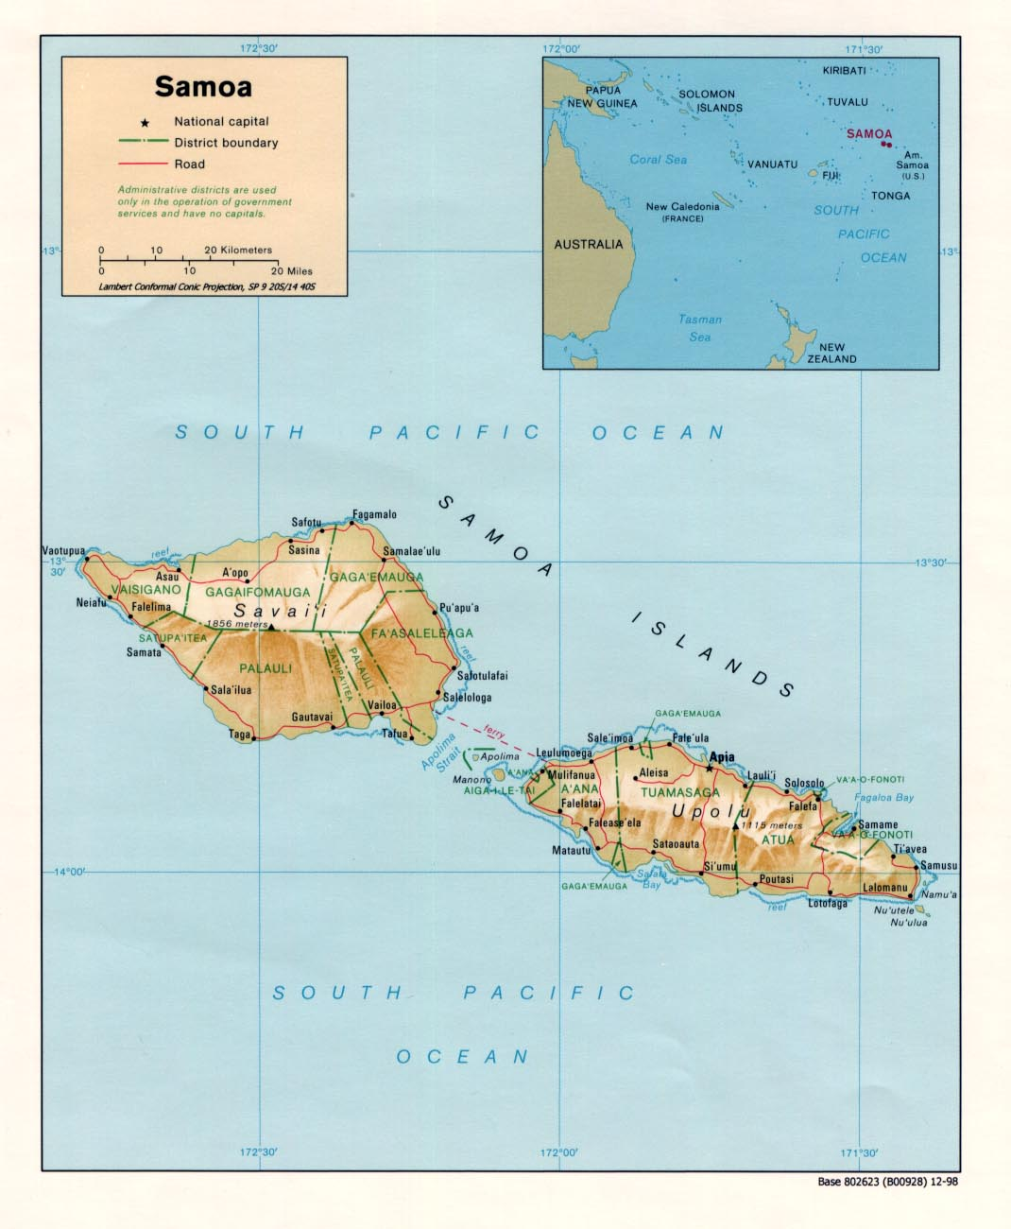

Courtesy of the University of Texas Libraries, The University of Texas at Austin.

3. Hardship, vulnerability and inequality

**3.1. Hardship in the Samoan context**

The term ‘poverty’ frequently elicits negative reactions from policymakers in Samoa, who prefer the term ‘hardship’ to reflect the deprivation characterising the less well-off. Definitions and perceptions of poverty, hardship and vulnerability are discussed in Box 1. Privation is different in Samoa than it is in lower income countries in other regions. Samoans living below the basic needs poverty line are not all experiencing hunger because they do not have access to subsistence agriculture. In greater Apia, for example, food security is an issue with more than half of reported cases of childhood malnutrition at the National Hospital from this area.[21] While pockets of poverty persist, absolute poverty has been largely mitigated by traditional and formal social protection instruments. At the same time, Samoa is experiencing greater prevalence of hardship, as global trends and agricultural shocks have dampened progress in improving livelihoods for subsistence farmers and for households depending on informal sector activity.

Initial analysis of Samoa HIES 2008 reports a 61 per cent reduction in the rate of food poverty (severe hardship) from 2002 to 2008. The country has achieved less progress in reducing basic needs poverty (hardship), with reductions in the urban area of greater Apia (North West Upolu (NWU) and Apia), but increases in rural areas. This is consistent with fieldwork observations, which identified few cases of food insecurity but highlighted increasing concern with diminishing opportunities for improved livelihoods. Figure 2 illustrates the changing geographic profile of hardship (basic needs poverty) from 2002 to 2008. The incidence of hardship did not decrease uniformly across the nation.

**Figure 2. The changing geographic profile of hardship (basic needs poverty) from 2002 to 2008**

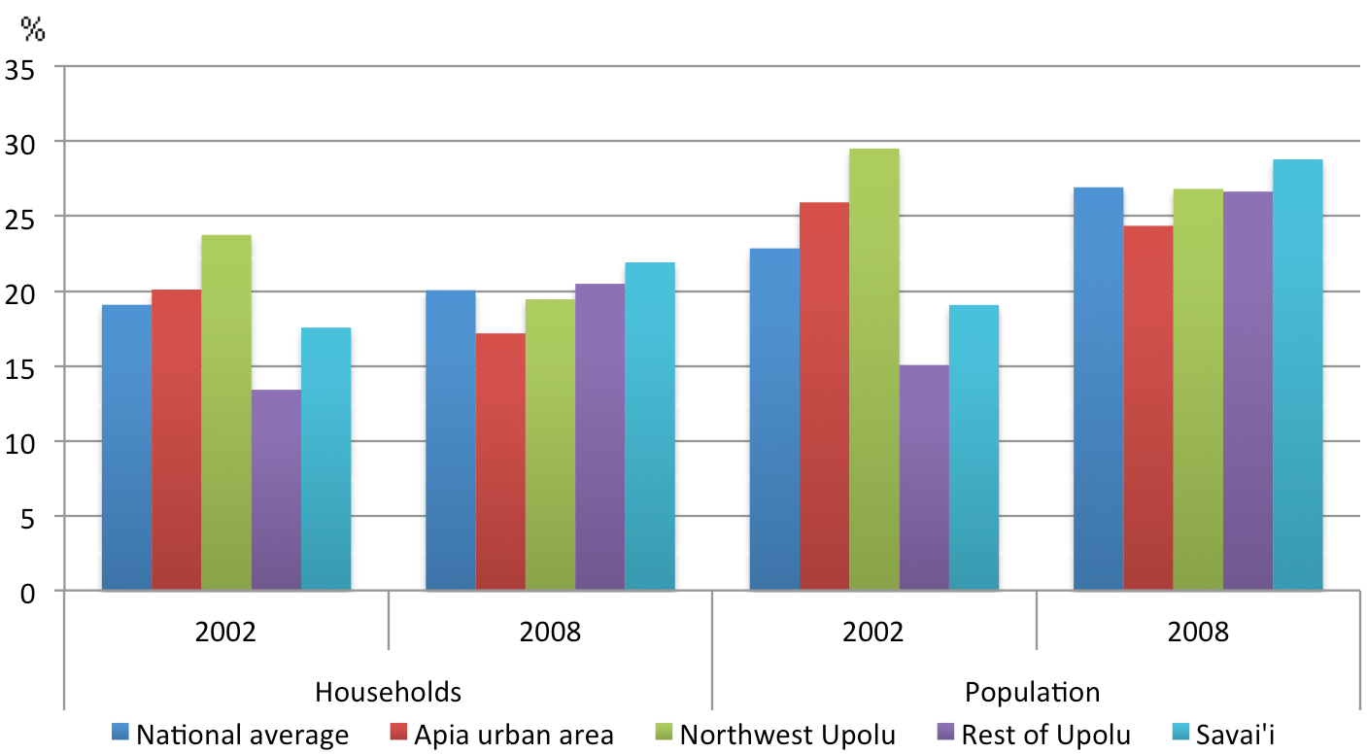

Source: Analysis of 2002 and 2008 household survey data undertaken by this study

|  |
| --- |
| **Box 1: Defining poverty, hardship and vulnerability in Samoa**  Vulnerability can be defined as ‘the inability of certain individuals or groups due to their age, health, social, or economic status to maintain their current welfare because of adverse impacts from multiple stressors, including deterioration of economic conditions or natural hazards, to which they are exposed.’ (ADB 2008)  Samoa’s 2008 HIES adopted the ADB’s definition of hardship—an inadequate level of sustainable human development manifested by a lack of:  > access to basic services such as healthcare, education and clean water  > opportunities to participate fully in the socioeconomic life of the community  > access to productive resources and income-generation support systems (rural credit, capital, markets, skill) to meet the basic needs of the household, and/or customary obligations to the extended family and village community.  Samoa’s HIES 2008 identified elements of hardship in these three major areas: |
| Economic  > unemployment  > limited markets for agricultural production  > limited land cultivation due to lack of able bodied men to work the land continued land disputes |
| Public services  > increased school fees and school dropout rates  > limited access to basic services and infrastructure (such as transport)  Social  > increased alcohol use, drugs and robberies  > increased domestic violence, child abuse, teenage pregnancies and suicides  > erosion of respect for village authorities and parents |

Source: HIES 2008, ADB and AusAID reports, consultations with households facing hardship in Samoa

Figure 3 depicts Samoa’s remarkable progress in tackling severe hardship. The national severe hardship (food poverty) rate fell from 8.5 per cent in 2002 to 3.3 per cent in 2008, a 62 per cent reduction. The larger reductions in severe hardship in the poorest parts of the country tend to moderate overall inequality.

**Figure 3. Samoa’s progress in reducing severe hardship (food poverty) from 2002 to 2008**

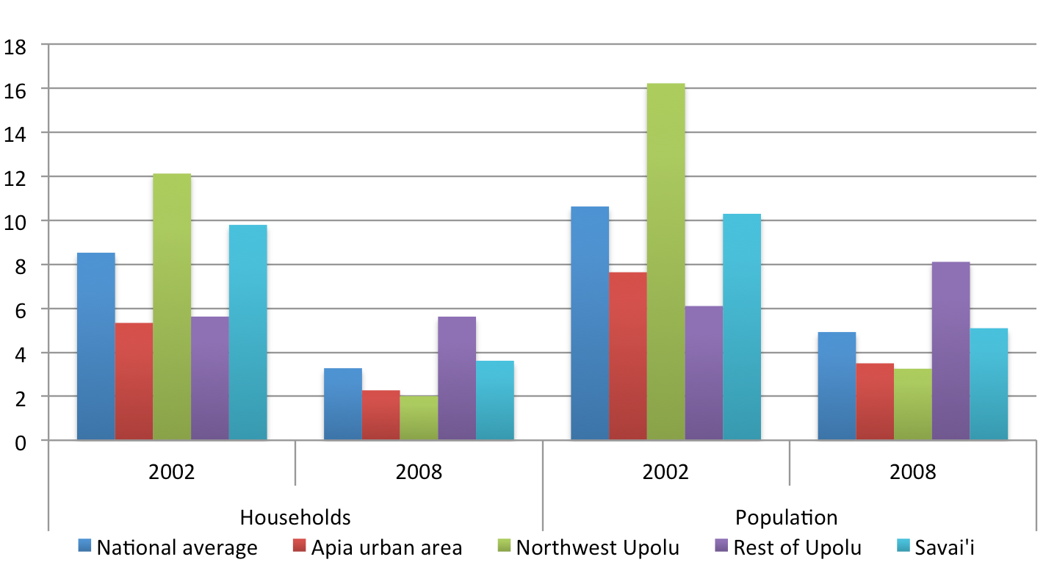

Source: HIES 2002 and 2008

Tackling hardship in Samoa is an increasing challenge with significant migration to urban areas bringing associated problems of unplanned urban growth. From 1991 to 2001 NWU experienced a 35 per cent population increase, attributed largely to rural-urban migration.[22] Recent immigrants to greater Apia (the Apia urban area and NWU) are often unemployed or earn low incomes and may not be able to rely on subsistence agriculture. Unable to afford adequate housing, these people often live in informal settlements that may have limited access to public services.[23] As more Samoans move to the city, these settlements are expanding up the northwest corridor of Upolu.

In Samoa employment is not a guarantee of escaping poverty. The 2002 HIES recorded that 27 per cent of households in the lowest income quintile were headed by someone in formal employment, and that another 41 per cent were in informal employment in farming and fishing.[24] The prevalence of hardship in these households is due to low wage levels, large family size and high dependency ratios and ongoing social/church obligations. Consumption borrowing is widespread in Samoa, a result of the transition to a modern cash economy and what the UNDP characterises as a ‘national appetite for over-consumption’. Banks have reported that many salaried workers have loan obligations that consume their entire pay check.[25]

Looking beyond consumption and expenditure measures, Samoa has made considerable strides in recent years. The current Human Development Index is 0.771, 94 out of 182 countries and on par with middle-income countries like Belize and China.[26] Figure 4 shows the significant improvements made since Samoa’s Human Development Index was 709. Improvement is due to increased life expectancy, rising adult literacy rates, increased enrolment in primary, secondary and tertiary schools, and growth in average income.[27]

The Samoan Government has made a concerted effort to achieve the eight Millennium Development Goals (MDGs) (Annex A). The goals have shaped Samoan Government and foreign donor investments in health and education.

**Figure 4: Samoa’s Human Development Index 1980 to 2007**

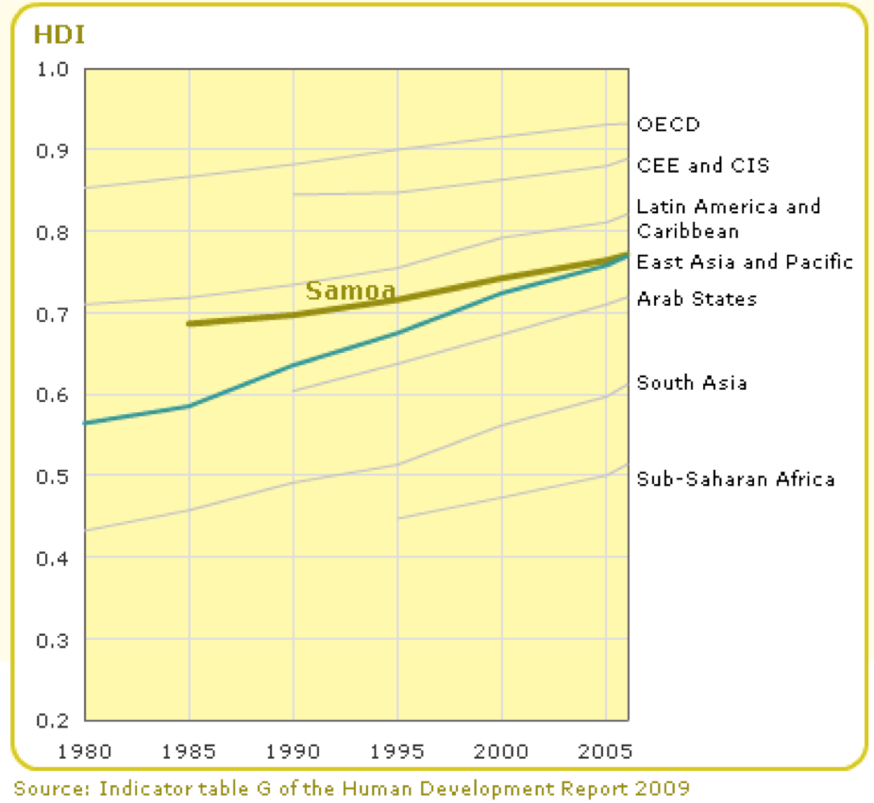

OECD: Organisation for Economic Co-operation & Development; CEE: Central and Eastern Europe; CIS: Commonwealth of Independent States

**3.2. Vulnerable groups**

In Samoa new vulnerabilities are emerging from the transition to a cash economy, urbanisation and changing societal norms. Vulnerable individuals are more likely to be living below the poverty line and may not have access to basic needs and services. They are more susceptible to, and less easily able to recover from, adverse shocks and natural disasters. In Samoa vulnerability is linked to an inability to participate in income-generating activities. Six vulnerable groups were identified through this study—women, youth, children, older people, people living with disability and households in rural areas. These are discussed below.

**3.2.1. Women**

Gender disaggregated data in Samoa’s planning documents and gender relations analysis is limited. However, economic, social and cultural factors promote the ascension and power of men more than women, in public life and at home. Samoa’s socio-political tradition continues to be largely patriarchal, while women’s vulnerability is increasing with the transition to a cash-based economy.

In legal frameworks, Samoan women are assured equality. The Constitution provides for equality for women under law and gives other fundamental rights. The Ministry of Women Affairs Act regulates the Ministry of Women, Community and Social Development, the office responsible for developing gender-related policy. The Public Service Act provides for equal employment opportunity and for appointing and promoting on the basis of merit. The public service offers generous maternity leave. The legal system provides for equal rights to inheritance, though not equal property rights with divorce.

Samoa’s Gender-related Development Index in 2007 was 0.76, ranking Samoa 80 out of 155 countries measured, on par with other countries classified as ‘medium human development’ in Human Development Index rankings.[28] However, international measures fail to capture women’s complicated and changing role in a rapidly evolving culture. Only 22 per cent of households surveyed in the 2008 HIES were headed by a woman. Gender relations in Samoa tend to follow more traditional boundaries in rural areas, where male household heads are usually the primary earner. In urban households incomes tend to be more equally sourced from males and females. The relative representation of men and women by economic activity is shown in Figure 5.

**Figure 5: Percentage of women and men occupied in different categories, 2008**

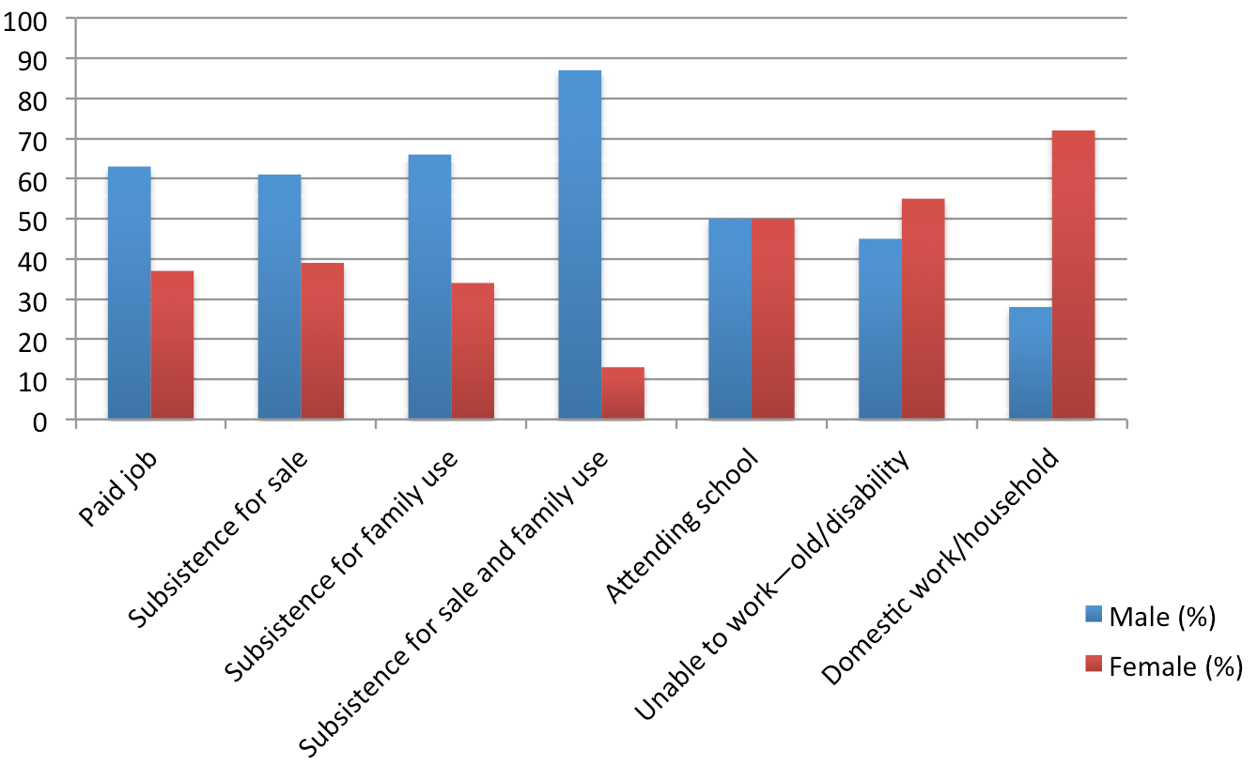

Source: HIES 2008

Women are increasingly vulnerable as Samoa moves to a cash-based economy because they are predominant in the caring economy—family and community work—where there is no cash or in-kind income. Women do the larger part of domestic duties, 70 per cent according to the HIES (2008), and are underrepresented in the labour market, accounting for 37 per cent of full-time paid jobs. This pattern is also reflected in part-time employment where women represent 16 per cent of the part-time workforce (HIES 2008).

The proportion of males and females attending school is almost equal. Slightly more females are unable to work as a result of having disability or old age, due in part to women’s significantly higher life expectancy in Samoa. Males, on the other hand, dominate in all other categories, among them paid employment where men count for more than 60 per cent. Women’s limited role in cash-generating activities restricts their options in Samoa’s increasingly monetised society.

One of the greatest challenges facing Samoa is the high rate of violence against women. According to a World Health Organization (WHO) study, 41 per cent of ever-partnered women in Samoa had experienced physical violence by an intimate partner and 20 per cent had experienced sexual violence.[29] Violence against women is correlated with education. The combined prevalence for physical or sexual violence by a partner for ever-partnered women was 54 per cent for women with only primary education, 45 per cent with secondary education and 35 per cent with higher education.[30]

The Ministry of Women, Community and Social Development works to eliminate sexual harassment and violence against women. Mapusa-o-Aiga, a local NGO, helps victims of domestic violence with counselling and referrals to police, legal aid and health services. Samoa has no specific legislation protecting women against gender-based domestic violence; victims are only protected under the broad 1961 Crimes Ordinance. However, laws explicitly address sexual assault, rape and sexual harassment in the workplace.

Women held only 8 per cent of seats in Parliament in 2008. Since all seats in Parliament, besides two, belong to *matais*[31], it is relevant to quantify the proportion of female *matais*. Women only count for 20.2 per cent of all *matais* (2006 estimate), but this is increasing.[32] While women are increasingly empowered at national level and promised equality under the Constitution, the high rates of domestic and sexual violence illustrate the substantial work needed to ensure women’s most basic right—to live free from violence and harm.

**3.2.2. Youth**

Youth vulnerability is in part a result of Samoa’s young age structure. The most pressing challenge is limited employment opportunities. Youth also face health-related challenges, including mental health and suicide, sexual and reproductive health, and substance abuse. These challenges are compounded by youth marginalisation and voicelessness, as described in a 2008 World Bank-commissioned report on youth in the Pacific. In surveys, youth attribute their challenges to traditional social structures which can be a barrier to participation in decision making.[33]

While youth unemployment is relatively high in any labour market globally, in Samoa it is more than double the total unemployment rate.[34] As of 2006—before the rise in unemployment accompanying the global financial crisis—unemployment among 15 to 24 years was 10 per cent.[35] Samoan unemployment figures may underestimate the real situation because the subsistence sector absorbs excess labour and a large number of young people work as unpaid family workers, a semi-disguised form of unemployment.[36] Across Samoa the high number of inactive young people, particularly males, is problematic. A 2008 World Bank report found that many youth ‘felt that job opportunities were limited with young people unable to find employment that matched their career ambitions and skills’.[37]

Lack of employment opportunities affects youth schooling and causes high-risk behaviours. Secondary school dropout rates have risen, increasing the number with diminished prospects of securing consistent, well-paying jobs. The result is a cycle of socioeconomic inequality. The increasing vulnerability of Samoan youth is evident in the documented rise in suicide, substance abuse, teenage pregnancy, crime and violence.[38] This is particularly true for rural youth in urban areas—if they fail or drop out of school they are often too ashamed to return home, yet they lack a support system in the city.

The Ministry of Women, Community and Social Development’s Division for Youth is the government office responsible for youth issues. It works closely with UN agencies and other NGOs to develop and implement objectives outlined in Samoa’s National Youth Policy. There is limited data and research on youth, but this is a priority issue in the National Youth Policy. The Church also plays an important role in addressing youth vulnerability, as church-related activities and volunteer work are widespread among Samoan youth.

**3.2.3. Children**

Households with children are one group in Samoan society facing the greatest hardship, as highlighted in the UN report *Protecting Pacific Island Children and Women During Economic and Food Crises* (2009). The report found children (and women) faced a potentially ‘very high’ impact from the current economic crisis.[39] In Apia city, households with children less than 5 years of age average a basic needs poverty rate of 27 per cent, compared to 17 per cent for all households in Apia (HIES 2008). This disparity is found in all parts of Samoa.

Childhood malnutrition, once a significant problem, has declined due to intensive food and nutrition education programs but the prevalence of iron-deficiency anaemia remains high among children aged 5 years and younger. Analysis of multiple deprivation indicators and the results of study consultations demonstrate that some children suffer from inadequate access to health and education services, compromising their human capital development and perpetuating an inter-generational transmission of disadvantage.

**3.2.4. Older people**

Older people in Samoa are increasingly vulnerable because of rural-to-urban migration and traditional social structure erosion. Older people rely heavily on family members and collective community assistance. However, this support structure is changing as more young people shift from working in agriculture to cash-generating jobs in urban areas. The effects are seen in the demand for care for older people. The Little Sisters of the Poor and the Catholic Church each provide accommodation for older people in Samoa, however the demand is ‘so overwhelming that some requests have been denied due to lack of facilities’.[40] Particularly vulnerable are older people in rural areas. In a focus group discussion with the Little Sisters of the Poor, Thornton et al. (2010) heard that:

We now have more invalids than sick people. It is expensive to take care of an invalid. In recent years, some of the mentally ill are wandering around, no home and no place to go [though this is rare]; more homeless types . . . In the old days, people used to take care of their own. [41]

While older people in Samoa are increasingly vulnerable, they have greater financial security as a result of the SCBS. This non-contributory pension grants all citizens aged 65 and older an income of $130 tālā a month. The nearly 100 per cent take-up rate indicates the need for the cash transfer. This instrument is discussed in the next chapter.

**3.2.5. People living with disability**

In Samoa there are minimal opportunities for people with disability, a result of lack of access to appropriate services and facilities. This group is more likely to have less than three years of schooling and are unlikely to find paid employment. According to the HIES (2008), approximately 53 per cent of people with disability over 15 years of age have not received formal education. Eight-five per cent of children with a disability live in rural areas and most have never attended school or only done so for limited periods.[42] Only 1.2 per cent of this group is able to earn an income, and fewer women with disability find paid employment.[43] Eighty per cent of women with a disability never marry, limiting inter-familial support options.[44] An increasing number of people are becoming disabled as a result of a rise in chronic illnesses (such as diabetes).[45]

Over the past 20 years, NGOs and individual benefactors have helped people with disability, including by forming the Society for the Intellectually Handicapped, *Loto Taumafai* School for the Disabled and the School for the Blind. There are no government-coordinated social protection interventions for this group, which has been identified as the highest priority for additional social protection interventions.

**3.2.6. Households living in rural areas**

Households in rural Samoa face barriers to developing sustainable livelihoods and improving human capital. Formal employment opportunities are very limited. Transportation and communications infrastructure is far less developed than in urban areas. Rural households largely depend on subsistence agriculture, but have limited or no access to markets for their crops and are being left behind as Samoa transitions to a monetised economy. Rural families are vulnerable to fluctuations in the prices of traditional produce (coconut and copra), which can reduce cash flow dramatically. In Savai’i and rural Upolu, imported foods are likely to be more expensive because of internal transport costs and lower levels of local competition.

Areas of economic growth—commerce, communication, construction and transport—are concentrated in urban areas. Individuals in rural areas have poorer access to government services such as education and health. Dependency ratios can generally predict the likely degree of hardship and vulnerability, and rural dependency ratios are significantly higher than those in urban areas. This indicates that rural areas have fewer people of working age and, as a result, greater burden falls on those who would otherwise be deemed too young to work.

**3.3. Inequality and social cohesion**

Inequality in Samoa manifests itself across the urban – rural divide, but operates at many levels. Samoa’s income inequality is on par with other middle-income countries. The most common measure of income inequality—the Gini coefficient—was 0.47 in 2008. This was an increase of nearly 10 per cent compared to 2002 (0.43).[46] In urban regions, the increase in inequality is more severe. Table 2 reports the changes in the Gini coefficient nationally and for Samoa’s four main geographic regions. Most striking is the 20 per cent increase in the Apia urban area from 2002 to 2008. Regional increases are all proportionally greater than is the national increase.

**Table 2. Gini coefficients for Samoa nationally and by region, 2002 to 2008**

|  |  |  |
| --- | --- | --- |
|  | 2002 | 2008 |
| National average | 0.43 | 0.47 |
| Apia urban area | 0.40 | 0.48 |
| NWU | 0.40 | 0.46 |
| Rest of Upolu | 0.39 | 0.44 |
| Savai’i | 0.41 | 0.46 |

Source: Abbot (2010) using HIES 2002 and 2008

Inequality can also be gauged by analysing the distribution of income and expenditure (Figure 6). The HIES 2008 found that of the four regions in Samoa, NWU had 30.5 per cent of all households in the lowest three expenditure deciles and 31.4 per  cent of the population in the lowest three expenditure deciles.[47] The Apia urban area has the smallest share of low expenditure households (18.7 per cent) and the smallest share of the population in the lowest three deciles (18.5 per cent).

This distribution reflects the nature of urban growth in Samoa, with informal urban settlements spreading up the northwest corridor of Upolu. The Rest of Upolu and Savaii each had approximately 25 per cent of both low-expenditure households and population. While there is higher proportion of the poor in NWU, data analysis and consultations found that households with real hardship live in all four regions.

Food insecurity is unequally distributed, particularly over the urban – rural divide. Subsistence production is important for low-income households, and poor rural households depend more critically on their own production. While nationally the average value of own produced consumption represents 12.5 per cent of average expenditure, in urban areas in and around Apia the percentage is only 4 per cent (HIES 2008).

**Figure 6. Distribution of income and expenditure in Samoa**

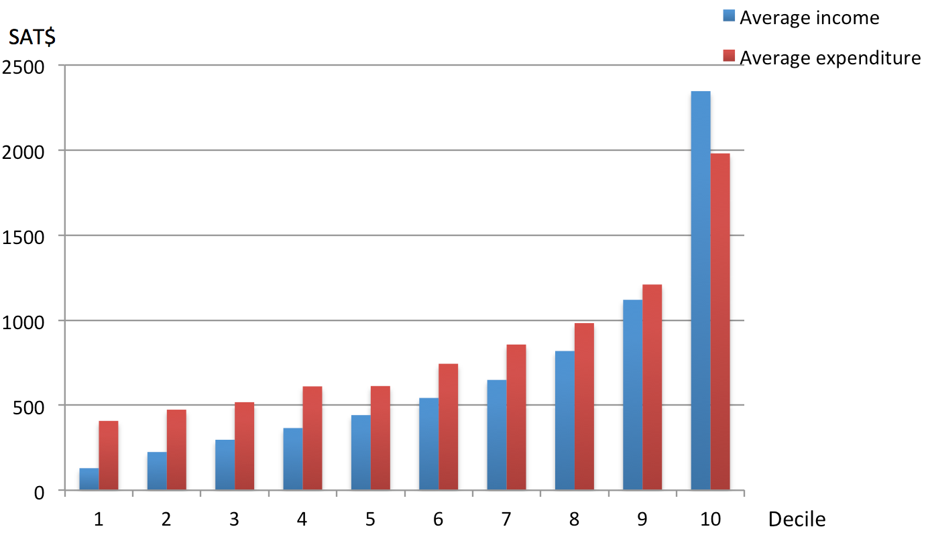

Source: Analysis of 2002 and 2008 household survey data undertaken by this study

Rural to urban migration has concentrated economic activity in and around urban areas, and increased monetisation is widening the gap between those in the cash economy and those depending on traditional subsistence activities. Around 70 per cent of Samoa’s domestic economic activity occurs directly or indirectly in the Apia urban area, which has only 40 per cent of the nation’s population.[48] As a result, the disparity between urban and rural incomes has increased significantly. According to the HIES 2008, the average weekly expenditure in Apia urban areas is $989 tālā , nearly 30 per cent higher than that of the rest of Upolu, with only an average weekly income of $708 tālā. NWU and Savai’i fall in-between. Data on average weekly income demonstrates similar disparities across the urban – rural divide. Income distribution disparities are expected to worsen.

Social cohesion appears to remain relatively strong, as a result of traditional social structures, a cultural emphasis on egalitarianism and the proactive role of government in addressing social challenges. Inequality is potentially reduced by traditional systems obliging better-resourced people to share what they have with their families and communities (discussed in Chapter 3). Customary land ownership provides for a level of equity in villages, preventing land alienation and protecting right of access to a crucial means of subsistence. However, it remains to be seen how strongly traditional egalitarianism will persist.

The Ministry of Internal Affairs plays a central role in strengthening social cohesion and deploys task teams to improve governance relations and address social issues. Consultations between the Ministry for Internal Affairs officials and local leaders and community members on Manono Island informed this research paper. Government officials meet extensively with *matais* and community groups to address governance issues and development priorities. This serves as an important channel for the Government of Samoa to monitor governance and development issues and foster mutual communications with local communities. Discussions with *matais* articulated a constructive, flexible relationship of trust and engagement—the foundation for proactive government interventions supporting social protection and inclusive development as well as building a bond between citizen and state.

Consultations and social policies demonstrate a desire to address the inequality arising with the transition to a cash economy. Assessment of hardship and poverty demonstrates that rural and urban communities share these types of priorities:

> reducing the cost of living

> creating job opportunities

> strengthening skills training programs and support systems (such as access to capital, markets and small business management for unemployed youth)

> ensuring community involvement and cooperation with government representatives in planning and developing policy

> improving access to education to ensure opportunities to earn an income.

Additional urban priorities include access to housing assistance. Rural priorities include accessibility of credit facilities and support for agriculture development in the form of markets, reduced cost of inputs, improved access to basic services and infrastructure (particularly water supply), and road systems.

4. The traditional social protection system

**4.1. Extended family and the *matai*****system**

Samoan traditional systems have remained relatively strong. The customary ways of doing things—*fa’a Samoa*—encapsulates practices, institutions, hierarchies, kinship systems and social protection.[49] *Fa’a* is the major network for socioeconomic sustenance of relatives and maintenance of cultural identity. Vaai (2007) cites Samoan traditional social systems as providing a socially and politically stable environment conducive for economic growth.[50]

The extended family system is the most important contribution to social protection, which is so central to the country’s social structure and way of life that the term ‘informal’ is a misnomer.[51] The extended family is the central unit and organisational structure for traditional social protection. The extended family system consists of several *aiga* (family units), each headed by a *matai* (chief). This hierarchy forms the basis of the *matai* system. Each family group is represented on the village’s ultimate decision-making body, the Council of Chiefs, by its *matai*. Each family is also represented in the *aualuma* and the *a’umaga*, two bodies in the traditional village social governing structure that serve the Council of Chiefs. The traditional role of the *aualuma* is maintaining peace, producing crafts and ensuring cleanliness in the village. The *a’umaga* mainly implements the Council of Chief’s decisions, helps families in need and provides food.

The *matai* system is integral to providing access to land, an important issue due to Samoa’s limited area, population growth and the role of subsistence agriculture. The Council of Chiefs can grant access to land and sea, and approximately 65 per cent of the population derives their livelihoods from *matai* land.[52] The *matai* also oversees land rights and titles, which follow a parental lineage. An important system characteristic is that rights and responsibilities extend to members even when they do not live in the village’s geographic domain. Non-residents may maintain links as a form of social insurance and as a retirement plan. Traditionally, members who have continuously fulfilled their traditional responsibilities can return at any point, request an allocation of land and participate in village life. The role of the *matai* in granting land access and rights contributes significantly to the protection of Samoan’s livelihoods. However, the system faces challenges as more Samoans migrate to urban areas, cutting ties with their *aigas*.[53] Landless households and individuals are most affected by hardship and are emerging as a new public concern.

The *matai* system is strong at rural and village levels where it provides social and financial security and protects the vulnerable. The traditional obligation of the extended family system is to ensure the vulnerable are looked after. The *aiga* in rural Samoa collect cash and food for the *matais* to allocate according to individual needs or for village enterprises, the church and ceremonial activities. In modern Samoa this primarily involves cash from wages and remittances. These social obligations are referred to generally as *fa’alavelave*. The role of collectivism is so strong that Samoans living abroad often continue to contribute to the *matai* system. Remittances are a key component of traditional social protection. Village and church obligations can make extraordinary financial demands on household income, forcing individuals to turn to loans or relatives abroad to meet social expectations.

The *matai* system also plays an integral role in national politics and government. Only two of the 49 seats in Parliament are reserved for non-*matais*. However, the *matai* system faces increasing challenges as Samoans adapt to the modern world. The shift to a more urbanised population has weakened traditionally strong ties to the *aiga* and collective responsibility for the vulnerable. Increased demand for homes for older people demonstrates the shift from collective family and community assistance.[54] Urbanisation is also accompanied by the rapid development of the cash economy and reliance on paid employment. Approximately 52 per cent of the economically active population had paid employment in 2006.[55] Many Samoans struggle with this transition and are able to contribute less to collective social interventions. The traditional system is increasingly under threat.

**4.2. Remittances**

Remittances are part of Samoa’s strong culture of collectivism and duty to family, resulting in Samoans working in the capital or overseas as permanent and seasonal migrants often sending a significant portion of their incomes back to their families. Samoa supplies more than 1000 workers a year to New Zealand under the Recognised Seasonal Employer Scheme. Australia has a similar agreement with Samoa, the Pacific Seasonal Worker Pilot Scheme.[56] A distinguishing pattern in Samoan migration is that emigrants intend to stay in the host country even though they may say they intend to return home.[57]

International remittances represent nearly one-quarter of Samoa’s national income (as measured by GDP) and reach approximately 40 per cent of all households.[58] In 2009, remittances to Samoa from the Samoan communities in New Zealand, Australia, the United States and elsewhere totalled approximately A$181 million. Levels have remained consistently high over the last decade.

Remittances play a critical role in Samoa’s traditional social protection system. Compared with other PICs Samoans rely most heavily on remittances. The project’s consultations with household members underscored the importance of remittances which are the only significant source of cash income for some families in hardship. Samoans in rural areas depend more heavily on remittances than do those living in urban areas. In rural areas access to remittances is increasingly the distinguishing factor between households facing hardship and those that prosper. For all of Samoa, 10.8 per cent of the average weekly income comes from cash and in-kind remittances (HIES 2008). Macpherson (2004) found that for households in Samoa:

… having young wage earners abroad diversified families’ earning streams and reduced their dependence on high-risk activities. Having family members in several locations abroad diversified earning sources and reduced risk levels still further.

Even for families not facing hardship, remittances constitute a key source of income and have been considered largely responsible for strong performance by the commercial sector [59], and a significant proportion are used for business and farm investments (Walker & Brown 1995).

Samoans tend to use remittances for daily expenses and investment, rather than as a source of funds for conspicuous consumption. However, there is limited evidence on the impact of remittance income on recipients’ livelihoods, employment and future income generation. Furthermore, there is evidence that remittances feed back into social and church obligations—Brown and Ahlburg (1999) found that 63 per cent of Samoan households used remittance income for ‘social uses,’ with 41 per cent typically directed to support churches.[60]

Remittance inflows have provided an important economic response to natural disasters. Remittances in the December quarter of 2009, immediately following the tsunami, were approximately $25 million tālā higher than the usual quarterly inflow.[61] Gibson (2010) found that if remittances were well-targeted they would be equivalent to an income replacement of one-third for people in the tsunami-affected region.

Heavy reliance on remittances can put emigrants under great financial stress. This pressure may be a result of Samoan families’ larger household size, as well as the strong cultural role of *fa’a*, with repeated requests for money from the Church, family elders and *matais*. As a result many Samoan emigrants find it difficult to save funds for mortgages and other financial transactions.[62]

Only recently have second and third generations of Samoans grown up in New Zealand and other destination countries. As a result the role of remitting for these generations is unknown. However, there is already some evidence that the links between second-generation Samoans in New Zealand and their kin in Samoa are declining.[63] If new generations abroad move away from collective culture and *fa’a*, and towards the more individualistic cultures in their new countries, there may be a significant impact on remittances and, with that, an impact on a critical component of traditional social protection.

**4.3. The Church**

The Church is central to Samoan culture and contributes to the traditional social protection system. The population is nearly 100 per cent Christian.[64] There is strong societal pressure at village and local levels to attend church and participate in church services and activities. The Church is well positioned to influence village life and larger-scale policy and social protection interventions.

The Church is closely linked to the state and the *matai* system. This can be seen through the practice of government leaders performing dual roles as church leaders. The church plays a central role in people’s lives, especially youth, with participation in church youth groups and church-related volunteer work widespread. A 2008 youth survey found that a majority of young men aspired to be pastors because pastors are highly regarded and likely to be wealthy.[65] Churches’ extensive reach has also been linked to Samoa’s high literacy rates.[66] Like the *matai* system, the Church involves a reciprocal system of gift giving that is increasingly monetised. A 2006 AusAID report estimated that 97 per cent of Samoan households donate to the Church and approximately 17 per cent of household income was spent on church donations.[67] Many Samoans living overseas send regular remittances to the church. Churches and their associations then redistribute some of these funds through community and household levels of outreach. However, a large share of contributions serves church expansion and largely goes towards building and maintaining new churches and church halls[68] and meeting the needs of the pastor and their residence. The *Samoa National Human Development Report 2006* criticised this practice, concluding that:

… ‘huge church buildings constructed from church offerings have always taken precedence over the near-poverty line situation in which church adherents live’ and ‘the church has yet to help the financial situation of individual members of congregations.[69]

The social expectation to donate to the Church can impose a heavy burden on families. Financial contributions are often more than 30 per cent of family income[70] leaving families with not enough money to pay for basic needs.[71] Failing to contribute can result in public shame and embarrassment. The 2006 UN Development Report noted that households failing to meet material expectations could be punished by village councils in ways that were ‘harsh and financially expensive’.[72] The monetisation of church membership in Samoa adds to the burden of those struggling to cope with increasing hardship.

5. Government and non-state social protection programs

The Government of Samoa has several formal social protection programs, with older people the group most comprehensively covered. The largest-scale programs are the country’s two pension programs—the SCBS, providing a universal pension to everyone 65 years of age and older, and the contributory SNPF, providing a compulsory savings scheme for all formal sector employees (public and registered private sector). These state-administered, state-funded programs are supported by legislation with the SNPF, for example, covering approximately 22 000 employed persons, of whom 40 per cent are women.[73] Other major programs include a worker’s compensation scheme for those in the formal sector, free healthcare services and, most recently, a school fees relief scheme.

Anyone employed in Samoa or abroad by an employer having its office in Samoa is required under the SNPF Act to pay contributions to the SNPF. The program is funded with 10 per cent of each employee’s gross salary, with half contributed by the employee and half by the employer (on behalf of employees).[74] The unemployed can pay voluntary contributions—a minimum of $34 tālā and a maximum of $6000 tālā a month. All members are eligible to open a special education fund to cover their children’s educational costs.

Contributors receive annual interest not less than four per cent on the contribution balance at the beginning of each fiscal year. The SNPF had a record $27 million tālā net profit for the financial year ending June 2010, and increased its asset base to $420 million tālā.[75] Each year the fund’s annual report is submitted to Parliament and an electronic copy posted on the fund’s website to ensure accountability and transparency.

SNPF members can withdraw funds once they reach 55 years of age, or if they have been unemployed for five years and are 50, or if they have a permanent residence overseas.[76] The SNPF provides a texting service so members can check their contributions, entitlements and balances from their mobile phones, an efficient way of delivering information in a country with widespread mobile phone coverage and use.

The universal SCBS guarantees an income for all older people in Samoa, for a cost of approximately 1 per cent of GDP.[77] As of June 2010 the scheme reported approximately 8700 pensioners. It is administered by the *National Provident Fund Amended Act* (1990) and financed through public funds. Accounts are audited and reported to Parliament annually. All citizens or permanent residents who have reached 65 years of age are eligible.[78] Pensioners get a pension identification card and can get medicine from the Ministry of Health pharmacy for free and other benefits.

As of July 2010 the SCBS provided a flat-rate monthly benefit of $130, an increase of four per cent from the previous amount. Benefits are disbursed by the third week of each month as a cash payment. Usually, pensioners do not get a pension for the months in which they are out of Samoa for more than 30 days.

Consultations with members of households in Samoa indicate universal awareness and take-up of SCBS and emphasised their central importance in reducing vulnerability in old age. The consultations suggest the value of increasing the size of the benefit (which has diminished recently in purchasing power terms) and extending its coverage by reducing the age of eligibility. Politically, the scheme has elicited public debates over dependency and the need for further improvements.

Samoa has several social protection programs administered in partnership with foreign governments and multilateral agencies. It relies heavily on overseas development assistance; for 2005–06 development assistance was US$52.3 million, with US$35.9 million from grants and US$16.4 million from loans.[79] Over the past decade the four largest donors were Australia, the European Union, Japan and New Zealand, while recently World Bank, Asian Development Bank and China have moved into the top spots. Excluding China, the majority of aid goes through the Government of Samoa.[80]

The School Fee Relief Scheme eliminates all primary school fees, addressing a financial burden for poor families. It is financed by Australia and New Zealand. The Australian Government is also financing a program for children and young adults with disability (2009–14), giving them the opportunity to go to school.

The Government of Samoa, in partnership with the ADB, financed a project (2000–08) for small businesses to generate income and employment in the micro and small-enterprise sector. The project improved access to credit and business development services, and strengthened the business environment by addressing outstanding policy issues. It succeeded in supporting 853 small business operators with loans and provided training to more than 2800 entrepreneurs.[81] However, a 2006 UNDP Financial Sector Assessment questioned the future of microcredit in Samoa, concluding that in most rural areas there are limited opportunities for generating return on investment.[82] Furthermore, micro-enterprise programs can conflict with the *fa’alavelave*. Pressure to meet extended family obligations, and the cultural emphasis on collectivism, can divert resources from investment in micro-enterprises.[83]

The impact of formal social protection interventions depends on design and implementation. Program design is important because sharing wealth in communities can affect an intervention’s impact on poverty and economic growth. Demands by relatives and the community for income and assets will likely interact with social protection interventions, while spillovers could benefit better-off members of the extended family or community at the expense of the vulnerable. To succeed, formal social protection interventions must complement, not crowd-out, traditional social protection. However, there are no studies in Samoa on the interaction between formal social protection and *fa’a Samoa*. This is a critical area for future research, in both Samoa and the larger Pacific region.

Strong governance and effective financial oversight are critical for a formal social protection intervention to translate to real poverty impact and growth. Samoa’s SCBS and SNPF reach a large population without significant delays. This indicates that, perhaps unlike other countries in the Pacific region, Samoa has the administrative capacity necessary to effectively design, implement, deliver and monitor a cash transfer.

6. Health and education services

The Government of Samoa effectively delivers basic health and education services to the vast majority, as reflected across a range of poverty indicators and outcomes. Within the Pacific region, Samoa’s adult literacy rate is second only to that of Fiji and the net enrolment rate for primary school is 97 per cent.[84] Samoa has already achieved two health-related MDGs (reducing child mortality and improving maternal health) and is on track to achieve a third (combating HIV/AIDS, malaria and other diseases). However, progress is needed to ensure access to health and education services—particularly for children—in the pockets of poverty across the country, as well as addressing rural and urban disparities.

**6.1. Education**

Education is a critical means of improving human development. Limited access to education and the impact of school fees are aspects of hardship in Samoa.[85] Public expenditure on education as a percentage of total government expenditures was 13.7 per cent between 2000 and 2007.[86] This figure represented approximately 4.6 per cent of GDP, high by regional and international standards.[87] The Samoan public school system includes 140 primary schools (at least one in every village and on all populated islands) and 24 secondary schools. There are also 27 private or mission primary schools and 17 such secondary schools.

The Samoan educational system faces the persistent challenge of improving enrolment and retention rates. In 2009 approximately 55 000 children were enrolled in primary and secondary school—39 000 at primary level.[88] Education at primary level is compulsory, but one 2006 estimate placed the number of Samoan children who did not go to school at all at 5 per cent, largely in the most remote areas where the ‘link between education and future standards of living is not viewed by all parents as essential’.[89] A more severe problem is retention. The Ministry of Education, Sports and Culture reported a 97 per cent primary school enrolment rate for 2006, with a primary completion rate of 93 per cent.[90]

Boys outnumber girls in the first nine years of school, but with higher dropout rates for boys. The situation reverses in grade 10 and girls outnumber boys in all secondary school grades.[91] At the secondary level 59.6 per cent of the age cohort is enrolled.[92] Differences in net school enrolment rates by household income are an issue at secondary level where 20 per cent more from the top-income quintile enrol compared to the poorest quintile.[93] Only about 40 per cent of children from the lowest wealth quintile enrol in secondary school compared to 64 per cent overall. Thus, more out-of-school children live in households experiencing hardship, limiting their prospects for well-paying jobs and perpetuating the cycle of hardship.

Samoa has proactively addressed the problem of student attrition by implementing the Samoa School Fee Relief Scheme (also known as the Samoa School Fee Grant Scheme). The scheme was launched in January 2010 with Australian and New Zealand support. Before implementation, seven government primary schools did not charge fees and the remainder charged widely divergent fees, with some reaching $300 tālā a year.[94] The Samoan Government directly funds teacher salaries, stationary and teaching supplies. School fees fund administration, maintenance, sports and cultural activities as well as utilities.

The School Fee Relief Scheme makes education free by providing school fee grants to 163 primary schools. All government, special-needs and church schools are eligible for this grant. In 2010 each school received $100 tālā per child to cover school fees.[95] The amount allocated for each school was based on the number of students on the previous year’s roll. The money could only be used to cover expenses previously funded by school fees and not for infrastructure projects, teachers’ salaries or bank loans. Australia has provided A$2 million and New Zealand NZ$1 million to support implementation. The design of the scheme benefited from lessons learned in other Pacific nations with similar schemes.[96]

The School Fee Relief Scheme addressed a key obstacle preventing disadvantaged Samoan children from continuing their schooling. Without the loss of family income, those otherwise unable to afford school could now attend. The scheme is now government priority helping Samoa meet the free education at primary level MDG by 2015.[97]

Other obstacles remain in education, however. In some isolated areas lack of access to reliable transport and poor road conditions force children to walk long distances to school. Access to high-quality schooling is also a challenge with untrained teachers accounting for 23.1 per cent of all primary teachers and a shortage of maths, science and agriculture secondary school teachers.[98] Communities in remote areas without local teachers experience frequent absenteeism of teachers who must travel long distances.[99] Urban schools, which have often best maintained quality standards, are under pressure as more students seek places in them. Many have become overcrowded with class sizes of up to 70 pupils.[100] Another challenge is the mismatch between skills taught and skills needed for employment and livelihood opportunities. The education system also emphasises core academic subjects, which prepare students for white-collar employment. Opportunities are limited for Samoan youth to access technical or vocational training.

To address these types of challenges, the Samoa Government’s 2006–15 education sector development plan identifies six goals, including universal primary education, improved adult literacy, access to life skills and continuing education for adults and youth, the elimination of gender disparities and the achievement of gender equity (as girls are currently performing better than boys).[101] The Education Sector Program plans to improve the quality of curriculums, teachers, teaching materials and infrastructure, building on previous donor support from Australia and New Zealand.[102]

Figure 7 illustrates the percentage of the population in each educational group that corresponds to each labour market category. For example, 60 per cent of people with tertiary education are employed full-time, while only 6 per cent of people with only kindergarten or no education are employed full-time. This highlights the importance of education in building human capital and achieving improved livelihoods.

**Figure 7. Labour market engagement by education level**

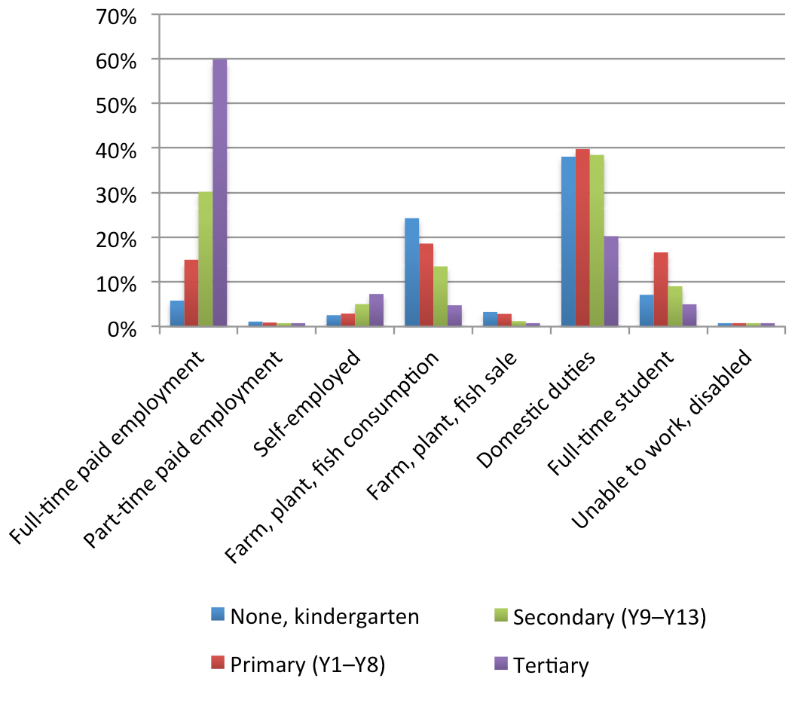

Source: Samoa Bureau of Statistics HIES Survey Tabulation Report (2008), table 1.4, p. 30, <http://bit.ly/wbKME3>

**6.2. Health**

The government provides subsidised primary care through a system of integrated health services delivered in district hospitals and community health centres. It funds the national health scheme from budget revenues and guarantees all residents access to public inpatient and outpatient care. Of all PICs, only Samoa offers state-run sickness insurance and aged-care programs.[103] Health conditions have consistently improved since the country’s Independence, although the transition to an open, modern cash economy has brought new challenges, most notably a rise in obesity.

The Ministry of Health provides primary, secondary, limited tertiary care and public healthcare through a network of facilities, healthcare centres in rural areas and national and district hospitals. Given Samoa’s limited tertiary capacities, the government subsidises overseas specialist care on referral. This absorbs a significant share of public health resources (approximately 14 per cent of the health budget) while only treating 0.1 per cent of the population.[104] While primary care is the backbone of the national health system and a priority in the government’s Health Sector Plan, only 5 per cent of the budget is allocated to primary care.[105] Samoa spent 10.5 per cent of government expenditure on health in 2006.[106] Within Asia and the Pacific, Samoa ranks 27 out of 51 countries in government expenditures on health. Total health expenditures equal approximately 5 per cent of GDP (2005 and 2006 estimates).[107] In comparison, health expenditures equal 4 per cent of GDP in Fiji, 9.4 per cent in New Zealand and 8.7 per cent in Australia.[108]

Although the health sector is dominated by public-funded services, there is a modern private sector. In 2006 the private sector represented 19 per cent of total health expenditures, a decrease from 29 per cent in 2000.[109] There are as many as 900 traditional healers in Samoa and 200 traditional birth attendants.[110] Samoa has decentralised health services. A network of Women’s Committees co-manages rural health facilities, ensuring access for many of the most vulnerable.[111]

Obstacles remain to accessing quality healthcare, however, particularly in rural areas and disadvantaged communities. Lack of reliable transport in isolated villages (for example Uafato) is a barrier to reaching health facilities, and a serious problem for the sick and elderly. Many rural health centres do not have enough medical staff and a study (ADB 2002) found medicines were often not available, with 85 per cent of respondents walking to another location for treatment.[112] Because of differential quality of care, services and facilities in urban areas are stretched.

Progress is needed to make healthcare provision equitable. There is inequality among income groups, with those in the highest income quintile using more resources per capita than the lowest quintile.[113] Urban residents use more healthcare per capita, further evidence of inequality across the urban – rural divide.[114] Another issue is the fees charged by the Women’s Committee’s rural health facilities which vary between members and non-members and potentially affect the most vulnerable citizens’ financial access to health services.[115]

Samoa has achieved the MDG goals of reducing infant, child and maternal mortality rates, although concerns remain about the coverage of pregnancies and the care for mothers in labour and delivery. Child (under 5) mortality decreased from 42 per 1000 in 1990 to 25 per 1000 in 2002.[116] Malnourishment among children also decreased significantly[117] and fertility rates declined from 4.4 in 2001 to 3.4 in 2004.[118] Reasons may be women’s increased educational level, larger female participation in the workforce, migration to urban areas and overseas and/or increased access to, knowledge and availability of family planning methods.

However, there is potential to improve health outcomes. The neonatal mortality rate remains high in Samoa, with 50 per cent of deaths of children under 5 years of age occurring in the first four weeks of life.[119] Preventable diseases among children remain a problem, particularly respiratory conditions, diarrhoea and other infectious diseases.[120] The prevalence of iron deficiency is high among children who are 5 years and younger, and it is estimated that one-fifth of peri-natal mortality and one-tenth of maternal mortality are attributable to anaemia.[121] Particularly concerning is the high rate of sexually transmitted infections.[122]

The leading cause of poor health outcomes in Samoa is obesity, with rates one of the highest in the world, at 53 per cent in 2004.[123] An independent report to the Ministry of Health (2004) described the diet of most Samoans as unhealthy, ‘…contributing significantly to obesity, heart diseases and diabetes’.[124] Rural to urban migration has increased Samoans’ access to unhealthy imported foods, as well as tobacco and alcohol although NCD’s are also a growing problem in rural areas. Changing lifestyle factors and access to cheap western processed food are causing non-communicable diseases (NCDs) such as diabetes, hypertension, cardiovascular disease, cancer and asthma to rise. An estimated 23 per cent of the population had diabetes in 2004, a number that has since increased.[125]

NCDs pressure the delivery of health services and lead to increasing costs for both service providers and the community. This has been exacerbated by demographic changes, with an increasing number of older people facing NCDs.[126] Most primary and public health programs rely heavily on donor funds (between 15 and 20 per cent in 2010).[127] This has potentially critical implications for the sustainability of health projects. However, a well-managed secondary prevention program could help.[128]

Samoa’s Health Sector Plan 2008–12 outlines its approach to improving health sector outcomes, and highlights key health priorities. It identifies lifestyle issues as the high-risk area in which to focus health promotion.[129] However, only 6 per cent of the National Health Account’s budget is used to promote health and prevent diseases (2002–03 estimate).[130]

7. Demographic change

Analysis of the need for social protection in Samoa, and the development of social protection programs, must take into account ongoing demographic changes. Over the past 50 years Samoa’s population has increased substantially, from 97 000 in 1956 to approximately 186 000 today.[131] The rate of natural growth from 2005 to 2010 was 1.8 per cent, above the world average.[132]

Samoa’s life expectancy at birth increased from 68 to 72 years from 1995, and the infant mortality rate fell from 32.7 per 1 000 live births in 1995 to 21.3 in 2009.[133] Life expectancy at birth is expected to rise, up to 80 years by 2050, and the infant mortality rate is predicted to fall further to 7 per 1000 live births.[134] Samoa has recently begun the demographic transition from having high fertility and high child mortality rates to having low fertility and low child mortality rates. Figure 8 illustrates these shifts. Ageing of the population is one significant change expected with approximately 5 per cent of Samoa’s population is currently 65 years or older. This is projected to increase to 14 per cent by the middle of the century.

Samoa’s ongoing demographic transition has important implications for social protection programs. The rising number of older people will increase the fiscal cost of the senior citizen’s benefit in absolute terms. However, even with regular inflation adjustments to maintain the benefit’s purchasing power, the share of national income required to finance the program will fall as long as economic growth (measured as the change in per capita GDP) averages 2.5 per cent or more. Samoa’s economy has grown faster than this over much of the past two decades.

**Figure 8. A comparison of Samoa’s population pyramids from 2010 to 2050**

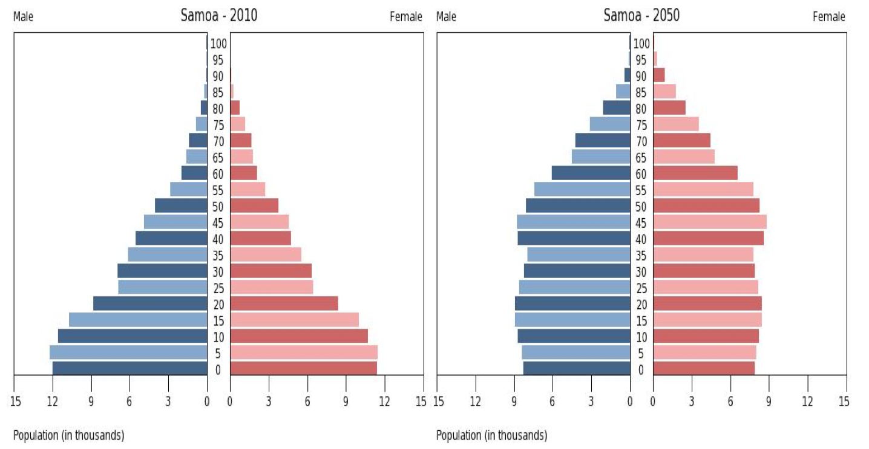

Source: International Census Database (2010)

While the number of older people in Samoa is increasingly significantly, the demographic transition is seeing a larger number of young people. Given Samoa’s young population and current rates of population growth, one of the greatest challenges is job creation. Approximately 66 000 people are active in the labour force (2007 estimates) and the number of people of economically-active age is expected to rise substantially over the next 50 years.

The pressure to provide employment is somewhat alleviated by the crucial role of emigration from Samoa. A history of fairly easy access to Australia, New Zealand and the United States has allowed sustained migration, and an estimated 100 000 Samoans live overseas.[135] The Samoan Government estimated that without emigration the country’s population would have increased by more than 30 per cent in the first decade of the 21st century.[136] Emigration has caused the domestic population to increase more slowly and steadily. It is a safety valve, reducing government pressures to provide employment and welfare.[137] However, as Samoa undergoes its demographic transition, the government will no longer be able to rely on this safety valve at the expense of job creation.

8. Crises and shocks

As a small island country, Samoa is highly vulnerable to natural disasters and global economic crises. The Commonwealth Vulnerability Index, which combines vulnerability to both economic and natural shocks, ranks Samoa among its five most vulnerable states.

Cyclones are the worst external threat, with agricultural production and manufacturing vulnerable because export-oriented manufacturing depends on local agricultural products. They also damage fishing fleets and tourist facilities, both of which depend on the sea. Cyclone Heta (in 2004), for example, caused significant damage to the production of coconut, banana, taro, breadfruit and cocoa. More than 10 000 households reported that Cyclone Heta resulted in food insecurity, while about 8370 had severely reduced incomes.[138]

The costs of natural disasters are expected to rise as extreme climate events associated with climate change increase in frequency and intensity. Over the long term, sea level rise poses a major risk as both the population and economic activity are heavily concentrated along low-lying coastal belts. Even after a tsunami or cyclone, Samoans return to coastal areas, in part due to traditional beliefs that these are ancestral lands.

Samoans facing hardship are the most vulnerable to natural disasters. Subsistence farmers depend more on natural resources for their livelihoods. Disadvantaged Samoans are also more likely to be living in exposed areas with inadequate shelter, and are thus more susceptible to the high winds and flooding associated with cyclones. Analysing villages affected by the 2009 tsunami using Samoa Labour Mobility Survey data, Gibson (2010) found that affected households had an average income significantly lower than the average for other households in Samoa. For Samoans facing hardship, the losses of assets and livelihoods resulting from a natural disaster can be devastating. Unable to generate cash to buy new tools or hire experts to repair damaged fishing boats, means this group may lose their only means of generating income.

Natural disaster preparation and response programs are critical, although as a small, isolated island nation it is impossible for Samoa to guard against all risks from natural disasters. The government’s disaster management response operates at two levels. In the immediate term, a dedicated government unit coordinates international and Samoan resources to provide emergency relief. Over the long term, integrated policy mechanisms provide developmental responses. For example, the government responded to the early 1990s cyclones with a major program of road building and infrastructure repair and upgrading. The government’s response to the 2009 tsunami included rebuilding the homes of affected families and providing funds ($18 000 tālā) for rebuilding.[139] The Office of the High Commissioner for Refugees, the Ministry of Women, Community and Social Development, and the UNDP are monitoring post-disaster displacement and patterns of return, resettlement and local integration in Samoa, working towards durable solutions.[140] There is also a sharper focus on the gendered dimensions of disaster risk management across the Pacific region.[141]

Crises in Samoa are not limited to natural disasters. In the early 1990s the taro leaf blight outbreak severely damaged production of the country’s main staple food, also a key export product. While Samoa coped by substituting less vulnerable varieties, resulting production reduced household incomes and failed to achieve the same level of international competitiveness. The taro blight also resulted in a shift to imported foodstuffs (primarily to rice as a staple), making poorer families more susceptible to rapid increases in imported food and fuel prices.[142]

Samoa has a complex relationship with the world’s economic state. In some ways global links strengthen Samoa’s economy. Greater integration into high-income countries’ labour markets through permanent settlement and seasonal migration provides some access to higher paid work opportunities. Migration can be a risk-management strategy, with some households diversifying the locations of family members overseas. Gibson (2009) finds that migration, on average, increases Samoan households’ consumption and reduces poverty among former household members.

However, links to the world economy can also bring economic vulnerability. The 2008–09 global economic downturn compounded domestic economic volatility, contributing to a contraction of 5 per cent in fiscal year 2008–09, the worst economic decline in two decades.[143] The resulting projected budget deficit—equivalent to approximately 10 per cent of GDP in fiscal year 2009–10—could threaten the provision of basic social services. The combination of large government expenditures and a depreciating currency has contributed to high inflationary pressures, 6.1 per cent in 2009.[144]

The decline in GDP growth rates had domestic origins. High growth rates in 2007 were largely due to construction, with preparations for the 2007 South Pacific Games and several other major building projects.[145] Between September 2005 and December 2007 the rate of annual real growth in the sector averaged 13.2 per cent, but declined to an average rate of –2.2 per cent after March 2008.[146] The global crisis exacerbated the economic slowdown. One example of the downturn’s effect was the September 2009 closure of a tuna cannery in neighbouring American Samoa. This impacted on Samoa’s fish exports and remittance inflows because 87 per cent of the 2000 employees laid off were Samoan migrants.[147] Overall, remittances continued declining into 2009, which continues to have substantial implications.[148]

Concentration of export revenue in a few sectors increased Samoa’s economic vulnerability. Only 12 products account for nearly the entire value of Samoa’s merchandise exports.[149] A highly visible impact was at the Apia factory producing automotive wire harnesses for export to Australia which cut back 70 per cent of its Samoan workforce in the aftermath of the financial crisis.[150] Samoa was also affected by a reduction in the demand for seasonal workers in New Zealand in 2009–10. Another contributor to Samoa’s economic contraction is high world commodity prices, particularly for food and fuel, with the average rate of consumer price index change peaking at 14 per cent in 2008–09.[151] As a result, many Samoans face a decline in living standards.

9. Micro-simulation analysis of potential social protection instruments

To assess the hypothetical potential of social protection interventions to reduce hardship and inequality, a micro-simulation model of Samoa tested combinations of two common cash transfer instruments (a child benefit and a pension), with varying benefit levels. The model employed the 2008 HIES, calibrated with a poverty line equal to the basic needs poverty line documented in the HIES main report.

In 2008 purchasing power terms, the per capita poverty line equates to $53.59 tālā a week. The poverty line represents approximately 35 per cent of per capita income. Based on an analysis of the weighted sample in the 2008 HIES, in the absence of Samoa’s social pension, an estimated 21 per cent of households fall below this poverty line. The total money poverty gap represents approximately 2.5 per cent of national income (as measured by GDP). In other words, it would require 2.5 per cent of GDP perfectly targeted to Samoa’s poor households to eliminate poverty, given the hypothetical and static scenario of providing all poor households with enough money to raise consumption levels to the poverty line.

At the time of the HIES, the Government of Samoa provided a social pension of $130 tālā a month to each person 65 years of age or older. Household interviews and stakeholder consultations conducted for this study suggested close to 100 per cent take-up rate for this benefit. Assuming complete coverage of the age-eligible group, based on the demographic and poverty profile in the 2008 HIES, this cash transfer reduces Samoa’s national poverty gap (measured in money terms) by 9.4 per cent, from 2.5 per cent of national income (measured by GDP) to 2.3 per cent. The social protection benefit costs approximately 1 per cent of GDP, excluding administrative costs. The estimated poverty-reducing efficiency of the benefit (without adjusting for administrative costs) is 22 per cent. That is, for every $100 tālā of benefits provided, the national poverty gap falls by $22 tālā . Since a large proportion of households are clustered around the poverty line in Samoa, the pension also is efficient in increasing household resilience, reducing the likelihood households will fall into poverty in the face of a shock.

The social pension also reduces the number of people in poverty by 4 per cent and lowers the household poverty rate from 20.9 per cent to 20.1 per cent—nearly 1 percentage point. Approximately 30 per cent of households in Samoa include a person 65 years or older, and in the absence of the social pension these households tend to be somewhat poorer than average. The social pension reduces the poverty rate of these households from 21.2 per cent to 18.4 per cent, a reduction of 15 per cent. The poverty rate for households with people 70 years of age and older reduces even more, by 17 per cent. Households with children under 5 years of age and people older than 60 years of age represent the poorest group and the social pension reduces the poverty rate for these households from 31.0 per cent to 28.9 per cent, a reduction of 7 per cent.

This research paper assesses the impact of five hypothetical social cash transfer scenarios. The first three combine child benefits and social pensions with the transfer amounts set at relatively low, moderate and high levels respectively. The fourth models the high child benefit and the fifth the high social pension.

Table 3 reports the corresponding benefit levels. For example, the low social protection package provides a child benefit equivalent to 10 per cent of the poverty line (equivalent to $6 tālā a week in 2010 and $5.36 tālā in 2008) and a social pension set at 25 per cent of the poverty line (equivalent to $15 tālā a week in 2010 and $13.39 tālā in 2008). The mid package doubles these benefit levels. The high package provides a child benefit equivalent to 30 per cent of the poverty line and a social pension set at 100 per cent of the poverty line. The low package would cost an estimated 0.9 per cent of national income (as measured by GDP) in 2010, less than what three-quarters of developing countries spend on social protection. The mid package would cost an estimated 1.8 per cent of GDP, within the inter-quartile range for developing countries. The high package would cost 3.2 per cent of GDP, comparable to the spending levels of the most generous developing countries. The child benefit scenario costs 1.4 per cent of GDP and the social pension scenario costs 1.8 per cent of GDP, both within the inter-quartile range for developing country social protection spending.

**Table 3. Benefit levels and costs for the modelled social protection scenarios**

|  |  |  |  |  |  |
| --- | --- | --- | --- | --- | --- |
| **Social protection poverty impact** | **Low social protection package** | **Mid social protection package** | **High social protection package** | **High child benefits only** | **High social pension only** |
| Child benefit (% of poverty line) | 10 | 20 | 30 | 30 | – |
| Social pension (% of poverty line) | 25 | 50 | 100 | – | 100 |
| Child benefit (2010 value) | 6 | 12 | 18 | 18 | – |
| Social pension (2010 value) | 15 | 30 | 60 | – | 60 |
| Child benefit (2008 value) | 5.36 | 10.71 | 16.07 | 16.07 | – |
| Social pension (2008) value) | 13.39 | 26.79 | 53.57 | – | 53.57 |
| Cost as % of GDP (2008) | 1 | 2 | 3.6 | 1.5 | 2 |
| Cost as % of GDP (2010) | 0.9 | 1.8 | 3.2 | 1.4 | 1.8 |

Source: Samson 2012

These five scenarios demonstrate substantial potential impacts for poverty reduction, and Table 4 reports overall impacts. The low benefit scenario reduces the household poverty rate by 4.4 per cent (to 20 per cent) and reduces the poverty gap by 10.3 per cent. The mid and high scenarios yield commensurately greater impacts, with the ‘high’ scenario reducing Samoa’s poverty gap by 31.6 per cent. The child benefit alone, while costing less than the social pension, reduces the poverty gap by 17.9 per cent, compared to the social pension’s impact of a 14.8 per cent reduction. For all scenarios, the percentage reduction in the poverty gap is about twice the percentage reduction in the household poverty rate. The poverty gap indicator reflects a greater sensitivity to social transfer interventions because much of the impact of these programs occurs well below the poverty line.

**Table 4. Overall poverty impacts and poverty-reducing efficiency**

|  |  |  |  |  |  |
| --- | --- | --- | --- | --- | --- |
| **Social protection poverty impact %** | **Low social protection package** | **Mid social protection package** | **High social protection package** | **High child benefits only** | **High social pension only** |
| New household poverty rate | 20 | 18.8 | 17.2 | 19.2 | 19.4 |
| Reduction in poverty rate | 4.4 | 10.0 | 17.7 | 8.2 | 7.2 |
| New poverty gap | 2.2 | 2 | 1.7 | 2 | 2.1 |
| Reduction in poverty gap | 10.3 | 19.9 | 31.6 | 17.9 | 14.8 |
| Poverty-reducing efficiency | 28.0 | 27.1 | 24.5 | 32.7 | 20 |
| Pro-poor index (100% = neutral) | 134 | 130 | 118 | 156 | 96 |

Source: Samson 2012

Poverty-reducing efficiency can be defined as the reduction in Samoa’s poverty gap per unit of expenditure on social transfers. The poverty-reducing efficiency demonstrated by these five scenarios is relatively low due to the low official poverty rate used to construct this indicator. The highest indicator is associated with the child benefits only scenario. For every $100 tālā spent on child benefits, Samoa’s poverty gap is reduced by $33 tālā.

The pro-poor index is constructed by dividing poverty-reducing efficiency by the national household poverty rate. A universal benefit will have an index value of 100 per cent, representing neutrality in pro-poor impact. The more the index value exceeds 100 per cent, the greater the pro-poor impact. Nearly all scenarios demonstrate a significant pro-poor impact, with the child benefits only scenario reflecting an index value of 1 56 per cent. That is, this scenario provides the greatest proportion of transfers to poor households.

These social protection interventions yield greater impacts on the households of the vulnerable groups targeted, which on average are poorer than the average household in Samoa. For example, households with children under 5 years of age have an average poverty rate of 23.8 per cent, 14 per cent higher than the poverty rate for all households. The child benefits only scenario reduces the poverty gap of households with young children by 20.4 per cent, compared to an average poverty gap reduction for all households of 17.9 per cent. The social pension alone has a substantial impact on households with young children, reducing the average poverty gap by 14.8 per cent.

**Table 5. Impacts of social protection interventions on households with children under 5 years of age**

|  |  |  |  |  |  |
| --- | --- | --- | --- | --- | --- |
| **Demographic poverty impact analysis for households with children under 5 years of age** | **Low social protection package** | **Mid social protection package** | **High social protection package** | **High child benefits only** | **High social pension only** |
| New poverty rate | 22.7 | 21.5 | 19.7 | 21.8 | 22.2 |
| Reduction in poverty rate | 4.4 | 9.5 | 17.3 | 8.3 | 6.6 |
| Poverty gap of poverty line | 8.5 | 7.5 | 6.3 | 7.6 | 8.1 |
| Reduction in poverty gap | 10.9 | 21.3 | 33.9 | 20.4 | 14.8 |

Source: Samson 2012

Likewise, these social protection interventions yield greater impacts for households that include people 65 years and older (Table 6). These have an average poverty rate of 21.2 per cent, and an average poverty gap indicator equivalent to 8.1 per cent of the poverty line. The high social pension only scenario reduces the poverty gap of households with older people by 36.5 per cent, compared to an average poverty gap reduction for all households of 14.8 per cent. The high child benefits only scenario has a more substantial impact on households with older people, reducing the average poverty gap by 15 per cent. The combination scenarios also yield greater impacts for older people than for all households. For example, the high social protection package reduces the poverty gap for households with older people by 48.8 per cent, compared to a 31.6 per cent reduction for all households.

**Table 6. Impacts of social protection interventions on households with people 65 years and older**

|  |  |  |  |  |  |
| --- | --- | --- | --- | --- | --- |
| **Demographic poverty impact analysis for households with people 65 years and older (%)** | **Low social protection package** | **Mid social protection package** | **High social protection package** | **High child benefits only** | **High social pension only** |
| New poverty rate | 19.9 | 17.6 | 13.6 | 20.2 | 16.2 |
| Reduction in poverty rate | 6.1 | 16.9 | 35.7 | 4.6 | 23.6 |
| Poverty gap of poverty line | 6.9 | 5.8 | 4.2 | 6.9 | 5.2 |
| Reduction in poverty gap | 15.2 | 29.3 | 48.8 | 15.0 | 36.5 |

Source: Samson 2012

Individuals in the poorest 10 per cent of households in Samoa spend on average only 6.2 per cent what those in the wealthiest 10 per cent of households spend (on a per capita basis). The social protection benefits modelled in these scenarios increase the spending of poor households relatively more than the spending of wealthier households (expressed as a percentage of pre-transfer household spending). As a result, the interventions reduce inequality measured on an income or expenditure basis.

Table 7 documents the impacts on a number of indicators, reflecting changes in inequality measured using the distribution of per capita expenditure. The low social protection package raises the ratio of the poorest to the richest decile’s expenditure to 6.4 per cent, an increase of 4 per cent. The mid and high scenarios yield commensurately greater impacts. The high child benefits only scenario improves this ratio by 8.3 per cent, compared to a 4.9 per cent improvement from the high social pension only scenario. The high social protection package scenario increases the spending of the poorest decile by 14.3 per cent, while it increases the spending of the wealthiest decile by only 1.1 per cent. The impact on the poorest households is 13 times greater.

**Table 7. Impact of social protection interventions on inequality and expenditure distribution**

|  |  |  |  |  |  |
| --- | --- | --- | --- | --- | --- |
| **Distributional analysis of social protection (%)** | **Low social protection package** | **Mid social protection package** | **High social protection package** | **High child benefits only** | **High social pension only** |
| Post-transfer poorest: richest decile per capita spending) | 6.4 | 6.6 | 7 | 6.7 | 6.5 |
| Change in poorest: richest spending ratio | 4 | 8 | 13.1 | 8.3 | 4.9 |
| Change in spending of poorest decile | 4.3 | 8.6 | 14.3 | 8.5 | 5.8 |
| Change in spending of richest decile | 0.3 | 0.6 | 1.1 | 0.3 | 0.8 |

Source: Samson 2012

The potential impacts quantified in this section make strong assumptions about the absence of micro-level behavioural response to the modelled cash transfer interventions. In particular, the model assumes no increase in household savings from the cash transfer income, and that remittances to poor households (private transfers) do not change after receipt of social cash transfers. These are heroic assumptions, and the poverty impacts may be significantly lower in the face of actual behavioural responses. However no research on Samoa has quantified the likelihood or likely magnitude of these kinds of behavioural responses to cash transfers. This type of study would significantly improve the policy relevance of this micro-simulation analysis. International evidence, however, documents significant poverty reduction impacts from social cash transfer programs around the world.[152]

10. Conclusions and recommendations

While Samoa has implemented important and effective social protection interventions over the past 10 years, the country would benefit from further reforms and innovations. This report makes the following recommendations:

> The SCBS represents a key instrument for tackling hardship in a group that is important to Samoan society. While this benefit has faced political controversy recently, it should be recognised as a pillar of social protection and maintained. The practice of adjusting its value in the year before national elections should be replaced with an annual inflation-linked adjustment process.

> The Government of Samoa should consider a benefit for people with disability, building on the successful implementation of its SCBS.

> Given the concerns expressed by key government stakeholders about dependency and the prospect of negative economic impacts, development partners should support a rigorous quantitative evaluation of Samoa’s cash transfer programs (the SCBS and subsequently implemented interventions). This will inform policymakers in Samoa about social protection’s contribution to socioeconomic development, and provide useful lessons for governments in the Pacific region, particularly for other countries with (or considering) social protection programs.

> Hand-in-hand with the extension of core social protection benefits, the Government of Samoa should ensure continued improvement in the quality of vital social services, particularly healthcare, education and water and sanitation in more remote rural areas.

Annex A: The Millennium Development Goals

|  |  |  |  |
| --- | --- | --- | --- |
| **Millennium Development Goals** | | | **Progress and key achievements** |
| Goal 1 | Eradicate extreme hunger and poverty | Target 1: Reduce by half (between 1990 and 2015) the proportion of people whose income is less than $1 a day.  Target 2: Reduce by half (between 1990 and 2015) the proportion of people who suffer from hunger. | **Unlikely to meet the goal**  Low level of food poverty but the incidence of basic needs poverty (as a % of total population) has increased. |
| Goal 2 | Achieve universal primary education | Target 3: Ensure that by 2015 all boys and girls complete a full course of primary schooling. | **Will potentially meet goal**  Free primary education for all from January 2010, but progress to be made with retention rates. |
| Goal 3 | Promote gender equality and empower women | Target 4: Eliminate gender disparity in primary and secondary education preferable by 2005, and in all levels of education no later than 2015. | **Will potentially meet goal**  The combined primary gross enrolment ratio for primary, secondary, and tertiary schools was 67.2% for females and 59.7% for males in 2001. |
| Goal 4 | Reduce child mortality | Target 5: Reduce by two thirds (between 1990 and 2015) the under-5 mortality rate. | **Goal already achieved**  The under-5 mortality rate fell from 50 per 1000 live births in 1990 to 26  per 1000 in 2008. |
| Goal 5 | Improve maternal health | Target 6: Reduce by three quarters (between 1990 and 2015) the maternal mortality ratio. | **Goal already achieved** |
| Goal 6 | Combat HIV/AIDS, malaria and other diseases | Target 7: Have halted and begun to reverse the spread of HIV/AIDS by 2015.  Target 8: Have halted by 2015, and begun to reverse, the incidence of malaria and other major diseases. | **On target to meet goal**  On track with universal access to HIV/AIDS treatment and reducing NCDs, but off track in HIV prevention. |
| Goal 7 | Ensure environ-mental sustain-ability | Target 9: Integrate principles of sustainable development into country policies and programs; reverse the loss of environmental resources.  Target 10: Halve the proportion of people without access to safe drinking water and basic sanitation. | **Will potentially meet goal**  More progress to be made with access to safe drinking water. |

Source: UNDP

Annex B: Formal social protection instruments in Samoa

|  |  |
| --- | --- |
| **Program name** | **Samoa National Provident Fund** |
| **Program objective** | To save and provide for quality retirement while stimulating wider economic activity for members and Samoa. |
| **Program start** | Started in 1972 with the SNPF Act. |
| **Program description** | Old age benefits  > A fund member has three benefit options: (i) a monthly pension based on total insured person and employer contribution plus interest; (ii) a monthly pensions based on 75% of total insured person and employer contributions plus interest with the remaining 25% paid as a lump sum; or (iii) a lump sum equal to the full amount in their account taken at 55 years of age.  > Drawdown Payment: Up to 50% of the total insured person and employer contributions may be drawn down. Payment is repaid as a loan at an annual interest rate of 11%. If used for building a house, the loan must be at least $50 000 tālā.  Permanent disability benefits  > Disability pension has three benefit options: (i) a monthly pension based on total employee and employer contributions plus interest; (ii) a monthly pension based on 75% of total employee and employer contributions plus interest with the remaining 25% paid as a lump sum; or (iii) a lump sum equal to the full amount in their account taken at 55 years of age.  Survivor benefits  > Survivor pension: 50% of the deceased’s monthly pension is split among named survivors to proportions stated by the deceased.  > Death benefit: A lump sum of $5000 tālā is paid. |
| **Program coverage** | Employed persons, including households workers Voluntary coverage for self-employed persons |
| **Beneficiary determination process** | Old-age pension  > 55 years of age and retired from covered employment. If covered employment continues after 55 years of age the member must continue to make contributions. Early withdrawal allowed at 50 years of age if unemployed for 5+ years. If new employment is found after early withdrawal the member must contribute for 12 months before withdrawing any further.  Disability pension  > Must be deemed incapable for employment. A general medical practitioner assesses the disability.  Survivor pension  > Paid for the death of the fund member. Eligible survivors are the spouse, children or siblings.  Death benefit  > Paid for the death of the fund member before 55 years of age. Fund member must have been an active contributor at the time of death. Eligible survivors include spouse, children and siblings. |
| **Finance** | Insured person  > 5% of gross monthly income (additional voluntary contributions are allowed without a limit).  Employer  > 5% of monthly payroll.  Self-employed person  > Voluntary contributions only, with a minimum of $34 tālā and a ceiling of $6000 tālā a month.  Government  > None—contributes as an employer.  Contributions and benefits  Tax-free.  Annual interest rate  > Not less than 4% on the contributions balance at the beginning of the financial year. |
| **Administrative framework** | The SNPF, managed by a tripartite board, administers the scheme. |
| **Program name** | **Senior Citizen Benefit Scheme** |
| **Program start** | Started in November 1990, amount of benefit increased periodically since. |
| **Program description** | > The current pension is $130 tālā per month or $1560 tālā a year, effective since July 2010.  > Payments in cash by the third week each month.  > Medicine free from the Ministry of Health pharmacy and free travel on the ferry between the islands of Upolu and Savai’i. |
| **Program coverage** | Universal for Samoan Citizens aged 65 years or older residing in Samoa with 8700 beneficiaries as of June 2010. |
| **Beneficiary determination process** | > A Samoan citizen or a permanent resident aged 65+.  > If the Samoan citizen turned 65 while overseas they must reside continuously in Samoa for 90 days to be eligible to register under the scheme (with exceptions for those overseas on government missions).  > The citizen is not entitled to the pension during months when they are abroad.  > Beneficiaries issued a pension a pension identification card once they are registered. An original copy of the birth certificate and a valid Samoan passport are required for registration. |
| **Finance** | > Government pays the entire cost. Financed through taxes.  > Cost is approximately 1% of GDP. |
| **Legal framework** | > The program is legislated; periodically amended.  > Funded from Public Funds approved by Parliament under the Ministry of Finance Budget of Output Transaction on behalf of the state.  > The accounts of the SCBS are audited and reported to Parliament annually. |
| **Administrative framework** | Administered by the SCBS Department of the SNPF. |
| **Program name** | **Accident compensation** |
| **Program overview** | Employer-liability system involving compulsory insurance with a private carrier. |
| **Program objective** | Provide employees with security against work-related accidents and medical-related shocks. |
| **Program start** | First law in 1960, with additional laws and amendments in 1978, 1989 (accident compensation) and 2003 (amendment). |
| **Program description** | Temporary disability benefits  > 70% of the insured’s earning is paid for up to five years and the benefit period may be extended. Maximum weekly benefit is $400 tālā.  Permanent disability benefits  > If the assessed degree of disability is at least 80%, then the weekly benefit is equal to 70% of the insured’s last earnings multiplied by the assessed degree of disability. Benefit is paid until rehabilitation or death. Maximum weekly benefit is $400 tālā.  Partial permanent disability  > If the assessed degree of permanent disability is less than 80% and the injured person returns to work before the period of entitlement to temporary disability benefits ceases, up to $8000 tālā as a lump sum is paid according to the assessed degree of disability.  Workers’ medical benefits  > Reasonable medical expenses.  Survivor benefits  > Survivor grant: A lump sum of $20 000 tālā is paid to dependents. Up to $200 tālā weekly is also paid for up to four years.  > Funeral grant: $2000 tālā is paid for a death caused by a work-related, motor vehicle or boat accident. |
| **Program coverage** | Employed persons—self-employed persons excluded. |
| **Beneficiary determination process** | Work injury benefits—no minimum qualifying period. |
| **Finance** | Insured person  > None for work related-injuries; 1% of earnings for non-work related injuries.  Employer  > 1% of payroll for work-related injuries.  Earmarked tax  > $0.05 tālā per gallon on motor fuel finances benefits for victims of motor vehicle and boat accidents. |
| **Administrative framework** | Labour Department provides general supervision. Accident Compensation Corporation administers the program. |
|  |  |
| **Program name** | **Samoa school fee grant system** |
| **Program overview** | Eliminates school fees by providing cash grants directly to schools  Implemented to achieve the MDG goal of free universal primary school education. |
| **Program objective** | > Economically disadvantaged students are able to continue their schooling without the threat of withdrawal due to loss of family income.  > Poor students who otherwise were unable to afford schooling will attend as part of the Government of Samoa’s commitment to the MDGs of free education at primary school level. |
| **Program start** | Started in January 2010. |
| **Program components** | Free education for more than 38 600 primary-aged children through the provision of school fee grants to 163 schools throughout Samoa. |
| **Program coverage** | All government, special-needs, and church primary schools in Samoa (private schools are excluded). |
| **Finance** | 163 primary schools given $100 tālā per student  > based on school enrolment for the previous year  Funded by Australia and New Zealand  > A$2 million from AusAID  > NZ$1 million from New Zealand Agency for International Development |
| **Administrative framework** | Government of Samoa |

Annex C. Partial consultation record

| **Name** | **Organisation** | **Position or responsibility** |
| --- | --- | --- |
| Sovala Agaiava | Ministry of Internal Affairs | Project Officer |
| Manabu Aiba | Japan International Cooperation Agency, Samoa Office | Resident Representative |
| Elena Alnuu | Ministry of the Prime Minister | Principal Analyst |
| Maulolo Amosa | Ministry of Internal Affairs | Assistant Chief Executive Officer |
| Louisa Apeli | Ministry of Women, Community and Social Development | Acting Chief Executive Officer |
| Marie Bentin | Ministry of Education | Policy, Research and Planning |
| Maeva Betham-Vaai | World Bank Group – ADB Joint Liaison Office | Liaison Officer |
| Frances Brebnew | Ministry of Health | Registrar Health Professions |
| Chris Chamberlin | World Bank and AusAID (consultant) | Consultant |
| Vaosa Elisaia | Ministry of the Prime Minister | Chief Executive Officer |
| Afamasaga Faamatala | Ministry of Internal Affairs | Consultant+D29 |
| Roina Faatauvaa-Vavatau | Samoa Umbrella for Non-Governmental Organisations | Chief Executive Officer |
| Mehdi Kamyab | UNDP, Multi Country Office Samoa | Program Coordinator (Interim) |
| Maria Kerslake | National University of Samoa | Professor (Sociology) |
| Si’ili’ili Aumua Isaia Lameko | Ministry of Commerce, Industry and Labour | Assistant Chief Executive Officer |
| Sunhwa Lee | ADB, Pacific Operations Division, Pacific Department | Senior Social Development Specialist (Gender and Development) |
| Pugaelo Lene (Spiki) | Ministry of the Prime Minister | Principal Policy Analyst |
| Fuimauno Falafa Lima | Development Bank of Samoa | General Manager |
| Justin Locke | UNDP, Multi Country Office Samoa | Development Specialist and Regional Program Manager |
| Rumanisine Mahe | Ministry of Health | Corporate Services (Assistant Chief Executive Officer) |
| Leilani Matalavea | Ministry of Health | Information and communications |
| Malaeulu Lose Niumata | Accident Compensation Corporation | General Manager |
| Andrew Peleu | Ministry of Health | Health Promotion and Prevention (Assistant Chief Executive Officer) |
| Esther Lameko Poutoa | SNPF | Chief Executive Officer (National Provident Fund and Senior Citizen’s Benefit) |
| Trevor Saaga | UNDP, Multi Country Office Samoa | Project Officer |
| Frances Soon Schuster | AusAID | Development Cooperation |
| Noumea Simi | Ministry of Finance | Assistant Chief Executive Officer |
| Pelenatete Storeus | Ministry of Health | Assistant Chief Executive Officer |
| Sarah Faletoese Su’a | Ministry of Health | Strategic development and planning (Assistant Chief Executive Officer) |
| Laupua Tapuai | Statistical department | Assistant Chief Executive Officer (HIES) |
| Dr. Robert Thomsen | Ministry of Health | Health Service Performance and Quality Assurance (Assistant Chief Executive Officer) |
| Palanitina Toelupe | Ministry of Health | Director General (Chief Executive Officer) |
| Allison Woodruff | ADB, Pacific Operations Division, Pacific Department | Economist |
| Heather Wrathall | AusAID | Education |

11. References

Abbott, D 2010, *Samoa Social Protection Analysis: Summary of Tabulations from 2008 HIES*, prepared for this research paper.

Abbott, D & Pollard, S 2004, *Hardship and Poverty in the Pacific,* Pacific Studies Series, ADB.

ADB 2002, *Priorities of the People: Hardship in Samoa 2002,* Manila, Philippines.

ADB 2009, *Samoa: Small Business Development Project 2009,* completion report.

ADB 2009, ‘Taking the Helm: A Policy Brief on a Response to the Global Economic Crisis 2009’, *Pacific Studies Series,* ADB.

ADB 2010, ‘Samoa: ADB Country Information 2010’, <http://www.adb.org/samoa/country-info.asp>, accessed December 2010.

ADB 2010, ‘ADB to Support Samoa Recovery from Global Crisis, Tsunami 2010’, <http://www.adb.org/Media/Articles/2010/13201-samoan-crisis-recoveries 15 April 2010>, accessed November 2010.

ADB 2011, *Pacific Economic Monitor,* ADB Pacific Department, February 2011.

Aiavao, FP 2006, ‘The health sector’, in So’o, A, Va’a, U & Boon, J (eds), *Samoa National Human Development Report,* chapter 5, pp. 69–80, Apia: National University of Samoa.

AusAID 2008, *Making Land Work.*

AusAID 2009, *Pacific Economic Survey: Engaging with the world.*

Bedford, R & Bedford, C 2010, ‘Maximising opportunity? RSES, Pacific employees and communities’, keynote address delivered at the Recognised Seasonal Employer Conference, Wellington, New Zealand, 7–8 July 2010.

Brown, R & Connell, J 2005, ‘Remittances in the Pacific: An Overview’, *Pacific Studies Series,* prepared for the ADB.

Brown, R & Ahlburg, D 1999, ‘Remittances in the South’, *International Journal of Social Economics,* 26(1/2/3): pp. 325–344.

Duncan, R & Nakagawa, H 2006, *Obstacles to Economic Growth in Six Pacific Island Countries,* World Bank, Washington DC.

UN Economic and Social Commission for Asia and the Pacific, ‘Economic and Social Survey of Asia and the Pacific 2010: briefing notes for the launch in Suva 2010’, <http://www.unescap.org/pdd/publications/survey2010/notes/Pacific.asp>, accessed November 2010.

Flaming, M & Mathison, S 2007, *Financial Service Sector Assessment: Kiribati, Tuvalu, Samoa, Solomon Islands, Vanuatu,* prepared for the UNDP and the UN Capital Development Fund.

*The Gendered Dimensions of Disaster Risk Management and Adaptation to Climate Change: Stories from the Pacific 2008,* prepared for AusAID and the UNDP Pacific Centre.

Gibson, J et al. 2009, *The Importance of Selectivity and Duration-Dependent Heterogeneity When Estimating the Impact of Emigration on Incomes and Poverty in Sending Areas: Evidence from the Samoan Quota Migration Lottery,* World Bank, Washington DC.

Gibson, J 2010, ‘Recent Shocks and Long-term Change in the Samoan Economy’, *Pacific Economic Bulletin,* 5(3), pp. 5–21.

Government of Samoa 2010, *Millennium Development Goals: Second Progress Report 2010,* prepared by the National Task Force.

International Labour Organization 2005, *Traditional Social Protection Systems in the Pacific—culture, customs and safety nets,* ILO: Suva, Fiji.

International Monetary Fund 2010, *World Economic Outlook: Rebalancing Growth 2010, World Economic and Financial Surveys,* IMF: Washington DC.

*Joint Samoa Program Strategy 2006–10,* 2006, Government of Samoa, Government of Australia, Government of New Zealand.

Jones, P & Cocks, J 2003, *Urban development and uncontrolled discharge in Apia, Samoa*, ADB.

Kidd, S, Samson, M, Ellis, F, Freeland, N & Wyler B 2010, ‘Social Protection in the Pacific: A Review of its Adequacy and Role in Addressing Poverty 2010’, AusAID, Canberra, Australia.

Kolia, FF 2006, ‘The church and development’, in So’o, A, Va’a, U & Boon, J (eds), *Samoa National Human Development Report,* chapter 9, pp. 137–147. Apia: National University of Samoa.

Macpherson, C 2004, ‘Transnationalism and Transformation in Samoan Society’, in Lockwood, V, Ed, *Globalization and Culture Change in the Pacific Islands,* Pearson, New  Jersey, pp. 165–181.

Ministry of Education, Sports and Cultuer 2010. Education Statistical Digest 2010. Apia: MESC.

Ministry of Health and the Samoa Bureau of Statistics , *Samoa Demographic and Health Survey 2009,* Ministry of Health and the Samoa Bureau of Statistics, Apia, Samoa.

Ministry of Health, *Samoa Health Sector Plan 2007–15,* Ministry of Health, Apia, Samoa.

Muagututi’a, SR 2006, ‘The human development indices’, in So’o, A, Va’a, U & Boon, J (eds), *Samoa National Human Development Report,* chapter 4, pp. 47–68. Apia: National University of Samoa.

Mulitalo, L 2005, *Samoa: Country Gender Profile,* prepared for the Japan International Cooperation Agency.

NZ AID, *New Zealand’s Development Assistance 2009*, <http://www.aid.govt.nz/library/docs/factsheet-samoa.pdf>.

Organisation for Economic Cooperation and Development 2011, *Aid Effectiveness 2005-10: Progress in implementing the Paris Declaration – Volume 2 (Country Chapters) : Samoa*, OECD, Paris, France.

Organisation for Economic Cooperation and Development and World Trade Organization 2009, *Samoa: Aid for Trade at a Glance 2009,* Organisation for Economic Cooperation and Development and World Trade Organization, <http://www.oecd.org/dataoecd/23/12/43195483.pdf>, accessed January 2010

Organisation for Economic Co-operation and Development 2009, *Social Protection, Poverty Reduction and Pro-Poor Growth, in Promoting Pro-Poor Growth: Social Protection,* OECD, Paris, France.

Parks, W & Abbott, D 2009, *Protecting Pacific Island children and women during economic and food crises: Working Edition One for advocacy, debate and guidance,* Suva: UNICEF Pacific and UNDP Pacific Centre.

‘Pilot Project on Monitoring Post Disaster Displacement and Durable Solutions in Samoa: Report on Phase One 2010’, draft: internal document, prepared for the Office of the High Commissioner for Human Rights, Regional Office for the Pacific.

Samoa Bureau of Statistics 2011, ‘2011 Census of Population and Housing – 2011 Preliminary Count’, Apia: SBS.

Samoa Bureau of Statistics and UNDP, ‘A Report on the Estimation of Basic Needs Poverty Lines and the Incidence and Characteristics of Hardship and Poverty in Samoa’, Analysis of HEIS 2008, first draft, July 2009, Samoa Bureau of Statistics and UNDP, Pacific Centre, Suva, Fiji.

Samoa National Provident Fund website 2010, <http://www.npf.ws/>, accessed January 2011.

*Samoa Population and Housing Census Report 2006* (2008), Samoa Bureau of Statistics.

*The Samoa School Fee Relief Scheme: Background Analysis 2009,* draft, commissioned by AusAID, Canberra, Australia.

Samson, M 2012, ‘Micro-simulation analysis of social protection interventions in Pacific island countries’, AusAID, Canberra, Australia.

Samson, M. et al. 2007, ‘Social Transfers Evidence Base: Synthesis Document, The Social and Economic Impact of Cash Transfers’, commissioned by DFID and produced by the Economic Policy Research Institute, Cape Town, South Africa.

‘School fee scheme to benefit all government primary school students in Samoa’ 2010, Radio New Zealand International, <http://www.rnzi.com/pages/news.php?op=read&id=51503>, accessed December 2010.

Shuaib, F Samoa Country Report 2006, prepared for AusAID, Canberra, Australia.

‘SNPF records $27 million profit’, Samoa Observer, 24 January 2011, <http://www.samoaobserver.ws/index.php?option=com_content&view=article&id=30871:snpf-records&catid=1:latest-news&Itemid=50>, accessed January 2011.

So’o, A, Va’a, U & Boon, J eds 2006, *Samoa National Human Development Report 2006,* Apia: Centre of Samoan Studies, National University of Samoa.

Statement by HE Ambassador Ali’ioaiga Feturi Elisaia, Permanent Representative of Samoa to the UN, UN Conference on the World Financial and Economic Crisis and its Impacts on Development, June 2009.

Stubbs, D & Tawake, S, *Challenges faced by women and girls with disabilities in the Pacific 2009,* UNDP, Pacific Centre, Suva, Fiji.

Sullivan, E, Koro, S & Tabrizi, S et al. 2004, ‘Prevalence of sexually transmitted diseases and human immunodeficiency virus among women attending prenatal services in Apia, Samoa’, *International Journal of STD and AIDS* (15): pp. 116–119.

Sundborn, G, Metcalf, P, Schaaf, D, Dyall, L, Gentles, D & Jackson, R 2006, ‘Differences in health-related socioeconomic characteristics among Pacific populations living in Auckland, New Zealand’, *Journal of the New Zealand Medical Association,* 119(1228).

Thornton, A, Kerslake, MT & Binns, T 2010, ‘Alienation and obligation: Religion and social change in Samoa’, *Asia Pacific Viewpoint*, 51: 1–16.

UNDP 2009, *Samoa National Human Development Report 2009—Overcoming barriers: Human mobility and development.*

UNDP 2011, *South – South Learning on Social Protection: Samoa 2011,* <http://south-south.ipc-undp.org/asia-pacific/item/349-samoa>, accessed January 2011.

UN Commission on Trade and Development 2006, ‘Vulnerability Profile of Samoa 2006.’ Prepared by the Special Program on the Least Developed Countries, Land-locked Developing Countries and Small Island Developing States, UNCTAD: New York.

UN Economic and Social Commission for the Pacific 2010, *Statistical Yearbook for Asia and the Pacific 2009 (2010).*

UNICEF, *The State of Pacific Youth 2005,* UN Fund for Population Activities and Secretariat of the Pacific Community, UNICEF Pacific: Suva, Fiji.

United States of America Census Bureau, *International Census Database 2010,* <http://www.census.gov/ipc/www/idb>, viewed 10 November 2010.

United States Bureau of Democracy, Human Rights, and Labor 2006, *International Religious Freedom Report 2006,* <http://www.state.gov/>, viewed 10 November 2010.

Walker, A & Brown, RPC 1995, ‘From Consumption to Savings? Interpreting Tongan and Western Samoan Sample Survey Data on Remittances’, *Asian and Pacific Migration Journal,* 4: 89–116.

World Health Organization 2005,. *Multi-country Study on Women’s Health and Domestic Violence against Women: Country Findings 2005.* <http://www.who.int/gender/violence/who_multicountry_study/fact_sheets/Samoa2. pdf>, viewed 10 November 2010.

World Health Organization 2005, ‘WHO Country Cooperation strategy at a glance 2005.’ <http://www.who.int/countryfocus/cooperation_strategy/ccsbrif_wsm_en.pdf>, viewed 10 November 2010.

World Bank 2006, *Opportunities to Improve Social Services: Human Development in the Pacific Islands,* Human Development Sector Unit, East Asia and Pacific Region.

World Bank 2006, *Giving South Pacific Youth a Voice,* Human Development Sector Unit, East Asia and Pacific Region.

World Bank 2010, ‘WB Approves US$20 million to boost economic recovery in Samoa’, 2010, <http://go.worldbank.org/D6QEKO1AD0>, viewed 10 November 2010.

World Bank 2010. ‘Samoa Country Data 2010.’ <http://data.worldbank.org/country/Samoa>, viewed 10 November 2010.

World Bank, World Development Indicators 2010, <http://data.worldbank.org/data-catalog/world-development-indicators?cid=GPD_WDI>, viewed 10 November 2010.

1. By Desmond Amosa and Michael Sampson, from 8 to 19 June and including the islands of Upolu and Manono.
2. ‘ADB to Support Samoa Recovery from Global Crisis, Tsunami’, <http://www.adb.org/Media/Articles/2010/13201-samoan-crisis-recoveries>, viewed 7 September 2011.
3. Flaming and Mathison (2007:2)
4. UN Statistics Division figure, cited in ‘Aid for Trade At a Glance’ (2009)
5. Vaai (2007:2)
6. Flaming and Mathison (2007:2)
7. Samoa School Fee Relief Scheme Background Analysis (2009:12)
8. Ibid.
9. Gibson (2010:19)
10. Jones and Cocks (2003:33)
11. UNDP Financial Sector Service Assessment: Samoa (2007:2)
12. GDP figures in constant prices, Economy Watch: Samoa (2010)
13. Strategy for the Development of Samoa 2008–12 (2008:2)
14. IMF World Economic Outlook (2010:162)
15. Ibid. (2010:162)
16. Vulnerability Profile of Samoa, UN Conference on Trade and Development (2006)
17. IMF World Economic Outlook (2010:175)
18. International Census Database (2010)
19. World Bank, Giving South Pacific Youth a Voice (2006:40)
20. 2010 estimate reported in Samoa National Human Development Report 2009 (2009:192)
21. Muagututi’a (2006:62)
22. Thornton et al. (2010:4)
23. Abbott and Pollard (2004:30)
24. Ibid. (2004:35)
25. UNDP Financial Sector Assessment (2007:11)
26. Samoa National Human Development Report 2009 (2009:168)
27. Life expectancy figure from the World Bank Samoa Country Data (2010), Strategy for the Development of Samoa 2008–12 (2008:2)
28. Samoa National Human Development Report 2009 (2009:182)
29. WHO, ‘Multi-country Study on Women’s Health and Domestic Violence Against Women’ (2005)
30. Ibid.
31. Matai are the holders of family chief titles and are essential to Fa’amatai, the key socio-political system of governance and way of life in Samoan culture.
32. Samoa Population and Housing Census Report (2006)
33. World Bank, Giving South Pacific Youth a Voice (2006)
34. Based on 2001 Census data, in Opportunities to Improve Social Services: Human Development in the Pacific Islands (2006:16)
35. Opportunities to Improve Social Services: Human Development in the Pacific Islands (2006:17)
36. Muagututi’a (2006:51)
37. World Bank, Giving South Pacific Youth a Voice (2006:42)
38. Opportunities to Improve Social Services: Human Development in the Pacific Islands (2006:7)
39. Parks and Abbott, ‘Protecting Pacific Island Children and Women During Economic and Food Crises’ (2009)
40. Muagututi’a (2006:141)
41. Thornton et al. (2010:10)
42. Lene (2009), cited in Pacific Economic Survey (2009:50)
43. Lene (2004), cited in Stubbs and Tawake (2009), Joint Samoa Program Strategy 2006–10 (2006:9)
44. Joint Samoa Program Strategy 2006–10 (2006:9)
45. Social Protection in the Pacific (2010:22)
46. Abbott (2010), using HIES 2002 and 2008
47. A Report on the Estimation of Basic Needs Poverty Lines and the Incidence and Characteristics of Hardship and Poverty in Samoa, analysis of HIES 2008 (2009)
48. Jones and Cocks (2003:33)
49. ‘Traditional Social Protection Systems in the Pacific—culture, customs and safety nets’ (2005:34)
50. Vaai (2007:2)
51. In consultations the term ‘traditional social protection’ was preferred to ‘informal social protection’ and more appropriate in Samoa’s context.
52. Opportunities to Improve Social Services: Human Development in the Pacific Islands (2006:73)
53. Thornton et al. (2010)
54. Muagututi’a (2006:141)
55. Samoa School Fee Relief Scheme Background Analysis (2009:11)
56. Gibson (2010:12)
57. Brown and Connell (2005:11)
58. Pacific Economic Survey (2009:8); Abbott and Pollard (2004: 61)
59. Gibson et al. (2006:7)
60. Brown and Ahlburg (1999:334)
61. Gibson (2010:6)
62. Brown and Connell (2007:21)
63. Ibid. (2007:7)
64. International Religious Freedom Report (2006)
65. World Bank, Giving South Pacific Youth a Voice (2006:45)
66. Samoa Population and Housing Census Report (2006)
67. Shuaib (2006:141)
68. Thornton et al. (2010:9)
69. Samoa National Human Development Report 2006 (2006:41-43)
70. International Religious Freedom Report (2006)
71. ‘Priorities of the People’ (2002), ADB for first-hand accounts of the burdens imposed by fa’lavelave.
72. Muagututi’a (2006:62)
73. ‘South – South Learning on Social Protection: Samoa’ (2011)
74. SNPF, <http://www.npf.ws/> (2010)
75. SNPF records $27 million profit, Samoa Observer (2011)
76. Qualifying conditions are discussed in greater detail in Annex B
77. ‘Social Protection in the Pacific’ (2010)
78. Ibid.
79. Joint Samoa Program Strategy 2006–2010 (2006:4-5)
80. Vulnerability Profile of Samoa (2006:4); Aid Effectiveness 2005-10: Progress in implementing the Paris Declaration – Volume 2 (Country Chapters): Samoa (OECD 2011).
81. Samoa: Small Business Development Project (2009:15)
82. UNDP Financial Sector Assessment (2007:11)
83. ‘Traditional Social Protection Systems in the Pacific—culture, customs and safety nets’ (2005:41)
84. Ministry of Education Sports and Culture figures, cited in Samoa School Fee Relief Scheme Background Analysis (2009:10)
85. Samoa School Fee Relief Scheme Background Analysis (2009:7)
86. Samoa National Human Development Report 2009 (2009:200)
87. Joint Samoa Program Strategy 2006–10 (2006:12)
88. Samoa School Fee Relief Scheme Background Analysis (2009:15)
89. Vulnerability Profile of Samoa (2006:3)
90. Ministry of Education Sports and Culture figures, cited in Samoa School Fee Relief Scheme Background Analysis (2009:10). A figure of 92 per cent is cited in the Strategy for the Development of Samoa 2008–12.
91. Ibid. (2009:16)
92. Education Statistical Digest (MESC 2010:5).
93. 2001 data, Opportunities to Improve Social Services: Human Development in the Pacific Islands (2006:15)
94. Samoa School Fee Relief Scheme Background Analysis (2009:20)
95. ‘School fee scheme to benefit all government primary school students in Samoa’ <http://www.rnzi.com/pages/news.php?op=read&id=51503> (2010)
96. Samoa School Fee Relief Scheme Background Analysis (2009)
97. Government of Samoa 2010, ‘Millennium Development Goals: Second Progress Report 2010.’ In its 2011-12 budget the government allocated $5.60 million towards the School Relief Scheme (see ‘Budget Details,’ Samoa Observer, Tuesday, 07 June 2011 http://www.samoaobserver.ws/index.php?view=article&id=33637%3Abudget-details&option=com_content&Itemid=82
98. Opportunities to Improve Social Services: Human Development in the Pacific Islands (2006:37), Joint Samoa Program Strategy 2006–10 (2006: 12)
99. ‘Priorities of the People’ (2002:7)
100. Muagututi’a (2006:65)
101. Strategy for the Development of Samoa 2008–12 (2008:30)
102. Joint Samoa Program Strategy 2006–10 (2006:12-13)
103. Parks and Abbott (2009:56)
104. Opportunities to Improve Social Services: Human Development in the Pacific Islands (2006:64)
105. Joint Samoa Program Strategy 2006–10 (2006:13)
106. Samoa National Human Development Report 2009 (2009:200)
107. UN Economic and Social Commission for Asia and the Pacific Statistical Yearbook for Asia and the Pacific (2010:72)
108. Ibid.
109. Ibid. (2010:73)
110. WHO Country Cooperation Strategy (2006)
111. Ibid.
112. ‘Priorities of the People’ (2002:11)
113. Aiavao (2006:78)
114. Ibid.
115. Ibid.
116. Vulnerability Profile of Samoa (2006:3)
117. Ibid. (2006:13)
118. Total fertility rate as reported in the Samoa Health Sector Plan 2007–15 (16)
119. Strategy for the Development of Samoa 2008–12 (2008:31)
120. Ibid.
121. Ministry of Health (2009:149-150)
122. Sullivan et al. (2004)
123. Strategy for the Development of Samoa 2008–12 (2008:32)
124. Vulnerability Profile of Samoa (2006:3)
125. Ibid.
126. Samoa Health Sector Plan 2007–15 (15)
127. World Bank Samoa Country Data (2010)
128. Samoa Health Sector Plan 2007–15 (15)v
129. Ibid. 2007–15 (19)
130. Ibid. 2007–15 (18)
131. Jones and Cocks (2002:31); 2011 Census of Population and Housing (SBS 2011)
132. Samoa National Human Development Report 2009 (2009:192)
133. World Bank, World Development Indicators (2010)
134. International Census Database (2010)
135. Gibson et al. (2009: 10)
136. Vulnerability Profile of Samoa (2006:18)
137. Brown and Connell (2005:11)
138. Vulnerability Profile of Samoa (2006:4)
139. Pilot Project on Monitoring Post Disaster Displacement and Durable Solutions in Samoa: Report on Phase One 2010.
140. Ibid.
141. The Gendered Dimensions of Disaster Risk Management and Adaptation to Climate Change, World Bank (2008)
142. Samoa School Fee Relief Scheme Background Analysis (2009:11)
143. ‘WB Approves US$20 million to boost economic recovery in Samoa’, <http://go.worldbank.org/D6QEKO1AD0> (2010)
144. Economic and Social Survey of Asia and the Pacific 2010: briefing notes for the launch in Suva, UN Economic and Social Commission for Asia and the Pacific (2010)
145. Gibson (2010:6)
146. Ibid.
147. Statement by HE Ambassador Ali’ioaiga Feturi Elisaia, UN Conference on the World Financial and Economic Crisis and its Impacts on Development (June 2009)
148. UNDP Financial Sector Service Assessment: Samoa (2007:3)
149. Joint Samoa Program Strategy 2006–10 (2006:17)
150. Vulnerability Profile of Samoa (2006:18), Statement by HE Ambassador Ali’ioaiga Feturi Elisaia, UN  Conference on the World Financial and Economic Crisis and its Impacts on Development (June 2009)
151. Gibson (2010:9)
152. Samson et al. (2007); OECD (2009).