SAFANSI
South Asia Food and
Nutrition Security Initiative
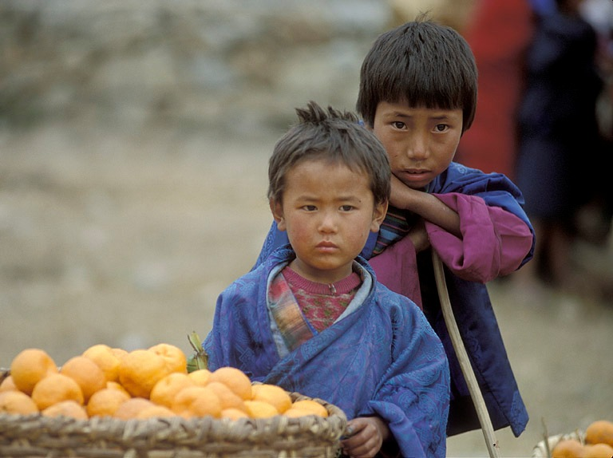
Ending poverty and hunger is the first Millennium Development Goal. Yet today, at 23% of the population (336 million people), the South Asia Region (SAR) has the highest rates of malnutrition in the world. India, Bangladesh, Pakistan, Afghanistan, and Nepal are among the 36 countries in the world which account for 90% of global malnutrition. Such malnutrition limits an individual’s potential for an active and healthy life and leads to a cycle of productivity losses, which are estimated at more than 10% of lifetime earnings. Potential GDP loss estimates for SAR range as high as 3%.

The long term goal of SAFANSI is to improve food and nutritional outcomes in SAR in line with the MDG (1c) targets. Towards this end, the objective of SAFANSI is to increase the commitment of governments and development partners in SAR to more effective and integrated Food and Nutrition Security (FNS) related policies and programs. An expected outcome of the Initiative is stronger emphasis and accountability for action on FNS-related outcomes in development plans and country strategies, and follow-through in terms of more effective policies, institutional arrangements and programs/projects.

The target audience of this Initiative are (a) high-level policy and decision makers in the region who will be assisted by the availability of improved evidence and analysis for decision-making and the opportunity to dialogue with and learn from colleagues in other countries in the region; (b) development partners who will benefit from the assimilation and sharing of innovations and good practices in formulation, implementation and monitoring of programs aimed at enhancing FNS; (c) the policy groups, civil-society organisations, and experts/opinion-makers who participate in the thematic groups.

Principles of SAFANSI: The initiative will seek to: (a) promote political leadership and stewardship for FNS outcomes; (b) ensure nutrition outcomes are central to regional and country food security policy and programming; (c) promote an inter-disciplinary, inter-ministerial and cross-sectoral approach; (d) build strong partnership among various institutions/players working on nutrition, safety nets and food security; (e) add value to existing country and regional efforts; (f) encourage coherence and coordination among countries and among development agencies on what needs to be done; (g) focus on actionable research (what works and does not); (h) focus on building South Asian regional capacity; and (i) prioritize action to tackle gender inequality and social exclusion.

SAFANSI is adopting a three-pronged approach, focusing on:

- improving evidence and analysis on the most effective ways to achieve FNS outcomes in SAR;
- improving awareness of FNS-related challenges, and advocacy for action, amongst relevant stakeholders; and
- strengthening regional and in-country policy and programming capacity to achieve FNS outcomes.

The implementation of SAFANSI is being done through a series of tasks described below. Each task consists of a set of activities with a defined results framework (i.e., outputs and measurable, time-based indicators). The activities included under these tasks typically pertain to one of the three core pillars – analysis, advocacy, capacity building – of the SAFANSI.

Current Tasks
SAFANSI has been set up as a multi-donor Trust Fund administered by the World Bank. The World Bank, as Trustee and Administrator, will be responsible for all key aspects of SAFANSI. These include program development, implementation, and monitoring and evaluation, as well as overall program management, communication and coordination. It will be assisted by a Donor Committee which will review proposed annual work plans and on-going operations as well as advise on projects to be pursued and other issues relating to the operation of the SAFANSI. DFID is currently the main active partner, although other donor partners are expected to join soon.
The tasks detailed below are part of SAFANSI rapidly growing portfolio. These tasks have been shaped up during the six-month Inception Phase of SAFANSI (April-September, 2010). They represent a mix of high-priority thrust areas identified under SAFANSI as well as specific opportunities that opened up in the course of dialogue with government and development partners. These tasks are being complemented with others that are currently under discussion.

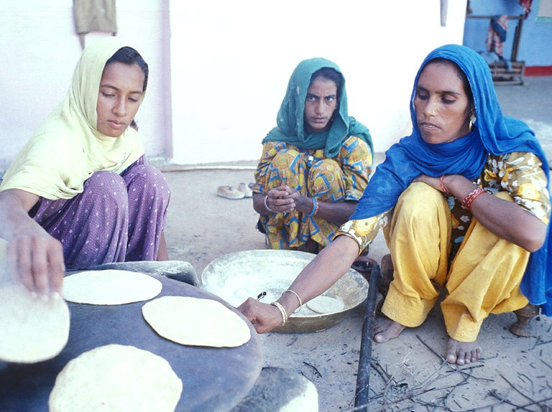

Infant and Young Child Nutrition (IYCN) South Asia Development Marketplace on Nutrition
Supporting Innovations through South Asia Development Market Place on Nutrition

The Development Marketplace on Nutrition (August 2009) identified through a rigorous, competitive process, 21 Civil Society Organization in SAR (from 1000 applicants and 60 finalists) who were doing highly innovative, community-based work, focused on improving maternal nutrition and empowering girls and women to address determinants of malnutrition, especially at household level and in feeding practices. Under this task, SAFANSI is working with these finalists to continue the support for these innovations and, in particular, to enhance their capacities to capture and share the IYCN experiences for more effective and widespread advocacy and agenda development. The goal is to use these ground-breaking innovations to have a larger impact on policy and program formulation as well as implementation approaches in the Region.

Leveraging Agriculture for Improving Nutrition and Health
International Conference

A high profile international conference is being organized in New Delhi between February 10-12, 2011. The Indian Prime Minister, Dr Manmohan Singh, is scheduled to inaugurate this influential conference which will bring together leaders in agriculture, nutrition, and health from around the world to deliberate how to create a more integrated system that mobilizes agriculture to improve people's nutrition and health. The program will: examine how agriculture, nutrition, and health are linked; explore the opportunities for improving nutrition and reducing health risks along the whole value chain; draw lessons from country experiences and program interventions; and identify key levers to make agriculture, nutrition, and health work better together. The Conference is being organized by the International Food Policy Research Institute (IFPRI) and is being co-sponsored by SAFANSI (along with other key donors such as USAID, ADB, IDRC, GTZ and so on).

Bangladesh: Strengthening Domestic Platform for Nutrition
Revitalizing the Bangladesh National Nutrition Council (BNNC)
Nutrition-related issues are being accorded high priority in Bangladesh. In this context there is need, as well as emerging opportunity, for more effective, well-coordinated/harmonized multi-sectoral response to the nutritional challenges. This SAFANSI task seeks to support the development of a domestic platform such as the BNNC to undertake more effective stewardship of the FNS agenda. The task will involve revitalization of the BNNC as well as provision of technical and other support as appropriate in the performance of its role.

Nepal: Strengthening Domestic Platform for Nutrition
Task planning for SAFANSI is a dynamic exercise, with new ideas and activities being identified, assessed, and presented for implementation when suitably matured to allow for evolving country circumstances, new partnership opportunities and unfolding events. As such, SAFANSI will use a rolling plan approach to allow maximum responsiveness to these emerging needs and opportunities. Tasks will be reviewed periodically, within resources limits, in order to extract useful information. As the products of this initiative take form, they will be communicated to ensure a steady pipeline of knowledge.
Supporting High Level Task Force on Food and Nutrition Security (of National Planning Commission)

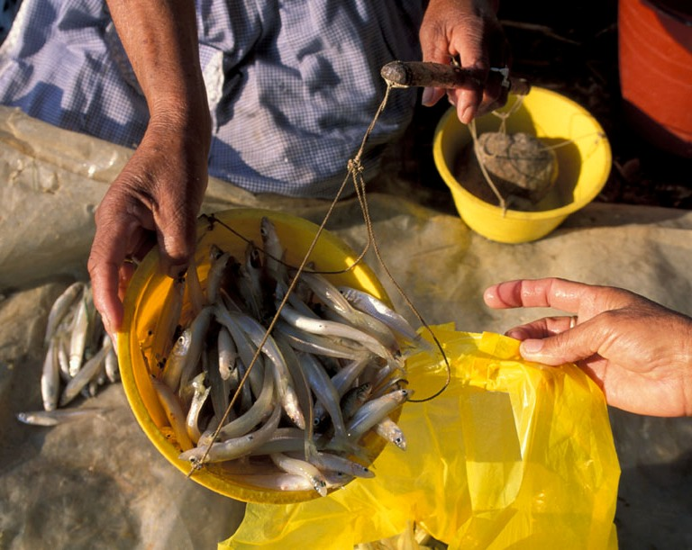
SAFANSI is supporting a specific request to help a High Level Task Force to develop integrated policies, programs and action plans for FNS, while increasing their ability to monitor progress and create accountability. SAFANSI will provide technical and other support as appropriate to help develop effective planning, coordination and monitoring mechanisms, which deliver enhance delivery of more effective FNS actions at the national and district level.

Afghanistan: Strengthening Domestic Platform for Nutrition
Supporting Afghanistan’s High Level Task Force on FNS

Several factors make Afghanistan highly susceptible to food and nutrition insecurity. There is need, however, to improve the multi-sectoral action plan relating to FNS as well as to push this issue higher up on the development agenda. This task will complement on-going efforts by development partners to encourage the formation of a High Level Task Force, which could develop integrated policies, programs, and action plans for FNS.

Pakistan: Strengthening Domestic Platform for Nutrition
Enhancing High Level Commitment for FNS Actions
The recent floods have highlighted the urgency of the FNS situation in Pakistan and the ramifications it has for national well-being/stability. The experience also suggests that FNS issues need to be accorded higher priority in development planning and policy formulation. This SAFANSI task will support development of more effective platform(s), involving the government and development partners, for cross-sectoral planning and learning, leading to the development of more integrated policies and programs.

Bangladesh
Multisectoral Simulation Tool for Scaling Up Nutrition (SUN)
The SUN initiative has been successful in generating widespread international support and in identifying the set of interventions that could be used to scale up effective programs. However, if the SUN initiative is to prove successful in SAR specifically, individual countries must ultimately adapt the recommended set of possible interventions to their own particular circumstance. The Multisectoral Simulation Tool (MST) represents an attempt to integrate these interventions into the country circumstance in order to manage the particular complexities. At the heart of the MST is a causal model that links multisectoral interventions to nutritional outcomes. In practical terms, it is envisioned that a web-based version of the MST will enable local planning officials, an expert in Dhaka, and an international expert to collaboratively review/simulate the circumstances of any given district in Bangladesh, and offer guidance on improving the design and implementation of programs.

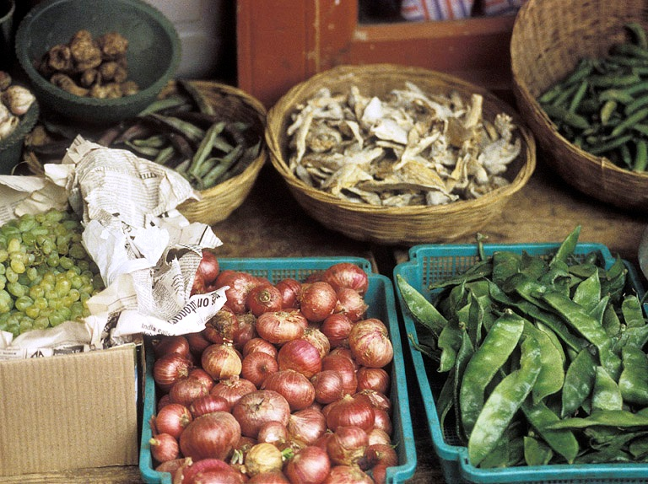

Bangladesh & India
Linking Nutritional Outcomes to Adequacy of Food, Health and Care
A focus on what constitutes adequate food, health and care has the potential to shape policy dialogue since it is only when one specifies what is “inadequate” and for which districts this inadequacy applies that the discussion moves to actionable activities. The most important innovation of this proposed work is that it will define explicit and scientific measures for the adequacy of food, health and care and thereupon substantially enhance the operational relevance of the UNICEF framework. This will enable subsequent research to demonstrate that these measures are linked empirically to nutritional outcomes, which can improve monitoring for nutrition.

Learning from Global Success Stories
Applicable Lessons for South Asia
A number of countries around the world have successfully addressed FNS issues, e.g., Thailand, China, Vietnam, Malaysia as well as some Latin American countries. The goal of this exercise is to understand the relevant experiences from other regions in order to extract usable lessons and “best practices”, and transfer them to the South Asian context, thus enabling policy makers to digest and understand these messages.

South Asia: Gender and Nutrition Nexus
Focus on Adolescent Girls
Gender has long been recognized as a critical factor in solving the ‘nutrition puzzle’ in SAR. However, the gender dimension remains ill-understood, with few operational implications for design of policies and programs. This SAFANSI task focuses on adolescent girls in order to break down the complex layers by which gender impacts trans-generational nutritional pathways. A concentration on adolescent girls can do much to eliminate deficiencies suffered in utero, which have consequences for future nutrition channels, such as the capacity to absorb nutrients. This linkage can be used to leverage gender’s strategic position in the complex FNS equation for the improvement of nutrition indicators in SAR. In order to effectively incorporate this useful mechanism into the FNS toolbox, this task will aim to strengthen analysis and understanding of the gender role in malnutrition.

India: Multisectoral Actions to Improve Nutrition
Building the Evidence Base
Although it is widely recognized that nutrition is a multi-dimensional problem, whose determinants lie across different sectors, there is little systematic evidence of on the nature or strength of these linkages, at least in the South Asian context. It is important, however, that these supposed cross-sectoral determinants be explicitly identified, tested and evaluated, in order to leverage nutrition-sensitive actions in traditionally “non-nutrition” sectors. This SAFANSI task will take important first steps towards generating such evidence through analysis of some on-going operations in India. Positive results generated from this study could provide powerful advocacy for scaling up these approaches throughout South Asia.

Bangladesh: Developing More Effective Targeting Systems to Ensure the Food and Nutrition Security of Vulnerable Populations
Identifying hardcore poor is a complex, multidimensional process. Bangladesh has yet to introduce a unified system of targeting food and nutrition insecure households to ensure the efficacy of government interventions. It is important however that the social protection programs in the country be anchored on a good targeting framework to ensure its fiscal sustainability, and to guarantee that proper administrative arrangements are in place, including an effective oversight and control mechanism facilitated by a strong M&E system. The task will address these issues, focusing in particular on establishing the extent to which different targeting systems affect the chances of women and children being identified for enrolment into social protection programs, which ensure their food and nutrition security.

Bangladesh
Assessment of Bangladesh Conditional Cash Transfer (CCT) Pilot through Local Governments

While CCT programs linked to child nutrition outcomes are common in other parts of the world, they are quite new in South Asia in general and in Bangladesh in particular. This grant proposes to assess the efficacy of an innovative nutrition (and education) cash transfer pilot that decentralizes program administration and implementation to the local government level. Results generated from this task will provide useful lessons and can potentially have very significant scaling-up implications.

Proposals under Development

South Asia: Political Economy Analysis (PEA) of FNS Agenda

While governments and development partners have paid increasing attention to FNS issues over the last decade and more, cases of successful reform and sustainable progress still remain more an exception than the rule. There is growing consensus on the need to give increasing emphasis to PEA in order to provide the missing link between reform processes and policy outcomes. This approach involves a deeper understanding of the political, institutional, social and economic issues at play, the power relations among actors, and the incentives that affect change. The purpose of the proposed task is two-fold: (i) to develop an understanding – through a suitable analytic framework – of the ways in which making (political) progress on FNS is difficult; and (ii) to present some practical implications for policy and program formulation based on that understanding/perspective.

Sri Lanka: Strengthening Domestic Platform for Nutrition

For further information about SAFANSI please contact:
Animesh Shrivastava
SAFANSI Program Manager
SASDA, The World Bank
202-473-3652
ashrivastava@worldbank.org
THE WORLD BANK
1818 H Street, NW
Washington, D.C. 20433 USA
Telephone: 202-473-3652
Internet: www.worldbank.org
Email: SAFANSI_Core@worldbank.org

The SUN Framework, released in April 2010, is a growing global effort endorsed by more than 100 entities from national governments, the United Nations system, civil society organizations, development agencies, academia, philanthropic bodies and the private sector. SAFANSI shares many common elements with the SUN framework.

