Australia Awards

Fellowships

Round 20 Successful Australian Host Organisations



**Australia Awards Fellowships – Round 20**

Australia Awards Fellowships program Round 20 has, to date, provided 35 Fellowships valued at $9.2 million to 30 Australian Host Organisations, involving 433 Fellows from the Pacific, Southeast Asia, South Asia and the Middle East, Africa, Caribbean and Europe.

Round 20 Australia Awards Fellowship programs are due to commence from October 2025, covering priority area sectors of:

* Climate change, adaptation, resilience and green energy transition
* Health
* Digital Economy, cyber resilience, and media engagement
* Gender equality, disability equity and social inclusion
* Maritime and the Blue Economy.

## Fellowship Programs by Priority Area

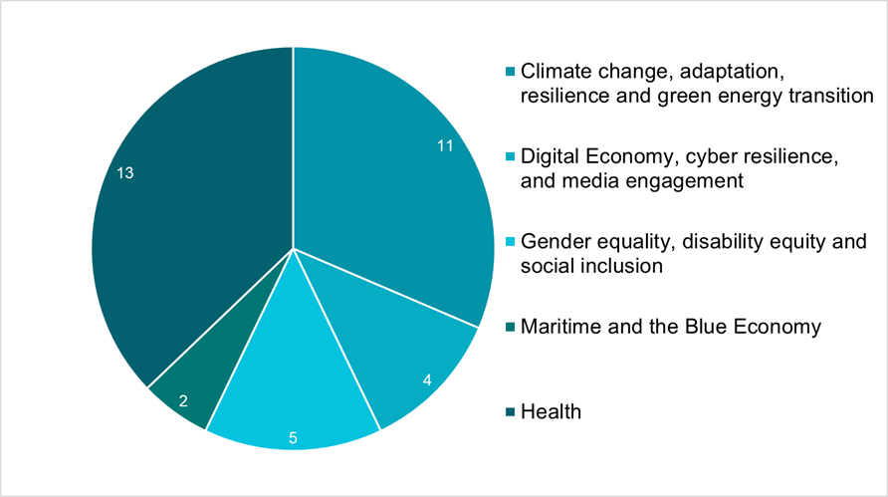

*Number of Fellowship Programs (to date) by Priority Area

## Fellows by Region

| Percentage of Fellows per regions | Number of Fellows | Percentage of Fellows |
| --- | --- | --- |
| Southeast Asia | 161 | 37% |
| Pacific | 142 | 32% |
| South Asia and Middle East | 98 | 22% |
| Europe | 15 | 4% |
| Caribbean | 10 | 3% |
| Africa | 7 | 2% |
| Total | 433 | 100% |

## Round 20 – Successful Australian Host Organisations and Programs

| **Australian Host Organisation** | **Program** | **Priority Area** | **Proposed Countries** |
| --- | --- | --- | --- |
| ASHM HEALTH | Deadly Sex: Cross-Cultural Knowledge Exchange and Leadership in Sexual and Reproductive Health | Health | PAPUA NEW GUINEA FIJI VANUATU SOLOMON ISLANDS |
| AUSTRALIAN ASSOCIATED PRESS LTD | Strengthening Journalism in PNG, Fiji and Vanuatu (Pacific) | Digital Economy, cyber resilience, and media engagement | FIJI PAPUA NEW GUINEA VANUATU PAPUA NEW GUINEA |
| AUSTRALIAN BROADCASTING CORPORATION | Indo-Pacific Media Executive Leadership Program | Digital Economy, cyber resilience, and media engagement | INDONESIA, TIMOR-LESTE PAPUA NEW GUINEA FIJI  TONGA  SAMOA VANUATU  SOLOMON ISLANDS |
| AUSTRALIAN HIMALAYAN FOUNDATION LTD | Strengthening Capacity to Respond to Climate Induced Forest Fires in Nepal | Climate change, adaptation, resilience and green energy (including critical mineral mining) | NEPAL |
| AUSTRALIAN HUMAN RIGHTS COMMISSION | Advancing the Human Rights of Women and Persons with Disabilities in Laos | Gender equality, disability equity and social inclusion | LAO PEOPLE'S DEMOCRATIC REPUBLIC |
| BEYOND ESSENTIAL SYSTEMS PTY LTD | Digital Health Professionals: Upskilling Public Sector Cohorts in the Pacific | Health | SAMOA  KIRIBATI PALAU  NAURU FIJI  TUVALU |
| EDITH COWAN UNIVERSITY | Cyber Resilience Fellowship: Strengthening Maldives-Australia Security Partnership | Digital Economy, cyber resilience, and media engagement | MALDIVES |
| FLINDERS UNIVERSITY | Clean Energy Transitions to Combat Climate Changes Around the World | Climate change, adaptation, resilience and green energy (including critical mineral mining) | INDIA MALAYSIA SOUTH AFRICA |
| GRIFFITH UNIVERSITY | Fostering Prosperity in the Blue Economy: Activating Timor-Leste’s Blue Generation | Maritime and the Blue Economy | TIMOR-LESTE |
| GRIFFITH UNIVERSITY | Scaling Finance for Indigenous Climate Adaptation Solutions in the Pacific | Climate change, adaptation, resilience and green energy (including critical mineral mining) | FIJI FEDERATED STATES OF MICRONESIA VANUATU SAMOA PAPUA NEW GUINEA |
| HEALTH EDUCATION AUSTRALIA LIMITED | Building Clinical Governance Capability and Capacity in the Pacific | Health | NAURU  SAMOA  PALAU  FIJI SOLOMON ISLANDS TUVALU  TONGA  VANUATU WALLIS AND FUTUNA KIRIBATI  PAPUA NEW GUINEA |
| INTERNATIONAL AGRICULTURE FOR DEVELOPMENT PTY LTD | Enhance Rural Community Climate Change Resilience | Climate change, adaptation, resilience and green energy (including critical mineral mining) | VIETNAM  CAMBODIA MYANMAR |
| MACQUARIE UNIVERSITY | Inclusive and Equitable Digital ID for Southeast Asia (ID4SEA) | Gender equality, disability equity and social inclusion | INDONESIA  THAILAND CAMBODIA |
| MONASH UNIVERSITY | Building Cyber Resilience in Fiji: Securing the Nation’s Digital Future | Digital Economy, cyber resilience, and media engagement | FIJI |
| MONASH UNIVERSITY | Towards Value-Based Digital Health Transformation in Indonesia | Health | INDONESIA |
| MONASH UNIVERSITY | Strengthening leadership of Melanesian Women in Climate Finance | Climate change, adaptation, resilience and green energy (including critical mineral mining) | PAPUA NEW GUINEA FIJI VANUATU FIJI  SOLOMON ISLANDS |
| NOSSAL INSTITUTE LIMITED | Strengthening Joined-up Responses to Violence Against Women and Children in Timor-Leste | Gender equality, disability equity and social inclusion | TIMOR-LESTE |
| NSW SERVICE FOR THE TREATMENT AND REHABILITATION OF TORTURE AND TRAUMA SURVIVORS (STARTTS) | Professional Development in Management of Trauma Survivors for Ukrainian Mental Health Professionals | Health | UKRAINE |
| ROYAL MELBOURNE INSTITUTE OF TECHNOLOGY | Addressing Challenges of Access to Safe-Drinking-Water for Climate Vulnerable Marginalised People in Bangladesh | Climate change, adaptation, resilience and green energy (including critical mineral mining) | BANGLADESH |
| ST. VINCENT'S INSTITUTE OF MEDICAL RESEARCH | Capacity Strengthening to Support the Reference Laboratory Towards International Accreditation (Cambodia) | Health | CAMBODIA |
| TAKING PAEDIATRICS ABROAD LTD | Improving Children's Cancer Treatment for the Solomon Islands | Health | SOLOMON ISLANDS |
| THE MACFARLANE BURNET INSTITUTE FOR MEDICAL RESEARCH AND PUBLIC HEALTH LTD | Supporting adolescent Girls' Menstrual Health through Research in Bangladesh (South Asia) | Gender equality, disability equity and social inclusion | BANGLADESH |
| THE MACFARLANE BURNET INSTITUTE FOR MEDICAL RESEARCH AND PUBLIC HEALTH LTD | Data-driven Improvements in Maternal and Newborn Health in the Asia-Pacific | Health | SOLOMON ISLANDS MONGOLIA  NEPAL THAILAND  INDONESIA FIJI  PAPUA NEW GUINEA TIMOR-LESTE  SRI LANKA, BANGLADESH |
| THE UNIVERSITY OF ADELAIDE | Training and Capacity Building in Vietnam in Irrigation and Water Management | Climate change, adaptation, resilience and green energy (including critical mineral mining) | VIETNAM |
| THE UNIVERSITY OF NEWCASTLE | Towards Nutrition Security (Papua New Guinea) | Health | PAPUA NEW GUINEA |
| THE UNIVERSITY OF QUEENSLAND | Addressing Digital Challenges in Gender: Building the Vietnam Gender Equality Collective (Vietnam) | Gender equality, disability equity and social inclusion | VIETNAM |
| THE UNIVERSITY OF QUEENSLAND | Elevating Women’s Leadership and Innovations in Food, Agriculture & Nutrition Systems (Indonesia) | Climate change, adaptation, resilience and green energy (including critical mineral mining) | INDONESIA |
| THE UNIVERSITY OF SYDNEY | Building Resilience in Food Security in Pakistan by improving Climate Resilient agroecosystems | Climate change, adaptation, resilience and green energy (including critical mineral mining) | PAKISTAN |
| THE UNIVERSITY OF SYDNEY | Building Research Capacity: Advancing Adolescents’ Health in the Solomon Islands and Vanuatu | Health | SOLOMON ISLANDS VANUATU |
| THE UNIVERSITY OF WOLLONGONG | Enabling a Sustainable Blue Economy in the Bay of Bengal (Indian Ocean) | Maritime and the Blue Economy | BANGLADESH INDIA SRI LANKA |
| THERAPEUTIC GOODS ADMINISTRATION | Improving the Indo-Pacific's Access to Medicines by Mainstreaming GEDSI in Regulatory Authorities | Health | TIMOR-LESTE VIETNAM CAMBODIA LAO PEOPLE'S DEMOCRATIC REPUBLIC FIJI |
| UNIVERSITY OF MELBOURNE | Climate, Energy and Health Resilience across the Pacific and Caribbean | Climate change, adaptation, resilience and green energy (including critical mineral mining) | FEDERATED STATES OF MICRONESIA FIJI,  KIRIBATI  NIUE  PALAU  SAMOA, SOLOMON ISLANDS TONGA  TUVALU  VANUATU  BELIZE  DOMINICA  GRENADA  HAITI  JAMAICA |
| UNIVERSITY OF NEW SOUTH WALES | Malaria Control and Health Security Capacity Building | Health | INDONESIA |
| UNIVERSITY OF TASMANIA | Southern-hemisphere Alliance for Measuring Climate Change | Climate change, adaptation, resilience and green energy (including critical mineral mining) | SOUTH AFRICA |
| WORLD MOSQUITO PROGRAM LTD | Empowering Public Health: Scaling Wolbachia for Sustainable Disease Control in Partner Countries | Health | BANGLADESH THAILAND SRI LANKA PHILIPPINES |

**For further information on the Australia Award Fellowships**: <https://www.dfat.gov.au/people-people/australia-awards/australia-awards-fellowships>

**Enquiries:** fellowships@australiaawards.org

