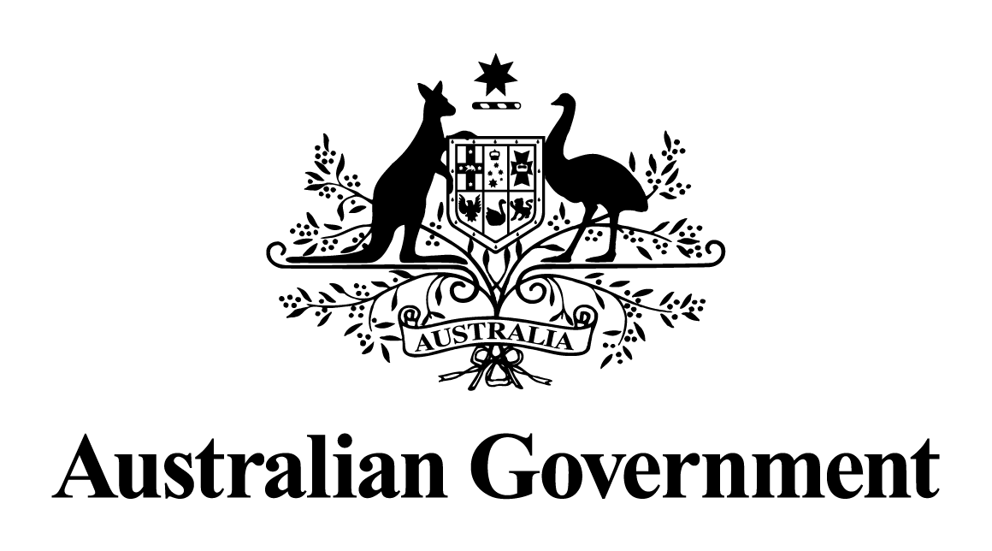

Australian Government Response

to the   
Senate Foreign Affairs, Defence and Trade References Committee report

**Funding for public research into foreign policy issues**

DECEMBER 2024

# **Response to recommendations**

## Recommendation 1

The committee recommends that the Australian Government investigate options for the best model for effective foreign policy research settings, including how best to fund this model, to ensure the Australian community and business is best placed to understand and respond to a rapidly changing geostrategic environment.

The Government agrees in-principle with the recommendation, as part of its ongoing work and subject to resourcing constraints. The outcomes of the 'Independent Review of Commonwealth funding for strategic policy work’ (Varghese Review) will also be relevant.

The quality of foreign policy research in Australia is high. According to the ‘2020 Global Go To Think Tank Index Report’, Australia hosts four of the top 100 international and foreign policy think tanks. Research produced by these think tanks is directly relevant to Australia’s national interests in navigating a rapidly changing geostrategic environment.

High quality well-targeted foreign policy research is evidence that the existing research model works well. In addition to conducting its own research, the Australian Government funds some of the research produced by think tanks, universities and other organisations, including through the Department of Foreign Affairs and Trade (DFAT); the Department of Defence; the Department of Education (previously the Department of Education, Skills and Employment) and the Australian Research Council (ARC).

A range of public funding models have been adopted, including funding for targeted research projects; allocations through DFAT-managed bilateral foundations; initiatives funded by the Official Development Assistance (ODA) program; long term support for key policy research institutes; block research grants to universities; competitive grants through the Australian Research Council; and financial support for bilateral university partnerships. The mix of funding modalities allows for a flexible approach, ensuring that research complements public service expertise and reinforces various foreign policy goals (for example, research funded through ODA reinforces Australia’s international development objectives). It is appropriate that some public funding generates research on specific policy challenges, and some funding supports policy-relevant but more independent research agendas.

As DFAT further builds its capacity for strategic influence, it will consider opportunities for a more integrated approach to engagement with, and funding of, think tanks and foreign policy researchers.

Foreign policy research is one tool that helps the Australian community and business sector to have a sound understanding of foreign policy issues. Think tanks, universities and other organisations undertake their own public outreach to share the outcomes of their research. Complementing these efforts, the Government actively engages with the Australian community and the private sector, both domestically and overseas. This engagement draws on the Government’s own expertise and analysis, which in part is informed by external foreign policy research.

One example of engagement with the private sector is strategic dialogues between business leaders and senior government officials (for example, from DFAT, Austrade and the Office of National Intelligence) to discuss foreign policy, economic, and security issues, and risks and opportunities relevant to Australian corporate interests. These discussions are complemented by support from Australia’s global diplomatic network and ministerial advocacy for Australian business. (The Government Response to the Joint Standing Committee on Trade and Investment Growth report ‘Pivot: Diversifying Australia’s Trade and Investment Profile’ also notes a range of additional engagement undertaken by Government to build industry awareness of national security and resilience risks in relation to trade and investment.)

The Government remains committed to close collaboration between Commonwealth agencies, state and territory governments, peak bodies, business, the media, civil society, universities, think tanks and diasporas. (Further detail of the Government’s efforts to engage the Australian community on foreign policy issues is provided in response to Recommendation 5.)

## Recommendation 2

The committee recommends that the Australian Government consider reviewing the security clearance process to ensure it remains fit for purpose and that processes are not inadvertently impeding Australians with much needed skills and knowledge from being employed.

The Government agrees with the recommendation, noting that security clearance processes are continually considered and adapted to ensure they remain fit for purpose.

The Protective Security Policy Framework (PSPF) establishes security clearance processes to ensure an individual is suitable for ongoing access to classified information. The PSPF is regularly reviewed and updated to ensure it is fit for purpose. The PSPF was reviewed and refreshed in its entirety in 2018, and further updates to PSPF policies, including security clearance requirements, have been undertaken since that time. In November 2021, the requirements for the highest level of clearance were updated following a review and changes to the PSPF are being progressed to align vetting for lower-level clearances.

In line with the Government’s commitment to streamlining the clearance process, the Australian Government Security Vetting Agency (AGSVA) has introduced a fully digital and automated vetting capability system with the launch of myClearance in November 2022. The myClearance system provides an enhanced user experience and process efficiencies for sponsors, applicants, assessors, decision-makers and clearance holders. In addition to the improved user experience, the implementation of myClearance bolsters AGSVA's data security, and is expected to improve clearance timeframes over time.

## Recommendation 3

The committee recommends that the Department of Foreign Affairs and Trade's Human Resources Modernisation program should consider the introduction of additional measures to attract individuals with specialist knowledge in identified priority countries and topics, including those with diverse backgrounds and those with language proficiencies.

The Government agrees with the recommendation, noting that the ‘Human Resources Modernisation program’ no longer exists but its objectives in relation to recruitment are being progressed through other departmental initiatives.

The Government is committed to ensuring that DFAT has staff with the right skills, knowledge and experience to deliver outcomes for Government now and into the future. DFAT is identifying the capabilities it requires, including specialist knowledge in priority countries and topics, and is committed to attracting, recruiting and retaining staff with the requisite skills and knowledge. This includes recognising the value that culturally and linguistically diverse staff add through their skills and perspectives, as well as investing in the development and maintenance of language proficiencies for many of its staff.

## Recommendation 4

The committee recommends that the Australian Government investigate new ways to leverage language resources to lift the capability of the Australian Public Service in this area.

The Government agrees with the recommendation, noting DFAT and Defence are already exploring opportunities for greater cooperation, with a language course pilot program being considered in the near term.

DFAT’s Diplomatic Academy delivers language training to Australian Public Service (APS) officers, including lunchtime discussion groups and immersion language courses for 28 languages. The languages are Arabic, Bislama, Burmese, Cantonese, Farsi, French, German, Hindi, Indonesian, Italian, Japanese, Kiribati, Korean, Khmer, Lao, Malay, Mandarin, Polish, Portuguese, Russian, Solomon Islands Pijin, Spanish, Tagalog, Tetum, Thai, Tok Pisin, Turkish and Vietnamese.

DFAT undertakes regular consultation with other government agencies regarding language training programs and conducts ongoing reviews of ways to leverage and pool language resources. In addition to delivering language training through lunchtime discussion groups and immersion classes, DFAT facilitates access to language examinations to test language proficiency. APS agencies are also able to access services from the provider that DFAT has contracted for language training.

The Defence Force School of Languages (DFSL) delivers Languages Other Than English (LOTE) and cultural training to Defence personnel to enhance Defence’s operational capability. DFSL currently conducts courses in Indonesian, Malay, Arabic, Chinese, French, Korean, Spanish, Urdu, Filipino, Tetum, Fijian, Tok Pisin, Japanese, Thai, Vietnamese, Portuguese and Khmer at its facilities in RAAF Williams, Victoria and Fyshwick, Australian Capital Territory.

The Foreign Language Upskilling Enhancement Training (FLUENT) Program, developed by the LOTE Capability Cell (LCC) at the Australian Defence College, assists qualified Defence linguists (Australian Defence Force and APS) in their target language. Where additional resources are available, participation may be offered to other Defence personnel, including APS and Australian Signals Directorate personnel.

## Recommendation 5

The committee recommends that the Department of Foreign Affairs and Trade consider strategies for increased engagement, with both the media and community in order to increase understanding of foreign policy issues.

The Government agrees with the recommendation, noting DFAT is taking steps to increase the department’s focus on external engagement, including through a recent organisational restructure.

DFAT is committed to building public understanding of foreign policy, trade and international development issues affecting Australia through professional and proactive engagement with the media; connecting with Australians directly on digital platforms; conducting outreach to stakeholders and the broader community; and funding foreign policy research in various ways.

DFAT receives thousands of media queries and interview requests every year – in Australia and overseas. The Department responds to these queries in way that is timely, accurate and in compliance with obligations on privacy and official information.

DFAT engages online across 303 global social media accounts. Of these, 65 are Australian-based accounts that highlight foreign policy, trade and international development issues for a domestic audience. Globally, DFAT’s social media accounts have a total following of more than 6.2 million (as at August 2023).

As Australians return to international travel with the easing of COVID-19 restrictions, interest in travel advice and consular assistance is a key driver in engagement with DFAT’s Smartraveller digital material, providing an opportunity to reach a broad audience with information on international issues. The Department continuously updates the Smartraveller website and provides advice to travellers through Smartraveller social media and the social media accounts of diplomatic posts.

In addition to working with portfolio ministers on their speeches and other messages on foreign policy, trade and international development, DFAT also conducts outreach with a wide range of Australian stakeholders including state and territory governments, peak bodies, business, the media, civil society, universities, think tanks and diasporas including through its network of overseas posts, state and territory offices, and foundations, councils and institutes. Through the New Colombo Plan, the Department helps thousands of young Australians deepen their understanding of foreign policy issues through study and internships across the Indo-Pacific.

As outlined in the response to recommendation 1, DFAT funds think tanks, academics, research organisations, institutes, and universities to conduct foreign policy research. Many of these institutions conduct their own external engagement that complement efforts by DFAT. The Department also funds research organisations to facilitate other activities, such as training, conferences and facilitation of 1.5 track dialogues. This research, engagement and other activities help the media and community build an understanding of foreign policy issues.

DFAT has also strengthened public advocacy of Australian trade and investment interests, including via greater industry engagement and high-level dialogues with business on foreign and trade policy. (Further detail of the Government’s efforts to engage the business community on foreign policy issues is provided in response to Recommendation 1.)

DFAT has implemented an internal organisational restructure (August 2023) which, inter alia, has created a new Strategic Communications Division. This restructure reflects the department’s heightened focus on coordinated and effective external communications and will further support the department’s efforts to engage the Australian public on foreign policy issues.

DFAT’s publication of the ‘Documents on Australian Foreign Policy’ series provides an accurate, comprehensive, and impartial documentary record of Australia’s foreign and trade policy history.

## Recommendation 6

The committee recommends that the Australian Government convene a task force to develop a whole-of-government strategy to identify gaps in data and information which will help to better deploy funding for foreign policy research and ensure that a diversity of views are considered. As part of the process, the taskforce should consider proposals outlined in this report, including the creation of pools of funds for: (i) innovative research; (ii) time sensitive research; (iii) long-term, over the horizon research; and (iv) priority thematic areas, such as peacebuilding or human security.

## and Recommendation 7

The committee recommends the task force on the whole-of-government strategy for funding foreign policy research consider the role of empirical research and how it can be promoted. The task force should analyse how the government can make research-relevant data more accessible, identify data gaps and consider commissioning research work to fill such gaps.

The Government notes the recommendations.

As noted in the response to Recommendation 1, the Government is confident that the existing approach to public funding of foreign policy produces high quality well-targeted research. The matrix of funding models used supports innovative research, time sensitive research, long term research and thematic research. The devolved nature of funding means that Government agencies, and teams within agencies, have the authority to allocate budget for external research in accordance with their specific priorities.

Likewise, the Government notes the value of empirical research and data, both to inform policy making and to build public understanding of international issues.

Access to research is one tool to build this understanding across the Australian community and the business sector, and Government agencies complement this with a range of other outreach activities. The Varghese Review will inform the Government’s next steps.

## Recommendation 8

The committee recommends the Australian Government establish a pilot exchange program, between the Department of Foreign Affairs and Trade and foreign policy think tanks and university departments, at a variety of levels of seniority.

The Government agrees in-principle with the recommendation.

Strong and productive relationships between the policy community and academic institutions or think tanks are mutually beneficial. Policy officers gain exposure to external thinking, deepen analytical skills and develop networks, while external experts build their understanding of government priorities and the policy making process.

DFAT seconds staff to a range of organisations, including:

* The National Security College, a joint initiative between the Australian National University (ANU) and the Commonwealth Government;
* The ANU Energy Change Institute, to facilitate collaborative research between DFAT and ANU as part of the Zero-Carbon Energy for the Asia-Pacific research program;
* Asialink, to assist to develop insights, capabilities and connections in the arts, business, diplomacy and education;
* The Business Council of Australia, working with Australian business leaders across a broad range of sectors on global engagement initiatives; and
* The Australian Civil-Military Centre, supporting best practice approaches to civil-military-police engagement by those involved in the strategic planning and delivery of conflict and disaster management activities; and
* The Lowy Institute, focusing on policy and analysis at the Indo-Pacific Development Centre.

Noting the utility of links between the foreign policy community and external experts, DFAT will continue to seek ways to enhance our policy engagement with a range of external institutions, such as think tanks and universities. The Government notes issues relating to resource constraints within the policy community, and appropriate security clearance arrangements, are barriers that would need to be suitably addressed.