Resourceful partnerships
Module length: 4 × 60 minutes

Summary
This module introduces students to the sustainable partnerships established between Australia and its neighbours in the Asia-Pacific region. Students explore the diversity of the region, and how the Australian Government and its neighbours collaborate to address shared challenges, strengthen resilience and build prosperity across the region. Through the module’s incorporation of economic concepts and mathematics skills, students learn how to analyse pie charts and assess budgets. They will also enhance their vocabulary
in global development.
This resource promotes student agency by fostering opportunities for them to make decisions about the distribution of resources to regional partners. Through learning activities and scenarios, students will practise social competencies such as collaboration, negotiation, critical thinking, leadership, mutual respect and problem-solving. Students are encouraged to take action and think strategically within the timeframe for each activity.

Success criteria
At the end of this module, students should be able to:
- classify and explain economic concepts related to Australia's development cooperation with partner countries
- interpret and describe data in the form of a pie chart
- utilise teamwork to make economic decisions based on data.

Organising ideas
The organising ideas are global relationships, global responsibilities and global futures. These reflect the Australian Government’s aims to build genuine partnerships to jointly tackle global challenges, work together on shared challenges that affect communities, and sustain a peaceful and prosperous future that keeps our region stable.
© Australian Humanitarian Partnership (AHP) Bangladesh/
Department of Foreign Affairs and Trade, CC BY

Prior knowledge
i
n
e
r
a
p
e
/
s
m
- Geography: an understanding of direction using the cardinal points, the equator and main continents on Earth.
- Economics and Business: concepts such as budget, needs and wants, the types of resources (human, natural and capital) and how to distinguish them.
- Mathematics: an understanding of percentages and how they can be represented through visualisations such as pie charts.
- Mathematics: exposure to statistics or data and how they are used to make decisions.

Key terminology

adaptation
budget
capital
education
governance
health
humanitarian support
infrastructure
life expectancy
median age
mitigate
natural
needs
Official Development Assistance
partnership
poverty
salinity
sustainable development
wants

Further resources
- Australian Government DFAT Development Cooperation Factsheets
- Australia’s Official Development Assistance Development Budget Summary 2025–26
- AusDevPortal
- Australian Aid Tracker

Curriculum links
The table below lists the Australian curriculum V9 content descriptions explicitly addressed in this module.

HASS

Geography
Year 5: the influence of people, including First Nations Australians and people in other countries, on the characteristics of a place AC9HS5K04
Year 6: the geographical diversity and location of places in the Asia region, and its location in relation to Australia AC9HS6K04
Year 6: Australia’s interconnections with other countries and how these change people and places AC9HS6K05

Economics and Business
Year 5: types of resources, including natural, human and capital, and how they satisfy needs and wants AC9HS5K08
Year 6: influences on consumer choices and strategies that can be used to help make informed personal consumer and financial choices AC9HS6K08

HASS skills
Years 5 and 6: locate, collect and organise information and data from primary and secondary sources in a range of formats AC9HS6S02
Years 5 and 6: evaluate information and data in a range of formats to identify and describe patterns and trends, or to infer relationships AC9HS6S03
Years 5 and 6: propose actions or responses to issues or challenges and use criteria to assess the possible effects AC9HS6S06
Years 5 and 6: present descriptions and explanations, drawing ideas, findings and viewpoints from sources, and using relevant terms and conventions AC9HS6S07

Mathematics
Year 5: recognise that 100% represents the complete whole and use percentages to describe, represent and compare relative size; connect familiar percentages to their decimal and fraction equivalents AC9M5N04
Year 6: interpret and compare data sets for ordinal and nominal categorical, discrete and continuous numerical variables using comparative displays or visualisations and digital tools; compare distributions in terms of mode, range and shape AC9M6ST01

General capabilities
Literacy: This module places emphasis on introducing students to new vocabulary and defining each term. The creation of a glossary is included as a task. Students are taught explicitly how to describe data and compose a paragraph, with prompts provided to extend their written expression.
Ethical Understanding: Students are provided with the opportunity to explore ethical issues regarding assessing needs and wants. Students are challenged to make decisions or confront a dilemma, considering multiple and possibly competing perspectives. Students analyse real-world data to consider how decisions about resource allocation can balance fairness, effectiveness and need.
Personal and Social Capability: Students will practise social management skills such as compromise, negotiation, listening and delegating during one activity where teamwork and collaboration are necessary to make budget decisions.

Cross-curriculum priorities
Asia and Australia’s Engagement with Asia: As this module has a global focus, students will explore the Australian Government’s development programs that involve partners in the Asia-Pacific region. Overall, global education clearly emphasises the interdependent nature of relationships and the importance of developing mutual understanding and accepting diversity.
Sustainability: Students will assess how partnerships and resources can build sustainable futures.

What makes the Asia-Pacific region so diverse?
Learning intentions | Materials
- To describe the natural features and location of the Asia-Pacific region.  - To compare the diversity of various countries within the Asia-Pacific region. | - PowerPoint: Resourceful partnerships (slides 1–3)  - Worksheet: Australia’s neighbours in the Asia-Pacific region

Introduction (10 min)
- Display the Resourceful partnerships PowerPoint (slides 1 and 2) to introduce the lesson and show students a map of Australia’s closest neighbours.
- Ask students if they or anyone in their family come from one of the countries on the map or whether students have visited any of these countries. Ask students if they are willing to share a memory or experience. They could describe the environment, a city, culture or local people, for example. Allow 5–7 minutes for students to share.
- Outline the learning intentions for the lesson (slide 3).

Guided instruction (15 min)
The aim in this activity is to build student awareness of the geographic concept of space. This includes how features are distributed and located on the Earth’s surface. The prompt questions will help students explore this.
- Return to slide 2 showing the map of the Asia-Pacific region. Explain to students that the class will explore this region to understand its diversity, location and environment. Prompt student thinking with the following:
- Using the map, describe Australia’s location in relation to the rest of the Asia-Pacific region.
- Identify some countries to the east, north and west of Australia and include sub-cardinal points such as north-west and north-east.
- Ask a student to draw where they think the equator may be located and ask the class what this might suggest about the climate.
- Ask students what the dominant colour on the map represents. What might this mean for countries in this region? Student answers may vary greatly. This is an ideal exploration of their previous knowledge.
- Compare the size of countries and the variety of different land masses. You could identify countries that are landlocked, coastal or islands to further explore the natural diversity of the area.
- Explain to students that they have just analysed the space, a skill geographers use to understand how features are located and distributed on the Earth’s surface.

Independent inquiry (25 min)
- Provide the Australia’s neighbours in the Asia Pacific region worksheet. Have students complete Activity 1: Who are our neighbours?
- Ask students to work in groups of three to complete Activity 2: Asia-Pacific country inquiry and compile a fact file about three countries, one from each sub-region. Assist students with their understanding of the terms ‘life expectancy’ and ‘median age’. In their groups, students can either divide the work up by country or by topic – for instance, one student performs research as a cultural expert, another as an environment and climate expert, and another as a people and society expert. Following the ‘expert’ model will allow students to make comparisons between countries as they are completing the research.
- Ensure all students have filled out the table in the worksheet.

Learning review (10 min)
Each group of three will now form some conclusions and review what they have uncovered about the three countries' lifestyles they have researched. Questions for their discussion could include:
- What makes your three countries so diverse? Discuss the major differences between each location.
- Are there any similarities between your countries?
- Do you believe a partnership between Australia and any of the countries could help improve people’s lifestyle in these countries by working together to address shared challenges? Look at the street images and compare statistics such as life expectancy, median age and possible environmental or climate concerns.

Australia’s neighbours in the Asia-Pacific region

Activity 1: Who are our neighbours?
Australia works together with many of our closest neighbours in Asia and the Pacific, particularly those countries within the following three regions: South-East Asia, South and Central Asia, and the Pacific. On the map below, draw an outline shape for each region, ensuring the countries listed for each region are included within your outline.
- South-East Asia: Cambodia, Indonesia, Laos, Myanmar, Philippines, Timor-Leste (East Timor), Vietnam, Thailand, Malaysia
- South and Central Asia: Afghanistan, Bangladesh, Bhutan, Maldives, Nepal, Pakistan, Sri Lanka, India
- The Pacific: Federated States of Micronesia, Fiji, Kiribati, Nauru, Papua New Guinea, Samoa, Solomon Islands,
Tonga, Tuvalu, Vanuatu and other countries within this area.
On the map, neatly add a label naming each region.
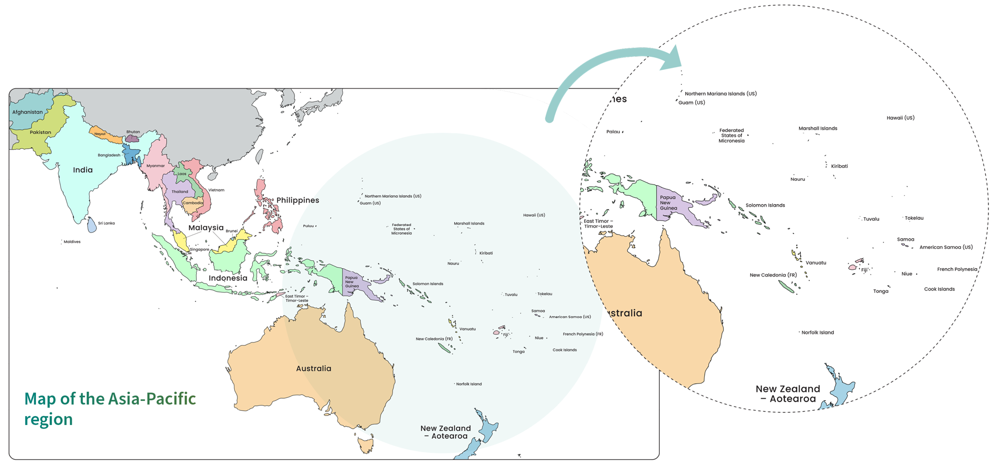
Adapted from: © VectorStock

Activity 2: Asia-Pacific country inquiry
Perform some research into three countries within each region of the map from Activity 1. A useful site for general statistics is the OpenFactBook – Country Data & Statistics.
South-East Asia | South and Central Asia | The Pacific
Country: | Country: | Country:
Major city/ies: | Major city/ies: | Major city/ies:
Population: | Population: | Population:
Life expectancy | Life expectancy | Life expectancy
Median age | Median age | Median age
Culture (e.g. preferred food or meals, main religion, main language,arts, customs, traditions) | Culture (e.g. preferred food or meals, main religion, main language,arts, customs, traditions) | Culture (e.g. preferred food or meals, main religion, main language,arts, customs, traditions)

South-East Asia | South and Central Asia | The Pacific
Describe any environmental features (e.g. forest, farming land, mountains, beaches, rivers). Hint: look at a physical map of the country. | Describe any environmental features (e.g. forest, farming land, mountains, beaches, rivers). Hint: look at a physical map of the country. | Describe any environmental features (e.g. forest, farming land, mountains, beaches, rivers). Hint: look at a physical map of the country.
Weather and climate (e.g. heavy rains or monsoonal, tropical, dry, possible hazards) | Weather and climate (e.g. heavy rains or monsoonal, tropical, dry, possible hazards) | Weather and climate (e.g. heavy rains or monsoonal, tropical, dry, possible hazards)
Conduct an image search. Find one image for each country. Search for ‘typical street in {insert country name}’. Paste the images below with a caption.

How does Australia work in partnership with the Asia-Pacific region?
Learning intentions | Materials
- To explain how Official Development Assistance supports sustainable development.  - To interpret data presented in a pie chart. | - PowerPoint: Resourceful partnerships (slides 4–10)  - Worksheet: Understanding Australia’s Official Development Assistance  - Animation: What is a partnership? (primary version 3 min)

Introduction (10 min)
In Lesson 1, students were asked to consider whether a partnership between Australia and the countries they researched could be beneficial to address shared challenges.
- Show students the animation: What is a partnership?
- Have students explain to a student sitting either side of them why a partnership between Australia and the country they researched in Lesson 1 would be beneficial for addressing shared challenges.
- Using the Resourceful partnerships PowerPoint, outline the learning intentions for the lesson (slide 5).
Guided instruction (25 min)
- Outline Australia’s Official Development Assistance using slides 6–8.
- Show students slide 9. The two pie charts show regional Official Development Assistance, which is planned with partner countries based on their priorities. The charts show how it is broken down into development sectors using percentages. The category ‘Other’ is often administrative or management funding across all sectors.
- See if students can identify:
- the development sector with the most Official Development Assistance allocated
- the development sector with the least Official Development Assistance allocated
- the differences in the budget allocated
to each development sector between the two charts.
- To ensure a gradual release of responsibility, display the pie charts on slide 10 and ask students to work in pairs to interpret the budget changes that have occurred over two years.
Independent practice (15 min)
This lesson assumes students have some knowledge of economic concepts, including the different types of resources (natural, labour and capital) and needs and wants. If students have not covered these concepts, see Lesson 3 in the Year 5-6 module Interconnected communities for an introductory activity using the Three Little Pigs story to explain these concepts. Ask students to re-read all 17 goals and decide which four they consider the highest priority. .
- Provide students with the worksheet Understanding Australia’s Official Development Assistance. Encourage them to look at the glossary in order to allocate the budget categories shown on the pie charts to the correct definition.
- As a class, confirm student choices for each column and discuss any variations.

Learning review (10 min)
Use the following quiz to clarify students’ understanding of the various categories of development assistance. Students need to choose the correct budget category for each scenario and answer the final question.
- Use the following quiz to clarify students’ understanding of the various categories of development assistance. Students need to choose the correct budget category for each scenario and answer the final question.
- A country has just been battered by a typhoon and many homes and shops are destroyed.
- A country has an outbreak of dengue fever.
- A country would like to improve girls’ access to secondary education.
- A country wants help to boost food supplies because long-term drought is reducing the growth of crops.
- A country needs to extend its phone network to ensure remote communities can access services.
- A country wants to hold an election but is concerned about potential conflict from rival groups.
- Based on one or two of the countries you researched in Lesson 1, what development category would be your highest priority?
- Go through the quiz answers with the class, and share various student answers for the final question.

Understanding Australia’s Official Development Assistance

Follow the steps below to complete the table.
- Allocate the following development sectors to the correct definition in the table below:
- Health
- Humanitarian
- Agriculture and other production
- Economic infrastructure and services
- Governance
- Education
© Department of Foreign Affairs and Trade
- Decide what type of resource each development sector most closely aligns to: natural, human or capital.
- Classify each development sector as either a ‘need’ or ‘want’.

Development sector | Definition | Main resource type | Need or want
 | Supports resources produced from the land and water, such as farming, fishing, forests, mining.
 | Supports the development of resources that improve lifestyle, such as technology, transport, banking, energy, roads and networks.
 | Develops resources such as teachers and schools to improve skills and knowledge.
 | Supports resources that enhance politics and how a country is run and organised.
 | Provides resources such as doctors, nurses and medical centres that prevent disease or illness and improve health.
 | Provides assistance and relief during disasters or emergencies and works to reduce risks.

Glossary

Agriculture: another word for ‘farming’. Preparing the land and soil for growing crops, raising animals, and collecting resources, especially food.
Economic infrastructure: services, systems and facilities that help people to produce and sell goods to earn money. Technology is one system that helps people to buy and sell goods.
Governance: how decisions are made and control is managed, through the setting of rules, for example.

Why are decisions about development resources carefully planned?
Learning intentions | Materials
- To make informed financial decisions about Australia’s allocation of Official Development Assistance to its neighbours.  - To interpret, compare and describe data presented in a table and chart format. | - PowerPoint: Resourceful partnerships (slides 11–14)  - Worksheet: Global education literacy and numeracy skills  - Set of 4 regional data cards: 1 card for each group of 3 students

Introduction (5–10 min)
This module has introduced students to many new terms, which will be required for this lesson. A review of these terms will ensure students feel confident to participate in activities.
- Outline the learning intentions for the lesson (slide 12).
- Hand out the Global education literacy and numeracy skills worksheet. For Activity 1: Global education glossary, ask students to work in pairs to write down all the new words they have learnt in this module, including words used in the pie charts.
- Prompt students with hints for any words listed in the following table that they may not recall.

agriculture
budget
capital
economic infrastructure
education
funds
governance
health
humanitarian support
labour
life expectancy
median age
natural
Official Development Assistance
poverty
sustainable development

Guided instruction (25 min)
Building a global education literacy supports students’ understanding of current affairs, and their ability to interpret news and media articles about international events. This part of the lesson revises vocabulary students have learned. It also encourages explicit teaching strategies such as modelling to demonstrate how to extract the data in a pie chart and describe it in a summary paragraph.
- Ask each pair to share their understanding of a term listed in their glossaries for Activity 1. Decide on a definition for each word and allow time for students to copy it down.
- Move on to Activity 2: Describing a pie chart. Read the guidelines with the class and use slide 13 of the Resourceful partnerships PowerPoint to show a model description. Key words are highlighted within the example.
- Students should now complete Activity 2 by describing the pie chart of Official Development Assistance to Fiji, 2026.
Independent practice (60 min)
This activity is based on a real-world scenario. Students will take on the role of the Australian Government by deciding how to budget Official Development Assistance for a few countries in the Asia-Pacific region. Students will work in small groups, which will require they practise social competencies such as negotiation, compromise, listening and delegation. Each student in the group may decide to represent a different development sector. A suggested schedule could be:
- 30 minutes to complete the task
- 10 minutes for discussion with another group
- 30 minutes for each group to present their findings.
Read the following outline to the class:
The Australian Government carefully manages how to use Official Development Assistance by listening to what partner countries need and value most. The government works to make the biggest difference with limited resources by building respectful partnerships, supporting local leadership and focusing on long-term solutions. Today you have been asked to take on this role of great responsibility. Working in small groups of three, you will need to investigate some country data and decide how to allocate funds based on a budget provided.
- Hand each group one of the four regional data cards. Aim for an even spread of regional data cards across the classroom.
- Assist students to understand how the data relates to the basic human needs of food, water, housing and education. The statistic about energy use per person relates to housing and a comfortable lifestyle. A good way to introduce this may be to ask students what energy is used for in their own home. They will soon realise that they probably could not bear living without it.
- Students will work in their groups to complete Activity 3: Regional budget needs analysis by making decisions about how to distribute Official Development Assistance among the three countries on their card. Explain to students that this activity requires them to undertake a needs and wants analysis. Encourage students to round numbers, if this makes it easier to inform their decision-making.

- Ask each group to pair with another group and have them discuss the decisions they have made based on the data. Together they could brainstorm some potential strategies that would help these countries improve one of the statistics on the development card. They should then discuss whether the strategies are sustainable.
- Present some scenarios to the groups for them to discuss:
- How would they deal with a budget cut; what would they keep unchanged and how would they justify who still receives funding?
- If they received a large donation, who or what sector would they allocate funding to?
Extension: When providing their reasoning, groups could consider the question: How will the partnership established through Official Development Assistance change a place? (slide 14).
- Ask each group to present their budget to the class. Students could use the following outline for their presentations:
- Discuss the pie chart breakdown and the reasons why each country received the amount that was decided on.
- Share three changes to funding within the sector amounts, including a reason why.
- Mention one strategy to assist a country that was brainstormed with another group.
- Invite two questions from the class.

Learning review (15 min)

Module wrap-up
- Congratulate students on their strategic thinking, problem-solving and decision-making in this lesson. Remind them of the challenges posed when trying to agree upon a budget.
- Ask students to pair with another student to reflect on the challenges faced by their group when trying to agree on a budget. This allows a class discussion about compromise, negotiation, listening, and justifying opinions with reasons.
- Ask students why these decisions required such careful consideration. This is a chance for students to reflect on their ethics and how to make decisions that are perceived as fair, moral or equitable. Help students consider the economic dilemma that a person working in this field may face every day, given there are limited resources available. For instance, do they fund resources that have the maximum reach across an entire population or do they prioritise funding for those groups with the greatest need?
- Finally, how can Australia ensure that the provided resources are sustainable and ensure long-term, locally led solutions that benefit both partner countries? This is a challenging question to pose, but its aim is to boost critical thinking.

Global education literacy and numeracy skills

Activity 1: Global education glossary
In the table below, list all the new words you have learnt in this module. You will then write a definition or example together as a class.
© Australian Department of Foreign Affairs and Trade
Term | Definition or example

Activity 2: Describing a pie chart
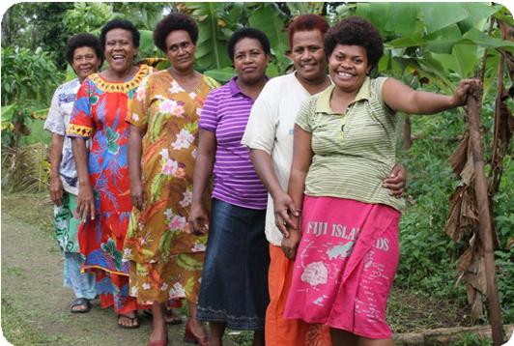
© Maggie Boyle/Department of Foreign Affairs and Trade, CC BY
When describing or comparing pie charts:
- The first sentence should summarise who, what, where and when.
- Mention the most, moderate and least proportions. Not every colour segment has to be mentioned.
- Compare the similarities and differences between two pie charts if they are side by side.
- Vary your vocabulary in your description – use the following table for suggestions:
Percentage | Descriptive term
90% | The majority
75% | Three-quarters
60% | Over half, almost two-thirds
50% | Half
45% | Almost half
30% | About a third
25% | A quarter
10% | A tenth
<5% | A negligible amount

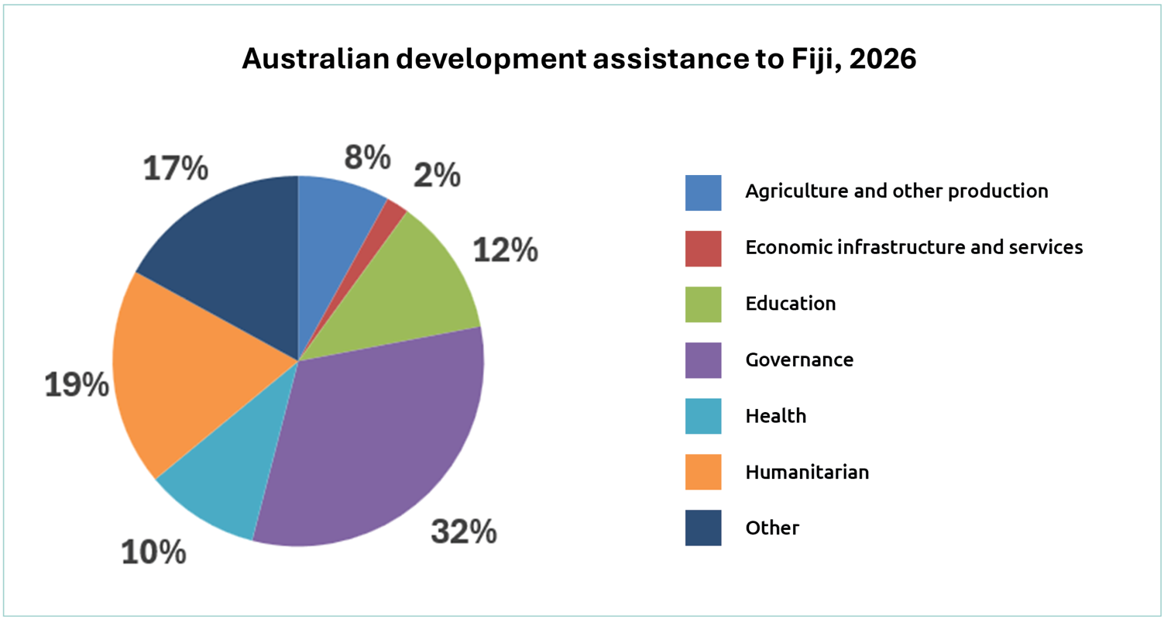
Pie charts on this page and pages 19 to 22 adapted from: Development cooperation fact sheets, Department of Foreign Affairs and Trade, https://www.dfat.gov.au/about-us/publications/development-cooperation-fact-sheets-for-country-regional-and-sector-thematic-programs, CC BY 4.0.
Describe the pie chart of Australian Official Development Assistance to Fiji in 2026.

Activity 3: Regional budget needs analysis

- Working in small groups, use the data card provided by your teacher to assess how best to support each of the three countries. Decide what percentage of the budget you will dedicate to each of the three countries based on the total available and fill in the pie chart to show this.
- Decide if you would you make any changes to the percentage of funds allocated to each sector. Remember, if the percentage for one sector (e.g. health) increases, another sector (e.g. governance) would need to decrease. Complete the table by circling your choices and providing reasons for any changes based on the statistics presented in the table.


Sector | Change (Country 1) | Change (Country 2) | Change (Country 3)
Agriculture |   Reason: | Reason: | Reason:
Economic infrastructure | Reason: | Reason: | Reason:
Education | Reason: | Reason: | Reason:
Health | Reason: | Reason: | Reason:
Governance | Reason: | Reason: | Reason:

South-East Asia region data card 1

Total Official Development Assistance budget available = $550 million
Country | Population | People over 15 years who can read and write | Energy use per person (kWh) | Access to safe drinking water | Income spent on household food | Population living in poverty
Indonesia | 285 million | 96% | 10,100 | No data | 34% | 9%
Cambodia | 18 million | 84% | 4,000 | 29% | 41% | 18%
Timor-Leste | 1.5 million | 68% | 1,600 | 68% | No data | 42%
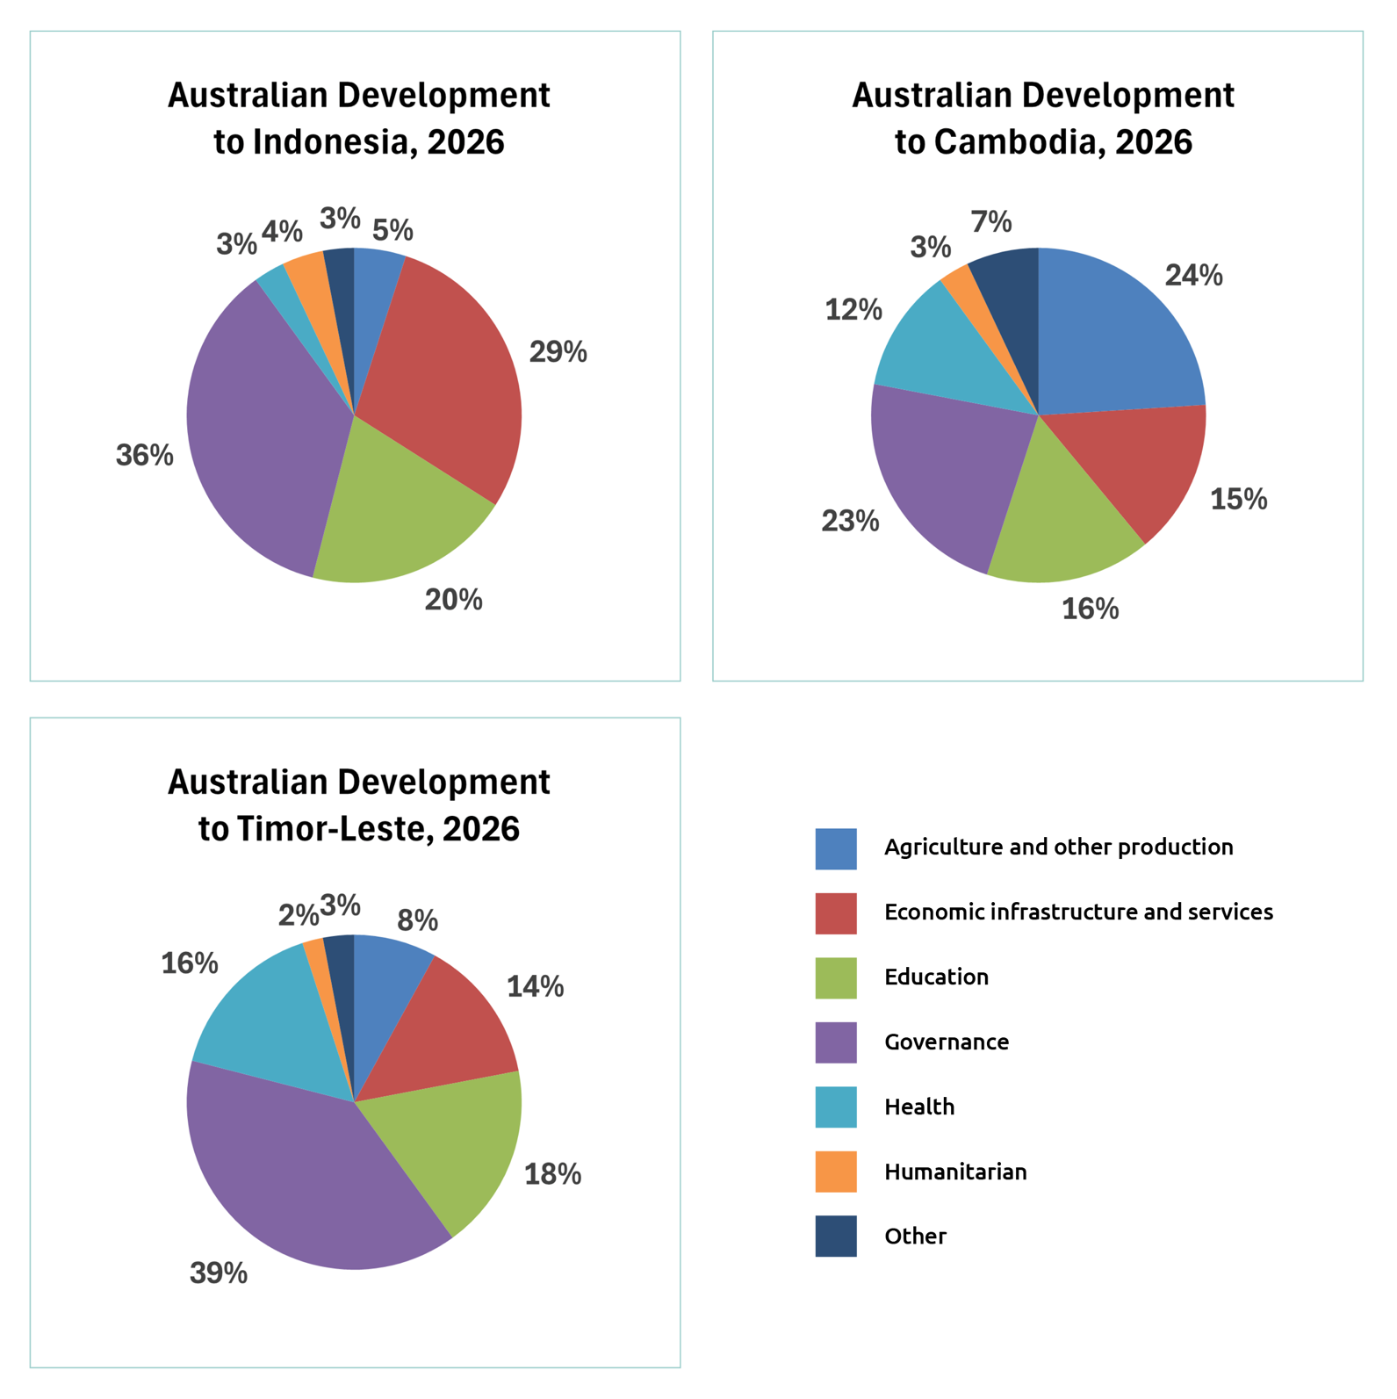

South and Central Asia region data card

Total Official Development Assistance budget available = $200 million
Country | Population | People over 15 years who can read and write | Energy use per person (kWh) | Access to safe drinking water | Income spent on household food | Population living in poverty
Bangladesh | 175 million | 75% | 3,000 | 59% | 53% | 19%
Sri Lanka | 23 million | 92% | 4,500 | 47% | 27% | 14%
Nepal | 30 million | 71% | 1,600 | 16% | – | 20%
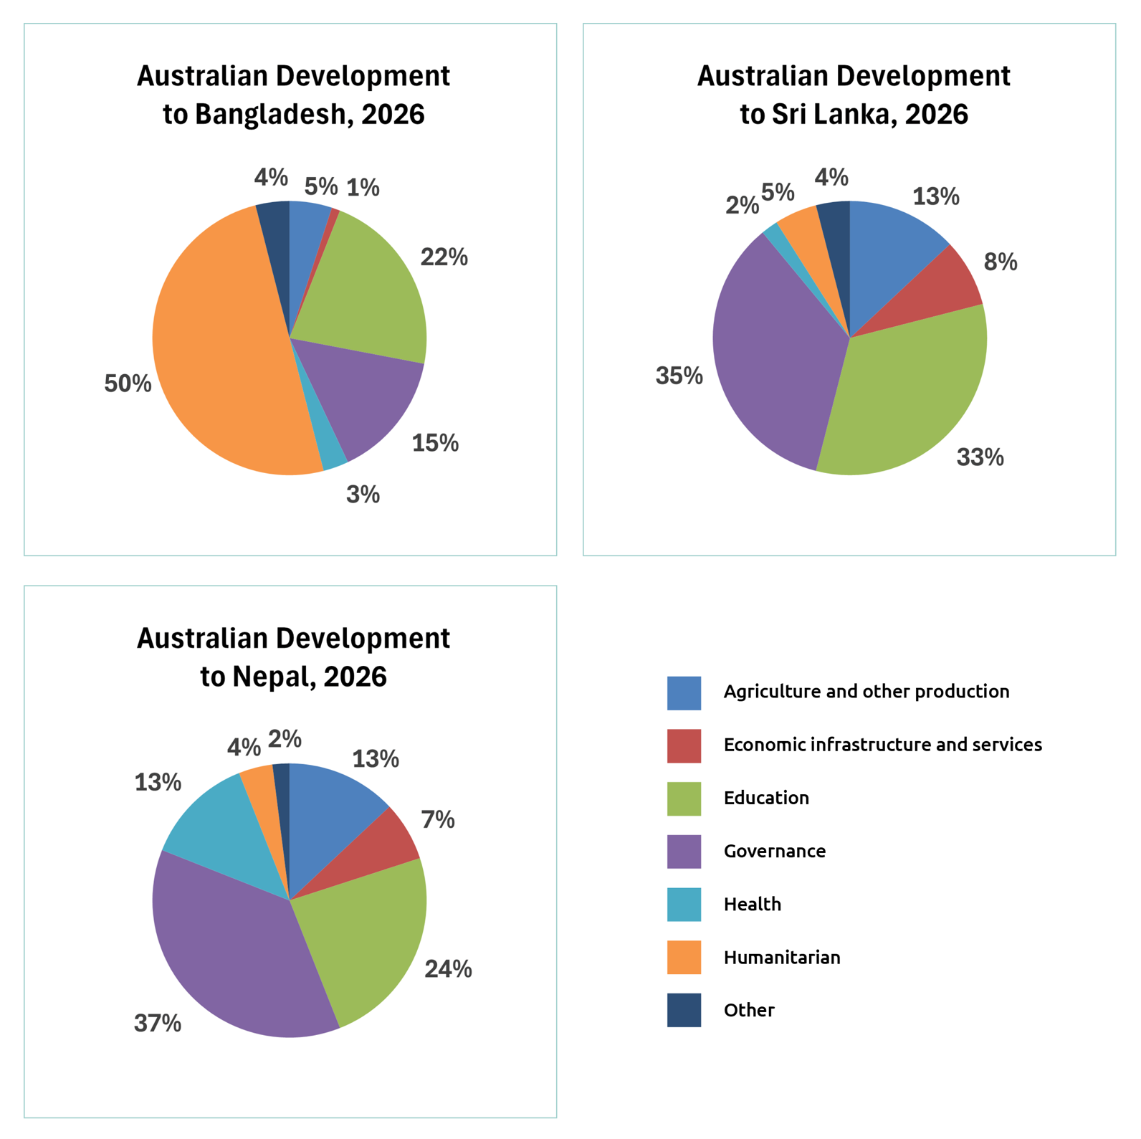

Pacific region data card

Total Official Development Assistance budget available = $850 million
Country | Population | People over 15 years who can read and write | Energy use per person (kWh) | Access to safe drinking water | Income spent on household food | Population living in poverty
Solomon Islands | 900,000 | 77% | 1,900 | 67% | 67% | 13%
Vanuatu | 335,000 | 89% | 3,000 | 91% | 91% | 16%
Papua New Guinea | 10.8 million | 64% | 2,100 | 50% | 50% | 40%
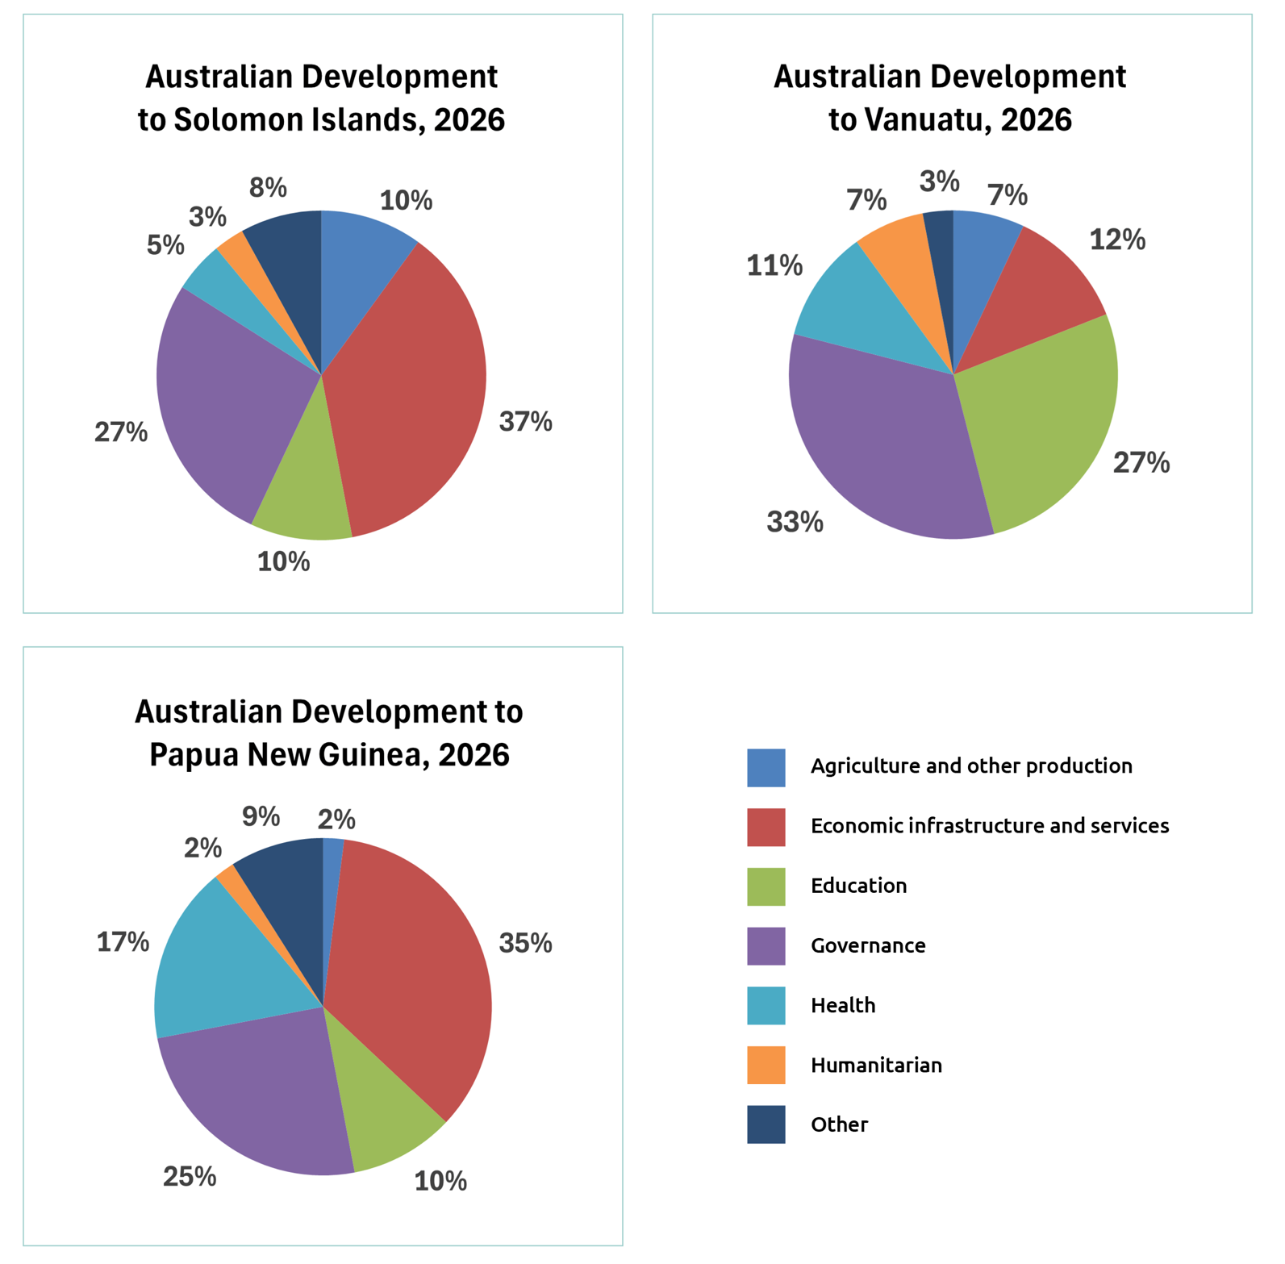

South-East Asia region data card 2

Total Official Development Assistance budget available = $250 million
Country | Population | People over 15 years who can read and write | Energy use per person (kWh) | Access to safe drinking water | Income spent on household food | Population living in poverty
Philippines | 117 million | 96% | 5,200 | 48% | 37% | 18%
Vietnam | 102 million | 96% | 13,700 | 58% | 35% | 4%
Laos | 8 million | 88% | 18,900 | 18% | 51% | 18%
