Australia’s neighbours in the Asia-Pacific region

Activity 1: Who are our neighbours?
Australia works together with many of our closest neighbours in Asia and the Pacific, particularly those countries within the following three regions: South-East Asia, South and Central Asia, and the Pacific. On the map below, draw an outline shape for each region, ensuring the countries listed for each region are included within your outline.
- South-East Asia: Cambodia, Indonesia, Laos, Myanmar, Philippines, Timor-Leste (East Timor), Vietnam, Thailand, Malaysia.
- South and Central Asia: Afghanistan, Bangladesh, Bhutan, Maldives, Nepal, Pakistan, Sri Lanka, India.
- The Pacific: Federated States of Micronesia, Fiji, Kiribati, Nauru, Papua New Guinea, Samoa, Solomon Islands,
Tonga, Tuvalu, Vanuatu and other countries within this area.
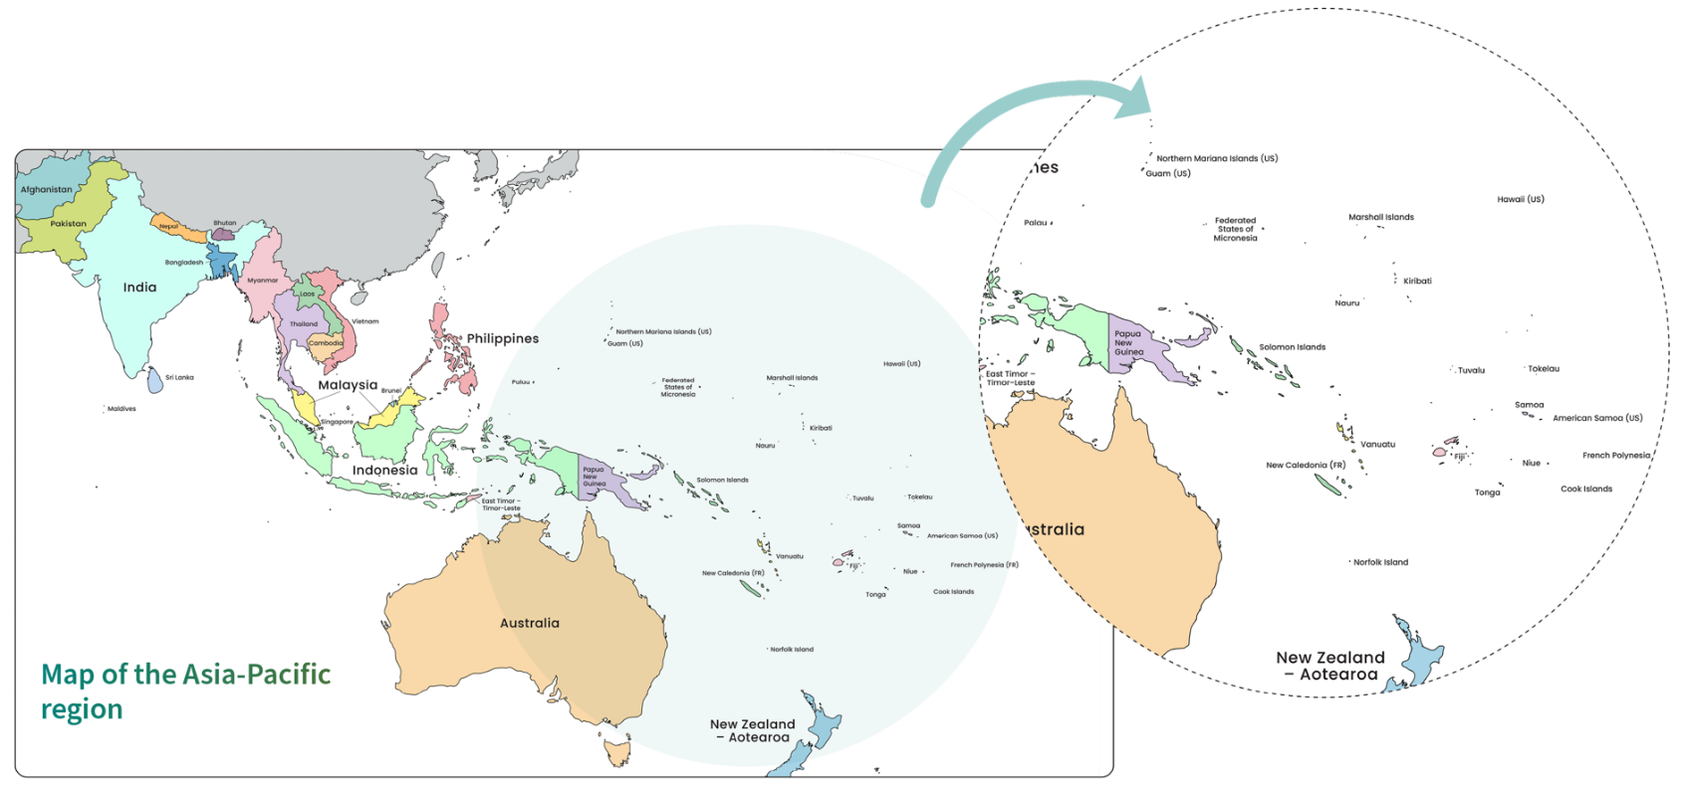
On the map, neatly add a label naming each region.

Adapted from: © VectorStock

Activity 2: Asia-Pacific country inquiry
Perform some research into three countries within each region of the map from Activity 1. A useful site for general statistics is the OpenFactBook – Country Data & Statistics.
South-East Asia | South and Central Asia | The Pacific
Country: | Country: | Country:
Major city/ies: | Major city/ies: | Major city/ies:
Population: | Population: | Population:
Life expectancy | Life expectancy | Life expectancy
Median age | Median age | Median age
Culture (e.g. preferred food or meals, main religion, main language,arts, customs, traditions) | Culture (e.g. preferred food or meals, main religion, main language,arts, customs, traditions) | Culture (e.g. preferred food or meals, main religion, main language,arts, customs, traditions)

South-East Asia | South and Central Asia | The Pacific
Describe any environmental features (e.g. forest, farming land, mountains, beaches, rivers). Hint: look at a physical map of the country. | Describe any environmental features (e.g. forest, farming land, mountains, beaches, rivers). Hint: look at a physical map of the country. | Describe any environmental features (e.g. forest, farming land, mountains, beaches, rivers). Hint: look at a physical map of the country.
Weather and climate (e.g. heavy rains or monsoonal, tropical, dry, possible hazards) | Weather and climate (e.g. heavy rains or monsoonal, tropical, dry, possible hazards) | Weather and climate (e.g. heavy rains or monsoonal, tropical, dry, possible hazards)
Conduct an image search. Find one image for each country. Search for ‘typical street in {insert country name}’. Paste the images below with a caption.

Understanding Australia’s Official Development Assistance

Follow the steps below to complete the table.
- Allocate the following development sectors to the correct definition in the table below:
- Health
- Humanitarian
- Agriculture and other production
- Economic infrastructure and services
- Governance
- Education
© Department of Foreign Affairs and Trade
- Decide what type of resource each development sector most closely aligns to: natural, human or capital.
- Classify each development sector as either a ‘need’ or ‘want’.

Development sector | Definition | Main resource type | Need or want
 | Supports resources produced from the land and water, such as farming, fishing, forests, mining.
 | Supports the development of resources that improve lifestyle, such as technology, transport, banking, energy, roads and networks.
 | Develops resources such as teachers and schools to improve skills and knowledge.
 | Supports resources that enhance politics and how a country is run and organised.
 | Provides resources such as doctors, nurses and medical centres that prevent disease or illness and improve health.
 | Provides assistance and relief during disasters or emergencies and works to reduce risks.

Glossary

Agriculture: another word for ‘farming’. Preparing the land and soil for growing crops, raising animals, and collecting resources, especially food.
Economic infrastructure: services, systems and facilities that help people to produce and sell goods to earn money. Technology is one system that helps people to buy and sell goods.
Governance: how decisions are made and control is managed, through the setting of rules, for example.

Global education literacy and numeracy skills

Activity 1: Global education glossary
In the table below, list all the new words you have learnt in this module. You will then write a definition or example together as a class.
© Australian Department of Foreign Affairs and Trade
Term | Definition or example

Activity 2: Describing a pie chart
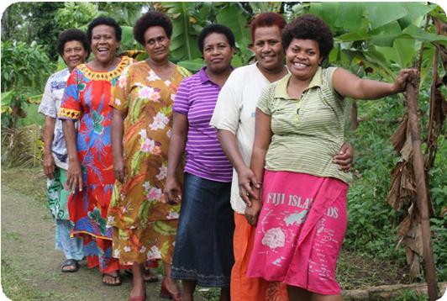
© Maggie Boyle/Department of Foreign Affairs and Trade, CC BY
When describing or comparing pie charts:
- The first sentence should summarise who, what, where and when.
- Mention the most, moderate and least proportions. Not every colour segment has to be mentioned.
- Compare the similarities and differences between two pie charts if they are side by side.
- Vary your vocabulary in your description – use the following table for suggestions:
90% | The majority
75% | Three-quarters
60% | Over half, almost two-thirds
50% | Half
45% | Almost half
30% | About a third
25% | A quarter
10% | A tenth
<5% | A negligible amount

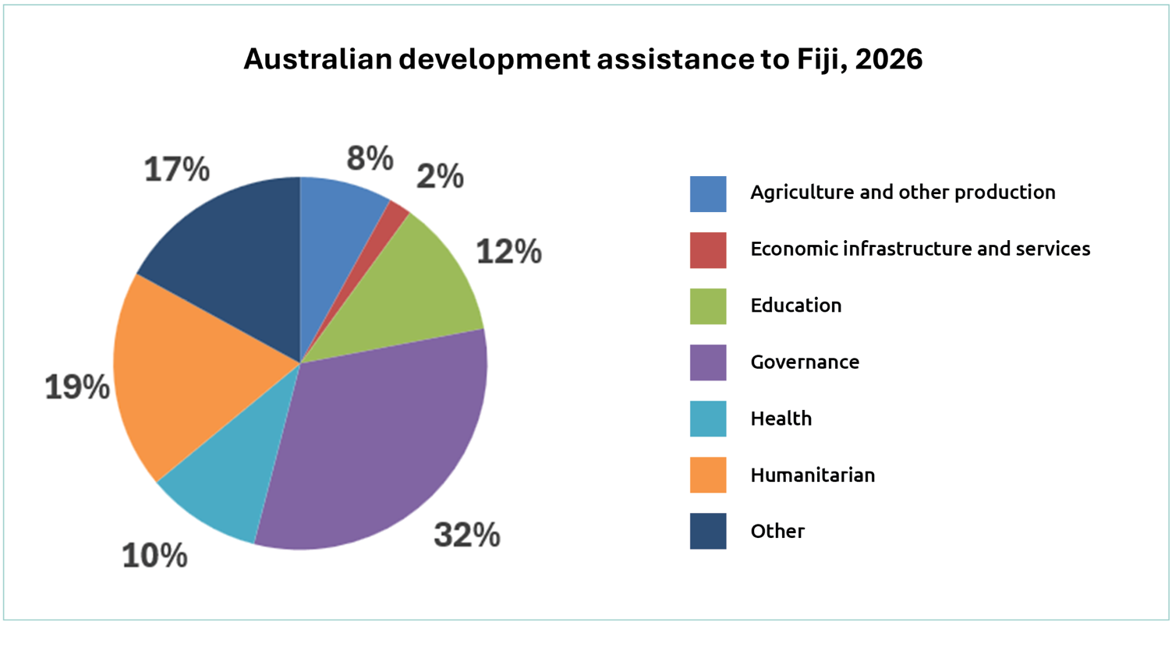
Pie charts on this page and pages 19 to 22 adapted from: Development cooperation fact sheets, Department of Foreign Affairs and Trade, https://www.dfat.gov.au/about-us/publications/development-cooperation-fact-sheets-for-country-regional-and-sector-thematic-programs, CC BY 4.0.
Describe the pie chart of Australian Official Development Assistance to Fiji in 2026.

Activity 3: Regional budget needs analysis

- Working in small groups, use the data card provided by your teacher to assess how best to support each of the three countries. Decide what percentage of the budget you will dedicate to each of the three countries based on the total available and fill in the pie chart to show this.
- Decide if you would you make any changes to the percentage of funds allocated to each sector. Remember, if the percentage for one sector (e.g. health) increases, another sector (e.g. governance) would need to decrease. Complete the table by circling your choices and providing reasons for any changes based on the statistics presented in the table.


Sector | Change (Country 1) | Change (Country 2) | Change (Country 3)
Agriculture |   Reason: | Reason: | Reason:
Economic infrastructure | Reason: | Reason: | Reason:
Education | Reason: | Reason: | Reason:
Health | Reason: | Reason: | Reason:
Governance | Reason: | Reason: | Reason:

South-East Asia region data card 1

Total Official Development Assistance budget available = $550 million
Country | Population | People over 15 years who can read and write | Energy use per person (kWh) | Access to safe drinking water | Income spent on household food | Population living in poverty
Indonesia | 285 million | 96% | 10,100 | No data | 34% | 9%
Cambodia | 18 million | 84% | 4,000 | 29% | 41% | 18%
Timor-Leste | 1.5 million | 68% | 1,600 | 68% | No data | 42%
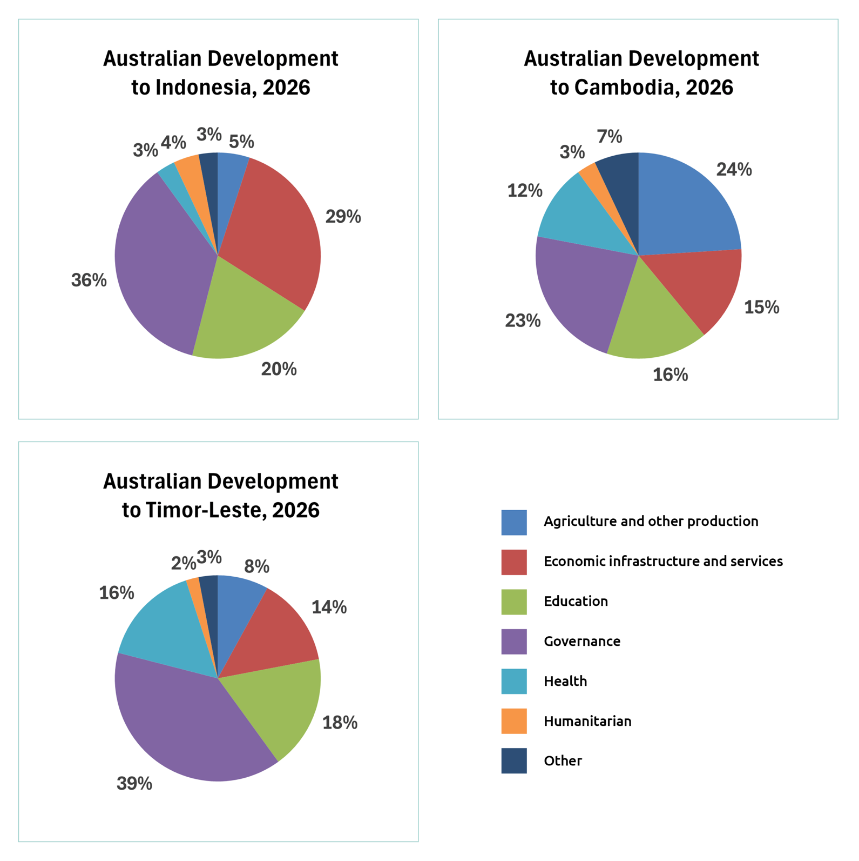

South and Central Asia region data card

Total Official Development Assistance budget available = $200 million
Country | Population | People over 15 years who can read and write | Energy use per person (kWh) | Access to safe drinking water | Income spent on household food | Population living in poverty
Bangladesh | 175 million | 75% | 3,000 | 59% | 53% | 19%
Sri Lanka | 23 million | 92% | 4,500 | 47% | 27% | 14%
Nepal | 30 million | 71% | 1,600 | 16% | – | 20%
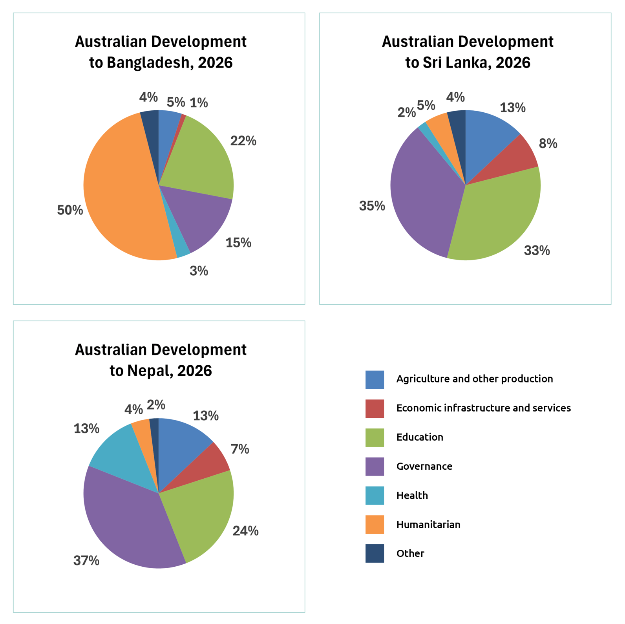

Pacific region data card

Total Official Development Assistance budget available = $850 million
Country | Population | People over 15 years who can read and write | Energy use per person (kWh) | Access to safe drinking water | Income spent on household food | Population living in poverty
Solomon Islands | 900,000 | 77% | 1,900 | 67% | 67% | 13%
Vanuatu | 335,000 | 89% | 3,000 | 91% | 91% | 16%
Papua New Guinea | 10.8 million | 64% | 2,100 | 50% | 50% | 40%
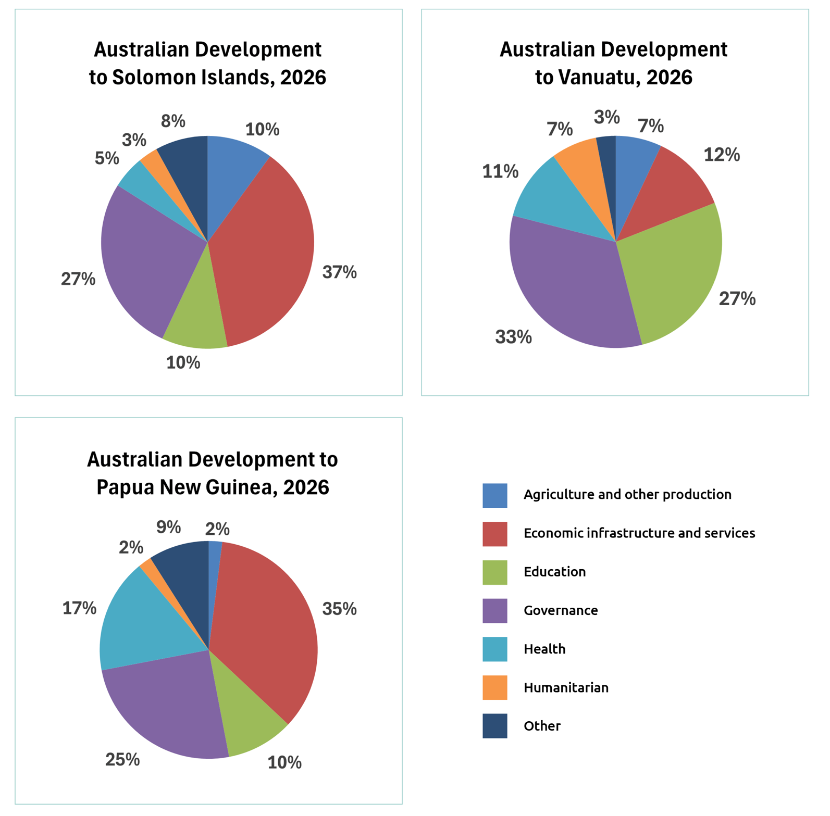

South-East Asia region data card 2

Total Official Development Assistance budget available = $250 million
Country | Population | People over 15 years who can read and write | Energy use per person (kWh) | Access to safe drinking water | Income spent on household food | Population living in poverty
Philippines | 117 million | 96% | 5,200 | 48% | 37% | 18%
Vietnam | 102 million | 96% | 13,700 | 58% | 35% | 4%
Laos | 8 million | 88% | 18,900 | 18% | 51% | 18%
