Australian Government Logo. AusAID.

Photograph of a farmer in the Phillipines, inspecting the ripening seeds of an experimental rice variety grown at the International Rice Research Institute in Los Banos south of Manila. 

Photograph of a Camboidan woman being interviewed by another woman. The two women are sitting on the floor outdoors, sharing the porch with clothes hung on a laundry line.AusAID Research Strategy 2012-16

July 2012

[www.ausaid.gov.au](http://www.ausaid.gov.au/)

AusAID Research Strategy 2012–16

July 201



Cover images from left to right:

Quirino Atienza inspects the ripening seeds of an experimental rice variety grown at the International Rice Research Institute in Los Banos south of Manila. Rice is the staple food of billions of people throughout Asia and the institute keeps the biggest collection of rice genomes, held in trusts for humanity. *Photo: Jay Directo/AFP*

Interviews with Cambodian women on their experiences of violence for the ‘Gender-based violence amongst women with disabilities in Cambodia’ project. Funded through the AusAID Development Research Awards Scheme the project is being undertaken by CBM Australia, Monash University, the International Women’s Development Agency and their Cambodian partners Banteay Srei and the Cambodian Disabled People’s Organisation. *Photo: Gender-Based Violence research team*

© Commonwealth of Australia 2012

Published by the Australian Agency for International Development (AusAlD), Canberra, July 2012.

This document is online at [www.ausaid.gov.au/publications](http://www.ausaid.gov.au/publications)

For further information about the Australian Government's international development program, contact:

Communications Section

AusAID

GPO Box887

Canberra ACT 2601

Phone (02) 6206 4000

Internet [www.ausaid.gov.au](http://www.ausaid.gov.au/)

Artwork by Great Impressions

Printed by Elect Printing

Content

**Key points** 1

**1. Overview** 2

Purpose 3

Outcomes 3

**2. Research priorities** 4

**3. What we fund and how** 7

**4. Delivering an effective research program** 9

4.1. Ensuring funded research advances AusAID’s research priorities 9

4.2. Enhancing performance oversight 9

4.3. Enhancing evaluation and risk management 10

4.4. Increasing the proportion of competitively funded research 10

4.5. Ensuring greater coordination through partnerships 12

4.6. Promoting better use of our research evidence and greater transparency 12

4.7. Building research capacity 13

**Attachment 1: AusAID research governance** 14

Responsibilities of AusAID's Research Section 14

**Attachment 2: Performance framework and key risks, likelihood and mitigation measures** 16

**Attachment 3: An indicative list of research partners** 19

Australian organisations 19

International partnerships 20

Other development research funders 21

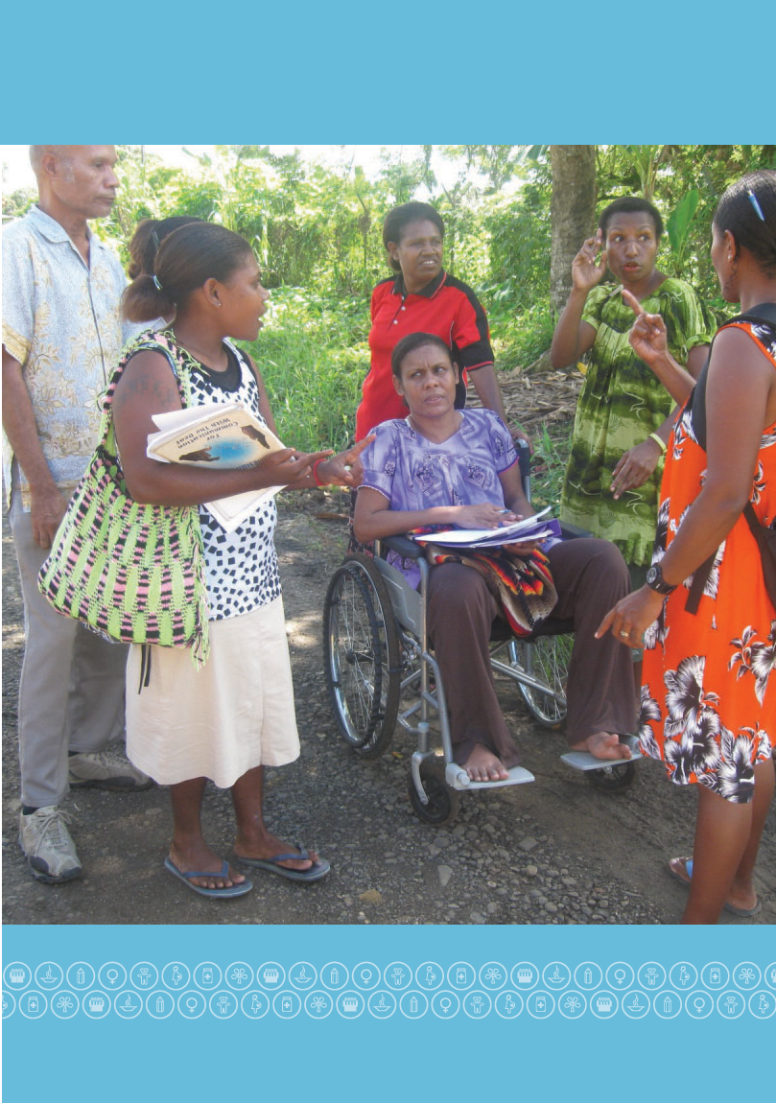

People with hearing impairments provide information about their use of road infrastructure to data collectors Mary and Hekoi, both of whom are local residents and people with disabilities. Photo: Disability Inclusive Road Development project



Key points

* + - The *AusAID Research Strategy* is aligned to the purpose and strategic goals of the Australian Government’s aid policy *An Effective Aid Program for Australia*.
    - The purpose of AusAID’s research program is to improve the quality and effectiveness of Australian aid in developing countries. To deliver an effective research program which provides better value for money, we will:
      * ensure all research helps improve the effectiveness of Australia’s aid program
      * increase the proportion of competitively funded research
      * enhance our performance oversight through stronger governance, evaluation and risk management
      * strengthen strategic partnerships that progress mutually beneficial research goals
      * increase use of our research by improving access to it both within AusAID and to others by promoting greater transparency
      * build capacity to perform and use research in Australia and in our partner countries.
    - In support of the transparency agenda in the Government’s aid policy we will:
      * improve the communication of research by requiring all research projects to have titles, reports and papers written in plain English
      * launch an online research database containing the AusAID funded research evidence
      * require researchers to publish in open access journals, or make pre-publication versions of their work available
      * support intermediary organisations that translate research into policy debates.

1. Overview

The Australian Government's aid policy *An Effective Aid Program for Australia* states that **“the fundamental purpose of Australian aid is to help people overcome poverty”** (page 1).

In terms of research, the policy commits the Government to:

* + - develop deeper research partnerships with Australian universities and research institutions, and to look to support the development of centres of excellence in key areas (page 26)
    - allocate research funding, where appropriate, on a competitive basis to ensure we are receiving value for money (page 26)
    - increase support for the Australian Centre for International Agricultural Research (ACIAR) (page 34).

The Government agreed in principle (Recommendation 23) that:

* + - there should be more aid funding for research by Australian and international institutions, particularly in agriculture and medicine, and that
      * allocations will be based on an assessment of poverty, national interest, capacity to make a difference and current scale and effectiveness.
      * AusAID will consult with the Australian Research Council and the National Health and Medical Research Council on relevant research.

The Government's 2012-13 Budget provides increased funding to the ACIAR, bringing their total budget to $10o million, to improve food security by lifting agricultural productivity. Supporting more medical research is also a key component of the Government's increased investment in saving lives of people living in developing countries in 2012-13.

## Purpose

The purpose of AusAID’s research program is to improve the quality and effectiveness of Australian aid in developing countries. Practical research will help inform where and how our own and our partners’ resources can most effectively and efficiently be deployed. This serves the overall purpose of the Australian aid program to help people overcome poverty.

## Outcomes

The strategy has four outcomes:

* + - research evidence informs and improves AusAID and partner country development decision-making
    - Australia plays a lead role in finding solutions to global development problems
    - new knowledge predicts and responds to development challenges and opportunities
    - partner countries’ capacity to do and use research is strengthened.

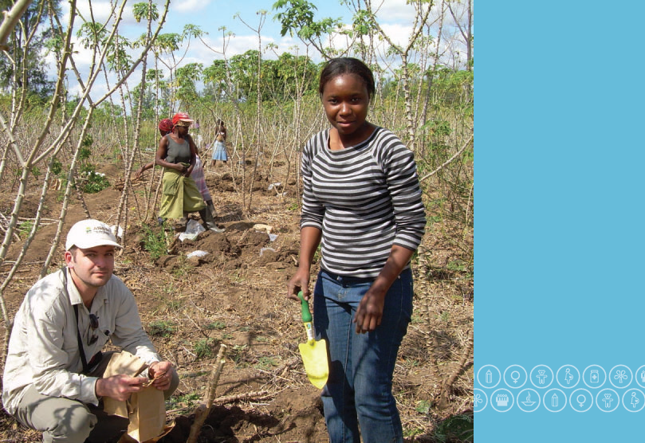Dr Timothy Cavagnaro, lead researcher, Monash University and one of the technical assistants, Laura Agronomy and Forest Engineering, Eduardo Mondlane University, Mozambique. Harvesting field plots to collect cassava tubers for analysis for the Cassava, climate change and food security project, Mozambique.

Photo: Monash University

1. Research priorities

AusAID's research investments will be driven by the research requirements of our country and regional programs working with partner governments in line with the *Comprehensive Aid Policy Framework*. Research funding decisions will also be based on an assessment of poverty, national interest, capacity to make a difference and current scale and effectiveness. As noted in *Effective Aid*, AusAID will place particular emphasis on its support for medical and agricultural research together with education as the flagship of the aid program.

As with the Government's broader aid commitments, the Asia-Pacific region will remain the primary geographic focus of our research support, with some expansion into Africa and South Asia. The breakdown of AusAID's research investment by region in 2010- 11 can be seen in chart 1 below. Research funding in 2010-11 amounted to $106 million representing 2-43 per cent of total Overseas Development Assistance (0DA). As with 2010-11, research funding going forward can be expected to remain consistent as a proportion of total ODA and to correlate with the future regional investment of the aid budget by the Australian Government. Chart 2 provides a breakdown of this projected investment by region in 2015-16.

| [1] |  |
| --- | --- |
| *Excludes global programs | |

Consistent with these regional funding priorities and with the policy goals of Effective Aid, AusAID’s research priorities are outlined below:

1. Research priorities

| Aid policy goal |  |
| --- | --- |
| Saving lives | * + - strengthening health systems in low resource environments     - maternal and child health     - disease prevention through better water, sanitation and hygiene practices     - understanding public health threats, including communicable and non-communicable diseases |
| Promoting opportunities for all | * + - increasing access to and completion of quality education, particularly for girls     - exploring links between education, employment and economic growth     - promoting gender equality through greater access to opportunities, services and rights     - improving the lives of people with disabilities |
| Sustainable economic development | * + - improving agricultural productivity, food availability and access to markets     - extractive industries and appropriate management of natural resource wealth     - the role of the private sector in development     - cleaner development and reducing the impacts of climate change on the poor     - understanding urbanisation and migration |
| Effective governance | * + - economic and public sector reform including areas of service delivery and security     - equitable access to law and justice services and promoting human rights     - increasing understanding of leadership |
| Humanitarian and disaster response | * + - the effects of climate change on disaster risk reduction     - enhancing disaster preparedness     - building the resilience of countries and communities to the impact of disasters |

Research that focuses on cross-cutting issues, for example, conflict, poverty or politics that cover two or more of the research priorities is also encouraged.

AusAID’s research priorities have been developed through extensive consultation with AusAID program and thematic areas. These priorities will be revisited at the mid-point of the strategy period to ensure they continue to align with the priorities of the aid program and respond to emerging needs.

1. What we fund and how

We define research as the creation of new knowledge and/or the use of existing knowledge in a new way in order to investigate complex issues, emerging challenges or test solutions to problems. The definition excludes data collection and analytical work that is part of routine agency business processes that only has an internal AusAID audience.

AusAID funds many different types of research to answer the wide range of challenges to development in our partner countries, to assist us to monitor development impacts, or to better target programs. Table 2 captures the range of research that we support.

1. Types of research that we support

| Applied | Innovation | Synthesis |
| --- | --- | --- |
| **Research directed towards a specific practical aim.** This can be characterised by one or more methodologies, including action research, statistical data analysis (such as sex and disability disaggregated data), longitudinal studies, multi- disciplinary research, epidemiological research, participatory research, impact evaluation, cost-benefit analysis, qualitative research, quantitative research. | **Use of the results of applied research and of empirical knowledge** to produce new goods or services; find new ways to develop products, or to grow a market.  Essentially creating value from knowledge. | **Analysis and summary of primary research.**  As well as bringing together the best answers already available, research synthesis identifies gaps in available research to better inform development policy.  This includes both literature and systematic reviews. |

Most research funding is provided through country bilateral programs, with the remainder supplied through sector groups, the Research Section and other programs such as the Office of Development Effectiveness. In 2010-11 the Research Section’s expenditure amounted to $8.1 million (less than eight per cent of total research funding). This decentralised approach ensures our portfolio of activity has close links to program design and implementation. Table 3 sets out AusAID’s research expenditure in 2010-11 by funding area.

1. Research expenditure in 2010-11 by focus and funding area

|  | | total in $m | | % of total | |
| --- | --- | --- | --- | --- | --- |
| Country or regional specific research  (bilateral program funded) | 57.0 | | 54 | |
| Sector specific research  (sector group funded) | 40.4 | | 38 | |
| Central research program  (Research Section) | 8.1 | | <8 | |
| Other funding | 0.4 | | <1 | |
| Total | 105.9 | | 100 | |

AusAID funds research through partnerships with Australian, international and developing country institutes, competitive grant schemes, direct grants and by commissioning research. In 2010-11 competitive grant schemes included $4.8 million (4.5 per cent of total research funding) for the AusAID Development Research Awards Scheme,

$510,000 (0.5 per cent of total research funding) for Systematic Reviews of Development Research, and $9.4 million in competitive tender processes (9 per cent of total research funding). Both the Research Awards and the systematic reviews are administered by the central Research Section, with

the other competitive tender processes administered by country and sector programs. Table 3 provides the percentages of how AusAID funded research in 2010-11.

1. Ways AusAID funded research in 2010-11

| Funding method | % |
| --- | --- |
| Partnerships | 55 |
| Direct grants | 22 |
| Competitive schemes | 14 |
| Commissioned | 9 |

1. Delivering an effective research program

To deliver an effective research program which provides better value for money, we will use the following approaches:

* + - ensuring funded research helps improve the effectiveness of Australia’s aid program
    - enhancing performance oversight
    - enhancing evaluation and risk management
    - increasing the proportion of competitively funded research
    - ensuring greater coordination through partnerships
    - promoting better use of research evidence and greater transparency
    - building research capacity

1. Ensuring funded research advances AusAID’s research priorities

In order to improve the practical relevance and use of research findings in AusAID’s decision-making, all research projects funded by AusAID will align with the priorities set out in Table 1.

1. Enhancing performance oversight

AusAID will strengthen the internal governance of research by:

* + - ensuring that all research be registered with the Research Section
    - strengthening internal advice provided by the Research Section to country and sector program areas as they develop research programs including the development of rules and tools for research project development, funding methods and monitoring and evaluation
    - establishing a greater oversight role for the Research Steering Committee including:
      * requiring all new research projects with a value of $500,000 or more to be approved by the Committee. Projects will be assessed according to: the competitiveness of the procurement process; quality of the research proposal; and whether the project will advance AusAID’s research priorities
      * having two external members with specific expertise in research administration on the committee.

The governance structure for research and the Research Section’s responsibilities are further detailed in Attachment 1.

1. Enhancing evaluation and risk management

Recipients of AusAID’s research funding continue to be required to meet contractual deliverables and timeframes, ensure proper financial acquittals and report on influence and uptake of their results. At the design stage, researchers will be required to outline how a research activity will lead to change in a given community including early and intermediate outcomes.

The Research Section offers guidance and advice to program areas to encourage good practice in the commissioning of research including appropriate monitoring and evaluation processes.

It also produces a report on research in AusAID to track research activity according to levels and types of funding, research themes, the mechanisms used and the impacts of the research. The report will be a public document from 2012.

In 2014, the report on research will include a mid-term review of the Research Strategy informed by the performance framework in Table 5, Attachment 2.

Managing risk

The steps we will take to manage key risks for AusAID’s research investment are set out in Table 6 in Attachment 2.

1. Increasing the proportion of competitively funded research

We promote fairness, transparency and value for money from our research investment including through the use of competitive mechanisms to fund research. In 2010–11 the proportion of AusAID’s research expenditure that was awarded competitively was 14 per cent. Consistent with the Government’s aid policy we will aim to increase this proportion to 30 per cent by 2015–16.

In setting this target, the strategy sets out to strike a balance between increasing competitive funding and supporting international development research bodies through collaborative partnerships (discussed further below).

Initially the use of competitive mechanisms will be encouraged for research projects that are sourced either through direct grants or by commission (see table 4). The competitive mechanisms used will depend on the nature of each research project or program. In the longer term, AusAID will move towards ensuring that relevant future partnerships are also competitively funded.

AusAID will use the following mechanisms to reach the target of 30 per cent competitive research funding by 2015–16:

Research Section advice and support: Through its enhanced oversight role with the compulsory registration of research projects, the Research Section will provide guidance to country and sector program areas on appropriate methods of procurement for research projects.

* + - **Research Steering Committee:** All new research projects and partnerships with a value of $500,000 or more will need to be approved by the Research Steering Committee. The Committee will consider the competitiveness of procurement as part of their approval process. Contract splitting to avoid Committee oversight will not be permitted.
    - **AusAID Development Research Awards Scheme:** The Scheme is a competitive grants program that supports primary research on priority themes and is open to researchers within Australia as well as internationally. The size and number of awards will grow to meet the wide range of challenges faced by program and policy areas. The fourth round of the research awards is to open in mid-2012. In selecting grant proposals, we will prioritise collaboration between developed and developing country researchers, and the inclusion of end-users in the research. The Awards will be held at least every two years and may occur more frequently where there is demand within the agency.
    - **Global competitive funding schemes:** AusAID will continue to support global and regional competitive funding schemes such as the Global Development Network. The Network is an international organisation and network focussed on building research capacity and undertaking research in developing contexts that runs global and regional research competitions for developing country-led teams. AusAID will also consider other research mechanisms, such as systematic reviews that provide syntheses of primary research evidence for decision-making and are a new approach in development research. Further support for systematic reviews will depend on a review of the results from AusAID’s initial joint funding round.
    - **Competitive grant schemes in partner countries:** AusAID will support such schemes where these exist, including through AusAID posts.

1. Ensuring greater coordination through partnerships

Long-term partnerships with key Australian, international and developing country research groups allow us to reduce fragmentation while leveraging the skills, knowledge and assets that each partner brings. Our research partners allow us to build a coordinated agenda, share lessons, and provide timely advice. An indicative list of AusAID research partners is at Attachment 3.

In order to strengthen existing partnerships AusAID will consolidate multiple individual agreements with selected research partners into longer-term strategic partnership agreements that reduce transaction costs while maintaining flexibility to fund projects in priority areas. AusAID will also evaluate the effectiveness of current partnerships with international research organisations to ensure our research investment is going to areas of strategic importance to the aid program.

1. Promoting better use of our research evidence and greater transparency

Investing in research driven by users

Research that is driven by users to meet their own needs is more likely to have impact. To support this AusAID will:

* + - promote the role of end-users in setting priorities and participating in doing the research
    - support the strengthening of research-to-policy systems in specific partner countries, such as Indonesia.

The Research Section will monitor how research is being used within the agency through ongoing engagement with country and thematic areas on their research programs as well as by conducting a survey of research uptake within the agency.

Supporting researchers to communicate

Targeted communication between researchers and policymakers or practitioner groups plays an important role in ensuring research is used. Communicating the research that AusAID funds to the Australian and international community is also an important part of AusAID’s transparency agenda. AusAID will require all research activities to:

* + - have titles, reports and papers written in plain English
    - prepare short summary briefs with actionable recommendations
    - build communication and engagement strategies into research projects at the design stage.

Greater transparency and access to the research AusAID funds

Consistent with AusAID’s Transparency Charter, AusAID is committed to making the research that it funds publicly accessible by:

* + - launching an online research database on the AusAID website
    - requiring researchers to publish in open access journals, or make pre- publication versions of their work available
    - preparing regular synthesis of the findings from the research that we fund
    - supporting intermediary organisations that translate research into policy debates.

1. Building research capacity

Capacity building is a priority of AusAID’s research investment, not only to undertake research but to stimulate demand for and use of research for development decision making. Developing research capacity requires a long term investment and adequate resourcing. We will build the research capacity in our partner countries by:

* + - fostering partnerships between Australian and partner country researchers and universities
    - providing a mix of core and project funding to key researchers in our partner countries to develop their capacity to undertake and use research
    - providing more opportunities for country partner researchers to access
    - AusAID funding by making more competitive mechanisms open to them.

Photograph of a number of corn ears of different sizes and colour, laid down on a blue quilt, categorized using a number of hand-written paper signs that read:
New variety from Sol (HAR 12), White.
New variety from Sol (Sele), Yellow.
Local variety (Sele Brue), Yellow, White.
The Local Variety corn ears are about one third the size of their corresponding new varieties.AusAID is working to improve rural livelihoods and food security through the Seeds of Life program in East Timor, with support from ACIAR.

Photo: Philippa Venning, AusAID

1. AusAID research governance

Responsibilities of AusAID's Research Section

AusAID's Research Section role is a focal point for research. Specific responsibilities include:

* + - tracking and reporting on research funded by AusAID
    - setting standards and procedures for research funding, management and the evaluation of research impact
    - providing advice to program areas on new and ongoing research activities
    - supporting the uptake and use of AusAID funded research
    - managing AusAID's central competitive funding mechanisms and partnerships
    - gathering information from programs as to their immediate priorities for research
    - lesson sharing and coordination with other development research funders
    - preparing regular synthesis of the findings from the research that we fund
    - providing the Secretariat to the Research Steering Committee.

**Research Steering Committee**

* oversees AusAID’s research funding
* provides strategic direction
* monitors effectiveness
* provides advice to Executive on research

**EXECUTIVE**

**Research partners**

* fund research in line with direct needs
* use research to inform policy and programming
* advise Research Section of research activities, impacts and outputs.

**Research Section**

* research methods support
* cross-agency reporting
* manage central competitive funding
* programming advice
* set policy direction
* support research use
* lesson sharing and coordination with other development research funders
* fund and distil knowledge on cross-cutting policy issues

**Country programs**

**Sectoral groups**

**Other programs**

Australian universities and research institutions

Whole of Australian government partners

Developing country partners

NGOs and private enterprises

International universities and research institutions

Multilateral organisations

1. Performance framework and key risks, likelihood and mitigation measures
2. Types of research that we support

| Outcome | Intermediate outcome | Output |
| --- | --- | --- |
| Research evidence informs development decision-making. | Research activities are embedded within development programs. | Proportion of AusAID programs with a linked research activity. |
| Research is relevant and useful.. | Increase in awareness and use of AusAID funded research by users, including AusAID staff. |
| Research is communicated to target audiences appropriately. | Increase in number of research activities with targeted communication and engagement strategies. |
| Research is accessible. | Percentage of publications in open access format.  Coverage by media and other development |
| Australia plays a lead role in finding solutions to global problems | Australian research institutions undertake high quality, collaborative development research. | Numbers of publications in peer reviewed journals.  Number of collaborations between Australian and international researchers. |
| Australian-led research influences global development debates. | Media coverage of Australian-led research.  Briefings for international or major meetings which draw on Australian research. |
| Australian research is discussed in international forums | International forums cite Australian development research. |
| New knowledge predicts and responds to development challenges and opportunities | Research-informed debate on issues and opportunities beyond a five year period. | Proportion of funding addressing emerging threats or challenges.  Development strategies and policies reference AusAID-funded research. |
| Partner countries’ capacity to do and use research strengthened | Strengthened partner country research institutes. | Increase in proportion of research funding allocated directly to partner country institutions.  Number of successful competitive grant applications from local research institutions. |
| Partner country researchers using new research skills. | Participants in research capacity development activities value and use new skills. |
| Research evidence informs partner decisions. | Awareness and use of AusAID funded research by users in partner countries. |

1. Key risks, likelihood and mitigation measures

| Risk | Likelihood | Mitigation measures | Residual risk |
| --- | --- | --- | --- |
| The research AusAID supports is not used to inform decision making,  including within  AusAID. | Medium | * + - Research program designs or funding applications are required to provide a pathway to expected impacts     - Annual activity reports are required to provide details on progress along the impact pathway     - Involvement of research end- users in research design, governance and implementation     - Provide access to results through an online research database and summary briefs     - In-house synthesis of research results     - Recognition that not all research will be immediately applicable to policy needs | Low |
| Contracted universities and research institutions do not deliver high quality products. | Medium | * + - Careful management of contracts and funding agreements     - Technical experts assess research proposals     - Self-managed by universities and research institutions who would be keen to preserve their research reputations | Low |
| Researchers breach Australian or in-country  ethical research codes. | Medium | * + - Research funding recipients are required to abide by Australian and in-country research ethics procedures | Low |

1. An indicative list of research partners

Australian organisations

Australian Centre for International Agricultural Research

An Effective Aid Program for Australia recognises both the need for more research investment in agriculture and the Australian Centre for International Agricultural Research's key role. With that in mind, AusAID's partnership with ACIAR will further expand, supporting increased investment in research and innovation. ACIAR will also continue to manage Australia's engagement with the Consultative Group on International Agricultural Research.

Commonwealth Scientific and Industrial Research Organisation (CSIRO)

AusAID supports CSIRO to conduct research in areas of importance to the Australian aid program including in areas of fisheries, food security, disaster risk reduction, climate change adaptation and monitoring. The AusAID-CSIRO alliance is one of the ways AusAID engages with CSIRO on the particular issues of the environment and poverty. Supporting a limited number of longer-term research activities, the alliance addresses issues of sustainable development including energy, water resources and climate change in South East Asia. AusAID is also working with the CSIRO on a large-scale collaboration with West African researchers to improve regional food security.

The research councils

As stated in An Effective Aid Program for Australia, AusAID will broaden its engagement with both the Australian Research Council and the National Health and Medical Research Centre. AusAID will continue to be a partner with higher education researchers on relevant Australian Research Council linkage project applications that promote innovative research.

Australian Government departments

AusAID will continue to collaborate with relevant Australian Government partners on setting research priorities as well as joint funding, review and use of relevant research. An example of such a partnership is the Pacific-Australia Climate Change Science and Adaptation Planning program. Managed by the Department of Climate Change and Energy Efficiency, the program involves effective collaboration with AusAID and CSIRO as key partners.

Australian Council for International Development (ACFID)

AusAID partners with ACFID as the peak body for Australian non- government organisations including collaboration on approaches to human research ethics.

International partnerships

AusAID will continue to engage in strategic partnerships with leading international development research institutions. Examples of successful AusAID partnerships, among others, include the:

* + - Overseas Development Institute that provides high quality, practical research and capacity development in areas such as impact evaluation, business engagement, humanitarian policy and public aid expenditure;
    - Brookings Institution and the Centre for Global Development that continue to provide useful research on aid effectiveness such as the annual Quality of Official Development Assistance Assessment;
    - Asia Foundation and the International Crisis Group that provide credible research grounded in operational experience and collaboration at the country level on issues of fragility, conflict and national security.

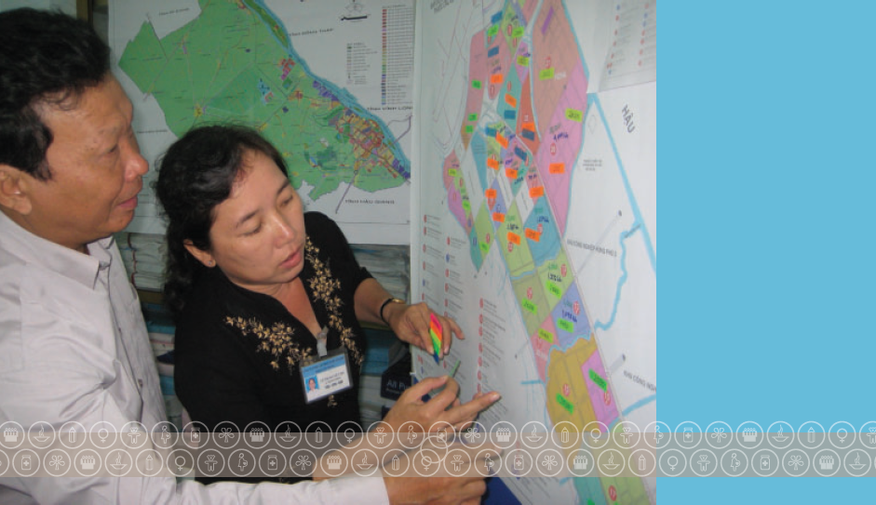Ms Le Thi Nguyet Thu and Mr Nguyen Van Sao of Can Tho Water Supply and Sewerage Company making predictions of the timing of developments in South Can Tho, Vietnam. The research project, ‘Assessing the cost-effectiveness and sustainability of sanitation infrastructure options for peri-urban areas - a Case Study of Can Tho, Vietnam’ was funded through the AusAID Development Research Awards Scheme.

Photo: Institute for Sustainable Futures, University of Technology, Sydney

Other development research funders

AusAID will continue to work closely with other development research funders through playing an active role in the International Forum for Research Donors. We have been an early advocate of a formalised administrative structure to support the effectiveness and influence of the network.

*Morris Agaba, Scientist and Molecular Biologist at the International Livestock Research Institute in Nairobi, Kenya has witnessed firsthand how the work of the Institute contributes to African food security. Australia provides funding to the Institute through the Australian Centre for International Agricultural Research (ACIAR), to improve African food security.*

Photo: Kate Holt/Africa Practice

1.