Improving the Teaching of Mathematics in Elementary Schools by using cultural activities and local languages

Australian Development Research Awards Scheme

2012 Funding Round

### Description

This project focuses on how to assist elementary teachers in remote areas of Papua New Guinea through professional learning using a set of key ideas and examples. The professional learning was through workshops with video enhance and then on a touch-screen laptop with solar power. The e-resource was expected to motivate the teacher to learn through pages on each key principle and relevant videos.

### Research Focus

**Focus 1: What are appropriate guidelines for elementary teachers to recognise and use cultural mathematical proficiencies for transition to school mathematics?**

* Can past research be converted to guidelines for the many languages and ecologies of PNG?
* Can linguistic guidelines be developed to guide communities to determine appropriate vernacular phrases for school mathematical concepts?
* How do the guidelines need refining for elementary teachers to understand?

**Focus 2: How can technology assist professional learning?**

* Has technology, infrastructure, costs changed sufficiently to permit this?
* How can technology/video enhance this understanding?

### Research Design

A design research methodology was used to set up principles relevant to PNG which were trialled and then modified based on results of implementation. Workshops were delivered in three different ecologies: the highlands, the coast, and the hinterland (coastal mountains) thus ensuring a diversity of cultures and languages. Research design was applied also to the use of a solar powered computer system and e-resource.

### Methodology

The initial design was prepared by the mathematics lecturers from the University of Goroka and Dr Kay Owens (CSU) based on research and their experiences of what was important in teacher professional learning. These were grouped under key principles:

* Mathematics in cultural activities
* Cultural capacity and partnerships
* Activities appropriate for children—play and inquiry through investigation
* Mathematical ways of thinking
* Early mathematical thinking in young children
* Early mathematical development activities
* Language treasures (there are 800 plus languages and cultures in PNG)
* Assessing, reporting and planning

The design of key ideas was implemented in a workshop, evaluated, refined, implemented and re-evaluated. Observations, reflection, and participant evaluation of workshops plus follow-up data from teacher questionnaires, children’s questionnaires, classroom observations and teacher interviews. Due to the remoteness of schools, the follow-up data was limited to accessibility.

Workshops were each run by two researchers with a sound knowledge of mathematics education and ethnomathematics, one of whom could speak a local language of the area. The first phase of workshop implementations incorporated a manual, videos, mathematics readers, appropriate activities including educational games and the opportunity to practice preparing inquiry method learning plans and assessing children. After each round, slight modifications were made and at the end of the phase, we selected three key principles and developed the model shown here.

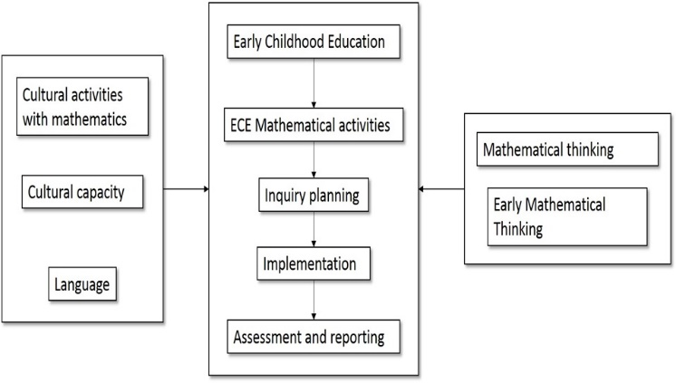

The second design to be evaluated related to technology enhancement with the key principles of:

* Sustainability
* Ease of use
* Engaging the teachers to read the professional learning materials and engage in preparing and implementing mathematics lessons by using local languages and cultural practices
* Build a community of practice of teachers implementing this approach

### Policy implications

The following outcomes of the project have implications for policy.

* The above design for professional learning developed capacity for elementary teachers, provincial elementary trainers and preservice teacher educators and so is appropriate for further professional learning and standards among teachers
* The project provided capacity for research and involvement of PNG researchers in the global community of researchers in mathematics education, and in ethnomathematics to which PNG can be a major contributor
* The professional learning model and implementation process integrates culture, language and mathematics for a multilingual society
* The design will be useful for other Indigenous communities
* The research supports the values and processes of learning numeracy in the vernacular
* The design provide a continuity between home and school mathematics in PNG education
* The workshops were effective for teachers
* The workshops and resources provided a approach that teachers could use as professionals at the beginning school level

### Challenges

* Landslides, responses to elections, differences in expectations of visits, and remoteness of sites made implementing workshops difficult
* The thirst for professional learning resulted in unexpected numbers in remote field workshops
* Adapting to opportunities resulted in support of the team, their communities, SIL PNG VERA course
* The time available for the project and length of workshop were not sufficient.
* Teachers had limited opportunities to use English and undertake initial teacher education so their background knowledge had to be considered further in preparing the materials
* Local languages are changing rapidly so teachers’ knowledge of their own cultures needed support
* Professional level is required for undertaking the planning using the inquiry method
* Recognising mathematical ways of thinking in cultural activities and turning these into appropriate mathematical inquiry for young children needs professional learning
* Enthusiasm to extend the reach of the project stretched our time, budget and opportunities for influencing policies.

### Achievements

* Publication of refereed research papers in journals and presentation of papers at International Conference on Pure and Applied Mathematics, Lae, PNG; International Congress on Ethnomathematics, Aboriginal and Torres Strait Islander Mathematical Alliance conferences, Psychology of Mathematics Education conferences, Mathematics Education Research Group of Australasia conferences, illustrating team’s growth in research capacity
* Multicultural research team working together
* Production of a comprehensive manual, readers, computer-enhancement, videos, making research available to teachers
* Development of an easy to use solar-lithium battery-touchscreen computer system with a short workshop effectively introducing the computer, the teaching principles, and the key ideas of open-ended questions, inquiry planning, and small group activities with teacher facilitating children to develop mathematical concepts.

#### Contact

|  |  |
| --- | --- |
| **Dr Kay Owens**  Charles Sturt University  Locked Bag 49  Dubbo NSW 2830  Australia  Tel: +61 2 68857352 kowens@csu.edu.au | Vagi Bino, [binov@uog.ac.pg](mailto:binov@uog.ac.pg)  Susie Daino, [dainos@uog.ac.pg](mailto:dainos@uog.ac.pg)  Dr Cris Edmonds-Wathen,  (Melbourne University) |