

RESTORATION AND REPARATION PROYECT FOR NURSURY SCHOOLS AND DAY CARE CENTERS DAMAGED BY THE EARTHQUAKE AND TSUNAMI ON FEBRUARY 27TH, 2010

REPORT UP TO MARCH 31st, 2011

This report includes:

- An assessment of the progress made to this date.
- An execution strategy and work program for the next period:
  - Requirements and results of the proposed work program.
  - Description of the contributions, works carried out and performance of the activity.
  - Pictures of both finished works and works under progress.

Assessment of Progress Made to this Date.
The assessment of the project is hereby presented according to the following structure:

A. Repair of Child Care and Kindergarten Institutions.
Facilities repaired.

B. Reconstruction of Nursery Schools.
Purchase of plots.
Nursery schools still under construction phase.
Nursery schools still under design phase.

C. Financial Statement.

A. Repair of establishments.

Establishments repaired

Table N°1: “Establishments repaired”
Nº | Region | District | Nursery School Name | Day Care Capacity | Infant Capacity | Hired Investment Cost  ($)
1 | Maule | Cauquenes | Semillita | 0 | 79 | 8.896.171
2 | Maule | Licantén | Papelucho | 0 | 76 | 11.278.968
3 | Maule | Licantén | S.C. Capullito | 24 | 0 | 10.022.422
4 | Maule | Linares | Niditos del Valle | 0 | 90 | 9.745.919
5 | Maule | Maule | Flor de Aromo | 22 | 84 | 5.658.926
6 | Bío Bío | Cañete | Huentelolen | 0 | 18 | 10.793.731
7 | Bío Bío | Concepción | Los Aromos | 0 | 128 | 12.817.833
8 | Bío Bío | Talcahuano | Los Lobos | 0 | 99 | 19.436.276
9 | Bío Bío | Coihueco | Los Castorcitos | 0 | 48 | 28.917.321
10 | Bío Bío | Yungay | Rayo de Luna | 0 | 64 | 25.852.555
11 | Araucanía | Freire | Los Notros | 0 | 108 | 6.912.640
12 | Araucanía | Temuco | Villa Austral | 36 | 94 | 10.946.870
13 | Araucanía | Angol | Teresita Domínguez | 18 | 65 | 12.524.185
14 | Araucanía | Ercilla | Cepillin | 0 | 33 | 7.985.049
15 | Metropolitana | Buin | Las Palmas | 54 | 64 | 2.941.531
16 | Metropolitana | San Bernardo | Mujeres de Chile | 0 | 137 | 5.853.408
17 | Metropolitana | María Pinto | San Enrique | 12 | 76 | 12.154.363
18 | Metropolitana | María Pinto | Valle Escondido | 12 | 47 | 13.456.520
19 | Metropolitana | San Pedro | Los Pelluquitos | 12 | 60 | 14.813.501
20 | Metropolitana | Pudahuel | Rinconcito Mágico | 77 | 146 | 37.642.941
21 | Metropolitana | Renca | María Flora Yánez | 42 | 153 | 6.220.963
22 | Metropolitana | Renca | Valle de Azapa | 18 | 108 | 9.603.776
23 | Metropolitana | El Monte | San Francisco del Monte | 18 | 104 | 8.960.733
 |  |  | TOTAL | 345 | 1.881 | 293.436.602
 |  |  |  | 2.226

The previous table shows that we have 23 repaired nursery schools and day care centers in four regions in the country, in 20 districts and directly benefiting 2.226 boys and girls.

B. Reconstruction of Nursery Schools
Purchase of Plots
This project includes the purchase of three plots of land for the restoration of the establishments. These plots have been purchased on behalf Integra Foundation.
Table N°2 “Purchase of Plots”
Nº | Region | District | Nursery School | Day Care Capacity | Infant Capacity | Plot Cost | Observation
1 | O’Higgins | Paredones | Rayito de Sol | 0 | 32 | 3.999.734 | Purchased
2 | Del Maule | Talca | Micaeliano | 18 | 32 | 43.178.938 | Purchased
3 | Araucanía | Vilcun | Copito de Nieve | 0 | 32 | 13.000.001 | Purchased
 |  |  |  | 18 | 96 | 60.178.673

Establishments still under construction
The Project includes resources for the construction of 9 institutions to be restored. It does not consider resources for the development of architecture and engineering projects. These funds shall be provided by Integra Foundation.
Table N°3: “Establishments under construction”
Nº | Region | District | Nursery School Name | Day Care Capacity | Infant Capacity | Construction Surface  (m2) | Cost of hired Construction
1 | Valparaíso | Petorca | Jorge Sabal Rabi | 0 | 32 | 109,23 | 59.805.828
2 | O’Higgins | Paredones | Rayito de Sol | 0 | 32 | 142,42 | 77.757.332
3 | Maule | Pencahue | Rayito de Luna | 0 | 96 | 269,75 | 106.208.128
4 | Maule | Talca | Micaeliano | 18 | 32 | 253,21 | 103.816.100
5 | Maule | San Clemente | Abejitas | 18 | 32 | 251,00 | 94.266.564
6 | Bío Bío | Cabrero | Javiera Carrera | 18 | 96 | 515,59 | 221.704.216
7 | Araucanía | Gorbea | Los Ciervitos | 0 | 96 | 339,15 | 141.127.437
8 | Araucanía | Vilcún | Copito de Nieve | 0 | 32 | 154,91 | 68.066.149
 |  |  |  | 54 | 448 | 2.035 | 872.751.754
 |  |  |  | 502

The previous table shows that we now have 8 nursery schools under construction in five regions in the country, in 8 districts, that directly benefit 502 boys and girls. Construction of Jorge Sabal Rabi nursery school in the Region of Valparaiso starts on April 4, 2011.
Due to the need for restoration and to budget adjustments, the Abejitas nursery school, from the Maule Region was incorporated as a restoration Project, regarding to that reported in November 2010.

Establishments under design stage
Table N°4: “Establishments still under design stage”
Nº | Region | District | Nursery School Name | Day Care Capacity | Infant Capacity | Construction Surface  (m2)
1 | Araucanía | Temuco | TrañiTrañi | 0 | 32 | 163,64
 |  |  |  | 0 | 32 | 163.64
 |  |  |  | 32

The establishment in the Araucania Region has the respective architecture and engineering projects completed.

C. Financial Statement

The contribution received for AUD 3.000.000 was exchanged into American dollars, with a total of USD 2.531.931, 00; from which USD 2.075.544, 69, equivalent to CHP 1.036.400.278, have been sold at the exchange rate reflected in table N°5.
A balance of USD 456.386,31 is maintained.
These resources have been used for hiring of repair works, reconstruction and purchase of plots of land.

Table N°5: “Financial Statement”
Date | Capital in  AUD | Investment Rate |  | Capital in  USD | Exchange Rate for  USD | Pesos  ($)
10-06-2010 | 3.000.000,00 | 0,843977 |  | 2.531.931,00
23-08-2010 |  |  |  | -700.000,00 | 502,00 | 351.400.000
24-08-2010 |  |  |  | -300.000,00 | 503,50 | 151.050.000
31-08-2010 |  |  |  | -500.000,00 | 501,80 | 250.900.000
06-01-2011 |  |  |  | -500.000,00 | 492,10 | 246.050.000
24-01-2011 |  |  |  | -75.544,69 | 489,78 | 37.000.278
 | Project Resources |  |  | 456.386,31 |  | 1.036.400.278

Execution strategy and work program for the next period:

Work program for the second period of the Project:

Reconstruction of nursery schools

The hiring of the construction of 1 nursery school is in the tender process. This is to directly benefit 23 boys and girls.

Table N°6 “Nursery schools still in tender process”
Nº | Region | District | Nursery School Name | Day Care Capacity | Infant Capacity | Construction Surface  (m2)
1 | Araucanía | Temuco | TrañiTrañi | 0 | 32 | 163,64
 |  |  |  | 0 | 32 | 163.64
 |  |  |  | 32

Schedule for completion of works

Table N°7 “Schedule for completion of restoration works
Nº | Region | District | Nursery School Name | Completion of works
1 | Valparaíso | Petorca | Jorge Sabal Rabí | Agosto del 2011
2 | O’Higgins | Paredones | Rayito de Sol | Mayo del 2011
3 | Del Maule | Pencahue | Rayito de Luna | Mayo del 2011
4 | Del Maule | Talca | Micaeliano | Junio del 2011
5 | Del Maule | San Clemente | Abejitas | Abril del 2011
6 | Bio-Bio | Cabrero | Javiera Carrera | Julio del 2011
7 | Araucanía | Gorbea | Los Ciervitos | Junio del 2011
8 | Araucanía | Temuco | TrañiTrañi | Julio del 2011
9 | Araucanía | Vilcún | Copito de Nieve | Julio del 2011

Equipment

The purchase of equipment for the 9 restored nursery schools is included. The said equipment must comply with Integra Foundation standards and will be distributed to each nursery school, arriving no later than 15 days after the completion of the works.

2.1 Requirements and results of the proposed work program.

The Project has developed mostly according to plan, without any significant alterations.

A lag of one month has been identified for the completion of restoration works regarding to that reported in November 2010.

2.2 Description of contributions, works carried out and performance of the activity.

There are 23 works completed, all of them corresponding to repair works of nursery schools. The amount of direct beneficiaries is 2.193 boys and girls.

There are 8 works still in progress, all of them corresponding to repair works of nursery schools.
The amount of direct beneficiaries is 502 boys and girls.

2.3 Pictures of both finished works and works still in progress

Annex N° 1 attached, “Pictures of Works Completed”, accounts for 23 reparation works completed to this date.
Annex N° 2 attached, “Pictures of works still in progress”, accounts for 6 restoration works still in progress to this date.

ANNEX N°1: Pictures of Works Completed
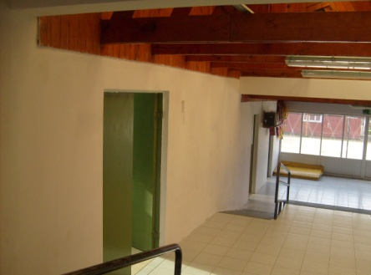  Semillita - Cauquenes, Del Maule | 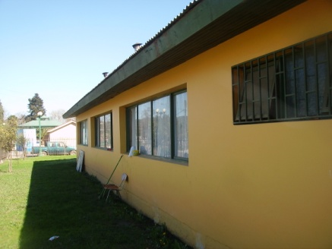  Papelucho – Licantén, Del Maule | 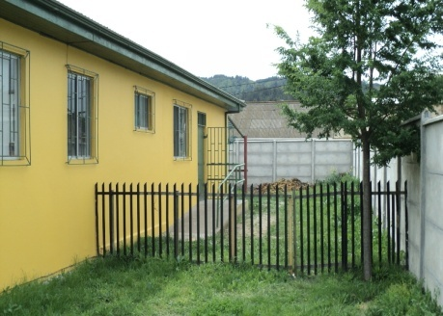  S.C Capullito – Licantén, Del Maule
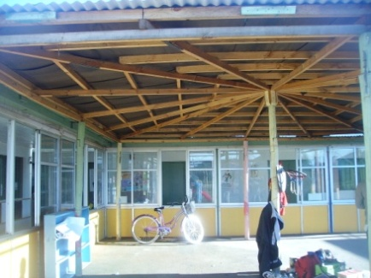  Niditos del Valle – Linares, Del Maule | 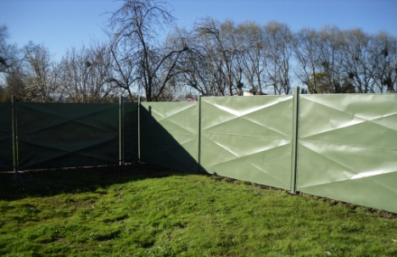  Flor de Aromo, Maule, Del Maule | 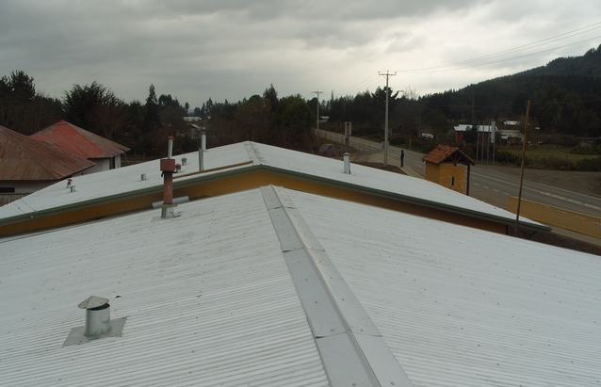  Huentelolen – Cañete, Del BíoBío
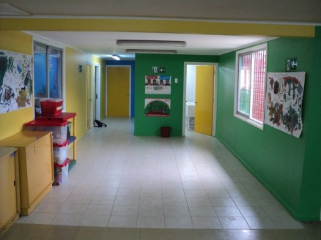  Los Aromos – Concepción, Del Bío Bío | 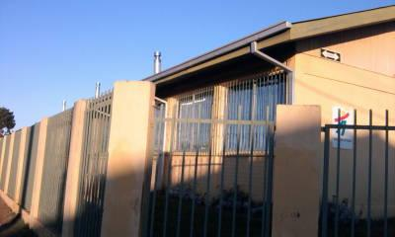  Los Lobos - Talcahuano, Del Bío Bío | 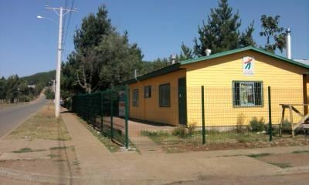  Los Castorcitos- Coihueco, Del Bío Bío
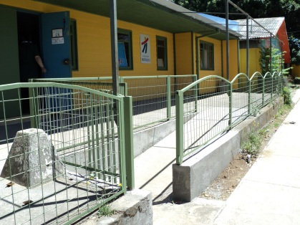  Rayo de Luna - Yungay, Del Bío Bío | 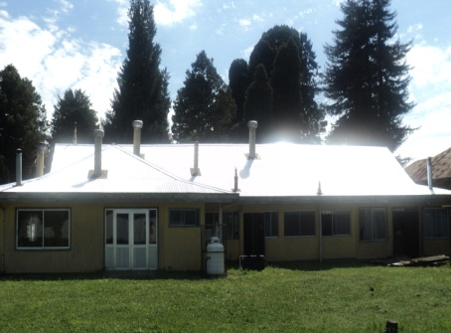  Los Notros - Freire, Araucanía | 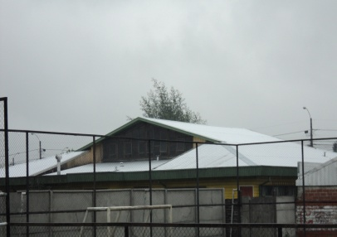  Villa Austral - Temuco, Araucanía
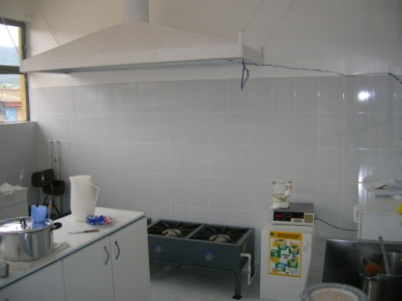  Teresita Domínguez - Angol, Araucanía | 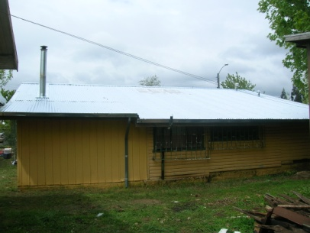  Cepillín - Ercilla, Araucanía | 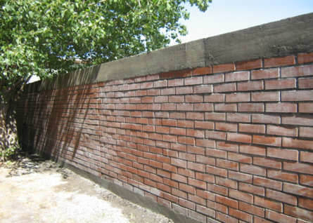  San Fco. Del Monte – El Monte, RM
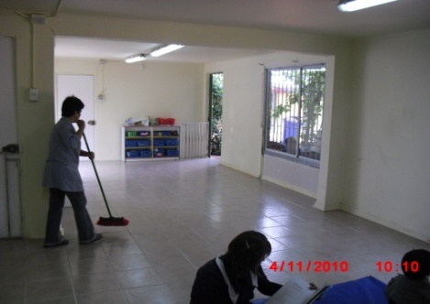  Rinconcito Mágico - Pudahuel, RM | 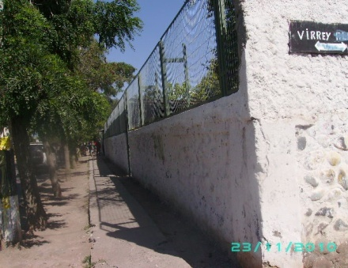  Mujeres de Chile – San Bernardo, RM | 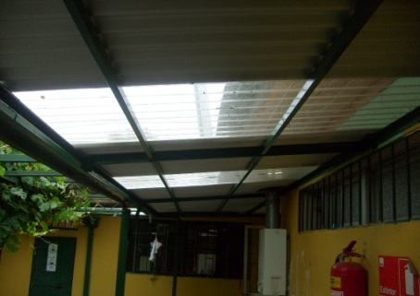  Las Palmas - Buin, RM
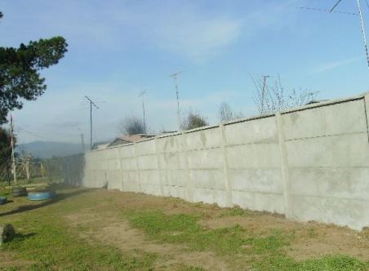  San Enrique – María Pinto, RM | 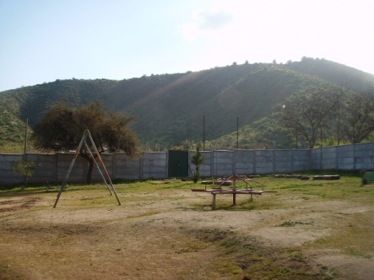  Valle Escondido – María Pinto, RM | 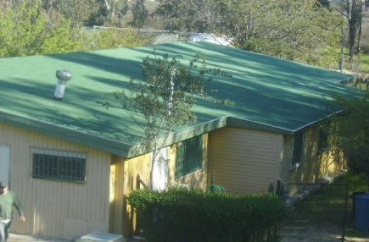  Los Pelluquitos – San Pedro, RM
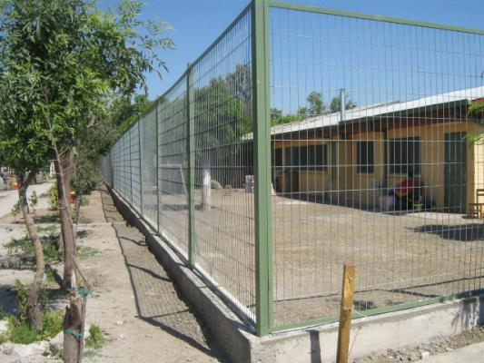  María Flora Yáñez – Renca, RM | 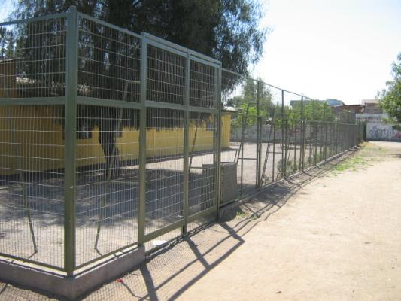  Valle de Azapa – Renca, RM

ANNEX N°2: Pictures of Works still in Progress
Rayito de Sol - Paredones, O´Higgins
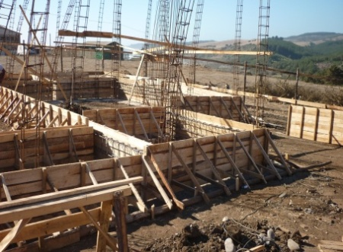 | 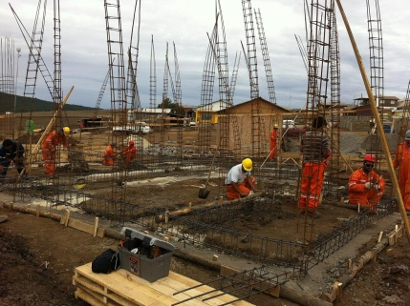 | 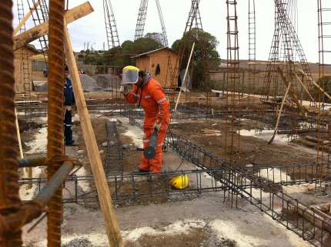
Rayito de Luna – Pencahue, Del Maule
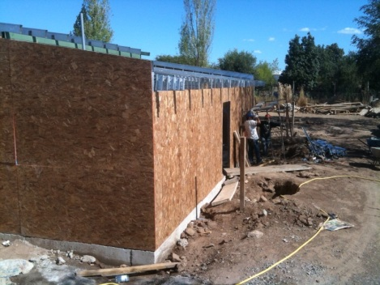 | 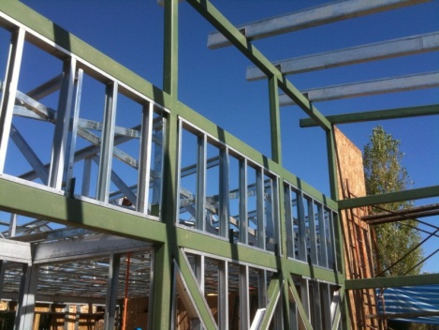 | 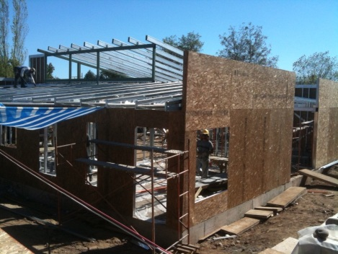
Micaeliano - Talca, Del Maule
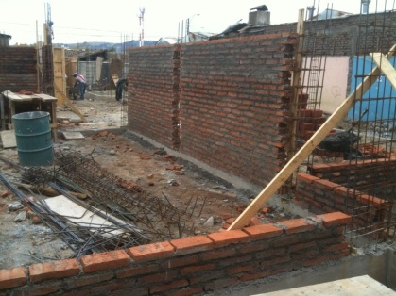 | 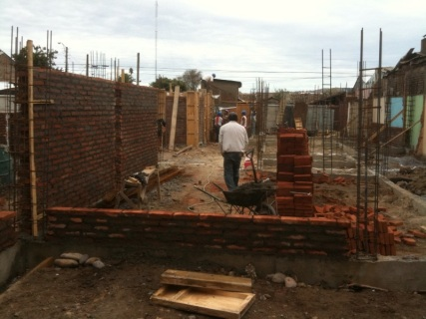 | 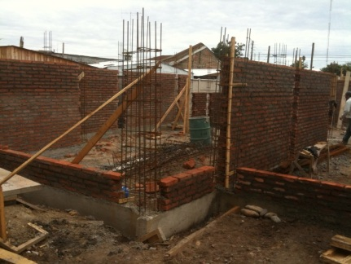
Abejitas – San Clemente, Del Maule
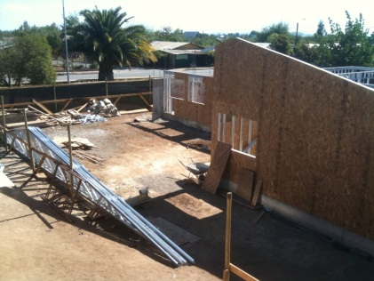 | 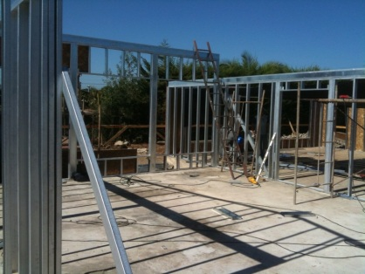 | 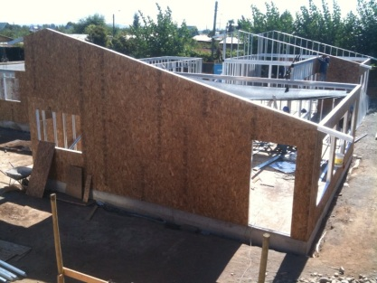
Javiera Carrera - Cabrero, Del Bío Bío
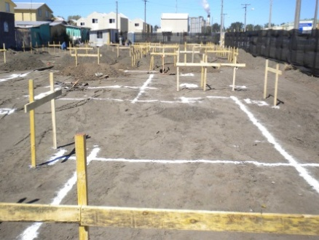 | 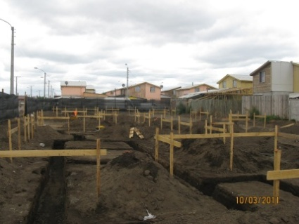 | 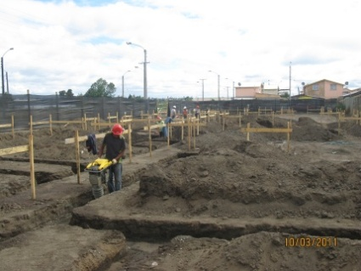
Los Ciervitos – Gorbea, Araucanía
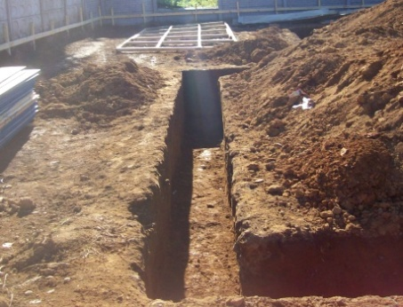 | 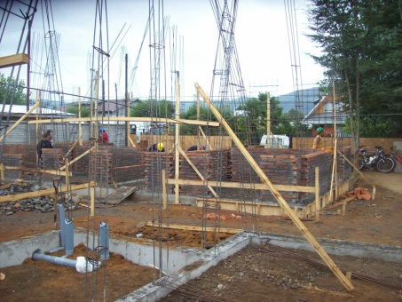 | 