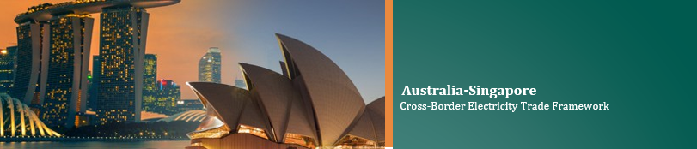

Quick guide to Australia-Singapore Cross-Border Electricity Trade Framework
Australia and Singapore have developed the Cross-Border Electricity Trade Framework based on the Ten Principles to Guide the Development of Cross-Border Electricity Trade announced by the Prime Ministers of both countries during the 9th Singapore-Australia Annual Leaders’ Meeting in March 2024.
We recognise the benefits that cross-border electricity trade in Southeast Asia can bring for all countries involved and the region at large including through the ASEAN Power Grid.

Boost to growth and industry
Accelerates growth; catalyses financing for clean energy; creates high-quality green jobs for local communities; generates revenue for exporting and transit countries.

Enhanced energy access and security
Moves surplus energy to areas with demand; sharing of reserve capacities; integrating grids with different energy mixes; diversifying energy sources.

Pathway to net-zero
Harnessing the region’s wealth of renewable resources to promote our collective decarbonisation.
Singapore and Australia will partner the region to put in place these key enablers for cross-border electricity trade.

Harmonisation and regulations
Implementing predictable, consistent, and transparent policies and regulations to improve project bankability; instituting of policies a framework to facilitate cross-border subsea power cable activities; and upholding commitments in bilateral and multilateral agreements as well as international law.

Governance
Promoting accountability and transparency through a robust governance framework.

Accounting
Facilitating international recognition of renewable energy certificates (RECs) associated with cross-border electricity trade; and incorporating best practices from embedded emissions accounting protocols.

Knowledge-sharing and Partnerships
Sharing information and advancing partnerships with stakeholders at the bilateral, regional and international levels.

