evaluation of australian government-supported sport for development investments 2013-17

dfat management response: OCTOBER 2017

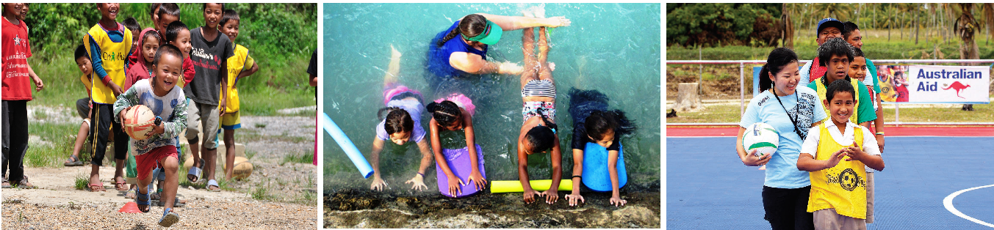

Photos: ChildFund Australia; Aaron Kearney, ABC International Development; Oceania Football Confederation

### DFAT response to evaluation

Australia was an early adopter of sport for development (S4D) and is one of relatively few governments active in this field. Our S4D programs are focused on the Asia Pacific region. This evaluation makes an important contribution to the small but growing evidence-base available to policy makers seeking to affect change through S4D programs.

DFAT considers the methodology used in this external evaluation to be sound and the report to be of high quality. It reflects the complexities of operating a sport-focused development program with a broad range of partner countries and organisations. DFAT welcomes the findings and recommendations of the evaluation and thanks the many stakeholders in Australia and the Pacific for their contributions.

Overall the findings recognise that Australia’s S4D program helps promote sport as a pathway to good health and social inclusion. The program resonates because Australia is seen as a passionate sporting nation, a hub for sports science and administration, and as a long-term and trusted development partner in our region.

DFAT and our implementing partners will be guided by the evaluation recommendations as we develop the next phase of our S4D program. DFAT will continue to deliver a range of sport programs to help Australia advance our foreign and trade policy, development and soft power interests.

| DFAT response to recommendations | | | |
| --- | --- | --- | --- |
|  |  |  |  |
| **Recommendation 1**  *Concrete efforts need to be made to ensure that PSP provides a framework to contribute in a meaningful way to country specific development priorities. This includes connection to local development priorities as well as DFAT’s Aid Investment Strategy.* | Agree | DFAT will strengthen the contribution that activities make to country-specific development priorities. | At design and implementation |
| **Recommendation 2**  *To position itself as a credible S4D actor, maximise PD potential and improve development effectiveness, Australia should pursue active engagement with S4D’s international community of practice. This requires engaging in relevant forums and dialogues, and supporting quality programs that move beyond participation and deliver development results.* | Agree | DFAT will seek opportunities to engage with the S4D community of practice where appropriate. | Ongoing |
| **Recommendation 3**  *a. To facilitate improved alignment and development effectiveness of Australia’s S4D investments we recommend a rationalisation of the PSP portfolio in terms of countries and sports, and the establishment of a mechanism to engage sports and government in locally contextualised planning and priority setting.* | Agree | DFAT will rationalise its S4D footprint with a view to maximising program impact, noting that development effectiveness is one of a number of considerations. | At design |
| *b. In doing so it is imperative that future partnerships should be based on a careful assessment of each sports strategic interest in sport for development and their ability to deliver on development as well as public diplomacy objectives. The potential to access wider contributions beyond DFAT grants to include co-financing and leveraging wider development and sporting resources should be explored as part of this equation.* | Agree | DFAT will pursue partnerships that reflect shared strategic interest in the next phase of S4D programming, and consider implementing good practice financing and partnership arrangements used in the Government’s NGO cooperation programs. | At design and procurement |
| *c. Greater diversification of the grant management system to allow new grant types for different purposes could facilitate a wider footprint through activities that contribute to DFAT’s wider public diplomacy priorities and/or emerging shared interest of DFAT and the sports.* | Agree | DFAT will explore diverse funding opportunities alongside core aid programming to ensure that the new S4D program can incorporate emerging priorities and innovative partnerships. Funding will be provided in line with the Commonwealth Grants Rules and Guidelines. | At design |
| **Recommendation 4**  *More effective targeting of specifically at risk groups to engage in regular physical activity and address the multiple risk factors of NCDs, women in remote areas and people with disability, will strengthen the effectiveness of PSP.* | Agree | S4D programs will engage specific groups within communities where this is identified as a priority by DFAT or within national development strategies. | At design |
| **Recommendation 5**  *Clear public diplomacy outcomes and metrics need to be articulated in the design of a future program.* | Agree | The design of the new program will clearly articulate expected foreign, trade, development and public diplomacy outcomes and how success will be measured. | At design and ongoing |
| **Recommendation 6**  *An ongoing media partnership should be an integral feature of the future program and include media capacity building of Australian and regional partners, and support for the amplification of key development messages to extend aid communication and public diplomacy efforts.* | Agree | DFAT believes it is important to communicate with a broad range of stakeholders in partner countries on the value of sport and will work with departmental and overseas media teams to promote sport for development initiatives. DFAT will assess the need for additional resources to this work. | At design and procurement |
| **Recommendation 7**  *Effective and sensitive management of the transition into a new phase of programming beyond PSP’s current phase is required. Specifically, the role and responsibilities of the MC, and indeed all partners, needs to be clearly articulated at design.* | Agree | DFAT is working closely with the managing contractor to support partners through program transition. In future programming, the managing contractor will play a key role in program implementation. The role of all partners will be articulated at design. | Ongoing |
| **Recommendation 8**  *The grant making system needs to establish clearer protocols and due diligence criteria for on-granting.* | Agree | DFAT is committed to best practice grant and contract management across all programs. DFAT will work with the managing contractor and grantees to reduce risks associated with the provision of DFAT funding to third parties for program implementation (on-granting). | Ongoing |
| **Recommendation 9**  *In determining resource allocations for the new S4D program, DFAT must pay attention to the resourcing implications of the evaluation recommendations on program scope and purpose, as well as positioning DFAT as a leader within a community of S4D good practice. This will include exploration of additional resources to support technical quality, or revisiting funding ratios or programming scope/footprint.* | Agree | As we design the next phase of the sport for development program, DFAT will consider options for improving program effectiveness in accordance with the principles of proportionality and value for money. We recognise that resourcing for technical support may reduce funds available for program implementation but improve the sustainability and impact of activities. | At design and procurement |
| **Recommendation 10**  *There is significant scope for strengthening the PSP partnership model into the future. The creation of opportunities for meaningful multi-stakeholder partnerships (including with non-sporting actors) would enable sports to focus on what they do best, and add value to development and sustainability outcomes. As such partnership should be viewed as a central approach and methodology to delivering on best practice sport for development objectives, and should be strongly and practically embedded within the future program logic.* | Agree | DFAT will seek to strengthen the partnership model used in the next phase of S4D programming. Fostering partnerships between sporting organisations and credible development organisations should help improve the overall quality of sporting programs delivered. | At design and procurement |
| **Recommendation 11**  *The logic model for any future investment should consider how to effectively address capacity building and institutional strengthening and articulate this in a meaningful way. This should include partners paying more systematic attention to the intended changes, and using effective tools to measure capacity building and institutional strengthening outcomes.* | Agree | DFAT is committed to working through local institutions wherever possible and recognises that better sport and development outcomes will be achieved by organisations with strong links to local communities. At the same time, DFAT will continue to work with local institutions to improve their capacity. | At design |
| **Recommendation 12**  *a. A program wide gender strategy is required to strengthen gender approaches and to address the wider risks, inhibiting factors and barriers to women’s participation, and contribute to outcomes beyond participation such as promoting women’s sport leadership, access to resources for women’s sports, increasing women’s roles in sports administration, tackling violence against women, and promoting women’s health. Each sport should in turn develop their own gender action plan to articulate how they will work towards achieving gender outcomes.* | Agree | DFAT agrees that gender is an important aspect of the program and will draw from DFAT’s Gender Equality and Women’s Empowerment Strategy to strengthen outcomes in the new program. | At design and implementation |
| *b. To deliver on this, DFAT must resource the focus on gender equality by ensuring that financial and technical resources are made available to support sports to establish meaningful gender partnerships, undertake research, build capacity and develop their gender action plans.* | Agree | DFAT is committed to supporting gender equality and will resource S4D investments in accordance with principles of proportionality and value for money. | At design and implementation |
| **Recommendation 13**  *It is vital that DFAT address the tension between participation represented as a numeric value (number of participants) against the transformative outcomes of inclusion experienced by PWD and other marginalised and/or excluded groups etc.* | Agree | DFAT recognises the potential for transformation that inclusion in sport provides to people with disability and other marginalised groups. We will work with partners to implement a monitoring and evaluation framework that supports an impact narrative that goes beyond participation data. | At design and implementation |
| **Recommendation 14**  *PSP should resource its focus on disability inclusion by ensuring that both financial and technical resources are made available to support strengthening disability inclusion including capacity building and engagement with key Disabled People’s Organisations* *and para-sporting organisations etc.* | Agree | S4D programs will engage specific groups within communities where identified as a priority by DFAT or within national development strategies. | At design and implementation |
| **Recommendation 15**  *DFAT and its partners have a duty of care to protect children from abuse, discrimination and harassment. As such technical investments in child protection policy development and capacity building need to be sustained in all future S4D investments. This should include resources to ensure that child protection efforts are contextually and culturally appropriate, resources should be made available to National Federations (in-country, not Australian in this* context) (*NFs) to access local or regional expertise for capability building.* | Agree | DFAT is committed to ensuring that our sport for development programs and partners safeguard children. DFAT will ensure that Australian expertise on child protection informs the design of the next phase of the sport for development program, and is drawn on by Australian and international partner organisations. | Continuous |
| **Recommendation 16**  *There is a strong need for continuity of purpose of PSP into the future and the current program logic and* Monitoring, Evaluation, Research and Learning Framework *should form the basis of arrangements of the next stage of programming irrespective of the contracting arrangements.* | Agree | DFAT will ensure that the social inclusion and community wellbeing benefits gained through sustained investment in sport for development programs (since 2009) remain fundamental to the design of future iterations of our sport for development programs. | At design |
| **Recommendation 17**  *Regular routine monitoring of investments by the MC is a minimum standard for accountability and risk and performance management. Adequate human and financial resources for (at least) biannual monitoring by the MC and/or a technical team should be allocated within the future program.* | Agree | DFAT strongly supports accountability and risk management and will work with the managing contractor to develop an appropriate monitoring schedule within a future Monitoring, Evaluation and Learning Framework. | At design |
| **Recommendation 18**  *Future resourcing for* Monitoring Evaluation and Learning (*MEL) should consider the need for increased technical resources to support partner M&E capabilities, whole of program and cross activity learning and data collection and analysis*. | Agree | DFAT will work with the managing contractor to develop an appropriate Monitoring, Evaluation and Learning Framework. The allocation of funding for technical resources will be considered in accordance with principles of proportionality and value for money. | At design |
| **Recommendation 19**  *Reporting arrangements should be strengthened through:* |  |  |  |
| *a. considering the proportionality of reporting requirements across the range of PSP and S4D grant types and* | Agree | DFAT will work with the managing contractor to develop a program reporting schedule that is appropriate for the level of grant complexity, value and risk. | At design |
| *b. making resourcing available for the development of an Integrated Management Information System to streamline reporting and data analysis.* | Agree | DFAT will explore options for end-to-end information management to simplify reporting and data analysis. | Immediate |
| **Recommendation 20**  *Ongoing support and partnerships for research should be a provided to contribute to both whole of program and activity design as well as building the evidence base for the contribution of sports to delivering on development outcomes.* | Agree | DFAT-funded sport for development programs have made a positive contribution to the small but growing evidence base for sport for development in the Pacific. The approach to research in the new program will be dependent on funding availability. | At design |
| **Recommendation 21**  *S4D investments provide the opportunity for DFAT to explore new ways of engaging non-traditional development actors, however, innovation activities need to be appropriate to the funding mechanism and must not be viewed as short-term entry points for long term funding. The next stage of programming should provide for* |  |  |  |
| *a. Targeted funds with clear innovation criteria to ensure a genuine competition for funding;* | Agree | DFAT is considering options to ensure that the program supports innovation. Funding mechanisms will include clear criteria to support competition in line with the Commonwealth Grants Rules and Guidelines. | At design and implementation |
| *b. Opportunities to expand S4D partners to engage in wider partnerships for development (e.g. with universities, NGOs, the private sector, other bilateral/multilateral programs* | Agree | DFAT is considering flexible funding opportunities alongside core aid programming to ensure that the new S4D program can incorporate partnerships with credible non-sporting actors. | At design and implementation |
| **Recommendation 22**  *a. The viability of extending the reach of Australia’s S4D investments to Asia needs to be pragmatically reviewed in the light of the findings of this evaluation, including the lessons that have emerged regarding what makes S4D investments effective and the level of resourcing available.* | Agree | DFAT will consider the evaluation findings and lessons learned from Pacific programs when determining its approach to sport for development in Asia. DFAT acknowledges that development and public diplomacy contexts differ markedly between regions, but is committed to expanding investments to better align with the Asia-Pacific focus of Australian aid, foreign policy and economic diplomacy interests. | Immediate |
| *b. If DFAT determines to proceed with an integrated program, given the size of the funding pool for Asia combined with the enormous scope of investing in Asia, DFAT needs to agree a clear and singular focus/objective for its S4D investments in Asia.* | Agree | DFAT will consolidate activities and partners, and articulate realistic objectives for its sport for development activities in Asia. | At design |
| **Recommendation 23**  *To gain credibility and maximise effectiveness and efficiency, S4D partnerships in Asia must work alongside and leverage upon the existing capabilities within the development sector.* | Agree | DFAT will support partnerships with organisations and institutions with a demonstrated ability to deliver results. This may involve sporting organisations partnering with an existing and credible development actor. | At design and procurement |
| **Recommendation 24**  *The costs of financing the integration of Asia and Pacific S4D investments into a single program must be identified immediately. This includes ensuring sufficient resources for implementing recommendations for strengthening the technical quality of work on gender, social inclusion, child protection, monitoring evaluation and learning which apply to ASP and PSP efforts in equal measure.* | Agree | DFAT will work with the sport for development program design team to identify partnership and funding models that satisfy a future program’s technical requirements while also meeting principles of proportionality and value for money. | Immediate |

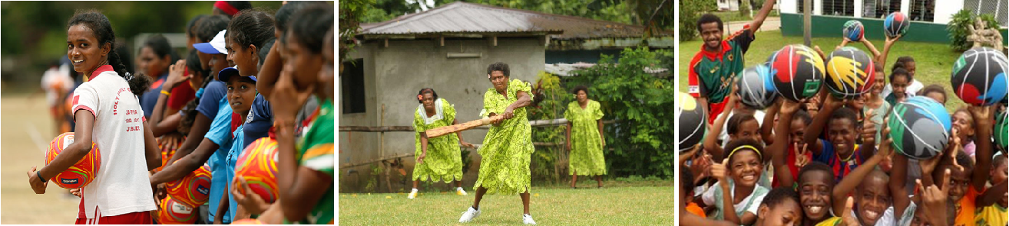

Photo credits: Netball Australia; International Cricket Council EAP; FIBA in Oceania